PUBLIC UTILITIES COMMISSION OF THE STATE OF CALIFORNIA

SAFETY AND ENFORCEMENT DIVISION RESOLUTION ROSB-004
Railroad Operations and Safety Branch June 27, 2013

R E S O L U T I O N

Resolution ROSB-004. This resolution grants the request of Union Pacific Railroad to deviate from the requirements of General Order 118-A governing walkway standards, at specific locations on its main-line track between Shed 10 and Norden on its Donner Pass Route through the Sierra Nevada Mountains.
____________________________________________________________

SUMMARY

This resolution grants Union Pacific Railroad’s request to deviate at specific locations from the requirements of the Commission’s General Order 118-A governing walkway safety standards. Union Pacific Railroad continues to reconstruct its California Donner Pass Line by replacing old wood-tie track with new concrete ties, new rail, and new underlying ballast materials. The project will take place in two locations. The first location is between Newcastle and Rocklin. The second location is between Shed 10 and Norden. By letter dated November 10, 2011, Union Pacific Railroad requested a deviation from the Commission’s walkway requirements at certain locations related to the first phase of its concrete tie project on its main lines between Rocklin and Colfax. The Commission granted that request by adopting Resolution ROSB-003. Union Pacific now requests the same deviation from the walkway requirements for the next phase of the project, at certain locations between Shed 10 and Norden. This resolution grants Union Pacific’s current request and adopts the conditions proposed by the railroad to address safety.

BACKGROUND

General Order 118-A is the Commission’s General Order that governs standards for walkways adjacent to railroad tracks.

General Order 118-A permits deviations to be granted under the following conditions, described in the following excerpts from Section 7 of the General Order and Section 5 of the “Consensus Agreement” adopted in Decision (D.) 90-09-047:
a.) In granting deviations, the principle to be followed is that of ensuring appropriate employee safety in performing tasks which are required under the circumstances of the particular activity being undertaken. Conformance to a particular pattern, formula, or design is not necessary. While cost effectiveness may be considered, it will not be the sole criterion, and the deviation procedure will not be employed, and deviations will not be granted, simply to avoid costs.
b.) Written requests for deviations shall be prepared by the carrier and submitted to the Director of the Safety Division, with a copy being served on the California State employee representatives of the carrier's affected trainmen, and on all other interested parties. The deviation request shall include a full statement of the conditions which prevail at the time and place involved, and shall specify the reasons why the deviation is deemed necessary. The request shall also include a showing that the deviation will not create a detriment to safety.

Consistent with the procedure set forth in Subsection b above, Union Pacific Railroad (Union Pacific) submitted a written letter to the Commission’s Consumer Protection and Safety Division on September 17, 2012 with a follow-up letter of November 12, 2012, modifying their request. Union Pacific submitted the descriptions of the specific locations of the requested deviations in an e-mail on February 9, 2013. Union Pacific plans to continue replacing the existing wood ties with concrete ties on its Donner Pass Line. The project will include installing 64,000 concrete ties and 19.8 miles of new continuously welded rail for an estimated project cost of $22,800,000. The project will take place in two locations. Reconstruction on the first location, between Newcastle and Rocklin on the number 2 track, is scheduled to finish on June 2, 2013. The second location is between Shed 10 and Norden on the number 1 track. Reconstruction on the Shed 10 to Norden segment is scheduled to finish on June 23, 2013.

By letter dated November 10, 2011, Union Pacific requested a deviation from the Commission’s walkway requirements at certain locations related to the first phase of its concrete tie project. The Commission granted that request by adopting Resolution ROSB-003. Union Pacific now requests the same deviations from the walkway requirements for the next phase of their project.

This project is part of Union Pacific's strategy to convert wood tie track to concrete tie track on its mountain grades. Union Pacific states that installing concrete ties improves safety, and that the railroad has seen a reduction in derailments where it has installed concrete ties. Other areas in California where concrete ties have been installed include the Tehachapi Mountains between Bakersfield and Mojave and the Cascade Mountains between Lakehead and Mt. Shasta (through Dunsmuir). The work to be done in 2013 will complete and extend a project to replace wood ties with concrete ties and install new continuous welded rail in the Sierras between Rocklin and Colfax that Union Pacific began in 2012.

As it did during this year’s concrete tie upgrade, Union Pacific plans to supplement the existing hot box and dragging equipment detectors by installing "wheel-down indicators" at intermediate signals within the project limits. The intermediate signals vary between one and two miles apart. A wheel-down indicator is a device that is attached to the top of a tie or placed between ties. When a wheel is "down" or derailed, a radio transmission automatically directs the train crew to stop their train. A wheel-down indicator differs from a dragging equipment detector by being hardened to the point that dragging equipment, such as banding or low air hoses between cars, will not activate the device.

Union Pacific states that it wishes to utilize this new technology to enhance safety. Installation of wheel-down indicators to supplement their existing detection systems will shorten the distance between any wheel-down notification and the possible distance a train may travel with any derailed wheels or cars, thereby reducing the probability of a derailment involving multiple cars, overturned cars, spills, or damage to private or public infrastructure. All of these improvements are directly related to the safety of employees, first responders, and members of the public.

The process that Union Pacific will use to install the concrete ties and new rail utilizes the railroad’s TRT-909 machine, an expensive production machine that replaces ties, rail, and supporting ballast in one move over the track being reconstructed. Union Pacific’s daily production target for this project is 3,500 ties, which is about 1.3 miles. The track renewal process will plow the existing ballast to the side, leaving a smooth surface adjacent to the track and improving the walkway area. Union Pacific states that this process improved the walkways areas during the 2012 project.

The terrain in the area where the project is planned is mountainous. There is limited space due to steep cuts, high fills, vertical rock walls, and adjacent creeks. Many of these features date back to the construction of the original transcontinental railroad in the 1860s. The railroad has had to work within the constraints created by these features since that time. One of the problems that this presents involves walkways. Walkway requirements did not exist when the Central Pacific Railroad built the original grade through the Sierras. This has left many places where physical features, such as rock walls, leave insufficient room for construction of a General Order 118-A walkway. Engineering additional space in these locations would be difficult and extremely expensive. In some places, Union Pacific estimates the unit cost for such work would be between $1,400 and $2,200 per linear foot (depending on the slope of embankments) to install the retaining walls necessary to construct fully complaint walkways. These figures do not include the engineering design costs. Widening a cut by removing more of the mountain where retaining walls may not be feasible would present additional costs and complications. In short, doing this project will not be cost effective if these types of retaining walls and widened cuts are required.

The areas where the deviation is requested are on main line track where trains are not required to stop under normal operating conditions, and the only time a train crew is required to be on the ground is after an emergency stop, when it becomes necessary for them to walk alongside the train to perform their assigned inspection duties. This means that this is Type D track under the 1990 Consensus Agreement related to tracks constructed prior to the Commission's adoption of General Order 118 in 1963. The Consensus Agreement provides the following definition:

Type D tracks are those where trains are not required to stop under normal operating conditions, and the only time railroad employees are required to be on the ground is after an emergency stop when it then becomes necessary for them to walk alongside the train to perform their assigned inspection and repair duties.

Union Pacific indicates that the addition of wheel-down indicators could be argued as converting this track’s designation to Type C track, thereby requiring an evaluation of whether walkway improvements are necessary within certain distances of the indicators.

Type C tracks are limited to locations on main and branch lines where the following functions occur: trains infrequently stop under established operating practices and railroad employees are required to get on and off and to walk alongside the stopped equipment to perform their assigned duties. Switching operations are not performed on Type C tracks.

Union Pacific believes that if this were to become Type C track, the historically low frequency of emergency stops would make it unlikely that the Consensus Agreement would require construction of walkway improvements related to the new indicators.

However, expressing the intent to remove any uncertainty, Union Pacific has requested a deviation from the Commission's walkway requirements related to the concrete tie project under the expedited deviation process described in the Consensus Agreement. According to Union Pacific, if Standard 1 walkways were to be required, this project and the incremental safety improvements that it will provide would be cost-prohibitive to execute. As it did in relation to the prior deviation, to mitigate the continued absence of walkways in some locations and confirm that this will continue to be Type D track, Union Pacific will issue a general order that will instruct employees not to walk their train when the wheel-down indicator is activated in this area and under other unplanned conditions such as a brake application due to a broken air hose.

When employees receive a wheel-down indication they will report to the dispatcher that they have been stopped by a wheel-down indicator and will require assistance. A team that is familiar with the area will respond, assess the situation, and mobilize whatever additional resources may be needed to re-rail the car and make repairs. This process will eliminate the chance that a crew member would ever have a reason to walk his or her train due to a derailment where there are not adequate walkways.

The project will improve employee safety in two additional ways. First, in the process of removing the existing ballast, the TRT-909 production machine will spread the old ballast to the sides, enhancing the walkway area. Second, Union Pacific will adopt an explicit operating rule giving employees the discretion to not walk into any area unsafe to occupy due to the absence of a safe walkway. While this has always been implicit in general safety rules, it is an added safety benefit to have this explicit reassurance.

The boundaries of the requested deviations were submitted in Union Pacific’s e-mail of February 9, 2013, and are listed in Appendix A to this resolution. The new operating rules providing added safety for employees who may otherwise be required to occupy these areas are included as Appendix B to this resolution. Tunnel locations where Standard 1 walkways are not required, and thus are not part of this deviation request, are listed in Appendix C.

NOTICE AND PROTEST

Union Pacific’s request was noticed on the Commission’s Daily Calendar of May 13, 2013.

DISCUSSION

The Commission’s SED staff (Staff) has reviewed the request and supporting documents and agrees that the deviation should be granted. The areas where the deviation is requested have been without G.O. 118-A Standard 1 walkways since the railroad was built in the 1860s. This track reconstruction project will result in better derailment prevention due to the enhanced track infrastructure, including stronger and more durable ties that will more safely secure the rails, and the installation of derailment detectors known as “wheel-down” detectors that will provide an early warning to the engineer allowing him or her to stop the train before the derailed wheels result in a bigger derailment of multiple cars.

Staff agrees that to install Standard 1 walkways throughout the reconstruction area would make the track reconstruction project cost-prohibitive. The cost of the project would be many times over the cost of the track reconstruction and detector installations. Unfortunately, the economics of the project are such that if Standard 1 walkways are required throughout, that the entire project would likely be dropped.

However, in keeping with the Consensus Agreement, that “cost will not be the sole criterion,” Staff agrees that the added operational protections for train and engine employees will provide more explicit protection for employees who must make important decisions regarding unplanned train inspections. Thus not only will there be a net safety improvement with the project with its deviations, but each element, both to the public and the employees, will have safety enhancements. Consistent with the requirements of the Consensus Agreement, approving the requested deviation “will not create detriment to safety.” Staff supports the deviation request as limited to the locations documented in Appendix A, and as addressed in the operating conditions as documented in Appendix B. The Director of the Safety and Enforcement Division recommends that the deviations be granted as described herein.

COMMENTS

Public Utilities Code Section 311(g)(1) requires that Draft Resolutions be served on all parties and subject to at least 30 days public review and comment prior to a vote of the Commission. Public Utilities Code section 311(g)(2) and Rule 14.6(c)(2) both provide that the 30-day comment period may be waived “…for an uncontested matter in which the decision grants the relief requested.” Therefore pursuant to Public Utilities Code section 311(g)(2) and Rule 14.6(c)(2) the 30-day comment period for Draft Resolutions is being waived in this instance.

FINDINGS

- The procedures employed for requesting and granting the deviations sought in Union Pacific’s September 17, 2012, letter, and as modified by its letter of November 12, 2012, and its e-mail of Feburary 9, 2013, comply with the requirements in the Consensus Agreement in D.90-09-047.
- No protests were received.
- Union Pacific’s request, accompanying additional safety mitigations, submitted by its letter dated September 17, 2012, and as modified by its letter of November 12, 2012, as well as Union Pacific’s supplemental proposal materials specifying locations of requested deviations submitted via e-mail on February 9, 2013, comply with the requirements of the Consensus Agreement in D.90-09-047 to limit the deviation to the time and place involved.
- Safety will be improved by the track reconstruction and wheel-down installation project.
- Some walkway areas will be improved through the spreading of the old ballast material adjacent to the track.
- Protections to employees whose duties at times require them to be on the ground adjacent to the track have been enhanced by new operating rules.
- The deviation request is limited to specifically identified areas.
- Granting the deviation will not create a detriment to safety.

THEREFORE IT IS ORDERED THAT:

- Union Pacific Railroad’s request to deviate from General Order 118-A Standard 1 walkway requirements for track reconstruction, as described in its letter of September 17, 2012, as modified by its letter of November 12, 2012, included herein as Appendix D, and as specified in its e-mail of February 9, 2013, included as Appendix A herein, is granted.
- The deviation is limited to mainline track 1 between Shed 10 and Norden at the locations documented in Appendix A.
- Union Pacific Railroad must preserve and observe the added protections to employees as documented in Appendix B.
- Changes to any conditions of this deviation must comply with the requirements of General Order 118-A and Decision 90-09-047.
This Resolution is effective today.

I certify that this resolution was adopted by the Public Utilities Commission at its regular meeting on June 27, 2013, by the following Commissioners approving it.

_____________________
PAUL CLANON
Executive Director

 | Deviation Boundaries
Track | MP | MP | Side | Distance
1 | 178.4 | 178.5 | N | 0.1
1 | 178.95 | 179.15 | N | 0.2
1 | 179.5 | 179.9 | N | 0.4
1 | 180.5 | 180.7 | N | 0.2
1 | 180.9 | 181.1 | N | 0.2
1 | 181.4 | 181.7 | N | 0.3
1 | 182 | 182.5 | N | 0.5
1 | 182.8 | 182.9 | N | 0.1
1 | 183.1 | 183.7 | N | 0.6
1 | 184 | 184.4 | N | 0.4
1 | 184.5 | 184.6 | N | 0.1
1 | 184.8 | 184.9 | N | 0.1
1 | 185 | 185.2 | N | 0.2
1 | 185.5 | 185.7 | N | 0.2
1 | 187.4 | 187.5 | N | 0.1
1 | 187.9 | 188.1 | N | 0.2
1 | 188.6 | 188.9 | N | 0.3
1 | 189.1 | 189.9 | N | 0.8

(END OF APPENDIX A)
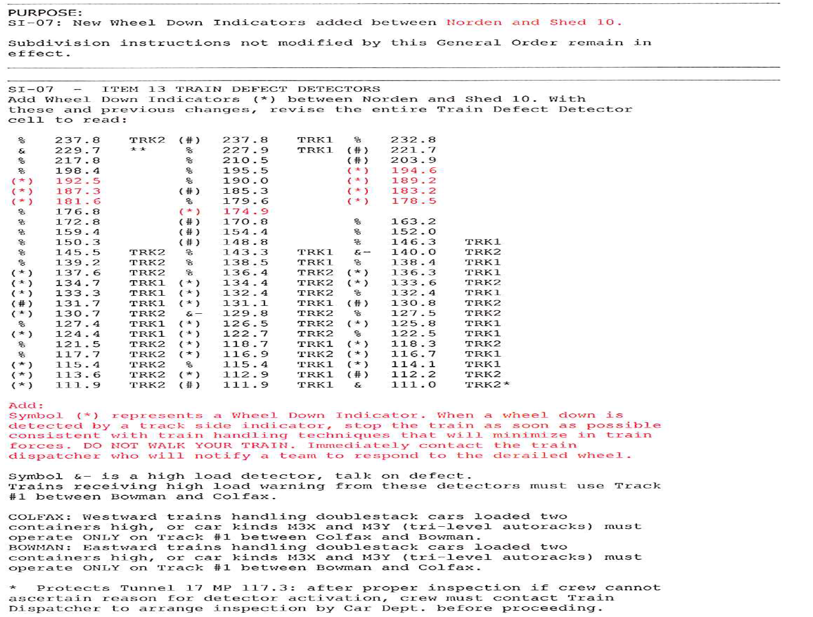

(END OF APPENDIX B)

Boundaries |  | Track | Tunnel Identification and Description | Distance
MP | MP
178.19 | 178.36 | 1 | Snow Shed 10 | 0.17
179.85 | 180.15 | 1 | Tunnel 39 | 0.3
191.12 | 191.29 | 1 | Snow Shed 25 | 0.17
192.49 | 194.57 | 1 | Tunnel 41 | 2.08

(END OF APPENDIX C)

(APPENDIX D)

D.90-09-047, Consensus Agreement, Section 5, Subsections a and b.
The name of the Division has since been changed to the Safety and Enforcement Division, effective on January 1, 2013.
D.90-09-047, Appendix C, Section 4.a.
D.90-09-047, Appendix C, Section 3.a.
The Consensus Agreement requires the recommendation of the “Director of the Safety Division.” The Safety and Enforcement Division (SED) is the successor to the Safety Division.

