PUBLIC UTILITIES COMMISSION OF THE STATE OF CALIFORNIA

Communications Division | RESOLUTION T- 17428
Broadband Policy and Analysis Branch | March 13, 2014

A L T E R N A T E R E S O L U T I O N

Resolution T-17428 Approval of Funding for the Grant Application of The Ponderosa Telephone Company (U-1014-C), from the California Advanced Services Fund in the Amount of $654,360 for the Cressman Unserved and Underserved Broadband Project
__________________________________________________________________

SUMMARY

This Resolution approves funding in the amount of $654,360 from the California Advanced Service Fund (CASF) for the CASF grant application of The Ponderosa Telephone Company (Ponderosa) for its Cressman Unserved and Underserved Broadband Project (Cressman Project). The Cressman Project will extend high-speed Internet service to 1.34 square miles covering the Cressman area of Fresno County.

BACKGROUND

On December 20, 2007, the California Public Utilities Commission (Commission) in Decision (D.) 07-12-054 established the CASF program as a two-year program to provide funds for the deployment of broadband infrastructure in unserved and underserved areas in California.

On September 25, 2010, Governor Schwarzenegger signed Senate Bill (SB) 1040 which codified the CASF program and expanded it to include three accounts: (1) the Infrastructure Grant Account, (2) the Consortia Grant Account, and (3) the Revolving Loan Account. The latter two accounts are intended to address the needs that were unmet under the original CASF program. Specifically, the purpose of the Revolving Loan Account is “to finance capital costs of broadband facilities not funded by a grant from the Broadband Infrastructure Grant Account.” SB 1040 also expanded the CASF fund from $100 million to $225 million adding $100 million to the Infrastructure Grant Account and allocating $10 million and $15 million to the Consortia Grant Account and the Revolving Loan Account, respectively.

On February 1, 2012, the Commission approved D.12-02-015 to implement new guidelines for the Infrastructure Grant and Revolving Loan Accounts. Key provisions of the Decision include:
- A maximum CASF grant award of 70 percent of project costs for unserved areas and 60 percent for underserved areas;
- A definition of an underserved area, “where broadband is available, but no wireline or wireless facilities-based provider offers service at advertised speeds of at least 6 megabits per second (Mbps) downstream and 1.5 Mbps upstream (6 Mbps /1.5 Mbps);” and
- A Revolving Loan Program to provide supplemental financing for projects also applying for CASF grant funding (up to 20% of projects costs, with a maximum of $500,000), utilizing the same project and applicant eligibility requirements as the Infrastructure Grant Program.

Consequently, on May 10, 2012, the Commission approved Resolution T-17362 which established the application deadlines for the CASF Broadband Infrastructure Grant Account and the Revolving Loan Account as follows:
- October 1, 2012, for unserved areas;
- February 1, 2013, for underserved areas not previously funded by the CASF and hybrid projects that cover both unserved and underserved areas; and,
- A date to be determined for projects in underserved areas where the existing broadband infrastructure was partially funded by a CASF grant.

On February 1, 2013, Ponderosa, an incumbent local exchange carrier, submitted an application for CASF funding in the underserved area of Cressman in Fresno County.

NOTICE/PROTESTS

Communications Division (CD) posted the proposed project area map, census block groups (CBG), and zip codes by county for the Cressman Project on the Commission’s CASF webpage under “Pending New CASF Applications to Offer Broadband as of February 11, 2013.” CD did not receive any challenges from any broadband provider purporting to provide service at served speeds in the proposed project areas.

DISCUSSION

This Resolution adopts CD’s recommended CASF fund award of $654,360 for the Cressman Project. This award represents 60% of the total project cost of $1,090,600. Key project information and maps are shown on pages A-1 through A-3 of Appendix A.

- Project Overview

Ponderosa has provided local exchange service in Fresno County for more than 100 years. In addition, Ponderosa also provides long distance, cable and internet services within its franchised service territory. Within its CASF application, Ponderosa proposes to bring broadband service to the Cressman area of Fresno County. Currently, the project area does not receive any broadband service, with the exception of a half mile within the project area between Wild Iris Lane and Upper Cressman Road that receives Ponderosa’s Asymmetric xDSL at speeds that qualify only as underserved.

The Cressman Project, as proposed, would bring high speed Internet access to a 3.56 square mile area and expand Ponderosa’s existing network by extending fiber optic backhaul facilities and connecting to multiple Broadband Loop Carrier systems (BLC). Ponderosa would extend fiber from an upgraded BLC site at Sierra Cedars to two new BLC sites at Lower Cressman and Rush Creek. The installations would utilize Ponderosa’s existing copper distribution plant in a fiber-to-the-node configuration and deploy VDSL2 and ADSL2+ technologies to connect end-users.

Ponderosa asserts that it chose the project area because of customer demand and economic viability. Ponderosa determined the project is economically feasible with the assistance of a CASF grant of $1,027,380, or 60% of the total project cost, to supplement Ponderosa’s funding of $684,920.

The Cressman Project, as submitted, would reach an estimated 70 households, of which 59 are classified as unserved and 11 as underserved. Ponderosa estimates the project would initially yield 52 of the 70 potential subscriber households in the proposed area. The project would reach all 70 households at the minimum served thresholds of 6 Mbps/ 1.5 Mbps. The maximum speeds offered, 24 Mbps/ 2 Mbps, would be available to approximately 21 households via VDSL2 technology. Most of the other households would receive ADSL2+ technology, with maximum advertised speeds of 12 Mbps/ 1.5 Mbps.

Ponderosa has committed to a broadband pricing plan under the terms shown below for two years, starting from the first day of service availability. This commitment is for its affiliate, Ponderosa Cablevision, which would provide Internet access over Ponderosa’s network. Ponderosa also committed to providing wholesale access to its network to other Internet service providers. The recurring monthly rates assume a one year commitment by the customer.

 | Broadband Speed (Up/Down) | Standalone Broadband Service | Broadband Price when purchased with Voice Service
Monthly Recurring Rates:
Standard | 6 Mbps/ 1.5 Mbps | $112.95 | $54.95
Broadband Pro | 12 Mbps/ 1.5 Mbps | $117.95 | $59.95
Broadband Extreme | 10 Mbps/ 3 Mbps | $149.95 | $74.95
Modem Rental (optional) |  | $3.95 | $3.95
Non-recurring Charges:
Modem Purchase (optional) |  | $89.00 | $89.00
Activation Charge |  | Fee Waived | Fee Waived

- Project Qualification

To qualify for the CASF program, the applicant is required to submit proof that the area is unserved or underserved by submitting shapefiles of the proposed project. CD reviews the submitted shapefiles and compares them with United States 2010 Census data and the California Interactive Broadband Availability maps which contain broadband availability data as of June 30, 2012. Once CD determines that the area is eligible either as an unserved or underserved area, CD evaluates all other information submitted by the applicant to determine if the project meets the requirements outlined in D.12-02-015. Other information CD reviews includes: proof of a Certificate of Public Convenience and Necessity (CPCN) from the Commission; descriptions of current and proposed broadband infrastructure; number of potential subscriber households and average income; project construction schedule; project budget; proposed pricing and commitment period for new subscribers; and financial viability of the applicant.

As an initial step in the review of Ponderosa’s application, CD checked the CBGs submitted in the project application and determined that the project area was indeed eligible for CASF funding. In doing so, CD found broadband availability at served speeds by satellite providers such as Hughes.net and Skycasters, LLC. However, as adopted in D.12-02-015, the Commission does not consider satellite broadband service in CASF project evaluation, unless the satellite project in an area was previously funded by the CASF.

Additionally, CD requested greater detail concerning the current infrastructure, project budget, pro forma financials, project broadband speeds, and possible impacts to the environment and community. CD also obtained a revised pricing plan to include standalone broadband service rates.

- Project Evaluation and Recommendation for Funding

CD evaluated the application with respect to the scoring criteria defined in D.12-02-015, Appendix 1, Section VIII (Scoring Criteria). The scoring criteria include: (i) Funds Requested per Potential Customer, (ii) Speed, (iii) Financial Viability, (iv) Pricing, (v) Total Number of Households in the Proposed Area, (vi) Timeliness of Completion of Project, (vii) Guaranteed Pricing Period, and (viii) Low-Income Areas.

This project received a relatively low score compared to other projects, due, in part, to the low number of households within the project area. However, the project did score particularly well in an important category, Financial Viability.

The Commission considers unserved areas as having the highest priority, and CD contends that the funding of the Cressman Project meets this goal. At the outset of CD’s evaluation of the Cressman Project, CD determined that the entire area was considered underserved. With the exception of the aforementioned half mile road that currently receives Ponderosa’s Asymmetric xDSL, the project area was considered underserved due to the availability of mobile broadband. According to the California Interactive Broadband Availability map, AT&T Mobility and Verizon Wireless provide all or part of the project area with mobile broadband service that qualifies as underserved. However, Ponderosa provided evidence to the contrary, namely the results of 24 CalSPEED mobile broadband tests. The test results, which measured broadband speeds on the AT&T Mobility and Verizon Wireless networks, show no available mobile broadband service. CD believes that these tests, which were performed at various locations throughout the proposed project area, sufficiently demonstrate the area is not served by mobile broadband. Therefore, CD considers the area to be unserved, except for the small portion that receives Ponderosa’s Asymmetric xDSL at underserved speeds.

CD’s review of the Cressman Project revealed some noteworthy qualities that did not factor into the project’s score, but have the potential to benefit consumers, businesses and anchor institutions in or around the project area. First, in order to expand their wireline broadband network and offer served speeds, Ponderosa plans to extend its fiber backhaul as part of the Cressman Project. In fact, extending the fiber backhaul would account for over 90% of the total project costs. The Cressman Project, as submitted, would cost $14,677 per household, which is more than four times the average cost of other CASF awards. However, the majority of the costs are directly related to the backhaul extension required to reach the remote location of the communities.

Although not part of the Cressman Project, Ponderosa contends that the extension of its fiber backhaul also has potential value beyond serving the Cressman Project area. Ponderosa states their long term plan is to eventually serve the Blue Canyon rural subdivision, which includes a United States Forest Service workstation and fire camp, approximately 5.5 miles beyond the Rush Creek BLC (or 8.15 miles beyond the Lower Cressman BLC). Beyond the Blue Canyon community, and also not part of the Cressman Project, Ponderosa aims to extend the fiber to connect to existing fiber at their Exchequer site so as to complete a fiber network ring, which would provide route diversity and protection in case of a fiber cut or disaster. CD has not seen or reviewed any specific plans related to these potential future projects and did not consider the above noted examples when scoring or ranking the Cressman Project.

However, upon review of the submitted application, CD determined that the fiber optic extension from Lower Cressman to the new BLC at Rush Creek will cost $621,700, or 36% of the total project costs. This equates to CASF funding of $74,604 per household, more than 23 times the average funds per household of approved CASF grants, for the Rush Creek portion of the Cressman Project. The Commission considers this portion of the project unreasonably expensive since it would bring broadband access to only five additional households.

Due to the high cost of extending the build out from Lower Cressman to Rush Creek, we only approve funding of the fiber optic extension from the BLC at Sierra Cedars to the BLC at Lower Cressman. CD and Ponderosa discussed this revision to the project. Ponderosa indicated that if the Commission determines that eliminating the Rush Creek segment of the project is a more prudent use of CASF funds, they will still consider the revised project technically and financially viable. Furthermore, Ponderosa can, in the future and separate from the grant recommended in this Resolution, seek to complete a project that includes an extension from Lower Cressman to Rush Creek and the Blue Canyon communities.

Therefore, as amended, the Cressman Project will extend broadband service to 1.34 square miles covering the Cressman area of Fresno County. The project will reach an estimated 65 households, including 54 that are currently unserved and 11 that are currently underserved. Ponderosa estimates the project will initially yield 41 of the 65 potential subscriber households in the proposed area. The project will reach all 65 households at the minimum served threshold of 6 Mbps/ 1.5 Mbps. The maximum speeds offered will be 24 Mbps/ 2 Mbps via VDSL2 technology available to approximately 13% of the households. Most of the other households will receive ADSL2+ technology, with maximum advertised speeds of 12 Mbps/ 1.5 Mbps.

- Safety Impact

The Cressman Project is in a remote area of the Sierra Nevada Mountains. Telephone and broadband access to emergency services is essential in these remote areas, where the threat of fire, harsh weather conditions, and other disasters can have severe impacts. During these types of emergencies, the first responders rely on the local communication network to acquire information and communicate with others.

CD did not identify any anchor institutions within the Cressman Project area. However, there are several anchor institutions in the area surrounding the Cressman Project, including: elementary and high schools, the US Forest Service, a county library, a fire station, the California Highway Patrol, Cal Trans, California Land Management, U.S. Postal Services, Fresno County Public Works, and Southern California Edison. High speed broadband will enhance the Cressman community’s access to these entities and the services they provide.

Compliance Requirements

Ponderosa is required to comply with all guidelines, requirements, and conditions associated with the grant of CASF funds as specified in D.12-02-015. Such compliance includes, but is not limited to:

- California Environmental Quality Act (CEQA)

The Cressman Project is subject to the CEQA review. The Commission must complete CEQA review prior to disbursing CASF funds for construction activities.

Ponderosa has provided the Commission with construction plans for the Cressman Project area. It consists of extending fiber backhaul facilities from an upgraded BLC site at Sierra Cedars to a new BLC site at Lower Cressman . The new BLC site will be capable of delivering high speed broadband via both VDSL2 and ADSL2+ Annex M over twisted copper pairs. The BLC site will be in Ponderosa’s existing road right-of-way within an existing private easement. The project includes the installation of approximately 3.75 miles of buried fiber. The fiber construction is within the Sierra National Forest along dirt roads parallel and adjacent to Ponderosa’s existing copper right-of-ways. Ponderosa believes that portions of Cressman Project will require a Sierra National Forest Special Use Permit.

Ponderosa has asserted that it is not aware of any sensitive environmental habitat, scenic highway or cultural resources near the project site.

Prior to any construction activity, Ponderosa is required to seek further authority from the Commission for such activity by filling a Proponent’s Environmental Assessment (PEA) pursuant to Commission Rule of Practice and Procedure 2.4; and must undergo an environmental review pursuant to CEQA. Ponderosa should contact the Supervisor of the Commission’s Energy Division CEQA Unit well in advance of a contemplated filing to consult with staff regarding the process of developing and filing a PEA; providing for cost recovery per Rule of Practice and Procedure 2.5; and entering into a Memorandum of Understanding to allow the Energy Division to initiate the retention of an environmental contractor to perform the environmental review.

Ponderosa may file a completed CEQA review conducted by another agency acting as the Lead Agency pursuant to CEQA. If this occurs, Ponderosa should make every effort to ensure that the Commission’s CEQA Unit is aware of and included in the CEQA process. Carriers should contact the Supervisor of the Commission’s Energy Division CEQA Unit well in advance of a contemplated filing to consult with staff regarding the applicability of another agency’s CEQA review.

Ponderosa must provide the PEA prior to the first 25% payment. The PEA submission should include information on any land crossing sites requiring discretionary or mandatory permits or environmental review pursuant to CEQA (including the type of permit required, the name of the permitting agency/agencies and the Lead Agency if an environmental review is required). Also, Ponderosa must also agree to identify, prior to the first 25% payment, any other special permits required with a reference to the government agencies which grant these permits.

Ponderosa must complete CEQA review prior to any of the company’s ground breaking activities, must identify any other special permit requirements, and must provide those with a cross-reference to the government agencies from which the permits will be or have been required for the project.

- Deployment Schedule

The Commission expects Ponderosa to complete the project within 18 months from the start date. If the applicant is unable to complete the proposed project within the 18 month timeframe established by the Commission, it must notify CD’s Director as soon as it becomes aware of this prospect. The Commission may reduce payment for failure to notify CD’s Director and timely complete the project. In D.12-02-015, the Commission’s requirement to complete the build-out of a CASF funded project is within 24 months from approval of the application.

- Execution and Performance

CD and the CASF grant recipient shall determine a project start date after the Commission has granted all approvals to the CASF grant recipient. Should the recipient or Contractor fail to commence work at the agreed upon time, the Commission, upon five days written notice to the CASF recipient, reserves the right to terminate the award.

In the event that the CASF recipient fails to complete the project, in accordance with the terms of approval granted by the Commission, the CASF recipient must reimburse some or all of the CASF funds that it has received.

The CASF grant recipient must complete all performance under the award on or before the termination date of the award.

- Performance Bond

The Commission does not require a performance bond if the applicant certifies that the percentage of the total project costs it is providing comes from its capital budget and is not obtained from outside financing. In its application, Ponderosa certified that 40% of the total project costs it is providing will come from its existing capital budget. Therefore, a performance bond is not required for this project.

- Price Commitment Period

The minimum required price commitment period for broadband service to all households within the project area is two years. Ponderosa guarantees the price of service offered in the project area for two years.

- Project Audit

The Commission has the right to conduct any necessary audit, verification, and discovery during project implementation/construction to ensure that CASF funds are spent in accordance with Commission approval.

The recipient’s invoices will be subject to a financial audit by the Commission at any time within three years of completion of the work.

- Providing Voice Service

Ponderosa currently provides voice services, which meet the Federal Communications Commission (FCC) standards for E-911 service. Ponderosa will continue to provide voice services.

- Reporting

Grantees must submit quarterly progress reports on the status of the project irrespective of whether grantees request reimbursement or payment.

Before full payment of the project, the CASF recipient must submit a project completion report. Progress reports shall use the schedule for deployment, major construction milestones and costs submitted in the proposal; indicate the actual date of completion of each task/milestone as well as problems and issues encountered, and the actions taken to resolve these problems and issues during project implementation and construction; and identify future risks to the project. Recipients shall also include test results on the download and upload speeds on a CBG and zip code basis in the final completion report. Recipients must certify that each progress report is true and correct under penalty of perjury.

- Submission of Form 477

The FCC currently requires broadband providers to biannually submit the Form 477, which includes speed data. While there is an imperfect match between the data that is reported in the Form 477 and to the CASF, Form 477 data will be useful in documenting CASF deployment for the new service area of the carrier. CASF recipients shall submit a copy of their Form 477 data directly to the Commission, under General Order 66-C, when they submit this data to the FCC for a five-year period after completion of the project.

Payments to CASF Recipients

Submission of invoices from and payments to Ponderosa shall be made in accordance with Section XI of Appendix 1, of D.12-02-015 and according to the guidelines and supporting documentation required in D.12-02-015.

Payment to Ponderosa shall follow the process adopted for funds created under P. U. Code § 270. The following table describes the timeline for processing CASF payments.

Event | Payment Cycle 1  (Day/ Month) | Payment Cycle 2  (Day/ Month)
Invoices due from Ponderosa, to CD | 5th of Month 1 | 20th of Month 1
Payment letters from CD to Administrative Services | On 19th of Month 1 | On 4th of Month 2
Invoices submitted from Administrative Services to State Controller’s Office for payments | 20th through 26th of Month 1 | 5th through 13th of Month 2

Ponderosa may submit its invoices under Payment Cycle 1 or 2.

If any date in this payment schedule falls on a weekend or holiday, that date will be advanced to the next business day, but the remaining dates in the payment schedule will remain unchanged. The State Controller’s Office (SCO) requires 14- 21 days to issue payment from the day that requests are received by SCO.

Comments on Draft Resolution

In compliance with P.U. Code § 311(g), a notice letter was emailed on February 11, 2014, informing all applicants filing for CASF funding, parties on the service list of R.06-06-028, and the CASF distribution list of the availability of the draft of this Resolution for public comments at the Commission’s website http://www.cpuc.ca.gov/PUC/documents/. This letter also informed parties that the final conformed Resolution adopted by the Commission will be posted and available at this same website.

Findings

- On May 10, 2012, the California Public Utilities Commission (Commission) approved Resolution T-17362 which established the application deadlines for the California Advanced Service Fund (CASF) Broadband Infrastructure Grant Account and the Revolving Loan Account as follows: October 1, 2012, for unserved areas; February 1, 2013, for underserved areas not previously funded by the CASF and hybrid projects that cover both unserved and underserved areas; and, a date to be determined for projects in underserved areas where the existing broadband infrastructure was partially funded by a CASF grant.

- Ponderosa filed an application for CASF funding for its Cressman Unserved and Underserved Broadband Project (Cressman Project) on February 1, 2013. The Cressman Project proposes to install new systems and infrastructure in order to provide high speed Internet service over a 3.56 square mile area that includes the build out of a fiber optic extension from an upgraded Broadband Loop Carrier system (BLC) at Sierra Cedars to a new BLC at Lower Cressman, and continuing to a new BLC at Rush Creek. The census block groups (CBG) impacted by the project area are: 060190064022 and 060190064026.

- Communications Division (CD) posted the proposed project area map, CBGs and zip codes by county for the Cressman Project on the Commission’s CASF webpage under “Pending New CASF Applications to Offer Broadband as of February 11, 2013.” CD received no challenges to the proposed project areas.
- CD reviewed and analyzed data submitted for the Cressman Project to determine the project’s eligibility for CASF funding.

- CD reviewed the submitted shapefiles, which mapped the proposed broadband deployment using United States 2010 Census data and the California Broadband Availability Map which contains broadband availability data as of June 30, 2012. The map helped to verify the existence or nonexistence of broadband service areas and broadband speeds, where available.

- Ponderosa provided CD with the results of 24 CalSPEED mobile broadband tests. The test results show a lack of mobile broadband service within the Cressman Project area. As a result, CD considers the area to be unserved, except for the small portion that receives Ponderosa’s Asymmetric xDSL at underserved speeds.

- CD determined that the fiber optic extension from Lower Cressman to the new BLC at Rush Creek will cost an estimated $621,700, or 36% of the total project costs, and would bring broadband access to only five households at a cost per household of $74,604.

- Based on its review, CD determined that the project qualifies for funding under D.12-02-015. However, due to the high cost of extending the build out from Lower Cressman to Rush Creek, this Resolution recommends funding for the fiber optic extension from an upgraded BLC at Sierra Cedars to a new BLC at Lower Cressman. As amended, the Cressman Project will extend broadband service to 1.34 square miles covering the Cressman area of Fresno County. The project will reach an estimated 65 households, including 54 that are currently unserved and 11 that are currently underserved.

- Ponderosa stated that if the Commission determines that eliminating the Rush Creek segment of the project is a more prudent use of CASF funds, they will still consider the revised project technically and financially viable.

- Ponderosa is not required to post a performance bond because 40% of the total project cost will be financed through Ponderosa’s existing capital budget.

- Ponderosa is required to comply with all guidelines, requirements, and conditions associated with the granting of CASF funds as specified in D.12-02-015 such as complying with California Environmental Quality Act (CEQA) and submitting the FCC’s Form 477, as specified in Resolution T-17143.

- The Commission must complete CEQA review prior to disbursing CASF funds for construction activities.

- Ponderosa shall submit the Proponent’s Environmental Assessment to Commission staff prior to the first 25% CASF payment.

- The Commission finds CD’s recommendation to fund Ponderosa’s Cressman Project as summarized in Appendix A to be reasonable and consistent with Commission Orders and, therefore, adopts such recommendations.

- A notice letter was emailed on February 11, 2014 informing all applicants filing for CASF funding, parties on the service list of R.06-06-028, and the CASF distribution list of the availability of the draft of this Resolution for public comments at the Commission’s website: http://www.cpuc.ca.gov/PUC/documents/. This letter also informed parties that the final conformed Resolution adopted by the Commission will be posted and available at this same website.

THEREFORE, IT IS ORDERED that:

- The California Public Utilities Commission shall award $654,360 from the California Advanced Services Fund to Ponderosa Telephone Company for the Cressman Unserved and Underserved Broadband Project as described herein and summarized in Appendix A of this Resolution.
- The program fund payment of $654,360 for this unserved and underserved project shall be paid out of the California Advanced Services Fund in accordance with the guidelines adopted in Decision 12-02-015, including compliance with California Environmental Quality Act.
- Payments to the California Advanced Services Fund recipient shall be in accordance with Section XI of Appendix 1, of Decision12-02-015 and in accordance with the process defined in the “Payments to CASF Recipients” section of this Resolution.
- The California Advanced Services Fund (CASF) fund recipient, Ponderosa Telephone Company, shall comply with all guidelines, requirements and conditions associated with the CASF funds award as specified in Decision 12-02-015 and must submit the Federal Communications Commission Form 477, as specified in Resolution T-17143.

This Resolution is effective today.

I hereby certify that this Resolution was adopted by the Public Utilities Commission at its regular meeting on April 10, 2014. The following Commissioners approved it:

PAUL CLANON

Executive Director

APPENDIX A
Resolution T–17428
Ponderosa Telephone Company Cressman Project
Key Information

Project Name | Ponderosa Telephone Company Cressman Project
Project Plan | Extend fiber optic backhaul from an upgraded BLC at Sierra Cedars to a new BLC at Lower Cressman. The installation will utilize Ponderosa’s existing copper distribution plants in a fiber-to-the-node configuration and deploy VDSL2 and ADSL2+ technologies to connect end-users.
Project Size (in square miles) | 1.34
Download/ upload speed (in Mbps) | 6 Mbps / 1.5 Mbps
Location | Fresno County
Community Name | Cressman
CBGs/ Household Income | 060190064022 / $59,127  060190064026 / $82,500
Zip Codes | 93664 and 93667
Estimated Potential Subscriber Size Households/ Subscribers | 65 (54 unserved and 11 underserved)
Deployment Schedule (from Commission approval date) | 18 months
Proposed Project Budget
Total | $1,090,600
Amount of CASF Funds requested (60%) | $654,360
Internally funded (40%) | $436,240

Resolution T–17428
A-1

Ponderosa Telephone Company Cressman Project
Map
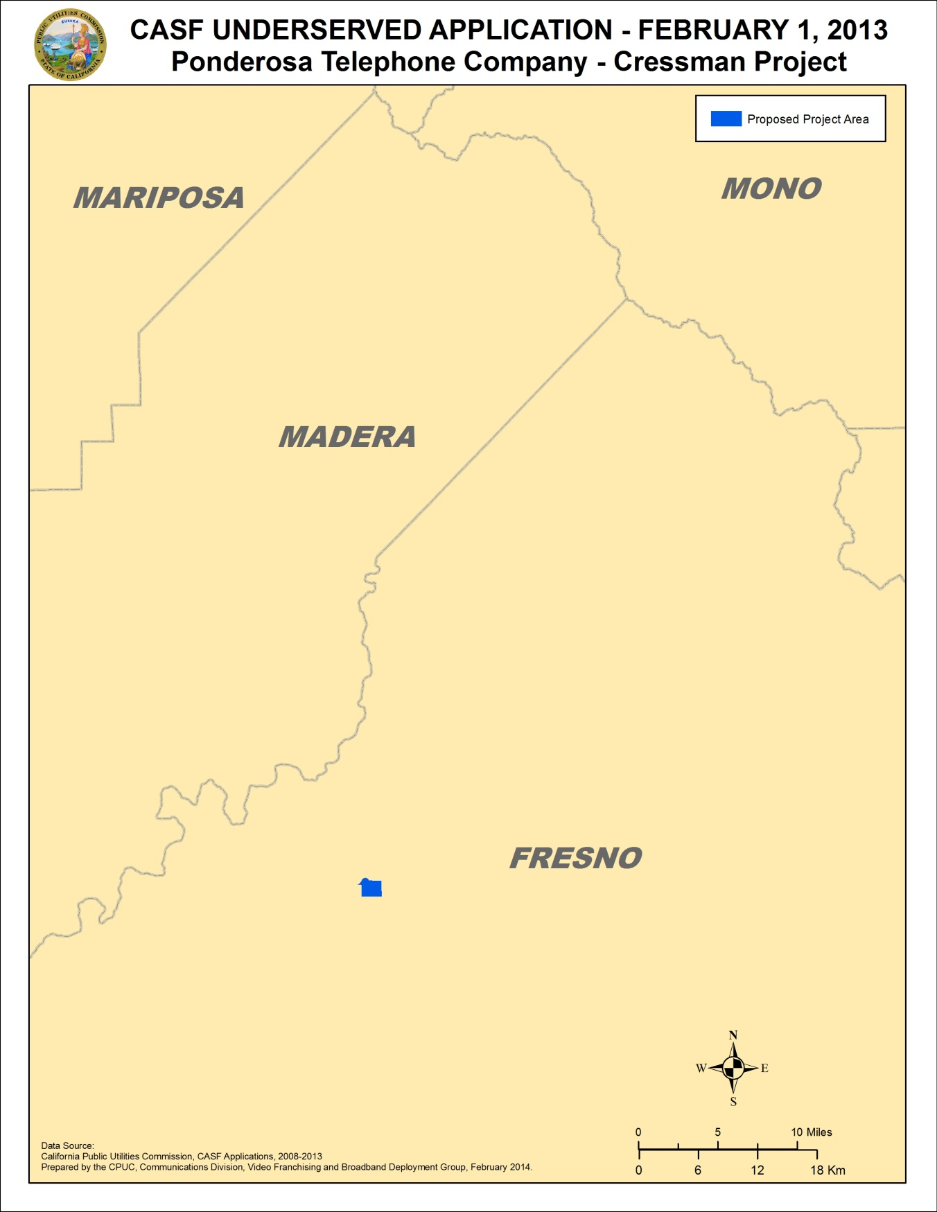

A-2
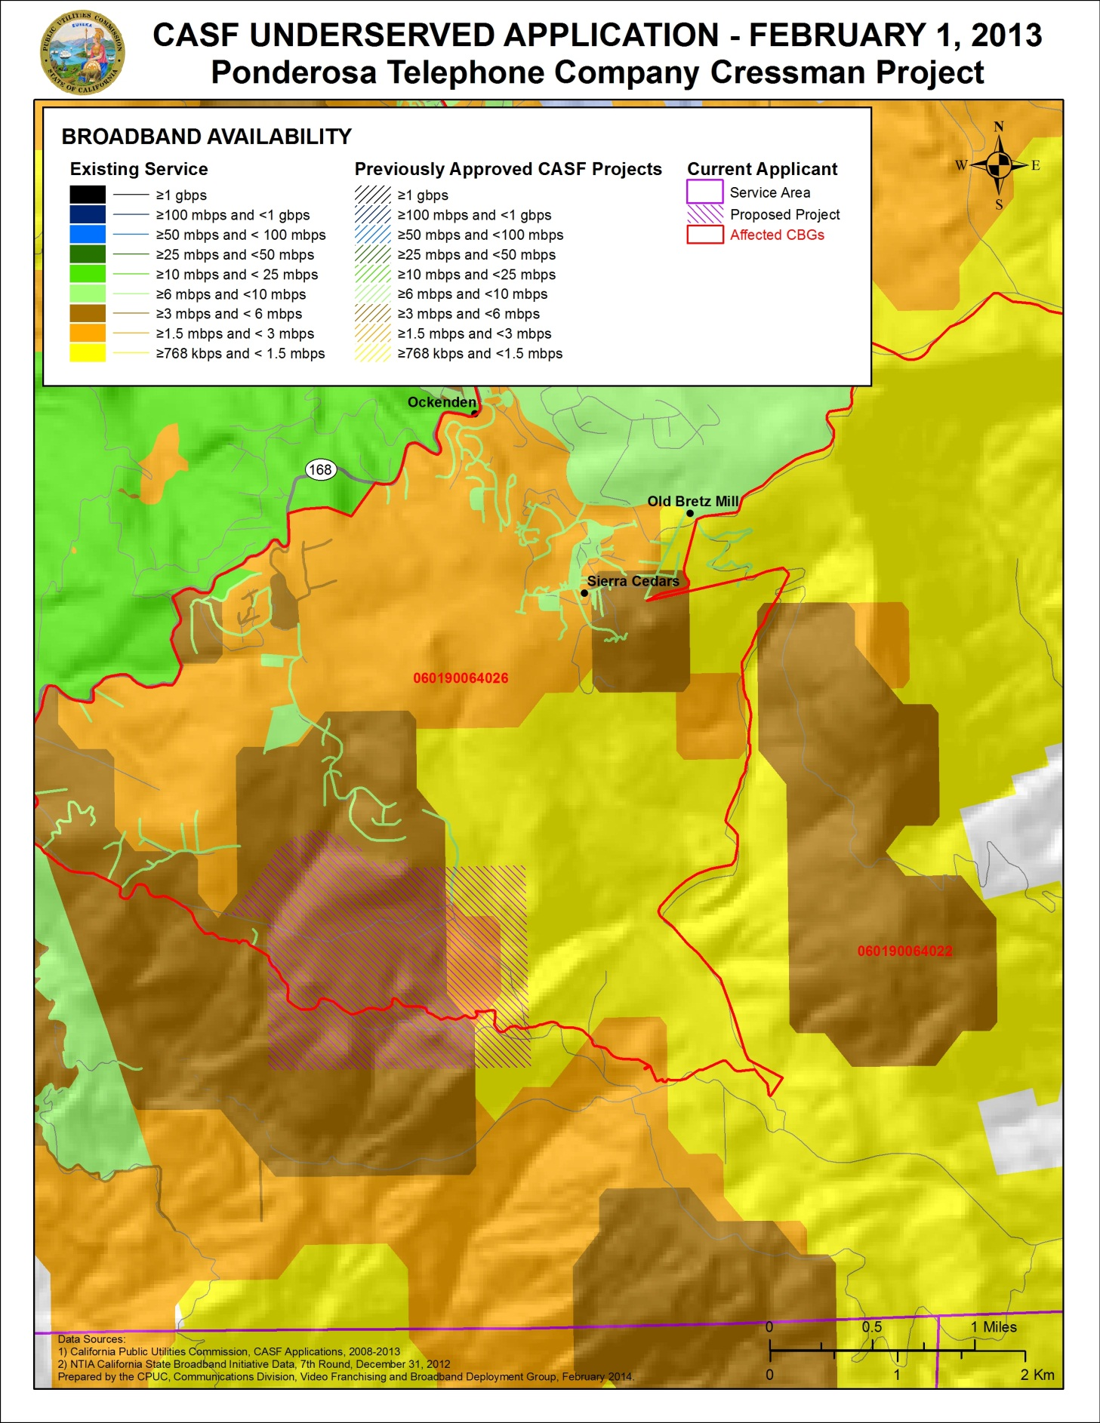

END OF APPENDIX A
A-3

Stats. 2010, c. 317, codified at Public Utilities (P.U.) Code § 281.
P.U. Code § 281(e).
P.U. Code § 281(b)(1).
The California Interactive Broadband Availability map and the map on page A-3 of Appendix A show the Cressman Project area receives broadband at underserved speeds. However, based on more detailed and up-to-date information, CD has determined that the majority of the area is actually unserved. See Section C, Project Evaluation and Recommendation for Funding, for a more in-depth discussion.
Pondersa currently supplies broadband to 11 customers within the Cressman Project area at speeds at or below 3 Mbps downstream and 384 kilobits per second upstream, which qualifies as underserved.
Since Ponderosa’s submission of its CASF project application, Round 7 broadband availability data as of December 31, 2012, has become available in the California Interactive Broadband Map. The latest data continues to show that the proposed project area does not have broadband availability at served speeds of 6 Mbps download and 1.5 Mbps upload.
This determination was based on the limited speed capabilities of satellite services, the cost to the consumer, high latency, and unreliability known at the time of the decision, D. 12-02-015 at 13-15. Since that time, like other technologies, satellite services have improved.
CalSPEED is a mobile application released by the Commission. It allows end-users to measure the quality and speed of a mobile data network. CalSPEED conducts a two-phase test, including initial testing and results validation to accurately reflect end-user experience. Results are uploaded to a public repository at the Commission.
The Cressman Project, as originally submitted by Ponderosa, requests a CASF grant of $14,677 per household; the CASF applications approved as of December 2013 cost an average of $3,337 per household.
See footnote #5.
California Public Resources Code § 21000 et seq.
Approval of the California Advanced Services Fund (CASF) Application Requirements and Scoring Criteria for Awarding CASF Funds (2008) Cal. P.U.C. Res. No. T-17143 at 4.
The above schedule is contingent on the CASF recipient submitting clear, complete, and error-free invoices to CD. Additional time to process payments may be necessary if CD finds problems with the submitted invoices.

