PUBLIC UTILITIES COMMISSION OF THE STATE OF CALIFORNIA

Communications Division | RESOLUTION T- 17439
Broadband Policy and Analysis Branch | June 26, 2014

R E S O L U T I O N

Resolution T-17439 Approval of Funding for the Grant Application of The Shasta County Telecom, Inc. (U-7129), from the California Advanced Services Fund in the Amount of $2,238,806 for the Shasta County Unserved and Underserved Broadband Project
__________________________________________________________________

- SUMMARY

This Resolution approves funding in the amount of $2,238,806 from the California Advanced Service Fund (CASF) for the CASF grant application of The Shasta County Telecom, Inc. (Shasta) for its Shasta County Unserved and Underserved Broadband Project (Shasta Project). The Shasta Project will extend high-speed Internet service to an estimated 331 square miles covering north of Bella Vista, Round Mountain, Montgomery Creek and Lake Margaret areas of Shasta County.

- BACKGROUND

On December 20, 2007, the California Public Utilities Commission (Commission) in Decision (D.) 07-12-054 established the CASF program as a two-year program to provide funds for the deployment of broadband infrastructure in unserved and underserved areas in California.

On September 25, 2010, Governor Schwarzenegger signed Senate Bill (SB) 1040 which codified the CASF program and expanded it to include three accounts: (1) the Infrastructure Grant Account, (2) the Consortia Grant Account, and (3) the Revolving Loan Account. The latter two accounts are intended to address the needs that were unmet under the original CASF program. Specifically, the purpose of the Revolving Loan Account is “to finance capital costs of broadband facilities not funded by a grant from the Broadband Infrastructure Grant Account.” SB 1040 also expanded the CASF fund from $100 million to $225 million adding $100 million to the Infrastructure Grant Account and allocating $10 million and $15 million to the Consortia Grant Account and the Revolving Loan Account, respectively.

On February 1, 2012, the Commission approved D.12-02-015 to implement new guidelines for the Infrastructure Grant and Revolving Loan Accounts. Key provisions of the Decision include:
- A maximum CASF grant award of 70 percent of project costs for unserved areas and 60 percent for underserved areas;
- A definition of an underserved area, “where broadband is available, but no wireline or wireless facilities-based provider offers service at advertised speeds of at least 6 megabits per second (Mbps) downstream and 1.5 Mbps upstream (6 Mbps /1.5 Mbps);” and
- A Revolving Loan Program to provide supplemental financing for projects also applying for CASF grant funding (up to 20% of projects costs, with a maximum of $500,000), utilizing the same project and applicant eligibility requirements as the Infrastructure Grant Program.

Consequently, on May 10, 2012, the Commission approved Resolution T-17362 which established the application deadlines for the CASF Broadband Infrastructure Grant Account and the Revolving Loan Account as follows:
- October 1, 2012, for unserved areas;
- February 1, 2013, for underserved areas not previously funded by the CASF and hybrid projects that cover both unserved and underserved areas; and,
- A date to be determined for projects in underserved areas where the existing broadband infrastructure was partially funded by a CASF grant.

On February 1, 2013, Shasta, a certificated public convenience and necessity (CPCN) holder, submitted an application for CASF funding in the unserved and underserved area Shasta County.

- NOTICE/PROTESTS

Communications Division (CD) posted the proposed project area map, census block groups (CBG), and zip codes by county for the Shasta Project on the Commission’s CASF webpage under “Pending New CASF Applications to Offer Broadband as of February 22, 2013.” CD received two challenges from Frontier Communications (Frontier) and Verizon, as described below, to the proposed project areas.

- DISCUSSION

This Resolution adopts CD’s recommended CASF fund award of $2,238,806 for the Shasta Project. This award represents 60% of the total project cost of $3,731,344. Key project information and maps are shown on pages A-1 through A-3 of Appendix A.

- Project Overview

Shasta is a California corporation in good standing. Its headquarters is located in San Diego. On December 2008, Shasta was granted a CPCN under Public Utilities Code Section 1001 (P.U. Code § 1001) to construct telecommunications facilities and provide local exchange and interexchange service to and within previously-unserved territory in the Northeastern Intermountain area of Shasta County.

With the CASF Shasta Project, Shasta proposes to bring broadband services to north of Bella Vista, Round Mountain, Montgomery Creek and Lake Margaret areas of Shasta County. Currently, the project area is primarily unserved by wireline technology and underserved by fixed wireless and mobile broadband. According to Shasta, there are an estimated 500 households within the project area that do not have telephone service available. The Shasta Project proposes to provide fixed wireless broadband and telephone services by installing fixed wireless transmitters and infrastructure on three mountain tops in Shasta County: Bear Mountain, Hatchet Mountain, and Round Mountain, in order to provide high speed Internet service over a 331 square mile area. Shasta plans to obtain backhaul capabilities from Level 3 Communications and the telephone central office, connection to the Public Switched Telephone Network (PSTN), and Emergency 911 network will be located in an offsite co-location facility located in San Diego, California. The CBGs impacted by the project area are: 060890127011, 060890126012, 060890126011, 060890118022, and 060890118031.

Shasta targeted the area for broadband deployment because of the existence of customer demand and economic viability. Shasta determined that the project is economically feasible with the assistance of a CASF grant of $2,238,806, or 60% of total project costs, to supplement Shasta’s funding of $1,492,538.

When complete, the Shasta Project will reach an estimated 1,444 households, including 32 that are currently unserved and 1,412 that are currently underserved. Shasta estimates the project will initially yield 977 of the 1,444 potential subscriber households in the proposed area. At project completion, 1,444 households will have broadband availability at advertised speeds of 20 Mbps download and 10 Mbps upload, which exceeds the served thresholds of 6 Mbps/ 1.5 Mbps.

Shasta has committed to a broadband pricing plan under the terms shown below for two years, starting from the beginning date of service. The recurring monthly rates assume a one year commitment by the customer.

 | Broadband Speed (Up/Down) | Price
Monthly Recurring Charges
Standalone Broadband Service | 20 Mbps/ 10 Mbps | $20
Telephone Service (Voice Over Internet Protocol (VoIP)) | N/A | $10
One-Time Charges
Installation/initial service connection fees  *waived for two years starting from the beginning date of service of the project. |  | Fee Waived
Telephone service/long distance installation fee  *beginning after two years of the start of service of the project |  | $100

- Project Qualification

To qualify for the CASF program, the applicant is required to submit proof that the area is unserved or underserved by submitting shapefiles of the proposed project. CD reviews the submitted shapefiles and compares them with United States 2010 Census data and the California Interactive Broadband Availability maps which contain broadband availability data as of June 30, 2012. Once CD determines that the area is eligible either as an unserved or underserved area, CD evaluates all other information submitted by the applicant to determine if the project meets the requirements outlined in D.12-02-015. Other information CD reviews includes: proof of a CPCN from the Commission; descriptions of current and proposed broadband infrastructure; number of potential subscriber households and average income; project construction schedule; project budget; proposed pricing and commitment period for new subscribers; and financial viability of the applicant.

As an initial step in the review of Shasta’s application, CD checked the CBGs submitted in the project application and determined that the project area was, for the most part, eligible for CASF funding. In doing so, CD found broadband availability at served speeds by satellite providers such as Hughes.net and Skycasters, LLC. However, as adopted in D.12-02-015, the Commission does not consider satellite broadband service in CASF project evaluation, unless the satellite project in an area was previously funded by the CASF. CD also found that very small parts of the project area show as served by wireline broadband, specifically by Frontier. North of Bella Vista, areas show as served by mobile broadband.

Additionally, CD requested greater detail concerning the current infrastructure, project budget, pro forma financials, project broadband speeds, and project milestones. CD also obtained a revised pricing plan to remove installation and initial service connection fees to be in compliance with Commission rules to waive installation and/or initial service connection fees for two years from the start of project service.

On March 11, 2013, Verizon challenged the application stating that wireless carriers continue to build-out their 4G LTE networks. Verizon’s challenge was very vague and did not contain information sufficient to determine if Verizon was challenging the entire project proposal or just a specific area of the project. On March 27, 2013, CD staff requested that Verizon clearly identify what areas of the project, by census block, it was challenging and to provide CD with the following information: number of subscribers by census block and speed tier, speed tests with a description on how the speed tests were conducted and what tools where used, and the address of the location of where the speed tests were performed to help determine if in fact the area is served. Verizon did not provide a response or any further information on the challenge. On April 2, 2013, CD staff e-mailed Verizon confirming that Verizon did not provide a response and informed Verizon that CD will continue to consider the majority of the project as eligible for CASF funding.

In addition, according to the California Interactive Broadband Map, Verizon Wireless and T-Mobile both offer mobile broadband at served speeds in some parts of the project area, specifically in the Western part of the project, north of Bella Vista. However, CD has not been able to validate the maximum advertised mobile broadband speeds in the project area. CD validates advertised speeds by conducting drive tests at an estimated 2,000 points within the State. There are five test points within the project area north of Bella Vista where four test points show Verizon’s speeds at unserved levels (speeds slower than 768 Kbps down or 200 Kbps up) and one test point shows speeds above the served threshold of 6 Mbps down and 1.5 Mbps up. In the case of T-Mobile, four test points show T-Mobile’s speeds to be below the unserved threshold and one test point at underserved speeds. Since the test points for the most part show speeds below the served threshold, CD staff considers the challenge by Verizon unsubstantiated.

On March 22, 2013, Frontier challenged the application stating that it offers residents broadband service at served speeds in some parts of the project area. Based on its review of the data, CD staff has determined that Frontier offers residents in parts of Round Mountain and Montgomery Creek broadband service at speeds that meet the served threshold of 6 Mbps download and 1.5 Mbps upload. There are a total of 35 census blocks and 127 households where Frontier has broadband availability at served speeds and therefore not eligible for CASF funding. For a list of census blocks, please reference Appendix B.

Subsequently, on January 28, 2014, CD issued a letter to the applicant, with a copy to Verizon and Frontier, stating that the vast majority of the project is eligible for CASF funding after removal of minor areas that are served.

- Project Evaluation and Recommendation for Funding

CD evaluated the application with respect to the scoring criteria defined in D.12-02-015, Appendix 1, Section VIII (Scoring Criteria). The scoring criteria include: (i) Funds Requested per Potential Customer, (ii) Speed, (iii) Financial Viability, (iv) Pricing, (v) Total Number of Households in the Proposed Area, (vi) Timeliness of Completion of Project, (vii) Guaranteed Pricing Period, and (viii) Low-Income Areas.

This project scored well compared to other projects particularly in pricing, timeliness to complete the project and low-income areas. The applicant will charge $20 per month for 20 Mbps download and 10 Mbps; an estimated $0.67 per megabit. The applicant estimates to complete the project in 9 months and the project will target low income areas where the average estimated median household income is $39,654.

The Commission considers unserved areas as having the highest priority, and the funding of the Shasta Project meets this goal where 32 households are estimated to be unserved.

- Safety Impact

The Shasta Project is in a rural area of Shasta County. Telephone and broadband access to emergency services is essential in these rural areas, where the threat of fire, harsh weather conditions, and other disasters can have severe impacts. During these types of emergencies, the first responders rely on the local communication network to acquire information and communicate with others.

CD identified a couple of anchor institutions within the Shasta Project area such as Hill County Community Clinic in Round Mountain. In addition, according to Shasta, the Fire Department will benefit from this project and facilities will be available for use by CalFire at their fire lookout point on Bear Mountain. According to the Fire Department, their radios are “hit and miss in a lot of areas” and it is not only fire emergencies that are their concern, but also many traffic accidents and medical aid events. High speed broadband will enhance the communities within the Shasta Project access to anchor institutions and the services they provide.

- Compliance Requirements

Shasta is required to comply with all guidelines, requirements, and conditions associated with the grant of CASF funds as specified in D.12-02-015. Such compliance includes, but is not limited to:

- California Environmental Quality Act (CEQA)

The Shasta Project is subject to the CEQA review. The Commission must complete CEQA review prior to disbursing CASF funds for construction activities.

Shasta has provided the Commission with construction plans for the Shasta Project area. It consists of installing fixed wireless transmitters and infrastructure on three mountain tops in Shasta County: Bear Mountain, Hatchet Mountain, and Round Mountain. According to Shasta, such installations will occur on existing towers on the mountain tops. There will be fiber and/or coax cable between the communications equipment buildings and the transmitter towers using existing conduit or existing utility poles; there will be no dirt disturbances. The project also includes the installation of a telephone switch that will be collocated in a telecommunications facility in San Diego since the project will be providing 911 services and interconnecting to the PSTN.

Accordingly, based on the above information, this project meets the criteria of the CEQA categorical exemption for existing facilities (CEQA Guidelines § 15301 G.). Thus, the project is categorically exempt from CEQA review.

- Deployment Schedule

The Commission expects Shasta to complete the project within 9 months from the start date. If the applicant is unable to complete the proposed project within the 9 month timeframe established by the Commission, it must notify CD’s Director as soon as it becomes aware of this prospect. The Commission may reduce payment for failure to notify CD’s Director and timely complete the project. In D.12-02-015, the Commission’s requirement to complete the build-out of a CASF funded project is within 24 months from approval of the application.

- Execution and Performance

CD and the CASF grant recipient shall determine a project start date after the Commission has granted all approvals to the CASF grant recipient. Should the recipient or Contractor fail to commence work at the agreed upon time, the Commission, upon five days written notice to the CASF recipient, reserves the right to terminate the award.

In the event that the CASF recipient fails to complete the project, in accordance with the terms of approval granted by the Commission, the CASF recipient must reimburse some or all of the CASF funds that it has received.

The CASF grant recipient must complete all performance under the award on or before the termination date of the award.

- Performance Bond

The Commission does not require a performance bond if the applicant certifies that the percentage of the total project costs it is providing comes from its capital budget and is
not obtained from outside financing. In its application, Shasta indicated that it will obtain its matching funds for the 40% of the total project costs from outside financing and not its existing capital budget. Therefore, a performance bond will be required for this project.

- Price Commitment Period

The minimum required price commitment period for broadband service to all households within the project area is two years. Shasta guarantees the price of service offered in the project area for two years.

- Project Audit

The Commission has the right to conduct any necessary audit, verification, and discovery during project implementation/construction to ensure that CASF funds are spent in accordance with Commission approval.

The recipient’s invoices will be subject to a financial audit by the Commission at any time within three years of completion of the work.

- Providing Voice Service

Shasta will provide voice services that meet the Federal Communications Commission (FCC) standards for E-911 service and battery backup.

- Reporting

Grantees must submit quarterly progress reports on the status of the project irrespective of whether grantees request reimbursement or payment.

Before full payment of the project, the CASF recipient must submit a project completion report. Progress reports shall use the schedule for deployment, major construction milestones and costs submitted in the proposal; indicate the actual date of completion of each task/milestone as well as problems and issues encountered, and the actions taken to resolve these problems and issues during project implementation and construction; and identify future risks to the project. Recipients shall also include test results on the download and upload speeds on a CBG and zip code basis in the final completion report. Recipients must certify that each progress report is true and correct under penalty of perjury.

- Submission of Form 477

The FCC currently requires broadband providers to biannually submit the Form 477, which includes speed data. While there is an imperfect match between the data that is reported in the Form 477 and to the CASF, Form 477 data will be useful in documenting CASF deployment for the new service area of the carrier. CASF recipients shall submit a copy of their Form 477 data directly to the Commission, under General Order 66-C, when they submit this data to the FCC for a five-year period after completion of the project.

- Payments to CASF Recipients

Submission of invoices from and payments to Shasta shall be made in accordance with Section XI of Appendix 1, of D.12-02-015 and according to the guidelines and supporting documentation required in D.12-02-015.

Payment to Shasta shall follow the process adopted for funds created under P. U. Code § 270. The following table describes the timeline for processing CASF payments.

Event | Payment Cycle 1  (Day/ Month) | Payment Cycle 2  (Day/ Month)
Invoices due from Shasta, to CD | 5th of Month 1 | 20th of Month 1
Payment letters from CD to Administrative Services | On 19th of Month 1 | On 4th of Month 2
Invoices submitted from Administrative Services to State Controller’s Office for payments | 20th through 26th of Month 1 | 5th through 13th of Month 2

Shasta may submit its invoices under Payment Cycle 1 or 2.

If any date in this payment schedule falls on a weekend or holiday, that date will be advanced to the next business day, but the remaining dates in the payment schedule will remain unchanged. The State Controller’s Office (SCO) requires 14- 21 days to issue payment from the day that requests are received by SCO.

- Comments on Draft Resolution

In compliance with P.U. Code § 311(g), a notice letter was emailed on April 15, 2014, informing all applicants filing for CASF funding, parties on the service list of R.06-06-028, and the CASF distribution list of the availability of the draft of this Resolution for public comments at the Commission’s website http://www.cpuc.ca.gov/PUC/documents/. This letter also informed parties that the final conformed Resolution adopted by the Commission will be posted and available at this same website.

No opening or reply public comments were submitted on this Resolution.

- Findings

- On May 10, 2012, the Commission approved Resolution T-17362 which established the application deadlines for the CASF Broadband Infrastructure Grant Account and the Revolving Loan Account as follows: October 1, 2012, for unserved areas; February 1, 2013, for underserved areas not previously funded by the CASF and hybrid projects that cover both unserved and underserved areas; and, a date to be determined for projects in underserved areas where the existing broadband infrastructure was partially funded by a CASF grant.

- Shasta filed an application for CASF funding for its Shasta Project on February 1, 2013. The Shasta Project proposes to provide fixed wireless broadband and telephone services by installing fixed wireless transmitters and infrastructure on three mountain tops in Shasta County: Bear Mountain, Hatchet Mountain, and Round Mountain in order to provide high speed Internet service over a 331 square mile area. The CBGs impacted by the project area are: 060890127011, 060890126012, 060890126011, 060890118022, and 060890118031. According to Shasta, there are an estimated 500 households within the project area that do not have telephone service available.

- CD posted the proposed project area map, CBGs and zip codes by county for the Shasta Project on the Commission’s CASF webpage under “Pending New CASF Applications to Offer Broadband as of February 22, 2013.” CD received two challenges to the proposed project areas.
- CD reviewed and analyzed data submitted for the Shasta Project CASF grant application to determine the project’s eligibility for CASF funding. This data includes, but is not limited to: proof of a CPCN from the Commission; descriptions of current and proposed broadband infrastructure; geographic information system (GIS) formatted shapefiles mapping the project areas; assertion that the area is unserved or underserved; number of potential subscribers and average household incomes; project construction schedule; project budget; proposed pricing and commitment period for new subscribers; and financial viability of the applicant.

- CD reviewed the submitted shapefiles, which mapped the proposed broadband deployment using United States 2010 Census data and the California Broadband Availability Map which contains broadband availability data as of June 30, 2012. The map helped to verify the existence or nonexistence of broadband service areas and broadband speeds, where available.

- Based on its review, CD determined that the project qualifies for funding under D.12-02-015 and recommends Commission approval of CASF funding for Shasta’s Shasta Project.

- Shasta is required to post a performance bond because 40% of the total project cost will be financed through outside financing and not Shasta’s existing capital budget.

- Shasta is required to comply with all guidelines, requirements, and conditions associated with the granting of CASF funds as specified in D.12-02-015 such as complying with CEQA and submitting the FCC’s Form 477, as specified in Resolution T-17143.

- This project meets the criteria of the CEQA categorical exemption for existing facilities (CEQA Guidelines § 15301 G). Thus, the project is categorically exempt from CEQA review.

- The Commission finds CD’s recommendation to fund the Shasta Project as summarized in Appendix A to be reasonable and consistent with Commission Orders and, therefore, adopts such recommendations.

- A notice letter was emailed on April 15, 2014 informing all applicants filing for CASF funding, parties on the service list of R.06-06-028, and the CASF distribution list of the availability of the draft of this Resolution for public comments at the Commission’s website: http://www.cpuc.ca.gov/PUC/documents/. This letter also informed parties that the final conformed Resolution adopted by the Commission will be posted and available at this same website.

- No opening or reply public comments were submitted on this Resolution.

THEREFORE, IT IS ORDERED that:

- The Commission shall award $2,238,806 from the CASF to Shasta for the Shasta Project as described herein and summarized in Appendix A of this Resolution.
- The program fund payment of $2,238,806 for this unserved and underserved project shall be paid out of the CASF fund in accordance with the guidelines adopted in D.12-02-015.
- Payments to the CASF recipient shall be in accordance with Section XI of Appendix 1, of D.12-02-015 and in accordance with the process defined in the “Payments to CASF Recipients” section of this Resolution.
- Shasta shall post a performance bond equal to the total CASF grant as specified in Section V, item #20 in Appendix 1 of D.12-02-015.
- The CASF fund recipient, Shasta, shall comply with all guidelines, requirements and conditions associated with the CASF funds award as specified in D.12-02-015 and must submit the FCC Form 477, as specified in T-17143.

This Resolution is effective today.

I hereby certify that this Resolution was adopted by the Public Utilities Commission at its regular meeting on June 26, 2014. The following Commissioners approved it:

/s/ Paul Clanon

PAUL CLANON

Executive Director

MICHAEL R. PEEVEY
President
MICHEL PETER FLORIO
CATHERINE J.K. SANDOVAL
CARLA J. PETERMAN
MICHAEL PICKER
Commissioners

APPENDIX A
Resolution T–17439
Shasta County Telecom, Inc. Shasta Project
Key Information
Project Name | Shasta Project
Project Plan | Installing fixed wireless transmitters and infrastructure on three mountain tops in Shasta County: Bear Mountain, Hatchet Mountain, and Round Mountain. There will be fiber and/or coax cable between the communications equipment buildings and the transmitter towers using existing conduit or existing utility poles; there will be no dirt disturbances. The project also includes the installation of a telephone switch that will be collocated in a telecommunications facility in San Diego since the project will be providing 911 services and interconnecting to the PSTN.
Project Size (in square miles) | 331
Download/ upload speed (in Mbps) | 20 Mbps / 10 Mbps
Location | Shasta County
Community Name | North of Bella Vista, Round Mountain, Montgomery Creek and Lake Margaret areas of Shasta County
CBGs/ Household Income | 060890127011 / $38,079  060890126012 / $35,476  060890126011 / $43,207  060890118031 / $45,709  090890118022 / $39,187
Zip Codes | Parts of 96013, 96065, 96069, 96008, 96003
Estimated Potential Subscriber Size Households/ Subscribers | 1,444 (32 unserved and 1,412 underserved)
Deployment Schedule (from Commission approval date) | 9 months
Proposed Project Budget
Total | $3,731,344
Amount of CASF Funds requested (60%) | $2,238,806
Internally funded (40%) | $1,492,538

A-1

Resolution T–17439
Shasta County Telecom, Inc.
Shasta Project Map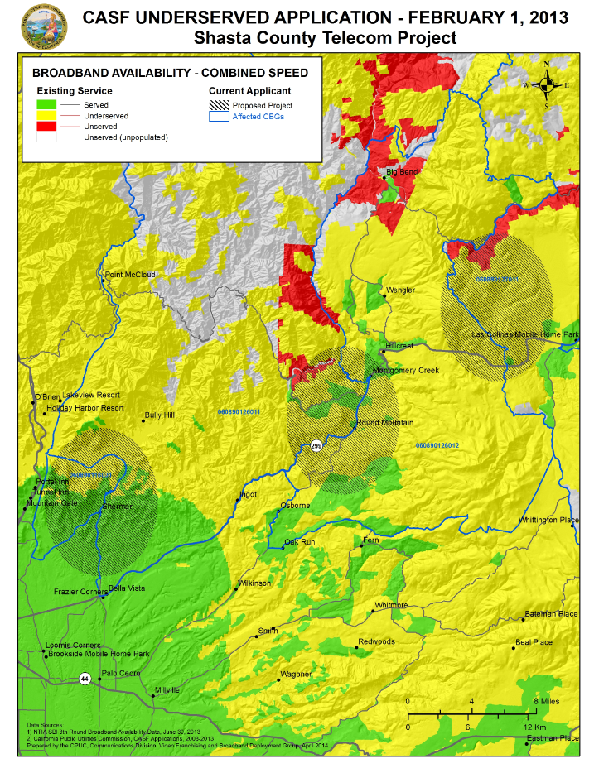

A-2
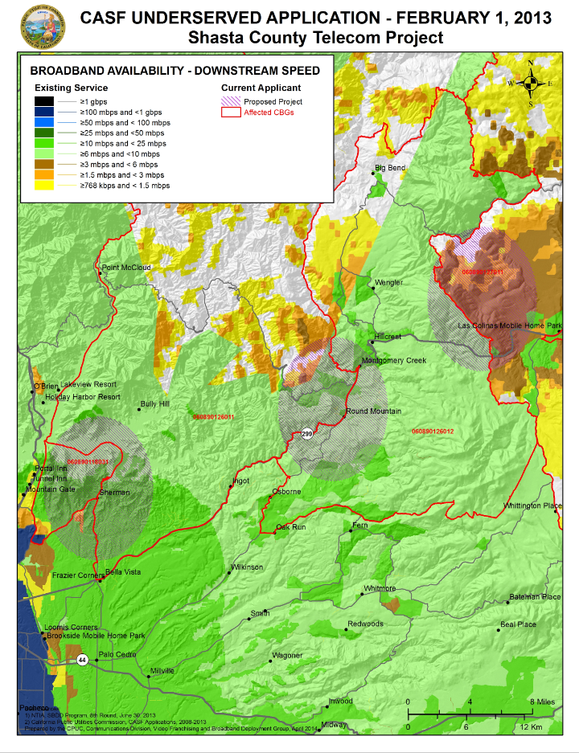END OF APPENDIX A
APPENDIX B
A-3
Resolution T–17439
Shasta County Telecom, Inc. Shasta Project – Ineligible Census Blocks
Full FIPS/Census Block Code | Census Block Households 2010
060890126012203 | 2
060890126012217 | 6
060890126012218 | 8
060890126012219 | 11
060890126012238 | 3
060890126012474 | 1
060890126012216 | 8
060890126012472 | 2
060890126012473 | 4
060890126012477 | 0
060890126011244 | 4
060890126012480 | 2
060890126012481 | 0
060890126011243 | 1
060890126011268 | 0
060890126011267 | 1
060890126011252 | 18
060890126012317 | 1
060890126011254 | 0
060890126011253 | 0
060890126012315 | 1
060890126012248 | 0
060890126011262 | 3
060890126011265 | 6
060890126012324 | 1
060890126012326 | 0
060890126012468 | 1
060890126012376 | 5
060890126012422 | 1
060890126012423 | 10
060890126012371 | 3
060890126012426 | 4
060890126012363 | 6
060890126012352 | 13
060890126012365 | 1
Total | 127
B-1

End of Appendix B

Stats. 2010, c. 317, codified at Public Utilities (P.U.) Code § 281.
P.U. Code § 281(e).
P.U. Code § 281(b)(1).
Decision (D.) 08-12-052 and D.10-09-022
Since Shasta’s submission of its CASF project application, Round 8 broadband availability data as of June 30, 2013, has become available in the California Interactive Broadband Map. The latest data continues to show that the proposed project area does not have broadband availability at served speeds of 6 Mbps download and 1.5 Mbps upload.
This determination was based on the limited speed capabilities of satellite services, the cost to the consumer, high latency, and unreliability known at the time of the decision, D. 12-02-015 at 13-15. Since that time, like other technologies, satellite services have improved.
4th round mobile field tests conducted in Fall 2013.
Approval of the California Advanced Services Fund (CASF) Application Requirements and Scoring Criteria for Awarding CASF Funds (2008) Cal. P.U.C. Res. No. T-17143 at 4.
The above schedule is contingent on the CASF recipient submitting clear, complete, and error-free invoices to CD. Additional time to process payments may be necessary if CD finds problems with the submitted invoices.

