PUBLIC UTILITIES COMMISSION OF THE STATE OF CALIFORNIA

Communications Division | RESOLUTION T-17475
Broadband, Policy and Analysis Branch | May 7, 2015

R E S O L U T I O N

Resolution T-17475: Approval of funding for the grant application of Ultimate Internet Access (U-7269C) from the California Advanced Services Fund in the amount of $1,937,380 for the Wrightwood Project.
__________________________________________________________________

- Summary

This Resolution approves funding in the amount of $1,937,380 from the infrastructure grant account of the California Advanced Service Fund (CASF) for the CASF grant application of Ultimate Internet Access (UIA) for installation of a fiber-to-the-premises (FTTP) system in Wrightwood (Wrightwood Project). The Wrightwood Project will extend gigabit high-speed internet service to approximately 1,857 households (or 2,710 housing units) spread over 3.2 square miles in and adjoining the underserved community of Wrightwood, which straddles the border between San Bernardino and Los Angeles counties on the north side of the San Gabriel Mountains. The Wrightwood Project is determined to be cost-effective as compared with the mean cost/household of previous CASF infrastructure projects. Further, this project provides substantial safety benefits to the Wrightwood community, including, but not limited to, making the community’s telecommunications infrastructure less vulnerable to wildfire and winter storms as well as providing additional voice service that would meet all safety standards, including e911.

Background

On December 20, 2007, the California Public Utilities Commission, in Decision (D.) 07-12-054, established the CASF program as a two-year program to provide funds for the deployment of broadband infrastructure in unserved and underserved areas in California.
On September 25, 2010, Governor Schwarzenegger signed Senate Bill (SB) 1040, which codified the CASF program and expanded it to include three accounts: (1) the Infra-structure Grant Account, (2) the Consortia Grant Account, and (3) the Revolving Loan Account. The latter two accounts are intended to address the needs that were unmet under the original CASF program. SB 1040 also expanded the CASF fund from $100 million to $225 million, adding $100 million to the Infrastructure Grant Account and allocating $10 million and $15 million to the Consortia Grant Account and the Revolving Loan Account, respectively.

On February 1, 2012, the Commission approved D.12-02-015 to implement new guidelines for the Infrastructure Grant and Revolving Loan Accounts. Key provisions of the decision include:

- A maximum CASF grant award of 70 percent of project costs for unserved areas and 60 percent for underserved areas; and,
- A definition of an underserved area, “where broadband is available, but no wireline or wireless facilities-based provider offers service at advertised speeds of at least 6 megabits per second (Mbps) downstream and 1.5 Mbps upstream (6 Mbps /1.5 Mbps).”

Subsequently, on June 26, 2014, the Commission approved Resolution T-17443, which (relevant to this resolution) opened the CASF Broadband Infrastructure Grant Account to new applications as of December 1, 2014, and offered existing providers a “right of first refusal” to upgrade service in unserved and underserved areas.

On December 8, 2014, Ultimate Internet Access submitted an application for CASF funding to bring symmetrical 1 gigabit-per-second broadband service to the homes and businesses of the unincorporated community of Wrightwood via a FTTP connection. No existing provider made a commitment to upgrade service before the Nov. 1, 2014, “first refusal” deadline and the Wrightwood area has been determined by CD staff to be “underserved” and thus eligible for new CASF grant applications.

- Notice/Protests

On December 15, 2014, Communications Division (CD) posted the proposed project area map, census block groups (CBGs) and zip codes for the Wrightwood Project on the Commission’s CASF webpage under “CASF Application Project Summaries” and also sent notice regarding the project to its electronic service list. CD received no challenges to the proposed project area.

- Discussion

This Resolution adopts CD’s recommended CASF fund award of $1,937,380 for the UIA Wrightwood Project. This award represents 60 percent of the applicant’s estimated total project cost of $3,228,967. Key project information and maps are shown in Appendix A.

- Project Overview

UIA was formed in 1996 as an independent Internet Service Provider, initially focused on the business-to-business sector. In the years since, through expansion and acquisition, UIA has grown to also provide residential communities with broadband services. The company is based in the city of Ontario, California, and was granted a Certificate of Public Convenience and Necessity (CPCN) as part of Decision 14-12-050 late in 2014. Staff consultations with the CASF-sponsored Inland Empire Regional Broadband Consortium and various local government agencies in the area (including community services district officials in the Wrightwood area) indicate that UIA is a respected, well-regarded local provider.

If this project is approved, UIA will install a FCC-licensed microwave backhaul from its existing middle-mile in the San Bernardino Valley to Table Mountain, one of the highest peaks above the community and within the Angeles National Forest. From that point, as a CPCN holder, UIA will have access to existing utility poles in the community of Wrightwood and utilize them to run single-mode optical fiber throughout the community. The proposed project covers about 3.2 square miles in aggregate, distributed in adjoining, contiguous CBGs.

UIA targeted the area for broadband deployment after determining that the project is economically feasible with a CASF grant of $1,937,380, which is 60 percent of the total project costs, to match UIA-attained funding of $1,291,587. When completed, the project will reach an estimated 1,857 households, with all customers capable of achieving speeds of 1 Gbps on both downloads and uploads – well above the Commission-defined “served” threshold of 6 Mbps download/1.5 Mbps upload. The CASF per-household subsidy would be about $1,043 per household – less than one-third the mean cost per household of previously approved CASF projects.

UIA has committed to a broadband pricing plan under the terms shown below for four years, starting from the beginning date of service. There is no long-term commitment required from the consumer.

Service Type | Broadband Speed | Monthly Charge: Standalone BB | Monthly Charge: Bundled with Voice
Residential | 1 Gbps down  1 Gbps up | $70 | $95
Small Business |  | $120 | Additional $35/line
Activation and installation (all types): Waived
Modem charge: No monthly residential equipment fee
Voice service includes unlimited calling in United States and Canada

- Project Qualification

To qualify for the CASF program, an applicant is required to submit proof that the area is unserved or underserved by submitting shapefiles of the proposed project. CD reviews the submitted shapefiles and compares them with United States 2010 Census data and the California Interactive Broadband Availability map. Once CD determines that the area is eligible either as an unserved or underserved area, CD evaluates all other information submitted by the applicant to determine if the project meets the requirements outlined in D.12-02-015. Other information CD reviews includes: proof of a CPCN from the Commission; descriptions of current and proposed broadband infrastructure; number of potential subscriber households and average income; project construction schedule; project budget; proposed pricing and commitment period for new subscribers; and financial viability of the applicant.

As an initial step in the review of UIA’s application, CD checked the CBGs submitted in the project application to determine that the project is indeed not currently served by wireline or fixed wireless broadband providers. The most-recent version of the California Interactive Broadband Availability Map, which primarily relies on provider-provided data, indicated that much of the proposed project area may be served by Verizon mobile service. In light of that information, CD staff turned to “ground truth” data gathered by mobile field tests in the area using the CalSPEED mobile application tool (CalSPEED), both by Commission-contracted testers and public sources, including the applicant.

When CASF staff took the net results of all CalSPEED tests in the project area, including those conducted under the Commission’s own mobile testing program, much of the area initially appeared to be served. The applicant, however, conducted seven tests using the CalSPEED app, none of which indicated service in the area. Moreover, only seven of 37 CalSPEED tests conducted by all parties within the proposed project area showed service at the Commission’s 6 mbps down/1.5 up standard. It should be noted that the majority of speed tests showing served speeds were done along State Highway 2, a relatively flat area in the Swarthout Valley (in which Wrightwood is situated). The majority of Wrightwood residences, however, are on the hillsides of the steep valley, where terrain and tall trees provide significant barriers to mobile service. These facts, when combined with the fact there were no challenges to the project, particularly from mobile providers, led staff to recommend that the area be considered underserved by mobile broadband because reliable, ubiquitous mobile service is unlikely under real-world conditions.

The California Interactive Broadband Availability map showed broadband availability at served speeds in the proposed project area by several satellite providers. However, as adopted in D.12-02-015, the Commission does not generally consider satellite broadband service in CASF project evaluation, unless said satellite service was established via a CASF grant.

- Project Evaluation and Recommendation for Funding

Wrightwood is a destination for Southern California families in both the summer (camping and hiking) and winter (skiing, particularly at the Mountain High Ski Resort situated within the project boundaries). The community had a population of 4,525, with 1,164 residents 19 years and younger in 2013, and a median age of 40.5 years, according to the US Census Bureau. The 2010 US Census also identified 1,857 households in Wrightwood, which combined with 626 housing units designated as “seasonal, recreational or occasional use” and more than 200 other units that were under construction, for sale or rent, or otherwise unoccupied at the time of the Census, add up to a potential 2,710 customers for the fiber project.

The applicant estimates that about 74 percent of households in Wrightwood would purchase UIA’s service because of the area’s historically underserved status and relatively high income. While CD believes such a “take rate” would be high based on historical adoption levels, there are factors in the area which could indeed lead to high adoption. For example, Wrightwood is ripe for the telecommuting opportunities that UIA’s project can provide, as 24.2 percent (a plurality) of commutes were 60 minutes or more in 2010. An additional 19.6 percent traveled 45 to 59 minutes each way to reach their workplace, with a mean travel time to work for all residents of 40.6 minutes.

There are several community anchor institutions within the project boundaries. These include San Bernardino County Fire Station 14, Wrightwood Elementary School, the Wrightwood Community Center, and the Wrightwood Branch of the San Bernardino County Library.

Locally, the Inland Empire Regional Broadband Consortium is an enthusiastic supporter of this project and assisted UIA in the preparation of this application. CD also received support letters from: the California Telehealth Network, the High Desert Community Foundation, the Inland Empire Economic Partnership, the San Bernardino Associated Governments, the San Bernardino County United Way, the Snowline Joint Unified School District, the Wrightwood Fire Safe Council, and San Bernardino County First District Supervisor Robert Lovingood.

As part of the evaluation process, CASF staff toured the proposed project area in January 2015 as part of a larger visit to the Eastern Sierra Regional Broadband Consortium’s annual summit and other proposed project areas in the region. Staff was accompanied for part of the visit by UIA representatives and board members from a local community services district. UIA representatives briefed staff on the technical issues and visited representative infrastructure sites. Staff took photographs of anchor institutions and potential connection points in the community, spoke with members of the local business sector, questioned several area residents regarding their Internet needs at a Farmer’s Market in the community center, and did independent field tests for mobile broadband.

During the analysis period, CD requested, and UIA provided, greater detail for the project budget. As a result, CD made some minor cost adjustments. CD reviewed the financial information included with the application and concluded that the applicant is financially viable as an ongoing business.

Because CASF funds are awarded on a reimbursement basis, UIA will be funding the bulk of the project costs beforehand with a small-business loan. As UIA will have the necessary funding up front, CD determines there is little risk of the applicant not completing the project. Still, staff concludes that in order to mitigate risk to the program, the Commission should condition the grant on a performance bond to assure completion of the project as further discussed in Section V.D. below. This condition is included in the orders section of this resolution.

CD evaluated the application with respect to the scoring criteria defined in D.12-02-015, Appendix 1, Section VIII (Scoring Criteria). The scoring criteria include: (i) Funds Requested per Potential Customer, (ii) Speed, (iii) Financial Viability, (iv) Pricing, (v) Total Number of Households in the Proposed Area, (vi) Timeliness of Completion of Project, (vii) Guaranteed Pricing Period, and (viii) Low-Income Areas.

The Wrightwood Project scored particularly well in the criteria of offering a relatively low per-household subsidy ($1,043, compared to the mean cost/household of just over $3,700 for previously approved CASF projects) and offering very high speeds. Furthermore, given the Commission’s strong commitment to public safety, the project’s potential to improve safety for area residents (as described in the next section) is an important factor in CD staff’s recommendation for funding.

CD found that the Wrightwood Project meets CASF funding requirements with respect to the following factors:

- Speed – the proposed speed offering of 1 Gbps download and 1 Gbps upload significantly exceeds the 6/1.5 mbps benchmark set by the Commission;
- Service area – is determined to be underserved and covers 3.2 square miles;
- Matching funds of 40 percent of project cost – the applicant has certified that it has access to sufficient matching funds to complete the project; the submitted balance sheet, income and cash flow statements show that the applicant is financially viable and has the financial capability to match the funds;
- Price commitment period – the applicant has committed to a pricing plan of two years as required;
- Deployment schedule – the applicant has submitted detailed planning documents, including a schedule with clear milestones to indicate the project will be completed within the 24-month construction timeline required.

Based on its review, CD determined that UIA’s grant application for the Wrightwood Project qualifies for funding as an underserved area and meets the requirements of D.12-02-015. CD staff finds that funding the UIA’s Wrightwood Project aligns with CASF’s goal to encourage the deployment of high-quality advanced information and communications technologies to all Californians to promote economic growth, job creation, and substantial social benefits.

- Safety considerations

This project will provide redundancy to the existing wired telecommunications infrastructure in the area, including a microwave data link out of the Swarthout Valley that would reduce the community’s telecommunications infrastructure’s vulnerability to wildfire and winter storms. Additionally, voice service provided as a part of this project would meet all safety standards, including battery backup, e911 data and access to local PSAPs.

- Compliance Requirements

UIA is required to comply with all the guidelines, requirements, and conditions associated with the grant of CASF funds as specified in D.12-02-015. Such compliance includes, but is not limited to:

- California Environmental Quality Act (CEQA)

All CASF grants are subject to CEQA requirements unless the project is statutorily or categorically exempt pursuant to the CEQA Guidelines.

UIA has provided the Commission with construction plans for the proposed project area. The Wrightwood area will be linked through FCC-licensed microwave backhaul from UIA’s existing middle-mile infrastructure in the Inland Empire to a tower located on Table Mountain, in the Angeles National Forest. UIA already has a lease agreement for the tower use from American Towers. The US Forest Service is not requiring a National Environmental Policy Act analysis for this project’s minor modifications to the tower because the tower has been at that location for more than 40 years.

Based on the above information, the project qualifies for the following categorical exemption from CEQA: CEQA Guidelines Section 15303 – New Construction or Conversion of Small Structures, involving construction, installation, and/or conversion of limited numbers of new and/or existing facilities/structures. For the aerial portion, which utilizes existing pole infrastructure, UIA will follow CPUC General Order 95 “Rules for Overhead Electric Line Construction.” UIA will not be expanding the utility pole infrastructure or have need for disturbing new soil.

- Deployment Schedule

The Commission expects UIA to complete the project within 24 months from start date (as determined by the procedure below). If the applicant is unable to complete the proposed project within the 24-month timeframe requirement established by the Commission, it must notify the Commission as soon as it becomes aware of this prospect. The Commission may reduce payment for failure to notify CD’s Director and satisfy this requirement.

- Execution and Performance

CD and the CASF grant recipient (UIA) shall determine a project start date after the CASF grant recipient has obtained all approvals. Should the recipient or Contractor fail to commence work at the agreed upon time, the Commission, upon five days written notice to the CASF recipient, reserves the right to terminate the award. In the event that the CASF recipient fails to complete the project in accordance with the terms of approval granted by the Commission, the CASF recipient must reimburse some or all of the CASF funds that it has received.

The CASF grant recipient must complete all performance under the award on or before the termination date of the award.

- Performance Bond

Because the matching funds for this project will be obtained through a small-business loan and not the company’s own capital budget, UIA will be required to put up a performance bond to assure its completion of the project. UIA has communicated to staff that it is aware of this requirement and it plans to comply.

E. Price Commitment Period

The minimum required price commitment period for broadband service to all households within the project area is two years under CASF program rules. UIA guarantees the price of service offered in the project area for four years.

F. Project Audit

The Commission has the right to conduct any necessary audit, verification, and discovery during project implementation/construction to ensure that CASF funds are spent in accordance with Commission approval.

The recipient’s invoices will be subject to a financial audit by the Commission at any time within three years of completion of the work.

G. Providing Voice Service

The proposed project will allow UIA to provide landline voice service via Voice over Internet Protocol (VoIP). UIA has been offering VoIP services for many years and is familiar with FCC requirements, particularly in reference to e911 services. UIA commits to adhere to all FCC requirements in regards to e911 service and will provide equipment with battery backup.

H. Reporting

Grantees must submit quarterly progress reports on the status of the project irrespective of whether grantees request reimbursement or payment. Before full payment of the project, the CASF recipient must submit a project completion report. Progress reports shall use the schedule for deployment, major construction milestones and costs submitted in the proposal; indicate the actual date of completion of each task/milestone as well as problems and issues encountered, and the actions taken to resolve these problems and issues during project implementation and construction; and identify future risks to the project.

Recipients shall also include test results on the download and upload speeds on a CBG and zip code basis in the final completion report. Recipients must certify that each progress report is true and correct under penalty of perjury.

I. Submission of Form 477

The FCC currently requires broadband providers to biannually submit the Form 477, which includes speed data. While there is an imperfect match between the data that is reported in the Form 477 and to the CASF, Form 477 data will be useful in documenting CASF deployment for the new service area of the carrier. CASF recipients shall submit a copy of their Form 477 data directly to the Commission, under General Order 66-C, when they submit this data to the FCC for a five-year period after completion of the project.

- Payments to CASF Recipients
Submission of invoices from and payments to UIA shall be made at 25-percent completion intervals, in accordance with Section XI of Appendix 1 of D.12-02-015 and according to the guidelines and supporting documentation required in D.12-02-015.

Payment to UIA shall follow the process adopted for funds created under P. U. Code §270. Payments are generally processed by the Commission, including CD and Administrative Services Division (ASD) review time, within 20-25 business days. The State Controller’s Office (SCO) requires an additional 14- 21 days to issue payment from the day that requests are received by SCO from the ASD.

Comments on Draft Resolution

In compliance with Public Utilities Code § 311(g), a notice letter was e-mailed on April 3, 2015, informing all parties on the CASF Distribution List of the availability of the draft of this resolution for public comments at the Commission's website at http://www.cpuc.ca.gov/PUC/documents/. This letter also informed parties that the final conformed Resolution adopted by the Commission will be posted and available at this same website. No comments were received.

- Findings

- On June 26, 2014, the Commission approved Resolution T-17443, which implemented new timelines for applications to the CASF Broadband Infrastructure Grant Account and offered existing providers a “right of first refusal” to upgrade service in unserved and underserved areas. The window for new applications opened on December 1, 2014.

- UIA filed an application for CASF funding for its Wrightwood Project on December 8, 2014. The proposed project will improve speeds by installing a fiber-to-the-premise system capable of symmetrical 1 gigabit-per-second download/upload service to 1,857 households (2,710 housing units) in the community of Wrightwood, which lies astride the border of San Bernardino and Los Angeles counties. This system would provide broadband Internet service to an area that is currently underserved by landlines and has a mix of underserved and unserved coverage from wireless providers. The CBGs impacted by the project are 060379303012, 060710092011, 060710092012, and 060710092013.

- CD posted the proposed project area map, CBGs and zip codes by county for the UIA Wrightwood Project on the Commission’s CASF webpage under “CASF Application Project Summaries” on December 15, 2014. CD received no challenges to this project.

- CD reviewed and analyzed data submitted for the UIA Wrightwood Project’s CASF grant application to determine the project’s eligibility for CASF funding. This data included, but was not limited to: proof of a CPCN from the Commission; descriptions of current and proposed broadband infrastructure; geographic information system (GIS) formatted shapefiles mapping the project areas; assertion that the area is underserved; number of potential subscriber households and average incomes; project construction schedule; project budget; proposed pricing and commitment period for new subscribers; and financial viability of the applicant.

- CD reviewed the submitted shapefiles, which mapped the proposed broadband deployment using United States 2010 Census data and the California Interactive Broadband Availability Maps, with availability data current as of June, 30, 2014. These maps helped to verify the availability and speed of any broadband service, where available. The project area was determined to be underserved.

- Based on its review, CD determined that the project qualifies for funding under D.12-02-015 and recommends Commission approval of CASF funding for UIA’s Wrightwood Project.

- UIA is required to post a performance bond, as it is funding its 40 percent share of total costs through a small-business loan and not its own capital budget.

- UIA is required to comply with all guidelines, requirements, and conditions associated with the granting of CASF funds as specified in D.12-02-015 and must submit the FCC Form 477, as specified in T-17143.

- The Commission finds CD’s recommendation to fund UIA’s project, as summarized in Appendix A, to be reasonable and consistent with Commission orders and, therefore, adopts such recommendation.

- The Commission has determined that the project is categorically exempt from CEQA review, under section 15303 regarding minor modifications to existing structures.

- A notice letter was e-mailed on April 3, 2015, informing all applicants filing for CASF funding, parties on the CASF distribution list of the availability of the draft of this Resolution for public comments at the Commission’s website http://www.cpuc.ca.gov/PUC/documents/. This letter also informed parties that the final confirmed Resolution adopted by the Commission will be posted and available at this same website. No comments were received.

THEREFORE, IT IS ORDERED that:

  - The Commission shall award $1,937,380 to UIA for the Wrightwood Project as described herein and summarized in Appendix A of this Resolution.
  - The program fund payment of $1,937,380 for this project in underserved areas shall be paid out of the CASF Infrastructure Grant Account in accordance with the guidelines adopted in D.12-02-015, including compliance with CEQA.
  - UIA shall post a performance bond equal to the total CASF grant award because the matching funds for this project will be obtained through a small-business loan and not from UIA’s existing capital budget.
  - Payments to the CASF recipient shall be in accordance with Section XI of Appendix 1 of D.12-02-015 and in accordance with the process defined in the “Payments to CASF Recipients” section of this Resolution.
  - The CASF fund recipient, UIA, shall comply with all guidelines, requirements and conditions associated with the CASF funds award as specified in D.12-02-015 and must submit the FCC Form 477 to the Commission, as specified in Resolution T-17143.

This Resolution is effective today.

I hereby certify that this Resolution was adopted by the Public Utilities Commission at its regular meeting on May 7, 2015. The following Commissioners approved it:

/s/ Timothy J. Sullivan

TIMOTHY J. SULLIVAN

Executive Director

MICHAEL PICKER
President
MICHEL PETER FLORIO
CATHERINE J.K. SANDOVAL
CARLA J. PETERMAN
LIANE M. RANDOLPH
Commissioners

Appendix
APPENDIX A
Resolution T-17475
Ultimate Internet Access, Wrightwood Project
Key Information

Project Name | UIA Wrightwood Project
Project Plan | UIA will install a licensed FCC microwave backhaul from its existing middle-mile in the San Bernardino Valley to Table Mountain, one of the highest peaks above the community and within the Angeles National Forest. From that point UIA will utilize existing utility poles in the community of Wrightwood to run single-mode fiber throughout the community.
Project Size (in square miles) | 3.2
Download/Upload Speed | 1 Gbps / 1 Gbps
Location | San Bernardino and Los Angeles counties
Community Name | Wrightwood
Census Block Groups | 060379303012, 060710092011  060710092012, 060710092013
Weighted Median Household Income | $70,938
Zip Codes | 92397, 93544, 93563
Estimated Potential Subscribers | 1,857 households / 4,525 population
Applicant expectations | 2,123 customers (includes businesses and second homes)
Monthly Pricing | Residential: $ 70 (with voice: $95)  (Small Business: $120, additional $35 per voice line)  No installation or modem fees
Deployment Schedule  (from Commission approval) | 24 months
Total Proposed Project Budget | $3,228,967
CASF funds requested (60%) | $1,937,380
Applicant funded (40%) | $1,291,587

Appendix B
Resolution T-17475 UIA Wrightwood
Project location map
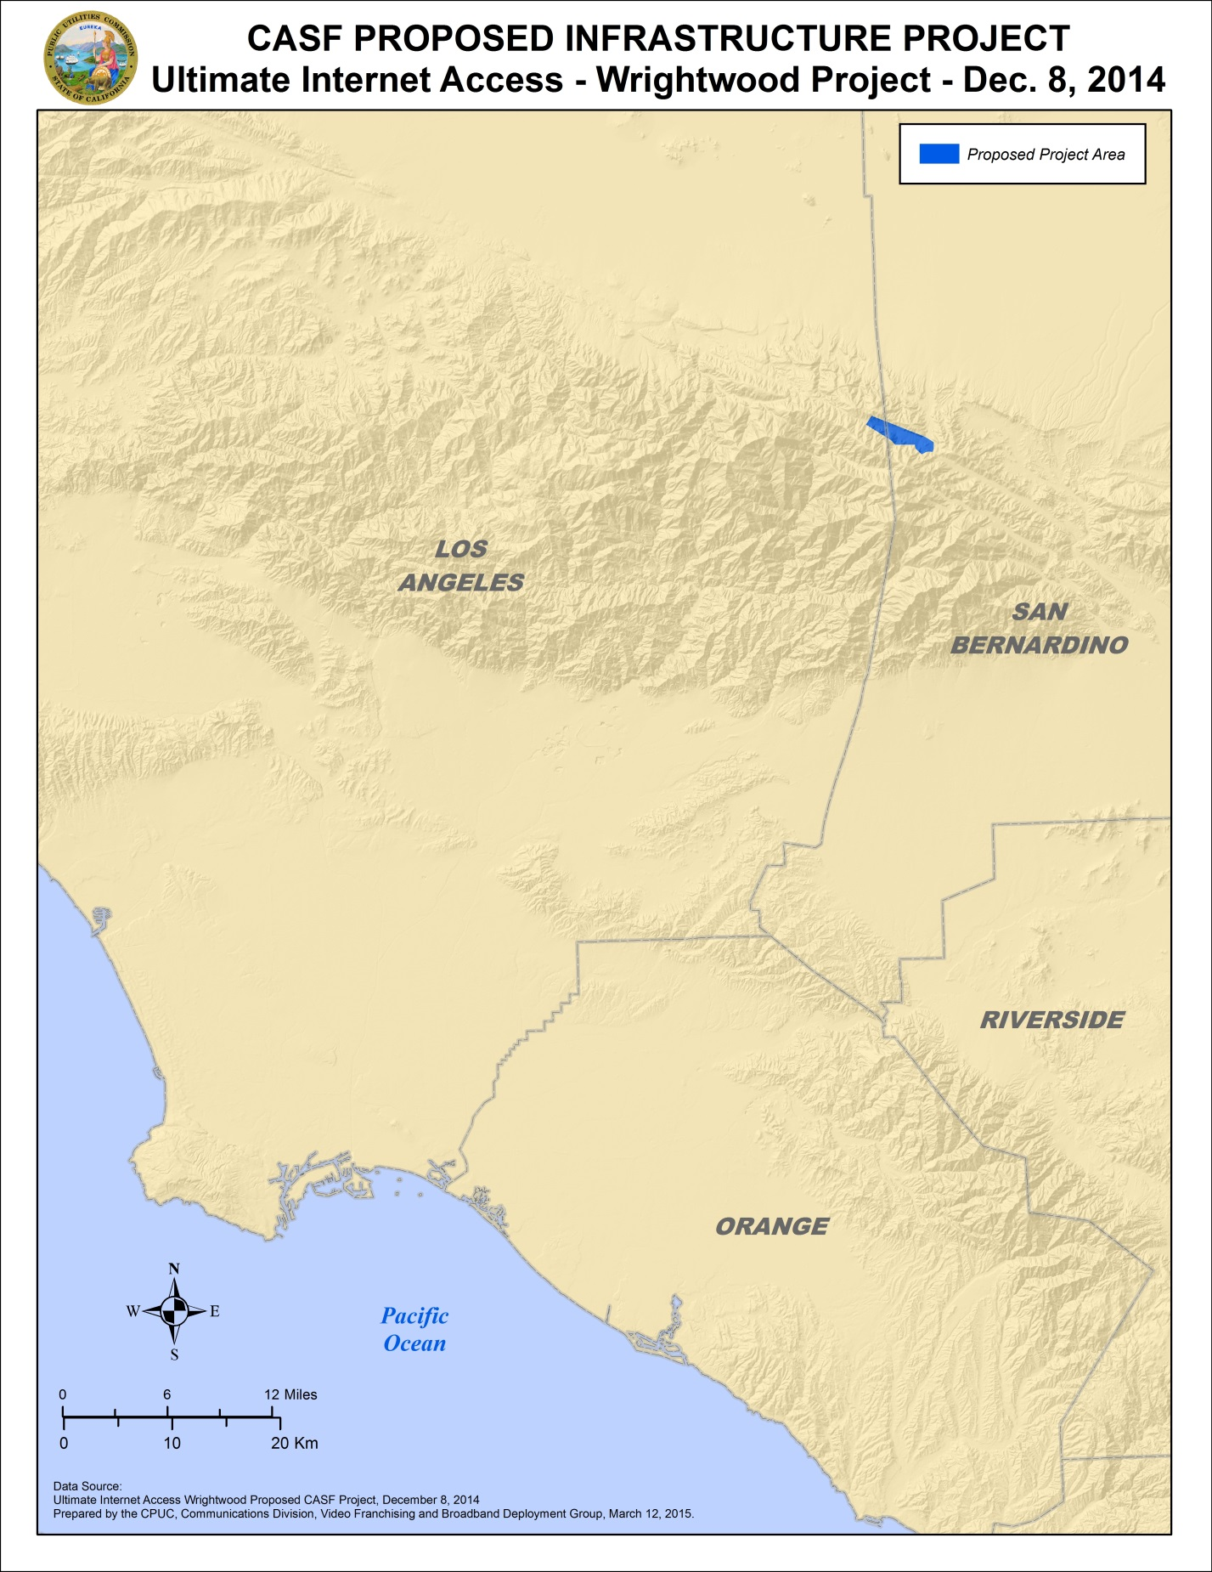
Appendix C
Resolution T-17475 UIA Wrightwood
Existing wireline download speeds
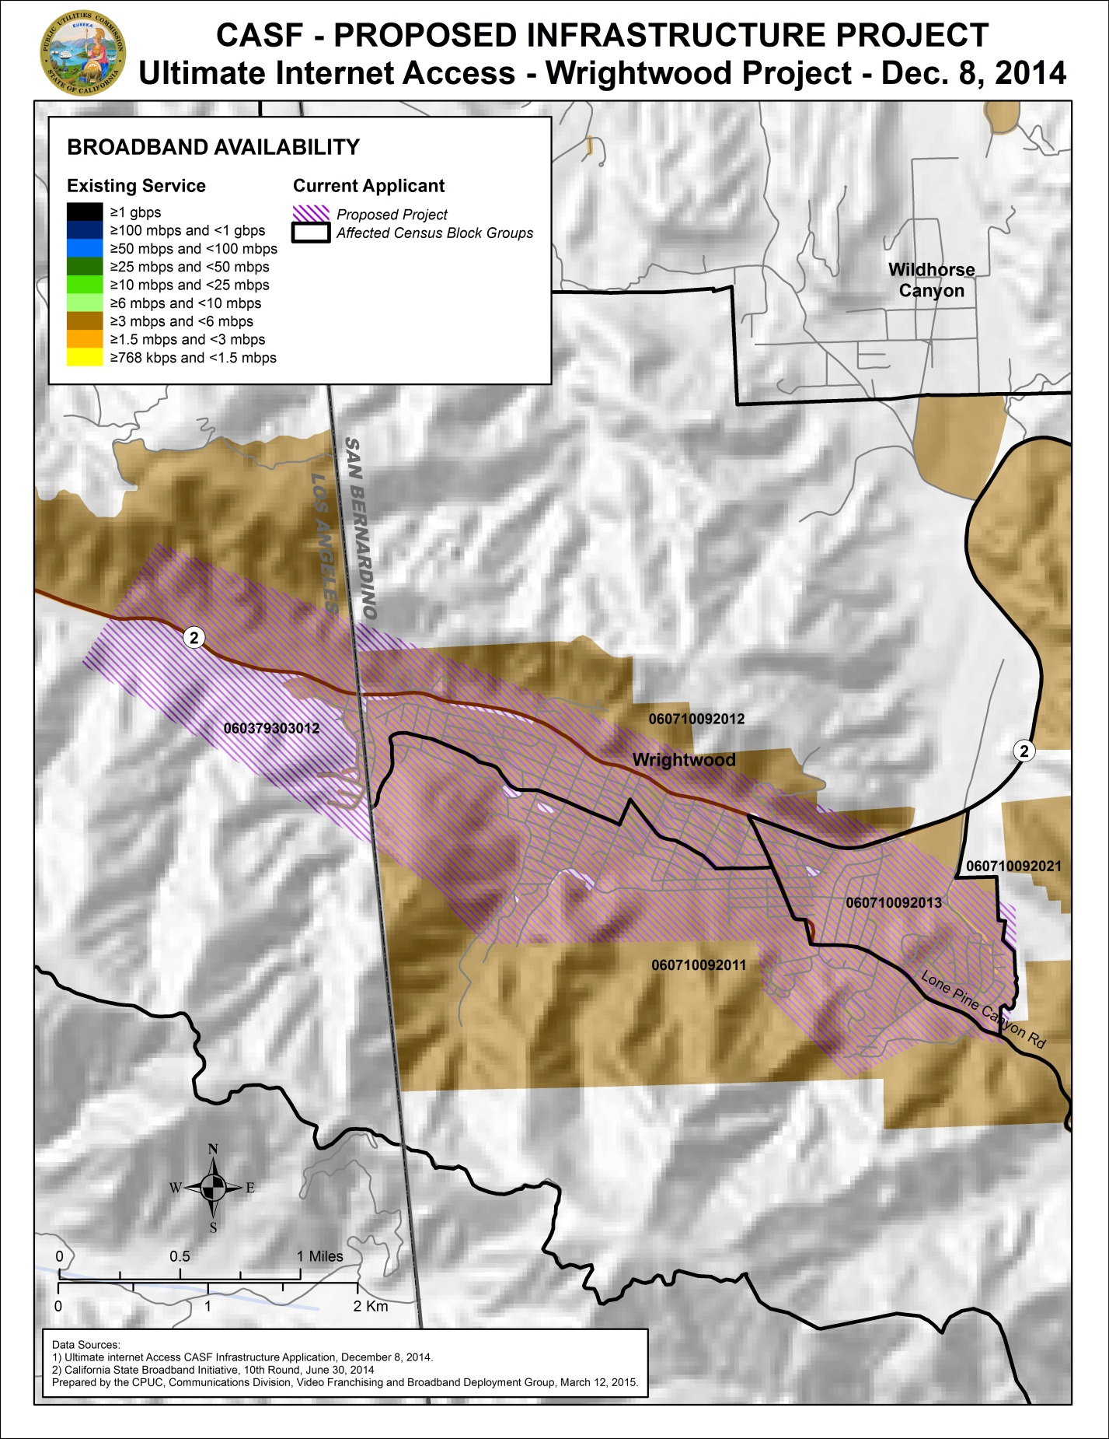
Appendix D
Resolution T-17475 UIA Wrightwood
Existing wireline service level
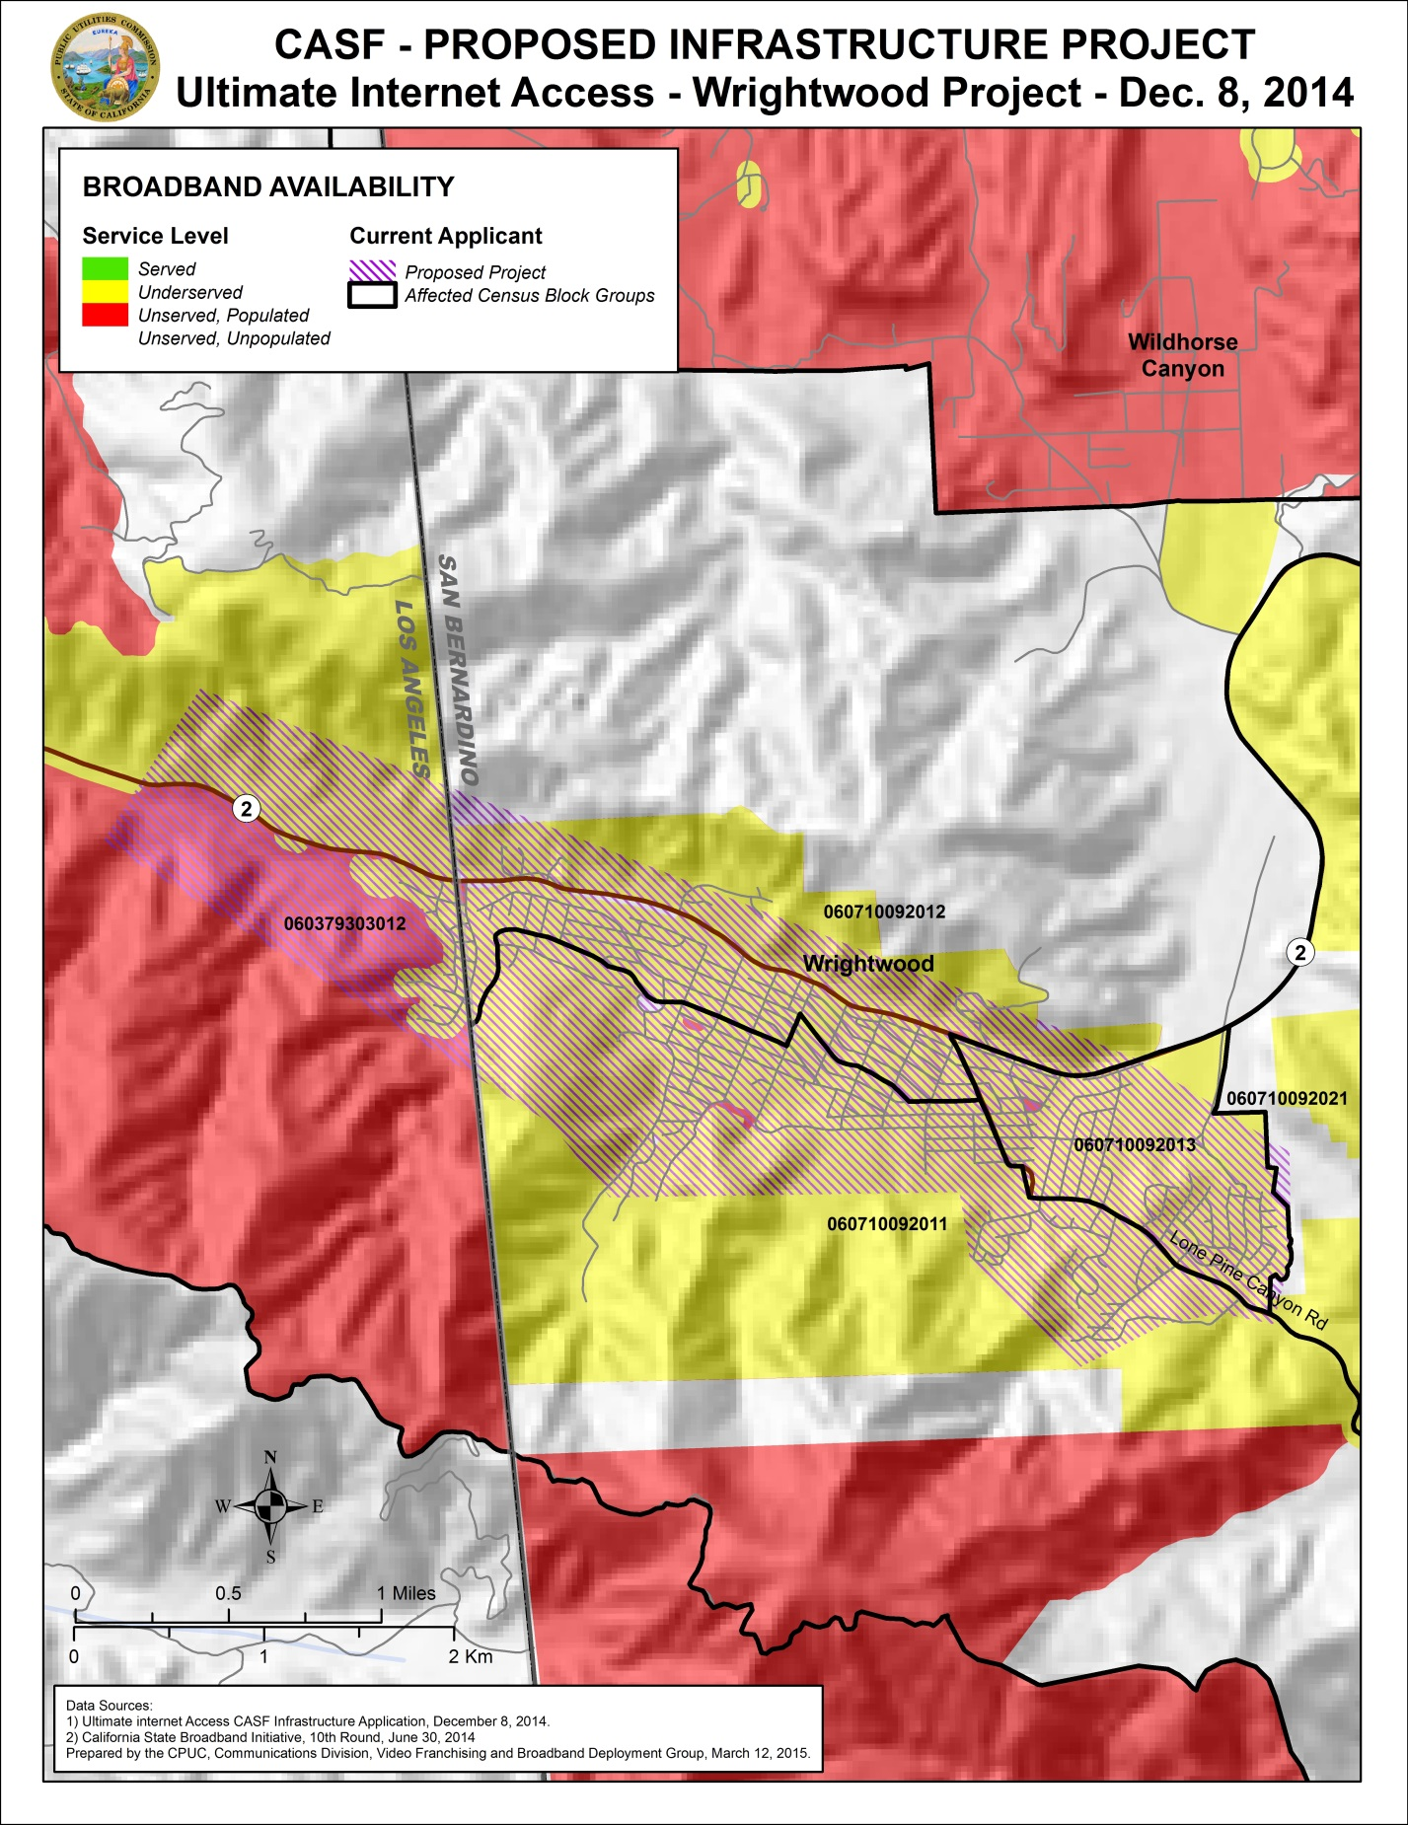

Stats. 2010, c. 317, codified at Public Utilities (P.U.) Code § 281
P.U. Code § 281(b)(1).
In addition to Resolution T-17443, the Commission issued D.14-02-018 to implement provisions in Senate Bill 740 (Padilla, Stats 2013, Chapter 522), which amended P.U. Code § 281 and expanded eligibility for CASF Infrastructure Grants/Loans to non-telephone corporations.
Since the initial draft of this resolution, UIA has entered into an agreement with Charter Communications to lease an additional 1 Gbps fiber line into the Wrightwood community in order to supplement the microwave backhaul. The fiber line will provide additional bandwidth and redundancy to the project and will not affect total project costs for the purposes of this resolution.
There are a total of 2,710 “housing units” in the Wrightwood area, with the bulk of the difference from the household count being seasonal or vacation homes. UIA considers each of these housing units to be a potential customer. If these additional residences are considered, the CASF subsidy drops to about $715 per housing unit.
In this case, the latest version of the California Interactive Broadband Availability Map, with data current as of June 30, 2014, was consulted.
Alternatively, applicants may submit a document asserting that they are seeking funding as a non-telephone corporation per Commission Decision 14-02-018, which implements the expanded CASF infrastructure funding eligibility provisions of Senate Bill 740.
CalSPEED is the Commission’s mobile application that is used to test mobile broadband speeds,
This determination was based on the limited speed capabilities of satellite services, the cost to the consumer, high latency, and unreliability known at the time of the decision, D.12-02-015 at 13-15. Since that time, like other technologies, satellite services have improved.
U.S. Census Bureau, 2009-2013 5-Year American Community Survey (Wrightwood CDP).
Ibid.
The only modifications to the tower and an adjacent building will be the installation of headend gear, commercial air conditioner, and a backup generator within the building. Any modifications will conform to existing US Forest Service guidelines – such as painting the headend gear to a color that blends with the surroundings and installing devices that discourage bird nesting.
Approval of the California Advanced Services Fund (CASF) Application Requirements and Scoring Criteria for Awarding CASF Funds (2008) Cal. P.U.C. Res. No. T-17143 at 4.

