PUBLIC UTILITIES COMMISSION OF THE STATE OF CALIFORNIA

Communications Division | RESOLUTION T-17478
Broadband, Policy and Analysis Branch | DATE May 7, 2015

R E S O L U T I O N

Resolution T-17478: Approval of funding for the grant application of Ultimate Internet Access (U-7269C) from the California Advanced Services Fund (CASF) in the amount of $1,385,825 for the Helendale Project.
__________________________________________________________________

- Summary

This Resolution approves funding in the amount of $1,385,825 from the California Advanced Service Fund (CASF) for the CASF grant application of Ultimate Internet Access (UIA) for installation of a fiber-to-the-premises (FTTP) system in Helendale, California (Helendale Project). The Helendale Project will extend gigabit high-speed internet service to approximately 2,279 households spread over 3.9 square miles in and adjoining the underserved community of Helendale which is located in San Bernardino County, California, on historic Route 66 between Barstow and Victorville, in the Victor Valley. Further, this project provides additional safety benefits to the Helendale community in the form of improved access to e-health services as well as providing additional communication facilities and voice service that would meet all safety standards, including E911.

Background

On December 20, 2007, the California Public Utilities Commission, in Decision (D.) 07-12-054, established the CASF program as a two-year program to provide funds for the deployment of broadband infrastructure in unserved and underserved areas in California.

On September 25, 2010, Governor Schwarzenegger signed Senate Bill (SB) 1040, which codified the CASF program and expanded it to include three accounts: (1) the Infra-structure Grant Account, (2) the Consortia Grant Account, and (3) the Revolving Loan Account. The latter two accounts are intended to address the needs that were unmet under the original CASF program. SB 1040 also expanded the CASF fund from $100 million to $225 million, adding $100 million to the Infrastructure Grant Account and allocating $10 million and $15 million to the Consortia Grant Account and the Revolving Loan Account, respectively.

On February 1, 2012, the Commission approved D.12-02-015 to implement new guidelines for the Infrastructure Grant and Revolving Loan Accounts. Key provisions of the decision include:

- A maximum CASF grant award of 70 percent of project costs for unserved areas and 60 percent for underserved areas; and,
- A definition of an underserved area, “where broadband is available, but no wireline or wireless facilities-based provider offers service at advertised speeds of at least 6 megabits per second (Mbps) downstream and 1.5 Mbps upstream (6 Mbps /1.5 Mbps).”

Subsequently, on June 26, 2014, the Commission approved Resolution T-17443, which (relevant to this resolution) opened the CASF Broadband Infrastructure Grant Account to new applications as of December 1, 2014, and offered existing providers a “right of first refusal” to upgrade service in unserved and underserved areas.

On December 8, 2014, Ultimate Internet Access submitted an application for CASF funding to bring symmetrical 1 gigabit-per-second broadband service to the homes and businesses of the unincorporated community of Helendale via a FTTP connection. No existing provider made a commitment to upgrade service before the Nov. 1, 2014, “first refusal” deadline and the Helendale area has been determined by CD staff to be “underserved.” Therefore CD deemed the Helendale area eligible for new applications.

- Notice/Protests

On December 15, 2014, Communications Division (CD) posted the proposed project area map, census block groups (CBGs) and zip codes for the Helendale Project on the Commission’s CASF webpage under “CASF Application Project Summaries” and also sent notice regarding the project to its electronic service list. CD received no challenges to the proposed project area.

- Discussion

This Resolution adopts CD’s recommended CASF fund award of $1,385,825 for the UIA Helendale Project. This award represents 60 percent of the applicant’s estimated total project cost of $2,309,708. Key project information and maps are shown in Appendix A.

- Project Overview

UIA was formed in 1996 as an independent Internet Service Provider (ISP), initially focused on the business-to-business sector. In the years since, through expansion and acquisition, UIA has grown to also provide residential communities with broadband services. The company is based in the City of Ontario, California, and was granted a Certificate of Public Convenience and Necessity (CPCN) as part of Decision 14-12-050 in late 2014. Staff consultations with the CASF-sponsored Inland Empire Regional Broadband Consortium and various local government agencies in the area (including community services district officials in the Helendale area) indicate that UIA is well-regarded ISP.

UIA proposes to utilize existing conduit that currently passes 3,150 residential lots within the primary community of Helendale. Of the 3,150 lots, 2,749 are established homes and 40 are businesses. The conduit was used by Falcon Cable Company for cable TV and then abandoned due to low subscribership numbers. UIA will remove existing co-ax cable and install fiber in its place. UIA will install equipment on an existing antenna tower in order to establish a backhaul link to UIA middle mile in the San Bernardino Valley. Both the existing conduit and the antenna tower are owned by the Helendale Community Services District (HCSD) and are to be leased by UIA in a 10-year term. Additionally, for a minor part of the project UIA will utilize existing telephone poles. UIA will have access to these poles because UIA is a CPCN holder. The proposed project covers about 3.9 square miles in aggregate, distributed in adjoining contiguous CBGs.

UIA targeted the area for broadband deployment after determining that the project is economically feasible with a CASF grant of $1,385,825, which is 60 percent of the total project costs, to match UIA funding of $923,883. When completed, the project will reach an estimated 2,279 households, with all customers capable of achieving speeds of 1 Gbps on both downloads and uploads – well above the Commission-defined “served” threshold of 6 Mbps download/1.5 Mbps upload. The CASF per-household subsidy would be about $608 per household which is 12% of the median and 5% of the mean cost per household for fiber projects previously funded by CASF.

UIA has committed to a broadband pricing plan under the terms shown below for four years, starting from the beginning date of service. There is no long-term commitment by the consumer.

Service Type | Broadband speed | Monthly charge: Standalone BB | Monthly charge: Bundled w/voice
Residential Broadband | 1 Gbps down  1 Gbps up | $70 | $95
Small Business |  | $120 | Additional $35 per line
Activation and installation (all type): Waived
Modem charge: No monthly residential equipment fee
Voice service includes unlimited calling in United States and Canada

- Project Qualification

To qualify for the CASF program, an applicant is required to submit proof that the area is unserved or underserved by submitting shapefiles of the proposed project. CD reviews the submitted shapefiles and compares them with United States 2010 Census data and the California Interactive Broadband Availability map. Once CD determines that the area is eligible either as an unserved or underserved area, CD evaluates all other information submitted by the applicant to determine if the project meets the requirements outlined in D.12-02-015. Other information CD reviews includes: proof of a CPCN from the Commission; descriptions of current and proposed broadband infrastructure; number of potential subscriber households and average income; project construction schedule; project budget; proposed pricing and commitment period for new subscribers; and financial viability of the applicant.

As an initial step in the review of UIA’s application, CD reviewed the CBGs submitted in the project application and determined that the project was indeed not served at adequate speeds via wireline or fixed wireless providers. With regard to mobile service, however, the California Interactive Broadband Availability Map indicates that 80% of the proposed project area may be served by Verizon and T-Mobile wireless service at speeds that qualify the area as served for CASF purposes (at least 6 mpbs up/1.5 down). In light of that information, CD staff turned to “ground truth” data gathered by mobile field tests in the area using the CalSPEED app, both by Commission-contracted testers and public sources, including the applicant.

The net result of the mobile service ground-truth data demonstrates that the area is not being served at the Commission’s standard of 6 mpbs up/1.5 down by mobile providers, and thus the proposed project area is underserved and eligible for CASF funding. This ground-truth data consists of 40 CalSPEED tests, 17 of which were conducted by the applicant on December 1 and 2 of 2014. None of the applicant’s tests resulted in speeds at the Commission’s standard. Five of the 40 CalSPEED tests (not those conducted by the applicant) resulted in speeds at or above the Commission’s standard, but these five tests were insufficient to change the area from underserved to served status. The applicant also provided CD with the results of an online survey showing that 89 (of 89) respondents reported that their current internet service delivers below standard speeds. These findings, when combined with the lack of challenges to the project (particularly from mobile providers), led staff to recommend that the area be considered underserved by mobile broadband.

The California Interactive Broadband Availability map shows broadband availability at served speeds in the proposed project area by several satellite providers. However, as adopted in D.12-02-015, the Commission does not generally consider satellite broadband service in CASF project evaluation, unless said satellite service was established via a CASF grant.

- Project Evaluation and Recommendation for Funding

Helendale is an unincorporated planned community that centers on two constructed lakes (named ‘Silver Lakes’). Construction began on the lakes in 1969 with housing development beginning soon after that. The community had a population of 5,693 in 2010 with a total household count of 2,272 using census block data (with a projected household count of 2,279 by 2014). Based on the 2010 census for the Silver Lakes Census Designated Place (CDP) (which incorporates most of the Helendale project area and with a similar population count), 25% of the population was 19 years of age or younger and 23% were 65 years or older, with the median age at 46.5 years. According to the HCSD, housing is 80% owner occupied and there is a 5% or less vacancy rate.

The project area includes three public schools: the Helendale Elementary School, the Riverview Middle School and the Academy of Careers and Explorations. UIA has already provided service to the schools in Helendale and has been recommended by the office of the San Bernardino County Superintendent of Schools due to UIA’s expedient and seamless response to the school district’s request for Internet access.

The applicant estimates that about 75 percent of households in Helendale would purchase UIA’s service because of the area’s historically underserved status and relatively high incomes. While CD believes such a “take rate” would be high based on historical adoption levels, there are factors in the area which could indeed lead to high adoption. The median household income is $71,321, well above the state average of $61,632 which indicates that residents have the funds to purchase at the monthly rate of $70.00 that UIA would offer. There is currently no wireline or fixed wireless provider offering served speeds in the area and the available mobile coverage was determined to be at underserved speeds (given mobile speed tests performed). The General Manager of the HCSD (Kimberly Cox) stated that realtors have to state to perspective home buyers that broadband service is not available in the area. In the letter of support for the project, the Silver Lakes (Homeowners) Association noted that many residents could not get Internet access. The HCSD hosts an online survey regarding Internet service. Of the 89 reported respondents, 90% wanted the HCSD to develop a plan for higher speeds and better service. These facts argue for an appetite for reliable and fast Internet.

UIA has received letters of support for the Helendale project. Besides the stated support of the San Bernardino County Superintendent of Schools, UIA has strong support from the HCSD, the Inland Empire Regional Broadband Consortium and the Silver Lakes Association (after surveying homeowners in the Association, they expressed unequivocal support for the project). UIA also received letters of support from the United Way 211 for San Bernardino County and the High Desert Community Foundation.

As part of the evaluation process, CASF staff toured the proposed project area and other proposed project areas in the region in January 2015 as part of a larger visit to the Eastern Sierra Regional Broadband Consortium’s annual summit. Staff was accompanied for part of the visit by UIA representatives. UIA representatives briefed staff on the technical issues and visited representative infrastructure sites. Staff took photographs of anchor institutions and potential connection points in the community, spoke with area residents and HCSD management regarding their Internet needs at the HCSD office, and did independent field tests for mobile broadband.

During the analysis period, CD requested, and UIA provided, greater detail for the project budget. As a result, CD made some minor cost adjustments. CD reviewed the financial information included with the application and concluded that the applicant is financially viable as an ongoing business.

Because CASF funds are awarded on a reimbursement basis, UIA will be funding the bulk of the project costs from existing capital. As UIA has the necessary funding up front, CD determines there is little risk of the applicant not completing the project.

CD evaluated the application with respect to the scoring criteria defined in D.12-02-015, Appendix 1, Section VIII (Scoring Criteria). The scoring criteria include: (i) Funds Requested per Potential Customer, (ii) Speed, (iii) Financial Viability, (iv) Pricing, (v) Total Number of Households in the Proposed Area, (vi) Timeliness of Completion of Project, (vii) Guaranteed Pricing Period, and (viii) Low-Income Areas.

The Helendale Project scored particularly well in the criteria of offering a relatively low per-household subsidy and offering very high speeds. Funding is relatively modest, given that this is a fiber project. The project will take a reasonably short time to complete (18 months rather than the 24 month standard time).

CD found that the Helendale Project meets CASF funding requirements with respect to the following factors:

- Speed – the proposed speed offering of 1 Gbps download and 1 Gbps upload significantly exceeds the 6/1.5 benchmark set by the Commission;
- Service area – is determined to be underserved and covers 3.9 square miles;
- Matching Funds of 40 percent of project cost – the applicant will use existing capital; the submitted balance sheet, income and cash flow statements show that the applicant is financially viable and has the financial capability to match the funds;
- Price commitment period – the applicant has committed to a pricing plan of four years; two years more than required;
- Deployment schedule – the applicant has submitted detailed planning documents, including a schedule with clear milestones to indicate it will be completed within the 18-month construction timeline required.

Based on its review, CD determined that UIA’s grant application for the Helendale Project qualifies for funding as an underserved area and meets the requirements of D.12-02-015. CD staff finds that funding the UIA’s Helendale Project aligns with CASF’s goal to encourage the deployment of high-quality advanced information and communications technologies to all Californians to promote economic growth, job creation, and substantial social benefits.

- Safety Considerations

The CASF program encourages the deployment of broadband throughout the State which can enable the public to access Internet-based safety applications, access to emergency services, and allow first responders to communicate with each other and collaborate during emergencies. As the Governor’s Broadband Task Force stated in its 2007 report, ubiquitous broadband will play a key role in enhancing public safety operations and applications in law enforcement, disaster relief, traffic management, and virtually every other aspect of public safety.

The unincorporated town of Helendale is outside of the main population centers in the Victor Valley with available hospitals and medical centers 15 miles away in Victorville or 20 miles away in Barstow. Telephone and broadband allows access to these facilities and providers and can be a critical factor in health and safety emergencies.

Additionally, voice service provided as a part of this project would meet all safety standards, including battery backup, E911 data and access to local PSAPs.

- Compliance Requirements

UIA is required to comply with all the guidelines, requirements, and conditions associated with the grant of CASF funds as specified in D.12-02-015. Such compliance includes, but is not limited to:

- California Environmental Quality Act (CEQA)

All CASF grants are subject to CEQA requirements. The Commission must complete environmental review before funding construction projects, unless the projects are statutorily or categorically exempt pursuant to the CEQA Guidelines.

UIA has provided the Commission with their plan to use existing infrastructure for the installation of a fiber-to-the-premises (FTTP) system in Helendale. Existing conduit (26 linear miles) passes 3,150 residential lots within the primary community of Helendale. This conduit was previously used for a cable TV network and currently contains co-axial cable. Access to the conduit is through pull boxes built on each lot. This conduit is linked to an antenna tower through an abandoned coaxial cable plant, which is on the same property as the tower. The fiber project includes provision of fiber to 40 businesses (including the HSCD office) that is situated outside of the residential area across the Mojave River. This area has no installed conduit but instead will be serviced aerially by fiber placed on existing utility poles.

In order to prepare the conduit for fiber installation, UIA will remove the existing CATV co-ax cable, manually clean the conduit free from obstructions, and repair and replace any damaged conduit and/or pull boxes. The fiber network will then be installed in the repurposed conduit.

The only new construction planned is for the build-out of microwave equipment on an existing antennae tower (the installation of head end gear and a commercial air conditioner, plus a backup generator within the adjacent tower building). This equipment will be used for connection to the UIA middle mile location, as well as to a fixed wireless receiver that will be placed on top of the HSCD office building. From the HSCD building, UIA can service the remaining businesses using the existing utility poles.

Based on the above information the project qualifies for the following categorical exemptions from CEQA: CEQA Guidelines Section 15301 – Existing Facilities – consists of the…minor alteration of existing public or private structures, facilities, mechanical equipment, or topographical features, involving negligible or no expansion of use beyond that existing at the time of the lead agency's determination; CEQA Guidelines Section 15303 – New Construction or Conversion of Small Structures – involving construction, installation, and/or conversion of limited numbers of new and/or existing facilities/structures; and CEQA Guidelines Section 15304 – Minor Alterations to Land –
involving minor trenching and backfilling where the surface is restored.

- Deployment Schedule

The Commission expects UIA to complete the project within 18 months from start date (as determined by the procedure below). If the applicant is unable to complete the proposed project within the 18-month timeframe requirement established by the Commission, it must notify the Commission as soon as it becomes aware of this prospect. The Commission may reduce payment for failure to notify CD’s Director and satisfy this requirement.

- Execution and Performance

CD and the CASF grant recipient (UIA) shall determine a project start date after the CASF grant recipient has obtained all approvals. Should the recipient or Contractor fail to commence work at the agreed upon time, the Commission, upon five days written notice to the CASF recipient, reserves the right to terminate the award. In the event that the CASF recipient fails to complete the project in accordance with the terms of approval granted by the Commission, the CASF recipient must reimburse some or all of the CASF funds that it has received.

The CASF grant recipient must complete all performance under the award on or before the termination date of the award.

D. Price Commitment Period

The minimum required price commitment period for broadband service to all households within the project area is two years. UIA exceeds the minimum period and guarantees the price of service offered in the project area for four years.

E. Project Audit

The Commission has the right to conduct any necessary audit, verification, and discovery during project implementation/construction to ensure that CASF funds are spent in accordance with Commission approval.

The recipient’s invoices will be subject to a financial audit by the Commission at any time within three years of completion of the work.

F. Providing Voice Service

The proposed project will allow UIA to provide landline voice service via Voice over Internet Protocol (VoIP). UIA has been offering VoIP services for many years and is familiar with FCC requirements, particularly in reference to E911 services. UIA commits to adhere to all FCC requirements in regards to E911 service and will provide equipment with battery backup.

G. Reporting

Grantees must submit quarterly progress reports on the status of the project irrespective of whether grantees request reimbursement or payment. Before full payment of the project, the CASF recipient must submit a project completion report. Progress reports shall use the schedule for deployment, major construction milestones and costs submitted in the proposal; indicate the actual date of completion of each task/milestone as well as problems and issues encountered, and the actions taken to resolve these problems and issues during project implementation and construction; and identify future risks to the project.

Recipients shall also include test results on the download and upload speeds on a CBG and zip code basis in the final completion report. Recipients must certify that each progress report is true and correct under penalty of perjury.

H. Submission of Form 477

The FCC currently requires broadband providers to biannually submit the Form 477, which includes speed data. While there is an imperfect match between the data that is reported in the Form 477 and to the CASF, Form 477 data will be useful in documenting CASF deployment for the new service area of the carrier. CASF recipients shall submit a copy of their Form 477 data directly to the Commission, under General Order 66-C, when they submit this data to the FCC for a five-year period after completion of the project.

- Payments to CASF Recipients
Submission of invoices from and payments to UIA shall be made at 25-percent completion intervals, in accordance with Section XI of Appendix 1 of D.12-02-015 and according to the guidelines and supporting documentation required in D.12-02-015.

Payment to UIA shall follow the process adopted for funds created under P. U. Code §270. Payments are generally processed by the Commission, including CD and Administrative Services review time, within 20-25 business days. The State Controller’s Office (SCO) requires an additional 14- 21 days to issue payment from the day that requests are received by SCO from Administrative Services.

Comments on Draft Resolution

In compliance with Public Utilities Code § 311(g), a notice letter was e-mailed on April 3, 2015, informing all parties on the CASF Distribution List of the availability of the draft of this resolution for public comments at the Commission's website at http://www.cpuc.ca.gov/PUC/documents/. This letter also informed parties that the final conformed Resolution adopted by the Commission will be posted and available at this same website. CD did not receive any comments or reply comments on this resolution.

- Findings

- On June 26, 2014, the Commission approved Resolution T-17443, which implemented new timelines for applications to the CASF Broadband Infrastructure Grant Account and offered existing providers a “right of first refusal” to upgrade service in unserved and underserved areas. The window for new applications opened on December 1, 2014.

- UIA filed an application for CASF funding for its Helendale Project on December 8, 2014. The proposed project will improve speeds by installing a fiber-to-the-premise system capable of symmetrical 1 gigabit-per-second download/upload service to 1,709 households in the community of Helendale, which is located in San Bernardino County, California between Barstow and Victorville. This system would provide broadband Internet service to an area that is currently underserved. The CBGs impacted by the project are 60710116002, 60710116003 and 60710117001.

- CD posted the proposed project area map, CBGs and zip codes by county for the UIA Helendale Project on the Commission’s CASF webpage under “CASF Application Project Summaries” on December 15, 2014. CD received no challenges to this project.

- CD reviewed and analyzed data submitted for the UIA Helendale Project’s CASF grant application to determine the project’s eligibility for CASF funding. This data included, but was not limited to: proof of a CPCN from the Commission; descriptions of current and proposed broadband infrastructure; geographic information system (GIS) formatted shapefiles mapping the project areas; assertion that the area is underserved; number of potential subscriber households and average incomes; project construction schedule; project budget; proposed pricing and commitment period for new subscribers; and financial viability of the applicant.

- CD reviewed the submitted shapefiles, which mapped the proposed broadband deployment using United States 2010 Census data and the California Interactive Broadband Availability Maps, with availability data current as of June, 30, 2014. These maps helped to verify the availability and speed of any broadband service, where available. The project area was determined to be underserved.

- Based on its review, CD determined that the project qualifies for funding under D. 12-02-015 and recommends Commission approval of CASF funding for UIA’s Helendale Project.

- UIA is required to comply with all guidelines, requirements, and conditions associated with the granting of CASF funds as specified in D.12-02-015 and must submit the FCC Form 477, as specified in T-17143.

- The Commission finds CD’s recommendation to fund UIA’s project, as summarized in Appendix A, to be reasonable and consistent with Commission orders and, therefore, adopts such recommendation.

- The Commission has determined that the project is categorically exempt from CEQA review, under Sections 15301, 15303, and 15304 of the CEQA Guidelines because the project involves minor modifications to existing structures and facilities and possibly a minor amount of trenching where the surface will be restored to existing conditions. .

- A notice letter was e-mailed on April 3, 2015, informing all applicants filing for CASF funding, parties on the CASF distribution list of the availability of the draft of this Resolution for public comments at the Commission’s website http://www.cpuc.ca.gov/PUC/documents/. This letter also informed parties that the final confirmed Resolution adopted by the Commission will be posted and available at this same website. CD did not receive any comments or reply comments on this resolution.

THEREFORE, IT IS ORDERED that:

  - The Commission shall award $1,385,825 to UIA for the Helendale Project as described herein and summarized in Appendix A of this Resolution.
  - The program fund payment of $1,385,825 for this project in underserved areas shall be paid out of the CASF Infrastructure Grant Account in accordance with the guidelines adopted in D.12-02-015, including compliance with CEQA.
  - Payments to the CASF recipient shall be in accordance with Section XI of Appendix 1 of D.12-02-015 and in accordance with the process defined in the “Payments to CASF Recipients” section of this Resolution.
  - The CASF fund recipient, UIA, shall comply with all guidelines, requirements and conditions associated with the CASF funds award as specified in D.12-02-015 and must submit the FCC Form 477 to the Commission, as specified in Resolution T-17143.

This Resolution is effective today.

I hereby certify that this Resolution was adopted by the Public Utilities Commission at its regular meeting on May 7, 2015. The following Commissioners approved it:

/s/ Timothy J. Sullivan

TIMOTHY J. SULLIVAN

Executive Director

MICHAEL PICKER
President
MICHEL PETER FLORIO
CATHERINE J.K. SANDOVAL
CARLA J. PETERMAN
LIANE M. RANDOLPH
Commissioners

APPENDIX
APPENDIX A
Resolution T-17478
Ultimate Internet Access, Helendale Project
CASF Applicant Key Information
Project Name | UIA Helendale Project
Project Plan | UIA will utilize an abandoned CATV conduit system that was constructed as base infrastructure to every housing lot in Helendale. UIA will replace the existing co-axial cable with single-mode fiber to the household. UIA will install equipment on an existing antenna tower to connect to its middle mile point in the city of San Bernardino through its FCC Licensed Microwave Backhaul.
Project Size (in square miles) | 3.9
Download/Upload speed | 1 Gbps / 1 Gbps
Location | San Bernardino County
Community Names | Helendale
Census Block Groups | 060710116002, 060710116003, 060710117001
Weighted Median Household Income | $71,321
Zip Codes | 92342, 92368
Estimated potential subscriber size | 2,279 households / 5,803 population
Applicant expectations | 1,709 customers
Pricing Plan | Residential Monthly Charge:  Standalone: $ 70/mo  With Voice: $ 95/mo  Small Business Charge:  Standard: $120/mo  With Voice: Additional $35 per line  (no installation or modem fees)
Deployment Schedule  (from Commission approval date) | 18 months
Proposed Project Budget (Total) | $ 2,309,708
Amount of CASF funds requested (60%) | $1,385,825
Applicant funded (40%) | $924,883

Appendix B
Resolution T-17478 UIA Helendale
Project location map
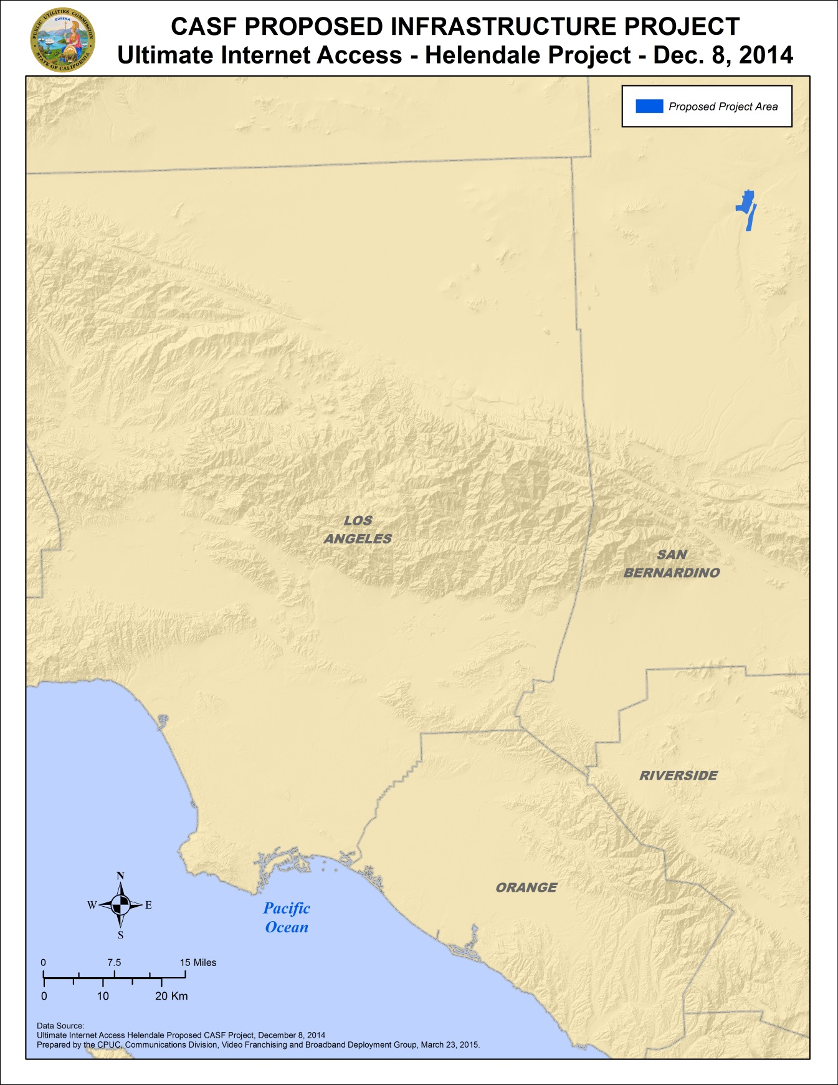
Appendix C
Resolution T-17478 UIA Helendale
Existing wireline download speeds
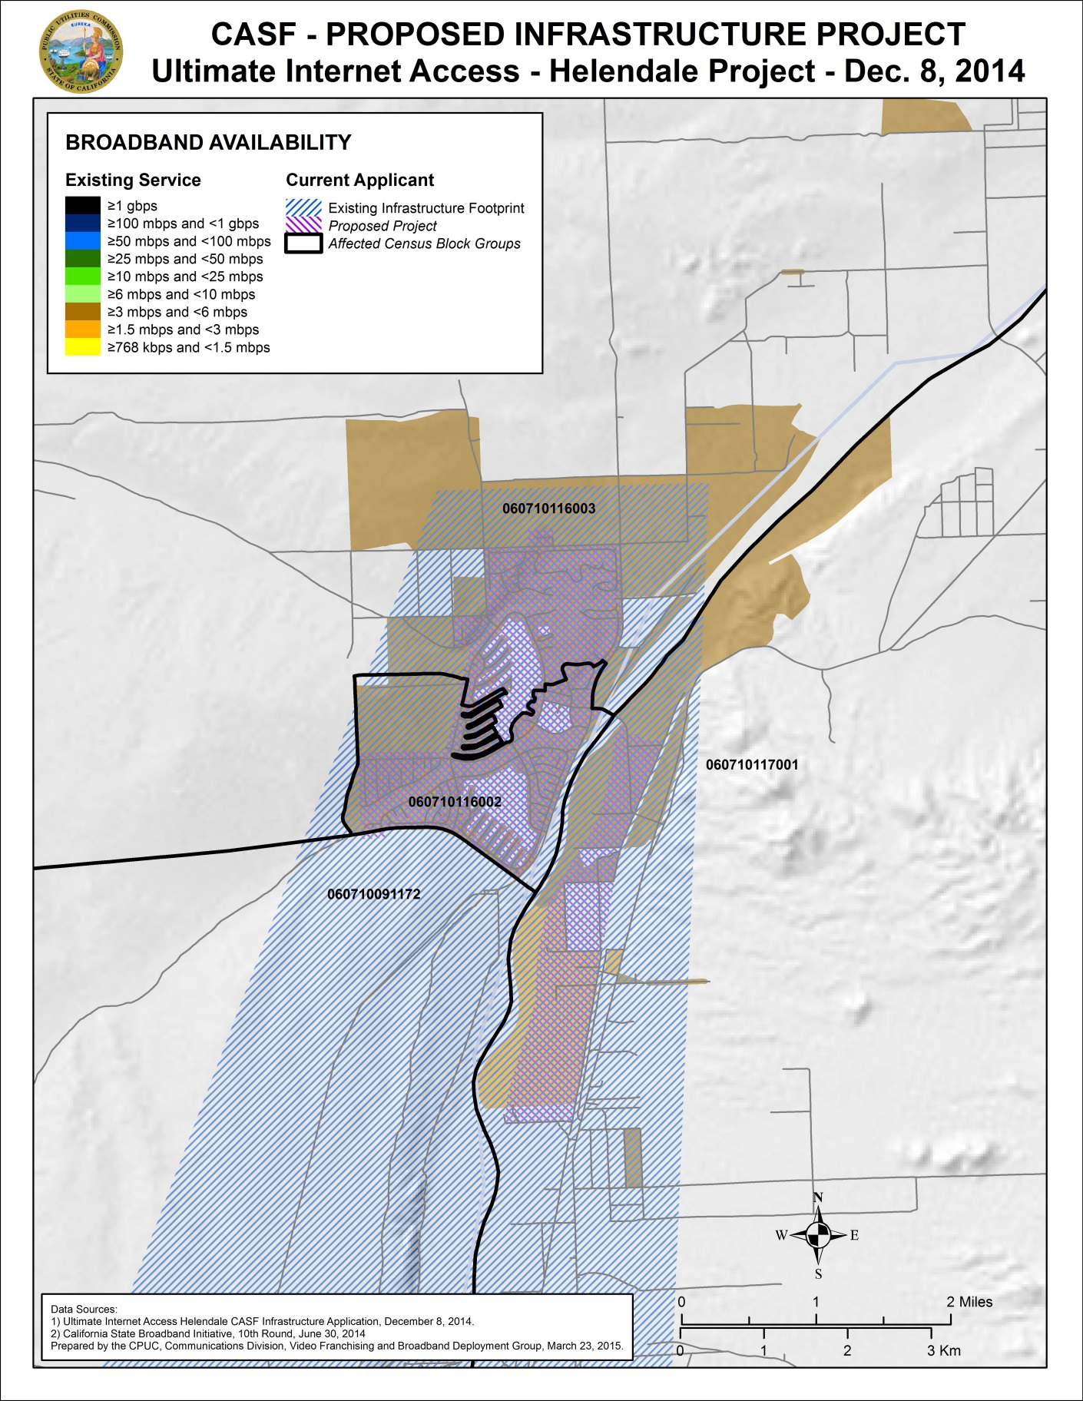

Appendix D
Resolution T-17478 UIA Helendale
Existing wireline service level
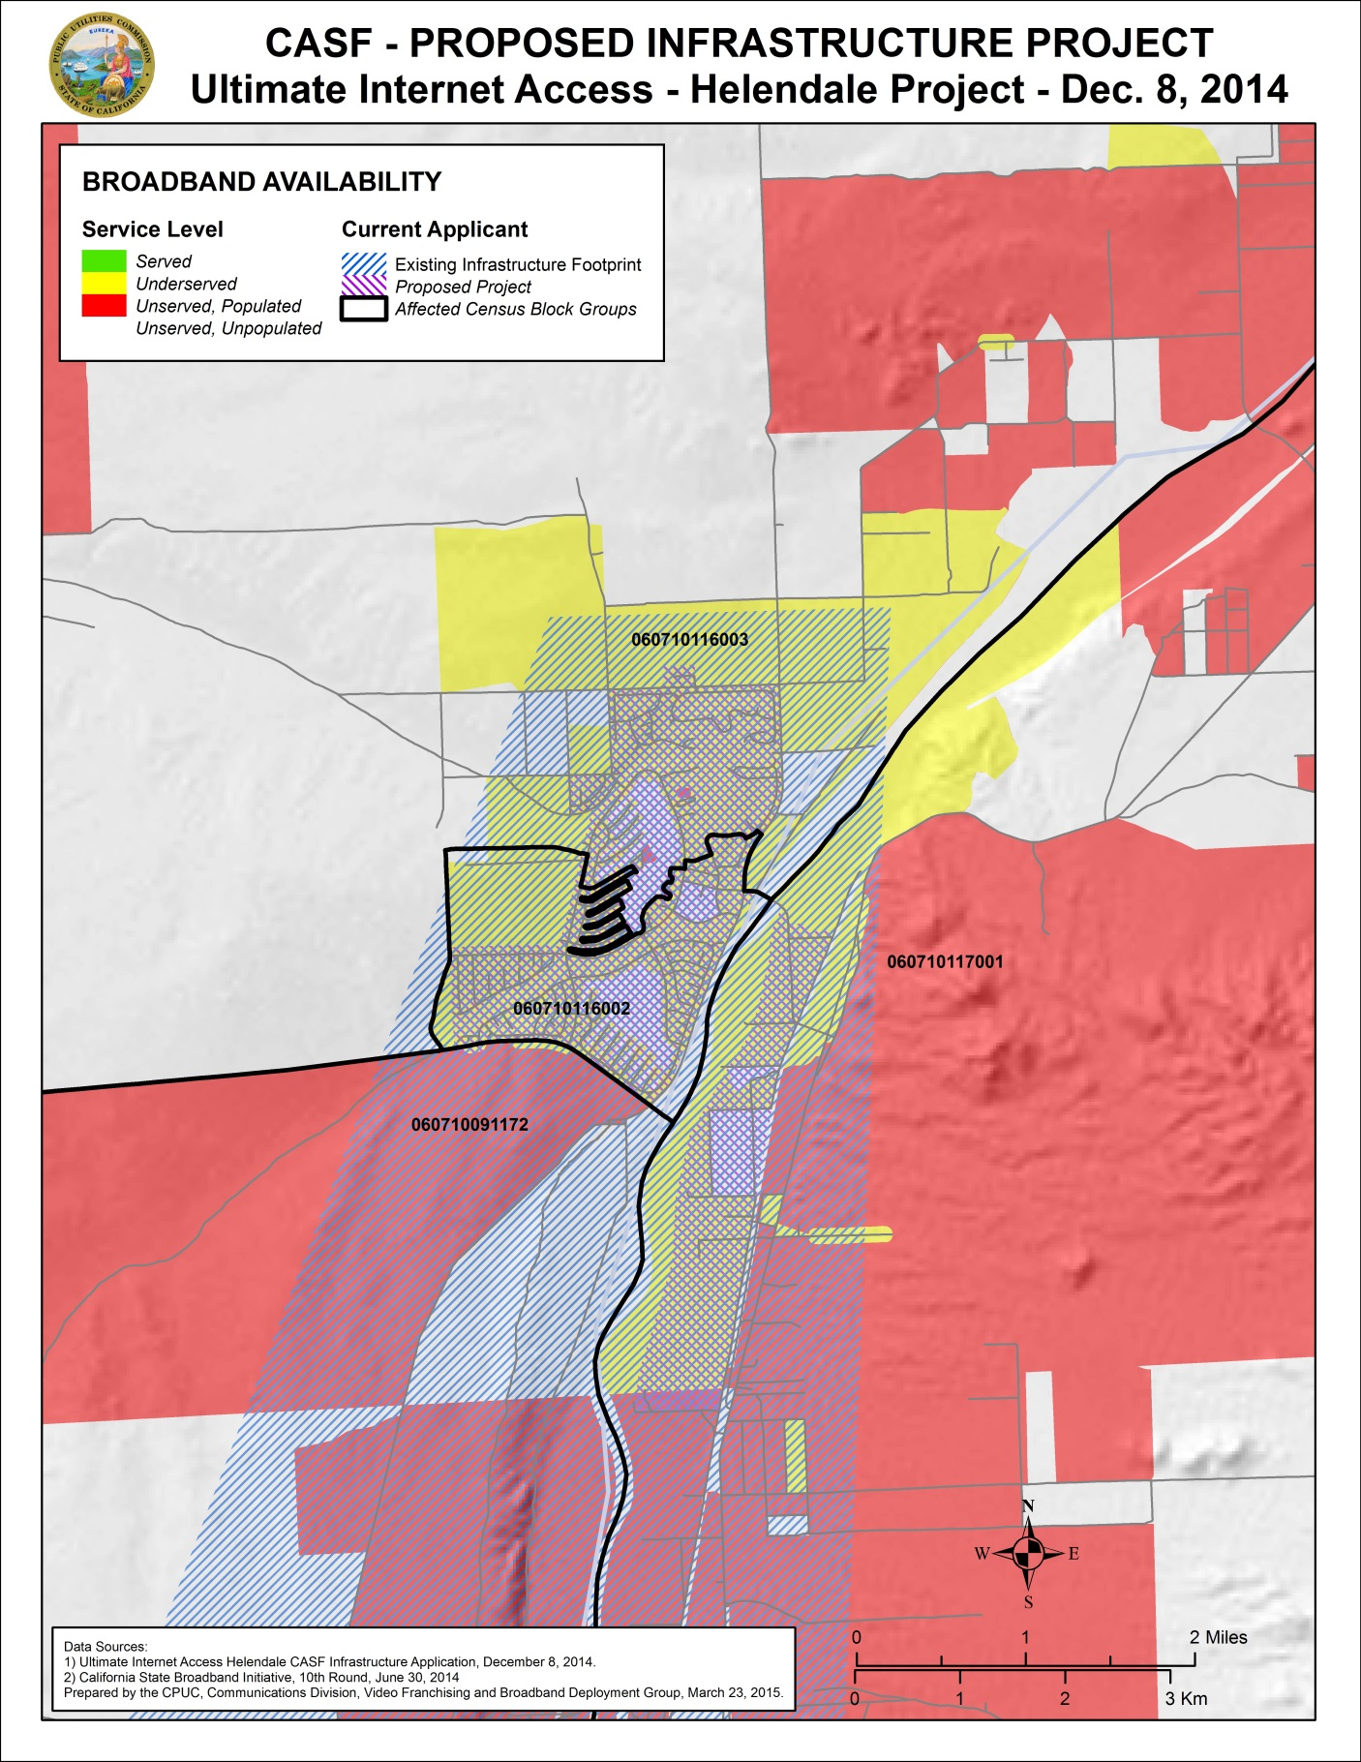

Stats. 2010, c. 317, codified at Public Utilities (P.U.) Code § 281
P.U. Code § 281(b)(1).
In addition to Resolution T-17443, the Commission issued D.14-02-018 to implement provisions in Senate Bill 740 (Padilla, Stats 2013, Chapter 522), which amended P.U. Code § 281 and expanded eligibility for CASF Infrastructure Grants/Loans to non-telephone corporations.
Lot and housing counts sourced from HCSD (owner of the existing conduit). Conduit is built on every housing lot. Not all lots have houses. A house was determined to exist on the lot if it received a water bill.
The estimated number of households for the project area was determined in the following way: the number of households by census block according to the 2010 US Census for the project area was projected to 2014 using the California Department of Finance projections.
In this case, the latest version of the California Interactive Broadband Availability Map, with data current as of June 30, 2014, was consulted.
CalSPEED is the Commission’s mobile application that is used to test mobile broadband speeds,
This determination was based on the limited speed capabilities of satellite services, the cost to the consumer, high latency, and unreliability known at the time of the decision, D. 12-02-015 at 13-15. Since that time, like other technologies, satellite services have improved.
Approval of the California Advanced Services Fund (CASF) Application Requirements and Scoring Criteria for Awarding CASF Funds (2008) Cal. P.U.C. Res. No. T-17143 at 4.

