PUBLIC UTILITIES COMMISSION OF THE STATE OF CALIFORNIA

Communications Division | RESOLUTION T-17484
Broadband, Policy and Analysis Branch | DATE July 23, 2015

R E S O L U T I O N

Resolution T-17484: Approval of funding for the grant application of Citizens Telecommunications Company of California (U-1024), subsidiary of Frontier Communications Corporation from the California Advanced Services Fund (CASF) in the amount of $202,557 for the Petrolia Project, located in a CASF “priority area.”

- Summary

This Resolution approves funding in the amount of $202,557 from the California Advanced Service Fund (CASF) for the grant application of Citizens Telecommunications Company of California, Inc. (Citizens), a subsidiary of Frontier Communications Corporation, for the upgrade of existing middle-mile infrastructure in Petrolia, California (Petrolia Project). These upgrades will enable Internet speeds of up to 25 Mbps download and 1.5 Mbps upload to approximately 138 households. The project area is spread over 12.7 square miles in and adjoining the underserved community of Petrolia, which is located in Humboldt County, California, 10 miles southeast of Cape Mendocino. The Petrolia Project was proposed to Citizens by the CASF-funded Redwood Coast Connect Consortium and is a “priority area” for CASF funding based on the rural community’s critical broadband needs, including their educational and economic digital divide. This project also provides safety benefits to the Petrolia community including, but not limited to, robust bandwidth in the event of wildfire, winter storms and earthquakes as well as improved access to e-health services.

Background

On December 20, 2007, the California Public Utilities Commission, in Decision (D.) 07-12-054, established the CASF program as a two-year program to provide funds for the deployment of broadband infrastructure in unserved and underserved areas in California.

On September 25, 2010, Governor Schwarzenegger signed Senate Bill (SB) 1040, which codified the CASF program and expanded it to include three accounts: (1) the Infra-structure Grant Account, (2) the Consortia Grant Account, and (3) the Revolving Loan Account. The latter two accounts are intended to address the needs that were unmet under the original CASF program. SB 1040 also expanded the CASF fund from $100 million to $225 million, adding $100 million to the Infrastructure Grant Account and allocating $10 million and $15 million to the Consortia Grant Account and the Revolving Loan Account, respectively.

On February 1, 2012, the Commission approved D.12-02-015 to implement new guidelines for the Infrastructure Grant and Revolving Loan Accounts. Key provisions of the decision include:

- A maximum CASF grant award of 70 percent of project costs for unserved areas and 60 percent for underserved areas; and,
- A definition of an underserved area, “where broadband is available, but no wireline or wireless facilities-based provider offers service at advertised speeds of at least 6 megabits per second (Mbps) downstream and 1.5 Mbps upstream (6 Mbps /1.5 Mbps).”

Subsequently, on June 26, 2014, the Commission approved Resolution T-17443, which (relevant to this resolution) opened the CASF Broadband Infrastructure Grant Account to new applications as of December 1, 2014, and offered existing providers a “right of first refusal” to upgrade service in unserved and underserved areas.

On February 6, 2015, Citizens Telecommunications Company of California, Inc. (Citizens) submitted a CASF grant application, requesting $202,557 in funding to bring broadband service with maximum speeds of 25 Mbps download, 1.5 Mbps upload (and a minimum of 6 Mbps download, 1.5 Mbps upload) to the homes and businesses of the unincorporated community of Petrolia through middle mile broadband infrastructure expansion using existing DSL connections. There were no commitments made by an existing provider to upgrade service before the November 1, 2014, “first right of refusal” deadline and the Petrolia area has been determined by Communications Division (CD) staff to be “underserved.” Therefore, CD deemed the Petrolia area eligible for new applications.

- Notice/Protests

On February 27, 2015, CD posted the proposed project area map, census block groups (CBGs) and zip codes for the Petrolia Project on the Commission’s CASF webpage under “CASF Application Project Summaries” and also sent notice regarding the project to its electronic service list. CD received no challenges to the proposed project area.

- Discussion

This Resolution adopts CD’s recommended CASF grant award of $202,557 for Citizens’ Petrolia Project. This award represents 60 percent of the applicant’s estimated total project cost of $337,596. An overview of the Petrolia Project and summary of the staff evaluation follow, with key project information and maps are shown in the appendices.

- Project Overview

Frontier Communications Corporation currently operates in California as Citizens Telecommunications Company of California (Citizens) (U-1024) and Frontier Communications Southwest (U-1026). Frontier Communications Corporation (Frontier) is a U.S. telephone company mainly serving rural areas and smaller communities. It was known as Citizens Utilities Company until May 2000 and Citizens Communications Company until July 31, 2008. Frontier is the sixth largest local exchange carrier and the fourth largest provider of DSL, based on coverage area, in the United States. In addition to local and long-distance telephone service, Frontier offers broadband Internet, digital television service, and computer technical support to residential and business customers in 28 states in the United States. The subsidiary, Citizens, is registered as a local exchange carrier (LEC) in California.

In its CASF grant application, Citizens has proposed to upgrade equipment on three existing microwave towers (located in Petrolia, on Branstetter Ridge, and on Bunker Hill). Existing low-capacity microwave radios will be replaced by higher capacity microwave radios. These radios and antennae dishes will be installed on these existing towers. The microwave radio on the Branstetter Ridge tower will function as a signal repeater. Given the remoteness of that tower, new solar panels will be installed on the existing tower to power the radio. Ethernet aggregation switches and associated technologies will be installed at the telephone switch centers. The increased capacity offered by the installation of the new microwave radios will be run through the new Ethernet aggregation switches which will more efficiently use the existing copper wire infrastructure. There is no need to upgrade/modify the existing copper infrastructure. Hence this is a middle-mile project which directly improves last-mile broadband capacity for Petrolia residents.

Citizens currently offers the area maximum broadband speeds of 700 Kbps download and 500 Kbps upload. The upgrade of the microwave radios and associated equipment, combined with the addition of Ethernet aggregation switches, will enable maximum broadband speeds of 25 Mbps download and 1.5 Mbps upload, which is higher than the Commission-defined “served” threshold speed of 6 Mbps download/1.5 Mbps upload. Citizens also provides landline telephone service to the area.

- Project Qualification

To qualify for the CASF program, an applicant is required to submit proof that the area is unserved or underserved by submitting shapefiles of the proposed project. CD reviews the submitted shapefiles and compares them with United States 2010 Census data and the California Interactive Broadband Availability map. Once CD determines that the area is eligible either as an unserved or underserved area, CD evaluates all other information submitted by the applicant to determine if the project meets the requirements outlined in D.12-02-015. Other information CD reviews includes: proof of a CPCN from the Commission; descriptions of current and proposed broadband infrastructure; number of potential subscriber households and average income; project construction schedule; project budget; proposed pricing and commitment period for new subscribers; and financial viability of the applicant.

As an initial step in the review of Citizens application, CD checked the CBGs submitted in the project application and determined that the project was indeed not served by wireline, fixed wireless, or mobile providers. The current version of the California Interactive Broadband Availability Map indicates that most of the area is underserved by any broadband provider (except satellite service). The only broadband service being provided is by Citizens, qualifying the area as underserved with maximum broadband speeds of 700 Kbps download and 500 Kbps upload. The map indicates that certain portions of the project area are being served by the fixed wireless provider 101 NetLink. However, 101 NetLink does not advertise service availability for the zip code 95558, which includes the Petrolia area.

The California Interactive Broadband Availability map shows broadband availability at served speeds in the proposed project area by one satellite provider. However, as adopted in D.12-02-015, the Commission does not generally consider satellite broadband service in CASF project evaluation, unless said satellite service was established via a CASF grant.

- Project Evaluation and Recommendation for Funding

CD evaluated the application with respect to the scoring criteria defined in D.12-02-015, Appendix 1, Section VIII (Scoring Criteria). The scoring criteria include: (i) Funds Requested per Potential Customer, (ii) Speed, (iii) Financial Viability, (iv) Pricing, (v) Total Number of Households in the Proposed Area, (vi) Timeliness of Completion of Project, (vii) Guaranteed Pricing Period, and (viii) Low-Income Areas. CD also conducted qualitative evaluation of the project area, existing infrastructure, and community needs.

The Community. Relative to funding criteria (i), (v), and (viii) above, and as context regarding project need, CD reviewed geographic and demographic characteristics of Petrolia. Petrolia is an unincorporated community in Humboldt County, California, 10 miles southeast of Cape Mendocino, at an elevation of 121 feet. Petrolia was the site of the first oil well drilled in California. It is located along the Mattole River in the Mattole Valley, which is part of the Lost Coast region. The Lost Coast region is one of the longest stretches of undeveloped coastline in the continental United States. Petrolia is situated five miles from the Pacific Ocean and is geographically isolated due to the surrounding Kings Range Mountains and the treacherous coastline. The nearest incorporated town is Ferndale, 30 miles to the north. Petrolia is connected by two steep and winding roads, one to the north to Ferndale and one to the south.

Based on the 2010 census block data for the Petrolia area, there are 138 households and a population count of 277. According to the US Census American FactFinder, for zip code 95558 (which includes Petrolia), the total number of households is 211 with a population of 425, with 16 percent of the population 19 years of age or younger and 16 percent of the population 65 years old or older, the median age being 48 years. The median household income by zip code is $36,538 (well below the state average of $61,094) with a poverty rate of 16.4% (slightly above the State poverty rate of 15.9%).

The project area includes two public schools: the Mattole Elementary and Mattole Triple Junction High with enrollment of 37 and 10 students, respectively. Petrolia has a volunteer fire department equipped for wildfires and medical emergencies.

Because of the area’s historically underserved status, the applicant estimates the take rate will be 75 percent of the total number of households in Petrolia that will have access. According to Citizens there are currently 82 subscribers to the current low-speed broadband offering. This project was proposed to Citizens by the Redwood Coast Connect Consortium (it is considered a “priority area” by the consortium). One reason the consortium considered it a priority was to help the local school district. An administrator from the Mattole Valley Unified School District noted that the lack of broadband in this area was creating issues in administering the mandatory online CAASPP (Common Core) testing, that the digital divide that very rural students (many of low socio-economic backgrounds) face will only continue to increase without adequate broadband, and that the lack of reliable Internet access makes it difficult to maintain vital student information systems (learning/file management, back-up and storage services). Additionally, it has the support of Humboldt County Supervisor Rex Bohn who stated, in a letter to the Commission, that “with school requirements, community, and business needs we are in desperate need of greater bandwidth.

Financial Viability. Citizens determined that the project is economically feasible with a CASF grant of $202,557, which is 60 percent of the total project costs, to match Citizens’ investment of $135,038. The CASF per-household subsidy would be about $1,468 per household (based on 138 households that will have access). Citizens has projected average earnings before interest and taxes (EBIT) of $37,389,000. The parent company, Frontier, has a market capitalization of 5.2 billion, revenues of 4.77 billion, and a net income of 133 million. The project will take a relatively short time to complete (seven months rather than the 24 month standard time).

CD’s review of these and other financial viability variables for Citizens and its parent company Frontier indicates that they have the existing capital resources for the 40 percent required matching funds to construct the Petrolia project, as well as a sound financial framework for future operations. Therefore, staff determined that there is a minimal risk that this project would encounter financial problems, such as the project not being completed. The relatively short construction period also reduces expenses and risk.

Pricing and Affordability. Staff looked at the Petrolia Project relative to the CASF funding criteria for pricing, guaranteed pricing period, and low income areas. Citizens has committed to a broadband pricing plan under the terms shown below for two years, starting from the beginning date of service. There is no long-term commitment by the consumer and activation and installation fees will be waived.

 | 6 Mbps/1.5 Mbps | 12Mbps/1.5 Mbps | 25Mbps/1.5 Mbps
DSL w/Access Line (Monthly)* | $19.99 | $54.99 | $64.99
Stand-alone DSL | $34.99 | $59.99 | $69.99
Activation and installation (all type): Waived
* The customer is required to purchase a dial tone line in conjunction with DSL for the DSL w/Access Line pricing
Note that, per communication with applicant, Citizens (Frontier Communications) does not assess a fee for a DSL modem.

As discussed in the Community section above, the Petrolia Project serves a relatively low income rural area that would benefit from broadband availability at served speeds. CD staff determined that the Petrolia Project pricing plans are affordable, particularly if the customer already has telephone service with Citizens (Citizens is the local area exchange carrier). Given the pricing structure and “priority area” designation, CD staff agrees that the applicant’s assumption that there will be at least a 75% uptake of the improved service is reasonable, based on the applicant’s attestations.

Key Findings. CD found that the Petrolia Project meets CASF funding requirements with respect to the following factors:

- Speed – The proposed speed offering (maximum of 25 Mbps download and 1.5 Mbps upload and minimum of 6 Mbps download and 1.5 Mbps upload) exceeds or matches the 6/1.5 benchmark set by the Commission.
- Service Area – The Petrolia Project area is determined to be underserved or unserved and covers 12.7 square miles.
- Matching Funds (40% of project cost) – The applicant will use existing capital; the submitted balance sheet, income and cash flow statements show that the applicant is financially viable and has the financial capability to match the funds.
- Price Commitment Period – The applicant has committed to a pricing plan of two years.
- Deployment Schedule – The applicant has submitted detailed planning documents, including a schedule with clear milestones to indicate it will be completed within the proposed 7-month construction timeline.

Based on its review, CD determined that Citizens’ grant application for the Petrolia Project qualifies for funding as an underserved area and meets the requirements of D.12-02-015. CD staff finds that funding the Citizens’ Petrolia Project aligns with CASF’s goal to encourage the deployment of high quality advanced information and communications technologies to all Californians to promote economic growth, job creation, and substantial social benefits.

- Safety Considerations

The CASF program encourages the deployment of broadband throughout the State which can enable the public to access Internet-based safety applications, access to emergency services, and allow first responders to communicate with each other and collaborate during emergencies. As the Governor’s Broadband Task Force stated in its 2007 report, ubiquitous broadband will play a key role in enhancing public safety operations and applications in law enforcement, disaster relief, traffic management, and virtually every other aspect of public safety.

The unincorporated town of Petrolia is outside of the main population centers in Humboldt County and is only accessible by two roads which transverse very mountainous country. The nearest hospital is over 30 miles to the north in Ferndale. This makes telecommunication services all the more crucial when dealing with a medical emergency. The area is susceptible to wildfires. The Humboldt County government website noted that ‘the landscape surrounding Petrolia is particularly hazardous for wildfires, with steep mountainous terrain and many narrow, windy roads’. Real-time management of geographic information systems (GIS) data by first-responders via a robust broadband connection can provide an important mitigation to wildfire hazard. Humboldt County is in one of the most hazardous earthquake zones in the country. In an event of a major earthquake the Petrolia area could easily become isolated. Robust and reliable broadband connectivity will help mitigate this risk. Additionally, the area has experienced significant flooding and landslide activity which can also isolate the community. In all of these situations, communications assets will take on a critical role.

- Compliance Requirements

Citizens is required to comply with all the guidelines, requirements, and conditions associated with the grant of CASF funds as specified in D.12-02-015. Such compliance includes, but is not limited to:

- California Environmental Quality Act (CEQA)

All CASF grants are subject to CEQA requirements unless the project is statutorily or categorically exempt pursuant to the CEQA Guidelines.

Citizens will upgrade equipment on three existing microwave towers (located in Petrolia, on Branstetter Ridge, and on Bunker Hill). Existing low-capacity microwave radios will be replaced by higher capacity microwave radios. These radios and antennae dishes will be installed on these existing towers. The microwave radio on the Branstetter Ridge tower will function as a signal repeater. Given the remoteness of that tower, new solar panels will be installed on the existing tower to power the radio. Ethernet aggregation switches will be installed in the telephone exchange offices in Petrolia and in Ferndale. The new Ethernet uplink will allow for use of ADSL2+ bonding and VDSL technologies. The increased capacity offered by the installation of the new microwave radios will be run through the new Ethernet aggregation switches which will more efficiently use the existing copper wire infrastructure. There is no need to upgrade/modify the existing copper infrastructure.

Based on the above information the project qualifies for the following categorical exemptions from CEQA: This project meets the criteria of the CEQA categorical exemption for existing facilities (CEQA Guidelines § 15301) and CEQA Guidelines Section 15303 – New Construction or Conversion of Small Structures, involving construction, installation, and/or conversion of limited numbers of new and/or existing facilities/structures.

- Deployment Schedule

The Commission expects Citizens to complete the project within seven months from start date (as determined by the procedure below). If the applicant is unable to complete the proposed project within the 7-month timeframe requirement established by the Commission, it must notify the Commission as soon as it becomes aware of this prospect. The Commission may reduce payment for failure to notify CD’s Director and satisfy this requirement.

- Execution and Performance

CD and the CASF grant recipient (Citizens) shall determine a project start date after the CASF grant recipient has obtained all approvals. Should the recipient or Contractor fail to commence work at the agreed upon time, the Commission, upon five days written notice to the CASF recipient, reserves the right to terminate the award. In the event that the CASF recipient fails to complete the project in accordance with the terms of approval granted by the Commission, the CASF recipient must reimburse some or all of the CASF funds that it has received.

The CASF grant recipient must complete all performance under the award on or before the termination date of the award.

D. Price Commitment Period

The minimum required price commitment period for broadband service to all households within the project area is two years. Citizens guarantees the price of service offered in the project area for two years.

E. Project Audit

The Commission has the right to conduct any necessary audit, verification, and discovery during project implementation/construction to ensure that CASF funds are spent in accordance with Commission approval.

The recipient’s invoices will be subject to a financial audit by the Commission at any time within three years of completion of the work.

F. Providing Voice Service

Citizens has certified that its basic analog telephone service meets the Federal Communications Commission (FCC) standards for E-911 service and battery backup.

G. Reporting

Grantees must submit quarterly progress reports on the status of the project irrespective of whether grantees request reimbursement or payment. Before full payment of the project, the CASF recipient must submit a project completion report. Progress reports shall use the schedule for deployment, major construction milestones and costs submitted in the proposal; indicate the actual date of completion of each task/milestone as well as problems and issues encountered, and the actions taken to resolve these problems and issues during project implementation and construction; and identify future risks to the project.

Recipients shall also include test results on the download and upload speeds on a CBG and zip code basis in the final completion report. Recipients must certify that each progress report is true and correct under penalty of perjury.

H. Submission of Form 477

The FCC currently requires broadband providers to biannually submit the Form 477, which includes speed data. While there is an imperfect match between the data that is reported in the Form 477 and to the CASF, Form 477 data will be useful in documenting CASF deployment for the new service area of the carrier. CASF recipients shall submit a copy of their Form 477 data directly to the Commission, under General Order 66-C, when they submit this data to the FCC for a five-year period after completion of the project.

- Payments to CASF Recipients
Submission of invoices from and payments to Citizens shall be made at 25 percent completion intervals, in accordance with Section XI of Appendix 1 of D.12-02-015 and according to the guidelines and supporting documentation required in D.12-02-015.

Payment to Citizens shall follow the process adopted for funds created under P. U. Code §270. Payments are generally processed by the Commission, including CD and Administrative Services review time, within 20-25 business days. The State Controller’s Office (SCO) requires an additional 14- 21 days to issue payment from the day that requests are received by SCO from Administrative Services.

Comments on Draft Resolution

In compliance with Public Utilities Code § 311(g), a notice letter was e-mailed on June 17, 2015, informing all parties on the CASF Distribution List of the availability of the draft of this resolution for public comments at the Commission's website at http://www.cpuc.ca.gov/PUC/documents/. This letter also informed parties that the final conformed Resolution adopted by the Commission will be posted and available at this same website.

On July 10, 2015, Citizens submitted comments on the draft resolution. In the comments, Citizens states that it supports the draft resolution’s conclusions and recommendations to approve the grant, but would like to point out an administrative correction that both Frontier Communications of America (U-5429) and Citizens are separate subsidiaries of the parent Frontier Communications Corporation. In addition, Frontier Southwest is a stand-alone subsidiary of its parent, Frontier Communications Corporation. Staff has incorporated Citizens’ comments.

- Findings

- On June 26, 2014, the Commission approved Resolution T-17443, which implemented new timelines for applications to the CASF Broadband Infrastructure Grant Account and offered existing providers a “right of first refusal” to upgrade service in unserved and underserved areas. The window for new applications opened on December 1, 2014.

- Citizens filed an application for CASF funding for its Petrolia Project on February 6, 2015. The proposed project will improve speeds by upgrading existing microwave radios and installing auxiliary equipment that will enable a maximum download speed of 25 Mbps and a maximum upload speed of 1.5 Mbps to 138 households in the community of Petrolia, California which is located in Humboldt County, California 10 miles (16 km) southeast of Cape Mendocino. This upgrade would provide broadband Internet service to an area that is currently underserved. The CBG impacted by the project is 060230112003.

- CD posted the proposed project area map, CBG and zip code for the Citizens’ Petrolia Project on the Commission’s CASF webpage under “CASF Application Project Summaries” on February 17, 2015. CD received no challenges to this project.

- CD reviewed and analyzed data submitted for the Citizens’ Petrolia Project’s CASF grant application to determine the project’s eligibility for CASF funding. This data included, but was not limited to: proof of a CPCN from the Commission; descriptions of current and proposed broadband infrastructure; geographic information system (GIS) formatted shapefiles mapping the project areas; assertion that the area is underserved; number of potential subscriber households and average incomes; project construction schedule; project budget; proposed pricing and commitment period for new subscribers; and financial viability of the applicant.

- CD reviewed the submitted shapefiles, which mapped the proposed broadband deployment using United States 2010 Census data and the California Interactive Broadband Availability Maps, with availability data current as of June, 30, 2014. These maps helped to verify the availability and speed of any broadband service, where available. The project area was determined to be underserved.

- Based on its review, CD determined that the project qualifies for funding under D. 12-02-015 and recommends Commission approval of CASF funding for Citizens’ Petrolia Project.

- Citizens is required to comply with all guidelines, requirements, and conditions associated with the granting of CASF funds as specified in D.12-02-015 and must submit the FCC Form 477, as specified in T-17143.

- The Commission finds CD’s recommendation to fund Citizens’ project, as summarized in Appendix A, to be reasonable and consistent with Commission orders and, therefore, adopts such recommendation.

- The Commission has determined that the project is categorically exempt from CEQA review, under section 15301 regarding exemption for existing facilities and section 15303 regarding minor modifications to existing structures.

- A notice letter was e-mailed on June 17, 2015, informing all applicants filing for CASF funding, parties on the CASF distribution list of the availability of the draft of this Resolution for public comments at the Commission’s website http://www.cpuc.ca.gov/PUC/documents/. This letter also informed parties that the final confirmed Resolution adopted by the Commission will be posted and available at this same website.

- Only Citizens submitted comments on this resolution.

THEREFORE, IT IS ORDERED that:

  - The Commission shall award $202,557 to Citizens for the Petrolia Project as described herein and summarized in Appendix A of this Resolution.
  - The program fund payment of $202,557 for this project in underserved areas shall be paid out of the CASF Infrastructure Grant Account in accordance with the guidelines adopted in D.12-02-015, including compliance with CEQA.
  - Payments to the CASF recipient shall be in accordance with Section XI of Appendix 1 of D.12-02-015 and in accordance with the process defined in the “Payments to CASF Recipients” section of this Resolution.
  - The CASF fund recipient, Citizens, shall comply with all guidelines, requirements and conditions associated with the CASF funds award as specified in D.12-02-015 and must submit the FCC Form 477 to the Commission, as specified in Resolution T-17143.

This Resolution is effective today.

I hereby certify that this Resolution was adopted by the Public Utilities Commission at its regular meeting on July 23, 2015. The following Commissioners approved it:

/s/ Timothy J. Sullivan

TIMOTHY J. SULLIVAN

Executive Director

MICHAEL PICKER
President
MICHEL PETER FLORIO
CATHERINE J.K. SANDOVAL
CARLA J. PETERMAN
LIANE M. RANDOLPH
Commissioners

APPENDIX

APPENDIX A
Resolution T-17484
Citizens (Frontier), Petrolia Project
CASF Applicant Key Information
Project Name | Citizens (Frontier) Petrolia Project
Project Plan | The project proposal is to upgrade the equipment on existing towers. Hence, it is a middle mile project. The existing microwave radios will be replaced with Cambium Ethernet radios capable of 499 Mbps. New dishes and radios will be installed on the existing towers. New solar panels will be installed on a remote tower to power the radio. Ethernet aggregation switches will be installed in the Ferndale and Petrolia CO locations. The new Ethernet uplink will allow for the use of ADSL2+ bonding and VDSL technologies.
Project Size (in square miles) | 12.7
Download/Upload speed | Maximum 25 Mbps / 1.5 Mbps
Location | Humboldt County
Community Names | Petrolia
Census Block Groups | 060230112003
Median Household Income (by Census Block Group) | $ 47,500
Zip Codes | 95558
Estimated potential subscriber size | 138 households / 277 population
Applicant expectations | 104 households
Pricing Plan (Monthly) | For DSL w/Access Line: 6/1.5 - $19.99; 12/1.5 - $54.99; 25/1.5 - $64.99  For Stand-alone DSL: 6/1.5 - $34.99; 12/1.5 - $59.99; 25/1.5 - $69.99  (no installation fee)
Deployment Schedule  (from Commission approval date) | 7 months
Proposed Project Budget (Total) | $ 337,596
Amount of CASF funds requested (60%) | $ 202,557
Applicant funded (40%) | $ 135,038

Appendix B
Resolution T-17484 Citizens (Frontier) Petrolia Project
Project location map
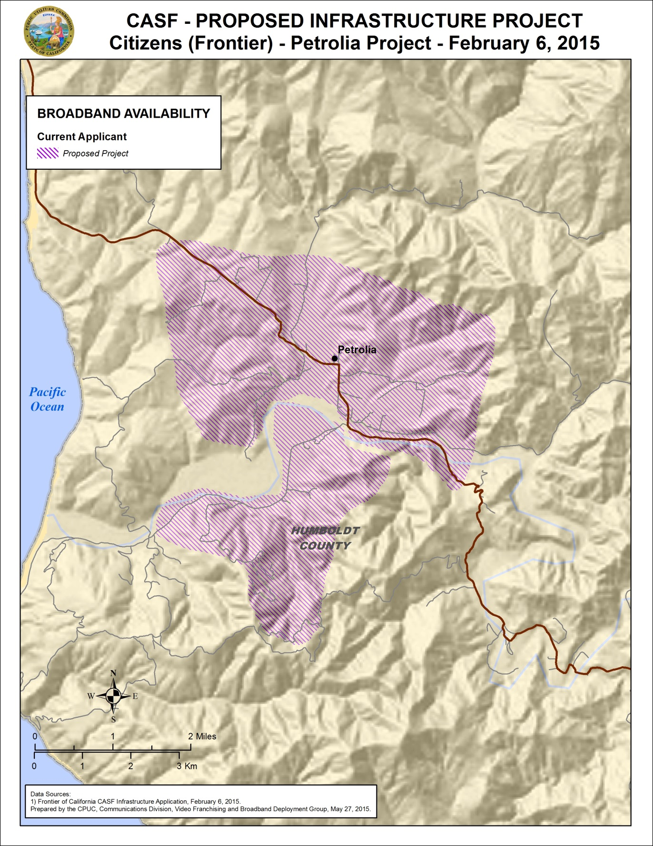

Appendix D
Resolution T-17484 Citizens (Frontier) Petrolia Project
Existing wireline service level
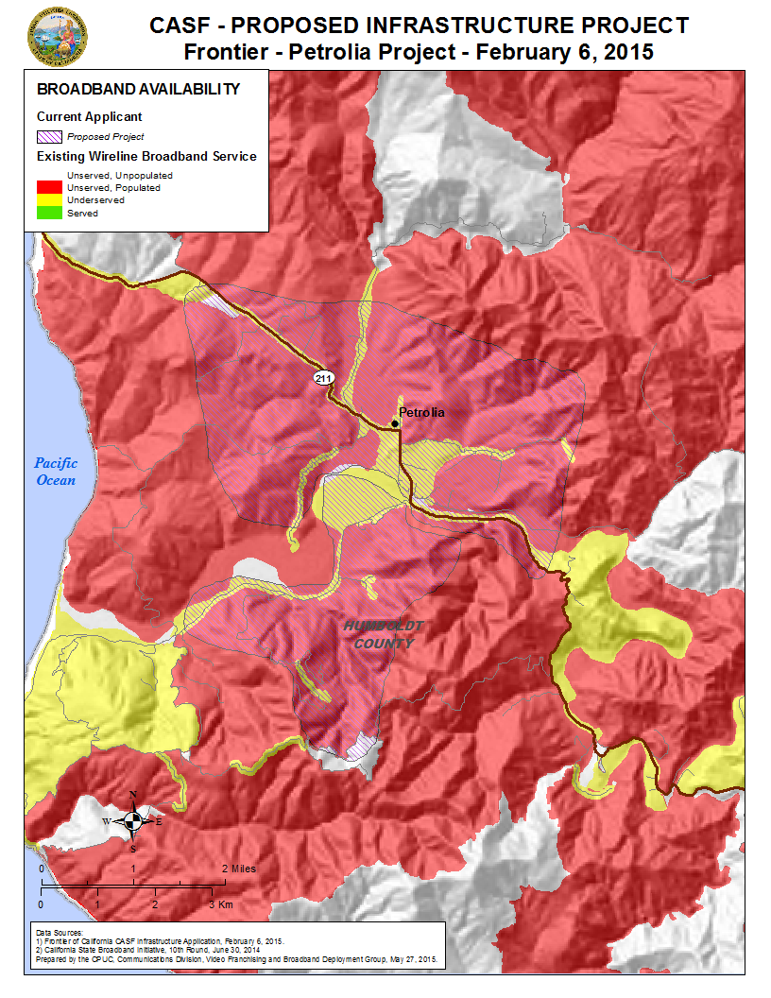

Priority Areas for CASF funding were established by regional stakeholders to identify communities with a high priority need of broadband infrastructure. For more information, see Resolution T-17443, adopted June 26, 2014, p. 10-14 and Appendix 4.
Stats. 2010, c. 317, codified at Public Utilities (P.U.) Code § 281
P.U. Code § 281(b)(1).
In addition to Resolution T-17443, the Commission issued D.14-02-018 to implement provisions in Senate Bill 740 (Padilla, Stats 2013, Chapter 522), which amended P.U. Code § 281 and expanded eligibility for CASF Infrastructure Grants/Loans to non-telephone corporations.
Established in 1935.
ADSL2+ bonding and VDSL
In this case, the latest version of the California Interactive Broadband Availability Map, with data current as of June 30, 2014, was consulted.
This determination was based on the limited speed capabilities of satellite services, the cost to the consumer, high latency, and unreliability known at the time of the decision, D.12-02-015 at 13-15. Since that time, like other technologies, satellite services have improved.
The median household income by census block group 060230112003 (in which Petrolia is located) is $47,500.
According to American Fact Finder, the poverty rate was determined for 83% of the total population.
Enrollment information from the California Department of Education, Year 2014-15
The CASF per-household subsidy for the Petrolia project is 146 percent of the median per-household subsidy for all approved CASF projects and 41 percent of the mean per-household subsidy.
Submitted by applicant
Information from New York Times, “Frontier Communications Corporation”, http://topics.nytimes.com/top/news/business/companies/citizens_communications_company/index.html, retrieved May 26, 2015
Information from Frontier Communications, “Financial Statements; Income Statement”, for year 2014, http://investor.frontier.com/financials-statements.cfm
Humboldt County government website, http://www.humboldtgov.org/739/Petrolia, retrieved May 26, 2015
Approval of the California Advanced Services Fund (CASF) Application Requirements and Scoring Criteria for Awarding CASF Funds (2008) Cal. P.U.C. Res. No. T-17143 at 4.

