PUBLIC UTILITIES COMMISSION OF THE STATE OF CALIFORNIA

Communications Division | RESOLUTION T-17480
Broadband, Policy and Analysis Branch | August 13 , 2015

R E S O L U T I O N

Resolution T- 17480 Approval of Funding for the Grant Application of Race Telecommunications Inc. (U-7060-C), from the California Advanced Services Fund (CASF) in the Amount of $2,239,991 for the Gigafy Backus Unserved Broadband Project.
____________________________________________________________

Summary

This Resolution approves funding in the amount of $2,239,991 from the California Advanced Services Fund (CASF) for the CASF grant application of Race Telecommunications Inc., (Race) for its Gigafy Backus Unserved Broadband Project (Gigafy Backus Project). The Gigafy Backus Project will extend high-speed internet service to 7.9 square miles covering Backus Road area of Mojave in Kern County, California. Further, this project provides safety benefits to the Backus Road community by providing additional communication facilities and voice service provided as a part of this project would meet safety standards, including battery backup, E911 data and access to local PSAPs.

Background

On December 20, 2007, the California Public Utilities Commission (Commission) in Decision (D.) 07-12-054 established the CASF program as a two-year program to provide funds for the deployment of broadband infrastructure in unserved and underserved areas in California.

On September 25, 2010, Governor Schwarzenegger signed Senate Bill (SB) 1040 which codified the CASF program and expanded it to include three accounts: (1) the Infrastructure Grant Account, (2) the Consortia Grant Account, and (3) the Revolving Loan Account. The latter two accounts are intended to address the needs that were unmet under the original CASF program. Specifically, the purpose of the Revolving Loan Account is “to finance capital costs of broadband facilities not funded by a grant from the Broadband Infrastructure Grant Account.” SB 1040 also expanded the CASF fund from $100 million to $225 million with the addition of $100 million to the Infrastructure Grant Account, and allocation of $10 million and $15 million to the Consortia Grant Account and the Revolving Loan Account, respectively.

On February 1, 2012, the Commission approved D.12-02-015 to implement new guidelines for the Infrastructure Grant and Revolving Loan Accounts. Key provisions of the Decision include:
- A maximum CASF grant award of 70 percent of project costs for unserved areas and 60 percent for underserved areas; and,
- A definition of an underserved area, “where broadband is available, but no wireline or wireless facilities-based provider offers service at advertised speeds of at least 6 megabits per second (Mbps) downstream and 1.5 Mbps upstream (6 Mbps /1.5 Mbps).”
Subsequently, on June 26, 2014, the Commission approved Resolution T-17443, which (relevant to this resolution) opened the CASF Broadband Infrastructure Grant Account to new applications as of December 1, 2014, and offered existing providers a “right of first refusal” to upgrade service in unserved and underserved areas.

On December 29, 2014, Race, a California Local Exchange Carrier (CLEC), submitted an application for CASF funding in the unserved area of Backus road of Mojave, in Kern County, California. No existing provider made a commitment to upgrade service before the Nov. 1, 2014, “first refusal deadline and the Kern area has been determined by CD staff to be “underserved.” Therefore, CD determined the Kern area eligible for new applications.

Notice/Protests

On January 5, 2015, Communications Division (CD) staff posted the proposed area project map, census block groups (CBGs) and zip codes lists by county for the Gigafy Backus Project on the Commission’s CASF website page under “CASF Application Project Summaries” and also sent notice regarding the project to its electronic service list. CD received no challenges to the proposed project area.

Discussion

This Resolution adopts CD’s recommended CASF funding award of $2,239,991 for the Gigafy Backus Project. This grant amount includes $352,888 for Contribution In Aid of Construction (CIAC), and $1,887,103 which represents 70% of the total project cost of $2,695,862 not including CIAC. Key project information and maps are shown on pages A-1 through A-6 of Appendix A.

Project Overview

Race has a Certificate of Public Convenience and Necessity (CPCN) (U-7060-C) and has been a fiber-based CLEC provider of next generation Voice Over Internet Protocol (VoIP)/Digital telephone, video, Internet Protocol television (IPTV) as well as traditional cable/satellite television for the past 12 years.

The proposed Gigafy Backus Project area is in the Mojave area of Kern County, an area that currently does not have access to wireline broadband service at served speeds. At best, wireline availability is limited to AT&T, a DSL service at a maximum advertised speed of 768 kbps to 1.5 mbps down and 200 to 700 kbps up in a small portion of the project area. (See Appendix A-3) When completed, the project will provide broadband access to households at speeds of 1 Gigabits per second (Gbps) download and 1 Gbps upload.

The Gigafy Backus Project extends high-speed internet service over a 7.9 square mile area by deploying fiber-to-the-premises (FTTP) Last Mile network into this area of Kern County. This expansion will bring high speed internet access to 253 households in the Backus Road area of Mojave, in Kern County. The CBGs impacted by the project are: 060290055062 and 060290065003 with median income of $30,625 and $40,536 respectively.

Race’s CASF grant amount includes $352,888 for CIAC, which is intended to fund any federal and/or state income taxes that may apply on the CASF grant award. The applicant will not receive the CIAC if the CASF grant is not taxed.

Race’s current infrastructure in California consists of an end‐to‐end fiber optic network from the internet source at One Wilshire in Los Angeles to the end‐user premises. Race currently has broadband infrastructure within five miles of the proposed service area. The Race network provides access to any last mile provider who can comply with IEEE 802.3 Ethernet, IEEE 802.3u fast Ethernet, or IEEE 802.3z Gigabit Ethernet as well as dark fiber services on a non‐discriminatory basis. Race does currently provide voice services that meet all FCC E-911 service and battery requirements.

Race will build the all new fiber network by deploying a complete fiber-to-the-premise (FTTP) network to 253 homes in the Backus Road area of Mojave, Kern County, California. The proposed Race fiber optic network is designed using 100-Gigabit backbone infrastructure that enables Race to offer IP-based products and services to residential and enterprise customers. Race intends to make use of their Mojave Airport Central Office facilities to connect to the Backus area. (See Appendix A-3, existing infrastructure) Race will also use the current long haul path from Zayo that runs on the backside of the service area. The use of fiber optics as the standard transmission medium allows Race to have a future-proof product offering that accommodates the pace of new technology and innovation by simply upgrading the electronic equipment installed on each end. An FTTP network will dramatically expand the reach of broadband in the region and improve existing communication capabilities.

Race has committed to a two-year broadband pricing plan starting from the initial date of service under the following terms:

Monthly Recurring Rates
Residential
Entry Level Speed 25 Mbps Down and 25 Mbps Up | $25
Mid-Level Speed 100 Mbps Down and 100 Mbps Up | $65
Other Optional Tier Speed 250 Mbps Down and 250 Mbps Up | $85
Max Level Speed 1 Gbps Down and 1 Gbps Up | $100

Business
Entry Level Speed 25 Mbps Down and 25 Mbps Up | $60
Max Level Speed 1 Gbps Down and 1 Gbps Up | $200

Setup Fees $0
Wireless Router Optional $10.00 per month

Race’s proposed pricing for residential broadband service in the proposed project area is affordable compared to most other provider offerings and is lower than its own current metropolitan area rates. According to Race, the pricing for business broadband service is more expensive than residential broadband service to account for a greater level of customer service support to businesses. An account executive is assigned to assist in identifying the needs of business customer. The account executive’s responsibility is to take as much time as required to supply the correct service form, provide the solution, and provide customer service at all times. Business customers may call the 24/7 customer service line to report issues or outages and the customer service group will take care of the problem. Business customers are flagged differently from residential customers in the system based on Service Level Agreement and issues may be escalated so technicians may be dispatched immediately to resolve issues. These service rates are very close to previous rates for the last four Race’s Projects that the Commission awarded in 2013 and 2014.

Project Qualification

To qualify under the CASF program, the applicant is required to submit proof that the area is unserved or underserved by submitting shapefiles of the proposed project. CD reviews the submitted shapefiles by comparing them with United States 2010 Census data and the California Broadband Availability Map, which at the time of this review contains broadband availability data as of June 30, 2014. Once CD determines that the area is eligible either as an unserved or underserved area, CD staff evaluates all other information submitted by the applicant to determine if the project meets the requirements as outlined in D.12-02-015. Other information CD review includes: proof of a CPCN from the Commission; descriptions of current and proposed broadband infrastructure; number of potential subscriber households and average incomes; project construction schedule; project budget; proposed pricing and commitment period for new subscribers; and financial viability of the applicant. CD additionally evaluates speed tests data provided by applicant and any filed challenge data provided by other providers in the area. CD staff also considers letters of support from anchor institutions, first responder agencies and communities.

As an initial step in the review of Race’s application, CD checked the CBGs as submitted in the project application to determine eligibility. While the Commission’s broadband availability map indicates that the project areas are not served by wireline facilities at served speeds (See Appendix A-4), it does indicate that the majority of the project and surrounding areas are “served” by mobile providers; Verizon Wireless and AT&T Mobility. (See Appendix A-3) Subsequently, CD required tests be conducted in the project area by Race. Tests were conducted for Verizon Wireless on March 5, 2015, and for AT&T Mobility on May 6, 2015. These test results showed the project is actually unserved by mobile despite that indicated on the published availability map. (See Appendix A-5 and A-6.)

Race filed its application with the knowledge of the broadband availability map indicating mobile served speeds. It argues that despite the map, mobile service does not meet the needs of the community and it disputed the likelihood of quality mobile availability at served speeds. CD staff concludes that the communities in the application are unserved at this time and eligible for CASF funding.

Project Evaluation and Recommendation for Funding

CD evaluated the application with respect to the scoring criteria defined in D.12-02-015, Appendix 1, Section VIII (Scoring Criteria). The Scoring Criteria includes: (i) Funds Requested per Potential Customer; (ii) Speed; (iii) Financial Viability; (iv) Pricing; (v) Total Number of Households in the Proposed Area; (vi) Timeliness of Completion of Project; (vii) Guaranteed Pricing Period; and (viii) Low-Income Areas. In addition, five bonus points are added to the score of an applicant that is able to submit local government and community endorsements or letters of support.

Race has received a letter of support for the Gigafy Backus project from the Board of Supervisors of Mono County. Its support letter stated strong support for all of Race’s applications including the Gigafy Backus project. The letter states that “students in rural communities rely on internet to receive access to equal educational opportunities. In addition, many rural residents are patients who need access to quality broadband for healthcare. With the bandwidth caps and cost restrictions of mobile broadband, it isn’t a practical solution for these applications…” The letter also indicates that a recent wildfire event caused the loss of Verizon Wireless service, which caused three days of communication collapse for the communities in Mono County. However, the network and internet service that were on Digital 395 remained functional and first responders were able to use the network for relief communication. The letter states that “having redundant and independent methods of delivering broadband services to our communities is vital for situations like these.”

Staff recommends this project for funding based on how it ranks as compared with previously funded CASF projects with regard to financial viability and low prices for the high speed of the service. Race is ranked well financially compared to other applicants and since CASF funds are awarded on a reimbursement basis and race will be funding 30% of the project costs from its existing capital up front, CD determines there is little risk of the applicant not completing the project. Staff also recommends this project, because it benefits this low-income area with median income of $30,625 and $40,536 for the two BCGs it covers. Race is offering maximum advertised speeds of 1 Gigabits per second (Gbps) download and 1 Gbps upload, which is the highest service speed compared to other applicants. The project also may serve anchor institutions nearby that may benefit from the deployment of high-speed Internet access in the area. The fiber network will connect the project area to anchor institutions outside the project area and will give them access to broadband services. The project will take a reasonably short time to complete (20 months rather than the 24 month standard time).

CD found that the Gigafy Backus Project meets CASF funding requirements with respect to the following factors:
- Speed – the proposed minimum speed offering of 25 mbps up to 1 Gbps download and 25 mbps up to 1 Gbps upload complies with the benchmark set by the Commission;
- Service Area - is determined to be unserved and covers 7.9 square miles;
- Matching Funds (30% of project cost) – the applicant has certified that the matching funds will come from their capital budget; the submitted balance sheet, income and cash flow statements show that the applicant is financially viable and has the financial capability to match the funds;
- Price Commitment Period - the applicant has committed to a pricing plan of two years as required;
- Deployment Schedule – the project will be completed within 20 months construction timeline, which is within the 24 month period construction timeline requirement.

These findings, when combined with the lack of challenges to the project (particularly from mobile providers), led staff to recommend that the area be considered unserved by mobile broadband.

Based on its review, CD determined that Race’s grant application qualifies for funding as an unserved area and meets the requirements of D.12-02-015. CD recommends Commission approval of CASF funding for Race’s Gigafy Backus Project.

CD staff finds that funding the Race’s Gigafy Backus Project aligns with CASF’s goal to encourage the deployment of high-quality advanced information and communications technologies to all Californians to promote economic growth, job creation, and substantial social benefits.

Safety Impact

The culmination of this project will improve connectivity to the surrounding areas and to a number of anchor institutions outside of the project area. The fiber will connect the project area to the City of Mojave’s Fire Department, and CHP and Sheriff Offices that are located 12.4 miles away. The City of Rosamond also has a fire department and the fiber will make it possible to connect this area to the closest communications hub allowing for reliable connectivity compared to the current low speed service that is currently available.

As described previously, the Gigafy Backus letter of support from the Board of Supervisors of Mono County indicated that a recent wildfire event caused loss of Verizon Wireless service, leading to a three-day communication collapse for the communities in Mono County. However, the Digital 395 network and internet service remained functional and first responders were able to use the network for relief communication. Thus, redundant communication services are of vital importance for safety, and high speed Internet connections facilitate the transmission of data and communications amongst first responders and to the public. The anchor institutions in the adjacent area, such as the CHP, sheriff’s office and fire department will potentially benefit from the broadband project. Additionally, voice service provided as a part of this project would meet safety standards, including battery backup, e911 data and access to local PSAPs.

The CASF program encourages the deployment of broadband throughout the State which can enable the public to access Internet-based safety applications, access to emergency services, and allow first responders to communicate with each other and collaborate during emergencies. As the Governor’s Broadband Task Force stated in its 2007 report, ubiquitous broadband will play a key role in enhancing public safety operations and applications in law enforcement, disaster relief, traffic management, and virtually every other aspect of public safety. Telephone and broadband allows access to these facilities and providers and can be a critical factor in health and safety emergencies.

Compliance Requirements

Race should comply with all the guidelines, requirements, and conditions associated with the granting of CASF funds as specified in D.12-02-015. Such compliance includes, but is not limited to:

- California Environmental Quality Act (CEQA)

All CASF grants are subject to CEQA requirements unless the project is statutorily or categorically exempt pursuant to the CEQA Guidelines.

Race has provided the Commission with construction plans for the Gigafy Backus Project. In order to deliver last mile service to households in the area, Race intends to make use of facilities available at the Mojave Airport CO to connect to Backus Road area. Race will also use the current long haul path from Zayo that runs on the backside of the service area.
Race proposes to conduct all work in already disturbed land avoiding cultural resources during project implementation and to focus network design around utilizing existing rights of way, above ground and aerial construction, dark fiber leasing where available, and utilizing easements to lessen the environmental impact. The Gigafy Backus project is a last mile project intended to bring fiber to the homes in already disturbed areas using a proven aerial design. This aerial design is based on using existing utility poles in existing roadways and will comply with the pole loading requirements of General Order 95. Utilizing K&B Engineering, an engineering firm, Race has stated that it will apply and exercise the process to determine whether pole loading requirements pass or fail. All fiber will be placed in the appropriate space on the existing utility pole in compliance with the pole owner specifications.

Based on the above information, the project qualifies for the following categorical exemptions from CEQA: CEQA Guidelines Section 15301 – Existing Facilities, involving minor alterations to existing utility facilities, and CEQA Guidelines Section 15304 – Minor Alterations to Land, involving minor trenching and backfilling where the surface is restored.

- Deployment Schedule

The Commission expects Race to complete the project in 20 months from the start date. If the applicant is unable to complete the proposed project within the 20-month timeframe identified in its application, Race must notify CD's Director as soon as it becomes aware of this prospect. The Commission may reduce payment for failure to notify CD's Director and timely complete the project. In D.12-02-015, the Commission required complete build-out of a CASF-funded project within 24 months from approval of the application.

- Execution and Performance

CD staff and the CASF grant recipient shall determine a project start date after the CASF grant recipient has obtained all approvals. Should the recipient or contractor fail to commence work at the agreed upon time, the Commission, upon five days written notice to the CASF recipient, reserves the right to terminate the award.

In the event that the CASF recipient fails to complete the project, in accordance with the terms of approval granted by the Commission, the CASF recipient must reimburse some or all of the CASF funds that it has received.

The CASF grant recipient must complete all performance under the award on or before the termination date of the award.

- Performance Bond

The Commission does not require a Performance Bond if the applicant certifies that the percentage of the total project costs it is providing comes from their capital budget and is not obtained from outside financing. In its application, Race certified that the percentage of the total project costs it is providing will come from its existing capital budget. Therefore, a performance bond is not required for this project.

- Price Commitment Period

The minimum required price commitment period for broadband service to all households within the project area is two years. Race guarantees the price of service offered in the project area for two years.

- Project Audit

The Commission has the right to conduct any necessary audit, verification, and discovery during project implementation and construction to ensure that CASF funds are spent in accordance with Commission approval.

The recipient’s invoices will be subject to a financial audit by the Commission at any time within three years of completion of the work.

- Providing Voice Service

If the grantee is providing voice service in the project area, it must meet the Federal Communications Commission (FCC) standards for E-911 service and utilize battery backup Power.

- Reporting

Grantees must submit quarterly progress reports on the status of the project irrespective of whether grantees request reimbursement or payment. Before full payment of the project, the CASF recipient must submit a project completion report. Progress reports shall use both the schedule for deployment; major construction milestones and costs submitted in the proposals, indicate the actual date of completion of each task/milestone as well as problems and issues encountered, and the actions taken to resolve these problems and issues during project implementation and construction; and identify future risks to the project. Recipients shall also include test results on the download speed and upload speed on a per CBG and per ZIP Code basis in the final completion report. Recipients must certify that each progress report is true and correct under penalty of perjury.

- Submission of Form 477

The FCC currently requires broadband providers to submit Form 477 biannually and include speed data. While there is an imperfect match between the current reporting areas for the Form 477 and CASF, Form 477 information will be useful in documenting CASF deployment for the specific new service area(s) of the carrier. CASF recipients shall submit a copy of their Form 477 data directly to the Commission, under General Order 66-C, when they submit this data to the FCC for a five year period after completion of the project.

Payments to CASF Recipients

Submission of invoices from and payments to Race shall be made in accordance with Section XI of Appendix 1 of D.12-02-015 and according to the guidelines and supporting documentation required in that decision.

Payment to Race shall essentially follow the process adopted for funds created under P. U. Code § 270. The following table describes the timeline for processing CASF payments.

Event | Payment Cycle 1  (Day/Month) | Payment Cycle 2  (Day/Month)
Invoices due from Race to CD | 5th of Month 1 | 20th of Month 1
Payment letters from CD to Administrative Services | On 19th of Month 1 | On 4th of Month 2
Invoices submitted from Administrative Services to State Controller’s Office (SCO) for payments | 20th through 26th of Month 1 | 5th through 13th of Month 2

Race may submit its invoices under Payment Cycle 1 or 2.

If any date in this payment schedule falls on a weekend or holiday, that date will be advanced to the next business day but the remaining dates in the payment schedule will remain unchanged. The State Controller’s Office (SCO) requires 14 to 21 days to issue payment from the day that requests are received by SCO.

Comments on Draft Resolution

In compliance with P.U. Code § 311(g), a notice letter was emailed on July 8, 2015, informing all applicants filing for CASF funding and parties on the service list of R.06-06-028, and the CASF distribution list of the availability of the draft of this Resolution for public comments at the Commission's website: http://www.cpuc.ca.gov/PUC/documents. This letter also informed parties that the final conformed Resolution adopted by the Commission will be posted and will be available at this same website. CD did not receive any comments or reply comments on this resolution.

Findings

- On June 26, 2014, the Commission approved Resolution T-17443, which implemented new timelines for applications to the CASF Broadband Infrastructure Grant Account and offered existing providers a “right of first refusal” to upgrade service in unserved and underserved areas. The window for new applications opened on December 1, 2014.

- Race filed an application for CASF funding for its Gigafy Backus Project on December 29, 2014. The Gigafy Backus Project is intended to extend high-speed internet service over a 7.9 square mile area through the expansion of fiber-to-the-premises (FTTP) Last Mile network deployment into the remote area of Race rural exchanges. This expansion will bring high speed internet access to 253 households in the covering Backus Road, Mojave in Kern County. The CBGs impacted by the project are: 60290055062 and 60290065003.

- CD posted the map, CBGs and zip codes lists by county for the Gigafy Backus Project on the Commission’s CASF website page under “Pending New CASF Applications to Offer Broadband as of January 5, 2015.” Communications Division did not receive any challenges.

- CD reviewed and analyzed data submitted for the Race Gigafy Backus Project CASF grant application to determine the project’s eligibility for CASF funding. This data includes, but is not limited to: proof of a CPCN from the Commission; descriptions of current and proposed broadband infrastructure; geographic information system (GIS) formatted shapefiles mapping the subject areas; assertion that the area is unserved; number of potential subscriber households and average incomes; project construction schedule; project budget; proposed pricing and commitment period for new subscribers; and financial viability of the applicant.

- CD reviewed the submitted shapefiles which mapped the proposed broadband deployment using United States 2010, Census data and the California Broadband Availability Map, which contains broadband availability data as of June 30, 2014. The map indicated mobile availability at served speeds. CD staff asked Race to perform mobile tests to validated Verizon Wireless’ and AT&T Mobility’s advertised speed in the project area and the tests showed the area is not served. CD staff considers the area as unserved.

- Based on its review, CD determined that the project qualifies for funding under D.12-02-015 and recommends Commission approval of CASF funding for Race Gigafy Backus Project.

- Race is not required to post a performance bond because 30% of the total project cost will be financed through Race’s existing capital budget.

- Race is required to comply with all guidelines, requirements, and conditions associated with the granting of CASF funds as specified in D.12-02-015 and must submit the FCC Form 477, as specified in Resolution T-17143.

- Race proposes to conduct all work in already disturbed land, active right of ways and on and in existing infrastructures with no forest, agricultural land or landmarks disturbed. Race will carry out avoidance measures to avoid cultural resources by either rerouting planned trenching or delivering the fiber aerially instead of trenching.

- This project is categorically exempt from CEQA review pursuant to CEQA Guidelines Sections 15301 –Existing Facilities and 15304 – Minor Alterations to Land.

- Race included funds for Contribution in Aid of Construction (CIAC) in its CASF grant request to pay for federal and/or state income taxes that may apply on the CASF grant award. The applicant will not receive the CIAC, if the CASF grant is not taxed.

- A notice letter was emailed on July 8, 2015, informing all applicants filing for CASF funding, parties on the service list of R.06-06-028, and the CASF distribution list of the availability of the draft of this Resolution for public comments at the Commission's website http://www.cpuc.ca.gov/PUC/documents. This letter also informed parties that the final conformed Resolution adopted by the Commission will be posted and available at this same website. CD did not receive any comments or reply comments on this resolution.

- The Commission finds CD’s recommendation to fund the Gigafy Backus Project of Race as summarized in Appendix A to be reasonable and consistent with Commission orders and, therefore, adopts such recommendation.

THEREFORE, IT IS ORDERED that:

- The Commission shall award from the CASF to Race up to $2,239,991 for the Race Gigafy Backus unserved area broadband project as described herein and summarized in Appendix A of this Resolution.

- The program fund payment of up to $2,239,991 for this unserved project shall be paid out of the CASF fund in accordance with the guidelines adopted in D.12-02-015 and in accordance with the compliance of avoidance measures described in this Resolution. This total CASF grant amount will be reduced by up to $352,888 of Contribution in Aid to Construction if the CASF grant award is not subject to federal and/or state income taxes.

- Payments to the CASF recipient shall be in accordance with Section XI of Appendix 1 of D.12-02-015 and in accordance with the process defined in the “Payments to CASF Recipients” section of this Resolution.

- The CASF fund recipient, Race, shall comply with all guidelines, requirements and conditions associated with the CASF funds award as specified in D.12-02-015 and must submit the FCC Form 477, as specified in Resolution T-17143.

This Resolution is effective today.

I hereby certify that this Resolution was adopted by the Public Utilities Commission at its regular meeting on August 13, 2015. The following Commissioners approved it:

/s/ Timothy J. Sullivan

TIMOTHY J. SULLIVAN Executive Director

MICHAEL PICKER
President
MICHEL PETER FLORIO
CATHERINE J.K. SANDOVAL
CARLA J. PETERMAN
LIANE M. RANDOLPH
Commissioners

APPENDIX

APPENDIX A
Resolution T- 17480
Race Telecommunication, Inc., Gigafy Backus Project
Key Information

Project Name | Race Telecommunication, Inc., Gigafy Backus Project
Project Plan | To deploy fiber-to-the-premises (FTTP) Last Mile network to serve 100% of the homes in a defined service area that includes the Backus Road area of Mojave, California. Fiber based Internet speeds will offer packages up to 1 Gbps down and 1 Gbps up.
Project Size (in square miles) | 7.9
Download / upload speed (in Mbps) | 1Gbps/1Gbps
Location | Backus Road, Kern County
Community Name | Backus Road, Mojave
CBGs / Household Income | 60290055062 | $30,625
 | 60290055003 | $40,536
ZIP Codes | 93501
Estimated Potential Subscriber Size | 253 Household
Pricing Plan | Residential  Entry Level Speed 25 Mbps Down and 25 Mbps Up $25  Mid-Level Speed 100 Mbps Down and 100 Mbps Up $65  Other Optional Tier Speed 250 Mbps Down and 250 Mbps Up $85  Max Level Speed 1 Gbps Down and 1 Gbps Up $100  Business  Entry Level Speed 25 Mbps Down and 25 Mbps Up $60  Max Level Speed 1 Gbps Down and 1 Gbps Up $200
Deployment Schedule (from Commission approval date) | 20 months
Proposed Project Budget | $3,048,750
Amount of CASF Funds Requested (70% without CIAC) | $ 1,887,103
Internally funded (30%) | $808,758
CIAC (18.7% of CASF Funds Requested) | $352,888 (intended for federal and/or state income taxes that may apply on the CASF grant award; will not be disbursed if grant is not taxed)
Net Total Project Budget (includes CIAC) | $3,048,750
Total Amount of CASF Award (includes CIAC) | $2,239,991
APPENDIX A
Resolution T-17480
Race Telecommunications Inc., Gigafy Backus Project Regional Map
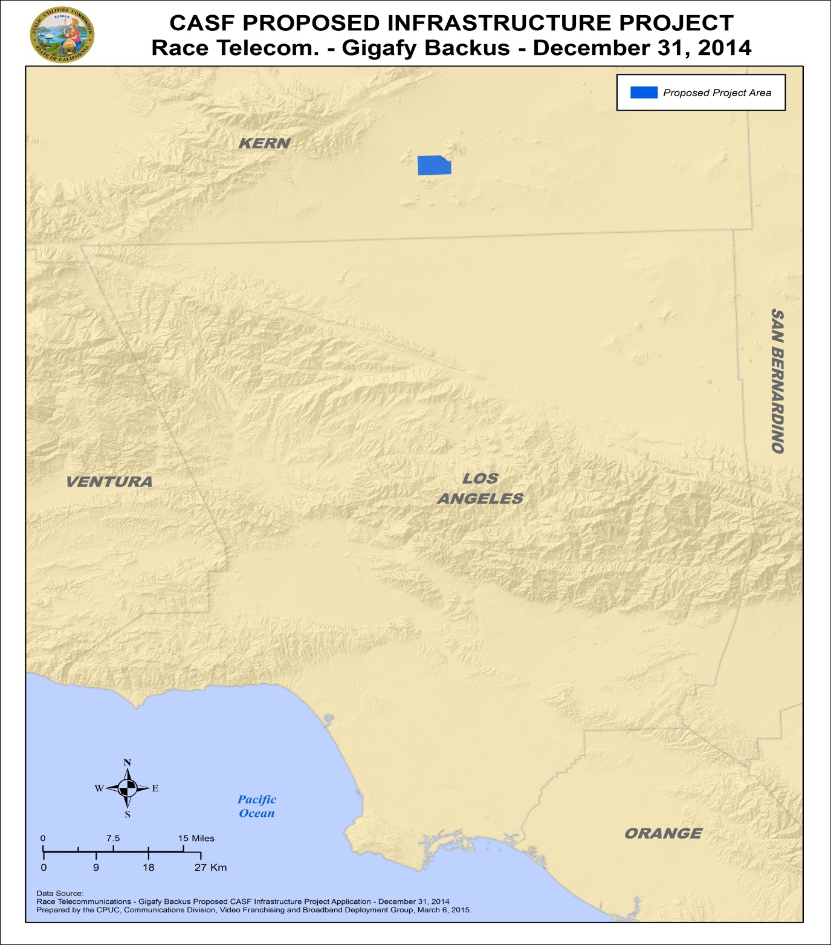
APPENDIX A
Resolution T- 17480
Race Telecommunications Inc., Gigafy Backus Project Shapefiles
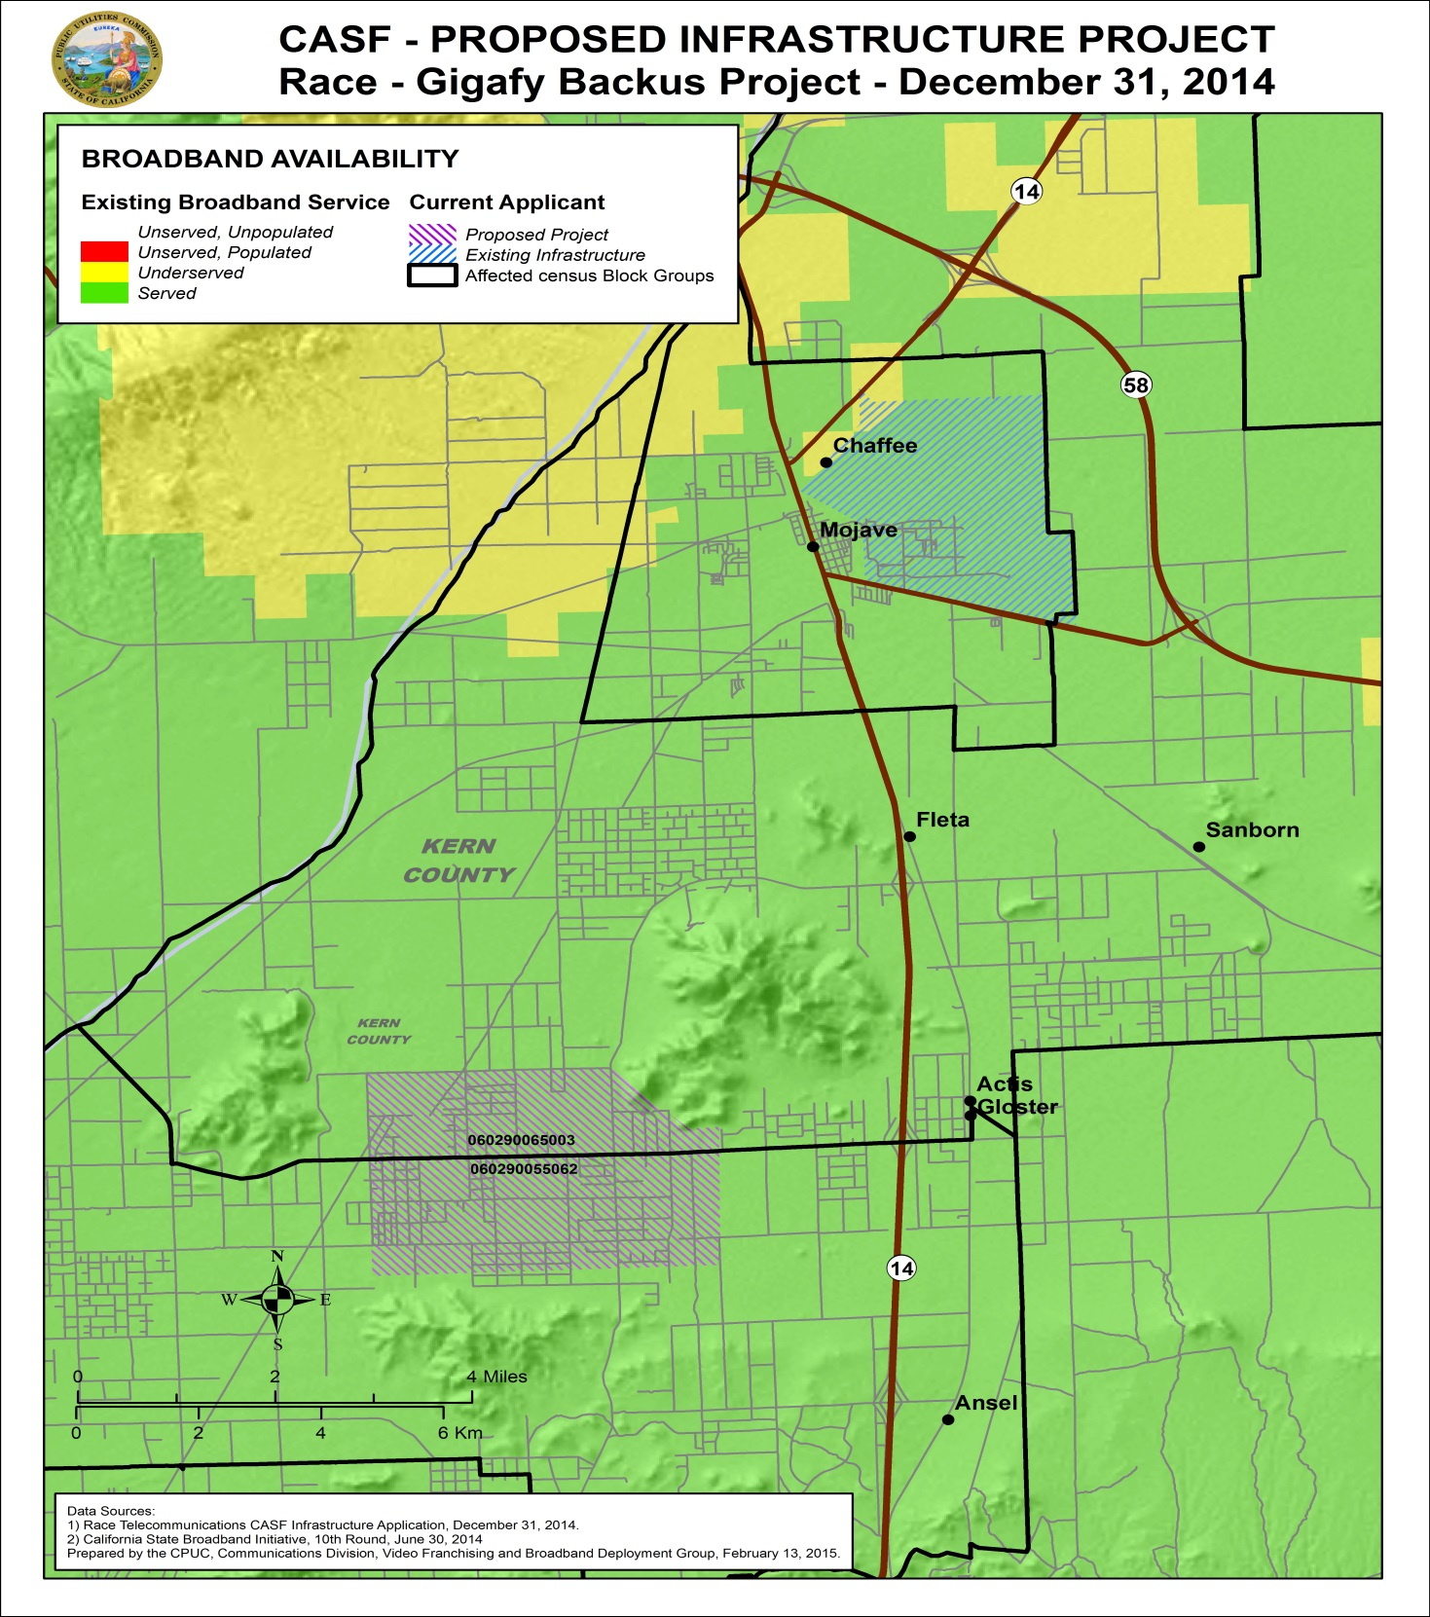
APPENDIX A
Resolution T- 17480
Race Telecommunications Inc., Gigafy Backus Project Shapefiles
Wireline Broadband Availability
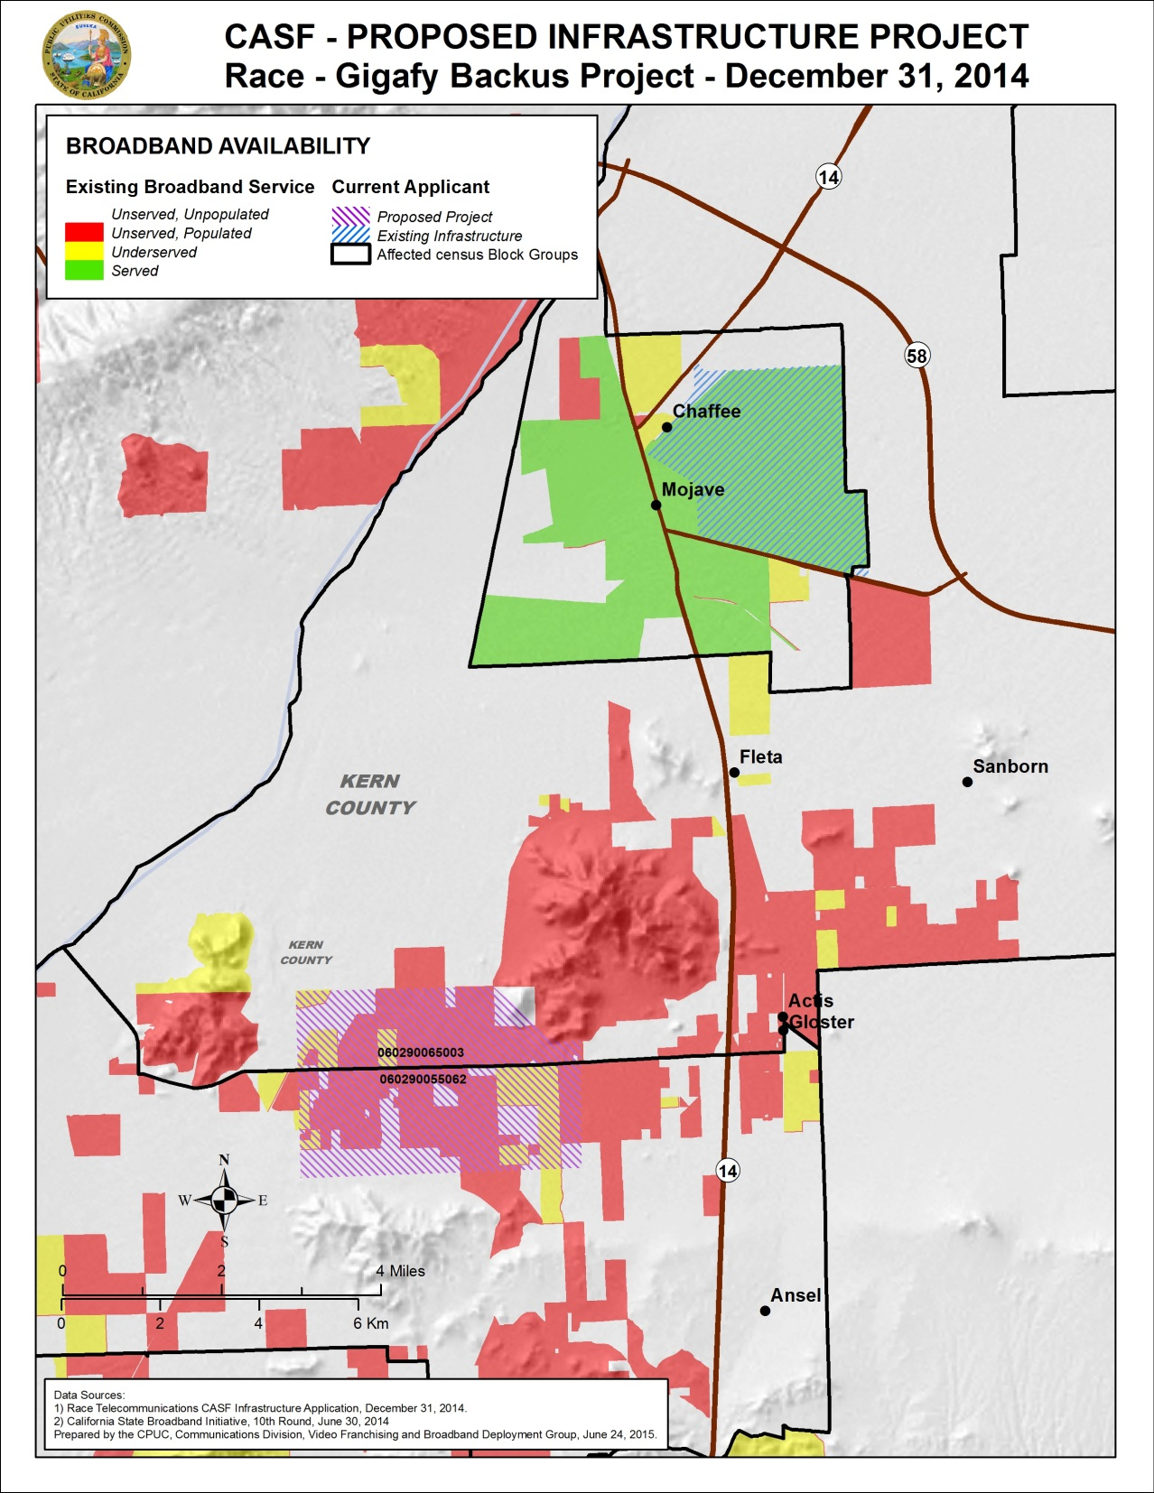

APPENDIX A
Resolution T- 17480
Race Telecommunications Inc., Gigafy Backus Project Shapefiles
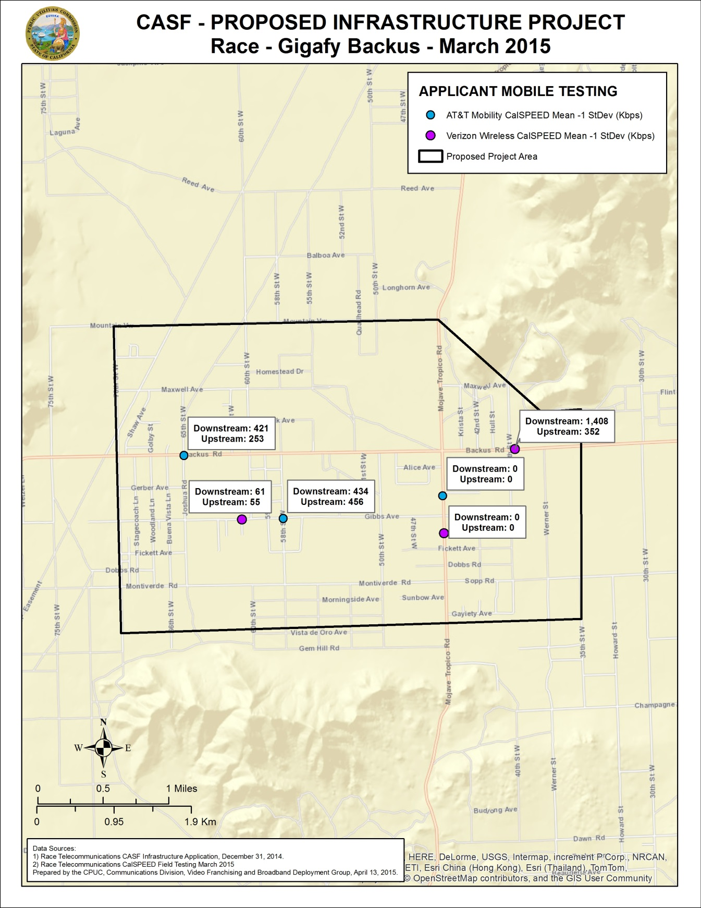
APPENDIX A
Resolution T- 17480
Race Telecommunications Inc., Gigafy Backus Project

Speed Test Summary for Gigafy Backus

Verizon Wireless (Kbps Down / Kbps Up)
CPUC Test Results* | Race Test Results** | No. of Tests | Test 1 | Test 2 | Test 3
Served | Unserved | 3 | 61 / 55 | 0 / 0 | 1,408 / 352

AT&T Mobility (Kbps Down / Kbps Up)
CPUC Test Results* | Race Test Results** | No. of Tests | Test 1 | Test 2 | Test 3
Served | Unserved | 3 | 421/258 | 0/0 | 434/468

*CPUC Field Test Results (Interpolated Fall 2014 Mean -1 LCD)
**Race Field Test Results (March 2015)

END OF APPENDIX A

Stats. 2010, c. 317, codified at Public Utilities (P.U.) Code § 281.
P.U. Code § 281(e).
P.U. Code § 281(b)(1).
From the Interactive California Broadband Availability Map. Information is from the Census data as of 6/30/2014 at: http://www.broadbandmap.ca.gov/map/.
Alternatively, applicants may submit a document asserting that they are seeking funding as a non-telephone corporation per Commission Decision 14-02-018, which implements the expanded CASF infrastructure funding eligibility provisions of Senate Bill 740.
Mobile availability depicted on the Commission’s broadband availability map is determined by the CalSPEED test project funded by the CASF program. The project contract utilizes teams to test at nearly 2,000 identified points around the state to measure mobile broadband service availability using smartphones and tablets. The data are interpolated and subject to quality verification measures before depicting availability throughout California on the map. More information is available at; http://www.cpuc.ca.gov/PUC/Telco/bb_drivetest.htm
CD also found broadband availability at served speeds by ViaSat satellite provider. However, as adopted in D.12-02-015, the Commission does not consider satellite broadband service in CASF project evaluation, unless the satellite project in an area was previously funded by the CASF.
Letter of support from Board of Supervisors of Mono County.
Ibid.
Approval of the California Advanced Services Fund (CASF) Application Requirements and Scoring Criteria for Awarding CASF Funds (2008) Cal. P.U.C. Res. No. T-17143 at 4.
The above schedule is contingent on the CASF recipient submitting clear, complete, and error-free invoices to CD. Additional time to process payments may be necessary if CD finds problems with the submitted invoices.

