PUBLIC UTILITIES COMMISSION OF THE STATE OF CALIFORNIA

Communications Division | RESOLUTION T-17503
Broadband, Policy and Analysis Branch | DATE December 17, 2015

R E S O L U T I O N

Resolution T-17503: Approval of funding for the grant application of Anza Electric Cooperative, Inc. from the California Advanced Services Fund (CASF) in the amount of $2,662,450 for the Connect Anza Project, located in a CASF “priority area.”
__________________________________________________________________

- Summary

This Resolution approves funding in the amount of $2,662,450 from the California Advanced Service Fund (CASF) in response to the grant application from Anza Electric Cooperative, Inc. (AEC) which proposes to install a fiber-to-the-premises (FTTP) system in the unincorporated communities of Anza, Aguanga, Lake Riverside Estates, and Reed Valley in Western Riverside County (Connect Anza Project). The Connect Anza Project will extend 50 Mbps and above broadband service to approximately 3,751 households spread over 213 square miles in the Anza Valley at a cost of $710 per household in CASF subsidies. The Anza Valley is located 13 miles south of Idyllwild, approximately 35 miles southwest of Palm Springs and 120 miles southeast of Los Angeles. The Connect Anza project will also provide substantial safety and health benefits including, but not limited to, resilient high capacity broadband infrastructure that will provide access to e-health services and voice service that will meet all safety standards, including E911.

Background

On December 20, 2007, the California Public Utilities Commission, in Decision (D.) 07-12-054, established the CASF program as a two-year program to provide funds for the deployment of broadband infrastructure in unserved and underserved areas in California.

On September 25, 2010, Governor Schwarzenegger signed Senate Bill (SB) 1040, which codified the CASF program and expanded it to include three accounts: (1) the Infra-structure Grant Account, (2) the Consortia Grant Account, and (3) the Revolving Loan Account. The latter two accounts are intended to address the needs that were unmet under the original CASF program. SB 1040 also expanded the CASF fund from $100 million to $225 million, adding $100 million to the Infrastructure Grant Account and allocating $10 million and $15 million to the Consortia Grant Account and the Revolving Loan Account, respectively.

On February 1, 2012, the Commission approved D.12-02-015 to implement new guidelines for the Infrastructure Grant and Revolving Loan Accounts. Key provisions of the decision include:

- A maximum CASF grant award of 70 percent of project costs for unserved areas and 60 percent for underserved areas; and,
- A definition of an underserved area, “where broadband is available, but no wireline or wireless facilities-based provider offers service at advertised speeds of at least 6 megabits per second (Mbps) downstream and 1.5 Mbps upstream (6 Mbps /1.5 Mbps).”

Subsequently, on June 26, 2014, the Commission approved Resolution T-17443, which (relevant to this resolution) opened the CASF Broadband Infrastructure Grant Account to new applications as of December 1, 2014, and offered existing providers a “right of first refusal” to upgrade service in unserved and underserved areas.

On July 16, 2015, AEC submitted an application for CASF funding to bring symmetrical 50 Mbps and above broadband service to the homes and businesses of the unincorporated communities of Anza, Aguanga, Lake Riverside Estates, and Reed Valley via a FTTP connection. No existing provider made a commitment to upgrade service before the November 1, 2014, “first refusal” deadline. Because of this, CD determined the proposed project area to be “underserved” and eligible for new applications.

On September 17, 2015, Anza modified their application. The initial application proposed to serve a 319 square mile area which includes the California State Route 74 ‘Pines to Palms’ state scenic highway. Given that a categorical CEQA exemption cannot be granted for above-ground fiber projects along scenic highways, Anza modified their application to exclude the Highway 74 corridor. This modification reduced the total project area to 213 square miles. The applicant estimates a 10 percent reduction in the number of households to be served (an estimated 375 households) given the 106 mile modification.

- Notice/Protests

On July 17, 2015, CD posted the proposed project area map, census block groups (CBGs) and zip codes for the Connect Anza Project on the Commission’s CASF webpage under “CASF Application Project Summaries” and also sent notice regarding the project to its electronic service list. CD did not receive any challenges to the proposed project.

- Discussion

This Resolution adopts CD’s recommended award of $2,662,450 in a CASF grant for the Connect Anza Project. This award represents 60 percent of the applicant’s estimated total project cost of $4,437,418. Key project information and maps are shown in Appendix A.

- Applicant and Project Overview

AEC currently owns and distributes electricity using over 700 miles of line in Southwest Riverside County covering the areas of Anza, Garner Valley, Pinyon, Alpine Village, Royal Carrizo and parts of Aguanga. AEC proposes to deploy a fiber optic network on its existing poles and rights of way and establish a network of sufficient capacity to establish high speed, quality Internet service for customers in AEC’s electrical service territory. Anza also proposes to serve approximately 170 transient residences (trailer homes) using a fixed wireless installation.

AEC requested a CASF grant of $2,662,450.81, which is 60 percent of the total project costs ($4,437,418.02), with matching AEC funding of $1,774,967. If this project is approved, the project will reach an estimated 3,751 households, with all customers capable of achieving speeds of at least 50 Mbps on both downloads and uploads which is above the Commission-defined “served” threshold of 6 Mbps download/1.5 Mbps upload.

The Connect Anza project will directly benefit the Cahuilla band of Indians whose reservation in within the project area. The reservation contains an estimated 70 households as well as the Cahuilla Creek Casino and tribal buildings.

- Project Qualification

To qualify for the CASF program, an applicant is required to submit proof that the area is unserved or underserved by submitting shapefiles of the proposed project. CD reviews the submitted shapefiles and compares them with United States 2010 Census data and the California Interactive Broadband Availability map. Once CD determines that the area is eligible either as an unserved or underserved area, CD evaluates all other information the applicant has submitted to determine if the project meets the requirements outlined in D.12-02-015. CD reviews other information including: descriptions of current and proposed broadband infrastructure; number of potential subscriber households and average income; project construction schedule; project budget; proposed pricing and commitment period for new subscribers; and financial viability of the applicant.

As an initial step in the review of AEC’s application, CD reviewed the CBGs submitted in the project application and determined that the project was indeed not served at adequate speeds via wireline or fixed wireless providers. With regard to mobile service, however, the California Interactive Broadband Availability Map indicates that 55% of the proposed project area may be served by Verizon and/or AT&T Mobility wireless service. The applicant disputed that the area is served by providing mobile field tests using the CalSPEED app.

The applicant provided 43 CalSPEED tests conducted on July 3, 2015 (see Appendix D for a list of speed test results). All of the test results showed unserved or underserved speeds within the project area. This finding, when combined with the fact that there were no challenges to the project, led staff to recommend that the area be considered underserved by mobile broadband.

- Project Evaluation and Recommendation for Funding

CD evaluated AEC’s application with respect to the scoring criteria defined in D.12-02-015, Appendix 1, Section VIII (Scoring Criteria). The scoring criteria includes: (i) Funds Requested per Potential Customer; (ii) Speed, (iii) Financial Viability; (iv) Pricing; (v) Total Number of Households in the Proposed Area; (vi) Timeliness of Completion of Project; (vii) Guaranteed Pricing Period; and (viii) Low-Income Areas. Five bonus points are also added to an applicant’s score if local government and community endorsements or letters of support are submitted. CD also conducted qualitative evaluation of the project area, existing infrastructure, and community needs.

The Community. The unincorporated communities of Anza, Aguanga, Lake Riverside Estates and Reed Valley are located in the high desert southwest of the San Jacinto Mountains. Anza Valley is located in the high desert southwest of the San Jacinto Mountains. Coachella Valley (which includes the city of Palm Springs) lies on the east side of the San Jacinto Mountains. Los Angeles is approximately 120 miles northwest and San Diego is approximately 75 miles to the southwest of the proposed project area. The project area is just north of the San Diego County border in southwestern Riverside County.

The communities within the project boundary have approximately 3,751 households with a total population of 9,701 (using 2010 US Census data). For the Census Designated Place (CDP) of Anza (population 3,040 as reported in the 2010 US Census), 8.3 percent of the population is 18 years of age or younger, 66 percent is between the ages of 18 and 62, and 26 percent is 62 years and above. The smaller CDP of Aguanga (population 1,128 per the 2010 Census) had an even higher percentage of the population 62 years and older (41 percent). The applicant noted that there is large number of retired people in the community. The Cahuilla Indian Reservation is within the project area.

Based on the information provided in AEC’s application, local economic activity is minimal and a large percentage of the working population commutes out of the area. Referring to the census data for Anza CDP, 65 percent of the working population’s commute time is 30 minutes or more, with the mean travel time to work at 41 minutes. The US 2010 Census reported the median household income (MHI) (per census block data) is $48,038 which is 79 percent of the state MHI average. However, the poverty rate for Anza CDP is reported at 11.5 percent which is below the state average (15.9 percent).

The Connect Anza project area includes two public schools; the Hamilton High School and the Hamilton Elementary School. According to the California Department of Education, total enrollment at Hamilton High School is 326 and at the Elementary School it is 445. The proposed project area also includes a small K-12 Christian school and a private religious university (Olivet University) whose current enrollment is 120 students and a projected enrollment of 2,000. There is also a public library, two fire stations and large California Department of Corrections and Rehabilitation Conservation (Fire) Camp (with a maximum capacity of 120 inmates).

The Connect Anza project will increase Internet capacity and enable local students to take advantage of open-sourced educational materials, thus helping the area bridge the digital divide. The local public schools already have a fiber connection through the CENIC network. However, the schools have expressed support for this project due to the opportunities provided to the students. A robust internet connection will allow students to utilize online teaching materials and techniques which they cannot currently access and use at home. Students and parents will be able to utilize online services to organize class assignments, check grades and communicate with teachers. Given the rural nature of the community and the substantial distances between schools and residences, reliable broadband access will allow students to learn at home without the need to travel to the school. Additionally free Internet access will be available at the local library and community hall.

Olivet University is a religious institution located in the project area. Olivet University has stated to the applicant that they will leverage the Anza project fiber network to enable online access and education at the university, a service that is not currently available.

CD has received 70 letters of support for the Connect Anza project. CD’s review of the letters of support revealed numerous complaints about the poor quality of Internet service in the area as well as the lack of broadband choices. Another theme portrayed in the letters of support for this CASF proposed project was AEC’s dependability for affordable and reliable energy utility service, including the community’s overarching confidence in AEC.

Further, the Inland Empire Regional Broadband Consortium recommended the communities of Anza and Aguanga as priority areas for CASF funding and fully supports the proposed project. They noted how vital this project is to the area’s long term viability given the needs and opportunities that this project will address related to telemedicine, education, economic development, fire and police communications as well as benefiting the Cahuilla Native American tribes. The project is also supported by elected officials at the local, state and federal level.

Pricing and Affordability. AEC has committed to a broadband pricing plan under the terms shown below, for four years starting from the beginning date of service. There is no long-term commitment required by the consumer.

Service Type | Broadband Speed  (in Mbps) | Monthly Charge: Standalone Broadband | Monthly Charge:  Bundled with Voice
Residential | 50 down / 50 up | $49.99 | $69.99
Small Business | 100 down / 50 up | $109.99 | $144.99
Commercial | 500 down / 500 up | $2,000.00 | $2,000.00
Activation and installation (all types): Waived
Modem charge: No monthly residential or business equipment fee.
Voice service includes unlimited calling in the United States and to Canada.

The applicant estimates that about 40 percent of households in the area would purchase AEC’s service because of the area’s underserved status. This take rate may actually be higher for a number of reasons. Given that AEC is the long-standing local utility for electrical service, area residents are familiar with the AEC. AEC is member-owned and the members voted to change the company’s by-laws for the purpose of providing this service. Given the large percentage of residents who commute out of the area, robust broadband access would provide an opportunity for telecommuting.

The Applicant. AEC is a not-for-profit business with six decades of experience providing affordable and reliable energy service. AEC owns and maintains over 10,000 poles and other structures necessary for the installation of the cable, as well as easements necessary to route the system through. AEC already has a 3-mile segment of fiber installed in the downtown Anza area that provides Internet service free of charge to the Anza Civic Improvement League, the Community Center Building and a fire station. Based on this information, CD determined that AEC has relevant experience and infrastructure for successfully installing and operating a high speed fiber optic network to the premises.

Financial Viability. AEC determined that the project is economically feasible with a CASF grant of $2,662,450, which is 60 percent of the total project costs, to match AEC’s investment of $1,774,967.

CD reviewed submitted balance sheet, income, cash flow statements and other financial viability variables for AEC and concluded that AEC has the existing capital resources for the 40 percent required matching funds to construct the Connect Anza project, as well as a sound financial framework for future operations. Therefore, staff determined that the risk that this project would encounter financial problems, such as the project not being completed or maintained over time, is minimal.

Key Characteristics. CD found that the Connect Anza Project meets CASF funding requirements with respect to the following factors:

- Speed – the proposed speed offering of 50 Mbps download and 50 Mbps upload (for residential customers) significantly exceeds the 6/1.5 benchmark set by the Commission;
- Service area – is determined to be underserved and covers 213 square miles;
- Matching Funds(40 percent of project cost) – the applicant will use existing capital; the submitted balance sheet, income and cash flow statements show that the applicant is financially viable and has the financial capability to match the funds;
- Price Commitment Period – the applicant has committed to a pricing plan of four years, which is two years more than required;
- Deployment Schedule – the applicant has submitted detailed planning documents, including a schedule with clear milestones to indicate that it will be completed within the required 24-month construction timeline;
- Number of Households – This project will potentially reach 3,751 households;
- Low Income – The median household income ($48,038) is 79 percent of the State’s median value.

This project is economical and provides a wide benefit. The CASF per-household subsidy is $710 per household (based on 3,751 households that will have access). This state subsidy, when compared to previous subsidies provided through the CASF program for fiber projects, is low. The number of households that Anza proposes to pass would be the fourth largest CASF last-mile project in terms of households served and the area served in terms of square miles would be the highest for all approved CASF last-mile projects.

Based on its review, CD determined that AEC’s grant application for the Connect Anza Project qualifies for funding as an underserved area and meets the requirements of D.12-02-015. CD staff further finds that funding the Connect Anza Project aligns with CASF’s goal to encourage the deployment of high-quality advanced information and communications technologies to all Californians to promote economic growth, job creation, and substantial social benefits.

- Safety Considerations

The CASF program encourages the deployment of broadband throughout the State which can enable the public to access important information in the event of an emergency, access to emergency services, and allow first responders to communicate with each other and collaborate during emergencies. As the Governor’s Broadband Task Force stated in its 2007 report, ubiquitous broadband will play a key role in enhancing public safety operations and applications in law enforcement, disaster relief, traffic management, and virtually every other aspect of public safety.

The census-designated communities of Anza and Aguanga and the communities of Lake Riverside Estates, and Reed Valley have no local medical clinics. The nearest facilities are located either in Hemet or Murrieta, both of which are 50-plus minutes by car on windy 2-lane roads. Telephone and broadband allows access to these facilities and providers and can be a critical factor in health and safety emergencies.
Additionally, voice service provided as a part of this project would meet all safety standards, including battery backup, E911 data and access to local PSAPs.

- Compliance Requirements

AEC is required to comply with all the guidelines, requirements, and conditions associated with the grant of CASF funds as specified in D.12-02-015. Such compliance includes, but is not limited to:

- California Environmental Quality Act (CEQA)

All CASF grants are subject to CEQA requirements. The Commission must complete environmental review before funding construction projects, unless the projects are statutorily or categorically exempt pursuant to the CEQA Guidelines.

AEC has provided the Commission with their plan to use existing infrastructure for the installation of a fiber-to-the-premises (FTTP) system in their service area. Existing electrical infrastructure (with over 700 miles of line and associated poles) provides power to area residents and businesses. AEC has been providing power to the area since 1955 and owns most of the existing towers, buildings, conduits, ducts, rights-of-way, trenches and other facilities (some poles are owned by Verizon who currently provides telephone service for the area). AEC will construct its fiber backbone using these existing facilities. AEC will likewise construct last mile segments in or on existing facilities, including replacement utility poles (when necessary to meet applicable engineering and safety standards). AEC anticipates that the only underground construction that may be required is for short utility extensions. In these limited instances, AEC may engage in relatively minor ground-disturbing activities primarily in existing, well-used rights-of-ways and utility easements in its electric service territory.

Based on the above information the project qualifies for the following categorical exemptions from CEQA: This project meets the criteria of the CEQA categorical exemption for existing facilities (CEQA Guidelines § 15301) and CEQA Guidelines Section § 15303 – New Construction or Conversion of Small Structures, involving construction, installation, and/or conversion of limited numbers of new and/or existing facilities/structures.

- Deployment Schedule

The Commission expects AEC to complete the project within 24 months from start date (as determined by the procedure below). If the applicant is unable to complete the proposed project within the 24 month timeframe requirement established by the Commission, it must notify the Director of CD as soon as AEC becomes aware of this possibility. If such notice is not provided, the Commission may reduce payment for failure to satisfy the requirement by timely notifying CD’s Director.

- Execution and Performance

CD and AEC shall determine a project start date after the CASF grant recipient has obtained all approvals. Should AEC or any Contractor it retains fail to commence work by the designated date, upon five days written notice to AEC, the Commission may terminate the grant. In the event that AEC fails to complete the project in accordance with the terms of CPUC approval as set forth in this resolution, AEC shall reimburse some or all of the CASF funds that it has received.

AEC must complete all construction covered by the grant on or before the termination date.

- Performance Bond

The Commission does not require a performance bond if the applicant is a CPCN/WIR holder and if the applicant certifies that the percentage of the total project costs it is providing comes from their capital budget and is not obtained from outside financing. In its application, AEC certified that the percentage of the total project costs will come from its existing capital budget.

On July 17, 2015, AEC also filed an application for a CPCN, which is currently pending before the Commission.

If the Commission grants the CPCN, a performance bond is not required for this project. However, in the event that the Commission does not award AEC a CPCN, AEC must provide evidence of an executed performance bond equal to the total amount payable under the CASF award at the time of the first payment request.

D. Price Commitment Period

The minimum required price commitment period for broadband service to all households within the project area is two years. AEC exceeds the minimum period and guarantees the price of service offered in the project area for four years.

E. Project Audit

The Commission has the right to conduct any necessary audit, verification, and discovery during project implementation/construction to ensure that CASF funds are spent in accordance with Commission approval.

The recipient’s invoices will be subject to a financial audit by the Commission at any time within three years of completion of the work.

F. Providing Voice Service

The proposed project will allow AEC to provide landline voice service via Voice over Internet Protocol (VoIP). AEC commits to adhere to all FCC requirements in regards to E911 service and must provide equipment with battery backup.

G. Reporting

All grantees must submit quarterly progress reports on the status of the project irrespective of whether grantees request reimbursement or payment. Before full payment of the project, AEC must submit a project completion report. Progress reports shall use the schedule for deployment, major construction milestones and costs submitted in the proposal; indicate the actual date of completion of each task/milestone as well as problems and issues encountered, and the actions taken to resolve these problems and issues during project implementation and construction; and identify future risks to the project.

Recipients shall also include test results on the download and upload speeds on a CBG and zip code basis in the final completion report. AEC must certify that each progress report is true and correct under penalty of perjury.

H. Submission of Form 477

The FCC currently requires broadband providers to biannually submit the Form 477, which includes speed data. While there is an imperfect match between the data that is reported in the Form 477 and to the CASF, the Form 477 data will be useful in documenting CASF deployment for the service providers new service. Pursuant to General Order 66-C, service providers in California must submit a copy of their Form 477 data directly to the CPUC concurrent with their submission of the same data to the FCC for a five-year period after completion of the project.

- Compliance Requirements

Submission of invoices from and payments to AEC shall be made at 25-percent completion intervals, in accordance with Section XI of Appendix 1 of D.12-02-015 and according to the guidelines and supporting documentation required in D.12-02-015.

Payment to AEC shall follow the process adopted for funds created under P. U. Code §270. Payments are generally processed by the Commission, including CD and Administrative Services review time, within 20-25 business days. The State Controller’s Office (SCO) requires an additional 14- 21 days to issue payment from the day that requests are received by SCO from Administrative Services.

Comments on Draft Resolution

In compliance with Public Utilities Code § 311(g), a notice letter was e-mailed on MMM DD, 2015, informing all parties on the CASF Distribution List of the availability of the draft of this resolution for public comments at the Commission's website at http://www.cpuc.ca.gov/PUC/documents/. This letter also informed parties that the final conformed Resolution adopted by the Commission will be posted and available at this same website.

On November 27, 2015, staff received one comment from a local Anza resident opposing the project. The resident stated that her location may not be serviced by the Connect Anza project in the near term because her location is located on the outskirts of the project area and not likely to be given access to the new infrastructure until the end of the project build-out. She expressed concern that in the interim, existing fixed wireless providers may abandon her area in the face of the new competition, leaving her without service until the Connect Anza project is near completion. The resident also commented on the Cooperative’s intentions and their eligibility.

On December 2, 2015, staff received reply comments from AEC stating that their intention is to improve the availability of service, not to drive out competitors. AEC further stated that they have offered bandwidth to the existing fixed wireless providers at a fair price, and that they have an aggressive build-out plan that exceeds Commission requirements.

AEC membership overwhelmingly voted in favor of changing the Cooperative’s Articles of Incorporation so that the Cooperative could provide fiber optic services. Given this show of support, and given the large number of support letters from both local individuals and local institutions, CD finds that the Connect Anza project is well-supported by the community and, therefore, continues to support the project as is.

- Findings

- AEC filed an application for CASF funding for its Connect Anza Project on July 16, 2015. The proposed project will improve speeds by installing a fiber-to-the-premise system capable of symmetrical 50 Mbps download/upload service to upwards of 3,751 households in the unincorporated communities of Anza, Aguanga, Lake Riverside Estates, and Reed Valley in Western Riverside County. This system would provide broadband Internet service to an area that is currently underserved. The CBGs impacted by the project are 060650444021, 060650444022, 060650444023, 060650444031, 060650444032 and 060650444033.

- CD posted the proposed project area map, CBGs and zip codes by county for the AEC Connect Anza Project on the Commission’s CASF webpage under “CASF Application Project Summaries” on July 17, 2015. CD received no challenges to this project.

- CD reviewed and analyzed data submitted for the AEC Connect Anza Project’s CASF grant application to determine the project’s eligibility for CASF funding. This data included, but was not limited to: descriptions of current and proposed broadband infrastructure; geographic information system (GIS) formatted shapefiles mapping the project areas; assertion that the area is underserved; number of potential subscriber households and average incomes; project construction schedule; project budget; proposed pricing and commitment period for new subscribers; and financial viability of the applicant.

- CD reviewed the submitted shapefiles, which mapped the proposed broadband deployment using United States 2010 Census data and the California Interactive Broadband Availability Maps, with availability data current as of June 30, 2014. These maps helped to verify the availability and speed of any broadband service, where available. The project area was determined to be underserved.

- Based on its review, CD determined that the project qualifies for funding under D. 12-02-015 and recommends Commission approval of CASF funding for AEC’s Connect Anza Project.

- AEC is required to comply with all guidelines, requirements, and conditions associated with the granting of CASF funds as specified in D.12-02-015 and must submit the FCC Form 477, as specified in T-17143.

- The Commission finds CD’s recommendation to fund AEC’s project, as summarized in Appendix A, to be reasonable and consistent with Commission orders and, therefore, adopts such recommendation.

- The Commission has determined that the project is categorically exempt from CEQA review, under Sections 15301, 15303 and 15304 of the CEQA Guidelines because the project involves minor modifications to existing structures and facilities and possibly a minor amount of trenching where the surface will be restored to existing conditions.

- AEC will be required to show evidence of a performance bond at time of first payment if its CPCN application is not been granted. If the CPCN is granted, AEC is not required to post a performance bond because 40% of the total project cost will be financed through AEC’s existing capital budget.

- A notice letter was e-mailed on November 13, 2015, informing all applicants filing for CASF funding, parties on the CASF distribution list of the availability of the draft of this Resolution for public comments at the Commission’s website http://www.cpuc.ca.gov/PUC/documents/. This letter also informed parties that the final confirmed Resolution adopted by the Commission will be posted and available at this same website.

- A single comment was received by a local resident opposing the project. AEC addressed the resident’s concerns in their reply comments. AEC has showed substantial public support for their proposal; therefore CD continues to support the proposal.

THEREFORE, IT IS ORDERED that:

  - The Commission shall award $2,662,450 to AEC for the Connect Anza Project as described herein and summarized in Appendix A of this Resolution.
  - The program fund payment of $2,662,450 for this project in underserved areas shall be paid out of the CASF Infrastructure Grant Account in accordance with the guidelines adopted in D.12-02-015, including compliance with CEQA.
  - Payments to the CASF recipient shall be in accordance with Section XI of Appendix 1 of D.12-02-015 and in accordance with the process defined in the “Payments to CASF Recipients” section of this Resolution.
  - The CASF fund recipient, AEC, shall comply with all guidelines, requirements and conditions associated with the CASF funds award as specified in D.12-02-015 and must submit the FCC Form 477 to the Commission, as specified in Resolution T-17143.

This Resolution is effective today.

I hereby certify that this Resolution was adopted by the Public Utilities Commission at its regular meeting on December 17, 2015. The following Commissioners approved it:

/s/ Timothy J. Sullivan

TIMOTHY J. SULLIVAN

Executive Director

MICHAEL PICKER
President
MICHEL PETER FLORIO
CATHERINE J.K. SANDOVAL
CARLA J. PETERMAN
LIANE M. RANDOLPH
Commissioners

APPENDIX
APPENDIX A
Resolution T-17503
Anza Electric Cooperative, Connect Anza Project
CASF Applicant Key Information
Project Name | AEC Connect Anza Project
Project Plan | Connect Anza will deploy a fiber optic cable on existing poles and rights of way and establish a network of sufficient capacity to establish high speed, quality Internet service for Anza Electric Cooperatives (AEC’s) existing service territory located wholly within western Riverside County.
Project Size (in square miles) | 213
Download/Upload speed | 50 Mbps / 50 Mbps
Location | Riverside County
Community Names | The unincorporated communities of Anza, Aguanga, Lake Riverside Estates, and Reed Valley
Census Block Groups | 060650444021, 060650444022, 060650444023, 060650444031, 060650444032, 060650444033
Weighted Median Household Income | $48,038
Zip Codes | 92536, 92539, 92544
Estimated potential subscriber size | 3,751 households
Applicant expectations | 1,500 households
Pricing Plan | Residential Monthly Charge:  Standalone: $ 49.99/mo  With Voice: $ 69.99/mo  Small Business Charge:  Standard: $109.99/mo  With Voice: Additional $35 per line  (no installation or modem fees)
Deployment Schedule  (from Commission approval date) | 24 months
Proposed Project Budget (Total) | $4,437,418.02
Amount of CASF funds requested (60 percent) | $2,662,450.81
Applicant funded (40 percent) | $1,774,967.21

Appendix B
Resolution T-17503 AEC Connect Anza
Project location map
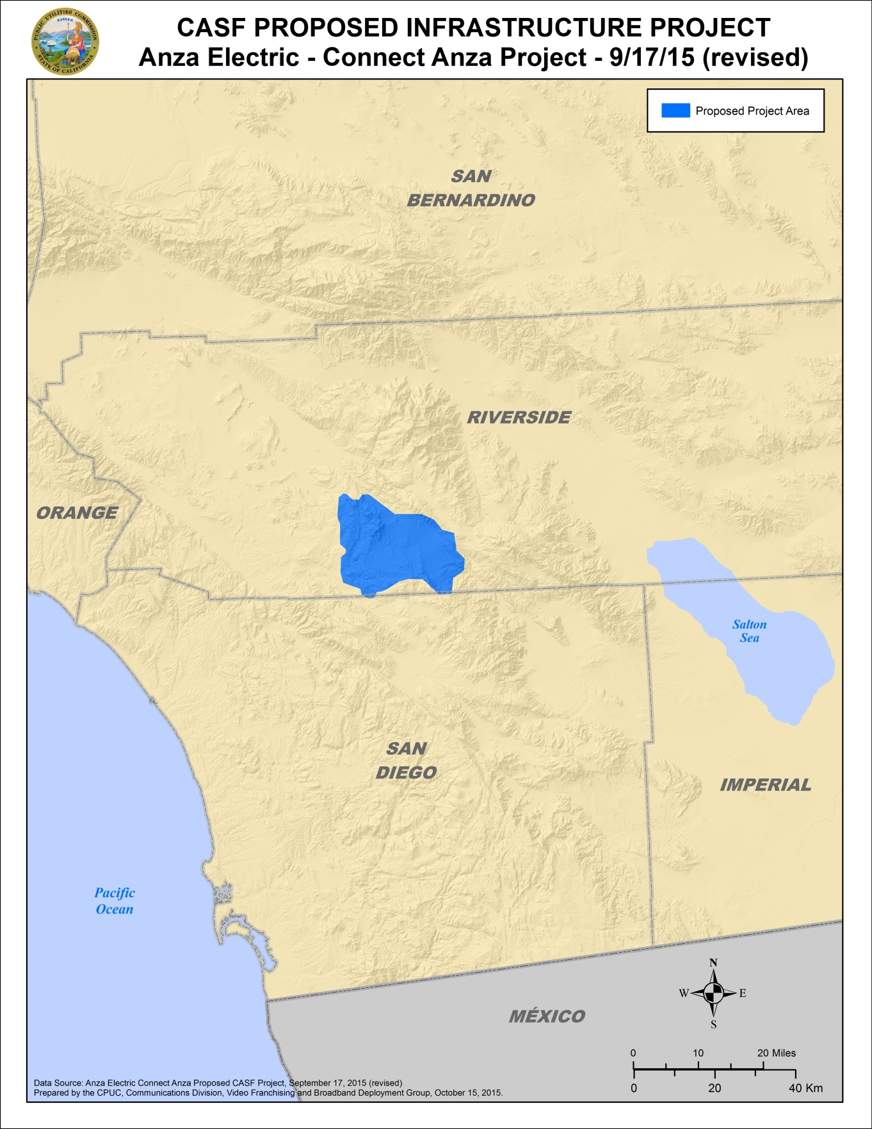

Appendix C
Resolution T-17503 AEC Connect Anza
Existing broadband download speeds
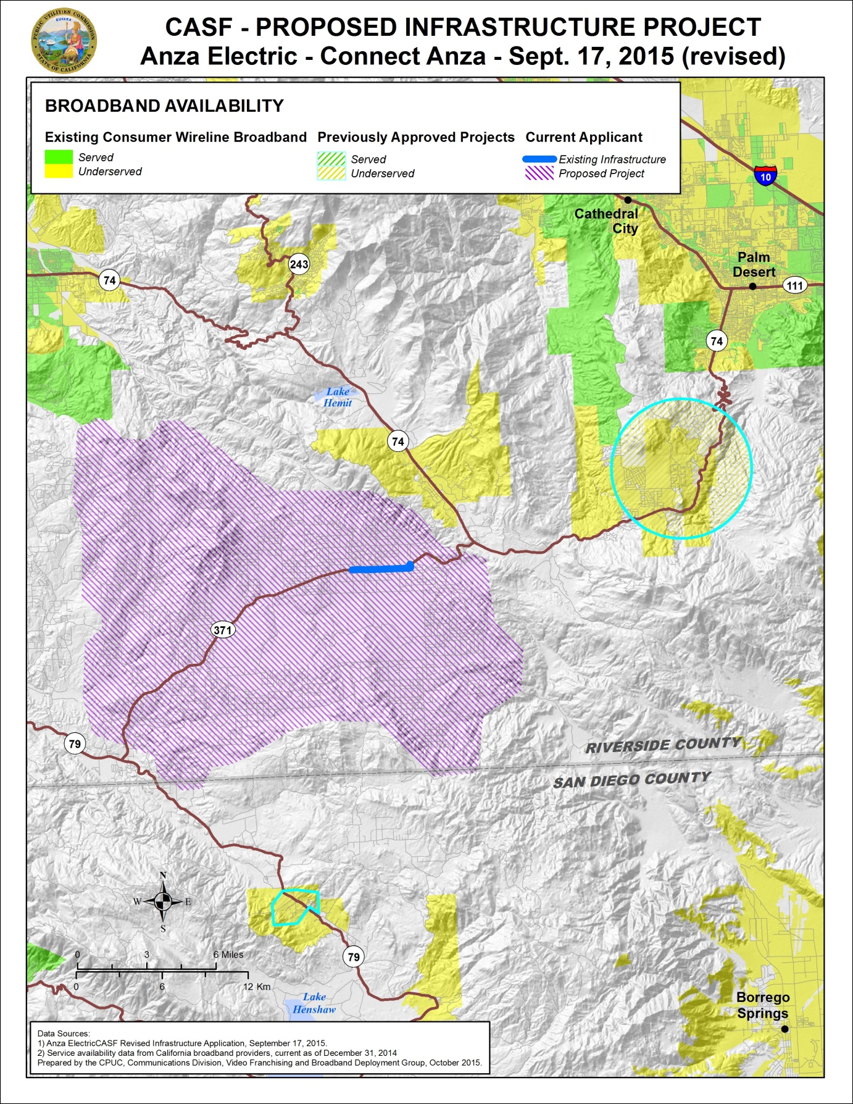

Appendix D – Applicant Provided Mobile Speed Tests
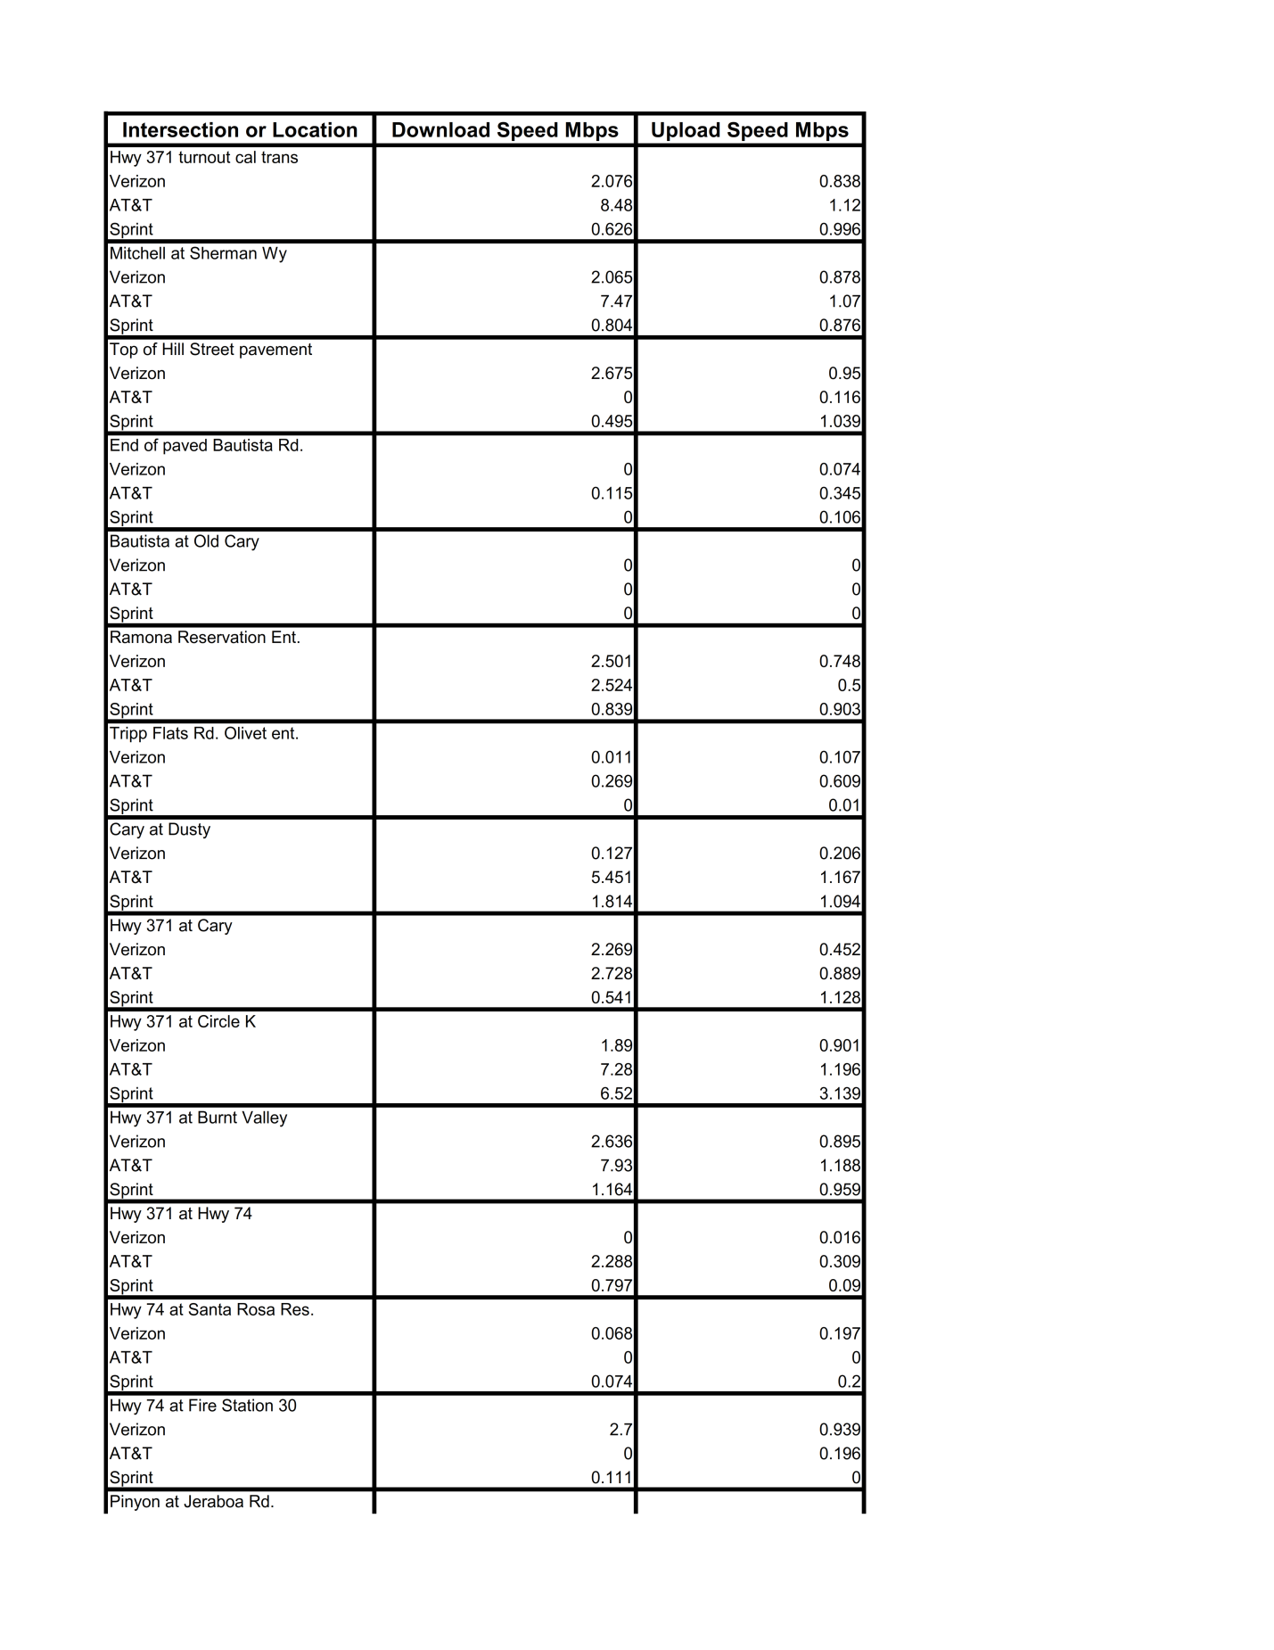
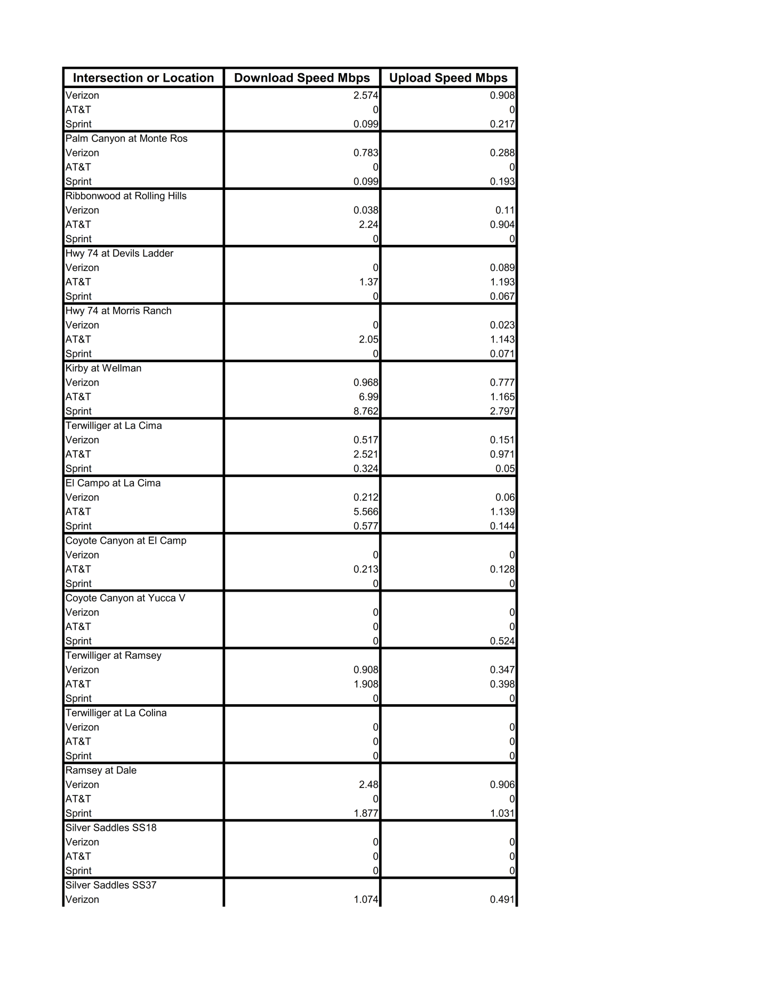
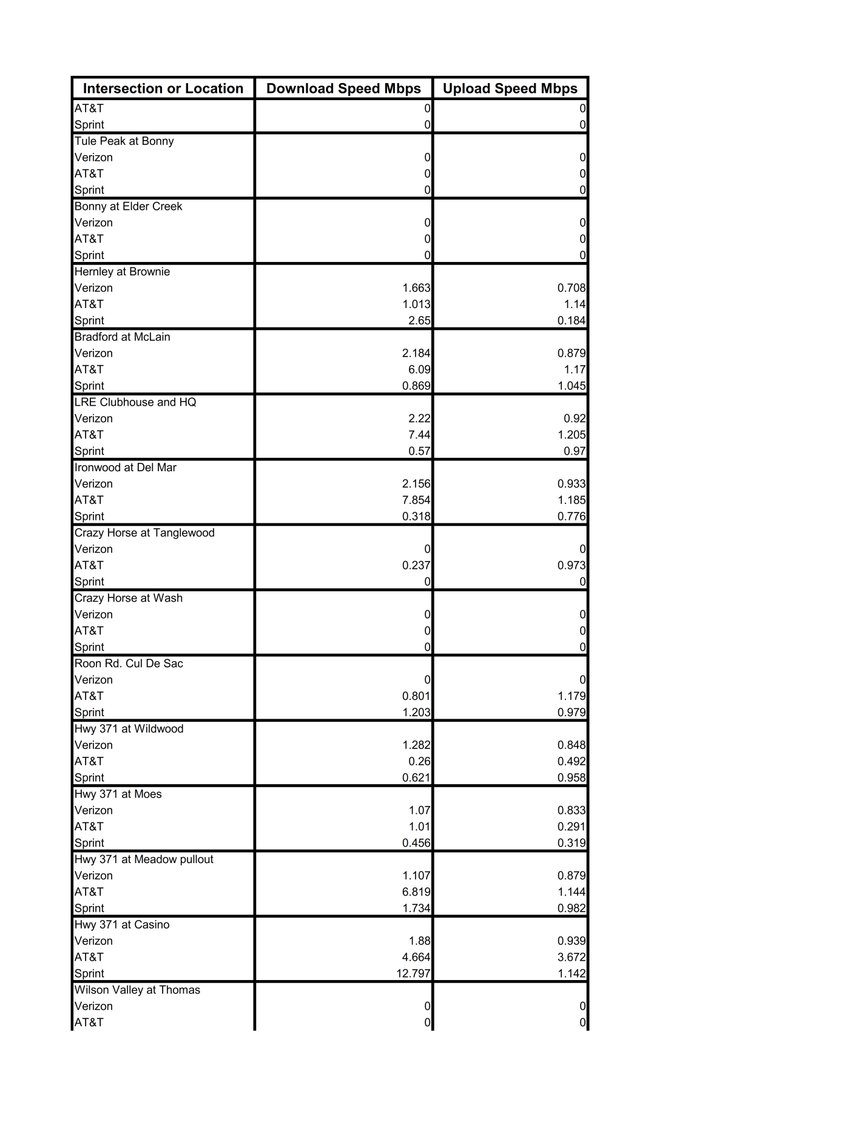
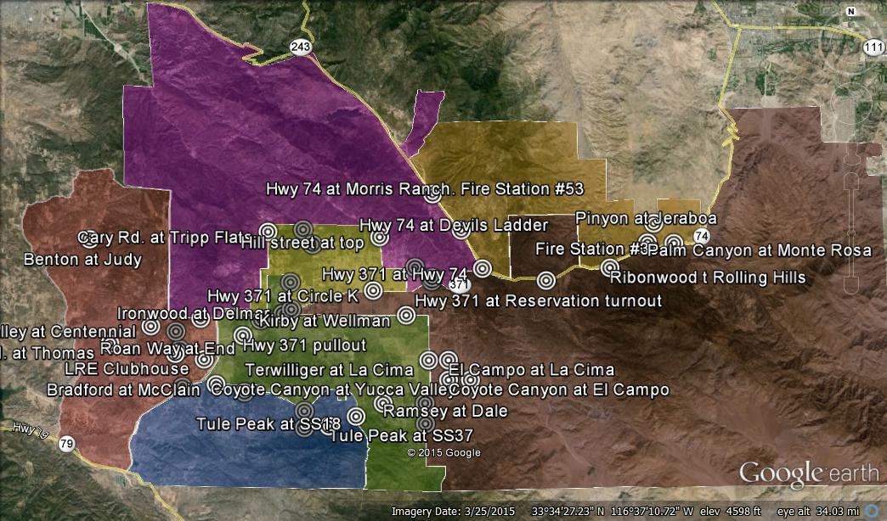
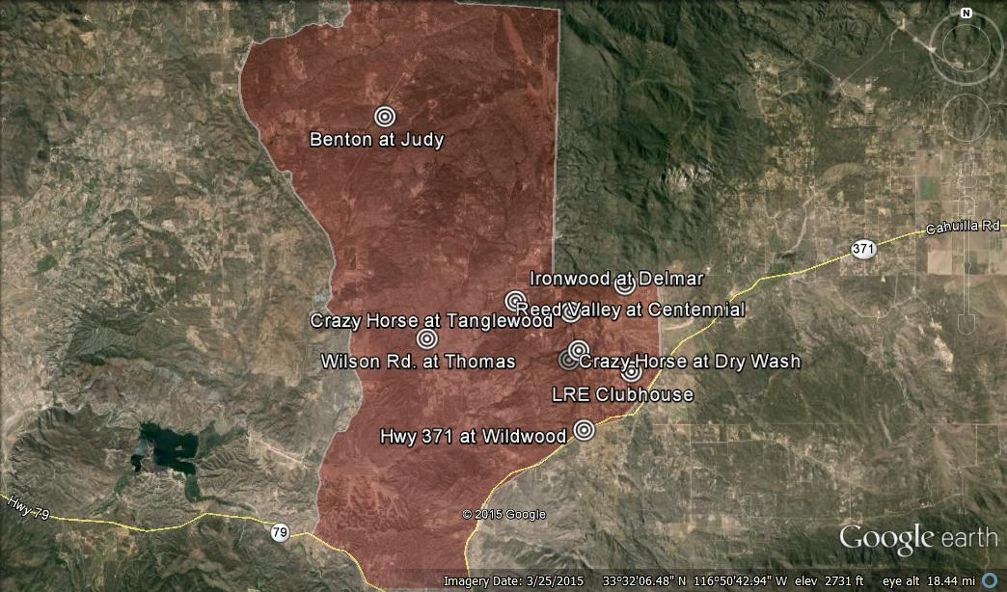

End of Appendix

Stats. 2010, c. 317, codified at Public Utilities (P.U.) Code § 281
P.U. Code § 281(b)(1).
The Commission later issued D.14-02-018 to implement provisions in Senate Bill 740 (Padilla, Stats 2013, Chapter 522), which amended P.U. Code § 281 and expanded eligibility for CASF Infrastructure Grants/Loans to non-telephone corporations.
CD received an email after the challenge period from an individual who has a small fixed wireless and satellite reseller business in Anza, CA. He did not challenge the project but, instead, expressed opposition to the fixed wireless portion of the project, noting the presence of the two small local wireless providers (MtPalomar.net and Wireless Internet Pro) who do advertise up to served speeds in some locations. The two providers do not provide data to the Commission and staff has no way of validating their service.
AEC is an incorporated non-profit 501(c) (12) electricity (member-owned) cooperative. According to the AEC website (http://www.anzaelectric.org/content/about-us), AEC provides power to 3900 homes, schools, businesses and 20 irrigation loads.
The number of trailer homes served and the information that the residents who live in the trailer homes are transient was stated by the applicant.
The total number of households as recorded in the US 2010 census for census block group areas to be served by the proposed project.
Total number of households on the Cahuilla Reservation estimated by the applicant.
Here, CD consulted the latest version of the California Interactive Broadband Availability Map, with data current as of June 30, 2014.
Mobile broadband coverage is based on either the advertised maximum mobile provider speed or the speed interpolated from CPUC mobile speed testing points (using the mean – 1 standard deviation of all speed readings for that point), whichever is least.
CalSPEED is the Commission’s mobile application that is used to test mobile broadband speeds.
See the CENIC website for a description of their network (http://cenic.org/about/about-overview).
AEC has committed to providing free Internet access for the community hall and community park.
The “take rate” is the percentage of potential subscribers who are offered the service that actually do subscribe to the service.
The Connect Anza broadband project would continue to provide complementary broadband to these organizations and to the other fire stations in the area.
In reference of the cost of fiber projects funded through the CASF grant program, the subsidy provided to the Connect Anza project when compared to the per household subsidy for the other funded fiber projects, is18 percent of the median and 8 percent of the mean cost per household.
Approval of the California Advanced Services Fund (CASF) Application Requirements and Scoring Criteria for Awarding CASF Funds (2008) Cal. P.U.C. Res. No. T-17143 at 4.
AEC provided documentation that showed that 91.3 percent of voting members voted for the change in the bylaws (948 for, 86 against and 4 abstaining).

