PUBLIC UTILITIES COMMISSION OF THE STATE OF CALIFORNIA

Communications Division | RESOLUTION T-17497
Broadband, Policy and Analysis Branch | January 14, 2016

R E S O L U T I O N

Resolution T-17497: Approval of funding for the grant application of a non-telephone corporation, Cal.net, Inc. (U-1340-C), from the California Advanced Services Fund (CASF) in the amount of $1,139,755 to build last-mile fixed wireless infrastructure to deliver broadband services to underserved rural communities of northern El Dorado County.

- Summary

This Resolution approves funding in the amount of $1,139,755 from the California Advanced Service Fund (CASF) in response to the grant application from Cal.net, Inc. (“Cal.net”). Cal.net, proposes to build last-mile fixed wireless infrastructure to provide broadband Internet and Voice over Internet Protocol (VoIP) telephony services to underserved rural communities of the northern regions of El Dorado County (El Dorado North project). The proposed service area includes the communities of Greenwood and Garden Valley, which the Gold Country Broadband Consortium (“GCBC”) identifies as priority areas that lack adequate broadband services.

The El Dorado North project will cover 97 square miles and will provide broadband speeds of up to 25 megabits per second (“Mbps”) download and 4 Mbps upload to 1,537 households. The CASF per-household subsidy is approximately $742. This project will also provide broadband services to two anchor institutions, which are Divide High School and Otter Creek Elementary School.
The El Dorado North project would also provide safety benefits to the communities in the area by allowing Cal.net to reach and serve 6 fire stations. The proposed project would also enable Cal.net to supply public safety agencies in the area with an interconnected public safety data communications network.

Background

On December 20, 2007, the California Public Utilities Commission, in Decision (D.) 07-12-054, established the CASF program as a two-year program to provide funds for the deployment of broadband infrastructure in unserved and underserved areas in California.

On September 25, 2010, Governor Schwarzenegger signed Senate Bill (SB) 1040, which codified the CASF program and expanded it to include three accounts: (1) the Infra-structure Grant Account, (2) the Consortia Grant Account, and (3) the Revolving Loan Account. The latter two accounts are intended to address the needs that were unmet under the original CASF program. SB 1040 also expanded the CASF fund from $100 million to $225 million, adding $100 million to the Infrastructure Grant Account and allocating $10 million and $15 million to the Consortia Grant Account and the Revolving Loan Account, respectively.

On February 1, 2012, the Commission approved D.12-02-015 to implement new guidelines for the Infrastructure Grant and Revolving Loan Accounts. Key provisions of the decision include:

- A maximum CASF grant award of 70 percent of project costs for unserved areas and 60 percent for underserved areas;
- A definition of an underserved area as an area where broadband is available, but no wireline or wireless facilities-based provider offers service at advertised speeds of at least 6 Mbps per second downstream and 1.5 Mbps upstream (6 Mbps /1.5 Mbps).

Subsequently, on February 27, 2014, the Commission, in D.14-02-018, amended the eligibility rules for the CASF Program to allow non-telephone corporations to participate in the program, in accordance with SB 740. In D.14-02-018, the Commission implemented additional safeguards on the CASF program for the participation of non-telephone corporations to ensure that non-telephone corporations comply with the requirements of the CASF program, and that ratepayer funds are protected. These safeguards include requiring non-telephone corporations obtain a performance bond for the construction phase of the project and requiring any non-telephone corporation that has been providing broadband services for less than 12 months to meet a liquidity requirement of 10% of the total project costs with a cap of $100,000. Additionally, the decision gives the Commission authority to invoke the penalty provisions of Public Utilities Code §§ 2111 and 2108 to ensure that non-telephone corporations comply with the terms and conditions of the CASF program, in both the construction and post-construction phase of the project.

On March 31, 2015, Cal.net submitted a grant application for CASF funding to build last-mile fixed wireless infrastructure to provide broadband Internet and VoIP telephony services to underserved rural communities in the northern regions of El Dorado County.

- Notice/Protests

On April 9, 2015, Communications Division (CD) posted the proposed project area map, census block groups (“CBGs”) and zip codes for this project on the Commission’s webpage under “CASF Application Project Summaries” and also sent notice regarding the project to the CASF distribution list. CD received no challenges to the proposed project area.

- Discussion

This Resolution adopts the CD’s recommended award of $1,139,755 in a CASF grant to Cal.net for the El Dorado North project. This grant amount represents 60 percent of the applicant’s estimated total project cost of $1,899,591. The CASF per-household subsidy is $742, based on 1,537 households that will be given access at served speeds by the grant. Key project information and maps are shown in the appendix.

- Project Application Overview

The Company. Cal.net is a wireless internet service provider with operations based in Shingle Springs, California. In 1997, Cal.net began its business as a facilities-based broadband service provider serving the communities of Davis, Woodland, and western El Dorado County area. Since 2006, Cal.net has been providing fixed wireless rural broadband service. In January 2015, Cal.net began providing residential and business customers facilities-based VoIP telephony service. Cal.net currently provides broadband service to over a 900 square mile area encompassing western El Dorado and Amador Counties with broadband speeds of up to 25 Mbps downstream and 4 Mbps upstream. Cal.net operates from about twenty constructed towers, four leased towers, and over a hundred rooftop locations. Cal.net currently uses a variety of technologies to deliver fixed wireless broadband services, including license-exempt 5 GHz spectrum, lightly-licensed 3.65 GHz WiMAX, license-exempt 2.4 GHz spectrum, license-exempt 900 MHz spectrum, and TV White Space in the UHF bands.

The Proposed Project: El Dorado North. The El Dorado North project will provide last-mile fixed wireless broadband Internet and VoIP telephony service in rural underserved portions of northern El Dorado County. This project will provide broadband service over 97 square miles, with speeds of up to 25 Mbps download and 4 Mbps upload. The proposed project would also provide broadband service to 1,704 underserved households in the communities of Quintette, Buckeye, Volcanoville, Fornis, Greenwood, Meadow Brook, and Garden Valley. Additionally, the project would provide broadband service to two anchor institutions, which are Divide High School and Otter Creek Elementary School. If this project is approved, Cal.net would deliver broadband service to the priority areas of Greenwood and Garden Valley, which the GCBC identifies as communities that lack adequate broadband services.

According to Cal.net, the project will be exclusively comprised of fixed wireless technology deployed on either leased towers or towers that are constructed by Cal.net. Cal.net will use a variety of technologies to provide broadband to end users, such as:
- Unlicensed National Information Infrastructure (“U-NII”) equipment in various 5-GHz bands for line-of-sight situations;
- Fixed-LTE (a non-mobile variation of the LTE commonly used in cell phones) initially in the 3.65-GHz band primarily for near-line-of-sight (minor obstructions), and later in the 3.55- to 3.65-GHz CBRS band where authorized after the FCC approves this for use; and
- TV White Space in the UHF and upper-VHF bands for heavily-obstructed non-line-of-sight situations.
Cal.net’s Network Operations Center in Shingle Springs will serve as the primary connection to the Internet. One of its fixed wireless towers, which are interconnected with the other towers in the network, will also connect to the Internet through the fiber network of the CASF-funded Central Valley Independent Network (“CVIN”) for redundancy and additional capacity. For backhaul connections to the Internet at every tower site, Cal.net will use very high capacity point-to-point FCC-licensed microwave links to interconnect the towers.

TV White Space Technology. According to Cal.net, the TV White Space technology proposed in this project is a new technology that can bring broadband services to the heavily forested and difficult to reach communities of Greenwood and Garden Valley. Because these rural communities are either in heavily forested areas or in very isolated areas, it is very expensive to reach them exclusively by fiber or cable lines. For this reason, fixed wireless technology has been used to deliver broadband services to the region. With fixed wireless technology, broadband services are delivered wirelessly from signals sent from the carrier’s antenna to the subscriber’s antenna. This requires a line-of-sight connection between the carrier’s and the subscriber’s antennas that is free from obstacles hindering the communication between antennas. With heavy forestation and mountainous terrains, line-of-sight connections have proven difficult to establish and therefore it is difficult to deliver broadband services to customers in these heavily forested areas.

TV White Space is the unused electromagnetic frequencies between operational over-the-air television broadcast channels. The major advantage of TV White Space is the very low electromagnetic frequency bands it operates within. The propagation characteristics of the TV White Space bands, 54 – 698 megahertz, allow radio signals to penetrate miles of forest and bend around mild terrain obstructions while still delivering a high quality signals to customers. Cal.net has been using the TV White Space technology to connect customers they previously have not been able to connect. Cal.net has demonstrated that the TV White Space technology can connect homes that do not have line-of-sight connections with the carrier to the Internet.

- Project Qualification

To qualify for the CASF program, an applicant is required to submit proof that the area is unserved or underserved by submitting shapefiles of the proposed project. CD reviews the submitted shapefiles and compares them with United States 2010 Census data and the California Interactive Broadband Availability Map. Once CD determines that the area is eligible either as an unserved or underserved area, CD evaluates all other information the applicant submitted to determine if the project meets the requirements outlined in D.12-02-015. CD reviews other information including: description of current and proposed broadband infrastructure; number of potential subscriber households and average income; project construction schedule; project budget; proposed pricing and commitment period for new subscribers; and financial viability of the applicant.

After reviewing the proposed service areas for eligibility of CASF funding, CD determined that the proposed project areas are underserved. The June 2015 Mobile Field Test showed that the proposed project area is underserved by mobile wireless providers. The California Interactive Broadband Availability Map further shows that the area is partially served by fixed wireless internet service providers (WISPs); however, a majority of the households (at least 85%) do not have broadband services at Commission-defined served speeds of 6 Mbps downstream and 1 Mbps upstream.

According to the California Interactive Broadband Availability Map, both Central Valley Broadband and Cal.net currently provide Internet services in the area through fixed wireless technologies. Of the 1704 households in the proposed service area, Cal.net provides service to 17 households. CD reached out to Central Valley Broadband and found that Central Valley Broadband provides service to approximately 150 households in the area. Therefore, CD removed a net total of 167 served households from the Cal.net’s proposed project boundaries.

A key limitation of fixed wireless technology is that the antenna at the customer’s premise and the provider’s ground station must have a direct line of sight. Here, the proposed project area is heavily forested and cannot be served with the currently deployed fixed wireless technologies. Additionally, Cal.net provided CD with a list of several hundred inquiries from prospective customers in the area who cannot get service from the existing WISPs in the area, demonstrating the need for broadband internet services in the area.

Although the project area is serviced by two WISPs with fixed wireless technologies, about 85% of the households in the area do not have broadband services. Because of the limitations of the existing fixed wireless technologies deployed; and that the relatively few served households are scattered among the project area and therefore cannot be isolated from the project area, staff determined that the entire area should be considered underserved and therefore eligible for CASF funding.

- Project Evaluation and Recommendation for Funding

CD evaluated the application with respect to the scoring criteria defined in D.12-02-015, Appendix 1, Section VIII (Scoring Criteria). The scoring criteria include: (i) Funds Requested per Potential Customer, (ii) Speed, (iii) Financial Viability, (iv) Pricing, (v) Total Number of Households in the Proposed Area, (vi) Timeliness of Completion of Project, (vii) Guaranteed Pricing Period, and (viii) Low-Income Areas. CD also conducted qualitative evaluation of the project area, existing infrastructure, and community needs.

Summary of Key Characteristics. CD found that this project meets CASF funding requirements with respect to the following factors:

- Speed – The proposed speed offering (maximum of 25 Mbps download and 4 Mbps upload) exceeds the 6/1.5 benchmark set by the Commission in D.12-02-015.
- Service Area/Community – The proposed project area consists of low-income, underserved communities in the northern region of El Dorado County.
- Matching Funds (40% of project cost) – Cal.net has secured a cash loan of $1 million and an equipment-financed loan of $2 million to match the project costs.
- Financial Viability – Cal.net’s CPA-attested financial statements show that the company is financially viable. Cal.net’s pro forma financial forecast over 5 years also shows that this project is financially viable.
- Prices and Price Commitments – Cal.net’s proposed prices are reasonable. Cal.net has committed to the proposed broadband prices for no less than three years, which is longer than the two years required by D.12-02-015. Cal.net has committed to the proposed VoIP prices for two years.
- Deployment Schedule – Cal.net has submitted detailed planning documents, including a schedule with clear milestones to indicate the project will be completed within 24 months of construction and deployment.

Based on its review, CD determined that the El Dorado North project qualifies for funding as an underserved area and meets the requirements of D.12-02-015, D.14-02-018, and Resolution T-17443. CD staff finds that this project aligns with CASF’s goal to encourage the deployment of high quality advanced information and communications technologies to all Californians to promote economic growth, job creation, and substantial social benefits.

The Community and Community Support. The El Dorado North project will serve several communities in the northern regions of El Dorado County, including Quintette, Buckeye, Volcanoville, Fornis, Greenwood, Meadow Brook, and Garden Valley. In particular, the communities of Greenwood and Garden Valley are identified by the GCBC as high priority areas, which are communities that lack adequate broadband services. Because most of these rural communities are located in heavily forested isolated areas these communities are currently underserved.

Based on the 2010 census block data, the proposed project area consists of 1,704 households and a population count of 4,236. There are two public schools in the project area, which are Divide High School in Greenwood, CA and Otters Elementary School in Georgetown, CA. The proposed project area will serve low income communities. According to the 2010 Census Data, the median household income of the 6 census block groups in the project area is $59,962. According to the State Income Limits established by California Department of Housing and Community Development, a 4-person household with an income of below $60,900 would qualify as low income in El Dorado County. One of the six census block groups in the area has a poverty rate above 15%.

Letters from Assembly member Frank Bigelow, the El Dorado Board of Supervisors, Sierra Economic Development Corporation (SEDCorp), and the GCBC expressed overwhelming support of this project. One letter from Brian Veerkamp, Chairperson representing the El Dorado County Board of Supervisors, stated that, “the current lack of reliable broadband infrastructure puts (their) community at a substantial economic disadvantage.” Mr. Veerkamp stated that El Dorado County ranks 34th of 58 California counties in broadband speed according to the National Broadband Map published by the FCC. Mr. Veerkamp also expressed concerns that the National Broadband Map shows “substantial service gaps” in their community, with many residents still relying on dial-up modems. In addition, Randy Wagner, representing the Sierra Economic Development Corporation (SEDCorp) and GCBC expressed similar sentiments in his letter, stating that “El Dorado County ranks among the lowest, at 34 out of 58 counties, in terms of broadband access for Internet speed and all technology according to a December 31, 2013 national survey for the state.”

Financial Viability. Cal.net determined that the project is economically feasible with a CASF grant of $1,139,755, which is 60 percent of the total project costs, to match AEC’s investment of $1,899,591.

CD reviewed submitted balance sheet, income, cash flow statements and other financial viability variables for Cal.net and concluded that Cal.net has the existing capital resources for the 40 percent required matching funds to construct the project, as well as a sound financial framework for future operations. Therefore, staff determined that the risk that the El Dorado North project would encounter financial problems, such as the project not being completed or maintained over time, is minimal.

Pricing and Affordability. Cal.net has committed to the following pricing for broadband services for the duration of the two-year construction phase of the project plus an additional three years thereafter. This means that first area to be deployed will provide nearly five years of price guarantees to the first customer(s) to sign up; later deployment areas will have shorter price-guarantee periods, but no less than three years. Further, Cal.net commits to apply a 50% discount to qualified low-income subscribers. There are no contracts and service is provided on a month-to-month basis. Cal.net also will provide a 30-day money-back guarantee for any reason and the broadband service plans do not have any data caps.

Cal.net’s El Dorado North Project ~ Pricing Plan
Account Type | Maximum Speed  (Download / Upload) | Monthly Fee* | Installation  Fee†
Wireless Power | 6.0 Mbps / 2.0 Mbps | $69.95* | Waived
Wireless Express | 10.0 Mbps / 3.0 Mbps | $84.95* | Waived
Wireless Supreme†† | 15.0 Mbps / 3.0 Mbps | $99.95* | Waived
Wireless Extreme†† | 25.0 Mbps / 4.0 Mbps | $159.95* | Waived
* Local, State, or Federal fees are not included in these prices, and may be subsequently added.
† Installation includes connection to the “MPOE” (“Minimum Point of Entry”) inclusive of the radio/antenna combination to the household premise. Additional installation charges may apply depending on customer requirements (e.g. if the customer requests customized routing of wire other than direct, normal installation.)
†† Wireless Supreme and Extreme require specific equipment and signal strength, and may not be available in all areas.

After comparing the current prices of broadband Internet services provided in the area with Cal.net’s proposed prices, CD has determined that the applicant’s proposed broadband prices are similar to prices for Internet service offered in the area. Currently, there are two wireless internet providers in the area (Cal.net, the applicant, and Central Valley Broadband) that provide broadband internet services through fixed wireless technologies. Cal.net’s proposed prices are the same as its current service offerings, but with installation fees waived as per D.12-02-015 in its proposed pricing plans.

Voice over Internet Protocol (VoIP) Services

Cal.net has committed to the following prices for its VoIP service for the first two years of the project. For residential customers, a simple plan will cost $19.95 per month and a standard plan will cost $24.95 per month. The standard plan includes additional features, such as call forward and call waiting. Qualified low-income subscribers will receive a 25% discount. For business customers, the standard plan is $39.95 per month for a single line. For both residential and business customers, one-time set up fees for number porting, new number provisioning, or 411 directory assistance enabling are waived.

- Safety Considerations

Cal.net proposes to extend their service availability to the following fire stations in the area: Garden Valley Fire Protection District, Georgetown Fire Department, Station 61, Georgetown Fire Department, Station 62, Georgetown Fire Department, Station 63, Georgetown Fire Department, Station 64 and Georgetown Fire Department, Station 65. Cal.net currently offers free service to all fire stations and will continue to do so. Cal.net further proposes to supply public safety entities with a comprehensive wide-ranging interconnected public safety data communications network in the 700-MHz and 4.9-GHz radio bands. Upon award of this grant, Cal.net will immediately reach out to officials of the California First Responders Network (“FirstNet”) and to other local public safety organizations in its coverage areas to begin discussions on how to implement this concept.

- Compliance Requirements

Cal.net is required to comply with all the guidelines, requirements, and conditions associated with the grant of CASF funds as specified in D.12-02-015, D.14-02-018, and Resolution T-17443. Such compliance includes, but is not limited to:

- California Environmental Quality Act (CEQA)

All CASF grants are subject to California Environmental Quality Act (CEQA) requirements unless the project is statutorily or categorically exempt pursuant to the CEQA Guidelines.

The El Dorado North project is subject to CEQA review, and the Commission must complete the associated CEQA review prior to disbursing CASF funds for construction activities.

Prior to any construction activity, Cal.net is required to seek further authority from the Commission for such activity by filing a Proponent’s Environmental Assessment (PEA) pursuant to Commission Rule of Practice and Procedure 2.4; and must undergo an environmental review pursuant to the CEQA. (California Public Resources Code § 21000 et seq.) Cal.net should contact the Supervisor of the Commission’s Energy Division CEQA Unit well in advance of a contemplated filing to: (a) consult with staff regarding the process of developing and filing a PEA; (b) provide for cost recovery per Rule of Practice and Procedure 2.5; and (c) enter into a Memorandum of Understanding to allow the Energy Division to initiate the retention of an environmental contractor to perform the environmental review.

Cal.net may file a completed CEQA review conducted by another agency acting as the Lead Agency pursuant to CEQA. However, Cal.net should make every effort to ensure that the Commission’s CEQA Unit is aware of and included in the CEQA process if it is conducted by another agency. Cal.net should contact the Supervisor of the Commission’s Energy Division CEQA Unit well in advance of a contemplated filing to consult with staff regarding the applicability of another agency’s CEQA review.

Cal.net must provide the PEA prior to the first 25% payment. Should the Energy Division recommend that a full CEQA analysis is required, the applicant may either pay for the analysis itself or seek a supplemental CASF grant to cover 60 percent of the cost.

- Deployment Schedule

The Commission expects Cal.net to complete the project within 24 months from start date (as determined by the procedure below). If the applicant is unable to complete the proposed project within the 24-month timeframe requirement, it must notify the Director of CD as soon as Cal.net becomes aware of this possibility. If such notice is not provided, the Commission may reduce payment for failure to satisfy this requirement by timely notifying CD’s Director.

- Performance Bond

Cal.net must obtain a performance bond during the construction phase of the El Dorado North project. Cal.net must send an executed bond, equal to the total amount payable under the CASF award, to the CPUC’s Executive Director and to the Director of Communications Division within five business days after the completion of the CEQA review. The performance bond must also be callable for failure to complete the CASF-funded broadband project.

- Execution and Performance

CD and Cal.net shall determine a project start date after Cal.net has obtained all approvals. Should Cal.net or any Contractor it retains fail to commence work by designated date, upon five days written notice to Cal.net, the Commission may terminate the grant. In the event that Cal.net fails to complete the project in accordance with the terms of CPUC approval as set forth in this Resolution, Cal.net must reimburse some or all of the CASF funds that it has received. Cal.net must complete all construction covered by this grant on or before the grant’s termination date.

D. Price Commitment Period

The minimum required price commitment period for broadband service to all households within the project area is two years. Cal.net guarantees the price of broadband services offered in the project area for no less than three years and the price of VoIP services offered in the project area for two years.

E. Project Audit

The Commission has the right to conduct any necessary audit, verification, and discovery during project implementation/construction to ensure that CASF funds are spent in accordance with Commission approval.

The recipient’s invoices will be subject to a financial audit by the Commission at any time within three years of completion of the work.

F. Providing Voice Service

Cal.net has certified that its voice over internet protocol (VoIP) service meets the Federal Communications Commission (FCC) standards for E-911 service and battery backup.

G. Reporting

All grantees must submit quarterly progress reports on the status of the project irrespective of whether grantees request reimbursement or payment. Before full payment of the project, the Cal.net must submit a project completion report. Progress reports shall use the schedule for deployment, major construction milestones and costs submitted in the proposal; indicate the actual date of completion of each task/milestone as well as problems and issues encountered, and the actions taken to resolve these problems and issues during project implementation and construction; and identify future risks to the project.

Recipients shall also include test results on the download and upload speeds on a CBG and zip code basis in the final completion report. Cal.net must certify that each progress report is true and correct under penalty of perjury.

H. Submission of Form 477

The FCC currently requires broadband providers to biannually submit the Form 477, which includes speed data. While there is an imperfect match between the data that is reported in the Form 477 and to the CASF, the Form 477 data will be useful in documenting CASF deployment for the service provider’s new service. Pursuant to General Order 66-C, service providers in California must submit a copy of their Form 477 data directly to the CPUC, concurrent with their submission of the same data to the FCC for a five-year period after completion of the project.

- Payments to CASF Recipients
Submission of invoices from and payments to Cal.net shall be made at 25 percent completion intervals, in accordance with Section XI of Appendix 1 of D.12-02-015 and according to the guidelines and supporting documentation required in D.12-02-015.

Payment to Cal.net shall follow the process adopted for funds created under P. U. Code § 270. The Commission generally processes payments within 20-25 business days, including CD and Administrative Services review time. The State Controller’s Office (SCO) requires an additional 14- 21 days to issue payment from the day that requests are received by SCO from Administrative Services.

Cal.net shall provide service to all residential properties within the project area. If Cal.net does not provide service to each household within the project area that requests service at the prescribed rates during the commitment period, the Commission reserves the right to reduce payment accordingly.

Comments on Draft Resolution

In compliance with Public Utilities Code § 311(g), a notice letter was e-mailed on December 10, 2015, informing all parties on the CASF Distribution List of the availability of the draft of this resolution for public comments at the Commission's website at (http://www.cpuc.ca.gov/PUC/documents). This letter also informed parties that the final conformed Resolution adopted by the Commission will be posted and available at this same website. No comments were received.

- Findings and Conclusions

- On March 31, 2015, Cal.net, Inc., a non-telephone corporation, submitted a CASF grant application to build last-mile fixed wireless infrastructure to provide broadband Internet and VoIP telephony services to underserved rural communities of the northern regions of El Dorado County. The CBGs impacted by the project are 060170306022, 060170306023, 060170306021, 060170306031, 060170306032 and 060170306033.
- CD posted the proposed project area map, CBG and zip code for Cal.net’s El Dorado North project on the Commission’s webpage under “CASF Application Project Summaries” on April 9, 2015. CD received no challenges to this project.
- CD reviewed and analyzed data submitted from the Cal.net grant application to determine the project’s eligibility for CASF funding. Based on its review, CD found that the proposed project area is serviced by two WISPs with fixed wireless technologies, but a majority of the households in the area (85%) do not have broadband services. CD removed a net total of 167 served households from the Cal.net’s proposed project boundaries. The project area was determined to be underserved.
- Based on its review, CD determined that the proposed project qualifies for funding under D.12-02-015 and recommends Commission approval of CASF funding for Cal.net’s El Dorado North Project.

- The Commission finds CD’s recommendation to fund Cal.net’s El Dorado North project, as summarized in Appendix A, to be reasonable and consistent with Commission orders and, therefore, adopts such recommendation.
- The El Dorado North project is subject to CEQA review. Prior to any construction activity, Cal.net is required to file a Proponent’s Environmental Assessment (PEA) and must undergo an environmental review pursuant to the CEQA. Cal.net must provide the PEA prior to the first 25% payment.

- As a non-telephone corporation, Cal.net must obtain a performance bond during the construction phase of the El Dorado North project, per D.14-02-018. Cal.net must send an executed bond, equal to the total amount payable under the CASF award, to the CPUC’s Executive Director and to the Director of Communications Division within five business days after the completion of the CEQA review.
- Cal.net is required to comply with all guidelines, requirements, and conditions associated with the granting of CASF funds as specified in D.12-02-015, D.14-02-018, and Resolution T-17443. Cal.net must submit the FCC Form 477, as specified in Resolution T-17143.
- A notice letter was e-mailed on December 10, 2015, informing all parties on the CASF distribution list of the availability of the draft of this Resolution for public comments at the Commission’s website (http://www.cpuc.ca.gov/documents/). This letter also informed parties that the final confirmed Resolution adopted by the Commission will be posted and available at this same website. No comments were received.

THEREFORE, IT IS ORDERED that:

  - The Commission shall award $1,139,755 to Cal.net for the El Dorado North project as described herein and as summarized in Appendix A of this Resolution.
  - The program fund payment of $1,139,755 for this project in underserved areas shall be paid out of the CASF Infrastructure Grant Account in accordance with the guidelines adopted in D.12-02-015, including compliance with CEQA.
  - Cal.net shall submit a full Proponent’s Environmental Assessment (PEA) to the Energy Division prior to the first 25% payment of CASF grant funds. No CASF funds may be disbursed for construction activities prior to the completion of the CEQA review.
  - Cal.net shall send an executed bond, equal to the total amount payable under the CASF award, to the CPUC’s Executive Director and to the Director of Communications Division within five business days after the completion of the CEQA review.
  - Cal.net shall provide service to all residential properties within the project area, as defined in Appendix B and GIS files submitted to the Communications Division as part of the application process.
  - Payments to the CASF recipient shall be in accordance with Section XI of Appendix 1 of D.12-02-015 and in accordance with the process defined in the “Payments to CASF Recipients” section of this Resolution. If Cal.net does not provide service to each household within the project area that requests service at the prescribed rates during the commitment period, the Commission reserves the right to reduce payment accordingly.
  - The CASF fund recipient, Cal.net, shall comply with all guidelines, requirements and conditions associated with the CASF funds award as specified in D.12-02-015, D.14-02-018, and Resolution T-17443. Cal.net shall submit the FCC Form 477 to the Commission, as specified in Resolution T-17143.

This Resolution is effective today.

I hereby certify that this Resolution was adopted by the California Public Utilities Commission at its regular meeting on January 14, 2016. The following Commissioners approved it:

/s/ Timothy J. Sullivan

TIMOTHY J. SULLIVAN

Executive Director

MICHAEL PICKER
President
MICHEL PETER FLORIO
CATHERINE J.K. SANDOVAL
CARLA J. PETERMAN
LIANE M. RANDOLPH
Commissioners

APPENDIX

APPENDIX A
Resolution T-17497
Cal.net, El Dorado North Project
CASF Applicant Key Information
Project Name | Cal.net, El Dorado North Project
Project Plan | Cal.net proposes to build last-mile fixed wireless infrastructure to provide broadband Internet and VoIP telephony services to underserved rural communities of the northern regions of El Dorado County. The project will use fixed wireless technology deployed on either leased towers or towers that are constructed by Cal.net. Cal.net will use a variety of different technologies to service broadband to end users, which includes Unlicensed National Information Infrastructure (“U-NII”) equipment for line-of-sight situations, fixed-LTE (a non-mobile variation of the LTE commonly used in cell phones) for near-line-of-sight situations (minor obstructions), and TV White Space in the UHF and upper-VHF bands for heavily-obstructed non-line-of-sight situations.
Project Size (in square miles) | 97
Download/Upload speed | Maximum 25 Mbps / 4 Mbps
Location | Northern regions of El Dorado County
Community Names | Quintette, Buckeye, Volcanoville, Fornis, Greenwood, Meadow Brook, and Garden Valley
Census Block Groups | 060170306022, 060170306023, 060170306021,  060170306031, 060170306032, 060170306033
Median Household Income (by Census Block Group) | $59,962
Zip Codes | 95633, 95634, 95635, 95664, 95667
Estimated potential subscriber size | 1,537 households
Applicant expectations | 738 households (in 2 years after construction is completed); 1,139 households (in 5 years after construction is completed)
Pricing Plan (Monthly) | $69.95 for 6.0 Mbps/2.0 Mbps; $84.95 for 10.0 Mbps/3.0 Mbps;  $99.95 for 15 Mbps/3.0 mbps; $159.95 for 25.0 Mbps/4.0 Mbps;  No installation fees applied.
Deployment Schedule  (from Commission approval date) | 24 months
Proposed Project Budget (Total) | $ 1,899,591
Amount of CASF funds requested (60%) | $ 1,139,755
Applicant funded (40%) | $ 759,836

Appendix B
Resolution T-17497 Cal.net’s El Dorado North Project
Project Location Map
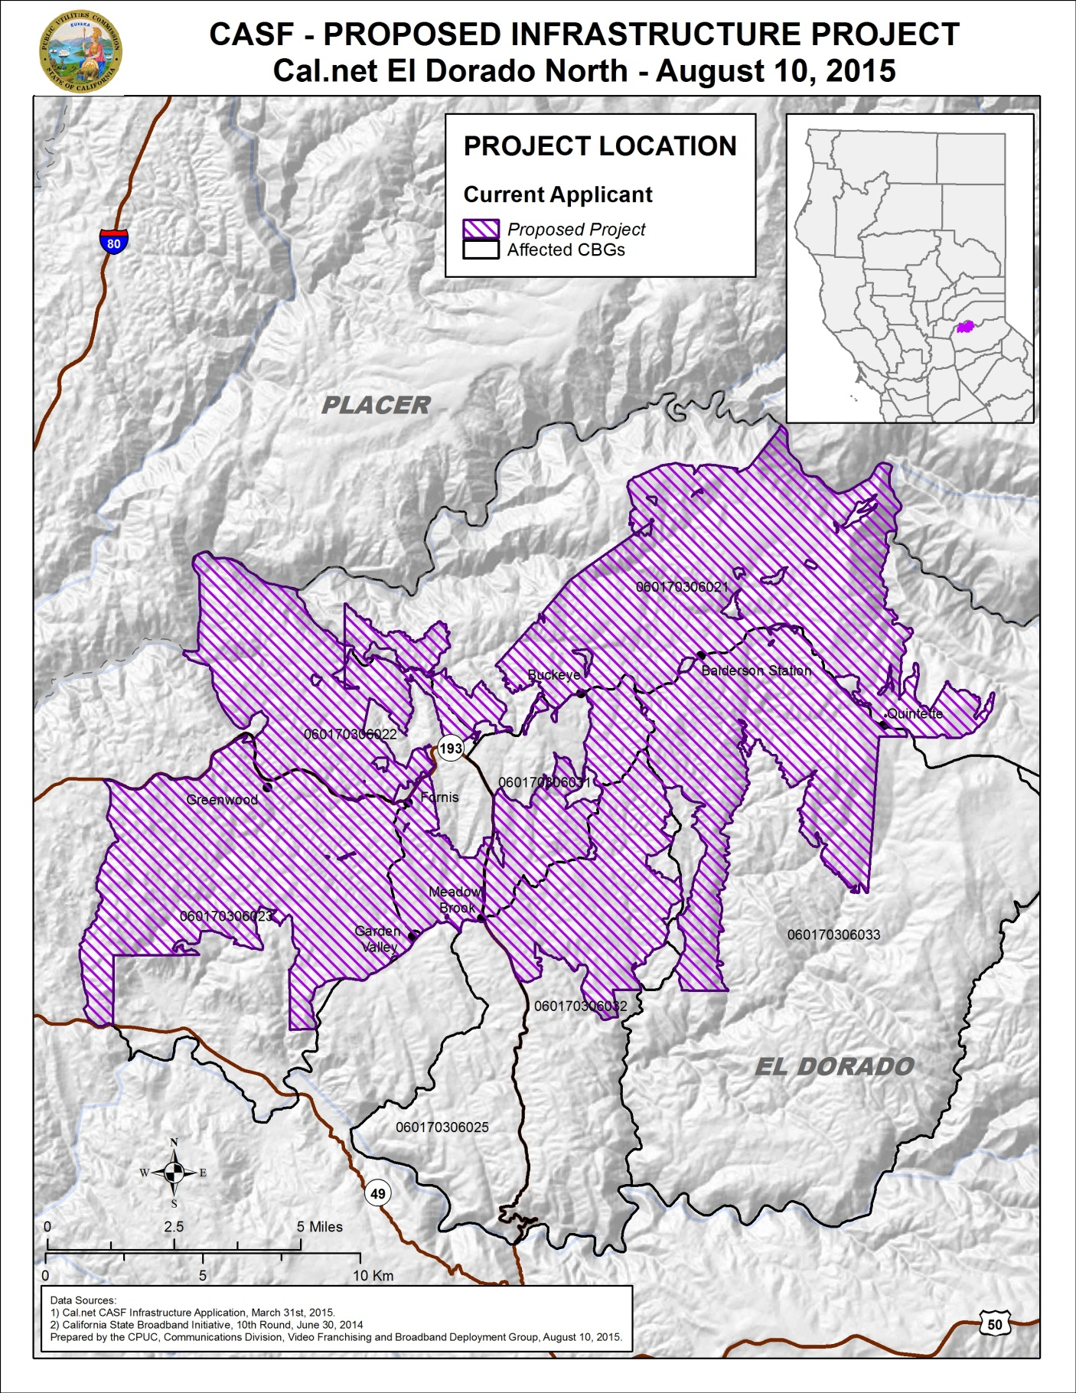

Appendix C
Resolution T-17497 Cal.net’s El Dorado North Project
Existing Wireline Service Levels
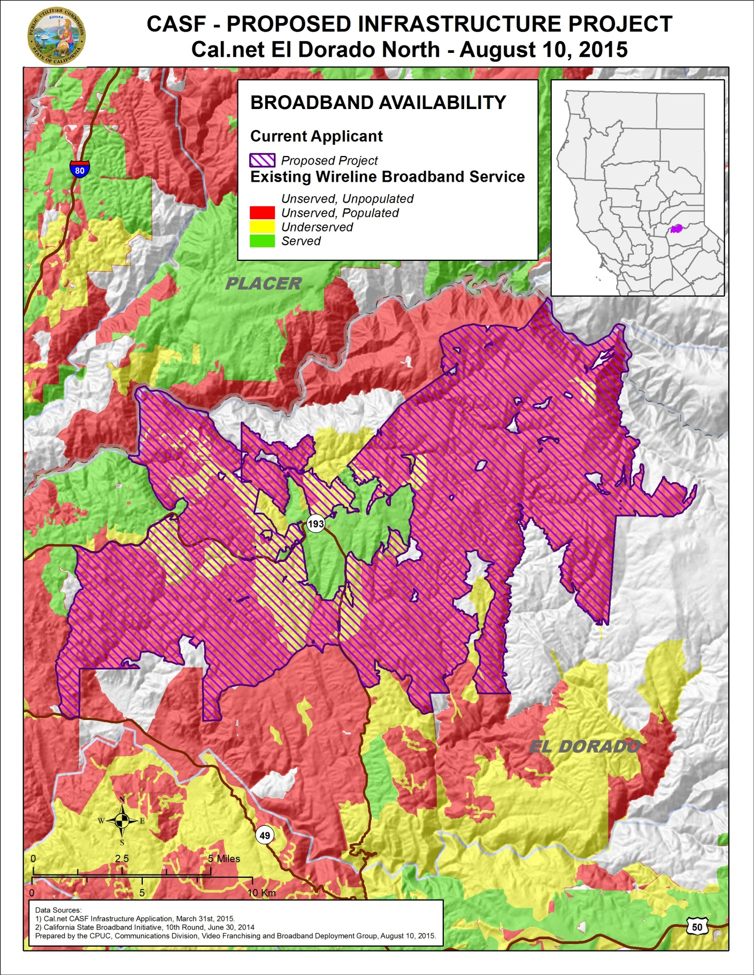
Appendix D
Resolution T-17497 Cal.net’s El Dorado North Project
Existing Fixed Wireless Services Levels
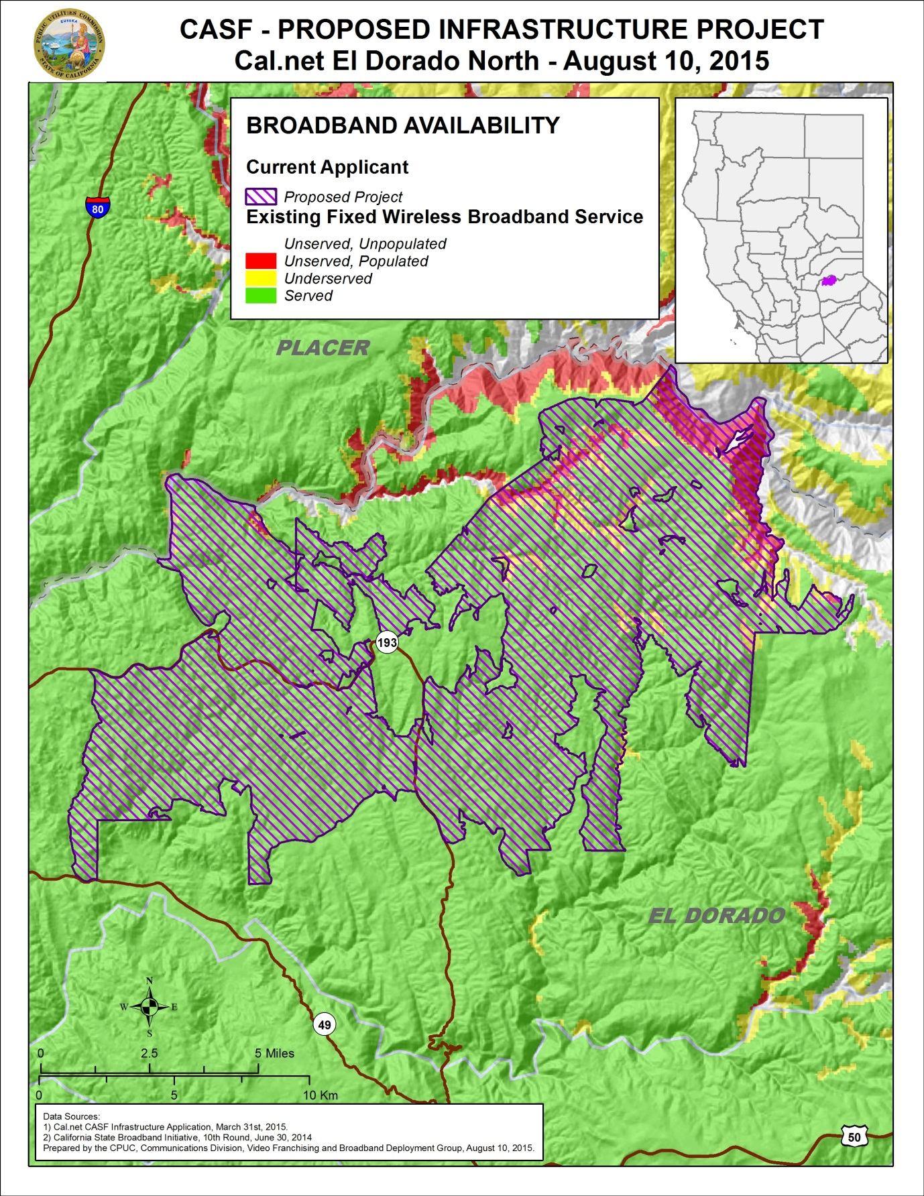
Appendix E
Resolution T-17497 Cal.net’s El Dorado North Project
Existing Mobile Wireless Services Levels
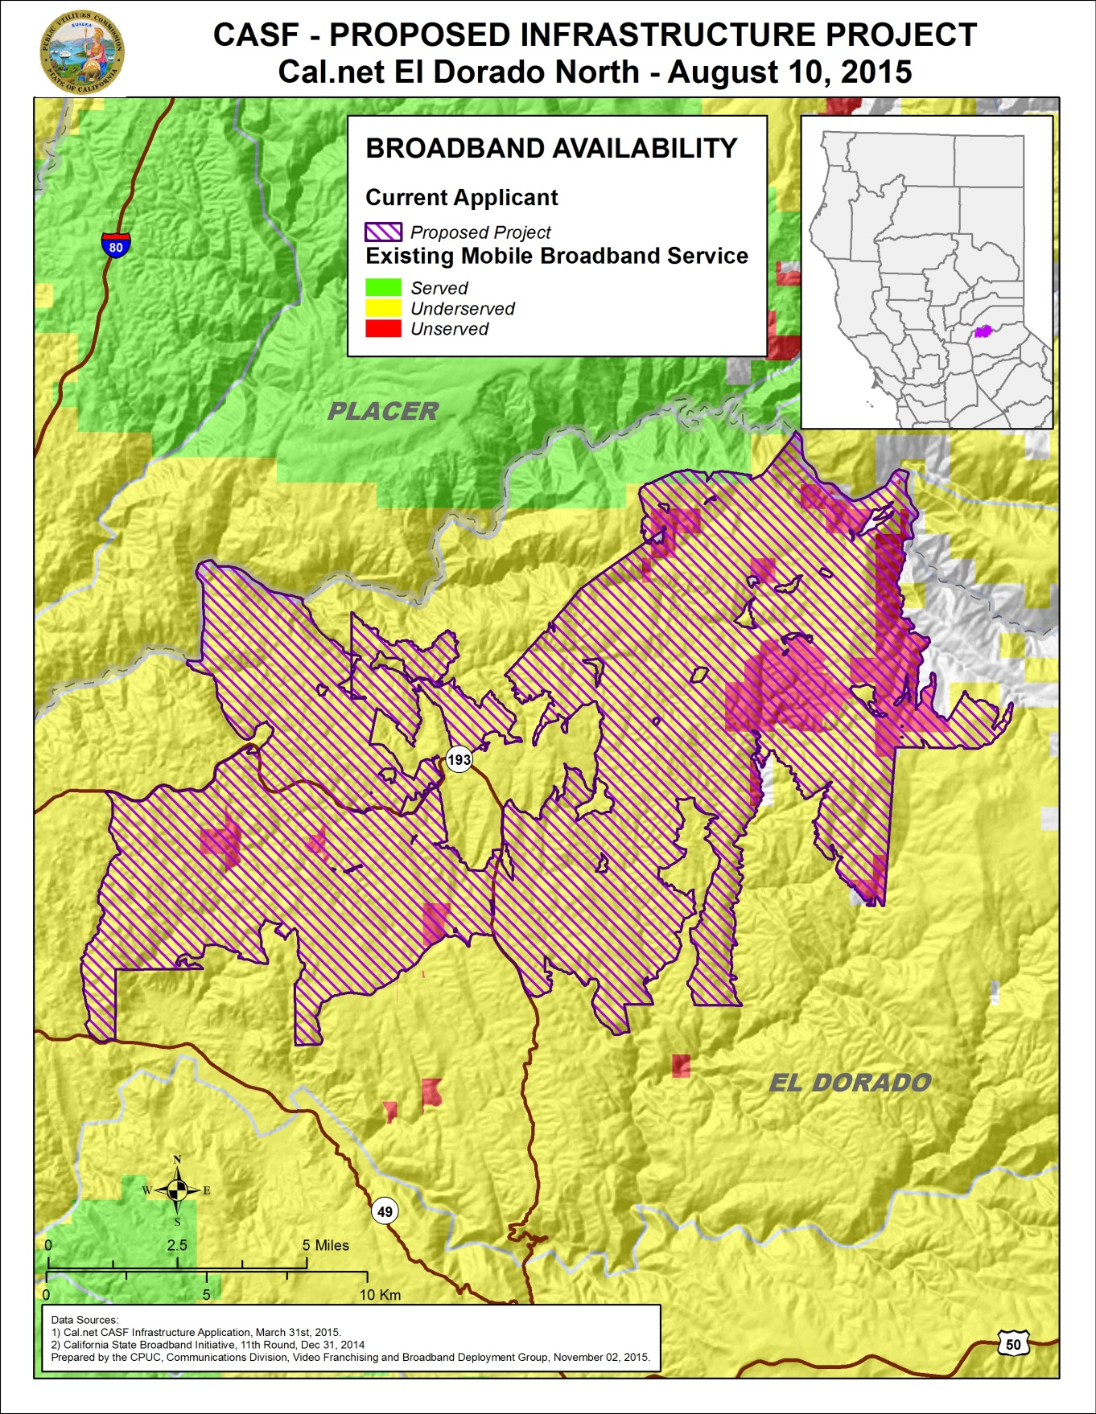

Cal.net is a non-telephone corporation. Cal.net does not possess either a Certificate of Public Necessity and Convenience (“CPCN”) or a Wireless Identification Registration (“WIR”). It has registered with the Commission and was issued a “U-Number.”
These fire stations include: Garden Valley Fire Protection District, Georgetown Fire Department, Station 61, Georgetown Fire Department, Station 62, Georgetown Fire Department, Station 63, Georgetown Fire Department, Station 64 and Georgetown Fire Department, Station 65.
Stats. 2010, c. 317, codified at Public Utilities (P.U.) Code § 281.
Pub.Util. Code § 281(b)(1).
D.12-02-015, p. 9.
Id. p. 17.
The speed threshold for underserved areas is at least 6 Mbps download and 1.5 Mbps upload. (D.12-02-015, p. 17.)
CD removed 167 households from Cal.net’s original household estimate of 1,704, and determined that 1,537 households are not receiving broadband service within the proposed project boundaries.
CD consulted the latest version of the California Interactive Broadband Availability Map, with data current as of June 30, 2014.
Cal.net’s CASF application, Req15, EDCN – Potential Subscriber Size.xlsx, “By CBG” Workbook, Column D “Existing Customers (Households).”
Estimated households currently receiving service by Central Valley Broadband in Cal.net’s North El Dorado service area was provided to CD staff by the company’s owner in a phone conversation on November 4, 2015.
Cal.net’s CASF application, Req14, EDCN – Assertion of Unserved or Underserved, p. 2.
CD also found broadband availability at served speeds by two satellite providers, Hughes.net and Skycasters.LLC. However, non-CASF satellite service is excluded from eligibility determinations for CASF based on the limited speed capabilities of satellite services, the cost to the consumer, high latency, and the service unreliability known at the time of the decision. (D.12-02-015, pp. 13-15.)
D.12-02-015, p. 17.
http://www.hcd.ca.gov/housing-policy-development/housing-resource-center/reports/state/inc2k15.pdf
Round 10 Data.
Letter from Brian Veerkamp, County of El Dorado Board of Supervisors, dated June 23, 2015.
Letter from The Sierra Economic Development Corporation and GCBC dated April 13, 2015, Resolution No.2015-001, p. 1.
For example, if the overall project construction commences July 1, 2016, then the price guarantee period lasts until June 30, 2021 regardless of whether any particular area within the project is brought into service in July 2016 or January 2017 or June 2018. Email from Ken Garnett of Cal.net dated November 20, 2015, with Subject line “El Dorado North—Pricing Commitment Clarification.”
Email from Ken Garnett of Cal.net dated July 31, 2015, with Subject line “Waiver of VoIP setup fees.”
See D.14-02-018
The Commission has the authority to enforce the terms and conditions of the grant award and to impose penalties under Pub. Util. Code §§ 2111 and 2108. (See D.14-02-018, p. 36.)
Email from Ken Garnett of Cal.net dated November 20, 2015, with Subject line “El Dorado North—Pricing Commitment Clarification.”
Pub. Util. Code §§ 270, 274 and 281.
Approval of the California Advanced Services Fund (CASF) Application Requirements and Scoring Criteria for Awarding CASF Funds (2008) Cal. P.U.C. (T-17143 p. 4).

