PUBLIC UTILITIES COMMISSION OF THE STATE OF CALIFORNIA

Communications Division | RESOLUTION T-17488
Broadband, Policy and Analysis Branch | January 14, 2016

R E S O L U T I O N

Resolution T-17488 Approval of Funding for the Grant Application of Race Telecommunications Inc. (U-7060-C), from the California Advanced Services Fund (CASF) in the Amount of $2,037,721 for the Five Mining Communities Underserved Broadband Project.
____________________________________________________________

Summary

This Resolution approves funding in the amount of $2,037,721 from the California Advanced Services Fund (CASF) Infrastructure Grant Account for the CASF grant application of Race Telecommunications Inc. (Race) for its Five Mining Communities Underserved Broadband Project (Five Mining Communities Project). The Five Mining Communities Project will extend high-speed internet service via fiber-to-the-premises (FTTP) to a 1.55 square mile project area at a cost of $10,087 per household. The project area is located in northwestern San Bernardino County and eastern Kern County. Facilities will interconnect through a nearby Digital 395 hub as well as an approved Race CASF project in Boron, California. The communities that will be served are Randsburg, Johannesburg, and Red Mountain, which after this installation will have gigabit broadband service available to 202 households in the total project area with a population of 365. All of the communities have been identified as Priority Areas by Resolution T-17443.

Further, this project includes social and economic benefits to the five communities in the form of improved access to e-health services and online educational and economic opportunities. The project will provide communications facilities and voice services that meet battery backup and E911 data standards, and provide access to local public-safety answering point (PSAPs).

Background

On December 20, 2007, the California Public Utilities Commission (Commission) in Decision (D.) 07-12-054 established the CASF program as a two-year program to provide funds for the deployment of broadband infrastructure in unserved and underserved areas in California.

On September 25, 2010, Governor Schwarzenegger signed Senate Bill (SB) 1040, which codified the CASF program and expanded it to include three accounts: (1) the Infrastructure Grant Account, (2) the Consortia Grant Account, and (3) the Revolving Loan Account. The latter two accounts are intended to address the needs that were unmet under the original CASF program. Specifically, the purpose of the Revolving Loan Account is “to finance capital costs of broadband facilities not funded by a grant from the Broadband Infrastructure Grant Account.” SB 1040 also expanded the CASF fund from $100 million to $225 million with the addition of $100 million to the Infrastructure Grant Account, and allocation of $10 million and $15 million to the Consortia Grant Account and the Revolving Loan Account, respectively.

On February 1, 2012, the Commission approved D.12-02-015 to implement new guidelines for the Infrastructure Grant and Revolving Loan Accounts. Key provisions of the Decision include:
- A maximum CASF grant award of 70 percent of project costs for unserved areas and 60 percent for underserved areas; and,
- A definition of an underserved area, “where broadband is available, but no wireline or wireless facilities-based provider offers service at advertised speeds of at least 6 megabits per second (Mbps) downstream and 1.5 Mbps upstream (6 Mbps /1.5 Mbps).”
Subsequently, on June 26, 2014, the Commission approved Resolution T-17443, which (relevant to this resolution) opened the CASF Broadband Infrastructure Grant Account to new applications as of December 1, 2014, and offered existing providers a “right of first refusal” to upgrade service in unserved and underserved areas.

On December 8, 2014, Race, a California Local Exchange Carrier (CLEC), submitted an application for CASF funding to bring symmetrical 1 gigabit-per-second broadband service to the homes and businesses in the underserved areas of northwestern San Bernardino County, covering Randsburg, Johannesburg, Red Mountain, Trona, and Searles Valley. No existing provider, including Verizon, the only landline service provider in the area, made a commitment to upgrade service in the project area before the November 1, 2014, “right of first refusal” deadline. However, a new entrant into the local market filed a comment on this draft resolution, claiming to serve the Trona/Searles Valley portion of the project area. Race subsequently removed this disputed area from its project. The remaining portion of the project area has been determined by CD staff to be underserved. Therefore, CD deemed the Five Mining Communities Project area eligible for new applications.

Notice/Protests

On December 15, 2014, Communications Division (CD) posted the proposed project area map, census block groups (CBGs) and zip codes listed by county for the Five Mining Communities Project on the Commission’s CASF website under “CASF Application Project Summaries” and also sent notice regarding the project to the CASF distribution list. CD received no challenges to the proposed project area.

Discussion

This Resolution adopts CD’s recommended CASF funding award of $2,037,721 for the Five Mining Communities Project. The grant amount of $2,037,721 represents 60% of the total underserved project cost of $3,396,201. Key project information and maps are shown in Appendix A.

Project Overview

Race has a Certificate of Public Convenience and Necessity (CPCN) (U-7060-C) and has been a fiber-based CLEC provider of next generation Voice over Internet Protocol (VoIP)/Digital telephone and video via Internet Protocol television (IPTV) and traditional cable/satellite television for the past 12 years.

The proposed Five Mining Communities Project area covers the communities of Randsburg, Johannesburg in Kern County, and Red Mountain in San Bernardino County. This area has no wireline broadband availability at all. When completed, the project will provide broadband access over FTTP to 202 households, as well as many businesses and at least five community anchor institutions at speeds of 1 Gigabits per second (Gbps) download and 1 Gbps upload.

The Five Mining Communities Project will extend high-speed internet service to an area totaling 1.55 square miles through the aerial deployment of a FTTP last mile network. This expansion will bring high-speed internet access to 202 households in San Bernardino and Kern Counties. The CBGs impacted by the project are: 060290065002 and 060710089012, with a project-wide median income of $33,128.

All of the communities have been identified as Priority Areas by Resolution T-17443. The Inland Empire Regional Broadband Consortium has designated Red Mountain as a Priority Area while the Eastern Sierra Connect Consortia has identified Randsburg/ Johannesburg as a Priority Area. The communities have expressed overwhelming support for the proposed project as evidenced by the nineteen individual letters of support for this project received by the Commission.

When completed, the project will reach an estimated 202 households, with all customers capable of achieving speeds of 1 Gbps both download and upload – well above the Commission-defined “served” threshold of 6 Mbps download and 1.5 Mbps upload. The CASF per-household subsidy is $10,087 per household.

Race’s current infrastructure in California consists of an end‐to‐end fiber optic network from the internet source at One Wilshire in Los Angeles to the end‐user premises. Race currently has no broadband infrastructure within five miles of the proposed service area. The Race network is designed according to Open Systems Interconnection (OSI) standards, providing access to anyone who can comply with IEEE 802.3 Ethernet, IEEE 802.3u fast Ethernet, or IEEE 802.3z Gigabit Ethernet, as well as dark fiber services on a non‐discriminatory basis. Race currently provides digital voice service that meets all Federal Communications Commission (FCC) E911 service and battery backup requirements.

The Five Mining Communities Project will build on previous CASF projects by connecting to existing Digital 395 facilities via a dark fiber Indefeasible Right of Use from the Race Boron Central Office to the Ridgecrest Digital 395 Node. Race will also add a drop in the Randsburg/ Johannesburg/ Red Mountain ODC for network ring protection. This will ensure a reliable connection while also leveraging prior CASF investments.

The proposed Race fiber optic network is designed using 100-Gigabit backbone infrastructure to all 202 households in the project area which will enable Race to offer IP-based products and services that meet both residential and enterprise requirements. The fiber cables will be installed by Race on existing utility poles, to which Race will have access as a CPCN holder. This will be an entirely aerial installation along existing rights-of-way which are already in use. The use of fiber optics as the standard transmission medium allows Race to adapt to market and technology changes by upgrading the electronic equipment installed on each end.

In terms of its broadband pricing, Race has committed to a two-year plan starting from the initial date of service under the following terms:

Race Five Mining Communities Project
Monthly Recurring Rates
Residential | Entry Level Speed 25 Mbps Down and 25 Mbps Up | $25
 | Mid-Level Speed 100 Mbps Down and 100 Mbps Up | $65
 | Other Optional Tier Speed 250 Mbps Down and 250 Mbps Up | $85
 | Max Level Speed 1000 Mbps Down and 1000 Mbps Up | $100
Business | Entry Level Speed 25 Mbps Down and 25 Mbps Up | $60
 | Max Level Speed 1000 Mbps Down and 1000 Mbps Up | $200
Setup Fees |  | $0
Wireless Router (Optional) |  | $10

Race’s proposed pricing for residential broadband service in the proposed project area is affordable compared to other provider offerings and is lower than its own current metropolitan area rates. According to Race, the pricing for business broadband service is more expensive than residential broadband service to account for a greater level of customer service support for businesses. An account executive is assigned to assist in identifying the needs of a business customer. The account executive’s responsibility is to take as much time as required to supply the correct service form, provide the solution, and provide customer service at all times. Business customers may call the 24/7 customer service line to report issues or outages and are flagged differently from residential customers in the system based on Service Level Agreement. Issues may be escalated so that technicians may be dispatched immediately to resolve issues. These service rates are very close to previous rates for the last four Race’s Projects that the Commission awarded in 2013 and 2014. Additionally, there is no long-term commitment required by the consumer.

Project Qualification

To qualify for the CASF program, an applicant is required to submit proof that the area is unserved or underserved by submitting shapefiles of the proposed project. CD staff review included: comparison of submitted shapefiles with United States 2010 Census data and the California Interactive Broadband Availability Map to determine whether the area is eligible either as an unserved or underserved area and determination that all other information submitted by the applicant meets the requirements outlined in D.12-02-015. Other information reviewed includes: proof of a CPCN from the Commission; descriptions of current and proposed broadband infrastructure; number of potential subscriber households and average income; project construction schedule; project budget; proposed pricing and commitment period for new subscribers; financial viability of the applicant; and project area availability test data provided by the applicant.

In reviewing Race’s application, CD checked the CBGs as submitted in the project application to determine that the project was indeed not served at adequate speeds via wireline or fixed wireless providers. The communities of Randsburg, Johannesburg and Red Mountain have no wireline broadband service at all.

The California Interactive Broadband Availability Map data available at the time of the application showed that some portions of the project may have mobile broadband available from Verizon Wireless at served speeds. Because the California Interactive Broadband Availability Map is based on interpolated data from testing that was conducted outside of the project area, CD staff requested that Race provide test results from populated sections within the project area. Accordingly, Race conducted ten tests of Verizon Wireless mobile broadband on March 5, 2015 using the CalSPEED app. Test results were inconsistent, showing served, underserved and unserved speeds within the project area. These results can be found in Appendix A.

On November 12, 2015, staff published new maps that used a stricter service quality of 98% availability. As a result, most areas previously ineligible were now eligible. In the case of the Five Mining Communities Project, the most recent California Interactive Broadband Availability Map does show the project area to be underserved by mobile. Additionally, several of the speed tests completed by Race from within the project area reported mobile broadband at underserved and unserved speeds. Therefore, CD finds that the project area is grant-eligible.

Project Evaluation and Recommendation for Funding

CD evaluated the application with respect to the scoring criteria defined in D.12-02-015, Appendix 1, Section VIII (Scoring Criteria). The Scoring Criteria includes: (i) Funds Requested per Potential Customer; (ii) Speed; (iii) Financial Viability; (iv) Pricing; (v) Total Number of Households in the Proposed Area; (vi) Timeliness of Completion of Project; (vii) Guaranteed Pricing Period; and (viii) Low-Income Areas. In addition, five bonus points are added to the score of an applicant that is able to submit local government and community endorsements or letters of support.

Staff recommends this project for funding based on how it ranks compared with previously funded CASF projects with regard to speed, pricing, serving low-income areas and expressed community support. The highest relative score for this project is for its high-speed offering, with maximum advertised speeds of 1 Gigabits per second (Gbps) download and upload available to all households. The project also encompasses several anchor institutions in low-income communities which will benefit from the deployment of high-speed internet access in the area.

In addition, the project scored well compared to other projects particularly in speed, community support, pricing and extending broadband to low-income areas. The applicant will charge as low as $25 per month for 25 Mbps, and all residents will have access to as much as 1 Gbps for $100 per month. The applicant estimates completion of the project in 21 months and the project will target low-income areas where the average estimated median household income is less than $35,000 annually. Race has targeted these areas for broadband deployment with the support of local consortium members because of the existence of customer demand and because it determined the project to be economically feasible with the assistance of a CASF grant of $2,037,721 to match Race’s funding of $1,358,480.

The CPUC received nineteen letters from the community supporting the Five Mining Communities Project. The fiber network will pass all the anchor institutions in the project area. These anchor institutions are:

- The Department of Forestry and Fire Protection (Cal Fire)
- Randsburg Elementary School
- San Bernardino County Sheriff Department
- San Bernardino County Fire Department
- U.S. Fire Service, Kern County
- United States Post Offices (Randsburg, Johannesburg)

This project is in a remote area of the Mojave Desert with an isolated population. The median household income for the project area is $33,128. Most of the support letters claim that over 20% of the project area residents are below the poverty line. The project area was classified as ‘severely disadvantaged’ by the Rural Communities Assistance Corporation in March 2011. The high percentage of low-income households in the area makes the fact that Race scored well in price all the more important as a factor for these communities. Race’s proposed price for its lowest speed tier represents a 21% discount over the lowest-priced regional competitor’s offering, a much-needed affordable rate in this area.

Many supporters noted that the Five Mining Communities Project would be an excellent way to leverage prior CASF investment nearby. All of the households in this project area are quite close, if not directly adjacent to Digital 395. One support letter noted, “our community is not able to connect to the high speeds that are available literally in our front yards as Digital 395 runs across our properties.” Another supporter called it a “tragic waste of capability” that without last mile sponsorship the fiber optic lines that are already there cannot be utilized by these communities lying in “telecommunication’s black hole.”

CD found that the Five Mining Communities Project meets CASF funding requirements with respect to the following factors:

- Speed – the proposed speed offering of 1 Gbps download and 1 Gbps upload complies with the benchmark set by the Commission;
- Service Area- is determined to be underserved and covers 1,55 square miles;
- Matching Funds (40% of the project cost) – the applicant has certified that the matching funds will come from their capital budget; the submitted balance sheet, income and cash flow statements show that the applicant is financially viable and has the financial capability to match the funds;
- Price Commitment Period- the applicant has committed to a pricing plan of two years as required;
- Deployment Schedule – the project will be completed within 21 months, less than the 24 month period construction timeline required.

Moreover, the local regional consortia (Eastern Sierra Connect Consortium and Inland Empire Regional Broadband Consortium) have identified the Five Mining Communities Project area as high priority for broadband deployment. On March 3 and 4, 2014, at the CASF’s Annual Consortia Learning Summit, Consortia groups identified their priority areas in need of broadband deployment throughout the State. Funding deployment in these communities will contribute to reaching the legislative mandate of the CASF program to approve funding for infrastructure projects that will provide broadband access to no less than 98% of California households no later than December 31, 2015.

Based on its review, CD determined that Race’s grant application qualifies for funding as an underserved project, and meets the requirements of D.12-02-015. CD recommends Commission approval of CASF funding for Race’s Five Mining Communities Project.

CD staff finds that funding Race’s Five Mining Communities Project aligns with CASF’s goal to encourage the deployment of high-quality advanced information and communications technologies to all Californians to promote economic growth, job creation, and substantial social benefits.

Safety Considerations

The culmination of this project improves connectivity to the surrounding areas and a number of anchor institutions within the project area. The fiber connects the project area to the San Bernardino County Sheriff and Fire Departments, and Cal Fire, Kern County. Race’s fiber project will make it possible to connect this area to the closest communications hub allowing for reliable and stable connectivity.

The CASF program encourages the deployment of broadband throughout the state, which can enable the public to access internet-based safety applications, access to emergency services, and allow first responders to communicate with each other and collaborate during emergencies. As the Governor’s Broadband Task Force stated in its 2007 report, ubiquitous broadband will play a key role in enhancing public safety operations and applications in law enforcement, disaster relief, traffic management, and virtually every other aspect of public safety. Telephone and broadband allows access to these facilities and providers and can be a critical factor in health and safety emergencies.

In the Five Mining Communities Project area, there is no wireline internet service at any speed. Mobile internet service at underserved speeds is the only option for these communities. As noted in the June 2015 CalSPEED report, rural areas experience higher rates of failure, dropped connections and other service quality compromises than users in urban areas. This could be a key safety issue if mobile broadband users are unable to reach 9-1-1 or utilize upcoming Next Generation 9-1-1 services. Letters from supporters in the community noted the increased risk of safety issues due to reliance on mobile broadband (delivered via above-ground facilities.) More importantly for fire safety consideration is the fact that the Five Mining Communities Project will allow this aerial last mile to connect to an underground backbone that is more fire resistant.

The high-speed internet connections facilitate the transmission of data and communications amongst first responders and to the public. The anchor institutions in the adjacent area, such as the sheriff’s office and fire department will benefit from the broadband project as will the area’s schools, homes and workplaces. Additionally, voice service provided as a part of this project would meet safety standards, including battery backup, E911 data and access to local PSAPs.

Compliance Requirements

Race should comply with all the guidelines, requirements, and conditions associated with the granting of CASF funds as specified in D.12-02-015. Such compliance includes, but is not limited to:

- California Environmental Quality Act (CEQA)

All CASF grants are subject to CEQA requirements unless the project is statutorily or categorically exempt pursuant to the CEQA Guidelines.

Race has provided the Commission with construction plans for the Five Mining Communities Project. In order to deliver last mile service to households in the area, Race intends to make use of Digital 395 long-haul facilities available at both Boron and Ridgecrest. These middle mile connections will utilize existing interconnect points connected via aerial fiber on existing poles. Race has stated that all fiber will be installed on existing utility poles. All proposed work is in already disturbed land avoiding cultural resources utilizing existing rights of way and easements to lessen the environmental impact.

This aerial design will comply with the pole loading requirements of General Order 95. Utilizing K&B Engineering, an engineering firm, Race has stated that it will apply and exercise the process to determine whether pole loading requirements pass or fail. All fiber will be placed in the appropriate space on the existing utility pole in compliance with General Order 95.

Based on the above information, the project qualifies for the following categorical exemptions from CEQA: CEQA Guidelines Section 15301 – Existing Facilities, involving minor alterations to existing utility facilities, and CEQA Guidelines Section 15304 – Minor Alterations to Land, involving minor trenching and backfilling where the surface is restored.

- Deployment Schedule

The Commission expects Race to complete the project in 21 months from the start date. If the applicant is unable to complete the proposed project within the 21-month timeframe identified in its application, Race must notify CD's Director as soon as it becomes aware of this prospect. The Commission may reduce payment for failure to notify CD's Director and timely complete the project.

- Execution and Performance

CD staff and the CASF grant recipient shall determine a project start date after the CASF grant recipient has obtained all approvals. Should the recipient or contractor fail to commence work at the agreed upon time, the Commission, upon five days written notice to the CASF recipient, reserves the right to terminate the award.

In the event that the CASF recipient fails to complete the project, in accordance with the terms of approval granted by the Commission, the CASF recipient must reimburse some or all of the CASF funds that it has received.

The CASF grant recipient must complete all performance under the award on or before the termination date of the award.

- Performance Bond

The Commission does not require a Performance Bond if the applicant certifies that the percentage of the total project costs it is providing comes from their capital budget and is not obtained from outside financing. In its application, Race certified that the percentage of the total project costs it is providing will come from its existing capital budget. Therefore, a performance bond is not required for this project.

- Price Commitment Period

The minimum required price commitment period for broadband service to all households within the project area is two years. Race guarantees the price of service offered in the project area for two years.

- Project Audit

The Commission has the right to conduct any necessary audit, verification, and discovery during project implementation and construction to ensure that CASF funds are spent in accordance with Commission approval.

The recipient’s invoices will be subject to a financial audit by the Commission at any time within three (3) years of completion of the work.

- Providing Voice Service

If the grantee is providing voice service in the project area, it must meet the FCC standards for E-911 service and utilize battery backup Power.

- Reporting

Grantees must submit quarterly progress reports on the status of the project irrespective of whether grantees request reimbursement or payment. Before full payment of the project, the CASF recipient must submit a project completion report. Progress reports shall use both the schedule for deployment; major construction milestones and costs submitted in the proposals, indicate the actual date of completion of each task/milestone as well as problems and issues encountered, and the actions taken to resolve these problems and issues during project implementation and construction; and identify future risks to the project. Recipients shall also include test results on the download speed and upload speed per CBG and per ZIP Code basis in the final completion report. Recipients must certify that each progress report is true and correct under penalty of perjury.

- Submission of Form 477

The FCC currently requires broadband providers to submit Form 477 biannually and include speed data. While there is an imperfect match between the current reporting areas for the Form 477 and CASF, Form 477 information will be useful in documenting CASF deployment for the specific new service area(s) of the carrier. CASF recipients shall submit a copy of their Form 477 data directly to the Commission, under General Order 66-C, when they submit this data to the FCC for a five year period after completion of the project.

Payments to CASF Recipients

Submission of invoices from and payments to Race shall be made at 25-percent completion intervals, in accordance with Section XI of Appendix 1 of D.12-02-015 and according to the guidelines and supporting documentation required in D.12-02-015.

Payment to Race shall follow the process adopted for funds created under P. U. Code § 270. Payments are generally processed by the Commission, including CD and Administrative Services review time, within 20-25 business days. The State Controller’s Office (SCO) requires an additional 14- 21 days to issue payment from the day that requests are received by SCO from the Administrative Services.

Comments on Draft Resolution

In compliance with P.U. Code § 311(g), a notice letter was emailed on October 29, 2015, informing all parties in the CASF Distribution List of the availability of the draft of this Resolution for public comments at the Commission's website at http://www.cpuc.ca.gov/documents/. This letter also informed parties that the final conformed Resolution adopted by the Commission will be posted and will be available at this same website.

Staff received one opening comment from SBC-Wireless, a new wireless Internet service provider, and no reply comments. SBC-Wireless claims to offer residential broadband service in Trona at speeds up to 25 Mbps download and 10 Mbps upload. The monthly rate for the lowest advertised tier at served speeds is $89.99 for 7 Mbps download and 2 Mbps upload. In its comment, SBC-Wireless maintains that Race should not receive CASF funding for the Trona area where they claim to have service available, and that approving this application would be detrimental to SBC-Wireless’ business prospects and its employees in an “area with a higher-than-average unemployment rate.”

Staff followed up with SBC-Wireless and was told that SBC-Wireless began operations in the area in late October 2015, has eight employees, and as of November 20, 2015 has 142 residential customers signed up for service. Working with Staff, the company subsequently began participation in the State Broadband Mapping data submission program, and submitted several speed tests from the Trona/Searles Valley area. As a result of this new data, Race removed the Trona/Searles Valley area from the Five Mining Communities Project. This resolution does not provide any CASF funding for the area claimed to be served by SBC-Wireless.

Findings

- Race filed an application for CASF funding for its Five Mining Communities Project on December 29, 2014. The Five Mining Communities Project is intended to extend high-speed internet service over a 1.55 square mile area through the expansion of fiber-to-the-premises (FTTP) Last Mile network deployment into the remote area of Race rural exchanges. This expansion will bring high-speed internet access to 202 households covering the Randsburg/Johannesburg/Red Mountain area straddling a portion of western San Bernardino County and a portion of eastern Kern County. The CBGs impacted by the project are: 60290065002 and 60710089012.

- CD posted the map, CBGs and zip codes lists by county for the Five Mining Communities Project on the Commission’s CASF website page under “Pending New CASF Applications to Offer Broadband as of December 15, 2014.” Communications Division did not receive any challenges.

- CD reviewed and analyzed data submitted for the Race Five Mining Communities Project CASF grant application to determine the project’s eligibility for CASF funding. This data includes, but is not limited to: proof of a CPCN from the Commission; descriptions of current and proposed broadband infrastructure; geographic information system (GIS) formatted shapefiles mapping the subject areas; assertion that the area is unserved or underserved; number of potential subscriber households and average incomes; project construction schedule; project budget; proposed pricing and commitment period for new subscribers; financial viability of the applicant; and project area availability test data.

- Mobile availability test results are inconsistent in the project area; community letters argue that mobile broadband available is not sufficient to meet the needs of the communities; and the current California Interactive Broadband Availability Map indicates that the project area is underserved by mobile broadband and unserved by wireline.

- Based on its review, CD determined that the project qualifies for funding under D.12-02-015 and recommends Commission approval of CASF funding for Race Five Mining Communities Project.

- Race is not required to post a performance bond because 40% of the total project cost will be financed through Race’s existing capital budget.

- Race is required to comply with all guidelines, requirements, and conditions associated with the granting of CASF funds as specified in D.12-02-015 and must submit the FCC Form 477, as specified in Resolution T-17143.

- Race proposes to conduct all work in already disturbed land, active right of ways and on and in existing infrastructures with no forest, agricultural land or landmarks disturbed.

- This project is categorically exempt from CEQA review pursuant to CEQA Guidelines Sections 15301 –Existing Facilities and 15304 – Minor Alterations to Land.

- A notice letter was emailed on October 29, 2015, informing all parties in the CASF distribution list of the availability of the draft of this Resolution for public comments at the Commission's website http://www.cpuc.ca.gov/documents/. This letter also informed parties that the final conformed Resolution adopted by the Commission will be posted and available at this same website. One comment was received and was addressed in Section VII of this resolution. Race removed the Trona/Searles Valley area from the Five Mining Communities Project in response to the comment.

- The Commission finds CD’s recommendation to fund the Five Mining Communities Project of Race as summarized in Appendix A to be reasonable and consistent with Commission orders and, therefore, adopts such recommendation.

THEREFORE, IT IS ORDERED that:

- The Commission shall award from the CASF to Race up to $2,037,721 for the Race Five Mining Communities Underserved Broadband Project as described herein and summarized in Appendix A of this Resolution.

- The program fund payment of up to $2,037,721 for this project shall be paid out of the CASF fund in accordance with the guidelines adopted in D.12-02-015.

- Payments to the CASF recipient shall be in accordance with Section XI of Appendix 1 of D.12-02-015 and in accordance with the process defined in the “Payments to CASF Recipients” section of this Resolution.

- The CASF fund recipient, Race, shall comply with all guidelines, requirements and conditions associated with the CASF funds award as specified in D.12-02-015 and must submit the FCC Form 477, as specified in Resolution T-17143.

This Resolution is effective today.

I hereby certify that this Resolution was adopted by the Public Utilities Commission at its regular meeting on January 14, 2016. The following Commissioners approved it:

/s/ Timothy J. Sullivan

TIMOTHY J. SULLIVAN Executive Director

MICHEL PETER FLORIO
CATHERINE J.K. SANDOVAL
CARLA J. PETERMAN
LIANE M. RANDOLPH
Commissioners
I dissent.

/s/ MICHAEL PICKER
President

Resolution T- 17488
APPENDIX A

Race Telecommunication, Inc.
Five Mining Communities CASF Project

Includes:

- Key Information
- Project Maps
- Mobile Testing Results
APPENDIX A
Race Telecommunication, Inc., Five Mining Communities Project
Key Information

CASF Application for the Five Mining Communities Project
KEY INFORMATION FACT SHEET
Project Plan | To deploy a fiber-to-the-premises (FTTP) Last Mile network to serve 100% of the homes in the defined service area at 1Gbps down and up.
Project Size | 1.55 square miles
Download / upload speed | Up to 1Gbps/1Gbps
Location | Randsburg, Johannesburg, Kern County  Red Mountain, San Bernardino County
Community Name | Randsburg, Johannesburg, Red Mountain
CBGs / Household Income | 60290065002 | $23,750
 | 60710089012 | $52,893
ZIP Codes | 93528, 93554, 93558
Estimated Potential Subscriber Size | 202 Households (population 365)
Pricing Plan | Residential  Entry Level Speed 25 Mbps Down and 25 Mbps Up $25  Mid-Level Speed 100 Mbps Down and 100 Mbps Up $65  Max Level Speed 1000 Mbps Down and 1000 Mbps Up $100  Other Optional Tier Speed 250 Mbps Down and 250 Mbps Up $85  Business  Entry Level Speed 25 Mbps Down and 25 Mbps Up $60  Max Level Speed 1000 Mbps Down and 1000 Mbps Up $200
Deployment Schedule (from Commission approval date) | 21 months
Proposed Project Budget | $3,396,201
Amount of CASF Funds Requested (60%) | $2,037,721
Internally funded (40%) | $1,358,480
Total Amount of CASF Award | $2,037,721
Cost per Household | $10,087
APPENDIX A
Race Telecommunications Inc., Five Mining Communities Project
Regional Map
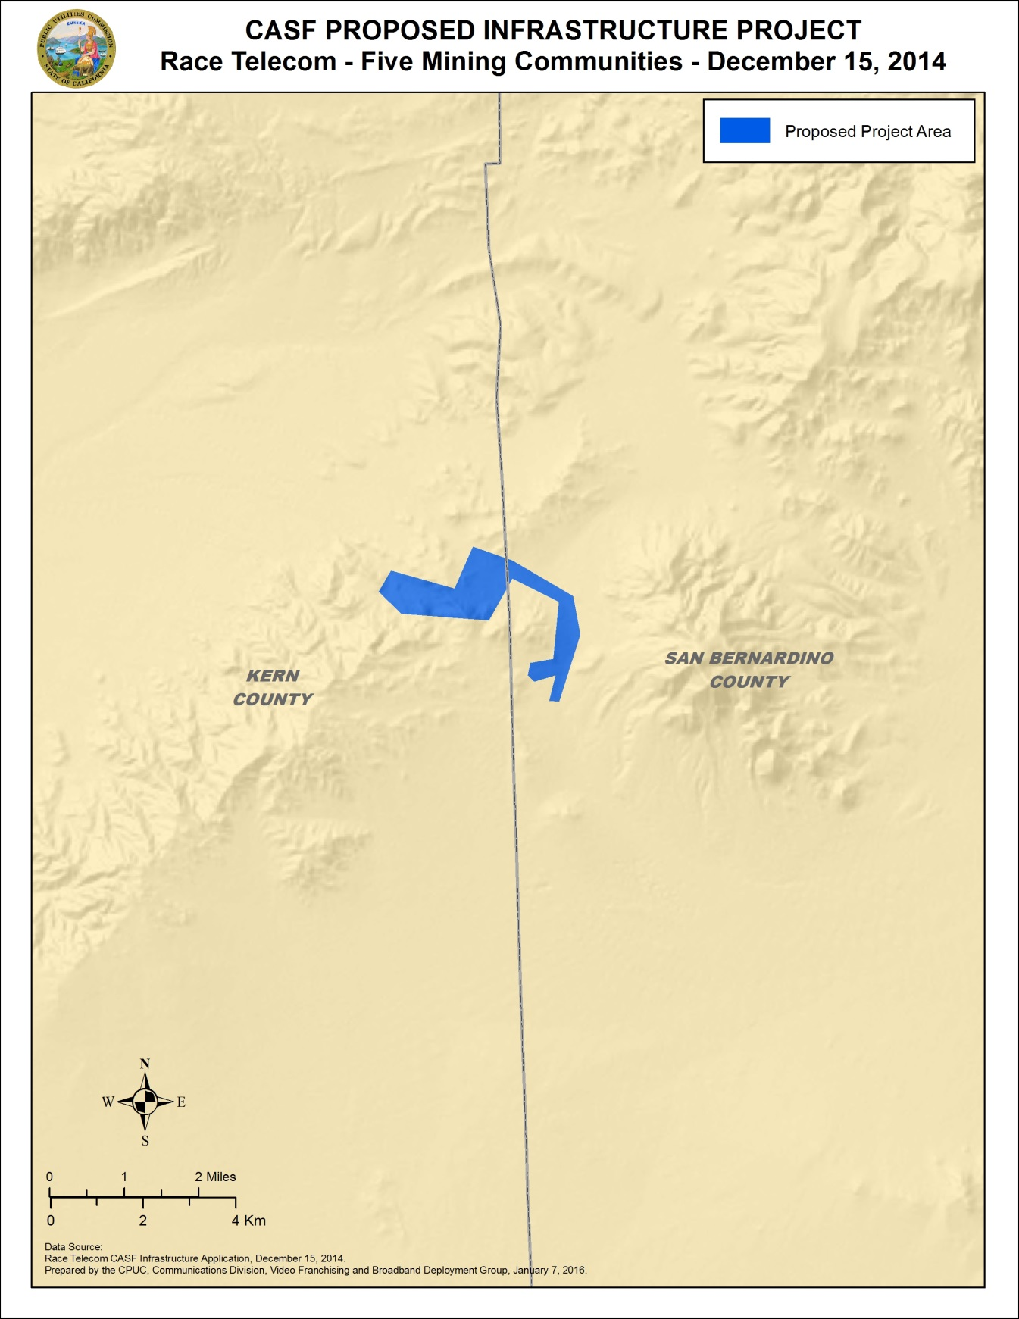
APPENDIX A
Race Telecommunications Inc., Five Mining Communities Project
Wireline Broadband Availability Map - Randsburg, Johannesburg and Red Mountain
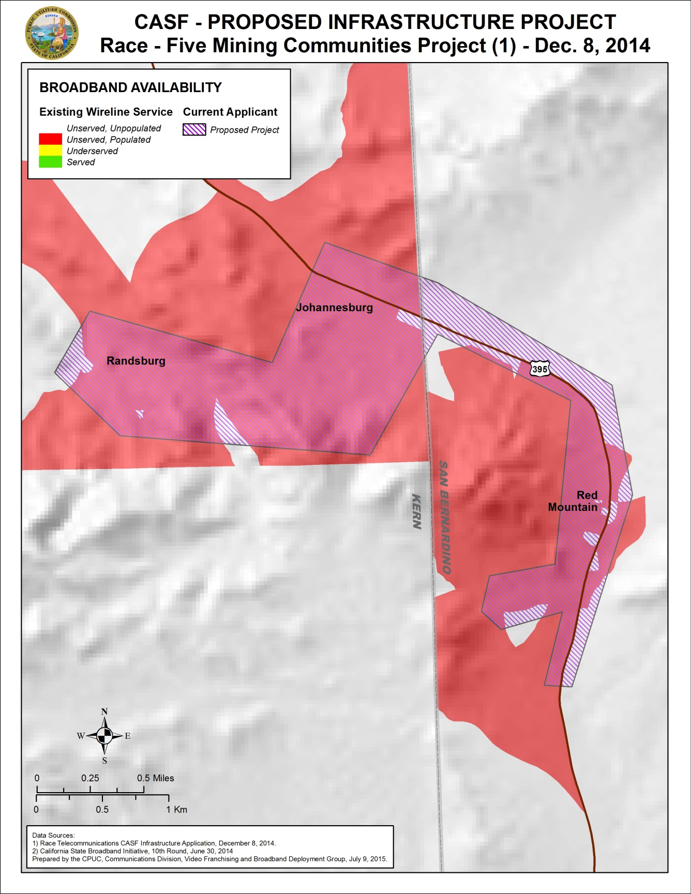
APPENDIX A
Race Telecommunications Inc., Five Mining Communities Project
Mobile Broadband Availability – Downstream Speed
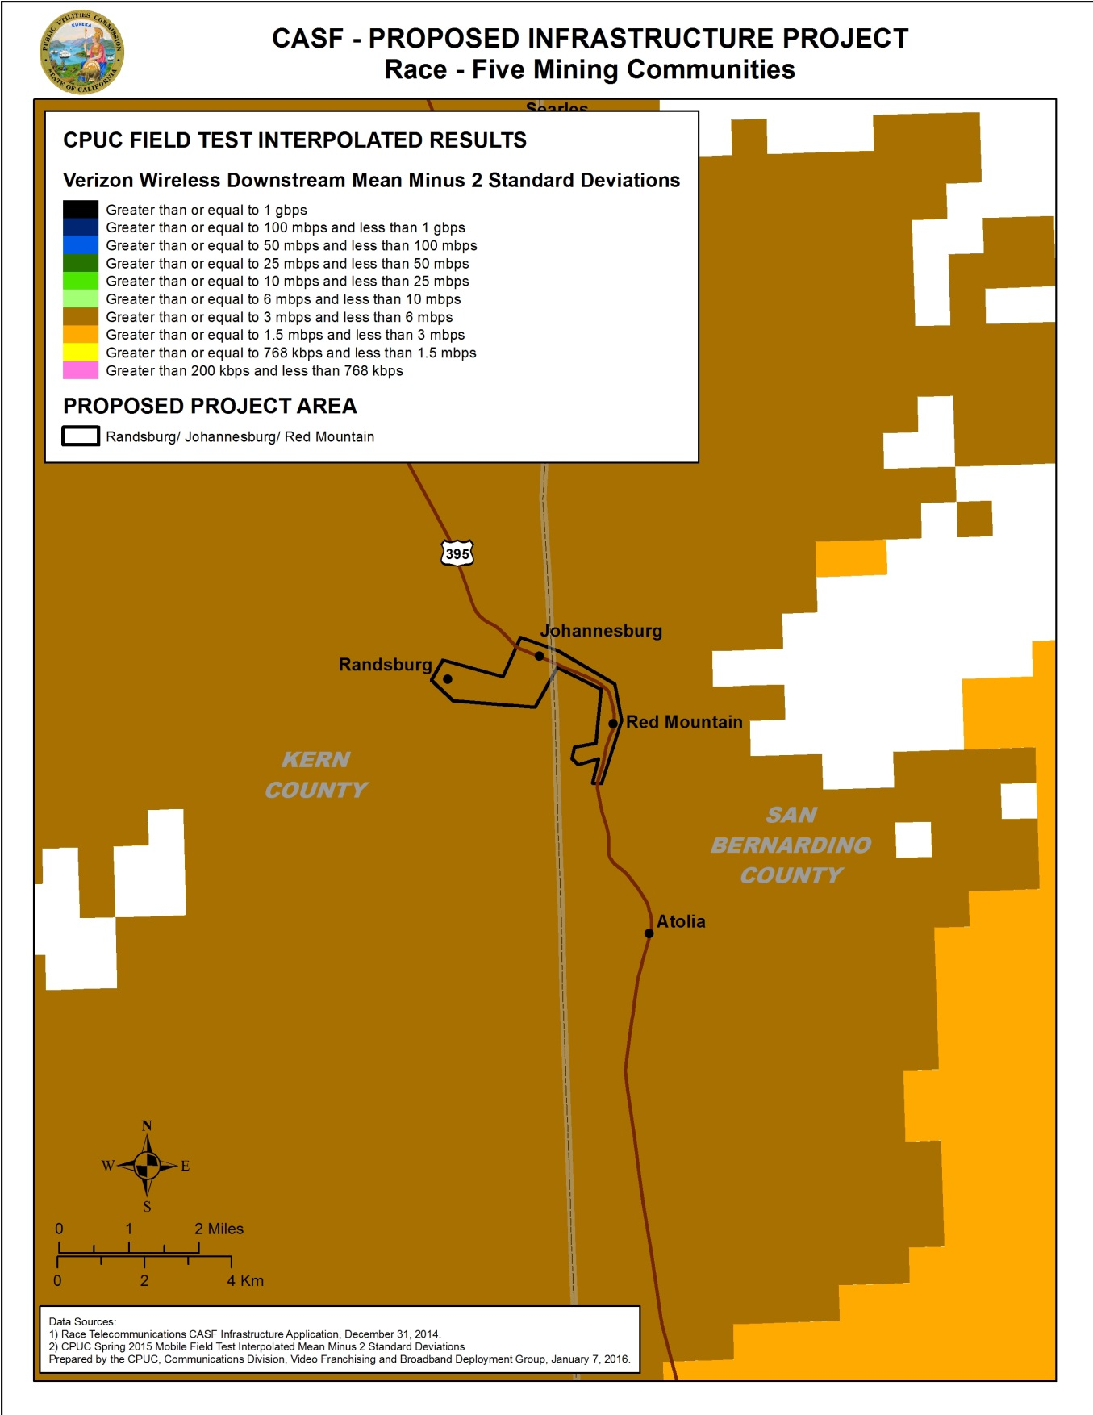
APPENDIX A
Race Telecommunications Inc., Five Mining Communities Project
Mobile Broadband Availability – Upstream Speed
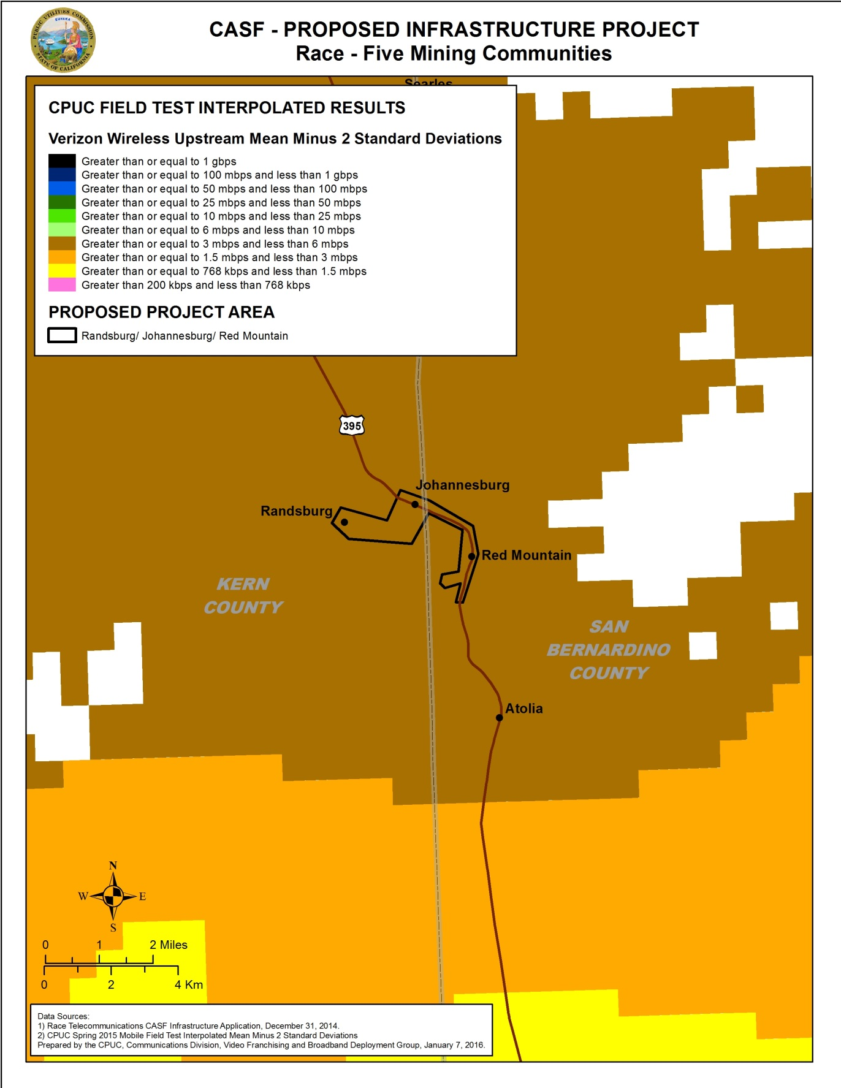
APPENDIX A
Race Telecommunications Inc., Five Mining Communities Project
Mobile Broadband Testing in Randsburg, Johannesburg, and Red Mountain
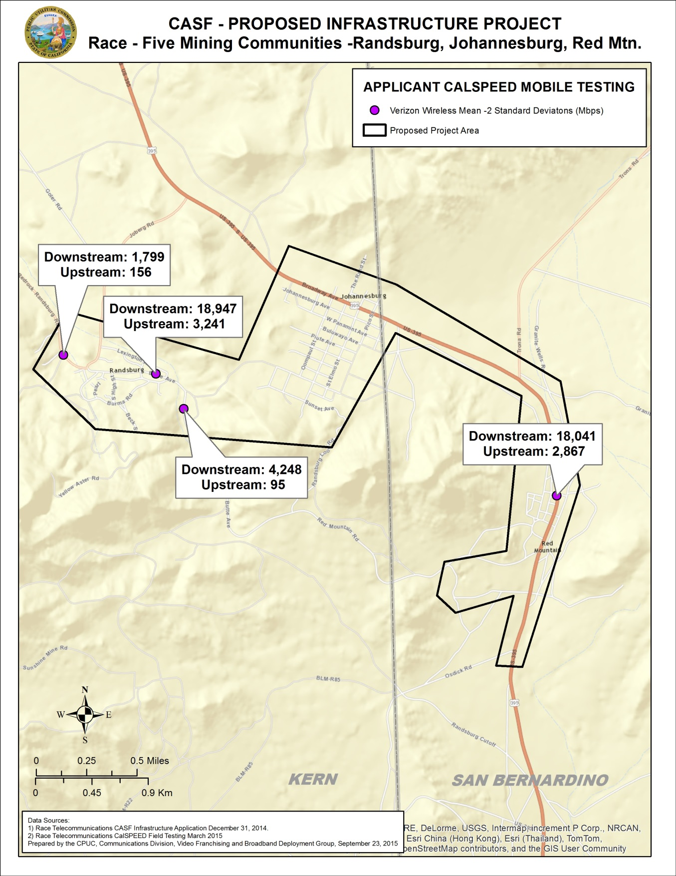

APPENDIX A
Race Telecommunications Inc., Five Mining Communities Project
Wireless Speed Test Summary

Randsburg/Johannesburg/Red Mountain: Verizon Wireless (Mbps Down / Mbps Up)
Availability Map* | Race Test Results** | Race Test 1 | Race Test 2 | Race Test 3 | Race Test 4
Underserved | Mixed Underserved and Served | 1.799 / 0.156 | 18.947 / 3.241 | 4.248 / 0.095 | 18.041 / 2.867

*CPUC Mobile Field Test Results (June 2015)—Interpolated mean minus 2 standard deviation results based on statewide test points
**Race Field Test Results (March 2015) calculated at mean minus 2 standard deviation.

END OF APPENDIX A

Resolution T-17416 approved Race’s Kern County City of Boron Underserved Broadband Project in October, 2013.
Stats. 2010, c. 317, codified at Public Utilities (P.U.) Code § 281.
P.U. Code § 281(e).
P.U. Code § 281(b)(1).
On November 13, 2015, SBC-Wireless Internet, a wireless Internet service provider, commented on this draft resolution and reported that it provides service in the Trona area. These comments are addressed in Section VII.
Calculated from census data as of 6/30/2014 via the California Interactive Broadband Availability Map.
CD received letters supporting this project from the following: the Inland Empire Regional Broadband Consortium; San Bernardino County 211; the High Desert Foundation; San Bernardino Associated Governments; California Telehealth Network; Ridgecrest Regional Hospital; Searles Valley Minerals; Inyo County District 5 Supervisor Matt Kingsley; Mono County Board of Supervisors; San Bernardino County First District Supervisor Robert A. Lovingood; Trona Unified School District; The Inland Empire Economic Partnership; Kern County Supervisor Mick Gleason; Ridgecrest City Manager Dennis Speer; National Public Lands News.Com; Rand Communities Water District; and Red Mountain residents Larry Brogan, William Lubscher, and Dan Stanford. Of the nineteen letters of support received by CD, three were from addresses in Trona.
Race’s outside plant cost per foot was determined by Race and G4S Technologies after months of site surveys. The deployment cost of $16.50 per foot, or roughly $87,000 per mile, is identical to the three other Race projects recently approved by the Commission: Gigafy Backus (T-17480), Mono County (T-17433), and Boron (T-17416).
See Race’s CASF Infrastructure Grant application materials, specifically FMC CEQA Exemption Request, June 15, 2015.
Verizon aDSL is the only nearby available wireline broadband, although it is not available in the project area. However, for comparison purposes, Race’s proposed entry-level plan costs $25 per month for 25 Mbps up and down. Per Verizon.com, Verizon’s entry-level rate is $19.99 for up to 1Mbps down and only 384 Kbps upload. This is an introductory rate good for one year but requires a phone subscription, bringing the total cost to a minimum of $34.99 for the first year.
The latest version of the California Interactive Broadband Availability Map uses wireline data as of June 30, 2014 and mobile field testing data as of June 15, 2015.
Alternatively, applicants may submit a document asserting that they are seeking funding as a non-telephone corporation per Commission Decision 14-02-018, which implements the expanded CASF infrastructure funding eligibility provisions of Senate Bill 740.
CD also found broadband availability at served speeds by ViaSat Satellite provider. However, non-CASF satellite service is excluded from eligibility determinations for CASF per D. 12-02-015, based on the limited speed capabilities of satellite services, the cost to the consumer, high latency, and the service unreliability known at the time of the decision. (D. 12-02-015, pp. 13-15.)
The CPUC has found that average measured speeds are not representative of a consumers’ actual mobile experience. Rather than use the mean throughput, Staff’s analysis quantifies expected speeds at varying confidence intervals by taking into account the distribution of throughput results around the mean in a single testing session. The mean throughput indicates that a consumer would theoretically receive service at least as fast approximately 50% of the time; one standard deviation below the mean indicates that a consumer would theoretically receive service at least as fast approximately 84% of the time; by extension, two standard deviations below the mean indicates a consumer would receive service at least that fast 98% of the time. The two standard deviations below the tested mean is the throughput a consumer can reliably expect to receive. At the time of the application, mobile testing results were interpolated using a mean minus 1 standard deviation approach. The current California Interactive Broadband Availability Map reflects the more exclusive mean minus 2 standard deviation method to interpolate speed data from the approximately 2,000 test points to determine statewide availability. (See “Comments of the California Public Utilities Commission” FCC GN Docket No. 15-191. September 15, 2015.)
The mobile broadband served/underserved/unserved status depicted on the Commission’s California Interactive Broadband Availability Map utilizes 1,986 geographic points around California to measure mobile broadband service availability. The data are then interpolated to predict mobile broadband availability throughout the state. More information is available at http://www.cpuc.ca.gov/PUC/Telco/bb_drivetest.htm.
CalSPEED is the Commission’s mobile application that is used to test mobile broadband speeds using tablets and smartphones. Race’s speed test results are shown in Appendix A.
On November 12, 2015, following CPUC comments to the FCC proposing a reliability standard for mobile availability, staff published new maps using criteria that required service to pass the “98%” availability test (i.e a consumer would receive service at least that fast 98% of the time). Based on this 98% reliability standard, now only 15% of California households are “served” by mobile. This criterion was established by CD using the methodology of two standard deviations below the mean to reflect whether an area is designated served.
See Appendix A, pp. 3 – 8.
http://www.city-data.com/poverty/poverty-Red-Mountain-Trona-California.html
Rand Communities Water District General Manager Michael Powell, Letter to Communications Division Director, Ryan Dulin, June 8, 2015
Verizon aDSL is the only nearby available wireline broadband and is not available in the project area. However, for comparison purposes, Race’s proposed entry-level plan costs $25 per month for 25 Mbps up and down. Per Verizon.com, Verizon’s entry-level rate is $19.99 for up to 1Mbps down and only 384 Kbps upload. This is an introductory rate good for one year but requires a phone subscription, bringing the total cost to a minimum of $34.99 for the first year.
Ridgecrest City Manager Dennis Speer, Letter to Ryan Dulin, June 8, 2015.
Michael Powell, Rand Communities Water District General Manager, Letter to Ryan Dulin, June 8, 2015.
The list of priority areas was subsequently prepared by staff and adopted by the Commission in Resolution T-17443.
See; “CalSPEED: California Mobile Broadband - An Assessment” by Ken Biba, Managing Director and CTO, Novarum, ftp://ftp.cpuc.ca.gov/telco/BB%20Mapping/Field%20Testing/Biba%20Mobile%20Broadband%20Assessment%209%204%2014%20filed.pdf
Mono County Supervisors Timothy Fesko, Fred Stup and Tim Alpers, Letter to Ryan Dulin, March 24, 2015. See also Ridgecrest City Manager Dennis Speer, Letter to Ryan Dulin, June 8, 2015. See also Red Mountain Resident William Lubscher, Letter to Ryan Dulin, June 9, 2015.
The Commission may impose penalties via a resolution for failing to notify CD of delays in the project completion and if `the project fails to meet the approved completion date. (See D.12-02-015, p. 46.)
The Commission has the authority to enforce the terms and conditions of the grant awards and to impose penalties under §§ 2111 and 2108. (See D.14-02-018, p. 36.)
Approval of the California Advanced Services Fund (CASF) Application Requirements and Scoring Criteria for Awarding CASF Funds (2008) Cal. P.U.C. Res. No. T-17143 at 4.
The comment was distributed to the CASF service list on Friday, November 13, 2015.
SBC-Wireless Comment, November 13, 2015.

