PUBLIC UTILITIES COMMISSION OF THE STATE OF CALIFORNIA

Communications Division | RESOLUTION T-17498
Broadband, Video and Market Branch | June 23, 2016

R E S O L U T I O N

Resolution T-17498: Approval of funding for the grant application of a non-telephone corporation, Cal.net, Inc. (U-1340-C), from the California Advanced Services Fund (CASF) in the amount of $1,256,524 to build last-mile fixed-wireless infrastructure to deliver broadband services to underserved rural communities of southern and eastern El Dorado County.

Summary

This Resolution approves funding in the amount of $1,256,524 from the California Advanced Service Fund (CASF) for the grant application of Cal.net, Inc. (“Cal.net”) to provide broadband Internet and Voice over Internet Protocol (VoIP) telephony services to underserved rural communities of the southern and east regions of El Dorado County (El Dorado South and East project). This project will provide broadband services to the Pleasant Valley priority area.

The El Dorado South and East project will cover 142 square miles and will provide broadband speeds of up to 25 megabits per second (“Mbps”) download and 4 Mbps upload to 1,350 underserved households at an average cost of $931 per household. This project will also provide broadband services to five anchor institutions, and will provide safety benefits to the communities in the area by allowing Cal.net to reach and serve six fire stations. Further, the proposed project will enable Cal.net to supply public safety agencies in the area with an interconnected public safety data communications network.

Applicant Request

On March 31, 2015, Cal.net submitted an application for CASF funding to build last-mile fixed wireless infrastructure to provide broadband Internet and VoIP telephony services with speeds of up to 25 Mbps download and 4 Mbps upload to underserved rural communities in the southern and eastern regions of El Dorado County. Cal.net is requesting $1,256,524, which represents 60 percent of the estimated total project cost of $2,093,983. The CASF per-household subsidy is $931, based on 1,350 households that will be given access at served speeds by the grant.

Topography: The El Dorado south and east project includes communities of Twin Bridges, Strawberry, Kyburz, Happy Valley, Gilberts, Omo Ranch, Sweeney’s Crossing, Grizzly Flats, Coyoteville, Outingdale, Somerset, Pleasant Valley, and Melson’s Corner. The proposed project will serve 137 Census Blocks and cover 141.91 square miles. This project encompasses the geographical areas of south-central El Dorado County and the eastern end of the west slope of El Dorado County (along Highway 50 west of Echo Summit) and includes areas that have been identified as “High Priority Areas” in T-17443.

Applicant: Cal.net Inc. (U-1340-C) is a Wireless Internet Service Provider with its base of operations in Shingle Springs, California. Cal.net began its business in 1997, as a facilities-based broadband service provider serving the communities of Davis, Woodland, and western El Dorado County area. Since 2006, Cal.net has been providing fixed wireless rural broadband service. In January 2015, Cal.net began providing residential and business customers facilities-based VoIP telephony service. According to Cal.net, it currently serves customers in western El Dorado and Amador Counties using twenty towers that it has built, four towers it leases from commercial tower companies and repeaters placed over a hundred rooftop locations. Cal.Net currently uses a variety of different technologies to deliver fixed-wireless broadband services, including license-exempt 5 GHz spectrum, lightly-licensed 3.65 GHz WiMAX, license-exempt 2.4 GHz spectrum, license-exempt 900 MHz spectrum, and TV White Space in the UHF bands.

Project: Cal.net proposes to build last-mile fixed wireless infrastructure to provide broadband Internet and VoIP telephony services with speeds of up to 25 Mbps download and 4 Mbps upload in the underserved rural communities of El Dorado County. The project will comprise fixed-wireless technology deployed on towers that are either constructed by Cal.net or leased from owners of existing towers.

Cal.net will use a variety of technologies to service broadband to end users, which includes Unlicensed National Information Infrastructure (“U-NII”) equipment for line-of-sight situations, fixed-LTE (a non-mobile variation of the LTE commonly used in cell phones) for near-line-of-sight situations (minor obstructions), and TV White Space in the UHF and upper-VHF bands for heavily-obstructed non-line-of-sight situations.

According to Cal.net, the VoIP telephony portion of the project will conform to FCC requirements, and will be provisioned via the Company’s existing VoIP infrastructure.
Cal.net for redundancy and additional capacity will also interconnect with the Central Valley Independent Network’s (“CVIN”) fiber network. The proposed project will utilize local subcontractors as much as possible to construct the tower facilities.

Notice and Challenges

On April 9, 2015, Communications Division (CD) posted the proposed project area map, census block groups (CBGs) and zip codes for this project on the Commission’s CASF webpage under “CASF Application Project Summaries”, and sent notice regarding the project to its electronic service list. CD received no challenges to the proposed project area.

There were no commitments made by an existing provider to upgrade service before the November 1, 2014, “first right of refusal” deadline.

Project Review

Project Area Eligibility

For the area to be project eligible, the CASF program requires an applicant to submit proof that the area is unserved or underserved by submitting shapefiles of the proposed project. CD reviews the submitted shapefiles and compares them with United States 2010 Census data and the California Interactive Broadband Availability map. Once CD determines that the area is eligible either as an unserved or underserved area, CD evaluates all other information submitted by the applicant to determine if the project meets the requirements outlined in D.12-02-015.

The California Interactive Broadband Availability Map shows the following:
- Both the eastern and southern regions of the proposed project area are unserved by wireline broadband providers; and
- The southern and eastern region of the proposed project area is underserved by mobile wireless carriers; and
- The eastern region of the proposed project area is unserved by any wireless internet service providers, while the southern region is served by two fixed wireless internet service providers.

There are currently two wireless internet service providers in the southern area, both providing Internet services through fixed wireless technologies. They are Central Valley Broadband, a wireless internet service provider, and the applicant, Cal.net. Of the 1439 households in the southern proposed service area, Cal.net provides service to only 164 households. CD reached out to Central Valley Broadband and found that they provide service to less than 50 households in the area. Therefore, the two wireless internet service providers currently provide broadband service to 214 of the 1,439 households in the southern area. CD removed 214 households that were served by the Central Valley Broadband and Cal.net from the total number of households, reducing the eligible households from 1564 to 1,350 for the total southern and eastern project areas.

Cal.net explains that Central Valley Broadband uses fixed wireless technologies that can only connect customers when line-of-sight connections can be established. However, the proposed project area is heavily forested and as such, cannot be served with the current fixed-wireless technologies. Additionally, Cal.net provided CD with a list of several hundred inquiries from prospective customers in the area that neither they nor any other WISPs in the area can serve.

After evaluating the above evidence, CD determined that although the project area is serviced by two fixed wireless internet service providers, a majority of the households in the area do not have broadband services at Commission-defined served speeds of 6 Mbps download and 1.5 Mbps upload. Because fixed wireless technologies require a line-of-sight connection, not all households in an area will necessarily receive broadband connection, since it depends on the number of trees surrounding each house. The households that have broadband services do not congregate in a specific area but are scattered among the project area. Hence, they cannot be isolated from the project area altogether. Since there are only a limited amount of households that have broadband services at Commission-defined served speeds, and these households are scattered across the proposed project area, CD determined that the project area is underserved.

The California Interactive Broadband Availability map shows broadband availability at served speeds by two satellite providers, Hughes.net and Skycasters, LLC, in the total proposed project area, both southern and eastern El Dorado County. However, as adopted in D.12-02-015, the Commission does not generally consider satellite broadband service in CASF project evaluation, unless said satellite service was established via a CASF grant. CD has determined that there are 1,350 underserved households in the total project area of the southern and eastern El Dorado County and that Cal.net is eligible to receive funding level of 60% of the total project costs.

Project Criteria Evaluation

CD evaluated the application with respect to the scoring criteria defined in D.12-02-015, Appendix 1, Section VIII (Scoring Criteria). The scoring criteria includes: (i) Funds Requested per Potential Customer, (ii) Speed, (iii) Financial Viability, (iv) Pricing, (v) Total Number of Households in the Proposed Area, (vi) Timeliness of Completion of Project, (vii) Guaranteed Pricing Period, and (viii) Low-Income Areas. CD also conducted qualitative evaluation of the project area, existing infrastructure, and community needs.

Funds per Household: The CASF per-household subsidy is $931, based on 1,350 households. This subsidy amount per households is comparatively low as compared to similar last-mile projects awarded in the past. This project scores below the average of previous awarded projects.

Speed: The proposed speed offering of up to 25 Mbps download and 4 Mbps upload exceeds the 6 Mbps download and 1.5 Mbps upload benchmark set by the Commission.
The proposed speeds are less than what is obtained in a typical fiber to the home project and its proposed speeds rank comparatively lower than the average of all CASF projects previously awarded.

Financial Viability: CD determined that Cal.net is a financially viable company. Cal.net has been experiencing increasing sales over the past four years. For 3 of the 4 years, Cal.net has experienced positive earnings before income tax (EBIT). For all 4 years, Cal.net has experienced positive cash flows. Its financial leverage has improved over the past 4 years, as measured by the total assets to total liabilities ratio. Moreover, Cal.net has secured a cash loan of $1 million and an equipment-financed loan of $2 million to match the project costs.

Based on the pro forma financial statement submitted by Cal.net for the first five years after receiving the grant, the projected return on investment of the project is about 4% after five years. Cal.net would be able to recoup the total project costs of $1,614.844 million, of which $1,256,524 is from the CASF grant, in five years. The pro forma financial statements, which forecasts Cal.net’s business after receiving the CASF grant, are derived by Cal.net’s estimated take rate. Cal.net estimates that the customer take-rate would be 46.36% within two years and 63.11% in five years after the CASF grant. Cal.net’s estimated take rate is based on 1) a statistical analysis of the data on the number of inquiries they have received on the proposed project areas and 2) the company’s historical take rates in its service areas.

Pricing: Cal.net has committed to the following pricing for broadband services for the duration of the two-year construction phase of the project plus an additional three years thereafter. This means that first area to be deployed will receive nearly five years of price guarantees to the first customer(s) to sign up; later deployment areas will have shorter price-guarantee periods, but no less than three years. Further, Cal.net commits to apply a 50% discount to qualified low-income subscribers. There are no contracts and service is provided on a month-to-month basis. Cal.net also will provide a 30-day money-back guarantee for any reason and the broadband service plans do not have any data caps.

Cal.net’s El Dorado South and East Project ~ Pricing Plan
Account Type | Maximum Speed  (Download / Upload) | Monthly Fee* | Installation  Fee†
Wireless Power | 6.0 Mbps / 2.0 Mbps | $69.95* | Waived
Wireless Express | 10.0 Mbps / 3.0 Mbps | $84.95* | Waived
Wireless Supreme†† | 15.0 Mbps / 3.0 Mbps | $99.95* | Waived
Wireless Extreme†† | 25.0 Mbps / 4.0 Mbps | $159.95* | Waived
* Local, State, or Federal fees are not included in these prices, and may be subsequently added
† Installation includes connection to the “MPOE” (“Minimum Point of Entry”) inclusive of the radio/antenna combination to the household premise. Additional installation charges may apply depending on customer requirements (e.g. if the customer requests customized routing of wire other than direct, normal installation.)
†† Wireless Supreme and Extreme require specific equipment and signal strength, and may not be available in all areas

Cal.net has also committed to the following prices for its VoIP service for the first two years of the project. For residential customers, a simple plan will cost $19.95 per month and a standard plan will cost $24.95 per month. The standard plan includes additional features, such as call forward and call waiting. Qualified low-income subscribers will receive a 25% discount. For business customers, the standard plan is $39.95 per month for a single line. For both residential and business customers, one-time set up fees for number porting, new number provisioning, or 411 directory assistance enabling are waived.

The prices for this project rank higher than the average prices of other last-mile fiber projects, but are lower than prices with similar fixed wireless technology in the area.

Households in Project Area: Based on the 2010 census block data, the project area consists of 1,728 households and a population count of 4,129. However, the number of households eligible for CASF funding is 1,350. The number of households for this project is comparable to the average of previously awarded last-mile projects.

Timeliness of Completion: Cal.net has submitted detailed planning documents, including a schedule with clear milestones to indicate the project will be completed within 24 months of construction and deployment. This project scores average compared to timeline for the previous awarded projects.

Low-Income Areas: The proposed project area consists of some low-income communities. According to the State Income Limits established by California Department of Housing and Community Development, a 4-person household with an income of below $60,900 would qualify as low income in El Dorado County. Seven of the ten census block groups have median household incomes below $60,900, ranging from $40,000 to $53,413. One of the ten census block groups (CBG) in the area has a poverty rate above 30%, while another CBG in the area has a poverty rate of 10%.

Safety and Community Input Considerations

Cal.net proposes to extend their service availability to the following fire stations in the area: El Dorado County Fire Protection District, Station 15, El Dorado County Fire Protection District, Station 16, Pioneer Fire Protection District CDF, Station 31, Pioneer Fire Protection District CDF, Station 32, Pioneer Fire Protection District CDF, Station 37, and Pioneer Fire Protection District CDF, Station 38. Cal.net currently offers free service to all fire stations and will continue to do so. Cal.net further proposes to supply public safety entities with a comprehensive wide-ranging interconnected public safety data communications network in the 700-MHz and 4.9-GHz radio bands. Upon award of this grant, Cal.net will immediately reach out to officials of the California First Responders Network (FirstNet) and to the various local public safety organizations in its coverage areas to begin discussions on how to implement this concept.

Additionally, there are five anchor institutions within the project area: Gold Oak Union Elementary school in Placerville, CA; Indian Diggings Elementary school in Somerset, CA; Mountain Creek Middle school in Somerset, CA; Pioneer Union Elementary school in Somerset, CA; and Silver Fork Elementary school in Kyburz, CA.

Letters from Assemblymember Frank Bigelow, the El Dorado Board of Supervisors, Sierra Economic Development Corporation (SEDCorp), and the GCBC expressed overwhelming support for this project. The letter from Brian Veerkamp, Chairperson representing the El Dorado County Board of Supervisors states, “The current lack of reliable broadband infrastructure puts (their) community at a substantial economic disadvantage.” Mr. Veerkamp points out that the El Dorado County ranks as 34th of 58 California counties in broadband speed according to the National Broadband Map published by the FCC. Mr. Veerkamp also expresses concern that the National Broadband Map shows “substantial service gaps” in their community, with many residents still relying on dial-up modems. By providing access to fire stations and schools and improving reliability, this project is expected to enhance public safety in rural communities of southern and eastern El Dorado County.

Staff Recommendation for Funding

CD has determined that Cal.net’s grant application for the El Dorado South and East project qualifies for funding as an underserved area. Based on CD’s evaluation of the project, CD finds that the Cal.net’s El Dorado South and East project meets the requirements of D.12-02-015, provides safety benefits and aligns with the goal of the CASF program.

Compliance Requirements

Cal.net is required to comply with all the guidelines, requirements, and conditions associated with the grant of CASF funds as specified in D.12-02-015, D.14-02-018, and Resolution T-17443. Such compliance includes, but is not limited to:

California Environmental Quality Act (CEQA)

All CASF grants are subject to California Environmental Quality Act (CEQA) requirements unless the project is statutorily or categorically exempt pursuant to the CEQA Guidelines.

The El Dorado South and East project is subject to the CEQA review, and the Commission must complete CEQA review prior to disbursing CASF funds for construction activities.

Prior to any construction activity, Cal.net is required to seek further authority from the Commission for such activity by filing a Proponent’s Environmental Assessment (PEA) pursuant to Commission Rule of Practice and Procedure 2.4; and must undergo an environmental review pursuant to the CEQA. (California Public Resources Code § 21000 et seq.) Cal.net should contact the Supervisor of the Commission’s Energy Division CEQA Unit well in advance of a contemplated filing to (a) consult with staff regarding the process of developing and filing a PEA; (b) provide for cost recovery per Rule of Practice and Procedure 2.5; and (c) enter into a Memorandum of Understanding to allow the Energy Division to initiate the retention of an environmental contractor to perform the environmental review.

Cal.net may file a completed CEQA review conducted by another agency acting as the Lead Agency pursuant to CEQA; Cal.net should make every effort to ensure that the Commission’s CEQA Unit is aware of and included in the CEQA process if it is conducted by another agency acting as the CEQA Lead Agency. Cal.net should contact the Supervisor of the Commission’s Energy Division CEQA Unit well in advance of a contemplated filing to consult with staff regarding the applicability of another agency’s CEQA review.

Cal.net must provide the PEA prior to the first 25% payment. Should the Energy Division recommend that a full CEQA analysis is required, Cal.net may either pay for the analysis itself or seek a supplemental CASF grant to cover 60 percent of the cost.

Deployment Schedule

The Commission expects Cal.net to complete the project within 24 months from start date (as determined by the procedure below). If Cal.net is unable to complete the proposed project within the 24-month timeframe requirement, it must notify the Director of CD as soon as Cal.net becomes aware of this possibility. If such notice is not provided, the Commission may reduce payment for failure to satisfy this requirement by timely notifying CD’s Director.

Execution and Performance

CD and Cal.net shall determine a project start date after Cal.net has obtained all approvals. Should Cal.net or any Contractor it retains fail to commence work by designated date, upon five days written notice to Cal.net, the Commission may terminate the grant. In the event that Cal.net fails to complete the project in accordance with the terms of CPUC approval as set forth in this resolution, Cal.net must reimburse some or all of the CASF funds that it has received. Cal.net must complete all construction covered by this grant on or before the grant’s termination date.

Performance Bond

Because the matching funds for this project do not come from an existing capital budget, Cal.net must send an executed bond, equal to the total amount payable under the CASF award, to the CPUC’s Executive Director and to the Communications Division Director within five business days after submission of the PEA. The performance bond must be callable for failure to complete the CASF-funded broadband project.

Should Cal.net complete the project and front-end all project costs before requesting reimbursement, the performance bond requirement will be waived.

Price Commitment Period

The minimum required price commitment period for broadband service to all households within the project area is two years. Cal.net guarantees the price of broadband services offered in the project area for three years and the price of VoIP services offered in the project area for two years.

Project Audit

The Commission has the right to conduct any necessary audit, verification, and discovery during project implementation/construction to ensure that CASF funds are spent in accordance with Commission approval.

The applicant’s invoices will be subject to a financial audit by the Commission at any time within three years of completion of the work.

Providing Voice Service
Cal.net has certified that its voice over internet protocol (VoIP) service meets the Federal Communications Commission (FCC) standards for E-911 service and battery backup.

Submission of Form 477

The FCC currently requires broadband providers to biannually submit the Form 477, which includes speed data. While there is an imperfect match between the data that is reported in the Form 477 and to the CASF, the Form 477 data will be useful in documenting CASF deployment for the new service area of the carrier. Pursuant to General Order 66-C, service providers in California must submit a copy of their Form 477 data directly to the CPUC, concurrent with their submission of the same data to the FCC. CASF recipients must continue to submit their Form 477 data to the FCC for a five-year period after completion of the project.

Reporting

All grantees must submit quarterly progress reports on the status of the project irrespective of whether grantees request reimbursement or payment. Quarterly progress reports are due on January 1, April 1, July 1, and October 1. Before full payment of the project, Cal.net must submit a project completion report. Progress reports shall use the schedule for deployment, major construction milestones and costs submitted in the proposal; indicate the actual date of completion of each task/milestone as well as problems and issues encountered, and the actions taken to resolve these problems and issues during project implementation and construction; and identify future risks to the project.

Cal.net shall also include test results on the download and upload speeds on a CBG and zip code basis in the final completion report. Cal.net must certify that each progress report is true and correct under penalty of perjury.

Payments to CASF Recipients

Submission of invoices from and payments to Cal.net shall be made at 25 percent completion intervals, in accordance with Section XI of Appendix 1 of D.12-02-015 and according to the guidelines and supporting documentation required in D.12-02-015.

Payment to Cal.net shall follow the process adopted for funds created under P. U. Code § 270. The Commission generally processes payments within 20-25 business days, including CD and Administrative Services review time. The State Controller’s Office (SCO) requires an additional 14- 21 days to issue payment from the day that requests are received by SCO from Administrative Services.

Cal.net shall provide service to all residential properties within the project area. If Cal.net does not provide service to each household within the project area that requests service at the prescribed rates during the commitment period, the Commission reserves the right to reduce payment accordingly.

Comments on Draft Resolution

In compliance with P.U. Code § 311(g), a notice letter was e-mailed on May 17, 2016, informing all parties on the CASF Distribution List of the availability of the draft of this resolution for public comments at the Commission's website at http://www.cpuc.ca.gov/PUC/documents/. This letter also informed parties that the final conformed Resolution adopted by the Commission will be posted and available at this same website. No comments were received.

Findings

- On March 31, 2015, Cal.net, Inc., a non-telephone corporation, submitted a CASF grant application to build last-mile fixed wireless infrastructure to provide broadband Internet and VoIP telephony services to underserved rural communities of the southern and eastern regions of El Dorado County. The CBGs impacted by the project are 060170306034, 060170314021, 060170314022, 060170314023, 060170314024, 060170314041, 060170314042, 060170314063, 060170315043, and 060170319001.
- CD posted the proposed project area map, CBG and zip code for Cal.net’s El Dorado South and East project on the Commission’s CASF webpage under “CASF Application Project Summaries” on April 9, 2015. CD received no challenges to this project.
- CD reviewed and analyzed data submitted from the Cal.net grant application to determine the project’s eligibility for CASF funding. This data includes but is not limited to proof that the applicant has a CPCN from the Commission; description of current and proposed broadband infrastructure; number of potential subscriber households and average income; project construction schedule; project budget; proposed pricing and commitment period for new subscribers; and financial viability of the applicant.

- Based on this review, CD determined that the proposed project area is served by two WISPs with fixed wireless technologies, Central Valley Broadband and Cal.net, but a majority of the households in the area do not have broadband services. CD removed 50 households that were served by the Central Valley Broadband from the total number of households. The project area was determined to be underserved.

- Based on its review, CD determined that the proposed project qualifies for funding under D.12-02-015 and recommends Commission approval of CASF funding for Cal.net’s El Dorado South and East project.

- The Commission finds CD’s recommendation to fund Cal.net’s El Dorado South and East project, as summarized in Appendix A, to be reasonable and consistent with Commission orders and, therefore, adopts such recommendation.

- The El Dorado South and East project is subject to CEQA review. Prior to any construction activity, Cal.net is required to file a PEA and must undergo an environmental review pursuant to the CEQA. Cal.net must provide the PEA prior to the first 25% payment.

- As a non-telephone corporation, Cal.net must obtain a performance bond during the construction phase of the El Dorado South and East project, per D.14-02-018. Cal.net must send an executed bond, equal to the total amount payable under the CASF award, to the Executive Director and to the Director of Communications Division within five business days after the completion of the CEQA review.
- Cal.net is required to comply with all guidelines, requirements, and conditions associated with the granting of CASF funds as specified in D.12-02-015, D.14-02-018, and Resolution T-17443. Cal.net must submit the FCC Form 477, as specified in Resolution T-17143.
- A notice letter was e-mailed on May 17, 2016, informing all applicants filing for CASF funding, parties on the CASF distribution list of the availability of the draft of this Resolution for public comments at the Commission’s website http://www.cpuc.ca.gov/documents/. This letter also informed parties that the final confirmed Resolution adopted by the Commission will be posted and available at this same website. No comments were received.

THEREFORE, IT IS ORDERED that:

  - The Commission shall award $1,256,524 to Cal.net for the El Dorado South and East project as described herein and as summarized in Appendix A of this Resolution.
  - The program fund payment of $1,256,524 for this project in underserved areas shall be paid out of the CASF Infrastructure Grant Account in accordance with the guidelines adopted in D.12-02-015, including compliance with CEQA.
  - Cal.net shall submit a full Proponent’s Environmental Assessment (PEA) to the Energy Division prior to the first 25% payment of CASF grant funds. No CASF funds may be disbursed for construction activities prior to the completion of the CEQA review.
  - Cal.net shall send an executed bond, equal to the total amount payable under the CASF award, to the CPUC’s Executive Director and to the Director of Communications Division within five business days after the completion of the CEQA review.
  - Cal.net shall provide service to all customers within the project area, as defined in Appendix B and GIS files submitted to the Communications Division as part of the application process.
  - Payments to Cal.net shall be in accordance with Section XI of Appendix 1 of D.12-02-015 and in accordance with the process defined in the “Payments to CASF Recipients” section of this Resolution. If Cal.net does not provide service to each customer within the project area that requests service at the prescribed rates during the commitment period, the Commission reserves the right to reduce payment accordingly.
  - Cal.net, shall comply with all guidelines, requirements and conditions associated with the CASF funds award as specified in D.12-02-015, and must submit the FCC Form 477 to the Commission, as specified in Resolution T-17143.

This Resolution is effective today.
I hereby certify that this Resolution was adopted by the Public Utilities Commission at its regular meeting on June 23, 2016. The following Commissioners approved it:

/s/ Timothy J. Sullivan

TIMOTHY J. SULLIVAN

Executive Director

MICHAEL PICKER
President
MICHEL PETER FLORIO
CATHERINE J.K. SANDOVAL
CARLA J. PETERMAN
LIANE M. RANDOLPH
Commissioners

APPENDIX

APPENDIX A
Resolution T-17498, Cal.net, El Dorado South & East Project
CASF Applicant Key Information
Project Name | Cal.net El Dorado South and East
Project Plan | Cal.net proposes to build last-mile fixed-wireless infrastructure to provide broadband Internet and VoIP telephony services to underserved rural communities of the southern and eastern regions of El Dorado County. The project will use fixed-wireless technology deployed on either leased towers or towers that are constructed by Cal.net. Cal.net will use a variety of different technologies to service broadband to end users, which includes Unlicensed National Information Infrastructure (“U-NII”) equipment for line-of-sight situations, fixed-LTE (a non-mobile variation of the LTE commonly used in cell phones) for near-line-of-sight situations (minor obstructions), and TV White Space in the UHF and upper-VHF bands for heavily-obstructed non-line-of-sight situations.
Project Size (in square miles) | 142
Download/Upload speed | Maximum 25 Mbps / 4 Mbps
Location | Southern and Eastern regions of El Dorado County
Community Names | Twin Bridges, Strawberry, Kyburz, Happy Valley, Gilberts, Omo Ranch, Sweeney’s Crossing, Grizzly Flats, Coyoteville, Outingdale, Somerset, Pleasant Valley, Melson’s Corner
Census Block Groups | 060170306034, 060170314021, 060170314022, 060170314023, 060170314024, 060170314041, 060170314042, 060170314063, 060170315043, 060170319001
Median Household Income (by Census Block Group) | $60,520
Zip Codes | 95636, 95667, 95684, 95709, 95720, 95726
Estimated potential subscriber size | 1,350 households
Applicant expectations | 626 households (in 2 years after construction is completed); 852 households (in 5 years after construction is completed)
Pricing Plan (Monthly) | $69.95 for 6.0 Mbps/2.0 Mbps; $84.95 for 10.0 Mbps/3.0 Mbps;  $99.95 for 15 Mbps/3.0 Mbps; $159.95 for 25.0 Mbps/4.0 Mbps;  No installation fees
Deployment Schedule  (from Commission approval date) | 24 months
Proposed Project Budget (Total) | $ 2,093,983
Amount of CASF funds requested (60%) | $ 1,256,390
Applicant funded (40%) | $ 837,593

Appendix B
Resolution T-17498 Cal.net’s El Dorado South & East Project
Project Location Map
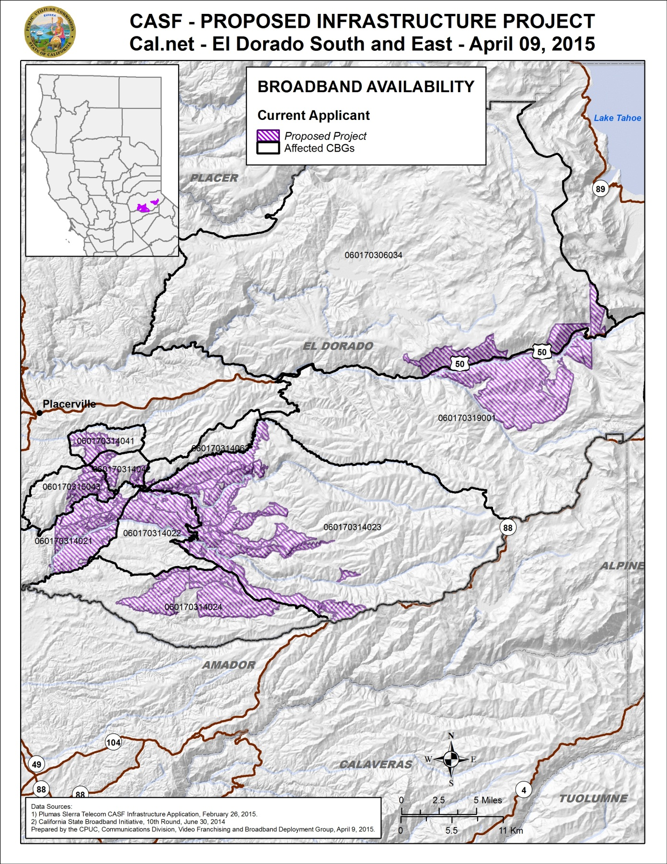

Appendix C
Resolution T-17498 Cal.net’s El Dorado South & East Project
Existing Wireline Service Levels
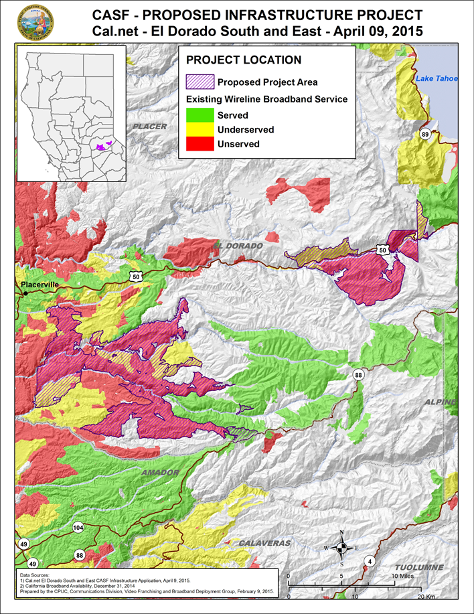

Appendix D
Resolution T-17498 Cal.net’s El Dorado South & East Project
Existing Fixed Wireless Service Levels
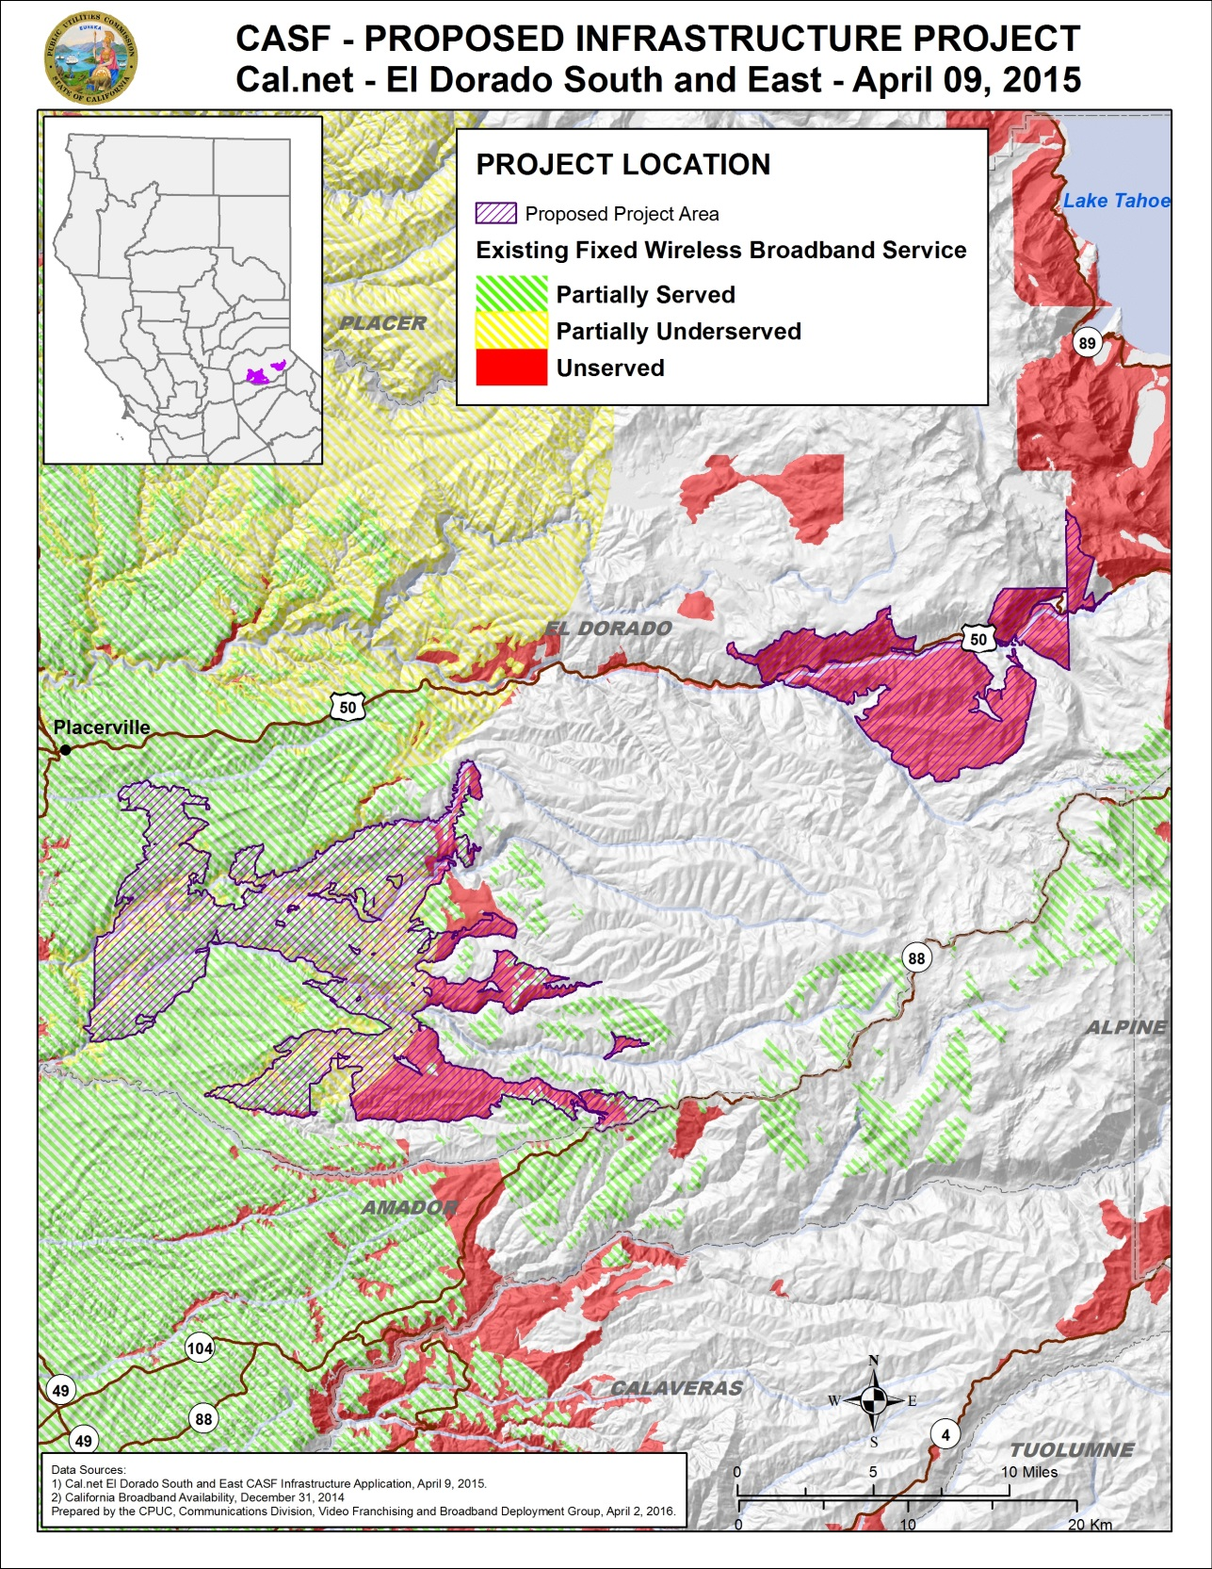
Appendix E
Resolution T-17498 Cal.net’s El Dorado South & East Project
Existing Mobile Wireless Services Levels
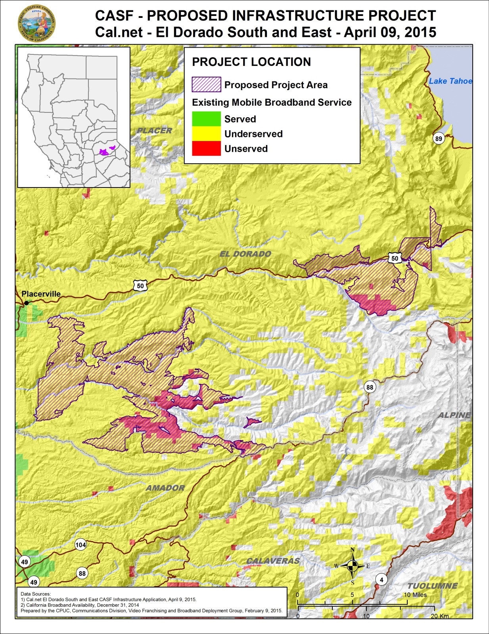

Cal.net requested funding for 1,564 households. However, based on staff’s analysis, the number of eligible households in the project area is 1,350. See Section IV. A.
Cal.net is a non-telephone corporation. Cal.net does not possess either a Certificate of Public Necessity and Convenience (“CPCN”) or a Wireless Identification Registration (“WIR”). It has registered with the Commission and was issued a “U-Number.”
The latest version of the California Interactive Broadband Availability Map uses wireline data as of December 31, 2014.
The CPUC’s June 2015 Mobile Field Test showed that the proposed project area is underserved by mobile wireless providers.
Cal.net’s CASF application, Req15, EDCS – Potential Subscriber Size.xlsx, “By CBG” Workbook, Column D “Existing Customers (Households)”
Cal.net’s CASF application, Req14, EDCS – Assertion of Unserved or Underserved, page 2.
Cal.net’s CASF application, Failed Surveys.xlsx.
This determination was based on the limited speed capabilities of satellite services, the cost to the consumer, high latency, and unreliability known at the time of the decision. (D.12-02-015, pp. 13-15). Like other technologies, satellite services have since improved.
Email from Ken Garnett of Cal.net dated July 31, 2015, regarding “Waiver of VoIP setup fees.”
One of the CBGs has median income of $105,500.
Letter from Brian Veerkamp, County of El Dorado Board of Supervisors, dated June 23, 2015.
The Commission has the authority to enforce the terms and conditions of the grant award and to impose penalties under P.U. Code §§ 2111 and 2108. (D.14-02-018, p. 36).
Email from Ken Garnett of Cal.net dated November 20, 2015, with Subject line “El Dorado North—Pricing Commitment Clarification.”
P.U. Code §§ 270 and 281.
Approval of the California Advanced Services Fund (CASF) Application Requirements and Scoring Criteria for Awarding CASF Funds (2008) Cal. P.U.C. Res. No. T-17143 at 4.

