PUBLIC UTILITIES COMMISSION OF THE STATE OF CALIFORNIA

|  |  |
| --- | --- |
| **Communications Division** | RESOLUTION T- 17518 |
| **Broadband, Video and Market Branch** | **August 18, 2016** |

**R E S O L U T I O N**

**RESOLUTION T-17518: Modifies D.14-12-039, Appendix B, Expedited Review rules for adoption projects. The modification changes the maximum age for an acceptable refurbished computer from two years to five years. Relying on this rule modification, this resolution approves funding for the public housing adoption grant applications of the Episcopal Community Services of San Francisco (Bishop Swing Community House, Canon Barcus Community House, Canon Kip Community House projects), Mutual Housing California (Lemon Hill, Mutual Housing at Sky Park, Mutual Housing at Spring Lake, Mutual Housing at the Highlands, New Harmony, Owendale projects) and West Sacramento Housing Development Corporation (Patio Apartments, Washington Courtyards, West Capitol Courtyards projects) from the California Advanced Services Fund (CASF) Broadband Public Housing Account (BPHA) Adoption Grant Program in the amount of $506,588.**

**I. SUMMARY**

This Resolution approves grant funding in the amount of $506,588 from the California Advanced Services Fund (CASF) Broadband Public Housing Account (BPHA) for the projects listed above. These 12 projects will provide digital literacy training for 2,183 residents in these Publicly Supported Communities (PSCs). All 12 projects use refurbished computers older than 2 years of age. This Resolution approves these projects and modifies the Expedited Review Criteria in D.14-12-039, Appendix B, changing the maximum age for an acceptable refurbished computer from two years to five years.The Digital Literacy training in public housing provided through this resolution will assist public housing organizations to connect residents to government and e-health services, which improves safety.

**II. BACKGROUND**

On December 18, 2014, the Commission approved D.14-12-039 which implements the rules and guidelines for the BPHA including: eligibility and application requirements, types of activities and costs to be funded by CASF, criteria for expedited review approval of project applications by Communications Division (CD) staff, and quarterly deadlines for applications beginning January 15, 2015 through October 1, 2016. Key provisions of the decision relevant to this Resolution include:

* The Commission delegated to CD staff the authority to approve applications through expedited review that meet all of the expedited review criteria.[1] Where an application does not meet the above expedited review criteria, it may still be considered for a grant but it must go through the traditional Commission Resolution approval process.
* Specific to successful BPHA adoption project applications, the Commission will provide reimbursement for acceptable computers and devices (excluding smartphones) and software intended for use either in a computer lab or their household.

The expedited review criteria for acceptable computers requires that the computers cost no more than $250 per device and, if refurbished, that these computers must not be more than two years old.[2]

**III. APPLICANT REQUEST**

On July 1, 2015, Episcopal Community Services (ECS) (Bishop Swing Community House, Canon Barcus Community House, Canon Kip Community House projects), Mutual Housing California (MHC) (Lemon Hill, Mutual Housing at Sky Park, Mutual Housing at Spring Lake, Mutual Housing at the Highlands, New Harmony, Owendale projects) and West Sacramento Housing Development Corporation (WSHDC) (Patio Apartments, Washington Courtyards, West Capitol Courtyards projects) submitted applications for CASF funding.

*Applicants:* ECS has been approved by the IRS as a 501(c)(3) nonprofit organization for providing affordable housing since 1990. ECS provides numerous social services such as housing shelters, transitional housing, job training and placement and adult education. ECS owns and manages (through limited partnerships) three properties (253 units, 391 residents) and has a 98% occupancy rate.

MHC has been approved by the IRS as a 501(c)(3) nonprofit organization for providing affordable housing since 1988. MHC owns and operates more than 1,000 homes in 19 multi-family communities in Sacramento and Yolo Counties, serving approximately 3,000 low-income residents. The occupancy rate for MHC properties is 99.7% with wait lists varying by time of year and property between six and 15 months.

WSHDC has been approved by the IRS as a 501(c)(3) nonprofit organization for providing affordable housing since 1993. WSHDC owns and manages (through limited partnerships) three properties (277 units with 750 tenants) and has a 95% occupancy rate.

*Projects*: The projects submitted by ECS will provide digital literacy training to residents who are recovering from homelessness. Two of the properties house single adults and one (Canon Barcus Community House) houses families. Curriculum will be provided and taught by Community Technology Network (CTN). The curriculum is customizable and will be based on resident needs assessment. The outreach and needs assessment will be done by resident case managers employed by ECS. Training is to be provided onsite (in both English and Spanish); once a resident has completed at least 8 hours of training they will receive a refurbished computer. Training will continue for 12 months or until 75 percent of residents are trained.

The projects submitted by MHC and WSHDC will provide digital literacy training to residents using modules created by Portland University’s software, Learner Web. These modules range from very basic to more advanced material and the presentation can be designed around the needs of the resident. Refurbished computers will be provided to residents who complete at least 8 hours of training. The residents can then continue their online training at home, or can return to the lab where one on one instruction is available. Training is provided by digital literacy instructors or trained volunteers. Training will continue for 12 months or until 75 percent of residents are trained.

**III. NOTICES AND CHALLENGES**

On July 15, 2015, CD posted a list of proposed projects inclusive of the projects funded by this resolution on the Commission’s CASF Public Housing account webpage[3] and sent notices regarding the proposed projects to its email distribution list. [4]

The 12 projects to be funded by this resolution are listed in the following table.



**IV. PROJECT REVIEW**

1. Project Eligibility

A PSC may be eligible for CASF BHPA grant funding only ”if the residential units in the facility to be served have access to broadband services or will have access to broadband services at the time the funding for adoption is implemented.”[5] The applicants have attested that all the units in all of the projects listed in Table 1 are “wired”[6] and, therefore, have access to broadband services.

1. Project Criteria Evaluation

D.14-12-039 delegates to staff the authority to approve applications under the BPHA that meet all expedited review criteria. CD evaluated these projects with respect to the expedited review criteria as defined in D.14-12-039.[7] All projects meet the expedited review requirements except for the requirement that the refurbished machine not be more than 2 years old.

1. Refurbished Computers

Of the 118 adoption projects submitted, approximately 35 (or 30%) propose to provide refurbished computers to be used as part of its digital literacy training.[8] The co-founder and Chief Innovation Officer at Human-I-T, an IT equipment refurbisher that also provides vocational training, recommended expanding the year range limitation of refurbished machines to 10 years. The co-founder and Chief Innovation officer stated that the performance of PCs from 10 years or less are powerful enough to keep up with the current needs of an entry level user. According to the co-founder and Chief Innovation officer, the two-year limit forces grantees to buy lower end models (with lower performance and quality) because of the $250 limit per device.[9] TechSoup, a nonprofit that provides for technology needs for the nonprofit sector, recommended that computers to be donated be no older than five years of age because refurbishers load current software on donated machines, software that may not work on older machines.[10] A representative from the ReliaTech, an IT equipment refurbisher, also recommended a five year limit, stating a similar rationale as TechSoup.[11]

1. Staff Recommendation

Based on the information provided by representatives from the technology companies (above), staff recommends modifying Appendix B, Section VII (Expedited Review), changing the refurbished machine age requirement to not be more than five years old (instead of two). The proposed modification would read: “If the applicant or partner organization provides residents computers or other devices to be use as part of its digital literacy training, the devices cost no more than $250 per device. New or refurbished computers or devices may be used; if the computer or device is refurbished, it must not be more than ~~two~~ five years old. Additionally, a Smartphone is not an eligible device.”

Further, staff recommends approval of the projects listed in Table 1 (with all projects using refurbished computers five years old or less) since, with this modification, all listed projects meet the expedited review requirements.

**V. COMPLIANCE REQUIREMENTS**

ECS, MHC and WSHDC are required to comply with all the guidelines, requirements, and conditions associated with the grant of CASF funds as specified in D.14-12-039. Such compliance includes, but is not limited to the following:

1. **Execution and Performance**

ECS, MHC and WSHDC must begin the project within nine months of Commission approval and thereafter must sustain the adoption project for 12 months or until 75 percent of residents are trained. If they are unable to complete the proposed projects within the 12 month time frame, they must notify the Director of CD as soon as they become aware of this possibility. If such notice is not provided, the Commission may reduce payment for failure to satisfy this requirement by timely notifying CD’s director.

In the event that the recipient fails to complete the performance in accordance with the terms of the CPUC approval, as set forth in this Resolution, the recipient must reimburse some or all of the CASF funds it has received.

1. **Project Audit**

The Commission has the right to conduct any necessary audit, verification, and discovery during project implementation/construction to ensure that CASF funds are spent in accordance with Commission approval.[12]

The recipient’s invoices will be subject to a financial audit by the Commission at any time within three years of completion of the project.

1. **Reporting**

ECS, MHC and WSHDC must submit quarterly progress reports on the status of the project irrespective of whether grantees request reimbursement or payment. Quarterly progress reports should be submitted on January 1, April 1, July 1 and October 1. ECS, MHC and WSHDC must include in the Quarterly progress reports identification of foreseeable risks that might prevent it from meeting future milestones. Once 75% of all residents have been trained or after the project has been training residents for 12 months, and before full payment of the project, the recipient must submit a project completion report. ECS, MHC and WSHDC must certify that each progress report is true and correct under penalty of perjury.

1. **Payments**

Submission of invoices from and payments to ECS, MHC and WSHDC shall be made at completion intervals in accordance with Section X of Appendix B of D.14-12-039 and according to the guidelines and supporting documentation required in D.14-12-039. As referred to in Section X, payment to ECS, MHC and WSHDC will be on a progress billing basis with the first 25 percent to be made upon the proponent’s submission to the Commission staff of a progress report showing that the project’s ramp-up time has been completed (in nine months or less). Subsequent payments shall be made on 25 percent increments showing percentage of residents trained (25 percent, 50 percent and 75 percent) with the total payment made when 75 percent of the residents are trained, or after the project has been training residents for 12 months. ECS, MHC and WSHDC must submit a project completion report before full payment.

Payment to ECS, MHC and WSHDC shall follow the process adopted for funds created under P.U. Code § 270. The Commission generally processes payments within 20-25 business days, including CD and Administrative Services review. The State Controller’s Office (SCO) requires an additional 14-21 days to issue payment from the day that requests are received by SCO from Administrative Services.

**VI. SAFETY CONSIDERATIONS**

Digital Literacy training in public housing will assist public housing organizations to connect residents to government and e-health services, which improves safety.

**VII. COMMENTS**

In compliance with P.U. Code Section 311(g)(1), a Notice of Availability was e-mailed on MM DD YY, informing all parties on the CASF Distribution List of the availability of the draft of this Resolution for public comments at the Commission’s website at <http://www.cpuc.ca.gov/> and is available for public comments. This letter also informed parties that the final conformed Resolution adopted by the Commission will be posted and available at this same website.

**VII. FINDINGS**

1. The Expedited Review requirements in D.14-12-039 state that if the applicant or partner organization provides residents computers or other devices to be use as part of its digital literacy training, the devices can cost no more than $250 per device, and if a refurbished device is used, it must not be more than two years old.
2. Pub. Util. Code § 281(h)(4)((A) states that a PSC may be an eligible applicant only if the residential units in the project location have access to broadband services or will have access to broadband services at the time the funding for adoption is implemented. ECS, MHC and WSHDC have attested that all units have such access or will have such access at the time when the funding is implemented.
3. On July 1, 2015, ECS (Bishop Swing Community House, Canon Barcus Community House, Canon Kip Community House projects), MHC (Lemon Hill, Mutual Housing at Sky Park, Mutual Housing at Spring Lake, Mutual Housing at the Highlands, New Harmony, Owendale projects) and WSHDC (Patio Apartments, Washington Courtyards, West Capitol Courtyards projects) submitted applications for CASF funding.
4. All 12 projects utilize refurbished computers that are not more than five years old.

1. Based on its review, CD determined that all 12 projects meet all expedited review requirements except for the age of refurbished computers to be paid for by the grant.
2. Based on the information provided by representatives from the technology companies, staff recommends modifying Appendix B, Section VII (Expedited Review), changing the refurbished machine age requirement to not be more than five years old (instead of two). CD concludes that the two year age requirement for refurbished machines is overly restrictive, and that refurbished machines as old as five years of age are acceptable devices and satisfy performance and quality needs of users.
3. With the modification, CD determined that the proposed projects qualify for funding under D.14-12-039.
4. The applicants are required to comply with all guidelines, requirements, and conditions associated with the granting of CASF funds as specified in D.14-12-039.
5. A notice letter was e-mailed on MM DD YY informing all applicants filing for CASF funding, parties on the CASF distribution list of the availability of the draft of this Resolution for public comments at the Commission’s website http://www.cpuc.ca.gov/PUC/documents/. This letter also informed parties that the final confirmed Resolution adopted by the Commission will be posted and available at this same website.

**THERFORE, IT IS ORDERED that**:

* 1. The Commission shall award $149,072 to the Episcopal Community Services of San Francisco for the Bishop Swing Community House ($49,959), Canon Barcus Community House ($49,520) and Canon Kip Community House ($49,593) projects; $235,632 to Mutual Housing California for the Lemon Hill ($42,058), Mutual Housing at Sky Park ($44,289), Mutual Housing at Spring Lake ($35,960), Mutual Housing at the Highlands ($49,533), New Harmony ($38,122) and Owendale ($25,670) projects; and $121,884 to West Sacramento Housing Development Corporation for the Patio Apartments ($26,140), Washington Courtyards ($45,760) and Capitol Courtyards ($49,984) projects; a grant total award of $506,588. All awards are based on the descriptions of the projects as described herein and are predicated on commitments to provide adoption services as expressed in the awardee’s applications and in compliance with the requirements in the expedited review checklist that the awardees agreed or attested to in their applications.
  2. Grant payments of up to a total of $506,588 for these public housing projects shall be paid out of the CASF Public Housing Account in accordance with the guidelines adopted in D.14-12-039, including compliance with CEQA.
  3. Payments to the CASF recipient shall be in accordance with Section X of Appendix B of D.14-12-039 and in accordance with the process defined in the “Payments” section of this Resolution.
  4. The CASF fund recipients shall comply with all guidelines, requirements and conditions associated with the CASF funds award as specified in D.14-12-039, and in accordance with the terms of the Commission’s approval as set forth in this Resolution.
  5. In the event that the CASF recipients fail to complete the project in accordance with the terms outlined in D.14-12-039 and this Resolution, recipients must reimburse some or all CASF funds it has received.
  6. The Commission adopts the revised Expedited Review Criteria as set forth in Appendix A of this Resolution, which modifies the age requirement of refurbished machines to be not more than five years old.

This Resolution is effective today.

I hereby certify that this Resolution was adopted by the Public Utilities Commission at its regular meeting on August 18, 2016. The following Commissioners approved it:

______________________________

TIMOTHY J. SULLIVAN

Executive Director

APPENDIX

**APPENDIX A**

**Resolution T-17518**

**Revised Expedited Review Criteria**

#### Expedited Review

The Commission delegates to CD staff the authority to approve applications that meet all of the following criteria:

Adoption Projects

* Applicant meets the eligibility requirements under P.U. Code § 281 (f)(2).
* Applicant requests a grant of $50,000 or less
* Applicant agrees to perform education and outreach to educate residents of best practice use of available broadband Internet services.
* Applicant or partner organization possesses at least one year experience in digital literacy training or has previously carried out at least one digital literacy project.
* Applicant must provide at least eight hours of digital literacy training to participating residents.
* Applicant or partner organization will use existing curriculum.
* Applicant has identified onsite designated space for digital literacy training.
* If the applicant or partner organization provides residents computers or other devices to be use as part of its digital literacy training, the devices cost no more than $250 per device. New or refurbished computers or devices may be used; if the computer or device is refurbished, it must not be more than ~~two~~ five years old. Additionally, a Smartphone is not an eligible device.
* Technical support, either by phone or in person, must be able to respond within 48 hours. A refurbished device supplier should provide a warranty of at least six months and seller of new products should provide a warranty of at least 30 days.
* Applicants must be ready to provide classes within nine months of being selected for a CASF grant and must submit a work plan with major milestones showing how they propose to meet this deadline.
* Applicants must sustain the adoption project for 12 months or until 75 percent of residents are trained. The applicant must submit a work plan with major milestones showing how they propose to meet this deadline.

**APPENDIX B**

**Resolution T-17518**

**Public Housing Projects Locations**

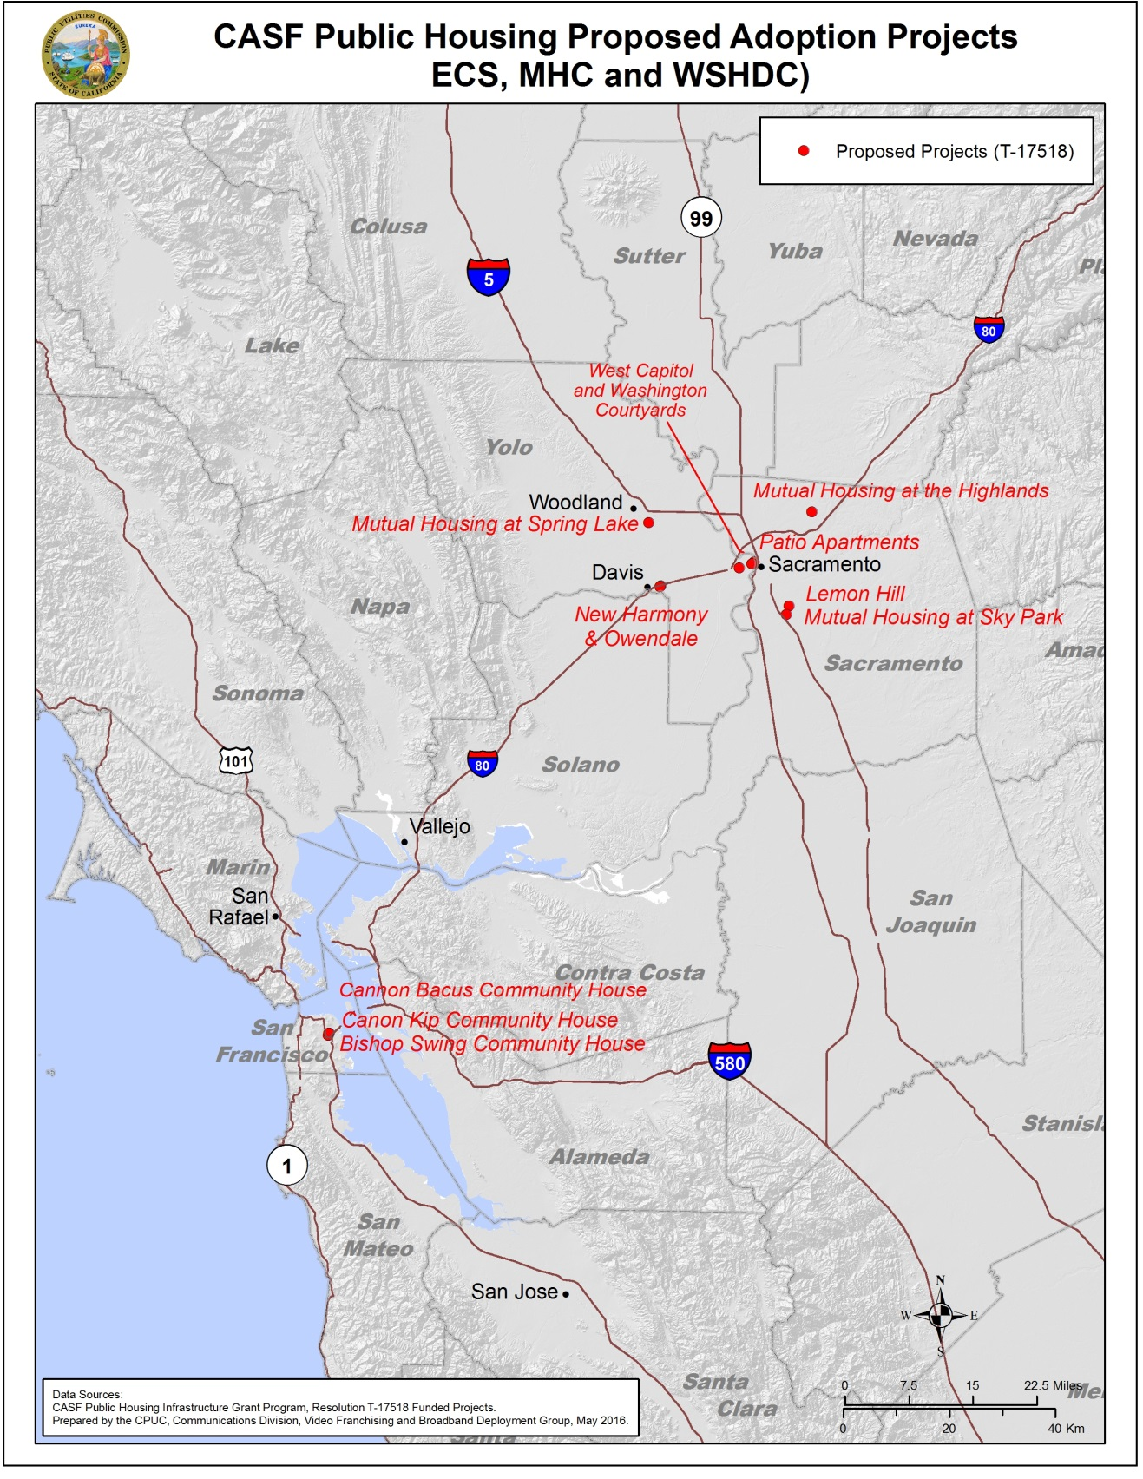

1. D.14-12-039, CASF Broadband Public Housing Account Application Requirements and Guidelines, Appendix B, (“Guidelines” or “Appendix B”), p. B14. References hereafter may be a part of the Guidelines/Appendix B adopted by D.14-12-039.
2. D.14-12-039, Appendix B, p. B14
3. <http://www.cpuc.ca.gov/General.aspx?id=908>
4. Pursuant to D.14-12-039, CD posts all applications on its website to give ISP two weeks from the date of posting to challenge applications. (Appendix B, p. B12). D.14-12-039 is silent with respect to the challenge process for BPHA adoption project applications.
5. P.U. Code § 281(h)(4)(A).
6. A unit is “wired” for broadband Internet if it is possible to subscribe to a commercially available broadband Internet service, such as via Digital Subscriber Line (DSL), cable modem or another protocol, utilizing the existing “wired” facilities. A unit having such wiring is considered as having broadband service “available.” An “unwired” property” has at least one unit that is not “wired” (D.14-12-039, Appendix B, p. B3).
7. D.14-12-039, Appendix B, pp. B14.
8. Approximately 58% provide new computers to residents, ~30% provide refurbished computers residents and approximately 13% do not provide a computer to residents.
9. Email exchange with James Jack, co-founder and Chief Innovation Officer at human-I-T
10. Email exchange with Jim Lynch, Green Tech Director, TechSoup with additional information provided on the TechSoup website (<http://www.techsoup.org/support/articles-and-how-tos/ten-tips-for-donating-a-computer>).
11. Email exchange with Karen Lincoln of ReliaTech (Director of Business Operations)
12. P.U. Code § 270.