**PUBLIC UTILITIES COMMISSION OF THE STATE OF CALIFORNIA**

**AGENDA ID 15021**

**ENERGY DIVISION RESOLUTION E-4795**

**Aug 18, 2016**

**RESOLUTION**

Resolution E-4795. Approval of the Database for Energy-Efficient Resources (DEER) updates for 2017 and 2018, in Compliance with D.15-10-028.

**PROPOSED OUTCOME**:

* DEER2017 Update (effective 1/1/2017)
* DEER2018 Update (effective 1/1/2018)

**SAFETY CONSIDERATIONS**:

* There is no impact on safety.

**ESTIMATED COST**:

* This Resolution is expected to result in no additional cost.

By Energy Division’s own motion.

__________________________________________________________

# **SUMMARY**

This Resolution approves updates to the Database for Energy-Efficient Resources (DEER) for 2017 and 2018. DEER2017 and DEER2018 values will be effective 1/1/2017 and 1/1/2018 respectively.

All of the updated DEER assumptions, methods, values and supporting documentation are available on the DEEResources.com website.

# **BACKGROUND**

DEER updates (available via on line datasets and documentation on DEEResources.com) flow into the portfolio development process by providing new savings estimates from which to design programs. New savings estimates, including assumptions and methods as well as values, inform where a current program may need to shift eligibility and/or incentive support to continue to capture savings cost effectively. DEER updates may also reflect new market conditions (reflected in required baseline assumptions and predicted attribution rates). Program Administrators (PA)s need to factor in all of these new assumptions and values by a) knowing there is an update, b) understanding the fundamental assumptions for the update, and c) identifying necessary shifts to their programs to still capture cost effective savings. Updates to DEER methods similarly may re-define the adopted approach to estimating savings, and hence would need to be applied in both workpaper development and custom project savings estimates as well as program deployment decisions.

Decision D.15-10-028, Ordering Paragraph 17: “Commission Staff shall propose changes to the Database of Energy Efficient Resources once annually via resolution, with the associated comment/protest period provided by General Order 96-B. However, Commission staff may make changes at any time without a resolution to fix errors or to change documentation.” Decision D.15-10-028, retains the direction from D.12-05-015 that DEER values be updated to be consistent with existing and updated state and federal codes and standards while incorporating these changes into the annual DEER update.[1] Decision D.15-10-028 also retains previous direction on Commission staff latitude in updating DEER.[2]

# **DISCUSSION**

Pursuant to D.15-10-28 on June 1 the Energy Division published a scoping memo on the proposed list of updates for DEER2017 and DEER2018. Commission staff identified the following priorities for determining the updates:

1. New Code Update or Code Update Not Covered in Previous DEER Updates: Code updates are the highest priority to ensure that code and Industry Standard Practice baselines are properly defined.
2. Updates to Underlying Methodology: The DEER Update will focus on updates and improvements to simulation and modeling methodologies to reflect latest research results.
3. Broad Updates with Applicability to DEER and non-DEER Measures: The DEER update will focus on revisions with broad application across all measures.
4. Updates that Affect Large Portfolio Contributions or Large Measure Counts: The DEER update will focus on updates that result in revisions to a majority of savings and other cost effectiveness values in terms of overall portfolio contribution as well as total measure counts.

This Resolution approves the final updates to the Database for Energy-Efficient Resources (DEER) for 2017 and 2018. DEER2017 and DEER2018 values will be effective 1/1/2017 and 1/1/2018 respectively. The final updated measures are listed in Table 1 with a more detailed description of the changes and additions provided in the Attachment to this Resolution . Complete documentation and supporting material on the updated assumptions and methods as well as all of the updated values are available at [DEEResources.com](http://DEEResources.com) on the DEER2017/DEER2018 page under DEER Versions on the website Main Menu. The updated values are in the ex-ante database and accessible for review and download via the Remote Ex Ante Data Interface ([READI](http://deeresources.com/index.php/component/users/?view=login)) tool which is also available for download from that same webpage.

**Table 1 - DEER2017 and DEER2018 Update Measures**

|  |  | **Reference** | | | | | | | | **Sector** | | | | | **Tech Group** | | | | | **Ex-Ante Value** | | | | | |
| --- | --- | --- | --- | --- | --- | --- | --- | --- | --- | --- | --- | --- | --- | --- | --- | --- | --- | --- | --- | --- | --- | --- | --- | --- | --- |
| **Area of Update** | **Justification for Update / Approach and Source** | Codes | Ex Post | | Market | ISP | Custom | Workpaper | Calc Methds | Cross | Res | Com | Ind | Ag | Lighting | HVAC | DHW | Envelope | Plug/Proc | UES | Load Shape | EUL/RUL | NTG | Cost | GSIA |
| **A. Updates based on Code Requirements** | |  |  | |  |  |  |  |  |  |  |  |  |  |  |  |  |  |  |  |  |  |  |  |  |
| **1. Residential Updates** | | | | | | | | | | | | | | | | | | | | | | | | | |
| Roof Insulation | 2016 Title-24 , model parameters | X |  |  | |  |  |  |  |  | X |  |  |  |  |  |  | X |  | X |  |  |  |  |  |
| Framed Wall U-value | X |  |  | |  |  |  |  |  | X |  |  |  |  |  |  | X |  | X |  |  |  |  |  |
| Duct Insulation | X |  |  | |  |  |  |  |  | X |  |  |  |  | X |  |  |  | X |  |  |  |  |  |
| Whole House Fan | 2013 Title-24 , model and methodology | X |  |  | |  |  |  | X |  | X |  |  |  |  | X |  |  |  | X | X |  |  |  |  |
| Attic Radiant Barrier | 2003 Title-24 , model and methodology | X |  |  | |  |  |  | X |  | X |  |  |  |  |  |  | X |  | X |  |  |  |  |  |
| Window Model | Title-24 code compliance standards, model and methodology | X |  |  | |  |  |  | X |  | X |  |  |  |  |  |  | X |  | X |  |  |  |  |  |
| Residential Vintage Definitions | 2016 Title-24 , methodology | X |  |  | |  |  |  | X |  | X |  |  |  |  |  |  |  |  | X |  |  |  |  |  |
| Residential HVAC Calibration | Methodology update required based on changes listed above |  |  |  | |  |  |  | X |  | X |  |  |  |  | X |  |  |  |  |  |  |  |  |  |
| Lighting HVAC Interactive Effects |  |  |  | |  |  |  | X |  | X |  |  |  | X |  |  |  |  | X |  |  |  |  |  |
| Residential Dishwasher | Update to latest Energy-Star parameters |  |  | X | |  |  |  |  |  | X |  |  |  |  |  | X |  |  | X |  |  |  |  |  |
| **2. Non-Residential Updates** | | | | | | | | | | | | | | | | | | | | | | | | | |
| Package HVAC Integrated Energy Efficiency Ratio (IEER) | 2016 Title 24 and federal standards, revised measure definitions based on code minimum EER and IEER requirements, update model parameters based on code compliant performance data | X |  | |  |  |  |  | X |  | X | X |  |  |  | X |  |  |  | X |  |  |  |  |  |
| Water Chiller full load efficiency (kW/ton) and Integrated Part Load Efficiency (IPLV) | 2016 Title 24 standards, revised measure definitions based on code minimum full-load and IPLV requirements, update model parameters based on code compliant performance data | X |  | |  |  | X | X |  |  |  | X |  |  |  | X |  |  |  | X |  |  |  |  |  |
| Linear fluorescent lighting code baseline | Based on comments to the scoping memo and further analysis this proposed update has been removed from consideration | X |  | |  |  |  |  |  |  |  | X |  |  | X |  |  |  |  | X |  | X |  |  |  |
| **B. Updates Based on Corrections to Error** | | | | | | | | | | | | | | | | | | | | | | | | | |
| Residential Lighting Use Profile | Alignment to previously published documentation , model parameters update |  | X |  | |  |  |  | X |  | X |  |  |  | X |  |  |  |  |  | X |  |  |  |  |
| Residential HVAC sizing |  |  |  | |  |  |  | X |  | X |  |  |  |  | X |  |  |  | X |  |  |  |  |  |
| Building shell insulation measures |  |  |  | |  |  |  | X |  | X |  |  |  |  |  |  | X |  | X |  |  |  |  |  |
| **C. Updates Based on Evaluation Results** | | | | | | | | | | | | | | | | | | | | | | | | | |
| Residential refrigerant charge adjustment | Update based on available evaluation data , model parameters update |  | X |  | |  |  |  |  |  | X |  |  |  |  | X |  |  |  | X |  |  |  |  |  |
| Duct sealing plus refrigerant charge adjustment |  | X |  | |  |  |  |  |  | X |  |  |  |  | X |  |  |  | X |  |  |  |  |  |
| Lighting Early retirement second baseline | Standard practice exceeds code, codes and standards research, manufacturer sales data, measure baselines update | X |  |  | | X |  |  | X | X |  |  |  |  | X |  |  |  |  | X |  |  | X |  |  |

# **COMMENTS**

Public Utilities Code section 311(g)(1) provides that this resolution must be served on all parties and subject to at least 30 days public review and comment prior to a vote of the Commission. Section 311(g)(2) provides that this 30-day period may be reduced or waived upon the stipulation of all parties in the proceeding.

The 30-day comment period for the draft of this resolution was neither waived nor reduced. Accordingly, this draft resolution was mailed to parties for comments, and will be placed on the Commission's agenda no earlier than 30 days from today."

# **FINDINGS**

1. Decision D.15-10-028, requires that Commission Staff propose changes to the Database of Energy Efficient Resources once annually via resolution, with the associated comment/protest period provided by General Order 96-B.
2. Decision D.15-10-028, retains the direction from D.12-05-015 that DEER values be updated to be consistent with existing and updated state and federal codes and standards.
3. Decision D.15-10-028 also states that Commission staff may make changes at any time without a resolution to fix errors or to change documentation.”
4. The approved updates are a result of a) New Code Update or Code Update Not Covered in Previous DEER Updates, b) Updates to Underlying Methodology,   
   c) Broad Updates with Applicability to DEER and non-DEER Measures and,   
   d) Updates that Affect Large Portfolio Contributions or Large Measure Counts.

# **THEREFORE IT IS ORDERED THAT:**

1. The DEER2017 and DEER2018 Updates, listed in table 1, described in the Attachment and available on the Ex-Ante Database, are approved.
2. Pacific Gas and Electric Company (PG&E), Southern California Electric Company (SCE), Southern California Gas Company (SoCalGas), and San Diego Gas & Electric (SDG&E), the approved Regional Energy Networks (BayREN and SoCalREN) and Marin Clean Energy (MCE) must use the updated assumptions, methods and values for 2017 and 2018 planning, implementation and reporting.

This Resolution is effective today.

I certify that the foregoing resolution was duly introduced, passed and adopted at a conference of the Public Utilities Commission of the State of California held on August 18, 2016; the following Commissioners voting favorably thereon:

_____________________

TIMOTHY J. SULLIVAN

Executive Director

Attachment

DEER2017 and DEER2018 Update Summary

1 Finding the DEER2017 and DEER2018 update values and supporting documentation……..2

1.1 DEER2017 and DEER2018 Measures and Impact Values 2

1.2 Other Documents 2

2 Non-residential Measure Updates Based on Energy Code 2

2.1 Linear Fluorescent Code Baselines 2

2.2 HVAC Equipment Measures 3

2.2.1 Packaged Unitary Air Conditioning and Air Source Heat Pumps Measures for unit capacity of 65,000 Btu/h or greater 3

2.2.2 Water Chiller Measures 7

3 Background: Residential Energy Code Changes Impacting DEER2017 15

3.1 Attic Radiant Barrier Requirement 15

3.2 Insulation Requirement for Ventilated Attics 16

3.3 Framed Wall U-Value 16

3.4 Duct Insulation 17

3.5 Whole House Fan 17

3.6 Window Model 17

4 Residential Measure Updates Based on Energy Code 19

4.1 2017 residential vintage addition 20

4.2 Whole House Fan 21

4.3 Lighting HVAC Interactive Effects 22

4.4 Residential Dishwasher Measures 23

5 Residential Measure Updates Based on Corrections to Errors 24

5.1 Lighting Use Profile 24

5.2 Building shell insulation measures 25

5.3 HVAC sizing Correction 26

6 DEER2018 Updates Based on Newly Available Evaluation Results and Related Market and Technology Research 28

6.1 Refrigerant Charge Adjustment 28

6.2 Standard Practice for Early Retirement Lighting Measures 31

6.2.1 Summary of DEER Revisions to Standard Practice Baseline for Outdoor Lighting Measures 31

6.2.2 Summary of DEER Revisions to Standard Practice Baseline for Interior Linear Fluorescent Lighting Measures 31

6.2.3 Background and Applicable Research for Standard Practice Baselines for Lighting Measures 32

# Finding the DEER2017 and DEER2018 update values and supporting documentation

The DEER2017 update, to be effective 1/1/2017, is limited to changes that are related to energy code requirements and changes due to corrections of errors in previous DEER versions. The DEER2018 update, to be effective 1/1/2018, encompasses changes due to program evaluation and market research.

## DEER2017 and DEER2018 Measures and Impact Values

The DEER2017 and DEER2018 measures and associated energy impacts have been added to the Preliminary Ex Ante Review (PEAR) database for the review period. This database is accessible using the latest version of READI, found on the DEEResources.com web site. Measures impacted by this update have a value of either “DEER2017” or “DEER2018” in the version field and have a start date of either 1/1/2017 or 1/1/2018 respectively.

Following the review period, the final DEER2017 and DEER2018 data will be moved to the ex-ante database, also accessible using the latest version of READI.

## Other Documents

This document along with support workbooks can be found on the DEEResources.com web page, under the menu DEER Versions => DEER2017 and DEER2018.

# Non-residential Measure Updates Based on Energy Code

The commercial measures updated for DEER2017 are based on energy code changes, as described in the following sections.

## Linear Fluorescent Code Baselines

*Alignment with California Title 24 Lighting Power Density Updates*

Since the 2013 update to Title 24, the CEC has been reducing allowances for lighting power based on the gradually increasing performance of linear fluorescent technologies. As discussed in Section 6.2.3 the office lighting power density (LPD) limits in 2013 Title 24 were developed assuming more efficient technologies than the current DEER code baseline of 2nd generation T8 lamps and normal light output (NLO) ballasts. However, 2016 Title 24 updates to non-office LPDs assumed technologies very similar to the DEER code baseline. Instead, the reduced 2016 Title 24 LPD values were developed by removing incandescent lights sources from typical lighting design assumptions. Furthermore, Title 24 offers flexibility in the use of optional lighting controls along with exceptions for small alterations. Because of varying assumptions made in the code development efforts along with the wide range of compliance approaches, the DEER team chose not to update any code baselines at this time. Instead, the DEER team believes these revisions are more appropriately incorporated into revisions to standard practice baselines covered in Section 6.2.

## HVAC Equipment Measures

*Alignment with California Title 24 and Federal Minimum Efficiency Requirements*

Title 24 requires air-cooled package HVAC air conditioners and heat pumps greater than 65 kBtuh and all water chillers (except absorption chillers) to meet both minimum full-load and minimum integrated part-load efficiency requirements. Additionally, program administrators offer incentives that allow the customer to choose which efficiency metric, either the full- or part-load value, as the basis for the deemed savings and incentive. Previous versions of DEER did not include part-load efficiency values for heat pumps or chillers, and the part-load values for air conditioners were based on typical market averages rather than the characteristics of the simulated equipment. This version of DEER will update all measure definitions to include reference full- and part-load efficiency requirements for both the baseline and measure technologies. These revisions will bring the DEER measure definitions in line with all minimum efficiency requirements that will be in place on January 1, 2017. Furthermore, DEER will be revised to include scale-able values and methods that facilitate the PAs’ development of non-DEER measure definitions without having to develop new savings values within workpapers.

### Packaged Unitary Air Conditioning and Air Source Heat Pumps Measures for unit capacity of 65,000 Btu/h or greater

The 2016 Title-24 Energy Standard has new requirements for the Integrated Energy Efficiency Ratio (IEER) for packaged air conditioning equipment while full load efficiency values (EER) are unchanged from the previous standard. However, both the EER and IEER minimum requirements must be met not one or the other. The IEER values reported for the air conditioning baselines and measures for the DEER 2016 version were based on a survey of equipment available in the market place. These market average values provided typical IEER values for each EER based efficiency Tier. At the time of previous DEER releases, the IEER requirements of the Title 24 standard were relatively low. Based on the market average IEER values, it was clear that the DEER Standard level models would exceed these requirements. With the increased stringency of the new IEER requirements in the energy code, it is no longer certain that the IEER values of the DEER standard models are in compliance. Therefore, an activity was undertaken to determine the appropriate rated IEER values for each of the DEER standard and measure cases.

For a given air conditioning system, there will always be both a rated EER and a rated IEER. The selection of tier level must be based on both of these parameters, while any interpolation between DEER tiers must be based solely on the rated EER. If the rated EER and the rated IEER are both greater than or equal to the tier level values, then that tier is valid. It is not acceptable to move to the next tier if the rated IEER satisfies the minimum IEER threshold of the tier but the rated EER for the equipment does not satisfy the EER requirement for the tier. Interpolations can be performed between two DEER tier levels based on EER, but not IEER, and only if the IEER for the equipment meets the interpolated minimum IEER threshold. The two examples in the table below show units with the same rated EER value and with differing IEER values that both resolve to using the same DEER savings value developed for an interpolation between the two bounding DEER measures using the unit rated EER value.

|  |  |  |  |  |
| --- | --- | --- | --- | --- |
| Rated EER | Rated IEER | Tier Below EER/ min IEER | Tier Above EER/ min IEER | Selected Tier EER |
| 12.2 | 14.1 | 12.0/13.8 | 12.5/14.1 | 12.0 |
| 12.2 | 15.2 | 12.0/13.8 | 12.5/14.1 | 12.0 |

The minimum IEER value for each DEER measure was developed from market data selecting the typical minimum IEER for each EER as shown in Figure 2 through Figure 4. These figures include both data collected by the DEER team as well as data provided by PG&E as part of their commenting on the DEER scope. The PG&E data was cleaned to exclude units not compliant with current code and also to exclude units that do not have IEER values reported for 2-speed fan operation. The DEER modeling for savings values, however, were calculated using typical unit performance maps for the range of equipment available at each EER level.

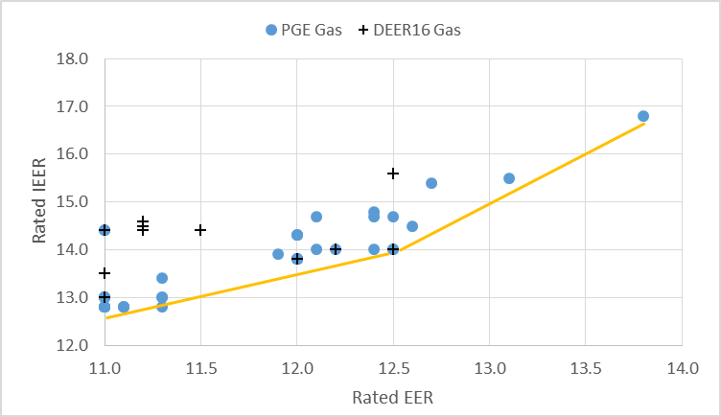

**Figure 1. Relationship Between Rated IEER and Rated EER for Gas Air Conditioning Units**

**65 to <135 kBtu/hr Equipment Capacity Range**

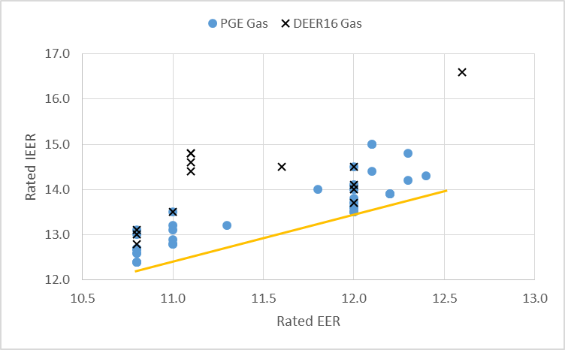

Figure 2. Relationship Between Rated IEER and Rated EER for Gas Air Conditioning Units

135 to <240 kBtu/hr Equipment Capacity Range

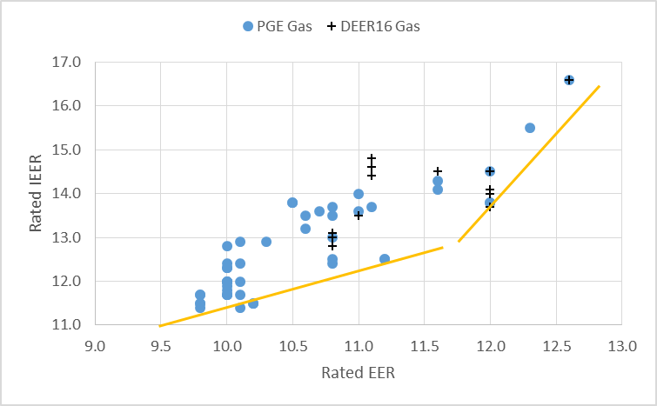  
Figure 3. Relationship Between Rated IEER and Rated EER for Gas Air Conditioning Units

240 to <760 kBtu/hr Equipment Capacity Range

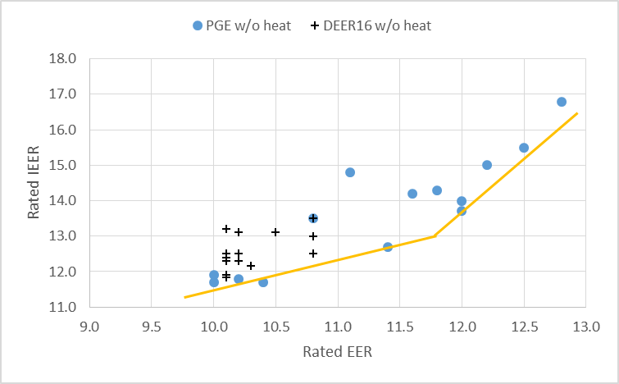

Figure 4. Relationship Between Rated IEER and Rated EER for Air Conditioning Units with No Heat or Electric Resistance Heat in the 240 to <760 kBtu/hr Equipment Capacity Range

|  |  |  |
| --- | --- | --- |
| **Capacity of 65 to <135 kBTU/hr with gas heating** | | |
| **Tier** | **Minimum Rated EER** | **Minimum Rated IEER** |
| Code | 11 | 12.7 |
| 1 | 11.5 | 13 |
| 2 | 12 | 13.5 |
| 3 | 12.5 | 14 |
| 4 | 13 | 15 |
| **Capacity of 135 to <240 kBTU/hr with gas heating** | | |
| **Tier** | **Minimum Rated EER** | **Minimum Rated IEER** |
| Code | 10.8 | 12.2 |
| 1 | 11.5 | 13 |
| 2 | 12 | 13.5 |
| 3 | 12.5 | 14 |
| **Capacity of 240 to <760 kBTU/hr with gas heating** | | |
| **Tier** | **Minimum Rated EER** | **Minimum Rated IEER** |
| Code | 9.8 | 11.4 |
| 1 | 10.8 | 12.2 |
| 2 | 11.5 | 12.7 |
| 3 | 12.5 | 15.5 |
| **Capacity of >=760 kBTU/hr with gas heating** | | |
| **Tier** | **Minimum Rated EER** | **Minimum Rated IEER** |
| Code | 9.5 | 11 |
| 1 | 10.2 | 11.6 |
| 2 | 11 | 12.3 |
| 3 | 12 | 13.8 |
| **Capacity of 240 to <760 kBTU/hr with no heating** | | |
| **Tier** | **Minimum Rated EER** | **Minimum Rated IEER** |
| Code | 10 | 11.6 |
| 1 | 10.8 | 12.3 |
| 2 | 11.5 | 12.8 |
| 3 | 12.5 | 15.3 |
| **Capacity of >=760 kBTU/hr with no heating** | | |
| **Tier** | **Minimum Rated EER** | **Minimum Rated IEER** |
| Code | 9.7 | 11.2 |
| 1 | 10.2 | 11.7 |
| 2 | 11 | 12.4 |
| 3 | 12 | 13.8 |

Table 2 below provides an example of the EER and IEER minimum values required to be met for code compliance as well as to qualify for savings at the various DEER tier levels of performance. As noted above to qualify for savings treatment at a tier level both the minimum EER and IEER requirements must be met. Interpolation between tiers is performed using EER values only.

|  |  |  |
| --- | --- | --- |
| **Capacity of 65 to <135 kBTU/hr with gas heating** | | |
| **Tier** | **Minimum Rated EER** | **Minimum Rated IEER** |
| Code | 11 | 12.7 |
| 1 | 11.5 | 13 |
| 2 | 12 | 13.5 |
| 3 | 12.5 | 14 |
| 4 | 13 | 15 |
| **Capacity of 135 to <240 kBTU/hr with gas heating** | | |
| **Tier** | **Minimum Rated EER** | **Minimum Rated IEER** |
| Code | 10.8 | 12.2 |
| 1 | 11.5 | 13 |
| 2 | 12 | 13.5 |
| 3 | 12.5 | 14 |
| **Capacity of 240 to <760 kBTU/hr with gas heating** | | |
| **Tier** | **Minimum Rated EER** | **Minimum Rated IEER** |
| Code | 9.8 | 11.4 |
| 1 | 10.8 | 12.2 |
| 2 | 11.5 | 12.7 |
| 3 | 12.5 | 15.5 |
| **Capacity of >=760 kBTU/hr with gas heating** | | |
| **Tier** | **Minimum Rated EER** | **Minimum Rated IEER** |
| Code | 9.5 | 11 |
| 1 | 10.2 | 11.6 |
| 2 | 11 | 12.3 |
| 3 | 12 | 13.8 |
| **Capacity of 240 to <760 kBTU/hr with no heating** | | |
| **Tier** | **Minimum Rated EER** | **Minimum Rated IEER** |
| Code | 10 | 11.6 |
| 1 | 10.8 | 12.3 |
| 2 | 11.5 | 12.8 |
| 3 | 12.5 | 15.3 |
| **Capacity of >=760 kBTU/hr with no heating** | | |
| **Tier** | **Minimum Rated EER** | **Minimum Rated IEER** |
| Code | 9.7 | 11.2 |
| 1 | 10.2 | 11.7 |
| 2 | 11 | 12.4 |
| 3 | 12 | 13.8 |

Table 2. EER and IEER Code and Tier Minimums for Packaged A/C units with Gas Heating

### Water Chiller Measures

Since 2013, Title 24 has required water chillers to meet minimum full-load efficiency (kW/ton) and minimum integrated part-load efficiency (IPLV) values. Additionally, Title 24 also included alternate efficiency paths for chiller types. Path A requires a fairly high full-load efficiency. Path B[3] sets a lower minimum full-load efficiency than Path A, but requires a much higher minimum integrated part-load efficiency compared to Path A. Previous versions of DEER included measures based only on Path A efficiency requirements and did not include IPLV values in the measure definition.

Based on a review of PA’s recently submitted workpapers, current programs offer incentives within Path A or Path B for the following categories:

1. Exceed Path A requirements for full-load efficiency
2. Exceed Path A requirements for integrated part-load efficiency
3. Exceed Path B requirements for full-load efficiency
4. Exceed Path B requirements for integrated part-load efficiency

For a given chiller, there will always be both a rated full-load efficiency (EER for air-cooled and kW/ton for water-cooled units) and a rated IPLV. The selection of an efficiency tier level must be based on both of these parameters, while any interpolation between DEER tiers must be based solely on the rated full-load efficiency. If the rated full-load efficiency and the rated IPLV are both greater than or equal to the tier level values, then that tier is valid. It is not acceptable to move to the next tier if the rated IPLV satisfies the minimum IPLV threshold of the tier but the rated full-load efficiency for the equipment does not satisfy the requirement for the tier. Interpolations can be performed between two DEER tier levels based on full-load efficiency, but not IPLV, and only if the IPLV for the equipment meets the interpolated minimum IPLV threshold. The complete list of updated DEER chiller measures is included in Table 6 in Section III.

The current version of DEER only supports measures defined using Path A full-load efficiencies. DEER2017 has been updated to include measure definitions that meet specific measure performance criteria within a specific efficiency path. For example, there is now a measure definition for a water cooled conventional centrifugal chiller that exceeds Path B full-load efficiency requirements by 15%. Additionally, DEER has been updated to include scale-able savings values for each of the four classes of measures listed above so that PAs can develop alternative non-DEER efficiency levels for chillers without having to develop new savings values in workpapers. Table 3 below shows the current DEER chiller measures that will expire at the end of 2016.

|  |  |  |  |  |  |  |
| --- | --- | --- | --- | --- | --- | --- |
| MeasureID | Version | | StartDate | | ExpiryDate | |
| NE-HVAC-Chlr-Screw-gte300tons-0p511kwpton | | DEER2014 | | 7/1/2014 | | 12/31/2016 | |
| NE-HVAC-Chlr-Cent-150to299tons-0p507kwpton-VSD | | DEER2014 | | 7/1/2014 | | 12/31/2016 | |
| NE-HVAC-Chlr-Cent-gte300tons-0p461kwpton-ConstSpd | | DEER2014 | | 7/1/2014 | | 12/31/2016 | |
| NE-HVAC-Chlr-Screw-150to299tons-0p574kwpton | | DEER2014 | | 7/1/2014 | | 12/31/2016 | |
| NE-HVAC-Chlr-Cent-150to299tons-0p507kwpton-ConstSpd | | DEER2014 | | 7/1/2014 | | 12/31/2016 | |
| NE-HVAC-Chlr-WtrRecip-lt150tons-0p672kwpton | | DEER2014 | | 7/1/2014 | | 12/31/2016 | |
| NE-HVAC-Chlr-AirScrew-AllSizes-1p008kwpton | | DEER2014 | | 7/1/2014 | | 12/31/2016 | |
| NE-HVAC-Chlr-WtrRecip-150to299tons-0p588kwpton | | DEER2014 | | 7/1/2014 | | 12/31/2016 | |
| NE-HVAC-Chlr-Cent-gte300tons-0p461kwpton-VSD | | DEER2014 | | 7/1/2014 | | 12/31/2016 | |
| NE-HVAC-Chlr-Cent-lt150tons-0p560kwpton-ConstSpd | | DEER2014 | | 7/1/2014 | | 12/31/2016 | |
| NE-HVAC-Chlr-Cent-lt150tons-0p560kwpton-VSD | | DEER2014 | | 7/1/2014 | | 12/31/2016 | |
| NE-HVAC-Chlr-Cent-lt150tons-0p700kwpton-1FrctnlsComp | | DEER2014 | | 7/1/2014 | | 12/31/2016 | |
| NE-HVAC-Chlr-Cent-lt150tons-0p700kwpton-gt1FrctnlsComp | | DEER2014 | | 7/1/2014 | | 12/31/2016 | |
| NE-HVAC-Chlr-WtrRecip-gte300tons-0p536kwpton | | DEER2014 | | 7/1/2014 | | 12/31/2016 | |
| NE-HVAC-Chlr-Screw-lt150tons-0p632kwpton | | DEER2014 | | 7/1/2014 | | 12/31/2016 | |
| NE-HVAC-Chlr-AirPkgRecip-AllSizes-1p008kwpton | | DEER2014 | | 7/1/2014 | | 12/31/2016 | |

**Table 3. DEER Chiller Measures updated for DEER2017**

#### Summary of Measure Updates

All measures have been updated to reflect minimum efficiency requirements in 2016 Title 24, which required breaking chiller technologies into more size ranges. Furthermore, all measure impacts are based on improving the full load efficiency over the minimum code requirements. If adequate manufacturers data was available (such as with air-cooled chillers), then discreet full-load, and paired part-load measure values were determined. In all other cases, measures were defined assuming a fixed percentage improvement of full load efficiency over the minimum code requirement.

Efficiency measures for centrifugal chillers meeting Path B minimum code requirements were also updated. In past versions of DEER, these measures assumed a change in compressor technology type. Magnetic bearing (or frictionless) compressor chillers were assumed to have a conventional centrifugal compressor chiller as the baseline. This assumption has been revised so that the baseline and measure compressor technologies are identical, and the measure consists only of an increase in the full load chiller efficiency.

This DEER update does not include measures for air cooled chillers or water cooled positive displacement chillers meeting Path B minimum code requirements. In order to model these technologies, whole new performance maps (as discussed below in Section IIII) must be developed using manufacturers literature or chiller specification software. The modeling process developed by the DEER team for the updates to chiller measures can be adapted to utilize additional performance maps once they become available through future DEER or workpaper development efforts.

#### Development of Savings Estimation Methods

Savings estimates for chillers are developed by using energy simulation software to model specific chiller characteristics. Savings for a specific type of chiller are represented by the difference in simulation results for a specific code baseline chiller and a specific measure chiller. In order to correctly model a chiller using the DEER simulation software, a “performance map” which is a compilation of inputs to the simulation software, consisting of the following information:

Full-load efficiency: This is the efficiency of the unit when operating at full-load conditions as specified by the Air-Conditioning, Heating and Refrigeration Institute (AHRI)[4].

Capacity as a function of leaving chilled water temperature and entering condenser temperature (Cap-fT): This is a mathematical formula (or “curve-fit”) that describes the capacity of the chiller as a function of the temperature of the water exiting the chiller evaporation and either:

* the temperature of the water entering the condenser for water-cooled chillers, or
* the ambient temperature of the air where air-cooled chiller condenser is located.

Efficiency as a function of part-load ratio and lift (EIR-fPLR&dT): This is a curve-fit that describes the chiller efficiency as a function of the chiller part-load ratio and the difference between the entering condenser temperature and the leaving chilled water temperature (often referred to as “lift”).

Efficiency as a function of chilled water and condenser temperatures (EIR-fT): This is a curve-fit that describes the chiller efficiency as a function of leaving chilled water temperature and either:

* the temperature of the water entering the condenser for water-cooled chillers, or
* the ambient temperature of the air where the air-cooled chiller condenser is located.

IPLV is not an input to the DEER simulation software. IPLV is derived outside of the simulation software based on the performance map for a particular chiller. The IPLV is not a single point value like full-load efficiency. Rather, it is a calculated value, based on a weighting of efficiencies at four different sets of operating conditions. To calculate the IPLV, the operating conditions and the performance map are used in a manual calculation. It is important to note that, for any particular full-load efficiency and set of curve-fits, only a single IPLV value is possible. Additionally, if the full-load efficiency is increased or decreased, but the same curve-fits are used, then the IPLV will increase or decrease in the same proportion as the change in full-load efficiency. For a given set performance map, it is not possible to have different values for IPLV with the same full-load efficiencies. For example, two air-cooled chillers, both with a full-load EER of 10.1, but one with an IPLV of 15 and the other with an IPLV of 16, cannot be modeled using the same performance maps. The full-load efficiencies are identical, but the performance maps must be different in order to yield different IPLVs.

At this time, DEER includes only single sets of curve-fits for various types of water chillers. Therefore, the only input that can vary as part of the performance map is full-load efficiency. In most cases, code minimum full-load efficiencies resolve to higher IPLVs when using the current sets of performance curves for each technology type. The DEER team has investigated other resources, such as the Title 24 Alternative Calculation Methods Non-residential Reference Manual, and found that these methods also specify a single set of curve-fits for each chiller type. As a result, DEER and ACM manual methods can only model shifts in IPLV that are proportionate to the shift in full-load efficiency. Table 4 provides a comparison of minimum code requirements for IPLV and the IPLV resulting from the DEER curve-fits when using the code minimum full-load efficiency. In order to model improvements in IPLV that are not in proportion to an improvement in full-load efficiency, completely different performance maps are needed for each efficiency level.

|  |  |  |  |  |  |  |
| --- | --- | --- | --- | --- | --- | --- |
| **Compressor Type** | **Condenser Type** | **Size Range** | **Efficiency Path** | **Title 24**  **Full- Load** | **Title 24 Part-Load** | **DEER Part-Load** |
| Any | Air | <150 tons | A | >10.1 EER | >13.7 IPLV | 13.7 IPLV |
| B | >9.7 EER | >15.8 IPLV | - n/a -[5] |
| >150 tons | A | >10.1 EER | >14.0 IPLV | 13.7 IPLV |
| B | >9.7 EER | >16.1 IPLV | - n/a - |
| Positive Displacement (including screw, scroll, helical rotary) | Water | <75 tons | A | <0.75 kW/ton | <0.60 IPLV | 0.574 IPLV |
| B | 0.78 kW/ton | <0.50 IPLV | - n/a -[6] |
| >75 tons and <150 tons | A | <0.72 kW/ton | <0.56 IPLV | 0.505 IPLV |
| B | 0.75 kW/ton | <0.49 IPLV | - n/a - |
| >150 tons and <300 tons | A | <0.66 kW/ton | <0.54 IPLV | 0.463 IPLV |
| B | 0.68 kW/ton | <0.44 IPLV | - n/a - |
| >300 tons and <600 tons | A | <0.61 kW/ton | <0.52 IPLV | 0.428 IPLV |
| B | 0.625 kW/ton | <0.41 IPLV | - n/a - |
| >600 tons | A | <0.56 kW/ton | <0.50 IPLV | 0.393 IPLV |
| B | 0.585 kW/ton | <0.38 IPLV | - n/a - |
| Centrifugal | Water | <150 tons | A | <0.61 kW/ton | <0.55 IPLV | 0.538 IPLV |
| B | 0.695 kW/ton | <0.44 IPLV | 0.397 IPLV |
| >150 tons and <300 tons | A | <0.61 kW/ton | <0.55 IPLV | 0.538 IPLV |
| B | 0.635 kW/ton | <0.40 IPLV | 0.363 IPLV |
| >300 tons and <400 tons | A | <0.56 kW/ton | <0.52 IPLV | 0.494 IPLV |
| B | 0.595 kW/ton | <0.39 IPLV | 0.341 IPLV |
| >400 tons and <600 tons | A | <0.56 kW/ton | <0.5 IPLV | 0.494 IPLV |
| B | 0.585 kW/ton | <0.38 IPLV | 0.341 IPLV |
| >600 tons | A | <0.56 kW/ton | <0.50 IPLV | 0.494 IPLV |
| B | 0.585 kW/ton | <0.38 IPLV | 0.341 IPLV |

**Table 4 - Title 24 and DEER Chiller Efficiencies**

Since only a single set of curve-fits are available for each chiller technology, savings must be estimated by varying the full-load efficiency input into the simulations. DEER includes “reference” measures with savings normalized by the difference of the baseline and measure full-load efficiencies. This supports the development of interpolated savings values for any pairing of baseline and measure full-load efficiencies when the desired measure efficiency is less then simulated reference measure efficiency and the desired baseline efficiency is greater than the simulated reference baseline efficiency. Table 5 lists the reference DEER measure definition for each chiller type available in DEER.

|  |  |  |  |  |  |  |
| --- | --- | --- | --- | --- | --- | --- |
| **Compressor** | **Condenser** | **Efficiency Path** | **Measure Efficiency** | | **Baseline Efficiency** | |
| **Full-Load** | **Part-Load** | **Full-Load** | **Part-Load** |
| Frictionless VSD Centrifugal 2 Compressor | Water | B | 0.439 kW/ton | 0.223 IPLV | 0.695 kw/ton | 0.353 IPLV |
| Frictionless VSD Centrifugal 1 Compressor | Water | B | 0.439 kW/ton | 0.213 IPLV | 0.695 kW/ton | 0.337 IPLV |
| Conventional VSD Centrifugal | Water | B | 0.439 kW/ton | 0.251 IPLV | 0.695 kW/ton | 0.397 IPLV |
| Conventional Constant Speed Centrifugal | Water | A | 0.420 kW/ton | 0.370 IPLV | 0.750 kW/ton | 0.661 IPLV |
| Constant Speed Screw | Water | A | 0.439 kW/ton | 0.308 IPLV | 0.790 kW/ton | 0.554 IPLV |
| Constant Speed Screw | Air | A | 13.47 EER | 18.29 IPLV | 9.23 EER | 12.54 IPLV |
| Constant Speed Reciprocating | Water | A | 0.439 kW/ton | 0.379 IPLV | 0.837 kW/ton | 0.592 IPLV |
| Constant Speed Reciprocating | Air | A | 13.47 EER | 21.92 IPLV | 9.23 EER | 15.03 IPLV |

**Table 5 - DEER Reference Chiller Measures**

#### Development of DEER Measure Definitions

As described in Section I, savings estimates must be based on the full-load efficiency of the chiller. A strict application of the scale-able savings values developed for this DEER update would mean that a measure or baseline could only be defined by a specific pairing of full-load efficiency and IPLV. In order to provide flexibility in the measure definitions, the DEER team reviewed available manufacturers literature and examined the range of IPLV values for a given full-load efficiency.

As an example, **Error! Reference source not found.** is a plot of IPLV versus EER for all chillers with manufacturers’ data that included both values in its published literature for air-cooled positive displacement chillers less than 150 tons. For any full-load efficiency value there is a wide range of available IPLV ratings. Even for very high full-load ratings there are a few chillers that barely meet the Title 24 minimum IPLV requirement of 13.7. Conversely, for chillers that meet or barely meet the Title 24 minimum full-load requirement of 10.1 EER, there are a range of IPLV ratings from minimally compliant to over 17 IPLV.



Figure . - IPLV vs. EER for Air Cooled, Positive Displacement Chillers (<150 tons)

In order to properly represent each of these efficiency levels, curve-fits as described in Section I would be required for all of the various combinations of full-load efficiency and IPLV. The data necessary to create these curve-fits is rarely if ever published for chillers and must be either obtained directly from the manufacturer or generated using specification software published by chiller manufacturers. The development of a larger set of curve-fits that represent various available full-load and IPLV pairings will likely be undertaken in future DEER updates. For this update, an alternative approach is needed that allows flexibility for varying IPLV ratings while still ensuring reasonable savings values.

This DEER update includes revised measure definitions for measures included in DEER along with minimum requirements for developing non-DEER measures. The most important of these requirements is that measures defined using only a single rating (either full-load efficiency or IPLV) will not be allowed. Moving forward, DEER and non-DEER chiller measures must have minimum full-load and IPLV requirements. Table 6 lists the revised measure definitions included in the DEER 2017 update.

| **Technology** | **Tech** | **Size Range** | **Path** | **Criteria** | **DEER EER** | **DEER IPLV** | **Max IPLV** | **Min IPLV** | **DEER Min IPLV** |
| --- | --- | --- | --- | --- | --- | --- | --- | --- | --- |
| AirCldScrewChlr-2Cmp-lt150tons-10.5EER-14.26IPLV | Air Cooled Constant Speed Screw Chiller w/1 Compressor | <150 tons | A | 10.5 EER | 10.5 | 14.26 | 15.7 | 13.8 | 13.8 |
| AirCldScrewChlr-2Cmp-lt150tons-11EER-14.94IPLV | <150 tons | A | 11.0 EER | 11.0 | 14.94 | 16.4 | 14.0 | 14.2 |
| AirCldScrewChlr-2Cmp-lt150tons-11.5EER-15.62IPLV | <150 tons | A | 11.5 EER | 11.5 | 15.62 | 15.8 | 15.8 | 15.8 |
| AirCldScrewChlr-2Cmp-gte150tons-10.5EER-14.26IPLV | >150 tons | A | 10.5 EER | 10.5 | 14.26 | 15.4 | 14.5 | 14.5 |
| AirCldScrewChlr-2Cmp-gte150tons-11EER-14.94IPLV | >150 tons | A | 11.0 EER | 11.0 | 14.94 | 15.3 | 14.0 | 14.5 |
| AirCldScrewChlr-2Cmp-gte150tons-11.5EER-15.62IPLV | >150 tons | A | 11.5 EER | 11.5 | 15.62 | 14.2 | 14.0 | 14.5 |
| WtrCldScrewChlr-1Cmp-lt75tons-0.702kwpton-0.492IPLV | Water Cooled Constant Speed Screw Chiller w/1 Compressor | <75 tons | A | Code+ 10% | 0.702 | 0.492 |  |  | 0.518 |
| WtrCldScrewChlr-1Cmp-75to149tons-0.648kwpton-0.454IPLV | 75-149 tons | A | Code+ 10% | 0.648 | 0.454 |  |  | 0.478 |
| WtrCldScrewChlr-1Cmp-150to299tons-0.594kwpton-0.417IPLV | 150-299 tons | A | Code+ 10% | 0.594 | 0.417 |  |  | 0.439 |
| WtrCldScrewChlr-1Cmp-300to599tons-0.549kwpton-0.385IPLV | 300-599 tons | A | Code+ 10% | 0.549 | 0.385 |  |  | 0.405 |
| WtrCldScrewChlr-1Cmp-gte600tons-0.504kwpton-0.353IPLV | >600 tons | A | Code+ 10% | 0.504 | 0.353 |  |  | 0.372 |
| WtrCldCentChlr-Conv-1Cmp-lt150tons-0.519kwpton-0.457IPLV | Water Cooled Constant Speed Centrifugal Chiller w/1 conventional compressor | <150 tons | A | Code+ 15% | 0.519 | 0.457 |  |  | 0.481 |
| WtrCldCentChlr-Conv-1Cmp-150to299tons-0.519kwpton-0.457IPLV | 150-299 tons | A | Code+ 15% | 0.519 | 0.457 |  |  | 0.481 |
| WtrCldCentChlr-Conv-1Cmp-300to399tons-0.476kwpton-0.42IPLV | 300-399 tons | A | Code+ 15% | 0.476 | 0.420 |  |  | 0.442 |
| WtrCldCentChlr-Conv-1Cmp-400to599tons-0.476kwpton-0.42IPLV | 400-599 tons | A | Code+ 15% | 0.476 | 0.420 |  |  | 0.442 |
| WtrCldCentChlr-Conv-1Cmp-gte600tons-0.476kwpton-0.42IPLV | >600 tons | A | Code+ 15% | 0.476 | 0.420 |  |  | 0.442 |
| WtrCldCentChlr-NoFric-2Cmp-lt150tons-0.591kwpton-0.3IPLV-VarSpd-CndRlf | Water Cooled Centrifugal Chiller w/2 frictionless VSD compressors and condenser relief | <150 tons | B | Code+ 15% | 0.591 | 0.300 |  |  | 0.316 |
| WtrCldCentChlr-NoFric-2Cmp-150to299tons-0.54kwpton-0.274IPLV-VarSpd-CndRlf | 150-299 tons | B | Code+ 15% | 0.540 | 0.274 |  |  | 0.288 |
| WtrCldCentChlr-NoFric-2Cmp-300to399tons-0.506kwpton-0.257IPLV-VarSpd-CndRlf | 300-399 tons | B | Code+ 15% | 0.506 | 0.257 |  |  | 0.270 |
| WtrCldCentChlr-NoFric-2Cmp-400to599tons-0.497kwpton-0.252IPLV-VarSpd-CndRlf | 400-599 tons | B | Code+ 15% | 0.497 | 0.252 |  |  | 0.266 |
| WtrCldCentChlr-NoFric-2Cmp-gte600tons-0.497kwpton-0.252IPLV-VarSpd-CndRlf | >600 tons | B | Code+ 15% | 0.497 | 0.252 |  |  | 0.266 |
| WtrCldCentChlr-NoFric-1Cmp-lt150tons-0.532kwpton-0.258IPLV-VarSpd-CndRlf | Water Cooled Centrifugal Chiller w/1 frictionless VSD compressor and condenser relief | <150 tons | B | Code+ 15% | 0.532 | 0.258 |  |  | 0.271 |
| WtrCldCentChlr-NoFric-1Cmp-150to299tons-0.54kwpton-0.262IPLV-VarSpd-CndRlf | 150-299 tons | B | Code+ 15% | 0.540 | 0.262 |  |  | 0.275 |
| WtrCldCentChlr-NoFric-1Cmp-300to399tons-0.506kwpton-0.245IPLV-VarSpd-CndRlf | 300-399 tons | B | Code+ 15% | 0.506 | 0.245 |  |  | 0.258 |
| WtrCldCentChlr-NoFric-1Cmp-400to599tons-0.497kwpton-0.241IPLV-VarSpd-CndRlf | 400-599 tons | B | Code+ 15% | 0.497 | 0.241 |  |  | 0.254 |
| WtrCldCentChlr-NoFric-1Cmp-gte600tons-0.497kwpton-0.241IPLV-VarSpd-CndRlf | >600 tons | B | Code+ 15% | 0.497 | 0.241 |  |  | 0.254 |
| WtrCldCentChlr-Conv-1Cmp-lt150tons-0.591kwpton-0.337IPLV-VarSpd-CndRlf | Water Cooled Centrifugal Chiller w/1 conventional VSD compressor and condenser relief | <150 tons | B | Code+ 15% | 0.591 | 0.337 |  |  | 0.355 |
| WtrCldCentChlr-Conv-1Cmp-150to299tons-0.54kwpton-0.308IPLV-VarSpd-CndRlf | 150-299 tons | B | Code+ 15% | 0.540 | 0.308 |  |  | 0.324 |
| WtrCldCentChlr-Conv-1Cmp-300to399tons-0.506kwpton-0.289IPLV-VarSpd-CndRlf | 300-399 tons | B | Code+ 15% | 0.506 | 0.289 |  |  | 0.304 |
| WtrCldCentChlr-Conv-1Cmp-400to599tons-0.497kwpton-0.284IPLV-VarSpd-CndRlf | 400-599 tons | B | Code+ 15% | 0.497 | 0.284 |  |  | 0.299 |
| WtrCldCentChlr-Conv-1Cmp-gte600tons-0.497kwpton-0.284IPLV-VarSpd-CndRlf | >600 tons | B | Code+ 15% | 0.497 | 0.284 |  |  | 0.299 |

**Table 6 - DEER 2017 Chiller Measures**

# Background: Residential Energy Code Changes Impacting DEER2017

There are a number of updates to the assumptions and methods based on adopted changes to the California Title 24 Building Standards which were adopted in 2015 and become effective 1 January 2017. Additionally, some previously effective code changes that were not correctly or appropriately considered in past DEER versions and are now updated. All of these changes impact the “code baseline” value results used in measure savings calculations. Some of these changes also impact the measure case value results (the model result for the building with the measure installed).

## Attic Radiant Barrier Requirement

Radiant barriers in attics of single-family and multi-family houses have been a Title-24 code requirement for most climate zones since 2003 as shown in **Error! Reference source not found.**. These requirements were not accurately included in previous DEER residential prototypes due to model limitations that did not allow separate specification of inside roof surface radiative and convective properties. Updates to the simulation program and DEER prototypes have been made to include the modeling of radiant barriers in all cases as required by code. The importance of this update was heightened and deemed necessary to the accuracy of the DEER values based on code changes related to roof insulation, duct insulation and whole house fans.

|  |  |  |  |  |  |  |  |
| --- | --- | --- | --- | --- | --- | --- | --- |
| Vintage | CZ01 | CZ02 | CZ03 | CZ04 | CZ05-07 | CZ08-15 | CZ16 |
| Pre-1978 | NR | NR | NR | NR | NR | NR | NR |
| 1978-1992 | NR | NR | NR | NR | NR | NR | NR |
| 1993-2001 | NR | NR | NR | NR | NR | NR | NR |
| 2002-2005 | NR | REQ | NR | REQ | NR | REQ | NR |
| 2006-2009 | NR | REQ | NR | REQ | NR | REQ | NR |
| 2010-2013 | NR | REQ | NR | REQ | NR | REQ | NR |
| 2014-2016 | NR | REQ | REQ | REQ | REQ | REQ | NR |
| 2017 | NR | REQ | REQ | REQ | REQ | REQ | NR |

**Table 7. Radiant Barrier requirements by Vintage and Climate Zone**

The properties assumed for the inside roof surfaces with and without radiant barriers are listed in Table 8. These were interpolated from values in the 1997 ASHRAE Fundamentals for a roof slope of 25 degrees with heat flowing down into the attic.

|  |  |  |  |
| --- | --- | --- | --- |
| Inside Surface Condition | Convective Resistance | Emissivity | Total Film Resistance |
| No Radiant Barrier | 4.0 | 0.9 | 0.86 |
| With Radiant Barrier | 4.0 | 0.05 | 3.35 |

**Table 8. Radiant Barrier Properties for DEER2017 Simulations**

## Insulation Requirement for Ventilated Attics

A new section in the 2016 version of Title-24 requires roof insulation in ventilated residential attics that contain heating and cooling ductwork. Since the DEER single family and multifamily prototypes both have ducts in the attic, this requirement was applied to these building types for DEER 2017. The requirement is applicable to climate zones 4 and 8 through 16, and the path that applies continuous R-8 insulation above the roof rafter was implemented.

## Framed Wall U-Value

The 2016 Title-24 increases the insulation level in exterior walls for all climate zones except CZ06 and CZ07. Previous versions of Title-24 described the framed wall insulation requirements in terms of the required R-value of fill insulation and continuous insulation. The new standard describes the requirement as an overall wall U-factor. Table 8 below lists the 2013 Title-24 requirements, the equivalent DEER prototype overall U-factor, and the 2017 required overall U-factor for each climate zone.

|  |  |  |  |  |
| --- | --- | --- | --- | --- |
| T-24 | Parameter | CZ01-05 | CZ06-07 | CZ08-16 |
|  | Fill R-value | 15 | 15 | 15 |
| 2013 | Continuous R-value | 4 | 4 | 4 |
|  | DEER Uoverall | 0.057 | 0.057 | 0.057 |
| 2017 | Uoverall | 0.051 | 0.065 | 0.051 |

##### **Table 8. Framed Wall U-value Requirements**

## Duct Insulation

The 2016 Title 24 increases the required level of duct insulation in most climate zones over the previous requirements as noted in Table 9 below.

|  |  |  |  |  |  |  |  |  |
| --- | --- | --- | --- | --- | --- | --- | --- | --- |
|  | CZ01-02 | CZ03 | CZ04 | CZ05 | CZ06-07 | CZ08 | CZ09-13 | CZ14-16 |
| DEER2015 | R-6.7 | R-6.7 | R-6.7 | R-6.7 | R-4.9 | R-4.9 | R-6.7 | R-8.7 |
| DEER2017 | **R-8.7** | R-6.7 | **R-8.7** | R-6.7 | **R-6.7** | **R-8.7** | **R-8.7** | R-8.7 |

##### **Table 9. Duct Insulation Requirements**

## Whole House Fan

Whole house fans became a Title-24 code requirement in 2015 for single-family homes in climate zones CZ08 through CZ14. Whole house fans were modeled as a measure in DEER2005, but had not been added to the pre-existing or code case prototype DEER models. The investigation of whole house fan modeling necessary to meet the Title-24 requirement in the DEER single-family prototypes has led to the identification of a number of changes needed for the specification of whole house fan parameters including:

* revised flow rate to align with Title-24 requirements;
* revised fan power based on current standard practice;
* updated control sequence based on current standard practice;
* Increase in the amount of thermal mass in the residential models to better account for the transient effects of lower nighttime space temperatures possible with whole house fan controls.

To ensure accurate whole house fan results based upon the above considerations, the simulation tool was updated to improve modeling capabilities for whole house fan controls.

## Window Model

All previous DEER modeling methods have incorporated simplified overall heat loss and solar gain models for glazing (the use of shading coefficients and center-of-glass u-values). This method was in agreement with the method used by the CEC in their development of Title 24 standards as well as CEC approved methods for calculating window impacts when using the performance method for showing compliance with Title 24. The DEER team demonstrated in previous work that the simplified glazing calculation method, for multi-pane and coated window glazing’s, will overestimate solar gains at non-normal (90 degree) angles of incidence, which, in turn, may overestimate savings for measures that reduce cooling energy usage (such as high efficiency air conditioners) and underestimate savings from measures that reduce heating energy (such as high efficiency furnaces).

DEER2017 replaces the simplified heat loss and gain methods for windows with a more accurate layer-by-layer method that considers specific fenestration performance characteristics such as opaque frame thermal performance, impacts of different coatings and tints and solar gain with respect to angle of incidence. This method is consistent with the NFRC window rating method upon which code requirements are based. This update is also consistent with trends throughout the energy modeling industry to adopt more robust fenestration calculation methods. For example, the CEC recently adopted a simulation tool for residential compliance (CBECC-Res) that also uses a layer-by-layer approach to window modeling.

|  |  |  |  |  |  |  |  |  |  |  |  |  |  |  |  |  |  |
| --- | --- | --- | --- | --- | --- | --- | --- | --- | --- | --- | --- | --- | --- | --- | --- | --- | --- |
| Code  Maximum | | DOE-2 model | | | | Window parameters | | | | | | | | | | | |
|  | | Overall | |  | |  | | Gap | | | | Frame | | | |
| U-Factor | SHGC | Frame Type | Glass Code | U-Factor | SHGC | Category | | Description | | inches | | Gas | | fraction | | U-value | |
| 1.09 | 0.8 | Alum | 1000 | 1.09 | 0.71 | Single Pane | Single Clear | | n/a | | n/a | | 0.17 | | 1 | |
| 0.95 | 0.87 | Vinyl | 1001 | 0.96 | 0.67 | Single Pane | Single Clear | | n/a | | n/a | | 0.17 | | 0.3 | |
| 0.9 | 0.87 | Alum | 1600 | 0.90 | 0.65 | Single Low-e | Single Low-E Clear (e2=.4) | | n/a | | n/a | | 0.17 | | 1 | |
| 0.79 | 0.79 | Vinyl | 1600 | 0.78 | 0.65 | Single Low-e | Single Low-E Clear (e2=.4) | | n/a | | n/a | | 0.17 | | 0.3 | |
| 0.77 | 0.79 | Vinyl | 1601 | 0.68 | 0.64 | Single Low-e | Single Low-E Clear (e2=.2) | | n/a | | n/a | | 0.17 | | 0.3 | |
| 0.77 | 0.61 | Vinyl | 1601 | 0.68 | 0.64 | Single Low-e | Single Low-E Clear (e2=.2) | | n/a | | n/a | | 0.17 | | 0.3 | |
| 0.77 | 0.4 | Alum | 2215 | 0.63 | 0.39 | Double Pane | Double Tint Grey | | 0.25 | | Air | | 0.17 | | 1 | |
| 0.67 | 0.79 | Alum | 2000 | 0.64 | 0.63 | Double Pane | Double Clear | | 0.25 | | Air | | 0.17 | | 1 | |
| 0.67 | 0.61 | Alum | 2004 | 0.57 | 0.58 | Double Pane | Double Clear | | 0.50 | | Air | | 0.17 | | 1 | |
| 0.67 | 0.47 | Alum | 2203 | 0.63 | 0.41 | Double Pane | Double Tint Bronze | | 0.25 | | Air | | 0.17 | | 1 | |
| 0.67 | 0.4 | Vinyl | 2636 | 0.41 | 0.32 | Double Low-e | Double Low-E (e2=.1) Tint | | 0.25 | | Air | | 0.17 | | 0.3 | |
| 0.62 | 0.79 | Vinyl | 2000 | 0.52 | 0.63 | Double Pane | Double Clear | | 0.25 | | Air | | 0.17 | | 0.3 | |
| 0.57 | 0.79 | Vinyl | 2000 | 0.52 | 0.63 | Double Pane | Double Clear | | 0.25 | | Air | | 0.17 | | 0.3 | |
| 0.57 | 0.4 | Alum | 2660 | 0.52 | 0.37 | Double Low-e | Double Low-E (e2=.04) Clear | | 0.25 | | Air | | 0.17 | | 1 | |
| 0.55 | 0.79 | Alum | 2610 | 0.55 | 0.60 | Double Low-e | Double Low-E (e3=.2) Clear | | 0.25 | | Air | | 0.17 | | 1 | |
| 0.55 | 0.65 | Alum | 2610 | 0.55 | 0.60 | Double Low-e | Double Low-E (e3=.2) Clear | | 0.25 | | Air | | 0.17 | | 1 | |
| 0.4 | 0.79 | Vinyl | 2601 | 0.39 | 0.61 | Double Low-e | Double Low-E (e3=.4) Clear | | 0.50 | | Air | | 0.17 | | 0.3 | |
| 0.4 | 0.4 | Alum | 2665 | 0.36 | 0.35 | Double Low-e | Double Low-E (e3=.04) Clear | | 0.50 | | Argon | | 0.17 | | 1 | |
| 0.4 | 0.35 | Alum | 2665 | 0.36 | 0.35 | Double Low-e | Double Low-E (e3=.04) Clear | | 0.50 | | Argon | | 0.17 | | 1 | |
| 0.32 | 0.79 | Vinyl | 2612 | 0.30 | 0.61 | Double Low-e | Double Low-E (e3=.2) Clear | | 0.50 | | Argon | | 0.17 | | 0.3 | |
| 0.32 | 0.25 | Vinyl | 2667 | 0.29 | 0.24 | Double Low-e | Double Low-E (e2=.04) Tint | | 0.50 | | Air | | 0.17 | | 0.3 | |

**Table 10. Window properties used for residential models**

# Residential Measure Updates Based on Energy Code

This section describes updates to DEER measures required by the energy code changes described above.

## 2017 residential vintage addition

A residential building vintage for 2017 is added as defined by the updated energy code requirements described in Section 3. The recent building vintage names and definitions have been updated to reflect the new vintage applications.

|  |  |  |  |
| --- | --- | --- | --- |
| DEER2016 Vintages | | DEER2017 Vintages | |
| Code | Description | Code | Description |
| 1975 | pre-1978 | 1975 | pre-1978 |
| 1985 | 1978 - 1992 | 1985 | 1978 - 1992 |
| 1996 | 1993 - 2001 | 1996 | 1993 - 2001 |
| 2003 | 2002 - 2005 | 2003 | 2002 - 2005 |
| 2007 | 2006 - 2009 | 2007 | 2006 - 2009 |
| 2011 | 2010 - 2013 | 2011 | 2010 – 2013 |
| 2014 | after 2013 | **2015** | **2014 - 2016** |
|  |  | **2017** | **2017** |

**Table 11. Vintages used in DEER2017**

The addition of a new building vintage requires that all measures impacted by the building codes (i.e. all measures except exterior lighting measures) be updated for the new building vintage. In addition, the rolled-up Existing vintage, which is created by weighting all of the defined vintages together, is updated using residential building weights that encompass all eight DEER2017 residential vintages.

An assessment of the magnitude of both the new and the existing vintage values will be made on a measure-by-measure basis and the DEER team will make a recommendation as to whether the updated existing vintage results should be included in the final DEER2017 results or the older results should be retained.

The following chart compares the energy impacts for a residential furnace measure across the various building vintages. The DEER2017 version has results for vintages through 2017 whereas the residential furnace measure impacts prior to DEER2017 are from DEER2014 and only include vintages through 2014.

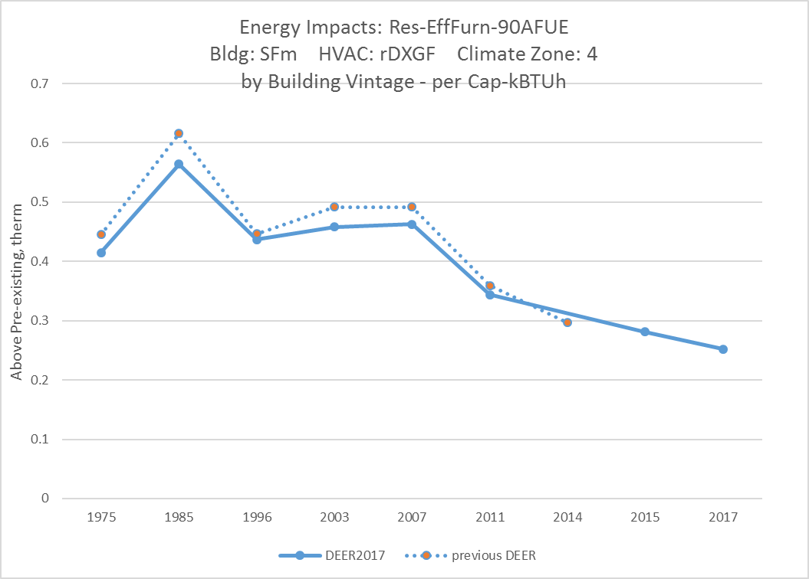

Figure 6. Example of the Vintage update for residential measures

## Whole House Fan

As described above, the whole house fan measure has been redefined to comply with the current Title-24 codes. The whole house fan measure in DEER prior to DEER2017 was developed for DEER2005 (MeasureID = D03-441). This measure has been updated using new measure parameters and the latest building prototypes. The new whole house fan measures consider a range of capacities and fan efficiencies as summarized in Table 12 below. The basis for the fan power values is described in the file WholeHouseFanData_2016_05_31.xlsx.

|  |  |  |  |
| --- | --- | --- | --- |
| DEER2017 Measure ID | Air Flow  CFM/sq ft | Fan Power  W/CFM | Fan Type |
| WHFan-0.7-PSC | 0.7 | 0.15 | PSC |
| WHFan-1.5-PSC | 1.5 | 0.15 | PSC |
| WHFan-2.0-PSC | 2.0 | 0.15 | PSC |
| WHFan-3.0-PSC | 3.0 | 0.15 | PSC |
| WHFan-0.7-ECM | 0.7 | 0.124 | ECM |
| WHFan-1.5-ECM | 1.5 | 0.124 | ECM |
| WHFan-2.0-ECM | 2.0 | 0.124 | ECM |
| WHFan-3.0-ECM | 3.0 | 0.124 | ECM |

Table 12. Whole house fan measure parameters

The whole house fan is utilized in single-family homes and assumes that the fan is on when cooling is available, the cooling load can be met by the whole house fan, and the outdoor temperature is at least three degrees below the cooling thermostat setpoint. The whole house fan will cool the space down to 70 F if possible regardless of the actual cooling thermostat setpoint.

## Lighting HVAC Interactive Effects

The cumulative effects on the calculated residential lighting HVAC interactive effects of the above listed modeling updates due to code requirements as well as corrections to errors are documented in the DEER2017 Lighting IE workbook. The summary graphics below compare the IOU-territory weighted IE factors by PA and building type for the existing and new vintages.

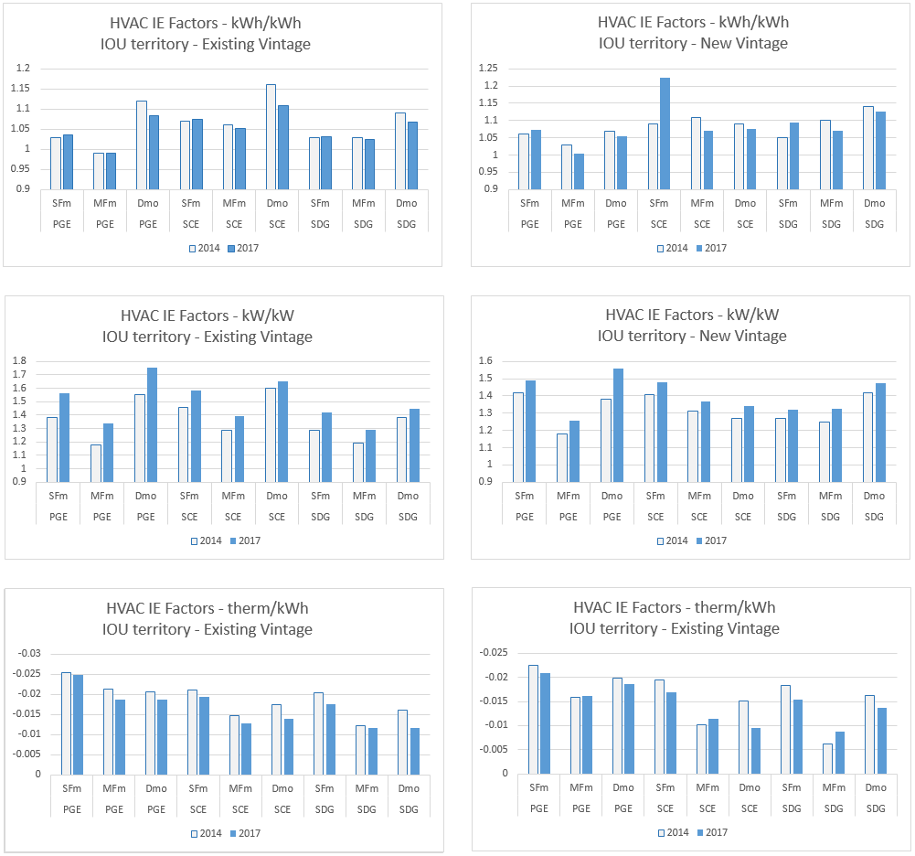

Figure 7. Summary of changes in residential HVAC IE factors

## Residential Dishwasher Measures

Measure updates were developed for the new Energy-Star criteria for dishwashers that became effective in early 2016. However, these updated values were found to not differ significantly from previous tier values and as such are not proposed to be included in the DEER2017 update. Similarly, updates for the clothes washer tier impacts were not incorporated due to their similarity to existing values.

# Residential Measure Updates Based on Corrections to Errors

## Lighting Use Profile

Analysis supporting DEER2011 resulted in revised lighting usage profiles, annual hours of use (HOU) and coincident demand factors (CDF). DEER2011 included updates to HOU and CDF values, which changed the overall savings values. However, the DEER2011 and subsequent updates neglected to include the lighting profiles advertised in the DEER2011 update documentation into the DEER prototypes. DEER2017 includes revisions to the interior lighting use profiles based on data used to update the lighting HOU and CDF values in DEER2011. Additional capabilities allow the specification of monthly profiles in DEER2017 as opposed to seasonal profiles used in earlier DEER versions. Figure 8. Comparison of Residential Lighting Profiles for DEER2017 Versus Previous DEER Versions below shows an example comparison between the previous profile and the updated profile. More complete data can be found in the “KEMA CFL load shape data.xls” workbook.

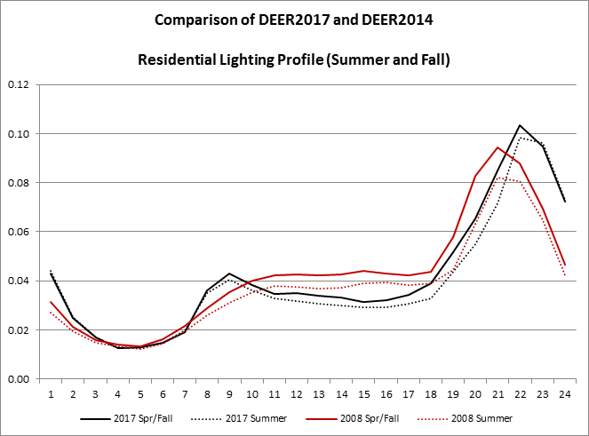

Figure . Comparison of Residential Lighting Profiles for DEER2017 Versus Previous DEER Versions

This correction contributes to the updated values for residential HVAC interactive effects factors described in the previous section. All residential indoor lighting measures are therefore impacted by this correction. No lighting direct impacts (lighting measure delta watts and hours of use) are impacted by this change, only the HVAC interactive effects are changed.

## Building shell insulation measures

During the investigation of the above listed Title 24 standards changes related to insulation levels, errors were discovered in the specification of some existing ceiling and wall insulation measures. The error associated with measures that add insulation to existing ceiling insulation levels caused energy savings values to be underestimated in most vintages and climate zones. Savings for the wall insulation measure were underestimated in all cases. A total of four measures were updated to correct the specification errors. The updated methodology was also used to add higher level ceiling insulation measures as requested by program administrators.

|  |  |
| --- | --- |
| MeasureID | Description |
| RB-BS-BlowInIns-R0-R13 | Wall Blow-In R-0 to R-13 Insulation |
| RB-BS-CeilIns-VintR-AddR11 | Ceiling - Add R-11 batts on top of vintage-specific existing insulation |
| RB-BS-CeilIns-VintR-AddR19 | Ceiling - Add R-19 batts on top of vintage-specific existing insulation |
| RB-BS-CeilIns-VintR-AddR30 | Ceiling - Add R-30 batts on top of vintage-specific existing insulation |

**Table 13. Residential Insulation Measures updated in DEER2017**

Additional Measures:

|  |  |
| --- | --- |
| MeasureID | Description |
| RB-BS-CeilIns-VintR-AddR38 | Ceiling - Add R-38 batts on top of vintage-specific existing insulation |
| RB-BS-CeilIns-VintR-AddR44 | Ceiling - Add R-44 batts on top of vintage-specific existing insulation |
| RB-BS-CeilIns-VintR-AddR50 | Ceiling - Add R-50 batts on top of vintage-specific existing insulation |

**Table 14. Additional residential Insulation Measures**

The following two charts show example comparisons for the “add R-19” ceiling insulation measure and the wall blow-in insulation measures. The increase in energy savings in DEER2017 over DEER2014 is largely due to a fix in the measure R-value specification.

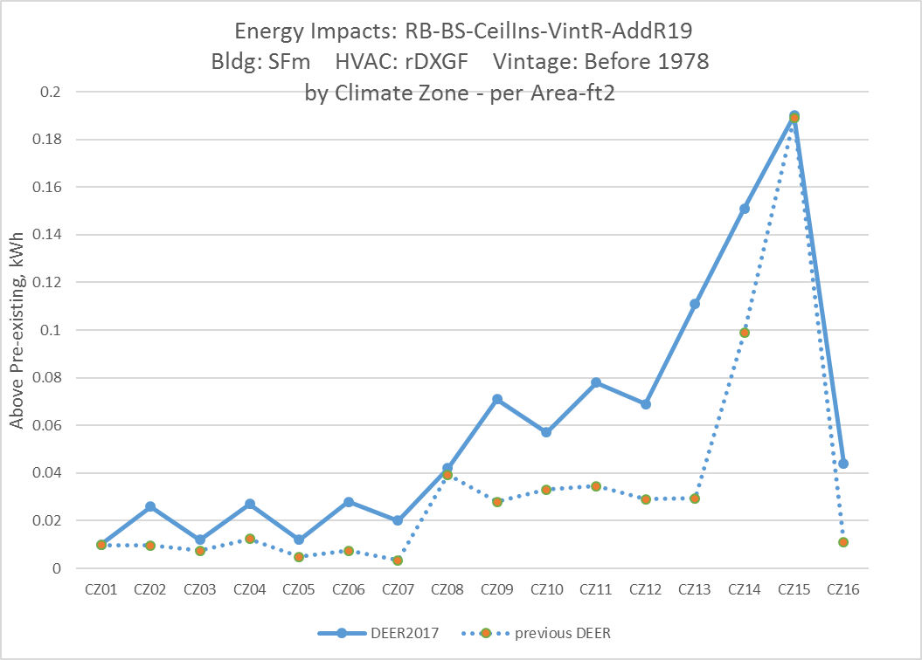

Figure 9. Example of energy impact changes in a residential ceiling insulation measure

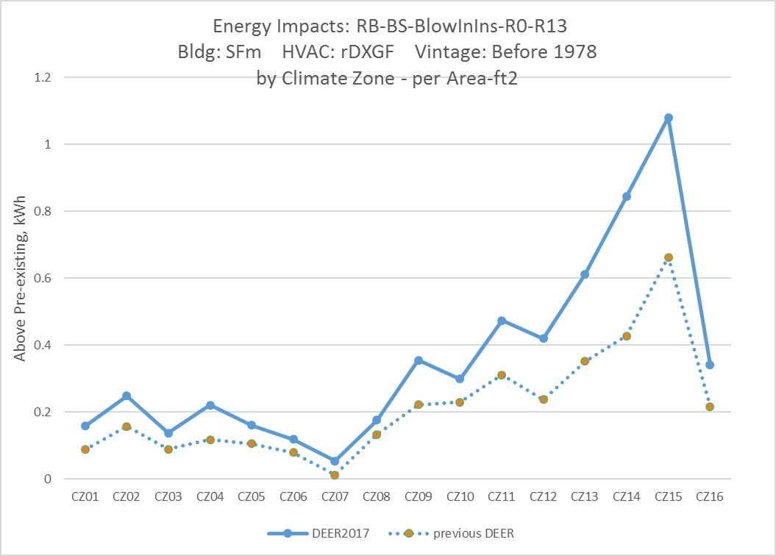

Figure 10. Example of energy impact changes in a residential wall insulation measure

## HVAC sizing Correction

The residential HVAC systems use pre-determined sizes based on building size, location and vintage. DEER2015 incorrectly applied commercial sizing factors to these values, resulting in system fans that were 30% larger than intended and cooling capacities that were 7% below the intended sizes. Savings for HVAC measures that are normalized by capacity used the intended capacity when calculating the unit energy savings. As a result of these two issues, the savings per ton of the HVAC cooling measures are overstated in DEER2015. The following two charts show example comparisons for a SEER 16 air conditioner measure and a SEER 18 heat pump measure. The savings decreases in DEER2017 largely due to the correction of the HVAC sizing factors.

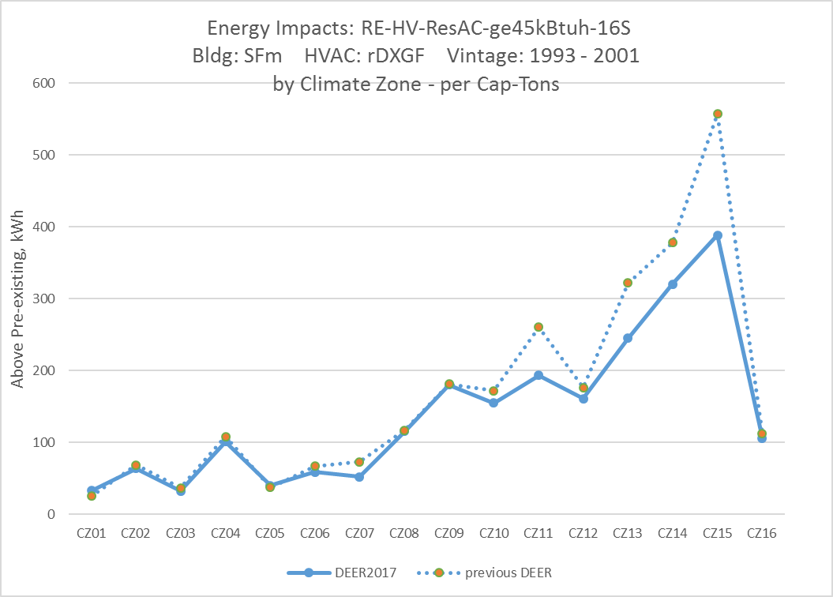

Figure 11. Example of energy impact changes in a residential air-conditioner measure

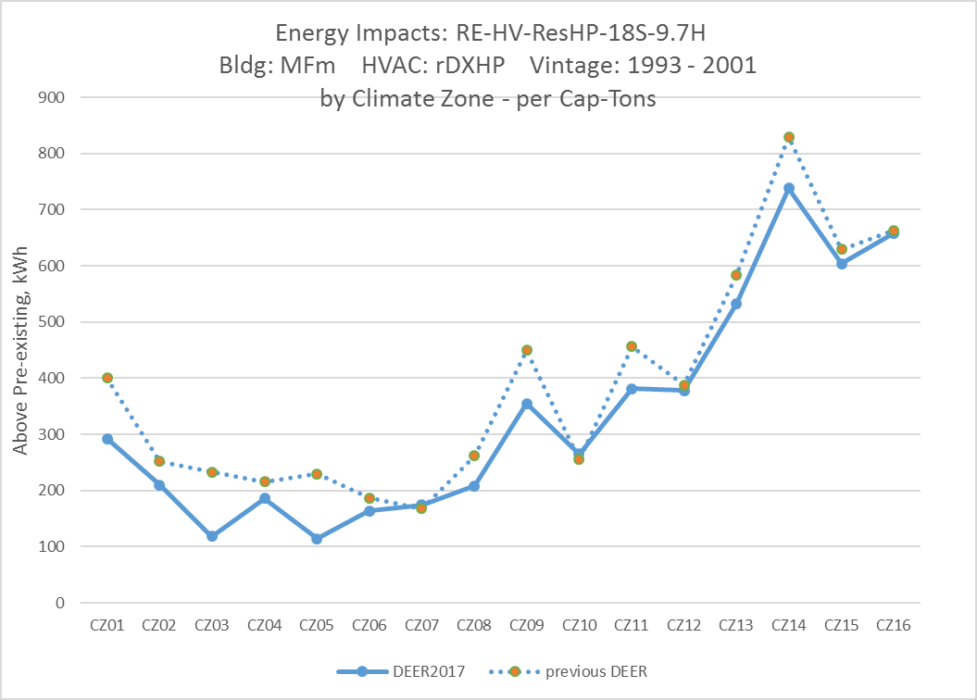

Figure 12. Example of energy impact changes in a residential heat pump measure

# DEER2018 Updates Based on Newly Available Evaluation Results and Related Market and Technology Research

These DEER2018 updates have a start date of 1/1/2018. There is some expectation, based on Decision language and 10-12 workpaper dispositions, that measures will be updated as evaluation results become available, however, these changes are proposed to be effective in 2018.

## Refrigerant Charge Adjustment

DEER2014 includes four refrigerant charge measures based on scenarios derived from monitored data along with a weighted measure that combines the results of the four scenarios into a single measure. The measure parameters were updated based on more recent EM&V data[7] and a new weighted refrigerant charge measure is created from these updated measure results. Supporting calculations are in the workbook UpdatedDataForRefrigerantCharge_2016_07_10.xlsx. The technology specifications based on the state of charge are summarized below.

|  |  |  |  |  |  |  |
| --- | --- | --- | --- | --- | --- | --- |
| Technology Criteria | Capacity Multiplier | | EIR Multiplier | | Sens Cap Multiplier | |
| prev | DEER2017 | prev | DEER2017 | prev | DEER2017 |
| High Over-Charge | 0.83 | 0.99 | 1.35 | 1.14 | 0.89 | 1.03 |
| Typical Over-Charge | 0.89 | 1.01 | 1.16 | 1.04 | 0.95 | 1.03 |
| Standard | 1.00 | 1.00 | 1 | 1.00 | 1.00 | 1.00 |
| Typical Under-Charge | 0.89 | 0.86 | 1.11 | 1.11 | 0.91 | 0.79 |
| High Under-Charge | 0.84 | 0.71 | 1.16 | 1.29 | 0.91 | 0.59 |

**Table 15. Residential refrigerant charge specifications**

|  |  |
| --- | --- |
| MeasureID | Description |
| RE-HV-RefChrg-Dec-high | Decrease Refrigerant Charge - High (>= 20% rated charge) |
| RE-HV-RefChrg-Dec-typ | Decrease Refrigerant Charge - Typical (< 20% rated charge) |
| RE-HV-RefChrg-Inc-high | Increase Refrigerant Charge - High (>= 20% rated charge) |
| RE-HV-RefChrg-Inc-typ | Increase Refrigerant Charge - Typical (< 20% rated charge) |
| Res-RefrigCharge-wtd | Adjusted Refrigerant charge |

**Table 16. Updated residential refrigerant charge measures**

The energy impacts for the high increase in refrigerant charge measure go up with this update, whereas the energy impacts for the other three measures decrease significantly.

The update to the refrigerant charge adjustment measures are also incorporated into the combined duct sealing plus refrigerant charge adjustment measures that were part of the previous DEER version.

|  |  |
| --- | --- |
| MeasureID | Description |
| RB-HV-MFDuctSeal-24pct-12pct | MultiFamily: Duct Sealing (Total Leakage Reduced from 24% of AHU flow to 12%) |
| RB-HV-MFDuctSeal-40pct-12pct | MultiFamily: Duct Sealing (Total Leakage Reduced from 40% of AHU flow to 12%) |
| RB-HV-MHDuctSeal-25pct-15pct | Mobile Home: Duct Sealing (Supply Leakage Reduced from 25% of AHU flow to 15%) |
| RB-HV-MHDuctSeal-35pct-15pct | Mobile Home: Duct Sealing (Supply Leakage Reduced from 35% of AHU flow to 15%) |
| RB-HV-SFDuctSeal-24pct-12pct | Single Family: Duct Sealing (Total Leakage Reduced from 24% of AHU flow to 12%) |
| RB-HV-SFDuctSeal-40pct-12pct | Single Family: Duct Sealing (Total Leakage Reduced from 40% of AHU flow to 12%) |
| RB-HV-MFDuctSeal-24pct-12pct | MultiFamily: Duct Sealing (Total Leakage Reduced from 24% of AHU flow to 12%) |

**Table 17. Updated residential refrigerant charge + duct sealing measures**

The charts below show example energy impact results to two of the refrigerant charge cases. Savings increase for the high increase in refrigerant charge case and decrease for the typical increase in refrigerant charge; overall savings decrease when weighted across all scenarios.

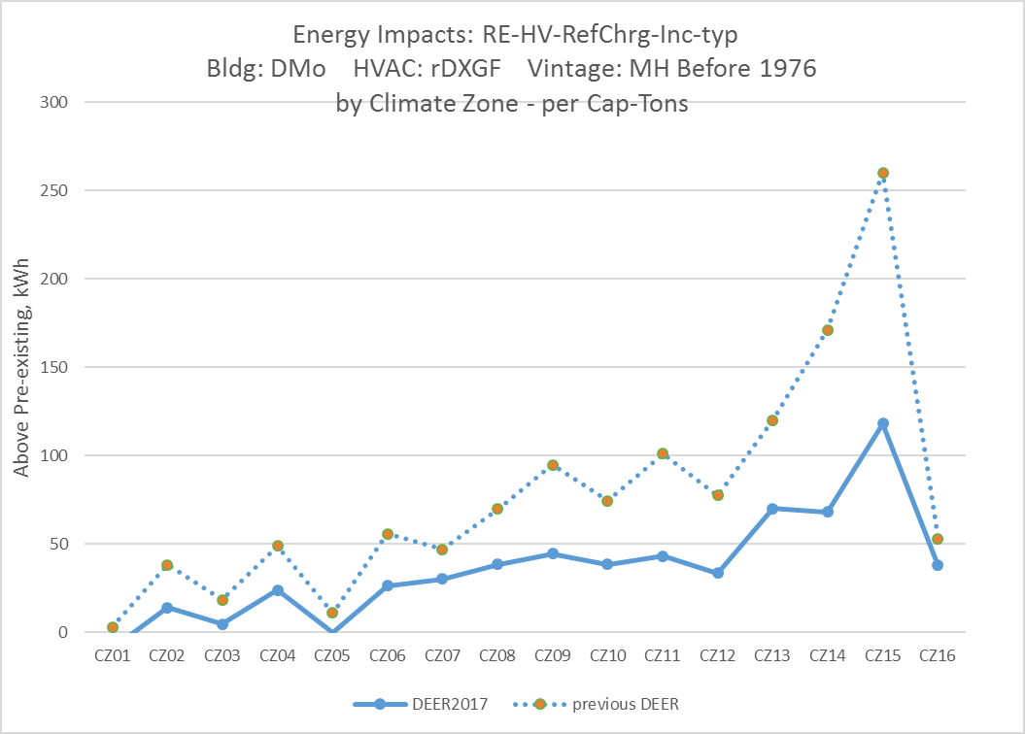

Figure 13. Example energy impacts for a typical increase in refrigerant charge

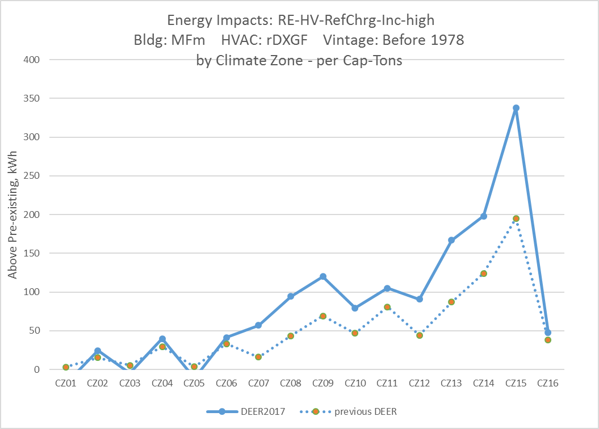

Figure 14. Example energy impacts for a high increase in refrigerant charge

## Standard Practice for Early Retirement Lighting Measures

### Summary of DEER Revisions to Standard Practice Baseline for Outdoor Lighting Measures

During the development of 2016 Title 24, the CEC concluded that it was cost-effective to update lighting power allowances (LPAs) for general hardscape[8] exterior lighting applications assuming LED technologies. As discussed in the 2016 CASE Outdoor Study[9], costs of exterior LED technologies are decreasing while performance is increasing. Due to the long EUL of most exterior lighting technologies, RUL for most exterior lighting measures will be five years, at which time price and performance will have continued to improve. Therefore, the DEER standard practice baseline for outdoor lighting early retirement measures has been revised to be LED technologies. The specific baseline technologies need to be developed through workpapers or custom project supporting documentation as new exterior lighting measures are introduced into programs. This second baseline will be applicable to all non-residential measures covering outdoor general (“OutGen” use subcategory) lighting measures. As a result of the change in standard practice baseline to LED technologies, all current DEER outdoor lighting measures (except screw-in CFLs) will no longer be approved for early retirement measures after December 31, 2017. These measures have been updated in the ex ante database to have an expiration date of December 31, 2017. New measures have been added with only DEER code baseline technologies (pulse start metal halide) and no pre-existing technologies.

### Summary of DEER Revisions to Standard Practice Baseline for Interior Linear Fluorescent Lighting Measures

The current DEER code baseline for linear fluorescent measures assumes 2nd generation T8 lamps with normal light output ballasts. However, recent market, technical and codes and standards research, along with 2013 and 2016 Title 24 updates (all described in Section 6.2.3) provide substantial support for a shift in this baseline to more efficient technologies, especially for standard practice (second) baseline in early retirement applications. The DEER standard practice baseline for 4-foot linear fluorescent early retirement measures has been revised to assume 3rd generation T8 lamps (3,100 initial lumens) and reduced light output ballasts. For a conventional, two-lamp fixture with a single ballast, this reduces the standard practice fixture power from 59 to 48 watts.

As a result of the change in standard practice baseline for early retirement to more efficient technologies, all current indoor lighting measures using four-foot linear T8 lamps will no longer be approved for early retirement measures after December 31, 2017. These measures have been updated in the ex ante database to have an expiration date of December 31, 2017. A limited number of new measures have been added in the following categories:

1. Replace-on-burnout, normal replacement and new construction: Any current DEER measures using technologies that exceed the DEER code baseline (2nd generation T8 lamps with normal light output ballasts) have been revised to have no pre-existing technology and DEER code baseline technologies. With these revisions, these measures will have no above customer average savings and therefore can only be used in ROB/NR/NC measure applications.
2. Early retirement: Any current DEER measures using technologies that exceed the DEER 2018 standard practice baseline (3rd generation T8 lamps with reduced light output ballasts) have been revised to have 2nd baseline technologies that meet the DEER 2018 standard practice baseline requirements.

### Background and Applicable Research for Standard Practice Baselines for Lighting Measures

At this time, DEER baselines for normal replacement (“NR”, also called Replace-on-Burnout or “ROB”) are the same as second baselines for early retirement (“ER”) measures. For NR projects, the baseline is the standard practice or code baseline in place at the time the project is commenced. For ER projects, the second baseline is the likely standard practice or code baseline that will be in place at the end of the remaining useful life (RUL) of the pre-existing lighting equipment. For early retirement lighting projects the RUL is approximately five years, except for projects replacing T12 linear fluorescent lamps where the EUL is rarely greater than two years.

D.12-05-015 Ordering Paragraph 151 directed that typical installation baselines be investigated as an alternative to code and/or standards baselines when appropriate. There are several recent evaluation and code development efforts that indicate increasing efficiency of standard practice baselines that are being influenced by many factors including improvements in technology, changes in design practice and the gradually increasing stringency of energy codes.

Commercial Market Share Tracking Study: The Commercial Market Share Tracking[10] study (CMST) indicated that by 2012, showed that selection and installation of “high efficiency” linear fluorescent lamps[11] was nearly a standard practice. Figure 15[12] is from the CMST study showing that “non-participants” (survey respondents who did not receive IOU incentives or participate in IOU programs as a means of financial support for projects) installed “high efficiency” linear fluorescent lamps in 67% of their projects. CMST does not include any information on ballasts. Since the light output rating of the ballast is necessary to estimate fixture power, the CMST findings provide qualitative evidence of change in standard practice to lower power lighting sources. However, Figure 15 also shows that reduced wattage lamps make up 52% of non-participant installations. The most common available wattages for these lamps are 25 and 28 watts.

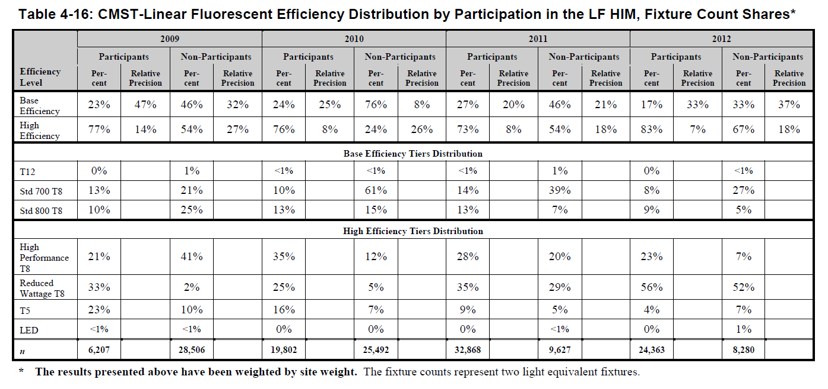

Figure 15 - Fluorescent Lamp Practices

2013 Codes and Standards Study – Indoor Lighting Controls: As part of the 2013 update to Title 24, the IOU’s Codes and Standards Enhancement “Measure Information Template” (2013 CASE study) [13] developed revised lighting power density requirements for office buildings and office space types. The analysis to develop these reductions assumed the use of high performance lighting technologies including “high performance” linear fluorescent lamps (with higher initial and mean lumen output ratings than lamps that comply with minimum federal standards) and reduced light output ballasts. Figure 16 is from the 2013 CASE study and shows the results of several prototypical lighting models used to develop the revised LPD levels. Fixture tags RF1, RF2, RF3, PF1, PF2 and PF3 represent the predominant linear fluorescent fixtures used in the model. Each of these fixtures shows initial lamp lumens of 3,100 (or a 3rd generation, high performance, T8 lamp) and a ballast factor of 0.71 (which is at the low range of ballast factors for reduced lighting output ballasts). The current DEER code baseline consists of 2nd generation T8 lamps (approximately 2,950 initial lumens) and normal light output ballasts (ballast factors of about 0.9).

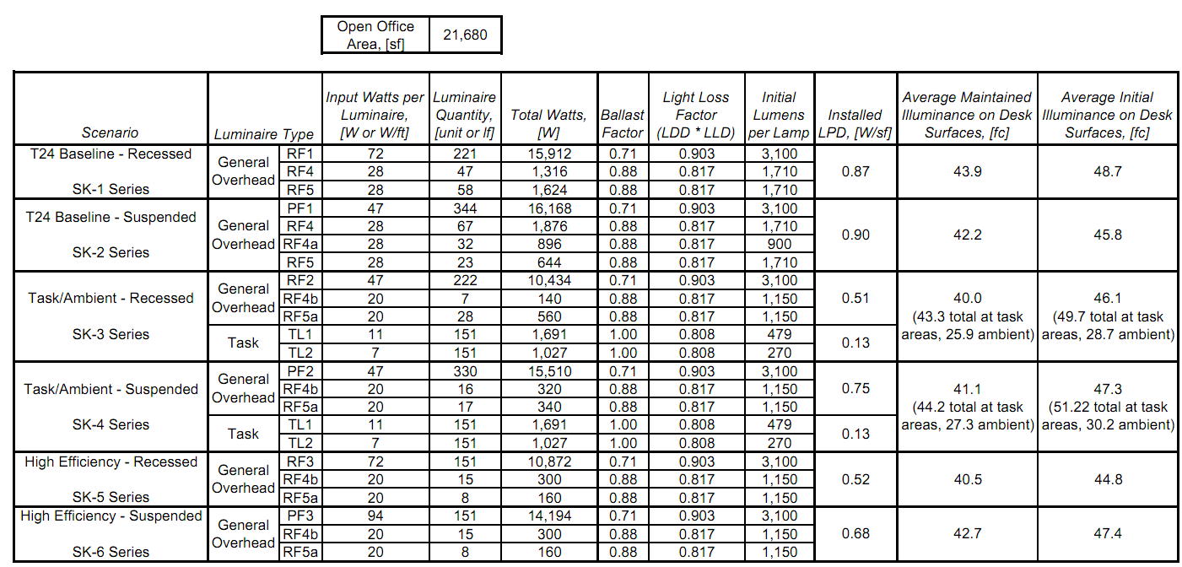

Figure 16 - 2013 CASE Office Lighting Model

2016 Codes and Standards Study – Non-residential Outdoor Lighting Power Allowance: As part of the 2016 update to Title 24, the IOU’s Codes and Standards Enhancement (CASE) program proposed revisions to Title 24 outdoor lighting power allowances (2016 CASE Outdoor Study). The report proposed that all lighting power allowances (LPA values) in Title 24 be reduced based on the standard practice usage of LED technologies. The final adopted Title 24 requirements only incorporated the recommendations for general hardscape lighting and did not reduce allowances for additional specialty lighting use categories such as vehicle service stations, outdoor sales lots, building facades, canopies and tunnels. Nevertheless, the report notes that many “many manufacturers expect this to be mostly complete in all outdoor lighting product categories by 2017.”

2016 Codes and Standards Study – Non-residential Lighting: Indoor LPDs: As part of the 2016 update to Title 24, the IOU’s Codes and Standards Enhancement (CASE) program proposed revisions to Title 24 indoor lighting power allowances for many non-office building and space types (2016 CASE Indoor Study).[14] The primary change in the 2016 analysis compared to previous efforts appears to be the assumption that all lighting sources consist of linear or compact fluorescent lamps. Previous analyses included some consideration for the use of incandescent lamps for a limited number of specialty applications. Normal light output ballasts were assumed for all modeled linear fluorescent fixtures, which differs from the assumptions in the 2013 Case Study where, for offices, reduced light output ballasts were assumed.

2016 Title 24 Updates for Alterations: There are two significant revisions to Title 24 Section 141.0(b)2I covering lighting system alterations:

1. Replacement lighting fixtures, where the entire lighting system is not being redesigned, in office, retail and hotel occupancies must have at least 50 percent, and all other occupancies at least 35 percent lower rated power at full light output compared to the replaced luminaires.
2. Lighting fixture retrofits (such as lamp and ballast replacements or LED kit retrofits) with at least 70 modified fixtures in office, retail and hotel occupancies must have at least 50 percent, and all other occupancies at least 35 percent lower rated power at full light output compared to the original, unmodified luminaires. Generally, in order to avoid these power reduction requirements a project would likely cover less than 6,000 square feet of floor space[15].

The two requirements (one for lighting fixtures, one for fixture modifications) present challenges for early retirement projects by making the code baseline dependent on the pre-existing technology. When a pre-existing fixture utilizes T12 lamps, then many commonly available T8 technologies will meet these requirements. However, if the pre-existing fixtures include T8 lamps, LEDs are likely the only technologies that can meet the 35-50% power reduction requirements. Title 24 allows any alteration to comply with new construction LPD limits. However, following the new construction requirements also invokes other requirements for multi-level output controls, occupancy/vacancy sensors, and day-lighting. In order to bypass the most burdensome control requirements, projects may meet LPD levels that are 15% less than the new construction requirements as allowed in Table 141.0-D.

1. D.16-10-28, at 80, states “D.12-05-015 allowed additional mid-cycle changes if there are new state and federal codes and standards that affect DEER values. Specifically, the decision stated in Conclusion of Law 84: “We generally agree with parties’ request that ex ante values should be adopted and held constant throughout the portfolio cycle. However, mid-cycle updates of ex ante values are warranted if newly adopted codes or standards take effect during the cycle.”
2. D.16-10-28, at 80, quotes from D.12-05-015: “Conclusion of Law 80 states: ‘Our Staff should have significant latitude in performing DEER and other policy oversight functions and, absent specific directives to the contrary, should not be required to consult with or otherwise utilize any other groups to perform this work.’”
3. ASHRAE introduced Path B in Standard 90.1-2010 as way to establish equivalent efficiency for chillers equipped with variable speed drives on compressors. Commonly available VSD chillers have lower full-load efficiencies that often would not comply with Path A requirements. However, VSD chillers typically have much higher efficiencies at part-load. The IPLV is weighted calculation of several part-load efficiency values. VSD chillers typically have much higher efficiencies at part-load compared to constant speed chillers, resulting in much higher IPLV ratings. Therefore, ASHRAE considers the lower full-load and higher part-load requirements of Path B to be equivalent to Path A.
4. AHRI Standard 550/590 Performance Rating of Water-chilling and Heat Pump Water-heating Packages Using the Vapor Compression Cycle
5. At this time, DEER does not include “Path B” performance maps for air cooled positive displacement chiller types.
6. At this time, DEER does not include “Path B” performance maps for water cooled positive displacement chiller types.
7. Draft Evaluation Report: Lab Tests of a Residential 3-Ton Split System Air Conditioner under Typical Installed Conditions, CPUC, 2012.
8. See 2016 Title 24 Section 140.7(d)1.A for the definition of outdoor general hardscape: *“The general hardscape area of a site shall include parking lot(s), roadway(s), driveway(s), sidewalk(s), walkway(s), bikeway(s), plaza(s), bridge(s), tunnel(s), and other improved area(s) that are illuminated. In plan view of the site, determine the illuminated hardscape area, which is defined as any hardscape area that is within a square pattern around each luminaire or pole that is ten times the luminaire mounting height with the luminaire in the middle of the pattern, less any areas that are within a building, beyond the hardscape area, beyond property lines, or obstructed by a structure. The illuminated hardscape area shall include portions of planters and landscaped areas that are within the lighting application and are less than or equal to 10 feet wide in the short dimensions and are enclosed by hardscape or other improvement on at least three sides.”*
9. “Codes and Standards Enhancement Initiative (CASE) Non-residential Outdoor Lighting Power Allowance” Measure Number: 2016-NR-LTG3-F, prepared by TRC Energy Services for California Utilities Statewide Codes and Standards Team, December 2014
10. Commercial Market Share Tracking Study (CMST), prepared for California Public Utilities Commission, Energy Division, Itron, Inc., July 18, 2014
11. CMST classifies high performance (or 3rd generation) T8, reduced wattage T8 (typically 25 or 28 watt) and T5 linear fluorescent lamps as “high efficiency.”
12. See page 4-30 of CMST
13. “CODES AND STANDARDS ENHANCEMENT INITIATIVE (CASE) Measure Information Template – Indoor Lighting Controls 2013 California Building Energy Efficiency Standards”, California Utilities Statewide Codes and Standards Team, October 2011
14. “Codes and Standards Enhancement Initiative (CASE) Non-residential Lighting: Indoor LPDs” Measure Number: 2016-NR-LTG1-F, prepared by TRC Energy Services for California Utilities Statewide Codes and Standards Team, October 2014
15. For a typical 8’x10’ grid of linear fluorescent fixtures (or 80 square feet per fixture), 70 fixtures would light about 5,600 square feet of floor area.