PUBLIC UTILITIES COMMISSION OF THE STATE OF CALIFORNIA

Communications Division | RESOLUTION T-17523
Broadband, Video and Market Branch | July 14, 2016

R E S O L U T I O N

Resolution T-17523 Conditional Approval of Funding for the Grant Application of Inyo Networks, Inc. (U-7159) from the California Advanced Services Fund (CASF) in the Amount of $1,491,078 for the Nicasio Broadband Project located in the Nicasio community of western Marin County, a CASF “priority area.”

Summary

This Resolution adopts contingent funding in the amount of $1,491,078 from the California Advanced Service Fund (CASF) for the grant application of Inyo Networks, Inc. (Inyo) for the construction of a Fiber-to-the-Premises last-mile network in the underserved Nicasio area of western Marin County, California. This approval is conditioned upon Inyo’s ability to secure the 40% matching fund within 365 days from the approval date of this Resolution.

The Nicasio Broadband Project (Nicasio Project) will cover 8 square miles and will be capable of delivering 1 gigabit (GB) symmetrical data along with voice and high definition video to 216 underserved households at an average CASF cost of $6,903 per household. This project will also provide broadband services to three anchor institutions and provide safety benefits in the area with a robust broadband service in the event of severe weather, natural disasters as well as improved access to e-health services.

Applicant Request

On November 13, 2015, Inyo submitted a CASF grant application to provide broadband Internet Service and Voice over Internet Protocol (VoIP) to 216 households with symmetrical speeds of 1 GB. In addition, three community anchor institutions including the Nicasio School (public K-8), Volunteer Fire Department headquarters, and County Public Works Corporation are within the project area.

The total cost of the proposed project would be $2,485,130. Inyo requested $1,739,591, or 70%, in funding because they asserted that the project area is unserved.

Topography: The community of Nicasio is located 11 miles west-southwest of Novato, Marin County, California. Nicasio is defined by a hydrologic zone containing the four main drainages of the Nicasio Creek. Much of the land is used for agricultural purposes, small-scale truck farming, and the raising of forage.

Applicant: Inyo’s Certificate of Public Convenience and Necessity (CPCN) to provide limited facilities-based and resold local exchange telecommunications service was granted by the Commission in D.09-12-036 on December 17, 2009. On February 12, 2015, the Commission adopted D.15-02-012 modifying Inyo’s CPCN to a full certificated facilities-based CLEC.

Inyo currently serves customers in California and Nevada, and offers competitive broadband services to end-users. It also provides open access network operations and support services for third party facility network owners. Inyo is also a past CASF grant recipient and successfully completed the $29 million California Broadband Cooperative Digital 395 network, a middle-mile project.

For the Nicasio Project, Inyo would serve as the fiscal agent, and owner/service operator of the facilities. The development and construction efforts of the project would be subcontracted to Praxis Associates, Inc. and Praxis Optical Networks, Inc., respectively. Praxis Associates, Inc. and Inyo are closely held corporations owned by the same principles Robert Volker and Michael Ort, and Praxis Optical Networks, Inc. is a wholly owned subsidiary of Praxis Associates, Inc.

Project: The Nicasio Project was proposed to Inyo by the North Coast Broadband Consortium and the Nicasio Land Owner Association (NLOA). Inyo proposes to construct and operate a Fiber-to-the-Premises last-mile network utilizing Point-to-Point Protocol over Ethernet transmission electronics to support voice, data and video services. The proposed network would be constructed using a combination of underground and aerial plant designs depending on the end user’s service location and status of existing plant. For the distribution cable where available, joint poles attachments and conduit occupancy in existing AT&T and Zayo Group (Zayo) ducts would be used. Where the utility joint poles would not meet General Order 95 loading standards, new underground conduits would be constructed. Inyo anticipated two new underground conduits in the Public Utility Easement (PUE) along a 2,400 foot section of Lucas Valley Road would be required. Approximately two-dozen splice boxes would house fiber access points that would serve as terminals feeding from two to eight homes each. Last-mile fiber distribution cable facilities would be aggregated to a Node Cabinet, located at the confluence of Lucas Valley and Nicasio Valley roads in the PUE. At each home, Inyo Networks would install Network Interface Devices that would have battery back-up supporting voice services. This proposed fiber ring would initially interconnect to the national Internet by obtaining gigabit backhaul and Internet access from Zayo.

The selection of fiber technology to serve the area is based upon the area’s topography, transmission distances, and the long-term economic development goals of local government. Upon completion, the network would be capable of delivering 1 GB symmetrical data along with voice and high definition video. The network would be configured to be upgradable to 10 GB, as future needs require.

Notice and Challenges

On November 24, 2015, Communications Division (CD) posted the proposed project area map, census block groups (CBGs) and zip codes for the Nicasio Project on the Commission’s CASF webpage under “CASF Application Project Summaries” and also sent notice regarding the project to its electronic service list. CD received no challenges to the proposed project area.

There were no commitments made by an existing provider to upgrade service before the November 1, 2014, “first right of refusal” deadline.

Project Review

For the area to be project eligible, the CASF program requires an applicant to submit proof that the area is unserved or underserved by submitting shapefiles of the proposed project. CD reviews the submitted shapefiles and compares them with United States 2010 Census data and the California Interactive Broadband Availability map. Once CD determines that the area is eligible either as an unserved or underserved area, CD evaluates all other information submitted by the applicant to determine if the project meets the requirements outlined in D.12-02-015.

Project Area Eligibility

The project location of the Nicasio Project by census block group is attached in Appendix B. Based on submitted shapefiles, United States 2010 Census data, and the California Interactive Broadband Availability map, CD concludes that Nicasio is in underserved area disproving the unserved designation asserted by Inyo. CD’s finding is supported by the California Interactive Broadband Availability Maps showing:

- The proposed project area is unserved by wireline broadband providers;
- The proposed project area is unserved by fixed wireless broadband providers; and
- The proposed project area is underserved by mobile wireless internet service providers.

As underserved, the CASF funding for the Nicasio Project is limited to 60%. Inyo agrees with CD’s finding; and for the 10% funding gap due to the decreased CASF funding, Inyo agrees to increase the matching fund to 40%, i.e. $994,052.

Project Criteria Evaluation

CD evaluated the application with respect to the criteria defined in D.12-02-015, Appendix 1, Section VIII (Scoring Criteria). The criteria include: (i) Funds Requested per Potential Customer, (ii) Speed, (iii) Financial Viability, (iv) Pricing, (v) Total Number of Households in the Proposed Area, (vi) Timeliness of Completion of Project, (vii) Guaranteed Pricing Period, and (viii) Low-Income Areas. CD’s evaluation of Nicasio Project is summarized below.

Funds per household: According to the 2010 census block data, there are 216 households in the Nicasio Project service area; hence, the CASF funds per-household will be $6,903. This project has a higher subsidy per household than the average of previously awarded last-mile projects.

Speed: The proposed 1 GB symmetrical speed offering exceeds the 6/1.5 benchmark set by the Commission. This project offers faster speeds than the average of previously awarded last-mile projects.

Financial Viability: Based on the pro forma financial statements submitted by Inyo, CD determined that Inyo is a financially viable company. Inyo performs better financially than the average of previously awarded last-mile projects.

For the project, Inyo projected positive annual earnings before interest and taxes (EBIT). This earning projection was based on a take-rate of 84%, which is consistent with Marin County’s 84% broadband adoption rate.

Pricing: Table 1, below, illustrates the pricing plan for the Nicasio Project.
Table 1: Inyo’s 2- Year Guaranteed Pricing Plan for Nicasio Project
 | Monthly Recurring | Non-Recurring
Data at 1 GB Up and Down | $89.95
Data at 100 Mb Up and Down | $69.95
Data at 25 Mb Up and Down for students in School Lunch Program | $29.95
Voice including E-911, unlimited national calls, voice mail and customer calling features – Available only if bundled with data service | $23.50
Network Connection Charge |  | $0.00

In the application, Inyo proposed a 2-year service contract requirement with early termination fee and $0 network connection charge during the initial service offering after construction. After the initial service offering, the network connection would be $350 per visit. CD followed up with Inyo on the proposed pricing program requirements on recurring and non-recurring fees established in D.12-02-015. At CD’s recommendation, Inyo agreed to a 2-year guaranteed pricing period and waived the 2-year service contract requirement as well as the service connection charge as demonstrated in Table 1 above.

The average weighted score for previously awarded last-mile projects under the Pricing criteria is 4 and this project has a weighted score of 4. The proposed price of this project is comparable to the average price of previously awarded last-mile projects.

Households in Project Area: There are 216 households in the Nicasio Project service area. The number of households for this project is comparable to the average of previously awarded last-mile projects.

Timeliness of Completion: Inyo has submitted detailed planning documents including a schedule with clear milestones. Inyo projected that the Nicasio Project will be completed within 11 months from the CASF grant approval date, which is less than the 24 month allowance. This project has a shorter time of completion than the average of previously awarded last-mile projects.

Guaranteed Pricing Period: Inyo has committed to a pricing plan of two years, starting from the beginning date of service. The proposed guaranteed pricing period for this project is shorter than the average of previous awarded last-mile projects.

Low-Income Areas: Nicasio is not in a low-income area. Based on 2010 census block group data, CBG 06041133002 (which includes Nicasio) has a population of 660, a median household income of $138,000 (more than double the state average of $61,094) and a poverty rate of 3.1% (below the State poverty rate of 15.9%). The median household income in Nicasio is higher than the average of previous awarded last-mile projects.

Safety and Community Input Considerations

Nicasio is a small community but has an important location at the geographical heart of the Marin County. Nicasio’s close proximity to the Pacific coastline and the San Andreas Fault, as well as its significant forest cover, make it vulnerable to monsoonal rainstorms, wild fires, and earthquakes. In addition to offering broadband services to residents and businesses, Inyo proposes to extend its service availability to anchor institutions including the Nicasio School, Volunteer Fire Department, and County Public Works Corporation, which will further enhance public safety in the Nicasio community.

Inyo submitted over 40 letters of support from local, state and federal elected officials; local and regional governmental agencies; educational leaders; access network providers; and business and home owners. From the elected officials’ perspective, Nicasio will serve as a “beachhead” that will facilitate the expansion of broadband throughout West Marin County enabling future projects to connect the unserved coastal communities, schools, clinics, and businesses. From the local and regional governmental agencies’ perspective, the proposed project will improve communications, establish interactive communications, and advance public safety. From the educational leaders’ perspective, the project will bring connectivity to the homes of K-12 school pupils enabling teacher-parent communication online and students to learn at home. From the access network providers’ perspective, the project will allow them to interconnect to the vitally important fiber backbone for necessary backhaul/middle-mile high capacity transport. From business owners’ perspective, the project will improve their business efficiency by allowing them to market products, ordering supplies and purchasing livestock online. From the homeowners’ perspective, Internet has become an essential part of life and the proposed project will bring them broadband equality including the potential for telemedicine at an affordable price.

Staff Recommendation for Funding

Although Inyo has demonstrated that the project is financially viable as a going-concern, it has not been able to secure the required matching funds for the construction of the project. According to Inyo, the required matching funds plus costs of offering will be obtained by a notes offering, which will be registered with the California Department of Business Oversight under the Securities & Exchange Commission’s standardized process, the Small Company Offering Registration (SCOR) process. The homeowners in the project area will be offered an opportunity to purchase the notes. The interest rate will be based on market conditions. Currently, the applicant is proposing an interest rate of 3% per year. Praxis Optical Networks, the developer of this project, is currently consulting with financial and legal advisors for the preparation and issuance of the Broadband Utility Note. If notes were not to be fully subscribed, according to the applicant the monies would be returned to the investors.

In the past, the Commission has rescinded several approved projects for various reasons including, but not limited to, the applicants’ opting out of the project due to the inability to secure the required matching funds. In this case, CD deviates from the matching funding requirement laid out in D.12-02-015, and recommends funding approval on a contingent basis. This approval should be conditioned upon Inyo’s ability to secure the 40% matching fund within 365 days from the approval date of this Resolution. Should Inyo be unable to secure the requisite funding within the time frame required, funding approval for the Nicasio Project should be rescinded automatically. CD bases this deviation on the facts that:

- This deviation does not waive the matching funding requirement but only extends the time for Inyo to satisfy the requirement.
- Inyo’s proposed financing for the matching fund through the Broadband Utility Note is innovative. If successful, this funding mechanism could become a viable alternative for others to follow.

CD further finds that the Nicasio Project aligns with CASF’s goal to encourage the deployment of high-quality advanced information and communications technologies to all Californians to promote economic growth, job creation, and substantial social benefits.

CD’s recommendation that the Commission approve CASF funding for Inyo’s Nicasio Project, subject to the matching fund condition described above, is reasonable and should be adopted. Inyo must notify the Director of Communications Division in writing certifying that it has or has not secured the 40% matching fund within 365 days from the approval date of this Resolution.

Compliance Requirements

Inyo is required to comply with all the guidelines, requirements, and conditions associated with the grant of CASF funds as specified in D.12-02-015, D.14-02-018, and Resolution T-17443. Such compliance includes, but is not limited to:

California Environmental Quality Act

All CASF grants are subject to California Environmental Quality Act (CEQA) requirements unless the project is statutorily or categorically exempt pursuant to the CEQA Guidelines.

At the request of Energy Division’s CEQA Team, Inyo submitted additional documentation describing all the project components and the construction methods to be employed. Inyo asserted that this project would be constructed and completed using existing conduit, aerial attachments to existing poles, and the placement of new conduit underground. Existing conduit and aerial attachment work would result in no impact to earth surfaces (soil, pavement, etc.) or surrounding vegetation. All infrastructure using both existing conduit and aerial attachments is currently in place and constitutes approximately 75% of the proposed project. The remaining 25% of the route requiring the placement of new conduit would be constructed using either hydro-directional boring (HDD) or trenching. HDD’s work would remain in the existing disturbed road prism and trenching work would occur in previously disturbed areas. The area to be trenched is relatively small (less than 15,000 feet) and after the conduit is placed underground, the surface would be restored to its previous condition.

Based on the above information, the CEQA Team determined that the Nicasio Project is exempt from CEQA review because it qualifies for the following categorical exemptions: Existing Facilities, including the minor alteration of existing public or private structures, facilities, or mechanical equipment (CEQA Guidelines § 15301); New Construction or Conversion of Small Structures, involving construction, installation, and/or conversion of limited numbers of new and/or existing facilities/structures (CEQA Guidelines § 15303); and Minor Alterations to Land, involving minor trenching and backfilling where the surface is restored; (CEQA Guidelines, § 15304).

Deployment Schedule

The Commission expects Inyo to complete the project within 24 months from start date (as determined by the procedure below). If Inyo is unable to complete the proposed project within the 24 month timeframe requirement, it must notify the Director of CD as soon as Inyo becomes aware of this possibility. If such notice is not provided, the Commission may reduce payment for failure to satisfy this requirement by timely notifying CD’s Director.

Execution and Performance

CD and Inyo shall determine a project start date after Inyo has obtained all approvals. Should Inyo or any contractor it retains fail to commence work by the designated date, upon five days written notice to Inyo, the Commission, may terminate the grant. In the event that Inyo fails to complete the project in accordance with the terms of CPUC approval as set forth in this resolution, Inyo must reimburse some or all of the CASF funds that it has received. Inyo must complete all construction covered by the grant on or before the grant’s termination date.

Performance Bond

The Commission does not require a Performance Bond if the applicant certifies that the percentage of the total project costs it is providing comes from its capital budget and (emphasis added) is not obtained from outside financing. Since Inyo proposed the 40% matching fund to be financed by the Broadband Utility Note, a debt funded by outside sources, a performance bond for the Nicasio Project is required. Upon CD’s recommendation, Inyo agrees to obtain a performance bond for the project.

Inyo must send an executed bond, equal to the total amount payable under the CASF award, to the Executive Director and to the Director of Communications Division at the time of the first payment request. The performance bond must also be callable for failure to complete the Nicasio Project.

Price Commitment Period

The minimum required price commitment period for broadband service to all households within the project area is two years. Inyo guarantees the price of service offered in the project area for two years.

Project Audit

The Commission has the right to conduct any necessary audit, verification, and discovery during project implementation/construction to ensure that CASF funds are spent in accordance with Commission approval.

Inyo’s invoices will be subject to a financial audit by the Commission at any time within three years of completion of the work.

Providing Voice Service

Inyo has certified that its VoIP telephone service meets the Federal Communications Commission (FCC) standards for E-911 service and battery backup.

Submission of Form 477

The FCC currently requires broadband providers to biannually submit the Form 477, which includes speed data. While there is an imperfect match between the data that is reported in the Form 477 and to the CASF, the Form 477 data will be useful in documenting CASF deployment for the new service area of the carrier. Pursuant to General Order 66-C, service providers in California must submit a copy of their Form 477 data directly to the CPUC, concurrent with their submission of the same data to the FCC. CASF recipients must continue to submit their Form 477 data to the FCC for a five-year period after completion of the project.

Reporting

All grantees must submit quarterly progress reports on the status of the project irrespective of whether grantees request reimbursement or payment. Quarterly progress reports are due on January 1, April 1, July 1, and October 1, which must include Inyo’s progress in securing and accessing the required matching funds.

Before full payment of the project, Inyo must submit a project completion report. Progress reports shall use the schedule for deployment, major construction milestones and costs submitted in the proposal; indicate the actual date of completion of each task/milestone as well as problems and issues encountered, and the actions taken to resolve these problems and issues during project implementation and construction; and identify future risks to the project.

Inyo shall also include test results on the download and upload speeds on a CBG and zip code basis in the final completion report. Inyo must certify that each progress report is true and correct under penalty of perjury.

Payments to CASF Recipients

Submission of invoices from and payments to Inyo shall be made at 25 percent completion intervals, in accordance with Section XI of Appendix 1 of D.12-02-015 and according to the guidelines and supporting documentation required in D.12-02-015.

Payment to Inyo shall follow the process adopted for funds created under P.U. Code §270. The Commission generally processes payments within 20-25 business days, including CD and Administrative Services review time. The State Controller’s Office (SCO) requires an additional 14- 21 days to issue payment from the day that requests are received by SCO from Administrative Services.

Comments on Draft Resolution

In compliance with Public Utilities Code § 311(g), a notice letter was e-mailed on June 6, 2016, informing all parties on the CASF Distribution List of the availability of the draft of this resolution for public comments at the Commission's website at http://www.cpuc.ca.gov/PUC/documents/. This letter also informed parties that the final conformed Resolution adopted by the Commission will be posted and available at this same website. CD received one comment. No reply comments were received.

CD received comments submitted jointly by Inyo and NLOA on June 17, 2016. Inyo and NLOA indicated that they have begun working with various governmental entities to complete the project, but the time for these entities to issue final approval is outside of their control. To this end, Inyo and NLOA requested some flexibility in the timeframes, as long as good progress is being made on the funding process. More specifically, Inyo requested that the contingency be extended from 180 days after the date of approval of this Resolution to 365 days following the approval date of this Resolution.

Inyo’s and the NLOA’s request to provide some flexibility in the timeframes in securing the matching funds have merit and are incorporated in this Resolution.

Findings

- Inyo filed an application for CASF funding for its Nicasio Project on November 13, 2015. The proposed project will deliver 1 GB symmetrical data along with voice and high definition video. The network would be configured to be upgradable to 10 GB, as future needs require.

- Key information of the approved project is in Appendix A of this Resolution.

- CD posted the proposed project area map, CBG and zip code for the Nicasio Project on the Commission’s CASF webpage under “CASF Application Project Summaries” on November 24, 2015. CD received no challenges to this project.

- CD reviewed and analyzed submitted data from the Inyo grant application to determine the project’s eligibility for CASF funding. This data includes but is not limited to proof that the applicant has a CPCN from the Commission; description of current and proposed broadband infrastructure; number of potential subscriber households and average income; project construction schedule; project budget; proposed pricing and commitment period for new subscribers; and financial viability of the applicant.

- Based on its review, CD determined that the proposed project area is underserved and eligible for 60% CASF funding.

- Inyo has not been able to secure the required matching funds for the construction of the project. In this case, CD recommends the Commission deviate from the matching funding requirement laid out in D.12-02-015, and approve Inyo’s request on a contingent basis because Inyo’s proposed financing for the matching fund through the Broadband Utility Note is innovative and the deviation only extends the time for Inyo to satisfy the requirement.

- CD recommends the approval of the CASF grant for Inyo’s Nicasio Project shall be contingent on Inyo securing the 40% matching fund with 365 days from the approval date of this Resolution.

- CD recommends that if Inyo is unable to secure the 40% matching fund within 365 days from the approval date of this Resolution, then the funding approval for the Nicasio Project is rescinded automatically.

- CD’s recommendation is reasonable and should be adopted.

- Since the 40% matching fund will be financed by outside sources, Inyo agrees to obtain a performance bond, equal to the total amount payable under the CASF award. The performance bond will also be callable for failure to complete the Nicasio Project.

- Inyo must notify the Director of Communications Division whether it has or has not obtained the required matching funds within 365 days from the approval date of this Resolution.

- Inyo is required to comply with all guidelines, requirements, and conditions associated with the granting of CASF funds as specified in D.12-02-015 and must submit the FCC Form 477, as specified in Resolution T-17143.

- The Commission finds CD’s recommendation to fund the Nicasio Project on the condition that Inyo is able to secure the required matching funds within 365 days from the approval date of this Resolution to be reasonable and consistent with Commission orders and, therefore, adopts such recommendation.

- The Nicasio Project is exempt from CEQA review because it qualifies for the following categorical exemptions: Existing Facilities, including the minor alteration of existing public or private structures, facilities, or mechanical equipment (CEQA Guidelines § 15301); New Construction or Conversion of Small Structures, involving construction, installation, and/or conversion of limited numbers of new and/or existing facilities/structures (CEQA Guidelines § 15303); and Minor Alterations to Land, involving minor trenching and backfilling where the surface is restored; (CEQA Guidelines, § 15304).

- Inyo should send an executed bond, equal to the total amount payable under the CASF award, to the Executive Director and to the Director of Communications Division at the time of the first payment request. The performance bond should also be callable for failure to complete the Nicasio Project.

- A notice letter was e-mailed on June 6, 2016, informing all applicants filing for CASF funding, parties on the CASF distribution list of the availability of the draft of this Resolution for public comments at the Commission’s website http://www.cpuc.ca.gov/PUC/documents/. This letter also informed parties that the final confirmed Resolution adopted by the Commission will be posted and available at this same website. CD received one comment.

- The Commission finds CD’s recommendation to fund the Nicasio Project as summarized in Appendix A to be reasonable and consistent with Commission orders, and therefore, adopts such recommendation.

THEREFORE, IT IS ORDERED that:

  - The Commission shall award $1,491,078 to Inyo Networks, Inc. (Inyo) for the Nicasio Broadband Project (Nicasio Project) on the condition that Inyo is able to secure the 40% matching fund of $994,052 within 365 days from the approval date of this Resolution. Key information of the approved project is in Appendix A of this Resolution.

  - Inyo shall notify the Director of Communications Division in writing certifying that it has or has not secured the required matching funds within 365 days from the Approval date of this Resolution. If Inyo is unable to secure the 40% matching fund, then the funding approval for the Nicasio Project is rescinded automatically.

  - Quarterly progress reports are due on January 1, April 1, July 1, and October 1, which must include Inyo’s progress in securing and accessing the required matching funds.

  - Inyo shall send an executed performance bond, equal to the total amount payable under the CASF award, to the Executive Director and to the Director of Communications Division at the time of the first payment request. The performance bond must also be callable for failure to complete the Nicasio Project.

  - The program fund payment of $1,491,078 for this project in underserved area shall be paid out of the CASF Infrastructure Grant Account in accordance with the guidelines adopted in D.12-02-015.

  - Payments to Inyo shall be in accordance with Section XI of Appendix 1 of D.12-02-015 and in accordance with the process defined in the “Payments to CASF Recipients” section of this Resolution.

  - Inyo shall comply with all guidelines, requirements and conditions associated with the CASF funds award as specified in D.12-02-015 and must submit the FCC Form 477 to the Commission, as specified in Resolution T-17143.

This Resolution is effective today.

I hereby certify that this Resolution was adopted by the Public Utilities Commission at its regular meeting on July 14, 2016. The following Commissioners approved it:

/s/ Timothy J. Sullivan

TIMOTHY J. SULLIVAN

Executive Director

MICHEL PETER FLORIO
CATHERINE J.K. SANDOVAL
CARLA J. PETERMAN
LIANE M. RANDOLPH
Commissioners
I dissent.

/s/ MICHAEL PICKER
President

APPENDIX
APPENDIX A
Resolution T-17523
Inyo’s Nicasio Project
Key Information

Project Name | Nicasio
Project Plan | To construct a Fiber-to-the-Premises last-mile network utilizing Point-to-Point Protocol over Ethernet transmission electronics with the initial capability of delivering 1 Gigabit (GB) symmetrical data along with voice and high definition video. The network will be upgradable to 10 GB, as future needs require.
Project Size (in square miles) | 8.0
Download/Upload speed | 1GB up and 1GB down
Location | Marin County
Community Names | Nicasio
Census Block Groups | 060411133002 and part of 06041113001
Median Household Income (by Census Block Group) | $138,000
Zip Codes | 94946
Estimated potential subscriber size | 216 households and 3 anchor institutions
Applicant expectations | 184 Units
Pricing Plan (Monthly) | 1 GB Up/Down $89.95  100 Mb Up/Down $69.95  25 Mb Up/Down for Students in School Lunch Program $29.95
Deployment Schedule  (from Commission approval date) | 11 months
Proposed Project Budget (Total) | $ 2,485,130
Amount of CASF funds requested (60%) | $1,491,078
Applicant funded (40%) | $ 994,052

Appendix B
Resolution T-17523
Inyo’s Nicasio Project
Project Location Map

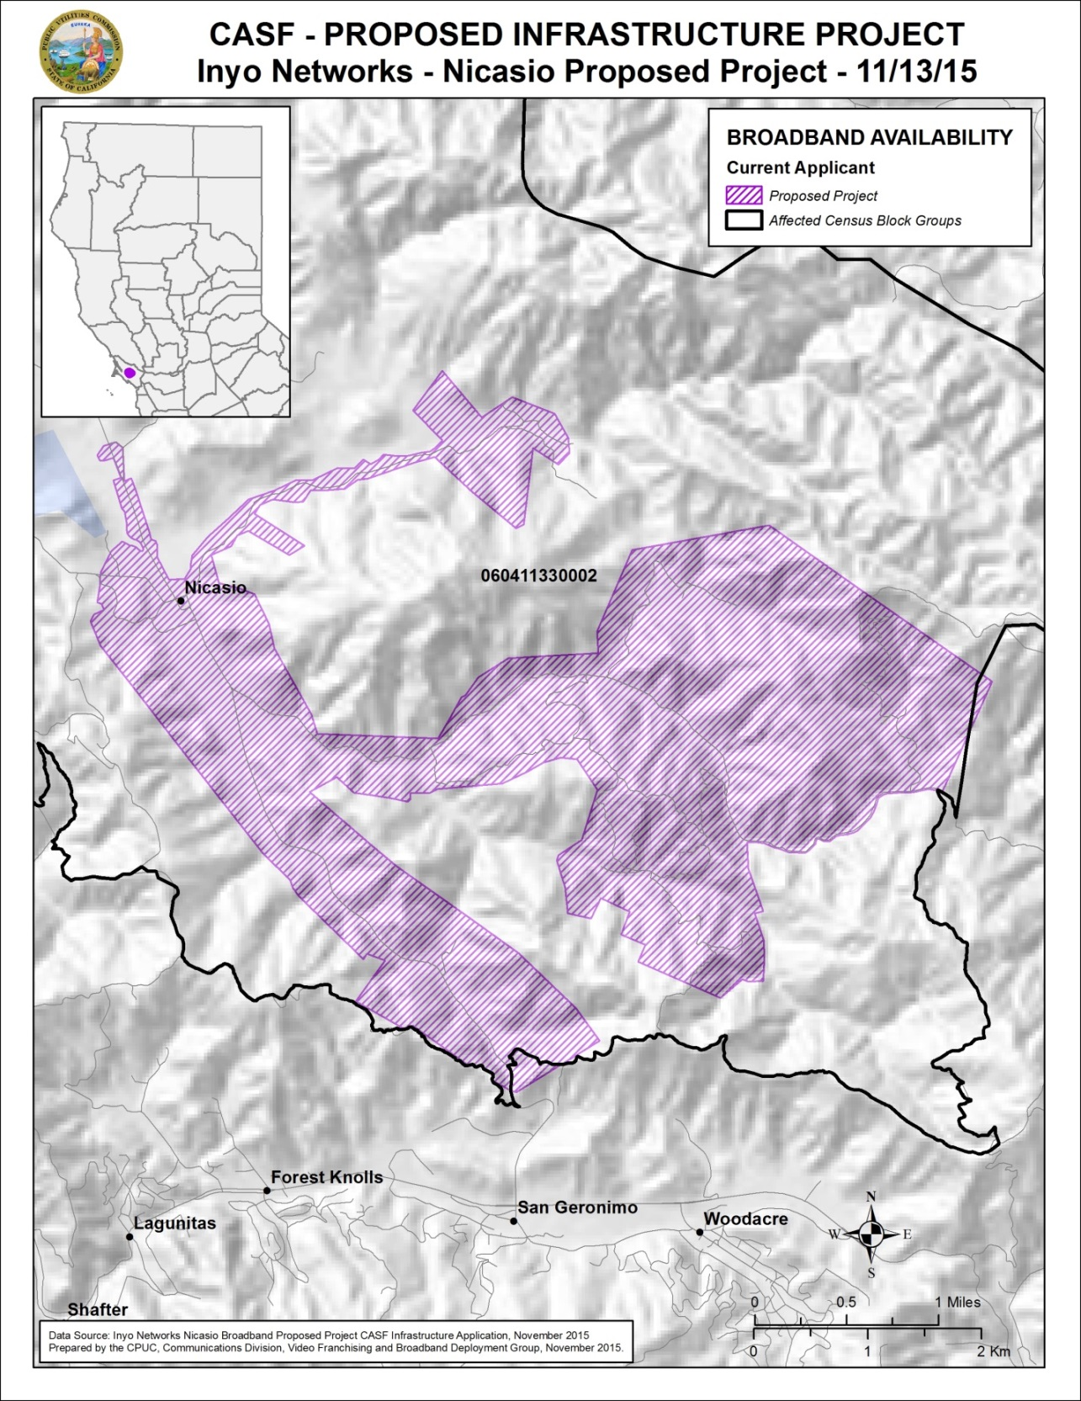

Appendix C
Resolution T-17523
Inyo’s Nicasio Project
Existing Wireline Service Level

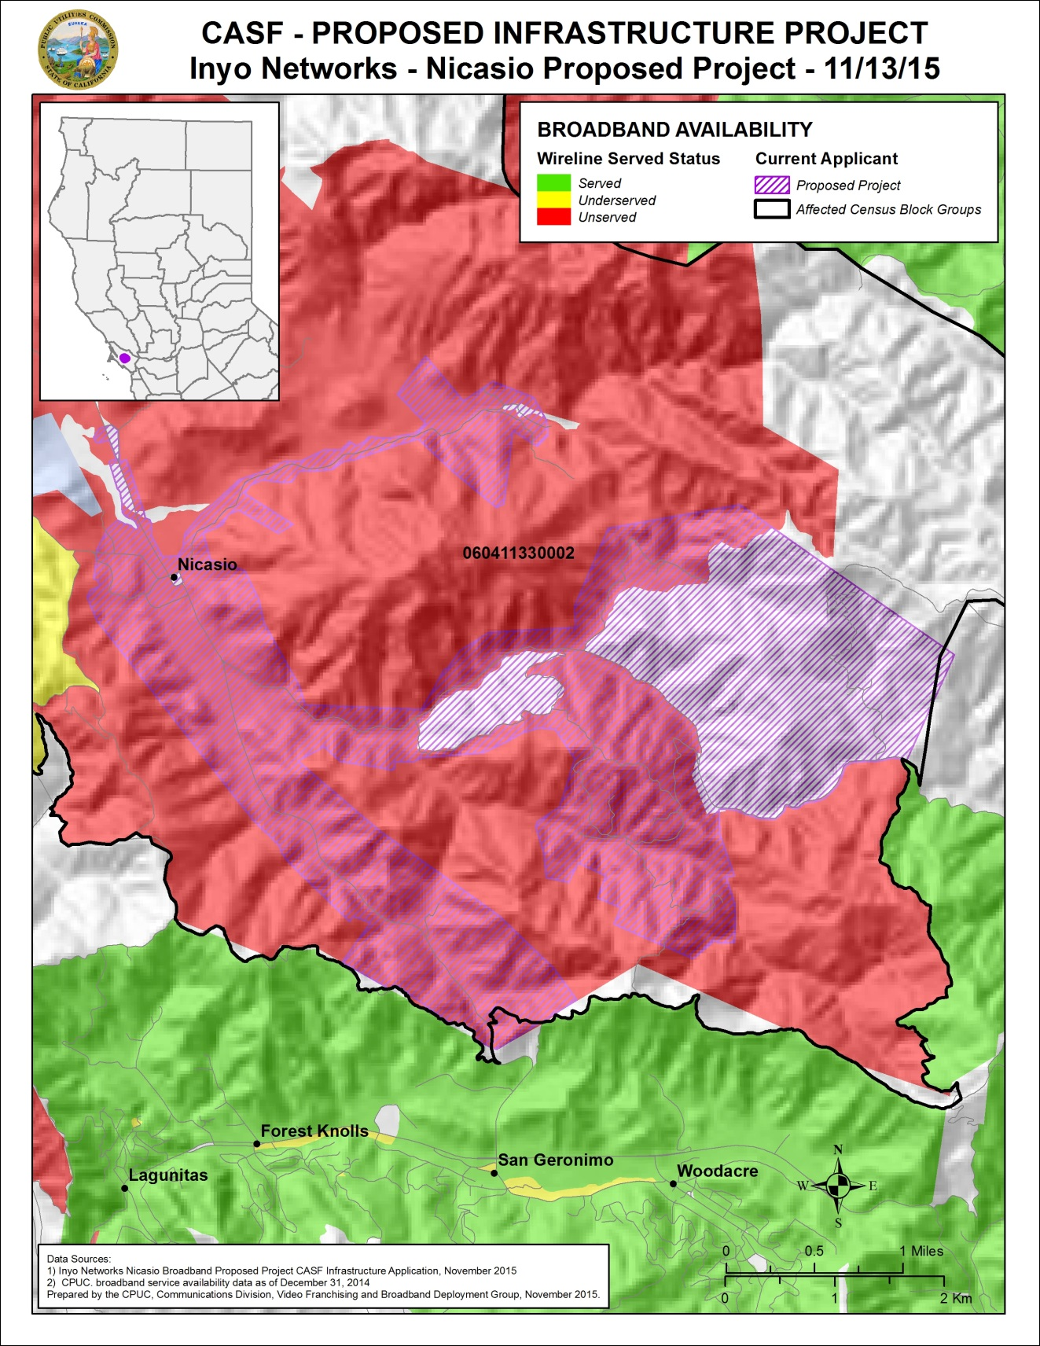
Appendix D
Resolution T-17523
Inyo’s Nicasio Project
Existing Fixed Wireless Service level

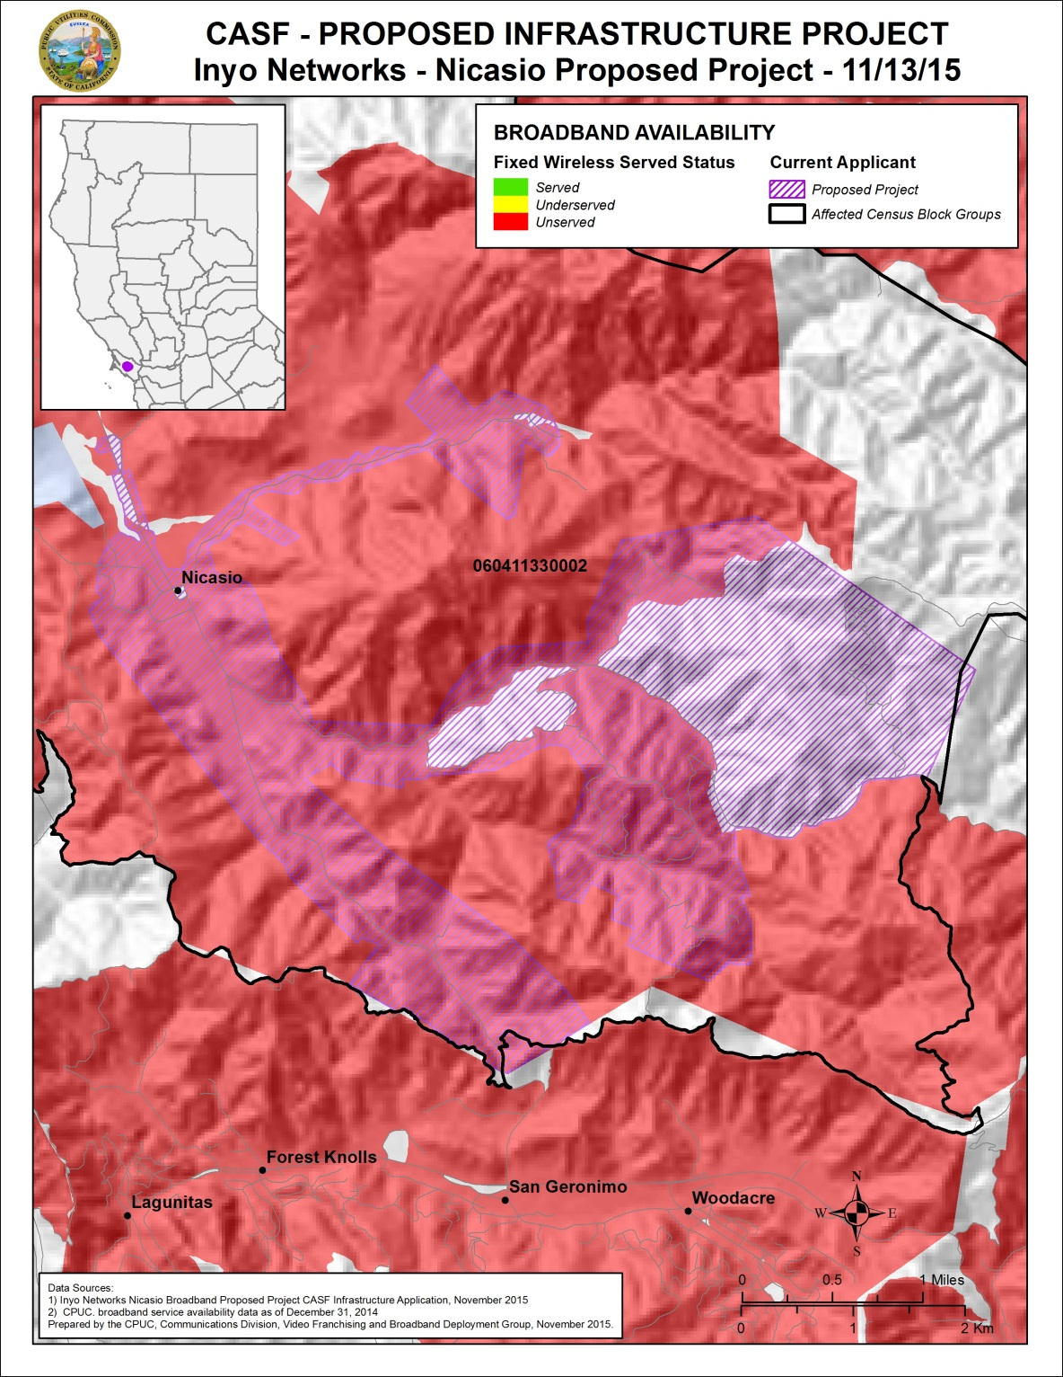

Appendix E
Resolution T-17523
Inyo’s Nicasio Project
Existing Mobile Wireless Service Level

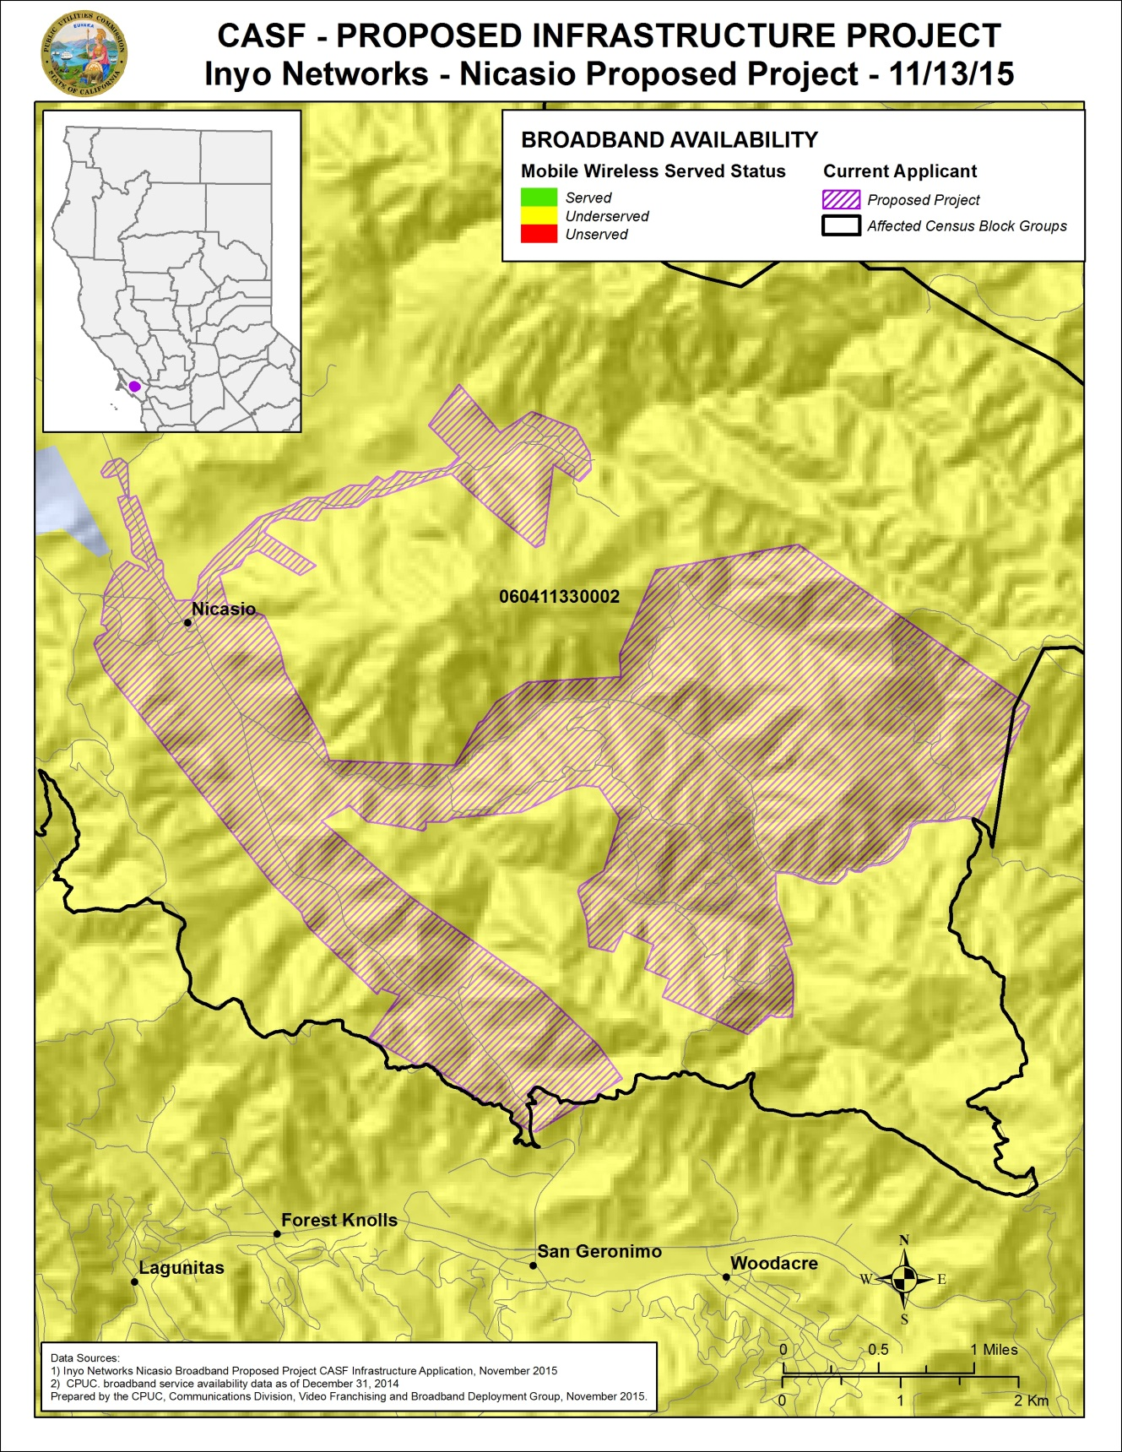

AT&T is the Incumbent Local Exchange Carrier and has aerial copper distribution plant in place.
Zayo Group’s fiber optic facilities were placed in the area to support pre and post production film editing at the Skywalker and Big Rock Ranches owned by Lucasfilm.
Attached as Appendix C, Appendix D, and Appendix E of this Resolution.
The CPUC has found that average measured speeds are not representative of a consumers’ actual mobile experience. Rather than use the mean throughput, Staff’s analysis quantifies expected speeds at varying confidence intervals by taking into account the distribution of throughput results around the mean in a single testing session. The mean throughput indicates that a consumer would theoretically receive service at least as fast approximately 50% of the time; one standard deviation below the mean indicates that a consumer would theoretically receive service at least as fast approximately 84% of the time; by extension, two standard deviations below the mean indicates a consumer would receive service at least that fast 98% of the time. The two standard deviations below the tested mean is the throughput a consumer can reliably expect to receive. (See “Comments of the California Public Utilities Commission” FCC GN Docket No. 15-191. September 15, 2015.)
Mobile wireless internet service providers currently serving Nicasio community include AT&T, T-Mobile, Sprint and Verizon.
See letter from Inyo, dated May 2, 2016.
Based on the 5-Year Pro Forma Statements submitted by Inyo.
CPUC’s June 2012 California Broadband Report, A Comparative Summary of Broadband Adoption for June 30, 2011 and June 30, 2012, at p. 4.
D.12-02-015, Section 3.8.2, at pp. 26-27.
See letter from Inyo, dated May 2, 2016.
Originally, the applicant had planned to offer the Broadband Utility Note securities under the Intra-state offering exemption of the Securities Act of 1933; however, after consultation, the applicant’s legal advisor advised them that for the Nicasio project, a SCOR offering would be a better alternative. See email from Inyo, dated July 13, 2016.
D.12-02-015, Section 3.9.2, at p.28.
See letter from Inyo, dated May 16, 2016.
P.U. Code §§ 274 and 281.
Approval of the California Advanced Services Fund (CASF) Application Requirements and Scoring Criteria for Awarding CASF Funds (2008) Cal. P.U.C. Res. No. T-17143 at p.4.

