PUBLIC UTILITIES COMMISSION OF THE STATE OF CALIFORNIA

Communications Division | RESOLUTION T-17524
Broadband, Video and Market Branch | DATE August 18, 2016

R E S O L U T I O N

Resolution T-17524: Approval of Funding for the Grant Application of Race Telecommunications, Inc. (U-7060C), from the California Advanced Services Fund (CASF) in the Amount of $7,687,016 for the Gigafy Occidental project, located in a CASF “priority area.”

Summary

This Resolution approves funding in the amount of $7,687,016 from the California Advanced Service Fund (CASF) for the grant application of Race Telecommunications, Inc. (Race) for the deployment of a last-mile fiber network in the community of Occidental, California (Gigafy Occidental project). The proposed project will build a network capable of internet upload and download speeds of up to 1Gbps to 458 households at an average cost of $16,784 per household in an area that is currently identified as “unserved,” having no broadband availability. The project area is spread over a 4.2 square mile area that includes the Joy Road area in Occidental, located in Sonoma County. The Gigafy Occidental project is a “priority area” for CASF. This project will also provide safety benefits to the Occidental community including robust broadband service in the event of as well as improved access to e-health services.

Applicant Request

On February 6, 2015, Race submitted a CASF grant application, requesting $7,687,016 in funding to bring broadband service with maximum upload/download speeds of 1Gbps to the community of Occidental in Sonoma County through the deployment of a complete fiber-to-the-premise (FTTP) last-mile network. Race asserted that the project area contains 757 households.

Topography: Occidental is a small community in Sonoma County, California at an elevation of 594 feet, with a population of just over 1,000, and is located in the hills surrounding the Russian River. It was founded in the 1870s as a center for the timber industry, before becoming a vacation destination for engaging in outdoor activities and exploring the region’s wineries. Occidental is surrounded by steep hills and redwood forests and is located just over 10 miles from the Pacific Ocean, approximately halfway between Santa Rosa and the coastal town of Bodega Bay. The proposed project area is east of Occidental primarily along Joy Road, which connects Bodega Hwy and Coleman Valley Road.

Applicant: Race has a Certificate of Public Convenience and Necessity (CPCN) (U-7060C) and has been a Competitive Local Exchange Carrier (CLEC) offering fiber-based internet, Voice over Internet Protocol (VoIP) telephone, video services, as well as traditional cable/satellite television for the past 12 years. Race has been involved with the CASF program on several prior projects, including four CASF-funded projects that are currently under construction.

Project: Race claims the project area is “unserved” by broadband and requests 70% funding. Race proposes to construct the fiber optic network using a 100-Gigabit backbone infrastructure. It would enable internet upload and download speeds of up to 1Gbps and be available to all households in the project area. According to Race, the construction of the FTTP last-mile network will consist of an entirely above ground and aerial installation along existing rights-of-way which are already in use. The fiber cables will be installed by Race on existing easements and utility poles.

Race also proposes to provide VoIP digital voice telephone service to the area.

Notice and Challenges

On December 24, 2015, Communications Division (CD) posted the proposed project area map, census block groups (CBGs), and zip codes for this project on the Commission’s CASF webpage under “CASF Application Project Summaries,” and sent notice regarding the project to its electronic service list. CD received no challenges to the proposed project area.

There were no commitments made by an existing provider to upgrade service before the November 1, 2015 “first right of refusal” deadline.

Project Review

Project Area Eligibility
For the area to be project eligible, the CASF program requires an applicant to submit proof that the area is unserved or underserved by submitting shapefiles of the proposed project. CD reviews the submitted shapefiles and compares them with the California Interactive Broadband Availability map. Once CD determines that the area is eligible either as an unserved or underserved area, CD evaluates all other information submitted by the applicant to determine if the project meets the requirements outlined in D.12-02-015.

Race included a letter in their application stating they do not have any facilities within five miles of the proposed project area, and thus do not possess any existing geographic information systems (GIS) formatted infrastructure shapefiles. However, Race did submit a GIS shapefile and maps of the proposed project area as evidence that the area is unserved. Staff reviewed the shapefile and maps, and determined the following regarding the availability of wireline, fixed-wireless, and mobile broadband within the project area:

Wireline: The California Interactive Broadband Availability data available at the time of the February 6, 2016 application showed that approximately 15% of the project area had wireline broadband available from Comcast at served speeds. However, CD received fourteen reports of public feedback from within this portion the project area, ranging from March 2013 to January 2014, indicating that these households do not actually have broadband service available from Comcast. Additionally, staff reviewed a map submitted by the Connect Joy Road Group, which shows that Comcast’s coverage area does not include the project area. As a result of this feedback, CD determined that all the homes in the project area are unserved by wireline broadband.

Fixed Wireless: CD reviewed the most recent California Interactive Broadband Availability map and determined the proposed project area is unserved by fixed wireless. However, staff notes there are 17 public feedback reports which precede the availability map, with dates ranging from March 2013 to February 2014. These reports indicate the presence of three fixed wireless internet service providers (WISP) within the project area at underserved and unserved speeds: CDS Wireless, Sonic, and Motec.

Eight reports were from consumers that subscribed to CDS Wireless. Of these, five reports did not contain any speed test data, while the other three reported underserved speeds (3.2/1.8 Mbps, 1.1 Mbps/300 Kbps, and 700/490 Kbps). These reports are between 2.5 and 3.5 years old. However, on June 3, 2016, staff accessed the latest information available on CDS’s website, a map showing that the entire proposed project area, including Joy Road, is not currently located within the company’s advertised wireless coverage area.

Seven reports of public feedback received indicated those customers subscribed to Sonic. Six of these reports did not include any speed test data; while the other report showed underserved speeds of 3.2/1.8 Mbps. However, on June 3, 2016, staff accessed Sonic’s website, which indicates that fixed wireless service is not currently available within the project area.

Two reports were from consumers that subscribed to Motec. One of these reports did not include any speed test data, while the other report indicated unserved speeds of 800/150 Kbps from Motec.

Despite the public feedback received, CD still concludes that the proposed project area is unserved by fixed wireless, based on the most recent California Interactive Broadband Availability Map and the latest information from the websites of CDS Wireless and Sonic.

Mobile: The most recent California Interactive Broadband Availability map shows the project area having mobile broadband available at underserved speeds from AT&T, Sprint, Verizon Wireless, and T-Mobile. The map was developed using regional data from the CPUC’s statewide mobile field tests. However, these results are not representative of the project area because the speed test locations are separated from the project area by up to ten miles over challenging terrain. Only one of those speed tests was conducted within the project area itself, and that test shows the location is unserved by mobile. Additionally, there were 95 speed tests conducted within the project area by the North Bay North Coast Broadband Consortium and via crowdsourcing using the Calspeed Mobile app. Ninety-two percent of those test results indicate that the proposed project area is unserved by mobile. Therefore, CD concluded that the project area is overall unserved by mobile broadband.

Project Criteria Evaluation

CD evaluated the application with respect to the criteria defined in D.12-02-015, Appendix 1, Section VIII (Scoring Criteria). The criteria include: (i) Funds Requested per Potential Customer, (ii) Speed, (iii) Financial Viability, (iv) Pricing, (v) Total Number of Households in the Proposed Area, (vi) Timeliness of Completion of Project, (vii) Guaranteed Pricing Period, and (viii) Low-Income Areas.

Funds per household: The CASF per-household subsidy is $16,784, based on the 458 households that would have access and total grant funds of $7,687,016. The number of households was reduced from 757 to 458 because staff reviewed the census block data and parcel data from the Sonoma County, and determined that some parcels were vacant, used for pasture and agricultural purposes, or were located entirely outside of the project area. Race’s per household subsidy is the second highest among the currently proposed last-mile projects, as well as over the average subsidy of previously awarded last-mile CASF projects.

Speed: The four tiers of proposed speed (1Gbps download and 1Gbps upload, 250 Mbps download and 250 Mbps upload, 100 Mbps download and 100 Mbps upload, and 25 Mbps download and 25 Mbps upload) exceed the 6 Mbps/1.5 Mbps benchmark set by the Commission. The maximum proposed speed offering (1Gbps download and 1Gbps upload) is 61% faster than the average speed proposed by the current last-mile projects, as well as 57% faster than the average proposed speeds from previously awarded CASF last mile projects.

Financial Viability: CD determined that Race is a financially viable company. CD’s review of the submitted balance sheet, income, cash flow statements and other financial viability variables confirmed that Race has the existing capital resources for the matching funds, as well as a sound financial framework for future operations.

Race’s 30 percent project investment is $3,294,435. The Gigafy Occidental project is expected to become profitable beginning in year 3 when construction is completed and service to customers begins. Race estimates that the customer take-rate would be at least a 68 percent within the five years after the CASF grant. Race derives its take rate based on forecasting a combination of their estimated market penetration and consumer interest in the project.

Pricing: Race has committed to a broadband pricing plan under the terms shown below for two years, starting from the beginning date of service. Customers will not be required to sign long-term service contracts, and there will be no service activation or installation fees.
Race’s Gigafy Occidental Project ~ Pricing Plan
Name of Tier | Advertised Speeds |  | Price Plan  ($ per Month)
 | Downstream (Mbps) | Upstream (Mbps)
Residential
Entry Level Speed | 25 | 25 | $25.00
Mid-Level Speed | 100 | 100 | $65.00
Max Level Speed | 1000 | 1000 | $100.00
Other Optional Tier | 250 | 250 | $85.00
Business or Institutions
Entry Level Speed | 25 | 25 | $60.00
Max Level Speed | 1000 | 1000 | $200.00

The average price per megabit for this project is lower than the average prices for the other pending last-mile projects and lower than the average price for previously approved last-mile projects.

Households in Project Area: Based on the current census block data and parcel data from the Sonoma County for the Occidental area, the proposed project area comprises 458 households and is covered by four Census Block Groups (CBGs).

Timeliness of Completion: Race has submitted detailed planning documents, including a schedule with clear milestones, which indicate the project will be completed in the allowable 24 month timeframe.

Guaranteed Pricing Period: Race has committed to a pricing plan of two years from the initial service deployment, in accordance with the program’s requirement.

Low-Income Areas: The median household incomes of the four CBGs are as follows: 1) 60971543021 - $69,138, 2) 60971543022 - $77,250, 3) 60971543023 - $61,736, and 4) 60971543043 - $67,625. By comparison, the four year average median income from 2010-2014 in California was $61,489. As a result, CD finds that the Gigafy Occidental project is not located in a low-income area.

Safety and Community Impact

Race’s proposal will improve connectivity for the community’s residents and businesses, as well as local educational and public safety institutions such as Salmon Creek Middle School, El Molino High School, and the Occidental Volunteer Fire Department.

CD received over 30 letters from both in and outside the community that expressed overwhelming support for the project. In his letter, Tom Gonnella of the Occidental Volunteer Fire Department states that without a reliable broadband connection, he and his fellow firefighters will face more difficult challenges and increasingly dangerous situations when responding to fires. He urges the Commission to approve the project because it will enable the Fire Department to coordinate more effective responses to emergency situations and also provide increased public safety benefits to the community.

The Commission received other letters of support, including one from Sonoma County Administrator Veronica Ferguson that says a reliable broadband connection will promote increased education, safety, and other benefits, and that “…the Gigafy Occidental project is an excellent first step in connecting a rural community in need of a broadband solution.” Matt Dunkle, the principal of El Molino High School, also wrote how being able to provide students broadband service is a necessity for them to succeed in their education and that the project “…would keep our students and teachers from being unnecessarily left behind.”

The community stated that by providing broadband access to homeowners and businesses, as well as institutions such as the local schools and fire department, the Gigafy Occidental project will further social and economic development and enhance public safety in the rural Occidental community.

Staff Recommendation for Funding

CD has determined that Race’s grant application for the Gigafy Occidental Project qualifies for funding as an unserved area. Even though the project area is not identified as a low-income area, the projects is tied for the highest rank for proposed download and upload speeds when compared to previously awarded and currently pending projects. Additionally, while the project has a negative EBIT in years 1 and 2, due to development and construction costs, staff expects the project to become profitable beginning in year three when Race’s FTTH network becomes operational.

CD believes this project is worthy of CASF grant funding because the project area is currently unserved, as well as being designated a “priority area” by the North Bay/North Coast Broadband Consortia. Based on staff’s evaluation of the project, the most recent California Interactive Broadband Availability map, public feedback, and research of the latest fixed wireless coverage within the project area, CD finds that the Gigafy Occidental project meets the requirements of D.12-012-015, provides safety and economic benefits, and aligns with the goals of the CASF program.

Compliance Requirements

Race is required to comply with all the guidelines, requirements, and conditions associated with the grant of CASF funds as specified in D.12-02-015, D.14-02-018, and Resolution T-17443. Such compliance includes, but is not limited to:

California Environmental Quality Act (CEQA)

All CASF grants are subject to California Environmental Quality Act (CEQA) requirements unless the project is statutorily or categorically exempt pursuant to the CEQA Guidelines.

Race has provided the Commission with construction plans for the Gigafy Occidental project. In order to deliver the last-mile service to households in the area, Race intends to lease existing dark fiber from Sonic for the backbone connection that will link the FTTP network to their existing facilities in San Francisco.

Race proposes to conduct all work in already disturbed land during the project’s construction in order to avoid any adverse effects on cultural resources. The network design is focused around utilizing existing rights of way, above ground and aerial construction, dark fiber leasing where available, and utilizing easements to lessen the environmental impact of the construction. The Gigafy Occidental project is a last-mile project intended to bring fiber to the homes in already disturbed areas using a proven aerial design. This aerial design is based on using existing utility poles in existing roadways and will comply with the pole loading requirements of General Order 95. Race has stated that it will utilize K&B Engineering firm to determine whether pole loading requirements pass or fail. All fiber will be placed in the appropriate space on the existing utility pole in compliance with the pole owner specifications.

Based on the above information, the project qualifies and was approved by the CPUC’s CEQA unit for the following categorical exemptions from CEQA: CEQA Guidelines Section 15301 – Existing Facilities, involving minor alterations to existing utility facilities, and CEQA Guidelines Section 15304 – Minor Alterations to Land, involving minor trenching and backfilling where the surface is restored.

Deployment Schedule

The Commission expects Race to complete the project within 24 months from start date (as determined by the procedure below). If the project will not be completed within the required 24 month timeframe, Race must notify the Director of CD as soon as it becomes aware of this possibility. If such notice is not provided, the Commission may reduce payment for failure to satisfy this requirement by timely notifying CD’s Director.

Execution and Performance

CD and Race shall determine a project start date after the CASF grant recipient has obtained all approvals. Should Race or any contractor it retains fail to commence work by the designated date, upon five days written notice to Race, the Commission may terminate the grant. In the event that Race fails to complete the project in accordance with the terms of CPUC approval as set forth in this resolution, Race must reimburse some or all of the CASF funds that it has received. Race must complete all construction covered by the grant on or before the grant’s termination date.

Performance Bond

The Commission does not require a Performance Bond if the applicant certifies that the percentage of the total project costs it is providing comes from their capital budget and is not obtained from outside financing. In its application, Race certified that the percentage of the total project costs it is providing will come from its existing capital budget. Therefore, a performance bond is not required for this project.

Price Commitment Period

The minimum required price commitment period for broadband service to all households within the project area is two years. Race guarantees the price of service offered in the project area for two years.

Project Audit

The Commission has the right to conduct any necessary audit, verification, and discovery during project implementation/construction to ensure that CASF funds are spent in accordance with Commission approval.

Race’s invoices will be subject to a financial audit by the Commission at any time within three years of completion of the work.

Providing Voice Service

Race has certified that its VoIP digital telephone service meets the Federal Communications Commission (FCC) standards for E-911 service and battery backup.

Submission of Form 477

The FCC currently requires broadband providers to biannually submit the Form 477, which includes speed data. While there is an imperfect match between the data that is reported in the Form 477 and to the CASF, the Form 477 data will be useful in documenting CASF deployment for the new service area of the carrier. Pursuant to General Order 66-C, service providers in California must submit a copy of their Form 477 data directly to the CPUC, concurrent with their submission of the same data to the FCC. CASF recipients must continue to submit their Form 477 data to the FCC for a five-year period after completion of the project.

Reporting

All grantees must submit quarterly progress reports on the status of the project irrespective of whether grantees request reimbursement or payment. Quarterly progress reports are due on January 1, April 1, July 1, and October 1. Before full payment of the project, Race must submit a project completion report. Progress reports shall use the schedule for deployment, major construction milestones and costs submitted in the proposal; indicate the actual date of completion of each task/milestone as well as problems and issues encountered, and the actions taken to resolve these problems and issues during project implementation and construction; and identify future risks to the project.

Race shall also include test results on the download and upload speeds on a CBG and zip code basis in the final completion report. Race must certify that each progress report is true and correct under penalty of perjury.

Payments to CASF Recipients

Submission of invoices from and payments to Race shall be made at 25 percent completion intervals, in accordance with Section XI of Appendix 1 of D.12-02-015 and according to the guidelines and supporting documentation required in D.12-02-015.

Payment to Race shall follow the process adopted for funds created under P. U. Code § 270. The Commission generally processes payments within 20-25 business days, including CD and Administrative Services review time. The State Controller’s Office (SCO) requires an additional 14- 21 days to issue payment from the day that requests are received by SCO from Administrative Services.

Race shall provide service to all residential properties within the project area. If Race does not provide service to each household within the project area that requests service at the prescribed rates during the commitment period, the Commission reserves the right to reduce payment accordingly.

Comments on Draft Resolution

In compliance with Public Utilities Code § 311(g), a notice letter will be emailed to inform all parties on the CASF Distribution List of the availability of the draft of this resolution for public comments at the Commission's website at http://www.cpuc.ca.gov/PUC/documents/. This letter also informed parties that the final conformed Resolution adopted by the Commission will be posted and available at this same website. CD did not receive any comments or reply comments on this resolution.

Findings

- Race filed an application for CASF funding for its Gigafy Occidental Project on November 27, 2015 to construct a FTTP last-mile network that will enable a maximum download speed of 1 Gbps and a maximum upload speed of 1 Gbps to 458 households in and around the community of Occidental, California in Sonoma County. The CBGs impacted by the project are 60971543021, 60971543022, 60971543023, and 60971543043.

- Key information about the project is in Appendix A of this Resolution.

- CD posted the proposed project area map, CBGs and zip code for the Gigafy Occidental project on the Commission’s CASF webpage under “CASF Application Project Summaries” on February 17, 2015. CD received no challenges to this project.

- CD reviewed and analyzed data submitted for the Gigafy Occidental Project’s CASF grant application to determine its eligibility for CASF funding.

- This data included, but was not limited to: proof of a CPCN from the Commission; descriptions of current and proposed broadband infrastructure; prior California Interactive Broadband Availability Map data available at the time of application filing; assertions that the project area is unserved based on public feedback received and the results from mobile speed tests; number of potential subscriber households and average incomes; project construction schedule; project budget; proposed pricing and commitment period for new subscribers; and financial viability of the applicant.

- CD reviewed the California Interactive Broadband Availability Map data as of December 31, 2014, as well as feedback received from the public and the results of mobile speed tests, and determined the project area as having unserved status.

- Based on its review, CD determined that the project qualifies for funding under D. 12-02-015 and recommends Commission approval of CASF funding for Race’s Gigafy Occidental Project, in the amount of $7,687,016.

- Race is required to comply with all guidelines, requirements, and conditions associated with the granting of CASF funds as specified in D.12-02-015, as well as with the terms set forth in this resolution, and must submit the FCC Form 477, as specified in T-17143.

- The Commission finds CD’s recommendation to fund Race’s project, as summarized in Appendix A, to be reasonable and consistent with Commission orders and, therefore, adopts such recommendation.

- The Commission has determined that the project is categorically exempt from CEQA review, under section 15301 regarding exemption for existing facilities and section 15304 regarding minor modifications to existing structures.

- A notice letter was e-mailed on ____, informing all applicants filing for CASF funding, parties on the CASF distribution list of the availability of the draft of this Resolution for public comments at the Commission’s website http://www.cpuc.ca.gov/PUC/documents/. This letter also informed parties that the final confirmed Resolution adopted by the Commission will be posted and available at this same website. CD did not receive any comments or reply comments on this resolution.

THEREFORE, IT IS ORDERED that:
  - The Commission shall award $7,687,016 to Race for the Gigafy Occidental Project, as described herein and summarized in Appendix A of this Resolution.
  - The program fund payment of $7,687,016 for this project in an unserved area shall be paid out of the CASF Infrastructure Grant Account in accordance with the guidelines adopted in D.12-02-015, including compliance with CEQA.
  - Payments to the CASF recipient shall be in accordance with Section XI of Appendix 1 of D.12-02-015 and in accordance with the process defined in the “Payments to CASF Recipients” section of this Resolution.
  - Race shall comply with all guidelines, requirements and conditions associated with the CASF funds award as specified in D.12-02-015, as well as with the terms of the Commission’s approval as set forth in this resolution, and must submit the FCC Form 477 to the Commission, as specified in Resolution T-17143.
  - If Race fails to complete the project in accordance with the terms outlined in D.12-02-015 and with the terms of the Commission’s approval, as set forth in this resolution, Race must reimburse some or all the CASF funds it has received.

This Resolution is effective today.

I hereby certify that this Resolution was adopted by the Public Utilities Commission at its regular meeting on August 18, 2016. The following Commissioners approved it:

/s/ Timothy J. Sullivan

TIMOTHY J. SULLIVAN

Executive Director
MICHAEL PICKER
President
MICHEL PETER FLORIO
CATHERINE J.K. SANDOVAL
CARLA J. PETERMAN
LIANE M. RANDOLPH
Commissioners

APPENDIX
APPENDIX A – Race’s Gigafy Occidental Project
Key Information
Project Name | Gigafy Occidental Project
Project Plan | To deploy a fiber-to-the-premises (FTTP) Last Mile network in the Joy Road area in Occidental, located in Sonoma County. The construction of the FTTP last-mile network will consist of an entirely above ground and aerial installation along existing rights-of-way which are already in use.
Project Area Size | 4.2 square miles
Download / Upload speed | Up to 1000 Mbps/1000 Mbps
Location | Sonoma County
Community Name | Occidental
CBGs / Household Income | 60971543021 | $69,138
 | 60971543022 | $77,250
 | 60971543023 | $61,736
 | 60971543043 | $67,625
ZIP Codes | 95465
Estimated Potential  Subscriber Size | 458 Households
Applicant expectations | 312 households
Deployment Schedule (from  Commission approval date) | 24 months
Pricing Plan | Residential  Entry Level Speed 25 Mbps Down/Up $25.00  Mid-Level Speed 100 Mbps Down/Up $65.00  Max Level Speed 1000 Mbps Down/Up $100.00  Other Optional Tier 250 Mbps Down/Up $85.00  Business  Entry Level Speed 25 Mbps Down/Up $60.00  Max Level Speed 1000 Mbps Down/Up $200.00
Proposed Project Budget (Total) | $10,981,451
Amount of CASF Funds  Requested (70%) | $7,687,016
Applicant funded (30%) | $3,294,435

Appendix B – Race’s Gigafy Occidental Project
Project Location 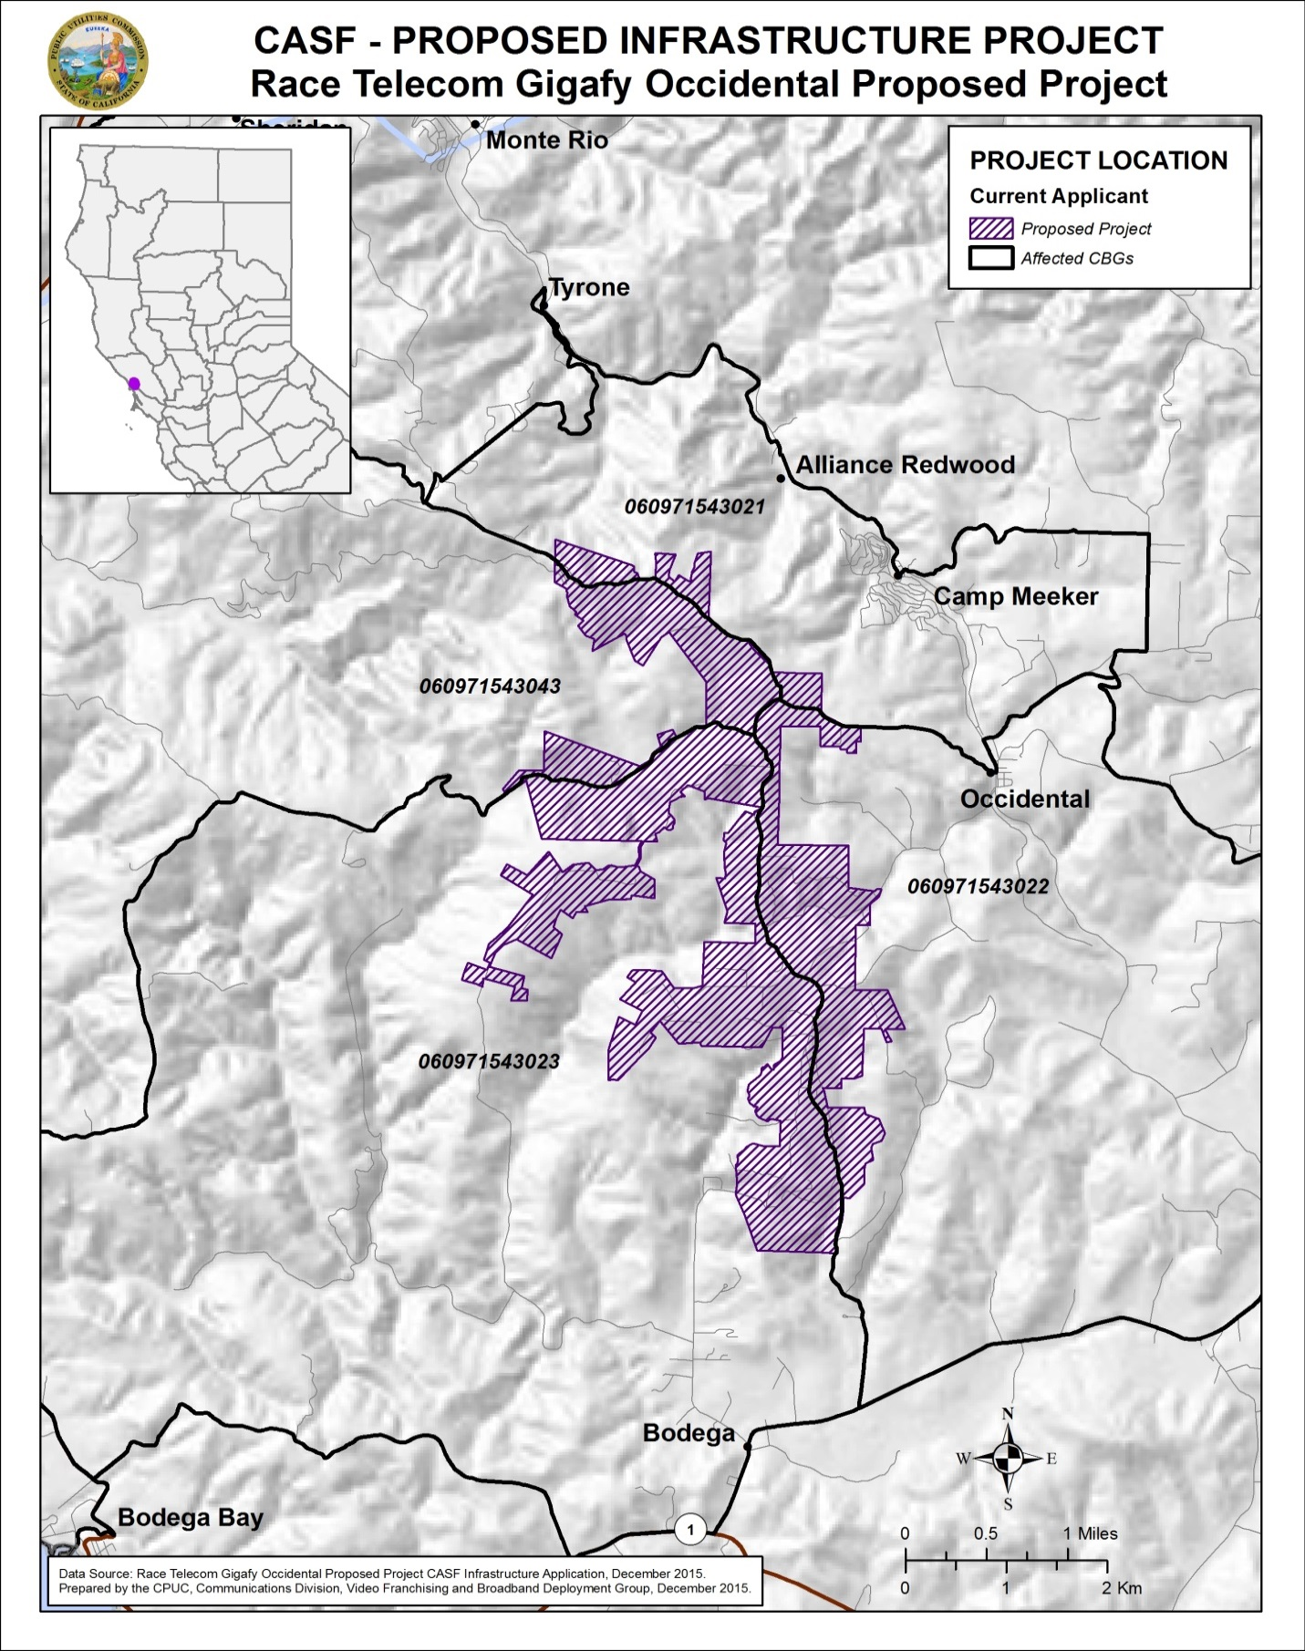

Appendix C - Wireline Broadband Availability
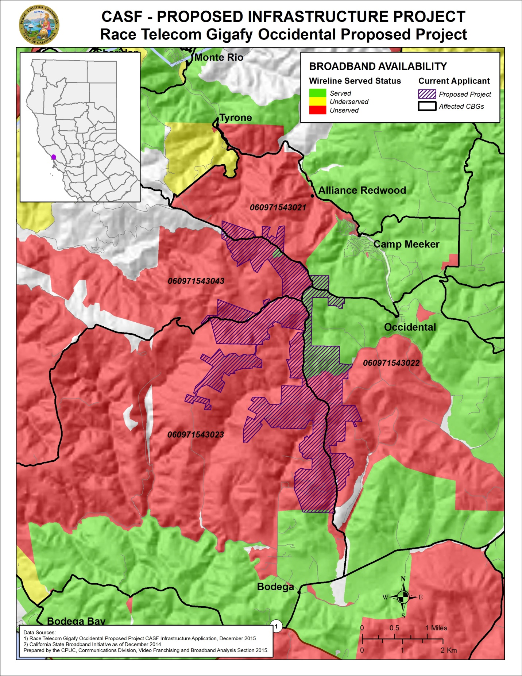

Appendix D - Fixed Wireless Broadband Availability
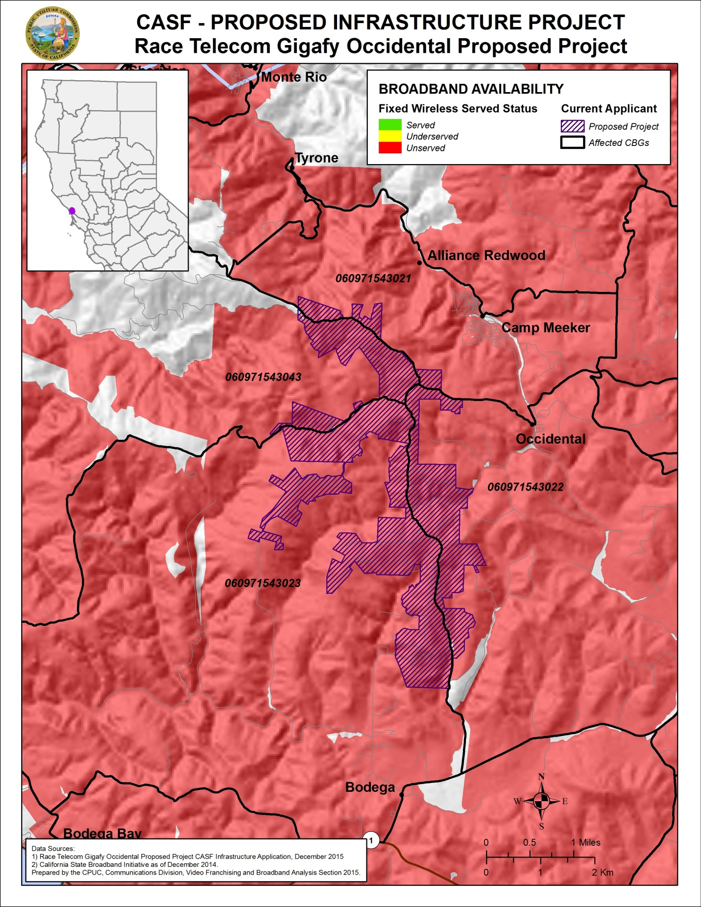
Appendix E - Mobile Wireless Broadband Availability
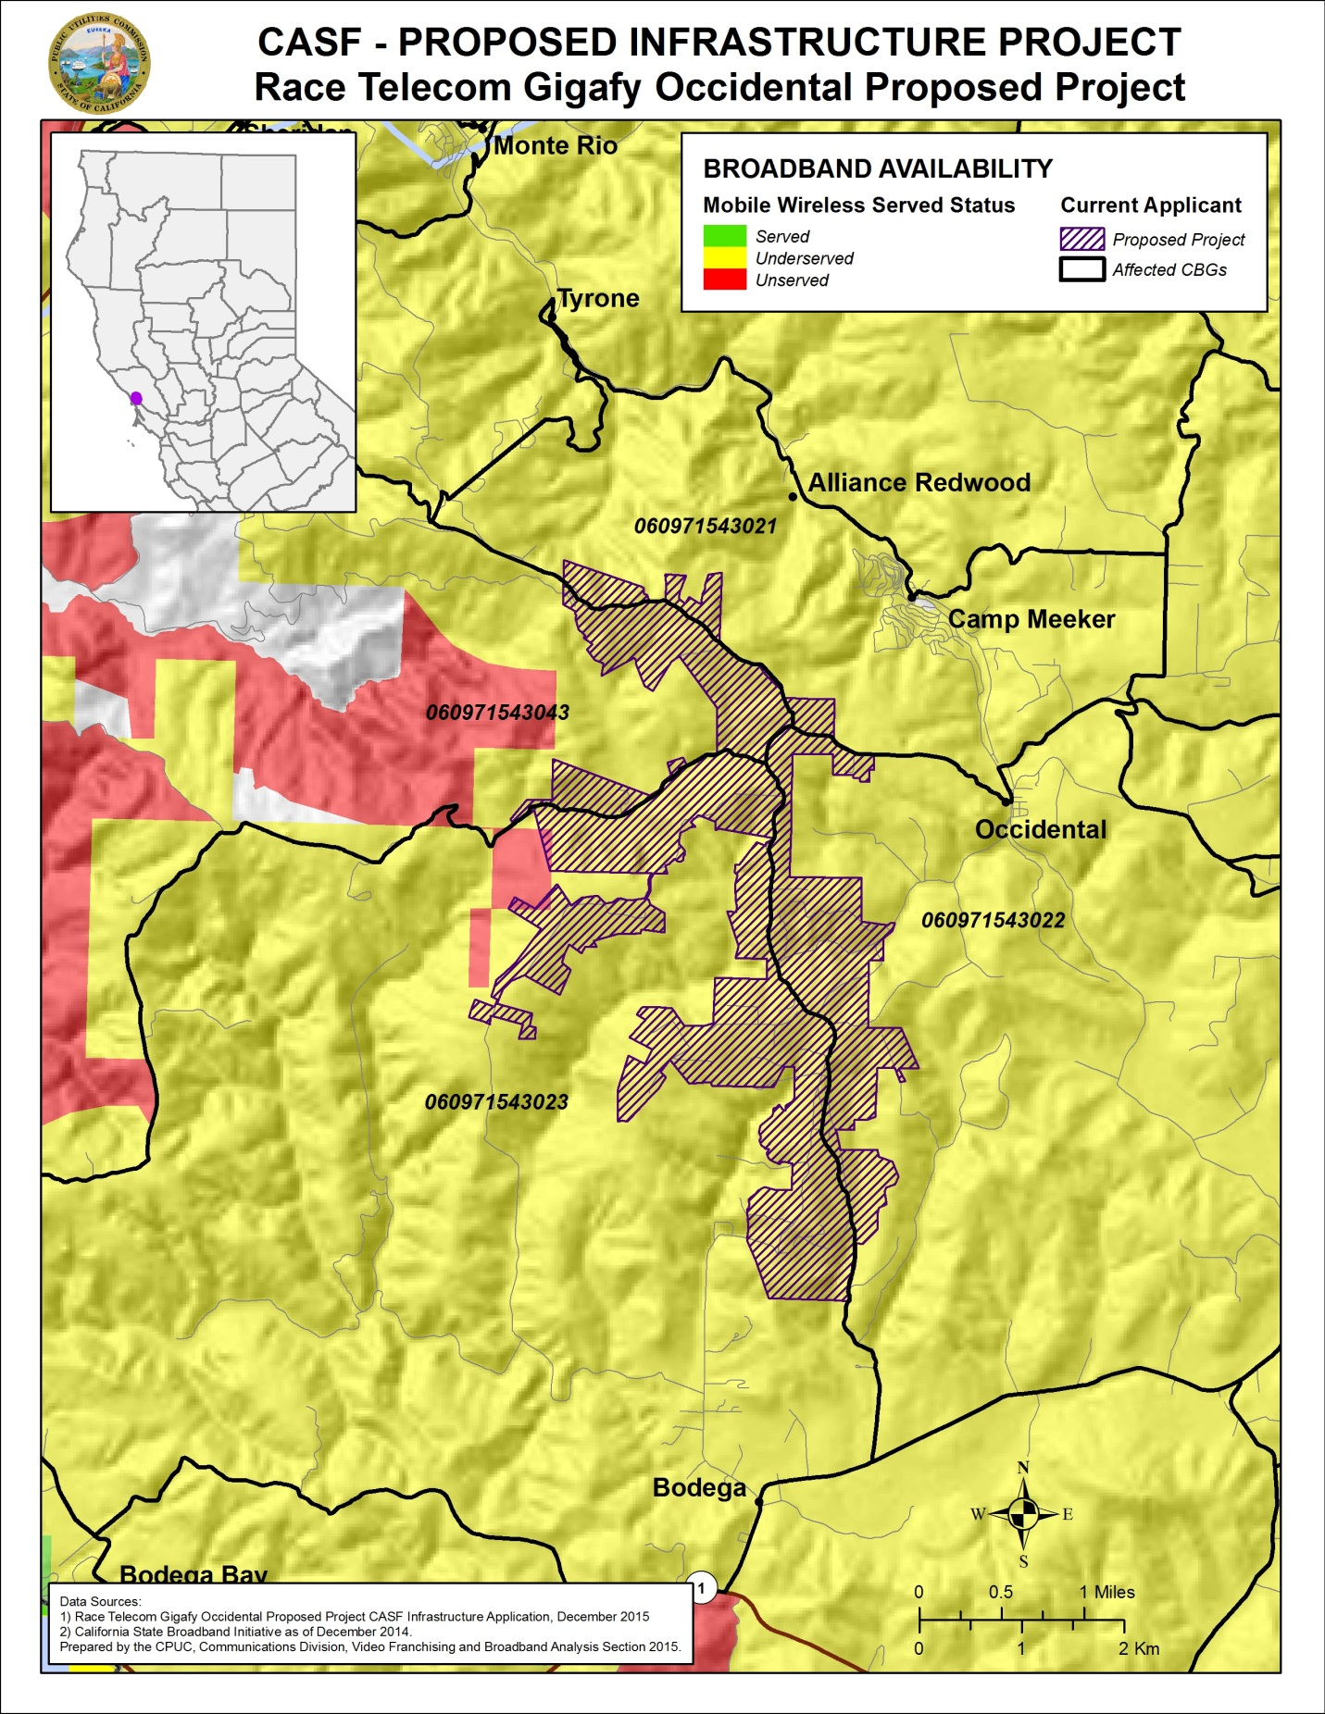

Priority Areas for CASF funding were established by regional stakeholders to identify communities with a high priority need of broadband infrastructure. For more information, see Resolution T-17443, adopted June 26, 2014, p. 10-14 and Appendix 4.
Other packages offer upload/download speeds of 250 Mbps, 100 Mbps, and 25 Mbps.
However, based on a further analysis of the census block data and parcel data from the Sonoma County, staff reduced the number of households located within the project area from 757 to 458.
CASF funded projects which are currently under construction include Gigafy Mono (Approved January 2016), Five Mining Communities (Approved January 2016), Gigafy Backus Unserved Broadband (Approved August 2015), and Mono County Underserved Broadband (Approved June 2014). Information about these and other CASF projects is available at: http://www.cpuc.ca.gov/General.aspx?id=1057
See Footnote No. 1 above
The latest version of the California Interactive Broadband Availability Map uses wireline data as of December 2014.
See Appendix C, p. 17.
These 14 reports represent the most recent public feedback received by CD on the availability of wireline service.
See Appendix D, p. 18.
These 17 reports represent the most recent public feedback received by CD on the availability of fixed wireless service.
The map of CDS Wireless’s coverage area is available at: http://www.cds1.net/wireless_coverage_area.php
Sonic’s webpage for determining availability of service is available at: https://www.sonic.com/availability. Additionally, Sonic does not report fixed wireless availability or subscribership data to the CPUC or FCC.
See Appendix E, p. 19.
The CPUC has found that average measured speeds are not representative of a consumers’ actual mobile experience. Rather than using the mean throughput, staff’s analysis quantifies expected speeds at varying confidence intervals by taking into account the distribution of throughput results around the mean in a single testing session. The mean throughput indicates that a consumer would theoretically receive service at least as fast approximately 50% of the time; one standard deviation below the mean indicates that a consumer would theoretically receive service at least as fast approximately 84% of the time; by extension, two standard deviations below the mean indicates a consumer would receive service at least that fast 98% of the time. The two standard deviations below the tested mean is the throughput a consumer can reliably expect to receive. At the time of the application, mobile testing results were interpolated using a mean minus 1 standard deviation approach. The current California Interactive Broadband Availability Map reflects the more exclusive mean minus 2 standard deviation method to interpolate speed data from the approximately 2,000 test points to determine statewide availability. (See “Comments of the California Public Utilities Commission” FCC GN Docket No. 15-191. September 15, 2015.)
Race asserts that while the number of households has been reduced, the requested amount of CASF funding remains the same because the proposed project area will not change.
U.S Census Bureau QuickFacts – California Median Household Income (in 2014 dollars), 2010-2014. QuickFacts data are derived from: Population Estimates, American Community Survey, Census of Population and Housing, Current Population Survey, Small Area Health Insurance Estimates, Small Area Income and Poverty Estimates, State and County Housing Unit Estimates, County Business Patterns, Non-employer Statistics, Economic Census, Survey of Business Owners, Building Permits.
Letter of Support from Tom Gonnella of the Occidental Volunteer Fire Department, December 2, 2015.
Letter of Support from Veronica Ferguson – Sonoma County Administrator, December 2, 2015.
Letter of Support from Matt Dunkle – El Molino High School Principal, December 4, 2015.
Pub. Util. Code §§ 274 and 281; see also D.12-02-015, Appendix 1, p. 25.
Approval of the California Advanced Services Fund (CASF) Application Requirements and Scoring Criteria for Awarding CASF Funds (2008) Cal. P.U.C. Res. No. T-17143 at 4.

