PUBLIC UTILITIES COMMISSION OF THE STATE OF CALIFORNIA

Communications Division | RESOLUTION T-17522
Broadband, Video and Market Branch | September 29, 2016

R E S O L U T I O N

Resolution T-17522: Approval of funding for the grant application of Citizens Telecommunications Company of California, Inc. (Frontier) (U-1024-C), subsidiary of Frontier Communications Corporation from the California Advanced Services Fund (CASF), in the amount of $545,690 to build last-mile fiber cable from the Shingletown, California central office to six digital loop carrier sites infrastructure to deliver broadband services to underserved community of Shingletown in Shasta County.

Summary

This Resolution approves funding in the amount of $545,690 from the California Advanced Service Fund (CASF) for the grant application of Citizens Telecommunications Company of California, Inc. (“Frontier”) to provide broadband Internet service to underserved community of Shingletown, Shasta County (Shingletown project).

The Shingletown project will cover 10.3 square miles and will provide broadband speeds of at least 6 Mbps download and 1.5 Mbps upload to 1,017 underserved households at an average cost of $537 per household. This project also provides safety benefits to the Shingletown Medical Center in Shingletown community including, but not limited to, higher bandwidth in the event of wildfire, winter storms and earthquakes as well as improved access to e-health services.

Applicant Request

On March 9, 2016, Frontier submitted an application for CASF funding to build 64,950 feet of fiber cable from the Shingletown, California central office to six digital loop carrier sites serving 1,165 households. The sites under this grant are currently served by broadband over copper facilities to DSLAM’s served from the Shingletown central office in Shasta County. The existing bandwidth is not capable of providing more than 3 Mbps download speeds and 768 Kbps upload speeds, and must be upgraded to a new technology (ADSL2+ with bonding) to meet the grant speeds. To upgrade to this using this combination of technology, the existing DSLAMs must be Ethernet-capable and the central office must have sufficient bandwidth coming into it. This technology delivers increasing speeds as proximity to the central office increases. If approved, Frontier states that all underserved rural communities in the Shingletown central office area will be capable of receiving at least 6 Mbps download speeds and 1.5 Mbps upload speeds. Customers within 7,200 feet of the DSLAM will be capable of receiving speeds of 25 Mbps download and up to 2 Mbps upload and those within 10,000 feet will be capable of receiving 10 Mbps download and up to 1.5 Mbps upload speeds.

The California Interactive Broadband Availability Map shows that Frontier is serving the lower portion of the project area at served speeds. On July 7, 2016, Frontier revised its application by removing the served Census block 060890126032022, and associated 148 households, reducing the project area from 12.7 to 10.3 square feet and the households’ numbers from 1,165 to 1,017. The total population according to 2010 Census for the revised project area is 3,980. Frontier did not revise its budget downward because it stated that “it is based on a fiber build to six digital loop carrier sites to increase the backhaul speed to those existing broadband locations. The removal of the small geographic area will not decrease the cost of the project.”

Frontier is requesting $545,690, which represents 60 percent of the estimated total project cost of $909,484. The CASF per-household subsidy is $537, based on 1,017 households that will be given access at served speeds by the grant.

Topography: The Shingletown project will serve four Census Blocks (068089126031, 060890126032, 060890126033 and 060890126041) covering 10.3 square miles. This project encompasses the geographical area along Lassen Peak highway 44, in Shasta County including Shingletown.

Applicant: Frontier Communications Corporation currently operates in California as Citizens Telecommunications Company of California (U-1024). Frontier Communications Corporation is a U.S. telephone company mainly serving rural areas and smaller communities. It was known as Citizens Utilities Company until May 2000 and Citizens Communications Company until July 31, 2008. Frontier is the sixth largest local exchange carrier and the fourth largest provider of DSL, based on coverage area, in the United States. In addition to local and long-distance telephone service, Frontier offers broadband Internet, digital television service, and computer technical support to residential and business customers in 28 states in the United States. The subsidiary, Citizens, is registered as a local exchange carrier in California.

Project: Frontier proposes to build last-mile fiber cable from the Shingletown, California central office to connect to six digital loop carrier sites. The existing DSLAM’s at these sites are Ethernet capable and the fiber feed will allow for the use of ADSL2+ bonding technology. The fiber upgrade will enable maximum broadband speeds of at least 6 Mbps download and 1.5 Mbps upload, which is the Commission-defined “served” threshold speed of 6 Mbps download and 1.5 Mbps upload.

Notice and Challenges

On March 9, 2016, Communications Division (CD) posted the proposed project area map, census block groups (CBGs) and zip codes for this project on the Commission’s CASF webpage under “CASF Application Project Summaries”, and sent notice regarding the project to its electronic service list. CD received no challenges to the proposed project area.

On October 31, 2014, Frontier provided a notice to the CPUC committing to upgrade service before the November 1, 2014, “first right of refusal” deadline. Frontier committed to upgrade its California northeast areas of Alturas Lake Amador, Janesville, Shingletown, before May 1, 2015. On April 30, 2015, Frontier sent a letter to CPUC explaining that the project upgrades for all but a portion of the Shingletown area had been completed under the first round of the Connect America Fund (CAF) and the sites not completed have been moved out to the CAF round 2 upgrade and as such will not be complete by May 1, 2015. Since the upgrades are not completed and the project area is underserved, the project area is eligible for CASF funding.

Project Review

Project Area Eligibility

For the area to be project eligible, the CASF program requires an applicant to submit proof that the area is unserved or underserved by submitting shapefiles of the proposed project. CD reviews the submitted shapefiles and compares them with United States 2010 Census data and the California Interactive Broadband Availability map. Once CD determines that the area is eligible either as an unserved or underserved area, CD evaluates all other information submitted by the applicant to determine if the project meets the requirements outlined in D.12-02-015.

The California Interactive Broadband Availability Map shows that there are currently no wireless internet service providers in the project area and the wireline service is at the underserved levels. After evaluating the above evidence, CD determined that households in the area do not have broadband services at Commission-defined served speeds of 6 Mbps download and 1.5 Mbps upload and the project area is underserved.

CD has determined that there are 1,017 underserved households in the total project area of the Shasta County and that Frontier is eligible to receive funding level of 60% of the total project costs.

Project Criteria Evaluation

CD evaluated the application with respect to the scoring criteria defined in D.12-02-015, Appendix 1, Section VIII (Scoring Criteria). The scoring criteria includes: (i) Funds Requested per Potential Customer, (ii) Speed, (iii) Financial Viability, (iv) Pricing, (v) Total Number of Households in the Proposed Area, (vi) Timeliness of Completion of Project, (vii) Guaranteed Pricing Period, and (viii) Low-Income Areas. CD also conducted qualitative evaluation of the project area, existing infrastructure, and community needs.

Funds per Household: The CASF per-household subsidy is $537, based on 1,017 households. This subsidy amount per households is comparatively low as compared to similar last-mile projects awarded in the past. This project scores below the average of previous awarded projects.

Speed: The proposed speed offering of at least 6 Mbps download speed and 1.5 Mbps upload speed complies with the benchmark set by the Commission. The proposed speeds are less than what is obtained in a typical fiber to the home project and its proposed speeds rank comparatively lower than the average of all CASF projects previously awarded, however, comparing to DSL technology, these speeds are reasonable. Frontier has stated that it “plans to send targeted marketing outreach to the affected customers advertising the availability of new speeds in the area.”

Financial Viability: CD determined that Frontier is a financially viable company.
Frontier determined that the project is economically feasible with a CASF grant of $545,690, which is 60 percent of the total project costs, to match Frontiers’ investment of $363,794. The CASF per-household subsidy would be $537 per household. Frontier has projected average earnings before interest and taxes (EBIT) of $36,375,330. The project will take a relatively short time to complete (eight months rather than the 24 month standard time).

CD’s review of these and other financial viability variables for Citizens and its parent company Frontier indicates that they have the existing capital resources for the 40 percent required matching funds to construct the Shingletown project, as well as a sound financial framework for future operations. Therefore, staff determined that there is a minimal risk that this project would encounter financial problems, such as the project not being completed. The relatively short construction period also reduces expenses and risk.

Pricing: Frontier has committed to the following pricing for broadband services for the duration of the two-year construction phase of the project.

Shingletown Product Price Proposal
Product | Down Speed  Mbps | Up Speed  Mbps |  | Monthly  Rate
Requires purchase of access line  Broadband Max | 6 | 1.5 |  | $ 44.99
Broadband Ultra | 12 | 1 |  | $ 54.99
Broadband Ultimate | 24 | 1 |  | $ 64.99
Stand alone product without access line
Simply Broadband Max | 6 | 1.5 |  | $49.99
Simply Broadband Ultra | 12 | 1 |  | $ 59.99
Simply Broadband Ultimate | 24 | 1 |  | $ 69.99
Activation and installation fees will be waived.

Frontier has stated that bundled service options are available which may lower the monthly price of the DSL offering, and in addition, occasional promotional discounts are offered which may lower these prices further.

The prices for this project rank the same as the average prices of other last-mile projects in the area.

Households in Project Area: Based on the 2010 census block data, the project area consists of 1,017 households and a population count of 3,980. Frontier estimates that out of 3,980 populations in the project area, 814 households will potentially sign up for service.

Timeliness of Completion: Frontier has submitted planning documents, including a schedule with clear milestones to indicate the project will be completed in eight months which is within the usual 24 months of construction and deployment. This project scores average compared to timeline for the previous awarded projects.

Low-Income Areas: The proposed project area consists of low-income communities. According to the State Income Limits established by California Department of Housing and Community Development, a 4-person household with an income of below $59,000 would qualify as low income in Shasta County. The median household income is $47,440.

Safety and Community Input Considerations

Frontier proposes to upgrade the existing facilities making it capable of providing safety benefits to the Shingletown community including, but not limited to, higher bandwidth in the event of wildfire, winter storms and earthquakes as well as improved access to e-health services. CD finds that upgrading and offering faster broadband services to residents and businesses and extending its faster service availability to the Shingletown Medical Center, schools, and fire department will enhance public safety in the Shingletown project area.

Staff Recommendation for Funding

CD has determined that Frontier’s grant application for the Shingletown project qualifies for funding as an underserved area. Based on CD’s evaluation of the project, CD finds that the Frontier’s Shingletown project meets the requirements of D.12-02-015, provides safety benefits and aligns with the goal of the CASF program.

Compliance Requirements

Frontier is required to comply with all the guidelines, requirements, and conditions associated with the grant of CASF funds as specified in D.12-02-015, D.14-02-018, and Resolution T-17443. Such compliance includes, but is not limited to:

California Environmental Quality Act (CEQA)

All CASF grants are subject to California Environmental Quality Act (CEQA) requirements unless the project is statutorily or categorically exempt pursuant to the CEQA Guidelines.

The California Department of Transportation issued Frontier an encroachment permit for its Shingletown project. The permit allows Frontier to “install an aerial communication line from Alward Way to Site Road on State Route 44 from PM 33.07 to 38.92 near community of Shingletown. The work involves installing 126 new communication poles and eight anchors.” Caltrans found the project to be categorically exempt from CEQA review. Caltrans review included all the new communication poles that are to be constructed for the Shingletown Project. The remainder of the project consists of placing new fiber on existing poles, which qualifies for the following categorical exemption from CEQA: CEQA Guidelines Section 15301 – Existing Facilities, involving minor alterations to existing utility facilities. Thus, the entirety of the Shingletown project is categorically exempt from CEQA review.

Deployment Schedule

The Commission expects Frontier to complete the project within 24 months from start date (as determined by the procedure below). If Frontier is unable to complete the proposed project within the 24-month timeframe requirement, it must notify the Director of CD as soon as Frontier becomes aware of this possibility. If such notice is not provided, the Commission may reduce payment for failure to satisfy this requirement by timely notifying CD’s Director.

Execution and Performance

CD and Frontier shall determine a project start date after Frontier has obtained all approvals. Should Frontier or any Contractor it retains fail to commence work by designated date, upon five days written notice to Frontier, the Commission may terminate the grant. In the event that Frontier fails to complete the project in accordance with the terms of CPUC approval as set forth in this resolution, Frontier must reimburse some or all of the CASF funds that it has received. Frontier must complete all construction covered by this grant on or before the grant’s termination date.

Performance Bond

The Commission does not require a Performance Bond if the applicant certifies that the percentage of the total project costs it is providing comes from their capital budget and is not obtained from outside financing. In its application, Frontier certified that 40% of the total project costs it is providing will come from its existing capital budget. Therefore, a performance bond is not required for this project.

Price Commitment Period

The minimum required price commitment period for broadband service to all households within the project area is two years. Frontier guarantees the price of broadband services offered in the project area for two years.

Project Audit

The Commission has the right to conduct any necessary audit, verification, and discovery during project implementation/construction to ensure that CASF funds are spent in accordance with Commission approval.

The applicant’s invoices will be subject to a financial audit by the Commission at any time within three years of completion of the work.

Providing Voice Service

Frontier has certified that its voice service offered is standard analog telephone service and it meets the Federal Communications Commission (FCC) standards for E-911 service and battery backup.

Submission of Form 477

The FCC currently requires broadband providers to biannually submit the Form 477, which includes speed data. While there is an imperfect match between the data that is reported in the Form 477 and to the CASF, the Form 477 data will be useful in documenting CASF deployment for the new service area of the carrier. Pursuant to General Order 66-C, service providers in California must submit a copy of their Form 477 data directly to the CPUC, concurrent with their submission of the same data to the FCC. CASF recipients must continue to submit their Form 477 data to the FCC for a five-year period after completion of the project.

Reporting

All grantees must submit quarterly progress reports on the status of the project irrespective of whether grantees request reimbursement or payment.

Quarterly progress reports are due on January 1, April 1, July 1, and October 1. Before full payment of the project, Frontier must submit a project completion report. Progress reports shall use the schedule for deployment, major construction milestones and costs submitted in the proposal; indicate the actual date of completion of each task/milestone as well as problems and issues encountered, and the actions taken to resolve these problems and issues during project implementation and construction; and identify future risks to the project.

Frontier shall also include test results on the download and upload speeds on a CBG and zip code basis in the final completion report. Frontier must certify that each progress report is true and correct under penalty of perjury.

Payments to CASF Recipients

Submission of invoices from and payments to Frontier shall be made at 25 percent completion intervals, in accordance with Section XI of Appendix 1 of D.12-02-015 and according to the guidelines and supporting documentation required in D.12-02-015.

Payment to Frontier shall follow the process adopted for funds created under P.U. Code § 270. The Commission generally processes payments within 20-25 business days, including CD and Administrative Services review time. The State Controller’s Office (SCO) requires an additional 14- 21 days to issue payment from the day that requests are received by SCO from Administrative Services.

Comments on Draft Resolution

In compliance with P.U. Code § 311(g), a notice letter was e-mailed on August 29, 2016, informing all parties on the CASF Distribution List of the availability of the draft of this resolution for public comments at the Commission's website at http://www.cpuc.ca.gov/PUC/documents/. This letter also informed parties that the final conformed Resolution adopted by the Commission will be posted and available at this same website. No comments were received.

Findings

- On March 9, 2016, Frontier, submitted a CASF grant application to build last-mile fiber infrastructure to provide broadband Internet to underserved community of Shingletown in Shasta County. Frontier revised its project area and the revised CBGs impacted by the project are 068089126031, 060890126032, 060890126033, and 060890126041.
- CD posted the proposed project area map, CBG and zip code for Frontier’s Shingletown project on the Commission’s CASF webpage under “CASF Application Project Summaries” on March 9, 2016. CD received no challenges to this project.
- CD reviewed and analyzed data submitted from the Frontier grant application to determine the project’s eligibility for CASF funding. This data includes but is not limited to proof that the applicant has a CPCN from the Commission; description of current and proposed broadband infrastructure; number of potential subscriber households and average income; project construction schedule; project budget; proposed pricing and commitment period for new subscribers; and financial viability of the applicant.
- Based on this review, CD determined that the proposed project area is underserved.
- Based on its review, CD determined that the proposed project qualifies for funding under D.12-02-015 and recommends Commission approval of CASF funding for Frontier’s Shingletown project.
- The Commission finds CD’s recommendation to fund Frontier’s Shingletown project, as summarized in Appendix A, to be reasonable and consistent with Commission orders and, therefore, adopts such recommendation.
- The Shingletown project is categorically exempt from CEQA review.
- Frontier is not required to post a performance bond because 40% of the total project cost will be financed through Frontier’s existing capital budget.
- This project provides safety benefits to the Shingletown community. CD finds that upgrading and offering faster broadband services to residents and businesses and extending its faster service availability to the Shingletown Medical Center will enhance public safety in the Shingletown project area.
- Frontier is required to comply with all guidelines, requirements, and conditions associated with the granting of CASF funds as specified in D.12-02-015, D.14-02-018, Resolution T-17443, and this Resolution. Frontier must submit the FCC Form 477, as specified in Resolution T-17143.
- A notice letter was e-mailed on August 29, 2016, informing all applicants filing for CASF funding, parties on the CASF distribution list of the availability of the draft of this Resolution for public comments at the Commission’s website http://www.cpuc.ca.gov/documents/. This letter also informed parties that the final confirmed Resolution adopted by the Commission will be posted and available at this same website. No comments were received.
THEREFORE, IT IS ORDERED that:

  - The Commission shall award $545,690 to Frontier for the Shingletown project as described herein and as summarized in Appendix A of this Resolution.
  - The program fund payment of $545,690 for this project in underserved areas shall be paid out of the CASF Infrastructure Grant Account in accordance with the guidelines adopted in D.12-02-015.
  - Payments to Frontier shall be in accordance with Section XI of Appendix 1 of D.12-02-015 and in accordance with the process defined in the “Payments to CASF Recipients” section of this Resolution. If Frontier does not provide service to each customer within the project area that requests service at the prescribed rates during the commitment period, the Commission reserves the right to reduce payment accordingly.
  - Frontier, shall comply with all guidelines, requirements and conditions associated with the CASF funds award as specified in D.12-02-015, D.14-02-018 and this Resolution, and must submit the FCC Form 477 to the Commission, as specified in Resolution T-17143.
  - In the event that Frontier fails to complete the project in accordance with the terms of CPUC approval as set forth in this resolution, Frontier must reimburse some or all of the CASF funds that it has received.

This Resolution is effective today.

I hereby certify that this Resolution was adopted by the Public Utilities Commission at its regular meeting on September 29, 2016. The following Commissioners approved it:

/s/ Timothy J. Sullivan

TIMOTHY J. SULLIVAN

Executive Director

MICHAEL PICKER
President
MICHEL PETER FLORIO
CATHERINE J.K. SANDOVAL
LIANE M. RANDOLPH
Commissioners

Commissioner Carla J. Peterman, being
necessarily absent, did not participate.

APPENDIX

APPENDIX A
Resolution T-17522, Citizens Telecommunications Company of California, Inc. (Frontier) Shingletown Project
CASF Applicant Key Information
Project Name | Shingletown
Project Plan | Citizens Telecommunications Company of California, Inc. (Frontier) will build 64,950’ of fiber cable from the Shingletown, California central office to six digital loop carrier sites serving 1,017 households. These sites are currently fed with Ethernet over copper technology and the existing bandwidth is not capable of providing more than 3 Mbps download speeds and 768 Kbps upload speeds. The existing DSLAM’s at these sites are Ethernet capable and the fiber feed will allow for the use of ADSL2+ bonding technology.
Project Size (in square miles) | 10.3
Download/Upload speed | Maximum 25 Mbps / 1.5 Mbps
Location | Shasta County
Community Names | Shingletown
Census Block Groups | 068089126031, 060890126032,060890126033, and 060890126041
Median Household Income (by Census Block Group) | $47,440
Zip Codes | 96088
Estimated potential subscriber size | 1,017 households
Applicant expectations | 814 subscribers based on 80% take rate
Pricing Plan (Monthly)
Deployment Schedule  (from Commission approval date) | 8 months
Proposed Project Budget (Total) | $909,484
Amount of CASF funds requested (60%) | $545,690
Applicant funded (40%) | $363,794

Appendix B
Resolution T-17522 Citizens Telecommunications Company of California, Inc. (Frontier) Shingletown Project
Project Location Map
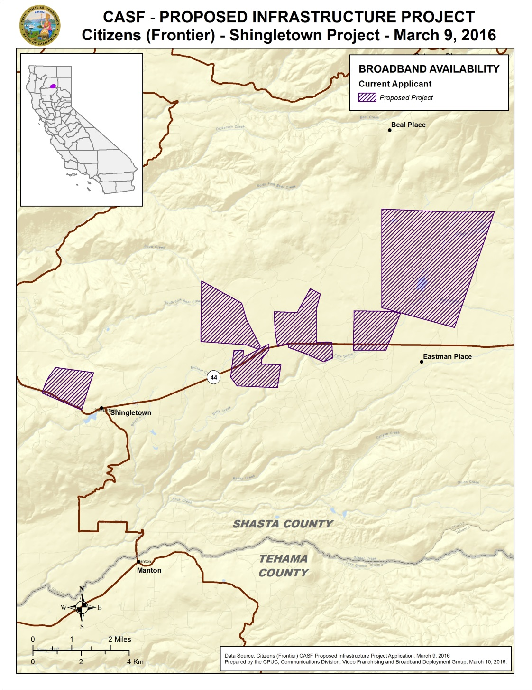

Appendix C
Resolution T-17522 Citizens Telecommunications Company of California, Inc. (Frontier) Shingletown Project
Existing Wireline Service Levels
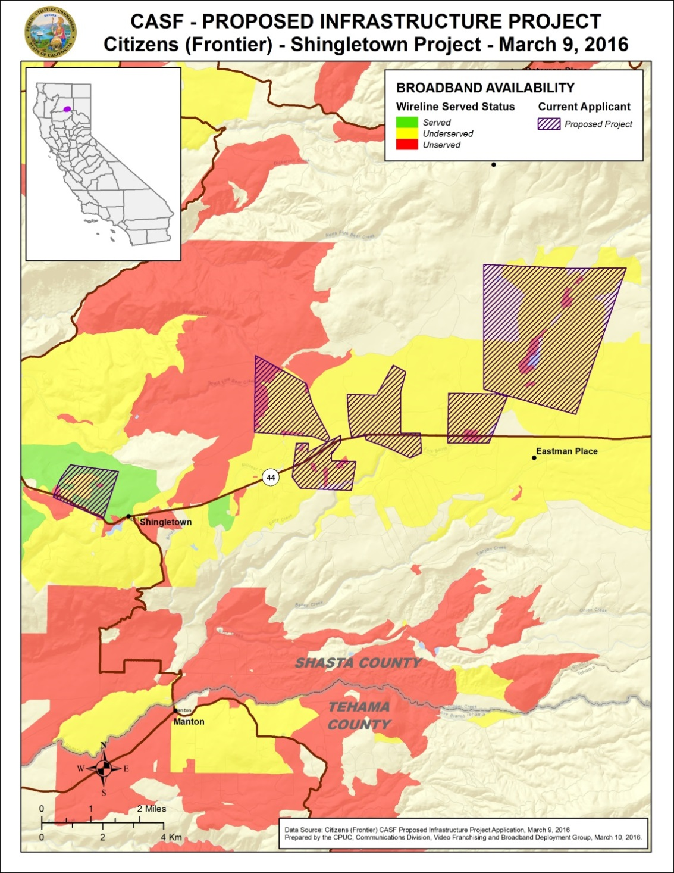
Appendix D
Resolution T-17522 Citizens Telecommunications Company of California, Inc. (Frontier) Shingletown Project
Existing Fixed Wireless Service Levels
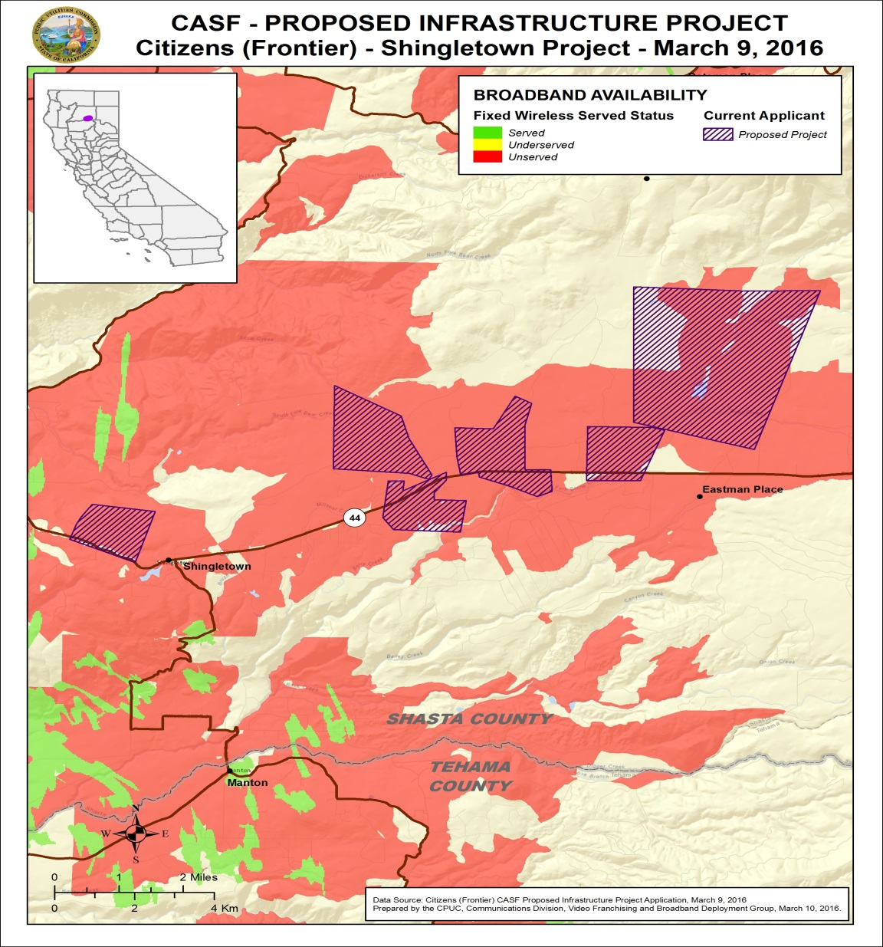
Appendix E
Resolution T-17522 Citizens Telecommunications Company of California, Inc. (Frontier) Shingletown Project
Existing Mobile Wireless Services Levels
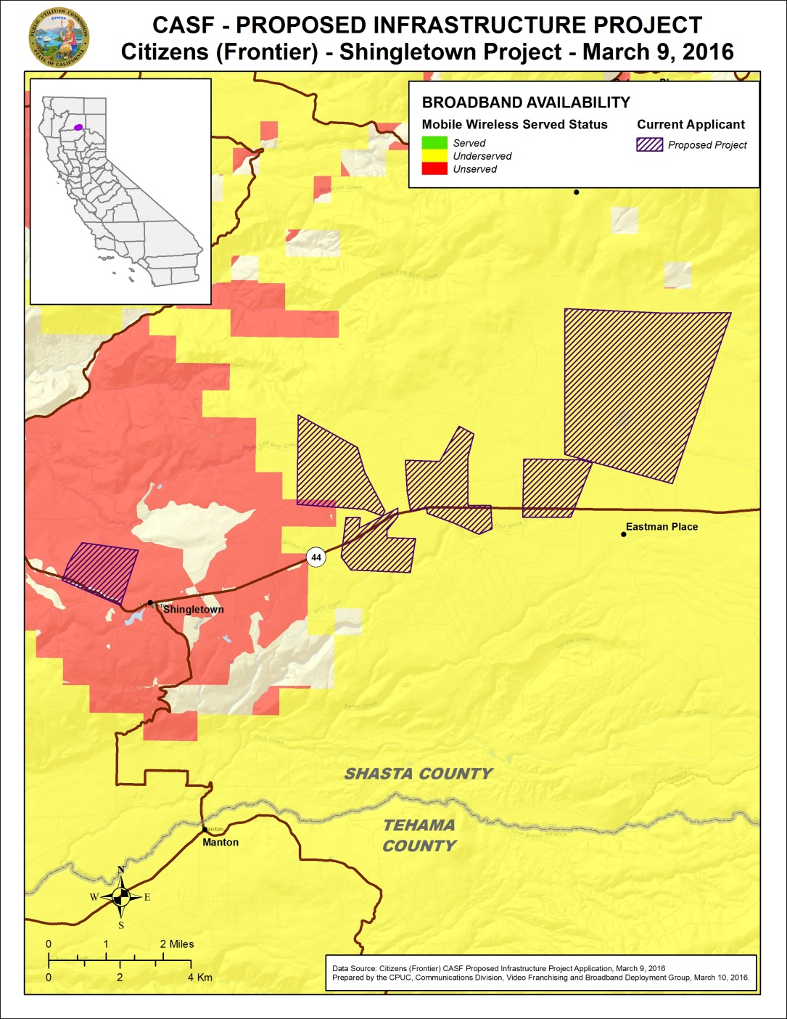

Frontier is the corporate name of the company group when discussing financials and management activities.
The Shingletown Central Office is fed via fiber with a 10 Gig connection.
ADSL2+ introduces the capability to use a technology called bonding, which requires some specific conditions on the infrastructure. The increased speed that will be enabled from using this technology also requires increased bandwidth (backhaul) to the central office to accommodate the increased throughput from the homes.
Email from Chris Burke of Frontier dated June 30, 2016 with subject line “RE: Questions Regarding Shingletown CASF Application.”
The latest version of the California Interactive Broadband Availability Map uses wireline data as of December 31, 2014.
Frontier Application File “Estimated Potential Subscribers Adoption Plan.”
The Commission has the authority to enforce the terms and conditions of the grant award and to impose penalties under P.U. Code §§ 2111 and 2108. (D.14-02-018, p. 36).
P.U. Code §§ 270 and 281.
Approval of the California Advanced Services Fund (CASF) Application Requirements and Scoring Criteria for Awarding CASF Funds (2008) Cal. P.U.C. Res. No. T-17143 at 4.

