PUBLIC UTILITIES COMMISSION OF THE STATE OF CALIFORNIA

|  |  |
| --- | --- |
| **Communications Division** | RESOLUTION T- 17544 |
| **Broadband, Video and Market Branch** | **December 1, 2016** |

**R E S O L U T I O N**

**RESOLUTION T-17544: Approval of funding for the Rural and Regional Consortia grant applications of the North Bay/ North Coast Broadband Consortium, Central Sierra Connect Broadband Consortium, and the Los Angeles County Regional Broadband Consortium in the amount of $1,099,000.**

**I. SUMMARY**

This Resolution approves grant funding in the amount of $1,099,000 from the California Advanced Services Fund (CASF) Rural and Regional Urban Consortia Account (Consortia Account) for the grant applications of the North Bay/ North Coast Broadband Consortium (NBNCBC), Central Sierra Connect Broadband Consortium (CSCBC), and the Los Angeles County Regional Broadband Consortium (LACRBC). These three projects will further broadband deployment, access and/or adoption in their regions.

By furthering broadband deployment, access and adoption, these projects are expected to enhance public safety in the North Bay/ North Coast, Central Sierra, and the associated areas of Los Angeles County in the event of fire, flooding, and earthquakes.

**II. BACKGROUND**

On June 23, 2011, the Commission adopted Decision (D.) 11-06-038, which implemented the provisions of Senate Bill (SB) 1040 (Padilla, Stats 2010, Chapter 317) relating to the CASF consortia program and outlined the application and filing process for the program. On September 2, 2015, the Governor signed Assembly Bill (AB) 1262 (Wood, Stats 2015, Chapter 242) that reallocated $5 million from the CASF Broadband Infrastructure Revolving Loan Account to the CASF Consortia Account, thus making additional funds available for consortia activities. Prospective applicants were invited to submit new proposals on January 29, 2016. The recent application process is consistent with [D. 11-06-038](http://docs.cpuc.ca.gov/PUBLISHED/FINAL_DECISION/138087.htm), with the addition of a performance review for applicants with prior Consortia grant experience.

**III. APPLICANT REQUEST**

On January 29, 2016, NBNCBC, CSCBC, and LACRBC submitted grant applications for CASF Consortia funding.[1]

*Applicants*

**NBNCBC** represents Marin, Mendocino, Napa and Sonoma Counties. NBNCBC received approval for a $250,000 Consortia Account grant in June 2014 (Resolution T- 17445). The program ended in June 2016.[2] NBNCBC’s prior consortia grant funded activities included: community and policy maker outreach, coordination with anchor institutions, initiation of countywide broadband planning for each of the four counties, verifying level of broadband service in priority areas, and updating the inventory of available adoption resources.

**CSCBC** represents Mariposa, Tuolumne, Calaveras and Amador counties, as well as the western side of Alpine county. CSCBC received approval for a $450,000 Consortia Account grant for a three-year program (Resolution T-17355). After one year extension, the grant ended in November 2015.[3] CSCBC’s prior consortia grant funded activities included: identification of viable projects aimed at increasing access to unserved and underserved areas; promoting adoption of broadband for the disadvantaged populations;[4] and providing opportunities for access and educational assistance through training programs and neighborhood information centers.

**LACRBC** received approval in December 2011 for a total of approximately $2.3 million from the Consortia Account for a three-year program (Resolution T-17349). After a six month extension, the grant ended in June 2015.[5] LACRBC contained five sub-regions, known as: Central /West Los Angeles, Gateway Cities, San Fernando Valley, San Gabriel, and South Bay. LACRBC’s prior consortia grant funded activities included: outreach at town hall and community events, internet classes and workshops, holding computer lab access hours, and facilitating wifi access to residents, businesses and their customers.

*Proposals*

**NBNCBC** requests $250,000 for a two-year program. Specifically, NBNCBC proposes to focus on planning and funding broadband infrastructure development. For example, NBNCBC will focus on identifying funding for expanded broadband into unserved and underserved areas of Marin County. In Mendocino and Sonoma Counties, NBNCBC will continue infrastructure planning work, including vetting, particularly last-mile plans, with community stakeholders. NBNCBC proposes to test available speeds of wireline and fixed wireless networks in Napa County, and work with broadband service providers for the development of last mile plans.

**CSCBC** requests $250,000 for a two-year program. CSCBC proposes to continue to focus its efforts on adoption, outreach, education and access-related activities to close the digital divide. Specifically, CSCBC proposes to assist local Internet service providers (ISPs) with their promotional and infrastructure build-out plans; educate and promote broadband needs for the region’s rural communities;[6] and enhance its education and adoption activities by replicating the recently developed Coach & Learn Computer Training Program[7] designed to attract people in the community with limited or no previous computer skills.

**LACRBC** initially requested $1,499,222 for a two-year program in its five sub-regions. Generally, the five sub-regions requested funding for similar activities: printing and distribution of outreach and educational materials, community events, carrying out demographic surveys, workshops, classes, and open computer labs. One activity, only proposed in the South Bay sub-region, was to map existing broadband infrastructure/ speeds related to local businesses and then survey local businesses.

**IV. NOTICES**

On February 18, 2016, CD posted a list of applications received on the Commission’s CASF Consortia Account webpage,[8] and sent email notices regarding the proposed projects to its CASF Distribution List.

**V. PROJECT REVIEW**

1. Project Eligibility

NBNCBC, CSCBC, and LACRBC applications are eligible because they meet the minimum criteria established by D.11-06-038 and CD’s review of how efficiently and cost-effectively previously granted Consortia funds were spent as a basis for awarding any new and/or additional funding.

1. Project Criteria Evaluation

Proposals from previously funded Regional Consortia were considered in the context of past performance in implementing NBNCBC’s and LACRBC’s Action Plan and Work Plan. Additionally, CD evaluated all proposals with respect to the criteria defined in D.11-06-038, Attachment G, Scoring Criteria. The criteria includes: (1) Work Plan, (2) Action Plan, (3) Budget, (4) Regional Consortium’s/Members Experience, and (5) Regional Consortium Representation and Endorsements. CD’s evaluation of these two projects is summarized below.

*Past Performance*

**NBNCBC** used its resources to engage residents, businesses, public agencies, and policy makers regarding the value of broadband infrastructure. NBNCBC also carried out ground-truthing[9] of existing internet service in priority areas and commenced efforts to establish a county-wide broadband plan for two counties, producing conceptual designs. NBNCBC further assisted with three infrastructure grant proposals (two were awarded)[10], as well as feasibility study for new middle mile segments, conducted an assessment of adoption resources and needs for two counties, and participated in establishing a computer literacy lab in Marin City.

**CSCBC** used its resources to launch an online data collection program, Map Your Speed and BIP; offer digital literacy classes in small groups; and conducted outreach to the disadvantaged populations.[11]

**LACRBC**’s sub-regions conducted community meetings for public outreach and education related to digital literacy. They also provided internet literacy classes and workshops on topics such as Telehealth, using the internet to look for work and banking, and held open computer labs in their respective communities. The sub-regions further helped individuals subscribe to low-cost internet services, informed policy makers of their efforts, handed out broadband literature and outreach material, and collected demographic data from class and event attendees. One sub-region, South Bay, worked to set up wifi connections in some businesses areas and three senior housing centers.

During the previous grant cycle, the Fiscal Agents for NBNCBC, CSCBC, and LACRBC filed appropriate documentation with reimbursement requests, and fulfilled other consortium-related responsibilities.

*Work Plan*

**NBNCBC**’s Work Plan contains discrete, clear tasks and deliverables, with acceptable timelines for completion (see Appendix A). The Work Plan is directly related to the Action Plan and its goals. For example, Mendocino and Sonoma counties began conceptual designs for Broadband Strategic Plans during the prior grant cycle. They propose to continue the development of countywide plans and last miles plans, including holding community meetings for public feedback.

**CSCBC**’s Work Plan contains discrete, clear tasks and deliverables, with acceptable timelines for completion (see Appendix B). The Work Plan is directly related to the Action Plan and its goals. For example, CSCBC plans to reach out to at least one ISP each quarter to assist them with promotional activities and identification of neighborhoods in the region suitable for potential build-out.

**LACRBC**’s Work Plan contains discrete, clear tasks and deliverables, with acceptable timelines for completion (see Appendix C). Activities itemized in the Work Plan are consistent with the Action Plan. For example, the Work Plan implements the Action Plan goals of: providing classes and public access to computer labs to residents.

*Action Plan*

**NBNCBC** provided a clear Action Plan consistent with program requirements defined in D.11-06-038.[12] For example, NBNCBC proposes to primarily focus on infrastructure planning, wherein counties will engage in last mile and financial planning, as well as ground truthing broadband services levels. These are consistent with the “core responsibilities” outlined in D.11-06-038.

**CSCBC** provided a clear Action Plan consistent with program requirements defined in D.11-06-038. CSCBC proposes to assist local ISPs with their promotional and expansion plans, and to increase digital literacy in the rural by building upon successes of the Coach & Learn Program. These are consistent with the “core responsibilities” outlined in D.11-06-038.

**LACRBC** provided a clear Action Plan consistent with program requirements defined in D.11-06-038. In its Action Plan, LACRBC proposes to promote adoption by providing internet subscription options, holding community meetings/events, by providing classes and workshops, as well as distributing literature on digital access and internet resources. These are consistent with the “core responsibilities” outlined in D.11-06-038.

*Budget*

**NBNCBC** proposed a $250,000 budget for two years. Based on CD staff’s review of the Action Plan and Work Plan, CD staff determined that the budget is reasonable for the tasks proposed and should be adopted.

**CSCBC** proposed a $250,000 budget for two-years. The budget includes $1,000 funding[13] for the recognition of community volunteers assisting in the Internet training classes. The acknowledgement and recognition of volunteers’ commitment and efforts have merits but the funding of these activities is inconsistent with the use of Consortia Account’s grant funds set forth in D. 11-06-038.[14] Therefore, CD staff determined that the budget should be reduced by $1,000 to $249,000

**LACRBC** initially requested a budget of $1,499,222 for a two-year period. Subsequently, one of the sub-regions (San Gabriel Valley) chose not to reapply for funding ($295,200 originally requested). In addition, LACRBC and CD staff worked together to reduce the proposed budget to $600,000 for a one-year program, since this consortia grant cycle is constrained by available funds, which must be divided by all successful applicants and the cost of state operations.[15] Based on CD staff’s review of the revised Action Plan and Work Plans, CD staff determined that the budget is reasonable for the tasks proposed and should be adopted.

*Regional Consortium’s/Members’ Experience*

**NBNCBC** and its members have experience with community groups and have demonstrated success in helping to extend broadband networks to public agencies, and to secure funds for broadband deployment in the region.[16] They have also had success in building regional, collaborative broadband related efforts. Members have direct experience with managing broadband services at libraries. Members have worked with culturally and linguistically diverse communities.

**CSCBC**’s membership includes stakeholders and businesses that have experience and success in helping to achieve broadband deployment in the region. Member organizations also have worked with a culturally and linguistically diverse community.

**LACRBC** has had direct experience with adoption efforts. LACRBC has also run programs in collaboration with or through community organizations, and has held computer literacy classes and telehealth workshops. LACRBC has also worked with culturally and linguistically diverse communities with coordination between sub-regions across the very large Los Angeles County region.

*Regional Consortium Representation and Endorsements*

**NBNCBC** is organized as a “confederation” of four counties, with the Oversight Committee consisting of one supervisor from each county. Each county has its own committee or task force that interacts with the respective local decision makers and the community to develop and implement the county Work Plan. CD received four endorsements from county governments, and nineteen endorsements from K-12 and post-secondary educators, public agencies (including water, emergency services and fire protection), community organizations and health clinics, business associations, and a landowner association.

**CSCBC** representation includes local city and regional government, public safety, K-12 education, health care, libraries, higher education, community-based organizations, tourism, parks and recreation, agricultural, and business. CD received four endorsements from local governments, an endorsement from the Volcano Communications Group, and an endorsement from Sierra NonProfit Services.

**LACRBC’s** members include education, employment development, internet access, and local religious organizations. LACRBC is endorsed by eight local and state office holders (Los Angeles mayor, county supervisors, state legislators, member of Board of Education). It is also endorsed by a Los Angeles manufacturer and others, including the Inglewood City Manager, and agencies and organizations providing education, employment development and other services to low income residents of the sub-regions.

**V. STAFF RECOMMENDATIONS FOR FUNDING**

CD staff has determined that NBNCBC, CSCBC, and LACRBC applications qualify for funding. They scored at least 70 of 100 points with clear and detailed proposals. CD staff’s evaluation of these proposals finds that they meet the requirements of D. 11-06-038, and support broadband deployment, access, and adoption. CD staff recommends approval of these proposals.

**VI. COMPLIANCE REQUIREMENTS**

NBNCBC, CSCBC, and LACRBC are required to comply with all the guidelines, requirements, and conditions associated with the grant of CASF funds as specified in D.11-06-038. Such compliance includes, but is not limited to the following:

A. Execution and Performance

CD staff will coordinate start dates with NBNCBC, CSCBC, and LACRBC. The expected start date is January 1, 2017. By receiving a CASF grant from the Commission, NBNCBC, CSCBC, and LACRBC agree to comply with the terms, conditions, and requirements of the grant as set forth in this resolution, and thus submit to the jurisdiction of the Commission with regard to disbursement and administration of the grant.

Should NBNCBC, CSCBC, or LACRBC fail to complete the project in accordance with the terms of the Commission’s approval as set forth in this resolution NBNCBC, CSCBC, or LACRBC must reimburse some or all of the CASF funds it has received. If NBNCBC, CSCBC, or LACRBC fails to perform in good faith, or in accordance with the expectations set forth in its Action Plan, Work Plan and Consent Form, as affirmed in the affidavit, the Commission may withhold subsequent grant disbursement or suspend or terminate the Consortium grant, as warranted.

Any changes to the substantive terms and conditions underlying the Commission approval of the Consortium grant must be communicated in writing to the Communications Director at least 30 days before the anticipated change, and may be subject to approval by either the Director or by Commission resolution before becoming effective.

B. Summit Requirement

D.11-06-038 directed CD staff to schedule and host, on at least an annual basis, a Regional Consortia Learning Community Summit, and required all consortia receiving California Advanced Services Fund grants to attend the Summit. D.11-06-038 allocated up to $10,000 per consortium for summit attendance. In Resolution T-17529, the Commission modified this requirement so that at least one summit during the grant implementation period will be organized.[17]

C. Fiscal Agent

D.11-036-038 requires:

Each regional Consortium must retain at least one Fiscal Agent with lead responsibility and legal authority to represent the Consortium for purposes of sponsoring the application, and for administration of Consortium activities, including receipt and disbursement of Consortium grant funds. In any event, the Fiscal Agent must affirmatively agree, on behalf of the Consortium, to comply with the Commission’s directives and conditions relating to the review, approval, and administration of any Consortia application grants. This requirement is to provide assurance that Consortium members or contractors retained by the Consortium are capable and committed to delivering on the commitments to be funded.[18]

CD staff reviewed applications submitted by NBNCBC, CSCBC and LACRBC and determined that the applications meet this requirement. Specifically, for each application, the Fiscal Agent signed an affidavit, under penalty of perjury, that to the best of his or her knowledge, all statements and representations made in NBNCBC’s, CSCBC’s and LACRBC’s application are true and correct, and affirmed to fulfill the Commission’s requirements with respect to grant administration.[19]

Each Fiscal Agent provided CD staff with a name of a qualified representative to carry out the duties and responsibilities described, and the Fiscal Agents will be the primary contact regarding NBNCBC’s, CSCBC’s and LACRBC’s fiscal matters.

Each Fiscal Agent shall comply with all rules and requirements set forth in D.11-06-038, including but not limited to ensuring implementation of the approved Work Plan within the allocated budget (in conjunction with the consortium program manager), and shall be responsible for notifying CD of any proposed changes to Work Plan or budget during the course of the grant cycle.

D.11-036-038 further requires each Consortia grantee to:

…maintain books, records, documents and other evidence sufficient to substantiate expenditures covered by the grant, according to generally accepted accounting practices. Each Consortia grantee shall make these records available to the Commission upon request and agrees that these records are subject to a financial audit by the Commission at any time within three years after the Grantee incurred the expense being audited. A Consortia grantee shall provide access to the Commission upon 24 hours’ notice to evaluate work completed or being performed pursuant to the grant.[20]

1. Distinguishing CASF from other Financial Resources

D.11-06-038 requires that the consortium take steps to ensure that that CASF grant budget does not duplicate funding from other non-Consortia Account funding.[21] NBNCBC, CSCBC, and LACRBC must ensure that *only* CASF-approved activities will be billed to the Consortia Account, and activities obligated to other funding resources will not be billed to the CASF Consortia Account.

Prior to initiation of Work Plan activities, the Fiscal Agents for NBNCBC, CSCBC, and LACRBC must communicate to CD staff how they will ensure that billing to discrete funding sources does not overlap.

E. Payments

D.11-06-038 requires that submission of invoices from and payments to the grantees shall be made at quarterly intervals. Specifically, D.11-06-038 states:

In order to receive a progress payment, the Consortium must first submit the Quarterly Progress Report to the Communications Division, together with all requests for payment and reimbursement supported by relevant invoices receipts, etc. … Further, the Quarterly Progress Report shall indicate the actual date of completion of each task/milestone as well as problems/issues encountered and the actions taken to resolve these problems/issues. The Quarterly Progress Report will be submitted and certified under penalty of perjury.[22]

Furthermore, documentation should substantiate NBNCBC’s, CSCBC’s, and LACRBC’s progress in following their proposed Action Plan, Work Plan, with the approved budget. Billing should only be for activities related to broadband deployment, access, and adoption.

All activities specified under the terms of the award shall be completed on or before the termination date of the award, as per the signed Consent Form between NBNCBC, CSCBC, LACRBC, and the Commission. A project completion report is required prior to full payment showing that all activities on the Work Plan have been accomplished. NBNCBC’s, CSCBC’s, and LACRBC’s final payment reports, including all documentation and receipts, should be submitted no later than 60 days after project completion.

1. Project Audit

The Commission’s Communications Division has delegated authority to initiate and enforce any necessary audit, verification, and discovery of consortium members relating to grant funding activities to ensure that CASF funds are spent in accordance with Commission adopted rules and standards.[23]

NBNCBC’s, CSCBC’s, and LACRBC’s invoices and other relevant records will be subject to a financial audit by the Commission or its designee at any time within three years after NBNCBC, CSCBC, and LACRBC incurred the expense being audited.

G. Lobbying and Advocacy Efforts

NBNCBC, CSCBC, and LACRBC are free to advocate on any legislation of their choosing. However, no work on proposed state legislation including meetings, travel, or lobbying may be billed to or reimbursed by the CASF Consortia Grant program

H. Reporting

NBNCBC, CSCBC, and LACRBC must submit quarterly progress reports on the status of the project irrespective of whether grantees request reimbursement or payment.[24] Quarterly progress reports must begin the first quarter after the Commission approval of the grant proposal. Quarterly reports are due April 1, 2017, July 1, 2017, October 1, 2017, and so on for the remainder of the grant period, irrespective of payment requests.

**VII. SAFETY IMPACT**

By furthering broadband deployment, access and adoption, these projects are expected to enhance public safety in the North Bay/ North Coast Consortium region, and the related parts of Los Angeles County in the event of fire, flooding, or earthquakes.

**VIII. COMMENTS**

In compliance with P.U. Code Section 311(g)(1), a Notice of Availability was e-mailed on November 1, 2016 informing all parties on the CASF Distribution List of the availability of the draft of this Resolution for public comments at the Commission’s website at <http://www.cpuc.ca.gov/>. This letter also served to inform parties that the final conformed Resolution the Commission adopts will be posted and available at this same website.

**VIII. FINDINGS**

1. On September 2, 2015, the Governor signed legislation (AB1262) that reallocated $5 million from the CASF Broadband Infrastructure Revolving Loan Account to the CASF Consortia Grant Account.
2. Fifteen prospective grantees filed applications on January 29, 2016. CD posted each applicant's name, contact information, and coverage area by county on the Commission Consortia Account webpage on February 18. NBNCBC, CSCBC, and LACRBC appear on this list.
3. CD reviewed NBNCBC, CSCBC, and LACRBC applications according to the guidelines, requirements, and evaluation criteria adopted in D.11-06-038, which include regional consortium representation and endorsements, regional consortium’s/members’ experience, action plans, work plans, and budgets. CD also evaluated the applications based on the merits of each proposal, past performance including achievements, fiscal responsibility and cost effectiveness. The remaining five applications will be considered for subsequent resolutions.
4. Based on its review, CD determined that all three proposals meet eligibility requirements. CD further determined that the proposed projects qualify for funding under D.11-06-038 and recommends approval. The Commission finds CD’s recommendation reasonable and consistent with Commission orders and, therefore, adopts such recommendation.
5. CD recommends CASF consortia grant approval of total funding of $1,099,000 for the three consortia.
6. NBNCBC, CSCBC, and LACRBC are required to comply with all guidelines, requirements, and conditions associated with the granting of CASF funds as specified in D.11-06-038 and this Resolution, including only billing for activities related to broadband deployment, access, and adoption in approved Action and Work Plans.
7. NBNCBC, CSCBC, and LACRBC are required to expressly exclude any costs for activities or programs from the proposed consortium budget that are separately funded from any other sources in order to ensure that CASF grants do not duplicate funding from any other sources.
8. D.11-06-038 directs CD to schedule and host a Regional Consortia Learning Community Summit, and authorizes $2,000 per person for up to five delegates annually for each approved consortium. Resolution T-17529, adopted on August 18, 2016 reduced the frequency of the summit to at least one during the implementation of the reallocated $5 million during this grant cycle.
9. A notice was emailed on November 1, 2016, informing the parties of record in Decision 11-06-038 of the availability of the draft of this Resolution for public comments at the Commission’s website http://www.cpuc.ca.gov/PUC/documents/. This letter also informed parties that the final conformed Resolution adopted by the Commission will be posted and available at this same website.

**THEREFORE, IT IS ORDERED THAT**:

1. The Commission shall award $250,000 to the North Bay/North Coast Broadband Consortium (NBNCBC), $249,000 to the Central Sierra Connect Broadband Consortium (CSCBC), and $600,000 to the Los Angeles County Regional Broadband Consortium (LACRBC). All awards are based on the descriptions of the projects as described herein. Work Plans are in the attached appendix.
2. Payments to the CASF recipients shall be in accordance with guidelines adopted in D.11-06-038 and in accordance with the process defined in the “Payments” section of this Resolution.
3. NBNCBC, CSCBC, and LACRBC each must retain at least one Fiscal Agent with lead responsibility and legal authority to represent the Consortium for purposes of sponsoring the application and administration of Consortium activities, including receipt and disbursement of Consortium grant funds.
4. Each Fiscal Agent must affirmatively agree, on behalf of NBNCBC, CSCBC, and LACRBC, to comply with the Commission’s directives and conditions relating to the review, approval, and administration of any Consortia application grants.
5. Prior to commencement of the NBNCBC, CSCBC, and LACRBC programs, each Fiscal Agent must provide CD with the method chosen to distinguish funding sources and billing practices, to ensure that CASF payments are not duplicated by other sources, and that only CASF-approved activities are billed to the Consortia Account.
6. The disbursement of funds shall be subject to the requirements set forth in D.11-06-038 including the submission of quarterly progress reports and supporting documentation for payment reimbursement, yearly status reports for informing the legislature and a Completion Report to be submitted before the final payment reimbursement will be made.
7. By receiving a CASF grant from the Commission, NBNCBC, CSCBC, and LACRBC agree to comply with the terms, conditions, and requirements of the grant and thus submit to the jurisdiction of the Commission with regard to disbursement and administration of the grant.
8. NBNCBC, CSCBC, and LACRBC shall complete activities in accordance with and within the performance period set forth in the Commission-approved Action and Work Plans.
9. NBNCBC, CSCBC, and LACRBC must use the grant funds solely for the approved projects/activities as described in the Consortia Commission-approved Action Plans and Work Plans, (or approved revisions to such Plans and budgets).
10. Each Consortia grantee shall make records available to the Commission upon request and shall agree that these records are subject to a financial audit by the Commission at any time within three years after the Grantee incurred the expense being audited. A Consortia grantee shall provide access to the Commission upon 24 hours’ notice to evaluate work completed or being performed pursuant to the grant.
11. The Commission may withhold or terminate grant payments to NBNCBC, CSCBC, or LACRBC if the consortium does not comply with any of the requirements set forth in Decision 11-06-038 and this Resolution.
12. NBNCBC, CSCBC, and LACRBC shall comply with all guidelines, requirements and conditions associated with the CASF funds award as specified in D.11-06-038 and this Resolution.
13. In the event that NBNCBC, CSCBC, or LACRBC fails to complete the project/activities in accordance with the terms of approval granted by the Commission and this Resolution, the consortium, represented by the Fiscal Agent, will be required to reimburse some or all of the CASF funds that it has received.
14. The commencement of the grant cycle will be January 1, 2017.
15. Any changes to the substantive terms and conditions underlying Commission approval of the grant (e.g., changes to Action Plan, Work Plan, budget or designated Fiscal Agent, etc.) must be communicated in writing to the Communications Division Director at least 30 days before the anticipated change, and may be subject to approval by either the Director or by Commission resolution before becoming effective.

I hereby certify that this Resolution was adopted by the Public Utilities Commission at its regular meeting on December 1, 2016. The following Commissioners approved it:

______________________________

TIMOTHY J. SULLIVAN

Executive Director

**APPENDIX**

**North Bay/North Coast Broadband Consortium Work Plan**

**Year 1**

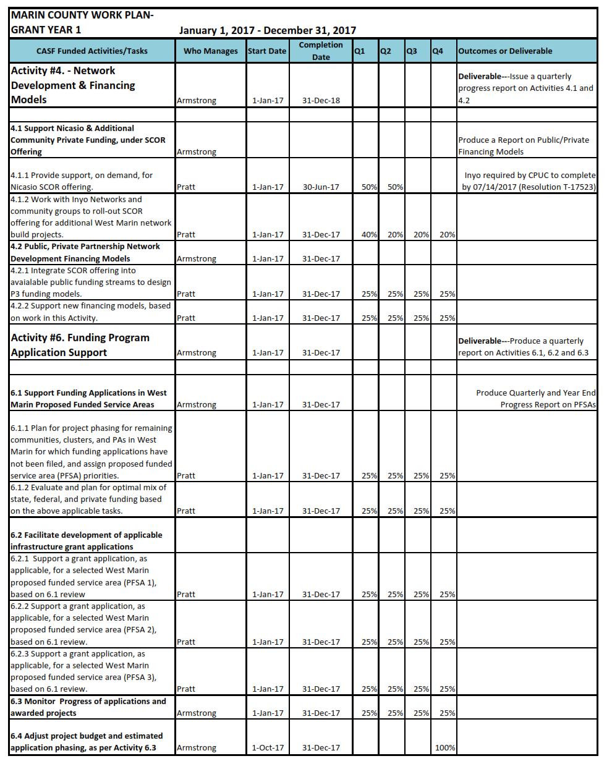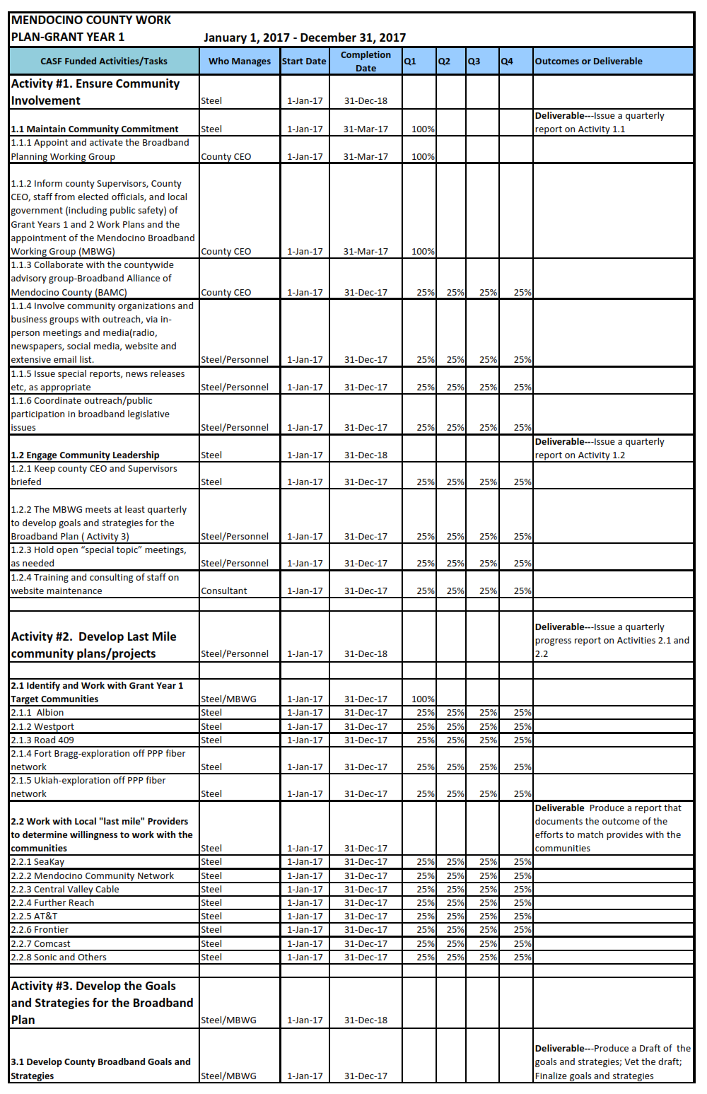

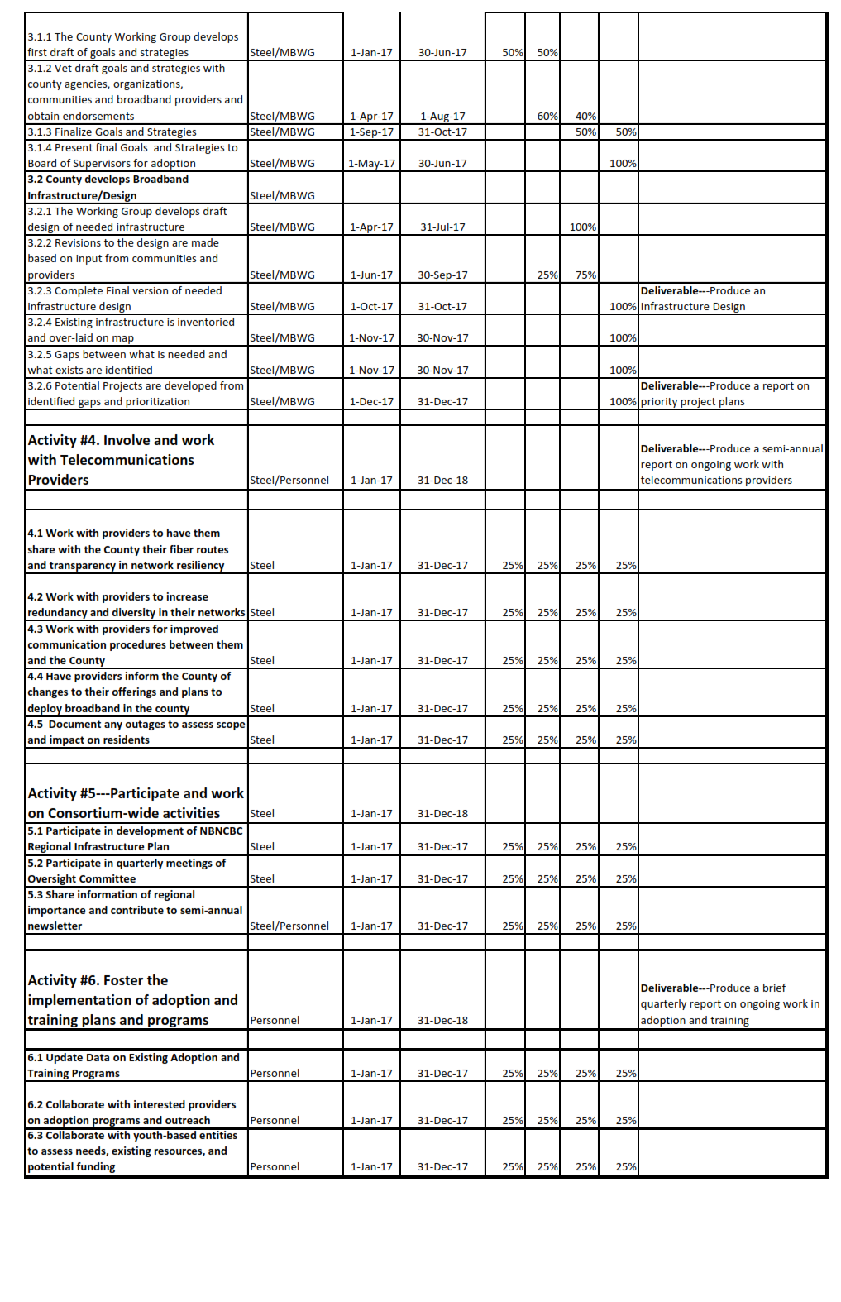

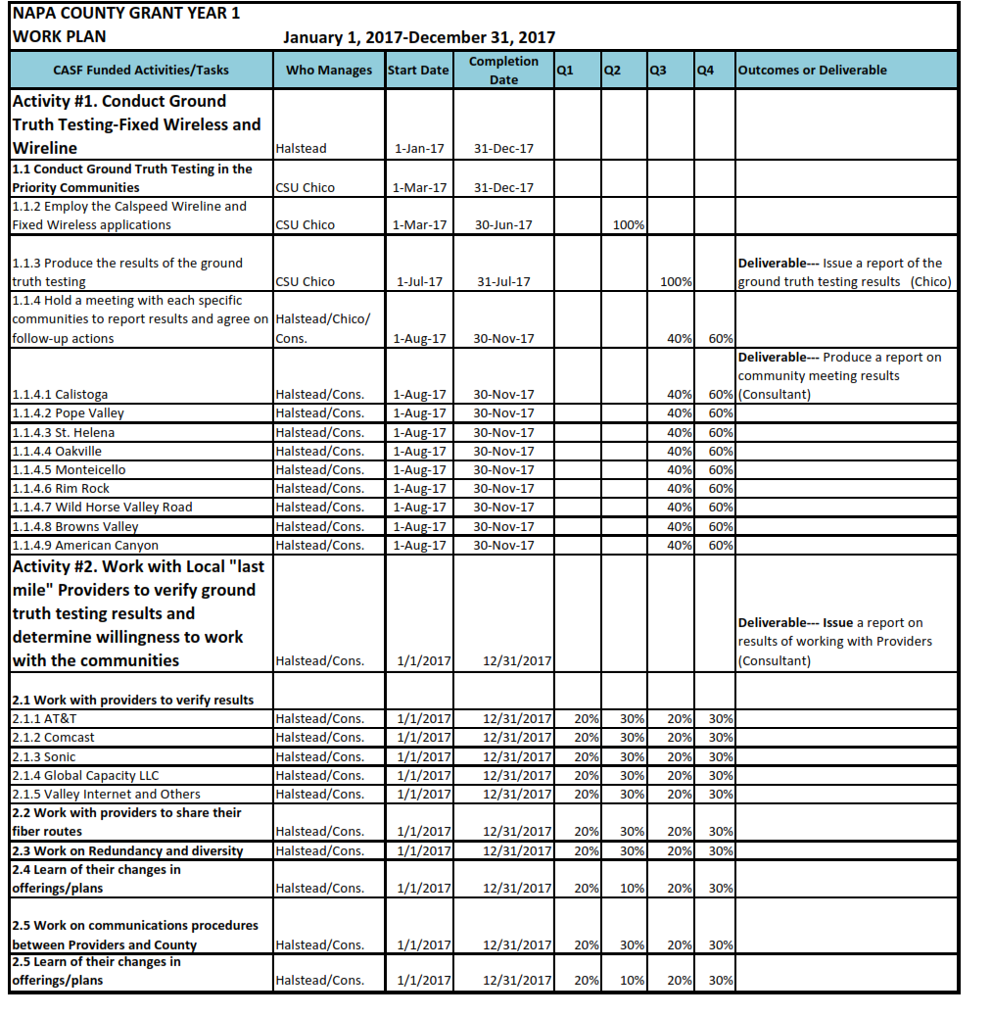

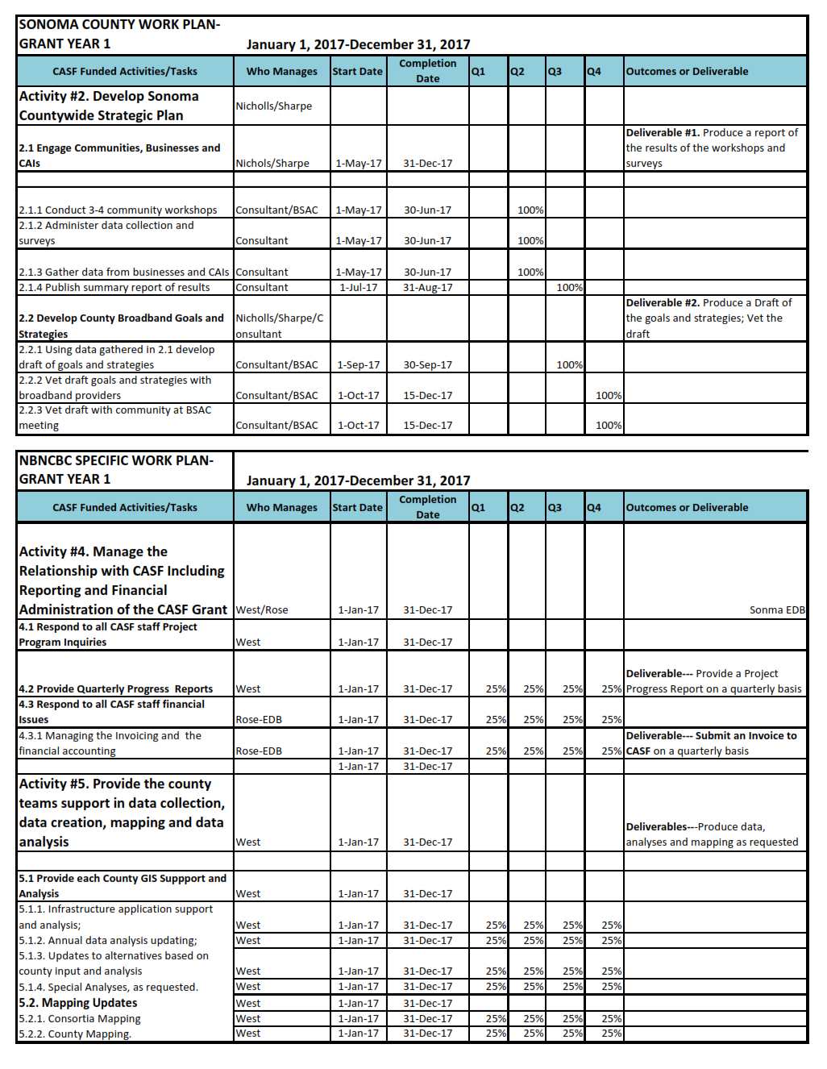

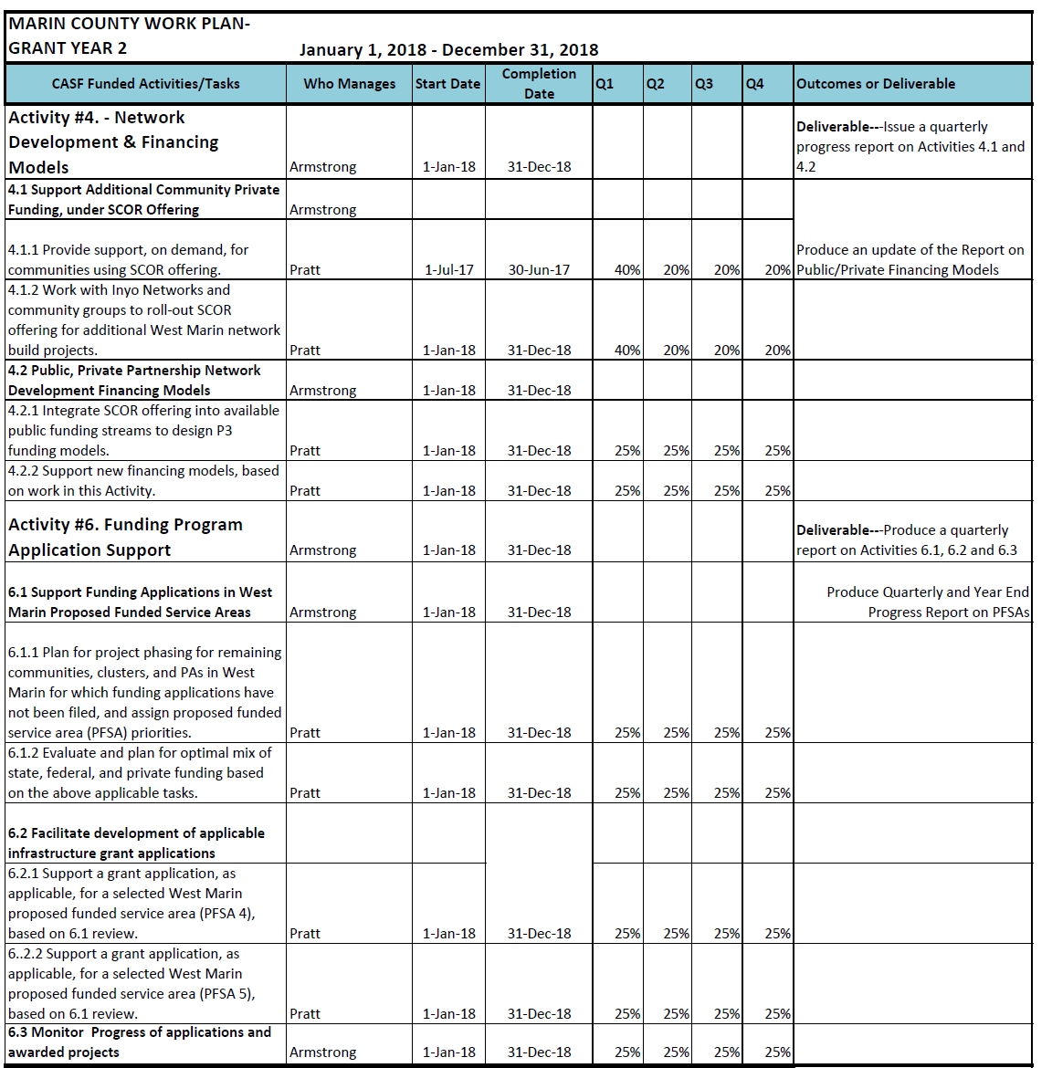

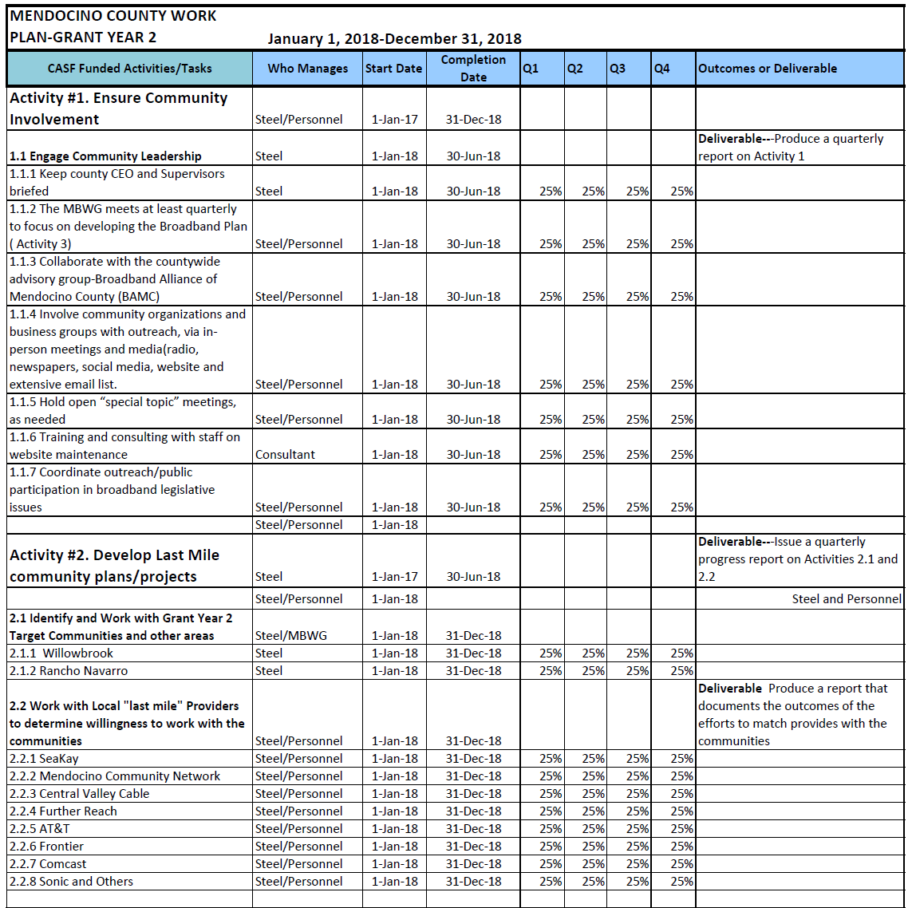

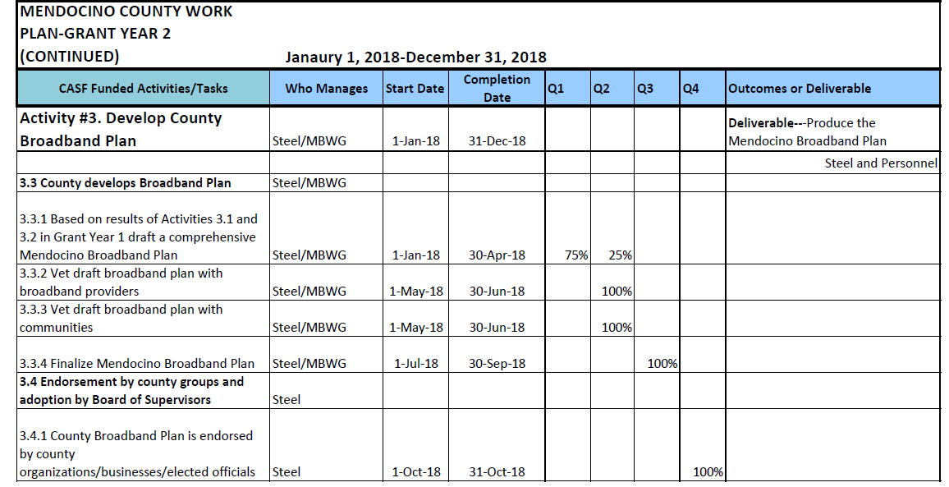

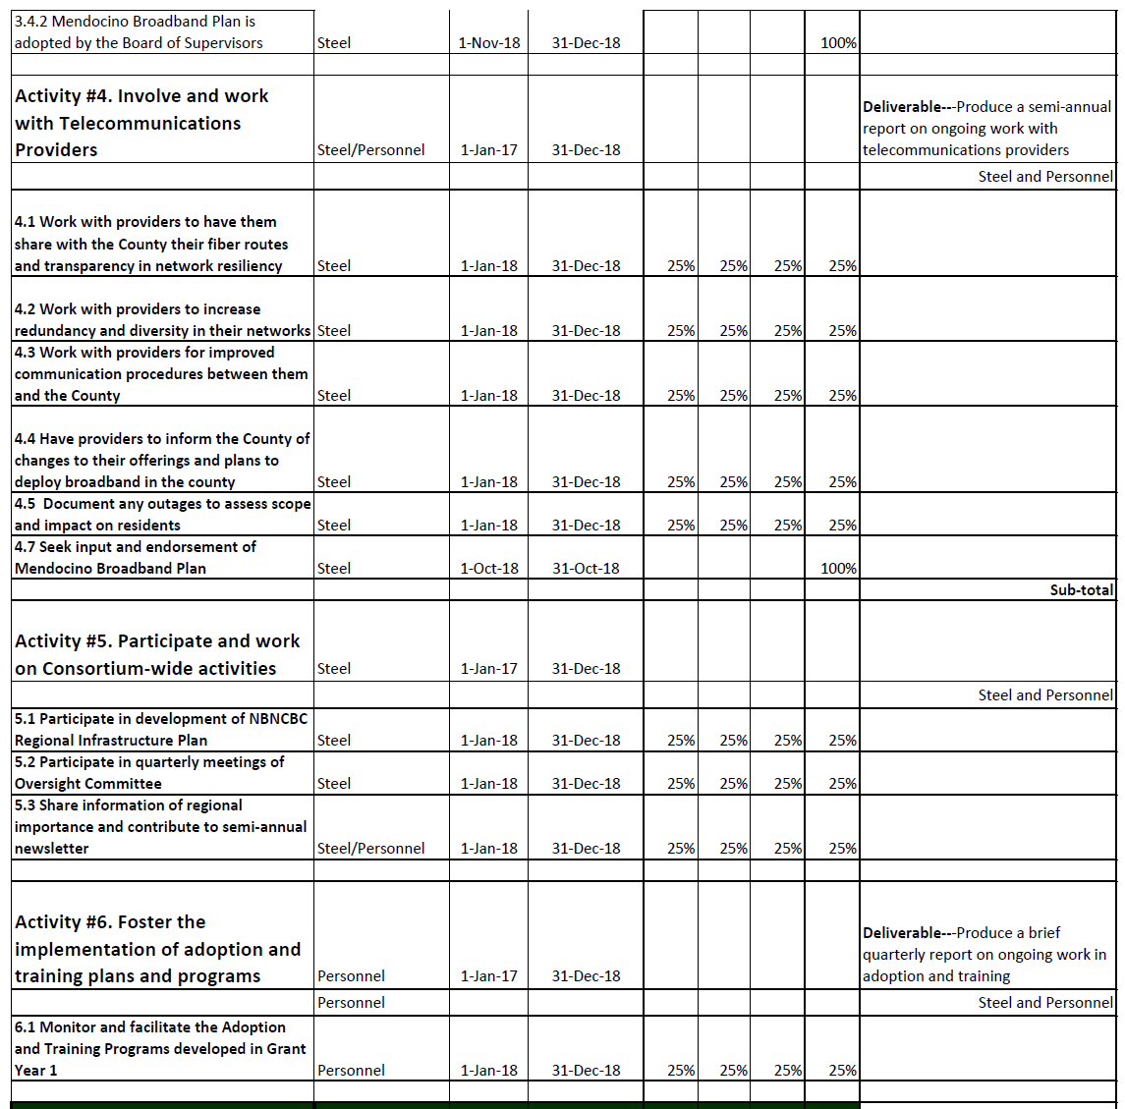

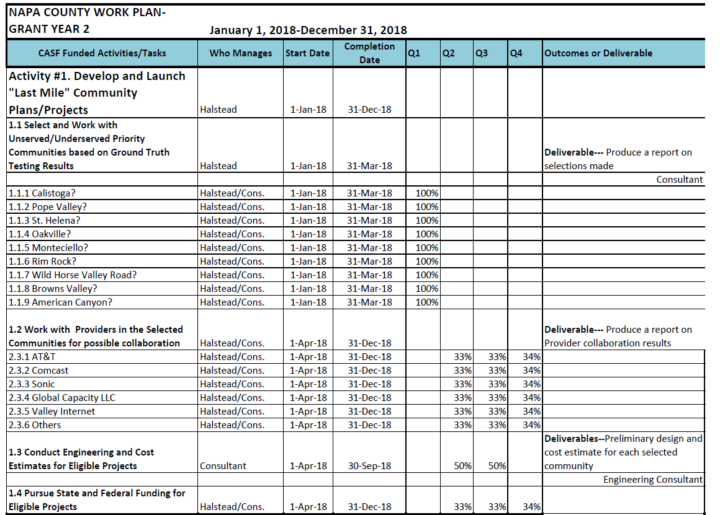

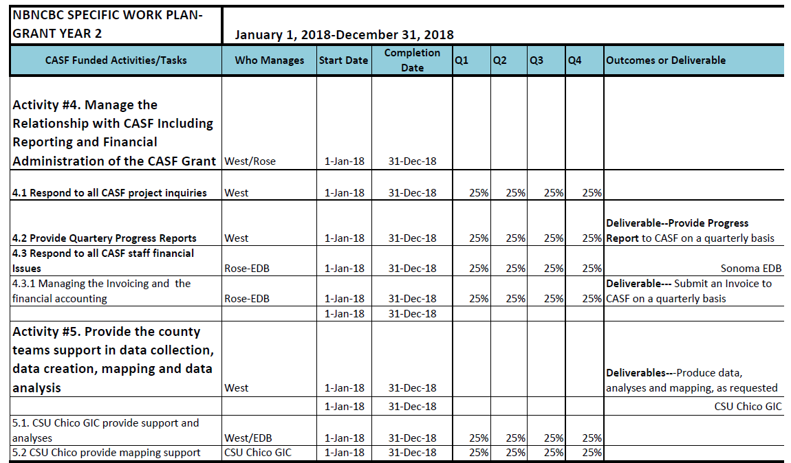

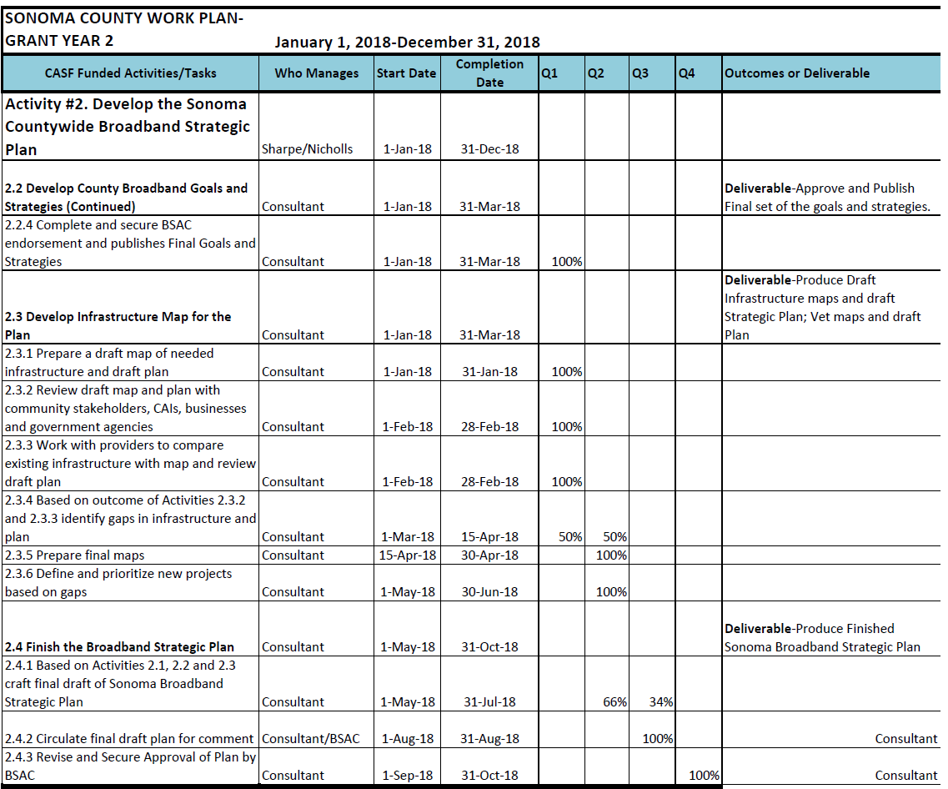

**APPENDIX B**

**Central Sierra Connect Broadband Consortium**

**Work Plan**

**Year 1**

|  |  |
| --- | --- |
|  |  |
|  |  |

**Central Sierra Connect Broadband Consortium**

**Work Plan**

**Year 2**

|  |  |
| --- | --- |
|  |  |
|  |  |

**APPENDIX C**

**Los Angeles County Regional Broadband Consortium**

**Work Plan**

|  |  |  |  |  |  |  |  |  |
| --- | --- | --- | --- | --- | --- | --- | --- | --- |
|  | **CENTRAL WEST REGIONAL BROADBAND CONSORTIUM** | | | | | |  |  |
|  |  | 1-year Work Plan | |  |  |  |  |  |
| **Activities/Tasks** | **Who Manages** | **Start Date** | **Completion Date** | **Q1** | **Q2** | **Q3** | **Q4** | **Outcome or Deliverable** |
| **Host and/or participate in 6 community events per year** | CW lead & Partners | 1/2/2017 | 12/29/2017 | x | x | x | x | Log of community events and materials distributed |
| **Distribute 600 pieces of broadband literature per year** | CW lead & Partners | 1/2/2017 | 12/29/2017 | x | x | x | x | Copies of broadband literature. Log of distribution locations and amounts |
| **Distribute 1,200 pieces of outreach materials per year** | CW lead & Partners | 1/2/2017 | 12/29/2017 | x | x | x | x | Copies of outreach literature. Log of distribution locations and amounts. |
| **Collect "Demographic, Deployment and Adoption" surveys from 200 individuals per year** | CW lead & Partners | 1/2/2017 | 12/29/2017 | x | x | x | x | Report of collected information. |
| **Provide 200 individuals with informative workshops per year** | CW lead & Partners | 1/2/2017 | 12/29/2017 | x | x | x | x | Attendance sign-in sheets |
| **Provide 100 individuals with informative classes per year** | CW lead & Partners | 1/2/2017 | 12/29/2017 |  | x | x | x | Attendance sign-in sheets |
| **Provide 4 telehealth education workshops per year** | CW lead & Partners | 1/2/2017 | 12/29/2017 | x | x | x | x | Attendance sign-in sheets |
| **Provide 1,500 users with open lab access per year** | CW lead & Partners | 1/2/2017 | 12/29/2017 | x | x | x | x | Web-based log-in or sign-in sheets |
| **Assist 100 L.A. County residents in adopting the use of Internet per year** | CW lead & Partners | 1/2/2017 | 12/29/2017 | x | x | x | x | Broadband verification checklists |
| **Attend monthly meetings with sub-region leads** | CW Lead | 1/2/2017 | 12/29/2017 | x | x | x | x | Meeting Agendas |
| **Prepare and submit quarterly reports** | CW Lead | 1/2/2017 | 12/29/2017 | x | x | x | x | Quarterly Reports |
|  |  |  |  |  |  |  |  |  |

|  |  |  |  |  |  |  |  |  |
| --- | --- | --- | --- | --- | --- | --- | --- | --- |
|  | **GATEWAY CITIES REGIONAL BROADBAND CONSORTIUM** | | | | | |  |  |
|  |  | 1-year Work Plan | |  |  |  |  |  |
| **Activities/Tasks** | **Who Manages** | **Start Date** | **Completion Date** | **Q1** | **Q2** | **Q3** | **Q4** | **Outcome or Deliverable** |
| **Host and/or participate in 6 community events per year** | GWC Lead & Partners | 1/2/2017 | 12/29/2017 | x | x | x | x | Log of community events and materials distributed |
| **Distribute 600 pieces of broadband literature per year** | GWC Lead & Partners | 1/2/2017 | 12/29/2017 | x | x | x | x | Copies of broadband literature. Log of distribution locations and amounts |
| **Distribute 1,200 pieces of outreach materials per year** | GWC Lead & Partners | 1/2/2017 | 12/29/2017 | x | x | x | x | Copies of outreach literature. Log of distribution locations and amounts. |
| **Collect "Demographic, Deployment and Adoption" surveys from 200 individuals per year** | GWC Lead & Partners | 1/2/2017 | 12/29/2017 | x | x | x | x | Report of collected information |
| **Provide 200 individuals with informative workshops per year** | GWC Lead & Partners | 1/2/2017 | 12/29/2017 | x | x | x | x | Attendance sign-in sheets |
| **Provide 100 individuals with informative classes per year** | GWC Lead & Partners | 1/2/2017 | 12/29/2017 |  | x | x | x | Attendance sign-in sheets |
| **Provide 4 telehealth education workshops per year** | GWC Lead & Partners | 1/2/2017 | 12/29/2017 | x | x | x | x | Attendance sign-in sheets |
| **Provide 500 users with open lab access per year** | GWC Lead & Partners | 1/2/2017 | 12/29/2017 | x | x | x | x | Web-based log-in or sign-in sheets |
| **Assist 250 L.A. County residents in adopting the use of Internet per year** | GWC Lead & Partners | 1/2/2017 | 12/29/2017 | x | x | x | x | Broadband verification checklists |
| **Attend monthly meetings with sub-region leads** | GWC Lead & Partners | 1/2/2017 | 12/29/2017 | x | x | x | x | Meeting agendas |
| **Prepare and submit quarterly reports** | GWC Lead | 1/2/2017 | 12/29/2017 | x | x | x | x | Quarterly reports |
|  |  |  |  |  |  |  |  |  |

|  |  |  |  |  |  |  |  |  |
| --- | --- | --- | --- | --- | --- | --- | --- | --- |
|  | **SAN FERNANDO VALLEY REGIONAL BROADBAND CONSORTIUM** | | | | | | |  |
|  |  | 1-year Work Plan | |  |  |  |  |  |
| **Activities/Tasks** | **Who Manages** | **Start Date** | **Completion Date** | **Q1** | **Q2** | **Q3** | **Q4** | **Outcome or Deliverable** |
| **Host and/or participate in 6 community events per year** | SFV Lead, Part-time Instructors & Partners | 1/2/2017 | 12/29/2017 | x | x | x | x | Log of community events and materials distributed |
| **Distribute 600 pieces of broadband literature per year** | SFV Lead, Part-time Instructors & Partners | 1/2/2017 | 12/29/2017 | x | x | x | x | Copies of broadband literature. Log of distribution locations and amounts |
| **Distribute 1,200 pieces of outreach materials per year** | SFV Lead, Part-time Instructors & Partners | 1/2/2017 | 12/29/2017 | x | x | x | x | Copies of outreach literature. Log of distribution locations and amounts |
| **Collect "Demographic, Deployment and Adoption" surveys from 200 individuals per year** | SFV Lead, Part-time Instructors & Partners | 1/2/2017 | 12/29/2017 | x | x | x | x | Report of collected information |
| **Provide 200 individuals with informative workshops per year** | SFV Lead, Part-time Instructors & Senior Technician | 1/2/2017 | 12/29/2017 | x | x | x | x | Attendance sign-in sheets |
| **Provide 100 individuals with informative classes per year** | SFV Lead, Part-time Instructors & Senior Technician | 1/2/2017 | 12/29/2017 | x | x | x | x | Attendance sign-in sheets |
| **Provide 12,000 users with open lab access per year** | SFV Lead, Part-time Instructors & Senior Technician | 1/2/2017 | 12/29/2017 | x | x | x | x | Web-based log-in or sign-in sheets |
| **Attend monthly meetings with sub-region leads** | SFV Lead | 1/2/2017 | 12/29/2017 | x | x | x | x | Meeting agendas |
| **Prepare and submit quarterly reports** | SFV Lead & Senior Technician | 1/2/2017 | 12/29/2017 | x | x | x | x | Quarterly reports containing all financial and program supporting documents |
|  |  |  |  |  |  |  |  |  |

|  |  |  |  |  |  |  |  |  |
| --- | --- | --- | --- | --- | --- | --- | --- | --- |
|  | **SOUTH BAY REGIONAL BROADBAND CONSORTIUM** | | | | | |  |  |
|  |  | 1-year Work Plan | |  |  |  |  |  |
| **Activities/Tasks** | **Who Manages** | **Start Date** | **Completion Date** | **Q1** | **Q2** | **Q3** | **Q4** | **Outcome or Deliverable** |
| **Host and/or participate in 6 community events per year** | SBRBC Lead & Partners | 1/2/2017 | 12/29/2017 | x | x | x | x | Log of community events and materials distributed |
| **Distribute 600 pieces of broadband literature per year** | SBRBC Lead & Partners | 1/2/2017 | 12/29/2017 | x | x | x | x | Copies of broadband literature. Log of distribution locations and amounts |
| **Distribute 1,200 pieces of outreach materials per year** | SBRBC Lead & Partners | 1/2/2017 | 12/29/2017 | x | x | x | x | Copies of outreach literature. Log of distribution locations and amounts. |
| **Collect "Demographic, Deployment and Adoption" surveys from 200 individuals per year** | SBRBC Lead & Partners | 1/2/2017 | 12/29/2017 | x | x | x | x | Report of collected information |
| **Provide 200 individuals with informative workshops per year** | SBRBC Lead & Partners | 1/2/2017 | 12/29/2017 | x | x | x | x | Attendance sign-in sheets |
| **Provide 60 individuals with informative classes per year** | SBRBC Lead & Partners | 1/2/2017 | 12/29/2017 |  | x | x | x | Attendance sign-in sheets |
| **Provide 12 telehealth education workshops per year** | SBRBC Lead & Partners | 1/2/2017 | 12/29/2017 | x | x | x | x | Attendance sign-in sheets |
| **Provide 500 users with open lab access per year** | SBRBC Lead & Partners | 1/2/2017 | 12/29/2017 | x | x | x | x | Web-based log-in or sign-in sheets |
| **Assist 150 L.A. County residents in adopting the use of Internet per year** | SBRBC Lead & Partners | 1/2/2017 | 12/29/2017 | x | x | x | x | Broadband verification checklists |
| **Attend monthly meetings with sub-region leads** | SB Lead | 1/2/2017 | 12/29/2017 | x | x | x | x | Meeting agendas |
| **Prepare and submit quarterly reports** | SB Lead | 1/2/2017 | 12/29/2017 | x | x | x | x | Quarterly reports |
|  |  |  |  |  |  |  |  |  |

1. Fifteen applications were submitted by January 29, 2016.
2. Approximately $174,000 in total expenditures has been requested/paid apart from summit expenses.
3. Approximately $423,000 in total expenditures has been requested/paid apart from summit expenses.
4. It included those who are retired, out of the workforce, and/or never having to use a computer.
5. Approximately $2,287,000 was requested/paid for all expenses including summit expenses.
6. CSCBC will provide educational and promotional activities through Consortium newsletters, reports to Board of Supervisors, collaboration with economic development entities, business community, schools or other partners.
7. The Coach & Learn Computer Training Program is a collaborative approach undertaken by a stakeholder’s group comprised of people from the county superintendent’s office, county library, a job-training agency, the local community college and a community action agency. It was launched in Tuolumne County in January 2016.
8. <http://www.cpuc.ca.gov/General.aspx?id=908>
9. For example, using mobile-based applications to compare actual speeds to advertised speeds.
10. See Resolution T-17523, dated July 26, 2016; see also Resolution T-17524, dated August 25, 2016.
11. CSCBC has reached out to those that are in the food bank line, the elderly shut-ins, the unemployed, and families with children in the school lunch program.
12. NBNCBC provided revised Action Plan and Work Plans to CD, dated 9/15/2016.
13. It includes $500 for Year 1 and $500 for Year 2.
14. See pages 11-12 of D.11-06-038.
15. The most recent budget allocation is $5,000,000, which must include not only expenses related to consortia program operational costs, but also those related to summits and state operations such as staff costs directly associated with the administration of the account, indirect personnel costs allocated to CASF, staff travel costs, contract and personnel services for audits, pro-rata interagency cost, and mobile telephony services allocation costs.
16. Consortium members contributed to CASF infrastructure applications for Nicasio (Marin County) and Occidental (Sonoma County). The Marin Broadband Task Force worked with providers to extend optical networks to local public agencies.
17. On August 18, 2016, the Commission adopted Resolution T-17529.
18. D.11-06-038, p. 25
19. Sonoma County Economic Development Board, Fiscal Agent for NBNCBC; Amador Tuolumne Action Agency, Fiscal Agent for CSCBC; and Youth Policy Institute, the Fiscal Agent for LACRBC agreed to fulfill the Commission’s requirements with respect to grant administration.
20. D.11-06-038, p. 29.
21. Any proposed consortium budget must expressly exclude any costs for activities or programs within the consortia region that are separately funded from any other sources in order to ensure that California Advanced Services Fund (CASF) grants do not duplicate funding from any other sources (D.11-06-038, Ordering Paragraph 11, p. 40.)
22. D.11-06-038, p. 30.
23. D.11-06-038, p. 29; see also P.U. Code § 270.
24. Id at p. 30.