PUBLIC UTILITIES COMMISSION OF THE STATE OF CALIFORNIA

Communications Division | RESOLUTION T-17501
Broadband, Video and Market Branch | November 10, 2016

R E S O L U T I O N

Resolution T-17501: Approval of funding for the grant application of a non-telephone corporation, Cal.net, Inc. (U-1340-C), from the California Advanced Services Fund (CASF) in the amount of $2,862,388 to build last-mile fixed wireless infrastructure to deliver broadband services to underserved rural communities in Amador Calaveras and Alpine Counties.

Summary

This Resolution approves funding in the amount of $2,862,388 from the California Advanced Service Fund (CASF) for the grant application of Cal.net, Inc. (“Cal.net”) to provide broadband Internet and Voice over Internet Protocol (VoIP) telephony services to underserved rural communities of the Amador Calaveras and Alpine Counties (Amador Calaveras and Alpine project). This project will provide broadband services to the communities of Bear Valley Mountain, Sky Ranch, Ganns, Cottage Springs, Big Trees, Fort Jones, Forest Meadows, Mountain Ranch, Murphys, Vallecito, Carson Hill, Melones, La Honda Park, Carmen City, Campo Seco, Paloma, Sunnybrook, Bonnefoy, Glencoe, Ione, Angels Camp, Calley Springs, and San Andreas. The Central Sierra Connect Broadband Consortium (“CSCBC”) identifies Mountain Ranch, Bear Valley Mountain, and Sky Ranch as priority areas.

The Amador Calaveras and Alpine project will cover 455.56 square miles and will provide broadband speeds of up to 25 megabits per second (“Mbps”) download and 4 Mbps upload to 4,878 households. The CASF per-household subsidy is $587. Additionally, the proposed project will provide broadband services to five anchor institutions and will provide safety benefits to the communities in the area by delivering broadband services to eight fire stations at discounted prices. The proposed project will also supply public safety agencies in the area with an interconnected public safety data communications network.

Applicant Request

On March 31, 2015, Cal.net submitted an application for CASF funding to build last-mile fixed wireless infrastructure to provide broadband Internet and VoIP telephony services with speeds of up to 25 Mbps download and 4 Mbps upload to underserved rural communities in the Amador, Calaveras, and Alpine Counties. Cal.net originally requested $2,794,920 of CASF funding covering 596 Census Blocks and 6,468 households in the project area. On September 23, 2015, Cal.net subsequently modified its submission to $3,066,529 to account for the additional costs that California Environmental Quality Act (CEQA) requires.

Topography: The Amador, Calaveras and Alpine project includes communities of Bear Valley Mountain, Sky Ranch, Ganns, Cottage Springs, Big Trees, Fort Jones, Forest Meadows, Mountain Ranch, Murphys, Vallecito, Carson Hill, Melones, La Honda Park, Carmen City, Campo Seco, Paloma, Sunnybrook, Bonnefoy, Glencoe, Ione, Angels Camp, Calley Springs, and San Andreas. The proposed project will serve 478 Census Blocks and cover 455.56 square miles in portions of Amador, Calaveras, and Alpine counties. This project encompasses the geographical areas of Mountain Ranch, Bear Valley Mountain, and Sky Ranch that have been identified as “High Priority Areas” in T-17443.

Applicant: Cal.net Inc. (U-1340-C) is a Wireless Internet Service Provider with its base of operations in Shingle Springs, California. Cal.net began its business in 1997, as a facilities-based broadband service provider serving the communities of Davis, Woodland, and western El Dorado County area. Since 2006, Cal.net has been providing fixed wireless rural broadband service. In January 2015, Cal.net began providing residential and business customers facilities-based VoIP telephony service. According to Cal.net, it currently serves customers in western El Dorado and Amador Counties using twenty towers that it has built, four towers it leases from commercial tower companies and repeaters placed over a hundred rooftop locations. Cal.Net currently uses a variety of different technologies to deliver fixed-wireless broadband services, including license-exempt 5 GHz spectrum, lightly-licensed 3.65 GHz WiMAX, license-exempt 2.4 GHz spectrum, license-exempt 900 MHz spectrum, and TV White Space in the UHF bands.

Project: Cal.net proposes to build last-mile fixed wireless infrastructure to provide broadband Internet and VoIP telephony services with speeds of up to 25 Mbps download and 4 Mbps upload in the underserved rural communities of Amador Calaveras and Alpine Counties. The project will comprise fixed-wireless technology deployed on towers that are either constructed by Cal.net or leased from owners of existing towers.

Cal.net will use a variety of technologies to service broadband to end users, which includes Unlicensed National Information Infrastructure (“U-NII”) equipment for line-of-sight situations, fixed-LTE (a non-mobile variation of the LTE commonly used in cell phones) for near-line-of-sight situations (minor obstructions), and TV White Space in the UHF and upper-VHF bands for heavily-obstructed non-line-of-sight situations.

According to Cal.net, the VoIP telephony portion of the project will conform to FCC requirements, and will be provisioned via the Company’s existing VoIP infrastructure.
Cal.net for redundancy and additional capacity will also interconnect with the Central Valley Independent Network’s (“CVIN”) fiber network. The proposed project will utilize local subcontractors as much as possible to construct the tower facilities.

Notice and Challenges

On April 9, 2015, Communications Division (CD) posted the proposed project area map, census block groups (CBGs) and zip codes for this project on the Commission’s CASF webpage under “CASF Application Project Summaries”, and sent notice regarding the project to its electronic service list. On April 24, 2015, CD received timely challenges from Calaveras Telephone Company, Volcano Telephone Company, Sierra Telephone Company, Inc. and their Affiliated ISPs to Cal.net, Inc.'s “Amador Calaveras Alpine" CASF Projects. On April 27, 2015, CD received a late-filed challenge by Conifer Communications Inc., (Conifer). No comments were received.

There were no commitments made by an existing provider to upgrade service before the November 1, 2014, “first right of refusal” deadline.

Project Review

Project Area Eligibility

For the area to be project eligible, the CASF program requires an applicant to submit proof that the area is unserved or underserved by submitting shapefiles of the proposed project. CD reviews the submitted shapefiles and compares them with United States 2010 Census data and the California Interactive Broadband Availability map. Once CD determines that the area is eligible either as an unserved or underserved area, CD evaluates all other information submitted by the applicant to determine if the project meets the requirements outlined in D.12-02-015.

CD’s Review of the California Interactive Broadband Availability Map

The California Interactive Broadband Availability Map shows that currently there are a number of providers in the project area.

- Wireline: Calaveras Telephone provides wireline broadband at served and underserved speeds within the project area;

- Fixed Wireless: Volcano advertises fixed wireless at served speeds, but it has no served subscribers within the project area; and

- Mobile Wireless: AT&T, Sprint, and Verizon offer mobile wireless at underserved speeds within the project area.

The Interactive Broadband Availability Map shows that there are 1,220 households that have served speeds in newly served blocks. CD removed these households from the household count. The map also shows AT&T Mobility serving 19 customers and CD removed these customers from the total count as well.

CD’s Review of Other Information Submitted by the Applicant

Inquiries from Prospective Customers and Survey: In its application, Cal.net provided CD with a list of several hundred inquiries from prospective customers in the project area that neither Cal.net nor any other WISPs in the area could serve. Cal.net also provided survey responses conducted by the Central Sierra Connect Broadband Consortium (“CSCBC”) which identified addresses at which broadband is unavailable at the Commission-defined served speeds of 6 Mbps download and 1.5 Mbps upload. CD reviewed this information and found that there are 281 households covered by the public feedback survey that are in fact underserved and as a result CD added back these households to the household count.

CD’s Review of Challenges

Calaveras Telephone Company, Volcano Telephone Company, Sierra Telephone Company, Inc. and their Affiliated ISP: In their challenge, Calaveras Telephone Company, Volcano Telephone Company, Sierra Telephone Company, Inc. and their Affiliated ISP claimed that “these companies are currently capable of offering wireline broadband services at or above 6.5 Mbps download and 1.5 Mbps upload speeds, and states that this challenge is not intended to foreclose Cal.net from qualifying for CASF grants in areas that are truly underserved or unserved.” CD requested and received customer level information and based on the information received, removed 317 customers from the project area who have service at served speeds.

Conifer: Conifer claimed that some areas stated as underserved and unserved within the Cal.net proposals are served by Conifer. Conifer stated that it currently serves business and consumers in Calaveras County with up to 100 Mbps synchronous download and upload speeds. Conifer then provided information on its customers in the area; however CD’s evaluation of the data showed that Conifer only serves one customer.

Cal.net’s Acquisition of Hstar Technology Group: On June 3, 2016, Cal.net informed CD that on May 1, 2016, Cal.net had acquired the assets of a small local Wireless Internet Service Provider based in Angels Camp, CA, named “Hstar Technology Group.” This acquisition had the effect of adding 304 new customers in the Amador Calaveras and Alpine project area, however, Cal.net removed these 304 households as well as seven census block groups (CBGs) that are now 100% served in the project area. The seven CBGs are: 060050001013, 060050001014, 060050001021, 060050004011, 060050004013, 060050004021, and 060050004022.

CD Eligibility Adjustments

Based on the information provided, CD determined that although portions of the project area is serviced by fixed wireless internet service providers, over 70% of the households in the area do not have broadband services at Commission-defined served speeds of 6 Mbps download and 1.5 Mbps upload. Because fixed wireless technologies require a line-of-sight connection, not all households in an area will necessarily receive broadband connection, since it depends on the number of trees surrounding each house. The households that have broadband services do not congregate in a specific area but are scattered among the project area. Hence, they cannot be isolated from the project area altogether. Since there are only a limited amount of households that have broadband services at Commission-defined served speeds, and these households are scattered across the proposed project area, CD determined that the project area is underserved.

During the eligibility analysis period, CD requested, and Cal.net provided, greater detail for the budget. As a result of reduction in the number of CBGs from 596 to 478, CD made cost and budget adjustments to the applicant’s request. Cal.net currently seeks 60-percent grant funding $2,862,388 for a project that would cost $4,682,180, cover 455.56 square miles and serve 4,878 households. Key project information and maps are showed in Appendices A & B.

CD has determined that there are 4,878 underserved households in the total project area of the Amador, Calaveras and Alpine Counties and that Cal.net is eligible to receive funding level of 60% of the total project costs.

Project Criteria Evaluation

CD evaluated the application with respect to the scoring criteria defined in D.12-02-015, Appendix 1, Section VIII (Scoring Criteria). The scoring criteria includes: (i) Funds Requested per Potential Customer, (ii) Speed, (iii) Financial Viability, (iv) Pricing, (v) Total Number of Households in the Proposed Area, (vi) Timeliness of Completion of Project, (vii) Guaranteed Pricing Period, and (viii) Low-Income Areas. CD also conducted qualitative evaluation of the project area, existing infrastructure, and community needs.

Funds per Household: The CASF per-household subsidy is $587, based on 4,878 households. This subsidy amount per households is low as compared to similar last-mile projects awarded in the past. This project scores below the average of previously awarded projects.

Speed: The proposed speed offering of up to 25 Mbps download and 4 Mbps upload exceeds the 6 Mbps download and 1.5 Mbps upload benchmark set by the Commission.
The proposed speeds are less than what is obtained in a typical fiber to the home project and its proposed speeds rank comparatively lower than the average of all CASF projects previously awarded.

Financial Viability: CD determined that Cal.net is a financially viable company. Cal.net has been experiencing increasing sales over the past four years. For 3 of the 4 years, Cal.net has experienced positive earnings before income tax (EBIT). For all 4 years, Cal.net has experienced positive cash flows. Its financial leverage has improved over the past 4 years, as measured by the total assets to total liabilities ratio. Moreover, Cal.net has secured a cash loan of $1 million and an equipment-financed loan of $2 million to match the project costs.

Based on the pro forma financial statement submitted by Cal.net, it would, in five years, be able to recoup the total project costs of $4,682,180, of which $2,862,388 is from the CASF grant. Cal.net estimates that the customer take-rate would be 47.3% (2,308 households with 5,328 subscribers) within two years, and 66.6% (3,249 households with 7,482 subscribers) in five years after the CASF grant. Cal.net’s estimated take rate is based on 1) a statistical analysis of the data on the number of inquiries they have received on the proposed project areas and 2) the company’s historical take rates in its service areas. Based on the statistical analyses provided by the applicant, the company’s historical take rates, and that the area consists of several priority areas and isolated, underserved communities, CD staff has determined that the take rate of 47.3% within the first two years is reasonable.

Pricing: Cal.net has committed to the following pricing for broadband services for the duration of the two-year construction phase of the project plus an additional three years thereafter. This means that first area to be deployed will receive nearly five years of price guarantees to the first customer(s) to sign up; later deployment areas will have shorter price-guarantee periods, but no less than three years. Further, Cal.net commits to apply a 50% discount to qualified low-income subscribers. There are no contracts and service is provided on a month-to-month basis. Cal.net also will provide a 30-day money-back guarantee for any reason and the broadband service plans do not have any data caps.

Cal.net’s Amador Calaveras Alpine Project ~ Pricing Plan
Account Type | Maximum Speed  (Download / Upload) | Monthly Fee* | Installation  Fee†
Wireless Power | 6.0 Mbps / 2.0 Mbps | $69.95* | Waived
Wireless Express | 10.0 Mbps / 3.0 Mbps | $84.95* | Waived
Wireless Supreme†† | 15.0 Mbps / 3.0 Mbps | $99.95* | Waived
Wireless Extreme†† | 25.0 Mbps / 4.0 Mbps | $159.95* | Waived
* Local, State, or Federal fees are not included in these prices, and may be subsequently added
† Installation includes connection to the “MPOE” (“Minimum Point of Entry”) inclusive of the radio/antenna combination to the household premise. Additional installation charges may apply depending on customer requirements (e.g. if the customer requests customized routing of wire other than direct, normal installation.)
†† Wireless Supreme and Extreme require specific equipment and signal strength, and may not be available in all areas

Cal.net has also committed to the following prices for its VoIP service for the first two years of the project. For residential customers, a simple plan will cost $19.95 per month and a standard plan will cost $24.95 per month. The standard plan includes additional features, such as call forward and call waiting. Qualified low-income subscribers will receive a 25% discount. For business customers, the standard plan is $39.95 per month for a single line. For both residential and business customers, one-time set up fees for number porting, new number provisioning, or 411 directory assistance enabling are waived.

The prices for this project rank higher than the average prices of other last-mile fiber projects, but are lower than prices with similar fixed wireless technology in the area.

Households in Project Area: Based on the 2010 census block data, the project area consists of 6,468 households. However, the number of households eligible for CASF funding is 4,878. The number of households for this project is comparable to the average of previously awarded last-mile projects.

Timeliness of Completion: Cal.net has submitted detailed planning documents, including a schedule with clear milestones to indicate the project will be completed within 24 months of construction and deployment. This project scores average compared to timelines for the previously awarded projects.

Low-Income Areas: The proposed project area consists of some low-income communities with median income of $53,650. According to the State Income Limits established by California Department of Housing and Community Development, a 4-person household with an income of below $60,900 would qualify as low income in Amador, Calaveras and Alpine Counties. Twenty of the 48 census block groups have median household incomes below $60,900, ranging from $28,611 to $59,083.

Safety and Community Input Considerations

The CASF program encourages the deployment of broadband throughout the State which can enable the public to access Internet-based safety applications, access to emergency services, and allow first responders to communicate with each other and collaborate during emergencies. As the Governor’s Broadband Task Force stated in its 2007 report, ubiquitous broadband will play a key role in enhancing public safety operations and applications in law enforcement, disaster relief, traffic management, and virtually every other aspect of public safety.

This project will allow Cal.net to provide broadband services to at least eight additional fire stations in the area. Cal.net will offer free entry-level broadband services or discounts to higher level broadband services to these fire stations. This project will also allow Cal.net to leverage its infrastructure to supply public safety officials with a comprehensive wide-ranging interconnected public safety data communications network in the 700-MHz and 4.9-GHz radio bands. Upon award of this grant, Cal.net will immediately reach out to officials of the California First Responders Network (“FirstNet”) and to the various local public safety organizations in its coverage areas to begin discussions on how to implement this concept.

Cal.net proposes to extend their service availability to the following fire stations in the area: Bear Valley Fire Department, Amador Fire Protection District, Cal Fire Tuolumne-Calaveras Unit, Cal Fire Tuolumne-Calaveras Unit, Central Calaveras Fire & Rescue Protection District, Central Calaveras Fire and Rescue Protection District (Station 2), Central Calaveras Fire and Rescue Protection District (Station 5), Stanislaus National Forest Fire and Aviation.

Additionally, there are five anchor institutions within the project area: Bear Valley, Calaveras Educational Transitions, Copperopolis, Ione Elementary, and Toyon Middle.

Cal.net has received letters of support from local governmental agencies, Board of Supervisors of Alpine, Amador, and Calaveras Counties, Central Sierra Economic Development District, individuals and businesses.

Staff Recommendation for Funding

CD has determined that Cal.net’s grant application for the Amador, Calaveras and Alpine project qualifies for funding as an underserved area. Based on CD’s evaluation of the project, CD finds that the Cal.net’s Amador, Calaveras and Alpine project meets the requirements of D.12-02-015, provides safety benefits and aligns with the goal of the CASF program.

Compliance Requirements

Cal.net is required to comply with all the guidelines, requirements, and conditions associated with the grant of CASF funds as specified in D.12-02-015, D.14-02-018, and Resolution T-17443. Such compliance includes, but is not limited to:

California Environmental Quality Act (CEQA)

All CASF grants are subject to California Environmental Quality Act (CEQA) requirements unless the project is statutorily or categorically exempt pursuant to the CEQA Guidelines.

The Amador, Calaveras and Alpine project is subject to the CEQA review, and the Commission must complete CEQA review prior to disbursing CASF funds for construction activities.

Prior to any construction activity, Cal.net is required to seek further authority from the Commission for such activity by filing a Proponent’s Environmental Assessment (PEA) pursuant to Commission Rule of Practice and Procedure 2.4; and must undergo an environmental review pursuant to the CEQA. (California Public Resources Code § 21000 et seq.) Cal.net should contact the Supervisor of the Commission’s Energy Division CEQA Unit well in advance of a contemplated filing to (a) consult with staff regarding the process of developing and filing a PEA; (b) provide for cost recovery per Rule of Practice and Procedure 2.5; and (c) enter into a Memorandum of Understanding to allow the Energy Division to initiate the retention of an environmental contractor to perform the environmental review.

Cal.net may file a completed CEQA review conducted by another agency acting as the Lead Agency pursuant to CEQA; Cal.net should make every effort to ensure that the Commission’s CEQA Unit is aware of and included in the CEQA process if it is conducted by another agency acting as the CEQA Lead Agency. Cal.net should contact the Supervisor of the Commission’s Energy Division CEQA Unit well in advance of a contemplated filing to consult with staff regarding the applicability of another agency’s CEQA review.

Cal.net must provide the PEA prior to the first 25% payment. Should the Energy Division recommend that a full CEQA analysis is required; Cal.net may either pay for the analysis itself or seek a supplemental CASF grant to cover 60 percent of the cost.

Deployment Schedule

The Commission expects Cal.net to complete the project within 24 months from start date (as determined by the procedure below). If Cal.net is unable to complete the proposed project within the 24-month timeframe requirement, it must notify the Director of CD as soon as Cal.net becomes aware of this possibility. If such notice is not provided, the Commission may reduce payment for failure to satisfy this requirement by timely notifying CD’s Director.

Execution and Performance

CD and Cal.net shall determine a project start date after Cal.net has obtained all approvals. Should Cal.net or any Contractor it retains fail to commence work by designated date, upon five days written notice to Cal.net, the Commission may terminate the grant. In the event that Cal.net fails to complete the project in accordance with the terms of CPUC approval as set forth in this resolution, Cal.net must reimburse some or all of the CASF funds that it has received. Cal.net must complete all construction covered by this grant on or before the grant’s termination date.

Performance Bond

Because the matching funds for this project do not come from an existing capital budget, Cal.net must send an executed bond, equal to the total amount payable under the CASF award, to the CPUC’s Executive Director and to the Communications Division Director within five business days after submission of the PEA. The performance bond must be callable for failure to complete the CASF-funded broadband project.

Should Cal.net complete the project and front-end all project costs before requesting reimbursement, the performance bond requirement will be waived.

Price Commitment Period

The minimum required price commitment period for broadband service to all households within the project area is two years. Cal.net guarantees the price of broadband services offered in the project area for three years and the price of VoIP services offered in the project area for two years.

Project Audit

The Commission has the right to conduct any necessary audit, verification, and discovery during project implementation/construction to ensure that CASF funds are spent in accordance with Commission approval.

The applicant’s invoices will be subject to a financial audit by the Commission at any time within three years of completion of the work.

Providing Voice Service
Cal.net has certified that its voice over internet protocol (VoIP) service meets the Federal Communications Commission (FCC) standards for E-911 service and battery backup.

Submission of Form 477

The FCC currently requires broadband providers to biannually submit the Form 477, which includes speed data. While there is an imperfect match between the data that is reported in the Form 477 and to the CASF, the Form 477 data will be useful in documenting CASF deployment for the new service area of the carrier. Pursuant to General Order 66-C, service providers in California must submit a copy of their Form 477 data directly to the CPUC, concurrent with their submission of the same data to the FCC. CASF recipients must continue to submit their Form 477 data to the FCC for a five-year period after completion of the project.

Reporting

All grantees must submit quarterly progress reports on the status of the project irrespective of whether grantees request reimbursement or payment. Quarterly progress reports are due on January 1, April 1, July 1, and October 1. Before full payment of the project, Cal.net must submit a project completion report. Progress reports shall use the schedule for deployment, major construction milestones and costs submitted in the proposal; indicate the actual date of completion of each task/milestone as well as problems and issues encountered, and the actions taken to resolve these problems and issues during project implementation and construction; and identify future risks to the project.

Cal.net shall also include test results on the download and upload speeds on a CBG and zip code basis in the final completion report. Cal.net must certify that each progress report is true and correct under penalty of perjury.

Payments to CASF Recipients

Submission of invoices from and payments to Cal.net shall be made at 25 percent completion intervals, in accordance with Section XI of Appendix 1 of D.12-02-015 and according to the guidelines and supporting documentation required in D.12-02-015.

Payment to Cal.net shall follow the process adopted for funds created under P. U. Code § 270. The Commission generally processes payments within 20-25 business days, including CD and Administrative Services review time. The State Controller’s Office (SCO) requires an additional 14- 21 days to issue payment from the day that requests are received by SCO from Administrative Services.

Cal.net shall provide service to all residential properties within the project area. If Cal.net does not provide service to each household within the project area that requests service at the prescribed rates during the commitment period, the Commission reserves the right to reduce payment accordingly.

Comments on Draft Resolution

In compliance with P.U. Code § 311(g), a notice letter was e-mailed on September 23, 2016, informing all parties on the CASF Distribution List of the availability of the draft of this resolution for public comments at the Commission's website at http://www.cpuc.ca.gov/PUC/documents/. This letter also informed parties that the final conformed Resolution adopted by the Commission will be posted and available at this same website. CD received no comments.

Findings

- On March 31, 2015, Cal.net, Inc., a non-telephone corporation, submitted a CASF grant application to build last-mile fixed wireless infrastructure to provide broadband Internet and VoIP telephony services to underserved rural communities of Amador, Calaveras and Alpine Counties. The CBGs impacted by the project are shown in Appendix A.
- CD posted the proposed project area map, CBG and zip code for Cal.net’s Amador, Calaveras and Alpine project on the Commission’s CASF webpage under “CASF Application Project Summaries” on April 9, 2015.
- On April 24, 2015, CD received Partial Challenge of Calaveras Telephone Company, Volcano Telephone Company, Sierra Telephone Company, Inc. and Their Affiliated ISPs to Cal.net, Inc.'s “Amador Calaveras Alpine" CASF Projects.
- On April 27, 2015, Conifer sent CD a late filed challenge to Cal.net’s Amador Calaveras Alpine CASF project proposal.
- CD reviewed and analyzed data submitted from the Cal.net grant application to determine the project’s eligibility for CASF funding. This data includes but is not limited to proof that the applicant has a CPCN from the Commission; description of current and proposed broadband infrastructure; number of potential subscriber households and average income; project construction schedule; project budget; proposed pricing and commitment period for new subscribers; and financial viability of the applicant.
- Cal.net provided CD with a list of several hundred inquiries from prospective customers in the area that stated neither they nor any other WISPs in the area can serve.
- Cal.net provided survey responses conducted by the Central Sierra Connect Broadband Consortium (“CSCBC”) which identified addresses at which broadband is unavailable.
- Cal.net acquired a small WISP in Calaveras County called “Hstar Technology Group” and as a result 304 customers of this WISP and the associated Census blocks were removed from the households within the project area.

- After reviewing the public and consortia feedback in Cal.net’s materials, CD concluded that the 281 requested households as eligible. CD also removed 1,220 newly served households, plus 317 households served by Calaveras fixed wireless, one served by Conifer, fixed wireless and 19 households served by AT&T Mobility. These modifications and removal of some of the blocks results in 4,878 total households at $587 subsidy per household without changing the served status of every household in the blocks.

- Based on its review, CD determined that the proposed project qualifies for funding under D.12-02-015 and recommends Commission approval of CASF funding for Cal.net’s Amador, Calaveras and Alpine project.

- The Commission finds CD’s recommendation to fund Cal.net’s Amador, Calaveras and Alpine project, as summarized in Appendix A, to be reasonable and consistent with Commission orders and, therefore, adopts such recommendation.

- The Amador, Calaveras and Alpine project is subject to CEQA review. Prior to any construction activity, Cal.net is required to file a PEA and must undergo an environmental review pursuant to the CEQA. Cal.net must provide the PEA prior to the first 25% payment.

- As a non-telephone corporation, Cal.net must obtain a performance bond during the construction phase of the Amador, Calaveras and Alpine project, per D.14-02-018. Cal.net must send an executed bond, equal to the total amount payable under the CASF award, to the Executive Director and to the Director of Communications Division within five business days after the completion of the CEQA review.
- Cal.net is required to comply with all guidelines, requirements, and conditions associated with the granting of CASF funds as specified in D.12-02-015, D.14-02-018, and Resolution T-17443. Cal.net must submit the FCC Form 477, as specified in Resolution T-17143.
- A notice letter was e-mailed on September 23, 2016, informing all applicants filing for CASF funding, parties on the CASF distribution list of the availability of the draft of this Resolution for public comments at the Commission’s website http://www.cpuc.ca.gov/documents/. This letter also informed parties that the final confirmed Resolution adopted by the Commission will be posted and available at this same website. CD received no comments.

THEREFORE, IT IS ORDERED that:

  - The Commission shall award $2,862,388 to Cal.net for the Amador, Calaveras and Alpine project as described herein and as summarized in Appendix A of this Resolution.
  - The program fund payment of $2,862,388 for this project in underserved areas shall be paid out of the CASF Infrastructure Grant Account in accordance with the guidelines adopted in D.12-02-015, including compliance with CEQA.
  - Cal.net shall submit a full Proponent’s Environmental Assessment (PEA) to the Energy Division prior to the first 25% payment of CASF grant funds. No CASF funds may be disbursed for construction activities prior to the completion of the CEQA review.
  - Cal.net shall send an executed bond, equal to the total amount payable under the CASF award, to the CPUC’s Executive Director and to the Director of Communications Division within five business days after the completion of the CEQA review.
  - Cal.net shall provide service to all customers within the project area, as defined in Appendix B and GIS files submitted to the Communications Division as part of the application process.
  - Payments to Cal.net shall be in accordance with Section XI of Appendix 1 of D.12-02-015 and in accordance with the process defined in the “Payments to CASF Recipients” section of this Resolution. If Cal.net does not provide service to each customer within the project area that requests service at the prescribed rates during the commitment period, the Commission reserves the right to reduce payment accordingly.
  - Cal.net, shall comply with all guidelines, requirements and conditions associated with the CASF funds award as specified in D.12-02-015, D.14-02-018, Resolution T-17443, and this Resolution, and must submit the FCC Form 477 to the Commission, as specified in Resolution T-17143.
This Resolution is effective today.
I hereby certify that this Resolution was adopted by the Public Utilities Commission at its regular meeting on November 10, 2016. The following Commissioners approved it:

/s/ Ryan Dulin
For Timothy J. Sullivan

TIMOTHY J. SULLIVAN

Executive Director

MICHAEL PICKER
President
MICHEL PETER FLORIO
CATHERINE J.K. SANDOVAL
CARLA J. PETERMAN
LIANE M. RANDOLPH
Commissioners

APPENDIX

APPENDIX A
Resolution T-17501
Cal.net, Amador, Calaveras and Alpine project
CASF Applicant Key Information
Project Name | Cal.net Amador, Calaveras and Alpine project
Project Plan | Cal.net proposes to build last-mile fixed-wireless infrastructure to provide broadband Internet and VoIP telephony services to underserved rural communities of the Amador, Calaveras and Alpine Counties. The project will use fixed-wireless technology deployed on either leased towers or towers that are constructed by Cal.net. Cal.net will use a variety of different technologies to service broadband to end users, which includes Unlicensed National Information Infrastructure (“U-NII”) equipment for line-of-sight situations, fixed-LTE (a non-mobile variation of the LTE commonly used in cell phones) for near-line-of-sight situations (minor obstructions), and TV White Space in the UHF and upper-VHF bands for heavily-obstructed non-line-of-sight situations.
Project Size (in square miles) | 455.56
Download/Upload speed | Maximum 25 Mbps / 4 Mbps
Location | Portions of Amador, Calaveras and Alpine Counties
Community Names | Bear Valley Mountain, Sky Ranch, Ganns, Cottage Springs, Big Trees, Fort Jones, Forest Meadows, Mountain Ranch, Murphys, Vallecito, Carson Hill, Melones, La Honda Park, Carmen City, Campo Seco, Paloma, Sunnybrook, Bonnefoy, Glencoe, Ione, Angels Camp, Calley Springs, San Andreas
Census Block Groups | 060030100001, 060050001012, 060050001022, 060050002002, 060050002004, 060050002005, 060050003011, 060050003012, 060050003031, 060050003032,  060050003041, 060050003042, 060050004012, 060050004014, 060050004023, 060050005001, 060050005002, 060050005003, 060090001201, 060090001211, 060090001212, 060090001221, 060090001222, 060090001223, 060090002101, 060090002102, 060090002103, 060090002104, 060090002201, 060090002202, 060090003001, 060090003002, 060090003003, 060090003004, 060090003005, 060090004001, 060090004002, 060090004003, 060090004004, 060090004005, 060090004006, 060090005011, 060090005012, 060090005031, 060090005032,060090005033, 060090005041, 060090005042
Median Household Income (by Census Block Group) | $53,650
Zip Codes | 95222, 95223, 95225, 95228, 95232, 95245, 95246, 95247, 95248, 95249, 95251, 95252, 95255, 95640, 95642, 95666, 95669, 95685
Estimated potential subscriber size | 4,878 households
Applicant expectations | 2,308 households (in 2 years after construction is completed); 3,249 households (in 5 years after construction is completed)
Pricing Plan (Monthly) | $69.95 for 6.0 Mbps/2.0 Mbps; $84.95 for 10.0 Mbps/3.0 Mbps;  $99.95 for 15 Mbps/3.0 Mbps; $159.95 for 25.0 Mbps/4.0 Mbps;  No installation fees
Deployment Schedule  (from Commission approval date) | 24 months
Proposed Project Budget (Total) | $4,682,180
Amount of CASF funds requested (60%) | $2,862,388
Applicant funded (40%) | $1,819,792

Appendix B
Resolution T-17501 Cal.net’s Amador, Calaveras and Alpine project
Project Location Map
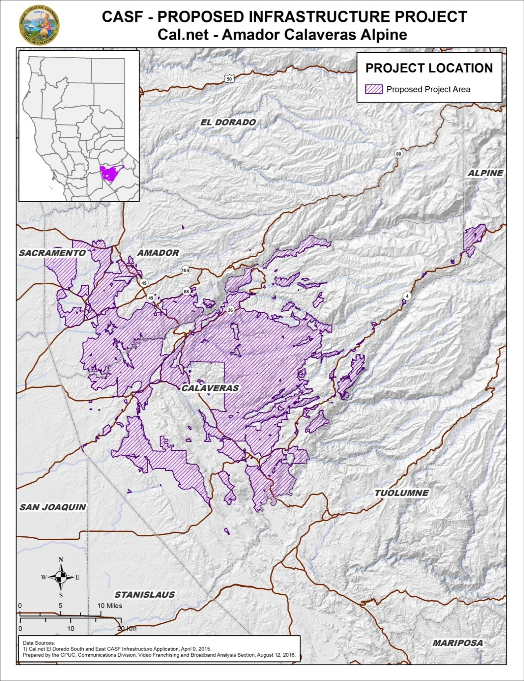

Appendix C
Resolution T-17501 Cal.net’s Amador, Calaveras and Alpine project
Existing Wireline Service Levels
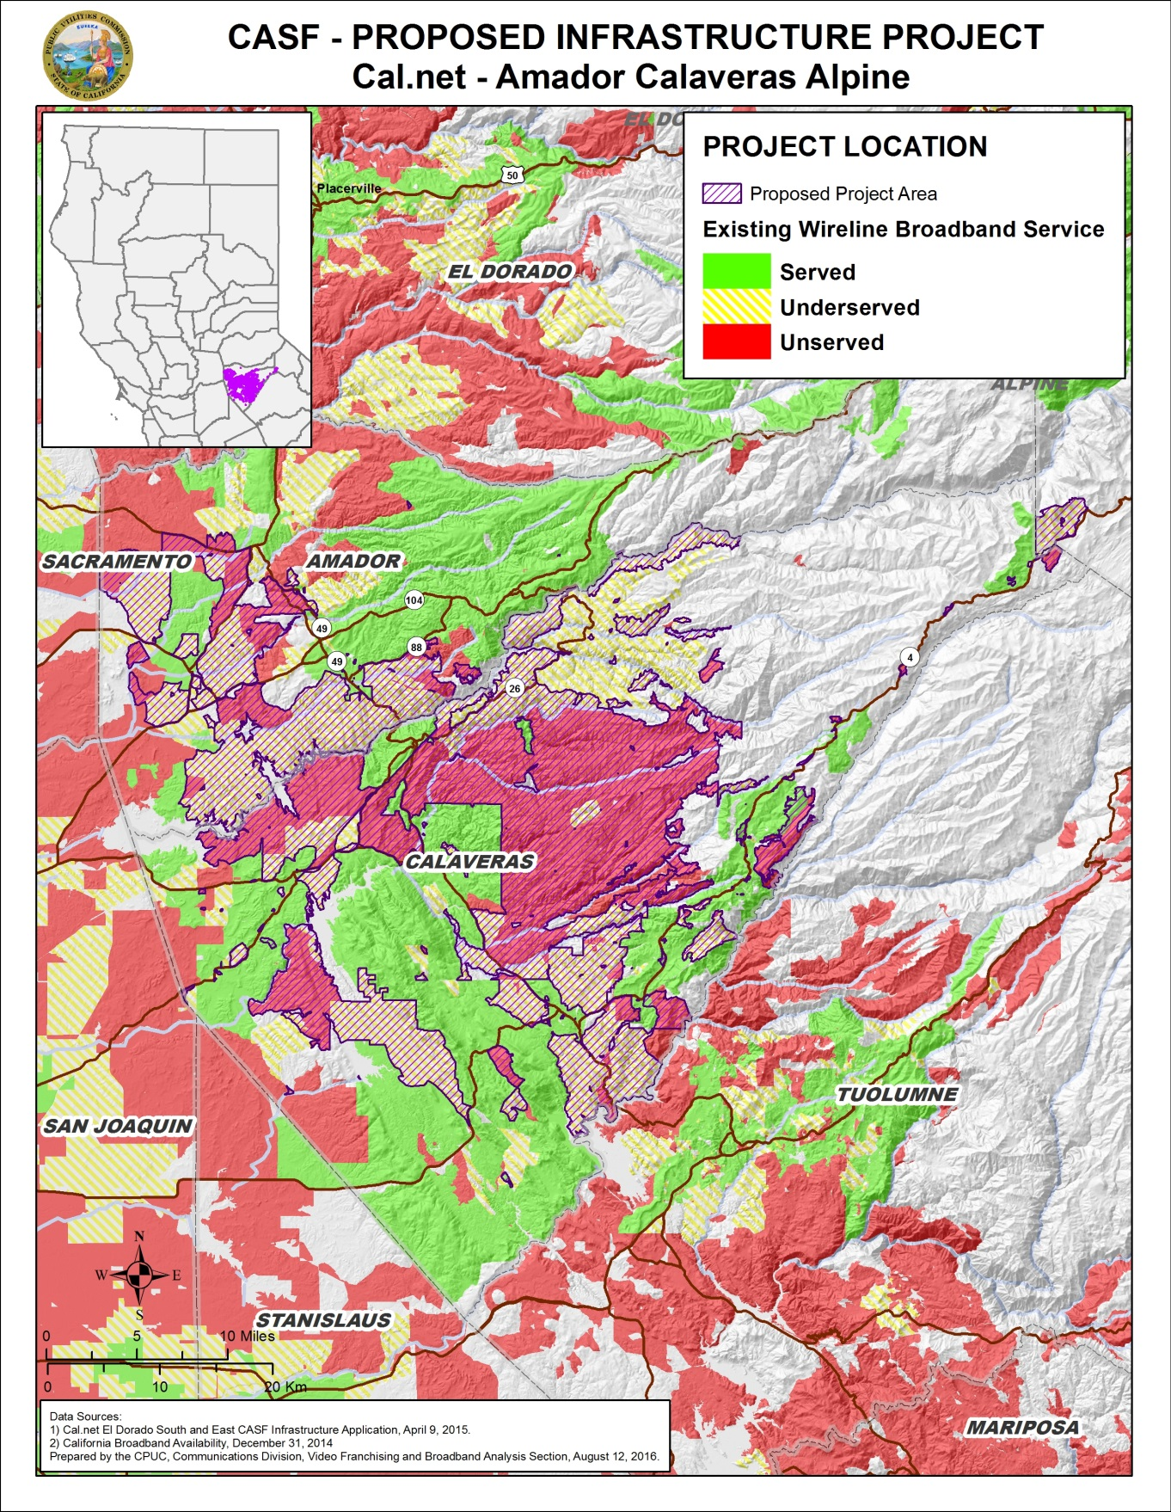
Appendix D
Resolution T-17501 Cal.net’s Amador, Calaveras and Alpine project
Existing Fixed Wireless Service Levels
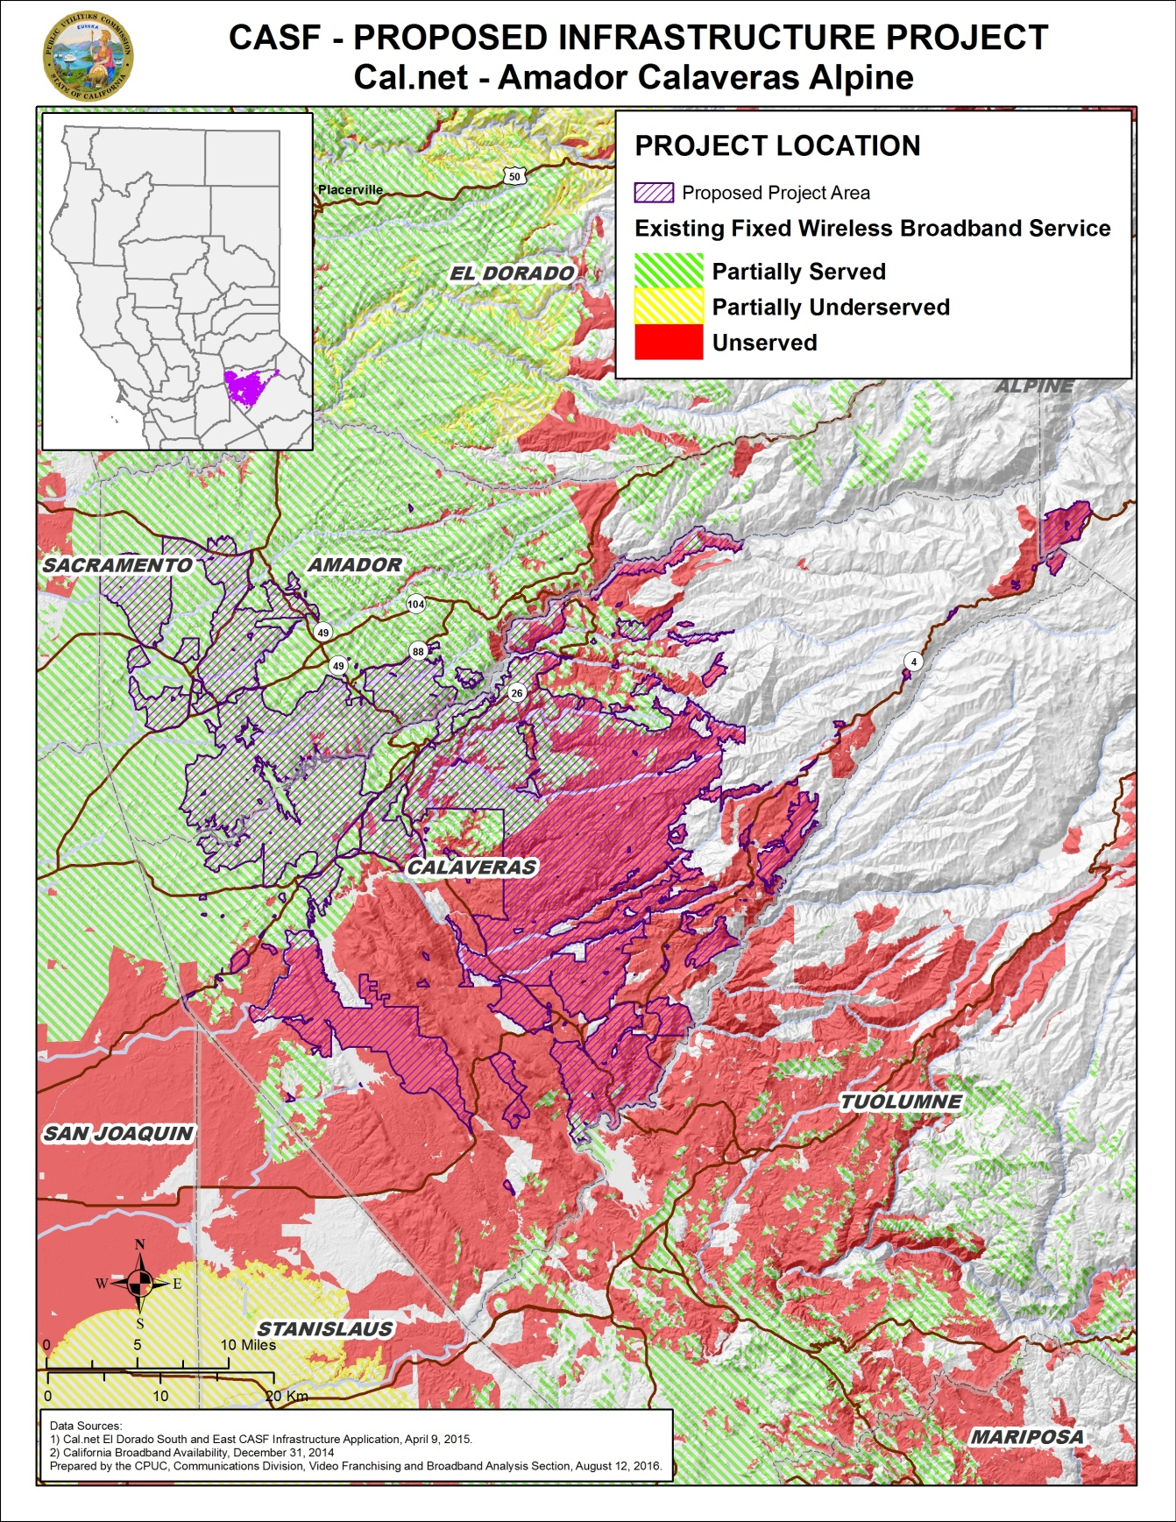
Appendix E
Resolution T-17501 Cal.net’s Amador, Calaveras and Alpine project
Existing Mobile Wireless Services Levels
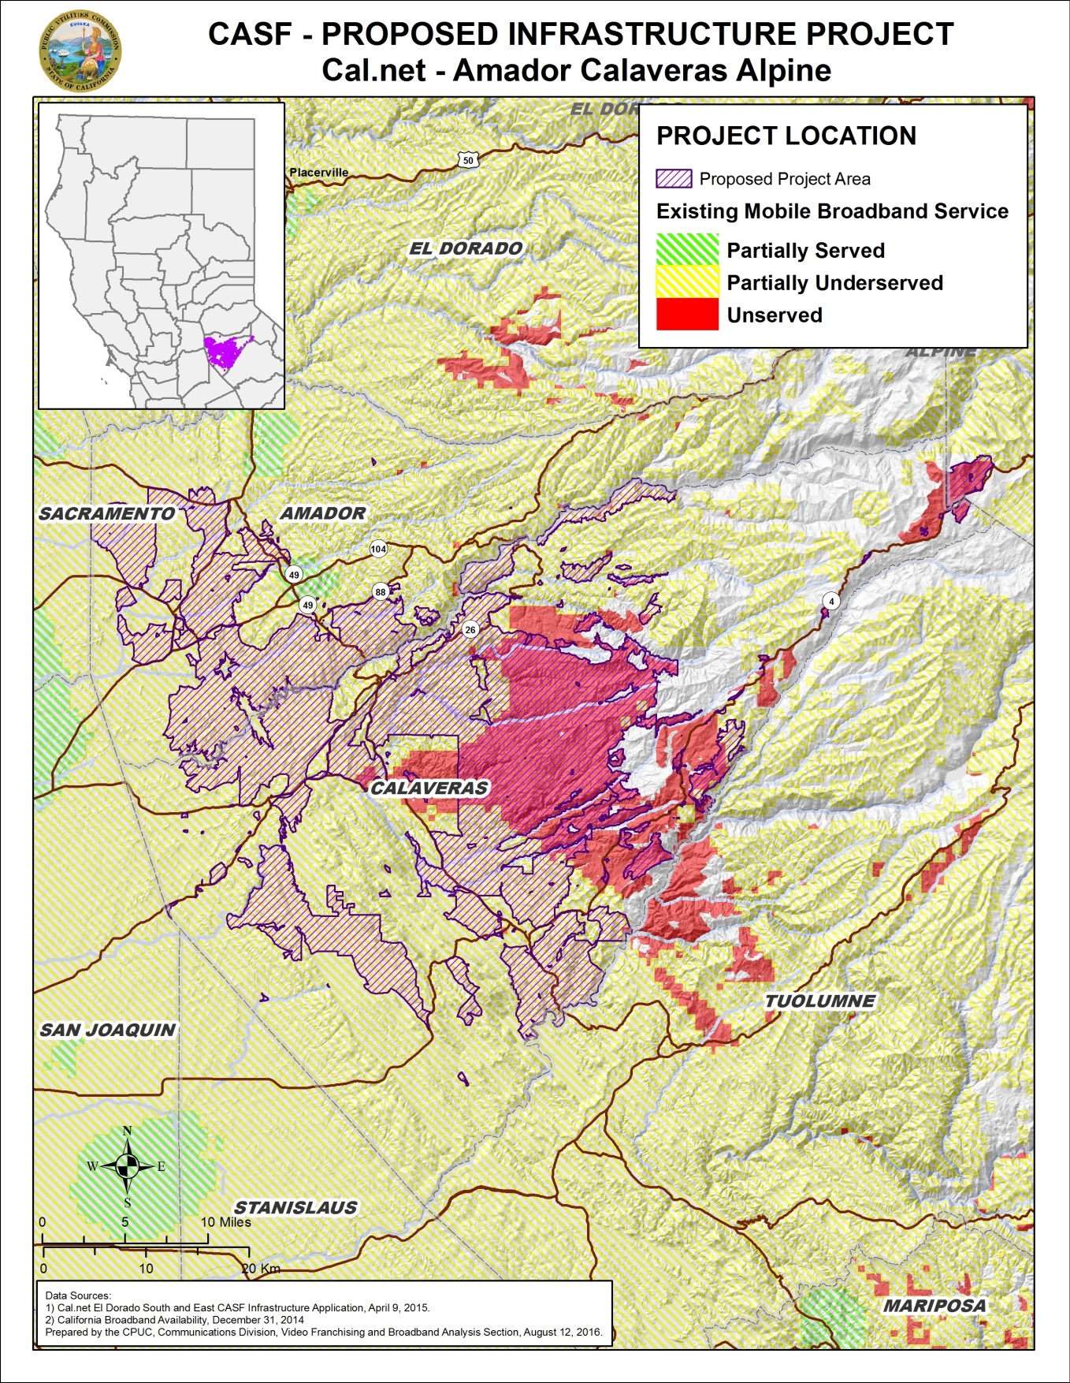

Priority areas are communities where adequate broadband services are lacking.
Cal.net is a non-telephone corporation. Cal.net does not possess either a Certificate of Public Necessity and Convenience (“CPCN”) or a Wireless Identification Registration (“WIR”). It has registered with the Commission and was issued a “U-Number.”
Call from Sonya Harris of Conifer to William Goedecke on April 27, 2015. Conifer informed CD staff that it was unaware of the Cal.net application until April 27, 2015, and stated its intent to challenge the application.
The latest version of the California Interactive Broadband Availability Map uses wireline data as of December 31, 2014.
Cal.net’s CASF application, Failed Surveys.xlsx.
Cal.net’s CASF application, Req14, AMCA- Assertion of Unserved or Underserved, file – “CSCBC Survey Responses for CalNet.xlsx”.
Calaveras Telephone Company, Volcano Telephone Company, Sierra Telephone Company, Inc. and their Affiliated ISP challenge letter, dated, April 24, 2015.
Conifer letter dated April 27, 2015
Cal.net stated, “…because we will be upgrading the service to these customers over the next few months, we will exclude them from our originally proposed subscriber count for the affected areas.”
Total number of CBGs was reduced to 48 with 478 CBs.
Cal.net originally requested funding for 6,468 households. Staff’s analysis revealed that the number of eligible households in the project area is 4,888 households; however, Cal.net in its latest revision has 4,878 households. CD used Cal.net’s revised 4,878 household’s number for its analysis.
Email from Ken Garnett of Cal.net dated July 31, 2015, regarding “Waiver of VoIP setup fees.”
The Commission has the authority to enforce the terms and conditions of the grant award and to impose penalties under P.U. Code §§ 2111 and 2108. (D.14-02-018, p. 36).
Email from Ken Garnett of Cal.net dated November 20, 2015, with Subject line “El Dorado North—Pricing Commitment Clarification.”
P.U. Code §§ 270 and 281.
Approval of the California Advanced Services Fund (CASF) Application Requirements and Scoring Criteria for Awarding CASF Funds (2008) Cal. P.U.C. Res. No. T-17143 at 4.

