PUBLIC UTILITIES COMMISSION OF THE STATE OF CALIFORNIA

Communications Division | RESOLUTION T-17541
Broadband, Video and Market Branch | December 01, 2016

R E S O L U T I O N

Resolution T-17541: Approval of Funding for the Grant Application of Race Telecommunications, Inc. (U-7060C), from the California Advanced Services Fund (CASF) in the Amount of $3,124,490 for the Gigafy North 395 Underserved project.

- Summary

This Resolution approves funding in the amount of $3,124,490 from the California Advanced Service Fund (CASF) for the grant application of Race Telecommunications, Inc. (Race) for the deployment of a last-mile fiber network in the underserved communities of Bridgeport and Walker, California (Gigafy North 395 project). The project area is in northern Mono County and covers the communities of Walker and Bridgeport. The proposed project will interconnect with the existing CASF Digital 395 middle-mile fiber network and will be capable of delivering internet upload and download speeds of up to 1Gbps to 444 households at an average cost of $7,037 per household.

This project will provide the two communities with improved access to e-health services, as well as online educational and economic opportunities. It will also provide public safety benefits by enabling the local communications facilities that provide voice services to meet FCC standards for E911 service and battery backup.

- Applicant Request

In January 2015, Race submitted a grant application requesting $4,234,830 in CASF funding, which included $667,155 in Contribution in Aid of Construction (CIAC). In its application, Race claimed the proposed project will bring broadband service through the deployment of a fiber-to-the-premise (FTTP) last-mile network, with maximum upload/download speeds of 1Gbps to 569 households in an underserved area covering the communities of Coleville, Walker, and Bridgeport in northern Mono County. On May 29, 2015, Race submitted a revised application that removed the served households and businesses to be covered by Frontier’s upgraded service in Coleville. Race’s revised application requests $3,124,490 in funding, and asserts that the project will cover 444 households in Walker and Bridgeport.

Topography: Bridgeport and Walker are two small communities in northern Mono County on the eastern side of the Sierra Nevada Mountains, less than 20 miles from the California and Nevada border. Bridgeport is at an elevation of 6,463 feet and has a population of 575. Walker is at an elevation of 5,400 feet, with a population of just over 700. The areas were first settled in the 1860s, becoming the center of the region’s mining and logging industries. Bridgeport is currently a tourist destination, and functions as a base for a variety of winter and summer outdoor recreational activities. The proposed project area is split into two portions, with one covering Bridgeport and the other Walker, which is 35 miles north of Bridgeport along U.S. Highway 395.

Applicant: Race has a Certificate of Public Convenience and Necessity (CPCN) (U-7060C) and has been a Competitive Local Exchange Carrier (CLEC) offering fiber-based internet, Voice over Internet Protocol (VoIP) telephone, video services, as well as traditional cable/satellite television for the past 12 years. Race has been involved with the CASF program on several prior projects, including five CASF-funded projects that are currently under construction.

Project: Race claims the project area is “underserved” and requests 60% in CASF funding. Race proposes to construct their FTTP last-mile fiber optic network using a 100-Gigabit backbone infrastructure. The network would enable internet upload and download speeds of up to 1Gbps and be available to all 444 households in the project area. According to Race, the proposed network will interconnect with the existing CASF Digital 395 fiber backbone network, with construction consisting of above ground and aerial installation along existing rights-of-way, which are already in use. Race will also install the fiber cables on existing easements and utility poles.

Race will also provide VoIP digital voice telephone service to the project area.

- Notice and Challenges

On January 5, 2015, Communications Division (CD) posted the proposed project area map, census block groups (CBGs), and zip codes for this project on the Commission’s CASF webpage under “CASF Application Project Summaries,” and sent notice regarding the project to its electronic service list.

In November 2014, Frontier invoked its “right of first refusal” as an existing provider in Coleville, and committed to upgrade its wireline service there before May 1, 2015. Race revised its application and removed Coleville from the proposed project area. CD has received no other challenges to the proposed project.

- Project Review

- Project Area Eligibility
For the area to be project eligible, the CASF program requires an applicant to submit proof that the area is unserved or underserved by submitting shapefiles of the proposed project. CD reviews the submitted shapefiles and compares them with the California Interactive Broadband Availability map. Once CD determines an area is eligible either as an unserved or underserved area, CD evaluates all other information submitted by the applicant to determine if the project meets the requirements outlined in D.12-02-015.

Race included a letter in their application stating they do not have any facilities within five miles of the proposed project area, and thus do not possess any existing geographic information systems (GIS) formatted infrastructure shapefiles. However, Race submitted a GIS shapefile and maps of the proposed project area as evidence that the area is underserved. Staff reviewed the shapefile and maps, and determined the following regarding the availability of wireline, fixed-wireless, and mobile broadband within the project area:

Wireline and Fixed Wireless: The California Interactive Broadband Availability map data from December 2014 shows that the proposed project areas in Bridgeport and Walker are unserved by wireline and fixed wireless broadband.

Mobile: The December 2014 California Interactive Broadband Availability map shows that mobile broadband is available from Verizon at underserved speeds in Walker, and at served speeds in Bridgeport. In August 2016, Staff conducted a site visit of the project area in order to determine the current availability of mobile broadband in Bridgeport. Using the CalSpeed mobile application, Staff conducted 32 speed tests spread throughout Bridgeport. The speed test results indicate that Bridgeport has mobile broadband available at underserved speeds, averaging 4.3 Mbps download and 2.3 Mbps upload at two standard deviations below the mean throughput. Based on CD’s site visit and the results of mobile speed tests, CD therefore concludes that Bridgeport is also underserved by mobile broadband.

- Project Criteria Evaluation

CD evaluated the application with respect to the criteria defined in D.12-02-015, Appendix 1, Section VIII (Scoring Criteria). The criteria include: (i) Funds Requested per Potential Customer, (ii) Speed, (iii) Financial Viability, (iv) Pricing, (v) Total Number of Households in the Proposed Area, (vi) Timeliness of Completion of Project, (vii) Guaranteed Pricing Period, and (viii) Low-Income Areas.

Funds per household: The CASF per-household subsidy is $7,037 based on the 444 households that would have access and total grant funds of $3,124,490. Race’s per household subsidy is the fourth highest among the currently proposed last-mile projects, as well as 51% higher than the average subsidy of $4,658 for all previously awarded last-mile CASF projects.

Speed: The four tiers of proposed speed (1Gbps download and 1Gbps upload, 250 Mbps download and 250 Mbps upload, 100 Mbps download and 100 Mbps upload, and 25 Mbps download and 25 Mbps upload) exceed the 6 Mbps/1.5 Mbps benchmark set by the Commission. The maximum proposed speed offering (1Gbps download and 1Gbps upload) is 52% faster than the average speed proposed by the current last-mile projects, as well as 36% faster than the average proposed speeds from previously awarded CASF last-mile projects.

Financial Viability: CD determined that Race is a financially viable company. CD’s review of the submitted balance sheet, income, cash flow statements and other financial viability variables confirmed that Race has the existing capital resources for the matching funds, as well as a sound financial framework for future operations.

Race’s 40 percent project investment is $2,082,994. The Gigafy North 395 project is expected to become profitable beginning in year 3 when construction is completed and service to customers begins. Race estimates that the customer take-rate would be at least at 68 percent within the five years after the CASF grant. Race derives its take rate based on forecasting a combination of their estimated market penetration and consumer interest in the project.

Pricing: Race has committed to a broadband pricing plan under the terms shown below for two years, starting from the beginning date of service. Customers will not be required to sign long-term service contracts or pay any setup fees. The application also states that customers will have the option of either purchasing a wireless router independently or electing to pay a $10.00 per month fee if they choose to obtain a wireless router from Race.

Race’s Gigafy North 395 Project ~ Pricing Plan
Name of Tier | Advertised Speeds |  | Price Plan  ($ per Month)
 | Downstream (Mbps) | Upstream (Mbps)
Residential
Entry Level Speed | 25 | 25 | $25.00
Mid-Level Speed | 100 | 100 | $65.00
Max Level Speed | 1000 | 1000 | $100.00
Other Optional Tier | 250 | 250 | $85.00
Business or Institutions
Entry Level Speed | 25 | 25 | $60.00
Max Level Speed | 1000 | 1000 | $200.00
Options
Setup Fees | 0 | 0 | $0.00
Wireless Router | 0 | 0 | $10.00

The average price per megabit for this project is lower than the average prices for the other pending last-mile projects and lower than the average price for previously approved last-mile projects.

Households in Project Area: Based on the current census block data and parcel data from Mono County for the communities of Walker and Bridgeport, the proposed project area comprises 444 households and is covered by two Census Block Groups (CBGs).

Timeliness of Completion: Race has submitted detailed planning documents, including a schedule with clear milestones, indicating that the project will be completed within a 20 month timeframe, which is less than the maximum allowed of 24 months.

Guaranteed Pricing Period: Race has committed to a pricing plan of two years from the initial service deployment, in accordance with the program’s requirement. This is comparable to previously approved last-mile projects.

Income: The median household incomes of the two CBGs are as follows: 1) 60510001022 - $35,694 and 2) 60510001023 - $59,063. Both are below the California 2010-2014 average median income of $61,489.

- Safety and Community Impact

Race claims that the project will improve broadband connectivity for the residents and businesses in Bridgeport and Walker, thereby providing them with better access to the local educational, as well as public health and safety anchor institutions in the project area.

CD received letters from both in and outside the two communities that expressed overwhelming support for Gigafy North 395 project. Robert Peters, owner of the Bridgeport Inn, wrote that Bridgeport is a depressed community in need of economic development, and that obtaining high-speed internet access is the first and most important step in that process. Mono County Supervisor Timothy Fesko expressed similar support in his letter when he stated that, “Over the past 7-8 years, the need for high-speed internet has increased dramatically at our local hospitality businesses. Many of them have been unable to compete with other rural areas just to the north and south of Bridgeport and Walker.” He further said that Race’s project will substantially improve the economies and provide more jobs in the two communities, as well as allow them to better compete with other areas.

Mono County supervisors Timothy Festo, Fred Stump, and Tim Alpers said in their letter that a reliable internet connection will help close the educational gap for students in rural communities like Bridgeport and Walker by providing them enhanced access to a wider range of educational opportunities. Their letter further illustrates the public safety concerns and the need for this project, stating:

“…during a recent wildfire event, Verizon Wireless service was lost for nearly three days. Communication collapsed because of a reliance upon cellular systems that were not hardened for catastrophe. The networks that were reliant upon Digital 395, however, remained up and provided valuable communications services to our residents and disaster relief workers. Having redundant and independent methods of delivering broadband service to our communities is vital in situations like these.”

Overall, the letters supporting the proposed project share the opinion that by increasing broadband access for homeowners and businesses, as well as providing them with more reliable access to the local anchor institutions, the Gigafy North 395 project will further social, educational, and economic development, and enhance public safety in the communities of Bridgeport and Walker.

- Staff Recommendation for Funding

CD has determined that Race’s grant application for the Gigafy North Project qualifies for funding as an underserved area. Based on staff’s evaluation of the project, the December 2014 California Interactive Broadband Availability map data, public feedback, and the results of the CalSpeed mobile speed tests that were conducted during CD’s August 2016 site visit of the project area, CD finds that the Gigafy North 395 project meets the requirements of D.12-012-015, provides safety and economic benefits, and aligns with the goals of the CASF program.

- Compliance Requirements

Race is required to comply with all the guidelines, requirements, and conditions associated with the grant of CASF funds as specified in D.12-02-015, D.14-02-018, and Resolution T-17443. Such compliance includes, but is not limited to:

- California Environmental Quality Act (CEQA)

All CASF grants are subject to California Environmental Quality Act (CEQA) requirements unless the project is statutorily or categorically exempt pursuant to the CEQA Guidelines.

Race has provided the Commission with construction plans for the Gigafy North 395 project. Race intends to interconnect with the Digital 395 middle-mile network, which will provide the backbone connection and then allow Race to deliver the last-mile service to the households in Walker and Bridgeport.

Race proposes to conduct all work in already disturbed land during the project’s construction in order to avoid any adverse effects on cultural resources. The network design is focused around utilizing existing rights of way, above ground and aerial construction, dark fiber leasing where available, and utilizing easements to lessen the environmental impact of the construction. The Gigafy North 395 project is a last-mile project intended to bring fiber to homes in already disturbed areas using a proven aerial design. This aerial design is based on using existing utility poles in existing roadways and will comply with the pole loading requirements of General Order 95. Race has stated that it will utilize the firm K&B Engineering to determine whether pole loading requirements pass or fail. All fiber will be placed in the appropriate space on the existing utility pole in compliance with the pole owner specifications.

Based on the above information, the project qualifies for the following categorical exemptions from CEQA: CEQA Guidelines Section 15301 – Existing Facilities, involving minor alterations to existing utility facilities, and CEQA Guidelines Section 15304 – Minor Alterations to Land, involving minor trenching and backfilling where the surface is restored.

- Deployment Schedule

The Commission expects Race to complete the project within 20 months from start date (as determined by the procedure below). If the project will not be completed within this 20 month timeframe, Race must notify the Director of CD as soon as it becomes aware of this possibility. If such notice is not provided, the Commission may reduce payment for failure to satisfy this requirement by timely notifying CD’s Director.

- Execution and Performance

CD and Race shall determine a project start date after Race has obtained all approvals. Should Race or any contractor it retains fail to commence work by the designated date, the Commission may terminate the grant upon five days written notice to Race. In the event that Race fails to complete the project in accordance with the terms of the Commission’s approval, as set forth in this resolution, Race must reimburse some or all of the CASF funds that it has received.

Race must complete all construction covered by the grant on or before the grant’s termination date.

- Performance Bond

The Commission does not require a Performance Bond if the applicant certifies that the percentage of the total project costs it is providing comes from their capital budget and is not obtained from outside financing. In its application, Race certified that the percentage of the total project costs it is providing will come from its existing capital budget. Therefore, a performance bond is not required for this project.

- Price Commitment Period

The minimum required price commitment period for broadband service to all households within the project area is two years. Race guarantees the price of service offered in the project area for two years.

- Project Audit

The Commission has the right to conduct any necessary audit, verification, and discovery during project implementation/construction to ensure that CASF funds are spent in accordance with Commission approval. Race’s invoices will be subject to a financial audit by the Commission at any time within three years of completion of the work.

- Providing Voice Service

Race has certified that its VoIP digital telephone service meets the Federal Communications Commission (FCC) standards for E-911 service and battery backup.

- Submission of Form 477
The FCC currently requires broadband providers to biannually submit the Form 477, which includes speed data. While there is an imperfect match between the data that is reported in the Form 477 and to the CASF, the Form 477 data will be useful in documenting CASF deployment for the new service area of the carrier. Pursuant to General Order 66-C, service providers in California must submit a copy of their Form 477 data directly to the CPUC, concurrent with their submission of the same data to the FCC. CASF recipients must continue to submit their Form 477 data to the FCC for a five-year period after completion of the project.
- Reporting

Race must submit quarterly progress reports on the status of the project irrespective of whether Race requests reimbursement or payment.

Quarterly progress reports are due on January 1, April 1, July 1, and October 1. Before full payment of the project, Race must submit a project completion report. Progress reports shall use the schedule for deployment, major construction milestones and costs submitted in the proposal; indicate the actual date of completion of each task/milestone as well as problems and issues encountered, and the actions taken to resolve these problems and issues during project implementation and construction; and identify future risks to the project.

Race shall also include test results on the download and upload speeds on a CBG and zip code basis in the final completion report.

Race must certify that each progress report is true and correct under penalty of perjury.

- Payments to CASF Recipients

Submission of invoices from and payments to Race shall be made at 25 percent completion intervals, in accordance with Section XI of Appendix 1 of D.12-02-015 and according to the guidelines and supporting documentation required in D.12-02-015. Payment will be based upon receipt and approval of invoices/other supporting documents showing the expenditures incurred for the project in accordance with the CASF funding request submitted in Race’s application.

Payment to Race shall follow the process adopted for funds created under P. U. Code § 270. The Commission generally processes payments within 20-25 business days, including CD and Administrative Services review time. The State Controller’s Office (SCO) requires an additional 14- 21 days to issue payment from the day that requests are received by SCO from Administrative Services.

Race must submit a project completion report before full payment.

Race shall provide service to all residential properties within the project area. If Race does not provide service to each household within the project area that requests service at the prescribed rates during the commitment period, the Commission reserves the right to reduce payment accordingly.

- Comments on Draft Resolution

In compliance with Public Utilities Code § 311(g), a notice letter will be emailed to inform all parties on the CASF Distribution List of the availability of the draft of this resolution for public comments at the Commission's website at http://www.cpuc.ca.gov/PUC/documents/. This letter also informed parties that the final conformed Resolution adopted by the Commission will be posted and available at this same website. CD did not receive any comments or reply comments on this resolution.

- Findings

- Race filed an application for CASF funding for its Gigafy North 395 Project in May 2015 to construct a FTTP last-mile network that will be capable of delivering maximum internet upload and download speeds of 1 Gbps to 444 households in the communities of Bridgeport and Walker, California in Mono County. The CBGs impacted by the project are 60510001022 and 60510001023.

- Key information about the project is in Appendix A of this Resolution.

- CD posted the proposed project area map, CBGs and zip codes for the Gigafy North 395 project on the Commission’s CASF webpage under “CASF Application Project Summaries” in January, 2015. Frontier invoked its “right of first refusal,” as an existing provider of wireline service in Coleville, and committed to upgrade its wireline service there before May 1, 2015. Race subsequently revised its application and removed Coleville from the proposed project area. CD received no additional challenges to this project.

- CD reviewed and analyzed data submitted from the Race grant application to determine its eligibility for CASF funding. This data included, but was not limited to: proof of a CPCN from the Commission; descriptions of current and proposed broadband infrastructure; number of potential subscriber households and average incomes; project construction schedule; project budget; proposed pricing and commitment period for new subscribers; and financial viability of the applicant.

- CD reviewed the California Interactive Broadband Availability Map data from December 31, 2014, feedback received from the public, the results of mobile speed tests from CD Staff’s site visit, and determined the project area as having underserved status.

- Based on its review, CD determined that the project qualifies for funding under D.12-02-015 and recommends Commission approval of CASF funding for Race’s Gigafy North 395 Project, in the amount of $3,124,490.

- Race is required to comply with all guidelines, requirements, and conditions associated with the granting of CASF funds as specified in D.12-02-015, as well as with the terms set forth in this resolution, and must submit the FCC Form 477, as specified in T-17143.

- The Commission has determined that the project is categorically exempt from CEQA review, under CEQA guidelines section 15301 regarding exemption for existing facilities and section 15304 regarding minor modifications to existing structures.

- The Commission finds CD’s recommendation to fund Race’s project, as summarized in Appendix A, to be reasonable and consistent with Commission orders and, therefore, adopts such recommendation.

- A notice letter was e-mailed on October 24, 2016, informing all applicants filing for CASF funding, parties on the CASF distribution list of the availability of the draft of this Resolution for public comments at the Commission’s website http://www.cpuc.ca.gov/PUC/documents/. This letter also informed parties that the final confirmed Resolution adopted by the Commission will be posted and available at this same website. CD did not receive any comments or reply comments on this resolution.

THEREFORE, IT IS ORDERED that:
  - The Commission shall award $3,124,490 to Race for the Gigafy North 395 project, as described herein and summarized in Appendix A of this Resolution.
  - The program fund payment of $3,124,490 for this project in an underserved area shall be paid out of the CASF Infrastructure Grant Account in accordance with the guidelines adopted in D.12-02-015.
  - Payments to the CASF recipient shall be in accordance with Section XI of Appendix 1 of D.12-02-015 and in accordance with the process defined in the “Payments to CASF Recipients” section of this Resolution.
  - Race shall comply with all guidelines, requirements and conditions associated with the CASF funds award as specified in D.12-02-015, as well as with the terms of the Commission’s approval as set forth in this resolution, and must submit the FCC Form 477 to the Commission, as specified in Resolution T-17143.
  - Race must complete all construction covered by the grant on or before the grant’s termination date. If the project will not be completed within the company’s 20 month timeframe, Race must notify the Director of CD as soon as it becomes aware of this possibility. If such notice is not provided, the Commission may reduce payment for failure to satisfy this requirement by timely notifying CD’s Director.
  - If Race fails to complete the project in accordance with the terms outlined in D.12-02-015 and with the terms of the Commission’s approval, as set forth in this resolution, Race must reimburse some or all the CASF funds it has received.

This Resolution is effective today.

I hereby certify that this Resolution was adopted by the Public Utilities Commission at its regular meeting on December 01, 2016. The following Commissioners approved it:

/s/ Timothy J. Sullivan___

TIMOTHY J. SULLIVAN

Executive Director

MICHAEL PICKER
President
MICHEL PETER FLORIO
CATHERINE J.K. SANDOVAL
CARLA J. PETERMAN
LIANE M. RANDOLPH
Commissioners

APPENDIX
APPENDIX A – Race’s Gigafy North 395 Project
Key Information
Project Name | Gigafy North 395 Project
Project Plan | To deploy a fiber-to-the-premises (FTTP) Last-Mile network in the communities of Walker and Bridgeport, located along U.S Highway 395 in Mono County. The FTTP last-mile network will interconnect with the Digital 395 middle-mile fiber network, with all construction consisting of an entirely above ground and aerial installation along existing rights-of-way which are already in use.
Project Area Size | 2.8 square miles
Download / Upload speed | Up to 1Gbps
Location | Mono County / U.S. Highway 395
Community Names | Walker and Bridgeport
CBG’s / Household Income | 60510001022 | $35,694
 | 60510001023 | $59,063
ZIP Codes | 93517 and 96107
Estimated Potential  Subscriber Size | 444 households
Applicant expectations | 302 households
Deployment Schedule (from  Commission approval date) | 20 months
Pricing Plan | Residential  Entry Level Speed 25 Mbps Down/Up $25.00  Mid-Level Speed 100 Mbps Down/Up $65.00  Max Level Speed 1000 Mbps Down/Up $100.00  Other Optional Tier 250 Mbps Down/Up $85.00  Business  Entry Level Speed 25 Mbps Down/Up $60.00  Max Level Speed 1000 Mbps Down/Up $200.00
Proposed Project Budget (Total) | $5,207,484
Amount of CASF Funds  Requested (60%) | $3,124,490
Applicant funded (40%) | $2,082,994

Appendix B – Race’s Gigafy North 395 Project
Project Location
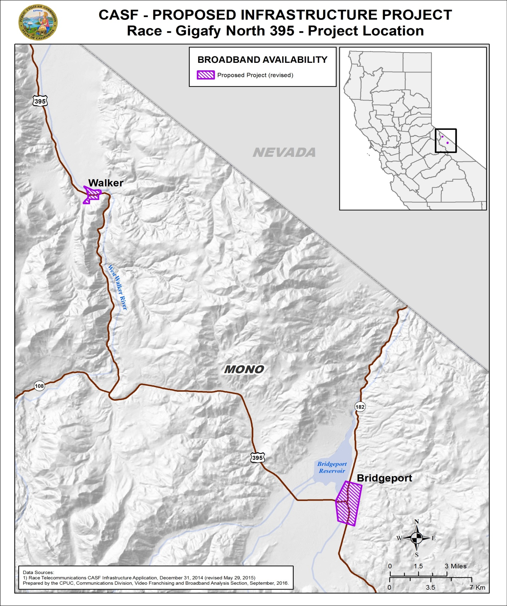

Appendix C - Wireline Broadband Availability
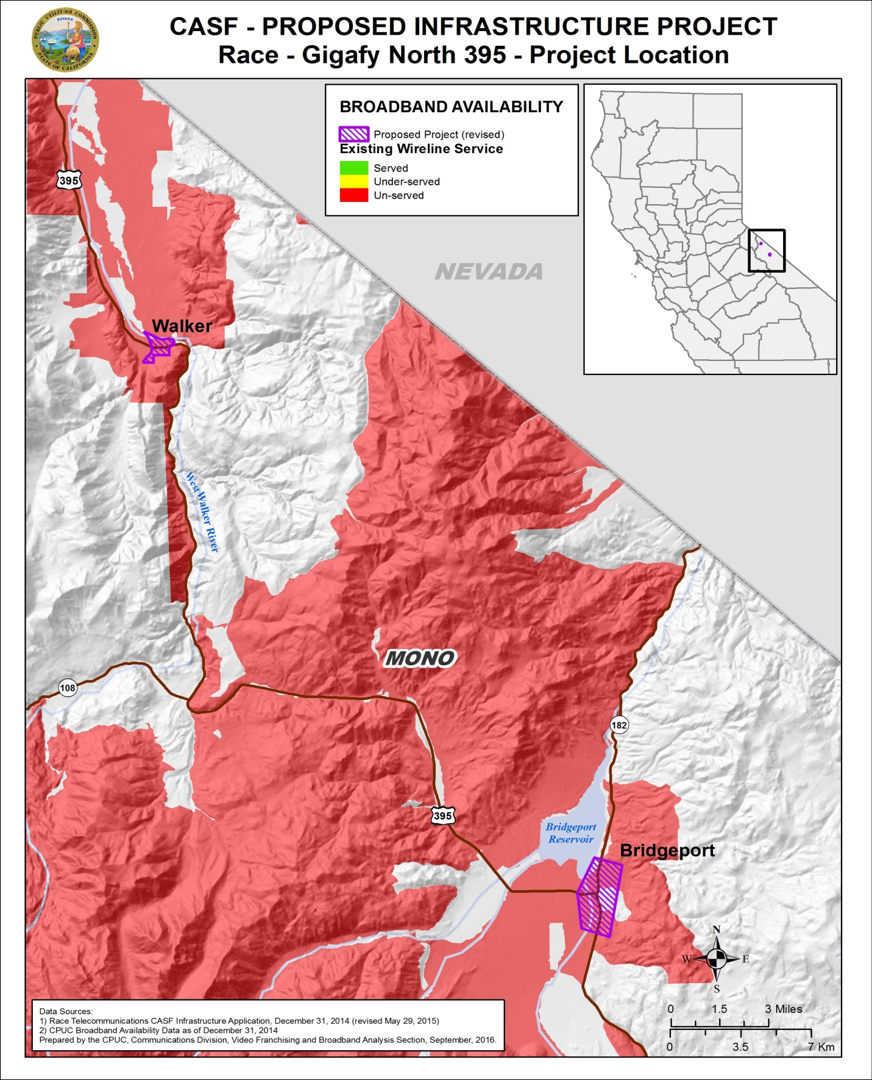

Appendix D - Fixed Wireless Broadband Availability
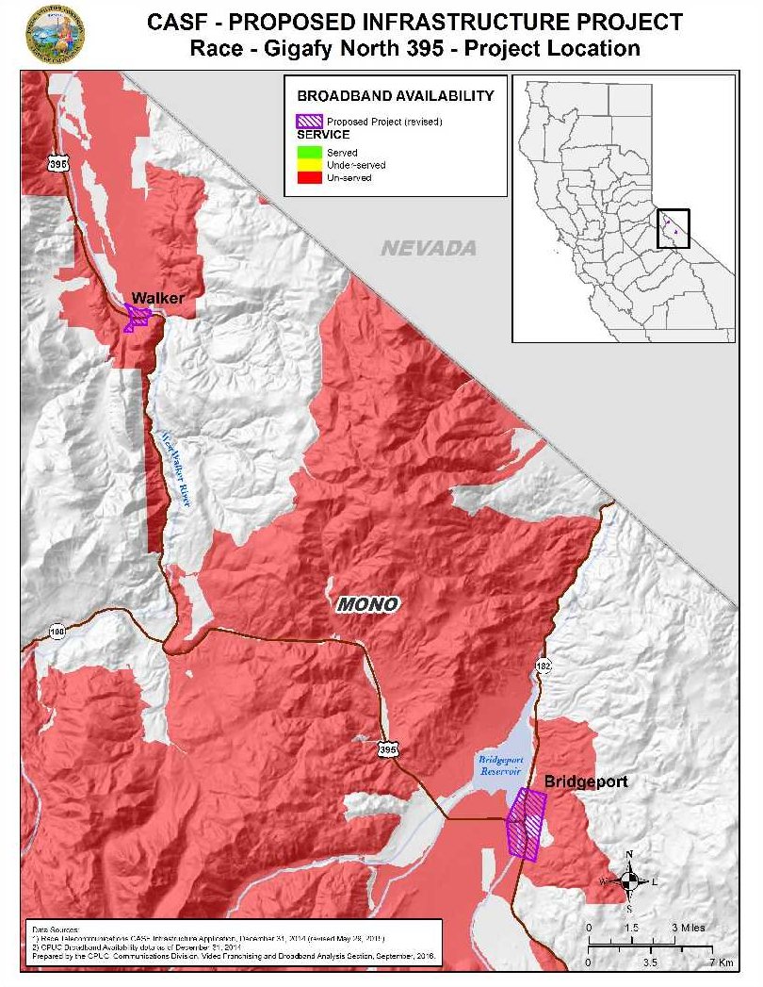

Appendix E - Mobile Wireless Broadband Availability
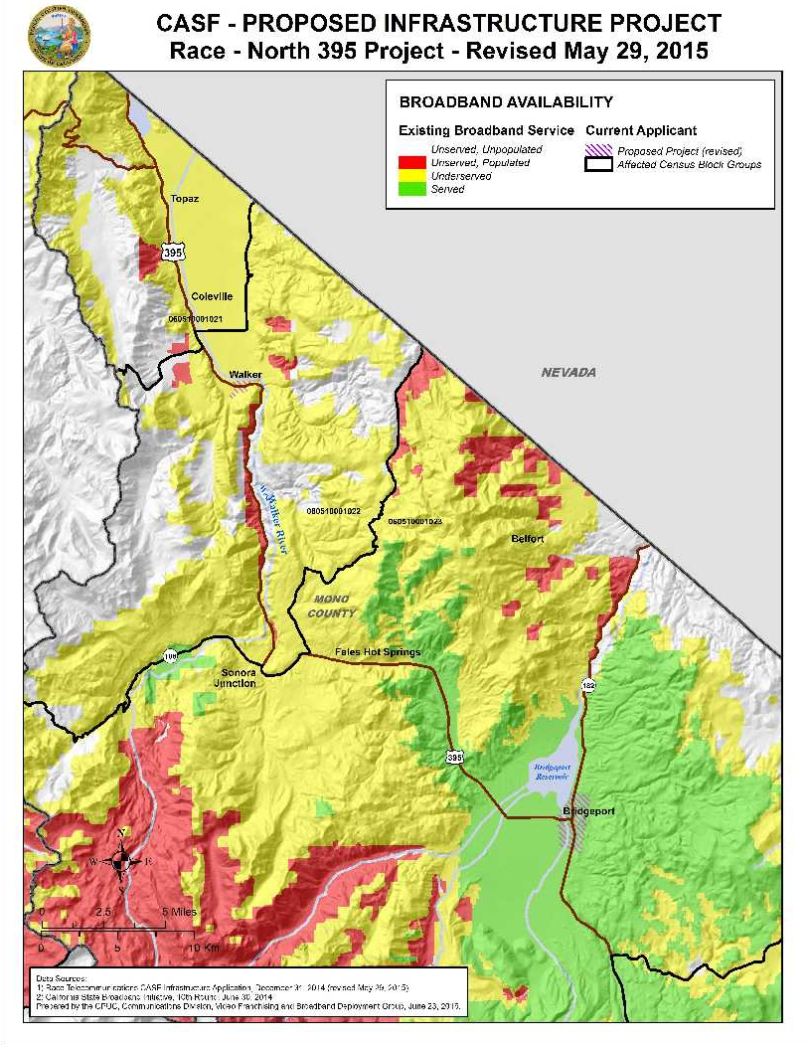
Appendix F – CalSpeed Mobile Wireless Field Test Results within Project Area August 2016
DATE | OPERATOR | UP MEAN  (Mbps) | UP STD DEV  (Mbps) | UP MEAN-1  (Mbps) | UP MEAN-2  (Mbps) | DOWN MEAN  (Mbps) | DOWN STD DEV  (Mbps) | DOWN MEAN-1  (Mbps) | DOWN MEAN-2  (Mbps)
3/5/2015 | Verizon Wireless | 4,063 | 1,441 | 2,623 | 1,182 | 19,375 | 5,453 | 13,922 | 8,469
3/5/2015 | Verizon Wireless | 6,108 | 1,074 | 5,033 | 3,959 | 21,876 | 3,299 | 18,577 | 15,278
3/5/2015 | Verizon Wireless | 10,787 | 3,146 | 7,642 | 4,496 | 22,936 | 6,693 | 16,243 | 9,549
8/8/2016 | Verizon Wireless | 608 | 331 | 277 | 0 | 879 | 386 | 493 | 107
8/8/2016 | Verizon Wireless | 1,566 | 570 | 997 | 427 | 9,608 | 3,667 | 5,941 | 2,274
8/8/2016 | Verizon Wireless | 172 | 338 | -166 | 0 | 431 | 351 | 80 | 0
8/8/2016 | Verizon Wireless | 0 | 0 | 0 | 0 | 0 | 0 | 0 | 0
8/8/2016 | Verizon Wireless | 544 | 475 | 69 | 0 | 1,613 | 719 | 893 | 174
8/8/2016 | Verizon Wireless | 388 | 489 | -101 | 0 | 1,412 | 561 | 851 | 290
8/8/2016 | Verizon Wireless | 3,493 | 1,027 | 2,466 | 1,438 | 8,908 | 2,999 | 5,909 | 2,911
8/8/2016 | Verizon Wireless | 0 | 0 | 0 | 0 | 0 | 0 | 0 | 0
8/8/2016 | Verizon Wireless | 6,154 | 1,688 | 4,466 | 2,778 | 12,330 | 5,719 | 6,611 | 892
8/8/2016 | Verizon Wireless | 4,404 | 1,514 | 2,890 | 1,376 | 4,537 | 3,152 | 1,385 | 0
8/8/2016 | Verizon Wireless | 6,095 | 1,434 | 4,661 | 3,227 | 7,745 | 5,756 | 1,988 | 0
8/8/2016 | Verizon Wireless | 4,470 | 2,412 | 2,057 | 0 | 9,173 | 4,364 | 4,808 | 444
8/8/2016 | Verizon Wireless | 4,928 | 903 | 4,025 | 3,122 | 14,344 | 2,517 | 11,828 | 9,311
8/8/2016 | Verizon Wireless | 8,726 | 2,003 | 6,723 | 4,719 | 16,298 | 4,311 | 11,987 | 7,676
8/8/2016 | Verizon Wireless | 6,861 | 1,524 | 5,337 | 3,813 | 5,682 | 1,894 | 3,788 | 1,894
8/8/2016 | Verizon Wireless | 8,205 | 3,964 | 4,241 | 277 | 14,988 | 3,973 | 11,015 | 7,041
8/8/2016 | Verizon Wireless | 10,368 | 3,065 | 7,303 | 4,238 | 18,167 | 4,918 | 13,248 | 8,330
8/8/2016 | Verizon Wireless | 9,712 | 3,142 | 6,570 | 3,428 | 11,338 | 4,540 | 6,798 | 2,258
8/8/2016 | Verizon Wireless | 10,217 | 2,562 | 7,655 | 5,093 | 17,563 | 3,413 | 14,150 | 10,737
8/8/2016 | Verizon Wireless | 2,677 | 858 | 1,819 | 960 | 6,885 | 5,250 | 1,635 | 0
8/9/2016 | Verizon Wireless | 9,703 | 2,610 | 7,093 | 4,483 | 16,947 | 3,751 | 13,196 | 9,444
8/9/2016 | Verizon Wireless | 10,600 | 3,361 | 7,240 | 3,879 | 14,542 | 4,366 | 10,176 | 5,809
8/9/2016 | Verizon Wireless | 8,143 | 1,673 | 6,470 | 4,797 | 17,155 | 3,384 | 13,771 | 10,387
8/9/2016 | Verizon Wireless | 9,680 | 2,503 | 7,177 | 4,674 | 15,636 | 3,304 | 12,332 | 9,027
8/9/2016 | Verizon Wireless | 9,863 | 2,675 | 7,188 | 4,513 | 12,884 | 5,372 | 7,512 | 2,140
8/9/2016 | Verizon Wireless | 3,060 | 540 | 2,520 | 1,980 | 10,373 | 1,841 | 8,532 | 6,691
8/9/2016 | Verizon Wireless | 0 | 0 | 0 | 0 | 0 | 0 | 0 | 0
8/9/2016 | Verizon Wireless | 9,890 | 2,497 | 7,392 | 4,895 | 11,687 | 3,177 | 8,510 | 5,333
8/9/2016 | Verizon Wireless | 485 | 530 | -45 | 0 | 5,748 | 2,216 | 3,532 | 1,316
AVERAGE SPEED OF MOBILE FIELD TESTS |  | 5,374 | 1,573 | 3,801 | 2,305 | 10,346 | 3,167 | 7,178 | 4,306

Resolution T-17232, dated December 3, 2009, approved the Broadband Cooperative of California’s Digital 395 Project.
The CIAC represents potential funding in the event that the CASF grant award is subject to federal and/or state income taxes.
Other packages offer upload/download speeds of 250 Mbps, 100 Mbps, and 25 Mbps.
The revised application originally requested $3,708,770 in funding, which included $584,280 in CIAC. However, because the CASF funding will not be taxed, Race decided to withdraw their CIAC request in September 2016, resulting in $3,124,490.
See Appendix B for a map of the proposed project area.
Race’s CASF funded projects which are currently under construction include: Gigafy Occidental (Approved August 2016), Gigafy Mono (Approved January 2016), Five Mining Communities (Approved January 2016), Gigafy Backus Unserved Broadband (Approved August 2015), and Mono County Underserved Broadband (Approved June 2014). Information about these and other CASF projects is available at: http://www.cpuc.ca.gov/General.aspx?id=1057
See Frontier’s Right of First Refusal submission, dated October 31, 2014: ftp://ftp.cpuc.ca.gov/Telco/CASF/Grant_Loan/GrantLoanRightOfFirstRefusal/FrontierCASFUpgradeLetter103114.pdf
CD used wireline data from December 2014.
See Appendices C and D for the availability maps of wireline & fixed wireless broadband.
See Appendix E for the 2014 availability map for mobile broadband.
See Appendix F for the table of results from the 32 CalSpeed mobile tests that were conducted in August 2016.
See Resolution T-17477, p. 8, which states, “On November 12, 2015, following CPUC comments to the FCC proposing a reliability standard for mobile availability, staff published new maps using criteria that required service to pass the “98%” availability test (i.e. a consumer would receive service at least that fast 98% of the time). Based on this 98% reliability standard, now only 15% of California households are “served” by mobile. This criterion was established by CD using the methodology of two standard deviations below the mean to reflect whether an area is designated served.” (See also. “Comments of the California Public Utilities Commission” FCC GN Docket No. 15-191. September 15, 2015.)
U.S Census Bureau QuickFacts – California Median Household Income (in 2014 dollars), 2010-2014.
Anchor institutions in the project area include the Toiyabe Indian Health Project in Walker, Eastern Sierra Unified School District, Bridgeport Elementary School, the Bridgeport Fire Protection District, the Bridgeport Post Office, the Bridgeport Family Medicine Clinic, as well as the Mono County District Attorney and Sheriff’s Office, Mono County Library – Bridgeport Branch, Mono County Office of Education, and the Mono County Departments of Social Services and Public Works.
Letter of Support from Robert C. Peters, dated January 11, 2015.
Letter of Support from Mono County Supervisor Timothy Fesko, dated December 17, 2014.
Letter of Support from Mono County Supervisors Timothy Festo, Fred Stump, and Tim Alpers, dated March 24, 2015.
Ibid.
Pub. Util. Code §§ 274 and 281; see also D.12-02-015, Appendix 1, p. 25.
Approval of the California Advanced Services Fund (CASF) Application Requirements and Scoring Criteria for Awarding CASF Funds (2008) Cal. P.U.C. Res. No. T-17143, p. 4.

