PUBLIC UTILITIES COMMISSION OF THE STATE OF CALIFORNIA

Communications Division | RESOLUTION T-17502
Broadband, Video and Market Branch | December 15, 2016

R E S O L U T I O N

Resolution T-17502: Approval of funding for the grant application of a Digital Voice Service provider, Cal.net, Inc. (U-1340-C), from the California Advanced Services Fund (CASF) in the amount of $3,608,224 to build last-mile fixed wireless infrastructure to deliver broadband services to underserved rural communities in Tuolumne and Mariposa Counties.

Summary

This Resolution approves funding in the amount of $3,608,224 from the California Advanced Service Fund (CASF) for the grant application of Cal.net, Inc. (Cal.net) to provide broadband Internet and Voice over Internet Protocol (VoIP) telephony services to underserved rural communities of the Tuolumne and Mariposa Counties (Tuolumne Mariposa project). This project will provide broadband services to the communities of Bear Valley, Columbia, Coulterville, Groveland, Pine Mountain Lake, Jamestown, Pinecrest, Sonora, Soulsbyville, Tuolumne, Twain Harte, Strawberry, Long Barn, Sierra Village, Cold Springs, Mi-Wuk Village, Cedar Ridge, Tuttletown, Moccasin, Greeley Hill, and Blanchard. The Central Sierra Connect Broadband Consortium (CSCBC) identifies Bear Valley Area, Greeley Hill Area, Cold Springs, Pinecrest, Strawberry area, Don Pedro/Tuolumne City Area, and Pine Mountain Lake (near Groveland) as priority areas.

The Tuolumne Mariposa project will cover 420.31 square miles and will provide broadband speeds of up to 25 megabits per second (Mbps) download and 4 Mbps upload to 7,711 households. The CASF per-household subsidy is $468. Additionally, the proposed project will provide broadband services to 19 anchor institutions and will provide safety benefits to the communities in the area by allowing Cal.net to deliver broadband services to 16 fire stations at discounted prices. The proposed project will also supply public safety agencies in the area with an interconnected public safety data communications network.

Applicant Request

On March 31, 2015, Cal.net submitted an application for CASF funding to build last-mile fixed wireless infrastructure to provide broadband Internet and VoIP telephony services with speeds of up to 25 Mbps download and 4 Mbps upload to underserved rural communities in the Tuolumne and Mariposa Counties. Cal.net originally requested $3,337,004 in CASF funding covering 884 Census Blocks and 7,928 households in the proposed project area. On October 1, 2015, Cal.net modified its submission to $3,469,295 to account for the additional costs for the California Environmental Quality Act (CEQA). On October 20, 2016, Cal.net revised its submission to account for the adjustment that CD required, and adjusted the requested grant amount upward from $3,469,295 to $3,608,224.

Topography: The Tuolumne Mariposa project includes communities of Bear Valley, Columbia, Coulterville, Groveland, Pine Mountain Lake, Jamestown, Pinecrest, Sonora, Soulsbyville, Tuolumne, Twain Harte, Strawberry, Long Barn, Sierra Village, Cold Springs, Mi-Wuk Village, Cedar Ridge, Tuttletown, Moccasin, Greeley Hill, and Blanchard. The proposed project will serve 834 Census Blocks and cover 420.31 square miles in portions of Tuolumne and Mariposa counties. This project encompasses the geographical areas of Bear Valley Area, Greeley Hill Area, Cold Springs, Pinecrest, Strawberry area, Don Pedro/Tuolumne City Area, and Pine Mountain Lake (near Groveland) that have been identified as “High Priority Areas” in T-17443.

Applicant: Cal.net (U-1340-C) is a Wireless Internet Service Provider (WISP) with its base of operations in Shingle Springs, California. Cal.net began its business in 1997, as a facilities-based broadband service provider serving the communities of Davis, Woodland, and western El Dorado County area. Since 2006, Cal.net has been providing fixed wireless rural broadband service. In January 2015, Cal.net began providing residential and business customers facilities-based VoIP telephony service. According to Cal.net, it currently serves customers in western El Dorado and Amador Counties using twenty towers that it has built, four towers it leases from commercial tower companies and repeaters placed on over one hundred rooftop locations. Cal.Net currently uses a variety of different technologies to deliver fixed-wireless broadband services, including license-exempt 5 GHz spectrum, lightly-licensed 3.65 GHz WiMAX, license-exempt 2.4 GHz spectrum, license-exempt 900 MHz spectrum, and TV White Space in the UHF bands.

Project: Cal.net proposes to build last-mile fixed wireless infrastructure to provide broadband Internet and VoIP telephony services with speeds of up to 25 Mbps download and 4 Mbps upload in the underserved rural communities of Tuolumne and Mariposa Counties. The project will comprise of fixed-wireless technology deployed on towers that are either constructed by Cal.net or leased from owners of existing towers.

Cal.net will use a variety of technologies to service broadband to end users, which includes Unlicensed National Information Infrastructure (U-NII) equipment for line-of-sight situations, fixed-LTE (a non-mobile variation of the LTE commonly used in cell phones) for near-line-of-sight situations (minor obstructions), and TV White Space in the UHF and upper-VHF bands for heavily-obstructed non-line-of-sight situations.

According to Cal.net, the VoIP telephony portion of the project will conform to FCC requirements, and will be provisioned via Cal.net’s existing VoIP infrastructure.
For redundancy and additional capacity, Cal.net will also interconnect with the Central Valley Independent Network’s (CVIN) fiber network. Cal.net proposes to utilize local subcontractors as much as possible to construct the tower facilities.

Notice and Challenges

On April 9, 2015, Communications Division (CD) posted the proposed project area map, census block groups (CBGs) and zip codes for this project on the Commission’s CASF webpage under “CASF Application Project Summaries”, and sent notice regarding the project to its electronic service list. On April 24, 2015, CD received a timely challenge from Calaveras Telephone Company, Volcano Telephone Company, Sierra Telephone Company, Inc. and their Affiliated ISPs to Cal.net, Inc.'s “Tuolumne Mariposa " CASF Projects. On April 27, 2015, CD received a late-filed challenge by Conifer Communications Inc., (Conifer). On June 8, 2015, CD received another late-filed challenge by Marv Dealy, Managing Partner of Throckmorten Enterprises, which was subsequently withdrawn on April 24, 2016.

There were no commitments made by an existing provider to upgrade service before the November 1, 2014, “first right of refusal” deadline.

Project Review

Project Area Eligibility

For the area to be project eligible, the CASF program requires an applicant to submit proof that the area is unserved or underserved by submitting shapefiles of the proposed project. CD reviews the submitted shapefiles and compares them with United States 2010 Census data and the California Interactive Broadband Availability map. Once CD determines that the area is eligible either as an unserved or underserved area, CD evaluates all other information submitted by the applicant to determine if the project meets the requirements outlined in D.12-02-015.

CD’s Review of the California Interactive Broadband Availability Map

The California Interactive Broadband Availability Map as of December 31, 2014, shows that there are a number of providers in the project area.

- Wireline: The majority of the project area has no wireline provider. AT&T California provides wireline broadband at underserved speeds to 20% of the project area; Calaveras Telephone Company, Volcano Telephone Company, Sierra Telephone Company, Inc. and their Affiliated ISPs, as well as Comcast provide wireline broadband at served speeds in a number of census blocks that were removed from the project, as well as in a few census blocks where public feedback reports indicate they do not serve all households;

- Fixed Wireless: Conifer provides fixed wireless at served speeds for some project areas (these households have been removed); and

- Mobile Wireless: AT&T Mobility and Verizon Wireless offer mobile wireless broadband at underserved speeds to the majority of the project area as well as at served speeds to a small number of households which have been removed.

Based on the California Interactive Broadband Availability Map as of December 31, 2014, CD removed households served by mobile wireless and wireline providers from the total households count.

CD’s Review of Other Information Submitted by the Applicant

Inquiries from Prospective Customers and Survey: Cal.net provided CD with a list of several hundred inquiries from prospective customers in the project area that neither Cal.net nor any other WISPs in the area could serve. Cal.net also provided survey responses conducted by the Central Sierra Connect Broadband Consortium (CSCBC) which identified addresses at which broadband is unavailable at the Commission-defined served speeds of 6 Mbps download and 1.5 Mbps upload. In total, 753 households reported unserved speeds in their public feedback surveys. CD reviewed this information and determined it reasonable that underserved and unserved households exist in otherwise served census blocks on the map, for example, within census blocks where Comcast serves some households. Further, the surveys followed the broadband availability public feedback survey protocols used to assist CD with correcting served status map errors. CD updated portions of the project area map and added these 753 households to the eligible household count.

Cal.net’s Acquisition of Hstar Technology Group: On June 3, 2016, Cal.net informed CD that on May 1, 2016, Cal.net had acquired the assets of a small local Wireless Internet Service Provider based in Angels Camp, CA, named “Hstar Technology Group.” This acquisition had the effect of adding 15 new customers in the Tuolumne Mariposa project area. CD removed these 15 households as well as census block groups (CBGs) that are now 100% served in the proposed project area.

CD’s Review of Challenges

Calaveras Telephone Company, Volcano Telephone Company, Sierra Telephone Company, Inc. and their Affiliated ISP: In their challenge, Calaveras Telephone Company, Volcano Telephone Company, Sierra Telephone Company, Inc. and their Affiliated ISP claimed that these companies are currently capable of offering wireline broadband services at or above 6.5 Mbps download and 1.5 Mbps upload speeds, and that this challenge is only for the served areas within the project area. CD requested, and in response, on June 6, 2016, Cal.net removed 12 census blocks from the proposed project area.

Conifer: In its challenge, Conifer stated that it currently serves business and consumers in Tuolumne and Mariposa Counties with up to 100 Mbps synchronous download and upload speeds. CD evaluated Conifer’s subscribership data and removed that number of households from the proposed project area. Conifer’s subscribership data is provided to CD under a non-disclosure agreement and is treated as confidential.

Summary of CD’s Analysis

Based on evaluation of challenges and analysis, CD determined that although portions of the project area are served by fixed wireless internet service providers, less than 10% of the households in the area subscribe and have broadband services at Commission-defined served speeds of 6 Mbps download and 1.5 Mbps upload. Because fixed wireless technologies require a line-of-sight connection, not all households in an area will necessarily receive broadband at served speeds, depending on tree coverage around each house. The households that do have broadband services do not congregate in a specific area but are scattered among the project area. Hence, they cannot be isolated from the project area altogether. Since there are only a limited number of households that have broadband services at Commission-defined served speeds, and these households are scattered across the proposed project area, CD determined that the project area is underserved.

Table 1, below, summarizes CD’s adjustments to the project area:

Table 1: Cal.net’s Tuolumne Mariposa Project ~ Household Adjustments
Cal.net’s Original Request | 7,928
Served by Mobile Wireless | -100
Broadband Availability Public Feedback Survey | +753
Cal.net’s Acquisition of Hstar Technology Group | -15
Served by Existing Provider | -855
Total Eligible Households | 7,711

CD has determined that there are 7,711 underserved households in the total proposed project area of the Tuolumne and Mariposa Counties, and that Cal.net is eligible to receive 60% funding level of the total project costs. Key project information and maps are shown in Appendices A through E.

Project Criteria Evaluation

CD evaluated the application with respect to the scoring criteria defined in D.12-02-015, Appendix 1, Section VIII (Scoring Criteria). The scoring criteria includes: (i) Funds Requested per Potential Customer, (ii) Speed, (iii) Financial Viability, (iv) Pricing, (v) Total Number of Households in the Proposed Area, (vi) Timeliness of Completion of Project, (vii) Guaranteed Pricing Period, and (viii) Low-Income Areas. CD also conducted qualitative evaluation of the project area, existing infrastructure, and community needs.

Funds per Household: The CASF per-household subsidy is $468, based on 7,711 households. This subsidy amount per household is comparatively low as compared to similar last-mile projects awarded in the past.

Speed: The proposed speed offering of up to 25 Mbps download and 4 Mbps upload exceeds the 6 Mbps download and 1.5 Mbps upload benchmark set by the Commission.
The proposed speeds are less than what is obtained in a typical fiber to the home project and Cal.net’s proposed speeds rank comparatively lower than the average of all CASF projects previously awarded.

Financial Viability: CD determined that Cal.net is a financially viable company. Cal.net has been experiencing increasing sales over the past four years. For the past four years, Cal.net has experienced positive earnings before income tax. For all four years, Cal.net has experienced positive cash flows and its financial leverage has also improved over the past four years, as measured by the total assets to total liabilities ratio. Moreover, Cal.net has secured a cash loan of $1 million and an equipment-financed loan of $2 million to match the project costs.

Based on Cal.net’s pro forma financial statement, Cal.net would be able to recoup the difference between total project costs of $5,969,067, and $3,608,224 which is from the CASF grant over five years. Cal.net estimates that the customer take-rate would be 47.05% (3,628 households) within two years and 59.60% (4,596 households) in five years after Cal.net completes the CASF project. Cal.net’s estimated take rate is based on 1) a statistical analysis of the data on the number of inquiries they have received on the proposed project areas, and 2) the company’s historical take rates in its service areas. Based on the statistical analyses provided by Cal.net, Cal.net’s historical take rates, and the fact that the proposed project area consists of several priority areas and isolated, underserved communities, CD staff has determined a 47.05% take rate within the first two years is reasonable.

Pricing: Cal.net has committed to a broadband pricing plan under the terms shown below for two years during the construction phase of the proposed project, plus an additional three years thereafter. This means that first area to be deployed will receive nearly five years of price guarantees to the first customer(s) to sign up; later deployment areas will have shorter price-guarantee periods, but no less than three years. Further, Cal.net will apply a 50% discount to qualified low-income subscribers. There are no contracts and service is provided on a month-to-month basis. Cal.net also will provide a 30-day money-back guarantee for any reason and the broadband service plans do not have any data caps.

Table 2: Cal.net’s Tuolumne Mariposa Project ~ Pricing Plan
Account Type | Maximum Speed  (Download / Upload) | Monthly Fee* | Installation  Fee†
Wireless Power | 6.0 Mbps / 2.0 Mbps | $69.95* | Waived
Wireless Express | 10.0 Mbps / 3.0 Mbps | $84.95* | Waived
Wireless Supreme†† | 15.0 Mbps / 3.0 Mbps | $99.95* | Waived
Wireless Extreme†† | 25.0 Mbps / 4.0 Mbps | $159.95* | Waived
* Local, State, or Federal fees are not included in these prices, and may be subsequently added.
† Installation includes connection to the Minimum Point of Entry (MPOE) inclusive of the radio/antenna combination to the household premise. Additional installation charges may apply depending on customer requirements (e.g. if the customer requests customized routing of wire other than direct, normal installation.)
†† Wireless Supreme and Extreme require specific equipment and signal strength, and may not be available in all areas.

Cal.net has also committed to the following prices for its VoIP service for the first two years of the project. For residential customers, a simple plan will cost $19.95 per month and a standard plan will cost $24.95 per month. The standard plan includes additional features, such as call forwarding and call waiting. Qualified low-income subscribers will receive a 25% discount. For business customers, the standard plan is $39.95 per month for a single line. For both residential and business customers, one-time set up fees for number porting, new number provisioning, or 411 directory assistance enabling are waived.

The Customer Retail prices for this project rank higher than the average prices of other last-mile fiber projects.

Households in Project Area: Based on the 2010 census block data, the proposed project area consists of 7,928 households. However, the number of households eligible for CASF funding is 7,711. The number of households for this project is comparable to the average of previously awarded last-mile projects.

Timeliness of Completion: Cal.net has submitted detailed planning documents, including a schedule with clear milestones indicating that the project will be completed within 24 months of construction and deployment. This project scores average compared to timeline for the previously awarded projects.

Low-Income Areas: The proposed project area has median household income of $46,711. According to the State Income Limits established by California Department of Housing and Community Development, a 4-person household with an income of below $60,900 would qualify as low income in Tuolumne and Mariposa Counties. Thirty-three of the 48 census block groups have median household incomes below $60,900, ranging from $17,179 to $60,750.

Safety and Community Input Considerations

The CASF program encourages the deployment of broadband throughout the State, which can enable the public to access Internet-based safety applications, emergency services, and allow first responders to communicate and collaborate with each other during emergencies. As the Governor’s Broadband Task Force stated in its 2007 report, ubiquitous broadband will play a key role in enhancing public safety operations and applications in law enforcement, disaster relief, traffic management, and virtually every other aspect of public safety.

The proposed project will allow Cal.net to provide broadband services to 16 fire stations in the area. Cal.net will offer free entry-level broadband services or discounts to higher level broadband services to these fire stations. The proposed project will also allow Cal.net to leverage its infrastructure to supply public safety officials with a comprehensive wide-ranging interconnected public safety data communications network in the 700-MHz and 4.9-GHz radio bands. Cal.net further proposes to reach out to officials of the California First Responders Network (FirstNet) and to the various local public safety organizations in its coverage areas to begin discussions on how to implement this concept.

Additionally, there are 19 anchor institutions within the project area:
Sierra Waldorf School, Greeley Hill Elementary, Coulterville High, Belleview Elementary, Chinese Camp Elementary, Sonora High, Long Barn High, Cold Springs High, Big Oak Flat-Groveland Adult, Moccasin Community Day, Tenaya Elementary, Columbia College, Groveland Branch, Red Cloud Library, John C. Fremont Healthcare District Northside Clinic, MPA 31, Groveland FS, Baseline CC, and Telegraph Hill COM.

CD received letters of support for the proposed project from local governmental agencies, the Board of Supervisors of Tuolumne and Mariposa Counties, and the Central Sierra Economic Development District. CD also received letters of support from 31 individuals and businesses.

Staff Recommendation for Funding

CD has determined that Cal.net’s grant application for the Tuolumne Mariposa project qualifies for funding as an underserved area. Based on CD’s evaluation of the project, CD finds that the proposed project meets the requirements of D.12-02-015, provides safety benefits and aligns with the CASF’s goal to encourage deployment of high quality advanced information and communications technologies to all Californians to promote economic growth, job creation and social benefits.

Compliance Requirements

Cal.net is required to comply with all the guidelines, requirements, and conditions associated with the grant of CASF funds as specified in D.12-02-015, D.14-02-018, and Resolution T-17443. Such compliance includes, but is not limited to:

California Environmental Quality Act (CEQA)

All CASF grants are subject to California Environmental Quality Act (CEQA) requirements unless the project is statutorily or categorically exempt pursuant to the CEQA Guidelines.

The Tuolumne Mariposa project is subject to the CEQA review, and the Commission must complete CEQA review prior to disbursing CASF funds for construction activities.

Prior to any construction activity, Cal.net is required to seek further authority from the Commission for such activity by filing a Proponent’s Environmental Assessment (PEA) pursuant to Commission Rule of Practice and Procedure 2.4; and must undergo an environmental review pursuant to the CEQA. (California Public Resources Code § 21000 et seq.) Cal.net should contact the Supervisor of the Commission’s Energy Division CEQA Unit well in advance of a contemplated filing to (a) consult with staff regarding the process of developing and filing a PEA; (b) provide for cost recovery per Rule of Practice and Procedure 2.5; and (c) enter into a Memorandum of Understanding to allow the Energy Division to initiate the retention of an environmental contractor to perform the environmental review.

Cal.net may file a completed CEQA review conducted by another agency acting as the Lead Agency pursuant to CEQA; Cal.net should make every effort to ensure that the Commission’s CEQA Unit is aware of and included in the CEQA process if it is conducted by another agency acting as the CEQA Lead Agency. Cal.net should contact the Supervisor of the Commission’s Energy Division CEQA Unit well in advance of a contemplated filing to consult with staff regarding the applicability of another agency’s CEQA review.

Cal.net must provide the PEA prior to the first 25% payment. Should the Energy Division recommend that a full CEQA analysis is required, Cal.net may either pay for the analysis itself or seek a supplemental CASF grant to cover 60 percent of the cost.

Deployment Schedule

The Commission expects Cal.net to complete the project within 24 months from start date (as determined by the procedure below). If Cal.net is unable to complete the proposed project within the 24-month timeframe requirement, it must notify the Director of CD as soon as Cal.net becomes aware of this possibility. If such notice is not provided, the Commission may reduce payment for failure to satisfy this requirement by timely notifying CD’s Director.

Execution and Performance

CD and Cal.net shall determine a project start date after Cal.net has obtained all approvals. Should Cal.net or any Contractor it retains fail to commence work by designated date, upon five days written notice to Cal.net, the Commission may terminate the grant. In the event that Cal.net fails to complete the project in accordance with the terms of CPUC approval as set forth in this resolution, Cal.net must reimburse some or all of the CASF funds that it has received. Cal.net must complete all construction covered by this grant on or before the grant’s termination date.

Performance Bond

Because the matching funds for this project do not come from an existing capital budget, Cal.net must send an executed bond, equal to the total amount payable under the CASF award, to the Commission’s Executive Director and to the Communications Division Director within five business days after submission of the PEA. The performance bond must be callable for failure to complete the CASF-funded broadband project.

Should Cal.net complete the project and front-end all project costs before requesting reimbursement, the performance bond requirement will be waived.

Price Commitment Period

The minimum required price commitment period for broadband service to all households within the project area is two years. Cal.net guarantees the price of broadband services offered in the project area for three years and the price of VoIP services offered in the project area for two years.

Project Audit

The Commission has the right to conduct any necessary audit, verification, and discovery during project implementation/construction to ensure that CASF funds are spent in accordance with Commission approval.

The applicant’s invoices will be subject to a financial audit by the Commission at any time within three years of completion of the work.

Providing Voice Service

Cal.net has certified that its voice over internet protocol (VoIP) service meets the Federal Communications Commission (FCC) standards for E-911 service and battery backup.

Submission of Form 477

The FCC currently requires broadband providers to biannually submit the Form 477, which includes speed data. While there is an imperfect match between the data that is reported in the Form 477 and to the CASF, the Form 477 data will be useful in documenting CASF deployment for the new service area of the carrier. Pursuant to General Order 66-C, service providers in California must submit a copy of their Form 477 data directly to the CPUC, concurrent with their submission of the same data to the FCC. CASF recipients must continue to submit their Form 477 data to the FCC for a five-year period after completion of the project.

Reporting

All grantees must submit quarterly progress reports on the status of the project irrespective of whether grantees request reimbursement or payment. Quarterly progress reports are due on January 1, April 1, July 1, and October 1. Before full payment of the project, Cal.net must submit a project completion report. Progress reports shall use the schedule for deployment, major construction milestones and costs submitted in the proposal; indicate the actual date of completion of each task/milestone as well as problems and issues encountered, and the actions taken to resolve these problems and issues during project implementation and construction; and identify future risks to the project.

Cal.net shall also include test results on the download and upload speeds on a CBG and zip code basis in the final completion report. Cal.net must certify that each progress report is true and correct under penalty of perjury.

Payments to CASF Recipients

Submission of invoices from and payments to Cal.net shall be made at 25 percent completion intervals, in accordance with Section XI of Appendix 1 of D.12-02-015 and according to the guidelines and supporting documentation required in D.12-02-015.

Payment to Cal.net shall follow the process adopted for funds created under P. U. Code § 270. The Commission generally processes payments within 20-25 business days, including CD and Administrative Services review time. The State Controller’s Office (SCO) requires an additional 14-21 days to issue payment from the day that requests are received by SCO from Administrative Services.

Cal.net shall provide service to all residential properties within the project area. If Cal.net does not provide service to each household within the project area that requests service at the prescribed rates during the commitment period, the Commission reserves the right to reduce payment accordingly.

Comments on Draft Resolution

In compliance with P.U. Code § 311(g), a notice letter was e-mailed on November 15, 2016, informing all parties on the CASF Distribution List of the availability of the draft of this resolution for public comments at the Commission's website at http://www.cpuc.ca.gov/PUC/documents/. This letter also informed parties that the final conformed Resolution adopted by the Commission will be posted and available at this same website. CD received no comments.

Findings

- On March 31, 2015, Cal.net, Inc., a DVS provider, submitted a CASF grant application to build last-mile fixed wireless infrastructure to provide broadband Internet and VoIP telephony services to underserved rural communities of Tuolumne and Mariposa Counties. The CBGs impacted by the project are shown in Appendix A.
- CD posted the proposed project area map, CBG and zip code for Cal.net’s Tuolumne Mariposa project on the Commission’s CASF webpage under “CASF Application Project Summaries” on April 9, 2015.
- On April 24, 2015, CD received Partial Challenge of Calaveras Telephone Company, Volcano Telephone Company, Sierra Telephone Company, Inc. and Their Affiliated ISPs to Cal.net, Inc.'s “Tuolumne Mariposa" CASF Projects.
- On April 27, 2015, Conifer sent CD a late-filed challenge to Cal.net’s Tuolumne Mariposa CASF project proposal. Conifer’s challenge stated that it serves some areas within Cal.net’s CASF project proposal in Tuolumne and Mariposa Counties.
- On June 8, 2015, CD received a late-filed challenge by Marv Dealy, Managing Partner of Throckmorten Enterprises, which was subsequently withdrawn on April 24, 2016.
- CD reviewed and analyzed data submitted from the Cal.net grant application to determine the project’s eligibility for CASF funding. This data includes but is not limited to proof that the applicant has a CPCN from the Commission; description of current and proposed broadband infrastructure; number of potential subscriber households and average income; project construction schedule; project budget; proposed pricing and commitment period for new subscribers; and financial viability of the applicant.
- Cal.net provided survey responses conducted by the CSCBC which identified addresses at which broadband is unavailable.
- CD removed 301 newly-served households which are served since Cal.net filed its application.
- Cal.net acquired a small WISP in Calaveras County called “Hstar Technology Group” and as a result 15 customers of this WISP and the associated Census blocks were removed from the households within the project area.
- CD removed 100 households that are served by Mobile carriers.
- CD removed households that subscribe to Conifer service.
- Cal.net provided CD with a list of several hundred inquiries from prospective customers in the area that stated neither they nor any other WISPs in the area are served. After reviewing the public and consortia feedback in Cal.net’s materials, CD concluded that the 753 requested households are eligible and they were added to the total number of households eligible.
- Based on evaluation of challenges and CD’s analysis, CD determined that 7,711 households in the proposed project area are eligible. Since there are only a limited number of households that have broadband services at Commission-defined served speeds, and these households are scattered across the proposed project area, CD determined that the project area is underserved.
- Based on its review, CD determined that the proposed project area is underserved and qualifies for funding under D.12-02-015, and recommends Commission approval of CASF funding for Cal.net’s Tuolumne Mariposa project.
- The Commission finds CD’s recommendation to fund Cal.net’s Tuolumne Mariposa project, as summarized in Appendix A, to be reasonable and consistent with Commission orders and, therefore, adopts such recommendation.
- The Tuolumne Mariposa project is subject to CEQA review. Prior to any construction activity, Cal.net is required to file a PEA and must undergo an environmental review pursuant to the CEQA. Cal.net must provide the PEA prior to the first 25% payment.
- As a Digital Voice Service provider, Cal.net must obtain a performance bond during the construction phase of the Tuolumne Mariposa project, per D.14-02-018. Cal.net must send an executed bond, equal to the total amount payable under the CASF award, to the Executive Director and to the Director of Communications Division within five business days after the completion of the CEQA review.
- Cal.net is required to comply with all guidelines, requirements, and conditions associated with the granting of CASF funds as specified in D.12-02-015, D.14-02-018, and Resolution T-17443. Cal.net must submit the FCC Form 477, as specified in Resolution T-17143.
- A notice letter was e-mailed on November 15, 2016, informing all applicants filing for CASF funding, parties on the CASF distribution list of the availability of the draft of this Resolution for public comments at the Commission’s website http://www.cpuc.ca.gov/documents/. This letter also informed parties that the final confirmed Resolution adopted by the Commission will be posted and available at this same website. CD received no comments.

THEREFORE, IT IS ORDERED that:

  - The Commission shall award $3,608,224 to Cal.net for the Tuolumne Mariposa project as described herein and as summarized in Appendix A of this Resolution.
  - The program fund payment of $3,608,224 for this project in underserved areas shall be paid out of the CASF Infrastructure Grant Account in accordance with the guidelines adopted in D.12-02-015, including compliance with CEQA.
  - Cal.net shall submit a full Proponent’s Environmental Assessment (PEA) to the Energy Division prior to the first 25% payment of CASF grant funds. No CASF funds may be disbursed for construction activities prior to the completion of the CEQA review.
  - Cal.net shall send an executed bond, equal to the total amount payable under the CASF award, to the Commission’s Executive Director and to the Director of Communications Division within five business days after the completion of the CEQA review.
  - Cal.net shall provide service to all customers within the project area, as defined in Appendix B and GIS files submitted to the Communications Division as part of the application process.
  - Payments to Cal.net shall be in accordance with Section XI of Appendix 1 of D.12-02-015 and in accordance with the process defined in the “Payments to CASF Recipients” section of this Resolution. If Cal.net does not provide service to each customer within the project area that requests service at the prescribed rates during the commitment period, the Commission reserves the right to reduce payment accordingly.
  - Cal.net shall comply with all guidelines, requirements and conditions associated with the CASF funds award as specified in D.12-02-015 and this Resolution and must submit the FCC Form 477 to the Commission, as specified in Resolution T-17143.
  - Cal.net must complete all construction covered by the grant on or before the grant’s termination date. If Cal.net is unable to complete the proposed project within the 24-month time frame requirement, it must notify the Director of CD as soon as Cal.net becomes aware of this possibility. If such notice is not provided, the Commission may reduce payment for failure to satisfy this requirement by timely notifying CD’s Director.
  - In the event that Cal.net fails to complete the project in accordance with the terms outlined in D.12-02-015 and with the terms of the CPUC approval as set forth in this Resolution, Cal.net must reimburse some or all of the CASF funds that it has received.

This Resolution is effective today.
I hereby certify that this Resolution was adopted by the Public Utilities Commission at its regular meeting on December 15, 2016. The following Commissioners approved it:

/s/ Timothy J. Sullivan

TIMOTHY J. SULLIVAN

Executive Director

MICHAEL PICKER
President
MICHEL PETER FLORIO
CATHERINE J.K. SANDOVAL
CARLA J. PETERMAN
LIANE M. RANDOLPH
Commissioners

APPENDIX

APPENDIX A
Resolution T-17502
Cal.net, Tuolumne Mariposa Project
CASF Applicant Key Information
Project Name | Cal.net, Tuolumne Mariposa Project
Project Plan | Cal.net proposes to build last-mile fixed-wireless infrastructure to provide broadband Internet and VoIP telephony services to underserved rural communities of the Tuolumne and Mariposa Counties. The project will use fixed-wireless technology deployed on either leased towers or towers that are constructed by Cal.net. Cal.net will use a variety of different technologies to service broadband to end users, which includes Unlicensed National Information Infrastructure (U-NII) equipment for line-of-sight situations, fixed-LTE (a non-mobile variation of the LTE commonly used in cell phones) for near-line-of-sight situations (minor obstructions), and TV White Space in the UHF and upper-VHF bands for heavily-obstructed non-line-of-sight situations.
Project Size (in square miles) | 420.31
Download/Upload speed | Maximum 25 Mbps / 4 Mbps
Location | Portions of Tuolumne Mariposa Counties
Community Names | Bear Valley, Columbia, Coulterville, Groveland, Pine Mountain Lake, Jamestown, Pinecrest, Sonora, Soulsbyville, Tuolumne, Twain Harte, Strawberry, Long Barn, Sierra Village, Cold Springs, Mi-Wuk Village, Cedar Ridge, Tuttletown, Moccasin, Greeley Hill, and Blanchard
Census Block Groups | 060430001014, 060430002001, 060430002002, 060430002003, 061090011001, 061090011002, 061090011003, 061090012001, 061090012002, 061090012003, 061090012004, 061090021001, 061090021002, 061090021003, 061090021004, 061090021005, 061090021006, 061090022001, 061090022002, 061090022003, 061090022004, 061090022005, 061090022006, 061090031001, 061090031002, 061090031003, 061090031004, 061090031005, 061090032001, 061090032002, 061090032004, 061090032005, 061090032006, 061090041001, 061090041002, 061090041003, 061090041004, 061090042001, 061090042002, 061090042003, 061090051001, 061090051002, 061090051003, 061090051004, 061090051005, 061090051006, 061090052011, 061090052012
Median Household Income (by Census Block Group) | $46,711
Zip Codes | 95306, 95310, 95311, 95321, 95327, 95329, 95338, 95335, 95345, 95346, 95364, 95370, 95372, 95375, 95379, 95383
Applicant expectations | 3,628 households (in 2 years after construction is completed); 4,596 households (in 5 years after construction is completed)
Pricing Plan (Monthly) | $69.95 for 6.0 Mbps/2.0 Mbps; $84.95 for 10.0 Mbps/3.0 Mbps;  $99.95 for 15 Mbps/3.0 Mbps; $159.95 for 25.0 Mbps/4.0 Mbps;  No installation fees
Deployment Schedule  (from Commission approval date) | 24 months
Proposed Project Budget (Total) | $5,969,067
Amount of CASF funds requested (60%) | $3,608,224
Applicant funded (40%) | $2,360,843

Appendix B
Resolution T-17502 Cal.net’s, Tuolumne Mariposa Project
Project Location Map
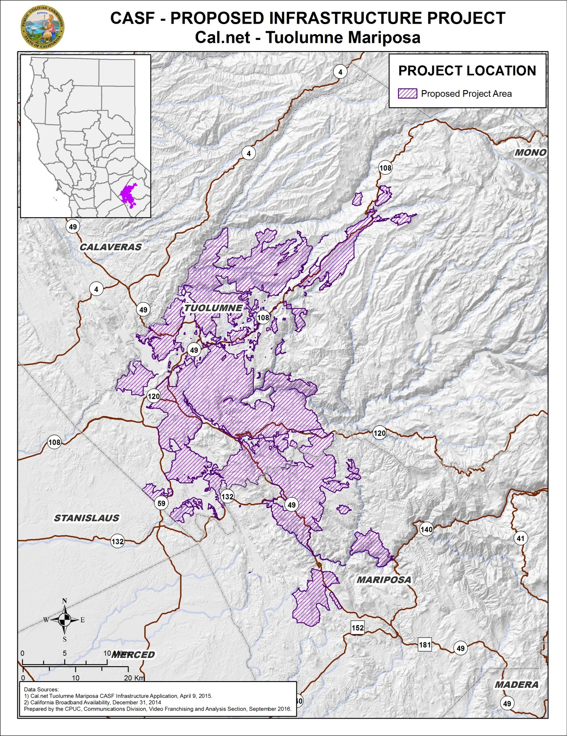

Appendix C
Resolution T-17502 Cal.net, Tuolumne Mariposa Project
Existing Wireline Service Levels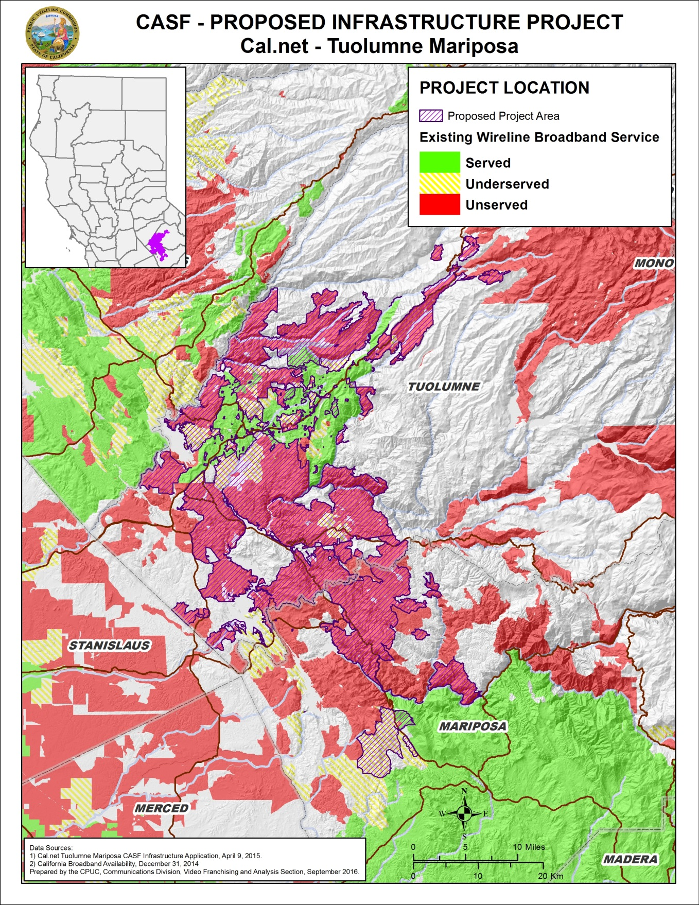

Appendix D
Resolution T-17502 Cal.net, Tuolumne Mariposa Project
Existing Fixed Wireless Service Levels
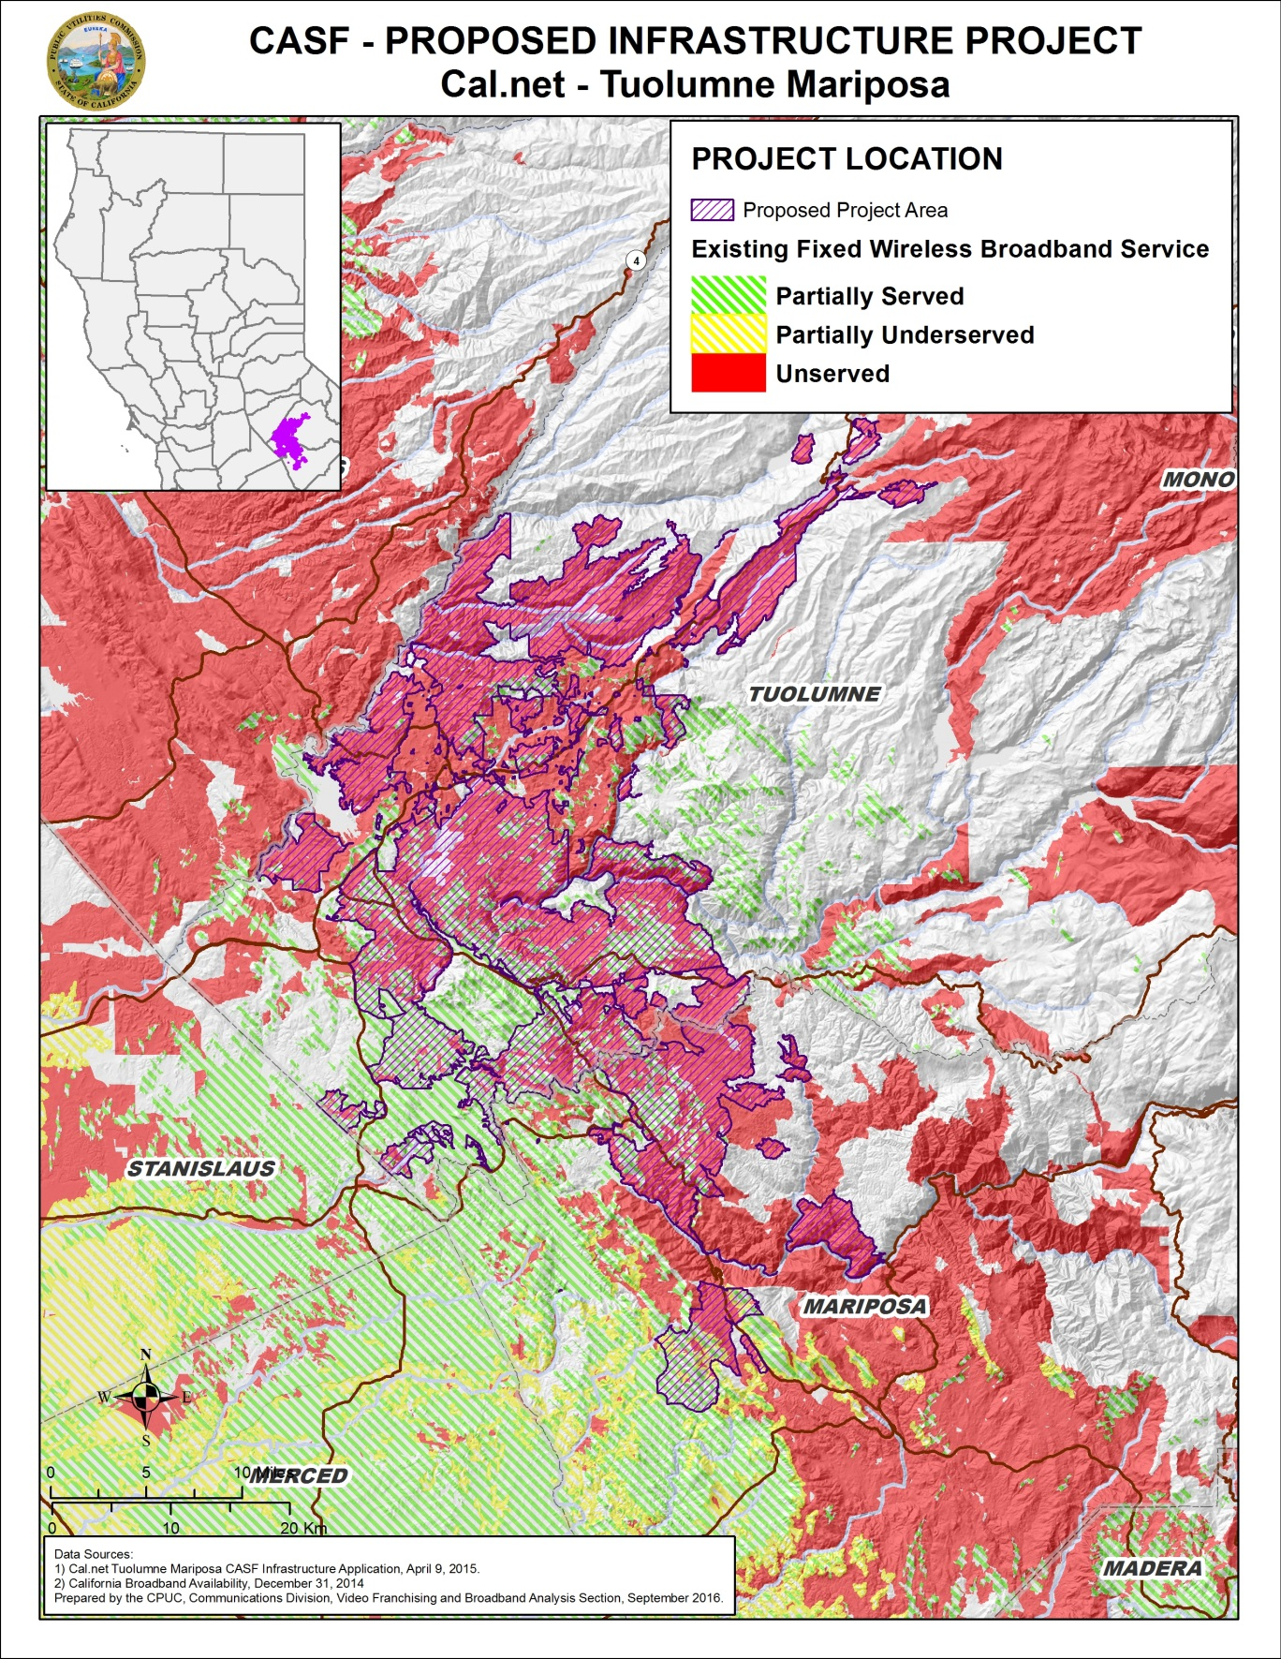
Appendix E
Resolution T-17502 Cal.net, Tuolumne Mariposa Project
Existing Mobile Wireless Services Levels
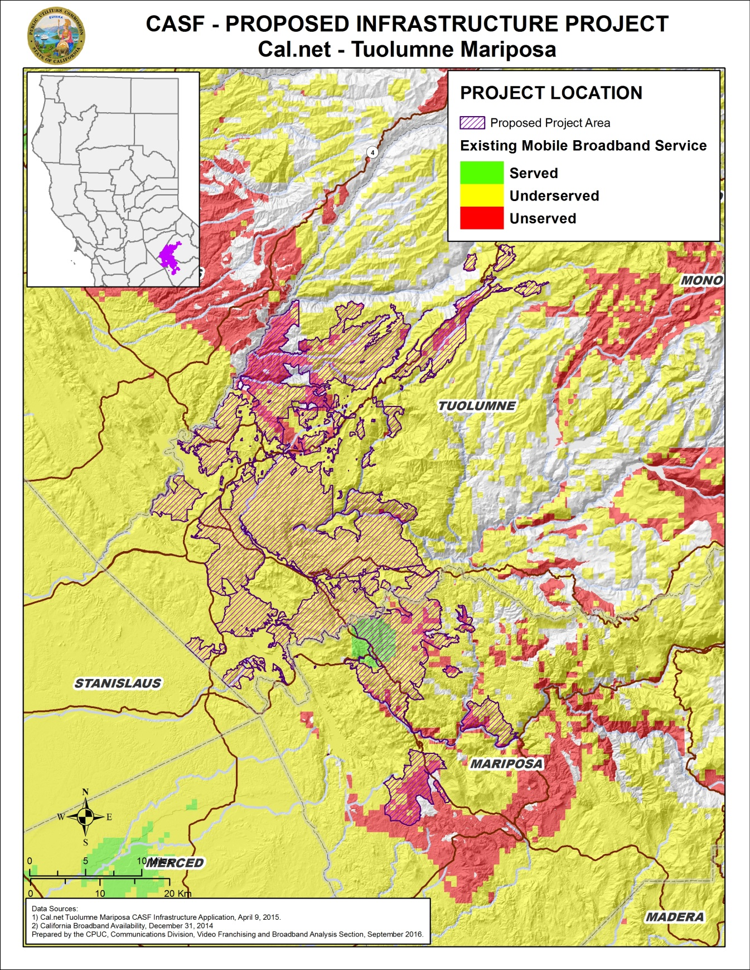

Priority areas are communities where adequate broadband services are lacking, as specified in Resolution T-17443.
Cal.net is a registered Digital Voice Service (DVS) provider, and does not possess either a Certificate of Public Necessity and Convenience (CPCN) or a Wireless Identification Registration (WIR). Registered DVS providers are issued a “U-Number” for purposes of reporting public purpose program fees as required of VoIP providers by statute.
In a call from Sonya Harris of Conifer to CD staff on April 27, 2015, Conifer informed CD staff that it was unaware of the Cal.net application until April 27, 2015 and stated its intent to challenge the application.
CD staff informed Mr. Dealy that he can submit comments for consideration on the draft resolution.
CD staff was informed that the challenge was withdrawn due to changes in Throckmorten Enterprises.
Cal.net’s CASF application, Failed Surveys.xlsx.
Cal.net’s CASF application, Req14, TM- Assertion of Unserved or Underserved, file – “CSCBC Survey Responses for CalNet.xlsx”.
Because of required “census block” reporting, the problem of “false positives” occurs when a service provider reports a census block as “served” although less than 100 percent of households within the block are actually served. The public feedback form is available at http://www.cpuc.ca.gov/General.aspx?id=5868
Calaveras Telephone Company, Volcano Telephone Company, Sierra Telephone Company, Inc. and their Affiliated ISP challenge letter, dated April 24, 2015.
See email from Cal.net, dated June 6, 2016, “Revisions to Census Blocks for last two projects”; wherein Cal.net removed the number of households located in the 12 Census blocks.
Conifer letter dated April 27, 2015.
Email from Ken Garnett of Cal.net dated July 31, 2015, regarding “Waiver of VoIP setup fees.”
The 16 fire stations in the area are Groveland, 53 Ponderosa Hills, 54 Long Barn, 55 Pinecrest, 56 Mono Vista, 57 Crystal Falls, 61 Chinese Camp, 62 Moccasin, 63 Smith Station, 79 Columbia College FD, 78 Groveland CSD, Strawberry FPD, Summit Ranger Station, Company 26, Company 31, and Coulterville.
The Commission has the authority to enforce the terms and conditions of the grant award and to impose penalties under P.U. Code §§ 2111 and 2108. (D.14-02-018, p. 36).
Email from Ken Garnett of Cal.net dated November 20, 2015, with Subject line “El Dorado North—Pricing Commitment Clarification.”
P.U. Code §§ 270 and 281.

