PUBLIC UTILITIES COMMISSION OF THE STATE OF CALIFORNIA

Communications Division | RESOLUTION T-17539
Broadband, Video and Market Branch | December 15, 2016

R E S O L U T I O N

Resolution T-17539 Approval of Funding for the Grant Application of The Siskiyou Telephone Company (U-1017-C), from the California Advanced Services Fund (CASF) in the Amount of $3,645,085 for the Happy Camp to Somes Bar Fiber Connectivity Project.
________________________________________________________

- Summary

This Resolution approves funding in the amount of $3,645,085 from the California Advanced Services Fund (CASF) for the CASF grant application of The Siskiyou Telephone Company (Siskiyou) for its Happy Camp to Somes Bar Fiber Connectivity Project (Somes Bar Project). The Somes Bar Project will build a 16.75 mile-long middle-mile fiber link from Happy Camp to Somes Bar and also construct last-mile connections to 10 unserved households in Siskiyou County.

The proposed $3,595,071 funding for the fiber middle-mile link will improve network reliability to the larger region by completing a critical segment of fiber link. This project will improve public safety by providing residents, schools and public safety agencies in the area a more reliable regional communications network, which is in a remote, rural region subject to service interruptions from forest fires and severe winter weather. The middle-mile facilities will also provide bandwidth needed to provide broadband service to 27 underserved households.

The proposed $50,014 funding is for constructing last-mile connections to 10 unserved households.

This proposed project is supported by the United States Forest Service (USFS), Frontier Telephone and the Karuk Tribe. When completed, this project will offer regional benefits beyond just Siskiyou’s customers. The fiber link will provide much needed bandwidth for Frontier Telephone, the Karuk Tribe and the community of Orleans. The fiber link will also become part of a regional fiber network in northern California that will establish an east-west fiber connection between the fiber networks of the I-5 corridor and the SR-101 corridor and improve regional network reliability.

Applicant Request

On November 13, 2015, Siskiyou submitted a CASF grant application, requesting $4,058,405 in funding to construct a 22-mile long middle-mile fiber-optic link from Happy Camp to Some Bar in Siskiyou County. According to Siskiyou, the total project cost would be $5,797,722. The Somes Bar Project would add 10 Gbps of additional bandwidth to the existing microwave link between the two communities, which is currently operating at its maximum bandwidth capacity of 445 Mbps.

Siskiyou also proposes to construct last-mile fiber to the home (FTTH) connections to 10 unserved households and 1 unserved USFS Dillon Creek Campground so these locations can have access to voice and data services for the first time. Siskiyou claims that the project is unserved and requests a 70% CASF grant. Additionally, the improved middle-mile capacity will allow Siskiyou to upgrade its Somes Bar customers to FTTH technology, at their own expense, to provide internet service at speeds of up to 90 Mbps download and upload.

Topography: The Somes Bar Project covers a 16.75 mile route along Highway 96 from Siskiyou’s Clear Creek subscriber carrier node to Siskiyou’s Ti-Bar subscriber carrier node.

Clear Creek is located about 10 miles away from Benjamin Creek on the southern edge of Happy Camp where Siskiyou’s current fiber network ends.

Ti-Bar is located just outside Somes Bar where a fiber connection has already been constructed and in use between Somes Bar and Orleans, California, located eight miles southwest of Somes Bar on Highway 96.

Applicant: Siskiyou Telephone Company (U-1017-C) is a U.S. telephone company founded in 1896 and serves all of western Siskiyou County plus a small portion of eastern Humboldt County. Its franchised service area covers 2,256 square miles, with
3,705 access lines over seven exchanges: Etna, Fort Jones, Hamburg, Oak Knoll, Sawyers Bar, Somes Bar and Happy Camp.

Project: Siskiyou currently offers internet service speed at or higher than 6 Mbps download and 1.5 Mbps upload in Somes Bar, but that speed is not available to at least 27 households due to limitation of its existing DSL technology and limited bandwidth. Siskiyou proposes to build a middle-mile fiber connection between its Clear Creek carrier node on the southern edge of Happy Camp to its Ti-Bar carrier node just outside Somes Bar to bring additional bandwidth to Somes Bar.

The project also includes last-mile connections from the project’s fiber middle-mile link to 10 unserved households located along the project’s 16.75-mile route. In total, this project will bring “served” speed broadband services to 37 households.

The proposed project will place two conduits underground along the 16.75 mile route using hard rock directional boring and conventional trenching techniques. One 72-strand fiber optic cable will be placed in one of the conduits, with the other conduit serving as a spare in case of damage or the need to upsize the route. The fiber route will be optically powered via existing ADTRAN fiber optic shelves in Siskiyou’s Happy Camp and Somes Bar central offices. Initial capacity on this link will be 10 Gbps.

Notice and Challenges

On November 13, 2015, CD posted the Somes Bar Project area map, census block groups (CBGs) and zip codes for the proposed Somes Bar Project on the Commission’s CASF webpage under “CASF Application Project Summaries” and also sent notice regarding the project to its electronic service list. CD received no challenges to the Somes Bar Project.

There were no commitments made by an existing provider to upgrade service before the November 1, 2014, “first right of refusal” deadline.

Project Review

Project Area Eligibility

For the area to be eligible, the CASF program requires an applicant to submit proof that the area is unserved or underserved by submitting shapefiles of the proposed project. CD reviews the submitted shapefiles and compares them with United States 2010 Census data and the California Interactive Broadband Availability map. Once CD determines that the area is eligible either as an unserved or underserved area, CD evaluates all other information submitted by the applicant to determine if the project meets the requirements outlined in D.12-02-015.

CD reviewed the project area census block group submitted and the current version of the California Interactive Broadband Availability Map. From the review, CD determined that Siskiyou is identified as the only broadband service provider and it offers broadband internet service speed at or higher than 6 Mbps download and 1.5 Mbps upload. CD Staff contacted Siskiyou and confirmed that while the project area is shown as “served,” broadband service speed of 6/1.5 Mbps is not available to all of its Somes Bar customers due to the existing DSL technology and middle-mile bandwidth limitations. Siskiyou indicated that at least 27 households in the project area do not have access to 6/1.5 Mbps broadband speed. When completed, the middle-mile facilities to the Somes Bar Project will provide additional bandwidth that will allow Siskiyou to upgrade its network in Somes Bar and provide all residents in Somes Bar with broadband service speed of higher than 6/1.5 Mbps. Siskiyou’s existing microwave link between Happy Camp and Somes Bar is at its capacity and cannot meet outstanding demands from other ISPs and telecommunications carriers for more bandwidth. Additionally, the middle-mile is indispensable and crucial to extending broadband services to the unserved and underserved households. As such, CD has determined that the middle-mile portion of the project will bring “served” broadband services to 27 underserved households. These 27 households do not require new last-mile facilities. Further, the 27 households are dispersed within the project area. Therefore, the entire portion of the middle-mile project costs is eligible for 60% grant funding.

While the California Interactive Broadband Availability Map has shown the entire area to have access to broadband service, Siskiyou identified 10 households located along the 16.75-mile project route that are not currently connected to its network (unserved), and proposed to connect them as part of the Somes Bar Project. Siskiyou stated that they drove the entire project route to identify these 10 unserved households and supplemented that effort by reviewing a Google map of the project area and believed it has identified all eligible unserved households. These 10 households cannot be connected to the existing microwave middle-mile link because they are located too far from the two microwave towers. However, Siskiyou indicated that these 10 households can be connected and served through the Somes Bar Project’s fiber middle-mile link. After a CD staff inquiry, Siskiyou provided a project area map identifying each of the 10 households and their GPS coordinates. After reviewing the map, CD staff determined that the 10 households Siskiyou identified are unserved. These households will receive service by the separate building of last-mile facilities from the middle-mile facilities. Therefore, the cost of constructing the last-mile connections to the 10 unserved households is grant eligible for 70% funding.

Project Criteria Evaluation

CD evaluated the application with respect to the criteria defined in D.12-02-015, Appendix 1, Section VIII (Scoring Criteria). The criteria include: (i) Funds Requested per Potential Customer, (ii) Speed, (iii) Financial Viability, (iv) Pricing, (v) Total Number of Households in the Proposed Area, (vi) Timeliness of Completion of Project, (vii) Guaranteed Pricing Period, and (viii) Low-Income Areas.

Funds per household: In its application, Siskiyou proposed a CEQA budget of $398,763. After reviewing the potential scope of work that will be required, the Commission’s CEQA Unit deemed it insufficient and proposed a budget of between $614,058 and $717,408 depending on the final scope of work completed for this project. The amount of $717,408 is used to calculate the total project amount. Thus, the total project cost is $6,063,233.

In D.12-02-015, the Commission established guidance for funding middle-mile projects where broadband infrastructure may have to pass served areas to reach an unserved or underserved area. In these instances, the Commission directed that applicants pro-rate the costs of such facilities and provide detailed explanation of the cost allocation.

CD staff followed up with Siskiyou about pro-rating the overall project cost to comply with the requirements in D.12-02-015. Siskiyou reduced the fiber cable to the smallest available 24 strand size, and removed the cost of the 72-strand fiber cable originally proposed and thereby reduced the project cost by $45,989. Because the fiber deployment construction costs are related to serving the project area, there are no costs to pro-rate.

Siskiyou further explained that middle-mile costs cannot be reduced further because much of the route is designated scenic highway, and therefore poles are not an option and that it cannot reduce the cost of building the underground conduits, because it is already using the most economical construction method of “directional hard rock boring,” and constructing the smallest diameter conduit possible. Additionally, since the Somes Bar project will be utilizing Siskiyou’s existing fiber optics equipment, there are no other costs to reduce.

Furthermore, CD staff adjusted Siskiyou’s proposed last-mile component budget to only account for the cost of building last-mile connection to the 10 unserved households and took out the cost for connecting the USFS campground.

After these budget adjustments, the total eligible CASF funding is $3,645,085, which includes $3,595,071 for the middle-mile portion of the Somes Bar Project, and $50,014 for the last-mile portion of the project.

The CASF per-household subsidy for the 27 middle-mile underserved households is $133,151; and the per-household subsidy for the 10 last-mile unserved households is $5,001.

We recognize the middle-mile cost per household is very high. This is because the entire project route requires underground directional hard rock boring. Poles are not an option because much of the route is designated scenic highway.

The primary benefit of the project is its middle-mile connectivity. The project would fill in the “missing link” in an otherwise contiguous fiber optic route between the I-5 corridor and the Highway 101 corridor (see Appendix B, Wireline Map and Regional Infrastructure Map). For example, the completion of the Somes Bar Project will allow the Karuk Tribe to increase the bandwidth it leases from Siskiyou to greatly expand and improve internet services for its customers in Orleans. The Karuk Tribe, through its Áan Chúuphan ISP, is the only internet service provider for Orleans, which has 264 households, and is relying solely on Siskiyou through Somes Bar for its internet connectivity.

Speed: The proposed project will allow Siskiyou to upgrade its network to offer served speed broadband services to the 27 underserved households in Somes Bar and increase the speed offering for the remaining households in the project area. The project also includes a last-mile component that will construct last-mile connections from the project’s fiber middle-mile link to 10 unserved households located along the project’s 16.75-mile route.

The proposed project’s additional bandwidth will also allow Siskiyou to increase its highest retail broadband speed offering in Somes Bar to 90 Mbps download and upload for all households in the project area.

Financial Viability: CD determined that Siskiyou is a financially viable company with sufficient cash reserve to meet its matching fund requirement for the Somes Bar Project based on its five year pro forma financial statements.

Siskiyou also submitted a five-year Earnings Before Interest and Tax (EBIT) forecast for the Somes Bar Project, which indicated that it will have positive annual cash flow for all five forecasted years. The forecast is based on approximately 5% revenue generated from Siskiyou’s retail customers and the remaining 95% from the Federal Communications Commission’s Universal Service Fund program.

Pricing: Siskiyou has committed to a broadband pricing plan under the terms shown below for two years for the retail last-mile broadband services portion of the project, starting from the beginning date of service. There is no long-term commitment required from the consumer and activation and installation fees will be waived for all retail customers in the project area.

Siskiyou’s Proposed Retail Pricing Plan in Project Area
Speed  (Download/Upload) |  | 1 Mbps / 1 Mbps |  |  | 4 Mbps / 1 Mbps |  |  | 8 Mbps / 1.5 Mbps |  |  | 10 Mbps / 1.5 Mbps
Monthly Price |  | $24.95 |  |  | $49.95 |  |  | $69.95 |  |  | $84.95
Speed (Symmetrical) | 10 Mbps |  | 20 Mbps | 30 Mbps |  | 40 Mbps | 50 Mbps |  | 60 Mbps | 70 Mbps |  | 80 Mbps | 90 Mbps
Monthly Price | $84.95 |  | $149.95 | $214.95 |  | $279.95 | $344.95 |  | $409.95 | $474.95 |  | $593.95 | $604.95
Installation Fee Is Waived

Siskiyou did not submit pricing information for wholesale customers or customers requesting higher-speed broadband services, indicating it will be negotiated on a case by case basis.

Households in Project Area: Based on the 2010 census block data for the Somes Bar Project area, there are 250 households in the project area. The average number of households for last-mile CASF grant applications approved in 2015-2016 is 1,441.

Timeliness of Completion: The applicant has submitted detailed planning documents, including a schedule with clear milestones to indicate it will be completed within the proposed 24-month construction timeline.

Guaranteed Pricing Period: The applicant has committed to a guaranteed retail pricing plan of 24 months for all retail customers in the project area in accordance with the program’s requirement.

Low-Income Areas: Based on the 2010 census block data for the Somes Bar Project area, the median household income is $26,250 (well below the statewide median income of $61,094) with a poverty rate of 42.2% (significantly above the statewide poverty rate of 15.9%).

Safety and Community Input Considerations

The proposed project will provide the addition of a fiber-optics backbone to the existing microwave link between Happy Camp and Somes Bar. This will increase service reliability and improve safety because there will be redundancy for communication traffic to flow between the two communities, greatly minimizing the chance of service interruption. Additionally, Siskiyou would be able to provide symmetrical 90 Mbps broadband service to all of its Somes Bar customers.

The United States Forest Service (USFS) also supported the proposed project, indicating its desire to subscribe to telecommunications services at its Dillon Creek Campground located near the Somes Bar Project’s path. USFS asserts that being connected to Siskiyou’s telecommunications network will allow many of the campground’s operations, such as water treatment, to be monitored remotely, and will “promote quicker response time for fire, medical and law enforcement and could save lives, protect resources and deter theft and vandalism.”

The Karuk Tribe stated in its letter of support that the Somes Bar Project, if completed, can connect with its own CASF-funded Klamath River Rural Broadband Initiative (KRRBI) and will form a regional fiber-optic backbone from the Yreka on the I-5 corridor to McKinleyville on the Highway 101 corridor that is also supported by Frontier. This will provide the region with two ways of reaching the internet backbone via fiber connections, greatly enhancing public safety and network reliability in the event of manmade and natural disasters that may interrupt one of the two connections.

The Karuk Tribe also supports the Somes Bar Project as a customer who purchases bandwidth from Siskiyou. The Karuk Tribe stated that it recently launched the only high-speed internet service for the community of Orleans, CA. It is currently leasing 155 Mbps bandwidth from Siskiyou, which is more than 1/3 of current bandwidth available to Somes Bar bandwidth (455 Mbps) from the existing middle-mile link. The Karuk Tribe asserts that the proposed project will provide additional bandwidth that will allow the Karuk Tribe to expand its broadband services coverage areas and increase speed in the community of Orleans.

The proposed project also received support from Frontier Communications (Frontier). Frontier supports the Somes Bar Project for several reasons including: 1) Somes Bar Project will relieve the “almost fully-loaded microwave route” between Happy Camp and Somes Bar that has been stretched to the limits allowed by radio engineering with a fiber-optic link that is also, unlike microwave links” immune from disruption caused by weather; 2) the proposed project, when completed, can be part of a regional fiber-optic backbone from the I-5 corridor to the Highway 101 corridor; and 3) the proposed project will improve safety and services to the rural communities served by Siskiyou in the project area. Additionally, Siskiyou indicated that Frontier had requested and received two T-1 circuits from Siskiyou’s existing microwave link between Happy Camp and Somes Bar in order to meet its need to serve its customers in the region. Additionally, according to Siskiyou, Frontier has indicated verbally that it might be interested in a 1 Gbps Ethernet data route from Orleans, through Siskiyou’s network, to Redding.

Staff Recommendation for Funding

Based on CD’s evaluation of the project, CD finds that Siskiyou’s Somes Bar Project meets the requirements of D.12-02-015, provides safety benefits such as network redundancy and aligns with the goals of the CASF program.

Compliance Requirements

Siskiyou is required to comply with all the guidelines, requirements, and conditions associated with the grant of CASF funds as specified in D.12-02-015. Such compliance includes, but is not limited to:

California Environmental Quality Act (CEQA)

All CASF grants are subject to California Environmental Quality Act (CEQA) requirements unless the project is statutorily or categorically exempt pursuant to the CEQA Guidelines.

Prior to any construction activity, Siskiyou shall submit a Proponent’s Environmental Assessment (PEA) to the CPUC pursuant to Commission Rule of Practice and Procedure 2.4; and must undergo an environmental review pursuant to the CEQA. (California Public Resources Code § 21000 et seq.)

The proposed project will involve the installation of approximately 88,282 feet of fiber optic cable along Highway 96. The proposal is to install the fiber optic cable within underground conduit along the entire project route. The fiber optic cable will be installed by both directional boring and trenching. Forty concrete hand hole utility boxes will be installed to function as access points for subscriber drop, splice points, and grounding locations. Additional boxes will also be placed as needed along the route to provide access points for each residential subscriber or fiber optic line splices. The purpose of the project is to: (1) Provide telephone service to existing residences along the proposed fiber optic cable route; and (2) Complete a middle-mile connection for the communities of Orleans and Somes Bar.

Siskiyou must provide the PEA prior to the first 25% payment. The Commission cannot release funds for the construction of the project until the Commission has completed CEQA review.

Deployment Schedule

The Commission expects Siskiyou to complete the project within 24 months from start date (as determined by the procedure below). If Siskiyou is unable to complete the Somes Bar Project within the 24 month timeframe requirement, it must notify the Director of CD as soon as Siskiyou becomes aware of this possibility. If such notice is not provided, the Commission may reduce payment for failure to satisfy this requirement by timely notifying CD’s Director.

Execution and Performance

CD and Siskiyou shall determine a project start date after Siskiyou has obtained all approvals. Should Siskiyou or any contractor it retains fail to commence work by the designated date, upon five days written notice to Siskiyou, the Commission, may terminate the award. In the event that Siskiyou fails to complete the project in accordance with the terms of Commission’s approval as set forth in this resolution, Siskiyou must reimburse some or all of the CASF funds that it has received. Siskiyou must complete all construction covered by the grant on or before the grant’s termination date.

Performance Bond

The Commission does not require a Performance Bond if the applicant certifies that the percentage of the total project costs it is providing comes from their capital budget and is not obtained from outside financing. In its application, Siskiyou certified that the percentage of the total project costs it is providing will come from its existing capital budget. Therefore, a performance bond is not required for this project.

Price Commitment Period

The minimum required price commitment period for broadband service to all households within the project area is two years. Siskiyou guarantees the price of service offered in the project area for two years.

Project Audit

The Commission has the right to conduct any necessary audit, verification, and discovery during project implementation/construction to ensure that CASF funds are spent in accordance with Commission approval.

Siskiyou’s invoices for the Somes Bar Project will be subject to a financial audit by the Commission at any time within three years of completion of the work.

Providing Voice Service

Siskiyou has certified that its basic analog telephone service for last-mile retail customers meets the Federal Communications Commission (FCC) standards for E-911 service and battery backup.

Submission of Form 477

The FCC currently requires broadband providers to biannually submit Form 477, which includes speed data. While there is an imperfect match between the data that is reported in the Form 477 and to the CASF, the Form 477 data will be useful in documenting CASF deployment for the service provider’s new service. Pursuant to General Order 66-C, service providers in California must submit a copy of their Form 477 data directly to the Commission, concurrent with their submission of the same data to the FCC for a five-year period after completion of the project.

Reporting

Siskiyou must submit quarterly progress reports on the status of the project irrespective of whether Siskiyou requests reimbursement or payment.

Quarterly progress reports are due on January 1, April 1, July 1, and October 1. Before full payment of the project, Siskiyou must submit a project completion report. Progress reports shall use the schedule for deployment, major construction milestones and costs submitted in the proposal; indicate the actual date of completion of each task/milestone as well as problems and issues encountered, and the actions taken to resolve these problems and issues during project implementation and construction; and identify future risks to the project.

Siskiyou shall also include test results on the download and upload speeds on a CBG and zip code basis in the final completion report as well as on both ends (Clear Creek and Ti-Bar) of this middle-mile fiber project. Siskiyou must certify that each progress report is true and correct under penalty of perjury.

Payments to CASF Recipients

Submission of invoices from and payments to Siskiyou shall be made at 25 percent completion intervals, in accordance with Section XI of Appendix 1 of D.12-02-015 and according to the guidelines and supporting documentation required in D.12-02-015.

Payment to Siskiyou shall follow the process adopted for funds created under P.U. Code §270. The Commission generally processes payments within 20-25 business days, including CD and Administrative Services review time. The State Controller’s Office (SCO) requires an additional 14-21 days to issue payment from the day that requests are received by SCO from Administrative Services.

In an emailed letter dated August 26, 2016 to CD staff, Siskiyou committed to complete the 5.2-mile (Benjamin Creek to Clear Creek) fiber link on or before the completion of Phase 1 of Somes Bar Project. This will enable the proposed project to be operational by connecting it to Siskiyou’s existing fiber network. Therefore, in order to ensure that the Somes Bar Project can be operational, Siskiyou must submit a completion report for both the Somes Bar Project and the 5.2-mile Benjamin Creek to Clear Creek middle-mile fiber project prior to receiving final payment for the Somes Bar Project.

Siskiyou shall notify the Commission as soon as they become aware that they may not be able to meet the 24-month timeline. In the event that Siskiyou fails to notify Communications Division of any delays in the project completion and the project fails to meet the approved completion date, the Commission may impose penalties to be adopted in a Commission resolution.

Comments on Draft Resolution

In compliance with Public Utilities Code § 311(g), a notice letter was e-mailed on November 16, 2016, informing all parties on the CASF Distribution List of the availability of the draft of this resolution for public comments at the Commission's website at http://www.cpuc.ca.gov/PUC/documents/. This letter also informed parties that the final conformed Resolution adopted by the Commission will be posted and available at this same website. No comments were received.

Findings

- On November 13, 2015, Siskiyou filed an application for CASF funding for its Somes Bar Project to construct a 16.75-mile long fiber middle-mile connection between Happy Camp and Somes Bar that will bring served speed broadband service to 27 underserved households as well as constructing last-mile connections to 10 currently unserved households in Siskiyou County, California. The CBG impacted by the project is 060930005003.

- Key information of the approved project is in Appendix A of this Resolution.

- CD posted the Somes Bar Project area map, CBG and zip code for Siskiyou’s Somes Bar Project on the Commission’s CASF webpage under “CASF Application Project Summaries” on November 13, 2015. CD received no challenges to this project.

- CD reviewed and analyzed data submitted for Siskiyou’s Somes Bar Project’s application to determine the project’s eligibility for CASF funding. This data includes but is not limited to: proof of a CPCN from the Commission; descriptions of current and proposed broadband infrastructure; geographic information system (GIS) formatted shapefiles mapping the project areas; assertion that the area is underserved; number of potential subscriber households and average incomes; project construction schedule; project budget; proposed pricing and commitment period for new subscribers; and financial viability of the applicant.

- While the California Broadband Interactive Map showed the project area to be served, Siskiyou indicated to the staff that it is not able to provide the served speed to 27 customers due to limitation of its current DSL technology and bandwidth.

- Based on its review, CD determined that the 27 underserved households do not require new last-mile facilities. Further, the 27 households are dispersed within the project area. Therefore, the entire portion of the middle-mile project costs is eligible for 60% CASF funding.

- CD further determined that the 10 unserved households will receive service by separate building of last-mile facilities form the middle-mile facilities. Therefore, the cost of constructing the last-mile connections to the unserved households is eligible for 70% funding.

- CD staff followed up with Siskiyou about pro-rating the overall project cost to comply with the requirements in D.12-02-015. Siskiyou reduced the fiber cable to the smallest available 24 strand size, and removed the cost of the 72-strand fiber cable originally proposed and thereby reduced the project cost by $45,989.

- Siskiyou further explained that middle-mile costs cannot be reduced further because much of the route is designated scenic highway, and therefore poles are not an option. Additionally, Siskiyou cannot reduce the cost of building the underground conduits, because it is already using the most economical construction to serve the 27 underserved households.

- The primary benefit of the project is its middle-mile connectivity to complete a “missing link” in an otherwise contiguous fiber optic route between the I-5 corridor and the Highway 101 corridor.

- CD staff adjusted Siskiyou’s proposed last-mile component budget to only account for the cost of building last-mile connection to the 10 unserved households.

- Based on its review, CD determined that the proposed project qualifies for funding under D.12-02-015 and recommends Commission approval of CASF funding for Siskiyou’s Somes Bar Project.

- Siskiyou is required to comply with all guidelines, requirements, and conditions associated with the granting of CASF funds as specified in D.12-02-015 and must submit the FCC Form 477, as specified in T-17143.

- Siskiyou is committed to complete the 5.2-mile (Benjamin Creek to Clear Creek) fiber link, which will connect the Somes Bar Project to Siskiyou’s fiber network, six months after construction starts on Somes Bar Project. To ensure that the Somes Bar Project can function as proposed, CD recommends that Siskiyou be required to submit a completion report for both the Somes Bar Project and the 5.2-mile Benjamin Creek to Clear Creek middle-mile fiber project prior to receiving final payment for the Somes Bar Project.

- The Commission has determined that this project is subject to CEQA review and the Commission cannot release funds for construction activities until CEQA review is complete. Siskiyou must comply with the requirements set forth in the CEQA Section of this Resolution. Prior to any construction activity, Siskiyou is required to file a PEA and must undergo an environmental review pursuant to CEQA. Siskiyou must provide the PEA prior to the first 25% payment.

- A notice letter was e-mailed on November 16, 2016, informing all applicants filing for CASF funding, parties on the CASF distribution list of the availability of the draft of this Resolution for public comments at the Commission’s website http://www.cpuc.ca.gov/PUC/documents/. This letter also informed parties that the final confirmed Resolution adopted by the Commission will be posted and available at this same website. No comments were received.

- The Commission finds CD’s recommendation to fund Siskiyou’s Somes Bar Project, as summarized in Appendix A, to be reasonable and consistent with Commission orders and, therefore, adopts such recommendation.

THEREFORE, IT IS ORDERED that:

  - The Commission shall award $3,645,085 to Siskiyou for its Somes Bar Project as described herein and summarized in Appendix A of this Resolution.

  - The program fund payment of $3,645,085 for this project shall be paid out of the CASF Infrastructure Grant Account in accordance with the guidelines adopted in D.12-02-015, including compliance with CEQA.

  - Payments to the CASF recipient shall be in accordance with Section XI of Appendix 1 of D.12-02-015 and in accordance with the process defined in the “Payments to CASF Recipients” section of this Resolution.

  - Siskiyou must submit a full Proponent's Environmental Assessment (PEA) to the Energy Division prior to the first 25% payment of CASF grant funds. No CASF funds may be disbursed for construction activities prior to the completion of the CEQA review.

  - Siskiyou must comply with all guidelines, requirements and conditions associated with the CASF funds award as specified in D.12-02-015 and this Resolution, and must submit the FCC Form 477 to the Commission, as specified in Resolution T-17143.

  - Siskiyou must complete all construction covered by the grant on or before the grant’s termination date. If the project will not be completed within the 24 month time frame, Siskiyou must notify the Director of CD as soon as it becomes aware of this possibility. If such notice is not provided, the Commission may reduce payment for failure to satisfy this requirement by timely notifying CD’s Director.

  - Siskiyou must submit a project completion report for both the 5.2-mile Benjamin Creek to Clear Creek middle-mile fiber project and the Somes Bar Project prior to receiving final payment for the Somes Bar Project.

  - If Siskiyou fails to complete the project in accordance with the terms outlined in D.12-02-015 and with the terms of the Commission’s approval, as set forth in this resolution, Siskiyou must reimburse some or all the CASF funds it has received.

This Resolution is effective today.

I hereby certify that this Resolution was adopted by the Public Utilities Commission at its regular meeting on December 15, 2016. The following Commissioners approved it:

/s/ Timothy J. Sullivan

TIMOTHY J. SULLIVAN

Executive Director
MICHAEL PICKER
President
MICHEL PETER FLORIO
CATHERINE J.K. SANDOVAL
CARLA J. PETERMAN
LIANE M. RANDOLPH
Commissioners

APPENDIX

APPENDIX A

Resolution T-17539
Siskiyou Happy Camp to Somes Bar Fiber Project
CASF Applicant Key Information

Project Name | Siskiyou Happy Camp to Somes Bar Project
Project Plan | To construct a fiber middle-mile connection between Happy Camp and Somes Bar in Siskiyou County to bring additional bandwidth not available from the existing microwave link. The proposed project will allow Siskiyou to provide 6/1.5 broadband service to 27 underserved households and 10 unserved households, and to provide additional bandwidth to the only ISP in Orleans, CA operated by the Karuk Tribe.
Project Size (miles) | 16.75 miles
Initial Middle-Mile Bandwidth | 10 Gbps
Download/Upload speed for last-mile | 90 Mbps / 90 Mbps
Location | Siskiyou County
Community Names | Somes Bar
Census Block Groups | 60930005003
Median Household Income (by Census Block Group) | $ 26,250
Zip Codes | 95568
Estimated potential subscriber size | 250 households / 533 population
Applicant expectations | 7 of the 10 unserved households connected
Pricing Plan for last-mile (Monthly) | Symmetrical Speed 10 Mbps 20 Mbps 30 Mbps 40 Mbps 50 Mbps 60 Mbps 70 Mbps 80 Mbps 90 Mbps  Monthly Price $84.95 $149.95 $214.95 $279.95 $344.95 $409.95 $474.95 $593.95 $604.95
Deployment Schedule  (from Commission approval date) | 24 months
Proposed Project Budget (Total) | $6,063,233
Amount of CASF funds granted  (60% & 70%) | $3,645,085  60% CASF Grant (Middle-Mile) - $3,595,071  70% CASF Grant (Last-Mile) - $50,014
Applicant Matching Fund | $2,418,148  40% (Middle-Mile) - $2,396,714  30% (Last-Mile) - $21,434

Appendix B
Resolution T-17539
Siskiyou’s Happy Camp to Somes Bar Project
Existing Wireline Service Levels
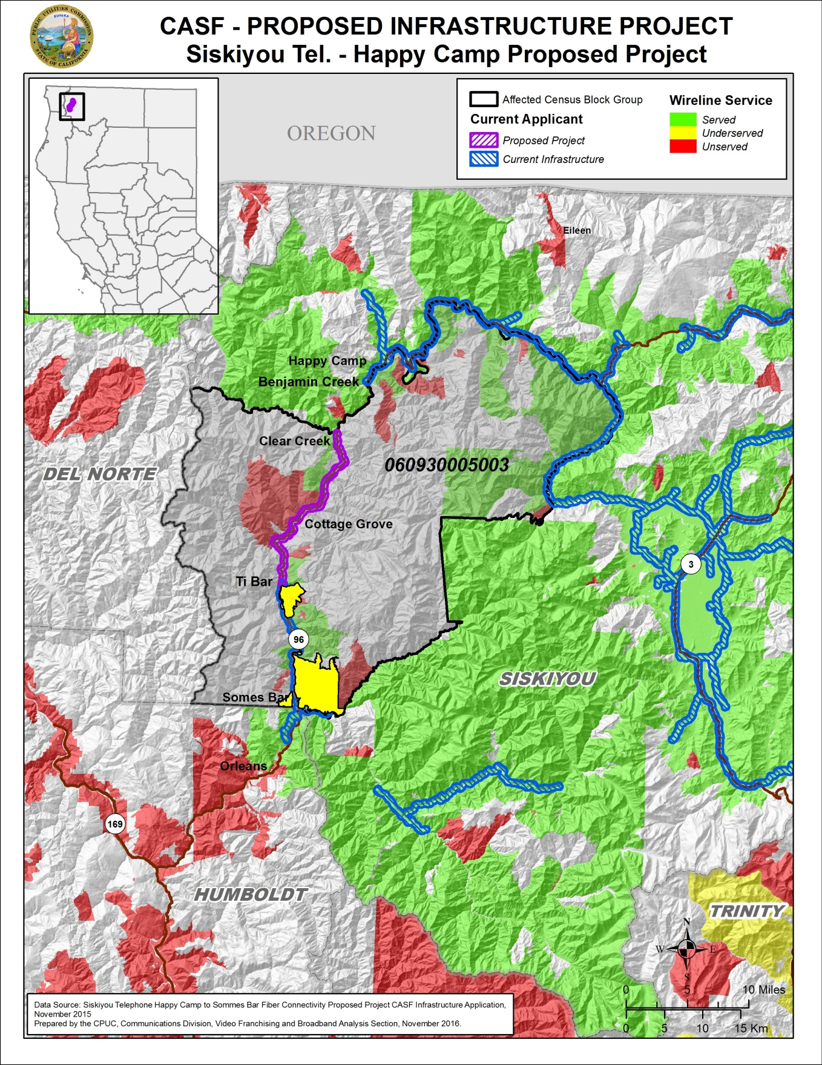

Resolution T-17539
Siskiyou’s Happy Camp to Somes Bar Project
Regional Infrastructure Map
(As Submitted by Siskiyou)
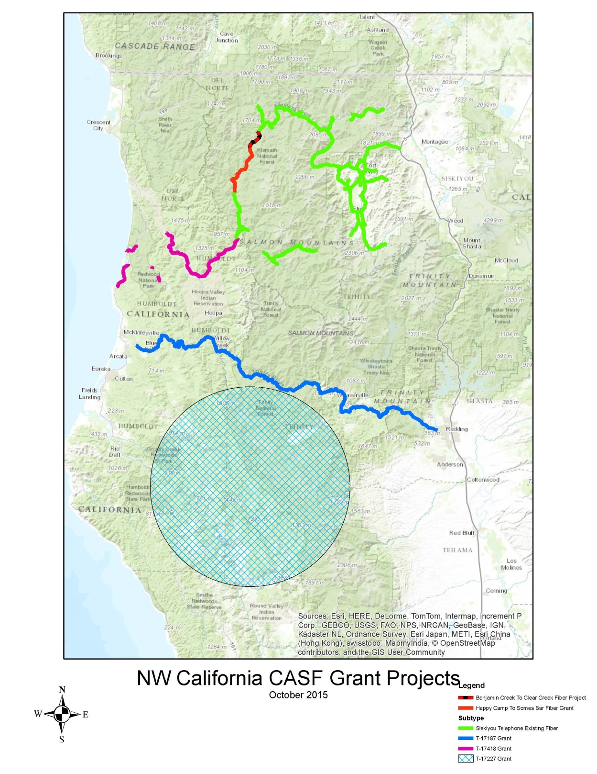

After staff follow up, Siskiyou clarified the actual project length is 16.75 mile. It accidentally included the length of its self-funded project to connect Benjamin Creek and Clear Creek.
Siskiyou will also, without using CASF funding, construct a 5.2-mile long middle-mile fiber connection between its Clear Creek carrier node and its Benjamin Creek carrier node. This fiber connection project will connect the Somes Bar Project to Siskiyou’s existing fiber network at Benjamin Creek in order for the Somes Bar Project to be operational. The 5.2 mile long middle-mile fiber connection will be completed no later than completion of Phase 1 of Somes Bar Project.
The latest version of the California Interactive Broadband Availability Map uses wireline data submitted as of December 31, 2015
Siskiyou email to staff, “RE: Somes Bar Project service speed,” dated October 27, 2016.
The 27 households are comprised of 20 households from Siskiyou’s 130 current customers, and at least 7 additional households from the remaining households that do not currently subscribe to Siskiyou’s service.
Siskiyou email to staff, “Possible Cost Reductions to Cost of Siskiyou's Happy Camp to Somes Bar CASF Grant Project,” dated November 9, 2016.
USFS’s Dillon Creek Campground is currently unserved and is one of the 11 last-mile connections that will be constructed as part of the Somes Bar Project.
KRRBI was approved for CASF funding in 2013 and is currently in CEQA review stage. Part of KRRBI is a fiber middle-mile backbone from McKinleyville, CA to Orleans, CA.
Approval of the California Advanced Services Fund (CASF) Application Requirements and Scoring Criteria for Awarding CASF Funds (2008) Cal. P.U.C. Res. No. T-17143 at 4.
The Somes Bar Project construction timeline is divided into three phases.
CD received an additional letter in support of this Draft Resolution from the Karuk Tribe during the comment period.

