PUBLIC UTILITIES COMMISSION OF THE STATE OF CALIFORNIA

**Item 9 (Rev. 1)**

**Agenda ID 15526**

**ENERGY DIVISION RESOLUTION E-4831**

**March 23, 2017**

RESOLUTION

Resolution E-4831. Approval of Southern California Edison request to establish Schedule TOU-EV-6, General Service Time-of-Use, Electric Vehicle Charging, Large Demand Metered.

PROPOSED OUTCOME:

* Approves Southern California Edison’s Schedule TOU-EV-6 to provide a time-of-use rate to large demand customers for electric vehicle charging.

SAFETY CONSIDERATIONS:

* There is no impact on safety.

ESTIMATED COST:

* This rate is designed to be cost neutral to other ratepayers.

By Advice Letter 3402-E, Filed on May 5, 2016.

__________________________________________________________

# Summary

This Resolution approves Southern California Edison’s Schedule TOU-EV-6 to provide a time-of-use rate to large demand customers for electric vehicle charging. The rate applies to a commercial customer’s electric vehicle charging with demand over 500 kilowatts (kW). Southern California Edison is required to re-examine this schedule in its next General Rate Case Phase 2 application, to ensure the rate continues to align with the most up-to-date rate design policies and time-of-use periods.

# Background

**State and Commission Electric Vehicle Policy**

The state’s Zero-Emission Vehicle Action Plan is a state-level plan for developing California’s market for zero-emission vehicles[1] to reach the Governor’s goal of   
1.5 million zero-emission vehicles in California by 2025. The Action Plan identifies specific actions various state agencies can take to help reach this goal. The Commission is assigned a lead role in activities related to utility infrastructure development, customer education, ensuring electric vehicles (EVs) support the grid, and developing electricity rates that make EVs cost-effective. The Commission is specifically tasked with developing “operational strategies and rate designs… that both protect against negative grid impacts and minimize costs” and helping to “mitigate or manage demand charges for high power uses such as electric buses, fast chargers, transit…”[2]

The California Air Resources Board oversees several initiatives to promote electric vehicle adoption and reduce greenhouse gas emissions from the transportation sector, including incentives for EV purchases; the Low Carbon Fuel Standard, which is designed to encourage the production and use of low-carbon fuels; and the Zero-Emission Vehicle Regulation, which is designed to reduce emissions from mobile sources.

In 2016, the Commission approved pilot programs for each of California’s three large investor-owned utilities – Southern California Edison (SCE), San Diego   
Gas & Electric, and Pacific Gas & Electric – to invest a total of $197 million to install and maintain the infrastructure to support up to 12,500 electric vehicle charging stations for light-duty vehicles.

Additionally, Senate Bill 350 directed the Commission to direct the investor-owned electric utilities to “file applications for programs and investments to accelerate widespread transportation electrification to reduce dependence on petroleum, meet air quality standards, achieve the goals set forth in the Charge Ahead California Initiative…and reduce emissions of greenhouse gases to   
40 percent below 1990 levels by 2030 and to 80 percent below 1990 levels by 2050.”[3] Pursuant to Commission guidance,[4] the three large utilities, including SCE, filed applications on January 20, 2017. SCE’s Application (A.) 17-01-021 proposed several programs to support EV infrastructure and develop EV rates, particularly for the commercial sector.

**Overview of SCE’s Approved and Proposed Electric Vehicle Rates**

SCE has two rate schedules for residential customers to charge their EVs. Schedule TOU-D[5] is a time-of-use (TOU) rate for the whole house, including an EV, while TOU-EV-1[6] requires a separate meter for the EV and applies only to the EV load.

SCE has two approved rate schedules for commercial EV customers: Schedule TOU-EV-3[7] for commercial EV customers with demand of 20 kW or less, and Schedule TOU-EV-4[8] for commercial EV customers with demand between   
20-500kW. SCE does not have an existing EV rate for customers with demand greater than 500 kW, so the rate proposed in AL 3402-E aims to address this gap. Since the time of the AL filing, SCE also proposed three additional commercial EV rates in A.17-01-021. SCE’s two current and four proposed commercial EV rates are summarized in Appendix B.

SCE has some experience providing a TOU rate for a large EV customer on an interim basis. In Resolution E-4514,[9] the Commission directed SCE to extend the applicability of Schedule TOU-GS-1[10] for a period of three years to government agencies that purchased or obtained zero-emission electric buses. Schedule   
TOU-GS-1 is otherwise only available for customers with demand of 20 kW and below, and it does not have a demand charge as part of the rate. During the   
three-year period, which ended in December 2015, one government transit agency with demand exceeding 500 kW took service under Schedule TOU-GS-1. After the three-year period ended, SCE developed Schedule TOU-EV-6 as a more permanent solution to meet the needs of larger EV customers.

**Proposed Schedule TOU-EV-6**

SCE states that it developed Schedule TOU-EV-6 based on inquiries from customers who have EV demand expected to exceed 500 kW. Those customers would otherwise be on Schedule TOU-8, a general service time-of-use rate for customers with demand in excess of 500 kW. Schedule TOU-EV-6 applies solely to the charging of EVs on a premises or public right of way where the customer requests a separate SCE meter to serve EV charging facilities.

SCE designed Schedule TOU-EV-6 to be revenue-neutral to Schedule TOU-8, as it has done for other optional rate schedules for large customers. SCE will rebalance Schedule TOU-EV-6 annually, consistent with the methodology used in SCE’s annual Energy Resource Recovery Account (ERRA) filing.

SCE is proposing TOU periods that are later in the day in comparison to the   
two existing commercial EV rates, to better align with changing grid conditions. The proposed TOU periods are as follows:

* On-Peak from 2 pm to 8 pm during weekdays except holidays
* Super Off-Peak from 10 pm to 8 am everyday
* Off-Peak for all other hours

Schedule TOU-EV-6 contains an energy charge, customer charge, facilities-related demand charge, and power factor adjustment. In contrast to Schedule TOU-8, it does not include a time-related demand charge. The energy charge for TOU-EV-6 ranges from approximately $0.06 per kWh during super off-peak to approximately $0.41 per kWh during summer on-peak periods. Tariff sheets for Schedule TOU-EV-6 are provided in Appendix A.

The facilities-related demand charge accounts for the maximum demand recorded during the monthly billing period. If a facility’s EV load is on Schedule TOU-EV-6 and its other load is on a General Service rate, then the facilities-related demand charge for the EV account is determined using the demand, if any, which exceeds the facilities-related demand of the General Service account. If the facilities-related demand for the EV account does not exceed the facilities-related demand for the General Service account, there will be no facilities-related demand charge for the EV account.

# Notice

Notice of AL 3402-E was made by publication in the Commission’s Daily Calendar. SCE states that a copy of the Advice Letter was mailed and distributed in accordance with Section 4 of General Order 96-B.

# Protests

On May 25, 2016, the City of Lancaster filed a timely response to Advice Letter 3402-E. The City of Lancaster requested that the Energy Division evaluate SCE’s workpapers provided to support the rate development, specifically a table containing billing determinants in the Excel tab labeled “TOU-EV-6 Rate Design” in Attachment C to AL 3402-E.

SCE responded to the City of Lancaster’s response on June 2, 2016 with additional information about its workpapers. SCE stated that the billing determinants for the otherwise applicable tariff, Schedule TOU-8, were recorded over a 12-month period ending October 2015. SCE states that the billing determinants for Schedule TOU-8 reflect the current TOU periods, while the billing determinants for Schedule TOU-EV-6 reflect the TOU periods as proposed for Schedule TOU-EV-6. SCE did not make any additional adjustments to the billing determinants.

Energy Division reviewed the billing determinants identified for Schedule TOU-8 and Schedule TOU-EV-6, and found the total kWh for both rates to be exactly equal. The only difference was the allocation of kWh across “on-peak,” “mid-peak,” and “off-peak” periods, because, as SCE suggests in its response, the two rates have different TOU periods.

# Discussion

On May 5, 2016, SCE filed AL 3402-E to establish a new rate schedule, TOU-EV-6, to provide TOU rates to large demand customers for EV charging. Energy Division has evaluated AL 3402-E and Schedule TOU-EV-6 on the following:

* Consistency with Commission and State EV policy
* Consistency with principles of time-varying rates
* Appropriateness of time-of-use periods
* Alignment with revenue-neutral rate design

**Consistency with Commission and State Electric Vehicle Policy**

The Commission and other State policies aim to promote a switch to EVs to help reduce emissions from the transportation sector. To help make EVs a financially attractive option for customers and increase their uptake, the Commission has worked to provide low cost rates for EV charging.

SCE does not have an existing rate specifically designed to serve EV load above 500 kW. Schedule TOU-EV-6 can be used by large customers whose demand exceeds 500 kW, such as government transit agencies with fleets of electric buses, large trucking companies, and large fleets of light-duty vehicles.

The proposed rate is better tailored to typical patterns of demand from EV charging, and can help lower electricity bills for customers that elect this rate in comparison to their otherwise applicable rate. Reducing charging costs, and thus total costs to operate a fleet of EVs, can encourage more customers to adopt EVs or to expand their existing fleet of EVs. Adopting a rate that provides customers a financial incentive to switch from fossil fuel vehicles to electric vehicles helps meet state goals for EV adoption and emissions reduction.

Schedule TOU-EV-6 is consistent with State and Commission EV policies and can enable additional customers to switch to electric vehicles.

**Consistency with Principles of Time-Varying Rates**

The Commission has a long history of moving toward time-varying rates to better reflect the cost of service.[11]

In comparison to Schedule TOU-8, the otherwise applicable tariff for customers with demand greater than 500kW, Schedule TOU-EV-6 has higher energy charges and lower demand charges. Because energy charges have a time-related component (on-peak, off-peak, or super off-peak), allocating more of the rate component to energy charges means that in total, the rate varies more depending on time of use, better reflecting grid conditions.

In comparison to the otherwise applicable tariff, Schedule TOU-EV-6 better aligns with the Commission’s policy of using time-varying rates to reflect cost of service.

However, the distribution facilities-related demand component of TOU-EV-6 is not time-based; therefore customers cannot reduce this component of their bills by shifting their charging load, even to super-off-peak hours. Because the Commission has expressed interest in continuing to move toward more time-based rates,[12] we direct SCE to review Schedule TOU-EV-6 in its next General Rate Case Phase 2 to consider whether it should (1) convert the majority of its distribution facilities-related demand charges to peak-related demand charges and/or volumetric TOU rates and (2) exempt super off-peak charging from distribution facilities-related demand charges. SCE is expected to file its next Phase 2 application in June 2017.

**Appropriateness of Time-of-Use Periods**

In contrast to the on-peak period of noon to 6pm for SCE’s two existing commercial EV TOU rates and TOU-8, Schedule TOU-EV-6 has a later on-peak period of 2 pm to 8 pm, intended to reflect changing grid conditions. We assess whether the proposed TOU periods for Schedule TOU-EV-6 are appropriate given recent information on grid conditions and other recent Commission decisions on TOU periods.

*SCE’s Rate Design Window Application*

In SCE’s rate design window application, A.16-09-003, filed in September 2016,[13] SCE requests to revise its standard TOU periods and seasons. If approved, SCE would implement the revised standard TOU periods for all non-residential customers on rate schedules with standard TOU periods. This proposal does not apply to Schedules TOU-EV-3, TOU-EV-4, or TOU-EV-6, which have non-standard schedules. SCE describes changing grid conditions that the California Independent System Operator (CAISO) has identified, namely that:

the increase in intermittent, non-dispatchable energy from renewable generation sources is transforming the “traditional” electricity demand curve and causing conditions of “oversupply” in periods that have historically been hours of high demand, and a steep “ramp” in the hours when solar generation tapers off. Because the availability of this renewable energy is not always correlated to the times when California electric customers have the highest demand for electricity, the integration of increasing levels of renewable energy into the CAISO grid is changing the cost of electricity at different times of the day and at different times of the year.[14]

To maintain cost-based rates, SCE’s rate design window application proposes TOU periods to be implemented in 2018 as shown in Appendix C. [15] Notably, SCE is proposing to shift its on-peak period for non-residential rate schedules with standard TOU periods from noon to 6 pm until 4 pm to 9 pm.

The Commission has not yet determined whether the TOU periods SCE proposed in its rate design window application should be adopted.

*SCE’s Transportation Electrification Application*

In A.17-01-021, SCE’s transportation electrification application, SCE proposes new commercial EV rates with a 4 pm to 9pm on-peak period, consistent with its rate design window proposal. This application was filed in January 2017, and the Commission has not yet reviewed or made a decision on the proposal.

*Commission Policy Guidelines for Time-of-Use Rates*

The Commission opened Rulemaking (R.) 15-12-012 to identify relevant principles and related data requirements at a broad level to assess TOU periods. On   
January 22, 2106, the CAISO submitted a filing[16] with results of a study that proposed the following TOU periods:

* Super-peak: 4 pm to 9 pm on July and August weekdays.
* Peak: 4 pm to 9 pm on all days except for July and August weekdays. During July and August weekdays, the peak from 12 pm to 4 pm
* Super off-peak: 10 am to 4 pm on weekdays in March and April and 10 am to   
  4 pm on weekends/holidays in all months except July and August.
* Off-peak: all other periods.

While CAISO’s proposal was incorporated into the record of the proceeding, the Commission did not adopt specific TOU periods for utility rates. Instead, in   
D.17-01-006, adoption of specific TOU periods was left to individual utility rate proceedings.

*PG&E’s Rate Design Window*

On November 5, 2016, the Commission issued D.15-11-013[17] in Pacific Gas and Electric’s (PG&E’s) 2015 rate design window proceeding. This decision adopted a settlement agreement related to PG&E’s rate schedules E-TOU-A and E-TOU-B that became effective in 2016.

For Schedule E-TOU-A, the peak period is 3 pm to 8 pm on non-holiday weekdays, all year, with all other hours being off-peak. Customers taking service under Schedule E-TOU-A shall move to a 4 pm to 9 pm peak period by   
January 1, 2020.

For Schedule E-TOU-B, the peak period is 4 pm to 9 pm on non-holiday weekdays, all year, with all other hours being off-peak.

*Analysis*

Consistent with the Commission’s recent decision regarding time-of-use rates,[18] other recent decisions,[19] and pending utility filings,[20] peak TOU periods are shifting to later times in the day. Therefore, SCE’s proposal for a 2 pm to 8 pm peak period for TOU-EV-6 is reasonable.

The Commission has not yet approved a 4 pm to 9 pm peak period for any SCE rates, although several proposals are pending Commission approval. We therefore direct SCE to re-examine the TOU periods for Schedule TOU-EV-6 in its next General Rate Case Phase 2, to determine whether the 2 pm to 8 pm peak period for Schedule TOU-EV-6 is reasonable, or if it should be shifted to later in the day.

**Alignment with Revenue-Neutral Rate Design**

If one rate is revenue-neutral to another it means that if all customers on the current rate switched to the new rate, SCE would collect the same amount of revenue from those customers on the new rate as they would have on the current rate. SCE designed Schedule TOU-EV-6 to be revenue-neutral in comparison to Schedule TOU-8, the otherwise applicable tariff.

As shown in Appendix C to AL 3402-E, for the same customer group and corresponding energy usage, SCE designed Schedule TOU-EV-6 in such a way that the projected total revenue it would collect for all customers on Schedule TOU-EV-6 is exactly equal to the projected total revenue it would collect from customers on Schedule TOU-8.

Schedule TOU-EV-6 aligns with the principle of revenue-neutral rate design.

# Comments

Public Utilities Code section 311(g)(1) provides that this resolution must be served on all parties and subject to at least 30 days public review and comment prior to a vote of the Commission. Section 311(g)(2) provides that this 30-day period may be reduced or waived upon the stipulation of all parties in the proceeding.

The 30-day comment period for the draft of this resolution was neither waived nor reduced. Accordingly, this draft resolution was mailed to parties for comments on February 16, 2017. No parties submitted comments.

# Findings

1. SCE does not have an existing rate specifically designed to serve EV load above 500 kW.
2. Schedule TOU-EV-6 is consistent with State and Commission EV policies and can enable additional customers to switch to electric vehicles.
3. In comparison to the otherwise applicable tariff, Schedule TOU-EV-6 better aligns with the Commission’s policy of using time-varying rates to reflect cost of service.
4. The distribution facilities-related demand charge component of Schedule TOU-EV-6 is not time-based.
5. SCE’s proposal for a 2 pm to 8 pm peak period for Schedule TOU-EV-6 is reasonable.
6. The Commission has not yet approved a 4 pm to 9 pm peak period for any SCE rates, although several proposals are pending Commission approval.
7. Schedule TOU-EV-6 aligns with the principle of revenue-neutral rate design.

# Therefore it is ordered that:

1. The request of Southern California Edison Company to establish Schedule TOU-EV-6 as requested in Advice Letter AL 3402-E is approved and will become effective at Southern California Edison’s next regularly scheduled rate change date.
2. SCE shall review Schedule TOU-EV-6 in its next General Rate Case Phase 2 to consider whether it should (1) convert the majority of its distribution facilities-related demand charges to peak-related demand charges and/or volumetric TOU rates and (2) exempt super off-peak charging from distribution facilities-related demand charges.
3. SCE shall re-examine the TOU periods for Schedule TOU-EV-6 in its next General Rate Case Phase 2, to determine whether the 2 pm to 8 pm peak period for TOU-EV-6 is reasonable, or if it should be shifted to later in the day.

This Resolution is effective today.

I certify that the foregoing resolution was duly introduced, passed and adopted at a conference of the Public Utilities Commission of the State of California held on March 23, 2017; the following Commissioners voting favorably thereon:

_____________________

TIMOTHY J. SULLIVAN

Executive Director

**Appendix A: Schedule TOU-EV-6 Tariff Sheets**

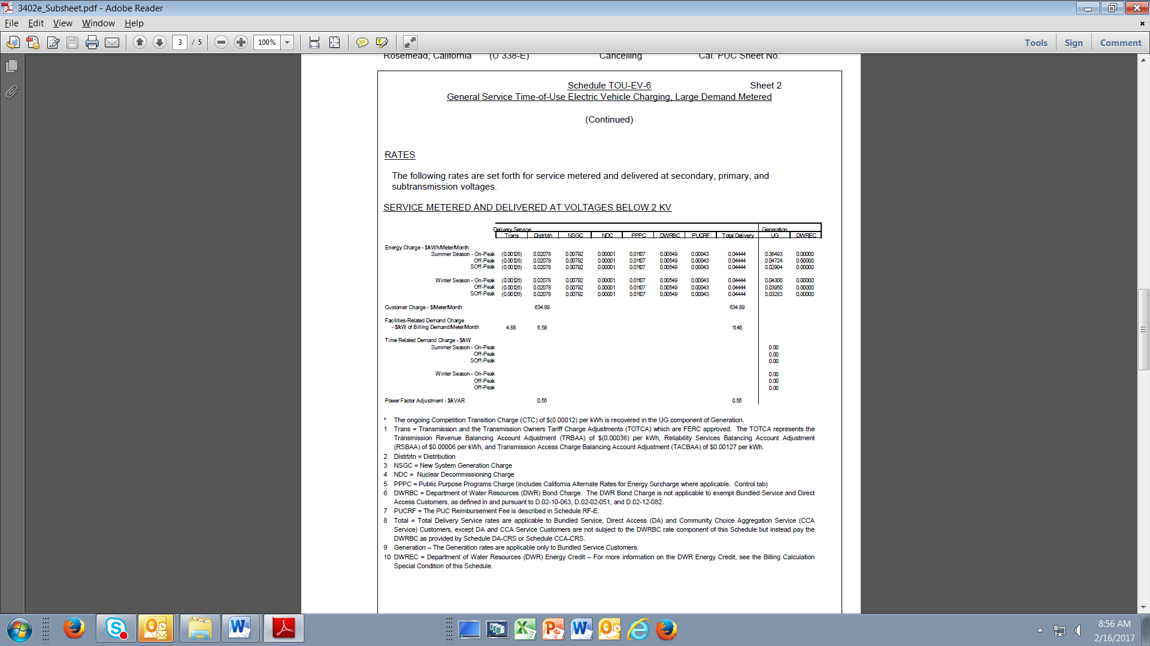

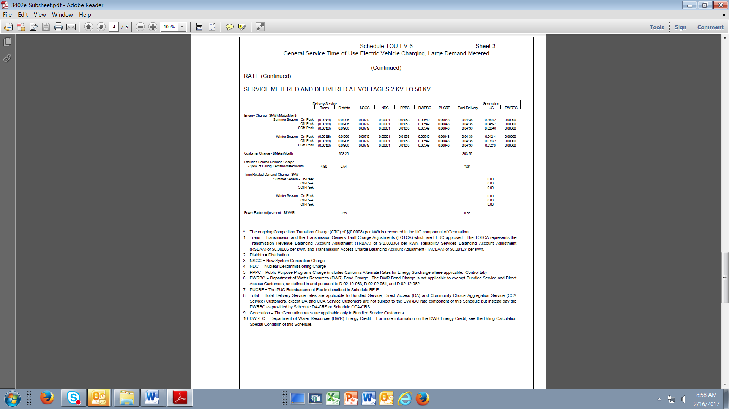

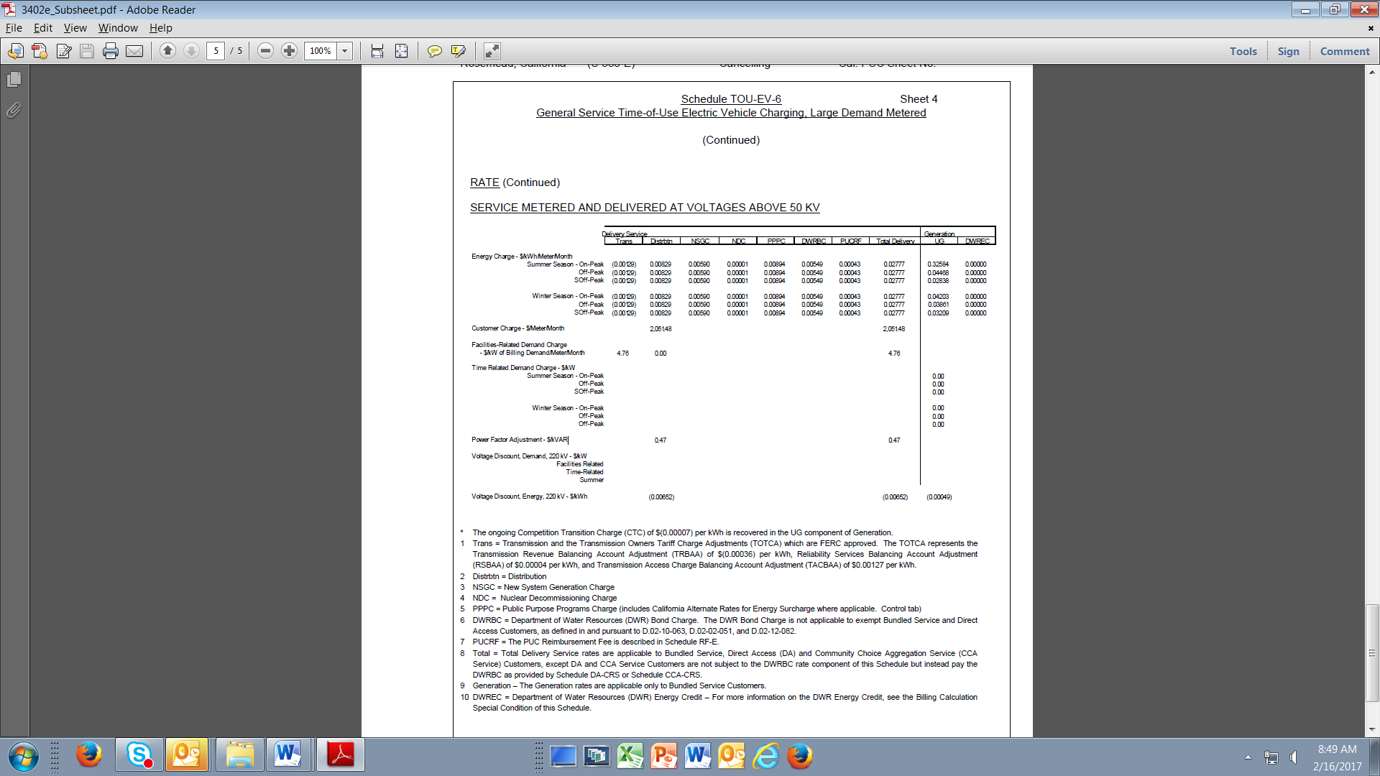

**Appendix B: SCE’s Approved & Proposed Commercial Rates for Separately-Metered EV Charging**

| Rate | Status | Demand | TOU Periods | Features |
| --- | --- | --- | --- | --- |
| TOU-EV-3 | Approved | ≤ 20kW | On-Peak: noon – 6 pm, weekdays except holidays  Mid-Peak: 8 am –noon; 6 pm – 11 pm, weekdays except holidays  Off-Peak: 11 pm – 8 am | Option B of this rate includes demand charges where the TOU-EV-3 account is only charged incremental Facilities-Related Demand (FRD) charges when the account registers a demand greater than the primary account |
| TOU-EV-4 | Approved | > 20 kW and  ≤ 500kW | On-Peak: noon – 6 pm, weekdays except holidays  Mid-Peak: 8 am –noon; 6 pm – 11 pm, weekdays except holidays  Off-Peak: 11 pm – 8 am | This rate includes demand charges where the TOU-EV-4 account is only charged incremental FRD charges when the account registers a demand greater than the primary account |
| TOU-EV-6 | Proposed in AL 3402-E | > 500kW | On-Peak: 2 pm – 8 pm, weekdays except holidays  Super Off-Peak: 10 pm – 8 am  Off-Peak: All other hours | This rate includes demand charges where the TOU-EV-6 account is only charged incremental FRD charges when the account registers a demand greater than the primary account |
| TOU-EV-7 | Proposed in A.17-01-021 | ≤ 20kW | Winter (Oct-May)  Off-Peak: 9pm – 8am  Super-Off-Peak: 8am – 4pm  Mid-Peak: 4pm – 9pm  Summer (June-Sept)  Off-Peak:9pm– 4pm, weekdays & weekends  On-Peak: 4pm– 9pm, weekdays  Mid-peak: 4pm – 9pm, weekends | The rate will phase in demand charges over a 10-year period. Five year introductory period with no demand charge, only volumetric TOU energy charge and customer charges. In years 6-10, SCE will phase in demand charges by initiating and increasing the facilities-related demand charge by 10% each year. In year 11, the schedule will reflect stable demand charges that collect 60% of all distribution capacity costs; the remaining 40% will be collected through TOU energy charges. |
| TOU-EV-8 | Proposed in A.17-01-021 | > 20 kW and  ≤ 500kW | Same as TOU-EV-7 | Same as TOU-EV-7 |
| TOU-EV-9 | Proposed in A.17-01-021 | > 500kW | Same as TOU-EV-7 | Same as TOU-EV-7 |

**Appendix C: Proposed Non-Residential TOU Periods in SCE’s Rate Design Window Application (A.16-09-003)**



1. Zero-emission vehicle technologies include hydrogen fuel cell electric vehicles and plug-in electric vehicles, which include both pure battery electric vehicles and plug-in hybrid electric vehicles.
2. Available at: <https://www.gov.ca.gov/docs/2016_ZEV_Action_Plan.pdf>.
3. Chapter 547, Statutes of 2015.
4. Guidance was adopted in D.16-11-005.
5. Tariff is available at: <https://www.sce.com/NR/sc3/tm2/pdf/ce360.pdf>.
6. Tariff is available at: <https://www.sce.com/NR/sc3/tm2/pdf/ce114-12.pdf>.
7. Tariff is available at: <https://www.sce.com/NR/sc3/tm2/pdf/ce116-12.pdf>.
8. Tariff is available at: <https://www.sce.com/NR/sc3/tm2/pdf/ce141-12.pdf>.
9. Available at: <http://docs.cpuc.ca.gov/PublishedDocs/Published/G000/M033/K911/33911865.PDF>.
10. Tariff is available at: <https://www.sce.com/NR/sc3/tm2/pdf/ce143-12.pdf>.
11. According to D.08-07-045:

    “The Commission articulated a comprehensive demand response policy in its 2003 Vision Statement. In that statement, the Commission stated that electric customers should have “the ability to increase the value derived from their electricity expenditures by choosing to adjust usage in response to price signals”… Prior to the 2003 Vision Statement, virtually all large customers had moved to time-of-use (TOU) rates. … The different [time-varying] rates reflect the fact that it is generally more expensive to serve customers during some time periods.”

    Following D.08-07-045, D.11-11-008 et seq. mandated that all non-residential customers transition to time-varying rates. Subsequently, enabled by the enactment of AB 327 (2013), D.15-07-001 set forth a path to residential default TOU rates by 2019.
12. See, for example, D.17-01-006 Findings of Fact Nos. 1, 6, 15, 17, and 18, and the Commission’s Distributed Energy Resource Action Plan, available at: <http://www.cpuc.ca.gov/uploadedFiles/CPUC_Public_Website/Content/About_Us/Organization/Commissioners/Michael_J._Picker/2016%20DER%20Action%20Plan%20FINAL.pdf>.
13. A.16-09-003, available here: <http://docs.cpuc.ca.gov/PublishedDocs/Efile/G000/M166/K502/166502217.PDF>.
14. A.16-09-003 at 7.
15. A.16-09-003 at 8.
16. Available at: <http://docs.cpuc.ca.gov/PublishedDocs/Efile/G000/M157/K905/157905349.PDF>.
17. Available at: <http://docs.cpuc.ca.gov/PublishedDocs/Published/G000/M155/K761/155761036.pdf>.
18. D.17-01-006 Findings of Fact 4, 5, and 6.
19. D.15-11-013 (PG&E) and D.14-12-048 (SCE).
20. A.15-04-012 (SDG&E), A.16-06-013 (PG&E), and A.16.09-003 (SCE).