PUBLIC UTILITIES COMMISSION OF THE STATE OF CALIFORNIA
Agenda ID 15637
ENERGY DIVISION RESOLUTION E-4847
May 11, 2017

RESOLUTION

Resolution E-4847. Adoption of Southern California Edison Company’s residential default time-of-use pricing pilot pursuant to Decision 15-07-001.

PROPOSED OUTCOME:
- Adopts Southern California Edison’s (SCE’s) Residential Default Time-of-Use (TOU) Pilot with modifications.

SAFETY CONSIDERATIONS:
- There is no impact on safety.

ESTIMATED COST:
- The cost of SCE’s default TOU pricing pilot is estimated to be up to $21.1 million. These costs shall be recorded and recovered as detailed in this Resolution.

By Advice Letter 3531-E filed on December 16, 2016 and 3531-E-A filed on February 24, 2017.
__________________________________________________________

Summary
On December 16, 2016, Southern California Edison Company (SCE) filed its Proposed Default Time-of-Use (TOU) Pilot advice letter (advice letter) in accordance with Decision (D.) 15-07-001 (the Decision) and an Administrative Law Judge (ALJ) Ruling issued on December 29, 2015 in Rulemaking
(R.) 12-06-013. The advice letter sets out SCE’s plan to default approximately 400,000 residential customers onto TOU rates in March 2018. SCE will submit a Rate Design Window (RDW) application no later than January 1, 2018 for a default residential TOU rate and a menu of optional TOU rates. The results of this default pilot are expected to inform the resolution of that application and SCE’s subsequent default of all eligible residential customers onto TOU rates. According to the advice letter, SCE’s proposed default pilot includes the following elements:

- Pre-default notifications will be sent to 400,000 eligible residential customers, and those who do not opt-out will be defaulted onto one of two default TOU rates (Default Rate 1 or Default Rate 2) over a two- to three-week period beginning in March 2018.
- The pilot study period will begin in March 2018 and continue for one year. Customers will remain on their default TOU rate at the end of the pilot study period unless they are removed from the pilot due to ineligibility or choose to opt-out. Customers are free to opt-out at any time prior to, during, or after the pilot study period.
- Customers will receive bill protection for 12 months from the date that they are enrolled onto Default Rate 1 or Default Rate 2 or up to the date that they are unenrolled from the default TOU rate, whichever occurs first.
- Default Rate 1 will have a summer weekday peak period from
4-9pm. The summer peak to off-peak price (POPP) ratio will be approximately 1.8:1 for usage above baseline.
- Default Rate 2 will have a summer weekday peak period from
5-8pm. The summer peak to off-peak price (POPP) ratio will be approximately 2.1:1 for usage above baseline.
- SCE will test a variety of marketing, education and outreach (ME&O) materials.

SCE’s default pilot will gather information on:

- SCE’s operational readiness to default large numbers of customers onto TOU rates over a short time. This will include testing and/or an assessment of call volumes, billing exception processing, database capabilities, tracking systems, rate change and bill processing, system enhancements, and bill protection processing.
- The impact of different ME&O strategies on awareness of rate options, engagement with the TOU rate and customer perceptions while on a TOU rate. At a minimum, SCE will test multiple versions of pre-default notifications, welcome communications and seasonal communications.
- The average peak and off-peak change in energy usage by customers enrolled on Default Rate 1 and 2.
- The bill impacts for customers enrolled on Default Rate 1 and 2.
- The opt-out rate for customers defaulted onto Default Rate 1 and 2.
- The impact of tools such as level payment plans (LPP) on customer retention on Default Rate 1 or 2 and load, bills and perceptions while on their default TOU rate.

This information must be collected in the evaluation and analysis of SCE’s default pilot. SCE is ordered to ensure that the deliverables as outlined in this Resolution are collected through the default pilot and are presented in the proceeding to resolve SCE’s RDW application. SCE’s advice letter also contains a request for authorization of default pilot study costs as required by the Decision.
As discussed in detail below, SCE’s advice letter, as modified herein, fulfills the requirements of the Decision and is expected to lead to the collection of the deliverables outlined in this Resolution. This Resolution adopts SCE’s Default TOU Pilot with modifications.

Background
Public Utilities (P.U.) Code § 745 establishes the conditions for implementing default TOU rates for residential electricity customers. The Decision established the pathway toward default TOU rates for all eligible residential electricity customers of California’s investor-owned utilities (SCE, Pacific Gas & Electric Company (PG&E), San Diego Gas & Electric Company (SDG&E), collectively the “IOUs”) in 2019, which includes a requirement that the IOUs conduct both opt-in and default TOU pilots.

Per the Decision’s instructions, the IOUs formed a TOU Working Group (Working Group) to develop study parameters and pilot design. The Working Group collectively selected a consultant to inform its work on TOU pilot design, and has met frequently since September 2015. SCE’s opt-in TOU pilots were the result of this collaboration and were approved in Resolution E-4761.

SCE enrolled approximately 20,000 customers onto its opt-in TOU pilots, which began in June 2016. Customers were enrolled onto one of three TOU rates (treatment customers) or remained on the tiered rate (control customers). These pilots are comparing the load and bills between treatment and control customers, as well as their responses to an extensive survey. The findings from the opt-in TOU pilots will inform the Commission’s decisions related to Section 745(c)(2), as well as provide valuable information regarding customers’ understanding, acceptance and engagement while taking service on a given TOU rate.

The Decision required a default pilot, in addition to opt-in pilots, to “study aspects of TOU that are directly impacted by self-selection bias, and to fine-tune customer education and test system operability prior to full rollout of default TOU.” The Working Group and its consultant collaborated on default TOU pilot design, and the final report of the consultant to the Working Group (consultant report) is attached to SCE’s advice letter. The consultant report heavily informed SCE’s default TOU pilot design. We expect the Working Group will remain extant to consider ongoing implementation issues related to the default pilot, further development of the monitoring and evaluation (M&E) plan for the default pilot, and the preparation of PG&E’s RDW application.

Notice
Notice of AL 3531-E and 3531-E-A was made by publication in the Commission’s Daily Calendar. SCE states that a copy of the Advice Letter was mailed and distributed in accordance with Section 4 of General Order 96-B, and was also served on the R.12-06-013 service list.

Protests
SCE’s Advice Letter AL 3531-E was timely protested by Environmental Defense Fund (EDF), the City of Lancaster, the Office of Ratepayer Advocates (ORA) and the Utility Reform Network (TURN). SCE responded to the protests of EDF, Lancaster, ORA and TURN on February 7, 2017.

Discussion
Energy Division has reviewed AL 3531-E and 3531-E-A and finds that SCE’s Proposed Default TOU Pilot fulfills the requirements outlined in D.15-07-001 and other direction provided in R.12-06-013, subject to certain modifications as discussed below.

Sample Size
SCE currently estimates that 3,300,000 residential customers are eligible for default TOU. In order to transition this volume of customers onto expeditiously, SCE estimates that it would need to transition customers at a rate of approximately 500,000 customers per month.

Per the Decision, a primary purpose of the default pilot is to “test system operability prior to full rollout of default TOU.” Thus, the default pilot will mimic the volume of rate changes SCE anticipates needing to perform in the full default rollout. SCE will send pre-default notifications to 400,000 eligible residential customers, and default those who do not opt-out over a two- to three-week period beginning in March 2018. SCE will test and/or assess call volumes, billing exception processing, database capabilities, tracking systems, rate change and bill processing, system enhancements, and bill protection processing. SCE’s proposed sample size is adequate to fulfill this pilot objective.

Rate Design
SCE proposes to default half of the pilot customers onto Default Rate 1, and the other half of pilot customers onto Default Rate 2 (and their California Alternate Rates for Energy (CARE) counterparts). Default Rate 1will have a summer weekday peak period from 4-9pm. Default Rate 2 will have a summer weekday peak period from 5-8pm.

Other elements of the rate structures and illustrative pricing (for non-CARE customers) are provided below.

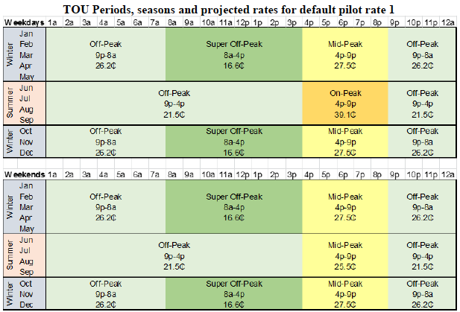

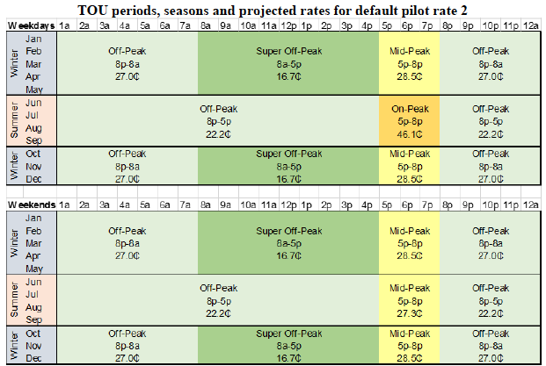

Default Rate 1 has a summer POPP ratio of approximately 1.8:1 for usage above baseline. Default Rate 2, with its shorter peak period, has a slightly higher summer POPP ratio of approximately 2.1:1 for usage above baseline. Both rates will have a projected baseline credit of 7.7 cents/kWh. The midday super-off peak period in the winter and spring for both rates is reflective of the low marginal energy costs during those hours due to an abundance of renewable energy at those times.

SCE states that if its proposed rates were completely cost-based, the difference in the average rate between summer and winter would be approximately
6 cents/kWh for both rates. However, as it did with the transition to TOU rates for its small commercial customers, SCE moderated the seasonal differential by designing the rates to recover some of the summer generation costs in the winter. Thus, as proposed, the difference in average rate between summer and winter is down to approximately 2 cents/kWh for both rates. This change is intended to reduce bill volatility.

SCE’s two proposed default TOU rates have been sufficiently moderated from fully cost-based and therefore fit the Decision’s criteria for an initial default “TOU Lite” rate and are approved. The load impact, bill impact and customer perception findings from SCE’s default pilot will help SCE to determine which of the two rates to use as the default rate in its full default rollout.

In its protest, EDF argues that the scope and objectives of SCE’s default pilot are too narrowly defined and that the pilot should additionally be testing how different TOU rates impact customers’ interest in distributed energy resources (DERs).

In its reply to EDF’s protest, SCE states that it does not disagree with EDF’s goals, but that they are impractical at this stage of the transition to TOU rates. SCE states that it will be offering other TOU rates to customers, but that technology-based proposals should not be tested in this pilot. However, SCE is open to considering more innovative pricing strategies in the future.

We disagree with EDF that the default pilot is the appropriate venue to test rate designs that impact the value proposition of DERs. The types of rates likely to provide the value proposition for DERs (shorter peak period, larger differences between period prices) do not fit the criteria of an initial default “TOU Lite” rate. As EDF itself states, there are other ongoing pilots in which such rates are being considered. Furthermore, SCE’s POPP ratio proposals are but two considerations of many rate designs in the default TOU development process. We encourage EDF to engage in those efforts and to look for other opportunities to continue this exploration.

Exclusions from the Default Pilot
Section 745 describes certain categories of customers that may not be defaulted onto TOU rates, customers that the Commission may elect to default or not, subject to certain considerations, and conditions that must be met before customers can be defaulted onto TOU rates. In addition, SCE proposes to exclude additional customers due to operational considerations.

Section 745(c)(1)
Section 745(c)(1) describes three categories of customers that may not be defaulted onto TOU rates: customers receiving a medical baseline allowance, customers requesting third-party notification and customers requiring an
in-person visit from a utility representative prior to disconnection.

SCE is able to identify the customers that fall into one of these categories in its Customer Service System (CSS), and thus, these customers are easily excluded from default TOU. SCE will be partnering with external agencies including Community Based Organizations (CBOs) and local governments to increase awareness of the medical baseline program and the other two offerings. SCE will also include language in its pre-default notifications that customers should contact SCE through its call center if they believe they qualify for one of the aforementioned categories.

The suggested processes are sufficient to guard against the unintentional inclusion of these customers in the default pilot.

Section 745(c)(2)
Section 745(c)(2) requires that the Commission “ensure that any time-of-use rate schedule does not cause unreasonable hardship for senior citizens or economically vulnerable customers in hot climate zones.” The Commission defined “senior citizens” as any person 65 years of older. For the purposes of 745(c)(2), the Commission will consider any customer whose household includes a senior citizen who is a full-time permanent occupant of the household. The senior citizen need not be the customer of record. The Commission defined “economically vulnerable customers” as any customer who is eligible for the CARE or Family Electric Rate Assistance (FERA) program even if that customer is not enrolled.

SCE’s opt-in TOU pilot was specifically designed to provide the Commission with the information necessary to determine whether or not TOU rates cause unreasonable hardship for these two groups of customers. The Scoping Ruling lays out the process for considering the evidence and anticipates issuing a Decision in September 2017, prior to the start of the default pilot.

D.16-09-016 required the IOUs to work with the Working Group to develop processes for identifying and excluding these customers, should the Commission decide that it is necessary to do so. SCEE and the Working Group reached consensus on the processes below for the default pilot.

- Customers enrolled in CARE or FERA
SCE can identify customers enrolled in CARE or FERA in its customer service system and can easily exclude existing CARE and FERA customers in the hot climate zone.
- Customers eligible for, but not enrolled in CARE or FERA
SCE has an existing quarterly direct mailer campaign that targets potential CARE/FERA eligible customers for enrollment in these programs. SCE will leverage this mailer to increase enrollment in the hot climate zone. Beginning with its spring 2017 mailer, SCE will target a higher number than usual of hot climate zone customers. Customers in the hot climate zone who enroll will be excluded from the default pilot.
- Households with senior citizen(s)
SCE has access to third party demographic data from the firm Axciom. If this data shows that a customer’s household has any senior citizens then those customers will be excluded. This exclusion only applies to customers in the hot climate zone.

The proposed processes are sufficient to guard against the unintentional inclusion of these customers in the default pilot.

Section 745(c)(4)
Section 745(c)(4) requires that a customer be “provided with not less than one year of interval usage data from an advanced meter and associated customer education.” SCE can identify customers without 12 month of interval usage data in its CSS and will ensure that none of these customers will be selected for the default pilot. SCE will provide all customers in the default pilot with a rate comparison in their pre-default notification, thus fulfilling the second part of the requirement.

Community Choice Aggregator
SCE currently has one Community Choice Aggregator (CCA) operating within its service territory – the City of Lancaster (City). CCA customers are not subject to default TOU, and can only be defaulted onto TOU rates if their CCA provider elects to do so. The City has indicated that it will not participate in the default pilot, but is still considering whether or not it intends to participate in the full default rollout. Thus, SCE will exclude the City’s customers from the default pilot. Should any other CCAs form ahead of the default pilot, those CCA customers will be also be excluded from the default pilot.

Other Exclusions
Finally, SCE proposes to exclude certain other categories of customers, including customers already on a TOU rate, customers accepted into the opt-in TOU pilots, smart-meter opt-out customers, customers without a TOU meter, master-metered customers and direct access customers.

Default TOU is aimed at customers not already on a TOU rate, so it is reasonable to exclude those customers. The Working Group agreed that customers accepted into the opt-in TOU pilots should not be made to participate in another pilot. We agree, and additionally note that these customers are no longer representative of the typical default customer. Smart-meter opt-out customers and customers without a TOU meter would be excluded anyway under Section 745(c)(4), due to insufficient interval usage data. Master-metered customers will not see or experience the TOU price signals and direct access customers do not receive their generation service from SCE. Thus, these exclusions are also reasonable.

Section 745(d)
Section 745(d)(1) and 745(d)(2) require that the Commission consider whether or not default TOU rates will cause hardship to “customers located in hot, inland areas, assuming no changes in overall usage by those customers during peak periods” and “[r]esidential customers living in areas with hot summer weather, as a result of seasonal bill volatility, assuming no change in summertime usage or in usage during peak periods.”

For the purposes of 745(d)(1), the Working Group concluded that “hot climate zone” and “hot inland areas” cover the same geographic area in SCE’s service territory. This includes SCE regions 13, 14 and 15. However, based on an analysis of regions where the temperature reached 98 degrees on ten or more days during the summer (June, July, August September) in each of the past three years, the Working Group decided that for the purposes of 745(d)(2), “areas with hot summer weather” additionally includes SCE region 10.

In its protest, TURN argues that the Commission cannot reach conclusions on Section 745(d) based only on the bill impact analyses of the proposed TOU rates. TURN argues that these analyses are insufficient for the Commission to reach conclusions concerning the potential hardship of TOU rates that are significantly different from the default pilot rates.

In its reply to TURN’s protest, SCE agrees that the Commission should not reach conclusions on Section 745(d) based only on the bill impacts provided in
AL 3531-E. SCE states that the Commission must consider opt-in TOU pilot findings before it can make any decisions with regards to Section 745.

We agree with TURN that the analyses provided in AL 3531-E are insufficient to consider the hardship from the potential bill impacts and bill volatility of SCE’s default pilot rates and rates that differ significantly from those rates. The Commission will consider the hardship from the potential bill impacts and bill volatility of different rate options alongside any relevant information from the opt-in TOU pilots in Phase 3 of R.12-06-013.

Removal from the Default Pilot
Eligible customers who are selected to participate in the default pilot may opt-out at any time prior to, during or after the default pilot study period. They may go back to the tiered rate or choose another available rate option.

Default pilot customers who terminate service with SCE will be automatically removed from the default pilot.

Default pilot customers who move and transfer service to another premise within SCE’s service territory will also automatically be removed from the default pilot and be put back on the tiered rate. This is reasonable for purposes of the default pilot. The Commission will consider treatment of these customers for the full default rollout in Phase 3 of R.12-06-013.

It is worth noting particular customers who will not be automatically removed from the pilot. If, in the course of the default pilot, customers’ situations change such that they meet one of the criteria described in Section 745(c)(1), they will not be automatically removed from the default pilot. Instead, the customer will be given the option to stay on the default TOU rate, to go back to the tiered rate or to choose another available rate option. These customers (and all other default pilot customers) will receive up to 12 months of bill protection, as described in the subsequent section. This approach maximizes customer choice and is appropriate.

Bill Protection
Section 745(c)(4) requires that customers defaulted onto a TOU rate receive one year of bill protection, such that the “total amount paid by the residential customer for electric service shall not exceed the amount that would have been payable by the residential customer under that customer’s previous rate schedule.”

SCE proposes only to default those customers currently on the tiered rate. Thus, SCE will compare the amount that customers pay on Default Rate 1 or 2 against the amount they would have paid on the tiered rate. If the customer would have paid less on the tiered rate, the customer will be credited the difference.

SCE will make this calculation at the time a customer is unenrolled from the default TOU rate, or 12 months after a customer begins service on Default Rate 1 or 2, whichever occurs first. As stated in the previous section, customers may leave or be automatically removed from the default pilot for numerous reasons.

Section 745(c)(4) only requires that bill protection be provided to those customers defaulted onto a TOU rate. However, a question arose in the Working Group regarding bill protection for those customers excluded from default TOU (per Section 745 or Commission direction) who nonetheless elect to participate in TOU. Per ALJ Ruling, bill protection shall be provided to any customer who opts-in to Default Rate 1 or 2, on or before the last day of the default pilot period. This expansion of the bill protection provision guards against the anomalous result in which vulnerable customers ineligible for default TOU, who nonetheless elect to participate in TOU, would be ineligible for a consumer protection afforded non-excluded customers.

This expansion applies to all customers who opt-in to Default Rate 1 or 2, regardless of whether or not the tiered rate was their previous rate schedule. Bill protection will be calculated for these customers in the same manner as for customers who move from the tiered rate to Default Rate 1 or 2, meaning that, even if customers opt-in to Default Rate 1 or Default Rate 2 from a different TOU rate, SCE will compare the amount the customers paid on Default Rate 1 or 2 rate against the amount they would have paid on the tiered rate, not their former TOU rate.

Bill Protection Revenue Shortfall
SCE estimates a revenue shortfall of $10.5 million related to providing bill protection. These shortfalls will occur across generation and distribution revenues and will be recorded in SCE’s Base Revenue Requirement Balancing Account, which includes both generation and distribution sub-accounts. Generation revenue shortfalls will be recovered across all of SCE’s residential generation customers and distribution revenue shortfalls will be recovered across all of SCE’s residential distribution customers.

In its protest, ORA requests more information on the projected revenue shortfalls associated with bill protection payments and load shifting, and the estimated cost savings resulting from load shifting. It its reply to ORA’s protest, SCE states that it provided estimates of revenue deficiency due to bill protection to the Working Group, of which ORA is a member. SCE also states that any revenue deficiency related to load shifting would be small.

We find that SCE has provided sufficient documentation to support its projected revenue shortfall of $10.5 million. We also find that estimates of revenue shortfalls and/or cost savings due to load shifting can be better assessed after the results from the opt-in TOU pilots are in.

Marketing, Education and Outreach
SCE states that its primary marketing objectives for the default pilot are to:

- Ensure that customers have support and easy access to timely and effective information in their transition to default TOU to ensure retention and to minimize customer effort.
- Prepare customers to understand TOU rate changes and make them aware that they have rate choices during the implementation period.
- Communicate directly and personally by sharing anticipated bill impact information for individual customers and recommend specific mitigation tools that will help to reduce negative impact.

To achieve the above objectives, SCE proposes to provide customers with pre-default notifications, welcome communications, seasonal communications, end-of-bill protection notices and other ME&O materials from across SCE’s other business areas not specific to TOU. In order to achieve the Decision’s purpose for the default pilot of “fine-tun[ing] customer education… prior to [the] full default rollout,” SCE proposes to test a number of variations of the aforementioned communications. These tests will help SCE to determine the best ways to meet its stated marketing objectives.

For example, SCE’s pre-default notifications will vary by granularity of the rate comparison information provided (annual and seasonal or monthly) and message content. SCE’s post-default communications will vary by content (“Basic” or more information based vs. “Enhanced” or more stylistic).

In order to address the seasonal bill volatility associated with TOU rates, SCE proposes to promote its level payment plan (LPP) program to a subset of customers as a part of its welcome communication. SCE states that it will target its LPP promotion to “income-constrained customers expected to experience greater monthly bill variation under TOU.”

SCE has not yet determined the exact messaging and design for its ME&O materials and will consider the results of current and future planned customer research in creating the final ME&O materials.

In its protest, EDF states that SCE should consider a broader set of customer attributes, such as the shape of the diurnal load and history of other energy interventions, and how these attributes vary between benefiters and non-benefiters, when determining which mitigation strategies to target at each customer. In its protest, the City of Lancaster states that SCE’s ME&O plan for the default pilot does not include a specific plan for CCA customers, and is concerned that CCA customers may think that SCE’s ME&O messages also apply to them.

In its reply to the City of Lancaster, SCE clarifies that pilot related communications will only be sent to customers eligible for and selected to participate in the default pilot. Since the City of Lancaster has chosen not to participate in the default pilot, SCE states that it would cause confusion if the City’s customers nonetheless received default pilot communications. SCE states that it is more appropriate to consider ME&O for CCA customers as a part of its ME&O plan for the full default TOU rollout (AL 3500-E).

We agree with EDF that SCE’s proposed ME&O strategies require further refinement. We find that SCE is testing a multitude of variations in its pre-default notifications and welcome communications, but that minimal variation is currently planned for seasonal communications. We order SCE to test persona based targeted messaging against non-targeted messaging as part of its summer seasonal communication.

We agree with SCE that default pilot communications should not be sent to the City’s CCA customers, as they are not participating in the default pilot. We encourage the City to work with SCE to ensure that MEO for the full default TOU rollout does not confuse CCA customers. This refinement is necessary, regardless of whether or not the City chooses to participate in the full default rollout.

We direct SCE to collaborate with Energy Division and the Working Group to finalize its ME&O collateral and strategies. We further direct SCE to file a Tier 2 advice letter with the final testing plan by November 1, 2017 and to include copies of all marketing collateral in its quarterly Progress on Residential Rate Reform reports.
SCE’s objectives for its ME&O are appropriate and its proposed tests for its communications materials are expected to provide valuable information to inform the ME&O for the full default rollout. The measurement and evaluation of SCE’s proposed tests is discussed below.

Metrics and Measurement & Evaluation
The default pilot will require extensive ex post measurement and evaluation (M&E) to ensure that SCE is prepared for the full default rollout, to identify aspects of the default pilot that worked well and to identify areas that require changes or augmentation. SCE’s advice letter and the consultant report attached to the advice letter begin the process of detailing the metrics by which the pilot will be assessed and the associated M&E activities needed to gather information on those metrics.

For instance, SCE proposes the metrics and M&E activities below to assess its ME&O approaches:

Directly Observable:
- Rates and timing of opt-out from default TOU;
- Selection of alternative rate options;
- Utilization of opt-out communication channels;
- Call volumes and inquiry and complaint patterns;
- Offer acceptance (e.g., LPP);
- Program enrollment and tool utilization (e.g., My Account);
- Retention on TOU rates; and
- Changes in customer payment patterns (e.g., propensity to go into arrears).

Through Customer Surveys:
- Customer awareness;
- Customer satisfaction;
- Other perceptions issues, such as fairness;
- (Reported) changes in usage behavior;
- Demographics; and
- Experience on the rate, such as increased hardship

Additionally, SCE proposes to measure load and bill impacts. SCE will provide load and bill impact results from the first summer by fall 2018, but thereafter would report its load and bill impacts through the Demand Response Measurement and Evaluation Committee’s annual April 1 filings.

SCE proposes to assess its operational readiness for the full default rollout by tracking and monitoring metrics such as time required to process rate change requests, volume of billing exceptions and call center volumes.

In its protest, ORA requests that the Commission adopt metrics to assess the default pilot’s effectiveness and success, and that the Commission consider SCE’s performance on these metrics as a part of its reasonableness review.

In its reply to ORA’s protest, SCE recommends that if the Commission adopts any metrics to assess the default pilot’s success, that they only be one factor in the Commission’s reasonableness review of SCE’s default pilot expenditures.

We agree with ORA that we should define metrics by which to assess the default pilot. We find that SCE’s proposed areas of evaluation and M&E activities for load and bill impacts and operational readiness are appropriate to assess the default pilot. We direct SCE to work with the Energy Division and the Working Group to define the customer segments for whom load and bill impacts are desired, and to further enumerate the metrics used to assess operational readiness.

With respect to the various ME&O approaches being tested, we find value in harmonizing the customer research activities across the IOUs. Therefore, we direct SCE to work closely with Energy Division, the Working Group and the other two IOUs to further refine, and harmonize across the three IOUs, the metrics and M&E activities required to assess the various ME&O approaches.

While these measures will help to gauge the success of the default pilot, their primary purpose is to inform the operational requirements and ME&O needed for the subsequent rollout of default TOU to the remainder of eligible residential customers. Thus, we decline to tie default pilot cost recovery to achievement on these metrics.

Budget and Cost Recovery
SCE estimates default pilot implementation costs of approximately $10.6 million over the period of 2016-2019, and proposes to record these costs in its RRIMA.

SCE additionally estimates a revenue shortfall of $10.5 million related to providing bill protection.

In its protest, ORA requests that SCE provide detailed cost information (budgeted and actual costs incurred) on a quarterly basis to aid in tracking and reasonableness review of SCE’s default pilot costs. ORA also seeks information regarding SCE’s accounting practices, to ensure that default pilot expenses are recorded in a transparent manner that facilitates future reasonableness review, and that prevents default pilot costs from being mistaken as part of the GRC revenue requirement. ORA wants SCE to provide a more detailed budget, and clarification on how the requested expenditures align with or are incremental to requests made in other recent filings in R.12-06-013.

In its protest, the City of Lancaster states that some of the SCE’s default pilot costs are related to generation, and is concerned that all of SCE’s pilot costs will be recovered through distribution rates, rather than being partially allocated to generation.

In its reply to ORA’s protest, SCE states that it will continue to provide its costs to date in its quarterly PRRR reports. SCE states that it will seek recovery of its Rate Reform Implementation Memorandum Account (RRIMA) as a part of the Energy Resource Recovery Account (ERRA) Review proceeding, and that stakeholders can assess SCE’s expenditures for reasonableness at that time. SCE also provided a more detailed budget, including a breakout of costs by month and associated milestone or activity, in a supplement 3531-E-A.
We agree with ORA that a detailed budget provides a necessary baseline against which to conduct future reasonableness review of expenditures. SCE’s budget filed in supplemental 3531-E-A provides a sufficient level of detail. We order SCE to track actual expenditures to date against its estimated costs as part of its PRRR reports, using each of the line item categories highlighted in the attached budget (Attachment 1), separating default pilot costs from opt-in TOU pilot costs where applicable. These reports and level of detail will better enable reasonableness review of SCE’s default pilot expenses.

We find that it is appropriate for SCE to record default pilot implementation costs in its RRIMA, which is intended to track pilot related costs. However, any generation revenue shortfall related to bill protection should only be collected from SCE’s generation customers. SCE will record generation and distribution revenue shortfalls in its Base Revenue Requirement Balancing Account, which includes both generation and distribution sub-accounts. Generation revenue shortfalls will be recovered across all of SCE’s residential generation customers and distribution revenue shortfalls will be recovered across all of SCE’s residential distribution customers.

While termed a “pilot,” we note that this is really the first step towards defaulting the entire eligible residential class onto TOU rates. Thus, some of the operational and system improvements required for the default pilot will also serve SCE for the full default rollout.

Other Issues Raised by Parties
In its protest, EDF states that SCE should be prepared to apply findings from other pilots that occur prior to 2018, such as the Distribution Resources Plan (DRP) demonstrations and the Demand Response Auction Mechanism, to the default pilot.

In its reply to EDF’s protest, SCE states that it is open to incorporating findings from other pilots into the default pilot.

We agree with EDF that SCE should look to incorporate findings from other relevant pilots into the default pilot. SCE should also keep Energy Division and the Working Group apprised of any applicable findings from other pilots.

Comments
Public Utilities Code section 311(g)(1) provides that this resolution must be served on all parties and subject to at least 30 days public review and comment prior to a vote of the Commission. Section 311(g)(2) provides that this 30-day period may be reduced or waived upon the stipulation of all parties in the proceeding.

The 30-day comment period for the draft of this resolution was neither waived nor reduced. Accordingly, this draft resolution was mailed to parties for comments, and will be placed on the Commission's agenda no earlier than
30 days from today.

Findings
- D.15-07-001 (the Decision) and the Administrative Law Judge’s Ruling (Ruling) of December 19, 2015 directed Southern California Edison Company (SCE) to file an Advice Letter proposing a default time-of-use (TOU) pilot for its residential customers.
- SCE will submit a Rate Design Window (RDW) application no later than January 1, 2018 for a default residential TOU rate and a menu of optional TOU rates.
- SCE estimates that 3,300,000 residential customers are currently eligible for default TOU.
- SCE will default approximately 400,000 residential customers in its default pilot to test its operational readiness to default the remainder of residential customers to TOU rates.
- SCE will default customers onto either Default Rate 1 or 2.
- Default Rate 1 has a 4-9pm peak period on summer weekdays and a peak to off-peak (POPP) ratio of approximately 1.8:1 in the summer for usage above baseline.
- Default Rate 2 has a 5-8pm peak period on summer weekdays and a peak to off-peak (POPP) ratio of approximately 2.1:1 in the summer for usage above baseline.
- California Public Utilities Code Section 745 requires that certain customers be excluded from default TOU. SCE will exclude these customers from its default pilot. SCE will also exclude certain other customers in addition to the statutory exclusions.
- Customers may opt-out of default TOU at any time.
- Customers may be removed from the default TOU rates if they become ineligible for default TOU.
- Customers defaulted onto Default Rate 1 or 2 or who opt-in to Default Rate 1 or 2 will receive up to 12 months of bill protection.
- SCE will test variations of marketing, education and outreach (ME&O) materials
- SCE will promote its Level Payment Plan (LPP) program to a subset of customers.
- SCE will measure load and bill impacts of the default TOU rate.
- SCE will assess call volumes, billing exception processing, database capabilities, tracking systems, rate change and bill processing, system enhancements, and bill protection processing in order to determine its operational readiness for the full rollout of default TOU.
- SCE will conduct customer research to determine the appropriate ME&O options to use for the full rollout of default TOU.
- SCE will record default pilot implementation expenses in its Rate Reform Implementation Memorandum Account (RRIMA).
- SCE will track revenue shortfalls related to bill protection by component (generation or distribution).

Therefore it is ordered that:
- SCE’s Default TOU Pilot advice letter (AL 3531-E and 3531-E-A) is approved as modified herein.
- SCE is ordered to ensure that the deliverables as outlined in this Resolution are presented as part of its Rate Design Window (RDW) filing for a default TOU rate and a menu of TOU rate options.
- SCE must provide up to 12 months of bill protection to all customers who opt-in to the default TOU rate, regardless of whether or not the tiered rate was their previous rate schedule.
- SCE’s summer seasonal communication must test persona based targeted messaging against non-targeted messaging.
- SCE must consult with Energy Division and the TOU Working Group to finalize its ME&O strategies.
- SCE must file a Tier 2 advice letter with the final testing plan by
November 1, 2017.
- SCE must include copies of all marketing collateral in its quarterly Progress on Residential Rate Reform (PRRR) reports.
- SCE must consult with Energy Division, the TOU Working Group, PG&E and SDG&E to refine and harmonize the metrics and M&E activities required to assess the various ME&O approaches.
- SCE must track its actual expenditures to date against its estimated costs in its PRRR reports, using each of the line item categories highlighted in the attached budget (Attachment 1).

This Resolution is effective today.

I certify that the foregoing resolution was duly introduced, passed and adopted at a conference of the Public Utilities Commission of the State of California held on May 11, 2017; the following Commissioners voting favorably thereon:

_____________________
TIMOTHY J. SULLIVAN
Executive Director

Attachment 1

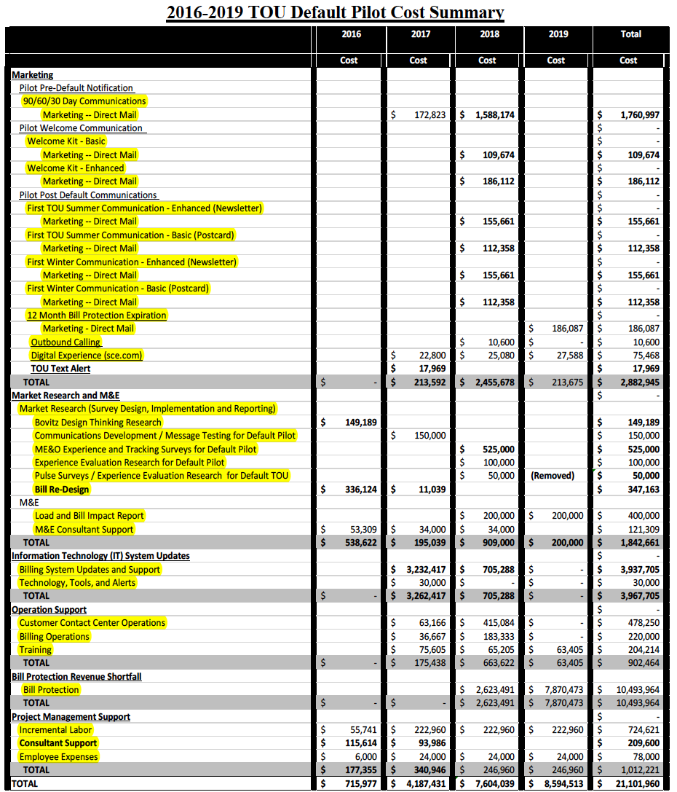

D. 15-07-001 at 166.
D.15-07-001 at 166.
All subsequent Section references are to the California Public Utilities Code unless otherwise indicated.
P.U. Code § 745(c)(2) The Commission shall ensure that any time-of-use rate schedule does not cause unreasonable hardship for senior citizens or economically vulnerable customers in hot climate zones.
D.15-07-001 at 170.
Some language about SCE’s proposed timeline for default
AL 3531-E, Attachment A at 25-26. All subsequent references to AL 3531-E are references to Attachment A to that advice letter, unless otherwise indicated.
D.15-07-001 at 135.
EDF Protest at 4.
D.15-07-001 at 135.
P.U. Code Section 745(c)(1) Residential customers receiving a medical baseline allowance pursuant to subdivision (c) of Section 739, customers requesting third-party notification pursuant to subdivision (c) of Section 779.1, customers who the commission has ordered cannot be disconnected from service without an in-person visit from a utility representative (Decision 12-03-054 (March 22, 2012), Decision on Phase II Issues: Adoption of Practices to Reduce the Number of Gas and Electric Service Disconnections, Order 2 (b) at page 55), and other customers designated by the commission in its discretion shall not be subject to default time-of-use rates without their affirmative consent.
P.U. Code Section 745(c)(2) The commission shall ensure that any time-of-use rate schedule does not cause unreasonable hardship for senior citizens or economically vulnerable customers in hot climate zones.
D.16-09-016 at 10.
D.16-09-016 at 8.
P.U. Code Section 745(c)(4) A residential customer shall not be subject to a default time-of-use rate schedule unless that residential customer has been provided with not less than one year of interval usage data from an advanced meter and associated customer education and, following the passage of this period, is provided with no less than one year of bill protection during which the total amount paid by the residential customer for electric service shall not exceed the amount that would have been payable by the residential customer under that customer s previous rate schedule.
D.16-09-016 at 38.
P.U. Code Section 745(d) The commission shall not require or authorize an electrical corporation to employ default time-of-use rates for residential customers unless it has first explicitly considered evidence addressing the extent to which hardship will be caused on either of the following: (1) Customers located in hot, inland areas, assuming no changes in overall usage by those customers during peak periods. (2) Residential customers living in areas with hot summer weather, as a result of seasonal bill volatility, assuming no change in summertime usage or in usage during peak periods.
Assigned Commissioner and Administrative Law Judge’s Ruling Amending Scoping Memorandum and Ruling issued January 23, 2017 (Scoping Ruling) at 10.
Scoping Ruling at 10.
February 6, 2017 Prehearing Conference Transcript at 452-459. March 6, 2017 Email Ruling Regarding Bill Protection for Customers Opting-in to Default TOU Pilot Programs
D.15-07-001 at 162.
AL 3531-E at 51.
AL 3531-E at 56.
AL 4979-E at 87.
D.15-07-001 at 162.

