PUBLIC UTILITIES COMMISSION OF THE STATE OF CALIFORNIA

Communications Division | RESOLUTION T-17545
Broadband, Video and Market Branch | June 15, 2017

R E S O L U T I O N

Resolution T-17545: Approval of funding for the grant application of LCB Communications LLC (U-7243—C)/Digital Voice Service provider, South Valley Internet, Inc.,(U-1312-C) from the California Advanced Services Fund (CASF) in the amount of $1,076,062 for the Light Saber Project in Paradise Valley, a portion of the rural unincorporated area of Santa Clara County to provide broadband access to 150 underserved households.

Summary

This Resolution approves funding in the amount of $1,076,062 from the California Advanced Service Fund (CASF) for the grant application of LCB Communications LLC/South Valley Internet Inc. (LCB/SVI) for its Light Saber Project. The Light Saber Project consists of approximately 17 miles of fiber optic cable and will offer fiber-to-the-premise (FTTP) providing 100 Mbps download speed and up to 1 Gbps upload speed for synchronous services to 150 underserved households in the Paradise Valley community, a portion of the rural unincorporated area of Santa Clara County. The Light Saber project consists of 0.4 square miles of last-miles and to reach the last-mile area, LCB/SVI will build approximately 5 miles of middle-mile. The proposed $397,017 funding for the fiber middle-mile link will enable LCB/SVI to reach Paradise Valley and the proposed $679,045 funding is for constructing last-mile connections to 150 underserved households at a cost per household of $7,174.

The Light Saber project will provide the Paradise Valley community with improved access to e-health services, as well as online economic opportunities. It will also provide public safety benefits by enabling the local communications facilities that provide voice services to meet FCC standards for E911 service and battery backup.

This resolution is substantially the same as the prior draft Resolution T-17545, which had been issued for public comment on January 4, 2017 for consideration at the February 9, 2017 Commission meeting. However, at the Commissioners’ request at the February 9, 2017 Commission meeting, draft Resolution T-17545 was withdrawn. On March 16, 2017, LCB/SVI submitted a revised funding request and decreased its CASF subsidy request from $1,120,408 to $1,105,696. This resolution reflects the revised funding request and makes changes in response to comments on draft Resolution T- 17545, submitted by the Office of Ratepayer Advocates on January 30, 2017.

Applicant Request

On November 19, 2015, LCB/SVI submitted a grant application requesting $2,801,023 in CASF funding. In its application, LCB/SVI proposes to build 59 miles of fiber optic cable serving 515 underserved households in San Martin and Paradise Valley of the unincorporated South Santa Clara County. LCB/SVI claimed that the total cost of the proposed project was $4,681,672.

In November 2016, LCB/SVI submitted a revised application that removed the served households covered by RazzoLink Inc. (RazzoLink). LCV/SVI revised its application in response to a challenge submitted by RazzoLink and CD’s analysis of the proposed project area. LCB/SVI’s revised application requests $1,120,408 in CASF funding, and asserts that the project will cover 150 underserved households in Paradise Valley. The revised $1,120,408 represents 60 percent of the total project cost of $1,867,348. LCB/SVI has stated that approximately 18,430 feet of 56,824 feet of the fiber is middle-mile section. The middle-mile passes through served areas in the adjacent proposed project area.

On March 16, 2017, after the February 9, 2017 Commission meeting, LCB/SVI revised its application and requested $1,105,696 in CASF funding.

Topography: The LCB/SVI’s Light Saber project will serve Census Block 060855122001 covering 0.4 square miles. The proposed project encompasses wooded terrain in the geographical area southwest of Morgan Hill bordering Llagas Creek, and includes the Paradise Valley community in southern Santa Clara County.

Applicant: South Valley Internet Inc. (SVI) was founded in 1994. In 2011, SVI created LCB Communications, LLC as a Competitive Local Exchange Carrier (CLEC) (U-7243—C) to be responsible for colocation and dealing with the Incumbent Local Exchange Carriers (ILECs). LCB/SVI has existing business in the south end of Santa Clara County, and has been working on colocation since 2014, in Morgan Hill and Gilroy, California.

Project: LCB/SVI plans to construct a fiber optic network consisting of approximately 17 miles of fiber optic cable. The network will serve the 0.4 square miles of the underserved Paradise Valley community. To reach the Paradise Valley, LCB/SVI will build approximately 56,824 feet of the middle-mile fiber. The middle-mile passes through served areas in the adjacent proposed project area. This network will offer fiber-to-the-home providing 100 Mbps and up to 1 Gbps synchronous services. The deployment of fiber optic will allow LCB/SVI to increase the underserved speed of its service offerings to meet subscriber demand in the area. The service area will be connected via diversely routed leased circuits to the Public Internet Backbone and Public Switched Telephone Network (PSTN). These circuits will be leased from existing providers such as AT&T and Global Crossings.

Notice and Challenges

On November 19, 2015, Communications Division (CD) posted the proposed project area map, census block groups (CBGs), and zip codes for this project on the Commission’s CASF webpage under “CASF Application Project Summaries,” and sent notice regarding the project to its electronic service list. On December 8, 2015, CD received a challenge from RazzoLink for the proposed project area.

There were no commitments made by an existing provider to upgrade service before the November 1, 2014, “first right of refusal” deadline. Existing providers may exercise their “right of first refusal” (i.e., demonstrates that they will upgrade service in their existing underserved territories within a reasonable amount of time).

Project Review

Project Area Eligibility

For the area to be project eligible, the CASF program requires an applicant to submit proof that the area is unserved or underserved by submitting shapefiles of the proposed project. CD reviews the submitted shapefiles and compares them with United States 2010 Census data and the California Interactive Broadband Availability map. Once CD determines that the area is eligible either as an unserved or underserved area, CD evaluates all other information submitted by the applicant to determine if the project meets the requirements outlined in D.12-02-015.

The California Interactive Broadband Availability Map as of December 31, 2015, shows that the original project area is underserved by wireline, fixed wireless, and mobile wireless.

However, in its challenge, RazzoLink stated that it currently offers speeds of at least 10 Mbps download and 2 Mbps upload to residential and business customers in the San Martin area, including all of the areas covered by the proposed Light Saber project area. RazzoLink provided sample invoices of customers in the proposed project area. RazzoLink also indicated that Etheric Networks Inc., another provider, is present and provides high speed Internet services in the proposed project area. According to RazzoLink, Verizon and AT&T are the Incumbent Local Exchange Carriers providing telephone and DSL based internet services in the proposed project area.

CD evaluated RazzoLink’s subscribership data. Based on its review, CD determined that RazzoLink only serves the San Martin area, and does not serve Paradise Valley. As such, CD asked LCB/SVI to remove the served area, and revise its application to only include Paradise Valley. This removal of served project area resulted in a reduction of 1,486 households.

CD received comments during the original comment period on the prior published draft resolution from the Office of the Ratepayer Advocates (ORA) on January 30, 2017. In its comments, ORA indicated that “the California Broadband Availability Map shows that the proposed project area contains some households that are already currently served by LCB/SVI and as such, the project should be prorated to remove served households and the associated costs.” Additionally, ORA questioned why the applicant is not augmenting existing infrastructure to enhance broadband speeds, but instead opts to construct a new fiber optic network to offer FTTH.

While the California Broadband Availability Map shows that a portion of the proposed service area is served by LCB/SVI, LCB/SVI confirmed that it dose not provide DSL services in Paradise Valley because it is too far away from the Central Office. According to LCB/SVI, Paradise Valley is greater than 15,000 feet away from LCB/SVI’s Morgan Hill Central Office. LCB/SVI confirmed that its speed data filing for the California Broadband Availability Map that is provided to the Commission is incorrectly showing served speeds and the California Broadband Availability Map erroneously describe the availability of the current existing technology. Therefore, CD determines that Paradise Valley is underserved.

According to LCB/SVI, it cannot simply augment existing infrastructure to enhance broadband speeds because it does not own the building in its headquarter. Therefore, per LCB/SVI, it does not make sense to build fiber lines to the existing headquarter building. Instead, LCB/SVI has a property nearby, where it will build a “Hut” and where all the fiber equipment will be housed.

CD staff followed up with LCB/SVI about pro-rating the project cost to comply with the requirements in D.12-02-015. In D.12-02-015, the Commission established guidance for funding middle mile projects where broadband infrastructure may have to pass served areas to reach an unserved or underserved area. Specifically, the Decision notes that the middle-mile portion must be an “indispensable” part of the plan to reach unserved and/or underserved communities, and that the applicant is required to pro-rate costs when projects include facilities in unserved, underserved, and served areas.

Given that the main fiber feed passes through some served areas by Charter Communications Inc., AT&T California and Frontier, CD pro-rated the costs of “middle-mile,” or the main feed along the transport route in the adjacent served area to Paradise Valley. Approximately 18,430 feet of 56,824 feet of the middle-mile fiber line that passed through served areas in the adjacent proposed project area have been pro-rated out of the middle-mile and common costs budgets. This resulted in $29,633 of the project budget being declared ineligible for CASF grant funding. After the pro-ration of the middle-mile costs, funding for the fiber middle-mile link is $397,017 and the last-mile funding for the 150 underserved households in Paradise Valley is $679,045.

Based on evaluation of the challenge and analysis, CD determined that the households in the Paradise Valley section of the proposed project area are underserved and therefore eligible to receive 60% in CASF funding.

Project Criteria Evaluation

CD evaluated the application with respect to the scoring criteria defined in D.12-02-015, Appendix 1, Section VIII (Scoring Criteria). The scoring criteria includes: (i) Funds Requested per Potential Customer, (ii) Speed, (iii) Financial Viability, (iv) Pricing, (v) Total Number of Households in the Proposed Area, (vi) Timeliness of Completion of Project, (vii) Guaranteed Pricing Period, and (viii) Low-Income Areas. CD also conducted qualitative evaluation of the project area, existing infrastructure, and community needs.

Funds per Household: The CASF per-household subsidy is $7,174, based on 150 households that would have access and total grant funds of $1,076,062. This subsidy amount per households is slightly higher than the average $5,771, amount of similar last-mile fiber projects approved in 2015-2016.

Speed: The proposed project will allow LCB/SVI to construct a fiber optic network consisting of approximately 17 miles of fiber optic cable that will serve the 0.4 square miles of the underserved Paradise Valley community. LCB/SVI will provide 100 Mbps download speed and up to 1 Gbps upload speed for synchronous services which exceeds the 6 Mbps/1.5 Mbps benchmark set by the Commission.

Financial Viability: CD determined that LCB/SVI is a financially viable company.
CD’s review of the submitted balance sheet, income statement, cash flow statements and other financial viability variables confirmed that LCB/SVI has the existing capital resources for the matching funds, as well as a sound financial framework for future operations.

LCB/SVI is expected to become profitable beginning in year 2018. LCB/SVI performed a market survey and concluded that 92% of residents who responded would purchase at least one of the high-speed broadband service options proposed by LCB/SVI. LCB/SVI has projected a 68% take rate, or 102 residential customers out of the potential of 150, as subscribers to the proposed LCB/SVI broadband service offerings at the price points described in the surveys.

Pricing: LCB/SVI has committed to the following pricing for broadband services for two years after the project is completed. LCB/SVI has a cancellation policy for its service contracts. Customers will pay a cancellation fee if they choose to cancel their two or three years contracts and the fee is the difference in the monthly recurring price they purchased and the actual contract fulfillment amount or $500, whichever is less. However, the cancellation fee does not apply if a customer upgrades the service or moves to another location within the project area.

LCB/SVI Product Price Proposal
SERVICE TYPE | TERM COMMITMENT | Download  (Mbps) | Upload  (Mbps) | Price per month
PK. 1 | 2 Year | 50 | 50 | $109
PK. 2 | 3 Year | 50 | 50 | $90
PK. 3 | 2 Year | 100 | 100 | $199
PK. 4 | 3 Year | 100 | 100 | $179
PK. 5 | 2 Year | 1000 | 1000 | $289
PK. 6 | 3 Year | 1000 | 1000 | $279
Add Voice for two and three Year plans | Voice |  |  | $19.95
Optical Network Terminal is included with the installation.
Activation and installation fees will be waived.

The prices for this project rank lower than the average prices of other last-mile projects awarded in the past.

Households in Project Area: Based on the 2010 census block data, the project area consists of 150 households with a population of 400 and is covered by one Census Block Group.
If approved, LCB/SVI expects to serve 102 of these households.

Timeliness of Completion: LCB/SVI submitted deployment documents, including a schedule with clear milestones to indicate the project will be completed within the required 24 months from the Commission approval date. This project scores average compared to the timeline for the previously awarded last-mile projects.

Low-Income Areas: The proposed project area does not consist of low-income communities. According to the State Income Limits established by California Department of Housing and Community Development, a 4-person household with an income of below $ 84,900 would qualify as low income in Santa Clara County. The median household income for the project area is $102,226.

Safety and Community Input Considerations

LCB/SVI provided a letter of support from Santa Clara County Supervisor Mike Wasserman. Supervisor Wasserman stated in his letter that despite the fact that the community is a short distance from the heart of Silicon Valley, it does not have high-speed Internet access. LCB/SVI provided five additional letters of support from residents of the local community expressing their support of this project. These letters complain about residents’ lack of economic opportunity due to no access to high-speed Internet, and the disadvantage that students face trying to perform homework assignments and other activities such as telecommuting.

The proposed project will provide the Paradise Valley community with improved access to e-health services, as well as online economic opportunities.

Staff Recommendation for Funding

CD has determined that LCB/SVI’s grant application for the Light Saber project qualifies for funding as an underserved area. Based on CD’s evaluation of the project, the December 31, 2015 California Interactive Broadband Availability map data, and evaluation of the information provided by the challenger, RazzoLink, CD finds that the LCB/SVI’s Paradise Valley area meets the requirements of D.12-02-015, provides safety benefits and aligns with the goal of the CASF program to encourage deployment of high quality advanced information and communication technologies to all Californians. Therefore, CD recommends the Light Saber project be approved for a CASF grant award of $1,076,062.

Compliance Requirements

LCB/SVI is required to comply with all the guidelines, requirements, and conditions associated with the grant of CASF funds as specified in D.12-02-015, D.14-02-018, and Resolution T-17443. Such compliance includes, but is not limited to:

California Environmental Quality Act (CEQA)

All CASF grants are subject to California Environmental Quality Act (CEQA) requirements unless the project is statutorily or categorically exempt pursuant to the CEQA Guidelines.

LCB/SVI has stated that its construction of Outside Plant network will be comprised of approximately 17 miles of fiber-optic cable in existing, previously disturbed, right-of-way. LCB/SVI will bury all cable, which will be placed in the public right-of-way a minimum of 30 inches, unless other depths are required by local highway, railroad, and municipal authorities. LCB/SVI will also install a passive network cabinet in the public right-of-way of the proposed service area.

LCB/SVI will construct a new network building (“hut”) in San Martin, CA. LCB/SVI will outfit the hut with network and transmission equipment and will provide connectivity to the hut by constructing a fiber optic point-to-point connection with LCB’s headquarters in San Martin (Approx. 1.2 miles away from LCB’s office and on the path to the proposed service area.) The hut will either be constructed on site or will be pre-fabricated and moved to the site. If LCB/SVI elects to use a pre-fabricated hut, the concrete pad for the pre-fab huts will be 17' x 22', and 6" deep in the center. The hut will have the necessary racking, cabling, environmental conditioning, emergency power backup, fire suppression, security and other ancillary equipment installed. LCB/SVI has stated that construction will comply with all applicable local, state and national codes.

Based on the project description, above, the project qualifies for the following categorical exemptions from CEQA: CEQA Guidelines Section 15301 for existing facilities, Section 15304 for minor alterations to land, and Section 15303 for new construction of small structures.

Deployment Schedule

The Commission expects LCB/SVI to complete the project within 24 months from the start date (as determined by the procedure below). If LCB/SVI is unable to complete the proposed project within the 24-month timeframe requirement, it must notify the Director of CD as soon as LCB/SVI becomes aware of this possibility. If such notice is not timely provided, the Commission may reduce payment for failure to meet this requirement.

Execution and Performance

By receiving a CASF grant from the Commission, LCB/SVI agrees to comply with the terms, conditions and requirements of the grant and thus submit to the jurisdiction of the Commission with regard to disbursement and administration of the grant.

CD and LCB/SVI shall determine a project start date after LCB/SVI has obtained all approvals. Should LCB/SVI or any Contractor it retains fail to commence work by the designated start date, upon five days written notice to LCB/SVI, the Commission may terminate the grant. In the event that LCB/SVI fails to complete the project in accordance with the terms of the Commission approval as set forth in this resolution, LCB/SVI must reimburse some or all of the CASF funds that it has received. LCB/SVI must complete all construction covered by this grant on or before the grant’s termination date.

Performance Bond

The CASF rules do not require a Performance Bond if the applicant certifies that the percentage of the total project costs it is providing comes from their capital budget and is not obtained from outside financing. In its application, LCB/SVI certified that 40% of the total project costs it is providing will come from its existing capital budget. Because the matching funds for this project come in whole from an existing capital budget and LCB/SVI operates under a CPCN, no performance bond is required under CASF rules.

Price Commitment Period

Under D.12-02-015, the minimum required price commitment period for broadband service to all households within the project area is two years. LCB/SVI guarantees the price of broadband services offered in the project area for two years.

Project Audit

The Commission has the right to conduct any necessary audit, verification, and discovery during project implementation/construction to ensure that CASF funds are spent in accordance with Commission approval. LCB/SVI’s invoices will be subject to a financial audit by the Commission at any time within three years of completion of the work.

Providing Voice Service

LCB/SVI has certified that its voice service offered is standard VoIP telephone service and it meets the Federal Communications Commission (FCC) standards for E-911 service and battery backup.

Submission of Form 477

The FCC currently requires broadband providers to biannually submit Form 477, which includes speed data. Pursuant to General Order 66-C, service providers in California must submit a copy of their Form 477 data directly to the Commission, concurrent with their submission of the same data to the FCC. CASF recipients must continue to submit their Form 477 data to the Commission and FCC and the Commission for a five-year period after completion of the project.

Reporting

LCB/SVI must submit quarterly progress reports on the status of the project irrespective of whether grantees request reimbursement or payment.

Quarterly progress reports during the construction on status of the project are due on January 1, April 1, July 1, and October 1. Before full payment of the project, LCB/SVI must submit a project completion report. Progress reports shall use the schedule for deployment, major construction milestones and costs submitted in the proposal; indicate the actual date of completion of each task/milestone as well as problems and issues encountered, and the actions taken to resolve these problems and issues during project implementation and construction; and identify future risks to the project.

LCB/SVI shall also include test results on the download and upload speeds on a CBG and zip code basis in the final completion report. LCB/SVI must certify that each progress report is true and correct under penalty of perjury.

Payments to CASF Recipients

Submission of invoices from and payments to LCB/SVI shall be made at 25 percent completion intervals, in accordance with Section XI of Appendix 1 of D.12-02-015 and according to the guidelines and supporting documentation required in D.12-02-015.

Payment to LCB/SVI shall follow the process adopted for funds created under Pub. Util. Code, § 270. The Commission generally processes payments within 20-25 business days, including CD and Administrative Services review time. The State Controller’s Office (SCO) requires an additional 14- 21 days to issue payment from the day that requests are received by SCO from Administrative Services. LCB/SVI must submit a project completion report before full payment.

Comments on Draft Resolution

In compliance with Pub. Util. Code, § 311(g), a notice letter was e-mailed on January 4, 2017, informing all parties on the CASF Distribution List of the availability of the draft of this resolution for public comments at the Commission's website at http://www.cpuc.ca.gov/PUC/documents/. This letter also informed parties that the final conformed Resolution adopted by the Commission will be posted and available at this same website.

Again, in compliance with Pub. Util. Code, § 311(g), a notice letter was e-mailed on May 12, this resolution was posted, informing all parties on the CASF Distribution List of the availability of the draft of this resolution for public comments at the Commission's website at http://www.cpuc.ca.gov/PUC/documents/. This letter also informed parties that the final conformed Resolution adopted by the Commission will be posted and available at this same website. CD received no comments.

Findings

- On November 19, 2015, LCB/SVI, submitted a CASF grant application to build last-mile fiber infrastructure to provide broadband Internet to underserved community of San Martin and Paradise Valley in Southern Santa Clara County. LCB/SVI revised its project area removing San Martin which eliminated 1,486 households and the revised CBG impacted by the project is 060855122001.
- On November 19, 2015, CD posted the proposed project area map, CBG and zip code for LCB/SVI’s Light Saber project on the Commission’s CASF webpage under “CASF Application Project Summaries”. On December 8, 2015, CD received a challenge from RazzoLink to this project.
- LCB/SVI revised its application to include only the Paradise Valley section of the original project area. LCB/SVI requested $1,120,408, which represents 60 percent of the estimated total project cost of $1,867,348.
- CD reviewed and analyzed data submitted from the LCB/SVI grant application to determine the project’s eligibility for CASF funding. This data includes but is not limited to proof that the applicant has a CPCN from the Commission; description of current and proposed broadband infrastructure; number of potential subscriber households and average income; project construction schedule; project budget; proposed pricing and commitment period for new subscribers; and financial viability of the applicant.
- Based on its review, CD determined that the proposed project area is underserved and qualifies for funding under D.12-02-015.
- CD pro-rated the costs of middle-mile or the main feed along the transport route in the adjacent served area Paradise Valley, because the main fiber feed passes through some served areas by Charter Communications Inc., AT&T California and Frontier. The CASF pro-rated funding is $1,076,062 and the per-household subsidy is $7,174, based on 150 households that will be given access at served speeds by the grant.
- CD’s recommendation to fund LCB/SVI’s Light Saber project is summarized in Appendix A, and this project is reasonable and consistent with Commission orders.
- The LCB/SVI’s Light Saber project is categorically exempt from CEQA review pursuant to the following exemptions: CEQA Guidelines Section 15301 for existing facilities, Section 15304, minor alterations to land, and Section 15303 new construction of small structures.
- LCB/SVI is not required to post a performance bond because 40% of the total project cost will be financed through LCB/SVI’s existing capital budget.
- This project provides benefits to the Paradise Valley community. CD finds that upgrading and offering faster broadband services to residents and businesses and extending its faster service availability to the community will enhance public safety in the LCB/SVI Light Saber project area.
- Further changes to this resolution were undertaken following its presentation at the February 9, 2017 Commission meeting. On March 16, 2017, LCB/SVI revised its application and requested $1,105,696, which represents 60 percent of the estimated total project cost of $1,842,826.

THEREFORE, IT IS ORDERED that:

  - The Commission shall award $1,076,062 to LCB/SVI for the Light Saber project as described herein and as summarized in Appendix A of this Resolution.
  - The program fund payment of $1,076,062 for this project in underserved areas shall be paid out of the CASF Infrastructure Grant Account in accordance with the guidelines adopted in D.12-02-015.
  - Payments to LCB/SVI shall be in accordance with Section XI of Appendix 1 of D.12-02-015 and in accordance with the process defined in the “Payments to CASF Recipients” section of this Resolution. If LCB/SVI does not provide service to each customer within the project area that requests service at the prescribed rates during the commitment period, the Commission reserves the right to reduce payment accordingly based on progress and information available.
  - LCB/SVI must complete all construction covered by the grant on or before the grant’s termination date. If the project will not be completed within the 24-month time frame, LCB/SVI must notify the Director of CD as soon as it becomes aware of this possibility. If such notice is not provided, the Commission may reduce payment for failure to satisfy this requirement by timely notifying CD’s Director.
  - LCB/SVI, shall comply with all guidelines, requirements and conditions associated with the CASF funds award as specified in D.12-02-015, D.14-02-018 and this Resolution, and with all applicable laws, and must submit the FCC Form 477 to the Commission, as specified in Resolution T-17143.
  - By receiving a CASF grant, LCB/SVI agrees to comply with the terms, conditions, and requirements of the grant and thus submit to the jurisdiction of the Commission with regard to disbursement and administration of the grant.
  - LCB/SVI must sign and return the attached consent form agreeing to the conditions set forth in this resolution.
  - LCB/SVI must submit project completion reports prior to receiving final payment.
  - In the event that LCB/SVI fails to complete the project in accordance with the terms of Commission approval as set forth in this resolution, LCB/SVI must reimburse some or all of the CASF funds that it has received.

This Resolution is effective today.

I hereby certify that this Resolution was adopted by the Public Utilities Commission at its regular meeting on June 15, 2017. The following Commissioners approved it:

____/s/ Timothy J. Sullivan______
TIMOTHY J. SULLIVAN
Executive Director

CARLA J. PETERMAN
LIANE M. RANDOLPH
CLIFFORD RECHTSCHAFFEN
Commissioners

I dissent.

/s/ MICHAEL PICKER
President

I dissent.

/s/ MARTHA GUZMAN ACEVES
Commissioner

APPENDIX

APPENDIX A
Resolution T-17545, LCB/SVI, Light Saber Project
CASF Applicant Key Information
Project Name | LCB Communications LLC/ South Valley Internet, Inc.
Project Plan | LCB/SVI plans to construct a fiber optic network consisting of approximately 17 miles of fiber optic cable to serve the proposed service area in Southern Santa Clara County. LCB/SVI will utilize this network to offer fiber to the home based solutions to provide100 Mbps and up to 1 Gbps synchronous service.
Project Size (in square miles) | 0.4
Download/Upload speed | 100 Mbps and up to 1 Gbps synchronous service
Location | Southern Santa Clara County
Community Names | Paradise Valley
Census Block Groups | 60855122001
Median Household Income (by Census Block Group) | $102,266
Zip Codes | 95037
Estimated potential subscriber size | 150 households
Applicant expectations | 102 subscribers based on 68% take rate
Pricing Plan (Monthly) | $109 for 50/50 Mbps &2 years; $90 for 50/50 Mbps &3 years; $199 for 100/100 Mbps &2 years; $179 for 100/100 Mbps &3 years; $289 for 1000/1000 Mbps &2 years; $279 for 1000/1000 Mbps &3 years; $19.95 for additional Voice lines. All services include one voice line. No installation fees
Deployment Schedule  (from Commission approval date) | 24 months
Proposed Project Budget (Total) | $1,842,826
Amount of CASF funds requested (58%) | Pro-rated $1,076,062
Applicant funded (42%) | $766,764

Appendix B
Resolution T-17545, LCB/SVI, Light Saber Project
Project Location Map
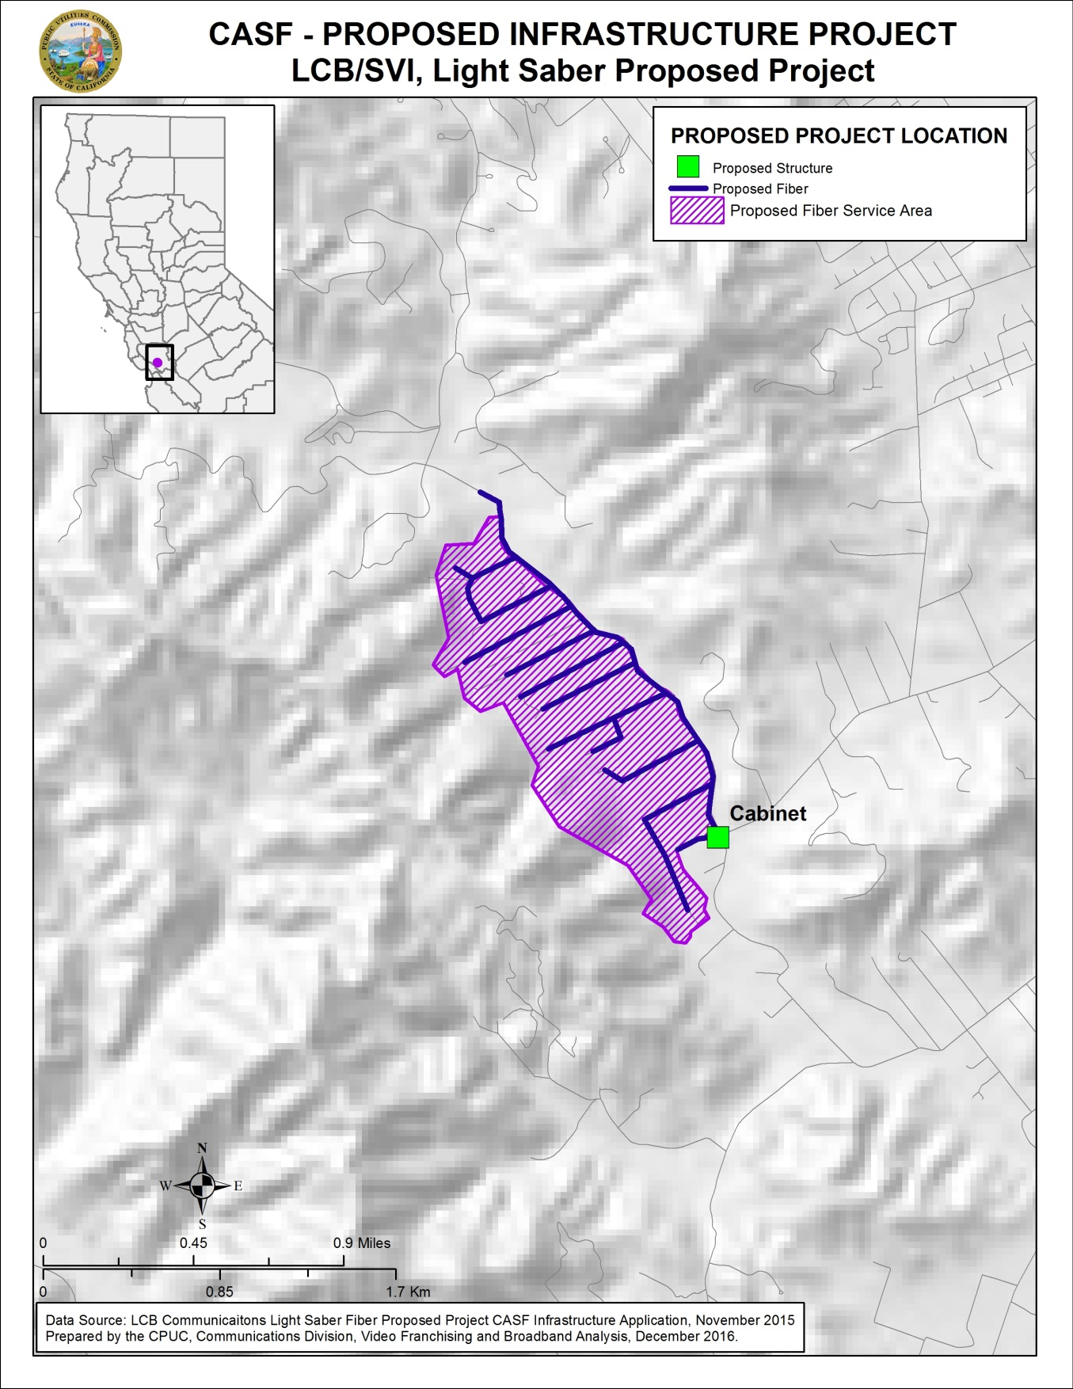

Appendix C
Resolution T-17545, LCB/SVI, Light Saber Project
Existing Wireline Service Levels
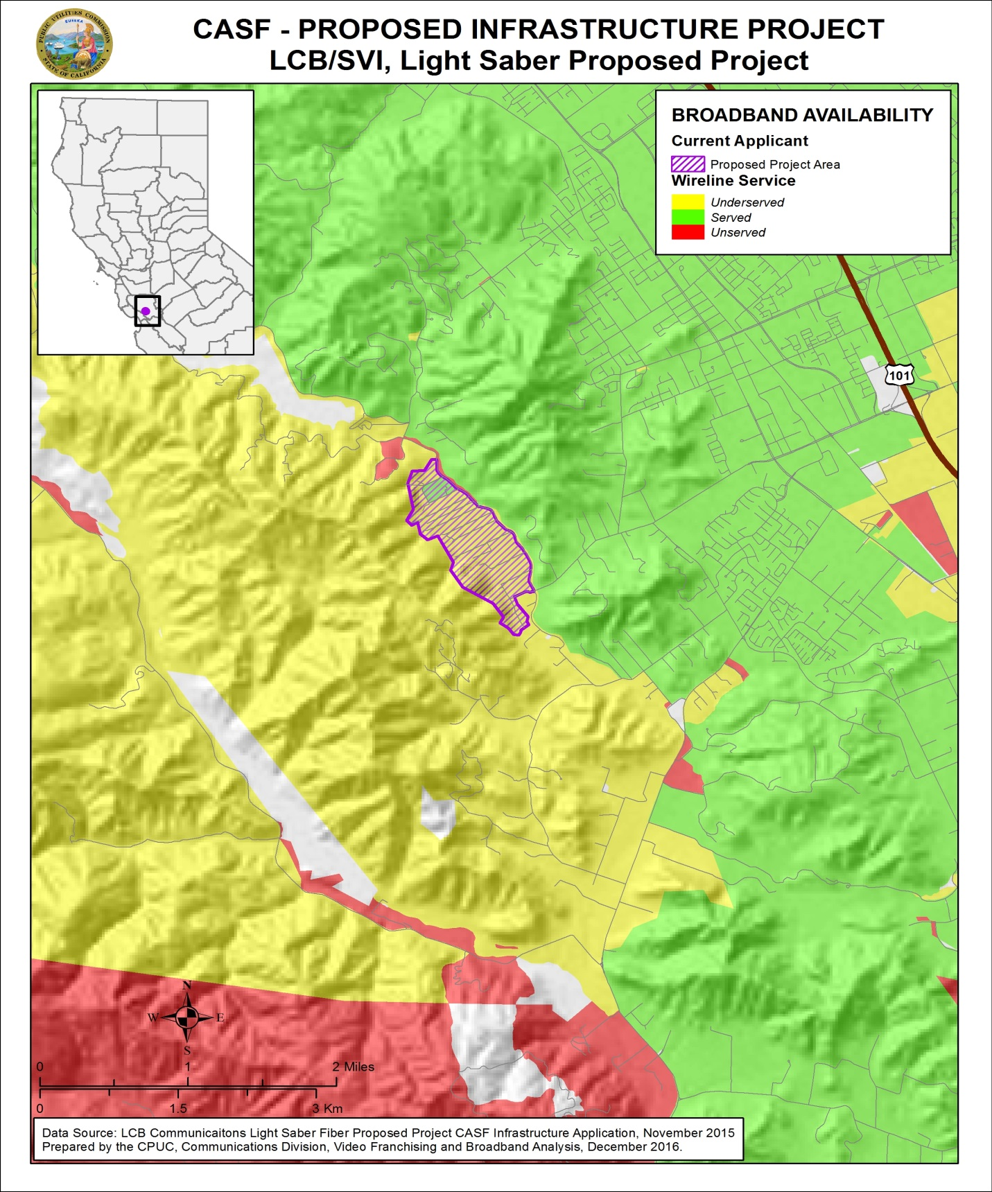
Appendix D
Resolution T-17545, LCB/SVI, Light Saber Project
Existing Fixed Wireless Service Levels

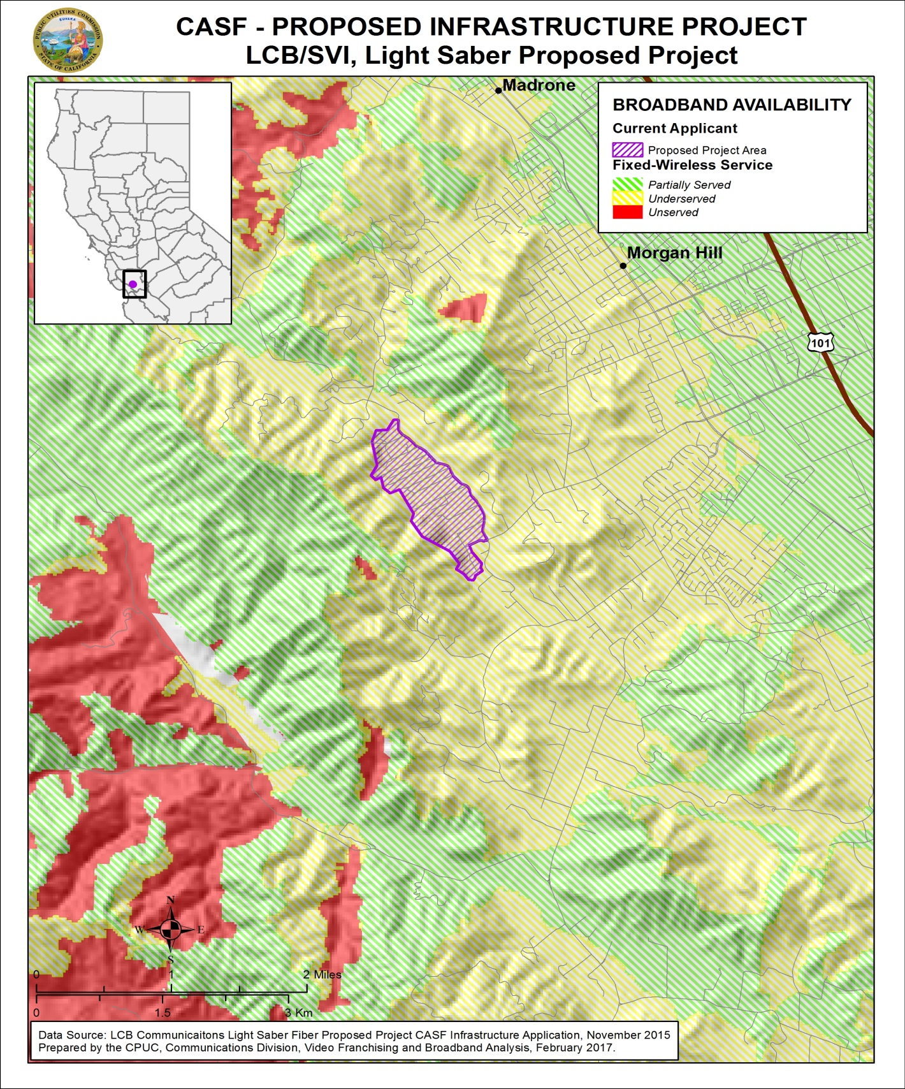
Appendix E
Resolution T-17545, LCB/SVI, Light Saber Project
Existing Mobile Wireless Services Levels

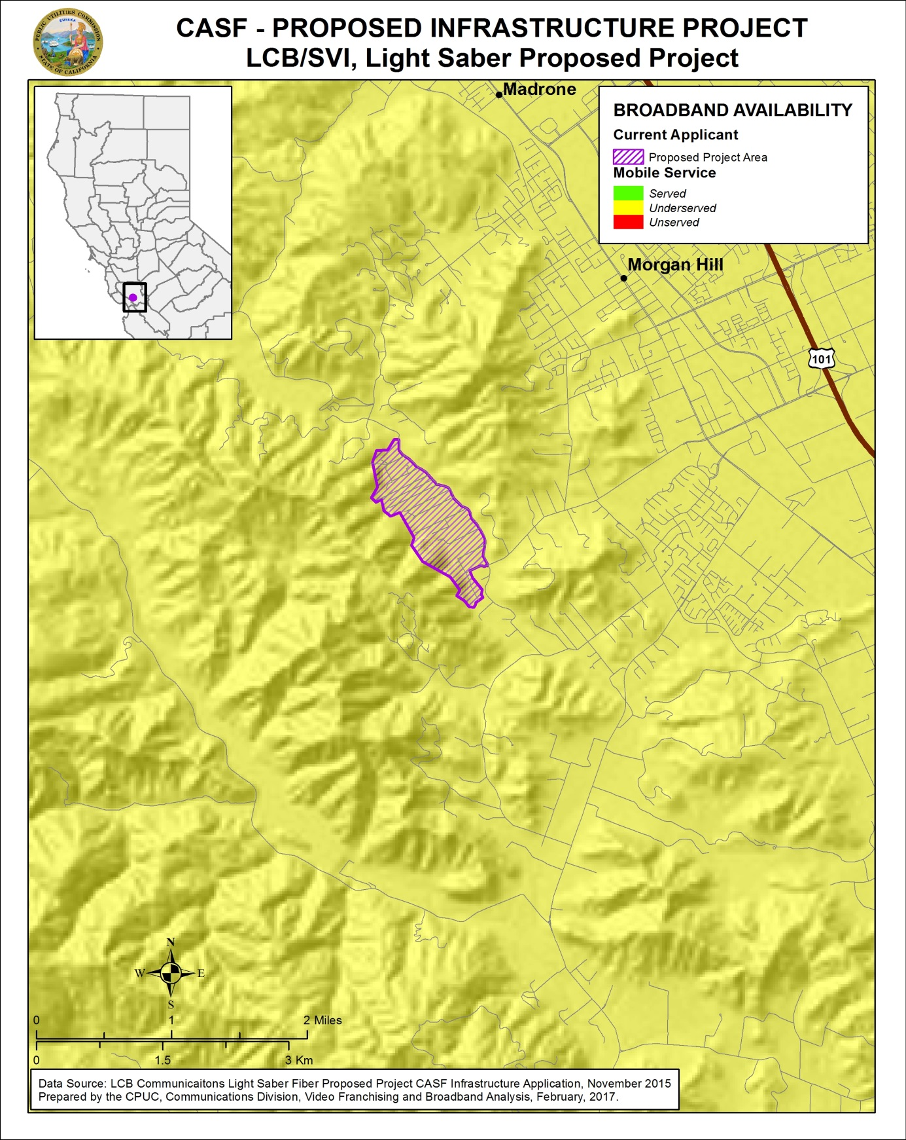

Email from Elise Brentnall, dated March 16, 2017, titled “Revised Light Saber Numbers T-17545.”
See Resolution T-17443.
The latest version of the California Interactive Broadband Availability Map uses wireline data as of December 31, 2015.
Etheric did not challenge the project however, the areas served by Etheric were removed from the proposed project area.
LCB/SVI application, dated November 11, 2015, file name:”Estimated_Potential_Subscriber_Size.”
D.12-02-015, pp. 11-12; see also Guidelines, pp. 3-4.
CD followed the formula on Page 4 of Appendix 1 of D.12-02-015 by equally pro-rating to served and unserved portions to get a disallowance of $29,633 for served areas. CD calculated 50 percent of LCB/SVI’s common cost for facility improvement that benefits both served and unserved area ($49,389*0.5= $29,633) and 60 percent of the project costs exclusive of facilities improvement ($1,744,078*0.6= $1,046,429). The total pro-rated cost is $1,076,062.
Approved Last-mile projects 2015-2016 can be found at: http://www.cpuc.ca.gov/general.aspx?id=1057
Email from Elise Brentnall, dated December 14, 2016, titled “Proposed pricing.”
SVI-Environmental Report-4, received by CD on 11/10/16.
The Commission has the authority to enforce the terms and conditions of the grant award and to impose penalties under Pub. Util. Code, §§ 2111 and 2108. (D.14-02-018, p. 36).
Pub. Util. Code, §§ 270 and 281.
Approval of the California Advanced Services Fund (CASF) Application Requirements and Scoring Criteria for Awarding CASF Funds (2008) Cal. P.U.C. Res. No. T-17143 at 4.

