**PUBLIC UTILITIES COMMISSION OF THE STATE OF CALIFORNIA**

**Agenda ID 15850**

**ENERGY DIVISION RESOLUTION E-4867**

**August 10, 2017**

**RESOLUTION**

Resolution E-4867. Approval of the Database for Energy-Efficient Resources (DEER) updates for 2019 and, revised versions 2017 and 2018 in Compliance with D.15-10-028, D.16-08-019, and Resolution E-4818.

PROPOSED OUTCOME:

* Revised DEER2017 Update (effective 1/1/2017)
* Revised DEER2018 Update (effective 1/1/2018)
* DEER2019 Update (effective 1/1/2019)

SAFETY CONSIDERATIONS:

* There is no impact on safety.

ESTIMATED COST:

* This Resolution is expected to result in no additional cost.

By Energy Division’s own motion in Compliance with D.15-10-028.

__________________________________________________________

SUMMARY

This Resolution approves updates to the Database for Energy-Efficient Resources (DEER) for 2019 and, revised versions for 2017 and 2018 in Compliance with   
D.15-10-028 and Resolution E-4818.

All of the updated DEER assumptions, methods, values and supporting documentation are available on the DEEResources.com website.

BACKGROUND

DEER updates flow into the portfolio development process by providing new savings estimates from which to design programs. New savings estimates, including assumptions and methods as well as values, inform where a current program may need to shift eligibility and/or incentive support to continue to capture savings cost effectively. DEER updates may also reflect new market conditions (reflected in required baseline assumptions and predicted attribution rates). Program Administrators (PA)s are required to factor in all of these new assumptions and values by a) knowing there is an update, b) understanding the fundamental assumptions for the update, and c) identifying necessary shifts to their programs to still capture cost effective savings. Updates to DEER methods similarly may re-define the adopted approach to estimating savings, and hence would need to be applied in both workpaper development and custom project savings estimates as well as program deployment decisions.

Decision D.15-10-028, Ordering Paragraph 17: “Commission Staff shall propose changes to the Database of Energy Efficient Resources once annually via resolution, with the associated comment/protest period provided by General Order 96-B. However, Commission staff may make changes at any time without a resolution to fix errors or to change documentation.” Decision D.15-10-028, retains the direction from D.12-05-015 that DEER values be updated to be consistent with existing and updated state and federal codes and standards while incorporating these changes into the annual DEER update.[1] Decision D.15-10-028 also retains previous direction on Commission staff latitude in updating DEER.[2] Additionally Resolution E-4818 Ordering Paragraph 17 required Commission staff to make any necessary updates to the DEER savings estimates to reflect the baseline policy summarized in this Resolution.

In Resolution E-4795 updating DEER2017 and DEER2018 the Commission acknowledged the importance of accurately forecasting and assessing the impacts of energy efficiency activities on the peak period and operation and planning of the grid.  The Commission also recognized that the update to the DEER peak period should be considered in a more thorough process, with broad stakeholder input. This issue is not yet resolved for this update. The Commission is ordering institution of a working group process to set forth for Commission consideration one or more proposals on methodologies for updating the DEER peak period definition.

DISCUSSION

Pursuant to D.15-10-28 on May 1 the Energy Division published a scoping memo on the proposed list of updates for DEER2019 and revised DEER2017 and DEER2018. Commission staff identified the following priorities for determining the updates:

1. Updates Based on The Recent Commission Resolution on Existing Baselines[3]
2. New Code Update or Code Update Not Covered in Previous DEER Updates
3. Updates to Underlying Methodology or Correction of Errors
4. Addition of New Measures
5. Updates Based on Evaluation Study Results

Commission staff reviewed stakeholders’ comments on the scoping memo and made adjustments and modifications to the scope based on submitted comments.

This Resolution approves the final updates for DEER2019 and revised DEER2017 and DEER2018. The final updated measures are listed in Table 1 with a more detailed description of the changes and additions provided in the Attachment to this Resolution. Complete documentation and supporting material on the updated assumptions and methods, a summary response to comments on the scoping memo and, all the updated DEER values are available at [DEEResources.com](http://DEEResources.com).[4]

**Table 1 - DEER Update Measures**

|  |  |  |  |  |  |  |  |  |  |  |  |
| --- | --- | --- | --- | --- | --- | --- | --- | --- | --- | --- | --- |
|  | Area of Update | Sector | | Tech Group | | | | | Ex Ante Value | | |
| DEER Version | Res | Non-Res | Lighting | VAC | HW | Envelope | Plug/Proc | ES Baseline | UES Methods | Measure Definition |
| **Updates Based on the Baseline Resolution** | | | | | | | | | | | |
| 2017 | Clothes washer | X |  |  |  |  |  | X | X |  |  |
| Refrigerator/freezer | X |  |  |  |  |  | X | X |  |  |
| Domestic water heater | X |  |  |  | X |  |  | X |  |  |
| Gas furnace efficiency | X |  |  | X |  |  |  | X |  |  |
| HVAC cooling efficiency | X | X |  | X |  |  |  | X |  |  |
| Exterior wall insulation | X |  |  |  |  | X |  | X |  |  |
| Attic insulation | X |  |  |  |  | X |  | X |  |  |
| Interior lighting | X | X | X |  |  |  |  | X |  | X |
| Domestic water heater | X | X |  |  | X |  |  | X | X | X |
| Gas boiler efficiency | Deferred to next update (lack of data) | | | | | | | | | |
| Effective/Remaining Useful Life | Deferred to next update (lack of data) | | | | | | | | | |
| Net-to-Gross | X | X | X | X | X | X | X |  |  |  |
| **New Measures** | | | | | | | | | | | |
| 2017 | VRF efficiency measures |  | X |  | X |  |  |  | X |  |  |
| **Updates Based on Correction of Errors or Methodology** | | | | | | | | | | | |
| 2017 | AC & HP Efficiency < 65 kBtu/hr |  | X |  | X |  |  |  | X | X |  |
| 2017 | Water chillers |  | X |  | X |  |  |  | X | X |  |
| 2018 | Residential refrigerant charge | X |  | X |  |  |  |  | X |  | X |
| **Updates Based on Code Changes** | | | | | | | | | | | |
| 2018 | Clothes Washer | X |  |  |  |  |  | X | X |  |  |
| **Updates Based on Available Evaluation Reports and Findings** | | | | | | | | | | | |
| 2019 | Net-to-gross | X | X | X | X | X | X | X |  |  |  |
| Refrigerant Charge Adjustment |  | X |  | X |  |  |  | X |  | X |
| DEER Peak Hours | Pending Working Group Report | | | | | | | | | |

COMMENTS

Public Utilities Code section 311(g)(1) provides that this resolution must be served on all parties and subject to at least 30 days public review and comment prior to a vote of the Commission. Section 311(g)(2) provides that this 30-day period may be reduced or waived upon the stipulation of all parties in the proceeding.

The 30-day comment period for the draft of this resolution was neither waived nor reduced. Accordingly, this draft resolution was mailed to parties for comments, and will be placed on the Commission's agenda no earlier than 30 days from today.

FINDINGS

1. Decision D.15-10-028, requires that Commission Staff propose changes to the Database of Energy Efficient Resources once annually via resolution, with the associated comment/protest period provided by General Order 96-B.
2. Decision D.15-10-028, retains the direction from D.12-05-015 that DEER values be updated to be consistent with existing and updated state and federal codes and standards.
3. Decision D.15-10-028 also states that Commission staff may make changes at any time without a resolution to fix errors or to change documentation.
4. The approved updates are a result of a) Updates Based on The Recent Commission Resolution on Existing Baselines, b) New Code Update or Code Update Not Covered in Previous DEER Updates, c) Updates to Underlying Methodology or Correction of Errors, d) Addition of New Measures and,   
   e) Updates Based on Evaluation Study Results.
5. Decision D.16-08-019 required that the adopted baseline policy apply to energy efficiency programs and projects beginning January 1, 2017.[5]
6. The Commission recognizes the need to update the DEER peak period definition should be considered in a more thorough process, with broad stakeholder input.

THEREFORE IT IS ORDERED THAT:

1. The DEER2019 and Revised DEER2017 + DEER2018 Updates, listed in table 1, described in the Attachment and available on the Ex-Ante Database, are approved.
2. Pacific Gas and Electric Company (PG&E), Southern California Electric Company (SCE), Southern California Gas Company (SoCalGas), and San Diego Gas & Electric (SDG&E), the San Francisco Bay Area Regional Energy Network (BayREN), Southern California Regional Energy Network (SoCalREN),   
   Tri-County Regional Energy Network (3CREN), Local Government Sustainable Energy Coalition (LGSEC), and Marin Clean Energy (MCE) must use the updated assumptions, methods and values for 2017, 2018 savings claims and 2019 planning, implementation and reporting.
3. The utilities shall initiate a working group process to develop one or more proposals on how the DEER peak period methodology should be adjusted.  The proposals shall be served on the following service lists by Dec 20, 2018.  The working group should consider what existing Commission policy directives in various related proceedings[6] are most relevant to the DEER peak period proposal update.  In establishing the working group, the IOUs shall invite participants from the following service lists. Energy Division staff from the   
   EE branch should be invited to the working group

* R1408013 – DRP Rulemaking
* R1410003 – IDER Rulemaking
* R1512012 – TOU Rulemaking
* R1602007 – IRP Rulemaking
* R1311005 – EE Rulemaking

1. Commission staff may, if deemed appropriate, issue a resolution updating the DEER peak period values based on the proposed methods from the working group.

This Resolution is effective today.

I certify that the foregoing resolution was duly introduced, passed and adopted at a conference of the Public Utilities Commission of the State of California held on August 10, 2017; the following Commissioners voting favorably thereon:

_____________________

TIMOTHY J. SULLIVAN

Executive Director

Attachment

DEER2019, Revised DEER2017 + DEER2018 Update Statement

1 Updates due to Baseline Resolution 2

1.1 Residential Clothes Washer Measures 3

1.2 Residential Refrigerator and Freezer Measures 7

1.3 Domestic Water Heater Measures 9

1.4 Residential Gas Furnace Efficiency Measures 17

1.5 HVAC Cooling Efficiency Measures 17

1.6 Residential Exterior Wall and Attic Insulation Measures 25

1.7 Lighting Measures 25

1.8 Effective and Remaining Useful Life 26

1.9 Net-to-Gross 27

2 Updates to Add New Measures 40

2.1 Top Loading Clothes Washer 40

2.2 Variable Refrigerant Flow (VRF) Efficiency Measures 41

3 Updates Based on Methodology or Correction of Errors 47

3.1 Air Conditioner and Heat Pump Efficiency Measures (<65 kBtu/hr) 47

3.2 Residential Refrigerant Charge Adjustment 49

3.3 HVAC Water Chillers 53

3.4 DEER Peak Hours 60

4 Updates Based on Energy Code 60

4.1 Residential Clothes Washer 61

5 Updates Based on EM&V Studies 61

5.1 Net-to-gross Review 61

5.2 Non-Residential Refrigerant Charge Adjustment 63

# Updates due to Baseline Resolution

Commission decision D.16-08-019 formally adopts a policy of existing conditions as the basis for estimating ex-ante savings of deemed energy efficiency measures. D.16-08-019 directs Commission staff to develop a resolution for measure-level treatment of energy savings baselines. Resolution E-4818 was approved by the Commission on March 2, 2017 and directed Commission staff to update DEER to reflect revised baseline policies.[7] Since the updates in response to the baseline resolution will be effective for claims in 2017, these changes are designated with the label DEER2017 Update in this report.

Pursuant to Commission direction in E-4818 Commission staff investigated available data sources for updates to existing condition baselines for DEER measures. For residential measures, the source for baseline data review was the 2012 California Lighting and Appliance Saturation Study (CLASS)[8]. The CLASS database contains building characteristics and appliance efficiency data collected in on-site surveys of 2,000 residences. For this DEER update, values from the database were averaged to estimate existing baseline conditions. For appliance measures, equipment less than four years old at the time of the surveys was excluded from the averages. Since the surveys were conducted in 2012, this translates to current day averages that are based on equipment 9 years old or older. It was found that trends in appliance efficiency versus building vintage were weak, reflecting the fact that original appliances have been replaced in all but the most recent building vintages. Thus, a single baseline was established representing all building vintages. Workbooks used in the development of the new pre-existing values from the CLASS data are provide in DEER2017 Update supporting materials.[9]

A similar approach was used for commercial measures using the California Commercial Saturation Survey (CSS)[10].

Proposed changes to measures and their associated energy impacts for this DEER update can be found by using the READI program to open the Preliminary Ex Ante Review (PEAR) database. On the Measures tab of the program interface, filter the “Source Desc” column to include only “June 2017 DEER Update”.

## Residential Clothes Washer Measures

The residential clothes washer measures were last updated for DEER2016 in response to federal appliance efficiency requirements that went into effect on March 7, 2015. Impacts in the Ex-Ante database include values for both pre-existing and standard baselines. Measures were evaluated for front loading and top loading machines, and the savings estimates were developed using the MASControl[11] tool which incorporates a building simulation application.

The clothes washer pre-existing baseline for DEER2016 was carried over from previous DEER versions. For all DEER2016 clothes washer measures, the pre-existing baseline used a Modified Energy Factor (MEF) value of 1.29, regardless of building vintage. The average efficiency for existing top loading washers from the CLASS database was found to be 1.50 MEF, and the average for front loading washers was 2.14 MEF. Note that the DEER2016 pre-existing baseline for front loading washers was based on typical efficiencies of top loading machines. This represented a technology switch, which is not allowed in DEER and is not consistent with the new federal standard, which rates front loading units separately. Development of the new performance values is documented in the DEER2017 Update Supporting Files.[12]

Table 2 - Pre-Existing Model Parameters for Clothes Washer - Modified Energy Factor

|  |  |  |  |  |  |
| --- | --- | --- | --- | --- | --- |
| Measure | Vintage | Old Pre-Existing Baseline | New Pre-Existing Baseline | New Federal Standard | DEER2017 Code/ Standard |
| Clothes washer, top loading | All | 1.29 | 1.50 | 1.57 | 1.50 |
| Clothes washer, front loading | All | 1.29 | 2.14 | 1.84 | 2.14 |

Figure **2** show examples of the changes to clothes washer measure savings due to the updated pre-existing baselines in the DEER2017 update. The reduction in savings is more significant for the front-loading system in Figure 1 due to the change to a same technology baseline mentioned above.

Figure 1 - Change in Savings vs. Pre-existing Baseline for Front Loading Clothes Washer Measure: RE-Appl-EffCW-med-ElecDHW-ElecCDryer-Tier1-Front

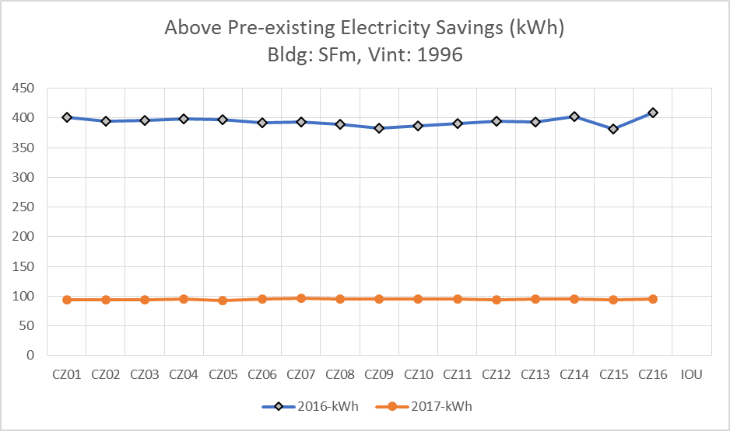

**Figure 2 - Change in Savings vs. Pre-existing Baseline for Top Loading Clothes Washer Measure: RE-Appl-EffCW-med-ElecDHW-ElecCDryer-Tier1-Top**

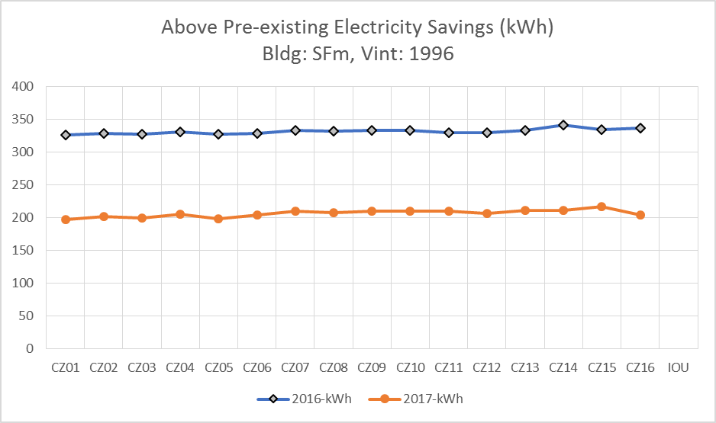

Table 3 and Table 4 show the annual energy impacts for the weighted residential building type in each of the IOU territories for DEER2016 and DEER2017 clothes washer measures. The reduction due to the baseline change is shown for each measure in the far-right columns.

Table 3 - Change in Above Pre-existing Energy Impacts from DEER2016 to DEER2017 for Clothes Washer measures

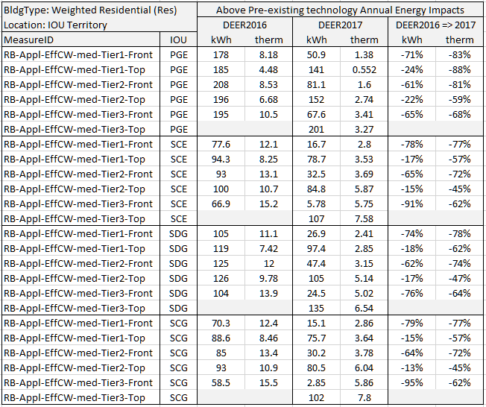

Table 4 - Change in Above Code/Standard Energy Impacts from DEER2016 to DEER2017 for Clothes Washer measures

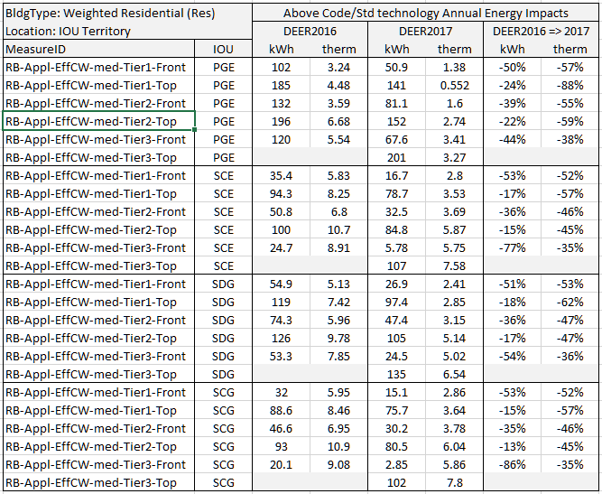

## Residential Refrigerator and Freezer Measures

Residential refrigerator and freezer measures were updated in August of 2016 for the DEER2017 update. Changes in the simulation results were based on updated residential prototypes and building vintage definitions that were developed for the DEER2017 release. The measure definitions did not include a pre-existing technology and all above pre-existing energy impacts were reported as zero. For this update, a pre-existing technology is established based on CLASS data for refrigerators and freezers four years old or older at the time of the survey (these units would be at least nine years old in 2017). The rated kWh factor for the units are compared to the rated kWh required by code for the same unit category. The rated kWh of the pre-existing technology is defined as the rated kWh of the code compliant technology times a factor determined from analysis of the CLASS data.

Table 5 - Ratio of Pre-existing technology rated kWh to Code rated kWh by category

|  |  |  |
| --- | --- | --- |
| Appliance Category | Count | Ratio |
| Refrigerator/Freezer | | |
| Top freezer, no icemaker | 617 | 1.35 |
| Side freezer, thru-door ice | 643 | 1.04 |
| Refrigerator Only | 28 | 1.19 |
| Bottom freezer, thru-door ice | 33 | 0.73 |
| Top freezer with icemaker | 19 | 1.18 |
| Bottom freezer, no icemaker | 121 | 0.98 |
| Built-in, thru-door ice, side frzr | 6 | 1.07 |
| Side freezer, no icemaker | 57 | 1.50 |
| Built-in, no icemaker, side frzr | 16 | 0.96 |
| Single door, thru-door ice | 2 | 2.61 |
| All (except Compact) | 1542 | **1.18** |
| Stand-alone Freezer | | |
| Chest | 49 | **1.10** |
| Upright | 120 | **1.54** |

Table 5 above shows the results of the CLASS analysis for residential refrigerators and freezers older than four years. The ratio of the rated-kWh for the CLASS records divided by the code required rated-kWh for the same appliance category is shown in the third column and the number of records utilized to determine the ratio is shown in the second column. Variation of the ratio among the refrigerator categories leads to some interesting observations, such as the existing population of bottom freezer refrigerators are already better than code. Since some of the category specific counts are quite low, the overall refrigerator/freezer ratio of 1.18 is utilized for all refrigerator/freezer categories. Note that compact refrigerators in the CLASS database were not utilized in this analysis since the CLASS definition is not compatible with the federal classification definition used in DEER.

The two major categories of stand-alone freezers, chest and upright freezers, use separate ratios to define the pre-existing rated-kWh. All modified measure definitions can be found in the PEAR database by filtering the Measure table with TechGroup = “Ref_Storage” and source description = “June 2017 DEER Update”.

## Domestic Water Heater Measures

**Residential**

Residential small storage, instantaneous and het pump water water heater measures were last updated in DEER2015 in response to new federal code requirements. The impacts were determined using a workbook calculation tool, with impacts calculated for both pre-existing and standard baselines. Pre-existing baseline values were carried forward from previous DEER values.

The CLASS database shows only minor differences in water heater efficiencies relative to building vintage, whereas the DEER2015 pre-existing baselines were significantly worse for older vintages than for newer vintages. Thus, the DEER pre-existing baseline for each residential water heater type is updated using CLASS data averaged across the building vintages. The following table shows how the pre-existing technology Energy Factors (EF) change from the DEER2015 assumptions to the DEER2017 update.

Table 6 - Residential water heater pre-existing technology Energy Factors

|  |  |  |  |  |  |  |  |  |  |  |
| --- | --- | --- | --- | --- | --- | --- | --- | --- | --- | --- |
| Measure Parameters | | Code/Std | DEER2015 Pre-existing technology EF by Building vintage | | | | | | | DEER2017  Pre-existing |
| Fuel Type | Gallons | EF | 1975 | 1985 | 1996 | 2003 | 2007 | 2011 | 2014 | tech EF |
| Elec | 30 | 0.95 | 0.89 | 0.89 | 0.89 | 0.89 | 0.93 | 0.93 | 0.93 | **0.91** |
| Elec | 40 | 0.94 | 0.88 | 0.88 | 0.88 | 0.88 | 0.92 | 0.92 | 0.92 | **0.92** |
| Elec | 50 | 0.94 | 0.86 | 0.86 | 0.86 | 0.86 | 0.90 | 0.90 | 0.90 | **0.92** |
| Elec | 60 | 1.98 | 0.85 | 0.85 | 0.85 | 0.85 | 0.89 | 0.89 | 0.89 | **0.89** |
| Elec | 75 | 1.96 | 0.83 | 0.83 | 0.83 | 0.83 | 0.87 | 0.87 | 0.87 | **0.87** |
| Gas | 30 | 0.63 | 0.57 | 0.57 | 0.57 | 0.58 | 0.61 | 0.61 | 0.61 | **0.59** |
| Gas | 40 | 0.61 | 0.57 | 0.57 | 0.57 | 0.58 | 0.59 | 0.59 | 0.59 | **0.60** |
| Gas | 50 | 0.60 | 0.57 | 0.57 | 0.57 | 0.58 | 0.58 | 0.58 | 0.58 | **0.59** |
| Gas | 60 | 0.75 | 0.56 | 0.56 | 0.56 | 0.56 | 0.56 | 0.56 | 0.56 | **0.57** |
| Gas | 75 | 0.74 | 0.48 | 0.48 | 0.48 | 0.48 | 0.53 | 0.53 | 0.53 | **0.52** |

The energy impacts for all DEER2015 residential hot water heater measures are re-calculated using the published DEER Water Heater Calculator. All update measures can be found in the PEAR database by filtering the Measure table with TechGroup = “WaterHtg_eq” and source description = “June 2017 DEER Update”.

The Table 7 below shows how the main energy use (kWh for the electric DHW measures, therms for the gas DHW measures) changes, for conventional storage water heaters only, due to the change in the pre-existing technology specification.

Table 7 - Change in Above Pre-existing Impacts due to update of pre-existing technology (conventional storage water heaters only)

|  |  |  |  |  |
| --- | --- | --- | --- | --- |
| Change in Above Pre-existing Energy Impacts for BldgLoc = IOU, BldgTtype = Res | | | | |
| DEER2015 & DEER2017 MeasureID | PGE | SCE | SDG | SCG |
| RE-WtrHt-SmlStrg-HP-lte12kW-30G-2p00EF | -11% | -10% | -9% | -10% |
| RE-WtrHt-SmlStrg-HP-lte12kW-30G-2p20EF | -9% | -9% | -8% | -8% |
| RE-WtrHt-SmlStrg-HP-lte12kW-30G-2p40EF | -8% | -7% | -7% | -8% |
| RE-WtrHt-SmlStrg-HP-lte12kW-40G-2p00EF | -23% | -22% | -21% | -21% |
| RE-WtrHt-SmlStrg-HP-lte12kW-40G-2p20EF | -20% | -18% | -18% | -18% |
| RE-WtrHt-SmlStrg-HP-lte12kW-40G-2p40EF | -17% | -16% | -16% | -16% |
| RE-WtrHt-SmlStrg-HP-lte12kW-50G-2p00EF | -25% | -24% | -22% | -23% |
| RE-WtrHt-SmlStrg-HP-lte12kW-50G-2p20EF | -21% | -20% | -19% | -20% |
| RE-WtrHt-SmlStrg-HP-lte12kW-50G-2p40EF | -19% | -18% | -17% | -18% |
| RE-WtrHt-SmlStrg-HP-lte12kW-60G-2p20EF | -16% | -16% | -15% | -15% |
| RE-WtrHt-SmlStrg-HP-lte12kW-60G-2p40EF | -15% | -14% | -14% | -14% |
| RE-WtrHt-SmlStrg-HP-lte12kW-75G-2p20EF | -16% | -15% | -14% | -14% |
| RE-WtrHt-SmlStrg-HP-lte12kW-75G-2p40EF | -14% | -13% | -13% | -13% |
| RG-WtrHt-SmlInst-Gas-150kBtuh-lt2G-0p82EF | -24% | -24% | -23% | -24% |
| RG-WtrHt-SmlInst-Gas-150kBtuh-lt2G-0p92EF | -21% | -22% | -20% | -21% |
| RG-WtrHt-SmlStrg-Gas-lte75kBtuh-30G-0p65EF | -32% | -32% | -31% | -32% |
| RG-WtrHt-SmlStrg-Gas-lte75kBtuh-30G-0p70EF | -19% | -19% | -18% | -19% |
| RG-WtrHt-SmlStrg-Gas-lte75kBtuh-30G-0p72EF | -18% | -18% | -17% | -18% |
| RG-WtrHt-SmlStrg-Gas-lte75kBtuh-40G-0p65EF | -40% | -40% | -39% | -40% |
| RG-WtrHt-SmlStrg-Gas-lte75kBtuh-40G-0p70EF | -31% | -31% | -31% | -31% |
| RG-WtrHt-SmlStrg-Gas-lte75kBtuh-40G-0p82EF | -21% | -21% | -20% | -21% |
| RG-WtrHt-SmlStrg-Gas-lte75kBtuh-50G-0p67EF | -25% | -25% | -25% | -25% |
| RG-WtrHt-SmlStrg-Gas-lte75kBtuh-50G-0p70EF | -21% | -21% | -21% | -21% |
| RG-WtrHt-SmlStrg-Gas-lte75kBtuh-50G-0p82EF | -14% | -15% | -14% | -14% |
| RG-WtrHt-SmlStrg-Gas-lte75kBtuh-60G-0p78EF | -11% | -11% | -11% | -11% |
| RG-WtrHt-SmlStrg-Gas-lte75kBtuh-60G-0p80EF | -10% | -11% | -11% | -11% |
| RG-WtrHt-SmlStrg-Gas-lte75kBtuh-60G-0p82EF | -10% | -10% | -10% | -10% |
| RG-WtrHt-SmlStrg-Gas-lte75kBtuh-75G-0p78EF | -23% | -23% | -22% | -22% |
| RG-WtrHt-SmlStrg-Gas-lte75kBtuh-75G-0p80EF | -22% | -22% | -22% | -22% |
| RG-WtrHt-SmlStrg-Gas-lte75kBtuh-75G-0p82EF | -22% | -21% | -21% | -21% |

Measure definitions for heat pump water heaters were updated to reflect products currently available in the market place. Figure 3 shows currently available water heaters using two different web search methods: 1) water heaters available from three major California retailers, and 2) water heaters published in available manufacturers’ literature. Results of the web search show that all available water heaters published in manufacturers’ literature exceed the minimum code requirements of 2.0 EF. Furthermore, the lowest efficiency water heater available through California retailers has an EF of 3.06. The current DEER measure definitions are based on definitions for both code/ISP and measure technologies that are much less efficient than any currently available products. Therefore, measure definitions for DEER 2017 include the following revisions:

1. 50 gallon minimum storage capacity: The smallest storage capacity available is 50 gallons. Therefore the measure definition for replacement of 30 and 40 gallon water heaters has been revised to a 50 gallon heat pump water heater.
2. Code/ISP baseline energy factor: The Code/ISP baseline energy factor is revised to 3.0 to reflect that there are no water heaters available in California with an EF lower than 3.06.
3. Revised measure levels: The revised measures include two efficiency tiers. The first tier represents the lowest efficiency available in California in each of three storage capacity classes (50 gallon, 65 gallon, 80 gallon). The second tier represents the most efficient water heater currently available from both manufacturers’ literature and California retailers.

Figure 3 - Availabe Heat Pump Water Heaters



Table 8 provides a sample comparison of current and proposed DEER measures. Due to the revision in the code/ISP baseline, above code savings for water heaters over 55 gallons have decreased. However, both above code and above pre-existing savings for smaller water heater have increased. Table 9 lists the revised heat pump water heater measure definitions.

Table 8 - Sample Comparison, Current to Revised Heat Pump Water Heaters

|  |  |  |  |  |  |  |  |  |  |  |  |  |  |  |
| --- | --- | --- | --- | --- | --- | --- | --- | --- | --- | --- | --- | --- | --- | --- |
| Category | Storage Capacity (gal) | | | | Energy Factor | | | | Above pre kWh | | | Above code/ISP kWh | | |
| Pre | Code | | Msr | Pre | Code | | Msr | PGE | SCE | SDG | PGE | SCE | SDG |
| 40 gallon pre-existing water heater | | | | | | | | | | | | | | |
| Current | 40 | 40 | 40 | | note 1 | 0.95 | 2.40 | | 1350 | 1378 | 1408 | 949 | 997 | 1038 |
| Update | 40 | 40 | 50 | | 0.92 | 0.94 | 3.24 | | 1860 | 1840 | 1870 | 1690 | 1670 | 1700 |
| Diff % |  |  |  | |  |  |  | | 27% | 25% | 25% | 44% | 40% | 39% |
| 60 gallon pre-existing water heater | | | | | | | | | | | | | | |
| Current | 60 | 60 | 60 | | note 1 | 1.98 | 2.40 | | 1560 | 1580 | 1610 | 408 | 371 | 380 |
| Update | 60 | 65 | 65 | | 0.89 | 3.00 | 3.17 | | 1960 | 1930 | 1970 | 94 | 84 | 84 |
| Diff % |  |  |  | |  |  |  | | 20% | 18% | 18% | -334% | -342% | -352% |

Note 1: Current pre-existing efficiencies vary by vintage and are listed in Table 6, above.

Table 9 - Revised Residential Heat Pump Water Heater Measures

|  |  |  |  |  |  |  |
| --- | --- | --- | --- | --- | --- | --- |
|  | Storage Capacity | | | Energy Factor | | |
| Revised Measure ID | Pre | Std | Msr | Pre | Std | Msr |
| RE-WtrHt-SmlStrg-HP-lte12kW-rep30G-3p24EF | 30 | 30 | 50 | 0.91 | 0.95 | 3.24 |
| RE-WtrHt-SmlStrg-HP-lte12kW-rep30G-3p50EF | 30 | 30 | 50 | 0.91 | 0.95 | 3.50 |
| RE-WtrHt-SmlStrg-HP-lte12kW-rep40G-3p24EF | 40 | 40 | 50 | 0.92 | 0.95 | 3.24 |
| RE-WtrHt-SmlStrg-HP-lte12kW-rep40G-3p50EF | 40 | 40 | 50 | 0.92 | 0.95 | 3.50 |
| RE-WtrHt-SmlStrg-HP-lte12kW-rep50G-3p24EF | 50 | 50 | 50 | 0.92 | 0.95 | 3.24 |
| RE-WtrHt-SmlStrg-HP-lte12kW-rep50G-3p50EF | 50 | 50 | 50 | 0.92 | 0.95 | 3.50 |
| RE-WtrHt-SmlStrg-HP-lte12kW-rep60G-3p17EF | 60 | 65 | 65 | 0.89 | 3.00 | 3.17 |
| RE-WtrHt-SmlStrg-HP-lte12kW-rep60G-3p50EF | 60 | 65 | 65 | 0.89 | 3.00 | 3.50 |
| RE-WtrHt-SmlStrg-HP-lte12kW-rep75G-3p06EF | 75 | 80 | 80 | 0.87 | 3.00 | 3.06 |
| RE-WtrHt-SmlStrg-HP-lte12kW-rep75G-3p50EF | 75 | 80 | 80 | 0.87 | 3.00 | 3.50 |

**Nonresidential**

Domestic water heater measures for commercial buildings were last updated in DEER2015 using a workbook analysis approach. This update included only small storage and instantaneous water heaters. Large storage water heaters were last updated in DEER2014 by simulation with the MASControl program. Ex Ante values for commercial water heaters include results for both pre-existing and Standard baselines.

There are no sources for new pre-existing conditions for commercial water heaters that are known to CPUC staff, so this measure is not slated for update in the current effort.

## Residential Gas Furnace Efficiency Measures

Residential gas furnace measures were updated in DEER2017 in order to include the 2015 and 2017 vintages in the measure impacts. Simulations for DEER2017 were developed using the MASControl2[13] tool which incorporates building simulation. Impacts are provided in the Ex-Ante database for both pre-existing and standard baselines.

The pre-existing baseline efficiency for DEER2017 was 78% for vintages through 2014, and 80% thereafter. Review of the CLASS database revealed an average furnace efficiency of 80% for existing systems, which is the same as the code value that has been in place since 2015. Thus, to-code savings for the DEER2017 Update will be zero for residential gas furnaces. Using an alternative value for any claim will require submission of an accelerated replacement workpaper or program plan that specifies how the proof of pre-existing equipment efficiency will be collected and placed into the project files and supplied with the savings claim to support the savings value in the claim.

Table 10 - Pre-Existing Model Parameters for Residential Gas Furnace - AFUE

|  |  |  |  |  |
| --- | --- | --- | --- | --- |
| Measure | Vintage | Old Pre-Existing Baseline | New Pre-Existing Baseline | Code/ Standard |
| Gas Furnace | Thru 2014 | 0.78 | 0.80 | 0.80 |
| Gas Furnace | After 2014 | 0.80 | 0.80 | 0.80 |

## HVAC Cooling Efficiency Measures

**Residential**

Cooling efficiency measures were updated in DEER2017, with simulations run using the MASControl program. Results in the Ex-Ante database for DEER2017 include impacts relative to both pre-existing and standard baselines. Pre-existing efficiency values for DEER2017 were SEER 10 for older vintages through 2005, SEER 13 from 2006 through 2014, and SEER 14 for 2015 and later. The average efficiency for pre-existing systems calculated from the CLASS database is   
SEER 11.4.

It should be noted that the residential Air Conditioning (AC) measure technologies were not affected by the baseline update. Since only the pre-existing baselines were affected, the impacts vs. code have not changed.

Table 11 - Pre-Existing Model Parameters for Residential Cooling Efficiency - SEER

|  |  |  |  |  |
| --- | --- | --- | --- | --- |
| Measure | Vintage | Old Pre-Existing Baseline | New Pre-Existing Baseline | Code/ Standard |
| Air conditioner efficiency | Thru 2003 | 10 | 11.4 | 14 |
| Air conditioner efficiency | 2004 - 2014 | 13 | 13 | 14 |

Figure 4 shows an example of the magnitude of change in savings due to the baseline update for a SEER 17 AC unit for a vintage 1996 single family home across all climate zones. The blue bars represent savings for the original DEER2017 release and the orange bars represent the current DEER2017 Update. On average, the above pre-existing impact is reduced for this case by about 25% relative to the DEER2017 values.

Figure 4 - Sample of Change to Measure Impacts for Residential AC Pre-existing Baseline Update

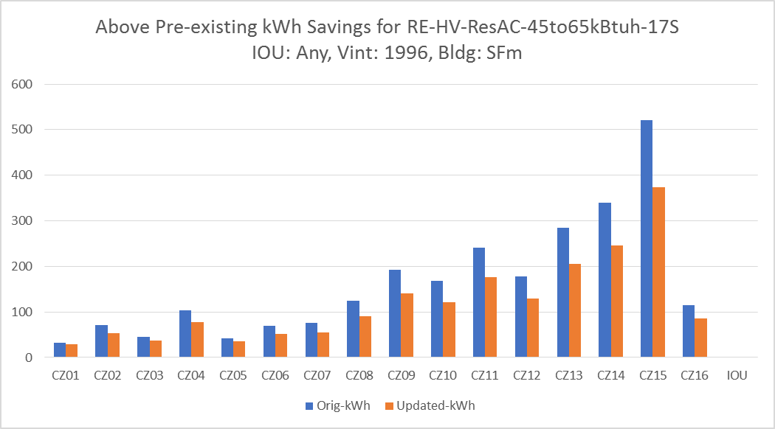

**Nonresidential**

The last significant update for commercial unitary air conditioners and heat pumps was in DEER2015. This update included all AC and heat pump (HP) units below 65 kBtu/hr, and all AC units 65 kBtu/hr and greater. Values in the Ex-Ante database include impacts relative to both pre-existing and standard baselines. The pre-existing baselines in DEER2015 were based on historic code requirements. For buildings built before 2002, it was assumed that the air conditioners had been updated to the efficiency level of the 2002 to 2005 vintage.

A review of the California Commercial Saturation Survey (CSS), summarized in Table 12, shows efficiency levels that are significantly above the DEER2015 pre-existing baselines for most equipment size categories. The first row of Table 12 includes data from all building vintages and all ages of AC units. Since the study was done in 2012, this would mean unit ages would be 5 years or older now. A survey of claims from the SCE Packaged HVAC Early Retirement Program[14] shows that there are relatively few claims where the replaced system is less than 9 years old, as shown by the histogram of Figure 5. Thus, the analysis for the DEER2017 pre-existing baseline update is based on the second row of Table 12, which excludes equipment less than 5 years old. While the data in the 240 to 760 kBtu/hr size range indicates a pre-existing baseline value that is more efficient than code (10.0 for VAV, 9.8 for CV)[15], the pre-existing baseline value for the DEER2017 Update was set equal to code due to the limited number of data points in that group. Moreover, since there was only a single data point in the over 760 kBtu/hr size range, that result was deemed inconclusive, and the DEER2015 pre-existing baseline value was carried over. A summary of the new values for the DEER2017 Update are listed in Table 13.

Table 12 - Summary of CSS Data for Commercial Air Conditioner Efficiency Pre-existing Baselines[16]



Figure 5 - Histogram of AC Unit Age from Claims Made for SCE's Packaged HVAC Early Retirement Program (claim years 2013 through 2016)

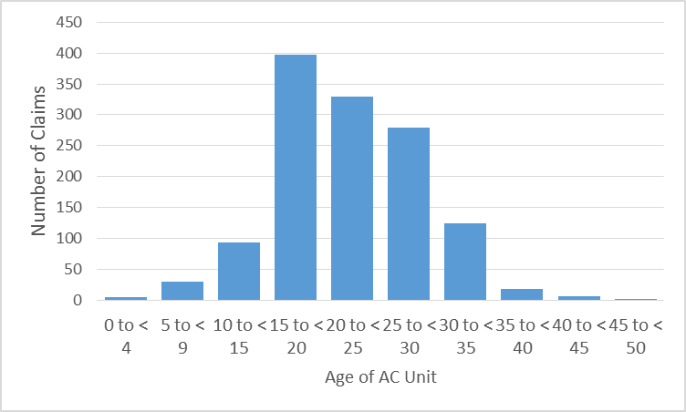

Table 13 - Pre-Existing Model Parameters for Nonresidential Cooling Efficiency

|  |  |  |  |  |
| --- | --- | --- | --- | --- |
| Measure | Vintages Affected | DEER2015 Pre-Existing Baseline | New Pre-Existing Baseline | Code/ Standard |
| Split AC < 65 kBtu/hr | Thru 2001 | 10 | 11.5 | 14 |
| Pkg AC, < 65 kBtu/hr | Thru 2001 | 9.7 | 11.6 | 14 |
| Split/Pkg AC, 65 to < 135 kBtu/hr | Thru 2009 | 10.1 | 10.0 | 11.0 |
| Split/Pkg AC, 135 to < 240 kBtu/hr | Thru 2009 | 9.5 | 9.7 | 10.8 |
| Pkg CV 240 to < 760 kBtu/hr | Thru 2009 | 9.3 | 9.8 | 10.0 |
| Pkg VAV 240 to < 760 kBtu/hr | Thru 2009 | 9.5 | 10.0 | 10.0 |
| Pkg VAV >= 760 kBtu/hr | Thru 2009 | 9.2 | no change | 9.7 |

Another important result gleaned from the SCE Packaged HVAC Early Retirement Claims is the prevalence of constant volume systems and variable volume systems for the larger equipment size categories. Table 14 shows the total equipment capacity from claims, organized by equipment vintage and by type of equipment. For the largest equipment size category, there were no constant volume systems. For the 240 to 760 kBtu/hr size range, 80% of systems that could be identified were variable volume. For the 135 to 240 kBtu/hr size range, only 8% were variable volume. Based on this data, constant volume systems in the largest size range have been removed from DEER in order to prevent accidental claims of VAV systems as if they were constant volume.

For the 240 to 760 kBtu/hr size range, a single weighed measure has been implemented in DEER based on the population data from the claims. The constant volume and VAV measures are retained in the database as component-type measures for reference.

For all HVAC (or other) measures’ equipment sizes, in order to use the (customer average) pre-existing savings values in DEER for ( which indicates an accelerated replacement measure type is being assigned to a claim), program claims will be required to provide rated efficiency values for the systems that are replaced. Evidence of the pre-existing equipment rated capacity must be retained in the project files (such as a picture of the equipment and its nameplate showing the model number and rating information). This information is required to support the claim, support evaluation verification of the claim and to provide data for future refinement of pre-existing baseline values.

Table 14 - Summary of Fan Control Distribution vs. System Vintage from Claims Made for SCE's Packaged HVAC Early Retirement Program (claim years 2013 through 2016)



Figure 6 through Figure 8 are plots showing the changes in commercial AC efficiency impacts due to the DEER2017 pre-existing baseline updates. The DEER2015 lines in these graphs include the error corrections that are discussed below so these comparisons include only the baseline update. The changes follow expected patterns relative to the changes in baseline efficiencies outlined in   
Table 13.

**Figure 6 - Sample Comparison of New DEER2017 Update Impacts with DEER2015 Impacts After Error Corrections for 55 to 65 kBtu/hr System Size**

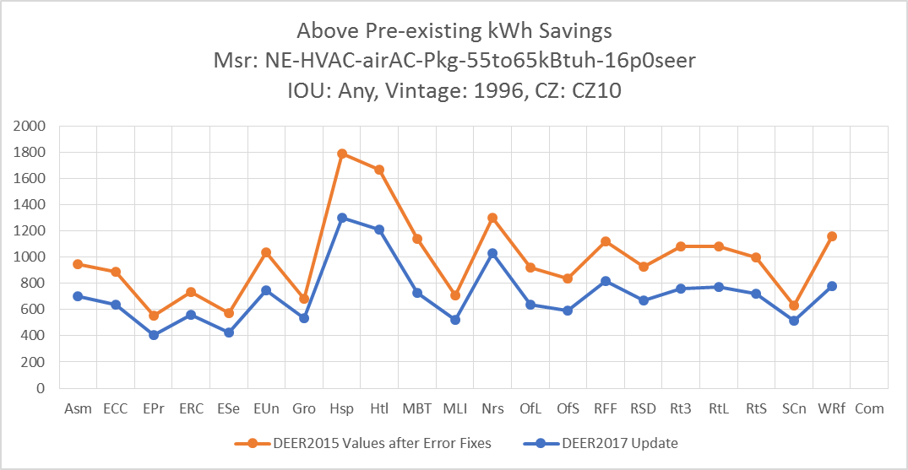

Figure 7 - Sample Comparison of New DEER2017 Update Impacts with DEER2015 Impacts After Error Corrections for 65 to 109 kBtu/hr System Size

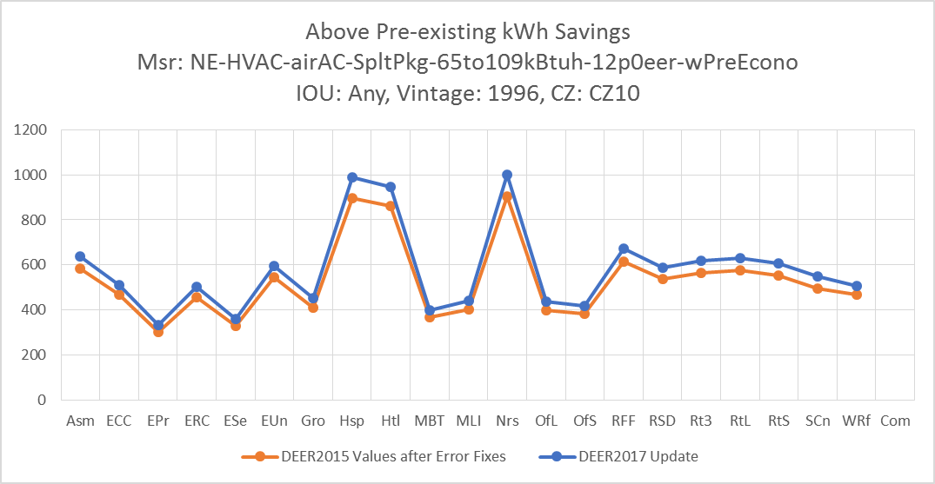

Figure 8 - Sample Comparison of New DEER2017 Update Impacts with DEER2015 Impacts After Error Corrections for 135 to 239 kBtu/hr System Size

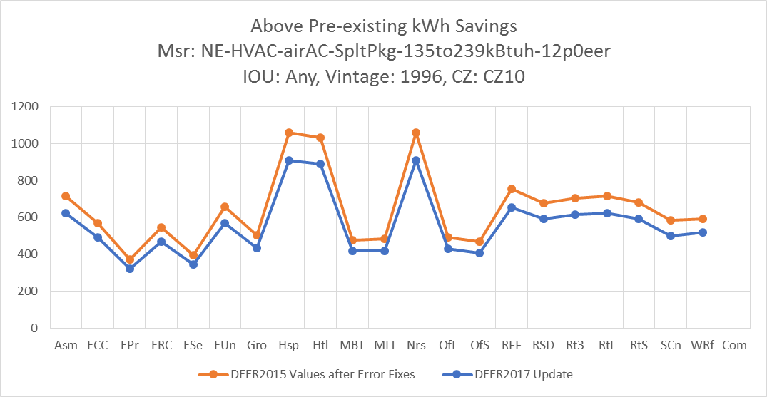

## Residential Exterior Wall and Attic Insulation Measures

Residential exterior wall and attic insulation measures were updated in DEER2017 in response to changes in Title 24-2016 requirements. The update was performed using simulations with the MASControl2 software, and the Ex-Ante database includes savings compared to both re-existing and standard baselines. The pre-existing baselines for DEER2017 are based on historical code requirements at the time of each vintage.

Values from the CLASS database suggest that pre-existing insulation levels are generally significantly lower than the values used in DEER2017. Since the current DEER pre-existing levels are based on the energy code requirements at the time of the building vintage, this implies insulation levels were worse than code, which is unlikely to be consistently true to the extent suggested by the data. This raises questions about the methods used in the site visits, such as where the measurements were taken and whether compaction of insulation was considered in the interpretation of the measurements. Resolution E-4818 makes it clear that the efficiency used for the baseline in existing conditions cases must be symmetric with the measure efficiency itself; use of a rated measure efficiency requires the use of a rated pre-existing condition efficiency with the acknowledgement that all technologies may experience performance degradation over their service life. Therefore, it is appropriate to utilize the insulation rated values of the pre-existing insulation likely to have existed at their time of installation unless it is chosen to use a measure efficiency that is degraded to match the pre-existing measure performance. Based on these considerations, the decision was made to retain the pre-existing baseline insulation levels from DEER2017; hence no changes were made to insulation measure values for this update.

## Lighting Measures

Commission staff has recently issued a Phase 1 workpaper disposition covering all screw-in LED and CFL lamps.[17],[18] The disposition includes direction for updates to energy savings and net-to-gross values. To develop the disposition, Commission staff examined available market sales data, claims history from the PAs along with the applicable data and analysis included in the Commission’s evaluation reports. As part of the DEER update process, Commission staff considered updating NTG values for CFLs and LEDs. However, due to the rapidly changing nature of the technologies, product availability, consumer preference and PA program rules, Commission staff has chosen not to update these NTG values in DEER. Instead, NTG values can be updated as part of the workpaper process, which allows them to be updated in a more timely fashion as EM&V results become available and market conditions change.

## Effective and Remaining Useful Life

Currently, Commission policy recommends a remaining useful life (RUL) equal to one-third of the effective useful life (EUL).[19] Resolution E-4818 provides guidance expected to allow more measures to be classified as early retirement (renamed as accelerated replacement), with savings calculated using the dual baseline approach.[20] Commission staff was initially concerned that the current default approach of setting the RUL equal to one-third of the EUL may not be reasonable for some measures. A more reasonable RUL may be higher or lower. However, Commission staff review of available market research, evaluation findings and data as well as previous stakeholder input failed to identify any specific revisions to EUL values or the default RUL method. Commission staff notes that Resolution   
E-4818 Ordering Paragraph 16 permits applying “an accelerated replacement baseline treatment to equipment that qualifies as repair eligible or repair indefinitely where the equipment is older than its predetermined effective useful life.” This new direction relieves the concerns Commission had that the policy limit on the maximum EUL values of twenty years was disadvantaging equipment such as space heating boilers, commercial and industrial process, or building shell components such as windows, that can have a service life well beyond the current EUL limit of twenty years. Considering that the RUL value used in accelerated replacement treatment is the time during which the existing equipment both can and likely will stay in place absent the program influence, Commission staff considers the current default value of one-third the existing equipment EUL as still appropriate.

## Net-to-Gross

**Updates to Address Direction in E-4818**

Resolution E-4818 establishes an expanded framework for applying the accelerated replacement dual baseline approach where savings are estimated above the existing baseline for the RUL and above the standard practice or code baseline for the post-RUL period (equal to the EUL minus the RUL of the replaced equipment). Historically, measures have been assigned a single net-to-gross value that was not dependent on the measure application type (such as accelerated replacement or normal replacement) or baseline (i.e. existing conditions, standard practice or code). However, available data and findings from the most recent lighting evaluations as well as analysis of several years of HVAC claims provide support for assuming higher levels of free ridership in the “to-code” portion of savings that is credited only for the RUL (first) savings period, compared to the free ridership in the “above code” savings that that is credited for the balance of the EUL (or second period). NTG values currently in DEER were developed for normal replacement measure types not for early replacement measure types. For this DEER update, Commission staff adds an adjustment factor to the DEER NTG table designed to provide an appropriate adjustment to the normal replacement NTG values for use with the measure when given an accelerated replacement measure type designation. The adjustment factor provides an incremental free ridership fraction for the to-code portion (RUL period) of the accelerated replacement savings calculation. The normal replacement NTG provides the net of free ridership for the above code portion of the saving while the new “accelerated replacement NTG adjustment factor (AFAR) provides an increment to the free ridership for the below code portion of the savings. The adjustment will reduce the net-to-gross value for the to-code savings to account for customers who were not influenced by a program to replace the existing equipment or systems prior to the end of the useful life.

The adjustment to the NTG applied to the to-code portion of the savings will reduce the net lifetime savings. The current method to calculate the lifetime net savings is shown in the following equation:

$${Savings}_{ln}={(Savings}_{tc}×RUL+{Savings}_{ac}×EUL)×NTG$$

Where:

*Savingsln* = The lifetime net savings

*Savingstc* = The savings occurring due to the improvement from the existing or as found conditions to the code baseline or industry standard practice efficiency level

*RUL* = The remaining useful life of the removed equipment or system

*Savingsac* = The savings occurring due to the improved efficiency of the installed measure over the code baseline or industry standard practice efficiency level

*EUL* = The effective useful life of the measure

*NTG* = Current approved net-to-gross value

Lifetime savings, taking into account the free-rider adjustment for the to-code savings, is calculated using the following equation:

$${Savings}_{ln}={(Savings}_{tc}×RUL×NTG×(1-{AF}_{AR}))+({Savings}_{ac}×EUL×NTG)$$

Where:

*AFAR* = The fraction of participants whose decisions to replace the equipment or system were not influenced by programs and are therefore free riders for the accelerated replacement decision

Commission staff has revised the net-to-gross table in the ex-ante database to include the adjustment fraction for the to-code savings for all values that could be applicable to accelerated replacement measure application types. Table 15 lists the NTG records from the ex-ante database for which to-code NTG adjustment factors have been added. Any currently approved values that do not appear in Table 15 are not applicable to accelerated replacement claims and therefore could not have a to-code adjustment factor. A discussion of supporting analysis for the listed values of AFAR is provided under “Background on Development of NTG Adjustments for To-Code Savings” below.

Table 15 - DEER Net-to-Gross Updates for Accelerated Replacement

| NTG ID | Stat-us | Bldg | Sec-tor | Description | NTG | AFAR |
| --- | --- | --- | --- | --- | --- | --- |
| Res-sAll-mHVAC-RmAC-dn | Ex | Any | Res | Energy Star Room AC and HP | 0.36 | 0.5 |
| Res-sAll-mHVAC-Pkg-dn | New | Any | Res | All package HVAC AC and HP replacements with downstream incentives | 0.6 | 0.75 |
| Res-sAll-mDHWgt62 | Ex | Any | Res | Water Heater EF >0.62<0.65, Cap>30 gal. | 0.23 | 0.5 |
| Res-sAll-mCW | Ex | Any | Res | Clothes washer MEF 10% > Energy Star | 0.31 | 0.5 |
| Res-sAll-mDHWshwr | Ex | Any | Res | Low flow showerheads | 0.7 | 0.5 |
| Res-mDHWaerator | Ex | Any | Res | Faucet aerators | 0.59 | 0.5 |
| Res-mDHWaerator | Ex | MFm | Res | Faucet aerators | 0.65 | 0.5 |
| Res-Default>2 | Ex | Any | Res | All other EEM with no evaluated NTGR; existing EEM with same delivery mechanism for more than 2 years | 0.55 | 0.5 |
| Res-Default-HTR-di | Ex | Any | Res | All other EEM with no evaluated NTGR; direct install hard-to-reach only. | 0.85 | 0.5 |
| EUC-Default | Ex | Any | Res | Energy Upgrade California | 0.7 | 0.5 |
| NonRes-sAll-mLFHBT5-Deemed | Ex | Any | NR | Nonresidential Linear Fluorescent: T5 lamps; high bay applications; deemed; all delivery mechanisms | 0.65 | 0.2 |
| NonRes-sAll-mLFHB-Deemed | Ex | Any | NR | Nonresidential Linear Fluorescent: high bay applications; deemed; all delivery mechanisms | 0.65 | 0.2 |
| NonRes-sAll-mLFDL-Deemed | Ex | Any | NR | Nonresidential Linear Fluorescent: delamping; deemed; all delivery mechanisms except upstream | 0.65 | 0.2 |
| NonRes-sAll-mLFOth-Deemed | Ex | Any | NR | Nonresidential Linear Fluorescent: measures not listed elsewhere; deemed; all delivery mechanisms | 0.6 | 0.2 |
| NonRes-sAll-mCust-Gas | Ex | Any | NR | Custom Natural Gas Measures (that may have electric savings due to the natural gas measures) | 0.5 | 0.5 |
| NonRes-sAll-mHVAC-Pkg | New | Any | NR | All package HVAC AC and HP replacements with downstream incentives | 0.6 | 0.75 |
| NonRes-sAll-mCust-Elec | Ex | Any | NR | Custom Electric Measures (that may have natural gas impacts due to the electric measures) | 0.6 | 0.5 |
| NonRes-sAll-mCust | Ex | Any | NR | Custom Mixed Electric and Natural Gas Measures | 0.6 | 0.5 |
| NonRes-sAll-mLtg-ci | Ex | Any | NR | Nonresidential Lighting: all technologies except screw-in lamps; custom; all delivery mechanisms | 0.55 | 0.2 |
| NonRes-sAll-mHVAC-Chiller | Ex | Any | Com | All chiller replacements - space cooling applications | 0.58 | 0.5 |
| Com-Default>2yrs | Ex | Any | Com | All other EEMs with no evaluated NTGR; existing EEM in programs with same delivery mechanism for more than 2 years | 0.6 | 0.5 |
| Com-Default-HTR-di | Ex | Any | Com | All other EEM with no evaluated NTGR; direct install to hard-to-reach only. | 0.85 | 0.5 |
| K-12School-ComCollege | Ex | Schools | Com | All K-12 and community college projects | 0.85 | 0.5 |
| Agric-Sprklr-All | Ex | Any | Ag | Agricultural water conserving sprinkler technologies; deemed; all delivery mechanisms except upstream | 0.4 | 0.5 |
| NonRes-sAg-mCust-ci | Ex | Any | Ag | All other custom either electric or natural gas measures | 0.7 | 0.5 |
| Agric-Default>2yrs | Ex | Any | Ag | All other EEMs with no evaluated NTGR; existing EEM in programs with same delivery mechanism for more than 2 years | 0.6 | 0.5 |
| Agricult-Default-HTR-di | Ex | Any | Ag | All other EEM with no evaluated NTGR; direct install to hard-to-reach only. | 0.85 | 0.5 |
| Ind-Default>2yrs | Ex | Any | Ind | All other EEMs with no evaluated NTGR; existing EEM in programs with same delivery mechanism for more than 2 years | 0.6 | 0.5 |
| Ind-Default-HTR-di | Ex | Any | Ind | All other EEM with no evaluated NTGR; direct install to hard-to-reach only. | 0.85 | 0.5 |
| All-Default<=2yrs | Ex | Any | Any | All other EEM with no evaluated NTGR; new technology in program for 2 or fewer years | 0.7 | 0.5 |
| ET-Default | Ex | Any | Any | Emerging Technologies approved by ED through work paper review | 0.85 | 0.5 |
| ConstrainedAreaProgram | Ex | Any | Any | All programs targeting local T&D or generation constrained area | 0.85 | 0.5 |

**Background on Development of NTG Adjustments for To-Code Savings**

The calculation of an overall NTG where the values differ for to-code versus above code savings is shown by:

$${NTG}_{life}= \frac{({(Savings}_{tc}×RUL×{NTG×(1-AF}_{AR})+({Savings}_{ac}×EUL×NTG))}{({(Savings}_{tc}×RUL)+({Savings}_{ac}×EUL))}$$

Where:

*NTGlife* = The overall lifetime net-to-gross value when additional free-ridership is incorporated into the to-code savings

*Savingstc* = The savings occurring due to the improvement from the existing or as found conditions to the code baseline or industry standard practice efficiency level.

*RUL* = The remaining useful life of the removed equipment or system

*AFAR* = The fraction of participants whose decisions to replace the equipment or system were not influenced by programs and are therefore free riders for the accelerated replacement decision

*Savingsac* = The savings occurring due to the improved efficiency of the installed measure over the code baseline or industry standard practice efficiency level

*EUL* = The effective useful life of the measure

*NTG* = The approved net-to-gross value

The overall NTG value for to accelerated replacement measures will vary based on the relative fractions of to-code and above-code savings. A higher fraction of to-code savings results in a lower overall NTG. Figure 9 shows how lifetime NTG values would vary based on the ratio of to-code to above-code savings and the fraction of free-ridership assumed for the to-code portion of the savings. Since net lifetime savings is heavily dependent on the ratio of to-code to above-code savings, it is not appropriate to set a single net-to-gross value for accelerated replacement measures. Therefore, Commission staff proposes a revision to net-life savings method that applies a free-ridership adjustment to the to-code savings.

Figure 9 - Variation of NTGlife



For this DEER update, the DEER team reviewed available research findings for results that indicated levels of free-ridership that could be linked to a customer’s decision to replace equipment or systems prior to the end of its useful life. Analysis was limited to assessing whether efficiency programs had influenced the decision for early retirement/accelerated replacement. For this update, the DEER team reviewed available results and utilized previous analysis for lighting and package HVAC measures.

The last three downstream lighting evaluations included investigations to determine the measure application type of lighting claims. Evaluators made their own determinations of either early retirement (ER) (now to be known as Accelerated Replacement or AR), replace-on-burnout (ROB) or normal replacement (NR) without consideration for how the PAs originally claimed these projects in their accomplishments reported to the Commission. The evaluators’ determinations were developed without consideration for the measure application types submitted by the PAs with their claims.[21],[22],[23]

Using phone surveys, evaluators asked customers questions with respect to six criteria, and then used their responses to determine the measure application type. These six criteria are described in Table 16. The third column identifies whether each of the criteria serves to adjust the gross baseline to the Industry Standard Practices (ISP) or whether it represents a net adjustment on a claim of early retirement/accelerated replacement.

Table 16 - Evaluation Criteria for Determining Measure Application Type for Lighting Projects

|  |  |  |
| --- | --- | --- |
| **Criteria Abbreviation** | **Description** | **Gross or Net Savings Adjuster** |
| > 50% Failed | Fifty percent or more of the equipment was broken or not working prior to the installation as reported by the customer. This criteria contradicts the requirement that the equipment be in proper working condition. | Gross |
| Poor Condition | The equipment was in poor condition, as reported by the customer. This criteria contradicts the requirement that the equipment be in proper working condition. | Gross |
| Age >= EUL | The current age of the equipment must was within one year of the EUL, as reported by the customer. This criteria contradicts the requirement that the equipment would have continued to operate for at least one year. | Gross |
| Expected Life <= 1 | The equipment would not have lasted more than one year before failing and requiring replacement, as reported by the customer. This criteria contradicts the requirement that the equipment would have continued to operate for at least one year. | Gross |
| Likely to Install | The customer must state a high likelihood that they would have done the project at the same time (a rating of 9 or 10 for N5B), or state they definitely or probably would have replaced the existing equipment within one year of when they did. | Net |
| Influential non-Program Factor | The customer must also provide other evidence that supports the claim that they would have replaced their equipment but failure was not imminent, by providing a non-program factor as a reason for the installation and rate that factor as very influential in their decision to install the measure. | Net |

Commission staff notes that the “Expected Life <= 1” item in Table 16 is not consistent with current Commission policy on accelerated replacement measure type assignment, which requires that, absent the program influence to cause the replacement, the measure can and more likely than not will remain in place for the RUL of the replaced equipment. The one year test used in the evaluation test must be replaced with the RUL of the replaced equipment when making the assessment to assign a measure as accelerated replacement.

Figure 10 provides an example of how the DEER team classified responses for each of the criteria listed in Table 16 and estimated the fraction of customers who were likely not influenced by the program to replace their lighting equipment early. This figure is from Table G-124 from the 2010-2012 downstream lighting evaluation.

Figure 10 - Assessment of Free-Ridership in Early Retirement Applications



Over the last three lighting evaluations, the evaluators have performed the assessments shown in Figure 10 for interior linear fluorescent, interior high-bay and exterior LED fixtures. When taking all responses to all criteria across all evaluations, the DEER team developed that an overall estimate of 20% of all installations would have been free-riders in an early retirement/accelerated replacement application.[24]

In addition, as part of the 2015 deemed ESPI payment analysis, Commission staff reviewed early retirement/accelerated replacement claims for upstream package HVAC programs in program years 2013 through 2016.[25] Commission staff estimated that free-ridership in those programs was approximately 75% for the “to-code” portion of the savings. The ratio of to-code to above-code savings vary widely across all package HVAC measures, with many exceeding 10. Figure 11 shows the relationship of adjusted NTG to the ratio of to-code to above-code savings assuming the DEER NTG of 0.75 for upstream HVAC programs and 75% free-ridership for the to-code savings. With the wide variation of lifetime NTG (and therefore lifetime savings), it is not appropriate to apply a single NTG adjustment to all accelerated replacement savings. Instead, the application of a net savings adjustment factor, applicable only to the to-code savings, is more appropriate so that measures with relatively small to-code savings do not have their savings reduced by a greater fraction than those with high to-code savings.

Figure 11- Adjusted NTGlife for Upstream Package HVAC Measures

(Assuming To-Code Free-Ridership = 75%)



Other than the measures discussed above, there are few if any evaluations or analyses that have been focused on identifying specific free-ridership aspects of accelerated replacement decisions. Commission staff considers the 20% approximate free-ridership recommended for lighting measures to represent the lowest amount while the 75% recommended for package HVAC programs to be the highest. For all other measures, Commission staff will utilize a 0.50 accelerated replacement adjustment factor (AFAR) on the NTG for the to-code portion of the savings. The DEER team notes that direction in Resolution E-4818 retains previous direction that an accelerated replacement assignment may be utilized whenever there is a preponderance of evidence (PoE) that the program activity caused the replacement to be accelerated. The preponderance of evidence standard requires the examination of evidence in both directions (supporting and refuting the program influence and likely continued in-place service of the equipment to be replaced) and making the determination that the program induced replacement is more likely than not correct. This PoE standard only requires a 50% probability that the accelerated retirement assignment is correct, therefore, Commission staff proposes an adjustment factor (*AFAR)* of 0.50 for accelerated replacement. These policy and technical considerations lead to a Commission staff developed AFAR value of 0.50 as the default value, absent additional data as presented in this Resolution for lighting and packaged HVAC measures, for all accelerated replacement claims moving forward.

**Updates to Improve Structure and Clarity**

The current NTG table, originally developed for the DEER2008 update, includes applicability fields intended to limit usage of NTG for specific technologies or measure application types. PAs and other parties involved with efficiency program implementation have commented for some time that the structure and nomenclature of the table is often difficult to interpret, especially for new measures supported by new workpapers. Commission staff reviewed the NTG table structure and nomenclature and made revisions to improve the clarity and remove confusion. Except for value revisions specifically discussed in this Resolution, Commission staff did not update any values in the NTG table.

# Updates to Add New Measures

## Top Loading Clothes Washer

In response to a request from PG&E, a new residential top loading clothes washer measure has been added in accordance with the Energy Star Most Efficient Appliance criteria, which requires an IMEF value of at least 2.76. Sample results for the new Tier 3 measure are shown in Figure 12 followed by the Tier 2 measure in Figure 13. The annual savings using the pre-existing baseline for the new Tier 3 measure is about 350 kWh/year, compared with about 280 kWh/year for the Tier 2 measure.

Figure 12 - New Tier 3 Top Loading Measure: RE-Appl-EffCW-med-ElecDHW-ElecCDryer-Tier3-Top

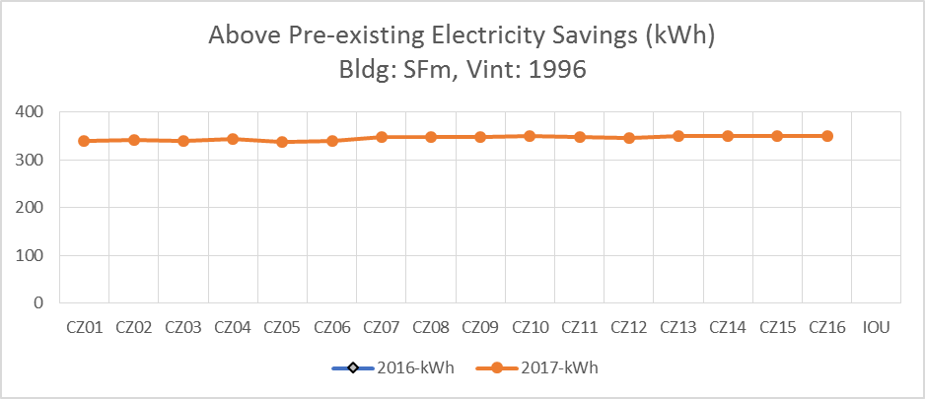

Figure 13 - Existing Tier 2 Top Loading Measure: RE-Appl-EffCW-med-ElecDHW-ElecCDryer-Tier2-Top

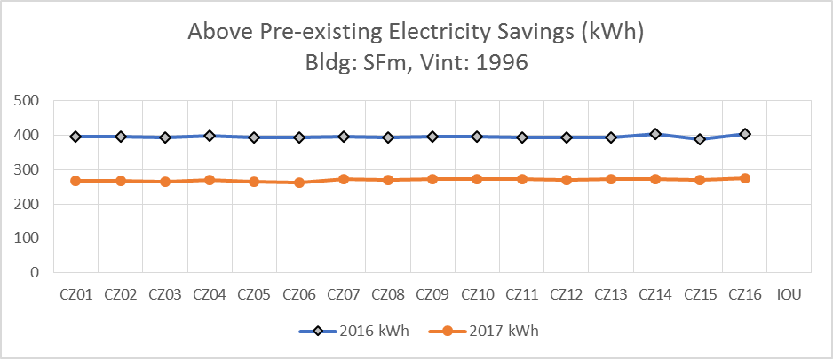

## Variable Refrigerant Flow (VRF) Efficiency Measures

In March 2017 Commission staff issued a Phase 1 disposition covering VRF measures.[26] The disposition includes direction for updates to energy savings values for a limited number of DEER building types and is supported by several documents and updated tools including:

* Assessment of VRF performance in typical commercial buildings
* Posting of to-code measures in the Preliminary Ex-Ante Database
* Research examining the energy impacts of baseline-to-VRF technology differences
* Limited investigation and results of analysis of “three-pronged” tests for fuel switching measures
* Updates to modeling tools to include capabilities for modeling multi-zone VRF systems (with and without heat recovery) and dedicated outside air systems (which are commonly incorporated with VRF systems)

For the current update the VRF efficiency measure assessment has been expanded to include additional building types and system capacity ranges, and the results have been added to the official Ex-Ante Database for DEER2017. Table 17 lists the building types that were included in the March 2017 assessment along with the expanded list of buildings that are included in the DEER2017 Update.

Table 17 - DEER Building Prototypes Included in the VRF Measure Update

|  |  |  |  |
| --- | --- | --- | --- |
| Bldg ID | Description | VRF Disposition Data | DEER2017 Update |
| OfS | Small Office | X | X |
| OfL | Large Office | X | X |
| EPr | Primary School | X | X |
| Htl | Hotel | X | X |
| Asm | Assembly |  | X |
| ESe | Secondary School |  | X |
| ECC | Community College |  | X |
| EUn | University |  | X |
| MLI | Manufacturing Light Industrial |  | X |
| Mtl | Motel |  | X |
| Nrs | Nursing Home |  | X |

Measure tiers for VRF systems have been established by a review of data from the product database published by the Air-Conditioning, Heating and Refrigeration Institute (AHRI).[27] Figure 14 shows a scatter plot of the AHRI product data for heat recovery VRF systems, along with lines delimiting the 2016 Title 20 requirements and measure tiers that were established at the upper boundary of the manufacturer values and in the mid-range. A limitation was placed on Tier 1 values that they must be at least 15% higher than the code EER.

Figure 14 - Code and Measure Tiers for Heat Recovery VRF with Supporting AHRI Data

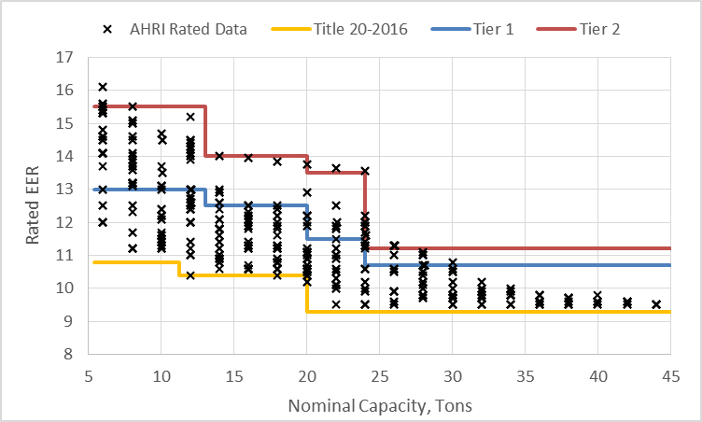

The complete list of measure and code efficiency values for both heat pump VRF and heat recovery VRF are provided in Table 18. The Title 20 values for heat recovery VRF are corrected in Table 18 relative to the values that were used in the March 1, 2017 assessment, which were taken from an older version of the Title 24 standard. The correction amounts to a reduction in EER of 0.2 for all size categories. The Heat Pump VRF code values are unchanged from the March 1, 2017 assessment.

In order to qualify for a program, the efficiency of a system must have a rated efficiency at least as high as the Tier 1 EER. For systems that have efficiencies above the Tier 1 value, it is acceptable to interpolate between Tier 1 and Tier 2 based on EER.

Table 18 - Code and Measure Tier Values for VRF Systems



Sample results comparing Impacts for the new Tier 1 measures are shown in Figure 15 and Figure 16 for heat recovery VRF in the large office prototype. The difference in savings between the original 20 ton results and the new 20 ton results are in line with the correction to the energy code value that was made for the new analysis. In Figure 16 the trends in savings vs. system capacity reflect the trends in EER values for the measure vs. standard.

Figure 15 - Impacts for Tier 1 20 Ton Heat Recovery VRF Measure for Large Office in Vintage 2014: Comparison of March 1, 2017 Results with DEER2017 Update Results

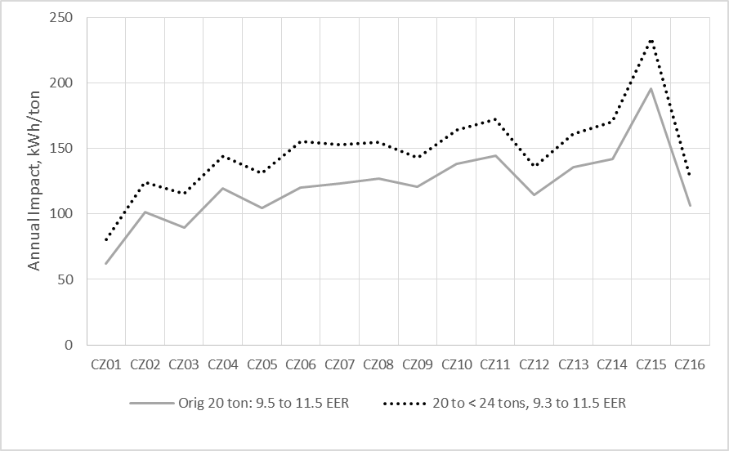

Figure 16 - Impacts for Tier 1 Heat Recovery VRF Measures for Large Office in Vintage 2014: Showing All Capacity Ranges

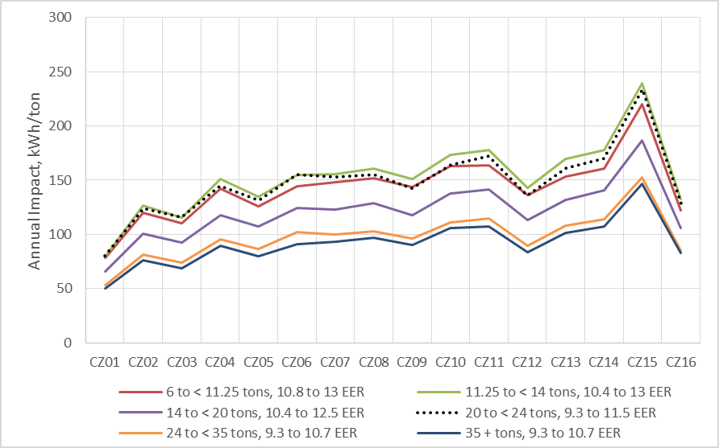

# Updates Based on Methodology or Correction of Errors

## Air Conditioner and Heat Pump Efficiency Measures (<65 kBtu/hr)

In the process of reviewing baseline updates two errors were discovered in the DEER2015 analysis of SEER rated air conditioning and heat pump systems for commercial buildings.

The first error was applicable to all one-speed split air conditioners less than 65 kBtu/hr, as well as all one-speed split and packaged heat pump systems less than 65 kBtu/hr. This error was due to an incorrect minimum threshold for the cycling loss performance curve, and the result was an underestimation of energy use for the affected simulations, which were always either pre-existing or code level models. Thus, correction of the error will result in slight increases in impacts for those measures as shown by the sample results in Figure 17.

Figure 17 - Sample Change in Measure Impacts Due To Cycling Loss Error Correction

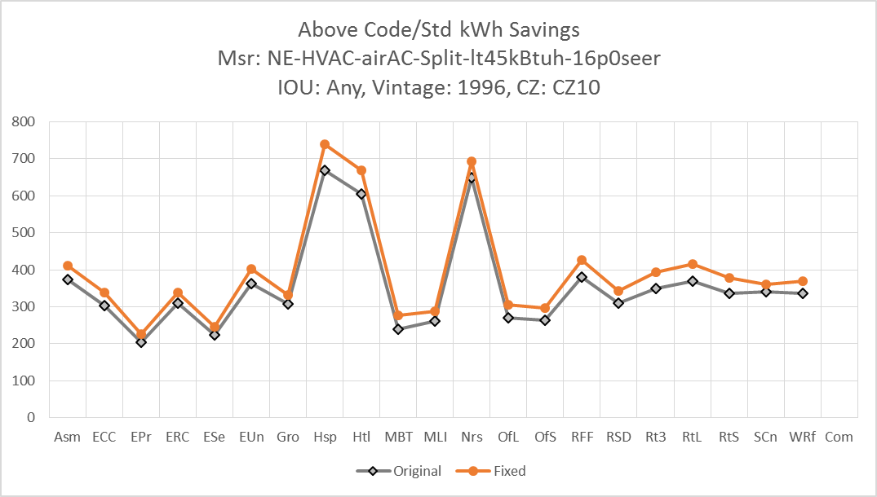

The second error was applicable to all split and packaged air conditioning and heat pump systems in the 55 to 65 kBtu/hr capacity range. For these situations, the code level system was incorrectly set up as a two-speed unit instead of a one-speed unit. This resulted in underestimation of the code model energy use, so correcting the error will increase to-code impacts. In accordance with this correction, the SEER 15 measure was also changed from a two-speed unit to a single speed unit. This correction results in significant increases in savings for cases where the code changes to constant speed while the measure remains at two-speed as shown in Figure 18.

Figure 18 - Sample Change in Measure Impacts Due To Change of Code From Two-Speed Unit to One-Speed Unit

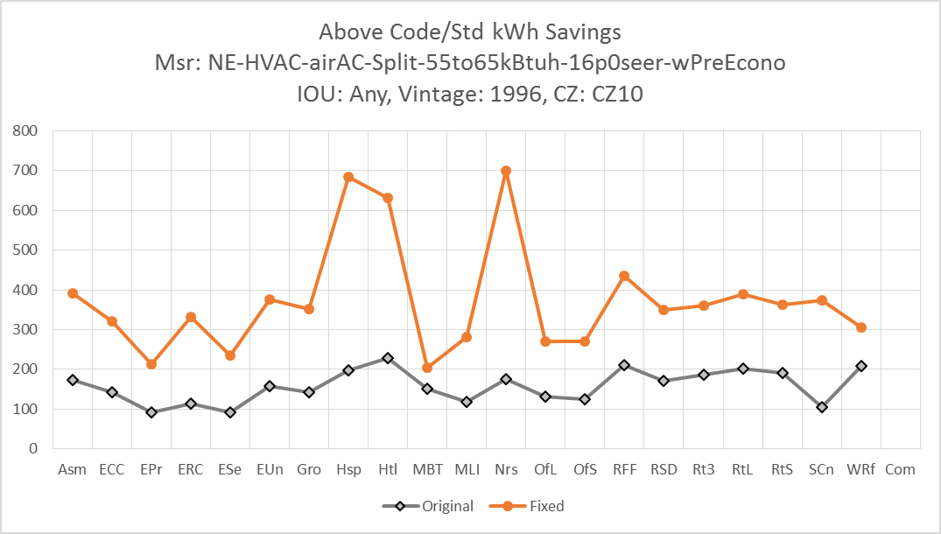

## Residential Refrigerant Charge Adjustment

During the development of the updates for the non-residential refrigerant change adjustment measure described in Section 5.2 below, the DEER team discovered a mistake in the calculation methodology. The previously measure modeling was done using measure assumption parameters developed by weighting together model input parameters for systems with thermal expansion valves (TXV) and those with non-TXV devices rather than weighting together the modeling results for TXV and non-TXV devices. This mistake was corrected and values were updated as shown in Table 19.

Table 19 - Updated Parameters for Residential Refrigerant Charge Adjustment Measures

|  |  |  |  |  |  |  |  |
| --- | --- | --- | --- | --- | --- | --- | --- |
|  | Valve | Capacity Mult | | EIR Mult | | Sens Cap Mult | |
| Measure Condition | Type | previous | new | previous | new | previous | new |
| Typical Over-Charge | Non-TXV | 1.003 | 1.005 | 1.031 | 1.030 | 1.025 | 1.033 |
| Typical Over-Charge | TXV | 1.003 | 0.996 | 1.031 | 1.035 | 1.025 | 0.982 |
| Typical Under-Charge | Non-TXV | 0.874 | 0.865 | 1.087 | 1.095 | 0.816 | 0.805 |
| Typical Under-Charge | TXV | 0.874 | 0.946 | 1.087 | 1.023 | 0.816 | 0.903 |
| Low Under-Charge | Non-TXV | 0.944 | 0.940 | 1.031 | 1.034 | 0.917 | 0.913 |
| Low Under-Charge | TXV | 0.944 | 0.973 | 1.031 | 1.009 | 0.917 | 0.952 |
| High Under-Charge | Non-TXV | 0.748 | 0.732 | 1.246 | 1.265 | 0.663 | 0.646 |
| High Under-Charge | TXV | 0.748 | 0.871 | 1.246 | 1.095 | 0.663 | 0.790 |

Table 20 - Updated Residential Refrigerant Charge Measure List

|  |  |
| --- | --- |
| MeasureID | MeasureDescription |
| RE-HV-RefChrg-Dec-TXV-typ | Decrease Refrigerant Charge - Typical (8% rated charge) - TXV |
| RE-HV-RefChrg-Inc-TXV-typ | Increase Refrigerant Charge - Typical (8% rated charge) - TXV |
| RE-HV-RefChrg-Inc-TXV-4pct | Increase Refrigerant Charge (4% rated charge) - TXV |
| RE-HV-RefChrg-Inc-TXV-16pct | Increase Refrigerant Charge (16% rated charge) - TXV |
| RE-HV-RefChrg-Dec-NTXV-typ | Decrease Refrigerant Charge - Typical (8% rated charge) - NTXV |
| RE-HV-RefChrg-Inc-NTXV-typ | Increase Refrigerant Charge - Typical (8% rated charge) - NTXV |
| RE-HV-RefChrg-Inc-NTXV-4pct | Increase Refrigerant Charge (4% rated charge) - NTXV |
| RE-HV-RefChrg-Inc-NTXV-16pct | Increase Refrigerant Charge (16% rated charge) - NTXV |

Figure 19 and Figure 20 show sample changes to refrigerant measure impacts for the single family residence with typical increase and decrease measures, respectively. For systems with non-TXV control, the change from the original DEER2018 results is minimal, since this was weighted heavily in the measure inputs. However, systems with TXV control have much lower savings for undercharged systems, and effectively zero savings for overcharged systems. As shown in Figure 21, savings for the "Typical" undercharge measure fall nearly mid-way between the "Low" and "High" undercharge measures.

Figure 19 - Example Changes to Refrigerant Charge Measure Impacts for Vintage 2015 Single Family Residence with Typical Charge Increase

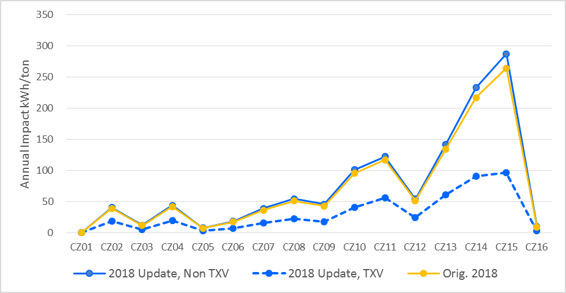

Figure 20 - Example Changes to Refrigerant Charge Measure Impacts for Vintage 2015 Single Family Residence with Typical Charge Decrease

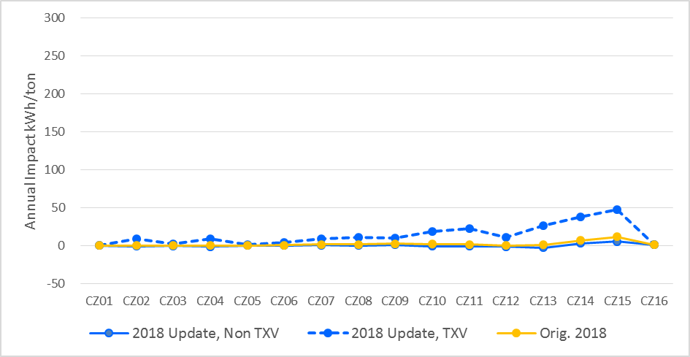

Figure 21 - Comparison of Updated DEER 2018 Impacts for Low, Typical and High Undercharge Measures for Vintage 2015 Single Family Residence

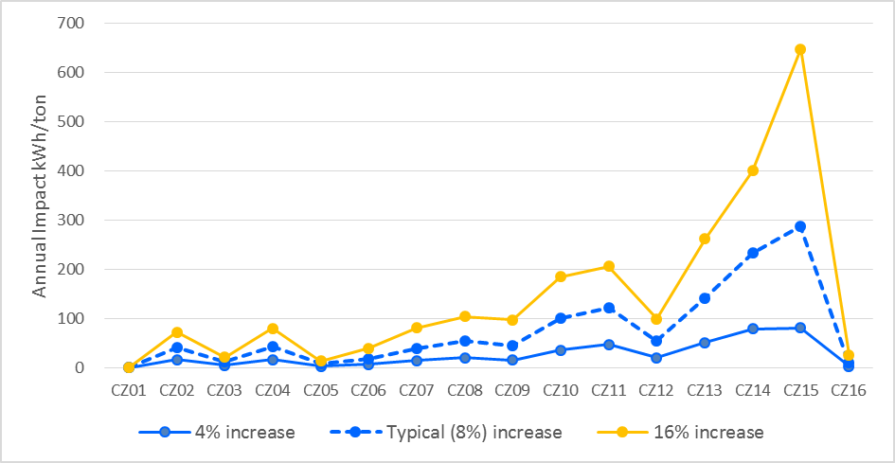

## HVAC Water Chillers

Since the release of the DEER2017 update, PAs have submitted concerns to Commission staff that the updated measure definitions for some classes of HVAC water chillers included part-load efficiency requirements that far exceeded the most efficient chillers currently available in the market. PAs have provided some preliminary market information for chillers that were incented during the most recent program activities. Commission staff examined the DEER2017 measure definitions, information submitted by PAs and the current DEER calculation methods and has revised all chiller measure definitions in a way that should allow for additional chiller types and models to be incorporated into programs. Additionally, Commission staff has added measures for variable speed positive displacement chillers (Path B) based on requests from PAs to include these measures in DEER.

Current DEER methods for chillers of all compressor types set minimum requirements for full-load efficiency (kW/ton for water-cooled machines and EER for air-cooled machines) based on the Title 24 minimum efficiency requirements. The minimum integrated part-load efficiency values (IPLV) are then derived from the chiller “performance maps” or “performance curves”, which are inputs to the DEER simulation models used to develop the DEER impacts by climate zone, building type and building vintage.

During 2017, SCE submitted information from manufactures showing available centrifugal chillers, their efficiencies and, how those chillers compare to the DEER minimum efficiencies. Figure 22 is an example showing that chillers available from this manufacturer in the size range of 300-400 tons would not meet DEER requirements for minimum IPLV requirements because the minimum IPLV is established using the simulated performance maps rather than scaled from the minimum Title 24 IPLV requirements. Figure 22 also shows that IPLV generally improves proportionally with improved full-load efficiency and that revising the DEER measure definition for IPLV to be based on Title 24, many chillers would likely be eligible.

Figure 22 - Example of Available Chillers vs. DEER Minimum Efficiency Requirements



To address the PAs’ concerns, Commission staff has revised all chiller measure definitions to set minimum IPLV requirements based on a proportional increase in efficiency over the Title 24 minimum requirements. DEER is revised to include measures for all chillers that are 10% better than Title 24 requirements for both full-load and integrated part-load efficiency. For air-cooled chillers, additional measures are added for chillers that exceed Title 24 requirements by 20%. For water-cooled chillers, additional measures are added for chillers that exceed   
Title 24 requirements by 15%. PAs may submit measures with different efficiency levels using workpapers, however, all measures included in programs must be at least 10% better than Title 24 minimum requirements for both full-load and integrated part-load efficiency. Table 21, Table 22, and Table 23 show available centrifugal chiller models provided by SCE. None of the models listed meet current DEER requirements; however, the most efficient models would meet revised DEER requirements.

Table 21 - DEER Eligibility, 300-399 Ton Centrifugal Chillers



Table 22 - DEER Eligibility, 400-599 Ton Centrifugal Chillers



Table 23 - DEER Eligibility, >= 600 Ton Centrifugal Chillers



Table 24 lists the revised DEER measure definitions for positive displacement chillers, and Table 25 lists the revised DEER measure definitions for centrifugal chillers.

Table 24 - Revised Measure Definitions for Positive Displacement Chillers



Table 25 - Revised Measure Definitions for Centrifugal Chillers



## DEER Peak Hours

DEER peak definition adopted by D.12-05-015 was developed to allow the selection of a sequence of days for any given year of weather conditions (either typical or actual) when a grid peak load is expected to occur and then, within those days specify how to calculate the peak demand reduction by averaging the measure energy impacts over a specified period. The DEER peak demand definition is based on the actual system peak and not the generation net peak. The definition was developed to provide a reasonable estimate of the peak grid load impact of installing an energy efficiency measure at a facility.

Last year in consideration of CAISO[28] and PG&E[29] comments relating to the possible update of the DEER definition of peak demand reductions, an analysis of CAISO data on grid load was undertaken to determine if the DEER definition relating to weather conditions can accurately forecast when the grid peak loads occur as well as how specific changes in the time period portion of the definition would impact typical measure peak demand savings values.

We also recognize the importance of accurately assessing and forecasting the impacts of energy efficiency activities on the net generation peak period and operation and planning of the grid. The Commission finds that updates to the DEER peak period should be considered in a more thorough process, with broad stakeholder input, and therefore the Commission is directing the utilities to initiate a working group process to develop one or more proposals on how the DEER peak period methodology should be adjusted.  The proposals shall be completed and served by Dec 20, 2018.

# Updates Based on Energy Code

The commercial measures updated for DEER2018 are based on energy code changes, as described in the following sections.

## Residential Clothes Washer

In addition to the baseline change, there is a forthcoming change to the federal standard for top loading clothes washers that will go into effect on 1/1/2018. This code update changes the IMEF for standard capacity top loading clothes washers from the DEER2017 code value of 1.50 as listed in Table 2 to the new federal standard value of 1.57. Figure 23 shows the about 10% decrease in savings for the Tier 3 all-electric top loading measure.

Figure 23 - Change in Savings Due To Code Update for Measure: RE-Appl-EffCW-med-ElecDHW-ElecCDryer-Tier3-Top

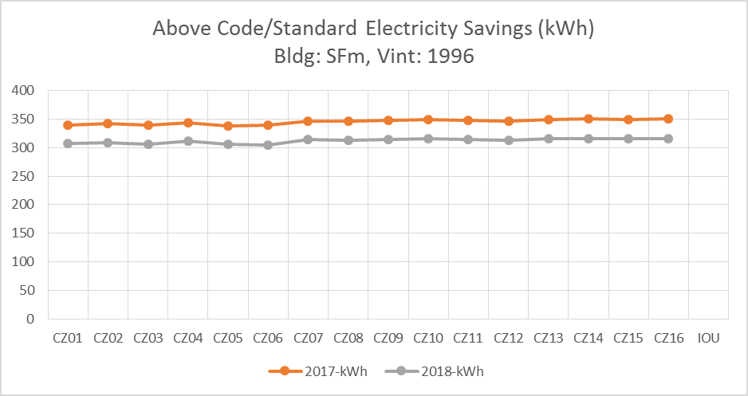

1. Updates Based on EM&V Studies
   1. Net-to-gross Review

The DEER team reviewed of recent EM&V findings and updated NTG values where EM&V findings indicate a substantial difference from current DEER values. The below table lists the EM&V studies reviewed. There were some shifts in NTG values in the evaluation results for recent participation, including the screw-in lighting measure values discussed above in Section 1.7 and the new accelerated replacement adjustment values discussed in Section 1.9. The DEER team reviewed evaluation findings from reports list in Table 26. The DEER team opinion is that evaluation results moving up or down less than five percent annually should not result in a shift in the DEER ex ante values unless there is evidence from two or more consecutive evaluations that the change represents a directional shift that is expected to persist into the future rather than simply a normal year-to-year change in participation or measure mix that can move NTG values either up or down. When an upward or downward trend is observed the DEER team also considered that these values will be applied four years later than the program year for which the evaluation was performed and thus addition adjustments may be warranted. Therefore, Commission staff recommends only the limited NTG adjustments shown in Table 27.

Table 26 - Recent Evaluation Reports Referenced for NTG Assessment

|  |  |
| --- | --- |
| **Item** | **Study** |
| 1 | Impact Evaluation of 2015 Upstream HVAC Programs (HVAC 1) |
| 2 | Impact Evaluation of 2015 Commercial Quality Maintenance Programs (HVAC3) |
| 3 | Year 2 Study of HVAC4 Deemed Measures Uncertainty |
| 4 | Laboratory HVAC Testing Research for 2013-14 (HVAC5) |
| 5 | Impact Evaluation of 2015 Upstream and Residential Downstream Lighting Programs |
| 6 | 2015 Nonresidential Downstream ESPI Deemed Pipe Insulation Impact Evaluation |
| 7 | 2015 Nonresidential Downstream ESPI Deemed Sprinkler Impact Evaluation |
| 8 | 2015 Nonresidential Downstream ESPI Deemed Pool Cover Impact Evaluation |
| 9 | 2015 Nonresidential ESPI Deemed Lighting Impact Evaluation |
| 10 | 2015 Nonresidential ESPI Custom Lighting Impact Evaluation |
| 11 | 2015 Nonresidential ESPI Deemed Sprinkler Impact Evaluation |

Table 27 - Updates to Net-to-Gross Values

|  |  |  |  |  |
| --- | --- | --- | --- | --- |
| **DEER NTG ID** | **Description** | **Current Value** | **DEER2019**  **Value** | **Report Reference from**  **Table 22** |
| None | LED outdoor lighting fixtures, deemed + downstream | 0.60 (default) | 0.45 | 9 |
| NonRes-sAll-mLtg-ci | Custom lighting | 0.55 | 0.50 | 10 |
| Agric-Sprklr-All | Sprinklers | 0.40 | 0.50 | 11 |
| NonRes-sAll-mPipeIns-deemed, NonRes-sAll-mPipeIns-ci | Pipe Insulation | 0.60 | 0.45 | 6 |
| NonRes-sAll-mHVAC-Pkg,  Res-sAll-mHVAC-DX-up | Upstream Package HVAC | 0.75 | 0.60 | 1 |

* 1. Non-Residential Refrigerant Charge Adjustment

The HVAC-5 EM&V study[30] included laboratory investigations of refrigerant charge adjustments (RCA), with data to demonstrate how those adjustments affect the cooling capacity and efficiency of package HVAC systems. The results of the HVAC-5 lab tests have been processed to produce performance adjustment factors as shown in Figure 24, which were used to update the DEER non-residential refrigerant charge measures. Results are shown separately for systems with thermal expansion valves (TXVs) and systems without TXVs. Figure 24 also shows the performance factors that were used in the last DEER update that included non-residential RCA measures (DEER2014). The HVAC-5 data also show significantly lower electric input ratio (EIR) adjustment factors than the DEER2014 values, especially for overcharged systems.

Consistent with the requirements outlined in Resolution E-4795[31] it is reiterated here the importance of proper technician training, use of a “fault” diagnosis and correction sequence and procedure as well as a continuous verification activity to assure the refrigerant charge adjustment, and related system fault detection and correction work is being performed properly. To ensure the refrigerant charge adjustment is performed correctly so as to result in the expected energy savings in DEER, the service must be performed using appropriate methods and tools that allow the identification and correction of all system “fault” conditions that affect the refrigerant system measurements prior to proceeding with a charge state measurement and then any indicated appropriate charge adjustment. Technicians performing HVAC system fault diagnosis and correction must have all the proper tools, must follow the appropriate procedures, and have been trained by an experienced a qualified professional on the procedures and use of the tools.

Figure 24 - Performance Adjustment Factors for Refrigerant Charge Adjustment Lab Tests Performed in HVAC-5 EM&V Study, Compared with DEER2014 Factors[32]



While the lab tests from HVAC-5 provide critical information to demonstrate the energy impacts of refrigerant charge adjustments, they cannot be applied to an energy model without additional data regarding the distribution of fault levels in actual buildings. This information was available in program claim data that was collected as part of the HVAC-3 EM&V study[33], and is illustrated with histogram charts in Figure 25 and Figure 26.[34]

One important observation in these histograms is that a large number of projects had adjustments that amounted to less than 4% of the system rated charge level (29% of samples for non-TXV and 49% of samples for TXV). The average charge adjustment in this +/-4% range amounts to only 4.5 ounces of refrigerant. The difficulty in precise measurements and diagnosis in the field for these small off-charge states makes it difficult to establish that small charge adjustments will result in any improved system state or performance. For these reasons the DEER savings values are only to be utilized for charge adjustments of four percent or greater and shall only be allowed if the technicians are utilizing approved methods and tools and have undergone approved training by a qualified professional. Additionally, in order to use the DEER savings values, the implementation activities must include a continuous verification element that ensures that the approved system fault diagnosis and correction protocols are being followed and that any charge adjustments are necessary and correct.

**Figure 25 - Histogram of Refrigerant Charge Adjustment for non-TXV Systems**

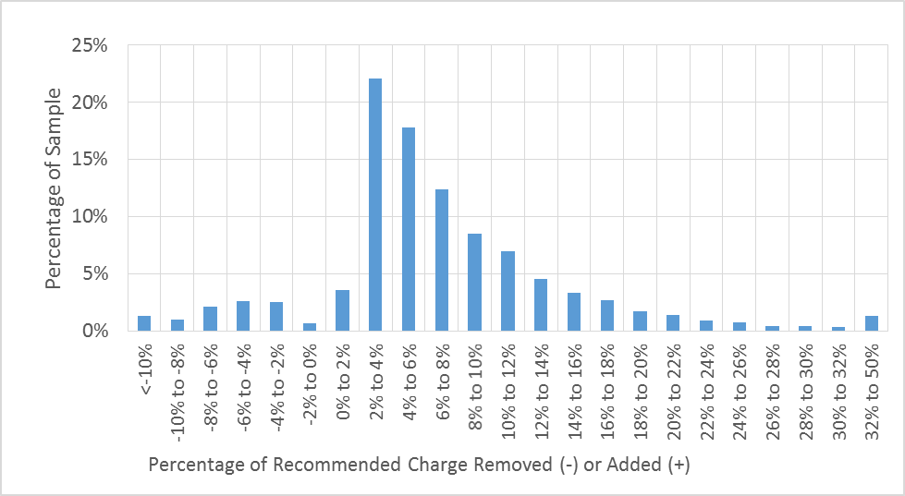

Figure 26 - Histogram of Refrigerant Charge Adjustment for TXV Systems

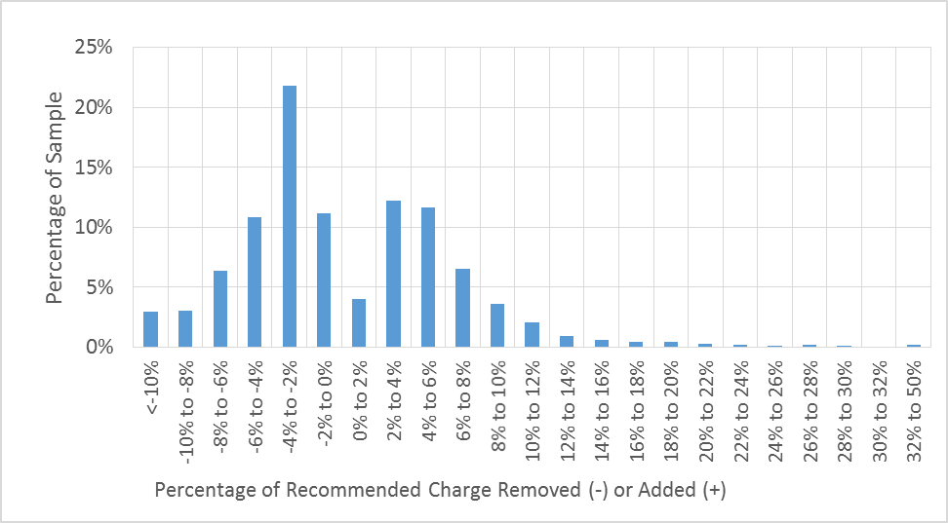

The program claim data includes information about the type of expansion valve used by each system, which was found in the lab test results to be an important factor to refrigerant charge adjustment sensitivity. In order to establish charge adjustment values for the measure simulations, the claim data was split into groups according to valve type and charge adjustment range as shown in Table 28. The charge adjustment levels and measure weights from DEER2014 are listed in Table 29 for comparison.

Table 28 - Distribution of Program Claim Data into Groups for Simulation[35]

|  |  |  |  |  |  |  |
| --- | --- | --- | --- | --- | --- | --- |
| Expansion Valve | Level | Charge Adjustment Type | Charge Adjustment Range | # in bin | Percent of Samples | Average Adjustment in Range |
| TXV | Typical | Remove | -50% to -4% | 1,003 | 7% | -7.0% |
| Non-TXV | Typical | Remove | -50% to 4% | 1,203 | 8% | -7.5% |
| TXV | Typical | Add | 4% to 50% | 1,187 | 8% | 8.5% |
| Non-TXV | Typical | Add | 4% to 50% | 10,869 | 76% | 10.0% |
| TXV | Low | Add | 4% to 5% | 270 | 2% | 4.5% |
| Non-TXV | Low | Add | 4% to 5% | 1590 | 11% | 4.5% |
| TXV | High | Add | 10% to 50% | 247 | 2% | 17.0% |
| Non-TXV | High | Add | 10% to 50% | 4,281 | 30% | 16.0% |

Table 29 - Measure Adjustment Assumptions and Weights from DEER2014

|  |  |  |  |  |
| --- | --- | --- | --- | --- |
| Level | Charge Adjustment Type | Charge Adjustment Range | Measure Weight | Average Adjustment in Range |
| Typical | Remove | 0 to 20% | 25% | -11.2% |
| Typical | Add | 0 to 20% | 25% | 12.5% |
| High | Remove | -50% to 4% | 25% | -33% |
| High | Add | 4% to 50% | 25% | +30% |

The average adjustment values from Table 28 were used along with the findings from the HVAC-5 lab test results to update the DEER refrigerant charge measures for non-residential buildings with new model parameters as listed in Table 30.

Table 30 - Updated Parameters for Non-Residential Refrigerant Charge Adjustment Measure

|  |  |  |  |  |  |  |  |  |  |
| --- | --- | --- | --- | --- | --- | --- | --- | --- | --- |
|  | Valve | Cap Mult | | EIR Mult | | Sens Cap Mult | | Coil Bypass Mult | |
| Measure Condition | Type | prev | 2018 | prev | 2018 | prev | 2018 | prev | 2018 |
| Typical Over-Charge | Non-TXV | 0.902 | 1.013 | 1.153 | 1.003 | 0.951 | 1.015 | 1.000 | 0.947 |
| Typical Over-Charge | TXV | 0.902 | 1.000 | 1.153 | 1.008 | 0.951 | 1.011 | 1.000 | 0.967 |
| Typical Under-Charge | Non-TXV | 0.884 | 0.926 | 1.117 | 1.050 | 0.912 | 0.941 | 1.000 | 1.130 |
| Typical Under-Charge | TXV | 0.884 | 0.973 | 1.117 | 1.005 | 0.912 | 0.984 | 1.000 | 1.011 |
| Low Under-Charge | Non-TXV | 0.902 | 0.967 | 1.153 | 1.019 | 0.951 | 0.975 | 1.000 | 1.052 |
| Low Under-Charge | TXV | 0.902 | 0.988 | 1.153 | 0.998 | 0.951 | 0.994 | 1.000 | 0.994 |
| High Under-Charge | Non-TXV | 0.884 | 0.879 | 1.117 | 1.093 | 0.912 | 0.902 | 1.000 | 1.233 |
| High Under-Charge | TXV | 0.884 | 0.927 | 1.117 | 1.041 | 0.912 | 0.948 | 1.000 | 1.114 |

Table 31 - Updated Nonresidential Refrigerant Charge Measures

|  |  |
| --- | --- |
| Measure ID | Description |
| NE-HVAC-RefChrg-Dec-Typ-ntxv | Decrease Refrig Charge - Typical (any adjustment >= 4%, typical value of 7.5%) |
| NE-HVAC-RefChrg-Dec-Typ-txv | Decrease Refrig Charge - Typical (any adjustment >= 4%, typical value of 7%) |
| NE-HVAC-RefChrg-Inc-Typ-ntxv | Increase Refrig Charge - Typical (any adjustment >= 4%, typical value of 10%) |
| NE-HVAC-RefChrg-Inc-Typ-txv | Increase Refrig Charge - Typical (any adjustment >= 4%, typical value of 8.5%) |
| NE-HVAC-RefChrg-Inc-Low-ntxv | Increase Refrig Charge - Typical (adjustment < 5% and >= 4%, typical value of 4.5%) |
| NE-HVAC-RefChrg-Inc-Low-txv | Increase Refrig Charge - Typical (adjustment < 5% and >= 4%, typical value of 4.5%) |
| NE-HVAC-RefChrg-Inc-High-ntxv | Increase Refrig Charge - Typical (any adjustment >= 10%, typical value of 16%) |
| NE-HVAC-RefChrg-Inc-High-txv | Increase Refrig Charge - Typical (any adjustment >= 10%, typical value of 17%) |

Figure 27 shows the change in savings for the Typical Undercharge RCA measures for the vintage 2014 large office prototype. The combined effects of weaker impact factors and lower average levels of adjustment result in significantly lower impacts for refrigerant charge measures for DEER2019 as compared with DEER2014. Moreover, systems with thermal expansion valves (TXV) show almost no savings in the DEER2019 results, indicating that the measure should only be implemented for systems with non-TXV control.

Figure 28 shows the same results for the Typical Overcharge case, where savings have gone to nearly zero for DEER2019. Thus, the results indicate that the measure should not be implemented for overcharged systems.

Figure 27 - Example Changes to Refrigerant Charge Measure Energy Impacts for Vintage 2014 Large Office with Typical Charge Increase Measure

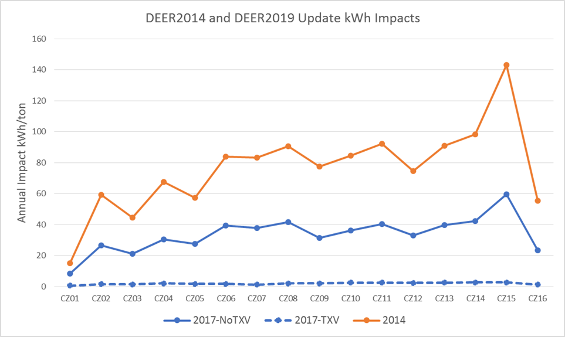

Figure 28 - Example Changes to Refrigerant Charge Measure Energy Impacts for Vintage 2014 Large Office with Typical Charge Decrease Measure

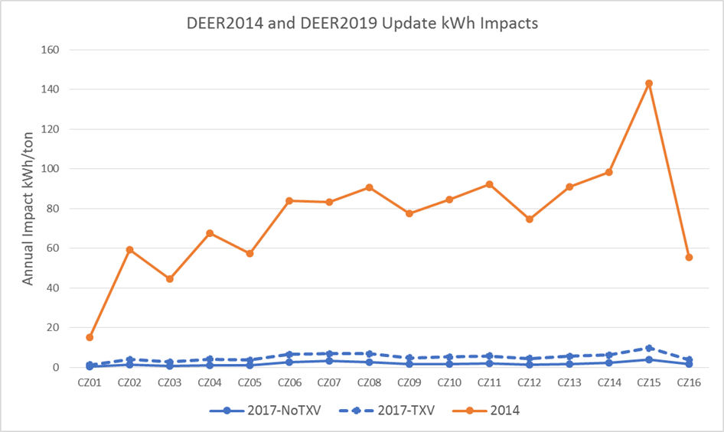

In DEER 2019, measures will be included only for "typical" overcharge and undercharge fault conditions. To test the appropriateness of this for the undercharge scenario, measures were also simulated for "low" and "high" fault conditions. Figure 29 shows a comparison of impacts for the three fault levels, and it can be observed that the "typical" fault results fall reasonably between the other two. Since the overcharge relationships are very weak with respect to level of overcharge, this test was not needed for the overcharge case.

Figure 29 - Comparison of DEER 2019 Impacts for Low, Typical and High Undercharge Measures for Vintage 2014 Large Office

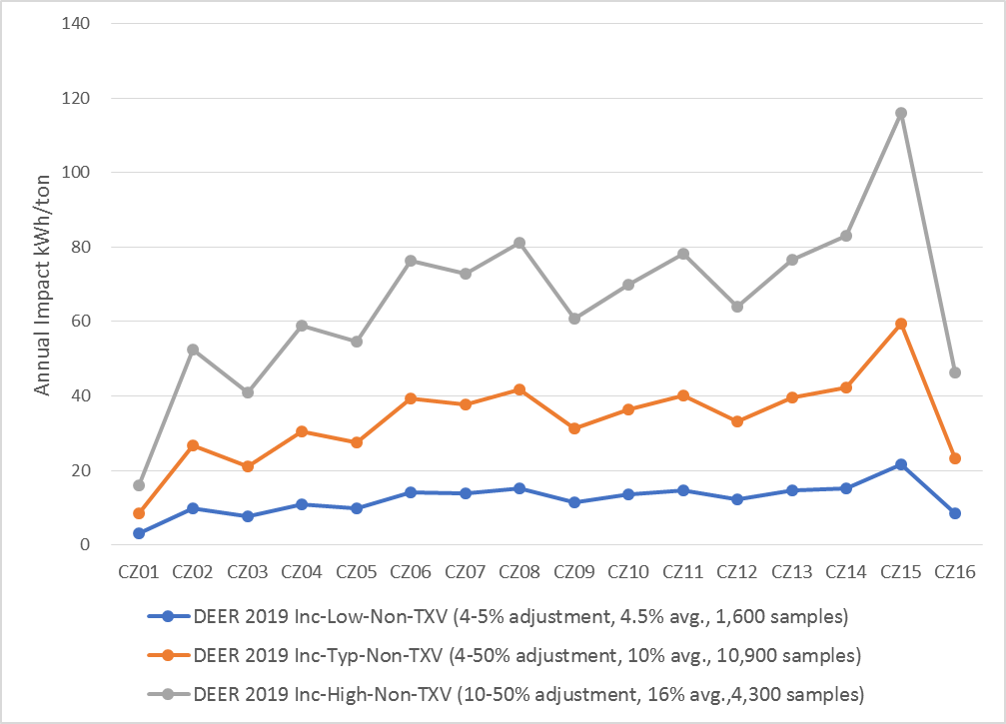

**Program Implementation of Nonresidential Refrigerant Charge Adjustment**

There are several key points that need to be considered in the development and implementation of nonresidential refrigerant charge adjustment measures:

1. Savings for systems with TXV control are minimal, so systems with TXV control shall not be included in RCA programs.
2. Savings for systems that are overcharged are minimal, so systems that are found to be overcharged during field work are not eligible for RCA programs.
3. Systems that are undercharged by less than 4% are not eligible for RCA programs.
4. For multi-circuit systems, the impacts in the DEER database are normalized by the tonnage of the circuit that is corrected by a refrigerant charge adjustment, not the tonnage of the entire system.

1. D.16-10-28, at 80, states “D.12-05-015 allowed additional mid-cycle changes if there are new state and federal codes and standards that affect DEER values. Specifically, the decision stated in Conclusion of Law 84: “We generally agree with parties’ request that ex ante values should be adopted and held constant throughout the portfolio cycle. However, mid-cycle updates of ex ante values are warranted if newly adopted codes or standards take effect during the cycle.”
2. D.16-10-28, at 80, quotes from D.12-05-015: “Conclusion of Law 80 states: ‘Our Staff should have significant latitude in performing DEER and other policy oversight functions and, absent specific directives to the contrary, should not be required to consult with or otherwise utilize any other groups to perform this work.”
3. Decision D.16-08-019 and Resolution E-4818
4. Supporting material is available under the main menu/DEER Version/DEER2017, DEER2018 and, DEER2019. The updated values are in the ex-ante database and accessible for review and download via the Remote Ex Ante Data Interface ([READI](http://deeresources.com/index.php/component/users/?view=login)) tool which is also available for download.
5. Conclusions of Law 37 and Ordering Paragraph 3.
6. Including but not limited to: Resource Adequacy proceeding, Time-of-Use OIR, GRC Phase 2 proceedings
7. E-4818 Ordering Paragraph 26
8. FINAL REPORT WO21: Residential On-site Study: California Lighting and Appliance Saturation Study (CLASS 2012), November 24, 2014, CALMAC Study ID: CPU00095.01.
9. DEER2017 Update Supporting files: Pivot_2014_06_09_CPUC_CLASS_2012_ClothesWasher.xlsx, Pivot_2014_06_09_CPUC_CLASS_2012_Cooling.xlsx, Pivot_2014_06_09_CPUC_CLASS_2012_Heating.xlsx, Pivot_2014_06_09_CPUC_CLASS_2012_WaterHeater.xlsx, Pivot_2014_06_09_CPUC_CLASS_2012_Refrigerator.xlsx, Pivot_2014_06_09_CPUC_CLASS_2012_Freezer.xlsx
10. “Commercial Saturation Survey” prepared for the California Public Utilities Commission, Itron, Inc., July 15, 2014.
11. MASControl, version 1 of the DEER energy analysis software available from www.deeresources.com
12. DEER2017 Supporting Files: DEER2017-2019-ClothesWasherUpdate.xlsx
13. MASControl2, update to MASControl version 1 of the DEER energy analysis software available from [www.deeresources.com](http://www.deeresources.com) 
14. From CPUC Data Request to SCE, submitted June 7, 2017, in supporting workbook: A.12-07-004-ED-SCE-EE Stats - 27475 Q.01 Attachment_HVAC_Early Retirement.xlsx
15. Constant Volume (CV), Variable Air Volume (VAV)
16. Supporting workbook: CSS_DX_Effic_Review.xlsx
17. “Comprehensive Workpaper Disposition for: Screw-in Lamps,” (2017ScrewInLampDisposition-1March2017-FINAL.docx) California Public Utilities Commission , Energy Division, March 1, 2017
18. “Comprehensive Workpaper Disposition for: Screw-In Lamps Revisions to Disposition Originally Issued on March 1, 2017,” (2017ScrewInLampDisposition-Revisions-26May2017.docx) California Public Utilities Commission, Energy Division, May 26, 2017
19. D.12-05-015 @ 347: “we note that DEER contains values for the effective useful life for many technologies and recommend using one-third of the effective useful life as the remaining useful life until further study results are available to establish more accurate values.”
20. For early retirement/accelerated replacement measures, a “dual baseline” applies which means that an existing baseline is used for the calculation of energy savings for the remaining useful life (RUL) of the removed equipment. At the end of the RUL, the customer would have needed to replace the failed equipment with equipment that reflected current energy efficiency standards and/or industry standard practices. This second baseline is used to calculate the [reduced] savings for the remainder of the effective useful life (EUL) of the measure.
21. Nonresidential Downstream Lighting Impact Evaluation Report, Prepared for California Public Utilities Commission by Itron, August 6, 2014.
22. 2014 Nonresidential Downstream Deemed ESPI Lighting Impact Evaluation, Prepared for California Public Utilities Commission by Itron, February 23, 2016
23. 2015 Nonresidential ESPI Deemed Lighting Impact Evaluation, Submitted to California Public Utilities Commission, Prepared by Itron, March 31, 2017
24. From DEER2017 Supporting Files: DEERToCodeNTGUpdates-Jul2017-1.xlsx
25. See Resolution E-4807 at 14 for details on adjustment made to packaged HVAC accelerated replacement claims.
26. “Disposition for: Variable Refrigerant Flow (VRF) Systems,” California Public Utilities Commission, Energy Division March 1, 2017; http://deeresources.com/files/2013_14_exante/downloads/VariableRefrigerantFlowDisposition-1March2017FINAL.docx.
27. www.ahridirectory.org, January 2017 (Select "VRF Multi-Split Air Conditioning and Heat Pump Equipment" from COMMERCIAL")
28. California Independent System Operator Corporation Comments on Draft Resolution   
    E-4795, 1 August 2016.
29. Comments of Pacific Gas and Electric Company on Draft Resolution E-4795,   
    1 August 2016, page 1.
30. Laboratory Test Results of Commercial Packaged HVAC Maintenance Faults, Prepared for CPUC by Robert Mowris & Associates, Inc., February 25, 2016.
31. Resolution E-4785 at 31
32. From DEER2017 Update Supporting Documents: RefgChg_ImpactCorrelations.xlsx
33. Impact Evaluation of 2015 Commercial Quality Maintenance Programs (HVAC3) California Public Utilities Commission, April 7, 2017, CALMAC Study ID CPU0117.03.
34. From DEER2019 Supporting Files: RefgChg_NonResHistograms.xlsx
35. From DEER2019 Supporting Files: RefgChg_MsrCalcs.xlsx