**PUBLIC UTILITIES COMMISSION OF THE STATE OF CALIFORNIA**

|  |  |
| --- | --- |
| **Communications Division** | **RESOLUTION T- 17596** |
| **Consumer Programs Branch** | **April 26, 2018** |

**R** **E** **S** **O** **L** **U** **T** **I** **O** **N**

RESOLUTION T-17596. This Resolution Approves Budget PrePay Inc.’s Advice Letter 20 Subject to Budget’s Payment of $817,730 to the California LifeLine Fund.

_____________________________________________________________________________________

**SUMMARY**

In this Resolution, the California Public Utilities Commission (Commission or CPUC) approves Budget PrePay, Inc.’s (Budget) Advice Letter (AL) 20 which requests approval: 1) to discontinue its offering of California LifeLine and federal Lifeline wireless services; and 2) to relinquish its designation as an Eligible Telecommunications Carrier (ETC) in California. We approve AL 20 subject to Budget’s payment of $817,730.00[1] to the California LifeLine Fund within 30 days from the effective date of this Resolution. We also direct Budget to comply and cooperate with the State Controller’s audit.

**BACKGROUND**

On September 1, 2011, the Commission issued Budget PrePay, Inc. (Budget), its Wireless Identification Registration number U-4412-C, allowing it to operate as a reseller of Commercial Mobile Radiotelephone Service (CMRS). On January 16, 2014, the Commission issued Resolution T-17432 designating Budget as an ETC within the service areas of the Uniform Regulatory Framework Carriers in California excluding the Small Local Exchange Carriers service areas.

On May 7, 2014, the CPUC approved Budget’s California LifeLine service offerings. Budget subsequently modified its California LifeLine service offerings in various advice letters.

On April 24, 2017, Budget submitted Tier 2 AL 20 to the CPUC requesting approval to discontinue its wireless telephone service plans offered under the California LifeLine Program and federal Lifeline program and to relinquish its designation as an eligible telecommunications carrier (ETC) in California. Budget no longer intends to offer wireless telephone services in California, and has stopped marketing its services.

On May 15, 2017, the CPUC’s Consumer Protection and Enforcement Division (CPED) submitted a protest (Protest) to Budget’s AL 20, and requested “appropriate penalties or restitution, and further evaluation by the Commission in a formal proceeding.”[2] CPED asserted that Budget’s requested relief in AL 20 was unjust and unreasonable for the following reasons:

1. Budget abused the California LifeLine enrollment process by improperly enrolling and collecting California LifeLine funds for 9,824 California LifeLine participants;
2. Budget failed to verify the residential addresses and other basic information of California LifeLine applicants in violation of the Public Utilities (PU) Code § 878[3] and California LifeLine rules; and
3. Budget improperly collected almost one million dollars ($1,000,000) from the California LifeLine Program.

CPED asserted that Budget should no longer offer California LifeLine services and should have its ETC designation rescinded, but “only after the Commission is able to fully consider the issues set forth in” its Protest and “decide on the appropriate restitution/penalties that Budget should be required to pay.”[4] Over the course of next several months, CPED and Budget engaged in settlement negotiations regarding the protested issues.

On August 25, 2017, Budget submitted a letter and a settlement agreement (Settlement) to CD indicating that the company and CPED reached a settlement on all protested issues, which is attached to this Resolution. Budget and CPED state that they have resolved all issues in the Protest, and request that the Commission approve Budget’s AL 20.

**DISCUSSION**

1. **Compliance with Federal Rules to Relinquish an ETC Designation**

Pursuant to 47 U.S.C. § 214(e)(4)[5] and 47 C.F.R. § 54.205(a) and (b), an ETC is permitted to relinquish its ETC designation if the following requirements are satisfied:

1. The service area must be served by another ETC;
2. The ETC must provide advance notice to the State commission of its request;
3. The ETC must ensure that all the customers it serves in the relevant service area will continue to be served by another ETC; and,
4. If applicable, the ETC must provide sufficient notice to permit the purchase or construction of adequate facilities by any remaining ETCs.

Consistent with these statutory requirements, once the requesting ETC makes the requisite showing under 47 U.S.C. § 214(e)(4) and 47 C.F.R. § 54.205(a) and (b), a state commission or the FCC must grant the request to relinquish the ETC designation.

1. **Service Area Served by Another ETC**

Budget, as a wireless reseller, used the underlying networks of Sprint, T-Mobile, and Verizon Wireless. There are 11 California LifeLine wireless telephone service providers offering California LifeLine services utilizing one or more of these three underlying networks. Additionally, there are also two Carriers of Last Resort (COLRs), Pacific Bell Telephone Company (AT&T) and Frontier California, Inc. operating in the same or overlapping designated areas as Budget.

1. **Advance Notice to the State Commission of Request to Relinquish ETC Designation**

Budget filed AL 20 with the CPUC at least four months before it ceased California LifeLine operations. Budget no longer offers California LifeLine and federal Lifeline services.

1. **Low-Income Households Will Continue to be Served by Other ETCs**

The California LifeLine participants that Budget previously served can continue to receive federal and state-supported services through one or more other ETCs and California LifeLine providers of their choice.

1. **Provision of Sufficient Notice to Permit the Purchase or Construction of Adequate Facilities by any Remaining ETCs**

Budget is a reseller of wireless telephone services and has no facilities in California. Thus no purchase or construction of facilities by other ETCs will be necessary to serve affected California LifeLine participants. Therefore, a notice to enable such construction or procurement is not necessary.

CD staff finds that Budget has met the four requirements to relinquish its ETC designation pursuant to 47 U.S.C. § 214(e)(4) and 47 C.F.R. § 54.205(a) and (b).

1. **Compliance with California LifeLine Program Rules to Withdraw California LifeLine Services**

GO 153 § 4.7.3 requires California LifeLine service providers to provide a 30-day notice to their California LifeLine participants for withdrawal of California LifeLine services. Budget complied with this notice requirement. Budget no longer has any California LifeLine participants. Therefore, CD staff finds that Budget has met the requirements to withdraw its California LifeLine services.

1. **Budget and CPED’s Settlement:**

Budget and CPED engaged in settlement negotiations to resolve the issues set forth CPED’s protest. Pursuant to these negotiations, Budget and CPED have agreed that Budget will refund $1,121,013.10[6] to the California LifeLine Fund. The parties state that this amount reflects the overpayment of LifeLine funds set forth in CPED’s Protest and other adjustments. With this repayment, CPED states that all of its protested issues are resolved. CD staff concurs with Budget and CPED that if Budget returns the overpaid LifeLine funds, the outstanding issues herein would be appropriately resolved.

1. **Ongoing SCO Audit**

PU Code § 274 requires the Commission to conduct a financial and compliance audit of the California LifeLine program-related costs and activities at least once every three years.  Currently, the Commission’s designee, the State Controller’s Office (SCO) is performing a compliance audit of Budget for July 1, 2015 through June 30, 2016 claims period to determine whether the company’s California LifeLine transactions were in compliance with all applicable CPUC laws and regulations associated with the program, including General Order (GO) 153. The SCO commenced its audit examination/engagement in October 2017 and the audit review is still ongoing. After completion of the audit, the SCO will submit to the CPUC an audit report detailing the audit findings. We direct Budget to comply and cooperate with the SCO audit.

1. **Reimbursement of Budget’s California LifeLine Claims**

CD staff suspended reimbursement of Budget’s California LifeLine claims for February 2017 through September 2017 until AL 20 issues were resolved. If the Commission approves this Resolution, CD staff will lift the suspension and process these outstanding claims. These claims total $303,283.10.

1. **Conclusions and Recommendations**

In light of the above discussions, CD staff concludes that Budget’s request in AL 20 (1) to relinquish its ETC designation in California complies with 47 U.S.C. § 214(e)(4), and (2) to withdraw its California LifeLine services complies with GO 153 § 4.7.3. CD recommends that the Commission approve AL 20, subject to Budget’s payment of $817,730.00 [7] ($1,121,013.10 total payment amount - $303,283.10 LifeLine reimbursement amount = $817,730.00) to the California LifeLine Fund within 30 days from the effective date of this Resolution.

**SAFTEY CONSIDERATIONS**

CD staff has identified no safety concerns with Budget’s request because low-income households in Budget’s designated service areas can continue to receive wireline and wireless telephone services from alternate service providers including ETCs and California LifeLine providers.

**COMMENTS**

In compliance with PU Code § 311(g), a Notice of Availability of this draft resolution was served on March 27, 2018 to the list of eligible telecommunication carriers, parties of record in Rulemaking 11-03-013, the California LifeLine Administrative Committee, and the California LifeLine Working Group list of the availability of this resolution for public comments at the Commission’s website [www.cpuc.ca.gov](http://www.cpuc.ca.gov). The Notice of Availability also informed the parties that the final confirmed resolution adopted by the Commission will be posted and available at the same website.

**FINDINGS AND CONCLUSIONS**

1. On September 1, 2011, the CPUC issued a WIR Number to Budget authorizing the company to provide resale Commercial Mobile Radio telephone Service to the public in California.
2. The CPUC designated Budget as an ETC in Resolution T-17432, issued on January 16, 2014.
3. Budget received authority to be a California LifeLine service provider to offer California LifeLine services in AL 4 on May 7, 2014.
4. Budget subsequently modified its California LifeLine service offerings in various advice letters.
5. On April 24, 2017, Budget submitted AL 20 to the CPUC requesting approval to discontinue its wireless telephone service plans offered under the California LifeLine Program and federal Lifeline program and to relinquish its designation as an ETC in California.
6. On May 15, 2017, CPED submitted a protest to Budget’s AL 20.
7. On August 25, 2017, Budget submitted a letter and a settlement agreement to CD that Budget and CPED reached a settlement on all protested issues.
8. Budget’s payment of 1,121,013.10 to the California LifeLine Fund appropriately resolves all issues set forth in CPED’s Protest.
9. PU Code § 274 requires the Commission to conduct a financial and compliance audit of the California LifeLine program-related costs and activities at least once every three years.
10. In October 2017, the SCO commenced an audit examination of Budget regarding the company’s California LifeLine transactions for July 1, 2015 through June 30, 2016 claims period and the audit is still ongoing.
11. Pursuant to 47 U.S.C. § 214(e)(4) and 47 C.F.R. § 54.205(a) and (b), an ETC is permitted to relinquish its ETC designation if it meets the following requirements: 1) the service area is served by another ETC; 2) the ETC provides advance notice to the State commission of its request; 3) the ETC ensures that all the customers it serves in the relevant service area will continue to be served by another ETC; and 4) if applicable, the ETC provides sufficient notice to permit the purchase or construction of adequate facilities by any remaining ETCs.
12. Communications Division identified no safety concerns regarding Budget’s request because other ETCs and California LifeLine providers offer discounted telephone services in the affected service areas.
13. Budget has satisfied ETC relinquishment requirements of 47 U.S.C. § 214(e)(4) and 47 C.F.R § 54.205(a) and (b).
14. Budget has satisfied the 30 day notice requirement in GO 153 § 4.7.3.
15. Budget’s two requests in AL 20 should be conditionally approved upon Budget refunding the California LifeLine Program the overpayment amount of $1,121,013.10and complying with the ongoing audit being conducted by the SCO. Of $1,121,013.10, Budget will make a payment of $817,730.00 to the California LifeLine fund. The remainder amount of$303,283.10 will be deducted from Budget’s filed claims from February through July 2017.
16. Budget is directed to comply and cooperate with SCO’s audit of its California LifeLine transactions.

**THEREFORE, IT IS ORDERED** that:

1. The Commission approves Budget PrePay Inc.’s Advice Letter 20 which requests: 1) to discontinue its wireless telephone service plans offered under the California LifeLine Program and federal Lifeline program; and 2) to relinquish its designation as an eligible telecommunications carrier in California.
2. Budget PrePay Inc. shall make a one-time lump sum payment to the California LifeLine Fund of $817,730.00 within 30 days from the effective date of this Resolution.

This Resolution is effective today.

I hereby certify that the California Public Utilities Commission adopted this Resolution at its regular meeting on April 26, 2018. The following Commissioners:

|  |
| --- |
|  |
| ALICE STEBBINS  Executive Director |

ATTACHMENT

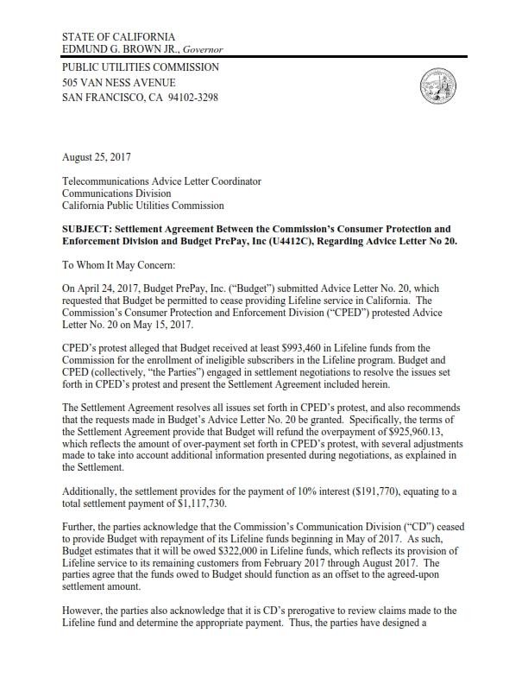

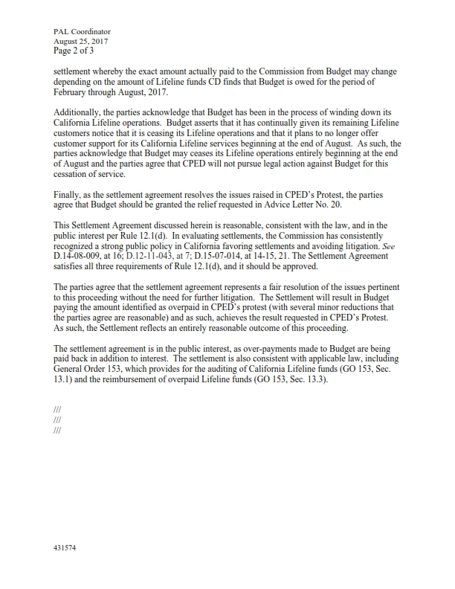

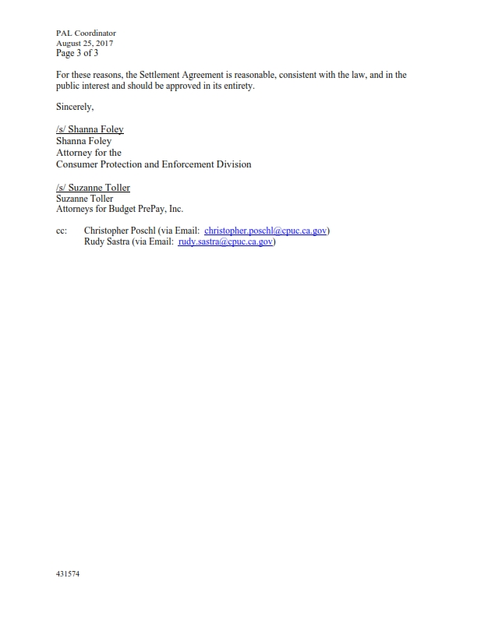

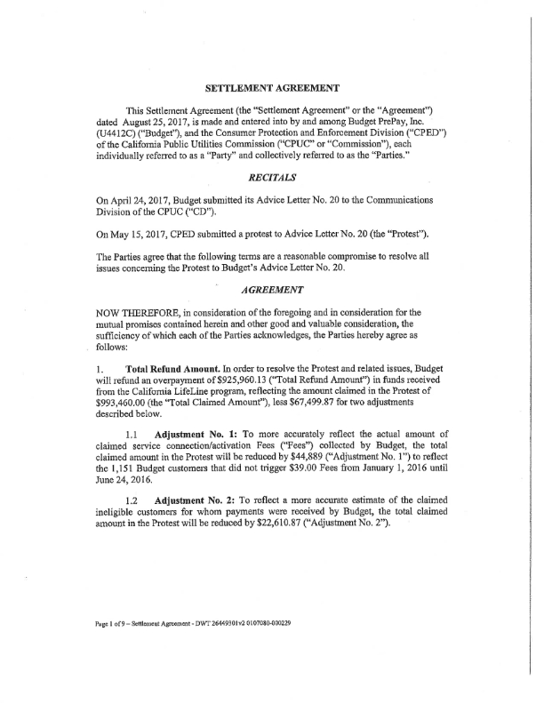

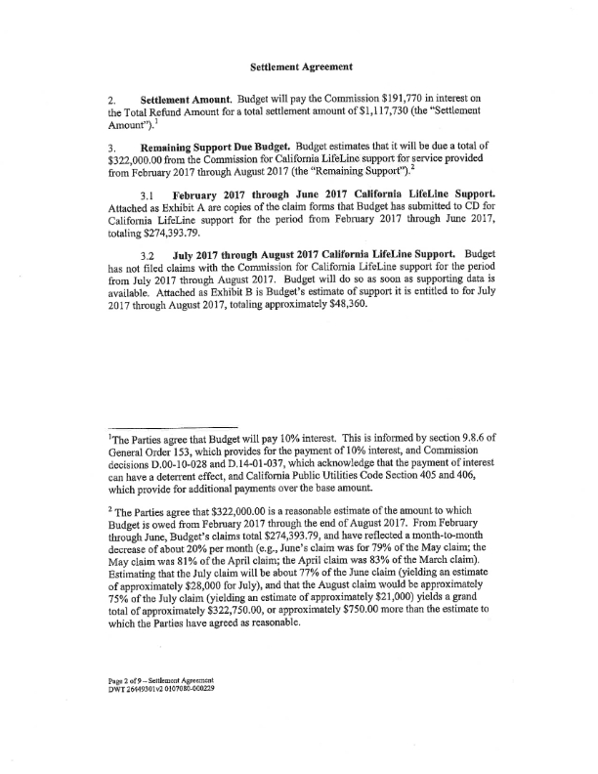

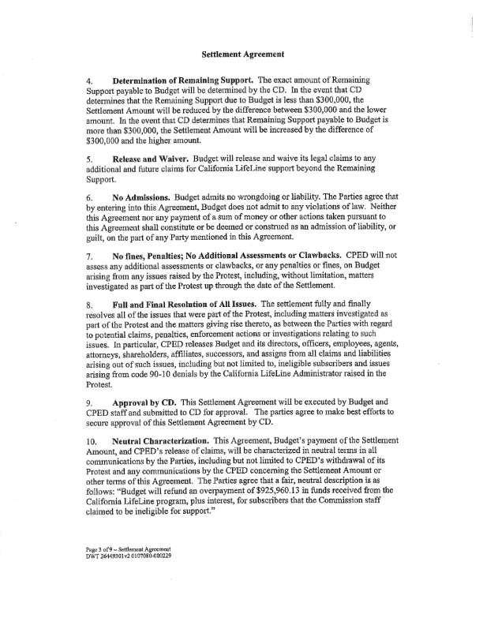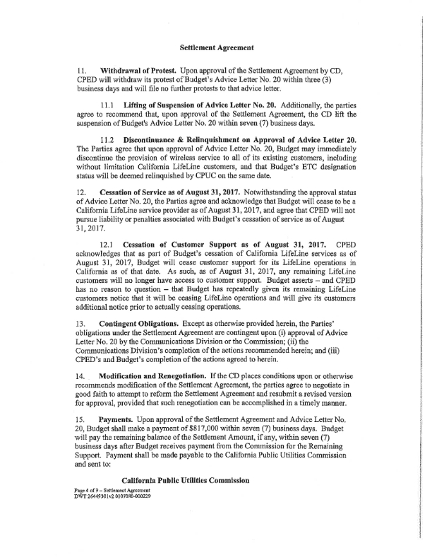

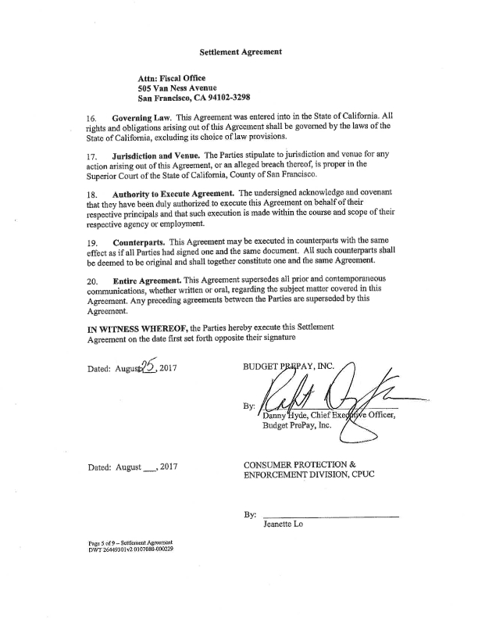

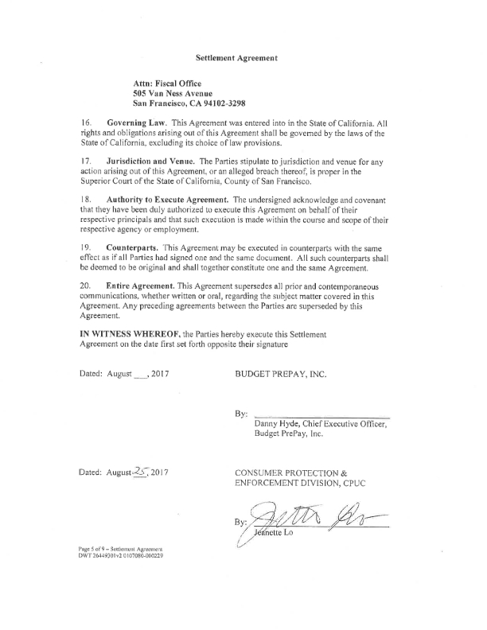



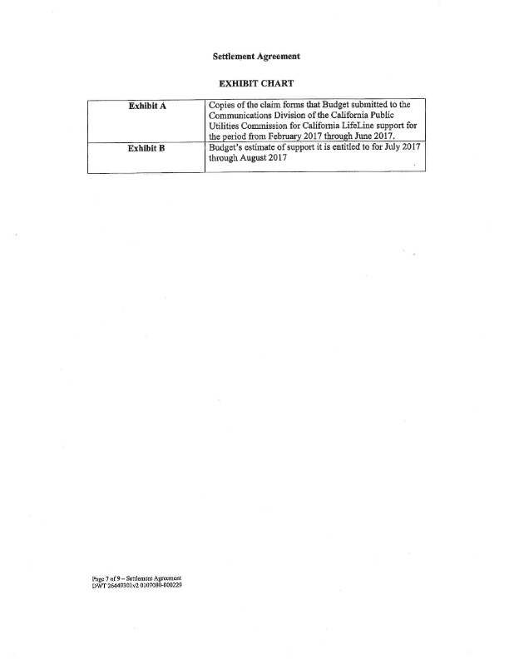



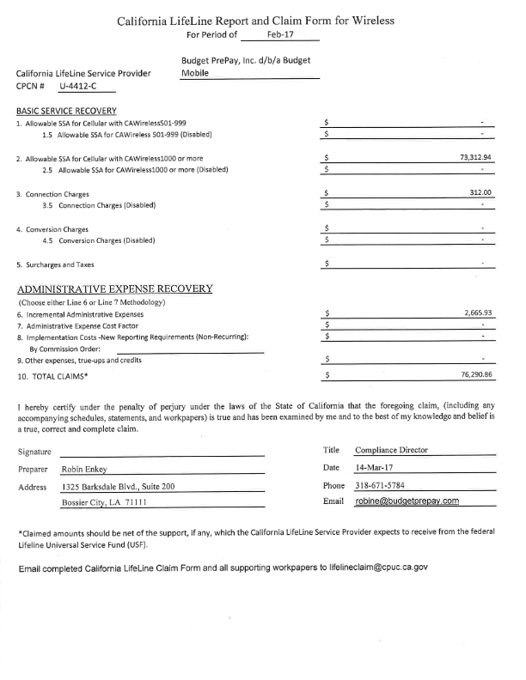

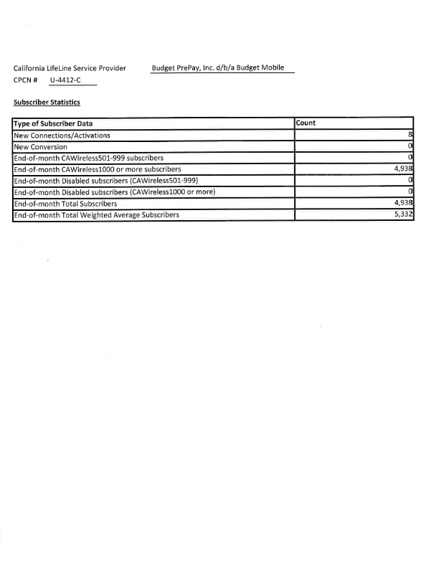

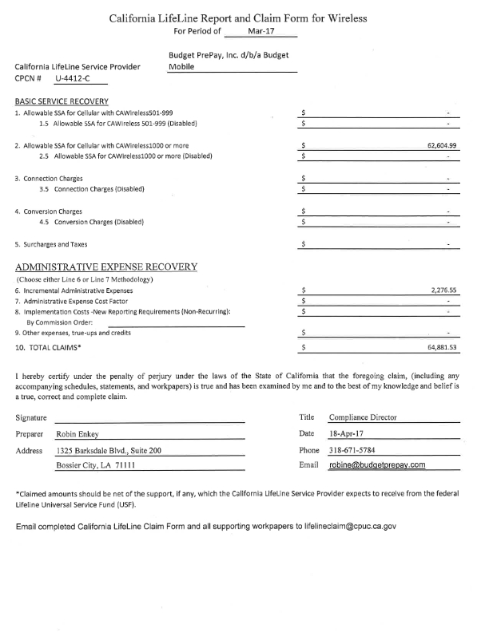

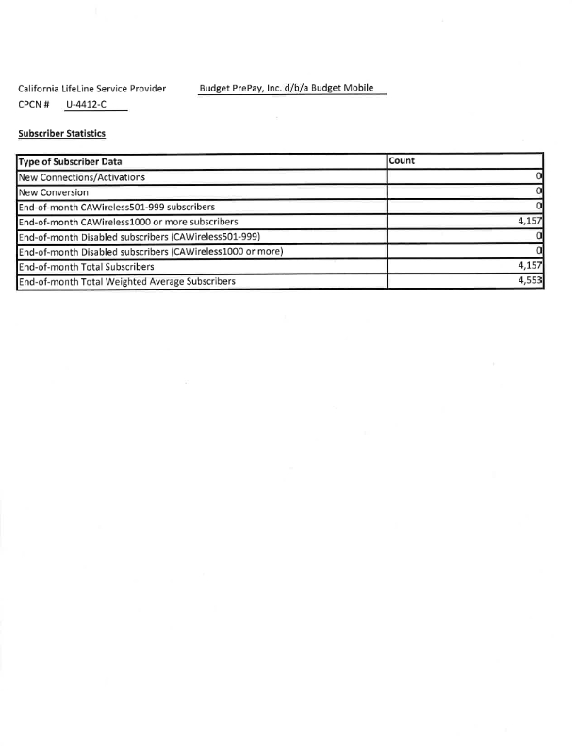

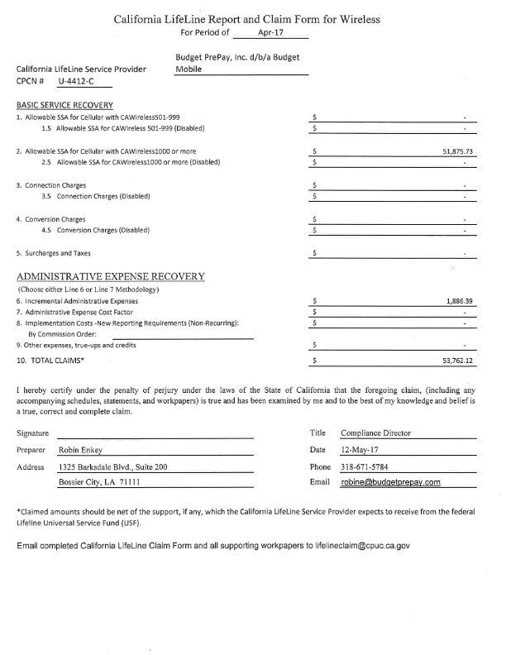

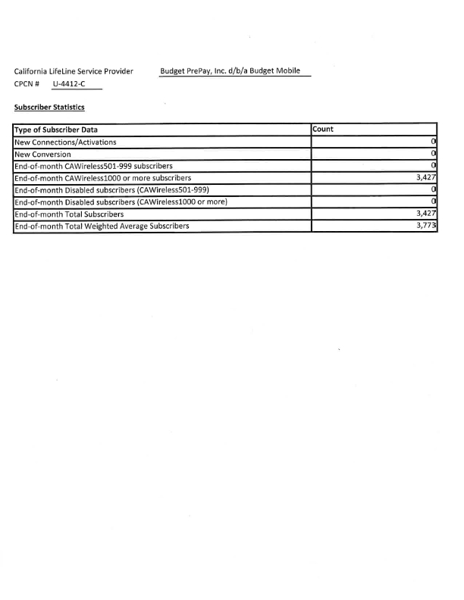

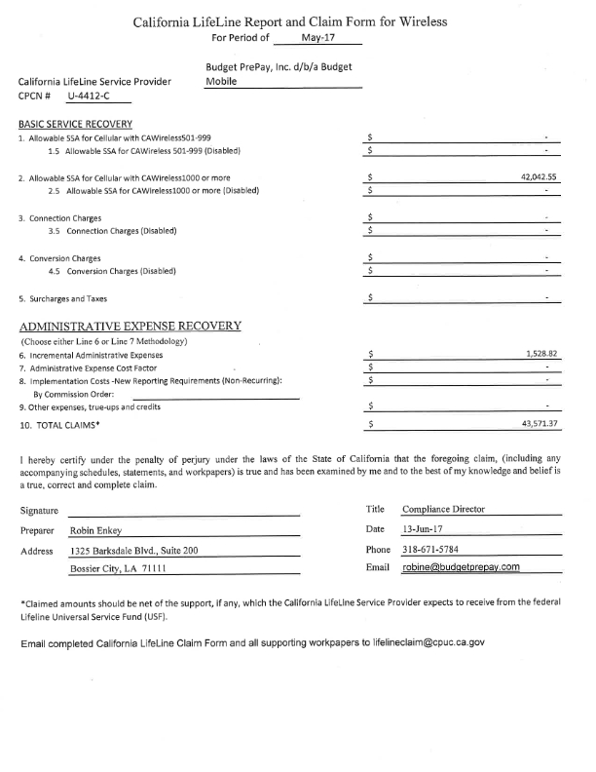

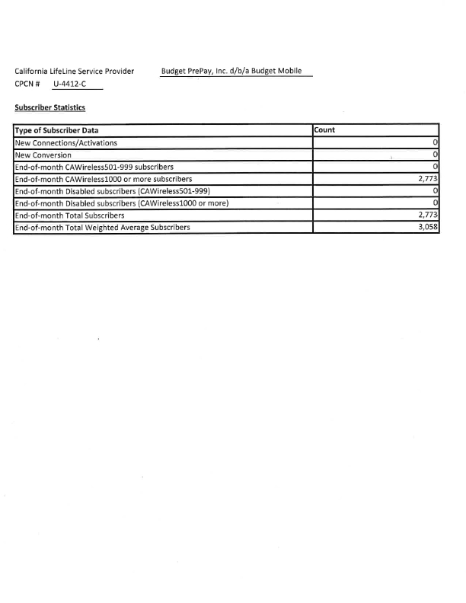

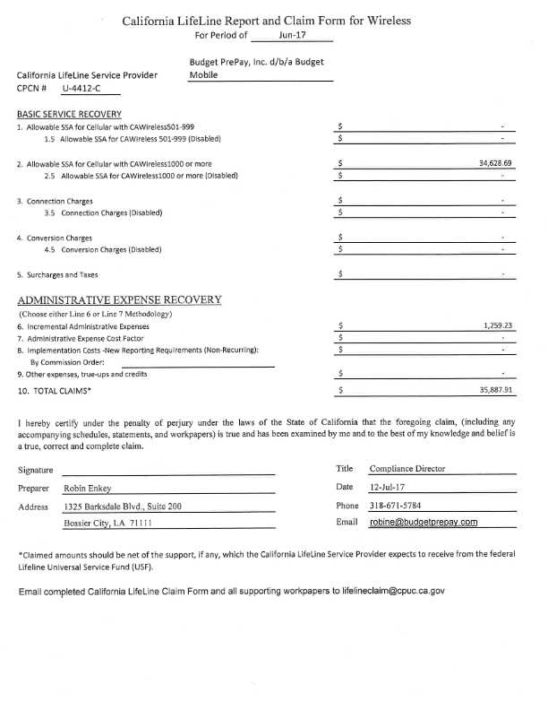

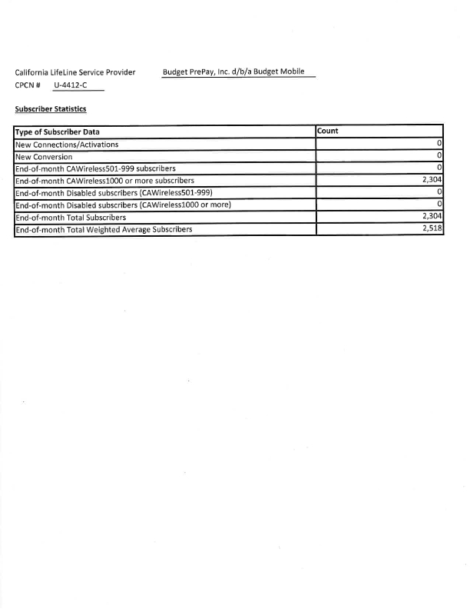

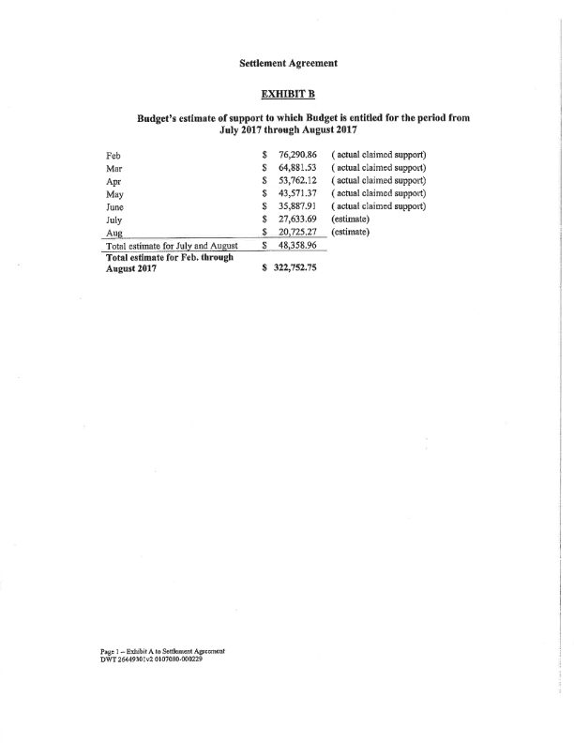

1. Under Budget and CPED’s Settlement Agreement, Budget proposes to refund $1,117,730 to the California LifeLine Fund. The California LifeLine Fund owes Budget $303,283.10 in LifeLine reimbursements for Budget’s claims from February through July 2017. Under Section 4 of the Settlement Agreement, “In the event that CD determines that Remaining Support payable to Budget is more than $300,000, the Settlement Amount will be increased by the difference of $300,000 and the higher amount.” Therefore, the total refund amount that Budget owes has been increased from $1,117,730 to $1,121,013.10.
2. Protest, pp. 1 and 17-18.
3. Pub. Util. Code § 878 “A lifeline telephone service subscriber shall be provided with one lifeline subscription, as defined by the commission, at his or her principal place of residence, and no other member of that subscriber’s family or household who maintains residence at that place is eligible for lifeline telephone service. An applicant for lifeline telephone service may report only one address in this state as the principal place of residence.”
4. Protest, p. 16.
5. 47 U.S.C. § 214(e)(4) states as follows:

   A State commission (or the Commission in the case of a common carrier designated under paragraph (6)) shall permit an eligible telecommunications carrier to relinquish its designation as such a carrier in any area served by more than one eligible telecommunications carrier. An eligible telecommunications carrier that seeks to relinquish its eligible telecommunications carrier designation for an area served by more than one eligible telecommunications carrier shall give advance notice to the State commission (or the Commission in the case of a common carrier designated under paragraph (6)) of such relinquishment. Prior to permitting a telecommunications carrier designated as an eligible telecommunications carrier to cease providing universal service in an area served by more than one eligible telecommunications carrier, the State commission (or the Commission in the case of a common carrier designated under paragraph (6)) shall require the remaining eligible telecommunications carrier or carriers to ensure that all customers served by the relinquishing carrier will continue to be served, and shall require sufficient notice to permit the purchase or construction of adequate facilities by any remaining eligible telecommunications carrier. The State commission (or the Commission in the case of a common carrier designated under paragraph (6)) shall establish a time, not to exceed one year after the State commission (or the Commission in the case of a common carrier designated under paragraph (6)) approves such relinquishment under this paragraph, within which such purchase or construction shall be completed.
6. Under Budget and CPED’s Settlement Agreement, Budget proposes to refund $1,117,730 to the California LifeLine Fund. The California LifeLife Fund owes Budget $303,283.10 in LifeLine reimbursements for Budget’s claims from February through July 2017. Budget did not submit a claim for August 2017. Under Section 4 of the Settlement Agreement, “In the event that CD determines that Remaining Support payable to Budget is more than $300,000, the Settlement Amount will be increased by the difference of $300,000 and the higher amount.” Therefore, the total refund amount that Budget owes has been increased from $1,117,730 to $1,121,013.10.
7. The remainder of the Settlement Amount will be deducted from Budget’s filed claims. Actual claims submitted for February through July 2017 total $303,283.10. Budget did not submit a claim for August 2017. According to Section 4 of the Settlement Agreement, “In the event that CD determines that Remaining Support payable to Budget is more than $300,000, the Settlement Amount will be increased by the difference of $300,000 and the higher amount”. Therefore the total settlement amount has been increased from $1,117,730 to $1,121,013.10.