**PUBLIC UTILITIES COMMISSION OF THE STATE OF CALIFORNIA**

|  |  |
| --- | --- |
| **Communications Division** | RESOLUTION T-17581 |
| **Broadband, Video and Market Branch** | **May 31, 2018** |

**RESOLUTION**

**Resolution T-17581: Approval of funding for the grant application of Anza Electric Cooperative, Inc. from the California Advanced Services Fund (CASF) in the amount of $1,796,070 for Phase 2 of the Connect Anza Project.**

**________________________________________________________­­­­­­_________________________**

# Summary

This Resolution approves funding in the amount of $1,796,070 from the California Advanced Service Fund (CASF) Infrastructure Grant Account for the grant application of Anza Electric Cooperative, Inc. (AEC) to construct the Connect Anza Project, Phase 2 (Phase 2). AEC proposes to extend a fiber-to-the-premises (FTTP) system into the unincorporated communities of Pinyon Pines, Pinyon Crest, Alpine Village and Ribbonwood (the Pinyon area) and into the Santa Rosa Reservation in western Riverside County east of Anza Valley.

Phase 2 is a continuation of the recently completed CASF funded Connect Anza Project, Phase 1 project (Phase 1).[1] In Phase 1, AEC installed a FTTP system offering broadband Internet service at symmetrical speeds of 50 Mbps and above to approximately 3,750 households in the Anza Valley (including the unincorporated communities of Anza, Aguanga, Lake Riverside Estates, and Reed Valley). Phase 2 will extend this service to over 400 households spread over 69 square miles in the areas of Pinyon and the Santa Rosa Reservation, at a cost of $4,349 per household in CASF subsidies. Phase 2 will also provide substantial safety and health benefits including, but not limited to, resilient high capacity broadband infrastructure that will provide access to emergency services and information, e-health services and voice service that will meet all safety standards, including E911.

# Applicant Request

On June 14, 2017, AEC submitted an application requesting 60-percent CASF grant funding of $2,213,420 (based on an estimated total project cost of $3,689,034) to extend the FTTP system to unserved and underserved areas in Riverside County, including the unincorporated communities of Mountain Center (including Garner Valley), the communities in the Pinyon area, and the Santa Rosa Reservation. Frontier Communications (Frontier) issued a timely challenge which reduced the eligible area for a CASF subsidy.

On February 13, 2018, AEC removed successfully challenged areas from its proposed project area and requested 70-percent grant funding of $1,796,070 (based on an estimated total project cost of $2,565,815) for Phase 2. Key project information and maps are shown in Appendices A and B.

*Location:* The unincorporated communities in the Pinyon area are located in a valley between the San Jacinto Mountains and Santa Rosa Mountains, east of Anza Valley. The Santa Rosa Reservation is located west of the Pinyon area along State Route 74 (see Appendix B).

*The Community:* According to 2010 census data, the communities within the project boundary have 413 households with a total population of 875 individuals. The median household income for the census block group inclusive of most of the Pinyon area (and inclusive of Garner Valley) is $83,383. The median household income of the census block group inclusive of the Santa Rosa Reservation is $34,563. In addition to Census data, the County of Riverside provided demographic and income data for the proposed project area.[2] According to this data, 39 percent of households have income under $50,000, with 18 percent below $15,000, while 21 percent of households have incomes above $200,000 (see Appendix C for details).

*Applicant:* AEC[3] currently owns and distributes electricity using over 700 miles of line in Southwest Riverside County covering the areas of Anza, Garner Valley, Pinyon, Alpine Village, Royal Carrizo and parts of Aguanga. The Commission previously awarded a CASF grant to AEC for Phase 1 of the Connect Anza Project, which AEC has since completed.[4]

*Project:* As part of the Phase 2 project, AEC will deploy fiber optic cable on existing poles and rights-of-way (ROW) and will extend the newly completed FTTP network with sufficient capacity to establish broadband Internet service for the communities in the Pinyon area and on the Santa Rosa Reservation. AEC estimates that approximately 40 to 60 households will be reached through a fixed wireless component; given that these are remote locations in the proposed project area (AEC stated that those customers reached through a fixed wireless component will be provided symmetrical speeds of 50 Mbps).

# Notice and Challenges

On June 14, 2017, Communications Division (CD) Staff posted the proposed project area map, census block groups and ZIP codes for the proposed Phase 2 project on the Commission’s webpage under “CASF Application Project Summaries” and also sent notice regarding the project to its electronic service list. On June 27, 2017, Frontier submitted a challenge to the Phase 2 project. In a subsequent email, Frontier asserted that it would complete planned deployment and upgrades within parts of the proposed project area on or before November 30, 2017. Specifically, at the time AEC submitted its Phase 2 application, Frontier was in the process of upgrading the existing DSL plant in the area as part of the federal and state obligations the company assumed when it purchased Verizon California, Inc.’s landline facilities.[5] [6]

The federal obligation Frontier cites in its challenge stems from its obligations to the Federal Communications Commission (FCC). In June 2015, Frontier accepted support under Phase II of the FCC’s Connect America Fund (CAF) program. A component of Frontier’s agreement with Verizon when it purchased Verizon California was that Verizon would accept CAF support in California. By combining Verizon’s commitments with Frontier’s, Frontier will receive $45 million annually through 2020 to provide over 90,000 locations with access to broadband Internet with speeds of at least 10 mbps download and 1 mbps upload.[7]

The state obligations Frontier references are the conditions of the Commission’s approving its acquisition of Verizon California, Inc., whereby Frontier agreed to the following buildout requirements:

* provision of 25/2-3 mbps service to an additional 400,000 households by December 31, 2022;
* provision of 10/1 mbps service to an additional 100,000 unserved households beyond its CAF II commitments by December 31, 2020; and
* deployment of 6/1.5 mbps service to 250,000 households.[8]

Frontier’s challenge asserts that the Commission should not award CASF Infrastructure Grant Account funding in areas where the company is required, either by the FCC or CPUC, to upgrade or build out its network, including census blocks in the Connect Anza Phase 2 project area.

On August 2, 2017, Staff visited Anza Valley to review the Phase 1 project and to observe the Frontier upgrade, as well as to hear from the local community regarding the community’s broadband needs. Staff met with network engineers from AEC and observed the successful deployment of Phase 1 and met with Frontier engineers and a government affairs manager to observe Frontier’s deployment of vDSL in both Anza Valley (Phase 1) and along Highway 74 (Phase 2).[9]

Staff confirmed through visual inspection, that Frontier upgraded its central office in Anza and installed remote terminals throughout the Anza Valley, including areas in the proposed Phase II project area. Based on Staff’s inspection, Staff has confidence that a legitimate network has been installed and that it is capable of providing served speeds to the majority of households along Highway 74, not inclusive of the Santa Rosa Reservation and further East. Staff later confirmed that Frontier is serving most of the census blocks in its challenge, through speed tests at installed remote cabinets, proving that service was turned on, and after reviewing service offerings on Frontier’s website. Staff concludes that the company offers service at served speeds.

Staff requested speed tests from Frontier in order to verify that the Frontier upgrade offered served speeds. Frontier provided 15 speed tests showing served speeds near the installed remote cabinets in the general vicinity of the area, including four in the proposed Phase 2 area that indicated speeds of 19-20 mbps download and over 2 mbps upload (see Appendix D).[10]

Based on this information, Staff contacted the applicant stating it was upholding the challenge in certain areas, provided the applicant the corresponding census block data, and requested the applicant update their project area finances and budget accordingly. Staff considers the Santa Rosa Reservation and the Pinyon area eligible for a CASF grant, as they are outside of the Frontier challenge area.

# Project Review

## Project area eligibility

To qualify for the CASF program, an applicant is required to submit shapefiles of the proposed project area. Staff reviews the submitted shapefiles and compares them with United States Census data and the California Interactive Broadband Availability map to determine whether the area is unserved or underserved.[11] Once Staff determines that the area is eligible either as an unserved or underserved area, Staff evaluates all other information submitted by the applicant to determine if the project meets the requirements outlined in D.12-02-015.

Information from the Broadband Availability map showed the area to be partially underserved by Frontier wireline services (identified on the availability map as Verizon California, Inc.), with advertised speeds as high as 15 down and 1 up (where the upload speed is below the benchmark served upload speed of 1.5 mbps established in D.12-02-015).[12] Staff received four speed test reports from Frontier customers in the Pinyon area, all showing speeds well below served speeds, and, when known (for three of the four tests provided), well below speeds they subscribed to (see Appendix D).[13]

According to the Broadband Availability map, the area is partially served by Verizon Mobile. AEC provided nine speed tests for the area shown to be served (see Appendix D). All provided speed tests indicated underserved speeds (two showing no connection). Because both the Availability map data and speed tests showed service that does not meet the CASF 6/1.5 mbps standard, Staff determined the proposed project area contains underserved and unserved households and therefore is eligible for CASF funding.

Because this application was submitted prior to the passage of AB 1665, signed into law by the Governor in October 2017,[14] Staff recommends applying the rules in place prior to enactment. Under these rules, an applicant is required to submit proof that the area is unserved or underserved by submitting shapefiles of the proposed project.[15] AB 1665 prohibits the Commission from awarding CASF funding for projects located in census blocks where an existing facility-based broadband provider has accepted federal funds for broadband deployment from the FCC’s CAF Phase II program (unless the existing facility-based broadband provider has notified the Commission before July 1, 2020, that it has completed its CAF deployment in the census blocks in question).[16] Staff recommends/finds these rules are not applicable for the Phase 2 project for the following reasons: 1) the project was submitted four months before AB 1665 was in effect and Staff review was well underway and; 2) the legislation did not apply retroactively. Therefore, the eligibility for grant funding for this project is being determined under the rules that were in place at the time of project submission (before modifications to program rules by AB 1665 were in force) because AB1665 did not specify that the new requirements of the CASF Program applied retroactively to Infrastructure Grant Account projects submitted prior to its passage.[17] However, staff, in its review, considered AB 1665’s prohibitions of overbuilding in areas with CAF-accepted locations. In this case, even if the Commission were to apply AB 1665 to this application, it would not impact the revised project area, given that Staff upheld Frontier’s challenge, and Frontier indicated it did not plan to serve communities within the revised project area absent funding beyond CAF.

## Project Criteria Evaluation

Staff evaluated the application with respect to the scoring criteria defined in D.12-02-015, Appendix 1, Section VIII (Scoring Criteria). The scoring criteria include: (i) Funds Requested per Potential Customer, (ii) Speed, (iii) Financial Viability, (iv) Pricing, (v) Total Number of Households in the Proposed Area, (vi) Timeliness of Completion of Project, (vii) Guaranteed Pricing Period, and (viii) Low-Income Areas. Staff also conducted a qualitative evaluation of the project area, existing infrastructure, and community needs.

*Funds per household:* The project results in a subsidy of $4,349 per household. This cost per household is slightly below the average for all approved CASF projects ($4,521 per household). For FTTP projects, the cost per household is below the average and the median for all FTTP projects ($8,228 and $5,491, respectively).[18]

*Speed:* The proposed speed offering of 50 Mbps download and 50 Mbps upload (for residential customers) significantly exceeds the 6/1.5 benchmark set by D.12-02-015.

*Financial Viability:* Staff reviewed the submitted balance sheet, income, cash flow statements and other financial viability information for AEC and concluded that the risk that this project would encounter financial problems, such as the project not being completed or maintained over time, is limited if the CASF finances 70 percent of the proposed project. Further, Staff determined that AEC has the existing capital resources for the 30 percent required matching funds to construct the Connect Anza Phase 2 project, as well as a sound financial framework for future operations.

Staff finds that AEC’s request to increase CASF funding to 70 percent in CASF funding is justified. Given that the Mountain Center and Garner Valley communities were removed from the proposed Phase 2 project area, AEC forecasts reduced revenue due to fewer potential subscribers. AEC also stated that it will have less economies of scale from its construction company due to a smaller project.

Although the reduction in the proposed project area will reduce the total cost of the proposed project by approximately $1.1 million, including over $400,000 less from the CASF, the corresponding reduced subscribership[19] results in a 72 percent decrease in earnings and delays significantly when Anza recovers its $769,7445 investment in the project. Assuming Anza meets its aggressive 80 percent take rate goal, the project will begin generating positive net income in December 2021.  If 60 percent of households subscribe to Anza’s service, the cooperative will not earn positive net income until 2022.  However, in either scenario, the positive net income the project generates will not allow the cooperative to recover its initial investment until several years beyond the five-year forecast the Commission requires applicants to submit.

*Pricing:* AEC has committed to a broadband pricing plan under the terms shown below for four years after project completion, two more than required under CASF rules. There is no required long-term commitment by the residential or small business consumer to obtain the pricing. For commercial users, a commitment period will be considered. International calling has an additional per-minute charge above the monthly charge.

**Table 1. Connect Anza Phase 1 and 2 Pricing**



*Households in Project Area:* Based on the latest available census block data there are 413 households in the project area.[20] If approved, the applicant expects to serve 330, or 80%, of these households.

*Timeliness of Completion:* AEC submitted detailed planning documents, including a schedule with clear milestones to indicate it will complete construction of the project within the required 24 months of the Commission approval date.

*Low-Income Areas:* Based on the demographic and income data for the project area provided by the County of Riverside, the area’s median household income of $78,688 is higher that the state MHI of $67,783. However, the data provided indicates that there are a significant number of households relative to the total household count (24% of all households) which would qualify as “very low income” or below (See Appendix C).

Although not part of the project evaluation criteria, staff feels it is important to highlight the service the applicant is providing to the local community. AEC is presently providing (in the Phase 1 area) free or discounted service to local community based organizations and to fire stations (as well as the community hall),[21] and will be doing so in the Phase 2 area.[22] Additionally, AEC is presently providing free digital literacy training to the community and refurbished computers to low-income residents and expects to offer these services to residents in the Phase 2 project area.

## Safety and Community Support Considerations

The CASF program encourages the deployment of broadband throughout the State which can enable the public to access important information in the event of an emergency, improve access to emergency services, and allow first responders to communicate with each other and collaborate during emergencies.

Parts of the Phase 2 area are classified as high to very high fire hazard severity zones, as specified by the California Department of Forestry and Fire Protection (CAL FIRE).[23] Reliable and ubiquitous broadband internet will assist emergency responders and local government in responding faster and with more accurate geo-positioning services to wildfire conditions. AEC further proposes to provide voice service which will be required to meet all safety standards, E911 data and access to local public-safety answering points (PSAPs).

*Community Support:* The community has shown their support for Phase 2 by signing an online petition (674 signatures as of March 14, 2018) and with 106 letters of support from Mountain Center (including Gardner Valley) and Pinyon area residents (as well as the Santa Rosa Reservation). Community institutions such as Camp Ronald McDonald for Good Times, the Girl Scouts of Orange County Camp Sherman, and Pathfinder Ranch also sent letters of support.[24] The majority of the letters of support expressed the view that existing providers have not wanted to invest in the area due to its rural qualities and low population density. Letters of support also spoke to issues regarding lack of access to health care, online merchandise, and educational resources. In addition, the Connect Anza Project, which was originally submitted as a single project, received support from elected officials at the local, state and federal level. Further, the Inland Empire Regional Broadband Consortium recommended the Pinyon area as a priority area and fully supports the proposed project. As previously noted, Staff met with AEC and community members during the August 2, 2018, site visit. Those in attendance expressed strong support for the initial Phase 2 proposal, as well as dissatisfaction with current service offerings.[25]

## Staff Recommendation for Funding

Staff has determined that AEC’s grant application for the Connect Anza Phase 2 Project qualifies for CASF funding as an unserved and underserved area (according to the Broadband Availability Map, the Santa Rosa Reservation is unserved).  The proposed project is a continuation of the successfully completed Phase 1 and will extend service to over 400 households spread over 69 square miles in the areas of Pinyon and the Santa Rosa Reservation.  Staff finds that Phase 2 meets CASF program rules and aligns with CASF’s goal to encourage the deployment of high-quality, advanced information and communications technologies.

As noted in the Financial Viability section, AEC’s grant request is for $1,796,070, or 70 percent of total project costs. Under the CASF rules in place prior to the passage of AB 1665, the Commission could award the applicant 70 percent in grant funding for the 44 unserved households and 60 percent in grant funding for the 369 underserved households. In total, that would be a grant of $1,566,943, or roughly 61 percent of total project costs. Providing the additional $229,127 in requested grant funding will reduce the time it takes Anza to recover its investment by several years. Given that, Staff recommends the Commission approve a one-time deviation from the normal percent allowances to ensure the proposed project’s long-term viability, thereby awarding a grant of $1,796,070 (at the 70% subsidy level) to the Anza Electric Cooperative.

# Compliance Requirements

AEC is required to comply with all the guidelines, requirements, and conditions associated with the grant of CASF funds as specified in D.12-02-015, D.14-02-018, and Resolution T-17443. Such compliance includes, but is not limited to:

## California Environmental Quality Act (CEQA)

All CASF grants are subject to California Environmental Quality Act (CEQA) requirements unless the project is statutorily or categorically exempt pursuant to the CEQA Guidelines.

Prior to any construction activity, AEC is required to seek further authority from the Commission for such activity by filing a Proponent’s Environmental Assessment (PEA) pursuant to Commission Rule of Practice and Procedure 2.4; and must undergo an environmental review pursuant to the CEQA (California Public Resources Code § 21000 et seq.).

AEC should contact the Supervisor of the Commission’s Energy Division CEQA Unit well in advance of a contemplated filing to (a) consult with staff regarding the process of developing and filing a PEA; (b) provide for cost recovery per Rule of Practice and Procedure 2.4 and 2.5; and (c) enter into a Memorandum of Understanding to allow the Energy Division to initiate the retention of an environmental contractor to perform the environmental review.

AEC may file a completed CEQA review conducted by another agency acting as the Lead Agency pursuant to CEQA. AEC should make every effort to ensure that the Commission’s CEQA Unit is aware of and included in the CEQA process if another agency acts as the CEQA Lead Agency. AEC should contact the Supervisor of the Commission’s Energy Division CEQA Unit well in advance of a contemplated filing to consult with staff regarding the applicability of another agency’s CEQA review.

AEC must provide the PEA prior to the first payment. The Commission cannot release funds for the construction project until the Commission has completed CEQA review.

## Deployment Schedule

The Commission expects AEC to complete Phase 2 within 24 months from start date (as determined by the procedure below). If AEC is unable to complete the proposed project within the 24-month timeframe, it must notify the Commission, by sending a letter to CD’s Director as soon as AEC becomes aware of this possibility. If such notice is not provided, the Commission may reduce payment for failure to satisfy this requirement.

## Execution and Performance

Staff and AEC shall determine a project start date after the CASF grant recipient has obtained all approvals. By receiving a CASF grant from the Commission, AEC agrees to comply with the terms, conditions, and requirements of the grant and thus submit to the jurisdiction of the Commission with regard to disbursement and administration of the grant. Should AEC or any Contractor it retains fail to commence work by the designated date, upon five days’ written notice to AEC, the Commission may terminate the grant. In the event that AEC fails to complete the project in accordance with the terms of CPUC approval as set forth in this resolution, AEC must reimburse some or all of the CASF funds that it has received.[26]

AEC must complete all performance under the award on or before the termination date of the award.

## Performance Bond

The Commission does not require a performance bond if the applicant certifies that the percentage of the total project costs it is providing comes from their capital budget and is not obtained from outside financing. In its application, AEC certified that the percentage of the total project costs it is providing will come from its existing capital budget. Therefore, a performance bond is not required for this project.

## Price Commitment Period

The minimum required price commitment period for broadband service to all last-mile households within the project area is two years. AEC guarantees the price of service for four years after project completion.

## Project Audit

The Commission has the right to conduct any necessary audit, verification, and discovery during project implementation/construction to ensure that CASF funds are spent in accordance with Commission approval. AEC’s invoices will be subject to a financial audit by the Commission at any time within three years of completion of the work.

## Providing Voice Service

AEC will offer VoIP residential and business telephone service that meets FCC standards for E-911 service. VoIP Telephony will be available simultaneously with Internet access.

## Reporting

AEC must submit quarterly progress reports on the status of the project irrespective of whether AEC requests reimbursement or payment.

Before full payment of the project, AEC must submit a project completion report. AEC shall also include test results showing the download and upload speeds on a census block group basis in the final completion report.

Progress reports shall use the schedule for deployment, major construction milestones and costs submitted in the proposal; indicate the actual date of completion of each task/milestone as well as problems and issues encountered, and the actions taken to resolve these problems and issues during project implementation and construction; and identify future risks to the project. AEC must certify that each progress report is true and correct under penalty of perjury.

## Submission of Form 477

The FCC currently requires broadband providers to biannually submit the Form 477, which includes speed data. CASF recipients shall submit a copy of their Form 477 data directly to the Commission, under General Order 66-D, when they submit this data to the FCC, for a five-year period after completion of the project.

## Prevailing Wage

Section 1720 of the California Labor Code specifies that CASF-subsidized projects are subject to prevailing wage requirements. AEC has committed to follow state prevailing wage requirements with regards to this project.

# Payments to CASF Recipients

Submission of invoices from and payments to AEC shall be made at 25 percent completion intervals, in accordance with Section XI of Appendix 1 of D.12-02-015 and according to the guidelines and supporting documentation required in D.12-02-015.

Payment to AEC shall follow the process adopted for funds created under Pub. Util. Code, § 270. The Commission generally processes payments within 20-25 business days, including CD and Administrative Services review time. The State Controller’s Office (SCO) requires an additional 14- 21 days to issue payment from the day that requests are received by SCO from Administrative Services. AEC must submit a project completion report before full payment.

# Comments on Draft Resolution

In compliance with Pub. Util. Code, § 311(g), a notice letter was e-mailed on April 27, 2018, informing all parties on the CASF Distribution List of the availability of the draft of this resolution for public comments at the Commission's website at <http://www.cpuc.ca.gov/PUC/documents/>.

# Findings

1. AEC filed an application for CASF funding for its Connect Anza, Phase 2, Project on June 14, 2017, requesting a 60-percent CASF grant of $2,213,420 (based on an estimated total project cost of $3,689,034). The project was to extend the FTTP system to underserved areas in Riverside County, including the unincorporated communities of Mountain Center (including Garner Valley) the communities in the Pinyon area and the Santa Rosa Reservation.
2. CD posted the proposed project area map, CBGs and zip codes by county for the AEC Connect Anza Phase 2 Project on the Commission’s CASF webpage under “CASF Application Project Summaries” on June 14, 2017. CD received a timely challenge from Frontier. Frontier submitted a challenge based on planned service to the unincorporated community of Mountain Center (including Garner Valley). Frontier later stated that the company completed this build on November 1, 2017. Staff confirmed that equipment was installed; four speed tests from the Phase 2 area was provided by Frontier to the Commission indicating served speeds.
3. On February 13, 2018, following Staff’s review and determination that it would uphold most of Frontier’s challenge and not recommend funding for certain high cost areas, AEC removed those areas from its proposed project area. As a result of reduced potential customers, AEC requested 70-percent grant funding of $1,796,070 (based on an estimated total project cost of $2,565,815) for Phase 2.
4. CD recommends deviating from the grant level set forth in D.12-02-015 and recommends instead the Commission approve funding the 70-percent request. This would result in a grant of $1,796,070 and ensure project viability.
5. The proposed project, as amended, would install a fiber-to-the-premise system capable of symmetrical 50 Mbps download/upload service to upwards of 413 households in the unincorporated communities of Pinyon Pines, Pinyon Crest, Alpine Village and Ribbonwood (the Pinyon area) and into the Santa Rosa Reservation in western Riverside County east of Anza Valley (40 to 60 of those households will be reached through a fixed wireless component). The CBGs impacted by the project are inclusive of parts of CBGs 060650444024, 060650444033, 060650451241, 060650448071.
6. Staff reviewed and analyzed data submitted for the AEC Connect Anza Project’s CASF grant application to determine the project’s eligibility for CASF funding. This data included, but was not limited to: descriptions of current and proposed broadband infrastructure; geographic information system (GIS) formatted shapefiles mapping the project areas; assertion that the area contains unserved and underserved households; number of potential subscriber households and average incomes; project construction schedule; project budget; proposed pricing and commitment period for new subscribers; and financial viability of the applicant.
7. Staff reviewed the submitted shapefiles, which mapped the proposed broadband deployment using United States 2010 Census data and the California Interactive Broadband Availability Maps, with availability data current as of December 31, 2015. These maps helped to verify the availability and speed of any broadband service, where available. The project area was determined to be underserved (with the Santa Rosa Reservation determined as unserved).
8. Based on its review, CD determined that the project qualifies for funding under D.12-02-015, D.14-02-018 and Resolution T-17443 and recommends Commission approval of CASF funding for AEC’s Connect Anza Project, Phase 2.
9. CD finds it reasonable that the Phase 2 Project be approved for a CASF grant award at the 70% subsidy level.
10. The Commission finds CD’s recommendation to fund AEC’s project, as summarized in Appendix A, to be reasonable.
11. The Commission has determined that the project must undergo CEQA review prior to construction and the Commission cannot release funds for construction activities until CEQA review is complete. AEC is required to comply with the requirements set forth in the CEQA Section of the Resolution. AEC must provide the PEA prior to the first payment.
12. AEC is not required to post a performance bond because 30% of the total project cost will be financed through AEC’s existing capital budget.
13. A notice letter was e-mailed on April 27, 2018, informing all applicants filing for CASF funding, parties on the CASF distribution list of the availability of the draft of this Resolution for public comments at the Commission’s website http://www.cpuc.ca.gov/PUC/documents/. This letter also informed parties that the final confirmed Resolution adopted by the Commission will be posted and available at this same website.

**THEREFORE, IT IS ORDERED that:**

* 1. The Commission awards $1,796,070 to AEC for the Connect Anza Project, Phase 2 as described herein and summarized in Appendix A of this Resolution.
  2. The payment of $1,796,070 for this project in underserved/unserved areas shall be paid out of the CASF Infrastructure Grant Account in accordance with the guidelines adopted in D.12-02-015, D. 14-02-018 and Resolution T-17443.
  3. AEC must comply with all guidelines, requirements, and conditions associated with the granting of CASF funds as specified in D.12-02-015, D.14-02-018, Resolution T-17443, and this Resolution, and with all applicable laws, including the State’s prevailing wage requirements. AEC must also submit the FCC Form 477, as specified in Resolution T-17143.
  4. AEC must submit a full Proponent’s Environmental Assessment (PEA) to the Energy Division prior to the first payment of CASF grant funds. No CASF grant funds may be disbursed for construction activities prior to the completion of the CEQA review.
  5. AEC agrees to comply with the terms, conditions, and requirements of the grant and thus submit to the jurisdiction of the Commission with regard to disbursement and administration of the grant.
  6. AEC must complete all construction covered by the grant on or before the grant’s termination date. If the project will not be completed within the 24-month time frame, AEC must notify the Director of CD as soon as it becomes aware of this possibility. If such notice is not provided, the Commission may reduce payment for failure to satisfy this requirement.
  7. AEC must submit a project completion report prior to receiving final payment.
  8. AEC must sign a consent form agreeing to the conditions set forth in this Resolution.
  9. If AEC fails to complete the project in accordance with the terms outlined in D.12-02-015, D.14-02-018 and Resolution T-17443, and with the terms of the Commission’s approval, as set forth in this Resolution, AEC must reimburse some or all the CASF funds it has received.

This Resolution is effective today.

I hereby certify that this Resolution was adopted by the Public Utilities Commission at its regular meeting on May 31, 2018. The following Commissioners approved it:

|  |
| --- |
|  |
| ALICE STEBBINSExecutive Director |

**APPENDIX**

**APPENDIX A**

**Resolution T-17581 – Connect Anza Project, Phase 2**

**CASF Applicant Key Information**

|  |  |
| --- | --- |
| *Project Name* | **Connect Anza Project, Phase 2** |
| *Project Plan* | In Phase 1, AEC installed a FTTP system that extended symmetrical 50 Mbps and above broadband service to approximately 3,751 households in the Anza Valley. Phase 2 will extend this service using on existing poles owned by AEC and rights of way into the unincorporated communities of Pinyon Pines, Pinyon Crest, Alpine Village and Ribbonwood (the Pinyon area) and into the Santa Rosa Reservation in western Riverside County east of Anza Valley. A designated scenic highway runs through the project area; therefore, a CEQA review is required. |
| *Project Size (in sq. miles)* | Approximately 69 |
| *Download/Upload speed* | Residential: 50 Mbps / 50 Mbps; Business: 100 Mbps / 100 Mbps |
| *Location* | Riverside County |
| *Community Names* | The unincorporated communities of Pinyon Pines, Pinyon Crest, Alpine Village and Ribbonwood (the Pinyon area) and the Santa Rosa Reservation |
| *Census Block Groups* | Inclusive of parts of CBGs 060650444024, 060650444033, 060650451241, 060650448071 |
| *Median Household Income (of proposed last-mile service area)* | $78,688 (with 18% of households with incomes below $15,000, 39% with incomes less than $50,000 and 21% of households with incomes above $200,000) |
| *Zip Codes* | 92561 |
| *Estimated potential last-mile subscriber size* | 413 households |
| *Applicant expectations* | 330 households |
| *Pricing Plan (Monthly)* | Residential Monthly Charge:  Standalone: $ 49 /mo  With Voice: $ 69 /mo    Low-Income Monthly Charge:  Standalone: $25/month  With Voice: $45/month    Small Business Charge:  Standard: $69/mo  With Voice: Additional $20 per line  (no installation or modem fees) |
| *Deployment Schedule* | 24 Months |
| *Proposed Project Budget* | $2,565,815 |
| *Amount of CASF funds requested (70 percent)* | $1,796,070 |
| *Self-Funding* | $769,744 |

**Appendix B**

**Resolution T-17581 Connect Anza Project, Phase II**

**Project location Map** 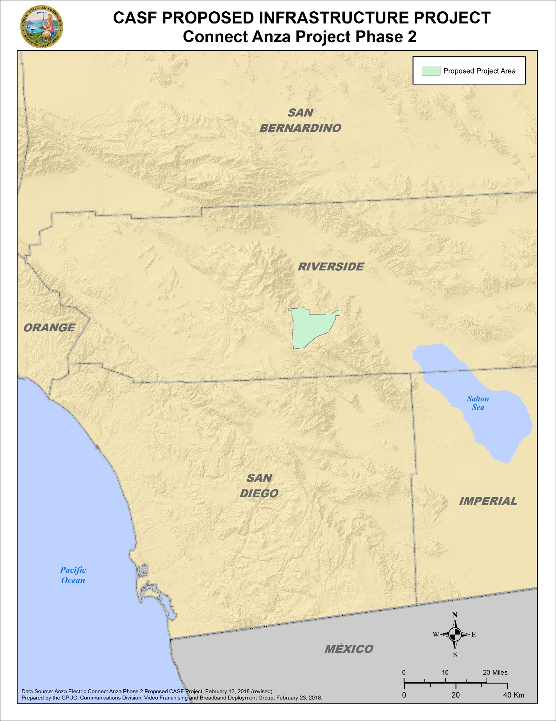

**Resolution T-17581 Connect Anza Project, Phase II**

**Existing Wireline Service**

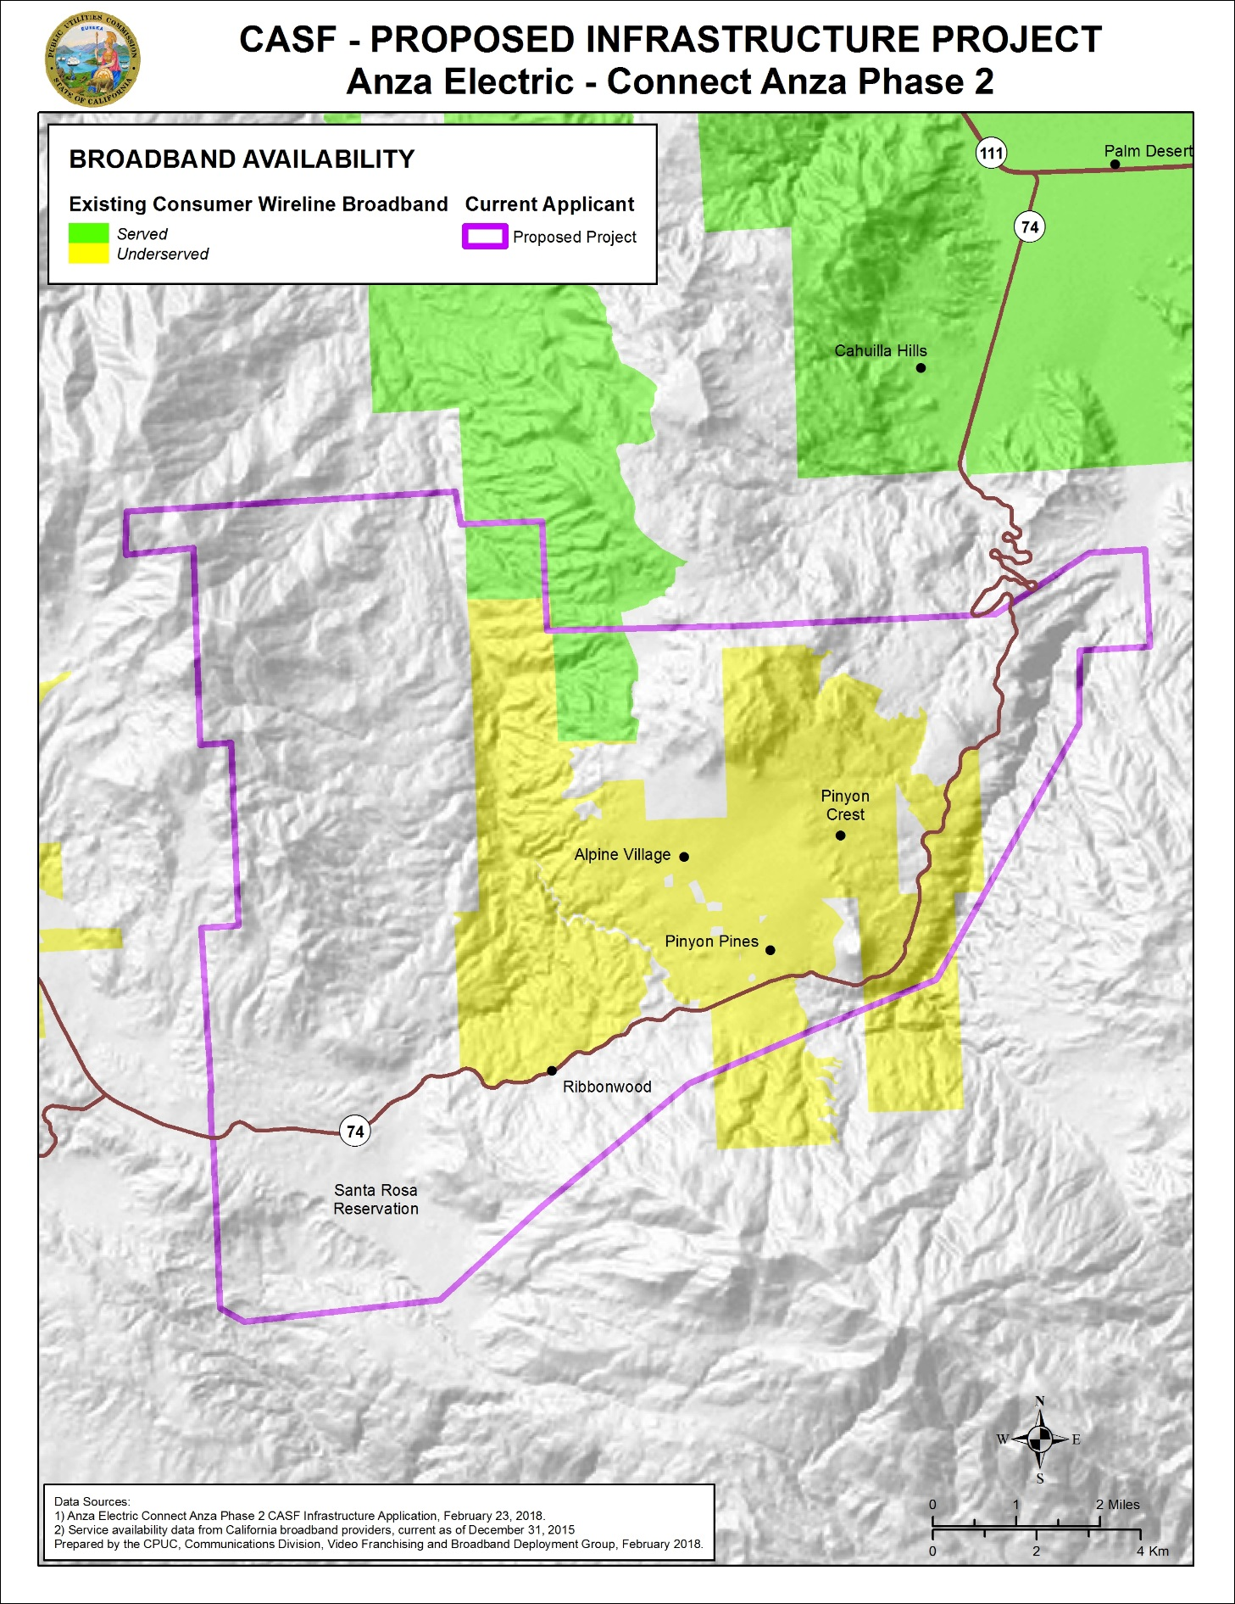

**Resolution T-17581 Connect Anza Project, Phase II**

**Appendix C**

**Resolution T-17581 Connect Anza Project, Phase II**

**General Demographics[27]**



**Appendix D**

**Resolution T-17581 Connect Anza Project, Phase II**

**Speed Test Data**

**Wireless Speed Test Summary**

**Pinyon Area, Santa Rosa Reservation: Verizon Wireless (Mbps Down / Mbps Up)**

|  |  |  |  |  |  |  |  |  |  |  |  |  |
| --- | --- | --- | --- | --- | --- | --- | --- | --- | --- | --- | --- | --- |
| Availability Map* | AEC Test Results** | AEC Test 1 | AEC Test 2 | AEC Test 3 | AEC Test 4 | AEC Test 5 | AEC Test 6 | AEC Test 7 | AEC Test 8 | AEC Test 9 | AEC Test 10 | AEC Test 11 |
| Served | Mixed Underserved and Unserved | 0/0 | N/A | N/A | N/A | N/A | N/A | 1.6/2.4 | 0/0.4 | 0/0 | 1.3/.3 | 1.3/.3 |

*CPUC Mobile Field Test Results (December 31, 2015)—Interpolated mean minus 2 standard deviation results based on statewide test points

**AEC Field Test Results (February, 2018) calculated at mean minus 2 standard deviation.

**Wireline Speed Test Summary**

**Pinyon Area: Frontier Communications (Mbps Down / Mbps Up)**

|  |  |  |  |
| --- | --- | --- | --- |
| Pinyon Area Frontier Customer Speed Tests | | | |
| **Frontier Customer** | **Date** | **Speeds** | **Subscription** |
| 1 | 29-May-17 | 1.53 / 0.66 | 3 mbps |
| 2 | 12-Jun-17 | 1.67 / 1.23 | 3 mbps |
| 3 | 11-Jun-17 | 2.05 / 0.50 | 3 mbps |
|  |  | 2.25 / 0.78 |  |
|  |  | 2.12 / 0.73 |  |
|  |  | 1.46 / 0.74 |  |
|  |  | 1.67 / 0.75 |  |
| 4 | 26-Dec-17 | 0.64 / 0.56 | "Faster service Frontier offers" |

**Wireline Speed Test Summary**

**Mountain Center (inclusive of Garner Valley): Frontier Communications (Mbps Down / Mbps Up)**

|  |  |  |
| --- | --- | --- |
| Frontier Communications Speed Tests in Mountain Center (inclusive of Garner Valley) | | |
| **Speed Test** | **Date** | **Speeds** |
| Site 8 | 7-Nov-17 | 20.44 / 2.22 |
| Site 9 | 7-Nov-17 | 19.92 / 2.31 |
| Site 10 | 7-Nov-17 | 19.42 / 2.29 |
| Site 11 | 7-Nov-17 | 19.59 / 2.37 |

1. Resolution T-17503, “Anza Electric Cooperative's Connect Anza Project, extending high-speed broadband service to approximately 3,751 households in the underserved communities of Anza, Aguanga, Lake Riverside Estates, and Reed Valley in Western Riverside County. “
2. Prepared by ESRI, February 21, 2018 for the County of Riverside.
3. AEC is an incorporated non-profit 501(c) (12) electricity (member-owned) cooperative. According to the AEC website (<http://www.anzaelectric.org/content/about-us>), AEC provides power to 3900 homes, schools, businesses and 20 irrigation loads.
4. Resolution T-17503.
5. See Decision 15-12-005, which approved the transaction.
6. Verizon (Frontier) CAF II blocks are also in the Pinyon area and Santa Rosa Reservation. Frontier also stated in an August 11, 2017 email that “Pinyon Hills” was not in the company’s current build given the high costs required to do the upgrade, but that it is open to completing this build using CASF funds (Frontier confirmed the census blocks where it will be completing its build, not inclusive of the Santa Rosa Reservation).
7. FCC Press Release, “[Carriers Accept Over $1.5 Billion in Annual Support from Connect America Fund to Expand and Support Broadband for Nearly 7.3 Million Rural Consumers in 45 States and One Territory](https://apps.fcc.gov/edocs_public/attachmatch/DOC-335080A1.pdf),” August 27, 2015. See also FCC Press Release “[Frontier Communications Accepts Over $283 Million Connect America Fund Offer to Expand and Support Broadband for 1.3 Million Rural Americans](https://apps.fcc.gov/edocs_public/attachmatch/DOC-333932A1.pdf),” June 16, 2015.
8. Decision 15-12-005, p. 57-58
9. Specific to the Frontier installation, Staff observed upgrades to the central office in Anza and the installation of remote cabinets (some cabinets were completely installed; others were in the process of being installed). This new installation provisions fiber to the cabinet and utilizes vDSL (very high bit rate digital subscriber line) technology which can best utilize the increased broadband capacity.
10. Frontier claimed that some of the other cabinets in the Phase 1 area would serve the Phase 2 area; CD is not confident of this, given the distance from the cabinet to the Phase 2 area and given that DSL signal capacity degrades over distance.
11. Available at http://www.broadbandmap.ca.gov/map/
12. The technology used is copper-based asymmetric DSL which has lower capacities than the vDSL being installed as part of the Frontier upgrade.
13. One customer indicated that his relative down the street could not get a Frontier connection when requested.
14. AB 1665 was an urgency measure; hence it was effective on the date of the Governor’s signature (October 15, 2017).
15. D.12-02-015, D.14-02-018 and Resolution T-17443.
16. See Pub. Util. Code Section 281 (f)(5)(C)(i) - 281 (f)(5)(C)(ii).
17. D.12-02-015, Resolution T-17443; see also AB 1665, which amended Pub Util. Code, § 281 effective October 15, 2017 and made numerous changes to the CASF program.
18. 40 to 60 households in the project area will be reached at the final point of connection through a fixed wireless component; These households will be provided with the same broadband capacity as other households in the project area.
19. The original proposed project would have served 1,188 households, while the recommended project will serve 413 households.
20. The household data count contains census projections of households and does not refer solely to 2010 census data.
21. Anza Community Building Association; Anza Community Broadcasting (96.3 KOYT streaming radio station which serves the Anza and surrounding communities), Minor Park Anza Civic Improvement League, and CalFire Anza Station 29.
22. The UC Riverside Deep Canyon Research Facility and the Riverside County Fire Station #30 in Pinyon.
23. <http://www.fire.ca.gov/fire_prevention/fire_prevention_wildland_statewide>
24. Note while these camps were located within the originally proposed project, they are not located within the recommended project area. Frontier has stated subsequent to its CAF area upgrade that it offers service to Camp Ronald McDonald.
25. For local coverage of the meeting, see <http://anzavalleyoutlook.com/local/anza-electric-cooperative-meets-california-public-utilities-commission/>.
26. Pursuant to Pub. Util. Code, § § 2108 and 2111, the Commission can enforce compliance measures in both the construction and the post-construction phases of the project, and can impose penalties for non-compliance.
27. Prepared by ESRI, February 21, 2018 for the County of Riverside, at the request of Martha van Rooijen, Executive Director, Inland Empire Regional Broadband Consortium. Income Limits information obtained from the California Department of Housing and Community Development.