PUBLIC UTILITIES COMMISSION OF THE STATE OF CALIFORNIA

Communications Division | RESOLUTION: T-17608
Broadband, Policy and Analysis Branch | DATE: May 10, 2018

RESOLUTION

Resolution T-17608: Approval of funding for the grant application of Inyo Networks, Inc. (U-7159-C), from the California Advanced Services Fund (CASF) up to the amount of $1,868,881 for the Bolinas Gigabit Network Project.

Summary

This Resolution approves funding in the amount of $1,868,881 from the California Advanced Services Fund (CASF) for the grant application of Inyo Networks, Inc. (Inyo Networks), to construct the Bolinas Gigabit Network Project, which includes new last mile broadband infrastructure in Bolinas (Marin County). The Bolinas Gigabit Network Project will enable up to 1 gigabit symmetrical speeds for 571 CASF-eligible households, and help to close the digital divide in Marin County. The proposed project will also benefit six community anchor institutions, enhancing social goals such as education, health, and public safety. This community is listed as a priority area by the North Bay North Coast consortium and is unserved by CASF standards. Additionally, in 2017, Staff included Bolinas on its list of High Impact projects.

Applicant Request

On December 13, 2017 Inyo Networks submitted a CASF grant application, requesting 60% grant funding of $1,868,881 to bring broadband service with maximum speeds of 1 gigabit per second to the homes, businesses, and community institutions of the unincorporated community of Bolinas. The Bolinas Gigabit Network project proposes to use last mile fiber-to-the-home connections. The backhaul will be provided by connecting to a microwave station on Mount Tamalpais, which is paired with a station in Berkeley.

Applicant: Inyo Networks is a Californian telephone corporation and public utility (U-7159-C). The company is certificated as a full facilities-based competitive local exchange and interexchange carrier. Inyo Networks and its affiliates have received CASF grants for middle mile and last mile fiber projects across the state.

Project: The Bolinas Gigabit Network Project will extend a fiber-to-the-home last mile network for both voice and broadband services. The proposed project will enable up to 1 gigabit symmetrical speeds for 571 CASF-eligible households, six anchor institutions and help to close the digital divide in Marin County. The core of the project will be an aerial construction, attaching to existing poles, with some use of existing conduit. A small portion of the 571 households served by the proposed project may require new underground structures, depending on the end user’s service location and the state of existing outside plant structure. Initially, Inyo Networks will use a licensed gigabit microwave radio link from Berkeley, CA, along with transmitter sites on Mt. Tamalpais and Muir Beach for its backhaul. Last-mile fiber facilities for the proposed project area will be constructed in previously disturbed areas where other utilities exist. The applicant asserts that all ground disturbances in the project area will occur within County rights-of-way or on homeowner properties.

Notice and Challenges

On December 20, 2017, Staff posted the proposed project area map, census block groups (CBG) and zip code for the Bolinas Gigabit Project on the Commission’s CASF webpage under “CASF Application Project Summaries” and also sent notice regarding the project to the CASF Distribution List. On January 4, 2018, Staff received a challenge from Horizon Cable (Horizon), asserting that it planned to offer broadband Internet service to Bolinas by the end of 2018.

CASF rules require parties challenging CASF Infrastructure Grant applications to provide documentation that the area in question is in fact already served. Horizon did not provide evidence to support that the area is already served. In a February 2, 2018 email to Staff, Horizon admitted that it does not already serve the census blocks contained in the proposed application, nor does it currently own or operate facilities in the community. The Commission can deny Horizon’s challenge based on these facts alone.

Staff has, in certain circumstances, accepted challenges based on planned service. In Resolution T-17525, Charter Communications challenged the Gigafy Phelan Project on the grounds that Charter planned to begin offering service, but there Charter submitted a firm completion date (on or before December 31, 2016) and Charter’s service was in place before the subsequent draft resolution was issued. Charter further provided a list of serviceable addresses and verification showing that all census blocks challenged would achieve speeds significantly above the minimum CASF standard of 6 Mbps download/1.5 Mbps upload.

By contrast, Horizon is attempting to challenge the project area on a planned network, where it does not already offer service or operate facilities. Further, Horizon has not submitted a firm completion date with respect to the proposed project, and instead states that, “[it remains] hopeful that all permits will be acquired within 6 months.”

Staff investigated further Horizon’s claims regarding its ability to serve Bolinas later this year. Based on its investigation, Staff determined that in order to extend its network into Bolinas, Horizon plans to construct under the channel entrance to the Bolinas Lagoon, which would require obtaining permits from several federal, state and local agencies, including: U.S. Army Corps of Engineers, California Coastal Commission, California Department of Fish & Game and the Regional Water Quality Control Board. Staff consulted with the Commission’s California Environmental Quality Act (CEQA) Section Staff, as well as analysts with the U.S. Army Corps of Engineers and the California Coastal Commission. Even assuming the permits would be granted (not a guaranteed outcome, even though Horizon has submitted permit applications to both the Army Corps of Engineers and the California Coastal Commission), Commission CEQA Staff found the goal of successfully obtaining permits from all of these agencies “highly unrealistic.” While the U.S. Army Corps analyst did not dismiss as unrealistic the possibility of the agency issuing a permit within six months, Coastal Commission Staff found it very unlikely it could issue one in that timeframe.

Staff finds that while it was reasonable to uphold Charter’s challenge to the Gigafy Phelan project, it is not reasonable to uphold Horizon’s challenge in this case because the circumstances differ. Charter’s challenge had a firm commitment date and it was clear that deployment and upgrades of broadband Internet service in certain parts of the proposed Gigafy Phelan project area was imminent. Specifically, Charter had existing infrastructure in the area, and proved itself capable of providing service within 2.5 months of the draft resolution’s issuance, warranting staff’s recommendation to uphold the challenge. Here, however, the Horizon challenge is based on planned service without having existing infrastructure in the area, and without a firm completion date. The fact that Horizon “remains hopeful permits can be acquired within six months” does not constitute a firm project completion date. Moreover, any date Horizon provides is reliant on Horizon receiving approved permits. Based on consultation with the CEQA team and contacts at the California Coastal Commission, as well as input from the Bolinas County Public Utility District, staff determined that Horizon is not guaranteed to receive those permits, let alone in the timeframe it anticipates.
Based on the information submitted, Staff finds that Horizon’s challenge does not establish that the area is already served nor justifies it being upheld based on planned service. Therefore, Staff finds that the proposed project area is eligible for CASF funding.

Project Review

Project Area Eligibility

AB 1665, signed into law by the Governor in October 2017, prohibits the Commission from awarding CASF funding to a project applicant if the existing facility-based broadband provider demonstrates, in response to the Commission’s annual offer, that it will deploy broadband or upgrade existing broadband service throughout the proposed project area within 180 days. Additionally, until July 1, 2020, the Commission cannot award funds for projects located in census blocks where an existing facility-based broadband provider has accepted federal funds for broadband deployment from the Federal Communications Commission’s Connect America Fund Phase II program (unless the existing facility-based broadband provider has notified the Commission before July 1, 2020, that it has completed its Connect America Fund deployment in the census blocks in question).
In addition to meeting the requirements of AB 1665 outlined above, for the proposed project area to be eligible, the CASF program requires an applicant to submit proof that the area is unserved. The applicant does this by submitting a shapefile of the proposed project area, which Staff compares with United States Census 2010 data and the California Interactive Broadband Availability map. Once Staff determines that the area is eligible as an unserved area, Staff evaluates all other information submitted by the applicant to determine if the project meets the requirements outlined in D.12-02-015.

Staff reviewed the project area census block groups submitted and determined that the project area was unserved by wireline, fixed wireless, or mobile providers. The current version of the California Interactive Broadband Availability Map indicates that this area is unserved, and the proposed project area does not contain census blocks with Connect America Fund Phase II accepted locations. Further, no provider expressed a commitment to serve the areas in question before the January 15, 2018 “right-of-first-refusal” deadline. Based on this review, Staff determined that the entire proposed project area is eligible for CASF funds.

Project Criteria Evaluation

Staff evaluated the application with respect to the criteria defined in D.12-02-015, Appendix 1, Section VIII (Scoring Criteria). The criteria include: (i) Funds Requested per Potential Customer, (ii) Speed, (iii) Financial Viability, (iv) Pricing, (v) Total Number of Households in the Proposed Area, (vi) Timeliness of Completion of Project, (vii) Guaranteed Pricing Period, and (viii) Low-Income Areas.

Funds per household: The CASF per-household subsidy for this proposed project is $3,273, based on the $1,868,881 requested and 571 eligible households. In comparison to other fiber-to-the-home projects approved by the Commission, some of which have cost $15,000 per household or more, this is a low per-household subsidy.

Speed: Inyo Networks plans to offer symmetrical speeds of up to 1 Gbps, well above the 10/1 Mbps required by the CASF. The company also intends to offer a student rate (25Mbps for $29.95/month) for families with students in the school lunch program (note this was not considered in the scoring for this criterion). These speeds are equivalent to other fiber-to-the-home projects.

Financial Viability: Based on the pro forma financial statements submitted by Inyo Networks, and from follow-up discussions with the company’s principles, Staff determined that Inyo Networks and its partner companies, Praxis Associates and Praxis Optical Networks, are financially viable companies. Inyo Networks’ share of the capital costs is $1,245,920, which is well within the company’s capacity to finance, based on its balance sheet, income, cash flow statements, and other financial documents, as well as Inyo Networks’ successful completion of previous CASF projects. Therefore, Staff finds that there is minimal risk that this project would encounter financial problems, such as the project not being completed or maintained over time. The relatively short construction period also reduces risk, as well as the support of the community.

Staff initially had some concerns about the proposed project’s estimated subscription rate, which is unusually high for a CASF project (80 percent), because the project requires a relatively high subscription rate in order to be profitable. However, given Inyo Networks’ experience with a similar project in neighboring Nicasio, where the company has met that high mark, along with the relatively high adoption rates in that portion of Marin County (in excess of 80 percent, as depicted on the Broadband Availability Map), Staff accepts that Inyo Networks could perform in a similar manner in Bolinas. The proposed project should be able to raise sufficient revenue to maintain the network.

Pricing: Inyo Networks has committed to a broadband pricing plan under the terms shown below for two years, starting from the beginning date of service. There is no long-term commitment required from subscribers. Activation and installation fees will be waived, unless the service location is more than 700 feet from the local serving terminal.

Bolinas Gigabit Network Pricing
Maximum Speed | Monthly Price
1Gbps Up and Down | $89.95
25 Mbps Up and Down (Qualified by Participation in School Lunch Program) | $29.95
Non-Recurring Charges: None, except for line extensions of more than 700 feet

Like other fiber-to-the-home projects, this project offers very high speeds, though at slightly higher prices than other technologies. Compared to other fiber-to-the-home projects offering similar speeds, these prices are 43% of the mean price.

Households in Project Area: Staff has verified that there are 571 CASF-eligible households in this project area.

Timeliness of Completion: Inyo Networks submitted planning documents committing it to a 15-month construction timeline, which is less than the 24-month allowance. The proposed project is scheduled to take 3.5 fewer months than the average project of its type.

Guaranteed Pricing Period: Inyo Networks has committed to maintain its proposed prices for two years after project completion, which meets but does not exceed the program’s pricing requirement.

Low-Income Areas: In its application, Inyo Networks stated that the proposed project area’s median household income is $74,310. The American Community Survey estimates the median household income for the Census-Designated Place as $67,300. Both numbers exceed the state median household income, which the US Census Bureau estimated as $63,783 in 2016.

Safety Considerations and Community Input

Inyo Networks asserts that the Bolinas Gigabit Network Project will enhance public safety and has received significant support from the community it would serve. For instance, real-time management of geographic information systems (GIS) data by first-responders via a robust broadband connection can provide an important mitigation to wildfire hazard. Robust and reliable broadband connectivity can also help mitigate the risks of landslides, flooding, earthquakes, and other natural disasters that can isolate communities and demand rapid communication with emergency services.

Completion of this project would also improve the community’s telehealth capabilities, which is especially important, as the nearest hospital (in contrast to the smaller healthcare facilities and clinics of West Marin) is roughly an hour away by car, under ideal conditions.

Additionally, the proposed project has received community support. The unserved households of Bolinas have been designated a priority area by the County of Marin and this area is the largest such priority area remaining in the County. The Bolinas Public Utilities District, in its letter of support to the Commission, asserted that the proposed project is, “the only serious effort that has been made to bring fiber optic broadband internet service to our rural community within a reasonable amount of time.” Additionally, the proposed project has the support of the Board of Supervisors of Marin County, Congressman Jared Huffman of California’s 2nd District, and local business owners. Bolinas is also home to a library, healthcare facility, and K-12 school, all of which would benefit either directly or indirectly from improved broadband facilities.

Staff Recommendation for Funding

Staff has determined that Inyo Networks’ Bolinas Gigabit Network Project qualifies for funding. The proposed project area is unserved, it contains no census block with CAF II accepted locations, and no provider filed a “right of first refusal” to serve this community. Based on Staff’s evaluation of the project, the Bolinas Gigabit Network meets the requirements of D.12-02-015 and AB 1665, provides safety benefits, scores better than other comparable projects under the Commission’s criteria, and aligns with the CASF’s goal of encouraging the deployment of high-quality advanced information and communications technologies to all Californians. Finally, the strong support of the community, and Inyo Networks’ own stake in this project, help strengthen the case for this project. Given all these reasons, Staff recommends the Bolinas Gigabit Network Project be approved for a CASF grant award of $1,868,881.

Compliance Requirements

Inyo Networks is required to comply with all the guidelines, requirements, and conditions associated with the grant of CASF funds as specified in D.12-02-015, D.14-12-018 and Resolution T-17443. Such compliance includes, but is not limited to:

California Environmental Quality Act (CEQA)

All CASF grants are subject to California Environmental Quality Act (CEQA) requirements unless the project is statutorily or categorically exempt pursuant to the CEQA Guidelines.

Inyo Networks has provided the Commission with basic construction plans for the proposed project area and area.

Based on the above information the project is categorical exempt from CEQA review. This project meets the criteria of the CEQA categorical exemptions for: CEQA Guidelines Section15301 - Existing Facilities, CEQA Guidelines Section 15303 – New Construction or Conversion of Small Structures, and CEQA Guidelines Section 15304 – Minor Alterations to Land.

Deployment Schedule

The Commission expects Inyo Networks to complete the project within 24 months from start date (as determined by the procedure below). If the applicant is unable to complete the proposed project within the 24-month timeframe requirement, it must notify the Director of the Communications Division as soon as Inyo Networks becomes aware of this possibility. If such notice is not provided, the Commission reserves its right to reduce payment for failure to satisfy this requirement. The Commission also expects Inyo Networks to meet its commitments to complete the project according to the abbreviated timeline it has submitted.

Execution and Performance

Staff and Inyo Networks shall determine a project start date after the CASF grant recipient has obtained all approvals. Should Inyo Networks or any contractor it retains fail to commence work by the designated date, upon five days’ written notice to Inyo Networks, the Commission may terminate the grant. In the event that Inyo Networks fails to complete the project in accordance with the terms of CPUC approval as set forth in this Resolution, Inyo Networks shall reimburse some or all of the CASF funds that it has received. Inyo Networks must complete all construction covered by the grant on or before the grant’s termination date.

Performance Bond

The Commission does not require a performance bond if the applicant certifies that the percentage of the total project costs it is providing comes from their capital budget and is not obtained from outside financing. In its application, Inyo Networks certified, and Staff verified, that the percentage of the total project costs it is providing will come from its existing capital budget. Therefore, a performance bond is not required for this project.

Price Commitment Period

The minimum required price commitment period for broadband service to all households within the project area is two years. Inyo Networks guarantees the price of service offered in the project area for two years starting from the proposed project’s completion date.

Project Audit

The Commission has the right to conduct any necessary audit, verification, and discovery during project implementation/construction to ensure that CASF funds are spent in accordance with Commission approval.

Inyo Networks’ invoices will be subject to a financial audit by the Commission at any time within three years of completion of the work.

Providing Voice Service

Inyo Networks has certified that its voice service meets the Federal Communications Commission (FCC) standards for E-911 service and battery backup.

Reporting

Inyo Networks must submit quarterly progress reports on the status of the project irrespective of whether Inyo requests reimbursement or payment.

Progress reports shall include the following components: the schedule for deployment; major construction milestones; costs submitted in the proposal; the actual date of completion of each task/milestone; problems and issues encountered; the actions taken to resolve these problems and issues; identification of future risks to the project. Inyo Networks must certify that each progress report is true and correct under penalty of perjury.

Before full payment of the project, Inyo Networks must submit a project completion report. Inyo Networks shall also include test results on the download and upload speeds on a CBG and zip code basis in the final completion report.

Submission of Form 477

The FCC currently requires broadband providers to biannually submit Form 477, which includes speed data. While there is an imperfect match between the data that is reported in the Form 477 and to the CPUC for CASF grants, the Form 477 data will be useful in documenting CASF deployment for the service provider’s new service. Pursuant to General Order 66-D, service providers in California must submit a copy of their Form 477 data directly to the CPUC, concurrent with their submission of the same data to the FCC for a five-year period after completion of the project.

Prevailing Wage

Section 1720 of the California Labor Code specifies that CASF-subsidized projects are subject to prevailing wage requirements. Inyo Networks has committed to follow state prevailing wage requirements with respect to this project.

Payments to CASF Recipients

Submission of invoices from and payments to Inyo Networks shall be made at 25 percent completion intervals, in accordance with Section XI of Appendix 1 of D.12-02-015 and according to the guidelines and supporting documentation required in D.12-02-015.

Submission of invoices from and payments to Inyo Networks shall be made at a minimum of 25-percent completion intervals, in accordance with Section XI of Appendix of D.12-02-015, and according to the guidelines and supporting documentation required in D.12-02-015.
Payment to Inyo Networks shall follow the process adopted for funds created under Pub. Util. Code, §270. The Commission generally processes payments within 20-25 business days, including Communications Division and Administrative Services review time. The State Controller’s Office (SCO) requires an additional 14 - 21 days to issue payment from the day that requests are received by SCO from Administrative Services.

Comments on Draft Resolution

In compliance with Pub. Util. Code, § 311(g), a notice letter was e-mailed on April 6, 2018, informing all parties on the CASF Distribution List of the availability of the draft of this resolution for public comments at the Commission's website at http://www.cpuc.ca.gov/PUC/documents/. This letter also informed parties that the final conformed Resolution adopted by the Commission will be posted and available at this same website.

No comments were received.

Findings

- Inyo Networks filed an application for CASF funding for its Bolinas Gigabit Network on December 13, 2017. The proposed project will extend gigabit service to the entire community of Bolinas by installing last-mile fiber and connecting to a pre-existing microwave connection between Mount Tamalpais and Berkeley. This will enable speeds of up to 1 gigabit per second for 571 CASF-eligible households. The CBG impacted by the project is 060411321002, and the ZIP code is 94924.

- Staff posted the proposed project area map, CBG and zip code for Inyo Networks’ Bolinas Gigabit Network on the Commission’s CASF webpage under “CASF Application Project Summaries” on December 20, 2017. Staff received one challenge to the project from Horizon Cable.

- Staff reviewed and analyzed data submitted for the Bolinas Gigabit Network Project CASF grant application to determine the proposed project’s eligibility for CASF funding. This data included, but was not limited to: proof of a CPCN from the Commission; descriptions of current and proposed broadband infrastructure; geographic information system (GIS) formatted shapefiles mapping the project areas; assertion that the area is underserved; number of potential subscriber households and average incomes; project construction schedule; project budget; proposed pricing and commitment period for new subscribers; and financial viability of the applicant.

- Staff reviewed the submitted shapefiles, which mapped the proposed broadband deployment using United States Census 2010 data and the California Interactive Broadband Availability Maps, with availability data current as of December 31, 2016. These maps helped to verify the availability and speed of any broadband service, where available. The project area was determined to be unserved.

- Based on its review, Staff determined that the project qualifies for funding under D.12-02-015 and recommends Commission approval of CASF funding for the Bolinas Gigabit Network Project.

- Inyo Networks is not required to post a performance bond because Inyo Networks certified that the percentage of the total project costs it is providing will come from its existing capital budget.

- Inyo Networks is required to comply with all guidelines, requirements, and conditions associated with the granting of CASF funds as specified in D.12-02-015, D.14-02-018 Resolution T-17443, and this Resolution, and must submit the FCC Form 477, as specified in T-17143.

- The Commission has determined that the project is categorically exempt from CEQA review, under section 15301 regarding exemption for existing facilities and section 15303 regarding minor modifications to existing structures.

- A notice letter was e-mailed on March 6, 2018 informing all applicants filing for CASF funding, parties on the CASF distribution list of the availability of the draft of this Resolution for public comments at the Commission’s website http://www.cpuc.ca.gov/PUC/documents/. This letter also informed parties that the final confirmed Resolution adopted by the Commission will be posted and available at this same website. No comments were received.

THEREFORE, IT IS ORDERED that:

  - The Commission shall award $1,868,881 to Inyo Networks for the Bolinas Gigabit Network Project as described herein and summarized in Appendix A of this Resolution.

  - Grant payments of $1,868,881 for the Bolinas Gigabit Network Project serving an underserved area shall be paid out of the CASF Infrastructure Grant Account in accordance with the guidelines adopted in D.12-02-015, D.14-02-018 and Resolution T-17443, including compliance with CEQA.

  - Payments to the CASF recipient shall be in accordance with Section XI of Appendix 1 of D.12-02-015, D.14-02-018, Resolution T-17443 and in accordance with the process defined in the “Payments to CASF Recipients” section of this Resolution.

  - Inyo Networks shall comply with all guidelines, requirements and conditions associated with the CASF funds award as specified in D.12-02-015, D.14-02-018, Resolution T-17443 and this Resolution, and all applicable laws, and must submit the FCC Form 477 to the Commission, as specified in Resolution T-17143.

  - By receiving a CASF grant, Inyo Networks agrees to comply with the terms, conditions, and requirements of the grant and thus submit to the jurisdiction of the Commission with regard to disbursement and administration of the grant.

  - Inyo Networks shall provide service to all households within the proposed project area, as defined in Appendix A and GIS files submitted to the Communications Division as part of this application process.

  - Inyo Networks must complete all construction covered by the grant on or before the grants termination date. If the project will not be completed within the 24-month timeframe, Inyo Network must notify the Director of Communications Division as soon as it becomes aware of this possibility. If such notice is not provided, the Commission may reduce payment for failure to satisfy this requirement.

  - If Inyo Networks fails to complete the project in accordance with the terms outlined in D.12-02-015, D.14-02-018, Resolution T-17443 and this Resolution, Inyo must reimburse some or all of the CASF funds that it has received.

  - Inyo must sign and return a consent form agreeing to the conditions set forth in this Resolution.

  - Inyo Networks must submit a project completion report prior to receiving final payment.

This Resolution is effective today.

I hereby certify that this Resolution was adopted by the Public Utilities Commission at its regular meeting on May 10, 2018. The following Commissioners approved it:

Alice Stebbins

Executive Director

APPENDIX

APPENDIX A
Resolution T-17608
Inyo Networks Bolinas Gigabit Network
CASF Applicant Key Information
Project Name | Inyo Networks Bolinas Gigabit Network
Project Plan | The project proposal is to attach fiber to pre-existing poles throughout Bolinas, with some digging on a house-by-house basis, in order to provide fiber service to up to 571 CASF-eligible households. through a pair of microwave stations on Mount Tamalpais and in Berkeley. The network will be capable of up to 1 Gbps service.
Project Size (in square miles) | 2.13
Download/Upload speed | Maximum 1 Gbps / Minimum 25 Mbps (qualified)
Location | Bolinas, Unincorporated Marin County
Community Names | Bolinas
Census Block Groups | 060411321002
Median Household Income (by Census Block Group) | $ 74,310
Zip Codes | 94924
Estimated potential subscriber size | 571
Pricing Plan (Monthly) | 1 Gbps: $89.95  25 Mbps (qualified by participation in school lunch program): $29.95
Deployment Schedule  (from Commission approval date) | 15 months
Proposed Project Budget (Total) | $ 3,114,801
Amount of CASF funds requested (60%) | $ 1,868,881
Applicant funded (40%) | $1,245,920

Appendix B
Inyo Networks Bolinas Gigabit Project
Project location map
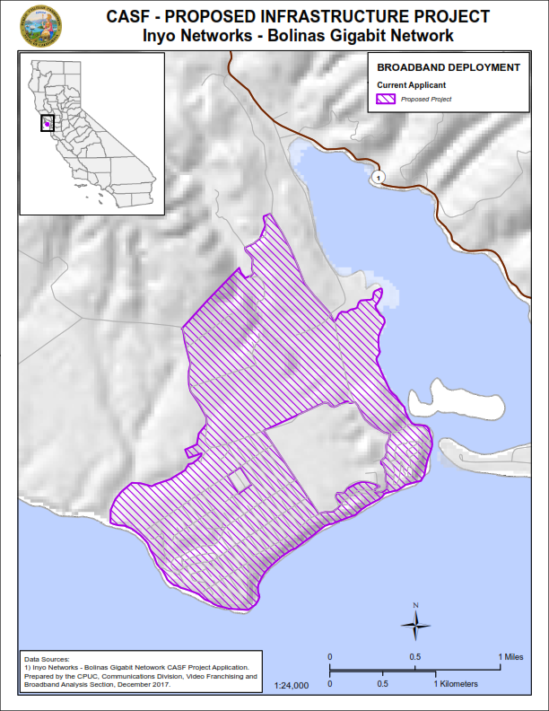
Appendix C
Inyo Networks Bolinas Gigabit Project
Wireline Service Status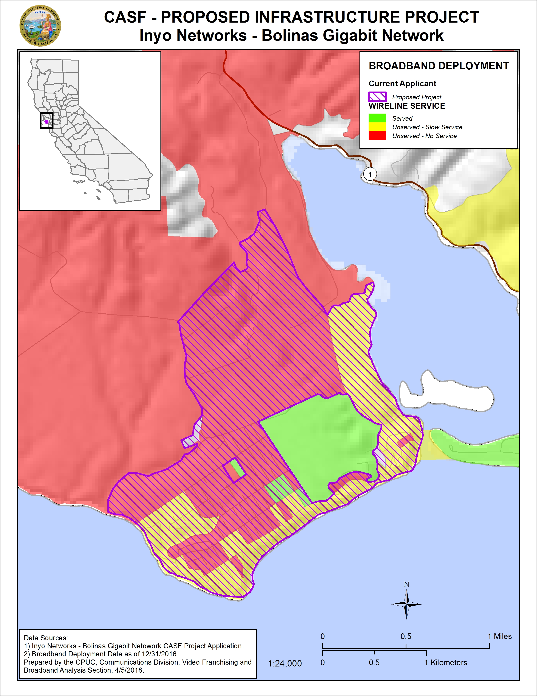
Appendix D
Inyo Networks Bolinas Gigabit Project
Mobile Wireless Service Status
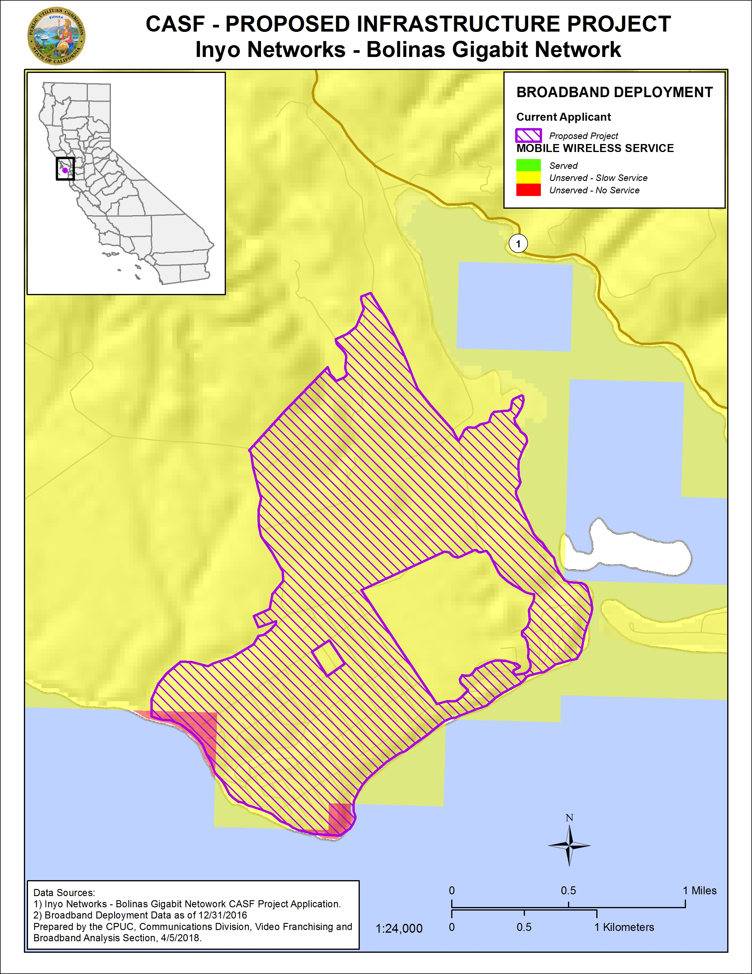
Appendix E
Inyo Networks Bolinas Gigabit Project
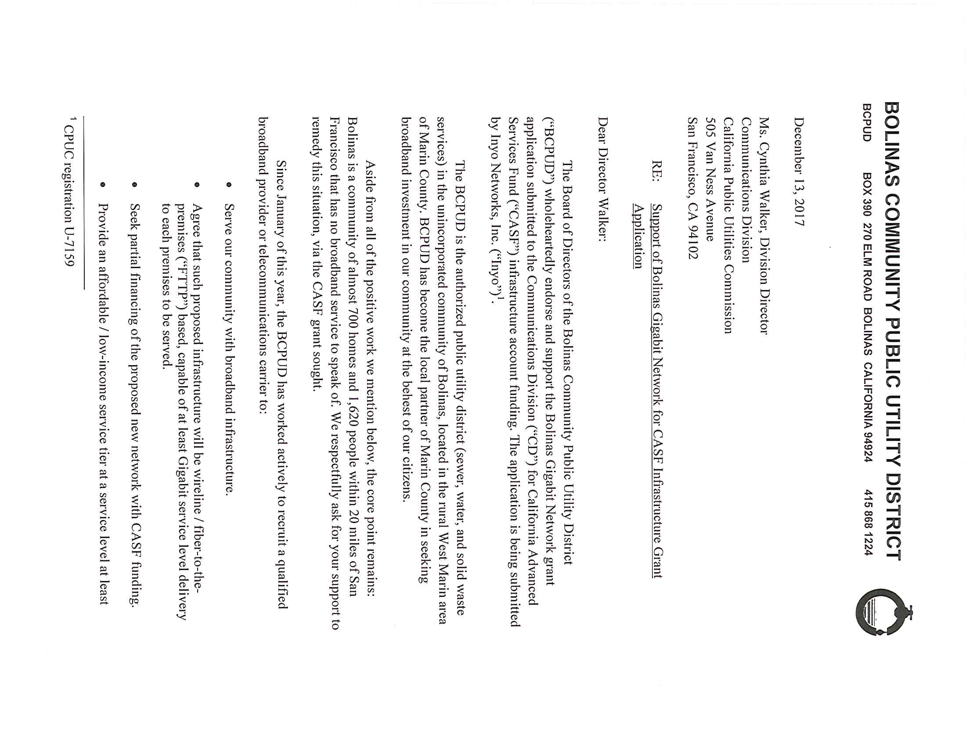
Letter of Support from BCPUD
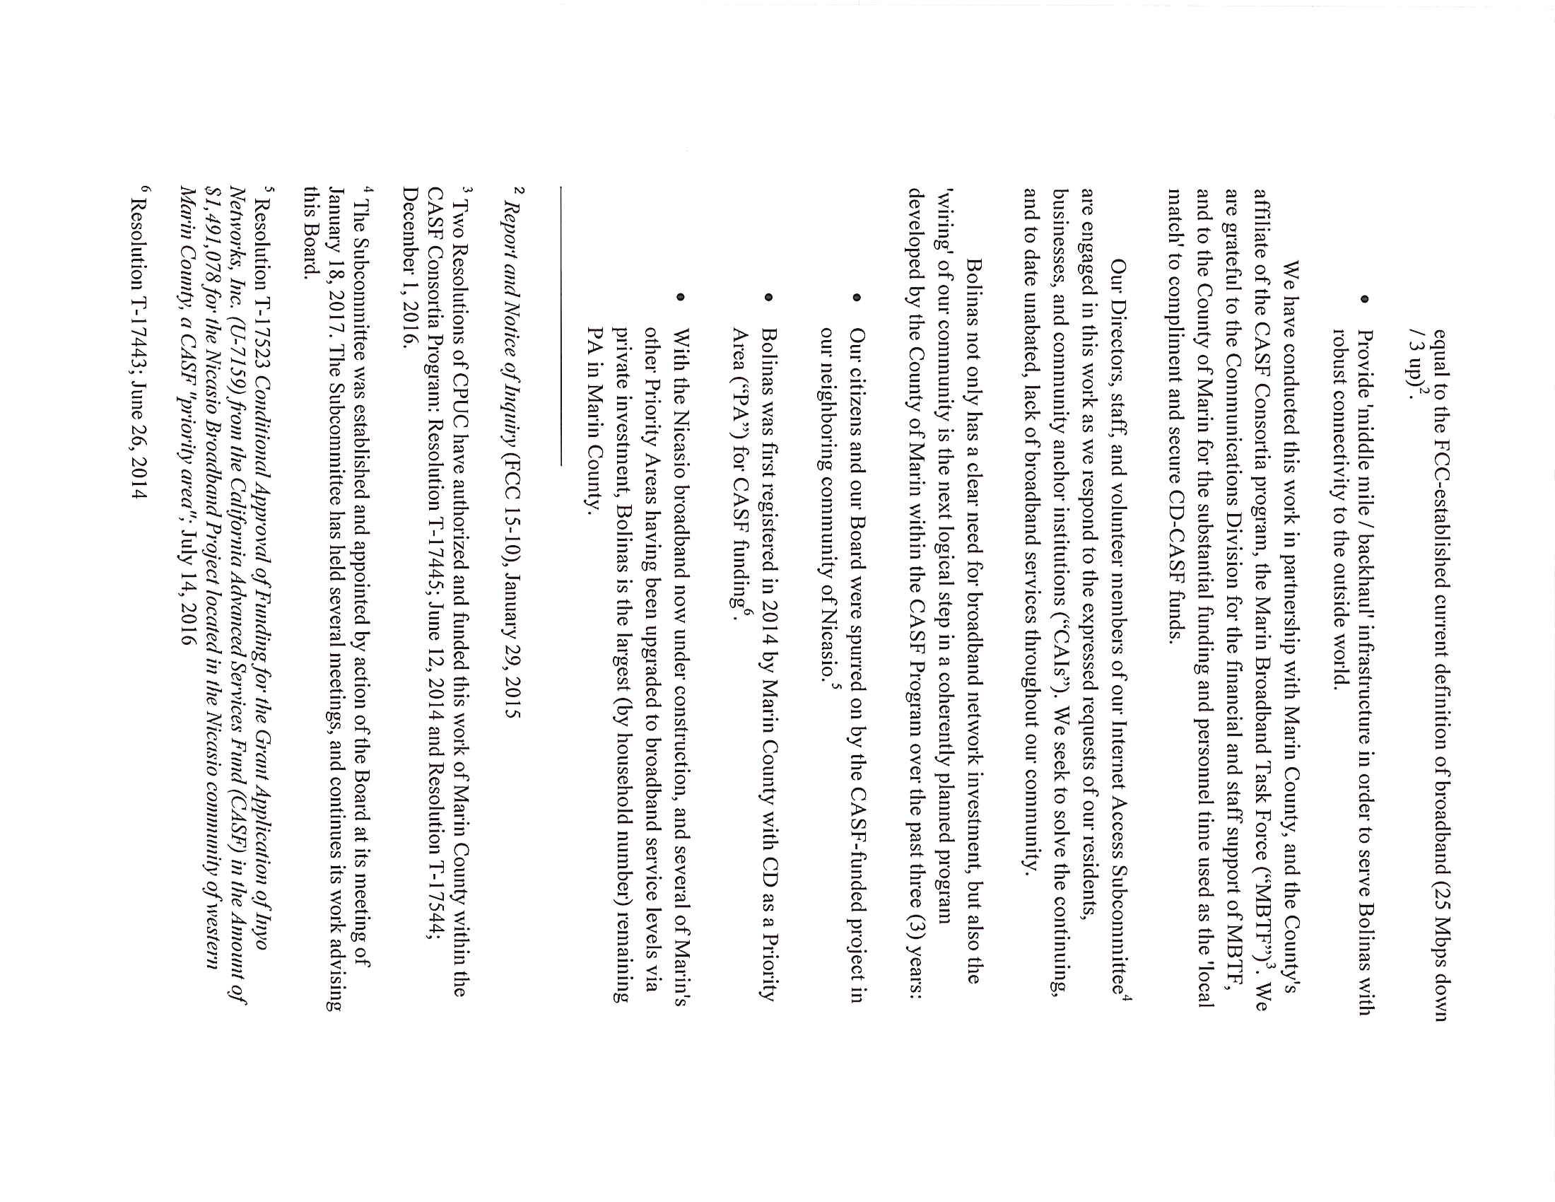
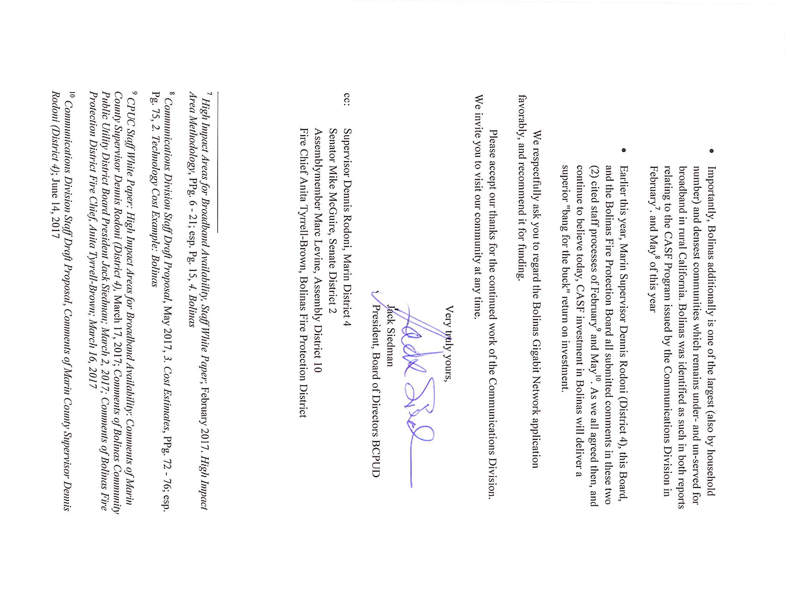

See Resolutions T-17523 T-17548, T-17232, and T-17408.
D.12-02-015, p. xx; Resolution T-17443, Revised Application Requirements and Guidelines, p. 18.
See Resolution T-17525 at p 4-5.
The Draft Resolution was published on September 26, 2016. Charter committed to offer service by December 31, 2016. On January 3, 2017, Charter informed Staff that it had completed its upgrades in the area and submitted “serviceable address” data.
Horizon letter, dated February 2, 2018.
See also February 26, 2018 letter to the Communications Division Director wherein the Bolinas Community Public Utility District asserts that Horizon is unable to serve Bolinas in a “reasonable period of time.” (see attached in Appendix E)
See Pub. Util. Code Section 281 (f)(4)(A)(i) - 281 (f)(4)(A)(ii). Note the Commission refers to this process at the “right of first refusal.”
See Pub. Util. Code Section 281 (f)(5)(C)(i) - 281 (f)(5)(C)(ii)
The latest version of the California Interactive Broadband Availability Map uses wireline data as of December 31, 2016.
Resolution. T-17143 at 4.

