PUBLIC UTILITIES COMMISSION OF THE STATE OF CALIFORNIA
Safety and Enforcement Division  Rail Transit Safety Branch | Resolution ST-212  October 11, 2018

RESOLUTION
RESOLUTION ST-212 GRANTING APPROVAL OF THE LOS ANGELES WORLD AIRPORTS LANDSIDE ACCESS MODERNIZATION PROGRAM AUTOMATED PEOPLE MOVER PROJECT
SAFETY CERTIFICATION PLAN

Summary
This Resolution grants the request of the Los Angeles World Airports for approval of the Safety Certification Plan for the Landside Access Modernization Program Automated People Mover Project.

Product Discruption
The Los Angeles World Airports (LAWA) Landside Access Modernization Program Automated People Mover (APM) Project includes planning, design, construction and operation of a 2.25-mile APM elevated fixed guideway system that will shuttle travelers and airport workers between the the Los Angeles Airport (LAX) Central Terminal Area (CTA) and rental car facilities, parking facilities, and regional public transportation services, including a connection to the Los Angeles County Metropolitan Transportation Authority (Metro) Crenshaw line, which is currently under construction.
The APM System is an automated, rubber-tired people mover that will operate between LAX and the Consolidated-Rent-A-Car facility (ConRAC). The LAWA APM and is owned and operated by LAWA and is scheduled to begin passenger service in March of 2023.
The APM System’s elevated dual guideways enable people movers to travel in both directions. At completion, the system will have 6 stations. Its approximate path runs east from the CTA West Station at the Tom Bradley International Terminal to the CTA Central Station, curling around the Theme Building and along Center Way to the CTA East Station, where it then crosses over Sepulveda Boulevard and then turns north to cross over Century Boulevard. When the guideway reaches 96th Street, it turns back to the east and stops at the Intermodal Transfer Facility (ITF) West Station, then crosses over the Metro Crenshaw line, stops at the ITF East Station, with a connection to the Airport Metro Connector Transit Station, and continues on to the ConRAC Station.
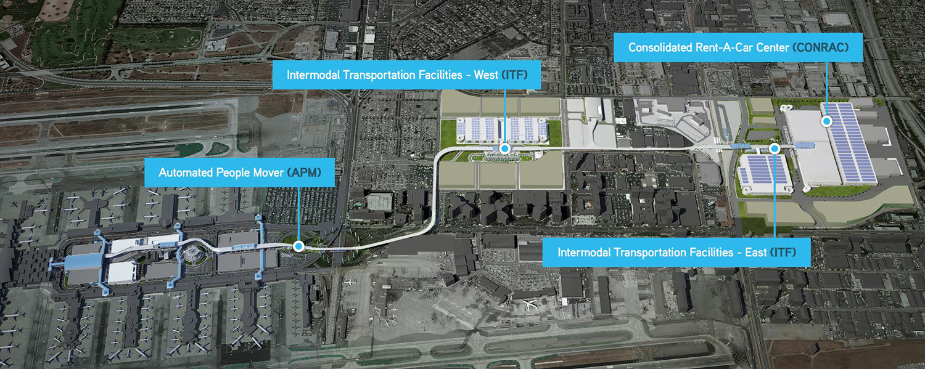
Project construction will include:
• Approximately 2.25 miles of elevated, grade-separated APM Guideway connecting passenger terminals in the CTA with new airport landside facilities east of the CTA;
• A total of six (6) APM Stations, five to be constructed by the P3 Developer under the APM Contract. The overall ConRAC Design and Construction scope will be under a separate contract and will consists of coordinating the design requirements for the APM operating components within the station enclosure provided by the ConRAC Developer;
• Mezzanine access to the Airport Metro Connector (AMC) Transit Station (provided by parties outside the scope of this project) to be located at West 96th Street/Aviation Boulevard;
• Elevated Pedestrian Walkways connecting the APM Stations to certain terminals and CTA garages, and connecting ITF West Station to the vertical circulation cores at ITF West Garage;
• APM Operating System components, including driverless vehicles, Automatic Train Control, and Communications;
• An APM Maintenance and Storage Facility; and
• Traction Power and Facilities Power Substations to support all the APM System electrical load requirements.

Background
Commission General Order 164-E, Rules and Regulations Governing State Safety Oversight of Rail Fixed Guideway Systems, Section 11, requires that Rail Fixed Guideway Systems prepare a project-specific Safety Certification Plan (SCP) for each major project and ensure that all entities involved in design, construction, operation, and maintenance of the project shall comply with the requirements outlined in the SCP. The purpose of the SCP is to describe organizational authority and responsibilities, safety certification activities and processes, and documentation requirements and responsibilities. The SCP ensures that elements critical to safety are planned, designed, constructed, analyzed, tested, inspected, and implemented. The SCP also ensures that training is provided, and rules and procedures are followed. The SCP includes consideration of security-related issues and the security of the completed and integrated project within LAX Terminal’s layout.
A written Safety Certification Verification Report (SCVR) is required by CPUC General Order 164-E at the end of the project, before revenue service can begin. The SCVR shall be submitted to CPUC staff (Staff) upon project completion. The SCVR is then reviewed by Staff and, if acceptable, an approval letter is sent to the transit agency by the Safety and Enforcement Division Director, allowing the project to be placed into revenue service.

Discussion
Commission General Order 164-E, Section 11, requires that Rail Fixed Guideway Systems prepare a project-specific SCP for all projects that initiate preliminary engineering after February 27, 2003. LAWA is responsible for ensuring that all entities involved in design, construction, operation, and maintenance of all of the LAX APM comply with the requirements of the Safety Certification process.
On May 22, 2018, LAWA submitted a SCP for the LAX APM project for Staff review and Commission approval. Based on Staff’s initial review of the submitted SCP, revisions were required. LAX APM SCP Rev. 2 was resubmitted on July 2, 2018, for Staff review and Commission approval.
The submitted SCP describes the processes, responsibilities, documentation, and procedures needed for certification. The intent of the SCP is to define the safety certification management including organizational authority and responsibilities, safety certification activities, processes and procedures. Additionally, it provides a framework for ensuring that appropriate safety-related activities are performed and documented to support each Certificate of Compliance that will be issued.
The SCP objectives are to ensure that the following safety requirements have been satisfied:
- Facilities and equipment have been designed, constructed, installed, inspected, and tested in accordance with applicable codes, standards, criteria, and specifications.
- Procedures, rules, and other documentation have been adequately developed or reviewed and modified as necessary, by the Contractor.
- Operations and Maintenance personnel have been trained and are certified to perform their respective functions.
The project is a design, build, operate and maintain project, so the selected contractors will have primary responsibility for implementation of the SCP, subject to approval and oversight of LAWA. LAWA will be ultimately responsible for project safety certification and submittal of the SCVR to Commission Staff.
The developer portion of the project consists of five contractors, Fluor Enterprises, Inc. (Fluor), Balfour Beatty Investments, Inc. (BBI), Hochtief PPP Solutions GmbH (Hochtief), ACS Infrastructure Development, Inc. (ACS), and Bombardier Transportation Holdings USA Inc. (Bombardier). The lead design-build contractor portion of the project consists of Fluor, BBII, Flatiron West, Inc. (Flatiron), HDR Engineering, Inc. (HDR), and Dragados USA, Inc. (Dragados USA). The lead operations and maintenance portion of the project consists of Fluor, BBII, Hochtief North America, Inc., ACS, and Bombardier. This conglomerate of contractors identifies themselves as the LAX Integrated Express Solutions (LINXS).
The SCP identifies the certifiable elements of the project, as well as the roles and responsibilities of each party (LINXS Contractor Group, LAWA, and CPUC Staff) involved throughout the project. Staff from the Rail Transit Safety Branch will conduct continuous and ongoing oversight and inspections of the project and SCP implementation as the project progresses.
The SCP may be revised and expanded as the project progresses with Staff’s review and approval.
Staff reviewed and analyzed the content of the SCP in accordance with General Order 164-E Section 11, Requirements for Safety Certification Plan. Staff finds that the SCP is in compliance with General Order 164-E. Based upon the results of this review, Staff recommends that the Commission grant approval of LAWA’s SCP.

Notice
On September 6, 2018, this Resolution was published on the Commission’s Daily Calendar.

Comments
The draft resolution of the Safety and Enforcement Division in this matter was mailed in accordance with Section 311 of the Public Utilities Code and Rule 14.2(d)(1) of the Commission’s Rules of Practice and Procedure.
_____ comments were received.

Findings
- On May 22, 2018, LAWA submitted its SCP for the Landside Access Modernization Program Automated People Mover Project for Staff review and Commission approval.
- Staff's initial review of the submitted SCP resulted in additional comments, which required updates to SCP Revision 1.
- Revision 2 of the SCP was submitted on July 2, 2018.
- The LAWA LAX APM Project includes approximately 2.25 miles of elevated, grade-separated APM Guideway connecting passenger terminals in the CTA with new airport landside facilities east of the CTA, with a total of 6 APM Stations.
- This SCP identifies the process by which the project will be certified as meeting the established safety and security criteria and standards to operate in revenue service.
- Staff reviewed and analyzed the content of the SCP and found it to be in accordance with General Order 164-E, Section 11 and the Rail Transit Safety Branch Program Management Standard Procedures Manual, State Safety and Security Oversight of Rail Fixed Guideway Systems, Section 9.

THEREFORE, IT IS ORDERED THAT:
- The request of the Los Angeles World Airports for approval of the Safety Certification Plan for the Landside Modernization Access Program Automated People Mover Project is granted.
- The Los Angeles World Airports shall submit the Safety Certification Verification Report to CPUC Staff upon project completion.
- This resolution is effective today.
I certify that this resolution was adopted by the Public Utilities Commission at its regular meeting held on October 11, 2018. The following Commissioners voting favorably thereon:

Alice Stebbins
Executive Director

Michael Picker
President
Carla J. Peterman
Liane M. Randolph
Martha Guzman Aceves
Clifford Rechtschaffen
Commissioners

