PUBLIC UTILITIES COMMISSION OF THE STATE OF CALIFORNIA

|  |  |
| --- | --- |
| **Communications Division** | RESOLUTION T- 17636 |
| **Broadband, Video and Market Branch** | **December 13, 2018** |

**R E S O L U T I O N**

**RESOLUTION T-17636: Approves funding for the public housing adoption grant application of the Housing Authority of the County of San Bernardino (HACSB) from the California Advanced Services Fund (CASF) Broadband Public Housing Account (BPHA) in the amount of $405,730.50.**

**I. SUMMARY**

This Resolution approves grant funding in the amount of $405,730.50 from the California Advanced Services Fund (CASF) Broadband Public Housing Account (BPHA) for the Housing Authority of the County of San Bernardino’s (HACSB) Broadband Adoption Digital Learning Centers project (Digital Learning Centers project). This project will provide digital literacy and computer-based job skills trainings for up to 2,760 residents in 26 public housing locations in San Bernardino County.[1]

**II. BACKGROUND**

On December 18, 2014, the Commission approved Decision (D.) 14-12-039 which implements the rules and guidelines for the BPHA including: eligibility and application requirements, types of activities and costs funded by CASF, criteria for expedited review approval of project applications by Communications Division (CD) staff, and quarterly deadlines for application submission.[2] Key provisions of the Decision relevant to this Resolution include:

* The Commission delegates to CD the authority to approve applications that meet all the expedited review criteria, including the requirement that the applicant’s grant request is $50,000 or less and the requirement that the applicant identifies an onsite designated space for digital literacy. [3]
* Where an application does not meet the above expedited review criteria, it may still be considered for a grant but it must go through the traditional Commission Resolution approval process.

*Applicant and designated contractor:* HACSB (established in 1941), is a public housing agency that owns 2,572 public housing units (and an additional 977 units, through its affiliate, Housing Partners I (HPI)) and administers 10,653 Voucher Rental Assistance Program Units.[4] The agency serves up to 30,000 people and has a waitlist of 61,448 (for both housing units and for housing vouchers).[5] HACSB is participating in the Department of Housing and Urban Development (HUD) ‘Moving to Work’ program. This program allows public housing authorities to use federal funds to design and implement innovative strategies to help residents find employment and become   
self-sufficient.

HACSB has contracted with Greater Harvest Community Center, Inc. (GHCC) to implement its digital literacy training project. GHCC, founded in 2014, has 4 years of experience in delivering digital literacy training programs.[6] GHCC stated that they have partnered with the California Emerging Technology Fund (CETF), AT&T, Frontier and Spectrum in making their affordable broadband adoption programs available to low-income residents, with city and public education institutions and others. Additionally, GHCC was chosen to be the contractor to provide digital literacy services for two recently approved BPHA projects;[7] their work on this project will be a continuation of the work already begun for these approved projects.

*Community:* Residents that will be served by this project are considered low income per the definition of HUD as they fall under 80% of area median income. Survey data of HACSB public housing residents and housing voucher participants found that 91% of families fall below the 50% area median income.

**III. APPLICANT REQUEST**

In 2015, HACSB, and its affiliate HPI, submitted a total of 26 applications for broadband adoption at 26 locations, for a total funding request of $604,164.[8] At the same time as the submission of the broadband adoption applications, HACSB also submitted applications for infrastructure grants to finance projects for inside networks to connect these locations to the internet. The infrastructure projects were approved through the expedited review process on March 10, 2016. However, HACSB notified CD by email on April 3, 2017 that they were withdrawing from the awarded infrastructure grant stating that the grant awarded did not cover the cost of the projects. No work was done on these projects and no payment was made to HACSB.

On September 27, 2018, HACSB and HPI revised its broadband adoption applications to include 26 locations in one application. This revised application will serve up to   
2,760 residents and 1,102 units. The new grant amount requested in the revised application is $405,730.50.

*Project*: According to HACSB, the proposed project implements a sustainable broadband adoption program which features community-based digital learning centers, quarterly digital literacy events, and training classes to support its residents. The goal is to create Digital Learning Centers in order to provide digital literacy training and conduct outreach to have residents sign up for existing low-cost internet plans provided by various carriers. Activities will include in-person digital literacy training conducted by GHCC at HACSB computer labs.

GHCC will use existing curriculum for basic digital literacy training such as material found at GCF Learn Free website (<https://edu.gcfglobal.org/en/>). GHCC can provide existing curriculum beyond the levels that are available from GCF Learn Free such as curriculum on advanced office productivity software.

At a minimum, the digital Literacy curriculum will include the following areas:

* Digital literacy and computer hardware basics
* Office productivity software
* Internet safety
* Employment access, job search, and resume building;

This project will also provide computer access in order to:

* Provide school aged children access to educational resources;
* Provide residents access to healthcare and primary care providers and to communicate with family and friends
* Provide additional, individual self-paced training; lab assistance will be available

Each resident will receive a minimum of 8 hours of training. Each session will be two hours in length. Upon completion of 8 hours of digital literacy training and enrollment in broadband internet services, a refurbished laptop computer will be issued to the resident.

*Digital Learning Centers:* Each center will feature up-to-date technology including, a maximum of 12 computer work stations, large digital screen/projector capabilities for training, as well as equipment to accommodate copy/scan/faxing capabilities.   
The proposed center locations are:

* Maplewood Homes, 1738 W. 9th Street, San Bernardino, CA
* Parkview Pines, 772 Pine Street, Colton, CA
* 13088 Monte Vista Ave, Chino CA
* 803 W. Brockton, Redlands CA
* 421 South 7th Ave, Barstow CA
* Summit Walk, 1206 West 4th Street, Ontario, CA
* Sunset Vista, 755 E. Virginia Way, Barstow, CA
* Sunset Pointe, 501 E. Virginia Way, Barstow, CA

See map in Appendix A of digital centers locations.

*Community Outreach Events:* HACSB will host community digital literacy/resource fairs where residents will not only learn about the importance of broadband technology but will have the opportunity to gain access to a variety of resources to promote the health and wellness of the family.

Community meetings will also be held to promote the benefits of being connected via the broadband service.

**III. NOTICES**

D.14-12-039 states that CD will post all submitted applications for each quarterly deadline on the Public Housing Account webpage.[9] On February 2, 2015 CD posted a list of proposed projects, inclusive of the HACSB submission of 24 adoption projects and 24 infrastructure projects, on the Public Housing Account webpage, and sent notices regarding the proposed projects submitted on January 15, 2015, to its electronic service list. On April 9, 2015 CD posted a list of proposed projects inclusive of the HPI submission of 2 adoption and 2 infrastructure projects on the Public Housing Account webpage, and sent notices regarding the proposed projects submitted on April 1, 2015, to its electronic service list.

**IV. PROJECT REVIEW**

1. Project Eligibility

A publicly supported community (PSC)[10] may be eligible for CASF BHPA grant funding only ”if the residential units in the facility to be served have access to broadband services or will have access to broadband services at the time the funding for adoption is implemented.”[11] HACSB has attested that all the units at project locations are wired, and, therefore, have access to broadband services.[12]

1. Project Criteria Evaluation

D.14-12-039 delegates to staff the authority to approve applications under the BPHA that meet all expedited review criteria. CD evaluated this project with respect to the expedited review criteria as defined in D.14-12-039.[13] The proposed project meets the expedited review requirements except for the requirement that the applicant requests a grant of $50,000 or less and that the applicant identify an onsite designated space for digital literacy training.

Where an application does not meet the expedited review criteria defined in  
 D.14-12-039,[14] it may still be considered for a grant but must go through the Commission Resolution approval process.

1. Project Grant Request

The proposed project request for $405,730.50 exceeds the $50,000 expedited review limit. The cost per resident for this project is reasonable when compared to the average cost per resident for approved BPHA adoption projects. The use of offsite digital literacy centers is reasonable, given that many of these locations have a low number of units where it would be an inefficient use of resources to do an onsite digital literacy class.

1. Staff Recommendation

Staff recommends approving this project. Staff agrees with HACSB that this project is comprehensive in its approach, addressing the needs of a diverse cross-section of the resident population from multiple locations. The contractor, GHCC, has the requisite experience in delivering digital literacy training programs.

**V. COMPLIANCE REQUIREMENTS**

HACSB is required to comply with all the guidelines, requirements, and conditions associated with the grant of CASF funds as specified in D.14-12-039. Such compliance includes, but is not limited to the following:

1. **Execution and Performance**

HACSB must begin the project within nine months of Commission approval and thereafter must sustain the adoption project for 12 months or until 75 percent of residents are trained. If they are unable to complete the proposed projects within the 12-month time frame, HACSB must notify the Director of CD as soon as they become aware of this possibility. If such notice is not provided, the Commission may reduce payment for failure to satisfy this requirement by timely notifying CD’s director.

In the event that HACSB fails to complete the performance in accordance with the terms of the CPUC approval, as set forth in this Resolution, the HACSB must reimburse some or all of the CASF funds it has received.

1. **Project Audit**

The Commission has the right to conduct any necessary audit, verification, and discovery during project implementation/construction to ensure that CASF funds are spent in accordance with Commission approval.[15]

HACSB’s invoices will be subject to a financial audit by the Commission at any time within three years of completion of the project.

1. **Reporting**

HACSB must submit progress reports on the status of the project irrespective of whether it requests reimbursement or payment. The first progress report is due at the end of the Ramp Up Period, which is to be completed within nine months from the date of issuance of this resolution. The second progress report is due when HACSB has trained 25 percent of the residents. The third progress report is due after HACSB has trained 50 percent of the residents. Once 75% of all residents have been trained or after the project has been training residents for 12 months, and before full payment of the project, HACSB must submit a project completion report. HACSB must certify that each report is true and correct under penalty of perjury.

1. **Payments**

Submission of invoices from and payments to HACSB shall be made at completion intervals in accordance with Section X of Appendix B of D.14-12-039 and according to the guidelines and supporting documentation required in D.14-12-039. As referred to in Section X, payment to HACSB will be on a progress billing basis with the first 25 percent to be made upon the HACSB’s submission to the Commission staff of a progress report showing that the project’s ramp-up time has been completed (in nine months or less). Subsequent payments shall be made on 25 percent increments showing percentage of residents trained (25 percent, 50 percent and 75 percent) with the total payment made when 75 percent of the residents are trained, or after the project has been training residents for 12 months. HACSB must submit a project completion report before full payment.

Payment to HACSB shall follow the process adopted for funds created under Pub. Util. Code, § 270. The Commission generally processes payments within 20-25 business days (including CD and Administrative Services Division review). The State Controller’s Office (SCO) requires an additional 14-21 days to issue payment from the day that requests are received by SCO from the CPUC’s Administrative Services Division.

**VI. SAFETY CONSIDERATIONS**

The Digital Literacy training provided through this resolution will assist the HACSB to connect residents to government and e-health services which improves safety.

**VII. COMMENTS**

In compliance with Pub. Util. Code section 311(g)(1), a Notice of Availability was   
e-mailed on November 9, 2018, informing all parties on the CASF Distribution List of the availability of the draft of this Resolution for public comments at the Commission’s website at <http://www.cpuc.ca.gov/> and is available for public comments. This letter also informed parties that the final conformed Resolution adopted by the Commission will be posted and available at this same website. No comments were received.

**VII. FINDINGS**

1. Pub. Util. Code, § 281(i)(4)(A) states that a PSC may be an eligible applicant only if the residential units in the project location have access to broadband services or will have access to broadband services at the time the funding for adoption is implemented. HACSB attested that all units have such access or will have such access at the time when the funding is implemented.
2. In 2015, HACSB, and its affiliate, HPI, submitted a total of 26 broadband adoption applications. HACSB and HPI concurrently submitted a total of   
   26 broadband infrastructure applications for the construction of inside networks at the same project locations. A grant was awarded for the construction of these inside networks; however, these inside networks were never built, as HACSB decided not to proceed with these projects and notified CD that they would like to withdraw from the awarded grants due to cost concerns. HACSB prioritized the infrastructure projects and did not pursue funding for the submitted adoption projects.
3. HACSB submitted one revised application for 26 locations (including two for HPI) on September 27, 2018.
4. Based on its review, CD determined that the project meets all expedited review requirements except for the total cost of the grant, which is greater than $50,000 and that the applicant did not identify an onsite designated space for digital literacy for most locations. CD has concluded that the total project funding of $405,730.50 and the use of offsite digital literacy centers are reasonable and recommends Commission approval of CASF funding for the Digital Learning Centers project.
5. HACSB is required to comply with all guidelines, requirements, and conditions associated with the granting of CASF funds as specified in D.14-12-039, and in accordance with the terms of the Commission’s approval as set forth in this Resolution.
6. A notice letter was e-mailed on November 9, 2018, informing all applicants filing for CASF funding, parties on the CASF distribution list of the availability of the draft of this Resolution for public comments at the Commission’s website http://www.cpuc.ca.gov/PUC/documents/. This letter also informed parties that the final confirmed Resolution adopted by the Commission will be posted and available at this same website. No comments were received.

**THERFORE, IT IS ORDERED that**:

* 1. The Commission shall award $405,730.50 to the Housing Authority of the County of San Bernardino for the Digital Learning Centers project. This award is based on the description of the project as described herein and is predicated on commitments to provide adoption services as expressed in the awardee’s application and in compliance with the requirements in the expedited review checklist that the awardees agreed or attested to in its application.
  2. Grant payments of up to a total of $405,730.50 for this public housing project shall be paid out of the CASF Public Housing Account in accordance with the guidelines adopted in D.14-12-039, including compliance with CEQA.
  3. Reporting requirements shall be in accordance with Section IX of Appendix B of D.14-12-039 and in accordance with the process defined in the “Reporting” section of this Resolution.
  4. HACSB must sign and return a consent form agreeing to comply with the conditions set forth in this resolution.[16]
  5. HACSB must complete all performance under the award on or before the termination date of the award.
  6. HACSB must submit a project completion report prior to receiving final payment.
  7. Payments to HACSB shall be in accordance with Section X of Appendix B of D.14-12-039 and in accordance with the process defined in the “Payments” section of this Resolution.
  8. HACSB shall comply with all guidelines, requirements and conditions associated with the CASF funds award as specified in D.14-12-039, and in accordance with the terms of the Commission’s approval as set forth in this Resolution.
  9. By receiving a CASF grant, HACSB agrees to comply with the terms, conditions, and requirements of the grant and thus submit to the jurisdiction of the Commission with regard to disbursement and administration of the grant.
  10. In the event that HACSB fails to complete the project in accordance with the terms outlined in D.14-12-039 and this Resolution, HACSB must reimburse some or all CASF funds it has received.

This Resolution is effective today.

I hereby certify that this Resolution was adopted by the Public Utilities Commission at its regular meeting on December 13, 2018. The following Commissioners approved it:

/s/ ALICE STEBBINS

Alice Stebbins

Executive Director

|  |
| --- |
| MICHAEL PICKER |
| President |
| CARLA J. PETERMAN |
| LIANE M. RANDOLPH |
| MARTHA GUZMAN ACEVES |
| CLIFFORD RECHTSCHAFFEN |
| Commissioners |

APPENDIX

**APPENDIX A**

**Resolution T-17636**

**HACSB Digital Literacy Centers Project Locations**

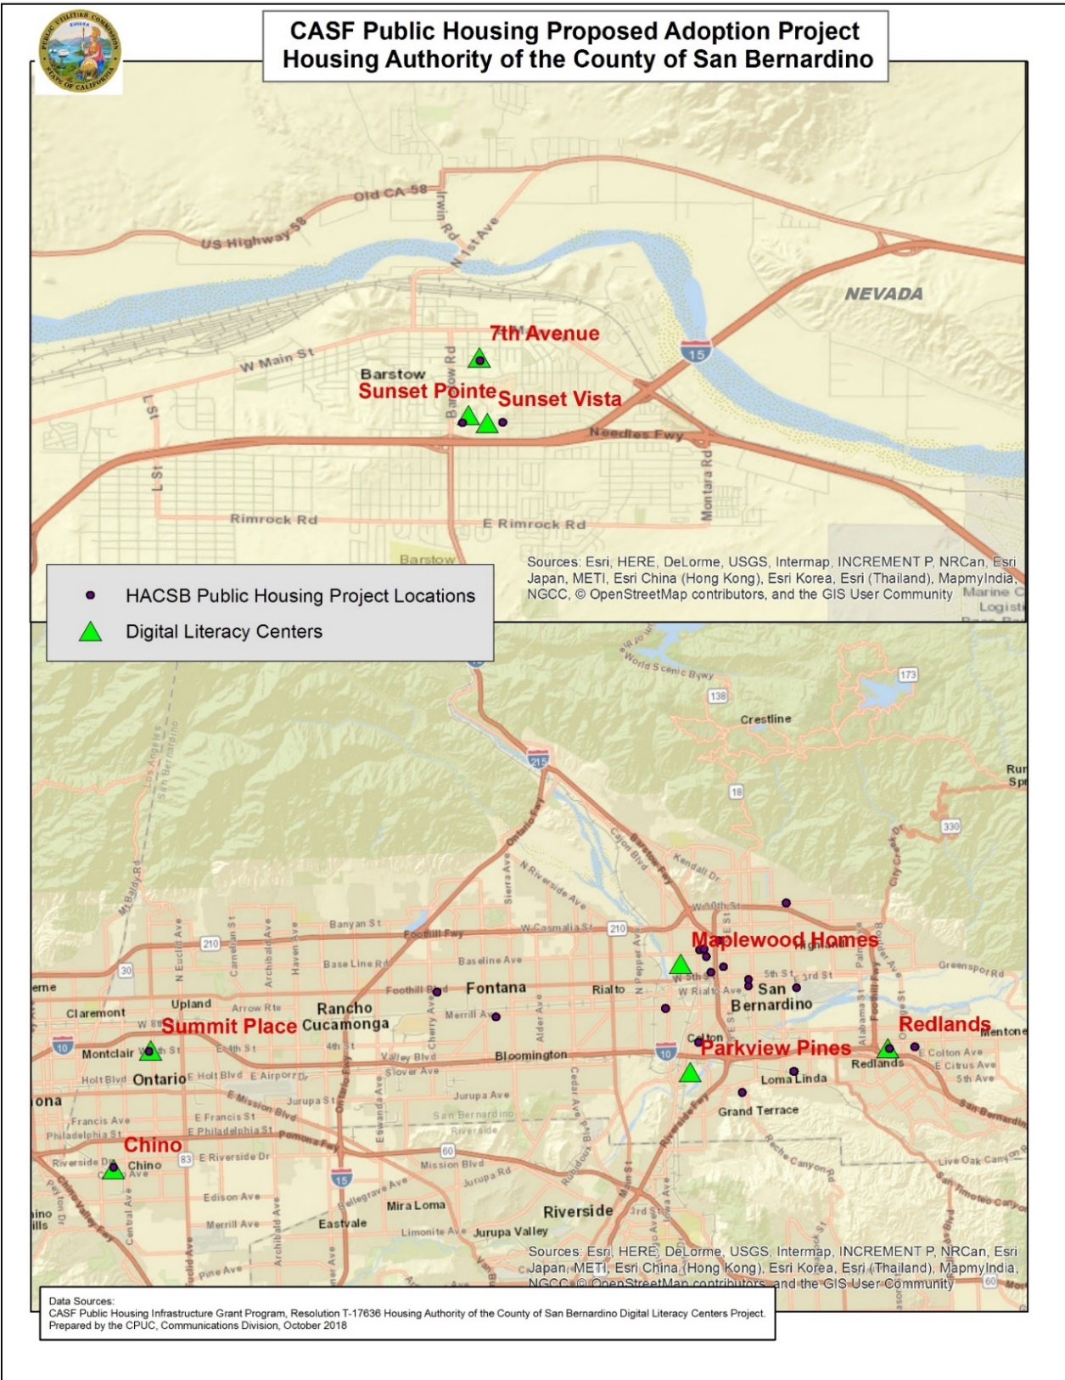





**APPENDIX B**

**Expedited Review Criteria as cited in D.14-12-039**

#### Expedited Review

The Commission delegates to CD staff the authority to approve applications that meet all of the following criteria:

Adoption Projects

* Applicant meets the eligibility requirements under P.U. Code § 281 (f)(2).
* Applicant requests a grant of $50,000 or less
* Applicant agrees to perform education and outreach to educate residents of best practice use of available broadband Internet services.
* Applicant or partner organization possesses at least one year experience in digital literacy training or has previously carried out at least one digital literacy project.
* Applicant must provide at least eight hours of digital literacy training to participating residents.
* Applicant or partner organization will use existing curriculum.
* Applicant has identified onsite designated space for digital literacy training.
* If the applicant or partner organization provides residents computers or other devices to be use as part of its digital literacy training, the devices cost no more than $250 per device. New or refurbished computers or devices may be used; if the computer or device is refurbished, it must not be more than two years old. Additionally, a Smartphone is not an eligible device.
* Technical support, either by phone or in person, must be able to respond within 48 hours. A refurbished device supplier should provide a warranty of at least six months and seller of new products should provide a warranty of at least 30 days.
* Applicants must be ready to provide classes within nine months of being selected for a CASF grant and must submit a work plan with major milestones showing how they propose to meet this deadline.
* Applicants must sustain the adoption project for 12 months or until 75 percent of residents are trained. The applicant must submit a work plan with major milestones showing how they propose to meet this deadline.

**APPENDIX C**

**Consent Form**

Name of Grantee: _______________________________________________

The Grantee identified above hereby acknowledges receipt of the California Public Utilities Commission Resolution T-17636 and agrees to comply with all grant terms, conditions, and requirements set forth in the Resolution.

Undersigned representative of ____________________________________ [Name of Grantee] is duly authorized to execute this Consent Form on behalf of the Grantee and to bind the Grantee to the terms, conditions, and requirements set forth in California Public Utilities Commission Resolution T-_____________.

Dated this _____ day of __________, 20___.

Signature                                                                     Printed Name

Title:

Organization or Name of Company

Business Address (include street address, suite/apt. number, city, state, and ZIP Code):

Telephone Number (include area code):            Email Address:

1. See Appendix A for location map and listing.
2. D.14-12-039 designated quarterly deadlines for calendar years 2015 and 2016.
3. D.14-12-039, CASF Broadband Public Housing Account Application Requirements and Guidelines, Appendix B, (“Guidelines” or “Appendix B”), Section VII, p. B14. See Appendix B for the expedited review requirements, as cited in D 14-12-039.
4. These units are privately owned, with rent subsidies paid directly to owners by HACSB.
5. HACSB 2017 Annual Report.
6. GHCC stated that they provided digital literacy training to over 600 people at their training center from 2014 to 2016. GHCC stated that, beginning in 2016, they refocused their efforts by doing digital literacy trainings at field locations. GHCC stated that they trained approximately 1,650 individuals at these field locations.
7. Maplewood Homes and Parkside Pines, approved by expedited review on August 6, 2018.
8. On January 15, 2015, HACSB submitted 24 applications for broadband adoption at 24 locations for a total of $519,283 in CASF funding. On April 1, 2015 the HACSB affiliate HPI submitted two applications for broadband adoption at 2 locations, for a total of $84,881.
9. <http://www.cpuc.ca.gov/General.aspx?id=908>
10. Per Pub. Util. Code, § 281(i)(1)(B), a publicly supported community is a publicly subsidized multifamily housing development that is wholly owned by either a public housing agency that has been chartered by the state, or by any city or county in the state, and has been determined an eligible public housing agency by the United States Department of Housing and Urban Development or an incorporated nonprofit organization as described in Section 501 (c)(3) of the Internal Revenue Code (26 U.S.C. Sec. 501(c)(3)) that is exempt from taxation under Section 501 (a) of that code (16 U.S.C. Sec. 501(a)), and that has received public funding to subsidize the construction or maintenance of housing occupied by residents whose annual income qualifies as “low-” or “very low” income according to federal poverty guidelines.
11. Pub. Util. Code, § 281(i)(4)(A).
12. ‘Access’ to broadband services means that the housing development is not ‘unserved’ as defined in Pub. Util. Code, § 281(i)(3)(B)(ii) – ‘a housing development is unserved when at least one housing unit within the housing development is not offered broadband internet service.’ Residents may have access to broadband services, but may not connect to broadband services due to affordability, or, other, socioeconomic issues.
13. D.14-12-039, Appendix B, p. B14.
14. See Appendix B for a listing of expedited review requirements as cited in D.14-12-039.
15. Pub. Util. Code, § 270.
16. See Appendix C for the consent form.