PUBLIC UTILITIES COMMISSION OF THE STATE OF CALIFORNIA

Communications Division | RESOLUTION T-17644
Carrier Oversight & Programs Branch | April 25, 2019

R E S O L U T I O N

Resolution T-17644. Approving AT&T California (U-1001-C) Advice Letter No. 47543 Changing the Method of Customer Notification of White Pages Availability and Elimination of the CD-ROM Option for White Pages Directory Delivery.
_________________________________________________________________

SUMMARY
This Resolution approves Pacific Bell dba AT&T California (U-1001-C) (AT&T) Advice Letter Number (No.) 47543, proposing to modify the customer notification method of white pages availability. Specifically, AT&T seeks to discontinue postcard notification for customers not proactively receiving a business white page directory as approved in Resolution T-17513. AT&T instead proposes to replace postcard notification with a notification via bill page messaging. This Resolution approves this proposal as well as a proposal to eliminate the CD-ROM option for white pages directory delivery.
BACKGROUND
All carriers are required to provide free white page directories to customers as part of the California Public Utilities Commission (Commission) basic service requirements. White page directories were traditionally provided in printed format.

On June 9, 2011, the Commission approved Resolution T-17302 which first modified its rules for carrier provision of residential white pages directories to customers. Resolution T-17302 approved Frontier California (U-1002-C) (Frontier) (formerly Verizon) Advice Letter No. 12535 proposing changes to Frontier’s method of providing residential white pages directory listings to customers. Specifically, Resolution T-17302 approved Frontier California’s request to: 1) end automatic delivery of printed white page directories; 2) instead offer customers the option of either a printed white pages directory or a CD-ROM copy in addition to an online directory listing; and 3) use business directories as the primary method of informing customers of the availability of residential white page directory listings and methods to request the directories.

Decision (D.) 12-12-038 extended the directory distribution changes approved in Resolution T-17302 to all other Basic Service providers through the filing of Tier 2 Advice Letters. The Decision also applied the general principle that customers be provided with options for obtaining a copy of the residential white page directory including electronic delivery via online access or on a CD-ROM.

Subsequently, AT&T filed Advice Letter No. 41980 on March 8, 2013 seeking approval to cease the automatic distribution of residential white pages directories and to opt-in to the white page distribution structure that was approved in Resolution T-17302 and D.12-12-038. AT&T’s Advice Letter became effective on April 7, 2013.

On November 20, 2015 AT&T filed Advice Letter No. 45050 proposing to modify its method of customer notice of availability of residential white page listing delivery from notices published in its business directories to postcards mailed to each customer. On August 18, 2016, the Commission approved Resolution T-17513, granting AT&T’s request.

AT&T currently mails postcards notifying customers of the availability of printed residential white page listings to each customer in markets where business white page directories are not proactively distributed. AT&T also currently makes available either a CD-ROM or printed version of residential white pages to basic service customers upon request and provides access to an online residential white page directory listing.
DISCUSSION
On September 12, 2018, AT&T filed a Tier 3 Advice Letter No. 47543 seeking to change the customer notice of residential white page availability and directory delivery methods authorized in Resolutions T-17302 and T-17513. No protests were received. AT&T subsequently filed supplements to its advice letter filing on December 19, 2018 and February 13, 2019. These supplements provided a copy of the proposed bill page messaging.

Through this advice letter, AT&T requested to be allowed to: 1) modify the way AT&T provides customer notice of residential white page listing availability from postcards to bill page messaging; and 2) eliminate the CD-ROM method of white page directory delivery. Attachment A of this Resolution is a draft bill page message explaining AT&T’s proposed revisions to white page directory distribution methods.

Bill Page Messaging

Bill page messaging would notify customers of white page availability via a message on customers’ bills. AT&T asserts that there has been a higher response rate in states where customers are notified of white page directory delivery via bill page messaging than there has been with postcards. AT&T provided data to Communication Division (CD) staff that supports this assertion. AT&T further asserts that notices printed on bills are an equal and acceptable form of customer notice pursuant to General Order (G.O.) 96-B Telecommunications Industry Rule 5.3 (Notice to Customers). Lastly, AT&T states the reduction in postcards would have environmental benefits, presumably due to a reduction in paper used.

Elimination of CD-ROM Directory Delivery

AT&T asserts demand for CD-ROM directories has been very low, that CD-ROMs are an outdated technology, and many computers no longer include a CD-ROM drive. Staff has reviewed the demand data for CD-ROMS confirming it is low. From 2016 to 2017 CD-ROM requests dropped by more than half. 2018 CD-ROM requests were less than 10% of 2017 CD-ROM requests. Also, Staff acknowledges that CD-ROM technology is outdated.

In determining whether to approve this Advice Letter, CD staff reviewed AT&T’s proposal and relevant Commission decisions. Specifically, CD staff noted that D.12-12-038 gives carriers the option of electronic delivery of white page directories either by CD-ROM or online access unless a customer elects to receive a printed paper white page directory.Under this proposal, a AT&T would still continue to provide electronic copies of the directory via on-line access in addition to printed directories. Therefore, AT&T would still be fulfilling its obligation of providing a published local directory as part of basic service.

Staff’s Recommendation

Staff recommends approval of AT&T’s proposal to change the method of customer notification of white page availability and to eliminate the CD-ROM. The proposed changes conform with the general principle that customers be provided options for accessing residential white page directories, including electronic delivery. However, Staff recommends the Commission require AT&T to give customers adequate notice of the elimination of the CD-ROM so that customers do not experience any disruption of access to directory information. Staff also finds AT&T’s draft bill page message in Attachment A of this Resolution is reasonable and recommends the Commission require AT&T to provide a similar bill page message informing customers of the change.

SAFETY IMPACT
There are no specific safety issues in this resolution.
COMMENTS

In compliance with PU Code § 311 (g), a Notice of Availability was e-mailed on
March 25, 2019 to all telephone corporations informing these parties that the draft of this Resolution is available at the Commission’s website http://www.cpuc.ca.gov/and is available for public comments. In addition, CD informed these parties that the subsequent conformed Resolution, when adopted by the Commission, will be available at the same Commission’s website

Notice of Draft Resolution T-17644 was published in the Commission Daily Calendar on March 26, 2019.

CONCLUSION
The Commission finds that it is reasonable to approve AT&T Advice Letter No. 47543 to modify method of customer notification of white pages availability and eliminate the CD-ROM option for white pages directory delivery subject to AT&T informing customers of the changes to residential white page distribution and providing instructions for ordering a hard copy of the directory and accessing the directory online.

FINDINGS
- As part of the Commission’s basic service requirements all carriers are required to provide free white page directories to customers.
- Although white page directories were traditionally provided in printed format, on June 9, 20111 the Commission approved Resolution T-17302 which first modified its rules for carrier provision of residential white pages directories.
- Resolution T-17302 approved Frontier’s (formerly Verizon) Advice Letter No. 12535 proposing changes to Frontier’s method of providing residential white pages directory listings to customers.
- Decision 12-12-038 extended the directory distribution changes approved in Resolution T-17302 to all other Basic Service providers via Tier 2 Advice Letter filings and applied the general principal that customers be provided options for methods of obtaining residential white page directories.
- On March 8, 2013 AT&T filed Advice Letter No. 41980 requesting approval to discontinue automatically distributing residential white pages directories and opt-in to the white page distribution structure approved in Resolution T-17302 and Decision D.12-12-038. AT&T’s Advice Letter was approved.
- On November 20, 2015 AT&T filed Advice Letter No. 45050 seeking approval to modify its customer notice of the availability of residential white page listings from notices published in its business directories to postcards mailed to each customer. Resolution T-17513 granted AT&T’s request.
- AT&T currently mails postcards notifying customers of the availability of printed residential white page listings and makes available a CD-ROM or printed copy of residential white pages to basic service customers upon request. AT&T also provides access to an online residential white page directory listing.
- On September 12, 2018 AT&T filed advice Letter No. 47543 seeking to change its customer notice of residential white page availability and directory delivery methods from postcards to bill page messaging and to discontinue the CD-ROM method of white page directory delivery. No protests were received. AT&T subsequently filed Advice Letter supplements on December 19, 2018 and February 13, 2019 in which it provided its proposed customer notice.

- Decision 12-12-038 gives customers not electing to receive a printed paper white page directory the option of electronic delivery of white page directories either by CD-ROM or online access.

- If AT&T Advice Letter No. 47543 is approved AT&T would continue to provide electronic directory copies via on-line access in addition to printed directories and would therefore continue to fulfill its obligation of providing a published local directory as part of basic service.

- CD Staff finds AT&T’s proposed changes to the customer notification method and proposal to eliminate the CD-ROM white page delivery method as reasonable and recommends the Commission approve the modifications with the condition that the Commission require AT&T to give customers adequate notice regarding the elimination of the CD-ROM.

- CD Staff finds AT&T’s draft bill page message in Appendix A reasonable and recommends the Commission require AT&T to provide its customers a similar bill page message.

THEREFORE, IT IS ORDERED that:
- This resolution approves Pacific Bell dba AT&T California’s request in Advice Letter No. 47543 to:
  - Modify the method of customer notification of white pages availability for customers not proactively receiving a business white page directory to bill page messaging; and
  - Eliminate the CD-ROM option for white pages directory delivery.

- Pacific Bell dba AT&T California shall use bill page messaging language similar to that in Attachment A to inform customers of the elimination of the CD-ROM option for white page directory delivery and to provide instructions for ordering a hard copy and accessing the directory online.

This Resolution is effective today.

I hereby certify that the California Public Utilities Commission adopted this Resolution at its regular meeting on ________________. The following Commissioners approved it:

Alice Stebbins
Executive Director

Attachment A

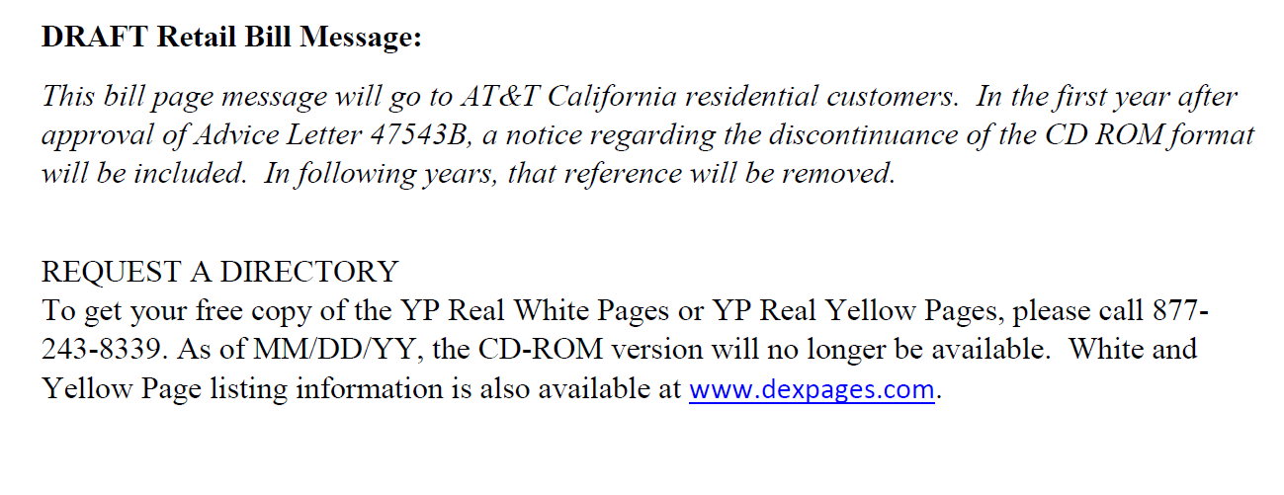

D.96-10-066 Appendix B.
D. 12-12-038 Appendix A I. 3. f.

