PUBLIC UTILITIES COMMISSION OF THE STATE OF CALIFORNIA

ENERGY DIVISION RESOLUTION E-4972
July 11, 2019

RESOLUTION

Resolution E-4972. Rejecting San Diego Gas & Electric Company’s Work Plan for implementing the Distributed Resource Plans Data Access Portal, pursuant to Decision 18-02-004.

PROPOSED OUTCOME:

- This Resolution rejects San Diego Gas & Electric Company’s Advice Letter 3227-E as non-compliant with Commission Decision 18-02-004.
- This Resolution orders San Diego Gas & Electric Company to file a Tier 2 Advice Letter within 30 days of the date this Resolution is issued demonstrating compliance with the Data Access Portal requirements of D.18-02-004.

SAFETY CONSIDERATIONS:
- There are no safety considerations.

ESTIMATED COST:
- Decision 18-02-004 established a memorandum account to record the incremental costs of implementing the Data Access Portal for each Investor Owned Utility.

By San Diego Gas & Electric Company Advice Letter 3227-E filed on May 16, 2018.
__________________________________________________________

Summary
On May 16, 2018, San Diego Gas & Electric Company (SDG&E) filed a Tier 3 Advice Letter (AL) 3227-E, with its preliminary proposed work plan for implementing the Distribution Resources Plan (DRP) data access portal in compliance with Ordering Paragraph (OP) 2.l and 2.m of Decision (D.)18-02-004. OP 2.l ordered the IOUs to develop a central Distributed Resource Plans (DRP) data access portal, by which users can (1) click between tabs to view Integration Capacity Analysis (ICA), Locational Net Benefit Analysis (LNBA), Grid Needs Assessment (GNA), and Distribution Deferral Opportunity Report (DDOR) data on the circuit map, (2) query and export data in tabular form based on a geographic search or keyword search, and (3) have Application Programming Interface (API) capability. Ordering Paragraph 2.m ordered the IOUs to (1) include a high-level description of the steps necessary to develop the data access portal, and (2) propose estimated interim milestones and a deadline for implementation based on those steps.
This Resolution rejects SDG&E’s AL because it does not meet the criteria established in D. 18-02-004. SDG&E is ordered to file a Tier 2 AL within 30 days implementing the Data Access Portal requirements of D.18-02-004 as further discussed in this Resolution.

Background
On August 14, 2014, the Commission issued Rulemaking (R.)14-08-013 to establish policies, procedures, and rules to guide California IOUs in developing DRPs required by Public Utilities (P.U.) Code §769. On October 21, 2016, the Commission issued the Assigned Commissioner’s Ruling on Track 3 Issues, which included consideration of a Distribution Investment Deferral Process as the third Sub-track of DRP Track 3.
Subsequently, the Commission issued D.18-02-004 (the Decision) on February 15, 2018 approving an annual Distribution Investment Deferral Framework (DIDF) whose central objective is to identify and capture opportunities for distributed energy resources (DERs) to cost-effectively defer or avoid traditional IOU investments that are planned to mitigate forecasted deficiencies on the distribution system. The Decision adopted two new IOU reports that serve as the foundation of the annual DIDF: the GNA and DDOR. The GNA documents the assumptions and results of the annual distribution planning process. The DDOR presents the planned investments needed to address deficiencies identified in the GNA, as well as a candidate distribution deferral opportunity shortlist determined by applying an approved set of deferral screening criteria to the list of planned investments.
Both reports serve the purpose of providing transparency into the annual distribution planning process, such that the Commission and stakeholders can ensure that the DIDF meets the objectives of maximizing ratepayer benefits by sourcing cost-effective DERs that satisfy distribution planning objectives per P.U. Code §769.
D.18-02-004 orders the GNA and DDOR data to be published on the same circuit model map, and found it reasonable to make all DRP-related data accessible in the same online location. Ordering Paragraph 2.l requires the IOUs to:
develop a central DRP data access portal, by which users can click between tabs to view ICA [Integration Capacity Analysis], LNBA [Location Net Benefits Analysis], GNA, and DDOR data on the circuit map, and can query and export data in tabular form based on a geographic search or keyword search. Data portals shall also have Application Programming Interface (API) capability that would allow users to access data in a functional format from back-end servers in bulk.
Decision Ordering Paragraph 2m. ordered the IOUs to “include a high-level description of the steps necessary to develop the data access portal, and propose estimated interim milestones and a deadline for implementation based on those steps.”
OP 2m. also required the IOUs to propose a work plan for implementing the DRP data access portal in a Tier 3 AL within 90 days of the issuance of the decision.
SDG&E filed their Data Access Portal implementation workplans on May 16, 2018.
D.18-02-004 was issued February 15, 2018. Subsequently, SDG&E filed AL 3227-E on May 16, 2018 in compliance with OP 2m. of the Decision. SDG&E’s data access portal work plans are summarized below.
SDG&E Advice Letter 3227-E
Advice Letter Requirements per D.18-02-004
- High Level Description: SDG&E states its data redaction criteria, as described in AL 3210-E, is incorporated into its work plan and process descriptions. SDG&E states it wants to ensure that a query of the geographical data required to be included in the data access portal per D.18-02-004 does not create cyber and physical vulnerabilities to SDG&E’s electric system.
- Milestones, Schedule and Implementation Deadline: SDG&E provides the following milestones and schedule, and specifies that they are estimates.
1. | File Tier 2 Advice Letter for Data Redaction | Complete: Filed April 16, 2018
2. | Publish DRP data access portal with ICA data | Qtr. 3 2018
3. | Publish GNA onto DRP portal | Qtr. 2, 2019
4. | Publish LNBA & DDOR onto DRP portal | Qtr. 3, 2019

DRP Data Access Portal Design Requirements per D.18-02-004
- Click between tabs to view ICA, LNBA, GNA, and DDOR data on the circuit map: SDG&E states its data access portal will include a “layering” of elements of the new DRP process adopted in D.18-02-004 along with elements of the existing annual distribution planning process. According to SDG&E, the ICA, LNBA, DDOR and GNA data layers will be made available as a pop-up layer atop of the circuit models.
- Query and export data in tabular form based on a geographic search or keyword search: SDG&E claims geographical searches will be included in the data portal when the ICA data layer is available.
- Application Programming Interface (API) capability: SDG&E does not propose to provide and API in the first issuance of LNBA, DDOR, nor GNA data. SDG&E claims it would create cyber and physical vulnerabilities to SDG&E’s electric system.
SDG&E’s Responses to Energy Division Data Request
Energy Division issued a Data Request to SDG&E on February 25, 2019, and SDG&E responded on March 11, 2019. Energy Division asked the following:
- Explain why SDG&E’s circumstances differ from SCE’s or PG&E’s to deviate from Commission decision.
- What secure API architecture can be adopted to ensure the API does not create cyber and physical vulnerabilities to SDG&E’s system?
- Why can’t SDG&E adopt this architecture on the first issuance of the data portals?
- Can SDG&E apply threat detection in its API? Please elaborate on the answer.
- What encryption systems can be used in the API to ensure the electric systems is not vulnerable?
- Why can’t SDG&E adopt any of the encryption systems from Request 5?
In its responses, SDG&E stated that it “began planning to provide an API as directed in D.18-02-004. SDG&E is on track to release API capabilities by the second quarter of 2019.”

Notice
Notice of SDG&E AL 3227-E was made by publication in the Commission’s Daily Calendar. SDG&E states that they served copies of the ALs to the interested parties on the GO-96-B and R.14-08-013 service lists.

Protests
Green Power Institute (GPI) protested SDG&E’s filing, claiming that SDG&E’s work plan fails to provide any pathway for developing an API and geographical query function.
GPI submitted a timely protest to SDG&E’s AL 3227-E on June 5, 2018. GPI recommends SDG&E be required to provide: 1) a more thorough work plan that includes a clear pathway and timeline for making a compatible API available, and 2) a general plan and timeline for including a geographical search function for their Data Access Portal.
GPI claims that while it is implied that SDG&E will provide an API for the second round of annual GNA, LNBA and DDOR results and thereafter, it is not certain. The GPI recommends that SDG&E be required to provide a more thorough work plan that includes a clear pathway and timeline for making a compatible API available.
GPI claims that SDG&E provides no specific plans or milestones for developing and including a geographical query that satisfies cyber security needs and fails to guarantee the addition of a geographical search component in the Data Access Portal interface as required by D.18-02-004. The GPI recommends SDG&E be required to provide a general plan and timeline for including a geographical search function for their Data Access Portal.
SDG&E, in reply, reiterates its claim that using an API places the electric system to physical and cyber security risk.
SDG&E filed timely reply to GPI’s protest on June 12, 2018. SDG&E “feels very strongly that some of the data required to be made public and available by APIs places the electric system at greater and unacceptable physical and cyber security risk.” SDG&E claims it’s proposed workplan aligns with its proposed data redaction criteria, and will file an updated DRP Data Access Portal work plan to reflect the outcome of AL 3210-E, the data redaction criteria advice letter.

Discussion
D.18-04-002 OP 2.l ordered the IOUs to develop a central DRP data access portal, by which users can (1) click between tabs to view ICA, LNBA, GNA, and DDOR data on the circuit map, (2) query and export data in tabular form based on a geographic search or keyword search, and (3) have API capability. Ordering Paragraph 2.m ordered the IOUs to (1) include a high-level description of the steps necessary to develop the data access portal, and (2) propose estimated interim milestones and a deadline for implementation based on those steps. The AL was reviewed and evaluated based on these requirements.
SDG&E’s DRP Data Access Portal work plans in AL 3227 do not meet the requirements of D.18-02-004 and SDG&E’s Advice Letter is rejected. SDG&E is ordered to file a Tier 2 AL within 30 days implementing the Data Access Portal requirements of D.18-02-004 as further discussed in this Resolution.
In AL 3227 SDG&E claims that it will not use an API because it would create cyber and physical vulnerabilities to SDG&E’s electric system and thus SDG&E does not propose to provide and API in the first issuance of LNBA, DDOR, or GNA data. We find that SDG&E’s proposed work plan in AL 3227 does not meet the requirements of D.18-02-004, OP 2.l and 2.m.
In AL 3227 SDG&E did not justify how an API creates these risks. Therefore, Energy Division issued a data request to SDG&E to inquire further information on the subject.
In SDG&E’s response to Energy Division’s data request, SDG&E states that it has begun planning to provide an API as directed in D.18-02-004. Therefore, although we reject SDG&E’s proposed work plan in AL 3227, we do recognize that SDG&E will be providing an API - and thus, GPI’s protest is now moot. We order SDG&E to submit a Tier 2 AL within 30 days of issuance of this Resolution demonstrating how its Data Access Portal conforms with the requirements of D.18-02-004, including a geographical query that satisfies cyber security needs and geographical search component in its Data Access Portal.
SDG&E’s Mischaracterization of Commission Orders
In its responses to Energy Division’s Data Request Question 5 (What encryption systems can be used in the API to ensure the electric systems is not vulnerable?), SDG&E states “SDG&E is not permitted to serve up the data in encrypted form, as it was ordered to be public by the Commission.” In response to Question 6 (Why can’t SDG&E adopt any of the encryption systems from Request 5?), SDG&E states “Per the Commission disposition letter dated August 29, 2018, SDG&E was denied the ability to encrypt the data as described in our advice letter 3210-E, therefore this questions is not relevant.”
The Commission has analyzed SDG&E’s AL 3210-E, and the disposition letter dated August 29, 2018. The Commission finds no mention in either document about encryption of data. SDG&E’s AL 3210-E was concerned about data redaction, not data encryption.
The Commission has remained cognizant of the importance of cybersecurity. In fact, the Commission has implemented a data request and release process. D.14-05-016 states “sensitive customer information or other confidential information must be transmitted to the third party with reasonable encryption.” We find that SDG&E has misconstrued the Commission’s intent—the fact that data is ordered to be public does not imply it cannot be encrypted via transit to protect bad actors from gaining access to it.

Comments
Public Utilities Code section 311(g)(1) provides that this resolution must be served on all parties and subject to at least 30 days public review. Please note that comments are due 20 days from the mailing date of this resolution. Section 311(g)(2) provides that this 30-day review period and 20-day comment period may be reduced or waived upon the stipulation of all parties in the proceeding.
The 30-day review and 20-day comment period for the draft of this resolution were neither waived nor reduced. Accordingly, this draft resolution was mailed to parties for comments, and will be placed on the Commission's agenda no earlier than 30 days from today.

Findings
- D.18-02-004 adopted several requirements for the DRP Data Access Portals.
- D.18-02-004 Ordering Paragraph 2l. and 2m. orders the IOUs to propose work plans by which they will develop and implement a Data Access Portal.
- SDG&E filed AL 3227-E on May 16, 2018 pursuant to Ordering Paragraph 2m. in D.18-02-004.
- GPI protested SDG&E’s filings, claiming SDG&E’s work plan fails to provide any pathway for developing an API and geographical query function.
- SDG&E, in reply, reiterates its claim that using an API places the electric system to physical and cyber security risk.
- SDG&E’s proposed work plan does not meet the requirements of D.18-02-004.
- Energy Division issued a data request to SDG&E to answer questions regarding its cyber security concerns.
- In response to the data request, SDG&E stated it is moving forward with implementing an API in its Data Access Portal.
- GPI’s protest is now moot because SDG&E will implement an API.
- It is prudent for SDG&E to file a Tier 2 Advice Letter with an update demonstrating that SDG&E’s Data Access Portal meets the requirements of D.18-02-004.

Therefore it is ordered that:
- This Resolution rejects San Diego Gas & Electric Company’s Advice Letter 3227-E.
- San Diego Gas & Electric Company is ordered to file a Tier 2 Advice Letter within 30 days after this Resolution is issued demonstrating that its Data Access Portal conforms with the requirements of D.18-02-004.

This Resolution is effective today.
I certify that the foregoing resolution was duly introduced, passed and adopted at a conference of the Public Utilities Commission of the State of California held on May 30, 2019; the following Commissioners voting favorably thereon:

_____________________
ALICE STEBBINS
Executive Director

APPENDIX A
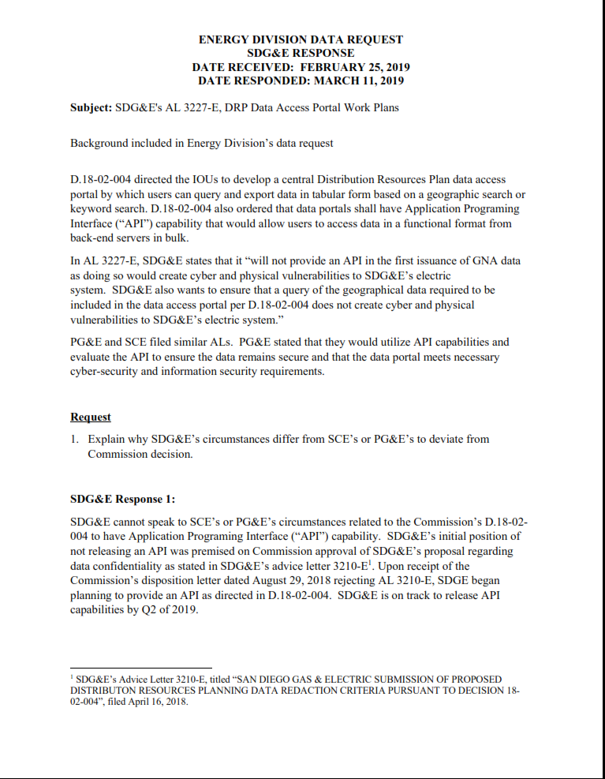
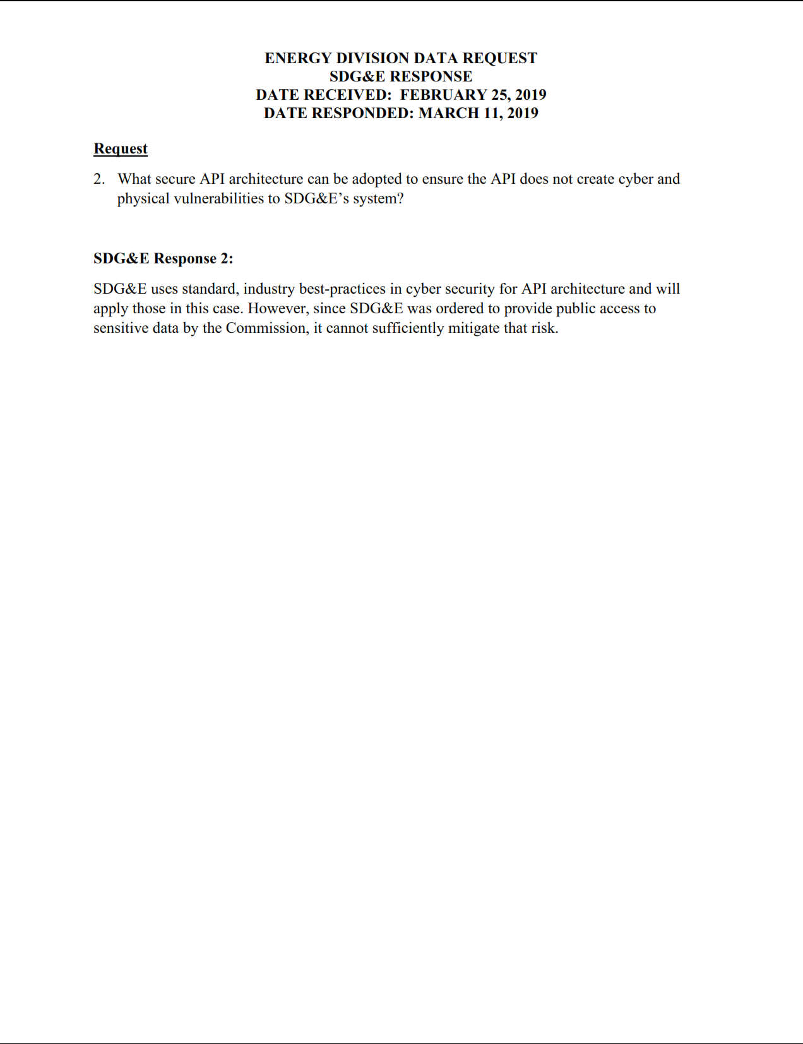
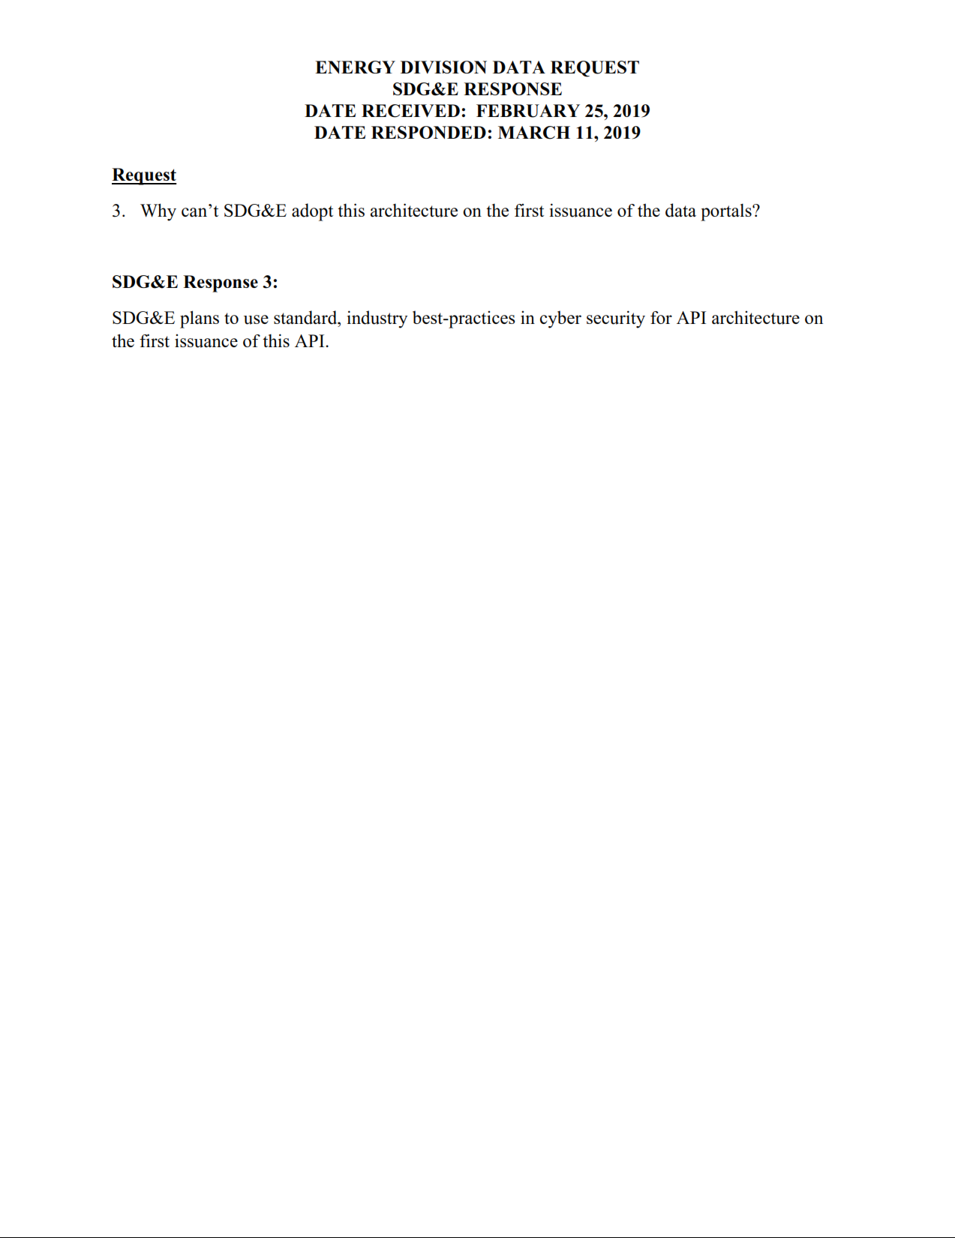
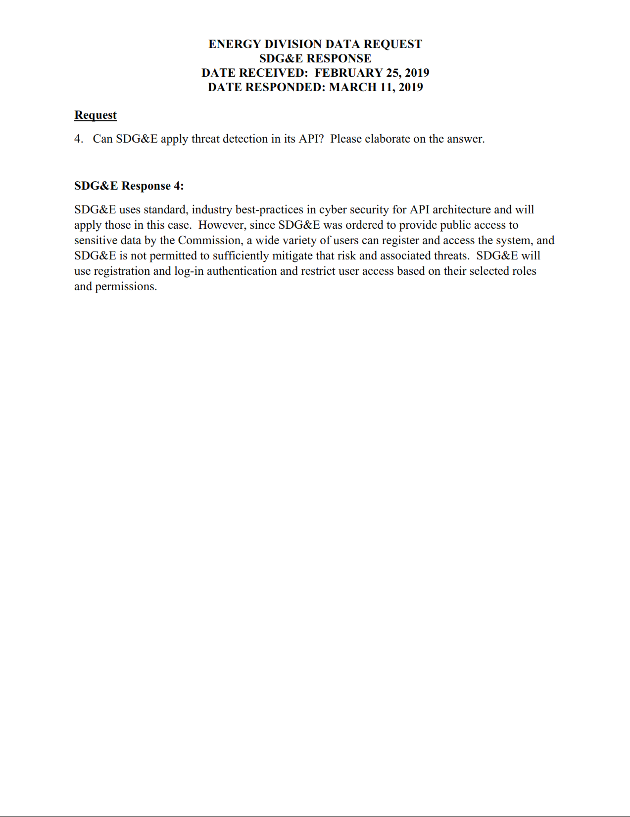

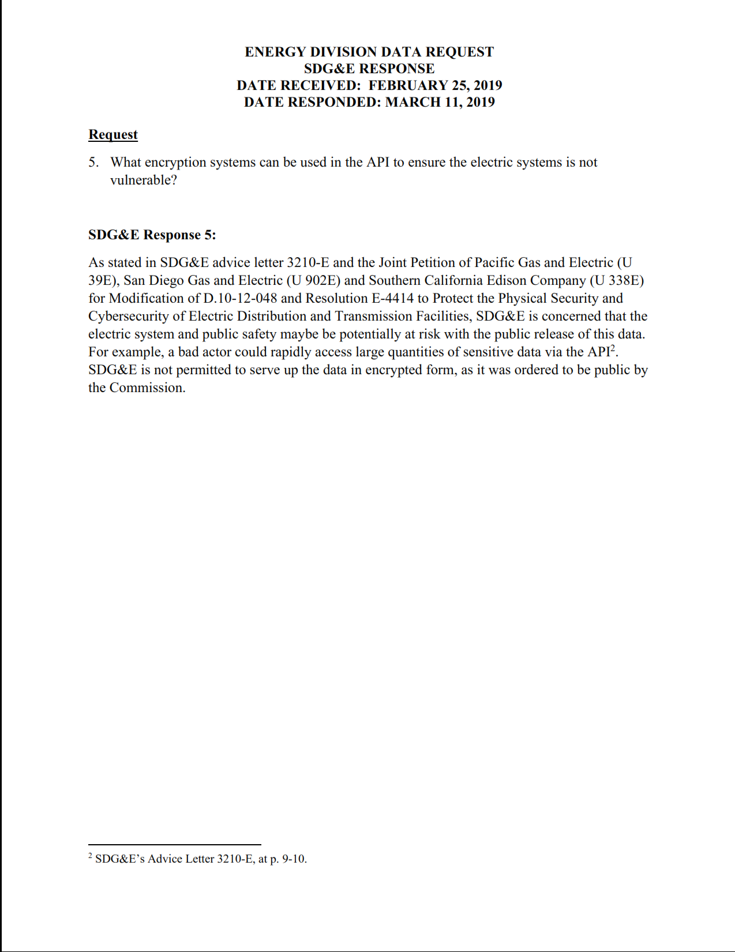

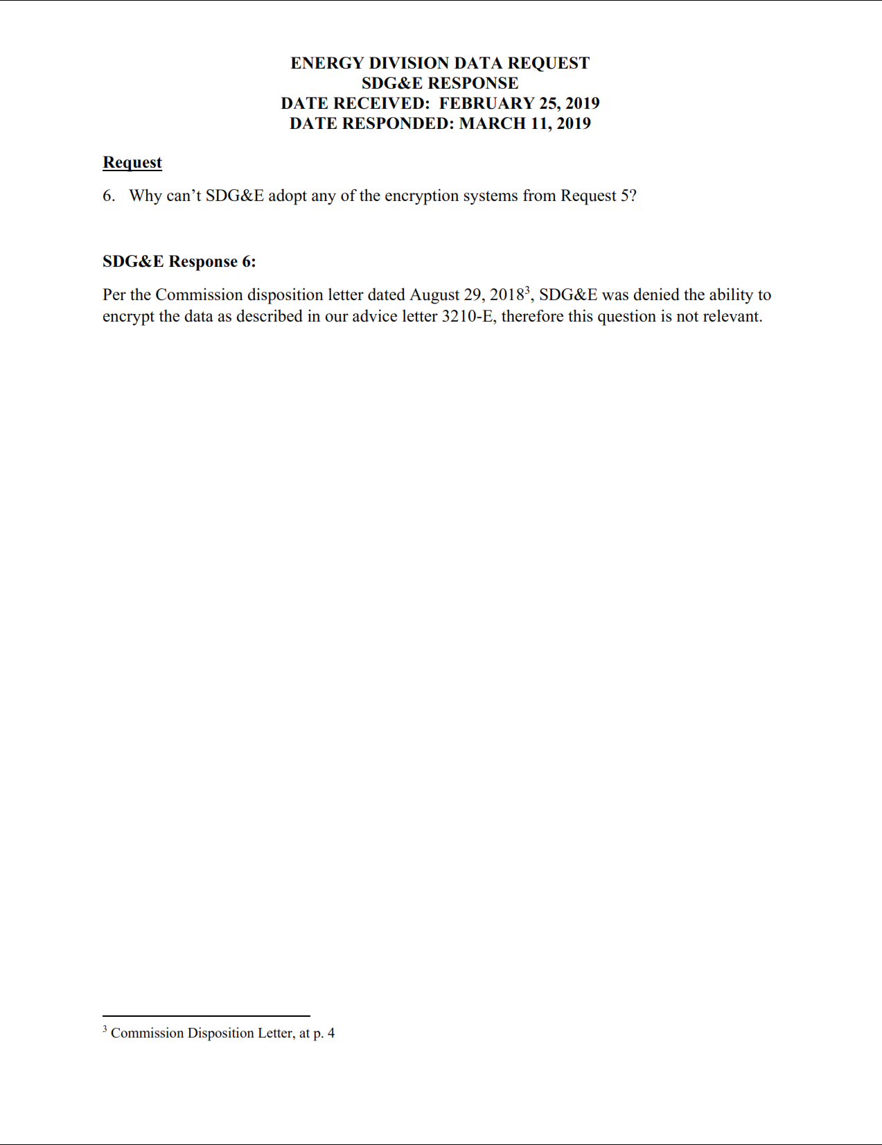

AL 3210-E was filed on April 16, 2018 per D.18-02-004 Ordering Paragraph (OP) 2.g which ordered the Investor Owned Utilities (IOUs) to propose data redaction criteria. GNA and DDOR data reporting requirements will be subject to DRP data redaction criteria established to ensure customer privacy and the physical and cyber security of the distribution system. The assigned Administrative Law Judge (ALJ) issued a ruling on June 8, 2018 ordering the IOUs to file motions requesting confidential treatment of information pursuant to General Order (GO) 66-D. The IOUs complied and filed motions on June 15, 2018, with stakeholder responses filed June 22, 2018. On July 24, 2018 the ALJ issued a ruling setting consistent DRP data redaction criteria across the three IOUs.
See Appendix A, “Energy Division Data Request: SDG&E Response”
The matter of data redaction was resolved via two rulings in R.14-08-013: (1) Administrative Law Judge’s Ruling Addressing Pacific Gas and Electric Company , Southern California Edison Company, and San Diego Gas & Electric Company’s Claims for Confidential Treatment and Redaction of Distribution System Planning Data Ordered by Decisions 17-09-026 and 18-02-004 (filed on July 24, 2018), and (2) Administrative Law Judge’s Ruling Resolving Confidentiality Claims Raised by Pacific Gas and Electric Company, Southern California Edison Company, and San Diego Gas & Electric Company as to Distribution System Planning Data Ordered by Decision 17-09-026 and D.18-12-004 (filed on December 17, 2018).
Decision Adopting Rules to Provide Access to Energy usage and Usage-Related Data While Protecting Privacy of Personal Data. In Order Instituting Rulemaking to Consider Smart Grid Technologies Pursuant to Federal Legislation and on the Commission’s own Motion to Actively Guide Policy in California’s Development of a Smart Grid System (R.08-12-009).
D. 14-05-016, Appendix A, p. 4.

