PUBLIC UTILITIES COMMISSION OF THE STATE OF CALIFORNIA

Communications Division | RESOLUTION T-17671
Broadband, Video and Market Branch | December 19, 2019

R E S O L U T I O N

Resolution T-17671: Approval of funding for the grant application of Citizens Telecommunications Company of California, Inc. (U-1024-C), d/b/a Frontier Communications of California Inc., from the California Advanced Services Fund (CASF) up to the amount of $10,655,969.83 for Phase I of the Northeast Project for unserved areas in Lassen and Modoc Counties.

SUMMARY

This Resolution approves $10,655,969.83 from the California Advanced Services Fund (CASF) Infrastructure Grant Account for the grant application of Citizens Telecommunications Company of California, d/b/a Frontier Communications of California Inc. (Frontier), to construct Phase I of the Northeast Project. Frontier proposes to deploy middle-mile fiber and last-mile very high-speed Digital Subscriber Line Second Generation (VDSL2) technology in unincorporated communities around Alturas, Ravendale, and Standish, in Lassen and Modoc Counties.

The project will enable broadband access speeds of at least 10 Mbps download and 1 Mbps upload to an estimated 222 CASF-eligible households. The proposed project area is currently unserved with no facilities-based wireline or fixed wireless broadband service provider. The proposed project will provide ancillary benefits, including improved connectivity in regions located within a Tier 2 Fire-Threat District of the California Public Utilities Commission’s (Commission) Fire Map.

BACKGROUND

The CASF Infrastructure Grant Account (CASF Infrastructure) assists Internet service providers to build or upgrade broadband infrastructure in areas that are unserved by existing broadband providers. The CASF program was initiated in 2008, after the program was first adopted by the Commission in Decision (D.) 07-12-054 and enacted into statue pursuant to Senate Bill (SB) 1193.

On October 15, 2017, Governor Brown signed Assembly Bill (AB) 1665 (Garcia) into law. This legislation amended the statute governing the CASF program, Public Utilities Code, § 281. The Commission issued D.18-12-018 adopting the programmatic changes to the CASF. Appendix 1 of D.18-12-018 set forth the rules, application requirements and guidelines for the CASF Infrastructure.

On May 1, 2019, Frontier submitted a CASF Infrastructure application, requesting 100-percent funding of $11,849,212.87 to deploy middle-mile fiber and last-mile VDSL2 broadband access to 235 unserved households in the region of Alturas, Ravendale, and Standish in Lassen and Modoc Counties. The CASF grant funding request will cover the majority costs of the Northeast Project Phase I. Frontier also accepted $473,487.74 in grant funding from the Federal Communications Commission’s Connect America Fund Phase II (CAF II), to provide broadband access to another 187 unserved households in the project area. Combined, the CASF and the CAF II grant funding will provide Frontier a total of $12,322,700.61 to provide high speed Internet access to 422 unserved households in Lassen and Modoc Counties. Table 1, below, identifies Frontier’s proposed project budget using CASF and CAF II funds.

Table 1: CASF Infrastructure Grant Application
 | Households | Funding
State: CASF Infra Grant Request | 235 | $ 11,849,212.87
Federal: CAF II Received | 187 | $ 473,487.74
Northeast Project Phase 1 | 422 | $ 12,322,700.61

Frontier is a publicly traded corporation, the fourth largest incumbent local exchange carrier (ILEC) in the United States, and the second largest in California. The CASF Infrastructure grant will be awarded to Citizens Telecommunications Company of California Inc.; a telephone operating company subsidiary of Frontier that is based in Elk Grove, California and was established in 1993 to acquire access lines from General Telephone & Electronics Corporation (GTE). As the Carrier-of-Last-Resort, Frontier currently provides voice service in the proposed project areas and does not provide broadband Internet service.

NOTICE

On May 15, 2019, Staff posted the proposed project area map, census block groups (CBGs) and zip codes for the Northeast Project Phase I on the Commission’s CASF webpage under “CASF Application Project Summaries” and sent notice regarding the project to its CASF Distribution List.

PROTEST/CHALLENGES

On June 5, 2019, DigitalPath Inc. (DigitalPath) challenged the application stating the company provides broadband availability at served speeds in the Standish project area.

Staff reviewed the customer address and billing information submitted by DigitalPath and determined the challenged census blocks were not in the proposed project area. Based on the review of the data, Staff concluded that DigitalPath’s challenge was not a valid claim for the proposed project area.

DISCUSSION

In compliance with D.18-12-018, Staff determined Frontier’s Revised Northeast Project Phase I is eligible to receive $10,655,969.83 in CASF Infrastructure grant funding. Frontier is required to comply with all the guidelines, requirements, and conditions associated with the grant of CASF Infrastructure funds. Payments to Frontier will be made in accordance to the Pub. Util. Code § 281 (f)(11).

Details of Staff analysis are explained in the following sections:
- Project Area Eligibility
- Minimum Performance Criteria
- Funding Determination
- Safety and Community Support
- Compliance Requirements
- Payments to CASF Recipients

Key project information and maps are shown in Appendix A and Appendix B.

Project Area Eligibility
No provider filed a “right-of-first refusal” for Frontier’s project area by January 15, 2019. Staff evaluated Frontier’s original application and found the project area needed to be revised after Staff identified thirteen census blocks were ineligible for a CASF Infrastructure grant. Frontier’s Revised Northeast Project Phase I Summary was posted on the Commission’s webpage on October 1, 2019. Based on Frontier’s revised project application, Staff determined the Northeast Project Phase I, including middle-mile infrastructure, is eligible for a CASF Infrastructure grant.

Frontier revised its proposed project area down from 235 to 222 unserved households because thirteen census blocks were identified as ineligible on the California Interactive Broadband Map. Only households that are unserved are eligible for the CASF Infrastructure grant. Unserved means there is no provider offering access at speeds of 6 Mbps downstream and 1 Mbps upstream. Staff identified thirteen census blocks with a total of thirteen households that are identified as ineligible on the California Interactive Broadband Map and directed Frontier to remove those census blocks from its application. The removal of the ineligible census blocks reduced the CASF-eligible households from 235 to 222, which directly reduces the total number of unserved households in the area from 422 to 409. Table 2, below, summarizes the revised CASF Infrastructure grant application.

Table 2: Frontier’s Revised CASF Infrastructure Grant Application
 | Households | Revised Households
State: CASF Infra Grant Request | 235 | 222
Federal: CAF II Received | 187 | 187
Northeast Project Phase 1 | 422 | 409

The revised Northeast Project Phase I is eligible for a CASF grant. There are no existing facilities-based wireline or fixed wireless broadband service providers in the project area. Staff estimates 16 of 409 households in the project area have access to slow broadband service; the remaining households only have access to dial-up.

Middle-Mile infrastructure is eligible for a CASF Infrastructure grant. Frontier proposes adding approximately 137 miles of middle-mile fiber to its network and upgrading equipment at its existing facilities in order to provide last-mile Internet service over the legacy copper infrastructure using VDSL2 technology. Presently, there is no middle-mile fiber optic cable infrastructure along the Highway 395 corridor between Alturas and Susanville, a stretch of 104 miles. These cities are the county seats of Lassen and Modoc Counties, respectively. Without the middle-mile infrastructure, Frontier is unable to deliver last-mile service to the unserved households. The middle-mile is also critical communications infrastructure for providing public safety capabilities in this remote area. The investment of high capacity backhaul has the potential to benefit many households, businesses, and anchor institutions beyond the CASF project areas. For these reasons, Staff determined the middle-mile infrastructure is necessary to serve the proposed communities, pursuant to Pub. Util. Code § 281 (f)(5)(B).

CAF II Auction census blocks located in Frontier’s Revised Project area are eligible for CASF Infrastructure grant. The proposed project area includes CAF II Auction census blocks awarded to GeoLinks (California Internet LP) by the FCC CAF II Auction on August 28, 2018. Out of the 222 CASF eligible households in the proposed project area, 155 households have been identified as within a CAF II Auction area. Pub. Util. Code § 281(f)(5)(C)(i) prohibits approval of CASF Infrastructure grants for projects in census blocks where an existing facilities-based broadband provider has accepted federal CAF II funds for broadband deployment. Although GeoLinks has recently been awarded federal funds to provide service to the 155 households, GeoLinks does not operate broadband facilities in the area at this time. Thus, Staff do not deem GeoLinks to be an existing facilities-based broadband provider. For this reason, Staff determined that the CAF II Auction census blocks are CASF grant eligible for Frontier’s Northeast Project Phase I. A letter of support for Frontier’s project was filed by GeoLinks, stating that the project will provide much-needed connectivity to the region.

Minimum Performance Criteria
Staff reviewed Frontier’s application and determined the revised Northeast Project Phase I meets the minimum performance criteria pursuant to D.18-12-018, Appendix 1, Section 6, as summarized in Table 3.

Table 3. Minimum Performance Criteria
 | CASF Performance Criteria | Proposed Project
Project Completion | CEQA-exempt projects must be completed within 12 months, and all other projects shall be completed within 24 months after receiving authorization to construct | 24 months  after CEQA approval
Pricing | Prices committed for two years  after completion of the project | 2-year
Speed | At least 10/1 Mbps | 10/1 Mbps
Latency | Maximum of 100 ms of latency | 60 – 100 ms
Data Caps | Minimum of 190 GBs per month | No data cap
Affordability | Must offer low-income plan | Yes – Frontier Affordable Broadband Plan

Frontier’s Northeast Project Phase I is subject to the California Environmental Quality Act (CEQA) review and the project must be complete within 24 months from the start date (whereby the applicants have secured CEQA approval from the Commission and all required permits).

Frontier has committed to a broadband pricing plan, as summarized in Table 4, for two years starting from the beginning date of service. There is no long-term commitment required by the consumer to receive these prices and activation and installation fees will be waived. Frontier does not provide discount pricing for bundled services; however, LifeLine-eligible subscribers are eligible for discounted broadband service (10 Mbps download / 1 Mbps upload for $13.99 per month) if broadband service is bundled with LifeLine-discounted voice service.

Table 4: Broadband Pricing Plan
Download Speed | Upload Speed | Monthly Price
12 Mbps | 1 Mbps | $25
18 Mbps | 1 Mbps | $30
25 Mbps | 2 Mbps | $35
45 Mbps | 3 Mbps | $40
70 Mbps | 3 Mbps | $45
90 Mbps | 5 Mbps | $50
115 Mbps | 7 Mbps | $60

The proposed speed offerings (up to 115 Mbps download and up to 7 Mbps upload) meet the 10/1 minimum performance requirement. Most households should expect speeds near 25 Mbps download and 2 Mbps upload. Only subscribers within roughly 3,000 feet of Frontier’s terminals should expect very fast service (25 Mbps to a maximum of 115 Mbps) but all subscribers within roughly 10,000 feet can expect to receive served speeds (over 10 Mbps). This service will be available to the general public, as well as anchor institutions and small businesses near the project area.

Funding Determination
Table 5, below, is a comparison of Frontier’s funding request and Staff’s funding recommendation.
Table 5: Summary of Frontier’s Funding
 | Middle-Mile  Funding | Last-Mile Funding | Total
Frontier’s Funding Request | $9,239,392.54 | $2,609,820.33 | $11,849,212.87
Staff’s Funding Recommendation | $9,239,392.54 | $1,416,577.29 | $10,655,969.83

Frontier is eligible to receive $1,416,577.29 to build last mile infrastructure, which is 54 percent of the cost. The proposed project will serve a total of 409 households in the project area – 187 households are CAF II (46 percent), and 222 households are CASF eligible households (54 percent). CASF and CAF II households will share common infrastructure as part of the project build. In compliance with D.18-12-018, overlap in funding is not allowed. Funds must be apportioned by the percentage of households that will be served by funding type. Staff determined the last-mile project costs of $2,609,820.33 should be spilt proportionally to the number of households between CAF II (46 percent) and CASF (54 percent). Based on this calculation, Frontier is eligible to receive $1,416,577.29 of funding to cover the last-mile infrastructure costs, as demonstrated in Table 6.
Table 6: Last-Mile Funding Determination
 | Number of Households | Percent of Households | Last-Mile  Funding
Federal: CAF II Location | 187 | 46% | $1,193,243.04
State: CASF Location | 222 | 54% | $1,416,577.29
Northeast Project Phase 1 | 409 | 100% | $2,609,820.33

Frontier is awarded 100 percent funding level to cover the cost for its Northeast Project Phase I. AB 1665 authorizes the Commission to award grants to fund all or portion of the project and requires that it determine, on a case-by-case basis, the level of funding to be provided. Staff considered the statutory factors to determine the grant funding level, as described by Pub. Util. Code §§ 281(f)(13) and 281(b)(2)(B)(i), and CASF rules adopted in D.18-12-018. Based on those factors, Staff determined Frontier’s request of a 100 percent funding level is appropriate; and thereby awards a CASF Infrastructure grant of $10,655,969.83 for the Northeast Project Phase I. Table 7 summarizes Staff’s funding level determination for Frontier’s Northeast Project.

Table 7. Criteria for Project Funding Level for Frontier Northeast
Funding Criteria | Revised Project
Baseline for Eligible Project (60%) | 60%
Service Level Preference: Only Dial-up or No Internet Connectivity (up to 40%)—no fixed or mobile broadband | 0%
Low Income – (up to 40%)  - Median Household Income for community is less than CARE standard for family of 4, which is currently $50,200 (30%)  - Applicant serves low-income customers for no more than $15/month (10%) | 30%  10%
Others: PU Code Sec 281 (f)(13) Criteria – (up to 20%)  - Inaccessible Location (10%)  - Uses Existing Infrastructure (10%)  - Makes a Significant Contribution to the Program Goal (10%) | 10%  10%  10%
Total Funding Level | 100%

Details of the appropriate funding level are described below.

Baseline for Eligible Project qualifies for 60 percent funding level. CASF program is intended to finance capital costs of projects deploying broadband facilities in unserved areas of California. The identified unincorporated communities of Alturas, Ravendale, and Standish meet all of the eligibility criteria, as previously described in the Project Area Eligibility section.

Service Level Preference does not qualify for funding level. Pub. Util. Code § 281(b)(2)(B)(i) encourages the Commission to give preference to projects in areas with no Internet connectivity or where Internet connectivity is available only through dial-up service and not served by any form of wireline or wireless facility-based broadband service. According to the California Interactive Broadband Map, Staff confirmed all the proposed project areas are unserved by wireline or fixed wireless broadband service; however, Staff discovered the area has Internet access via mobile data services.

Low Income area qualifies for 40 percent funding level. The median income of the census block groups in the Revised Project area is $44,981.42, and thus qualifies for an additional 30 percent funding. Frontier commits to offer LifeLine-eligible subscribers discounted broadband plans at $13.99/month, which meets the criteria for an additional 10 percent funding.

Other Factor Considerations qualifies for 20 percent funding level. The Northeast Project Phase I meets all three criteria and qualifies for the additional 20 percent funding.

Staff determined the proposed project meets the Inaccessible Location criteria for an additional 10 percent funding. The project is located in the remote foothills of the Sierra Nevada mountains and the Modoc Plateau. Staff considers the project area to be complex terrain and relatively inaccessible to advanced broadband communications infrastructure. Details of geography and topography are shown in Appendix C.

Staff also determined the proposed project is eligible for an additional 10 percent funding for use of existing copper infrastructure. Frontier proposed to use its existing infrastructure to upgrade and deploy broadband.

The Commission established priority areas for broadband infrastructure deployment in Resolution T-17443, based on Staff’s published High-Impact Analysis. The communities of Davis Creek and Likely in the project area meet the criteria set forth in T-17443. Based on this determination, Staff finds the project makes a significant contribution to the program goal and is eligible for an additional 10 percent funding.

Safety and Community Support
The CASF program encourages the deployment of broadband throughout the State to enable the public to access Internet-based safety applications, telehealth services, access to emergency services, and to allow first responders to communicate with each other and collaborate during emergencies.

Frontier’s Northeast Project Phase I will provide enhanced communications services that will promote public safety capabilities in an area located in a Tier 2 High Fire-Threat District. Reliable broadband Internet will promote public safety and play an important role in response and recovery from future fires. The communities of Alturas, Ravendale, and Standish have all been designated by CalFire as “Communities at Risk” of damage from wildfire, where there has been an increase in the occurrence of wildfires in the nearby areas, including the Lassen, Modoc, and Plumas National Forests. The most notable fire in the area was the Rush Fire that occurred in 2012. The Rush Fire burned 315,577 acres in the Five Springs Wilderness Study Area, 15 miles southeast of Ravendale. The local Madeline Fire Protect District (located at 712-060 Lassen Street) and BLM Ravendale Fire Station (located at US-395 Ravendale) will have access to enhanced communications capabilities as a result of the proposed project.
The project is greatly supported by the community for its potential to remove barriers to economic and workforce development, health care, education and public safety. Lassen County of Education supports the project based on the premise that access to high-speed internet is integral in connecting teachers to students, parents and educational resources. Many schools in the project area have broadband access via the K-12 High Speed Network (K12HSN), but many students lack internet connectivity at home and are at a disadvantage when assignments require online access and interaction. The Alturas and Lassen County Chamber of Commerce also support the project as broadband availability is associated to economic growth by enabling local businesses access to regional markets and greater professional development and training opportunities. Letters of Support were received from the California Emerging Technology Fund, US House Representative Doug LaMalfa (District 1), and California Assemblyman Brian Dahle (District 1).

V. Compliance Requirements
Frontier is required to comply with all the guidelines, requirements, and conditions associated with the grant of CASF Infrastructure funds as specified in D.18-12-018. Such compliance includes, but is not limited to, Items A-I noted below.

California Environmental Quality Act (CEQA)
Frontier’s Northeast Project Phase I is subject to the CEQA review. The Commission must complete CEQA review prior to disbursing CASF funds for construction activities. The funding granted in this Resolution may be used for project development and other Frontier activities that do not involve construction or any activities that would have any direct or indirect effect on the physical environment.

Prior to any construction activity, Frontier is required to seek further authority from the Commission for such activity by filing a Proponent’s Environmental Assessment (PEA) pursuant to Commission Rule of Practice and Procedure 2.4; and must undergo an environmental review pursuant to CEQA. (California Public Resources Code § 21000 et seq.) Frontier should contact the Supervisor of the Commission’s Energy Division CEQA Unit well in advance of a contemplated filing to (a) consult with staff regarding the process of developing and filing a PEA; (b) provide for cost recovery per Rule of Practice and Procedure 2.5; and (c) enter into a Memorandum of Understanding to allow the Energy Division to initiate the retention of an environmental contractor to perform the environmental review.

Frontier may file a completed CEQA review conducted by another agency acting as the Lead Agency pursuant to CEQA. Frontier should make every effort to ensure that the Commission’s CEQA Unit is aware of and included in the CEQA process if it is conducted by another agency acting as the CEQA Lead Agency. Frontier should contact the Supervisor of the Commission’s Energy Division CEQA Unit well in advance of a contemplated filing to consult with staff regarding the applicability of another agency’s CEQA review.
Frontier must provide the PEA prior to the first payment. The Commission cannot release funds for the construction project until the Commission has completed CEQA review. Frontier has agreed in its application to provide a PEA, and has allocated $780,000 in its budget for environmental review and permitting.

Deployment Schedule
The Commission expects Frontier to complete the project within 24 months from the start date (whereby the applicants have secured CEQA approval from the Commission and all required permits), and the applicant has committed to do so. If the applicant is unable to complete the proposed project within the 24-month timeframe requirement, Frontier must notify the Director of the Communications Division as soon as Frontier becomes aware of this possibility. If such notice is not provided, the Commission may reduce payment for failure to satisfy this requirement of notifying the Director on a timely basis.

Execution and Performance
Staff and Frontier shall determine a project start date after the CASF grant recipient has obtained all approvals, including CEQA permits. Should Frontier or any contractor it retains fail to commence work by the designated date, upon five days written notice, the Commission, may terminate the grant. In the event that Frontier fails to complete the project in accordance with the terms of CPUC approval as set forth in this resolution, Frontier shall reimburse some or all of the CASF funds that it has received. Frontier must complete all construction covered by the grant on or before the grant’s termination date.

Letter of Credit
The Commission exempts Certificate of Public Convenience and Necessity (CPCN) holders from providing a letter of credit, on the basis that the company submitted a performance bond to the Commission to maintain its CPCN and that the Commission has other means to enforce compliance. In its application, Frontier provided proof of CPCN registration and thus is exempt from the requirement of providing a letter of credit.

Project Audit
The Commission has the right to conduct any necessary audit, verification, and discovery during project implementation/construction to ensure that CASF funds are spent in accordance with Commission approval.

Frontier’s invoices will be subject to a financial audit by the Commission at any time within three years of completion of the work.

Providing Voice Service
Frontier has certified that its basic analog telephone service meets the Federal Communications Commission (FCC) standards for E-911 service and battery backup.

Reporting
All grantees must submit quarterly progress reports on the status of the project irrespective of whether grantees request reimbursement or payment. Before full payment of the project, the Frontier must submit a project completion report. Progress reports shall identify the schedule for deployment, major construction milestones and costs submitted in the proposal; indicate the actual date of completion of each task/milestone as well as problems and issues encountered, and the actions taken to resolve these problems and issues during project implementation and construction; and identify future risks to the project.

Recipients shall also include test results on the download and upload speeds on a census block basis in the final completion report. Frontier must certify that each progress report is true and correct under penalty of perjury.

Submission of Form 477
The FCC currently requires broadband providers to biannually submit Form 477, which includes speed data. While there is an imperfect match between the data that is reported in the Form 477 and to the CASF, the Form 477 data will be useful in documenting CASF deployment for the service provider’s new service. Pursuant to General Order 66-D, service providers in California must submit a copy of their Form 477 data directly to the CPUC, concurrent with their submission of the same data to the FCC for a five-year period after completion of the project.
- Prevailing Wage
Section 1720 of the California Labor Code specifies that CASF-subsidized projects are subject to prevailing wage requirements. Frontier has committed to follow state prevailing wage requirements with regards to this project.

Payments to CASF Recipients
The Commission may reimburse Frontier’s expense in accordance to Pub. Util. Code § 281(f)(11). Details of reimbursable expenses are in Appendix D.

COMMENTS ON DRAFT RESOLUTION

In compliance with Public Utilities Code § 311(g), a notice letter was e-mailed on November 1, 2019, informing all parties on the CASF Distribution List of the availability of this draft resolution for public comments at the Commission's website at http://www.cpuc.ca.gov/PUC/documents/. This letter also informed parties that the final conformed Resolution adopted by the Commission will be posted and available at this same website.

FINDINGS

- Frontier filed an application for CASF funding for its Northeast Project Phase I on May 1, 2019. The revised proposed project would upgrade Frontier’s existing copper-based network in the area to provide up to 10 Mbps download and 1 Mbps upload broadband service to 222 CASF eligible households in the unincorporated communities of Alturas, Ravendale and Standish, California, in Lassen and Modoc Counties.

- On May 15, 2019, Staff posted a project summary of the Northeast Project Phase I, including a listing of the census blocks and zip codes covered by the project, and the proposed project area map. The summary was posted on the “CASF Applications Project Summaries” webpage, which may be found on the Commission’s CASF webpage.

- Staff received one challenge to this project from DigitalPath, Inc for the Standish project area. Based on the review of information submitted, Staff concluded that DigitalPath’s challenge was not a valid claim for the proposed project area.

- Staff requested Frontier to revise its application to remove thirteen census blocks that were identified as ineligible for a CASF Infrastructure grant. On October 1, 2019, Staff posted the revised project summary on the “CASF Applications Project Summaries” webpage. The application eligible areas are located in CBGs: 060490003001, 060490003002, 060490003003, 060350401003, 060350404001, 060350405001, 060350406001

- Based on its review, Staff determined that the project qualifies for funding pursuant to D. 18-12-018 and recommends Commission approval of CASF funding for Frontier’s Northeast Project Phase I in the amount of $10,655,969.83.

- The Commission has determined that the project is not categorically exempt from CEQA review.

- A notice letter was e-mailed on November 1, 2019, informing all applicants filing for CASF funding and parties on the CASF distribution list of the availability of the draft of this Resolution for public comments at the Commission’s website http://www.cpuc.ca.gov/PUC/documents/. This letter also informed parties that the final confirmed Resolution adopted by the Commission will be posted and available at this same website.

THEREFORE, IT IS ORDERED that:

  - The Commission shall award $10,655,969.83 to Frontier for the Northeast Project Phase I as described herein and summarized in Appendix A of this Resolution, which shall be paid out of the CASF Infrastructure Grant Account in accordance with the guidelines adopted in D.18-12-01 and its Appendix 1, and with the process defined in Appendix D “ Payments to CASF Recipients” of this Resolution.

  - Frontier shall comply with all guidelines, requirements and conditions associated with a CASF award, as specified in D.18-12-018 and its Appendix 1, and all requirements for this project included in this Resolution, and must submit FCC Form 477 to the Commission, as specified in Resolution T-17143.

  - If Frontier fails to complete the project in accordance with the CASF guidelines and requirements outlined in D.18-12-018 and its Appendix 1, and the terms outlined in this Resolution, Frontier must reimburse some or all of the CASF funds that it has received.

  - Frontier must complete and execute the consent form (to be sent to the Grantee after this Resolution is adopted) agreeing to the conditions set forth in this Resolution and return it the CASF Staff within 30 calendar days from the date of the adoption of this Resolution. Failure to submit the consent form within 30 calendar days from the adoption date of this Resolution may result in the Commission voiding the grant award.

  - The Commission cannot release funds for construction activities until CEQA review is complete. Frontier is required to comply with the requirements set forth in the CEQA Section of the Resolution. Frontier must provide the PEA prior to the first payment. CASF will reimburse Energy Division for all costs related to the PEA.

This Resolution is effective today.

I hereby certify that this Resolution was adopted by the Public Utilities Commission at its regular meeting on _________________. The following Commissioners approved it:

Alice Stebbins

Executive Director

APPENDIX A
Resolution T-17671: Frontier Northeast Project Phase I
CASF Application Key Information
Project Name | Frontier California Northeast Project Phase I
Project Plan | The project proposes to upgrade existing wireline infrastructure in Alturas, Ravendale, and Standish including the installation of 137 miles of middle mile fiber optic cable to enable VDSL2 service for up to 222 CASF-eligible households. The project will provide up to 115 Mbps download and 12 Mbps upload speeds.
Project Size  (in square miles) | 285.3 sq miles for last mile
Download/Upload speed | 10 Mbps / 1 Mbps
Location | Lassen and Modoc County
Community Name | Alturas, Ravendale, Standish
Census Block Groups | 060490003001  060490003002  060490003003  060350401003  060350404001  060350405001  060350406001
Median Household Income | $ 44,981.42
Estimated Potential Subscriber Size | 222 households (2010 US Census)
Applicant Expectations | 170 customers (76-percent take rate)
Pricing Plan (Monthly) | Simply Internet (stand-alone pricing):  Min: 9-12 Mbps / 1 Mbps for $25;  Max: 115 Mbps /7 Mbps for $60  LifeLine for $13.99
Deployment Schedule  (from permit approval date) | 11 months
Grant Requested Amount | $ 11,849,212.87
Eligible Proposed Project Budget (Total) | $ 10,655,969.83  Last mile Budget: $ 1,416,577.29  Middle mile Budget: $ 9,239,392.54
CASF Grant Amount  (100 percent) | $ 10,655,969.83
Recommended Grant per household passed | $ 48,000  $ 6,381 (last mile cost only)

APPENDIX B
Resolution T-17671: Frontier Northeast Project Phase I
Location Maps
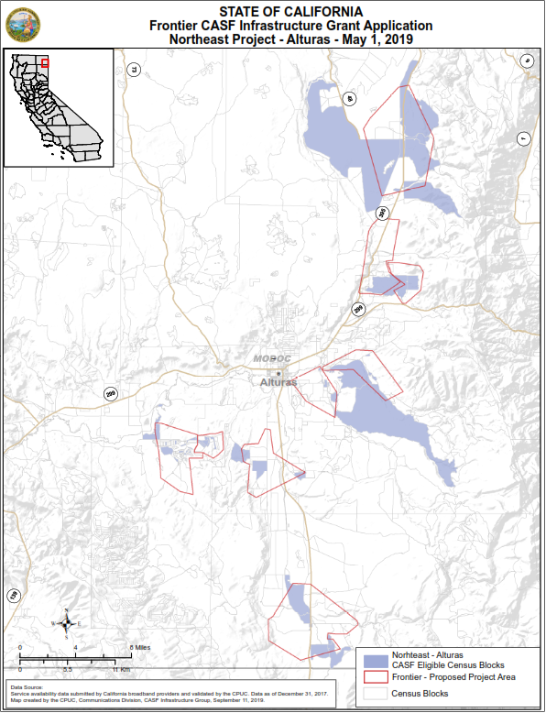
APPENDIX B
Resolution T-17671: Frontier Northeast Project Phase I
Location Maps
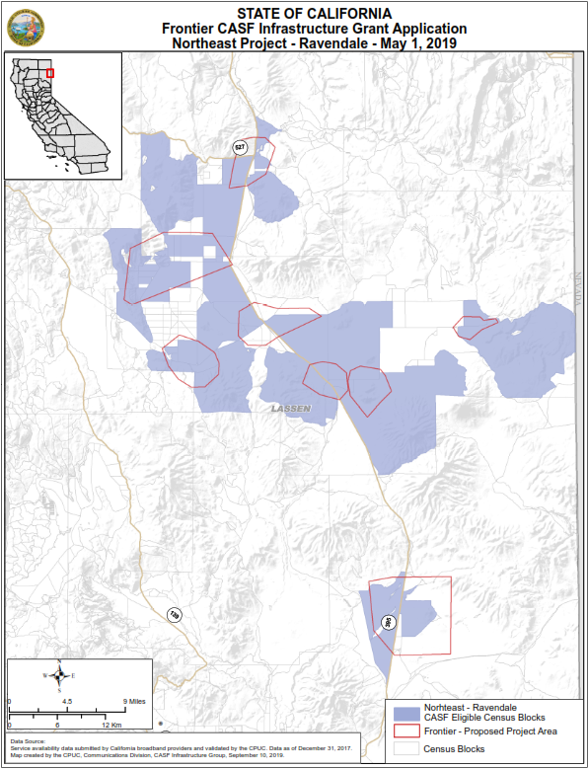
APPENDIX B
Resolution T-17671: Frontier Northeast Project Phase I
Location Maps
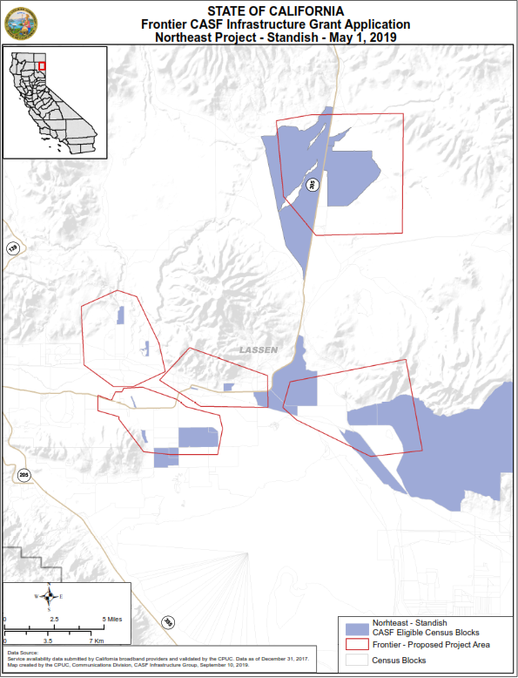
APPENDIX C
Resolution T-17671: Frontier Northeast Project Phase I
Geography and Topography

The Northeast Project area consists of unincorporated communities along Highway 395 from Goose Lake in Modoc County to Standish in Lassen County. The proposed middle-mile infrastructure will traverse along the Highway 395 corridor from Alturas to Standish to provide last mile access to unserved communities in Alturas, Ravendale, and Standish.

Alturas is the county seat of Modoc County, located on the Pit River at an elevation of 2,800 feet. It is in the north east corner of California, approximately 35 miles south of the Oregon border and 30 miles west of the Nevada border, and approximately 105 miles from Susanville. The area is geographically diverse with the Warner Mountains to the east, the South Fork Valley to the south, and the Modoc Plateau to the north. The Modoc Plateau is a mile-high expanse of lava flows, juniper flats, pine forests, and seasonal lakes (including Goose Lake). To the south is a unique ecosystem of isolated oak trees and volcanic mountains with intermountain river valleys.

Ravendale is an unincorporated community in Lassen County at an elevation of 5,300 feet. It is approximately 55 miles southeast of Alturas and 55 miles northeast of Susanville. The terrain includes cinder cone volcanic mountains with intermountain river valleys.

Standish is an unincorporated community in Lassen County at an elevation of 4,000 feet. It is approximately 14 miles east of Susanville, the only incorporated city in Lassen County, and located in the intermountain river valleys of the Honey Lake watershed. The proposed project route follows Highway 395 and Wendel Road.

APPENDIX D
Resolution T-17671: Frontier Northeast Project Phase I
Payments to CASF Recipients

Pub. Util. Code § 281(f)(11) defines the costs the Commission may reimburse as follows:
- Costs directly related to the deployment of infrastructure;
- Costs to lease access to property or for Internet backhaul services for a period not to exceed five years; and
- Costs incurred by an existing facility-based broadband provider to upgrade its existing facilities to provide for interconnection.

Additionally, D. 18-12-018 (Appendix 1, Section 7) caps administrative expenses directly related to the project at 15 percent of the grant amount.

The grantee may submit reimbursement requests at the following intervals:
- 10 percent completion;
- 35 percent completion;
- 60 percent completion;
- 85 percent completion; and
- 100 percent completion.

The final 15 percent payment request (from 85 to 100 percent) will not be paid without an approved completion report. Payments are based on submitted receipts, invoices and other supporting documentation showing expenditures incurred for the project in accordance with the approved CASF funding budget included in the CASF grantee’s application.

Payment to grantees shall follow the process adopted for funds created under P.U. Code § 270. The Commission generally processes payments within 20-25 business days, including Communications Division and Administrative Services review time. The State Controller’s Office (SCO) requires an additional 14- 21 days to issue payment from the day that requests are received by SCO from Administrative Services.

AB 1665 is codified at Public Utilities (Pub. Util.) Code § 281.
The Commission extended the CASF Infrastructure application deadline from April 1 to May 1, 2019, and all subsequent deadlines are moved back by one month. Assigned Commissioner’s Ruling R.12-10-012, March 14, 2019.
https://www.cpuc.ca.gov/General.aspx?id=1040
https://www.cpuc.ca.gov/General.aspx?id=8246
Pub. Util. Code § 281 (f)(4)(A)(ii) prohibits the Commission from awarding CASF funding to a project applicant if the existing facility-based broadband provider demonstrates, in response to the Commission’s annual offer, that it will deploy broadband or upgrade existing broadband service throughout the proposed project area within 180 days.
Unserved slow service provides speeds less than 6 Mbps downstream and 1 Mbps upstream.
Dial-up provides speed less than 200 Kbps downstream and 200 Kbps upstream.
See FCC Public Notice, Connect America Fund Phase II Auction (Auction 903) Closes, Winning Bidders Announced, FCC Form 683 Due October 15, 2018, AU Docket No. 17-182, WC Docket No. 10-90, (DA 18-887), released August 28, 2018.
See Section V.A and V.B for details of CEQA compliance requirement.
Section 2.10.2
Pub. Util. Code, § 281(f)(13). See Bill Analysis prepared by California Assembly Committee on Conveyance, April 26, 2017, p.4. “Arguably since the creation of CASF, most areas that have been served by CASF funds are projects in which applicants feel that their cost, combined with CASF funds, warrant an investment in deploying broadband in such areas. However, this leaves most of the remaining unserved areas of state, mostly in rural and small communities, still without broadband connectivity due to the lack of investment by providers who feel that the difficulties associated with deploying and maintaining such a network in the area for a limited amount of potential customers, even combined with CASF funds, would not result in a positive return on investment. Arguably, the remaining unserved households potentially are households in which even a 70% total cost CASF grant still does not provide enough incentive for a provider to build. Hence, CPUC should consider awarding grants that offer funding for 100% of total costs when warranted.”
D.18-12-018 Table 1. Summary of Funding Level Determinations - Maximum funding level is 100 percent.
The Resolution T-17443 and the Staff High-Impact Analysis are available on the CPUC website; www.cpuc.ca.gov/General.aspx?id=6442455975
Approval of the California Advanced Services Fund (CASF) Application Requirements and Scoring Criteria for Awarding CASF Funds (2008) Cal. P.U.C. Res. No. T-17143 at 4.
Administrative costs are defined as “indirect overhead costs attributable to a project, per generally accepted accounting principles (GAAP), and the direct cost of complying with Commission administrative and regulatory requirements related to the grant itself.” Applicants seeking additional funds will require a Commission exemption included in a draft resolution.

