PUBLIC UTILITIES COMMISSION OF THE STATE OF CALIFORNIA

Communications Division | RESOLUTION T-17715
Broadband, Video and Market Branch | December 17, 2020

R E S O L U T I O N

Resolution T-17715: Approval of funding for the grant application of Citizens Telecommunications Company of California, Inc. (U-1024-C), d/b/a Frontier Communications of California, Inc., from the California Advanced Services Fund (CASF) up to the amount of $2,841,772 for the Crescent City and Smith River Projects for unserved areas in Del Norte County.

SUMMARY

This Resolution approves up to $2,841,772 from the California Advanced Services Fund (CASF) Infrastructure Grant Account for two grant applications of Citizens Telecommunications Company of California, d/b/a Frontier Communications of California Inc. (Frontier), to construct the Crescent City and Smith River Projects. Frontier proposes to deploy last-mile fiber-to-the-premise (FTTP) technology to communities in Del Norte County.

The projects will enable broadband access speeds of at least 50 Mbps download and 50 Mbps upload to 160 CASF-eligible households. The proposed project areas are currently unserved, with no facilities-based wireline or fixed wireless broadband service provider. The proposed projects will provide ancillary benefits, including improved connectivity to low income and Tribal communities.

BACKGROUND

The CASF Infrastructure Grant Account (CASF Infrastructure) provides grant funding to Internet service providers to build or upgrade broadband infrastructure in areas that are unserved by existing broadband providers The CASF program was initiated in 2008, after the program was first adopted by the California Public Utilities Commission (Commission) in Decision (D.) 07-12-054 and enacted into statute pursuant to Senate Bill (SB) 1193.

On October 15, 2017, Governor Brown signed Assembly Bill (AB) 1665 (Garcia) into law. This legislation amended the statute governing the CASF program, Public Utilities Code § 281. The Commission issued D.18-12-018 adopting the programmatic changes to the CASF. Appendix 1 of D.18-12-018 set forth the rules, application requirements and guidelines for the CASF Infrastructure.

On June 29, 2020, Governor Newsom signed AB 82 into law, amending Public Utilities Code § 281 to authorize leveraging of CASF Infrastructure grant funding to supplement the costs of broadband infrastructure already funded, in whole or in part, by the federal Rural Digital Opportunity Fund (RDOF). In an effort to effectively utilize both state and federal funding toward meeting the CASF program goals, Staff has recommended project applications that include areas eligible to receive RDOF may be deferred for approval until after the results of the RDOF Phase I (Auction 904) have been published.

On May 4, 2020, Frontier submitted two CASF Infrastructure applications, requesting 100 percent funding of $3,015,364 to deploy last-mile FTTP broadband access to 189 unserved households in the region of Crescent City and Smith River in Del Norte County. The CASF grant funding request would cover the complete project deployment costs of the Crescent City and Smith River Projects. Table 1, below, identifies Frontier’s proposed project budgets.

Table 1: CASF Infrastructure Applications
Proposed Project | Households | Funding Request
Crescent City | 134 | $ 1,586,885
Smith River | 55 | $ 1,428,479
Total Grant Request | 189 | $3,015,364

Frontier is a publicly traded corporation, the fourth largest incumbent local exchange carrier (ILEC) in the United States, and the second largest in California. The CASF Infrastructure grant will be awarded to Citizens Telecommunications Company of California (U-1024-C); a telephone operating company based in Elk Grove, California established in 1993 to acquire access lines from General Telephone & Electronics Corporation (GTE). As the Carrier-of-Last-Resort, Frontier currently provides circuit-switched (POTS) voice service in the proposed project areas and does not provide broadband Internet service.

NOTICE

On May 18, 2019, Staff posted the proposed project area map, census block groups (CBGs) and zip codes for the Crescent City and Smith River Projects on the Commission’s CASF webpage under “CASF Application Project Summaries” and sent notice regarding the project to the CASF Distribution List.

PROTEST/CHALLENGES

On June 8, 2020, Charter Communications Inc. (Charter) challenged the Crescent City project application, stating the company provides broadband at served speeds in the project area. Staff received no challenges to the Smith River Project.

The outcome of the Charter challenge is addressed in Discussion, Section I, Project Area Eligibility.

DISCUSSION

In compliance with D.18-12-018, Staff determined Frontier’s Crescent City and Smith River Projects are eligible to receive a total of $2,841,772 in CASF Infrastructure grant funding.

Table 2: Recommended Funding for Frontier Projects
Project | Staff Funding Recommendation | Unserved Households
Crescent City | $ 1,413,293 | 105
Smith River | $ 1,428,479 | 55
Recommended Funding | $ 2,841,772 | 160

Details of Staff analysis are explained in the following sections:

- Project Area Eligibility
- Minimum Performance Criteria
- Funding Determination
- Safety and Community Support
- Compliance Requirements
- Payments to CASF Recipients

Key project information and maps are shown in Appendix A and Appendix B.

Project Area Eligibility
No provider filed a “right-of-first refusal” for Frontier’s project areas by January 15, 2020, nor do the proposed projects areas include census blocks identified by the Federal Communications Commission’s (FCC) Connect America Fund Phase II program. Additionally, the proposed project areas do not include census blocks identified by the FCC as eligible to receive RDOF as part of Phase I (Auction 904).

As discussed further below, Staff evaluated Frontier’s applications and determined the revised Crescent City Project and the Smith River Project are eligible for a CASF grant. There are no existing facilities-based wireline or fixed wireless broadband service providers in the project area. According to the California Interactive Broadband Map, the area is unserved; only dial-up service is available.

        - Crescent City Project Area Eligibility
Staff requested Frontier to revise its original application based on the challenge submitted by Charter. The revised Crescent City Project Summary was posted on the Commission’s webpage on October 12, 2020.

Frontier revised its proposed project after two census blocks were identified as served by Charter. Funding from the CASF Infrastructure can only be approved for households that are unserved. Unserved is defined as no provider offering broadband service access at speeds of at least 6 Mbps downstream and 1 Mbps upstream. In Frontier’s original application, Frontier proposed to offer broadband services to 134 unserved households located within eight census blocks in the Crescent City area. Charter challenged the application stating it provides broadband service at served speeds in Crescent City. Based on the customer address and billing information submitted by Charter, Staff determined two census blocks in the proposed project area were already served and directed Frontier to revise its application. In its revised application, Frontier reduced the grant funding request to $1,413,293 to serve 105 households in the remaining six census blocks. Table 3, below, summarizes the revised CASF Infrastructure grant application.

Table 3: Frontier Crescent City Project Revision
 | Unserved Households | Census  Blocks | CASF Infrastructure Grant Funding
Original Application | 134 | 8 | $ 1,586,885
Revised Application | 105 | 6 | $ 1,413,293

Staff finds the grant funding request reasonable even with the reduction of households from 134 to 105 because most of the project costs are fixed equipment costs to upgrade the central office. These upgrades to the central office are still necessary to provide broadband to the Crescent City project area.

        - Smith River Project Area Eligibility
Frontier’s Smith River Project proposes to provide last-mile access to 55 unserved households. In Frontier’s application, Frontier requested $1,428,479 in grant funding to serve 55 households in the South Park Mobile Homes area of Howonquet Village in Smith River. According to the California Interactive Broadband Map, there are an estimated 48 households, with a total of 58 housing units, within the five census blocks in the Smith River project area. Based on satellite imagery of the project area, Staff identified 55 mobile homes within the project area. Therefore, Staff determined the household count for this project is 55 unserved households.

Minimum Performance Criteria
Staff reviewed Frontier’s applications and determined the Crescent City and Smith River Projects meet the minimum performance criteria pursuant to D.18-12-018, Appendix 1, Section 6, as summarized in Table 4.

Table 4: Minimum Performance Criteria
 | CASF Performance Criteria | Proposed Project
Project Completion | CEQA-exempt projects must be completed within 12 months, and all other projects shall be completed within 24 months after receiving authorization to construct | 12 months  (CEQA Exempt)
Pricing | Prices committed for two years  after completion of the project | 2-year
Speed | At least 10/1 Mbps | 50 / 50 Mbps
Latency | Maximum of 100 ms of latency | 25 ms
Data Caps | Minimum of 190 GBs per month | No data cap
Affordability | Must offer low-income plan | Yes – Frontier Affordable Broadband Plan

Frontier’s Crescent City and Smith River Projects are categorically exempt from California Environmental Quality Act (CEQA) review. Frontier has provided the Commission with its plan to use joint-use utility poles and existing Frontier-owned underground conduit systems for the installation of aerial and underground fiber cable. In locations where conduit or poles do not exist, new fiber facilities will be placed in existing utility easements and rights-of-way (ROW) in which Frontier has existing copper facilities. The proposed Crescent City project area would cover approximately 0.11 square miles and the Smith River project area would cover approximately 0.015 square miles. Both projects will deploy last-mile FTTP facilities in Del Norte County.

Frontier’s methods of aerial installation will follow General Order 95 pole safety and loading requirements. All permits and traffic control will be obtained to allow for proper placement of aerial fiber cable. Frontier’s methods of underground installation will follow existing guidelines necessary to obtain permit approval. Permits will be obtained for access to manholes/handholes and necessary underground equipment to allow for proper placing of underground fiber. Following the installation of underground facilities and cabling, the site will be returned to its original condition. Table 5 provides details for the proposed installation of fiber facilities.
Table 5: Summary of Proposed Fiber Construction
Total Distance  (based on Installation Method) | Project
 | Crescent City | Smith River
Aerial | 4.11 miles | 11.7 miles
Underground (In Existing Conduit) | 0.65 miles | 1.82 miles
Underground (Direct Burial) | 1.43 miles | 0.89 miles
Total Miles | 6.19 miles | 14.41 miles

Based on the above information, the Commission’s Energy Division has confirmed that the projects are categorically exempt from CEQA review. Both projects meet the criteria of the CEQA categorical exemptions found in CEQA Guidelines, 14 C.C.R. § 15301 (Existing Facilities) and 14 C.C.R. § 15302 (Replacement or Reconstruction of Existing Structures and Facilities). Thus, the entirety of the Crescent City and Smith River Projects are categorically exempt from CEQA.

Frontier’s broadband service offering for its Crescent City and Smith River Projects meets CASF minimum performance criteria. Frontier commits to residential broadband pricing plans, as summarized in Table 6 and Table 7, for two years starting from the beginning date of service. There is no long-term commitment required by the consumer to receive these prices. Furthermore, Frontier will waive the activation and installation fees during the commitment period. Frontier provides discount pricing for bundled broadband and voice services. Additionally, low-income subscribers, including LifeLine voice subscribers, are eligible for discounted broadband service (10 Mbps download / 1 Mbps upload for $14.99 per month).

Table 6: Standalone Broadband Pricing Plan
Download Speed | Upload Speed | Monthly Price
50 Mbps | 50 Mbps | $39.99
100 Mbps | 100 Mbps | $49.99
200 Mbps | 200 Mbps | $49.99
500 Mbps | 500 Mbps | $49.99
940 Mbps | 880 Mbps | $74.99

Table 7: Broadband/Voice Bundled Pricing Plan
Download Speed | Upload Speed | Monthly Price
50 Mbps | 50 Mbps | $49.99
100 Mbps | 100 Mbps | $59.99
200 Mbps | 200 Mbps | $59.99
1,000 Mbps | 1,000 Mbps | $84.99

The proposed speed offerings (up to 1,000 Mbps download and up to 1,000 Mbps upload) meet the 10/1 minimum performance requirement. This service will be available to the general public, as well as anchor institutions and small businesses near the project area.

Funding Determination
Frontier is eligible to receive 100 percent funding to cover the cost of its Crescent City and Smith River Projects. AB 1665 authorizes the Commission to award grants to fund all or a portion of the project and requires that it determine, on a case-by-case basis, the level of funding to be provided. Staff considered the statutory factors to determine the grant funding level, as described by Pub. Util. Code §§ 281(f)(12) and 281(b)(2)(B)(i), and CASF rules adopted in D.18-12-018. Based on those factors, Staff determined Frontier’s request for 100 percent funding is appropriate, and thereby awards a CASF Infrastructure grant of $2,841,772 for the Crescent City and Smith River Projects. Table 8 is a comparison of Frontier’s revised funding request and Staff’s funding recommendation.

Table 8: Summary of Frontier’s Funding
Project | Funding Level Requested | Staff Recommendation
Crescent City | $ 1,413,293 | $ 1,413,293
Smith River | $ 1,428,479 | $ 1,428,479
CASF Grant Amount | $ 2,841,772 | $ 2,841,772

- Crescent City Funding Determination
Details of Staff’s funding level determination for Frontier’s Crescent City Project are summarized in Table 9.
Table 9: Criteria for Project Funding Level for Frontier Crescent City
Funding Criteria | Revised Project
Baseline for Eligible Project (60%) | 60%
Service Level Preference: Only Dial-up or No Internet Connectivity (up to 40%) | 40%
Low Income – (up to 40%)  - Median Household Income for community is less than CARE standard for family of 4, which is currently $50,200 (30%)  - Applicant serves low-income customers for no more than $15/month (10%) | 30%  10%
Others: PU Code § 281 (f)(12) Criteria – (up to 20%)  - Inaccessible Location (10%)  - Uses Existing Infrastructure (10%)  - Makes a Significant Contribution to the Program Goal (10%) | 0%  10%  10%
Total Funding Level | 100%

Details of the appropriate funding level are described below.

Baseline for an Eligible Project qualifies for an additional 60 percent funding. CASF program is intended to finance capital costs of projects deploying broadband facilities in unserved areas of California. The identified Crescent City project area meets all the eligibility criteria, as previously described in the Project Area Eligibility section.

Service Level Preference qualifies for an additional 40 percent funding. Pub. Util. Code § 281(b)(2)(B)(i) encourages the Commission to give preference to projects in areas with no Internet connectivity or where Internet connectivity is available only through dial-up service and not served by any form of wireline or wireless facility-based broadband service. According to the California Interactive Broadband Map, Staff confirmed all the proposed project areas are unserved by wireline or fixed wireless broadband service and are therefore eligible for an additional 40 percent funding.

Low Income Consideration qualifies for an additional 40 percent funding. Based on the proportion of households located in each census block group, the weighted median household income of the proposed project area is $44,227, and thus qualifies for an additional 30 percent funding. Frontier commits to offer low-income broadband programs, including broadband and voice bundled plans for LifeLine-eligible subscribers at $14.99/month, which meets the criteria for an additional 10 percent funding.

Other Factor Considerations qualify for an additional 20 percent funding. The Crescent City Project meets two of the three criteria defined in Pub. Util. Code § 281(f)(12) and qualifies for the additional 20 percent funding.

Staff determined the proposed project does not meet the inaccessible location criteria and is not eligible for an additional 10 percent funding. The proposed project is located in Crescent City in Del Norte County. The surrounding areas are census designated places (CDP) that are classified as urban and are therefore, fairly populated and developed. There is access to highways, public utilities, and community health and educational resources. The project area is considered to be relatively flat terrain with feasible access including Frontier’s existing infrastructure.

The proposed project is eligible for an additional 10 percent funding for its use of existing pole infrastructure and underground conduit systems for the installation of aerial and underground fiber cable. Additionally, Del Norte County is part of the Redwood Coast Connect Consortium region in which 90.3 percent of households are served, which is below the 98 percent CASF program goal. Therefore, Staff determined the project will make a significant contribution to the program goal and is eligible for an additional 10 percent funding.

- Smith River Funding Determination
Details of Staff’s funding level determination for Frontier’s Smith River Project are summarized in Table 10.

Table 10: Criteria for Project Funding Level for Frontier Smith River
Funding Criteria | Revised Project
Baseline for Eligible Project (60%) | 60%
Service Level Preference: Only Dial-up or No Internet Connectivity (up to 40%) | 40%
Low Income – (up to 40%)  - Median Household Income for community is less than CARE standard for family of 4, which is currently $50,200 (30%)  - Applicant serves low-income customers for no more than $15/month (10%) | 30%  10%
Others: PU Code § 281 (f)(12) Criteria – (up to 20%)  - Inaccessible Location (10%)  - Uses Existing Infrastructure (10%)  - Makes a Significant Contribution to the Program Goal (10%) | 0%  10%  10%
Total Funding Level | 100%

Details of the appropriate funding level are described below.

Baseline for Eligible Project qualifies for an additional 60 percent funding. CASF program is intended to finance capital costs of projects deploying broadband facilities in unserved areas of California. The identified Smith River project area meets all the eligibility criteria, as previously described in the Project Area Eligibility section.

Service Level Preference qualifies for an additional 40 percent funding. Pub. Util. Code § 281(b)(2)(B)(i) encourages the Commission to give preference to projects in areas with no Internet connectivity or where Internet connectivity is available only through dial-up service and not served by any form of wireline or wireless facility-based broadband service. According to the California Interactive Broadband Map, Staff confirmed all the proposed project areas are unserved by wireline or fixed wireless broadband service and is therefore eligible for an additional 40 percent funding.

Low Income Consideration qualifies for an additional 40 percent funding. The median income of the census block group in the proposed project area is $31,901, and thus qualifies for an additional 30 percent funding. Frontier commits to offer low-income broadband programs including broadband and voice bundled plans for LifeLine-eligible subscribers at $14.99/month, which meets the criteria for an additional 10 percent funding.

Other Factor Considerations qualify for an additional 20 percent funding . The Smith River Project meets two of the three criteria defined in Pub. Util. Code § 281(f)(12) and qualifies for the additional 20 percent funding.

Staff determined the proposed project does not meet the inaccessible location criteria and is not eligible for an additional 10 percent funding. The proposed project is located in Smith River along Highway 101 in Del Norte County. The surrounding areas are fairly populated and developed with access to highways, public utilities, and community health and educational resources. The project area is considered to be relatively flat terrain with feasible access including Frontier’s existing infrastructure.

The proposed project is eligible for an additional 10 percent funding for its use of existing pole infrastructure and underground conduit systems for the installation of aerial and underground fiber cable. Additionally, Del Norte County is part of the Redwood Coast Connect Consortium region in which 90.3 percent of households are served, which is below the 98 percent CASF program goal. Therefore, Staff determined the project will make a significant contribution to the program goal and is eligible for an additional 10 percent funding.

Safety and Community Support
The CASF program encourages the deployment of broadband throughout the State to enable the public to access Internet-based safety applications, telehealth services, emergency services, and to allow first responders to communicate with each other and collaborate during emergencies. Letters of Support were received from the College of the Redwoods for both the Crescent City and Smith River Projects and Humboldt State University for the Smith River Project.

The projects are supported by the community for its potential to remove barriers to economic and workforce development, health care, education, and public safety. College of the Redwoods supports the Crescent City Project based on the importance of broadband access to rural communities. The college has a campus in Crescent City and has historically advocated for the expansion of broadband deployment and adoption. Tourism and hospitality are major economic drivers for the area, and both will be served with high speed Internet access.

College of the Redwoods and Humboldt State University support the Smith River Project and recognize the importance of broadband to residents and businesses in Smith River. College of the Redwoods has historically advocated for the expansion of broadband deployment and adoption for rural communities in the region. The project will provide services to members of the Tolowa Dee-Ni’ Nation and community anchor institutions such as the Smith River Fire Department and Community Services District.

V. Compliance Requirements
Frontier is required to comply with all the guidelines, requirements, and conditions associated with the grant of CASF Infrastructure funds as specified in D.18-12-018. Such compliance includes, but is not limited to, the items noted below.

Deployment Schedule
The Commission expects Frontier to complete the project within 12 months from the start date (whereby the applicants have secured CEQA approval from the Commission and all required permits), and the applicant has committed to do so. If the applicant is unable to complete the proposed project within the 12-month timeframe requirement, Frontier must notify the Director of the Communications Division as soon as Frontier becomes aware of this possibility. If such notice is not provided, the Commission may reduce payment for failure to satisfy this requirement of timely notification to the Director.

Execution and Performance
Staff and Frontier shall determine a project start date after the CASF grant recipient has obtained all approvals, including CEQA permits. Should Frontier or any contractor it retains fail to commence work by the designated date, upon five days written notice the Commission may terminate the grant. In the event that Frontier fails to complete the project in accordance with the terms of Commission approval as set forth in this resolution, Frontier shall reimburse some or all of the CASF funds that it has received. Frontier must complete all construction covered by the grant on or before the grant’s termination date.

Letter of Credit
The Commission exempts Certificate of Public Convenience and Necessity (CPCN) holders from providing a letter of credit, on the basis that the company submitted a performance bond to the Commission to maintain its CPCN and that the Commission has other means to enforce compliance. In its application, Frontier provided proof of CPCN registration and thus is exempt from the requirement of providing a letter of credit.

Project Audit
The Commission has the right to conduct any necessary audit, verification, and discovery during project implementation/construction to ensure that CASF funds are spent in accordance with Commission approval.

Frontier’s invoices will be subject to a financial audit by the Commission at any time within three years of completion of the work.

Providing Voice Service
Frontier has certified that its basic analog telephone service (POTS) meets the FCC standards for E-911 service and battery backup.

Reporting
All grantees must submit biannual progress reports on the status of the project, irrespective of whether grantees request reimbursement or payment. These reports are due semi-annually, in March and September, until the project is completely built and operational. Progress reports shall use the schedule for deployment, major construction milestones and costs submitted in the proposal; indicate the actual date of completion of each task/milestone as well as problems and issues encountered, and the actions taken to resolve these problems and issues during project implementation and construction; and identify future risks to the project.

Before full payment of the project is made, Frontier must submit a project completion report. Frontier shall also include test results on the download and upload speeds by census block in the final completion report. Frontier must certify that each progress report is true and correct under penalty of perjury.

Submission of Form 477
The FCC currently requires broadband providers to biannually submit Form 477, which includes speed data. While there is an imperfect match between the data that is reported in the Form 477 and data relevant to the CASF program, the Form 477 data will be useful in documenting CASF deployment for the service provider’s new service. Pursuant CASF rules, service providers in California must submit a copy of their Form 477 data directly to the Commission, concurrent with their submission of the same data to the FCC, for a five-year period after completion of the project.
- Prevailing Wage
Section 1720 of the California Labor Code specifies that CASF-subsidized projects are subject to prevailing wage requirements. Frontier has committed to follow state prevailing wage requirements with regards to this project.

Payments to CASF Recipients
The Commission may reimburse Frontier’s expenses in accordance with Pub. Util. Code § 281(f)(11). Details of reimbursable expenses are in Appendix C.

COMMENTS ON DRAFT RESOLUTION

In compliance with Public Utilities Code § 311(g), a notice letter was e-mailed on November 13, 2020, informing all parties on the CASF Distribution List of the availability of this draft resolution at the Commission's website at http://www.cpuc.ca.gov/PUC/documents/ and of the opportunity to provide comments on the resolution. This letter also informed parties that the final conformed Resolution adopted by the Commission will be posted and available at this same website.

FINDINGS

- Frontier submitted an application for CASF funding for its Crescent City and Smith River Projects on May 4, 2020. The proposed projects would provide at least 50 Mbps download and 50 Mbps upload broadband service to 160 CASF eligible households in Crescent City and Smith River in Del Norte County.

- On May 18, 2020, Staff posted project summaries of the Crescent City and Smith River Projects, including a listing of the census blocks and zip codes covered by the project, and the proposed project area map. The summaries were posted on the “CASF Applications Project Summaries” webpage, which may be found on the Commission’s CASF webpage.

- Staff received one challenge to the Crescent City project application from Charter Communications, Inc. Based on the review of information submitted, Staff concluded two of the proposed census blocks were already served. Staff requested Frontier to revise its Crescent City application to remove two census blocks that were identified as ineligible for a CASF Infrastructure grant. On October 12, 2020, Staff posted the revised project summary on the “CASF Applications Project Summaries” webpage.

- Staff received no challenges to the Smith River project.

- Based on its review, Staff determined that the projects qualify for funding pursuant to D. 18-12-018 and its Appendix 1 and recommends Commission approval of CASF funding for Frontier’s Crescent City and Smith River Projects up to the amount of $2,841,772.

- The Commission has determined that the projects are categorically exempt from CEQA review, pursuant to CEQA guidelines at 14 C.C.R § 15301 regarding exemption for existing facilities and 14 C.C.R § 15302 regarding minor modifications to existing structures.

- A notice letter was e-mailed on November 13, 2020, informing all applicants filing for CASF funding and parties on the CASF distribution list of the availability of the draft of this Resolution, and of the opportunity for comment, at the Commission’s website http://www.cpuc.ca.gov/PUC/documents/.

THEREFORE, IT IS ORDERED that:

  - The Commission shall award up to $2,841,772 to Frontier for the Crescent City and Smith River Projects as described herein and summarized in Appendix A of this Resolution, which shall be paid out of the CASF Infrastructure Grant Account in accordance with the guidelines adopted in D.18-12-01 and its Appendix 1, and with the process defined in Appendix C “ Payments to CASF Recipients” of this Resolution.

  - Frontier shall comply with all guidelines, requirements and conditions associated with a CASF award, as specified in D.18-12-018 and its Appendix 1, and all requirements for this project included in this Resolution, and must submit FCC Form 477 to the Commission, as specified in Resolution T-17143.

  - If Frontier fails to complete the project in accordance with the CASF guidelines and requirements outlined in D.18-12-018 and its Appendix 1, and the terms outlined in this Resolution, Frontier must reimburse some or all of the CASF funds that it has received.

  - Frontier must complete and execute the consent forms (to be sent to the Grantee after this Resolution is adopted) agreeing to the conditions set forth in this Resolution and return it the CASF Staff within 30 calendar days from the date of the adoption of this Resolution. Failure to submit the consent form within 30 calendar days from the adoption date of this Resolution may result in the Commission voiding the grant award.

This Resolution is effective today.

I hereby certify that this Resolution was adopted by the Public Utilities Commission at its regular meeting on _______________. The following Commissioners approved it:

RACHEL PETERSON

(Acting) Executive Director

APPENDIX A
Resolution T-17715: Frontier Crescent City
CASF Application Key Information
Project Name | Frontier Crescent City Project
Project Plan | The project proposes to build last-mile fiber optic infrastructure in Crescent City to enable fiber-to-the-premise (FTTP) high-speed Internet service to 105 unserved households. The project will provide at least 50 Mbps download and 50 Mbps upload speeds.
Project Size  (in square miles) | 0.11
Download/Upload speed | 50Mbps / 50 Mbps
Location | Del Norte
Community Name | Crescent City
Census Blocks | 060150001041007  060150001041019  060150001051001 | 060150001051003  060150001053001  060150001055008
Weighted Median Household Income | $ 44,227
Estimated Potential Subscriber Size | 105 households (2010 US Census)
Applicant Expectations | 84 customers (80-percent take rate)
Pricing Plan (Monthly) | Fiber Internet (stand-alone pricing):  50 Mbps / 50 Mbps for $39.99  100 Mbps / 100 Mbps for $49.99  940 Mbps / 880 Mbps for $74.99  Low Income 10 Mbps / 1 Mbps for $14.99
Deployment Schedule  (from permit approval date) | 11 months
Proposed Project Budget (Total) | $ 1,413,293
Grant Requested Amount | $ 1,413,293
CASF Grant Amount  (100 percent) | $ 1,413,293
Recommended Grant per household | $ 13,460

APPENDIX A
Resolution T-17715: Frontier Smith River
CASF Application Key Information
Project Name | Frontier Smith River Project
Project Plan | The project proposes to build last-mile fiber optic infrastructure in Smith River to enable fiber-to-the-premise (FTTP) high-speed Internet service to 55 unserved households. The project will provide at least 50 Mbps download and 50 Mbps upload speeds.
Project Size  (in square miles) | 0.015
Download/Upload speed | 50Mbps / 50 Mbps
Location | Del Norte
Community Name | Howonquet Village Mobile Homes
Census Blocks | 060150002021083  060150002021087  060150002021090  060150002021091  060150002021104
Median Household Income | $ 31,901
Estimated Potential Subscriber Size | 55 households (2010 US Census)
Applicant Expectations | 44 customers (80-percent take rate)
Pricing Plan (Monthly) | Fiber Internet (stand-alone pricing):  50 Mbps / 50 Mbps for $39.99  100 Mbps / 100 Mbps for $49.99  940 Mbps / 880 Mbps for $74.99  Low Income 10 Mbps / 1 Mbps for $14.99
Deployment Schedule  (from permit approval date) | 11 months
Proposed Project Budget (Total) | $ 1,428,479
Grant Requested Amount | $ 1,428,479
CASF Grant Amount  (100 percent) | $ 1,428,479
Recommended Grant per household | $ 25,972

APPENDIX B
Resolution T-17715: Frontier Smith River
Location Maps
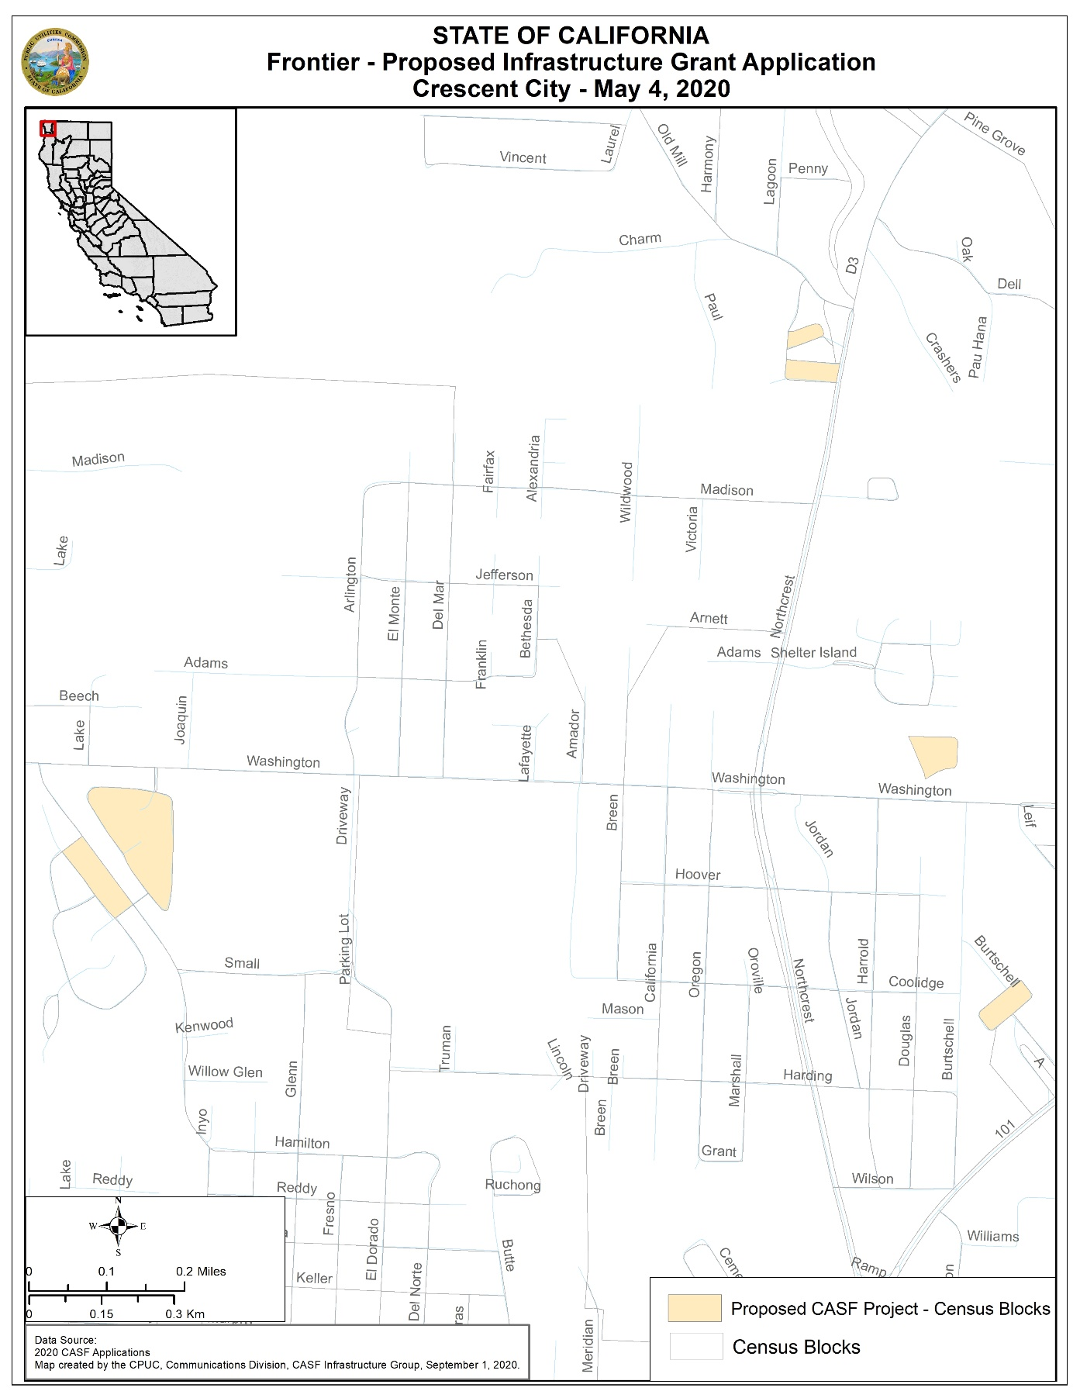
APPENDIX B
Resolution T-17715: Frontier Smith River
Location Maps 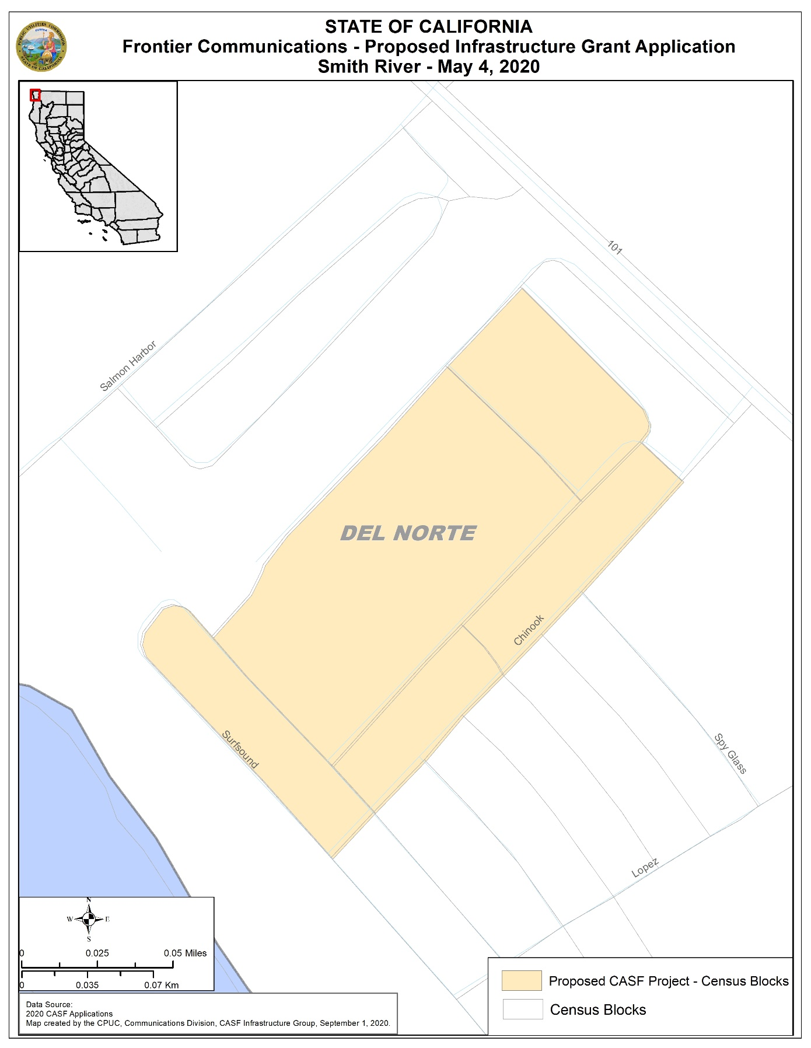

APPENDIX C
Resolution T-17715: Frontier Crescent City and Smith River
Payments to CASF Recipients

Pub. Util. Code § 281(f)(11) defines the costs the Commission may reimburse as follows:
- Costs directly related to the deployment of infrastructure;
- Costs to lease access to property or for Internet backhaul services for a period not to exceed five years; and
- Costs incurred by an existing facility-based broadband provider to upgrade its existing facilities to provide for interconnection.

Additionally, D. 18-12-018 (Appendix 1, Section 7) caps administrative expenses directly related to the project at 15 percent of the grant amount.

The grantee may submit reimbursement requests at the following intervals:
- 10 percent completion;
- 35 percent completion;
- 60 percent completion;
- 85 percent completion; and
- 100 percent completion.

The final 15 percent payment request (from 85 to 100 percent) will not be paid without an approved completion report. Payments are based on submitted receipts, invoices and other supporting documentation showing expenditures incurred for the project in accordance with the approved CASF funding budget included in the CASF grantee’s application.

Payment to grantees shall follow the process adopted for funds created under Public Utilities Code § 270. The Commission generally processes payments within 20-25 business days, including Communications Division and Administrative Services review time. The State Controller’s Office (SCO) requires an additional 14- 21 days to issue payment from the day that requests are received by SCO from Administrative Services.

AB 1665 is codified at Public Utilities (Pub. Util.) Code § 281.
The Commission extended the CASF Infrastructure application deadline from April 1 to May 4, 2020, and all subsequent deadlines are moved back by five weeks due to COVID-19 public health emergency. See Executive Director Letter to CASF Distribution and Service Lists, Postponement of the 2020 CASF Infrastructure Application Deadlines, March 20, 2020.
See Public Utilities Code § 281(b)(1)(B)(ii).
See Staff Proposal on State-Federal Broadband Infrastructure Funds Leveraging Rulemaking (R.)20-08-021, October 1, 2020, which is pending Commission decision.
https://www.cpuc.ca.gov/General.aspx?id=1040
https://www.cpuc.ca.gov/General.aspx?id=8246
Pub. Util. Code § 281(f)(4)(A)(ii) prohibits the Commission from awarding CASF funding to a project applicant if the existing facility-based broadband provider demonstrates, in response to the Commission’s annual offer, that it will deploy broadband or upgrade existing broadband service throughout the proposed project area within 180 days.
Pub. Util. Code § 281(f)(5)(C)(i) prohibited the Commission, prior to July 1, 2020, from awarding CASF funding to a project applicant where an existing facility-based broadband provider has accepted federal funds for broadband deployment from Phase II of the Connect America Fund.
See https://www.broadbandmap.ca.gov/federalfunding/.
Dial-up provides speed less than 200 Kbps downstream and 200 Kbps upstream.
Household estimates are based on the 2010 U.S. Census data updated with population and demographic information published by the California Department of Finance on May 1, 2019.
See Pub. Util. Code, § 281(f)(12).
D.18-12-018 Table 1. Summary of Funding Level Determinations - Maximum funding level is 100 percent.
See 2019 Annual Report on the California Advanced Services Fund, California Public Utilities Commission, Issued April 2020, Table 7: Remaining Unserved Households in Each Consortia Region.
D.18-12-018 Table 1. Summary of Funding Level Determinations - Maximum funding level is 100 percent.
See 2019 Annual Report on the California Advanced Services Fund, California Public Utilities Commission, Issued April 2020, Table 7: Remaining Unserved Households in Each Consortia Region.
Approval of the California Advanced Services Fund (CASF) Application Requirements and Scoring Criteria for Awarding CASF Funds (2008) Cal. P.U.C. Res. No. T-17143 at 4.
Staff performed a weighted average calculation of the census block group median household incomes to accurately represent the income distribution of the households in the project area.
Administrative costs are defined as “indirect overhead costs attributable to a project, per generally accepted accounting principles (GAAP), and the direct cost of complying with Commission administrative and regulatory requirements related to the grant itself.” Applicants seeking additional funds will require a Commission exemption included in a draft resolution.

