PUBLIC UTILITIES COMMISSION OF THE STATE OF CALIFORNIA

Executive Division Date: April 15, 2021

Resolution M-4852

RESOLUTION

**RESOLUTION M-4852: PLACING PACIFIC GAS AND ELECTRIC COMPANY INTO STEP 1 OF THE “ENHANCED OVERSIGHT AND ENFORCEMENT PROCESS” ADOPTED IN DECISION 20-05-053**

**SUMMARY**

This Resolution is issued to Pacific Gas and Electric Company (PG&E) in accordance with Commission Decision (D.) 20-05-053, which gave Commission approval of PG&E’s bankruptcy plan of reorganization with conditions and modifications. The decision established an Enhanced Oversight and Enforcement Process (EOE Process) allowing the Commission to take additional steps to ensure PG&E is improving its safety performance if specific Triggering Events occur. The steps range from Step 1, which contains enhanced reporting and oversight requirements, to Step 6, involving the potential revocation of PG&E’s ability to operate as a California electric utility.

This Resolution invokes Step 1, with regard to PG&E’s insufficient progress with risk-driven wildfire mitigation efforts and requires PG&E to submit a Corrective Action Plan within 20 days of the Resolution effective date.

It is appropriate to place PG&E into Step 1 of the EOE Process due to the following Triggering Event:

PG&E Has Made Insufficient Progress Toward Approved Safety or Risk-Driven Investments Related to Its Electric Business (EOE Process Step 1, Triggering Event A(iii)).

The findings supporting this Triggering Event include the following:

PG&E is not sufficiently prioritizing its Enhanced Vegetation Management (EVM) based on risk. PG&E ranks its power line circuits by wildfire risk, but the work performed in 2020 demonstrates that PG&E is not making risk-driven investments. PG&E is not doing the majority of EVM work – or even a significant portion of work – on the highest risk lines.

In 2020, PG&E conducted more work in 2020 on lower risk power lines than high risk lines if one examines the 161 power lines on which PG&E performed EVM.  Less than five percent of the EVM work PG&E completed was on the 20 highest risk power lines according to PG&E’s own risk rankings.

The foregoing facts meet the triggering requirements for placing PG&E into Step 1 of the EOE Process, which warrants imposition of a Corrective Action Plan containing enhanced reporting requirements. No later than 20 days following issuance of this Resolution, PG&E shall submit a Corrective Action Plan containing the material set forth below. The enhanced reporting requires PG&E to prioritize EVM on power lines that pose the greatest wildfire risk.

PG&E shall serve the Corrective Action Plan on the service lists for Investigation   
(I.) 19-09-016 (which created the EOE Process) and Rulemaking (R.) 18-10-007 (the Commission’s wildfire mitigation proceeding), as well as on the Wildfire Safety Division (WSD) at [wildfiresafetydivision@cpuc.ca.gov](mailto:wildfiresafetydivision@cpuc.ca.gov) and the Safety and Enforcement Division at [ESRB_ComplianceFilings@cpuc.ca.gov](mailto:ESRB_ComplianceFilings@cpuc.ca.gov). PG&E shall also send the Corrective Action Plan to the Commission’s Executive Director seeking her approval.

The EOE Process does not supplant existing Commission regulatory or enforcement jurisdiction, and nothing in this Resolution is intended to affect such jurisdiction or limit the Commission’s or WSD’s authority to pursue other enforcement related to the facts set forth herein. Further, nothing in this Resolution alters the requirements of D.20-05-019.**[1]**

**BACKGROUND**

PG&E entered bankruptcy in 2019 following several catastrophic wildfires in its service territory. In D.20-05-053, the Commission approved a reorganization plan, giving its approval for PG&E to emerge from bankruptcy with specific financial and operational conditions. To hold PG&E accountable for improving its safety record, including the need to reduce the risk of catastrophic wildfire caused by its infrastructure, the decision instituted a new EOE Process to supplement the Commission’s existing enforcement authority. Appendix A to this Resolution provides the EOE Process adopted in   
D.20-05-053.

The Commission may invoke the EOE Process if PG&E self-reports, or the Commission becomes aware of, Triggering Events covered by the EOE Process. In this case, PG&E did not self-report problems. Instead, through persistent inquiry, the Commission and WSD have discovered that PG&E did not prioritize EVM in 2020 in a risk-driven manner that would entail performing work on its highest risk power lines first. PG&E has failed to provide the WSD with consistent information about how it assesses power line risk for prioritizing EVM work, but under any of PG&E’s risk rankings, PG&E has not made sufficient progress toward risk-driven investments in the area of EVM.

1. **EOE Process**

The EOE Process has six steps, which range from adoption of additional reporting requirements in Step 1 to formal review of PG&E’s Certificate of Public Convenience and Necessity (CPCN) in Step 6. D.20-05-053 states that the Commission need not necessarily move PG&E through the steps sequentially. This Resolution relies on findings made, and requirements imposed, by the WSD through its review of PG&E’s Wildfire Mitigation Plan (WMP) performance, and places PG&E into Step 1 of the EOE Process.

The EOE Process:

contains six steps which are triggered by specific events, some of which would rely on Safety and Operational Metrics. The Process includes enhanced reporting requirements and additional monitoring and oversight. The Process also contains provisions for PG&E to cure and permanently exit the Process if it can satisfy specific criteria. If triggered, the Process would occur in coordination with the Commission’s existing formal and informal reporting requirements and procedures and would not replace or limit the Commission’s regulatory authority including the authority to impose fines and penalties.

If triggered, the Commission would place PG&E in the appropriate step upon the occurrence of a specified Triggering Event, with appropriate notification by the Commission’s Executive Director, or as otherwise provided below. The Commission’s Executive Director may move PG&E through the steps of the Process sequentially, or the Commission or its Executive Director may place PG&E in the appropriate step upon the occurrence of a specified Triggering Event. D.20-05-053 at 58.

1. **Step 1**

This Resolution places PG&E into Step 1 of the EOE Process, which provides that if PG&E’s conduct meets any of the Triggering Events listed below, a Corrective Action Plan is required. Specifically, this Resolution invokes Step 1 Section A(iii).

**STEP 1: Enhanced Reporting**

1. Triggering Events
   1. PG&E fails to obtain an approved wildfire mitigation plan or fails in any material respect to comply with its regulatory reporting requirements;
   2. PG&E fails to comply with, or has shown insufficient progress toward, any of the metrics (i) set forth in its approved wildfire mitigation plan including Public Safety Power Shutoffs (PSPS) protocols, (ii) resulting from its on-going safety culture assessment, (iii) contained within the approved Safety and Operational Metrics, or (iv) related to other specified safety performance goals;
   3. PG&E demonstrates insufficient progress toward approved safety or risk-driven investments related to the electric and gas business; or
   4. PG&E (or PG&E Corporation) fails in any material respect to comply with the Commission’s requirements and conditions for approval of its emergence from bankruptcy.
2. Actions During Step 1

PG&E will submit a Corrective Action Plan to the Executive Director within twenty days of a Commission Order placing PG&E into Step 1.

* 1. The Corrective Action Plan shall be designed to correct or prevent a recurrence of the Step 1 Triggering Event, or otherwise mitigate an ongoing safety risk or impact, as soon as practicable and include an attestation stating that it has been approved by the Chief Risk Officer (CRO).
  2. The Corrective Action Plan, including any timeframes set forth therein for the correction of the Triggering Events or mitigation of any ongoing safety risk or impact, shall be approved by the Commission or the Executive Director.
  3. Commission staff will monitor PG&E’s compliance with its Corrective Action Plan based on, among other things, existing or enhanced reporting.
  4. The CRO, the Safety and Nuclear Oversight (SNO) Subcommittee, and the boards of directors shall provide reporting to the Commission as directed.

1. Performance that Results in Exit from Step 1
   1. PG&E shall exit from Step 1 of the Process upon issuance of a Commission Resolution finding that PG&E has met the conditions of its Corrective Action Plan within the required timeframe.
   2. The Commission, by Resolution, will move PG&E to Step 2 if it fails to adequately meet the conditions of its Corrective Action Plan within the required timeframe. PG&E may remain in Step 1 if it demonstrates sufficient progress toward meeting the conditions of its Corrective Action Plan and additional time appears needed to successfully address the Triggering Event(s).

**DISCUSSION**

PG&E should be placed in Step 1 of the EOE Process based on Triggering Event A(iii) above. PG&E failed to prioritize its limited vegetation management resources in 2020 on working the highest risk power lines for EVM, thereby “demonstrat[ing] insufficient progress toward approved safety or risk-driven investments related to the electric … business.”

To remedy this failure, PG&E’s Corrective Action Plan must explain in detail how it will both perform risk modeling and use the results of risk modeling to ensure the highest risk power lines are prioritized for vegetation management under its EVM program in 2021 before working lower risk lines. It must report changes to its risk modeling and output proactively. It must report accurately to the Commission the location where it intends to engage in EVM and demonstrate that it is prioritizing high risk power lines for EVM work.

The facts supporting invocation of Triggering Event in Step 1 Section A(iii) appear below.

**1. Failure to Target Highest Risk Power Lines for EVM**

The WSD’s Action Statement and Commission’s Resolution approving PG&E’s 2020 WMP required PG&E to demonstrate that it was using a system of risk prioritization in all of its wildfire mitigation work.[2] This direction included a requirement that PG&E use risk assessment to determine where to target its EVM work.

Over the course of 2020 and early 2021, PG&E provided the WSD with three different lists ranking its power lines by risk (with item 1 being the highest-risk circuit or feeder). Each risk ranking differed from the others in material respects. Notwithstanding these differences in approach to identifying high risk power lines, under each risk ranking list, less than five percent of the EVM work PG&E completed in 2020 was done to the 20 highest-risk power lines. This failure to appropriately prioritize and execute EVM on its highest-risk power lines is a Triggering Event under Step 1, Section A(iii), because PG&E has demonstrated insufficient progress toward approved safety or risk-driven investments related to its electric business.

As detailed in WSD’s recently published Audit Report on PG&E’s Implementation of Enhanced Vegetation Management Program in 2020 (EVM Audit),[3] PG&E furnished WSD with three risk rankings dated September 2020, December 2020, and January 2021. If one tallies the total percentages worked under either the September 2020 or January 2021 risk rankings, the work completed as a percentage of the total was at most 4.9 percent, as shown in Table 1 below:

**Table 1 - Work Completed on Top 20 Circuits as Proportion of Total EVM Work Completed (September 2020 and January 2021 Rankings)**



Table 2 shows the risk rankings of PG&E’s power line circuits:

**Table 2 - Risk Rankings from PG&E (September 2020, December 2020, January 2021) Sorted by January 2021 Rankings; Highest Risk is #1**

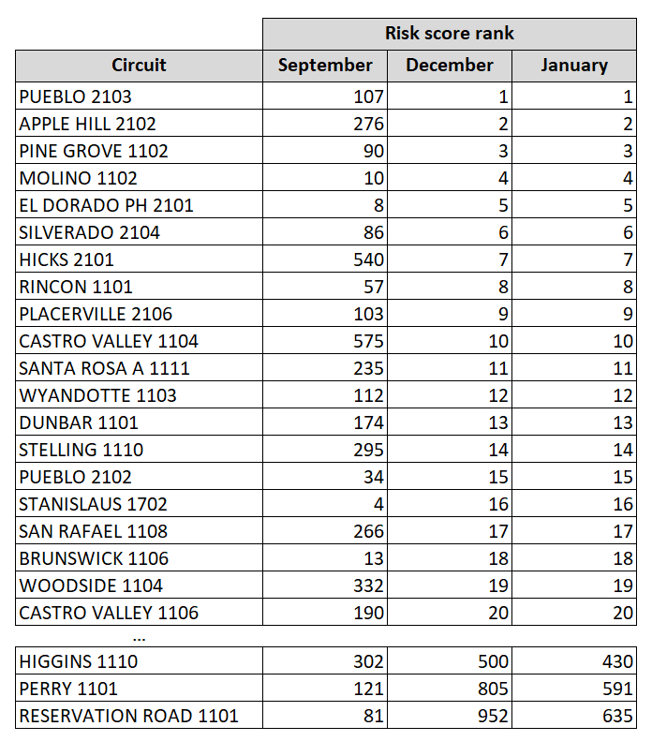

While PG&E’s changing approach to its risk ranking made it more challenging for WSD to evaluate PG&E’s EVM work, under all three risk rankings, PG&E has made insufficient progress toward risk-driven investments in its EVM program. Simply put, PG&E failed to risk-prioritize its EVM work on the ground, as is apparent from an analysis of the EVM work performed under any of the results.[4] This failure is demonstrated in the following tables and figures and summary, which are based on WSD’s EVM Audit.

PG&E states it completed 1,800 miles of EVM work in 2020 on 161 circuits. As shown in Table 3, using the September risk ranking, fewer than 60 miles of EVM work was completed on the top 20 highest risk lines. As shown in Table 4, using the January risk ranking, fewer than 92 miles of the 1,800 miles of EVM work was completed on the top 20 highest risk circuits.

**Table 3 - Miles of Completed Work, Top 20 Highest Risk Circuits (September 2020)**

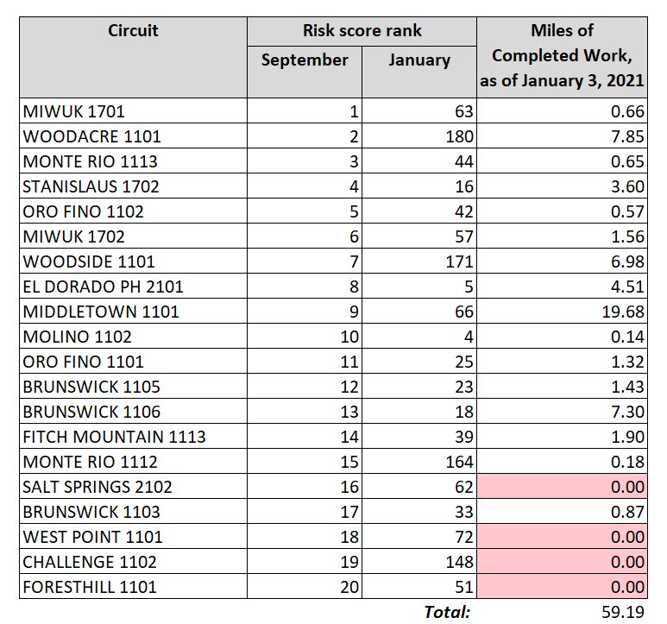

**Table 4 - Miles of Completed Work, Top 20 Highest Risk Circuits (January 2021)**

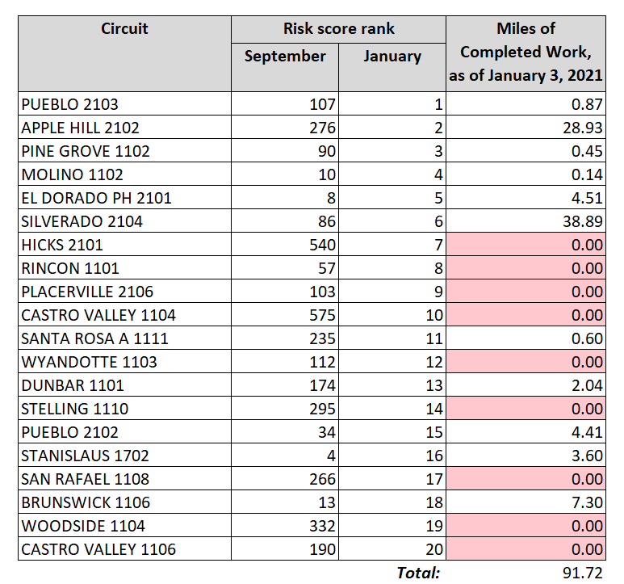

Seen another way, based on either PG&E’s September 2020 or January 2021 risk rankings, as of January 3, 2021, PG&E’s own reports show that a significant portion of the total miles for the 20 highest risk circuits remains unworked. This fact is demonstrated in Figures 1 and 2:

**Figure 1 - Miles Completed and Unworked Miles, Top 20 Circuits (September 2020)**

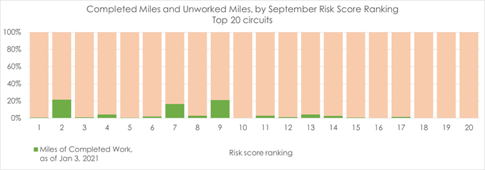

**Figure 2 - Miles Completed and Unworked Miles, Top 20 Circuits (January 2021)**

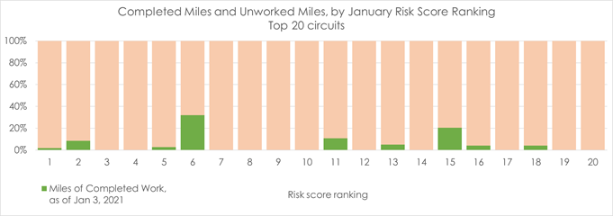

Further, looking at the full set of 161 circuits on which PG&E performed any EVM work in 2020, the highest percentage of this work was completed on the lowest-risk circuits. Figures 3 and 4 below illustrate the percentage of miles worked (in the green bars) on all 161 circuits, showing the September risk rankings in Figure 3 and the January risk rankings in Figure 4:

**Figure 3 - Miles Completed and Unworked Miles**

**161 Circuits with Work Performed in 2020, September Risk Rankings**

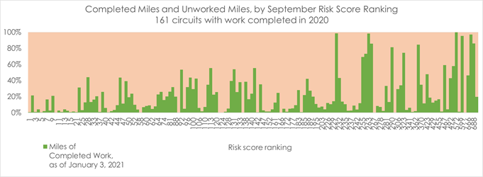

**Figure 4 - Miles Completed and Unworked Miles**

**161 Circuits with Work Performed in 2020, January Risk Rankings**

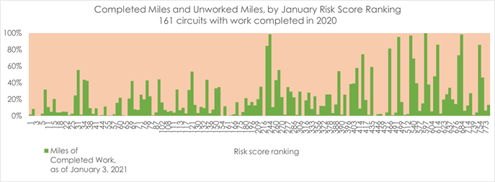

The examination in Figures 3 and 4 of the full set of 161 circuits on which PG&E performed EVM work in 2020 shows that the low-risk circuits received the greatest focus. This result is the opposite of the desired result and contrary to the expectations in the EOE Process that PG&E would demonstrate progress toward approved safety or risk-driven investments or else be placed into Step 1 of the EOE process.

By failing to prioritize EVM on the circuits PG&E itself identified as highest risk and allocating resources instead to conducting EVM on lower-risk circuits, in 2020 PG&E made insufficient progress toward approved safety or risk-driven investments.

1. **Consequences of Step 1 – Corrective Action Plan**

Step 1 triggers a requirement for PG&E to submit a Corrective Action Plan for approval by the Commission’s Executive Director. The Commission may move PG&E to another Step if it fails to adequately meet the conditions of its Corrective Action Plan within a required timeframe. If PG&E complies with the Corrective Action Plan requirements, it may exit Step 1. The Commission will inform PG&E whether PG&E has complied with the Step 1 conditions and may exit Step 1 via a Resolution. The Commission will issue a new Resolution in the event PG&E is required to move to another step of Enhanced Oversight and Enforcement.

PG&E’s Corrective Action Plan must explain how it will model the highest risk power lines and demonstrate that PG&E is prioritizing the highest risk lines in its EVM program. PG&E must also report accurately to the Commission where it is performing work and keep the Commission apprised of changes in its plans or the risk model(s) used to inform those plans. PG&E’s Corrective Action Plan is due no later than 20 days following issuance of this Resolution.

**3.** **Corrective Action Plan for Triggering Event A(iii)**

PG&E shall submit its Corrective Action Plan for approval by the Commission’s Executive Director. The Corrective Action Plan for Step 1 Section A(iii) shall consist of reporting starting on day 20 and every 90 days thereafter (until the Commission issues a Resolution or other communication ceasing the required reporting) as follows:

1. A description of the circumstances that contributed to PG&E’s failure to adequately prioritize the highest risk lines, as described in this Resolution and the WSD’s EVM Audit, in its EVM in 2020;
2. A description of its risk model(s) for determining where to target EVM in the next 90 days;
3. A detailed list of the EVM projects for the 12 months following the reporting date;
4. A description of how the list in item 3 above ensures PG&E is prioritizing the power lines with highest risk first;
5. An explanation of any planned EVM work does not target the power lines with highest risk first;
6. Any changes to its risk model occurring over the prior 90 days or planned for the subsequent 90 days;
7. A description of the circumstances that contributed to PG&E management’s inconsistent reporting on the details of its risk modeling and risk ranking lists;
8. Verification by a senior officer of PG&E that the risk model it is using to prioritize EVM is as set forth in its report;
9. Verification by a senior officer of PG&E that it will target EVM to the highest risk power lines first, as shown by its risk model or other ranking, in the next 90 days for EVM;
10. Verification by a senior officer of PG&E that it targeted EVM to the highest risk power lines first, as shown by its risk model or other ranking, in the prior 90 days;
11. Verification by a senior officer of PG&E that the company has communicated information in items 3, 4 and 9 above to personnel of PG&E’s EVM programs and that such personnel is aware of where to target EVM in the subsequent 90 days.
12. A proposed timeline for ending the required reporting, with a detailed explanation of why the proposal ensures PG&E is in compliance with the requirement that it prioritize high risk circuits in its EVM work. The timeline shall include milestone goals for June 1, 2021, September 1. 2021, and December 31, 2021. These goals shall include a targeted percentage of high risk power line circuits to be completed by those dates.
13. A description of how the Corrective Action Plan proposed in response to this Resolution will complement and not undermine PG&E’s compliance activities ordered in D.20-05-019.[5]

PG&E shall coordinate with Commission Staff on the formatting of its reporting for its Corrective Action plan to ensure the information provided is clearly discernable and demonstrates whether PG&E has made progress over the prior 90 days. At all times, the Commission retains the authority to exercise all powers within its jurisdiction regardless of PG&E’s position in Step 1 of the EOE Process.

**CONCLUSION**

PG&E’s conduct set forth herein justifies its placement into Step 1 of the EOE Process established in D.20-05-053. Consequently, PG&E is required to serve a Corrective Action Plan, as described herein, no later than 20 days following issuance of this Resolution for approval by the Commission’s Executive Director, and a progress report on the Corrective Action Plan every 90 days thereafter. If PG&E demonstrates that it is prioritizing high risk lines for EVM to the Commission’s satisfaction, it may be removed from the EOE process by Resolution. If it fails to satisfy the Step 1 requirements, it may be placed in Step 2 or such other Step as the Commission may direct. The Commission will issue a new Resolution specifying the consequences of such a failure by PG&E.

Nothing in this Resolution precludes the Commission from placing PG&E into another Step of the EOE Process if warranted.

**COMMENTS**

Public Utilities Code Section 311(g)(1) provides that this Resolution must be served on all parties and subject to at least 30 days public review and comment prior to a vote of the Commission. This Resolution is being served on the service lists for I.19-09-016 (which created the EOE Process) and R.18-10-007 (a formal Commission wildfire-related proceeding).

**FINDINGS**

1. PG&E is not sufficiently prioritizing its Enhanced Vegetation Management (EVM) based on risk.
2. PG&E’s progress on the highest risk power lines in 2020 is set forth herein in Tables 1-4 and Figures 1-4, as well as the EVM Audit.
3. PG&E’s failure to prioritize EVM on the highest risk power lines is a Triggering Event under Step 1 Section A(iii) of the EOE Process in D.20-05-053, which applies Step 1 if PG&E fails to make progress toward approved safety or risk-driven investments related to the electric business.
4. As a consequence of PG&E being in Step 1, PG&E is required by D.20-05-053 and this Resolution to submit a Corrective Action Plan. The Corrective Action Plan shall address the issues contained in this Resolution and be served as directed herein no later than 20 days following issuance of this Resolution, with follow-up reporting every 90 days thereafter.
5. The Commission will notify PG&E whether it meets or fails to meet the requirements of the Corrective Action Plan ordered in this Resolution. If it meets the requirements, the Commission will determine by Resolution that PG&E may exit Step 1.
6. If the Commission determines that PG&E has failed to satisfy the Corrective Action Plan, it may place PG&E in Step 2 or other relevant Step set forth in D.20-05-053. The Commission will issue a new Resolution specifying the consequences of such a failure by PG&E.

**THEREFORE, IT IS ORDERED that:**

1. Pacific Gas and Electric Company is in Step 1 of the Commission’s Enhanced Oversight and Enforcement Process adopted in Decision 20-05-053.
2. Pacific Gas and Electric Company shall serve in Investigation 19-09-016 (the proceeding resulting in Decision 20-05-053), Rulemaking 18-10-007 (a formal wildfire-related proceeding), and serve on the Wildfire Safety Division at [wildfiresafetydivision@cpuc.ca.gov](mailto:wildfiresafetydivision@cpuc.ca.gov), and on the Safety and Enforcement Division at [ESRB_ComplianceFilings@cpuc.ca.gov](mailto:ESRB_ComplianceFilings@cpuc.ca.gov), on the Commission’s Executive Director, and/or any other proceeding service lists or persons requested by the Commission or its staff, a Corrective Action Plan as described herein. The Corrective Action Plan shall be served no later than 20 days following issuance of this Resolution. The Corrective Action Plan shall request approval by the Commission’s Executive Director.
3. Every 90 days following service of the Corrective Action Plan described above, Pacific Gas and Electric Company shall serve in the same proceedings, and on the same email addresses as in ordering paragraph 2, a report updating the information required in the Corrective Action Plan until such time as the Commission issues a Resolution or other communication ceasing such required reporting.
4. In its Corrective Action Plan, Pacific Gas and Electric Company shall propose a timeline for the cessation of reporting required in this Resolution, with justification of the proposal.
5. Upon Pacific Gas and Electric Company’s demonstration that it is prioritizing high risk lines for Enhanced Vegetation Management to the Commission’s satisfaction and meeting all of the Step 1 conditions imposed by this Resolution, the Commission will issue a Resolution allowing Pacific Gas and Electric Company to exit Step 1.
6. If Pacific Gas and Electric Company fails to demonstrate that it is prioritizing high risk lines for Enhanced Vegetation Management to the Commission’s satisfaction and meeting all of the Step 1 conditions, the Commission may place Pacific Gas and Electric Company in Step 2 or other relevant Step set forth in Decision 20-05-053. If the Commission determines such action is appropriate, it will issue a new Resolution.
7. Nothing in this Resolution limits the Commission’s authority to place Pacific Gas and Electric Company into any Step set forth in Decision 20-05-053's Enhanced Oversight and Enforcement process at any time.
8. Nothing in this Resolution limits the Commission’s authority to take actions to ensure safe and reliable gas and electric service, enforce its own orders or California law and regulation, or take any other steps to ensure Pacific Gas and Electric Company’s system is designed, operated and maintained to mitigate catastrophic wildfire.

This Resolution is effective today.

I certify that the foregoing Resolution was duly introduced, passed and adopted at a conference of the Public Utilities Commission of the State of California held on   
April 15, 2021, the following Commissioners voting favorably thereon:

*______________________*

Rachel Peterson

Executive Director

Attachment 1:

[Appendix A - Enhanced and Enforcement Process](http://docs.cpuc.ca.gov/PublishedDocs/Published/G000/M367/K859/367859331.PDF)

1. *Rehearing denied*, D.20-12-015. The underlying decision adopts, with modifications, a settlement with regard to the *Order Instituting Investigation on the Commission’s Own Motion into the Maintenance, Operations and Practices of Pacific Gas and Electric Company (U39E) with Respect to its Electric Facilities; and Order to Show Cause Why the Commission Should not Impose Penalties and/or Other Remedies for the Role PG&E’s Electrical Facilities had in Igniting Fires in its Service Territory in 2017.* The decision and settlement require reporting, root cause analyses of past fires, and other actions related to wildfires in PG&E’s territory.
2. *See, e.g.,* Resolution WSD-003 at 24-25 & Appendix A, Conditions PGE-5 and PGE-18; Resolution WSD-002 at 21 & Appendix A, Conditions Guidance-1 and Guidance-3; and WSD June 11, 2020 Action Statement on PG&E’s WMP at 3-5.
3. The EVM Audit is available at the following link: <https://www.cpuc.ca.gov/uploadedFiles/CPUCWebsite/Content/About_Us/Organization/Divisions/WSD/2021.02.08.EVMAudit.pdf>. Its contents are incorporated as if set forth herein. In response to the EVM Audit, PG&E has stated the January 2021 risk ranking is not a “model” but that characterization does not alter the basic conclusion of this Resolution.
4. The December 2020 and January 2021 Risk Rankings are similar for the highest risk circuits; accordingly, like the EVM Audit this Resolution uses the September 2020 and January 2021 lists.
5. D.20-05-019 adopted a settlement agreement among PG&E, the Safety and Enforcement Division and other parties which required several actions by PG&E with regard to its vegetation management, including 1) a Tree Crew Training and Certificate Program; 2) a Pre-Inspector Training and Certificate Program; 3) a Vegetation Management Oversight Pilot; 4) Semi-Annual Wildfire Mitigation Meetings among PG&E and local government planning, public works, emergency services, and fire leadership to exchange feedback and information regarding ongoing wildfire safety activities; 5) Independent Wildfire Safety Audits; 6) Quarterly Reports on Electric Maintenance Work; 7) Fuel Reduction Funding; 8) Local Government Vegetation Management Data Sharing: and 9) a PG&E shareholder-funded Independent Study of PG&E’s Distribution and Transmission System.