PUBLIC UTILITIES COMMISSION OF THE STATE OF CALIFORNIA

Communications Division Resolution T-17704

Carrier Oversight & Programs Branch June 3, 2021

R E S O L U T I O N

Resolution T-17704. Approval of the partial refund of surcharge and user fee overpayments to Santa Barbara Cellular Systems, LLC, AT&T Mobility Wireless Operations Holdings, Inc., and New Cingular Wireless PCS, LLC (AT&T Mobility). Additionally, the Commission requires AT&T Mobility to pay the outstanding amounts due to the Commission and authorize deduction of this from the total approved refund amount. The final approved total refund to AT&T Mobility is $270,370.75.

_____________________________________________________________________________

SUMMARY

This Resolution approves in part the requests for refund of overpayments of the California Public Utilities Commission (CPUC or Commission) Public Purpose Program surcharges (surcharges) and Public Utilities Commission user fees (user fees) submitted by Santa Barbara Cellular Systems, LLC (U-3015-C), AT&T Mobility Wireless Operations Holdings, Inc. (U-3021-C), and New Cingular Wireless PCS, LLC (U-3060-C), (hereafter referred to collectively as AT&T Mobility) all submitted via Advice Letter (AL) Numbers 166, 161, and 8, respectively. These overpayments were the result of AT&T Mobility erroneously submitting surcharges and user fees associated with data revenues.

AT&T Mobility owes the Commission $326,732.95 in accrued interest for its failure to report and correctly remit the amounts due to the California Advanced Service Fund (CASF) program for two reporting periods in 2011. The Commission is deducting the amounts AT&T Mobility owes from the total amount of approved refund to AT&T Mobility. Therefore, the total remaining surcharges and user fees this Resolution approves for refund is equal to $270,370.75. Table 1 provides the summary of the refunds and owed amounts.

**Table 1: Summary of AT&T Mobility Approved CPUC Refund and Amounts Owed**

|  |  |  |  |  |
| --- | --- | --- | --- | --- |
|  | **Santa Barbara Cellular  (U-3015-C)** | **AT&T Mobility Wireless  (U-3021-C)** | **New Cingular Wireless (U-3060-C)** | **Total** |
| Surcharge Refund | $ 9,481.52 | $ 7,029.51 | $ 526,283.05 | $ 542,794.08 |
| User Fees Refund | $ 1,346.77 | $ 702.02 | $ 52,260.83 | $ 54,309.62 |
| *Subtotal of Refund* | $ 10,828.29 | $ 7,731.53 | $ 578,543.88 | $ 597,103.70 |
| Total Owed | $ 3,393.82 | $ 7,013.15 | $ 316,325.98 | $ 326,732.95 |
| **Total Refund** | **$ 7,434.47** | **$ 718.38** | **$ 262,217.90** | **$ 270,370.75** |

The CPUC Administrative Service Division’s Fiscal Office shall undertake the necessary procedures to transmit the funds, subject to refund, to AT&T Mobility and update the records regarding the monies owed as identified in this resolution.

BACKGROUND

All telephone corporations (carriers) are required to assess Telecommunications surcharges[1] and user fees[2] on California end-user intrastate service revenues, and to remit the collected funds to the Commission. Attachment A to this Resolution provides background information on surcharges and user fees.

In 2010, the Commission created the proprietary Telecommunications and User Fee Filing System (TUFFS) to facilitate the reporting and remittances of surcharges and user fees. Prior to January 2016, carriers reported their intrastate revenues subject to surcharges and user fees using separate methods: for surcharge assessment, carriers utilized TUFFS; and for user fee assessment, carrier used the paper User Fee Statement. Beginning in 2016, TUFFS allowed carriers to enter one intrastate revenue base for the purpose of surcharge and user fee assessment.

AT&T Mobility provides both prepaid and postpaid wireless telephone services in California. As a registered cellular provider and telephone corporation in California, AT&T Mobility is required to collect, report and remit surcharges and user fees to the Commission. Surcharges and user fees, further discussed below, are assessed on a carrier’s intrastate revenues. These charges are calculated as a percentage of intrastate prepaid and postpaid wireless service revenues subject to surcharge. The Federal Communications Commission (FCC) has classified internet access and data services as interstate information services and the Commission has not required collection and remittance of surcharges and user fees from those services.[3]

On January 26, 2016, AT&T Mobility sent a letter to the Director of the Commission’s Communications Division (CD) explaining that, from January 2013 through September 2015, AT&T Mobility overpaid its surcharges and user fees by erroneously including prepaid data and text messaging (text) revenues in reporting its intrastate telecommunications revenues to the Commission. AT&T Mobility claims that these services should not have been included in the intrastate revenues because, it asserts, surcharging these services violates federal law.

In February 2016, staff advised AT&T Mobility to submit Tier III ALs to formally request the recovery of alleged overpayments to the Commission. In addition, staff advised AT&T Mobility that the period allowed for the recovery of surcharges and user fees resulting from carrier’s reporting errors was limited. On March 2016, Acting CD Director issued a letter to AT&T Mobility reminding them that text messaging revenues were subject to surcharges and user fees.[4] Hence, the requested refund amounts shall be limited to a one-year period prior to the date on which the Commission was notified and shall pertain to only the portion involving data.

On August 15, 2016, AT&T Mobility submitted Tier III AL Nos. 166, 161, and 8. In these ALs, AT&T Mobility requested refunds for overpayments of surcharges and user fees that it erroneously made for prepaid services from January 2013 through September 2015.

On September 14, 2016 and January 23, 2017, staff suspended AT&T Mobility’s AL   
Nos. 166, 161, and 8 to allow for adequate time to collect and analyze the data in preparation of a Resolution.

On June 6, 2018, AT&T Mobility revised its claims by submitting a letter to CD to reflect a refund for only data or Internet access service.[5]The revised requested refund amount totals were: $50,387.00 for Santa Barbara Cellular Systems, LLC; $27,922.00 for AT&T Mobility Wireless Operations Holdings, Inc.; and $2,100,265.00 for New Cingular Wireless PCS, LLC.

During the AL review, staff discovered that the AT&T Mobility companies’ monthly remittances to the Commission were generally erroneous. Underpayments and overpayments occurred for numerous reporting periods for surcharges and user fees from 2010 to 2017. Staff informed AT&T Mobility about these issues.

On June 15, 2018, the CD Deputy Director issued a letter to AT&T Mobility to remind the company of its responsibility to ensure accurately reporting and remittance of surcharges. The letter noted that AT&T Mobility did not accurately report and remit CASF surcharges timely, resulting in accrued interest.[6] Per D.98-01-023 and G.O. 153 (11.4), carriers who are late in remitting surcharges shall pay a penalty equal to an annual interest rate of 10%. The letter also directed AT&T Mobility to pay the accrued interest of $326,732.95 in addition to remitting the amounts due for the periods owed. AT&T Mobility addressed the remittances of the amounts due for the periods owed but it did not pay the accrued interest.[7]

In July 2020, staff noted that AT&T Mobility reported different intrastate revenue amounts for the purpose of surcharge and user fee assessments for the periods requested. Staff relayed this information to AT&T Mobility, which was able to provide the Commission an explanation to support its calculation methodology for the different intrastate revenue bases.

On September 30, 2020, CD staff issued a data request to AT&T Mobility related to its refund request. Among other things, staff requested an explanation for AT&T Mobility’s failure to address the outstanding amounts owed identified in the CD June 2018 letter issued. On December 4, 2020, AT&T Mobility provided its response to CD’s data request but did not provide an explanation for its failure to address the outstanding amounts owed of accrued interest. On December 23, 2020, staff issued a second data request to AT&T Mobility seeking additional information and again requesting an explanation as to why AT&T Mobility did not address the outstanding amounts owed identified in the June 2018 letter. On January 25, 2021, AT&T Mobility provided a response to the data request and identified that it should not be required to pay the accrued interest and stated the following “… there is no Commission order that authorizes a 10% interest penalty for late-paid CASF surcharge remittances…”.

Issuance and Withdrawal of Draft Resolution T-17553

On January 17, 2019, CD prepared and issued draft Resolution T-17553 for public comment. On February 11, 2019, AT&T Mobility filed comments to the draft Resolution. Due to new issues that required additional review, the draft Resolution was ultimately withdrawn from the March 14, 2019 Commission meeting agenda.

CPUC Internal Audit Review

Shortly after withdrawal of the draft Resolution T-17553, CD requested that the Commission’s Utility Audit Branch (UAB) conduct a review of the surcharges and user fees refund requested by AT&T Mobility. The results of the internal audit review were inconclusive and were not taken into account in staff’s recommendations in this Resolution.

DISCUSSION

In its respective ALs, AT&T Mobility claimed that, in reporting intrastate revenues to the Commission from January 1, 2013 through September 30, 2015, it erroneously included intrastate prepaid wireless data service revenue, which is not subject to surcharges or the user fee. AT&T Mobility asserted that the inadvertent overstatement of revenues resulted in overpayments for the periods identified.

The total amounts requested by AT&T Mobility companies to be refunded are summarized in Table 2 and Table 3.

**Table 2: AT&T Mobility Requested Refund Amounts (Advice Letters)**

|  |  |  |  |
| --- | --- | --- | --- |
| **Carrier** | **Surcharges** | **User Fees** | **Total** |
| Santa Barbara Cellular (U-3015-C) AL No. 166 | $ 34,535 | $ 1,763 | $ 36,298 |
| AT&T Mobility Wireless (U-3021-C) AL No. 161 | $ 26,549 | $ 1,373 | $ 27,922 |
| New Cingular Wireless (U-3060-C) AL No. 8 | $ 1,996,821 | $ 103,444 | $ 2,100,265 |
| **Total** | **$ 2,057,905** | **$ 106,580** | **$ 2,164,485** |

**Table 3: Updated AT&T Mobility Requested Refund Amounts (June 6, 2018 Letter)**

|  |  |  |  |
| --- | --- | --- | --- |
| **Carrier** | **Surcharges** | **User Fees** | **Total** |
| Santa Barbara Cellular (U-3015-C) | $ 47,731 | $ 2,656 | $ 50,387 |
| AT&T Mobility Wireless (U-3021-C) | $ 26,549 | $ 1,373 | $ 27,922 |
| New Cingular Wireless (U-3060-C) | $ 1,996,821 | $ 103,444 | $ 2,100,265 |
| **Total** | **$ 2,071,101** | **$ 107,473** | **$ 2,178,574** |

Additionally, AT&T Mobility stated in their ALs that “*No AT&T Mobility customers were affected by this accounting error and no refunds to customers are owed. These specific Surcharge and User Fee amounts were not collected from prepaid customers.*” CD requested information to support this claim. Because the surcharge amounts were levied on prepaid transactions, AT&T Mobility was unable to provide additional information due to the nature of prepaid transactions during the period requested.[8] AT&T Mobility states that prepaid surcharges were paid out of general prepaid revenue prior to January 2016, and not billed to customers as a specific line item. Therefore, a refund to prepaid customers is not necessary.

CD reviewed the jurisdictional allocation percentages AT&T Mobility presented in their ALs’ request. In December 2016, AT&T Mobility provided jurisdictional allocation percentages, i.e., intrastate, interstate, and international percentages, for the periods of January 2013 through March 2016. According to AT&T Mobility, these jurisdictional allocation percentages result from its quarterly-conducted traffic studies and are used to establish and report intrastate revenues to the Commission. AT&T Mobility utilized the same jurisdictional allocation percentages.

Along with its traffic studies, AT&T Mobility also provided its summarized service allocation percentages for the periods of January 2013 through March 2016, i.e., voice, text, and data service allocations, which were derived from its marketing studies. The summarized results illustrate monthly shifts in the service allocation percentages. However, in its response to the staff’s data request, AT&T Mobility identified that “the 3rd quarter 2013 marketing study continued to be used until it was updated in 2015.” AT&T Mobility further explained that in 2015, “there was a shift from AT&T offering stand-alone plans to bundled plans.” Hence, the marketing study was updated.[9] According to AT&T Mobility, similar to traffic studies, they utilized the service allocation factors derived from the same marketing studies.

AT&T Mobility also presented its calculations for the claimed overpayments of surcharges and user fees in spreadsheets provided to staff. Tables 4 and 5 illustrate AT&T Mobility’s spreadsheets by detailing the column headers and formulas as shown below.[10]

The spreadsheets detailed the AT&T Mobility’s monthly total intrastate revenues as reported in TUFFS(B)[11] and total monthly prepaid revenues(C).[12] The total monthly prepaid revenue was allocated between services (i.e. voice (D), text (E), and data (F)) using factors or percentage rates derived from the marketing studies as discussed above.[13] AT&T Mobility then multiplied its prepaid data revenue (F) by the intrastate factor derived from its traffic studies (G), also discussed above, to arrive at the monthly intrastate prepaid revenue attributed to data (H). These are the amounts which AT&T Mobility claims were inadvertently included in the reports to the Commission, thus resulting in overpayment of surcharges and user fees.

AT&T Mobility provided the “correct” revenue amount (I) by subtracting the intrastate prepaid data revenues (H) from the total intrastate revenues originally reported in TUFFS (B).

**Table 4. Column Headings and Formula to Calculate “Correct” Revenue Amount**

|  |  |  |  |  |  |  |  |  |
| --- | --- | --- | --- | --- | --- | --- | --- | --- |
| **Reporting**  **Period** | **Original**  **Reported**  **Amount** | **Prepaid**  **Revenue** | **Prepaid**  **Voice** | **Prepaid**  **SMS** | **Prepaid**  **Data** | **Intrastate**  **Factor** | **Intrastate**  **Prepaid**  **Data** | **Correct Revenue**  **Amount** |
| (A) | (B) | (C) | (D) =  (C * %) | (E) =  (C * %) | (F) =  (C * %) | (G) | (H) =  (F * G) | (I) =  (B - H) |

In the same spreadsheets, to illustrate the dollar amounts of surcharges and user fees its alleged were overpaid to the Commission (Q, R…W), AT&T Mobility multiplied the intrastate prepaid data revenues (H) by each individual program’s rates effective for the corresponding time periods (J, K…P).

**Table 5. Column Headings and Formula to Calculate Overpayment**



Staff believes that AT&T Mobility’s calculation methodology is generally reasonable and utilized the same methodology to calculate the appropriate final refund amounts. However, in doing so, staff incorporated adjustments to correct the data used in the calculation. Among the adjustment made were:

1. **Reported Intrastate Revenues for User Fee.** Staff further reviewed and validated the intrastate revenues identified for each reporting period identified by AT&T Mobility. Staff noted that AT&T Mobility have reported intrastate revenues differently for surcharge and user fee assessments. Therefore, the allowed surcharge and user fee refunds will be based on the actual reported revenue by AT&T Mobility (i.e., user fee refunds will be based on the intrastate revenues as reflected in their User Fee Statement instead of their reported revenue reported in TUFFS and surcharge revenues will be based on revenues reported in TUFFS).
2. **Service Allocation Factors.** Only three marketing studies were conducted from January 2013 through September 2015, the last of which was conducted in the 3rd quarter of 2013.[14] After that, the shift from stand-alone to bundled services in mid-June 2015 is the only proof of a change in service allocations provided to the Commission. For this reason, staff disregards the service allocation figures reflected from the 1st quarter of 2014 through the 2nd quarter of 2015. Instead, staff relied on the documented figures presented for December 2013 period to compute the overpayments from January 2014 through June 2015. Staff then utilized AT&T Mobility’s provided service allocation figures for January 2013 through December 2013 and July through September 2015 for the corresponding reporting periods. Therefore, staff only used service allocation figures supported by documented marketing studies.
3. **Allowable Refund Period.** AT&T Mobility requested the refund period from January 2013 through September 2015 for both surcharges and user fees. AT&T Mobility provided notice to the Commission in January 2016 and subsequently submitted ALs in August 2016. The Government Claims Act requires claims for refunds on surcharges to be submitted within one year of the accrual of the claim. (See Gov. Code, § 911.2.). Staff had published instructions that stated adjustments in TUFFS could be made within 36 months from the original reported date. However, staff removed these specific instructions from the Commission’s website before these ALs were submitted in August 2016 to be consistent with the Government Claims Act. Therefore, staff is recommending that the Commission only allow AT&T Mobility to obtain the following refunds for the specified period:

* Surcharge refunds from January 2015 through September 2015 periods; and
* User Fee refunds from January 2013 through September 2015 periods.

After incorporating all the adjustments and utilizing the same calculation methodology by AT&T Mobility, the final approved refund amounts are shown in Table 6.

**Table 6: CPUC Approved Refund Amounts**

|  |  |  |  |
| --- | --- | --- | --- |
| **Carrier** | **Surcharge Refund** | **User Fees Refund** | **Total Refund** |
| Santa Barbara Cellular (U-3015-C) | $ 9,481.52 | $ 1,346.77 | $ 10,828.29 |
| AT&T Mobility Wireless (U-3021-C) | $ 7,029.51 | $ 702.02 | $ 7,731.53 |
| New Cingular Wireless (U-3060-C) | $ 526,283.05 | $ 52,260.83 | $ 578,543.88 |
| **Total Refund** | **$ 542,794.08** | **$ 54,309.62** | **$ 597,103.70** |

At the issuance of this Resolution, AT&T Mobility has not paid the Commission the outstanding CASF interest accrued for November and December 2011 reporting periods. AT&T Mobility asserted that there was no Commission order that authorizes a 10% late penalty for failure to report and remit on CASF surcharges. The January 29 data request response submitted by AT&T Mobility also reminded CD that in March 2019, and again in May 2019, it requested for consideration to harmonize existing public purpose program rules related to the administrative aspects of the programs, e.g., company claims and payments, collection and remittance of program surcharges, program audits, etc. AT&T Mobility recommended that their request could be achieved by issuing a Resolution for Commission consideration.

CD believes that it has applied the appropriate penalty structure for failure to report and remit on CASF surcharges. Also, if there were administrative program issues that required correction, the proposed issuance of a Resolution would only apply on a prospective basis. Staff informed AT&T Mobility of the deficiency in 2018 for CASF reporting and remittance for November and December 2011 periods. Therefore, the requested Resolution cannot be applied retroactively. CD believes it is appropriate to recoup the money owed by deducting it from the amount of aforementioned refund. The total amount of outstanding CASF Interest accrued and owed to the Commission is shown in Table 7.

**Table 7: AT&T Mobility Amount of Outstanding CASF Interest Accrued**

|  |  |  |  |
| --- | --- | --- | --- |
| **Carrier** | **CASF Surcharge Interest for Late Payment** | | **Total Owed** |
| **Nov 2011** | **Dec 2011** |
| Santa Barbara Cellular (U-3015-C) | $ 1,701.04 | $ 1,692.78 | $ 3,393.82 |
| AT&T Mobility Wireless (U-3021-C) | $ 3,458.28 | $ 3,554.87 | $ 7,013.15 |
| New Cingular Wireless (U-3060-C) | $ 157,623.10 | $ 158,702.88 | $ 316,325.98 |
| **Total Owed** | **$ 162,782.42** | **$ 163,950.53** | **$ 326,732.95** |

Because AT&T Mobility failed to pay the amounts owed to the Commission as directed by CD Deputy Director in June 2018, staff recommends that the Commission deduct the amounts owed from the total amount of CPUC-approved refund for AT&T Mobility. Therefore, the final total surcharges and user fees approved for refund by this Resolution is equal to $270,370.75 as summarized in Table 1 of this resolution.

The CPUC Administrative Service Division’s Fiscal Office shall undertake the necessary procedures to transmit the funds, subject to refund, to AT&T Mobility and update the Commission’s records regarding the monies owed as identified in this resolution.

Safety Considerations

There are no specific safety issues raised in this Resolution.

**COMMENTS ON PROPOSED RESOLUTION**

In compliance with P.U. Code § 311(g), a notice letter was emailed on April 27, 2021 informing interested parties of the availability of the draft of this Resolution for public comments at the Commission’s website <http://www.cpuc.ca.gov>. This letter also informed parties that the final Resolution adopted by the Commission will be posted and will be available at the same website.

CONCLUSION

Staff recommends that the Commission approve a partial refund of surcharge and user fee overpayments to AT&T Mobility resulting from the erroneous inclusion of intrastate data revenue in its monthly reporting. Staff further recommends that the Commission require AT&T Mobility to pay the outstanding amounts due to the Commission and authorize this amount to be deducted from the total approved refund amount.

Upon adoption of this Resolution, the Administrative Service Division’s Fiscal Office will undertake the necessary procedures to issue the refund amount to the respective AT&T Mobility companies and update its records accordingly.

Lastly, we remind AT&T Mobility and all other carriers providing services in California to be mindful of their responsibility to timely and accurately to report and remit surcharges and user fees to the Commission. We also note that each case involving overpayments and refunds of surcharges and user fees has its own set of facts. Therefore, this Resolution shall not serve as a precedent for other situations involving overpayments of surcharges and/or user fees.

On March 24, 2020, the CPUC Administrative Service Division’s Fiscal Office staff established and posted on the Commission website an updated guideline for internal processing of surcharge and user fee-related refund claims.[15] Among other things, the updated guidance identified that *“Claims are limited to reporting errors that occurred within 12 months prior to the date the carrier notifies the Commission by e-mail of the error.”* All future refunds must comply with the internal process for surcharge and user fee-related refund claims established on March 24, 2020. See Attachment B of this Resolution.

FINDINGS

1. On January 26, 2016, Santa Barbara Cellular Systems (U-3015-C), AT&T Mobility Wireless Operations Holdings, Inc. (U-3021-C) and New Cingular Wireless PCS, LLC (U-3060-C), collectively referred to as AT&T Mobility, notified the Commission’s CD staff of its erroneous inclusion of prepaid Internet access (data) services in its reported intrastate revenues from January 2013 through September 2015. AT&T Mobility claimed that this error resulted in overpayment of surcharges and user fees for the period of January 2013 through September 2015.
2. In February 2016, staff advised AT&T Mobility to submit a Tier III AL to request a refund for any overpayment of surcharges and user fees. Staff advised AT&T Mobility that the recovery would be limited to a one-year period prior to the date on which AT&T Mobility first reported the overpayments to the Commission.
3. On August 15, 2016, AT&T Mobility submitted Tier III AL No. 166 (U-3015-C, Santa Barbara Cellular Systems), AL no. 161 (U-3021-C, AT&T Mobility Wireless Operations Holdings, Inc.), and AL no. 8 (U-3060-C, New Cingular Wireless PCS, LLC) to request for the recovery of overpaid surcharges and user fees of the said companies from January 2013 through September 2015.
4. All telephone corporations are subject to the Commission’s jurisdiction and are required to assess Telecommunications surcharges and user fees on California end-user intrastate service revenues; and are responsible for timely and accurate reporting and remittance of surcharges and user fees.
5. The FCC has classified internet access and data services as interstate information services, and the Commission has not required collection and remittance of surcharges and user fees from those services. Text messaging revenues were subject to surcharges and user fees.
6. AT&T Mobility, a registered cellular provider and telephone corporation in California, provides both prepaid and postpaid wireless telephone services in California.
7. AT&T Mobility states that surcharges and user fees were not collected from prepaid customers. AT&T Mobility was unable to provide additional information due to the nature of prepaid transactions during the period requested. AT&T Mobility states that prepaid surcharges were paid out of general prepaid revenue prior to January 2016, and not billed to customers as a specific line item. Therefore, a refund to prepaid customers is not necessary.
8. AT&T Mobility states that it conducts quarterly traffic studies for jurisdictional allocation. AT&T Mobility provided the Commission with summarized results which are shown as percentage rates for the periods of January 2013 through March 2016. AT&T Mobility allocates its revenues between intrastate, interstate, and international jurisdictions according to these percentage rates.
9. AT&T Mobility states that it conducts quarterly market analysis for service allocation. It provided the Commission with summarized results which are shown as percentage rates for the periods of January 2013 through March 2016. AT&T Mobility allocates its revenues between voice, text, and data services, according to these percentage rates.
10. AT&T Mobility provided staff with spreadsheets illustrating their calculations of surcharge and user fee overpayments. With the exception of service allocation rates utilized, staff deems AT&T Mobility’s calculation methodology to be reasonable.
11. Staff utilized service allocations based on the companies’ documented market study only.
12. Staff noted that AT&T Mobility reported intrastate revenues differently for surcharge and user fee assessments, as was authorized by the Commission during the period in question. Therefore, the allowed refund for user fees should be based on the actual reported revenue by AT&T Mobility as reflected in their User Fee Statement instead of their reported revenue as reported in TUFFS. From this, Staff applied the calculation methodology to derive the revised intrastate revenue for user fee purposes.
13. In accordance with the Government Claims Act (See Gov. Code, § 911.2) refund claims must be submitted within one year of the claim accrual.  In this case, the refund request for surcharges shall only apply to overpayments made from January 2015 through September 2015, consistent with the January 2016 date that AT&T Mobility first notified the CPUC of the overpayment issue.
14. The Commission has determined that AT&T Mobility’s refund request for user fees shall be granted for all periods requested: January 2013 through September 2015.
15. On June 15, 2018, the CD Deputy Director issued a letter to AT&T Mobility to remind the company of its responsibility to accurately report and remit surcharges. The letter noted that AT&T Mobility did not accurately report and remit CASF surcharges timely and resulted in accrued interest. AT&T Mobility addressed the remittances of the amounts due for the periods owed but it did not pay the accrued interest. AT&T Mobility owed approximately $326,732.95in accrued interest and has not paid this amount as of issuance of this Resolution.
16. Staff recommends that $597,103.70 is owed in refunds to AT&T Mobility and from which will be deducted the amount owed to the Commission of $326,732.95. The total amount of refund after deductions of accrued interest is $270,370.75. The amounts applicable to each company are detailed in Tables 1, 6 and 7 of this Resolution.
17. On March 24, 2020, the Administrative Service Division’s Fiscal Office staff established and posted on the Commission’s website an updated guideline for internal processing of surcharge and user fee-related refund claims.
18. The CPUC Administrative Service Division’s Fiscal Office will undertake the necessary procedures to issue AT&T Mobility its respective refund amounts (via issuance of a check) and update its records accordingly within 60 days upon adoption of this Resolution.

**THEREFORE, IT IS ORDERED that:**

1. The Commission approves in part the refund of $597,103.70 owed to AT&T Mobility and from which shall be deducted the amount owed to the Commission of $326,732.95. The total amount of refund after deductions of accrued interest is $270,370.75.
2. Within 60 days from the date of adoption of this Resolution, CPUC Administrative Service Division’s Fiscal Office shall undertake the necessary procedures to update its records and issue a refund (via check) of $7,434.47 to Santa Barbara Cellular Systems, LLC’s (U-3015-C) for overpaid surcharges from January through September 2015 and user fees from January 2013 through September 2015.
3. Within 60 days from the date of adoption of this Resolution, CPUC Administrative Service Division’s Fiscal Office shall undertake the necessary procedures to update its records and issue a refund (via check) of $718.38 to AT&T Mobility Wireless Operations Holdings, Inc.’s (U-3021-C) for overpaid surcharges from January through September 2015 and user fees from January 2013 through September 2015.
4. Within 60 days from the date of adoption of this Resolution, CPUC Administrative Service Division’s Fiscal Office shall undertake the necessary procedures to update its records and issue a refund (via check) of $262,217.90 to New Cingular Wireless PCS, LLC ‘s (U-3060-C) for overpaid surcharges from January through September 2015 and user fees from January 2013 through September 2015.

This Resolution is effective today.

I hereby certify that the Public Utilities Commission adopted this Resolution at its regular meeting on _________________. The following Commissioners adopted it:

___________________________

Rachel Peterson

Executive Director

**ATTACHMENT A**

Public Purpose Program Surcharges

The Public Purpose Program surcharges are assessed on revenues collected from end-use intrastate telecommunications services.[16] Carriers’ report and remit the PPP surcharges revenues and user fees through the Commission’s proprietary Telecommunications User Fee Filing System (TUFFS). The surcharges collected fund the six universal service funds administered by the Commission, set forth in Public Utilities Code Sections 275 through 281 and 2881. They are as follows:

* **Universal Lifeline Telephone Service (ULTS):** provides discounted home phone and cellular phone services to qualifying low-income households.
* **Deaf and Disabled Telecommunications Program (DDTP):** provides telecommunications devices to deaf or hearing-impaired consumers.
* **California High Cost Fund-A (CHCF-A):** provides subsidy to small local exchange carriers for providing telephone service to residential customers in rural high-cost areas.
* **California High Cost Fund-B (CHCF-B):** provides subsidy to carriers of last resort for providing telephone service to residential customers in rural high-cost areas.
* **California Teleconnect Fund (CTF):** provides a discount on select communications services to schools, libraries, hospitals, and other non-profit organizations.
* California Advanced Services Fund (CASF): supports the deployment of broadband facilities and broadband services adoption in unserved and underserved areas through project specific grant funding.

The surcharge rates vary for each program discussed above and are adjusted periodically based on forecasted budget. The following table reflects the effective surcharge rates from January 1, 2013 through September 30, 2015. The adjustments made for each rate are highlighted for reference.

**Table A-1: Public Purpose Program Surcharge Rates**

|  |  |  |  |  |  |  |
| --- | --- | --- | --- | --- | --- | --- |
| Effective Date | ULTS | DDTP | CHCF-A | CHCF-B | CTF | CASF |
| 12/01/12 | 1.150% | 0.200% | 0.400% | 0.300% | 0.590% | 0.140% |
| 04/01/13 | 1.150% | 0.200% | 0.400% | 0.300% | 0.590% | 0.164% |
| 10/01/13 | 1.150% | 0.200% | 0.180% | 0.300% | 0.590% | 0.164% |
| 02/01/14 | 1.150% | 0.200% | 0.180% | 0.000% | 0.590% | 0.164% |
| 04/01/14 | 1.150% | 0.200% | 0.180% | 0.000% | 0.590% | 0.464% |
| 10/01/14 | 1.150% | 0.200% | 0.180% | 0.000% | 0.930% | 0.464% |
| 01/01/15 | 2.400% | 0.200% | 0.350% | 0.000% | 0.930% | 0.464% |
| 02/01/15 | 2.400% | 0.500% | 0.350% | 0.000% | 0.930% | 0.464% |
| 06/01/15 | 2.400% | 0.500% | 0.350% | 0.000% | 1.080% | 0.464% |
| 08/01/15 | 3.800% | 0.500% | 0.350% | 0.000% | 1.080% | 0.464% |

The surcharge rates on August 1, 2015 remained effective through September 2015.

CPUC User Fees

Public Utilities Code Sections 431 through 435 sets forth the User Fee requirements. The monies collected as user fees are deposited into the Public Utilities Commission Utilities Reimbursement Account and finance the Commission's annual operating budget.

The Commission annually determines the User Fee rate which is to be assessed on all CPUC regulated entities. For telecommunication carriers, the fee is assessed on intrastate telecommunications revenues. For carriers with reported annual intrastate revenues of $750,000 or more, the User Fee rate was .18% (.0018) from January 1, 2013 through September 30, 2015. These carriers are required to remit user fees quarterly, by the 15th of January, April, July, and October.[17]

Prior to January 1, 2016, carriers submitted hardcopy reports and actual checks to the Commission for User Fee payments. Upon receiving the documents, Commission staff recorded the revenues and tracked the payments through an electronic filing system which was decommissioned in December 2015.[18] As of January 2016, carriers submit revenue reports and user fee payments, along with surcharge revenue reports and payments, through the TUFFS database.

**END OF ATTACHMENT A**

**ATTACHMENT B**

March 24, 2020 CPUC Internal Process for Surcharge and User Fee-related refund claims

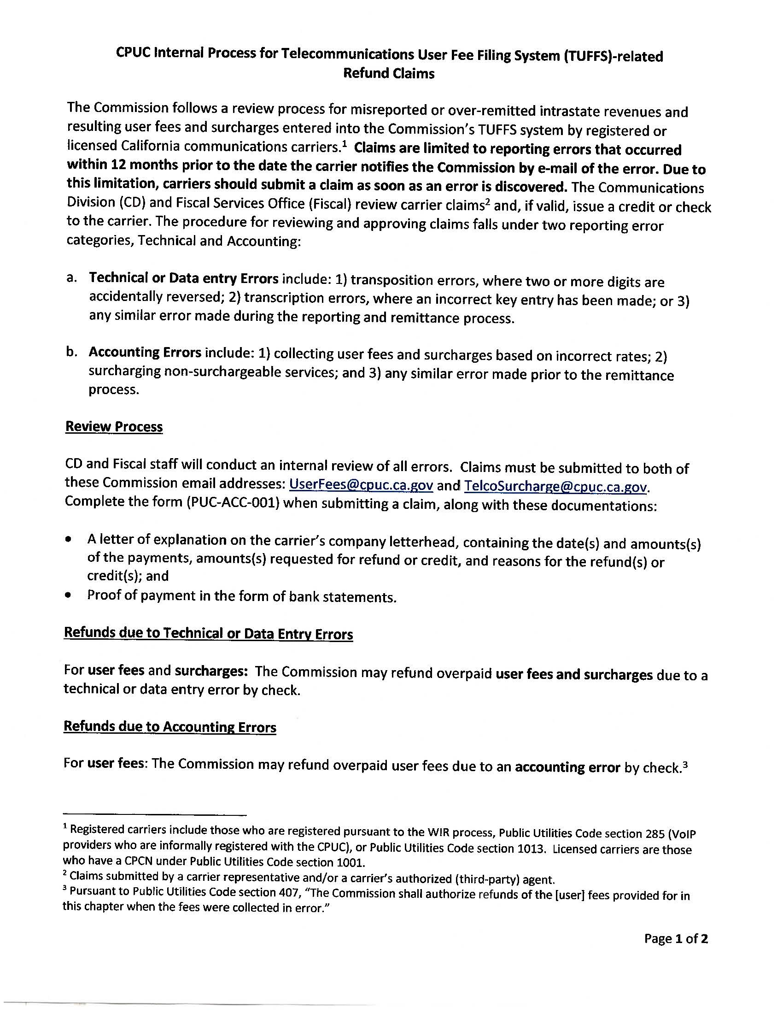

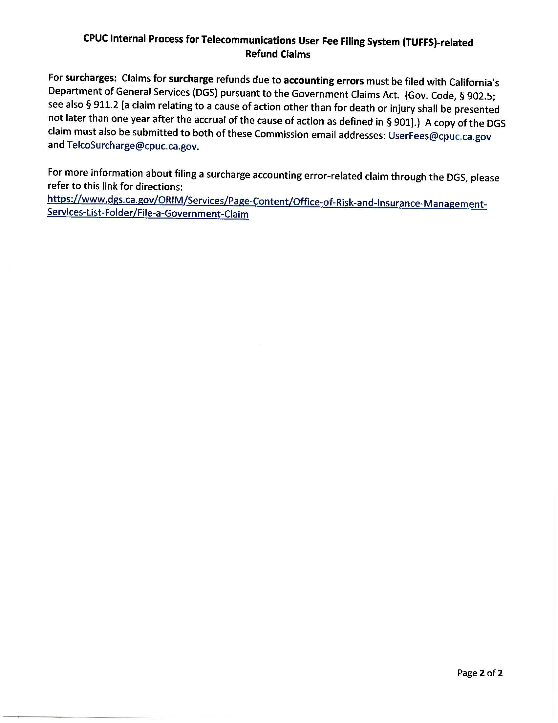

END OF ATTACHMENT B

1. The surcharges collected fund the six universal service funds administered by the Commission, set forth in Public Utilities Code Sections 275 through 281: California High-Cost Fund A (CHCF-A), California High Cost Fund B (CHCF-B), California Universal Lifeline Telephone Service (LifeLine or ULTS), California Teleconnect Fund (CTF), Deaf & Disabled Telecommunication Program (DDTP), and California Advance Service Funds (CASF).
2. Public Utilities Code Sections 431 through 435 sets forth the User Fee requirements.
3. FCC 1998 Stevens Report.
4. On December 12, 2018, the FCC declared that wireless text messaging services were “information services.” (FCC Declaratory Ruling, FCC 18-178, WC Docket No. 08-7 (Dec. 12, 2018).) However, the surcharges and fees at issue here were imposed well before the FCC adopted its ruling.
5. On June 6, 2018, AT&T sent an email providing a revised spreadsheet showing the prepaid revenue reconciliation for AT&T Mobility. The email was identified by AT&T as “Proprietary and confidential information under California Government Code § 6254(k); 47 cfr 64.2001 et seq., the stored communications act, 18 U.S.C. § 2701 et. Seq., California Pub. Util. Code sections 2891 and 2891.1; may not be disclosed pursuant to public utilities code section 583.”
6. June 15, 2018 letter to AT&T Mobility from former CD Deputy Director Michael Amato stated that “*Senate Bill 1193 established CASF to be subject to the conditions and restrictions applicable to the existing universal service funds while CPUC Decision 07-12-054 established CASF collection using the same surcharge mechanism as the CHCF-B. The TUFFS User Guide also clearly states that the late payments are charged 10% interest after the due date. In addition, along with the reasons stated in your letter, the 10% interest is set in place to deter carriers from incorrectly remitting surcharges.”*
7. Commission records indicate that AT&T Mobility paid the outstanding principal for CASF November and December 2011 report periods in April 2017.
8. In June 2018, AT&T’s response to CD staff Data Request identified that prepaid surcharges were paid out of general prepaid revenue prior to January 2016.
9. Based on the spreadsheets provided to staff, the analysis to update the marketing study took place on June 15, 2015.
10. Staff deemed these tables as most appropriate for illustration purposes. AT&T Mobility spreadsheets do not appear exactly as illustrated.
11. The total intrastate revenues include both postpaid and prepaid wireless revenues.
12. The total monthly prepaid revenues identified by AT&T Mobility in its spreadsheets encompass intrastate as well as interstate, and international services. Prior to 2016, prepaid revenues were not required to be separately reported from postpaid revenues. Further, interstate, international and non-jurisdictional services are beyond the Commission’s jurisdiction. Hence, the total monthly prepaid revenues are not available on TUFFS.
13. Percentage rates derived from AT&T Mobility’s marketing studies are illustrated using “%” symbols in the table.
14. Staff believes that this marketing study can be appropriately applied to the 4th quarter of 2013.
15. CPUC Internal Process: Refund Claims is available at https://www.cpuc.ca.gov/uploadedFiles/CPUC_Public_Website/Content/Utilities_and_Industries/Communications_-_Telecommunications_and_Broadband/Refund%20Claims_CPUC%20Internal%20Process_03242020.pdf
16. General Order 153; D. 96-10-066
17. Carriers with reported intrastate revenues of less than $750,000 annually, referred to as de minimis, are required to pay a flat $100 annual fee on or before January 15 of each year.
18. The Commission continues to utilize the electronic system to track revenues and corresponding user fee information for periods prior to 2016.