PUBLIC UTILITIES COMMISSION OF THE STATE OF CALIFORNIA
WATER DIVISION | RESOLUTION W-5236
 | June 24, 2021

R E S O L U T I O N
(RES. W-5236) RR LEWIS SMALL WATER COMPANY. ORDER AUTHORIZING A GENERAL RATE INCREASE PRODUCING AN ADDITIONAL ANNUAL REVENUE OF $28,003, OR 27.42%, FOR TEST YEAR 2021, AND $16,493, OR 12.67% FOR ESCALATION YEAR 2022, TO BE PAID BY THE RATEPAYERS.

SUMMARY
By Advice Letter (AL) No. 43-W, filed on March 5, 2020, RR Lewis Small Water Company seeks a general rate increase producing additional annual revenues of $57,516, or 56.30%, based on a Rate of Margin (ROM) of 24.00%.
This Resolution grants RR Lewis Small Water Company an increase in gross annual revenues of $28,003, or 27.42%, for Test Year 2021, and $16,493, or 12.67%, for Escalation Year 2022, which is estimated to provide a ROM of 23.65%.

BACKGROUND
RR Lewis Small Water Company (RRL) has requested authority under General Order (GO) 96-B, Rule 1.7 and 7.6.2, Water Industry Rules 7.3.3(5), and Section 454 of the Public Utilities Code to increase its water rates by $57,516, or 56.30% in gross annual revenues for Test Year (TY) 2020, based on a ROM of 24.00%. RRL also requests Commission authority to add a Schedule No. 4, Private Fire Protection Service, to prepare for potential future Fire Protection services. Additionally, RRL requests to delete Schedule No. 6, Small Business Administration (SBA) Loan Surcharge, from its tariff book because no SBA Loan was procured, and the tariff is not needed.

RRL’s present rates became effective on December 30, 2019 with the approval of AL 42-W, which authorized a Consumer Price Index (CPI) increase of 1.90%. RRL’s last General Rate Case (GRC) rate increase became effective August 2, 2012, pursuant to Resolution W-4926, which authorized a general rate increase of $31,564, or 53.98%, based on an authorized ROM of 17.84%.
RRL is a Class D investor-owned water utility with 126 service connections (1 flat rate service and 125 metered services). RRL receives revenues from its Fire Protection Tariff for hydrant maintenance for its contract with Sierra City, but the utility currently does not have any fire protection service connections. The RRL service territory is located in the area northeast of Sierra City, north of the North Yuba River and adjacent to Highway 49 in Sierra County. The median household income (MHI) in the 96125 zip code area of Sierra City, where the utility is located, is $144,091.
The Ostrom Family Trust is the owner of RRL. Mr. Larry Ostrom, who was the owner and manager of the utility, passed away in 2020. Since his passing, the Ostrom Family Trust has been looking to sell the utility and this GRC will assist in that process by providing a recent analysis of utility plant, rate base, expenses, and setting an appropriate revenue requirement and rates for a prospective buyer.
RRL’s sources of supply for its water distribution system are the Anderson Spring and the Wixson Spring. The Wixson Spring has been offline since 2015 when the State Water Resources Control Board (SWRCB) issued an order requiring “continuous reliable chlorination” at the Wixson Spring. A chlorination project for the Wixson spring is still in progress to remediate this order. The Anderson Spring provided 28 Acre-Feet of water to customers in 2019, according to the 2019 CPUC Annual Report for RRL. The utility is served by 6 storage tanks (concrete, steel, and other) with a total storage capacity of 60,750 gallons. With this storage and source capacity, the utility can meet the maximum day demand in accordance with GO 103-A to meet minimum standards for water service. The utility’s annual water sales average 14,234 Hundred Cubic Feet (CCF) over the last three years.
Since RRL’s last GRC in 2012, capital improvements to the utility’s water distribution system have been made including investments into water mains and structures, and a chlorination project for the Wixson Spring that is ongoing. The WD has confirmed via email that to address SWRCB’s compliance order and complete the chlorination project, RRL acquired an agreement for an easement to use the planned site, as well as a conditional use permit from Sierra County. The next step for the chlorination project will be the acquisition of a building permit. RRL’s rates have increased three times since the last GRC, through CPI increases in 2012, 2016, and 2018.

NOTICE AND PROTESTS
In accordance with GO 96-B, RRL served a copy of AL 43-W to its service list on March 5, 2020. Three protests were received by the WD regarding RRL’s AL 43-W filing. The protests raised questions regarding the inclusion of health benefit costs for employees, although no employees were listed by RRL. The protests also raised concerns about the rate increase and the comparability of RRL’s rates to those of nearby utilities.
In this resolution, the WD is disallowing employee pension and benefits from RRL’s request, since the utility did not report any additional employees other than the utility owner who was also the manager. In setting rates in this resolution, the WD balanced the financial requirements of RRL with rate concerns of its customers. For RRL’s GRC request, the WD analysis applied cost-of-service ratemaking principles for developing the recommended revenue requirement and rates, which at a minimum is required to satisfy the utility’s technical, managerial, and financial capacity.
On March 4, 2020, Governor Gavin Newsom declared a State of Emergency as part of the State of California’s response in addressing the COVID-19 outbreak. On March 16, 2020 and September 12, 2020, the California Department of Public Health (CDPH) issued formal guidance on public gatherings. In response to the ongoing COVID-19 outbreak, and to abide by current directives on public gatherings, the WD has taken precautions for the safety of the involved parties, including WD staff, utility representatives, and utility customers by determining that in-person public participation meetings for small water companies will not be held while California is in a State of Emergency in dealing with the ongoing COVID-19 outbreak.

DISCUSSION
In reviewing RRL’s rate increase request, the WD made an independent analysis of the utility’s rate increase request and its operations. Appendix A provides RRL’s and the WD’s estimated Summary of Earnings (SOE) at present, requested, and recommended rates. RRL was informed of the differing view of revenues, expenses and rate base, and the company agrees with the WD’s recommended revenue requirement and rates shown in Appendix B.
The WD used TY 2021, rather than the TY 2020 requested, for RRL’s GRC analysis to include more current relevant cost information in developing the proposed revenue requirement and rates. Accordingly, the WD in its analysis escalated RRL’s cost data from 2019 to develop 2020 and 2021 estimates in its expense calculations.

Operating Expenses
The WD’s estimated operating expenses are based on a 3-year average (2017 through 2019) of expenses reported in the utility’s annual reports to derive TY 2020 expense estimates, with escalation rates applied for 2020 and 2021 to bring the operating expense estimates to TY 2021. RRL’s estimated operating expenses are very close to the WD’s estimate – a difference in total of $983 (1.0%) annually, as shown in Appendix A of this resolution.
The utility is structured as a partnership owned by the Ostrom Family Trust Doing Business As (DBA) RR Lewis Small Water Company and reported no employees in its GRC request. Accordingly, no employee pensions or benefits are authorized in operating expenses for RRL.

Taxes
RRL is structured as a partnership and reported in its 2019 annual report that it paid no Federal Income Taxes (FIT) and the minimum of $800 for State Income Taxes (SIT). However, RRL in its income tax expense estimates for TY 2020 GRC used an income tax rate of 21.00% for estimating its FIT expense and 8.81% for its SIT expense, based on the applicable tax rates for utilities structured as C-Corporations.
In Decision (D.) 20-07-036, the Commission affirmed its ratemaking policy for the income tax allowance in setting utility rates for the Commission regulated utilities, as set-forth in D. 11-05-045, in which the Commission determined that pass-through entities, such as partnerships, are not entitled to a ratemaking allowance for income taxes because partnerships do not directly pay income taxes. Furthermore, in D.12-03-026, the Commission determined that it views utilities as separate from their affiliates for ratemaking purposes, and therefore, rates should only include allowances for expenses the utility itself pays. Accordingly, since RRL is structured as a partnership, the WD applied the Commission’s income tax allowance policy for RRL’s TY 2021 GRC and no FIT allowance is included in rates. However, $800 is allowed for SIT as it is the minimum tax liability for all corporations, including partnerships, in California.

Utility Plant and Rate Base
For TY 2021, the WD’s analysis of RRL’s rate base estimate included examining utility plant in service, plant-under-construction, materials & supplies, working cash, depreciation reserve, deferred income taxes, and advances. Since RRL’s last GRC, the utility reported $146,566 in utility plant investments in water mains, structures, meters, and new service installations.
RRL’s Wixson Spring Chlorination project has been in progress since RRL’s last GRC and is slated to be completed in 2021. No capital additions to rate base are being requested for this GRC.
The main difference between RRL’s and WD’s average utility plant and rate base estimates is due to the use of a different test year, and the WD’s use of more recent utility plant data. RRL’s estimated average utility plant in service for TY 2020 is $530,198 based on its 2018 annual report. The WD’s estimated average utility plant in service is $558,548 based on the 2019 end-of-year (EOY) balance. Similarly, the use of different year annual reports accounts for the differences between RRL’s and the WD’s estimated accumulated depreciation amount.
The Materials and Supplies estimate in RRL’s calculation used a three-year average from 2016 to 2018, whereas the WD used a three-year average from 2017-2019. The difference between RRL’s and WD’s estimated working cash amounts are due to RRL’s use of two months of total expenses for its calculation, and the WD used one month of total expenses, consistent with the Simplified Method described in Standard Practice U-16. Based on these calculations, WD’s rate base estimate for TY 2021 is $156,590, as shown in Appendix A of this resolution.

Rate of Return
RRL requested a ROM of 24.00% for its TY 2020 GRC. In accordance with Commission ratemaking policies adopted for Class C and D water utilities by D. 92-03-093, two methods can be used for ratemaking, the Rate of Return (ROR) and ROM methods. The WD is directed to calculate the company’s revenue requirement using both methods and to recommend the ratemaking method resulting in the greater return. In this rate case, the WD determined that the ROM method produced the higher revenue requirement. The WD’s recommended ROM for Class D water utilities for 2020 is 23.65%. Using the recommended ROM, the WD calculated a revenue requirement of $146,630.

Rates and Rate Design
RRL’s rate structure consists of two rate schedules: Schedule No. 1 General Metered Service, and Schedule No. 2R Residential Flat Rate Service.
RRL is requesting that a third schedule be added: Schedule No. 4 Private Fire Protection Service. The utility currently has no private fire protection connections but anticipates providing this service in the future. Current fire protection revenue comes from a contract with Sierra City for Fire Hydrant maintenance and is a fixed amount of $3,200 per year. The WD reviewed RRL’s proposed private fire protection service rates and finds them comparable to the rates of other Class D water utilities like RRL. Accordingly, the WD finds RRL’s request and rates for its Schedule No. 4, Private Fire Protection Service reasonable and recommends approving the utility’s request.
For the rate design of the flat rate service schedule, the WD recommends that 1.54% of the total annual revenue be allocated to flat rate service tariff. A single customer remains on flat rate service and all new service connections are now placed on the metered service tariff. RRL’s Schedule 2R Flat Rate Service contains the necessary provision that allows the utility, if it elects to do so, to install a meter and switch the customer to the utility’s Schedule No. 1 for General Metered Service tariff for billing. The CPUC recommends and strongly encourages RRL to install a meter on the one remaining flat rate customer’s service to comply with the State’s meter installation policy for promoting additional water conservation in the utility’s service area. The one remaining customer has not consented to previous attempts made by the utility to install a meter. As part of the rate design by this GRC, flat rate bills have been set to be approximately twice the average metered bill, to incentivize the customer to switch to a metered service.
For the metered service rate design, the WD concurs with RRL’s fixed cost allocation of 80.00% to the service charge and 20.00% to the volumetric charge. This cost allocation balances the magnitude of the rate increase between the service charge and quantity rate. RRL requested to implement the rate increase over a two-year period, from 2020 to 2021 to mitigate the impact of the rate increase on customers. The WD concurs with RRL’s request and recommends that the rate increase be implemented over the two-year period in TY 2021 and Escalation Year (EY) 2022.
At the WD’s recommended rates, the increase in revenue will be $28,003, or 27.42%, for TY 2021, and $16,493, or 12.67% for EY 2022, based on an ROM of 23.65%. At the recommended rates shown in Appendix B, the monthly bill for an average metered residential customer with a 5/8 x 3/4-inch size meter with an average monthly water use of 9.40 hundred cubic feet (CCF) will increase from $70.88 to $81.46, or 14.94% for TY 2021, and from $81.46 to $92.05, or 13.00% in EY 2022. A comparison of customer bills at present and recommended rates is provided in Appendix C of this resolution.
The Utility Rate Comparison table below provides a monthly metered rate comparison with nearby water utilities. The recommended metered rates are slightly higher than nearby utilities, but are still within a reasonable range, given that the nearby utilities are not investor-owned and therefore have a substantially different ratemaking methodology for establishing the revenue requirement and rates than RRL.
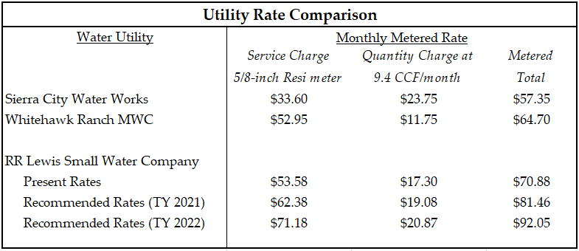

Affordability of Proposed Rates
As discussed above in the recommended rates for TY 2021, the monthly bill for an average metered residential customer with a 5/8 x 3/4-inch size meter with an average monthly water use of 9.40 CCF will increase from $70.88 to $81.46, or 14.94% for TY 2021, and from $81.46 to $92.05, or 13.00% in EY 2022. These rate increases represent 0.34% and 0.38% of the median household income (MHI) of $144,091 for TY 2021 and EY 2022, respectively, for Sierra City where RRL’s service area is located.
It should be noted that no affordability criteria has been developed and adopted in any Commission Decision or legislation. However, the Commission adheres to cost-of-service regulatory principles in developing rates for its jurisdictional utilities, and the WD’s recommended rates for RRL are at the minimum required to satisfy the utility’s technical, managerial, and financial capacity. The discussion regarding affordability is presented to indicate to the Commission the relationship between the proposed rates and local incomes.

COMPLIANCE
RRL had several deficiencies noted during the most recent Sanitary Survey performed by the SWRCB’s, Division of Drinking Water (DDW) in 2015. The utility has outstanding DDW enforcement fees and fines resulting from the bacteriological sampling issue at the Wixson Spring, beginning in 2014. However, DDW confirmed that RRL has obtained its conditional use permit for its chlorination building to address the compliance issues at the Wixson Spring, and that RRL anticipates completing this required project in 2021. The DDW and WD have been actively working with RRL to bring its system into compliance to address the outstanding chlorination issues. This GRC increase will also provide RRL with critical funding to maintain its water system. Accordingly, the WD finds RRL is taking the necessary steps to bring its water system into compliance with the SWRCB's applicable water quality standards and regulations for safe drinking water.

UTILITY SAFETY
Safety for water utilities considers a number of factors such as water quality, system design, operation and maintenance, and service. One of the highest safety priorities for the Commission is ensuring that water utilities serving water for human consumption provide water that is not harmful or dangerous to health. As previously indicated, RRL is working closely with the DDW to bring the Wixson Spring into compliance. The Anderson Spring however is currently providing potable water that meets the DDW’s drinking water standards, and the source provides adequate supply to meet the maximum day demand for RRL’s customers.

COMMENTS
Public Utilities Code section 311(g)(1) provides that resolutions generally must be served on all parties and subject to at least 30 days public review and comment prior to a vote of the Commission.
Accordingly, the draft resolution was mailed to the service list, protestants, and made available for public comment on May 12, 2021.
No comments received.

FINDINGS
- The Summary of Earnings (Appendix A) recommended by the Water Division (WD) is reasonable and should be adopted.

- The rates recommended by the WD (Appendix B) are reasonable and should be adopted.

- The quantities (Appendix D) used to develop the WD’s recommendations are reasonable and should be adopted.

- The water rate increase authorized herein is justified and the resulting rates are just and reasonable.
- RRL should be allowed to file a supplement to Advice Letter No. 43-W to incorporate the revised rate schedules (Appendix B) for Test Year 2021 and to concurrently cancel its presently effective rate schedules.

- RRL should file a Tier 2 Advice Letter on or before November 20, 2021, to implement the escalation rates for 2022 shown in Appendix B. The escalation rates shall be made effective January 1, 2022.

THEREFORE, IT IS ORDERED THAT:
- Authority is granted under Public Utilities Code Section 454, for RR Lewis Small Water Company to file a supplement to Advice Letter 43-W to incorporate the rate schedules attached to this Resolution as Appendix B, and concurrently cancel its presently effective rate Schedules. The effective date of the revised schedules shall be five days after the date of filing.

- RR Lewis Small Water Company shall file a Tier 2 Advice Letter on or before November 20, 2021 to implement the escalation year 2022 rates attached to this Resolution as Appendix B. The escalation rates should become effective on January 1, 2022.

This Resolution is effective today.

I certify that the foregoing resolution was duly introduced, passed, and adopted at a conference of the Public Utilities Commission of the State of California held June 24, 2021; the following Commissioners voting favorably thereon:

Rachel Peterson
Executive Director

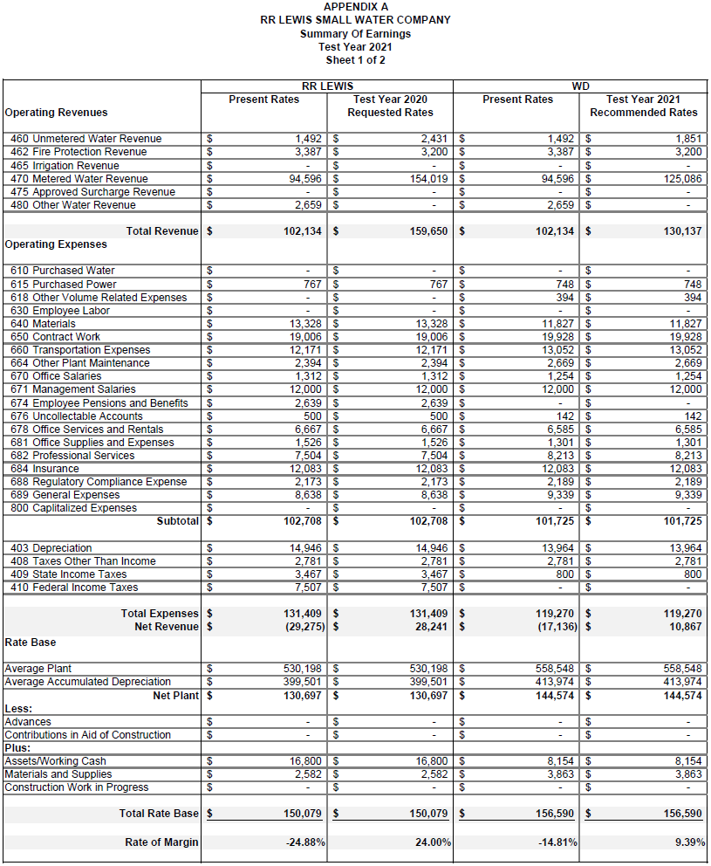
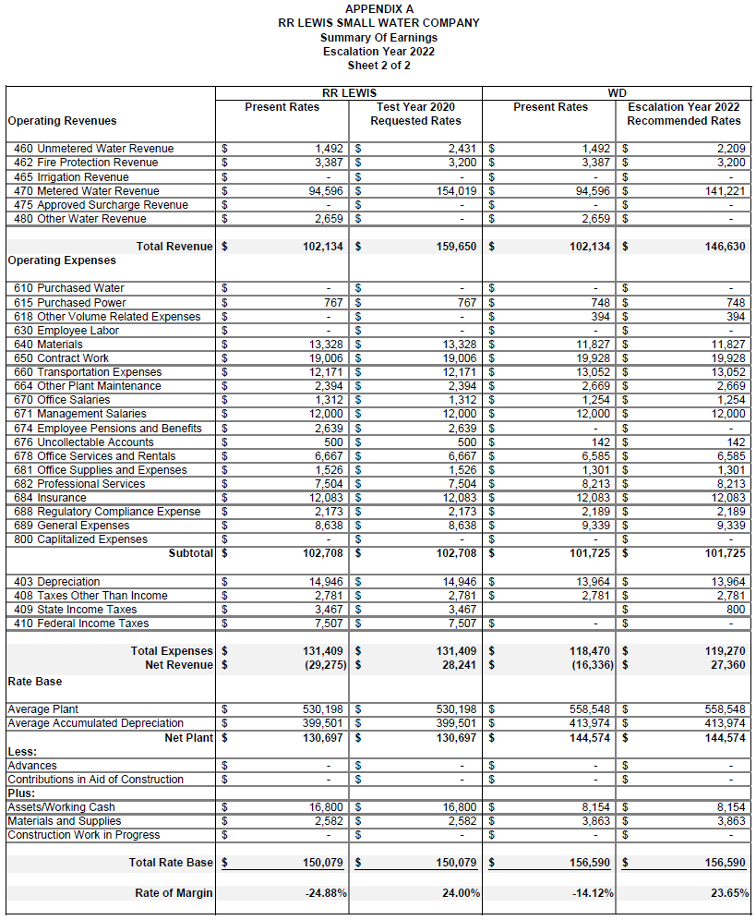 END OF APPENDIX A
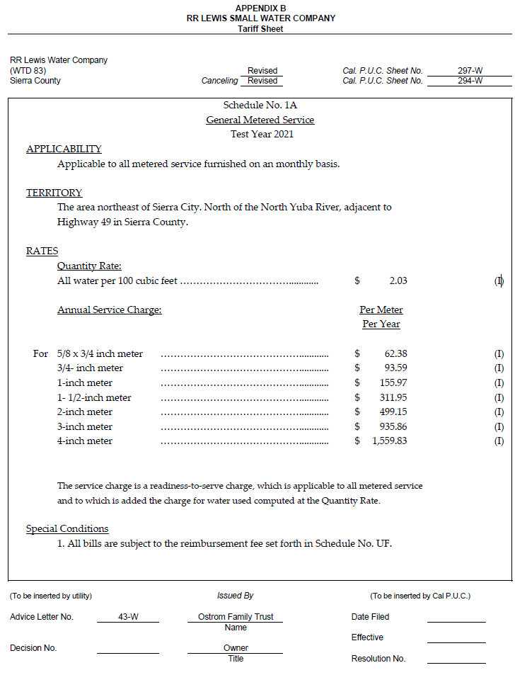
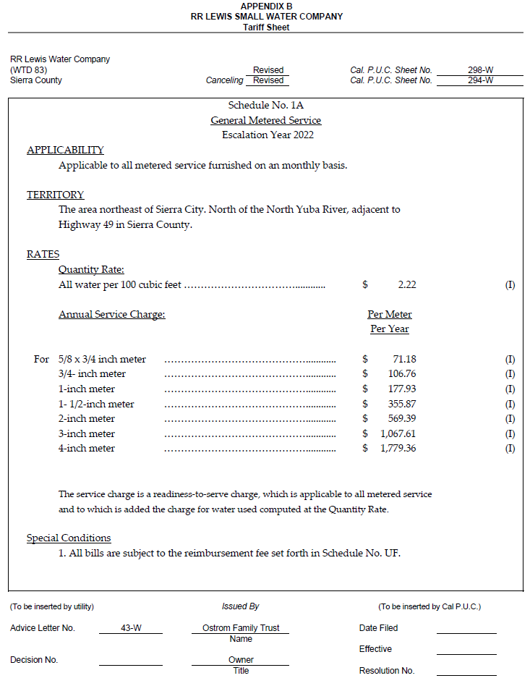
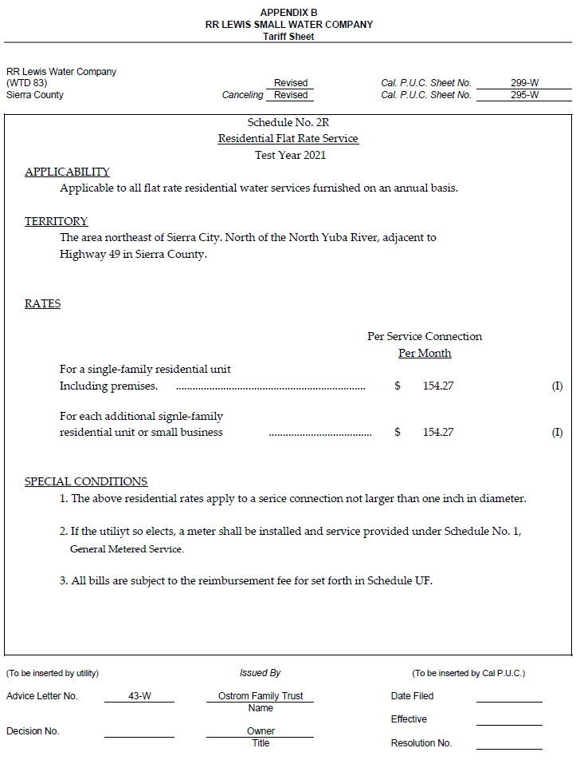
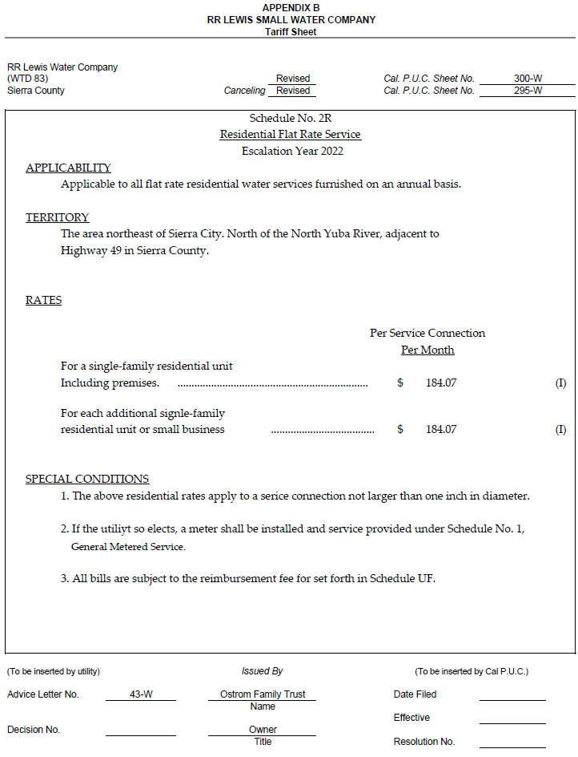
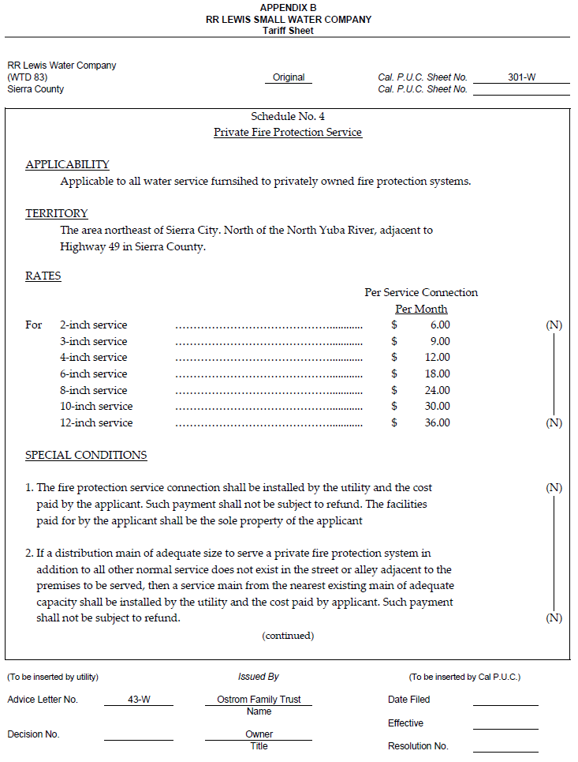
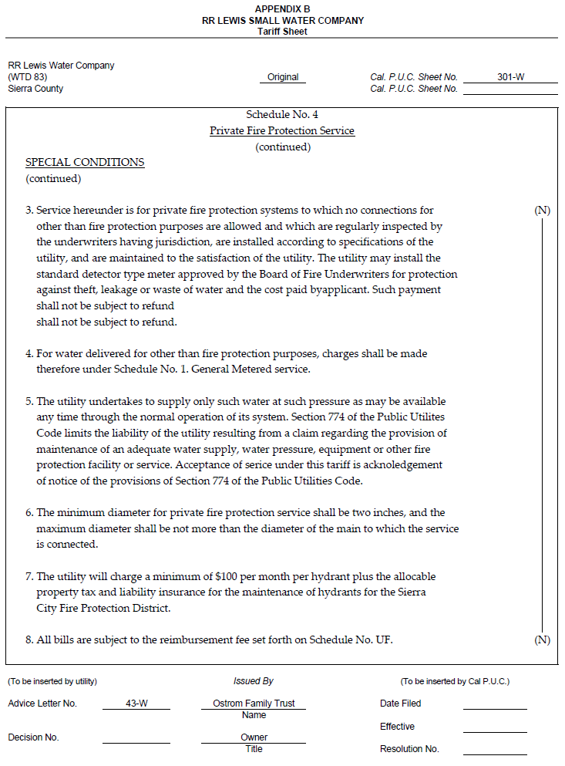
END OF APPENDIX B
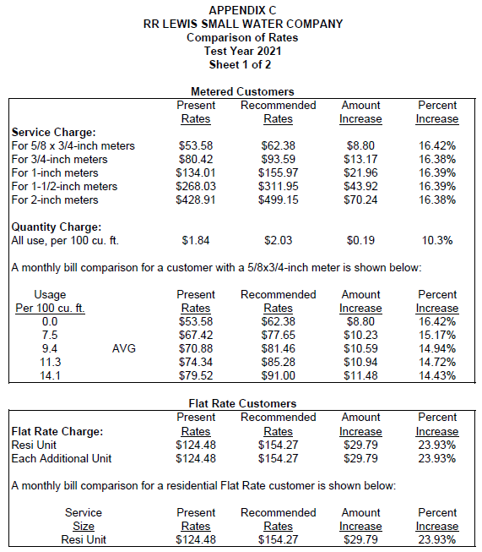
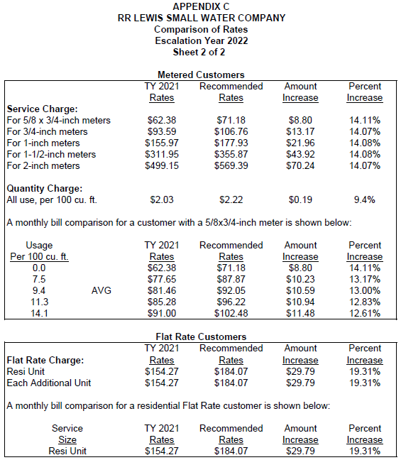
END OF APPENDIX C
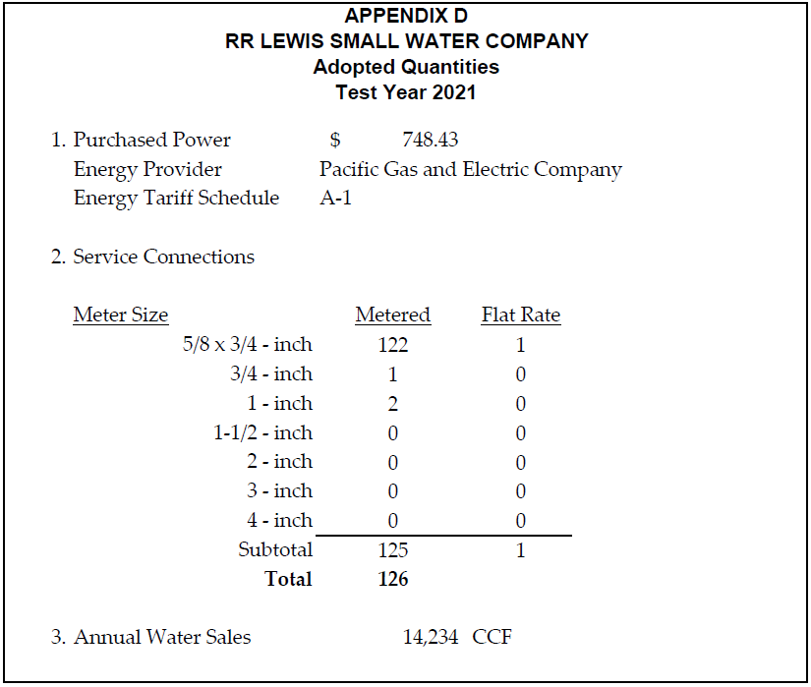
END OF APPENDIX D

RR Lewis Small Water Company
4500 E. Fremont Street, Stockton, CA 95215
Telephone: (209) 948 – 1886 Email: rrlewish2o@gmail.com

ADVICE LETTER 43
SERVICE LIST

Heather Foster  Sierra County Clerk  P.O. Drawer D  Downieville, CA 95936 | Jennifer Capitolo  California Water Association  601 Van Ness Ave., Ste. 2047  San Francisco, CA 94102  jcapitolo@calwaterassn.com
Ed Viray  eviray@gmail.com | Jennifer Spaletta  jennifer@spalettalaw.com
Sierra City Waterworks, Inc.  732 Butler St.  Grass Valley, CA 9545 | Elise Ostrom  P.O. Box 215  Sierra City, CA 96125
Sig Ostrom  218 Forty Niner Drive  Sierra City, CA 96125 | Loren and Dawn Brown  P.O. Box 197  Sierra City, CA 96125

Sierra City, CA | Data USA. https://datausa.io/profile/geo/sierra-city-ca
Conversion rate: 1 Acre-Foot = 435.6 Hundred Cubic Feet = 325,851.43 Gallons
Amended Annual Report of RR Lewis Small Water Company, California Public Utilities Commission. March 31, 2020.
General Order 103-A Rules Governing Water Service, Including Minimum Standards for Operation, Maintenance, Design, and Construction, Section II, B, (3).
Public Water System No. 4600017 Inspection Report, State Water Resources Control Board’s Division of Drinking Water. July 15, 2015
March 4, 2020 Proclamation of a State of Emergency, https://www.gov.ca.gov/wp-content/uploads/2020/03/3.4.20-Coronavirus-SOE-Proclamation.pdf
March 16, 2020 CDPH Guidance for the Prevention of COVID-19 Transmission for Gatherings, https://www.cdph.ca.gov/Programs/CID/DCDC/Pages/COVID-19/CDPH-Guidance-for-the-Prevention-of-COVID-19-Transmission-for-Gatherings.aspx
September 12, 2020 CDPH Guidance for the Prevention of COVID-19 Transmission for Gatherings, https://www.cdph.ca.gov/Programs/CID/DCDC/Pages/COVID-19/Guidance-for-the-Prevention-of-COVID-19-Transmission-for-Gatherings.aspx
Order Granting Rehearing in Application 19-04-024 of Cypress Ridge Owners Association for Rehearing of Resolution W-5187.
Decision Resolving Case 97-04-025 Dismissing Application 00-03-044 and Resolving in Part Other Consolidated Proceedings.
Bruce DeBerry, Water Division Program Manager, to The California Public Utilities Commission. March 9, 2020. Rates of Return and Rates of Margin for Class C, Class D Water and Sewer Utilities.
Public Utilities Code Section 781.5
Conversion Rate: 1 CCF = 748 gallons.

