PUBLIC UTILITIES COMMISSION OF THE STATE OF CALIFOR NIA

Communications Division | RESOLUTION T- 17749
Broadband, Video and Market Branch | December 16, 2021

R E S O L U T I O N

RESOLUTION T-17749: Approves up to $18,785,426.76 from the California Advanced Services Fund for the Broadband Infrastructure Grant Account applications of Frontier California, Inc. (U-1002-C) for the Garberville-Alderpoint and Piercy-Leggett-Laytonville Projects; and Citizens Telecommunications Company of California, Inc.
(U-1024-C) d/b/a Frontier Communications of California, Inc. for the Mad River Project.

I. SUMMARY

This Resolution approves grant funding in the amount of up to $18,785,426.76 from the California Advanced Services Fund (CASF) Broadband Infrastructure Grant Account (Infrastructure Account) for the grant applications of Frontier California, Inc. (U-1002-C) and Citizens Telecommunications Company of California, Inc. (U-1024-C) d/b/a Frontier Communications of California, Inc. (Frontier). Collectively, these projects will serve 514 households.

The three projects approved are as follows:
PROJECT | REQUESTED AMOUNT  (ORIGINAL) | REQUESTED  AMOUNT  (REVISED) | CASF APPROVED AMOUNT | HOUSEHOLDS
Garberville-Alderpoint | $3,776,254.38 | $3,719,163.96 | $3,719,163.96 | 48
Mad River | $8,169,979 | $8,023,897.78 | $8,023,897.78 | 105
Piercy-Leggett-Laytonville | $7,797,273 | $7,042,365.02 | $7,042,365.02 | 361
TOTAL | $19,743,506.38 | $18,785,426.76 | $18,785,426.76 | 514

II. BACKGROUND

The CASF Infrastructure Account provides grant funding to Internet service providers to build or upgrade broadband infrastructure in areas that are unserved by existing broadband providers. The CASF program was initiated in 2008, after the program was first adopted by the California Public Utilities Commission (Commission) in Decision (D.) 07-12-054 and enacted into statute pursuant to Senate Bill (SB) 1193.

On October 15, 2017, Governor Brown signed Assembly Bill (AB) 1665 (Garcia) into law. This legislation amended the statute governing the CASF program, Public Utilities Code § 281. The Commission issued D.18-12-018 adopting the programmatic changes to the CASF. Appendix 1 of D.18-12-018 set forth the rules, application requirements and guidelines for the CASF Infrastructure Account.

The most recent Infrastructure Account grant application deadline was May 4, 2020.

On June 29, 2020, Governor Newsom signed AB 82 into law, amending Public Utilities Code § 281 to authorize leveraging of CASF Infrastructure grant funding to supplement the costs of broadband infrastructure already funded, in whole or in part, by the federal Rural Digital Opportunity Fund (RDOF). In an effort to effectively utilize both state and federal funding toward meeting the CASF program goals, the Commission has deferred project applications that include areas eligible to receive RDOF for consideration until after the results of the RDOF Phase I (Auction 904) have been published.,

On March 10, 2021, the Commission issued D. 21-03-006 modifying data submission requirements and requiring open access for CASF projects. Revised CASF program guidelines were set forth in Appendix A of D.21-03-006.

On July 20, 2021, Governor Newsom signed historic broadband legislation to help bridge the digital divide. Among other things, SB 156, authored by the Committee on Budget and Fiscal Review, instituted several changes to the CASF program. The bill changed the definition of “unserved area” to “an area for which there is no facility-based broadband provider offering at least one tier of broadband service at speeds of at least 25 mbps downstream, 3 mbps upstream…” However, in the interests of administrative efficiency and to ensure proper notice to project applicants, the Commission will use the standard of 6 mbps downstream and 1 mbps upstream to determine eligibility for funding for project applications submitted in 2020.

Further, SB 156 changed the requirements for the infrastructure that could be funded by the CASF program. Pursuant to Pub. Util. Code Sec. 281(f)(5), the Commission may only fund projects that "deploy infrastructure capable of providing broadband access at speeds of a minimum of 100 mbps downstream and 20 mbps upstream…" This is a clear legislative directive to the Commission, which the Commission must implement immediately. All infrastructure funded by the CASF program must be capable of providing broadband access at speeds of a minimum of 100 mbps downstream and 20 mbps upstream. In addition, the legislature added the requirement that each entity that receives CASF funding must report when it uses a licensed contractor or subcontractor with a contract in excess of $25,000 for work funded by CASF and that the Commission must post this information on a monthly basis.

Among other things, the broadband legislation also includes a $3.25 billion statewide middle-mile plan to build, operate and maintain an open access, state-owned middle-mile network of high-capacity fiber lines that carry large amounts of data at higher speeds over longer distances between local networks.

Applicant
Frontier is a publicly traded corporation, the fourth largest incumbent local exchange carrier (ILEC) in the United States, and the second largest in California.

Frontier California, Inc. (Frontier California) is a Frontier-owned telephone operating company providing service in former Verizon Communications, Inc. (Verizon) service territories. In 2016, Verizon acquired Frontier California as part of a three-state purchase that also included Verizon wireline operations in Florida and Texas. These ILEC operations were previously owned by General Telephone & Electronics Corporation (GTE) prior to its 2000 merger with Bell Atlantic that formed Verizon. The transaction also included Verizon’s Fiber Optic Service (FiOS) Internet and Video customers, high-speed Internet service and long-distance voice accounts.

Citizens Telecommunications Company of California, Inc., (Citizens), a Frontier affiliate telephone operating company based in Elk Grove, California, was established in 1993 to acquire access lines from GTE. As the Carrier-of-Last-Resort, Frontier currently provides circuit-switched (POTS) voice service but no broadband Internet service in the proposed project areas.

III. APPLICANT REQUESTS AND NOTICE

On May 4, 2020, the Communications Division received 54 applications for the CASF Infrastructure Account. On May 18, 2020, Staff posted the proposed project area map, census block groups (CBGs) and Zone Improvement Plan (ZIP) Codes for Frontier’s Garberville-Alderpoint, Mad River, and Piercy-Leggett-Laytonville Projects on the Commission’s CASF webpage under “CASF Application Project Summaries” and sent notice regarding the project to the CASF Distribution List.

IV. CONDITIONAL APPROVAL OF MIDDLE-MILE COMPONENTS

Through SB 156, the legislature developed a statewide strategy to build, operate and maintain an open access, state-owned middle-mile network of high-capacity fiber lines that carry large amounts of data at higher speeds over longer distances between local networks. The middle-mile component of projects funded by the CASF Program should complement this statewide strategy. Thus, the CASF grant award for the middle-mile components of the Garberville-Alderpoint, Mad River, and Piercy-Leggett-Laytonville projects are conditioned on whether the Director of the California Department of Technology (CDT) finds that the middle-mile components of the projects complement the California middle-mile initiative described in SB 156.

This approval process should take place within three months from the approval of this Resolution. However, the time allowed for the CDT Director or designee to approve the middle-mile components of the Garberville-Alderpoint, Mad River, and Piercy-Leggett-Laytonville projects each may be extended an additional three months, or longer, by mutual agreement between the CDT Director or designee and Frontier. Frontier will send written notice of time extensions, if any, to the CD Director.

If the CDT Director or designee notifies the CD Director in writing that the CDT Director or designee approves the middle-mile component of the project, the CD Director shall, in writing, approve release of CASF funding for the middle-mile component of the project. At that time Staff may proceed with project funding activities. If the CDT Director or designee does not approve the middle-mile component of the project, CASF Program funding for the middle-mile component of the Garberville-Alderpoint, Mad River, and/or Piercy-Leggett-Laytonville project are automatically rescinded on the date that the CD Director receives written notice that CDT did not approve the middle-mile component.

The CASF Program operates more efficiently if it is clear which projects actually are being deployed, so that funds are not encumbered for projects that will not be built. Thus, Frontier has 90 days from the date that the CDT Director or designee does not approve the middle-mile component of the Garberville-Alderpoint, Mad River, and/or Piercy-Leggett-Laytonville projects to inform the CD Director by a written letter that it still plans to deploy the last-mile components of the projects, even though it will not receive any funding for the middle-mile components. The written letter must include the following:
- Identifying information for the project(s) such as the grantee organization name, project name, project address, any identifying project number, the date of the award, and the grant amount.
- A statement that Frontier will deploy the last-mile component of the project(s) and comply with all the guidelines, requirements, and conditions associated with the grant of the CASF funds.

V. APPLICATION REVIEW AND EVALUATION

Staff reviewed all applications according to the guidelines, requirements, and evaluation adopted in D.21-03-006, as follows:

- Project Area Eligibility
- Minimum Performance Criteria
- Funding Determination
- Safety and Community Support

Staff’s review and evaluation of the applications is summarized below.

- Garberville-Alderpoint Project
On May 4, 2020, Frontier submitted a CASF Infrastructure application requesting $3,776,254 to deploy middle-mile and last-mile fiber infrastructure to provide fiber-to-the-premise (FTTP) technology in Garberville and Alderpoint in Humboldt County. The project will enable broadband access speeds of up to 940 Mbps download and
880 Mbps upload to 106 unserved households. The project costs cover the complete project deployment costs of the Garberville Project.

Project Area Eligibility
No provider filed a valid “right-of-first refusal” for Frontier’s Garberville-Alderpoint project area by January 15, 2020. The proposed project area includes census blocks identified by the Federal Communications Commission’s (FCC) Connect America Fund Phase II program awarded to Frontier. Staff requested that Frontier revise its original application based on updates to the California Interactive Broadband Map. The revised Garberville-Alderpoint Project Summary was posted on the Commission’s website on September 15, 2021.

Based on the latest California Interactive Broadband Map, five census blocks in the Garberville-Alderpoint project area are served. Staff contacted Frontier to revise its original application and remove the served census blocks. Frontier revised its application three times in response to Staff inquiries. On September 21, 2021, Frontier sent the final revised budget of $3,719,163.96. Table 1, below, provides a summary of Frontier’s revised CASF Infrastructure grant application.

Table 1: Frontier Garberville-Alderpoint Project Revision
 | Unserved Households | Census  Blocks | CASF Infrastructure Grant Funding
Original Application | 106 | 17 | $ 3,776,254.38
Final Revision | 48 | 12 | $ 3,719,163.96

Staff finds the grant funding request reasonable even with the reduction of households from 106 to 48 because most of the project costs are for construction of the indispensable middle-mile infrastructure which benefits the greater Humboldt County area. This middle-mile infrastructure must be offered at reasonable rates to other carriers. Table 2 below, summarizes Frontier’s budgeted project costs.

Table 2: Summary of Garberville-Alderpoint Project Funding
 | Middle-Mile  Funding | Last-Mile Funding | Total
Original Application | $ 2,426,658.65 | $ 1,349,595.73 | $ 3,776,254.38
Final Revision | $ 1,943,858.65 | $ 1,775,305.31 | $ 3,719,163.96

There are no existing facilities-based wireline or fixed wireless broadband service providers in the project area. According to the latest 2020 California Interactive Broadband Map, the area is unserved; only dial-up service is available.

- Challenges
Pursuant to Public Util. Code Sec. 281(f)(8) and as required by D.18-12-018, the Commission provided an opportunity for entities to challenge the applications. Challenges were due on June 8, 2020.

101Netlink filed a timely challenge. However, the challenge was based on the 2018 California Interactive Broadband Map (with data as of December 31, 2018) and is a year behind the updated 2019 California Interactive Broadband Map (with data as of December 31, 2019).

The Commission updates its California Interactive Broadband Map once a year after collecting broadband deployment data from providers. The data are validated using resources such as loop length, consumer feedback and location of subscribers. The latest map is based on December 2019 data and was published in December 2020. The latest map should reflect (or should have reflected) the challenges claimed by the challenger if the provider submitted correct broadband data to the Commission for the annual data submission. Therefore, the challenge is denied since the latest 2019 California Interactive Broadband Map shows the project area is eligible.

- RDOF
While some portions of this project overlaps with RDOF-eligible areas, Etheric Networks, Inc. (the winning bidder for census block groups contained within the project area) did not receive California Eligible Telecommunications Carrier (ETC) status; therefore, Staff did not remove the RDOF-eligible areas from this project.

- Middle-Mile Infrastructure
Frontier proposes adding approximately 12.2 miles of middle-mile fiber to its network and upgrading equipment at its existing facilities to provide last-mile FTTP service. The new infrastructure will provide network resiliency and route diversity for 2,000 households in the Garberville and Alderpoint areas.

Frontier is the local ILEC and does not currently offer broadband Internet service to households in the project census blocks. Further, Frontier is unable to deliver 17.4 miles of last-mile broadband service without constructing the middle-mile infrastructure. Therefore, Staff determined the middle-mile infrastructure is necessary to provide
last-mile service to the proposed communities and thus eligible for CASF funding pursuant to Pub. Util. Code § 281(b)(2)(A).

Frontier must offer open access to last-mile communications service providers requesting to use the middle-mile infrastructure, as set forth in D.21-03-006.

Minimum Performance Criteria
Staff reviewed Frontier’s application and determined the Garberville-Alderpoint Project meets the minimum performance criteria pursuant to D.21-03-006, Appendix A,
Section 6, as summarized in Table 3.

Pursuant to the CASF Program rules, project construction must be completed, following receipt of permits, within 12 months if the project is categorically exempt from CEQA, and within 24 months for all other projects. However, the Garberville-Alderpoint project may need additional time to ensure that CDT approves the middle-mile component. As additional time is needed to ensure that the middle-mile component of CASF projects complement California’s initiatives for broadband deployment, a waiver in the CASF Program rules regarding project completion is required. Thus, the Garberville-Alderpoint project must be completed in 27 months. If the time necessary for CDT to approve the middle-mile component is extended by mutual agreement between CDT and Frontier, Staff is authorized to also extend the time for completion of the project by the period of time specified by the CDT Director or designee.

Table 3: Minimum Performance Criteria
 | CASF Performance Criteria | Proposed Project
Project Completion | CEQA-exempt projects must be completed within 15 months (unless further extended by CD); and all other projects shall be completed within 27 months (unless further extended by CD), to allow for CDT approval of middle-mile component | 24 months  (Not CEQA exempt)
Pricing | Prices committed for two years  after completion of the project | 2-year
Speed | At least 100/20 Mbps | 940 / 880 Mbps
Latency | Maximum of 100 ms of latency | < 100 ms
Data Caps | Minimum of 190 GBs per month | No data cap
Affordability | Must offer low-income plan | $14.99 monthly

Project Completion and CEQA
Frontier’s Garberville-Alderpoint Project is subject to California Environmental Quality Act (CEQA) review and the project must be complete within 27 months from the start date (whereby Frontier has secured CEQA approval from the Commission and all required permits).

Pricing, Speed, Latency, Data Caps, and Affordability
Frontier commits to residential broadband pricing plans, as summarized in Table 4 and Table 5, for two years after completion of the project. There is no long-term commitment required from the consumer to receive these prices. Furthermore, Frontier will waive the activation and installation fees during the commitment period. Frontier provides discount pricing for bundled broadband and voice services. Additionally, low-income subscribers, including LifeLine voice subscribers, are eligible for discounted broadband service (10 Mbps download / 1 Mbps upload for $14.99 per month).

Table 4: Standalone Broadband Pricing Plan
Download Speed | Upload Speed | Monthly Price
50 Mbps | 50 Mbps | $39.99
100 Mbps | 100 Mbps | $49.99
200 Mbps | 200 Mbps | $49.99
500 Mbps | 500 Mbps | $49.99
940 Mbps | 880 Mbps | $74.99

Table 5: Broadband/Voice Bundled Pricing Plan
Download Speed | Upload Speed | Monthly Price
50 Mbps | 50 Mbps | $49.99
100 Mbps | 100 Mbps | $59.99
200 Mbps | 200 Mbps | $59.99
1,000 Mbps | 1,000 Mbps | $84.99

The proposed speed offerings (up to 1,000 Mbps download and up to 1,000 Mbps upload) meet the 100/20 minimum performance requirement. This service will be available to the general public, as well as anchor institutions and small businesses near the project area.

Funding Determination
Frontier is eligible to receive 100 percent funding to cover the cost of its Garberville-Alderpoint Project. Table 6, below, details Staff’s funding level determination for Frontier’s Garberville-Alderpoint Project.

Table 6: Criteria for Project Funding Level for Garberville-Alderpoint
Funding Criteria | Revised Project
Baseline for Eligible Project (60%) | 60%
Service Level Preference: Only Dial-up or No Internet Connectivity (up to 40%) | 40%
Low Income – (up to 40%)  - Median Household Income for community is less than CARE standard for family of 4, which is currently $53,000 (30%)  - Applicant serves low-income customers for no more than $15/month (10%) | 30%  10%
Others: PU Code § 281(f)(11) Criteria – (up to 20%)  - Inaccessible Location (10%)  - Uses Existing Infrastructure (10%)  - Makes a Significant Contribution to the Program Goal (10%) | 10%  0%  10%
Total Funding Level | 100%

Baseline for an Eligible Project qualifies for 60 percent funding. CASF program is intended to finance capital costs of projects deploying broadband facilities in unserved areas of California. The identified Garberville-Alderpoint project area meets all the eligibility criteria, as previously described in the Project Area Eligibility section.

Service Level Preference qualifies for an additional 40 percent funding. According to the latest 2020 California Interactive Broadband Map, Staff confirmed all the proposed project areas are unserved by wireline or fixed wireless broadband service and are therefore eligible for an additional 40 percent funding.

Low Income Consideration qualifies for an additional 40 percent funding. The weighted average median income of the census block groups in the proposed project area is $43,621, and thus qualifies for an additional 30 percent funding. Frontier commits to offer broadband and voice bundled plans for LifeLine-eligible subscribers at $14.99/month, which meets the criteria for an additional 10 percent funding.

Other Factor Considerations qualify for an additional 20 percent funding . The Garberville-Alderpoint Project meets two of the three criteria defined in Pub. Util. Code § 281(f)(11) and qualifies for the additional 20 percent funding.

Staff determined the proposed project area meets the inaccessible location criteria for an additional 10 percent funding. The project area is located in the California Coast Range of the Pacific Mountain System. The project area is considered to be difficult terrain and relatively inaccessible to advanced broadband communications infrastructure. The proposed project areas are in unincorporated communities and are rural census blocks as defined by the U.S. Census.

The proposed project is not eligible for an additional 10 percent funding for use of existing infrastructure. Frontier estimates the project to be 51 percent underground construction of fiber in unattested infrastructure that may not be suitable to accommodate the new fiber infrastructure, and thus ineligible for the additional funding.

Humboldt County is part of the Redwood Coast Connect Consortium region in which 90.3 percent of households are served, which is below the 98 percent CASF program goal. Therefore, Staff determined the project will make a significant contribution to the program goal and is eligible for an additional 10 percent funding.

Safety and Community Support
The CASF program encourages the deployment of broadband throughout the State to enable the public to access Internet-based safety applications, telehealth services, emergency services, and to allow first responders to communicate with each other and collaborate during emergencies. The Garberville-Alderpoint Project will provide enhanced communications services that will promote public safety capabilities in an area located in a Tier 2 Fire-Threat District.

Letters of Support were received from California Center for Rural Policy, City of Arcata, Humboldt State University, California Assemblymember Jim Wood (District 2), and U.S. Congressman Jared Huffman (District 2), noting the project’s ability to bring crucial middle-mile and last-mile infrastructure that will deliver high-speed Internet to households and anchor institutions in Southern Humboldt County. The area has difficult access issues due to the rugged topology and is identified by the Redwood Connect Consortium as a high priority area. The community supports the project and acknowledge the importance of broadband access to the future of rural communities. Access to essential resources is a cornerstone of economic development, and broadband brings the opportunity of direct access to education, healthcare, and other resources.

The Humboldt County Economic Development Division support the project as it is in accordance with the County’s Comprehensive Economic Development Strategy and framework for the creation (and preservation) of local jobs and ongoing local economic development efforts. Additionally, the Northern California Small Business Development Center and North Coast Small Business Development Center, which serve small businesses across rural coastal communities of Humboldt, Del Norte and adjacent Tribal lands, state improved broadband access will further enable the ability to provide virtual support services to entrepreneurs, business owners, and employees in isolated areas.

Arcata Economic Development Corporation attests to the importance of broadband in rural communities in light of the unprecedented pandemic and how lack of access is a true hardship for disconnected communities in and limits growth in economy, education, and quality of life. Humboldt County Workforce Development Board supports the project’s ability to bring livable wage job creation; broadband access is crucial for rural communities to thrive.

- Mad River Project
On May 4, 2020, Frontier submitted a CASF Infrastructure application requesting $8,169,979 to deploy middle-mile and last-mile fiber infrastructure to provide FTTP technology in Weaverville, D, and Mad River of Trinity and Humboldt Counties. The project will enable broadband access speeds of up to 940 Mbps download and 880 Mbps upload to 203 unserved housing units. The project costs cover the complete project deployment costs of the Mad River Project.

Project Area Eligibility
No provider filed a valid “right-of-first refusal” for Frontier’s Mad River project area by January 15, 2020. The proposed project area includes census blocks identified by the Federal Communications Commission’s (FCC) Connect America Fund Phase II program awarded to Frontier. Staff requested that Frontier revise its original application based on updates to the California Interactive Broadband Map. The revised Mad River Project Summary was posted on the Commission’s website on September 15, 2021.

Based on the latest California Interactive Broadband Map, two census blocks in the Mad River project area are served. Staff requested that Frontier revise its original application to remove the served census blocks. In its revised application, Frontier reduced the grant funding request to $8,052,412.42 to serve 105 households within 32 census blocks; on September 8, 2021, in response to Staff inquiry, Frontier sent a revised budget of $8,023,897.78. Table 13, below, provides a summary of Frontier’s revised CASF Infrastructure grant application.

Table 13: Frontier Mad River Project Revision
 | Unserved Households | Census  Blocks | CASF Infrastructure Grant Funding
Original Application | 113 | 34 | $ 8,169,979.00
Final Revision | 105 | 32 | $ 8,023,897.78

Staff finds the grant funding request reasonable even with the reduction of households from 113 to 105 because most of the project costs are for construction of the middle-mile infrastructure along a rural section of Highway 36 in a sparsely populated area within Humboldt and Trinity Counties. There is no existing high-speed infrastructure in this area and therefore, Frontier’s deployment of middle-mile facilities is indispensable and necessary in order to provide last-mile broadband service to the residents of Mad River and the surrounding area. This middle-mile infrastructure must be offered at reasonable rates to other carriers per D. 21-03-006.Table 14 below, summarizes Frontier’s budgeted project costs.

Table 14: Summary of Mad River Project Funding
 | Middle-Mile  Funding | Last-Mile Funding | Total
Original Application | $ 3,924,866.00 | $ 4,245,113.00 | $ 8,169,979.00
Final Revision | $ 3,828,366.76 | $ 4,195,531.02 | $ 8,023,897.78

There are no existing facilities-based wireline or fixed wireless broadband service providers in the project area. According to the latest 2020 California Interactive Broadband Map, the area is unserved; only dial-up service is available.

- Challenges
Pursuant to Public Util. Code Sec. 281(f)(8) and as required by D.18-12-018, the Commission provided an opportunity for entities to challenge the applications. Challenges were due on June 8, 2020.

101Netlink and Velocity Communications, Inc. filed timely challenges. However, the challenges were based on the 2018 California Interactive Broadband Map (with data as of December 31, 2018), and are a year behind the updated 2019 California Interactive Broadband Map (with data as of December 31, 2019).

The Commission updates its California Interactive Broadband Map once a year after collecting broadband deployment data from providers. The data are validated using a number of resources, including technical information such as loop length, consumer feedback and location of subscribers. The latest map is based on December 2019 data and was published in December 2020. The latest map should reflect (or should have reflected) the challenges claimed by the challenger if the provider submitted correct broadband data to the Commission for the annual data submission. Therefore, the challenge is denied since the latest 2019 California Interactive Broadband Map shows the project area is eligible.

- RDOF
While some portions of this project overlaps with RDOF-eligible areas, Etheric Networks, Inc. (the winning bidder for census block groups contained within the project area) did not receive California ETC status; therefore, Staff did not remove the RDOF-eligible areas from this project.

- Middle-Mile Infrastructure
Frontier proposes adding approximately 58.9 miles of middle-mile and 61.7 miles of last-mile fiber to its network and upgrading equipment at its existing facilities to provide last-mile FTTP service. Frontier is the local ILEC and does not offer broadband Internet service to households in the project census blocks. Further, as stated earlier, Frontier is unable to deliver last-mile broadband service without constructing the middle-mile infrastructure. Therefore, Staff determined the middle-mile infrastructure is necessary to serve the proposed communities and thus eligible for CASF funding pursuant to Pub. Util. Code § 281(b)(2)(A).

Frontier must offer open access to last-mile communications service providers requesting to use the middle-mile infrastructure, as set forth in D.21-03-006.

Minimum Performance Criteria
Staff reviewed Frontier’s application and determined the Mad River Project meets the minimum performance criteria pursuant to D.21-03-006, Appendix A, Section 6, as summarized in Table 15.

Pursuant to the CASF Program rules, project construction must be completed, following receipt of permits, within 12 months if the project is categorically exempt from CEQA, and within 24 months for all other projects. However, the Mad River project may need additional time to ensure that CDT approves the middle-mile component. As additional time is needed to ensure that the middle-mile component of CASF projects complement California’s initiatives for broadband deployment, a waiver in the CASF Program rules regarding project completion is required. Thus, the Mad River project must be completed in 27 months. If the time necessary for CDT to approve the middle-mile component is extended by mutual agreement between CDT and [the Applicant], Staff is authorized to also extend the time for completion of the project by the period of time specified by the CDT Director or designee.

Table 15: Minimum Performance Criteria
 | CASF Performance Criteria | Proposed Project
Project Completion | CEQA-exempt projects must be completed within 15 months (unless further extended by CD); and all other projects shall be completed within 27 months (unless further extended by CD), to allow for CDT approval of middle-mile component | 24 months  (Not CEQA exempt)
Pricing | Prices committed for two years  after completion of the project | 2-year
Speed | At least 100/20 Mbps | 940 / 880 Mbps
Latency | Maximum of 100 ms of latency | < 100 ms
Data Caps | Minimum of 190 GBs per month | No data cap
Affordability | Must offer low-income plan | $14.99 monthly

Project Completion and CEQA
Frontier’s Mad River Project is subject to California Environmental Quality Act (CEQA) review and the project must be complete within 27 months from the start date (whereby Frontier has secured CEQA approval from the Commission and all required permits).

Pricing, Speed, Latency, Data Caps, and Affordability
Frontier commits to residential broadband pricing plans, as summarized in Table 16 and Table 17, for two years after completion of the project. There is no long-term commitment required from the consumer to receive these prices. Furthermore, Frontier will waive the activation and installation fees during the commitment period. Frontier provides discount pricing for bundled broadband and voice services. Additionally, low-income subscribers, including LifeLine voice subscribers, are eligible for discounted broadband service (10 Mbps download / 1 Mbps upload for $14.99 per month).

Table 16: Standalone Broadband Pricing Plan
Download Speed | Upload Speed | Monthly Price
50 Mbps | 50 Mbps | $39.99
100 Mbps | 100 Mbps | $49.99
200 Mbps | 200 Mbps | $49.99
500 Mbps | 500 Mbps | $49.99
940 Mbps | 880 Mbps | $74.99

Table 17: Broadband/Voice Bundled Pricing Plan
Download Speed | Upload Speed | Monthly Price
50 Mbps | 50 Mbps | $49.99
100 Mbps | 100 Mbps | $59.99
200 Mbps | 200 Mbps | $59.99
1,000 Mbps | 1,000 Mbps | $84.99

The proposed speed offerings (up to 1,000 Mbps download and up to 1,000 Mbps upload) meet the 100/20 minimum performance requirement. This service will be available to the general public, as well as anchor institutions and small businesses near the project area.

Funding Determination
Frontier is eligible to receive 100 percent funding to cover the cost of its Mad River Project. Table 18, below, details Staff’s funding level determination for Frontier’s Mad River Project.

Table 18: Criteria for Project Funding Level for Mad River Project
Funding Criteria | Revised Project
Baseline for Eligible Project (60%) | 60%
Service Level Preference: Only Dial-up or No Internet Connectivity (up to 40%) | 40%
Low Income – (up to 40%)  - Median Household Income for community is less than CARE standard for family of 4, which is currently $53,000 (30%)  - Applicant serves low-income customers for no more than $15/month (10%) | 30%  10%
Others: PU Code § 281(f)(11) Criteria – (up to 20%)  - Inaccessible Location (10%)  - Uses Existing Infrastructure (10%)  - Makes a Significant Contribution to the Program Goal (10%) | 10%  10%  10%
Total Funding Level | 100%

Baseline for an Eligible Project qualifies for 60 percent funding. CASF program is intended to finance capital costs of projects deploying broadband facilities in unserved areas of California. The identified Mad River project area meets all the eligibility criteria, as previously described in the Project Area Eligibility section.

Service Level Preference qualifies for an additional 40 percent funding. According to the latest 2020 California Interactive Broadband Map, Staff confirmed all the proposed project areas are unserved by wireline or fixed wireless broadband service and are therefore eligible for an additional 40 percent funding.

Low Income Consideration qualifies for an additional 40 percent funding. The weighted average median income of the census block groups in the proposed project area is $35,426, and thus qualifies for an additional 30 percent funding. Frontier commits to offer broadband and voice bundled plans for LifeLine-eligible subscribers at $14.99/month, which meets the criteria for an additional 10 percent funding.

Other Factor Considerations qualify for an additional 30 percent funding. The Mad River Project meets all three criteria defined in Pub. Util. Code § 281(f)(11) and qualifies for an additional 30 percent funding.

Staff determined the proposed project area meets the inaccessible location criteria for an additional 10 percent funding. The project area is located in the California Coast Range of the Pacific Mountain System within the Six Rivers National Forest and Shasta-Trinity National Forest. The project area is considered to be difficult terrain and relatively inaccessible to advanced broadband communications infrastructure. The proposed project areas include unincorporated communities and are rural census blocks as defined by the U.S. Census.

The proposed project is eligible for an additional 10 percent funding for its use of existing pole infrastructure and underground conduit systems for the installation of aerial and underground fiber cable. Frontier estimates the project to be 60 percent aerial construction. Additionally, the Mad River project area is located in the Redwood Coast Connect Consortium region in which 90.3 percent of households are served, which is below the 98 percent CASF program goal. A majority of the project households are located in Trinity County where only 68.5 percent of households are served. Therefore, Staff determined the project will make a significant contribution to the program goal and is eligible for an additional 10 percent funding.

Safety and Community Support
The CASF program encourages the deployment of broadband throughout the State to enable the public to access Internet-based safety applications, telehealth services, emergency services, and to allow first responders to communicate with each other and collaborate during emergencies. The Mad River Project will provide enhanced communications services that will promote public safety capabilities in an area located in a Tier 2 Fire-Threat District.

Humboldt State University and North Coast Clinics Network support the project for its ability to provide high-speed broadband access to essential community services such as Southern Trinity Health Service, Southern Trinity Volunteer Fire Department, and the Community Services District. North Coast Clinics Network is a consortium of federally qualified community health centers working to improve access to high quality medical, mental, and dental health care to 1/3 of the region’s population. The proposed project will provide much needed connectivity for communities that have been actively lobbying for service.

- Piercy-Leggett -Laytonville Project
On May 4, 2020, Frontier submitted a CASF Infrastructure application requesting $7,797,273 to deploy middle-mile and last-mile fiber infrastructure to provide FTTP technology in Piercy, Leggett, and Laytonville, communities in Humboldt and Mendocino Counties. The project will enable broadband access speeds of up to 940 Mbps download and 880 Mbps upload to 805 unserved households. The project costs cover the complete project deployment costs of the Piercy-Leggett-Laytonville Project.

Project Area Eligibility
No provider filed a valid “right-of-first refusal” for Frontier’s Piercy-Leggett-Laytonville project area by January 15, 2020. The proposed project area includes census blocks identified by the Federal Communications Commission’s (FCC) Connect America Fund Phase II program awarded to Frontier. Staff requested that Frontier revise its original application based on updates to the California Interactive Broadband Map. The revised Piercy-Leggett-Laytonville Project Summary was posted on the Commission’s website on September 15, 2021.

Based on the latest California Interactive Broadband Map, 45 census blocks in the Piercy-Leggett-Laytonville project area are served. Staff requested that Frontier revise its original application to remove the served census blocks. In its revised application, Frontier reduced the grant funding request to $7,042,365.02 to serve 361 households within 99 census blocks. Frontier’s grant funding request amount is less than the revised project budget amount of $7,370,965.02. Table 19, below, provides a summary of Frontier’s revised CASF Infrastructure grant application.

Table 19: Frontier Piercy-Leggett-Laytonville Project Revision
 | Unserved Households | Census  Blocks | CASF Infrastructure Grant Funding
Original Application | 805 | 144 | $ 7,797,273.00
Revised Application | 361 | 99 | $ 7,042,365.02

Staff finds the grant funding request reasonable even with the reduction of households from 805 to 361 because most of the project costs are for construction of the middle-mile infrastructure. While the number of households is fewer, the middle-mile costs are still needed in order to provide last-mile FTTP service. The middle-mile infrastructure will be deployed along rural sections of Highways 101 in a sparsely populated area within Mendocino County. There is no existing high-speed infrastructure in this area and therefore, Frontier’s deployment of middle-mile facilities is indispensable and necessary in order to provide last-mile broadband service to the residents of Piercy, Leggett, Laytonville and the surrounding area. This middle-mile infrastructure must be offered at reasonable rates per D.20-03-006. Table 20 below, summarizes Frontier’s budget for the middle-mile vs. last-mile component of the project.

Table 20: Summary of Piercy-Leggett-Laytonville Project Funding
 | Middle-Mile  Funding | Last-Mile Funding | Total
Original Application | $ 3,908,790.00 | $ 3,888,483.00 | $ 7,797,273.00
Revised Application | $ 4,215,374.96 | $ 3,155,590.06 | $ 7,370,965.02

According to the California Interactive Broadband Map, the Piercy-Leggett-Laytonville project area contains two census blocks that have access to Asymmetric DSL broadband services at unserved speeds provided by Willits Online. There are no other existing facilities-based wireline or fixed wireless broadband service providers in the project area. The remaining census blocks are unserved; only dial-up service is available.

- Challenges
Pursuant to Public Util. Code Sec. 281(f)(8) and as required by D.18-12-018, the Commission provided an opportunity for entities to challenge the applications. Challenges were due on June 8, 2020.

101Netlink and Your Town Online, Inc. dba Willits Online filed timely challenges. However, the challenges were based on the 2018 California Interactive Broadband Map (with data as of December 31, 2018) and are a year behind the updated 2019 California Interactive Broadband Map (with data as of December 31, 2019).

The Commission updates its California Interactive Broadband Map once a year after collecting broadband deployment data from providers. The data are validated using a number of resources, including technical information such as loop length, consumer feedback and location of subscribers. The latest map is based on December 2019 data and was published in December 2020. The latest map should reflect (or should have reflected) the challenges claimed by the challenger if the provider submitted correct broadband data to the Commission for the annual data submission. Therefore, the challenge is denied since the latest 2019 California Interactive Broadband Map shows the project area is eligible.

- RDOF
While some portions of this project overlaps with RDOF-eligible areas, Etheric Networks, Inc. did not receive California ETC status; therefore, Staff did not remove the RDOF-eligible areas for this project.

- Middle-Mile Infrastructure
Frontier proposes adding approximately 35 miles of middle-mile and 33.6 miles of last-mile fiber to its network and upgrading equipment at its existing facilities to provide last-mile FTTP service. Frontier is the local ILEC and does not offer broadband Internet service to households in the project census blocks. Further, Frontier is unable to deliver last-mile broadband service without constructing the middle-mile infrastructure. Therefore, Staff determined the middle-mile infrastructure is necessary to serve the proposed communities and thus eligible for CASF funding pursuant to Pub. Util. Code § 281(b)(2)(A).

Frontier must offer open access to last-mile communications service providers requesting to use the middle-mile infrastructure, as set forth in D.21-03-006.

Minimum Performance Criteria
Staff reviewed Frontier’s application and determined the Piercy-Leggett-Laytonville Project meets the minimum performance criteria pursuant to D.21-03-006, Appendix A, Section 6, as summarized in Table 21.

Pursuant to the CASF Program rules, project construction must be completed, following receipt of permits, within 12 months if the project is categorically exempt from CEQA, and within 24 months for all other projects. However, the Piercy-Leggett -Laytonville project may need additional time to ensure that CDT approves the middle-mile component. As additional time is needed to ensure that the middle-mile component of CASF projects complement California’s initiatives for broadband deployment, a waiver in the CASF Program rules regarding project completion is required. Thus, the Piercy-Leggett -Laytonville project must be completed in 27 months. If the time necessary for CDT to approve the middle-mile component is extended by mutual agreement between CDT and Frontier, Staff is authorized to also extend the time for completion of the project by the period of time specified by the CDT Director or designee.

Table 21: Minimum Performance Criteria
 | CASF Performance Criteria | Proposed Project
Project Completion | CEQA-exempt projects must be completed within 15 months (unless further extended by CD); and all other projects shall be completed within 27 months (unless further extended by CD), to allow for CDT approval of middle-mile component | 24 months  (Not CEQA exempt)
Pricing | Prices committed for two years  after completion of the project | 2-year
Speed | At least 100/20 Mbps | 940 / 880 Mbps
Latency | Maximum of 100 ms of latency | < 100 ms
Data Caps | Minimum of 190 GBs per month | No data cap
Affordability | Must offer low-income plan | $14.99 monthly

Project Completion and CEQA
Frontier’s Piercy-Leggett-Laytonville Project is subject to California Environmental Quality Act (CEQA) review and the project must be complete within 27 months from the start date (whereby Frontier has secured CEQA approval from the Commission and all required permits).

Pricing, Speed, Latency, Data Caps, and Affordability
Frontier commits to residential broadband pricing plans for two years after completion of the project, as summarized in Table 22 and Table 23. There is no long-term commitment required from the consumer to receive these prices. Frontier will waive the activation and installation fees during the two-year commitment period. Furthermore, Frontier provides discount pricing for bundled broadband and voice services. Additionally, low-income subscribers, including LifeLine voice subscribers, are eligible for discounted broadband service (10 Mbps download / 1 Mbps upload for $14.99 per month).

Table 22: Standalone Broadband Pricing Plan
Download Speed | Upload Speed | Monthly Price
50 Mbps | 50 Mbps | $39.99
100 Mbps | 100 Mbps | $49.99
200 Mbps | 200 Mbps | $49.99
500 Mbps | 500 Mbps | $49.99
940 Mbps | 880 Mbps | $74.99

Table 23: Broadband/Voice Bundled Pricing Plan
Download Speed | Upload Speed | Monthly Price
50 Mbps | 50 Mbps | $49.99
100 Mbps | 100 Mbps | $59.99
200 Mbps | 200 Mbps | $59.99
1,000 Mbps | 1,000 Mbps | $84.99

The proposed speed offerings (up to 1,000 Mbps download and up to 1,000 Mbps upload) meet the 100/20 minimum performance requirement. This service will be available to the general public, as well as anchor institutions and small businesses near the project area.

Funding Determination
Frontier is eligible to receive 100 percent funding to cover the cost of its Piercy-Leggett-Laytonville Project. Table 24, below, details Staff’s funding level determination for Frontier’s Mad River Project.

Table 24: Criteria for Project Funding Level for Piercy-Leggett-Laytonville
Funding Criteria | Revised Project
Baseline for Eligible Project (60%) | 60%
Service Level Preference: Only Dial-up or No Internet Connectivity (up to 40%) | 39%
Low Income – (up to 40%)  - Median Household Income for community is less than CARE standard for family of 4, which is currently $53,000 (30%)  - Applicant serves low-income customers for no more than $15/month (10%) | 30%  10%
Others: PU Code § 281(f)(11) Criteria – (up to 20%)  - Inaccessible Location (10%)  - Uses Existing Infrastructure (10%)  - Makes a Significant Contribution to the Program Goal (10%) | 10%  10%  10%
Total Funding Level | 100%

Baseline for an Eligible Project qualifies for 60 percent funding. CASF program is intended to finance capital costs of projects deploying broadband facilities in unserved areas of California. The identified Piercy-Leggett-Laytonville project area meets all the eligibility criteria, as previously described in the Project Area Eligibility section.

Service Level Preference qualifies for an additional 39 percent funding. According to the California Interactive Broadband Map, Staff confirmed two of the ninety-nine census blocks in the Piercy-Leggett-Laytonville project area have access to DSL service at unserved speeds, and thus, do not qualify for additional funding. The remaining census blocks are unserved by wireline or fixed wireless broadband service and are therefore eligible for additional funding based on the Service Level Preference.

The maximum funding level for Service Level Preference is 40 percent. Staff calculated the percentage of additional funding in proportion to the percentage of unconnected households in the project area. The unconnected census blocks identified above include 352 of 361 CASF-eligible households in the project area or 97.5 percent of the households. Therefore, this project should receive 97.5 percent of the Service Level Preference funding, which equates to an additional 39 percent funding.

Low Income Consideration qualifies for an additional 40 percent funding. The average weighted median income of the census block groups in the proposed project area is $38,276, and thus qualifies for an additional 30 percent funding. Frontier commits to offer broadband and voice bundled plans for LifeLine-eligible subscribers at $14.99/month, which meets the criteria for an additional 10 percent funding.

Other Factor Considerations qualify for an additional 30 percent funding. The Piercy-Leggett-Laytonville Project meets all three criteria defined in Pub. Util. Code § 281(f)(11) and qualifies for the additional 30 percent funding.

Staff determined the proposed project area meets the inaccessible location criteria for an additional 10 percent funding. The project area is located in the California Coast Range of the Pacific Mountain System along the South Fork of the Eel River. The project area is considered to be difficult terrain and relatively inaccessible to advanced broadband communications infrastructure. The proposed project areas include unincorporated communities and are rural census blocks as defined by the U.S. Census.

The proposed project is eligible for an additional 10 percent funding for its use of existing pole infrastructure and underground conduit systems for the installation of aerial and underground fiber cable. Frontier estimates the project to be 70 percent aerial construction. Additionally, the Piercy-Leggett-Laytonville project area is located in consortium regions which have not yet met the CASF program goal of 98 percent of households served. The Redwood Coast Connect Consortium region is reported to have 90.3 percent of households served and the North Bay / North Coast Consortium region is reported to have 96.6 percent of households served. Therefore, Staff determined the project will make a significant contribution to the program goal and is eligible for an additional 10 percent funding.

Safety and Community Support
The CASF program encourages the deployment of broadband throughout the State to enable the public to access Internet-based safety applications, telehealth services, emergency services, and to allow first responders to communicate with each other and collaborate during emergencies. The Piercy-Leggett-Laytonville Project will provide enhanced communications services that will promote public safety capabilities in an area located in a Tier 2 Fire-Threat District.

VI. COMPLIANCE REQUIREMENTS

Frontier is required to comply with all the guidelines, requirements, and conditions associated with the Infrastructure Account grant funding as specified in D.21-03-006 and this Resolution. Such compliance includes, but is not limited to those listed in Appendices A and B.

VII. PAYMENTS TO CASF RECIPIENTS

The Commission may reimburse Frontier’s expenses in accordance with Pub. Util. Code § 281(f)(10). Details of reimbursable expenses are in Appendix B.

VIII. COMMENTS

In compliance with Pub. Util. Code section 311(g)(1), a Notice of Availability was
e-mailed on November 12, 2021 , informing all parties on the CASF Distribution List of the availability of the draft of this Resolution, and of the opportunity to comment, at the Commission’s website at http://www.cpuc.ca.gov/. This letter also served to inform parties that the final conformed Resolution the Commission adopts will be posted and available on this same website.

FINDINGS

- On May 4, 2020, the Communications Division received 54 applications for the CASF Infrastructure Account.

- On May 18, 2020, Staff posted the project summaries, including a listing of the census blocks and ZIP Codes covered by the projects, and the proposed project area maps. The summary was posted on the “CASF Applications Project Summaries” webpage, which may be found on the Commission’s CASF webpage.

- Pub. Util. Code Sec. 281(f)(5) requires the Commission to fund projects that "deploy infrastructure capable of providing broadband access at speeds of a minimum of 100 mbps downstream and 20 mbps upstream."

- The middle-mile component of projects funded by the CASF Program should complement California’s middle-mile initiatives.

- The CASF Program operates more efficiently if it is clear which projects actually are being deployed, so that funds are not encumbered for projects that will not be built.

- Staff received one challenge to the Garberville-Alderpoint Project. The latest California Interactive Broadband Map should reflect the challenges claimed by 101Netlink if the provider submitted correct broadband data to the Commission for the annual data submission. Therefore, the challenge is denied since the California Interactive Broadband Map shows the project area as eligible.

- Staff received two challenges to the Mad River Project. The latest California Interactive Broadband Map should reflect the challenges claimed by 101Netlink and Velocity if the providers submitted correct broadband data to the Commission for the annual data submission. Therefore, the challenges are denied since the California Interactive Broadband Map shows the project area as eligible.

- Staff received two challenges to the Piercy-Leggett-Laytonville Project. The latest California Interactive Broadband Map should reflect the challenges claimed by 101Netlink and WillitsOnline if the providers submitted correct broadband data to the Commission for the annual data submission. Therefore, the challenges are denied since the California Interactive Broadband Map shows the project area as eligible.

- While some portions of the projects overlap with RDOF-eligible areas, Etheric did not receive California ETC status; therefore the project areas are eligible for a CASF award.

- Based on its review, Staff determined that the project qualifies for funding pursuant to D.21-03-006 and its Appendix A and recommends Commission approval of CASF funding for Frontier’s Garberville-Alderpoint, Mad River and Piercy-Leggett-Laytonville Projects up to the amount of $ 18,785,426.76.

- The Commission has determined that the projects are not categorically exempt from CEQA review.

- As additional time is needed to ensure that the middle-mile component of CASF projects complement California’s initiatives for broadband deployment, a waiver in the CASF Program rules regarding project completion is required.

- A notice letter was e-mailed on November 12, 2021, informing all applicants filing for CASF funding and parties on the CASF distribution list of the availability of the draft of this Resolution, and of the opportunity for comment, at the Commission’s website http://www.cpuc.ca.gov/.

THEREFORE, IT IS ORDERED that:

  - The CASF Infrastructure Account funding for Frontier’s Garberville-Alderpoint, Mad River and Piercy-Leggett-Laytonville projects as discussed in this resolution is adopted.

  - The total approved from the CASF Infrastructure Account is up to $18,785,426.76, as follows:

PROJECT | CASF APPROVED AMOUNT
Garberville-Alderpoint | $ 3,719,163.96
Mad River | $ 8,023,897.78
Piercy-Leggett-Laytonville | $ 7,042,365.02

  - Frontier shall comply with all guidelines, requirements and conditions associated with a CASF award, as specified in D.18-12-018 and its Appendix 1, D. 21-03-006, Appendix A, and all requirements for this project included in this Resolution, including Appendices A – D.

  - Frontier must offer open access to last-mile communications service providers requesting to use middle-mile infrastructure funding by CASF grants, as set forth in D.21-03-006.

  - The CASF grant award for the middle-mile components of the Garberville-Alderpoint, Mad River, and Piercy-Leggett -Laytonville projects are conditioned on whether the Director of the California Department of Technology (CDT) or designee finds that the middle-mile components of the projects complement the California middle-mile initiative described in SB 156.

  - This process for CDT approval of the middle-mile components of the Garberville-Alderpoint, Mad River, and Piercy-Leggett -Laytonville projects should take place within three months from the approval of this Resolution. However, the time allowed for the CDT Director or designee to approve the middle-mile components of the Garberville-Alderpoint, Mad River, and Piercy-Leggett -Laytonville projects may be extended an additional three months, or longer, by mutual agreement between the CDT Director or designee and Frontier. Frontier will send written notice of this time extension, if any, to the CD Director.

  - If the CDT Director or designee approves the middle-mile component of the project, the CD Director shall, in writing, approve release of CASF funding for the middle-mile component. At that time, Staff may proceed with project funding activities. If the CDT Director or designee does not approve the middle-mile component of the project, CASF Program funding for the middle-mile component of the Garberville-Alderpoint, Mad River, and Piercy-Leggett -Laytonville projects are automatically rescinded on the date that the CD Director receives written notice that CDT did not approve the middle-mile component.

  - In the event that the CDT Director or designee does not approve the middle-mile component of the Garberville-Alderpoint, Mad River, and Piercy-Leggett -Laytonville projects, Frontier has 90 days from the date that the CD Director receives written notice that CDT did not approve the middle-mile component to inform the CD Director by a written letter that it still plans to deploy the last-mile component of the Garberville-Alderpoint, Mad River, and Piercy-Leggett -Laytonville projects, even though it will not receive any funding for the middle-mile component. The written letter must include the information specified in this resolution.

  - The Garberville-Alderpoint, Mad River, and Piercy-Leggett-Laytonville projects must be completed in 27 months. If the time necessary for CDT to approve the middle-mile component is extended by mutual agreement between CDT and Frontier, Staff is authorized to also extend the time for completion of the project by the period of time specified by the CDT Director or designee.

  - If Frontier fails to complete the project in accordance with the CASF guidelines and requirements outlined in D.21-03-006 and its Appendix A, and the terms outlined in this Resolution, Frontier must reimburse some or all of the CASF funds that it has received.

  - Frontier must complete and execute the consent forms (to be sent to the Grantee after this Resolution is adopted) agreeing to the conditions set forth in this Resolution and return it the CASF Staff within 30 calendar days from the date of the adoption of this Resolution. Failure to submit the consent form within 30 calendar days from the adoption date of this Resolution may result in the Commission voiding the grant award.
  - The Commission cannot release funds for construction activities until CEQA review is complete. Frontier is required to comply with the requirements set forth in the CEQA Section of the Resolution. Frontier must provide the Proponent’s Environmental Assessment (PEA) prior to the first payment. CASF will reimburse Energy Division for all costs related to the PEA.
This Resolution is effective today.

I hereby certify that this Resolution was adopted by the Public Utilities Commission at its regular meeting on _______________. The following Commissioners approved it:

Rachel Peterson

Executive Director

APPENDIX A
Compliance Requirements

California Environmental Quality Act (CEQA)
All CASF grants are subject to CEQA requirements unless the project is statutorily or categorically exempt pursuant to the CEQA Guidelines. Frontier’s Garberville-Alderpoint, Mad River, and Piercy-Leggett-Laytonville Projects are subject to California Environmental Quality Act (CEQA) review.

Prior to any construction activity, Frontier is required to seek further authority from the Commission for such activity by filing a Proponent’s Environmental Assessment (PEA) pursuant to Commission Rule of Practice and Procedure 2.4; and must undergo an environmental review pursuant to CEQA (California Public Resources Code § 21000 et seq.).

Frontier should contact the Supervisor of the Commission’s Energy Division CEQA Unit well in advance of a contemplated filing to (a) consult with staff regarding the process of developing and filing a PEA; (b) provide for cost recovery per Rule of Practice and Procedure 2.5; and (c) enter into a Memorandum of Understanding to allow the Energy Division to initiate the retention of an environmental contractor to perform the environmental review.

Frontier may file a completed CEQA review conducted by another agency acting as the Lead Agency pursuant to CEQA. Frontier should make every effort to ensure that the Commission’s CEQA Unit is aware of and included in the CEQA process if another agency acts as the CEQA Lead Agency. Frontier should contact the Supervisor of the Commission’s Energy Division CEQA Unit well in advance of a contemplated filing to consult with staff regarding the applicability of another agency’s CEQA review.

Prior to any construction activity, Frontier is required to seek further authority from the Commission for such activity by filing a Proponent’s Environmental Assessment (PEA) pursuant to Commission Rule of Practice and Procedure 2.4; and must undergo an environmental review pursuant to CEQA (California Public Resources Code §21000 et seq.). Frontier should contact the Supervisor of the Commission’s Energy Division CEQA Unit well in advance of a contemplated filing to (a) consult with staff regarding the process of developing and filing a PEA; (b) provide for cost recovery per Rule of Practice and Procedure 2.5; and (c) enter into a Memorandum of Understanding to allow the Energy Division to initiate the retention of an environmental contractor to perform the environmental review.

Frontier will file a completed CEQA review conducted by another agency acting as the Lead Agency pursuant to CEQA. Frontier should make every effort to ensure that the Commission’s CEQA Unit is aware of and included in the CEQA process if it is conducted by another agency acting as the CEQA Lead Agency. Frontier should contact the Supervisor of the Commission’s Energy Division CEQA Unit well in advance of a contemplated filing to consult with staff regarding the applicability of another agency’s CEQA review.

Frontier must provide the PEA prior to the first payment. The Commission cannot release funds for the construction project until the Commission has completed CEQA review. Frontier has agreed in its application to provide a PEA and has allocated $1,807,300 in its budget for environmental review and permitting. A summary of Frontier’s budgeted CEQA and permitting costs are in Table A1 below.

Table A1: Summary of Frontier’s CEQA and Permitting Funding
PROJECT | PERMITTING COSTS
Garberville-Alderpoint | $328,600
Mad River | $492,900
Piercy-Leggett-Laytonville | $985,800
Total | $1,807,300

Deployment Schedule
The Commission expects Frontier to complete the projects within 27 months from the start date (whereby the applicants have secured CEQA approval from the Commission and all required permits), and the applicant has committed to do so.
If the applicant is unable to complete the proposed project within the 27-month timeframe requirement, Frontier must notify the Director of the Communications Division as soon as Frontier becomes aware of this possibility. If such notice is not provided, the Commission may reduce payment for failure to satisfy this requirement of timely notification to the Director.

Execution and Performance
Staff and Frontier shall determine a project start date after the CASF grant recipient has obtained all approvals, including CEQA permits. Should Frontier or any contractor it retains fail to commence work by the designated date, upon five days written notice the Commission may terminate the grant. In the event that Frontier fails to complete the project in accordance with the terms of Commission approval as set forth in this resolution, Frontier shall reimburse some or all of the CASF funds that it has received. Frontier must complete all construction covered by the grant on or before the grant’s termination date.

Letter of Credit
The Commission exempts Certificate of Public Convenience and Necessity (CPCN) holders from providing a letter of credit, on the basis that the company submitted a performance bond to the Commission to maintain its CPCN and that the Commission has other means to enforce compliance. In its application, Frontier provided proof of CPCN registration and thus is exempt from the requirement of providing a letter of credit.

Project Audit
The Commission has the right to conduct any necessary audit, verification, and discovery during project implementation/construction to ensure that CASF funds are spent in accordance with Commission approval.

Frontier’s invoices will be subject to a financial audit by the Commission at any time within three years of completion of the work.

Providing Voice Service
Frontier has certified that its basic analog telephone service (POTS) meets the FCC standards for E-911 service and battery backup.

Reporting
All grantees must submit biannual progress reports on the status of the project, irrespective of whether grantees request reimbursement or payment. These reports are due semi-annually, in March and September, until the project is completely built and operational. Progress reports shall include the schedule for deployment, major construction milestones and costs submitted in the proposal; indicate the actual date of completion of each task/milestone as well as problems and issues encountered, and the actions taken to resolve these problems and issues during project implementation and construction; and identify future risks to the project.

Before full payment of the project is made, Frontier must submit a project completion report. Frontier shall also include test results on the download and upload speeds by census block in the final completion report. Frontier must certify that each progress report is true and correct under penalty of perjury.

- Prevailing Wage
Section 1720 of the California Labor Code specifies that CASF-subsidized projects are subject to prevailing wage requirements. Frontier has committed to follow state prevailing wage requirements with regards to this project.

- Contractor Reporting
Frontier must comply with the contractor reporting requirements of Section 281(l)(1) of the California Public Utilities Code, which requires reporting of certain information for all contractors and subcontractor undertaking a contract or subcontract in excess of twenty-five thousand dollars ($25,000) on CASF-subsidized projects.
APPENDIX B
Payments to CASF Recipients

Pub. Util. Code § 281(f)(10) defines the costs the Commission may reimburse as follows:
- Costs directly related to the deployment of infrastructure;
- Costs to lease access to property or for Internet backhaul services for a period not to exceed five years; and
- Costs incurred by an existing facility-based broadband provider to upgrade its existing facilities to provide for interconnection.

Additionally, D. 18-12-018 (Appendix 1, Section 7) caps administrative expenses directly related to the project at 15 percent of the grant amount.

The grantee may submit reimbursement requests at the following intervals:
- 10 percent completion;
- 35 percent completion;
- 60 percent completion;
- 85 percent completion; and
- 100 percent completion.

The final 15 percent payment request (from 85 to 100 percent) will not be paid without an approved completion report. Payments are based on submitted receipts, invoices and other supporting documentation showing expenditures incurred for the project in accordance with the approved CASF funding budget included in the CASF grantee’s application.

Payment to grantees shall follow the process adopted for funds created under Public Utilities Code § 270. The Commission generally processes payments within 20-25 business days, including Communications Division and Administrative Services review time. The State Controller’s Office (SCO) requires an additional 14- 21 days to issue payment from the day that requests are received by SCO from Administrative Services.

APPENDIX C
Frontier Garberville-Alderpoint
CASF Application Key Information
Project Name | Garberville-Alderpoint Project
Project Plan | The project proposes to build middle-mile and last-mile fiber infrastructure to deploy fiber-to-the-premise (FTTP) high-speed Internet service to 48 unserved households.
Project Size  (in square miles) | 6.587
Download/Upload speed | 940 Mbps / 880 Mbps
Location | Humboldt County
Community Name | Garberville and Alderpoint
Census Blocks | 060230116001214  060230116001216  060230116001217  060230116001222 | 060230116001224  060230116001231  060230116001236  060230116001248 | 060230116001249  060230116001257  060230116001301  060230116002071
Median Household Income | $43,621
Estimated Potential Subscriber Size | 48 households
Applicant Expectations | 46 customers (96 percent take rate)
Pricing Plan (Monthly) | Simply Internet (stand-alone pricing):  50 Mbps / 50 Mbps for $39.99  100 Mbps / 100 Mbps for $49.99  200 Mbps / 200 Mbps for $49.99  500 Mbps / 500 Mbps for $49.99  940 Mbps / 880 Mbps for $74.99  LifeLine for $14.99
Deployment Schedule  (from permit approval date) | 27 months
Proposed Project Budget (Total) | $3,719,163.96
Grant Requested Amount | $3,719,163.96  Middle-mile Budget: $2,426,658.65  Last-mile Budget: $1,349,595.73

APPENDIX C
Frontier Garberville-Alderpoint
CASF Application Key Information
Project Name | Garberville-Alderpoint Project
CASF Grant Amount  (100 percent) | $3,719,163.96  Middle-mile Budget: $ 1,943,858.65  Last-mile Budget: $1,775,305.31
Recommended Grant per household | $77,483  $36,986 (last-mile costs only)

APPENDIX C
Frontier Mad River
CASF Application Key Information
Project Name | Mad River Project
Project Plan | The project proposes to build middle-mile and last-mile fiber infrastructure to deploy fiber-to-the-premise (FTTP) high-speed Internet service to 105 unserved households.
Project Size  (in square miles) | 42.016
Download/Upload speed | 940 Mbps / 880 Mbps
Location | Humboldt and Trinity Counties
Community Name | Weaverville, Hayfork, and Mad River
Census Blocks | 060230109021219  060230109021227  060230109021230  060230109021233  060230109021234  060230109021240  060230109021241  060230109021243  060230109021244  060230109021245  061050004001063 | 061050004001064  061050004001067  061050004001069  061050004001073  061050004001074  061050004001165  061050004001166  061050004001171  061050004001190  061050004001191  061050004001198 | 061050004001201  061050004001203  061050004001204  061050004001205  061050004001206  061050004001212  061050004001219  061050004001221  061050004001224  0610500040012029
Median Household Income | $35,426
Estimated Potential Subscriber Size | 105 households
Applicant Expectations | 93 customers (88 percent take rate)
Pricing Plan (Monthly) | Simply Internet (stand-alone pricing):  50 Mbps / 50 Mbps for $39.99  100 Mbps / 100 Mbps for $49.99  200 Mbps / 200 Mbps for $49.99  500 Mbps / 500 Mbps for $49.99  940 Mbps / 880 Mbps for $74.99  LifeLine for $14.99
Deployment Schedule  (from permit approval date) | 27 months

APPENDIX C
Frontier Mad River
CASF Application Key Information
Project Name | Mad River Project
Proposed Project Budget (Total) | $8,023,897.78
Grant Requested Amount | $8,023,897.78  Middle-mile Budget: $3,924,866.00  Last-mile Budget: $4,245,113.00
CASF Grant Amount  (100 percent) | $8,023,897.78  Middle-mile Budget: $3,828,366.76  Last-mile Budget: $4,195,531.02
Recommended Grant per household | $76,418  $39,957 (last-mile costs only)

APPENDIX C
Frontier Piercy-Leggett-Laytonville
CASF Application Key Information
Project Name | Piercy-Leggett-Laytonville Project
Project Plan | The project proposes to build middle-mile and last-mile fiber infrastructure to deploy fiber-to-the-premise (FTTP) high-speed Internet service to 361 unserved households.
Project Size  (in square miles) | 83.477
Download/Upload speed | 940 Mbps / 880 Mbps
Location | Humboldt and Mendocino Counties
Community Name | Piercy, Leggett, and Laytonville
Census Blocks | 060230115003141  060230115003144  060230115003157  060230116002093  060230116002094  060450102001006  060450102001010  060450102001018  060450102001060  060450102001063  060450102001087  060450102001090  060450102001091  060450102001096  060450102001097  060450102001101  060450102001157  060450102001158  060450102001168  060450102002030  060450102002041  060450102002091  060450102002097  060450102002099  060450102002124  060450102002125  060450102002161 | 060450102002163  060450102002177  060450102002178  060450102002188  060450102002189  060450102002197  060450102002201  060450102002202  060450102002203  060450102002222  060450102002224  060450102002225  060450102002243  060450102002250  060450102002251  060450102002253  060450102002260  060450102002261  060450102002268  060450102002270  060450102002271  060450102002353  060450102002365  060450102002366  060450102002372  060450102002374  060450102002375 | 060450102002376  060450102002377  060450102002383  060450102002384  060450102002385  060450102002394  060450102002399  060450102002400  060450102004001  060450102004009  060450102004011  060450102004015  060450102004018  060450102004105  060450102004107  060450102004121  060450102004122  060450102004123  060450102004124  060450102004125  060450102004126  060450102004138  060450102005001  060450102005010  060450102005014  060450102005017  060450102005020

APPENDIX C
Frontier Piercy-Leggett-Laytonville
CASF Application Key Information
Project Name | Piercy-Leggett-Laytonville Project
Census Blocks | 060450102005022  060450102005029  060450102005033  060450102005036  060450102005040  060450102005044 | 060450102005046  060450102005047  060450102005049  060450102005050  060450102005051  060450102005061 | 060450102005063  060450102005066  060450102005068  060450102005070  060450102005076  060450102005078
Median Household Income | $38,276
Estimated Potential Subscriber Size | 361 households
Applicant Expectations | 313 customers (87 percent take rate)
Pricing Plan (Monthly) | Simply Internet (stand-alone pricing):  50 Mbps / 50 Mbps for $39.99  100 Mbps / 100 Mbps for $49.99  200 Mbps / 200 Mbps for $49.99  500 Mbps / 500 Mbps for $49.99  940 Mbps / 880 Mbps for $74.99  LifeLine for $14.99
Deployment Schedule  (from permit approval date) | 27 months
Proposed Project Budget (Total) | $7,370,965.02
Grant Requested Amount | $7,042,365.02  Middle-mile Budget: $4,215,374.96  Last-mile Budget: $3,155,590.96
CASF Grant Amount  (100 percent) | $7,042,365.02  Middle-mile Budget: $4,215,374.96  Last-mile Budget: $3,155,590.06
Recommended Grant per household | $19,508  $8,352 (last-mile costs only)

APPENDIX D
Frontier Garberville-Alderpoint
Location Map
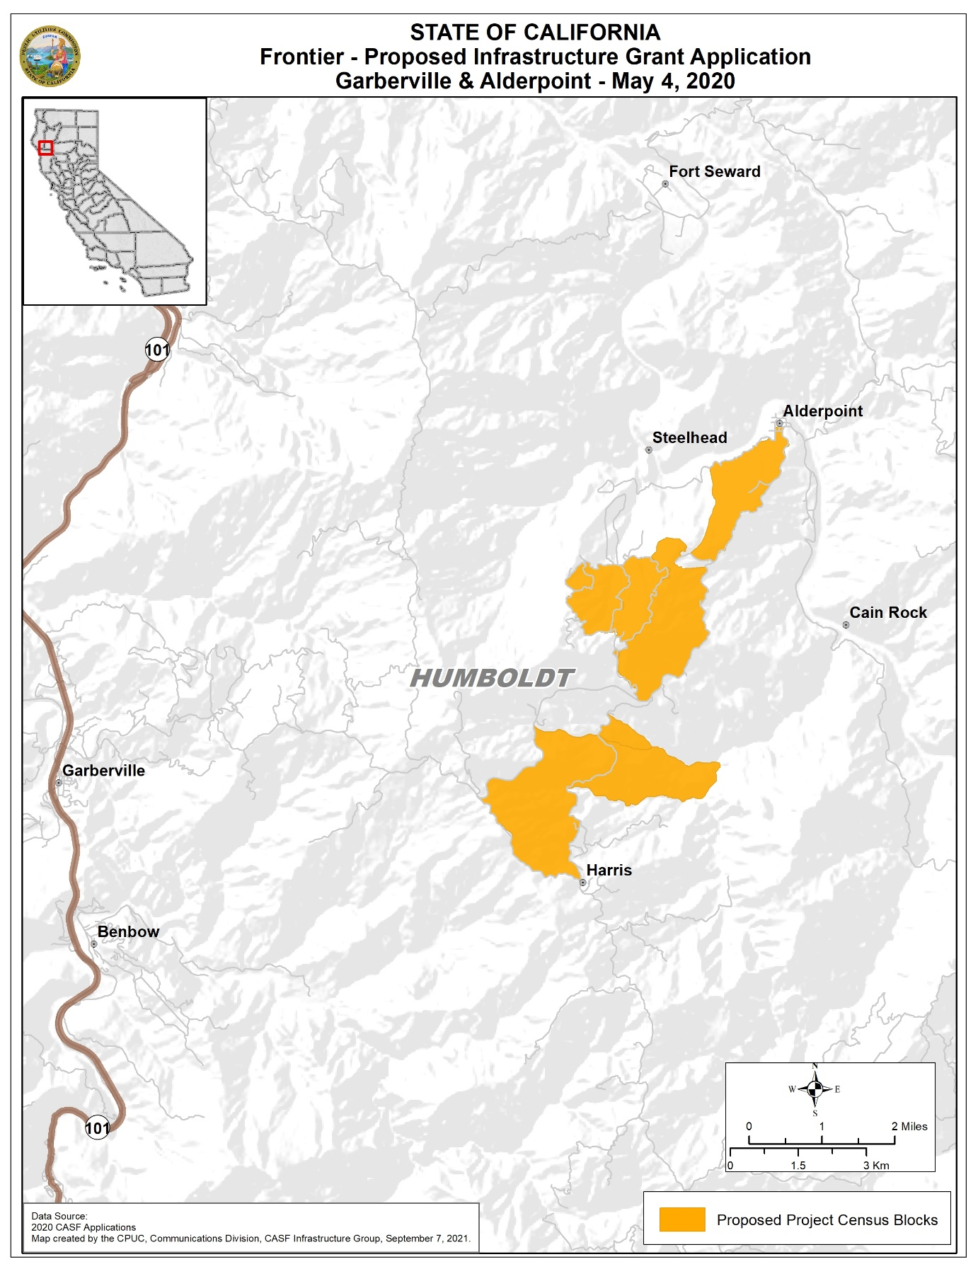
APPENDIX D
Frontier Garberville-Alderpoint
Middle-Mile Map
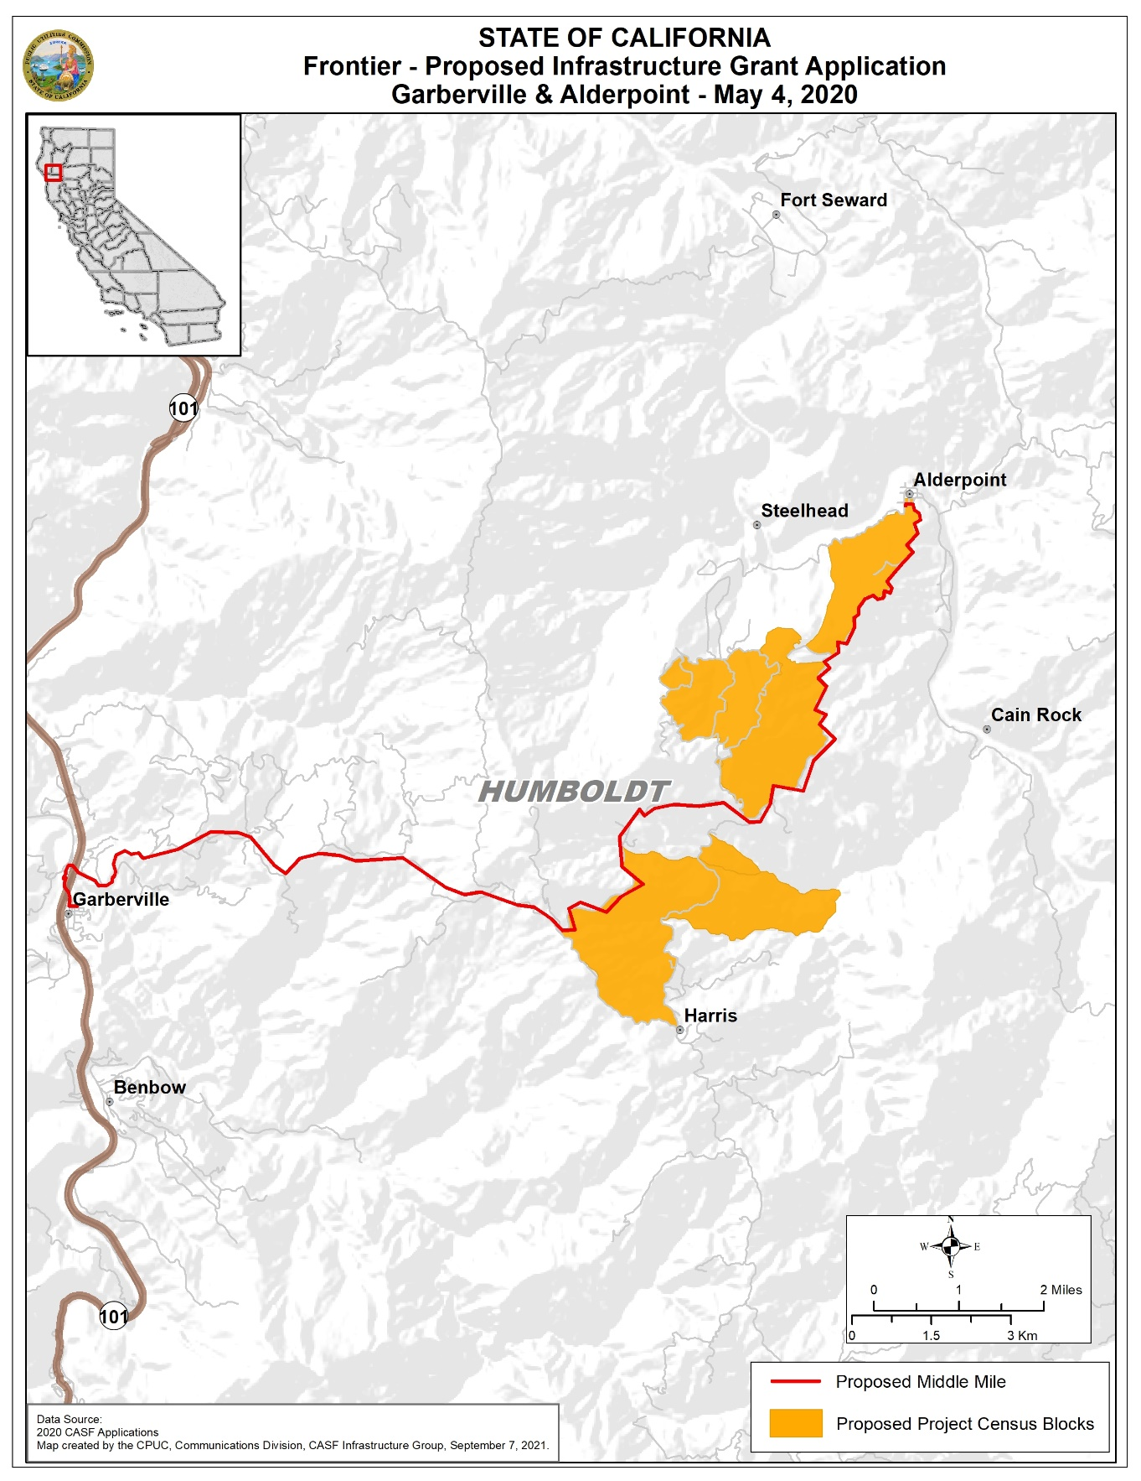
APPENDIX D
Frontier Mad River
Location Map 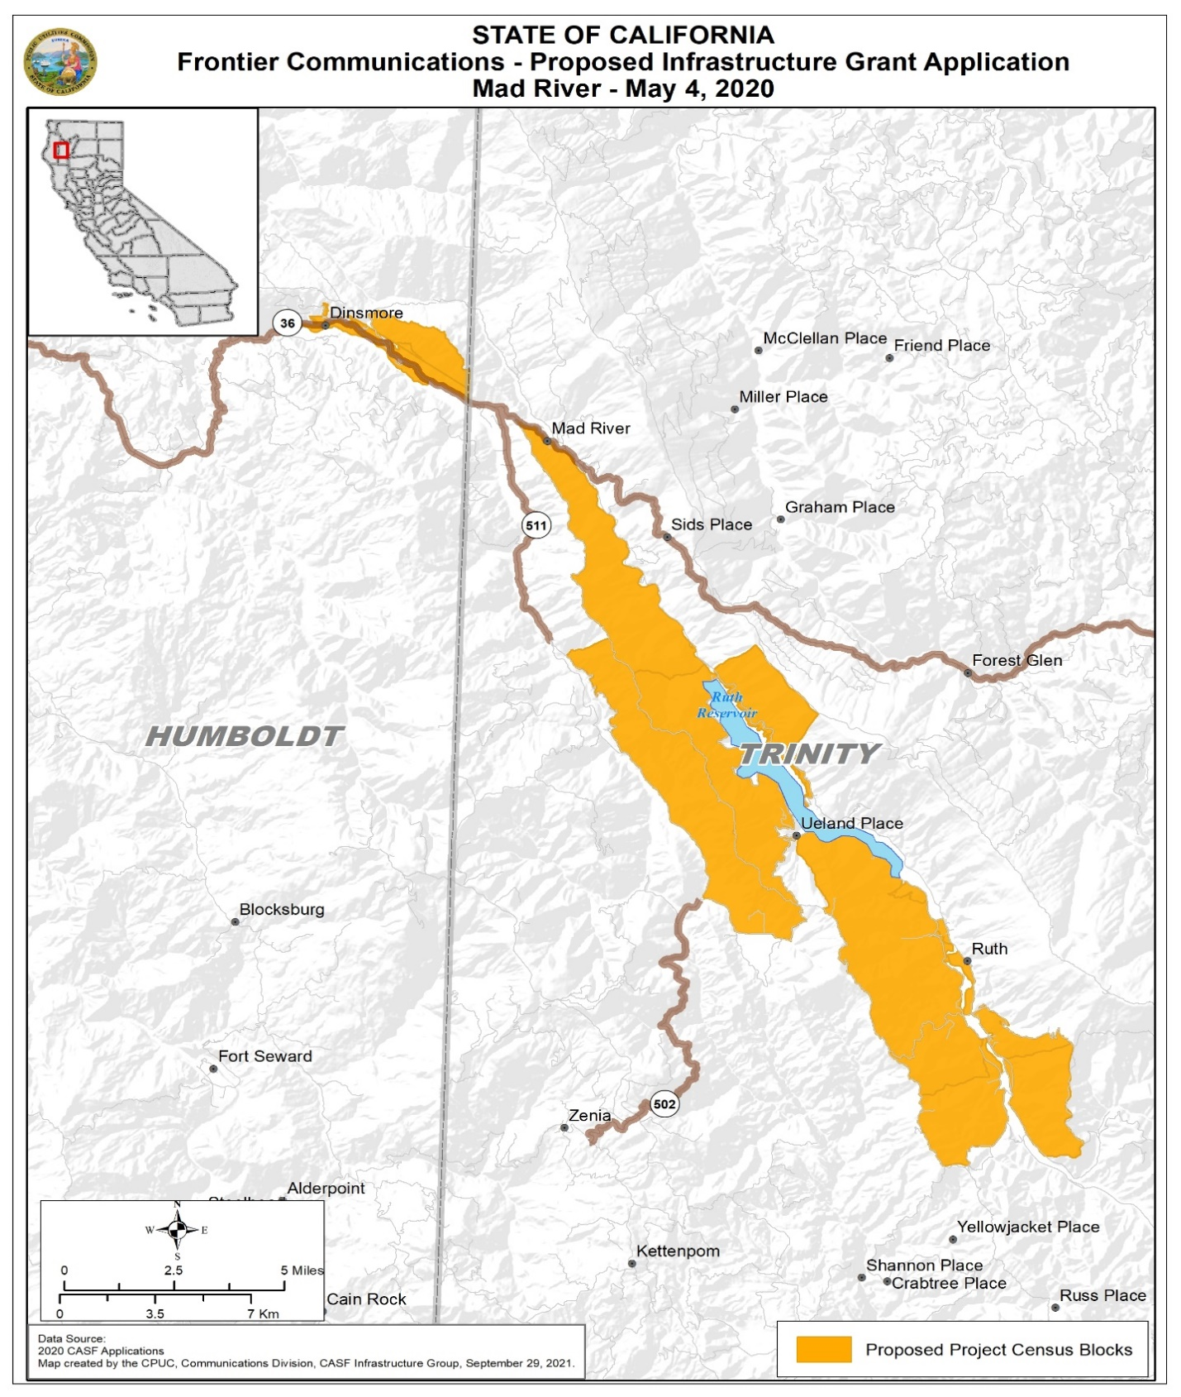
APPENDIX D
Frontier Mad River
Middle-Mile Map
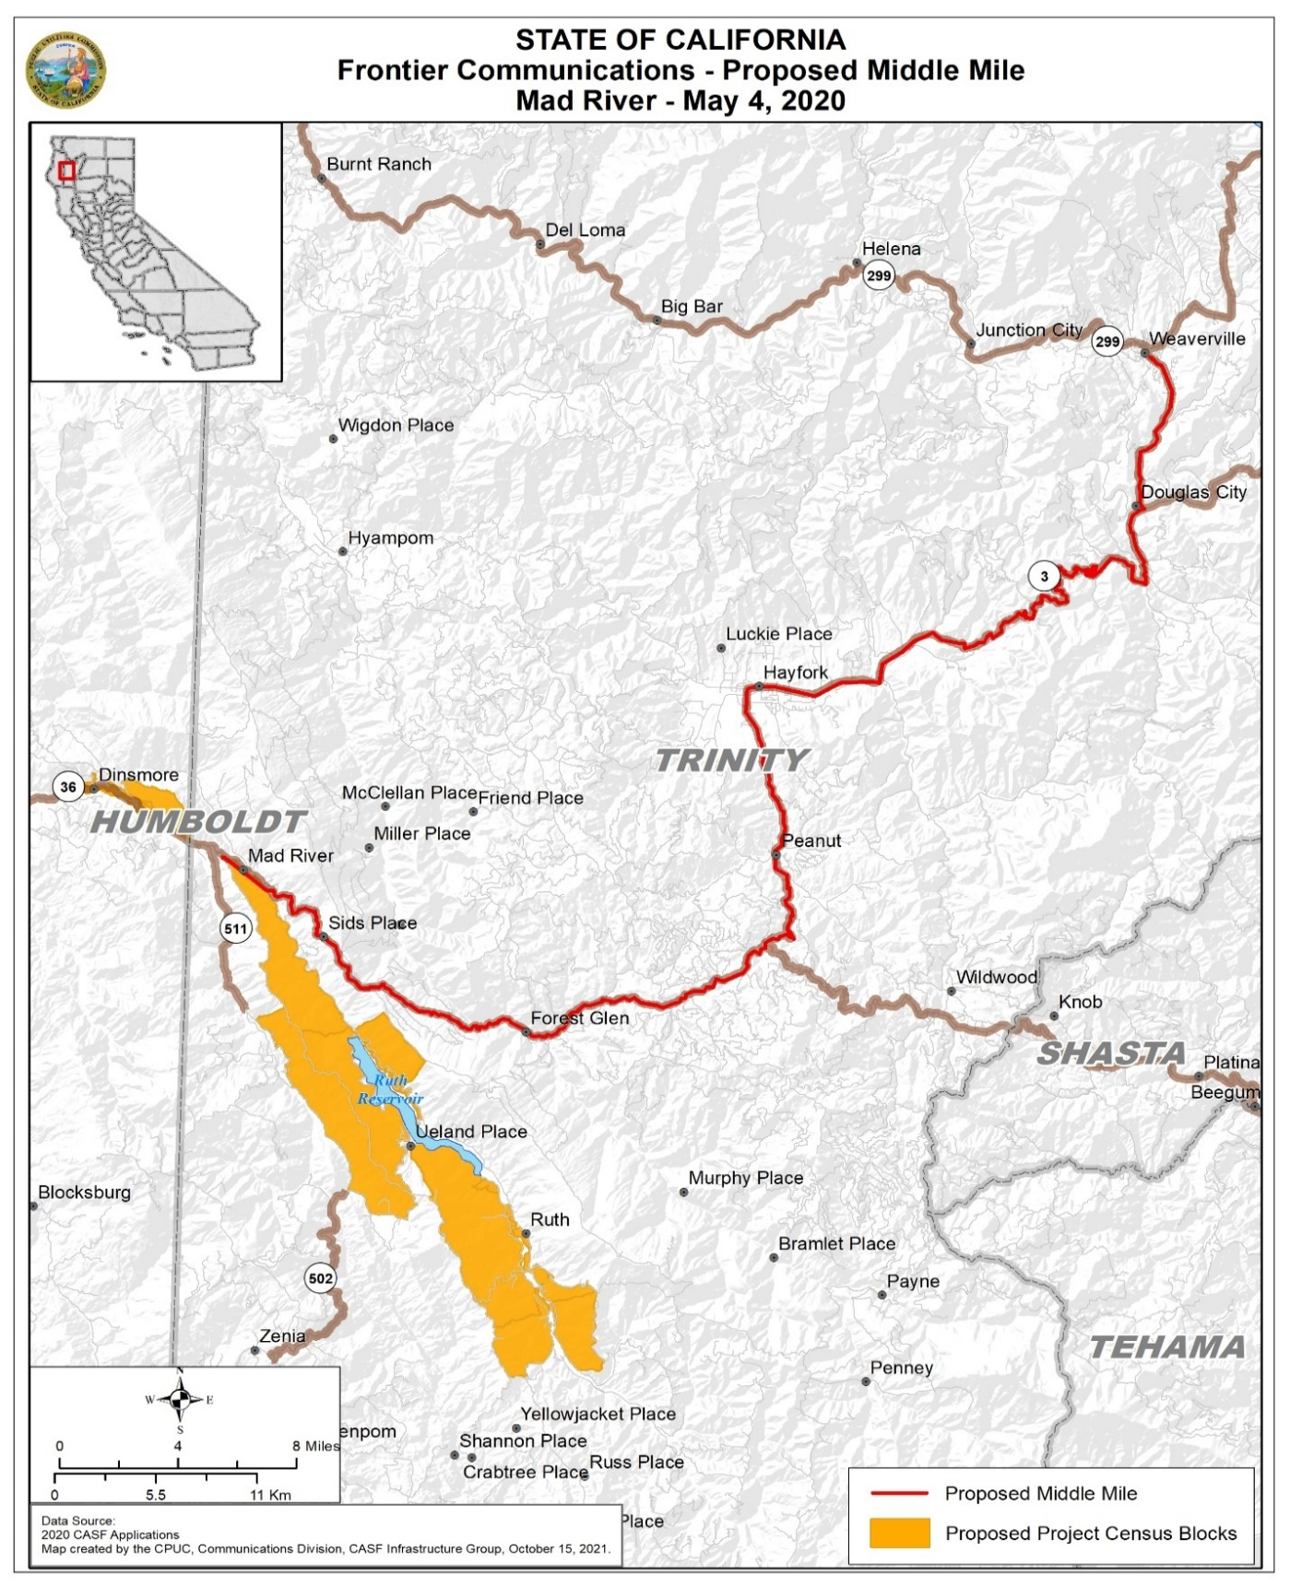

APPENDIX D
Frontier Piercy-Laytonville
Location Map
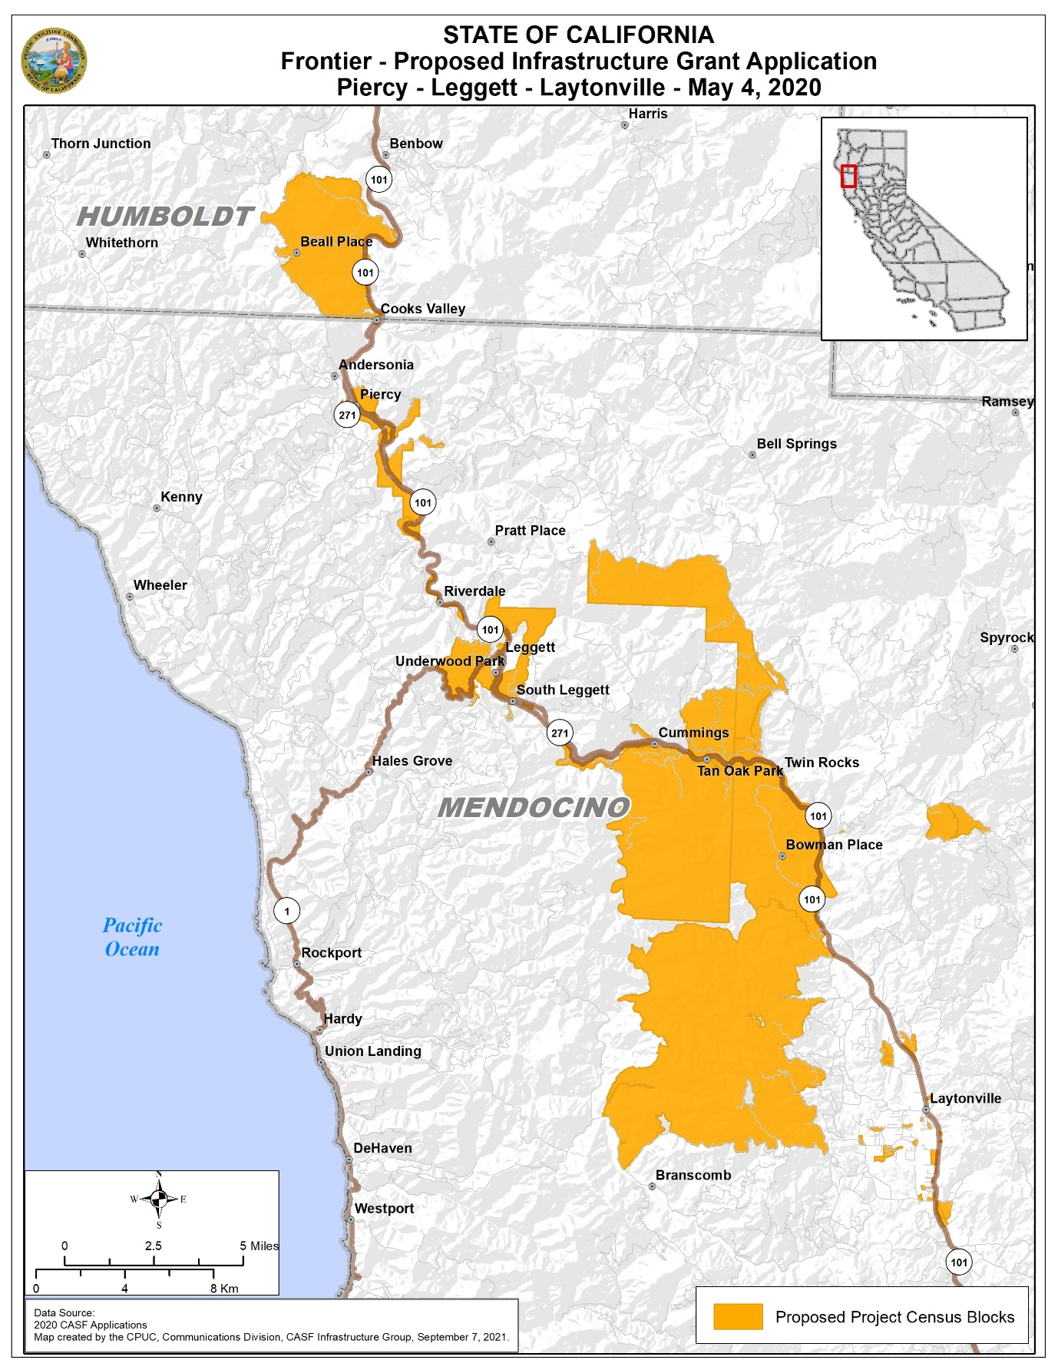
APPENDIX D
Frontier Piercy-Laytonville
Middle-Mile Map
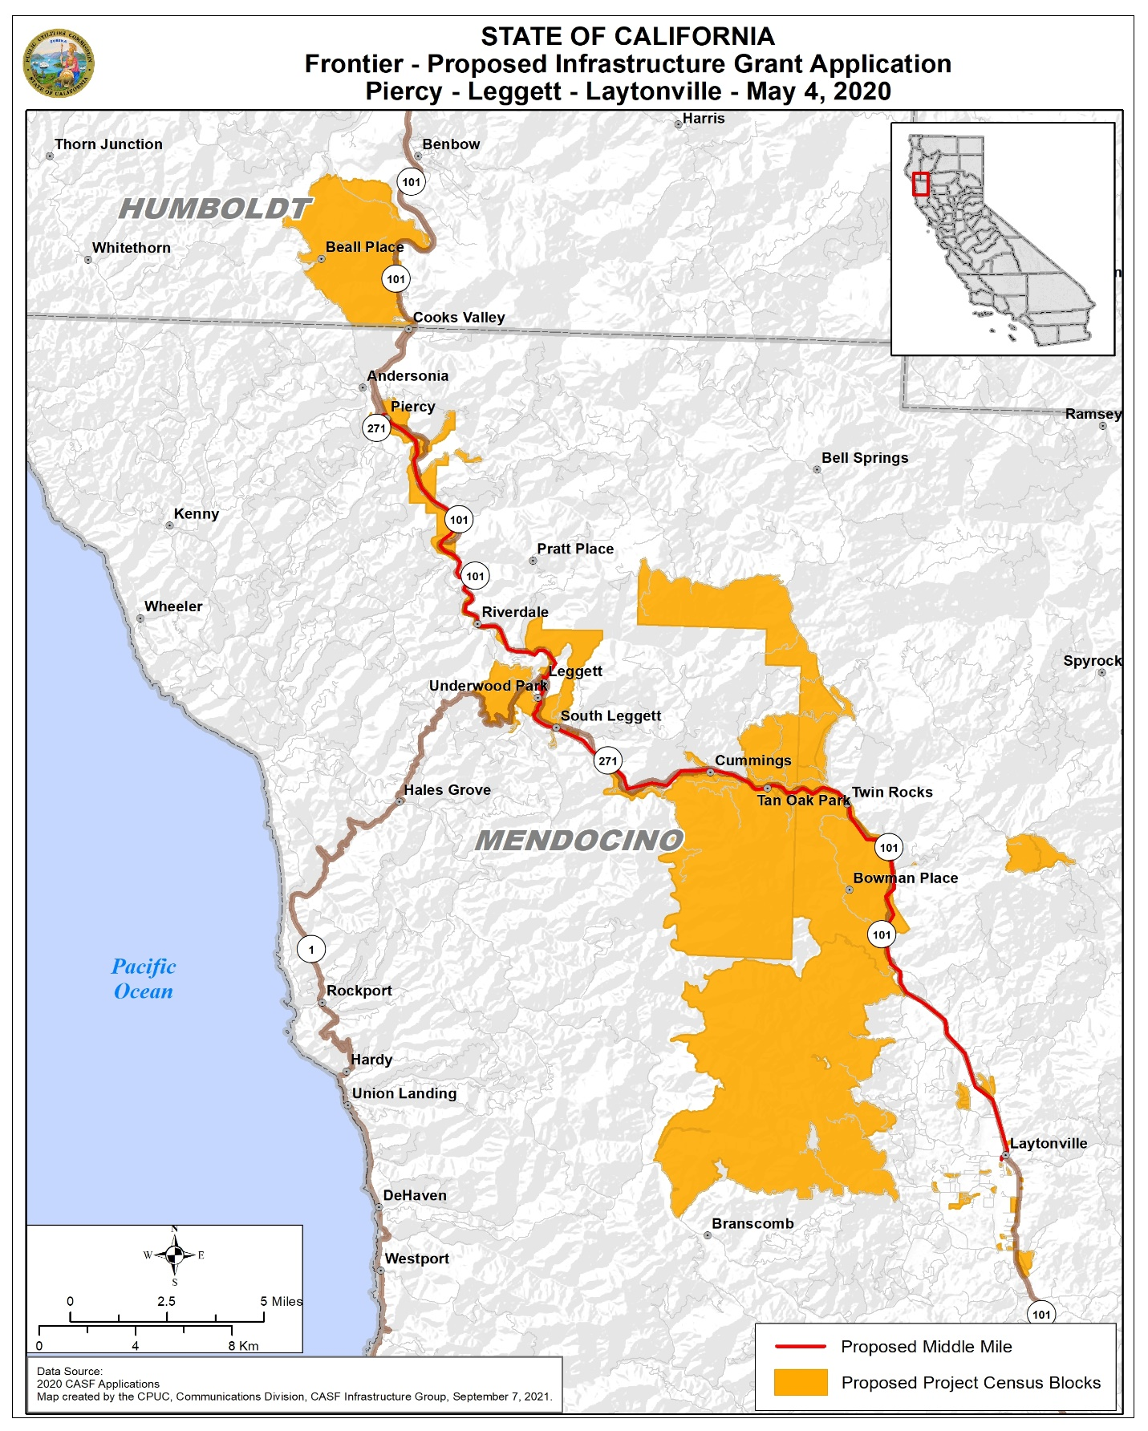

AB 1665 is codified at Public Utilities (Pub. Util.) Code § 281.
The Commission extended the CASF Infrastructure application deadline from April 1 to May 4, 2020, and all subsequent deadlines are moved back by five weeks due to the COVID-19 public health emergency. See Executive Director Letter to CASF Distribution and Service Lists, Postponement of the 2020 CASF Infrastructure Application Deadlines, March 20, 2020.
See Public Utilities Code § 281(b)(1)(B)(ii)(II).
See D.21-01-003, p. 23.
See March 26, 2021 “Postponement of the Deadline for Action on Pending CASF Infrastructure Applications and the Deadline for Submitting 2021 CASF Infrastructure Applications” Letter to CASF Service and Distribution Lists, available at https://www.cpuc.ca.gov/casf/.
https://www.gov.ca.gov/2021/07/20/governor-newsom-signs-historic-broadband-legislation-to-help-bridge-digital-divide/.
See Pub. Util. Code Sec. 281(b)(1)(B)(ii)(I).
See Pub. Util. Code Sec. 281(1).
https://www.gov.ca.gov/2021/07/12/governor-newsom-legislative-leaders-announce-historic-broadband-budget-bill/; SB 156, Chapter 112, available at https://leginfo.legislature.ca.gov/faces/billNavClient.xhtml?bill_id=202120220SB156.
See https://www.cpuc.ca.gov/industries-and-topics/internet-and-phone/california-advanced-services-fund/casf-infrastructure-project-summaries for project summaries and https://www.cpuc.ca.gov/industries-and-topics/internet-and-phone/california-advanced-services-fund/casf-infrastructure-grant/casf-infrastructure-approved-projects for approved projects.
See https://www.cpuc.ca.gov/industries-and-topics/internet-and-phone/california-advanced-services-fund/casf-infrastructure-grant.
https://www.cpuc.ca.gov/-/media/cpuc-website/files/uploadedfiles/cpuc_public_website/content/utilities_and_industries/communications_-_telecommunications_and_broadband/service_provider_information/casfdistributionlist.xlsx
Pub. Util. Code § 281(f)(4)(A)(ii), repealed in 2021, prohibited the Commission from awarding CASF funding to a project applicant if the existing facility-based broadband provider demonstrated, in response to the Commission’s annual offer, that it would deploy broadband or upgrade existing broadband service throughout the proposed project area within 180 days.
Pub. Util. Code § 281(f)(5)(C)(i), repealed in 2021, prohibited the Commission, prior to July 1, 2020, from awarding CASF funding to a project applicant where an existing facility-based broadband provider has accepted federal funds for broadband deployment from Phase II of the Connect America Fund.
CAF II funding awarded to Frontier as part of CAF II Connect America Model version 4.3.
With data as of December 31, 2019.
With data as of December 31, 2019.
Dial-up provides speed less than 200 Kbps downstream and 200 Kbps upstream.
For projects that contain a middle-mile component, Frontier may request an extension of time to allow for CDT approval of middle-mile components. However, CEQA exempt projects shall be completed within 15 months and all other projects shall be completed within 27 months, unless the time is further extended by the Director of CD.
SB 156, enacted on July 20, 2021, and effective immediately, requires the Commission to fund projects that “deploy infrastructure capable of providing broadband access at a minimum of 100 Mbps downstream and 20 Mbps upstream . . .” See Pub. Util. Code Sec. 281(f)(5).
See Appendix A for details of CEQA compliance requirement.
https://www.cpuc.ca.gov/industries-and-topics/electrical-energy/electric-costs/care-fera-program
D.18-12-018 Table 1. Summary of Funding Level Determinations - Maximum funding level is 100 percent.
See 2020 Annual Report on the California Advanced Services Fund, California Public Utilities Commission, Issued April 2020, Table 7: Remaining Unserved Households in Each Consortia Region.
See https://ia.cpuc.ca.gov/firemap/
Pub. Util. Code § 281(f)(4)(A)(ii), repealed in 2021, prohibited the Commission from awarding CASF funding to a project applicant if the existing facility-based broadband provider demonstrated, in response to the Commission’s annual offer, that it would deploy broadband or upgrade existing broadband service throughout the proposed project area within 180 days.
Pub. Util. Code § 281(f)(5)(C)(i), repealed in 2021, prohibited the Commission, prior to July 1, 2020, from awarding CASF funding to a project applicant where an existing facility-based broadband provider has accepted federal funds for broadband deployment from Phase II of the Connect America Fund.
CAF II funding awarded to Frontier as part of CAF II Connect America Model version 4.3.
With data as of December 31, 2019.
With data as of December 31, 2019.
Dial-up provides speed less than 200 Kbps downstream and 200 Kbps upstream.
For projects that contain a middle-mile component, Frontier may request an extension of time to allow for CDT approval of middle-mile components. However, CEQA exempt projects shall be completed within 15 months and all other projects shall be completed within 27 months, unless the time is further extended by the Director of CD.
See Appendix A for details of CEQA compliance requirement.
https://www.cpuc.ca.gov/care/
D.18-12-018 Table 1. Summary of Funding Level Determinations - Maximum funding level is 100 percent.
See 2020 Annual Report on the California Advanced Services Fund, California Public Utilities Commission, Issued April 2020, Table 7: Remaining Unserved Households in Each Consortia Region.
See https://ia.cpuc.ca.gov/firemap/
Pub. Util. Code § 281(f)(4)(A)(ii), repealed in 2021, prohibited the Commission from awarding CASF funding to a project applicant if the existing facility-based broadband provider demonstrated, in response to the Commission’s annual offer, that it would deploy broadband or upgrade existing broadband service throughout the proposed project area within 180 days.
Pub. Util. Code § 281(f)(5)(C)(i), repealed in 2021, prohibited the Commission, prior to July 1, 2020, from awarding CASF funding to a project applicant where an existing facility-based broadband provider has accepted federal funds for broadband deployment from Phase II of the Connect America Fund.
CAF II funding awarded to Frontier as part of CAF II Connect America Model version 4.3.
With data as of December 31, 2019.
With data as of December 31, 2019.
Dial-up provides speed less than 200 Kbps downstream and 200 Kbps upstream.
For projects that contain a middle-mile component, Frontier may request an extension of time to allow for CDT approval of middle-mile components. However, CEQA exempt projects shall be completed within 15 months and all other projects shall be completed within 27 months, unless the time is further extended by the Director of CD.
See Appendix A for details of CEQA compliance requirement.
https://www.cpuc.ca.gov/care/
D.18-12-018 Table 1. Summary of Funding Level Determinations - Maximum funding level is 100 percent.
See 2020 Annual Report on the California Advanced Services Fund, California Public Utilities Commission, Issued April 2020, Table 7: Remaining Unserved Households in Each Consortia Region.
See https://ia.cpuc.ca.gov/firemap/
Frontier will be contracting with Panorama Environmental, Inc. as the lead agency on CEQA.
Administrative costs are defined as “indirect overhead costs attributable to a project, per generally accepted accounting principles (GAAP), and the direct cost of complying with Commission administrative and regulatory requirements related to the grant itself.” Applicants seeking additional funds will require a Commission exemption included in a draft resolution.

