PUBLIC UTILITIES COMMISSION OF THE STATE OF CALIFORNIA

Agenda ID: 20270
ENERGY DIVISION RESOLUTION E-5187
February 24, 2022

RESOLUTION

Resolution E-5187. Pacific Gas & Electric Company’s Annual Reporting of Executive Compensation Awards pursuant to
D.20-05-053.

PROPOSED OUTCOME:
- This Resolution approves Pacific Gas & Electric Company’s (PG&E) Advice Letter 4419-G/6157-E as modified by supplemental 4419-G-A/6157-E-A, denies the Protest of Cal Advocates, and requires PG&E to provide additional information related to executive compensation awards in future annual reports.

SAFETY CONSIDERATIONS:
- There are no safety considerations associated with this resolution.

ESTIMATED COST:
- This Resolution is not expected to impact costs for PG&E’s ratepayers.

By Advice Letter 4419-G/6157-E and supplemental 4419-G-A/6157-E-A, filed on April 9, 2021 and April 30, 2021, respectively.
__________________________________________________________

Summary
This Resolution approves Pacific Gas and Electric Company's (PG&E) Tier 1 Advice Letter (AL) 4419-G/6157-E as modified by supplemental AL 4419-G-A/6157-E-A, denies the protest filed by the Public Advocates Office at the California Public Utilities Commission (Cal Advocates) and requires PG&E in future annual reports to include specific position titles and dollar amounts for its executive compensation awards. In addition, this Resolution requires PG&E, before submitting future annual reports on executive compensation awards pursuant to D.20-05-053, to first consult with the CPUC Energy Division (ED) and the Safety and Policy Division (SPD) for guidance related to additional reporting requirements.

Background
On January 29, 2019, PG&E filed for voluntary bankruptcy under Chapter 11 of the United States Bankruptcy Code. The CPUC opened Order Instituting Investigation (I.) 19-09-016 to consider the ratemaking and other implications of PG&E's bankruptcy, resulting in Decision (D.) 20-05-053.

In addition, on July 12, 2019, Assembly Bill (AB) 1054 was signed into law by the Governor of California. Among its many provisions, AB 1054 added certain requirements pertaining to executive compensation.

In the portion of D.20-05-053 addressing PG&E's executive compensation awards, through the adoption of Assigned Commissioner Ruling (ACR) Proposal 9, the CPUC requires from PG&E the “Annual reporting of awards to the CPUC through a Tier 1 Advice Letter compliance filing.”

Notice
Notice of AL 4419-G/6157-E was made by publication in the Commission’s Daily Calendar. PG&E states that a copy of the Advice Letter was mailed and distributed in accordance with Section 4 of General Order 96-B.

Advice Letter 4419-G/6157-E
On April 9, 2021, PG&E submitted AL 4419-G/6157-E to report its 2020 executive compensation awards, as required by D.20-05-053, and to address how such executive compensation awards comply with the requirements of D.20-05-053 and AB 1054.
PG&E AL 4419-G/6157-E reports the annual awards mainly in the form of a Table showing three categories of compensation (Base Salary, Short-Term Incentive Program (STIP), and Long-Term Incentive Program (LTIP)) and the percentage of total compensation for each category assigned to seven executive officers.
This Table is reproduced from AL 4419-G/6157-E below:

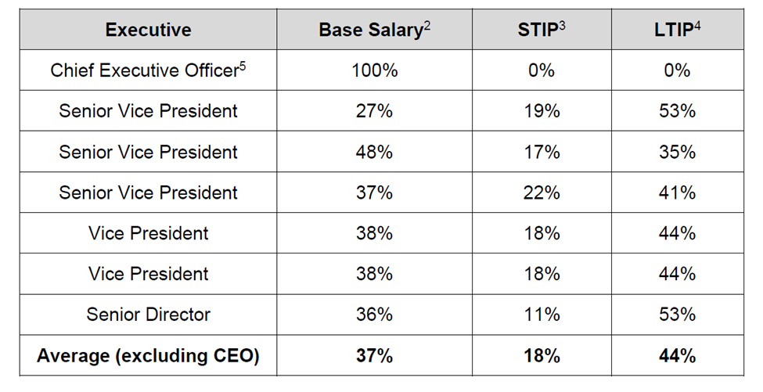

PG&E states that it believes the information presented in the Table is compliant with AB 1054 and D.20-05-053.

In addition to the Tier 1 Advice Letter annual reporting of awards requirement, D.20-05-053 adopted the following requirements related to PG&E's executive compensation:
- Holding or deferring the majority or super-majority of incentive compensation, in the form of equity awards, for at least 3 years.
- Guaranteed cash compensation as a percentage of total compensation that does not exceed industry norms.
- Annual review of awards by an independent consultant.

AL 4419-G/6157-E addresses these requirements by stating that PG&E’s 2020 LTIP performance share equity awards for executive officers are subject to a three-year hold and that PG&E used independent consultant Meridian Compensation Partners, LLC to “confirm, among other things, that base salaries for all officers- including executive officers- as a percentage of total compensation do not exceed industry norms.”

D.20-05-053 also added the following requirement:
- “[A] material portion of executive incentive compensation shall be withheld if . . . PG&E is the ignition source of a catastrophic wildfire, unless the Commission determines that it would be inappropriate based on the conduct of the utility.”

Related to this requirement, PG&E explains that following the September 2020 Zogg fire “[the Board of Directors Executive Compensation] Committee determined to exercise its discretion to materially reduce incentive compensation paid to all PG&E officers—both executive and non-executive—for the 2020 STIP performance year and the 2018 LTIP performance period ending in December 2020.” PG&E further explains the Committee exercised its discretion to reduce 2018 LTIP awards to zero, and 2020 STIP payouts to 65% of target resulting in an average 58% reduction.

In addition to D.20-05-053 requirements, AB 1054 includes the following principles upon which the structure of executive compensation should be based:
- “Strict limits on guaranteed cash compensation, with the primary portion of the executive officers’ compensation based on achievement of objective performance metrics.”
- “No guaranteed monetary incentives in the compensation structure.”
- “A long-term structure that provides a significant portion of compensation, which may take the form of grants of the electrical corporation’s stock, based on the electrical corporation’s long-term performance and value,” with such “compensation . . . held or deferred for a period of at least three years.”

PG&E explains that the information presented in the Table included with AL 4419-G/6157-E addresses these requirements:
- “As shown in the chart, guaranteed cash compensation was a minority of total executive officer compensation, with the primary portion of the executive officers’ compensation being 'at risk' and granted during 2020 through the STIP and the LTIP.”
- As reflected in the chart, there were no guaranteed monetary incentives for PG&E executive officers; the only cash incentive payments were granted through the STIP, and they were entirely “at risk.”
- As reflected in the chart, a significant portion of executive officer compensation, ranging from 35% to 53% at target levels, consisted of equity-based performance share awards (with such awards being subject to a three-year hold).

PG&E filed supplemental AL 4419-G-A/6157-E-A on April 30, 2021 to correct an error in one of the executive’s percentages on the chart included in AL
4419-G/6157-E, as well as an error in footnote 3. The revised chart appears below:

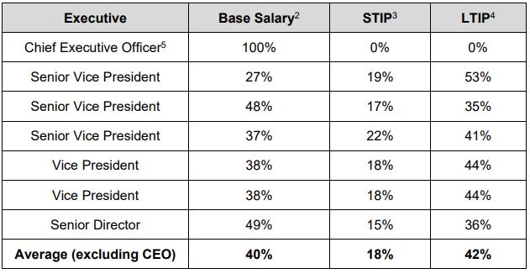

Protests
On April 29, 2021, Cal Advocates filed a timely protest (Protest), pursuant to
GO 96-B Rule 7.4.2(3). PG&E replied to the protest (Reply) on May 6, 2021.
The issues raised by Cal Advocates in the protest are discussed below.

Cal Advocates Protest
Cal Advocates protests on the grounds that the analysis, calculations, or data in the advice letter contain material errors or omissions. Cal Advocates’ Protest requests that the CPUC require PG&E to supplement AL 4419-G/6157-E to correct the following deficiencies:
- PG&E fails to quantify the presented 2020 executive compensation awards and conceals the exact roles and responsibilities of awarded executive officers;
- PG&E fails to include all executive compensation awards;
- PG&E fails to provide the calculations used to quantify award reductions due to implications in the September 2020 Zogg Fire; and
- PG&E fails to provide the results of the safety metrics used to calculate the 2020 executive compensation awards.

The Protest provides further specificity regarding the alleged deficiencies, noting “D.20-05-053 requires PG&E to annually report via Tier 1 Advice Letter ‘awards provided to PG&E executive officers.’ However, PG&E’s AL only describes the percentage compositions of executive officers’ compensations and a percentage reduction applied as a result of PG&E being the ignition source of a catastrophic wildfire.”

Cal Advocates requests that the Commission require PG&E to supplement AL 4419-G/6157-E to include the following information:
- Quantifiable values of awards in dollar amounts received by executive officers at PG&E in 2020 and the identities of each executive officer receiving the award;
- Results and respective calculations of safety metrics and performance indicators used to calculate the 2020 executive compensation awards; and
- Calculations supporting the 58% reduction in 2018 LTIP performance share payments and 2020 STIP payments which PG&E states it applied as a result of the California Department of Forestry and Fire Protection's (CAL FIRE) announcement that PG&E equipment was the cause of the September 2020 Zogg Fire, which killed four people.

In addition, Cal Advocates states that the CPUC should require PG&E to include all executive compensation awarded in 2020, asserting that the “percentages reported in PG&E’s AL do not corroborate the award amounts reported in [PG&E’s Joint Proxy Statement filed with the United States Securities Exchange Commission (SEC)].”

Lastly, Cal Advocates states that if the CPUC requires PG&E to supplement the AL, the protest period of 20 days from the day of submission should be reinstated.

PG&E’s Reply to Cal Advocates’ Protest
In its Reply, PG&E addressed each of the points raised in the Protest while asserting that “Cal Advocates’ arguments are unfounded because they are untethered to any statutory or regulatory requirement.”

PG&E’s Reply further argues that individual names and dollar amounts are neither required by D.20-05-053 nor relevant and that AB 1054 and D.20-05-053 discuss the “portions” and the “percentages” of executive compensation – therefore the percentages as discussed in the AL are what is relevant for complying:
- PG&E states that for nearly all of PG&E’s executive officers, dollar amounts and names are specified in PG&E’s and PG&E Corporation’s 2021 joint proxy statement, which is publicly available. Cal Advocates ignores that the Advice Letter expressly incorporates a reference to the pertinent pages from the proxy statement.
- PG&E asserts that for a small number of PG&E executive officers as defined in PU Code §§ 451.5 and 8389(e), securities laws do not require such disclosures in the proxy statement.
  - PG&E argues these executive officers have a protectable privacy interest in such information, and it would be inappropriate to require its disclosure—especially with no requirement in D.20-05-053.

PG&E explains that contrary to Cal Advocates' claims, it indeed listed all executive compensation awards required.
- PG&E states that Cal Advocates mixes apples and oranges by trying to compare the 2020 information presented in the AL with awards from 2018 and 2019 discussed in the SEC proxy statement as well as awards for PG&E Corporation's executives, all of which are items that are not subject to this annual filing of 2020 awards.

PG&E's Reply explains that the reductions for the Zogg fire are indeed discussed in the AL (at 4-5) even though there is not a specific requirement for PG&E to do so.
- As a result, PG&E states the information Cal Advocates claims is omitted was included in the AL.

Regarding Cal Advocates' argument that because the AL does not “include the safety metrics and performance indicators results used to calculate 2020 executive officer compensations,” it is “difficult to understand whether PG&E has corrected improper executive incentivization as discussed in NorthStar Consulting’s recommendations”, PG&E's Reply explains:
- There is no requirement for the AL to provide this information and this AL is not the proper place for it because such issues are addressed in other proceedings.
- Whether PG&E’s 2020 incentive compensation programs used appropriate performance metrics, whether those metrics adequately promoted safety and other priorities, whether the metrics were weighted appropriately, and so forth, were questions that were resolved when the Commission approved PG&E’s Plan of Reorganization and approved PG&E’s executive compensation structure as compliant with AB 1054.
- Whether PG&E complied with “NorthStar Consulting’s recommendations” is addressed in PG&E’s detailed Safety Culture and Governance Quarterly Reports pursuant to D.18-11-050.

DISCUSSION

The Commission has reviewed PG&E AL 4419-G/6157-E, supplemental AL
4419-G-A/6157-E-A, Cal Advocates’ Protest, PG&E’s Reply and the relevant portions of AB 1054 and D.20-05-053.

The Commission finds that for the 2020 executive compensation award reporting period only, PG&E’s AL 4419-G/6157-E and supplemental AL 4419-G-A/6157-E-A complies with the requirement set forth by the CPUC in D.20-05-053 for the annual reporting of awards.

It is true that D.20-05-053 does not specify that exact compensation dollar amounts or that names or position titles of individuals are required to be presented in the annual report. However, the specific language requires the "annual reporting of awards" and not the annual reporting of ratios or percentages. Therefore, the Commission finds it reasonable to interpret and expect the "annual reporting of awards" to include dollar amounts.

This resolution also finds that in order to better understand PG&E's executive compensation awards, PG&E is required to provide positions titles with greater specificity and the total dollar amount of executive compensation for each executive position presented in its annual report, beginning with its 2021 annual report Tier 1 Advice Letter submittal and each year thereafter. This additional specificity provided here by the Commission should pose little burden on PG&E as it readily admits, "for nearly all of PG&E's executive officers, dollar amounts and names are specified in PG&E's and PG&E Corporation's 2021 joint proxy statement, which is publicly available." For any PG&E executive positions that securities laws do not require such disclosures of, PG&E is directed to submit to the Commission an additional confidential unredacted version of the Tier 1 Advice Letter using the standard confidentiality processes already established.

Although Cal Advocates’ Protest was filed based on the grounds that the analysis, calculations, or data in the advice letter contain material errors or omissions, the Protest does not cite to any specific requirement from D.20-05-053 for the 2020 annual report that is presented in error or that is omitted. Regarding the absence of specific position titles and compensation dollar amounts, we have addressed this prospectively.

The Commission finds that PG&E’s Reply adequately addresses the concerns raised in Cal Advocates' Protest for the 2020 annual report:

Awards Presented
- PG&E listed the required compensation awarded for 2020; Cal Advocates’ concern is misplaced given its reliance on 2018 and 2019 compensation information referenced in PG&E Corporation’s 2021 Joint Proxy Statement.
Reductions due to the Zogg fire
- For purposes of AL 4419-G/6157-E, the Commission finds PG&E has adequately explained the reductions to compensation for the Zogg fire, despite the apparent lack of a requirement to do so.

Safety Metrics and Performance Indicators
- Cal Advocates' Protest does not cite any requirement for PG&E’s AL
4419-G/6157-E annual report for 2020 to present safety metrics and performance indicators, or show compliance with NorthStar Consulting’s recommendations.

For the reasons stated above, Cal Advocates' Protest of PG&E AL 4419-G/6157-E is denied.

In summary, the Commission finds that the information presented by PG&E for reporting its 2020 executive compensation awards in AL 4419-G/6157-E, as modified by supplemental AL 4419-G-A/6157-E-A, complies with the requirement set forth in D.20-05-053. This finding is specific to PG&E’s reporting of 2020 executive compensation awards.

We acknowledge Cal Advocates’ suggestion for PG&E to include more specificity with regard to position titles and total dollar amounts. To provide further clarification and direction for PG&E, beginning with its annual report of 2021 executive compensation awards and each year thereafter, PG&E shall be required to include more specific position titles and total dollar amounts of compensation awarded for each specific executive position listed. For any PG&E executive position for whom securities laws do not require such disclosures, PG&E is directed to annually submit to the Commission an additional confidential unredacted version of the Tier 1 Advice Letter using the standard processes for confidentiality already in place.

In addition, PG&E is required, before submitting future annual reports on executive compensation awards pursuant to D.20-05-053, to first consult with the CPUC Energy Division and the Safety and Policy Division for guidance related to additional reporting requirements.

Comments

Public Utilities Code section 311(g)(1) provides that this resolution must be served on all parties and subject to at least 30 days public review. Please note that comments are due 20 days from the mailing date of this resolution. Section 311(g)(2) provides that this 30-day review period and 20-day comment period may be reduced or waived upon the stipulation of all parties in the proceeding.
The 30-day review and 20-day comment period for the draft of this resolution was neither waived nor reduced. Accordingly, this draft resolution was mailed to parties for comments, and will be placed on the Commission's agenda no earlier than 30 days from today

Findings
- D.20-05-053 adopted, in part, Assigned Commissioner Proposal 9 that set forth requirements for PG&E's executive compensation plan, including the "annual reporting of awards to the CPUC through a Tier 1 Advice Letter compliance filing."
- For the 2020 executive compensation award reporting period only, PG&E’s AL 4419-G/6157-E, as modified by supplemental AL 4419-G-A/6157-E-A, complies with the specific requirements set forth in D.20-05-053.
- D.20-05-053 does not specify that exact compensation dollar amounts or that names of individuals are required to be presented in the annual report. However, the specific language requires "annual reporting of awards" and not the annual reporting of ratios or percentages.
- It is reasonable to interpret the "annual reporting of awards" to include dollar amounts.
- Beginning with PG&E's Tier 1 Advice Letter submittal reporting 2021 executive compensation awards and each year thereafter, PG&E is required to provide the specific position titles and the total dollar amount of executive compensation awarded for each executive position presented.
- PG&E is required, before submitting future annual reports on executive compensation awards pursuant to D.20-05-053, to first consult with the CPUC Energy Division and the Safety and Policy Division for guidance related to additional reporting requirements.
- Cal Advocates' Protest does not cite to any specific requirement from
D.20-05-053 that is presented in error or that is omitted for the 2020 annual report; therefore, the Protest is denied.

Therefore it is ordered that:
- PG&E's Advice Letter 4419-G/6157-E and supplemental 4419-G-A/6157-E-A complies with the requirement set forth in D.20-05-053 and is approved without modification.
- Beginning with PG&E's Tier 1 Advice Letter submittal reporting 2021 executive compensation awards and each year thereafter, in addition to the percentages provided, PG&E is required to provide the position title and total dollar amount of executive compensation awarded for each executive position presented.
- For any PG&E executive positions for whom securities laws do not require such public disclosures, PG&E is directed to annually submit to the Commission an additional confidential unredacted version of the annual Tier 1 Advice Letter using the standard confidentiality processes already established.
- PG&E is required, before submitting future annual reports on executive compensation awards pursuant to D.20-05-053, to first consult with the CPUC Energy Division and the Safety and Policy Division for guidance related to additional reporting requirements.

This Resolution is effective today.

I certify that the foregoing resolution was duly introduced, passed and adopted at a conference of the Public Utilities Commission of the State of California held on February 24, 2022; the following Commissioners voting favorably thereon:

_____________________
RACHEL PETERSON
Executive Director

D.20-05-053 at 97.
Table footnotes not reproduced.
D.20-05-053 at 96.
Id.
D.20-05-053 at 97.
AL 4419-G/6157-E at 3-4.
Id.
AL 4419-G/6157-E at 5.
Id.
Pub. Util. Code § 8389(e)(6)(A)(i)(I).
Pub. Util. Code § 8389(e)(6)(A)(i)(II).
Pub. Util. Code § 8389(e)(6)(iii).
AL 4419-G/6157-E at 3.
Id.
Id.
“PG&E’s Chief Executive Officer departed PG&E on August 3, 2020, shortly after PG&E’s emergence from Chapter 11. In accordance with his departure arrangements, he was not eligible for awards under the 2020 STIP or for 2020 LTIP performance shares. He is not included in the averages in the chart.” AL 4419-G/6157-E at 2.
Cal Advocates’ Protest at 4.
Cal Advocates’ Protest at 4-5.
Cal Advocates’ Protest at 6.
PG&E’s Reply to Cal Advocates’ Protest at 2.
For additional information, note that PG&E is already required to file an annual report to the Commission including names and total compensation of Executive Officers pursuant to CPUC General Order 77-M.
PG&E's Reply to Cal Advocates' Protest at 2.

