# 

Modeling Assumptions for the 2022-2023 Transmission Planning Process  
  
CPUC Staff Report

February 2022



Contents

1. Document Purpose 3

2. Scope 6

3. Report Summary 7

4. Inputs 8

4.1 Reconciling New Baseline Resources 8

4.2 38 MMT with 2020 IEPR High EV Portfolio 10

5. Busbar Mapping Methodology Improvements 16

6. Analysis 18

6.1 Initial Mapping Process and Discussion 18

6.2 Round 1 Mapping Analysis and Subsequent Mapping Adjustments 20

6.3 Remapping and additional adjustments following Round 1 44

7. Results 45

7.1 Geothermal Mapping Results 45

7.2 Wind Mapping Results 46

7.3 Solar and Co-Located Battery Mapping Results 49

7.4 Stand-alone Storage Mapping Results 54

7.5 Transmission Implications of the Mapped Portfolio for the Proposed Decision 56

7.6 Summary of the Mapped 2032 Portfolio for the December Proposed Decision 58

7.7 Final Mapping Adjustments Following Comments and Replies to the Proposed Decision 60

7.8 Transmission implications of Final Mapped Portfolio 69

7.9 Summary of Final Mapping Results 70

8. Other Assumptions for TPP 73

8.1 Thermal Generator Retirement 73

8.2 Demand Response 73

9. Conclusion and Next Steps 75

9.1 Guidance on the 38 MMT with 2020 IEPR with High EV Base Case Resource Portfolio 76

9.2 Busbar Mapping for 2023-24 TPP and Future Cycles 78

10. Appendices 79

## Document Purpose

Resource-to-busbar mapping (“busbar mapping”) is the process of refining the geographically coarse electricity resource portfolios produced in the California Public Utilities Commission’s (CPUC) Integrated Resource Plan (IRP) proceeding, into plausible network modeling locations for transmission analysis in the California Independent System Operator’s (CAISO) annual Transmission Planning Process (TPP).

The purpose of this Report is to memorialize and communicate the methodology and results of the busbar mapping process performed by the CPUC, CAISO and California Energy Commission (CEC), for input into the 2022-2023 TPP, providing transparency and opportunity for IRP and TPP stakeholder engagement.

Similar to preparation for the 2021-2022 TPP, this Report includes the key guidance for TPP studies that in past years was conveyed in the “Long-Term Procurement Plan Assumptions and Scenarios” and later the “Unified Inputs and Assumptions”, thus superseding earlier guidance and documents.

The approach taken in this Report serves to provide detailed documentation to accompany several Excel workbooks that identify the locations for future generation and storage resources that are expected to be necessary to support the California electric grid. Please see Section 10: Appendices for links to these workbooks:

1. Methodology for Resource-to-Busbar Mapping & Assumption for the TPP
2. CEC Busbar Mapping Results for Generation Resources – 38 MMT with 2020 IEPR and high EV base case portfolio
3. Busbar Resource Mapping Calculator
4. Busbar Mapping Dashboard workbook
5. 2020 IRP Baseline Reconciliation (for non-battery and battery resources)
6. Retirement List of Thermal Generation Units

Figure 1 below includes a table and a graph which provide an overview of the composition of the mapped base case portfolio for 2032 as well as a visual map-based representation that conveys the mapped resources, one of the primary inputs being transmitted by the CPUC to the CAISO for the 2022-2023 TPP, in an easily digestible manner. The map provides an overview of the results of the implementation of the busbar mapping process. These results, as well as the inputs, methodology, and analysis are described in detail in the following sections of this Report.

Figure 1: Final busbar mapping results of the proposed base case portfolio for 2032. (Left) Map of the final busbar mapping results show the location and amount of resources mapped by resource type. (Right) Plot show the total mapped capacity broken down by region.

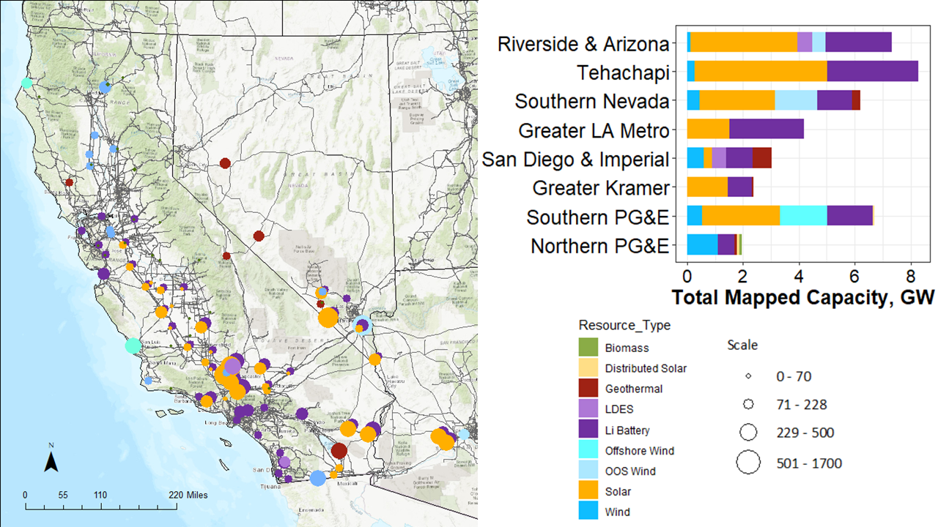

With 13,571 MW of battery storage capacity mapped to busbars for the 2022-2023 TPP, battery storage will play an important role in California’s ability to meet policy goals, and in CAISO’s transmission planning process. The battery storage capacity was mapped using the established methodology which takes into consideration policy goals as one of multiple factors. Figure 2 below shows a subset of the total storage resources mapped and depicts the degree to which staff was able to map storage to various prioritized areas including local capacity requirement (LCR) areas, Disadvantaged Communities (DACs), and air-quality non-attainment areas.

Figure 2: Locational[1] distribution of mapped battery storage for three of the battery mapping policy objectives

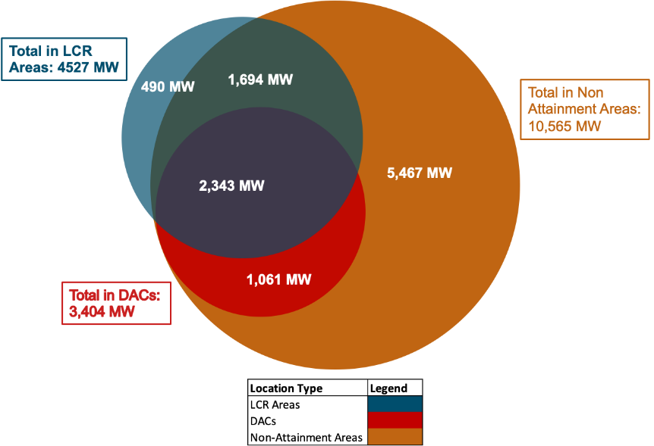

## Scope

This Report addresses the busbar mapping and other modeling assumptions for the portfolio being transmitted by the CPUC to the CAISO for the 2022-2023 TPP, as outlined in Table 1 below.

Table 1: Modeling assumptions reported in this document

|  |  |  |
| --- | --- | --- |
| **IRP Portfolio** | **2022-2023 TPP Portfolio Use Case(s)** | **Modeling Assumptions** |
| 38 MMT using 2020 IEPR[2] High EV (Electric Vehicles) base case portfolio (38 MMT portfolio) | * Reliability base case * Policy-driven base case assessment * Economic assessments | * Busbar allocations of non-battery resources and battery resources * New baseline resources identified since the February 2020 baseline transmitted for the 2020-2021 TPP. * Demand response assumptions * Thermal generation RESOLVE input assumptions |

## Report Summary

The August 17, 2021 Ruling Seeking Comments on Proposed Preferred System Plan (PSP) proposed the 38 MMT core portfolio as the reliability and policy-driven base case portfolio for the 2022-2023 TPP. Based on party comments the decision was made to utilize the 38 MMT 2020 IEPR High EV portfolio as the proposed PSP portfolio instead. The busbar mapping work was conducted by staff taking into consideration parties’ comments on the busbar mapping methodology. This Report describes the portfolio, its mapping to specific busbars, as well as additional inputs and assumptions for the CAISO’s TPP. This Report is structured as follows:

Section 4 states the objectives of studying the base case portfolio and details the inputs CPUC staff provided to the mapping process.

Section 5 summarizes the updates made to the proposed methodology[3] used by CPUC, CAISO and CEC staff to conduct busbar mapping and produce other inputs and assumptions for the 2022-2023 TPP.

Section 6 details the analysis and steps taken by staff to improve the allocations in order to meet the criteria.

Section 7 summarizes the final results of the mapping process.

Section 8 presents other information about the portfolio that is required for TPP.

Section 9 draws conclusions regarding mapping the portfolio for the 2022-2023 TPP and provides guidance to the CAISO.

## Inputs

In order to the complete the steps in the methodology described below, the following input is needed: Portfolio of selected resources for 2032, by transmission zone, with Fully Deliverable (FD) and Energy-Only (EO) megawatt (MW) amounts specified.

The portfolio described below was developed using the same modeling assumptions as were used to develop the proposed 2021 Preferred System Plan (PSP) 38 MMT by 2030 with 2020 IEPR and High EV portfolio.

### Reconciling New Baseline Resources

Since the previous busbar mapping cycle, new resources have been added to the baseline, the master array of resources online, under-construction, or contracted and assumed to be operational in the years modeled. These new resources need to be reconciled to ensure they are properly accounted for in busbar mapping and the transmission planning process. The previous RESOLVE baseline was set in February 2020 and was included as part of the 2020-2021 TPP portfolio transmittal to the CAISO. The CAISO utilized this baseline set to develop the updated transmission capacities in the CAISO’s White Paper – 2021 Transmission Capability Estimates for use in the CPUC’s Resource Planning Process (CAISO’s 2021 White Paper),[4] which the CPUC utilized in both the RESOLVE model used to develop the portfolio and in the busbar mapping process. The new baseline resources need to be accounted for in both the portfolio creation and the transmission deliverability information.

Since the development of the February 2020 baseline, Load Serving Entities (LSEs) have submitted integrated resource plans and other separate resource contract filings to the CPUC that identified new resources coming online or being developed that the LSEs have procured but are not in the 2020-2021 TPP baseline. CPUC staff used two datasets to quantify the changes from the previous baseline to new baseline. The first dataset was the CPUC updated partial baseline dataset which included new resources contracted by LSEs, which the LSEs submitted as part of their September 2020 integrated resource plans to the CPUC. The second was a separate compilation of additional LSE contracts filed with the CPUC by February 2021 pursuant to D.19-11-016.

These new resources need to be accounted for by the CPUC in busbar mapping and by the CAISO in the transmission planning process to ensure their transmission capability is accurately captured in planning. The steps below describe with reference to the 38 MMT 2020 IEPR High EV portfolio how these new resources were identified and included in the mapping process:

* The two sets of LSE contracted resources were combined and filtered to show projects that did not exist in the previous 2020-2021 RESOLVE baseline (“Gen List” tab in the Resource Cost and Build Workbook from February 2020). This required some manual comparisons between each dataset and the previous CPUC gen list.
* The remaining resources were aggregated by RESOLVE resource type and substation, to establish the set of new baseline resources. The summary result is shown below in Table 2.
* In developing 38 MMT 2020 IEPR High EV portfolio, rather than utilizing the updated baseline, staff accounted for these new baseline resources in the portfolio by forcing the RESOLVE model to include as “planned” resources in its portfolio the amount of each resource type. This ensured that RESOLVE reserved the transmission headroom that these new baseline resources require, as well. In previous busbar mapping cycles, baseline resources were subtracted from the selected portfolios because they were not accounted for in the RESOLVE “planned” set of resources.
* In the busbar mapping process, staff then reconcile the new baseline resources by specifically mapping planned resources selected by RESOLVE to match the locations of the new baseline resources.

For the 2021 PSP December Proposed Decision,[5] resources identified as hybrid in LSE plans were split into individual battery and energy only deliverability status (EODS) solar components to maintain consistency with the implementation and treatment of co-located solar and storage in the busbar mapping process. Following stakeholder comments on the proposed decision, staff adjusted this methodology assigning FCDS status to a portion of the solar in a hybrid resource, depending on the max MW output of the resource.

As a result of this baseline reconciliation, a total of 4,480 MW of solar; 1,128 MW of wind; 3,988 MW of storage; 30 MW of geothermal; and 7 MW of biomass/biogas was mapped to corresponding substations as seen in Table 2. There were 432 MW of resources whose substations could not be identified or the resource is identified as an import. These substations were not identified because the substation name specified could not be matched to a corresponding substation name in the list used by the CPUC. The detailed summary of the new baseline resources, including the resources not able to be mapped is included in Appendix E and will be transmitted to the CAISO. Appendix E contains more detailed information on how hybrids are treated and includes the baseline summary information previously utilized in mapping the portfolio for the Proposed Decision. Updated information procurement data that LSEs submitted in September 2021 per D.20-12-044 and D.19-11-016 requirements is not utilized in this baseline reconciliation analysis, as its availability came too late in the busbar mapping process to be successfully incorporated. Thus, there may be some discrepancies in this new baseline resource summary when compared with the most recent data.

Table 2. Summary of new baseline resources by substation and resource type in MWs



### 38 MMT with 2020 IEPR High EV Portfolio

#### Objective and Rationale

The objective of transmitting this portfolio to the CAISO for the TPP base case studies is to ensure that transmission planning and development aligns with resource planning and development. The design of this portfolio achieves this objective by reflecting a possible lowest-cost achievement of the state’s greenhouse gas reduction goals as informed by individual LSE planning efforts, staff aggregation of these plans, and IRP capacity expansion modeling. In the “ALJ Ruling Seeking Comments on Proposes Preferred System Plan (PSP)”, the proposed PSP portfolio was developed based on a greenhouse gas (GHG) emissions target for the electric sector of 38 MMT in 2030. This 38 MMT with 2020 IEPR High EV portfolio is designed around that 2030 GHG target and is named based on the convention of referring to that target. However, because the resource planning horizon needed specifically for the 2022-2023 TPP extends to 2032, the emissions of the portfolio in 2032 are lower than 38 MMT. This is described in more detail under the “Description” section below.

To improve the degree of accuracy of the transmission upgrade information that comes out of the RESOLVE analysis, the CPUC updated the modeling of transmission deliverability using data from the CAISO’s 2021 White Paper. This update also improved the locational information for battery resources modeled in RESOLVE and the ability to select them in the same transmission constraints as solar resources. Ultimately, this resulted in improved information as inputs for the busbar mapping process for assigning co-located solar and battery resources. This eliminated the need for some of the busbar mapping steps that were conducted for the 2021-2022 TPP, which transferred full capacity deliverability status (FCDS) from solar resources to battery resources in order to maximize co-location and reduce the likelihood of triggering an exceedance.

However, one of the challenges with this updated transmission information from the CAISO is a disconnect with the transmission information that was used in developing the LSE plans. To incorporate both the LSE plans and the new transmission deliverability data, some modifications were made to assumptions of resources that could be selected to levels contained in the LSEs’ plans. For instance, although offshore wind from the Humboldt area is contained in the LSE plans, the RESOLVE portfolio was allowed to use offshore wind from Morro Bay as a replacement option. This was done to enable the model to solve, because the amount of available transmission deliverability at Humboldt was less than the amount of resource contained in the LSE plans. In addition, the lack of information on the cost and timing of additional upgrades at Humboldt would make the model unable to solve, without the above adjustment to the assumptions; because it would not be able to meet the constraint even at a higher cost.

#### Relationship Between RESOLVE Selected Resources and the CAISO TPP

RESOLVE is a system level capacity expansion model with simplified transmission capability and cost assumptions. As an input to the busbar mapping process the resources selected by RESOLVE and their locations get evaluated based on interconnection feasibility, potential required transmission upgrades, and other criteria. The RESOLVE portfolio for this 2022-2023 TPP indicates the need for transmission upgrades to accommodate approximately 691 MW of resources selected in 2032 that could not be accommodated by the existing transmission system.

However, CPUC staff cannot know for certain the transmission implications until they are studied by the CAISO in the TPP at actual busbar locations. For this reason, the CPUC will transmit this portfolio to the CAISO to conduct detailed transmission planning to assess the exact transmission needs. CAISO TPP results will indicate whether any reliability or policy-driven transmission upgrades are found necessary, and if so, those transmission upgrades may be recommended to the CAISO Board of Governors for approval.

If any of the approved transmission upgrades are investments made specifically to accommodate the resource development future reflected by the CPUC in this portfolio, this portfolio will have helped ensure that transmission and generation resources are developed concurrently. This should minimize risk of stranded generation assets later being discovered to be undeliverable to load due to a lack of available transmission capability.

To ensure this is a bidirectional minimization of ratepayer costs, the CPUC expects to receive information from the CAISO regarding which approved transmission projects are developed to accommodate policy-driven resource planning. (Typically, the CAISO Transmission Plan clearly identifies the policy-driven projects). The CPUC can then act accordingly to encourage the development of those resources that can utilize the transmission capacity in order to avoid stranded transmission assets. Further, the CPUC’s transmittal cannot be assumed to prejudge the outcome of a future siting Application for a specific transmission line (e.g. a Certificate of Public Convenience and Necessity Proceeding). However, the CPUC’s transmittal of resource planning assumptions can be considered in the need determination phase of the CPUC’s consideration of any specifically proposed transmission project.

#### Description of Portfolio

For the planning year 2032, the portfolio comprises 13,571 MW of new battery storage, 24,928 MW of new in-state renewable resources (which includes 1,708 MW of offshore wind), and 1,500 MW of new out-of-state (OOS) renewable resources on new OOS transmission, among other resources.

Table 3 summarizes the resource build out in 2032, the resource planning year needed specifically for the 2022-2023 TPP. The GHG target modeled in 2032 was 28.6 MMT.[6]

Table 3. Capacity Additions in 2032 in the 38 MMT with 2020 IEPR High EV Portfolio

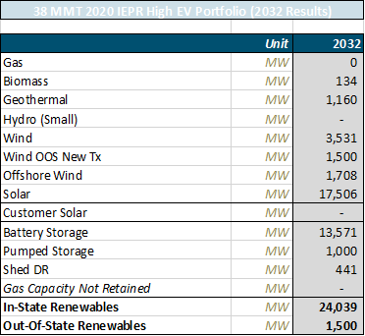

This portfolio meets the RESOLVE 22.5% Planning Reserve Margin (PRM) constraint which includes the adjustments made to incorporate the mid-term reliability decision (D.21-06-035) requirements. The loss of load expectation (LOLE) study results include a 0.0023 LOLE in 2026 a 0.0005 LOLE in 2030, and a 0.0006 LOLE in 2032, indicating that this is a reliable portfolio. The inputs to the mapping process for this portfolio are summarized in Table 4 below. Note that RESOLVE selected offshore wind only at Morro Bay rather than also at the LSE-selected Humboldt area due to the lack of available transmission in the Humboldt area noted earlier.

Table 4: All resources selected in the 38 MMT 2020 IEPR High EV portfolio (2032 cumulative)

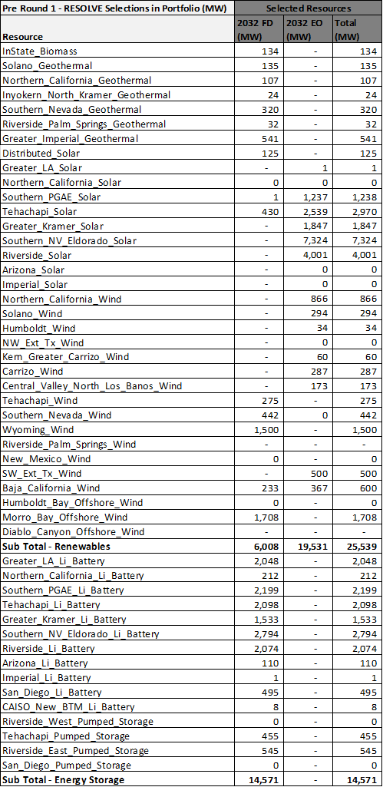

In addition to the resource selection information from RESOLVE, transmission upgrade results are also used to inform the mapping analysis. Table 5 summarizes the selected upgrades triggered in RESOLVE, showing that there are few upgrades selected through 2032. This is partly due to the construction times associated with the upgrades as provided in the CAISO’s 2021 White Paper. Most upgrades have longer completion times and cannot come online or be selected by RESOLVE until the late 2020s period. By 2032 a total of 691 MW of partial transmission upgrades is selected by the portfolio.

Table 5: Summary of RESOLVE triggered transmission expansion; amounts are in MWs.



## Busbar Mapping Methodology Improvements

Staff from the two agencies and the CAISO completed the steps described in the CPUC Staff Proposal: Methodology for Resource-to-Busbar Mapping & Assumptions for the Annual TPP, except where improvements were identified, as summarized here. The full, updated Methodology is available as a separate document (see Appendix A).

Figure 3. Flowchart of the 2022-2023 TPP busbar mapping process

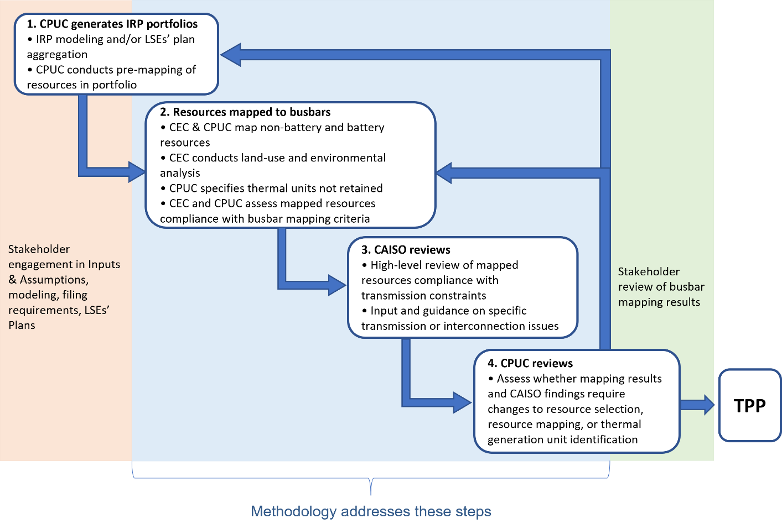

Improvements to the Staff Proposal were informed by stakeholder feedback, recommendations from the CEC and CAISO, and staff’s experience during implementation of the busbar mapping process, as summarized below.

#### Busbar Mapping Steps

* Added pre-mapping step which incorporates commercial interest to inform first-round of mapping, prior to land use evaluation.
* Clarified busbar mapping steps to show integration of battery mapping with non-battery as a result of utilizing new transmission constraints from the CAISO’s 2021 White Paper.
* Added details in Step #2 part 5 on the data sets utilized for land-use and environmental analysis of out-of-state resources.
* Added details in Step #2 part 7 on the process and data used to map state-level biomass resources and distributed solar resources included in the portfolio.

#### Busbar Mapping Criteria

* “Commercial interest” language now better reflects consideration of projects in non-CAISO queues and other sources.
* Implementation of the Busbar Mapping Criteria
  + 3a. Land-use: Adjust criteria percentage threshold for level 3 and level 2 to 75% of high and low value land respectively and note use of WECC[7] dataset levels for OOS resource land-use screening.
  + 4 – Commercial Interest: Criteria under commercial interest were clarified to better distinguish flags for “high confidence” commercial interest and to clarify flags for when commercial interest is higher and lower than the amount of resources mapped to substation.
  + 5 – Prior Base Case: Noted process by which non-compliance could be reduced in subsequent mappings based on analysis by the working group.

#### Battery Mapping Steps

Based on feedback from stakeholders and recommendations from the CAISO the battery mapping steps have been updated.

* Due to the improved integration between the non-battery busbar mapping and battery mapping, the issues addressed by the policy directive #1 Minimizing Ratepayer Costs have been modified. The amount of co-located battery and solar resources mapped is now a function of the non-battery resource mapping.
* The order of the mapping steps also now reflects the increased integration with the non-battery busbar mapping.
* The mapping steps no longer make a distinction between stand-alone and co-located battery resources.
* The mapping steps now explicitly differentiate between levels of confidence for commercial interest.
* Due to the RESOLVE portfolio not including any economically non-retained gas capacity, the battery mapping analysis does not include any information on proximity of substations to potentially non-retained units.
* Co-location mapping now occurs after the battery resources have been mapped. This step is now carried out while the CPUC is mapping the EODS resources.

## Analysis

This section details the analysis and mapping process performed to reach the final results in Section 6. For the non-battery resources staff use a “dashboard” to identify whether busbar allocations of a particular round of mapping of a portfolio comply with the five key criteria described in the Methodology (see Appendix A.). This informs whether changes to the allocation may be required. For the battery resources CPUC staff apply the methodology and analyze it through the lens of achievement of policy objectives, interaction with the non-battery resources, and transmission implications. Both the battery and the non-battery mapping build on the locational information reported in the resource selection results Section 4.2 from the RESOLVE optimization.

The analysis first summarizes the initial mapping effort CPUC staff performed to map all resources to substations in Section 6.1. CEC then conducted land-use and environmental impact analysis of the mapped resources and CAISO provided additional transmission analysis of the mapped resources in accordance with the Methodology. Section 6.2 presents the results of the criteria assessment performed on this Round 1 of mapping, identifying and discussing mapped resources non-compliances with the criteria as outlined in the Methodology. This discussion is broken down by resource type: Section 6.2.A Geothermal, 6.2.B Wind, 6.3.C Solar and co-located storage, and 6.4.D stand-alone storage. Within each resource subsection, staff then discuss what reallocations and adjustments were made to the mapped resources to better comply with the criteria and to better achieve policy objectives. These changes were made through additional rounds of mapping with further input and review by the CEC and CAISO. The results of the final round of mapping, after which CPUC staff determine no further mapping is necessary, are discussed in Section 7. Details and analysis of the additional intermediate rounds between Round 1 and the final round are included in Appendix D.

### Initial Mapping Process and Discussion

This section discusses the initial pre-mapping analysis that CPUC staff carried out in Step 1 of the flow chart in Figure 1: translate the portfolio resources into data that could then be used by the CEC and CAISO analysis listed in Steps 2 and 3.

Starting with the portfolio resources identified in 38 MMT core portfolio of the August 17, 2021, proposed PSP ruling, the CPUC mapped the selected resources in accordance with the Methodology for the non-battery and battery resources. The first part of this initial mapping involved allocating the FCDS and EODS resources in the following respective order: geothermal, wind, out-of-state wind, offshore wind, pumped-storage hydroelectric, and finally solar (FCDS resources only). The long lead-time resources (resources that have a longer development timeline, particularly compared to resources like solar PV and onshore wind) and the wind resources were mapped first because of the necessity of mapping resources within the transmission constraints that RESOLVE selected. For the solar FCDS resources, staff decided to assign these resources next due to the limited amount of FCDS solar resources selected by RESOLVE.

Battery resources were assigned next. CPUC staff mapped battery resources to substations utilizing the steps described in the Methodology. Three stages were involved in the battery assignment: the first two stages utilizing an automated calculator tool based on high-confidence commercial interest and low-confidence commercial interest respectively; and a third stage that was manually conducted based on further interaction with the initial non-battery resource allocations and previous TPP busbar mapping results.

Upon completing the mapping of battery resources, CPUC staff allocated the solar EODS resources, utilizing the same Methodology as the other non-battery resources while also maximizing the amount of co-located solar and battery resources.

Table 6 below shows the results of the pre-mapping analysis.

Table 6: Summary of the initial mapping analysis conducted by the CPUC to initially map the resources to substations.

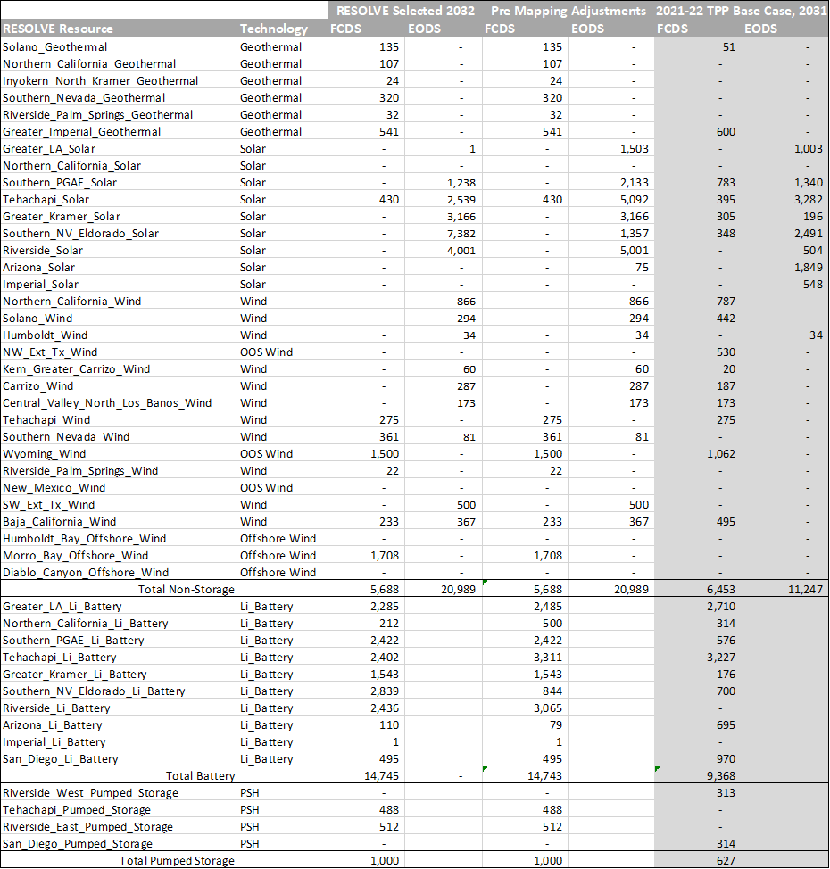

### Round 1 Mapping Analysis and Subsequent Mapping Adjustments

Following the initial mapping analysis conducted in Section 6.1 above, CEC conducted land-use and environmental impact analysis of the mapped resources and CAISO provided additional transmission analysis of the mapped resources in accordance with the Methodology. This section discusses the Round 1 mapped resources compliance with the mapping criteria: criteria 1 (distance to transmission of appropriate voltage), 2 (transmission capability limits), 3a (available land area), 3b (high environmental impacts), 4 (commercial interest), and 5 (consistency with prior year’s base case mapping). Note, compliance with criterion 5 was assessed with reference to the 2021-2022 TPP 46 MMT base case portfolio. The analysis below consists of a review of the criteria compliance and a discussion of mapping adjustments that are then made to improve criteria alignment to reach the final portfolio. The discussion is segmented by resource type.

As part of the mapping adjustments discussed below, staff had to account for three issues that result in significant mapping adjustments. The first adjustment resulted from CAISO staff providing updated transmission constraint information for several areas following Round 1 mapping analysis. CAISO staff included these adjustments in the updated CAISO’s 2021 White Paper.[8] Key changes included:

* Transmission constraint capability headroom for several constraints include significant adjustments to the Windhub and the Mesa-Laguna Bell constraints.
* Adjustments to which constraints applied to certain substations: Palo Verde and Delaney substations were removed from the East of Miguel Constraint; Bannister substation was removed from the East of Miguel and other San Diego area constraints; Big Creek area substations were included in the Mesa-Laguna Bell constraint.

The impacts of these transmission constraint updates are discussed in the criteria analysis discussion below. They result in more transmission headroom at key substations, allowing for more resources to be mapped to them and result in transmission exceedances at other substations that can be alleviated with upgrades noted in the CAISO’s 2021 White Paper.

The second significant adjustment in post-Round 1 remapping was the updated PSP RESOLVE portfolio. The PSP portfolio utilized an updated RESOLVE run with adjusted inputs following feedback on the portfolio issued in the PSP ruling. The updated portfolio, the 38 MMT 2020 IEPR High EV portfolio, which is described in Section 4.2, resulted in a reduction of 22 MW of wind, ~1,377 MW of solar, and ~1,182 MW of batteries when compared with the 38 MMT core portfolio released with the August 17, 2021, proposed PSP ruling. As the busbar mapping process began using the 38 MMT core portfolio resource amounts, the remapping discussed below also accounts for these adjustments by removing resources at selected substations in line with the updated RESOLVE outputs to improve their criteria compliance.

Staff also conducted relocations to align the mapped resources with the baseline reconciliation resources identified in Section 4.1 to properly account for the transmission capability implications of resources identified as contracted or in development but not in the CAISO’s 2021 White Paper and the RESOLVE model baselines.

##### Geothermal Resources Discussion

Table 7 depicts a summary of the Round 1 mapping of geothermal resources and their compliance with the busbar mapping criteria as described in the busbar mapping methodology (See Appendix A). In Table 7, Level 3 non-compliance, material breach, is represented by a 3 in a cell shaded red; Level 2 non-compliance, possible or moderate breach, is represented by a 2 in a cell shaded yellow; and Level 1 strong compliance is represented by a 1 in a green shaded cell. Land-use and environmental criteria datasets are not always available to assess resources mapped to substations outside of California and thus these criteria compliances are noted as “Not Available” in the summary tables.

Table 7: Summary of the mapped geothermal resources and the compliance of the geothermal allocations with the criteria after Round 1 of mapping.



**Criteria Non-compliance Discussion**

Round 1 resulted in multiple level-3 and level-2 non-compliance flags across all mapping criteria. The details of these non-compliance flags and staff’s mapping adjustments to alleviate them are discussed below.

Criteria 1 – Distance to Transmission of appropriate voltage: Northern California geothermal resources mapped to the Pit 1 substation and Southern Nevada resources mapped to Beatty in VEA’s 138 kV system both trigger level-3 non-compliances. Northern California geothermal was mapped to the Medicine Lake geothermal area; and though Pit 1 is the closest system substation of appropriate voltage, it is over 40 miles from the resource area. Similarly Southern Nevada geothermal would require an intertie greater than 40 miles, likely much longer.

Criteria 2– Transmission Capability Limit: The Northern California substations of Pit 1 and Geysers have a level-3 non-compliance because of the exceedance in the Cortina-Vaca Dixon FCDS transmission constraint for both. The Imperial County Bannister substation has a level-3 non-compliance due to an exceedance in the Internal San Diego constraint. However, as noted, CAISO staff updated this constraint to exclude IID’s Bannister substation, as the likely intertie for geothermal at Bannister would be to the north in Riverside, resulting in this flag being removed. In the GLW area constraint, transmission capability exceedance triggers level-3 non-compliance at the Beatty substation for the Southern Nevada Geothermal. RESOLVE partially triggered the upgrade noted in the CAISO’s 2021 White Paper for this constraint as cost-effective for interconnecting geothermal. This upgraded could alleviate this non-compliance.

Criteria 3a and 3b – Land-use and Environmental Impacts: The Ransburg geothermal area has no low-environmental-value land, resulting in the level-2 flag for criteria 3a. In this area a larger percentage of the land has high values for terrestrial intactness, connectivity, rare species richness, and important habitat triggering a level-3 flag for criteria 3b. The Medicine Lake geothermal area interconnecting at Pit 1, has a level-2 non-compliance in criteria 3b for a high intactness value and a high wildfire threat. The resources mapped to the Pit 1 substation also have a level-2 flag for criteria 3a noting the potential high environmental and tribal land-value of this area. The Geysers area geothermal has a level-2 flag for criteria 3b because of high values for native species richness and a wildfire threat. The Imperial geothermal at Bannister also has a level-2 flag for criteria 3b, however it is due to a high percentage of the area residing in Audubon important bird areas, on which geothermal resources would have a more limited impact.

Criteria 4 – Commercial Interest: All the substations have either a level-2 or level-3 non-compliance flag for commercial interest. Ransburg and Pit 1 have no geothermal commercial interest, and thus level-3 flags are triggered. The Bannister substation in Imperial, the Geysers substations, and the Beatty substation in the VEA system all have commercial interest; however, almost none of it is high-confidence commercial interest.

Criteria 5 – Prior Base Case Alignment:Only Bannister has a non-compliance flag with respect to changes from the prior year base case. Its level-2 flag is due to a slight reduction (~27 MW) in the amount of geothermal mapped compared to the prior base case. Additional geothermal initially was not be mapped to Bannister as more resources would have created an exceedance in the East of Miguel constraint. However, CAISO staff updates to the 2021 CAISO’s White Paper provide additional transmission capability for interconnecting geothermal resources.

**Mapping Adjustments**

Following the analysis discussed above, staff implemented the following series of adjustments to the geothermal resource mapping based on the analysis above, the results of which are discussed in Section 7.1:

* Relocated the 107 MW of geothermal from the Pit 1 substation in northern California. The only known geothermal area that could potentially account for this amount of geothermal, Medicine Lake, has multiple criteria non-compliance. These resources were relocated to the Bannister substation in Imperial.
* Relocated the 24 MW of geothermal at the Randsburg substation on the East side of the Sierra Nevada mountains, due to the high land-use, environmental, and commercial interest criteria non-compliance. Resources were relocated to the Control substation, also in the Eastern Sierra.
* Relocated 36 MW of geothermal in the Geysers area to reduce the transmission headroom exceedance and to better align with the amount of development interest from the Cluster 14 interconnection queue. Relocated the resources to the Control and Bannister substations to obtain totals noted below.
* Mapped 40 MW of geothermal to interconnect at the Control substation, which has high confidence commercial interest and improved land-use and environmental criteria compliance.
* Mapped an additional 123 MW of geothermal resources to the Bannister substation in the Greater Imperial area. This adjustment was enabled by the CAISO constraint adjustments for the IID Bannister substation that increased the CAISO transmission headroom.

##### Wind Resource Discussion

Table 8 summarizes the mapping of wind resources and the compliance of the wind allocations with the criteria after Round 1. The table and the discussion below segregate the wind resources by region. Again, compliance flags are color coded as Level 3 – red, Level 2 - yellow, Level 1 – green. Certain data sets used to assess compliance with the land-use and environmental criteria cannot be applied to resources mapped to substations outside of California or offshore, thus compliance information is shown as not available. Table 8 includes greyed-out substations with no resources mapped to them. These substations have been included because they have non-compliances in criteria 4 (commercial interest) due to significant commercial interest at the substation or criteria 5 (previous base case) due to the resources being mapped to the substation in the 2021-2022 TPP base.

Table 8: Summary of mapped wind resources and the compliance of these allocations with the criteria after Round 1 of mapping.



###### Northern PG&E

**Criteria Non-Compliance Discussion**

Nearly all the substations in this area have non-compliance flags with multiple criteria.

Criteria 1 – Distance to Transmission of appropriate voltage: The wind resource areas that intertie to the Birds Landing, Tulucay, and Vaca Dixon substations all are further than 10 miles from the substation triggering level-2 flags. The resources interconnecting to Pit 1 are partially over 20 miles from the substation triggering a level-3 flag.

Criteria 2– Transmission Capability Limit: Following Round 1 mapping, the Cortina-Vaca Dixon FCDS constraint is exceeded triggering the level-3 non-compliance at Tesla which has FCDS wind mapped to it. Although LSE plans included Humboldt area offshore wind, RESOLVE selected only Morro Bay offshore wind. As discussed in Section 4.2, transmission capability is severely limited in both in the Humboldt area and in the larger Northern California area as observed with the Cortina-Vaca Dixon exceedance. The amount of offshore wind chosen in LSE plans could not be accommodated within these constraints even if the Humboldt constraint transmission upgrade is triggered.

Criteria 3a and 3b – Land-use and Environmental Impacts: Bridgeville and Round Mountain have limited amounts of low environmental value land resulting in level-2 flags for criteria 3a, while Pit 1 has a limited amount of total available land (low and high value) for the amount of resources mapped triggering a level-3 flag. Resources mapped to Bridgeville received a criteria 3b level-2 flag due to high values of landscape intactness and terrestrial connectivity. Pit 1 wind resources’ level-2 flag is due to high values of landscape intactness and high wildfire threat, while wind resources mapped to Round Mountain received a level-3 flag for landscape intactness, high wildfire threat, and high terrestrial native species richness.

Criteria 4 – Commercial Interest: The level-3 flags for the commercial interest criteria are due to the lack of commercial wind interest at the substations. Round Mountain has a level-2 flag because there is high-confidence commercial interest located there, however the total amount mapped exceeds the amount of that interest.

Criteria 5 – Prior Base Case Alignment: Multiple substations have level-3 flags for significant reductions in wind resource amount compared with the previous base case. The Shilo III substation previously mapped to is adjacent to the Birds Landing substation currently mapped. The remaining level-3 flags are broadly triggered by less wind being selected in Northern California than prior years and resources being mapped to other substations with more commercial interest (better commercial interest alignment than prior years). Additionally, most of the wind resources mapped to these substations had been FCDS in the prior base case but is now limited to EODS due to transmission headroom constraints.

**Mapping Adjustments**

* Shifted a portion of the wind resources at Northern California substations: Kelso (50 MW), Thermalito (40 MW), Cortina (15 MW), Delevan (50 MW), and Glenn (100 MW), from EODS to FCDS to better align with the prior base case and the general deliverability status favored by wind commercial interest.
* Relocated the 20 MW at the Tulucay substation to the Birds Landing substation to better align resources with development interest. Also shifted the wind resources at Birds Landing to FCDS.
* Relocated the 200 MW at the Pit 1 substation to eliminate the distance to transmission, land-use, environmental, and commercial interest criteria non-compliances. Relocated 100 MW to Tesla as FCDS to better align with commercial development interest. Relocated 100 MW to Devers to align with baseline reconciliation wind resources sited at the substation.
* Relocated 5.5 MW from the Round Mountain substation to the Devers substation to align with baseline reconciliation resources at Devers. Shift 115 MW of EODS wind at Round Mountain to FCDS.

###### Riverside & Arizona

**Criteria Non-compliance Discussion**

Devers has a level-2 flag in criteria 1 (distance to transmission) because the wind resource is greater than 10 miles from the substation. The Palo Verde substation has a level-2 non-compliance in criteria 4 (commercial interest) because developer interest in this OOS wind is as FCDS rather than the Round 1 mapped EODS.

**Mapping Adjustments**

CPUC staff first updated the mapped wind resources to align with reduced wind selected in the updated RESOLVE portfolio by removing the initial 22 MW mapped to Devers to align with the reduction of Riverside Wind. Staff then implemented the following adjustments:

* Relocated 105.5 MW of wind resources to the Devers substation from the Northern PG&E stations noted above to align with baseline reconciliation resources.
* Shifted the 500 MW of OOS wind on existing OOS transmission from EODS to FCDS. CAISO staff provided feedback that the Palo Verde substation could be excluded from the East of Miguel transmission constraint. This update increased the amount of FCDS headroom available at Palo Verde, permitting this adjustment.

###### San Diego and Imperial

**Criteria Non-compliance Discussion**

All three substations listed in Table 8 have multiple non-compliance flags across multiple criteria.

Criteria 1 – Distance to Transmission of appropriate voltage: Suncrest’s and East County 500 kV’s high voltages trigger the level-2 flags for criteria 1 (distance to transmission of appropriate voltage). Suncrest has an additional non-compliance as the distance to the wind resource potential is greater than 10 miles from the substation.

Criteria 2– Transmission Capability Limit:The East County 230 kV and 500 kV substations have a level-3 flag due to the EODS exceedance in the San Diego Internal constraint. This exceedance could be alleviated by the transmission upgrade noted in the CAISO’s 2021 White Paper.

Criteria 3a and 3b – Land-use and Environmental Impacts: The limited amount of low environmental value land in the wind resource area triggers the criteria 3a level-2 flag for all three substations.

Criteria 4 – Commercial Interest: The lack of high-confidence commercial wind interest causes level-2 non-compliance at Suncrest, while the East County 500 kV substation has a significant amount of commercial interest, albeit none high-confidence, which triggers its level-2 flag.

Criteria 5 – Prior Base Case Alignment: The prior base case had 495 MW mapped to East County 500 kV compared to none after Round 1.

**Mapping Adjustments**

CPUC staff relocated the 200 MW of wind at the Suncrest substation to the East County 230 kV substation to reduce distance to transmission of appropriate voltage and land-use/environmental criteria non-compliance and improve alignment with commercial interest. Staff also shifted all the wind mapped to East County to FCDS. East County 230 kV is favored over the 500 kV busbar due to its lower interconnection costs and higher amount of high-confidence commercial interest.

###### Southern Nevada

**Criteria Non-compliance Discussion**

In the Southern Nevada area, Pahrump has the most significant non-compliances. The amount of wind mapped to Pahrump triggers a level-2 non-compliance with criteria 1, distance to transmission, and a level-3 non-compliance with criteria 3a, available land area indicating Pahrump has limited available land. This is still true despite the fact that staff combined the WECC level-2[9] low environmental impact and WECC level-3[10] high environmental impact areas to identify available wind resource land, even beyond a 10-mile radius. Additionally, there is no significant commercial interest at Pahrump.

The wind resources mapped to Sloan Canyon, trigger a level-2 non-compliance with criteria 3a indicating a limited amount of low environmental value WECC level-2 land within an appropriate distance. Both substations have level-3 flags for criteria 2 due to the exceedance in the GLW area constraint. However, as noted in the geothermal discussion, the GLW area upgrade is a cost-effective transmission expansion that could alleviate this non-compliance.

**Mapping Adjustments**

Staff made the follow mapping adjustments at Southern Nevada substations:

* Relocated the 142 MW of wind from Pahrump to other Southern Nevada substations to reduce the available land area non-compliance.
* Relocated 3 MW to the Sloan Canyon substation to align with commercial interest.
* Relocated 139 MW to the Innovation substation and shifted it to FCDS. The Innovation substation better aligns with the land-use/environmental criteria.

###### Southern PG&E

**Criteria Non-compliance Discussion**

Multiple Southern PG&E substations with wind resources have non-compliance flags for criteria 1 (distance to transmission of appropriate voltage) and criteria 4 (commercial interest) while only one substation has a non-compliance flag for criteria 3a&b and criteria 5.

Criteria 1 – Distance to Transmission of appropriate voltage: Caliente (north of Carrizo Plain) is greater than 20 miles from the wind resource potential triggering the level-3 non-compliance. The amount mapped to Templeton (near Paso Robles) requires interconnecting resources greater than 10 miles from the substation triggering the level-2 flag. Diablo 500 kV and Morro Bay 500 kV have level-2 flags due to their high voltage and the higher costs associated with interconnection.

Criteria 2 – Transmission Capability Limit:RESOLVE modeled the Morro Bay offshore wind as interconnecting to the Morro Bay 230 kV substation, which results in an exceedance in the Gates-Arco-Midway Constraint. RESOLVE triggered a partial upgrade on this constraint to support this resource selection. However, in the busbar mapping process, the working group realized that this mapping also caused exceedances on two other constraints which do not have known upgrades in the CAISO’s 2021 White Paper. In the pre-Round 1 mapping efforts, CAISO staff provided updated information that note these exceedances could be alleviated, based on cursory information from the 2021-2022 TPP study, by mapping the offshore wind to a proposed Morro Bay 500 kV substation that interconnects with the Diablo-Gates 500 kV line. This mapping places the wind in the Gates-Panoche Constraint, which has significantly more headroom; and in addition to avoiding triggering multiple exceedances, it frees headroom on those constraints for additional solar and storage resources. Prior to Round 1, CPUC staff relocated Morro Bay offshore wind to the proposed 500 kV substation, which alleviated in criteria 2 non-compliances.

Criteria 3a and 3b – Land-use and Environmental Impacts:Only Templeton has level-2 flags in either criterion 3a and 3b. Templeton received these flags due to a limited amount of low environmental value land in the resource area and high levels of rare species richness and wildfire threat.

Criteria 4 – Commercial Interest: Caliente and Templeton substations both have level-3 flags because neither substation has wind commercial interest. The Morro Bay Proposed 500 kV substation has a level-3 flag for exceeding the total amount of offshore wind commercial interest at the substation, while the Diablo 500 kV substation has a level-2 flag for a significant amount of total offshore wind interest but none mapped to it. The Morro Bay 500 kV substation is proposed to intertie to the Diablo-Gates 500 kV transmission line and the CAISO interconnection queue has only a single Cluster 14 project of 1,190 MW of offshore wind with a proposed interconnection on the Diablo-Gates 500 kV line. However, there is an additional Cluster 14 offshore wind project of 600 MW proposing to interconnect at the existing Morro Bay 230 kV. Furthermore, it is unclear in the CAISO interconnection queue if the offshore wind interconnecting at the Diablo 500 kV substation is all Diablo offshore wind or some could be considered Morro Bay offshore wind, with the project choosing a longer interconnection distance to the Diablo 500 kV substation over a proposed new 500 kV Morro Bay substation. Finally, the recent proceedings by the Bureau of Ocean Energy Management[11] lead staff to believe the likelihood of Diablo offshore wind has been reduced.

Criteria 5 – Prior Base Case Alignment: The Cholame substation has no resources mapped to it, and this triggers the non-compliance with the prior base case. Given the excessive distance to resources at the Caliente substation, interconnecting those resources to Cholame would address both non-compliance flags.

**Mapping Adjustments**

CPUC staff relocated the 60 MW of wind from the Caliente substation to the Cholame substation to reduce the resource’s distance to transmission and better align the mapping with the prior base case. Additionally, staff relocated 99 MW of wind from Templeton to the Cabrillo substation in the Southern PG&E area to align with baseline reconciliation resources.

###### Tehachapi

**Criteria Non-compliance Discussion**

The wind resources mapped to the Windhub 230 kV substation trigger a level-2 non-compliance in criteria 1, distance to transmission, because portions of this resource are between 10-20 miles from the substation, and a level-2 non-compliance in criteria 4, commercial interest, because the amount of wind mapped slightly exceeds the total amount of commercial interest at the substation.

**Mapping Adjustments**

CPUC staff relocated 93 MW of wind from the Windhub substation to the Whirlwind substation to reduce overall transmission headroom burden and to better align with limited amount of commercial interest at Windhub.

##### Solar and Co-located Battery Resource Discussion

This section contains analysis of the Round 1 mapping of solar and co-located resources and remapping performed to improve alignment with the busbar mapping methodology’s criteria. This analysis is organized by geographic region. Table 9 depicts a summary of Round 1 mapping of solar and co-located battery resources and their compliance with the methodology criteria for Greater Kramer, Riverside & Arizona, San Diego & Imperial, and Southern Nevada areas. Table 10 depicts the same summary for the Greater LA Metro, Tehachapi, and Southern PG&E areas. RESOLVE did not select and CPUC staff did not map any solar and co-located battery resources to the Northern PG&E area. Tables 9 and 10 have the same format as the tables for previous resources. Criteria compliance is represented by 1 – green, 2 – yellow, and 3 – red. Again, the tables include greyed-out substations highlighting that they have no resources mapped to them but have non-compliance flags triggered by significant commercial interest or resources being mapped to them in the previous base case.

Table 9: Summary of mapped solar and co-located battery resources in the Greater Kramer, Riverside & Arizona, San Diego & Imperial, and Southern Nevada areas and the compliance of these allocations with the criteria after Round 1 of mapping.

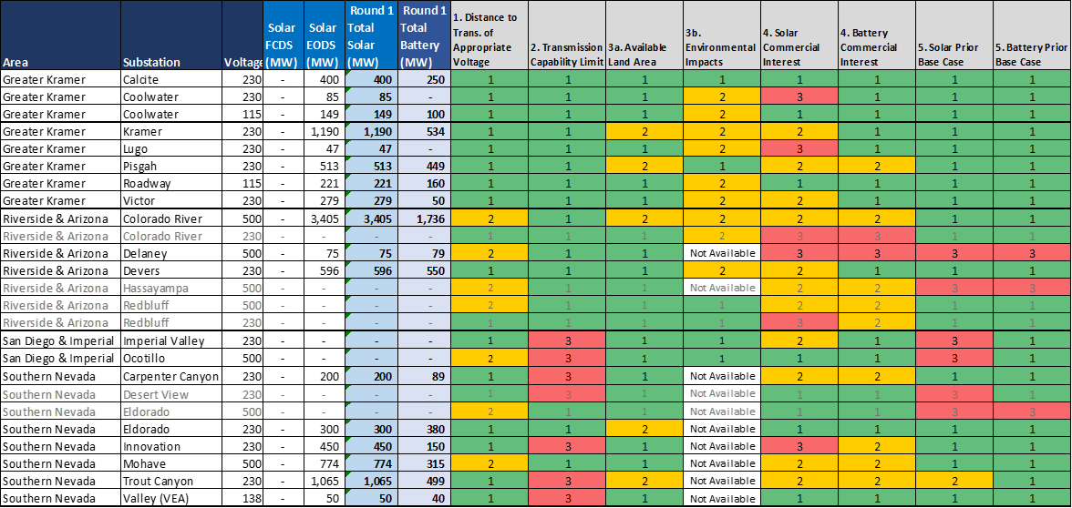

###### Greater Kramer

**Criteria Non-compliance Discussion**

As observed in Table 9, nearly all substations to which staff mapped solar resources in Greater Kramer have land-use or environmental criteria non-compliance. Several substations also have some commercial interest criterion non-compliance.

Criteria 3a and 3b: Land-use and Environmental Impacts:The Kramer and Pisgah substations have limited low environmental land within an appropriate distance of the substations for the resources mapped to each, triggering level-2 non-compliance. For nearly all the substations, a large percentage of surrounding lands have high values of terrestrial biodiversity and terrestrial rare or native species richness. This screening results in level-2 non-compliance at all mapped-to substations except Pisgah and Calcite.

Criteria 4: Commercial Interest:The Lugo and Coolwater 230 kV substations have level-3 commercial interest non-compliance as both substations have no resources in the queues. The Kramer, Pisgah, and Victor substations have level-2 commercial interest non-compliance as the amount mapped to each substation exceeds the amount of high-confidence commercial interest but remains within the total amount of commercial interest.

**Mapping Adjustments**

The updated RESOLVE model run for the final portfolio reduced the amount of solar selected in the Greater Kramer area by 1,319 MW. This amount aligns well with the need to reduce the amount of resources mapped to Greater Kramer substations to better align with land-use, environmental, and commercial interest criteria. In total, CPUC staff reduced the amount of solar mapped to Greater Kramer by 1,428 MW, removing 1,319 MW and relocating 109 MW to the Southern SPG&E area. CPUC staff also reduced the amount of batteries mapped to Great Kramer substations by 674 MW to account for a portion of the 1,182 MW battery reduction in the updated portfolio. The reduced amount of solar improves compliance with the land-use, environmental, and commercial interest criteria. Additionally, staff sought to shift some solar resources mapped from EODS to FCDS. Specifically, the following adjustments were made:

* Removed all solar and battery resources mapped to Coolwater 230 kV (85 MW solar), Lugo (47 MW solar), Pisgah (513 MW solar, 449 MW battery) substations due to no commercial interest at the Coolwater and Lugo substations and no high-confidence solar commercial interest and land-use criteria non-compliance at Pisgah.
* Removed 64 MW of solar from Victor and shifted 110 MW of solar at Victor from EODS to FCDS.
* Removed 610 MW of solar from Kramer, relocated 109 MW of solar from Kramer to Southern PG&E substations and shifted 150 MW of solar at Kramer from EODS to FCDS.

###### Riverside & Arizona

**Criteria Non-compliance Discussion**

Riverside & Arizona substations trigger some non-compliance flags for criteria 1, 2, 3a, 3b, and 5, as seen in Table 9. However, Table 9 also shows significant non-compliance within criteria 4 (commercial interest).

Criteria 1 – Distance to Transmission of Appropriate Voltage: The level-2 non-compliance flags for these criteria are all based on the significant cost increases associated with interconnecting to a 500 kV substation. However, interconnecting to these 500 kV subs can be cost effective if there are no adequate lower voltage substation alternatives nearby as is the case for the Hassayampa and Delaney substations or if the amount mapped to the substation is large as is the case for the Colorado River 500 kV substation.

Criteria 2 – Transmission Capability Limit: All substations are in compliance, with no exceedances; however, the East of Miguel constraint was initially calculated as fully utilized. Further input from CAISO staff in the updated CAISO’s 2021 White Paper adjust which substations are impacted by the East of Miguel constraint, removing the Delaney, Palo Verde, and Bannister substations from the constraint. This updated information as noted in the resource discussions above allows the mapping of additional resources to these substations.

Criteria 3a and 3b – Land-use and Environmental Impacts: The Colorado River substation has a level-2 non-compliance in the land-use criteria due to the limited amount of low environmental value land an appropriate distance from the substation and the significant amount of solar mapped to it. Additionally, large areas of high terrestrial biodiversity, native species richness, and rare species richness trigger the level-2 non-compliance for criteria 3b for the Colorado River and Devers substations. Reducing the amount of solar resources at both substations can eliminate the Criteria 3a non-compliance at the Colorado River substation and reduce the environmental impacts at both.

Criteria 4 – Commercial Interest:Every substation has some solar or battery non-compliance. The level-3 non-compliance flags at the Colorado River 230 kV, Redbluff 230 kV, and Delaney substations are due to the substations having significantly more high-confidence solar and battery commercial interest than the resources currently mapped. Hassayampa and Redbluff 500 kV substations, likewise have level-2 non-compliance flags for significantly more total commercial interest. Only Devers has a level-2 non-compliance in solar commercial interest for lack of high-confidence commercial interest compared to the amount mapped to the substations. Given the magnitude of commercial interest from the CAISO interconnection queue at these substations, relocating resources can only partially address these non-compliance flags.

Criteria 5 – Prior Base Case Alignment: Both the Delaney and Hassayampa substations have level-3 non-compliance for battery and solar resources because the prior base case had a significant amount of resources mapped to both substations. With the updated transmission constraint information providing additional headroom at both substations, remapping resources to these substations can alleviate this non-compliance.

**Mapping Adjustments**

Overall, CPUC staff relocated a significant amount of solar and batteries to Arizona substations to better align with the prior base portfolio mapping and commercial interest following CAISO staff’s updated guidance on transmission constraints in this area, which opened additional transmission headroom for the Arizona substations. Additionally, staff relocated 227 MW of solar to the Imperial Valley substation to improve criteria alignment. Specifically, the following mapping adjustments were made:

* Relocated 2,787 MW of solar and 1,213 MW of batteries from the Colorado River 500 kV to other Riverside and Arizona area substations to reduce the land-use and environmental impacts at the substation and improve compliance with the methodology’s criteria at other substations. Additionally, shifted 100 MW of solar from EODS to FCDS to align with baseline reconciliation resources identified in Section 4.1.
* Relocated 596 MW of solar and 145 MW of batteries from the Devers substation to reduce environmental impacts and lack of commercial interest non-compliance. 227 MW of the solar was remapped to the Imperial Valley substation.
* Relocated 450 MW of solar (100 MW as FCDS, 350 MW as EODS) and 250 MW of batteries to the Colorado River 230 kV substation and 900 MW of solar (600 MW as FCDS and 300 MW as EODS) and 430 MW of batteries to the Redbluff 230 kV substation to better align with commercial interest and baseline reconciliation resources at both substations.
* Relocated 935 MW of solar (400 MW as FCDS, 535 MW as EODS) and 412 MW of batteries to the Delaney substation and 871 MW of EODS solar and 269 MW of batteries to the Hassayampa substation to eliminate the non-compliance flags for the prior baseline criteria at both substations.

###### San Diego & Imperial

**Criteria Non-compliance Discussion**

For Round 1, no solar or battery resources were mapped to Imperial Valley or Ocotillo substations in the Imperial area, as seen in Table 9 because of the level-3 criteria 2 (transmission headroom) non-compliance created by the EODS exceedance of the San Diego Internal constraint. This mapping resulted in level-3 non-compliance for criteria 5 (prior base case) for both substations as the prior base case contained solar resources at both substations. Additionally, the Imperial Valley substation has high-confidence solar commercial interest triggering level-2 non-compliance for criteria 4 (commercial interest). Remapping resources from other areas will alleviate these non-compliance flags.

**Mapping Adjustments**

CPUC staff relocated 300 MW of solar (227 MW from Southern SPGE and 73 MW from Southern Nevada) and 50 MW of batteries from Southern Nevada to the Imperial Valley substation to improve mapping criteria and alignment with baseline reconciliation resources.

###### Southern Nevada

**Criteria Non-compliance Discussion.**

The Southern Nevada substations have multiple level-2 non-compliance flags discussed below. The only significant area of level-3 non-compliance is in criteria 2 (transmission capability limit), which can be alleviated by the cost-effective GLW area transmission upgrade.

Criteria 1 – Distance to Transmission of Appropriate Voltage: The two substations with level-2 non-compliance are 500 kV substations and the flags represent the likelihood of higher costs for interconnecting to the substations. As noted for other areas, interconnecting to these 500 kV subs can be cost-effective if there are no adequate lower voltage substation alternatives or if a significant amount of resources is mapped.

Criteria 2 – Transmission Capability Limit:Multiple substations in this area have level-3 non-compliance due to the resources at these substations exceeding the transmission capability limit of the GLW area transmission constraint. These non-compliances can be eliminated by utilizing the cost-effective transmission upgrade for the GLW area transmission constraint listed in the CAISO’s 2021 White Paper to expand transmission headroom in the area. This upgrade was partially triggered by RESOLVE.

Criteria 3a and 3b – Land-use and Environmental Impacts:Both the El Dorado 230 kV and Trout Canyon substations have level-2 non-compliance due to the limited availability of WECC level-2 (low-to-moderate environmental risk) land an appropriate distance from the substation for the amount of resources mapped.

Criteria 4 – Commercial Interest: The amount of solar and battery resources mapped to Carpenter Canyon, Mohave, and Trout Canyon exceed the amount of high-confidence but not the total amount of commercial interest at each substation, triggering level-2 non-compliance lags.

Criteria 5 – Prior Base Case Alignment:Neither the Desert View nor the El Dorado 500 kV substations have any resources mapped to them and thus have level-3 non-compliances. The amount of resources mapped to El Dorado 230 kV is greater than the amount mapped to the El Dorado 230 kV and 500 kV substations combined in the last base case and better aligns with commercial interest as the El Dorado 500 kV substation has none. Further, it avoids the higher 500 kV interconnection costs. The level-2 non-compliance at Trout Canyon is due to a small reduction in solar resources mapped compared to the prior base case.

**Mapping Adjustments**

Overall, CPUC staff reduced the amount of solar mapped to Southern Nevada substations by 123 MW, relocating 73 MW to the Imperial area and removing 50 MW to account for a portion of the 1,377 MW solar reductions in the updated portfolio. CPUC staff also reduced the amount of batteries by 237 MW, relocating 50 MW to the Imperial area, relocating 112 MW to standalone batteries, and removing 75 MW to account for a portion of the 1,182 MW battery reductions in the updated portfolio. Specifically, staff made these minor adjustments:

* Reduced the amount of batteries at these substations by the following amounts: Carpenter Canyon, 9 MW; El Dorado 230 kV, 72 MW; Innovation, 25 MW; Mohave, 87 MW; and Trout Canyon, 44 MW, to accommodate the relocations and reductions noted above and to avoid exceeding the upgrade expanded transmission capability limit.
* Relocated 78 MW of solar to Trout Canyon to improve alignment with prior base case and shifted 175 MW of EODS solar to FCDS to improve alignment with baseline reconciliation resources.
* Made minor relocations of solar at Carpenter Canyon (adding 10 MW) and Innovation (reducing by 5 MW).
* Reduced the amount of solar at Mohave by 205 MW, relocating a portion to other Southern Nevada and Imperial substations and removing the 50 MW as noted above. This reduction brings the amount of resources at Mohave to the same level as in the prior base case and helps to alleviate the commercial non-compliance as Mohave has no high-confidence commercial interest.

Table 10: Summary of the mapped solar and co-located battery resources in the Greater LA Metro, Southern PG&E, and Tehachapi areas and the compliance of these allocations with the criteria after Round 1 of mapping.



###### Greater LA Metro

**Criteria Non-compliance Discussion**

The Vincent substation has a level-2 noncompliance in the commercial interest criteria for batteries and solar because the substation has a significant amount of commercial interest but only a small amount that is considered high-confidence. The level-3 non-compliance in criteria 2 for both substations is due to a FCDS capability exceedance in the Laguna Bell – Mesa constraint, which can be alleviated by the upgrade noted in the CAISO’s 2021 White Paper.

**Mapping Adjustments**

CPUC staff made no solar and co-located battery adjustments to the Greater LA Metro substations as the few non-compliances do not warrant significant remapping.

###### Tehachapi

**Criteria Non-compliance Discussion**

The criteria compliance of the solar and co-located battery resources mapped to Tehachapi area substations after Round 1 of mapping is shown in Table 10. Resources mapped to Tehachapi substations are mostly in compliance with the criteria except for a few situations of commercial interest and one situation of environmental impacts non-compliance.

Criteria 2 – Transmission Capability Limit: The level-3 non-compliance flags at the Pastoria and Vestal substations are due to an exceedance in the FCDS capability of the Laguna Bella – Mesa constraint, which can be alleviated by the upgrade noted in the CAISO’s 2021 White Paper.

Criteria 3b – Environmental Impacts:Only the Whirlwind substation has a level-2 non-compliance for high values of terrestrial biodiversity and Audubon important bird areas.

Criteria 4 – Commercial Interest: The amount of solar mapped to the Antelope substation exceeds the total amount of commercial interest at the substation triggering a level-3 non-compliance. The solar mapped to Vestal substation has a level-2 non-compliance for exceeding the amount of high-confidence commercial interest but not the total amount of solar interest. The batteries mapped to Antelope and Whirlwind likewise exceed the amount of high-confidence but not the total amount of battery interest.

The Windhub 230 kV substation has a level-2 non-compliance for batteries because the high-confidence commercial interest is significantly higher than the resources mapped. Additionally, the Windhub 500 kV substation has a level-2 non-compliance for solar due to the fact that there is some commercial interest at the substation; however, since it is not high confidence commercial interest, any resources mapped to it would face higher interconnection costs. Additionally, significant solar and battery resources have been mapped to the Windhub 230 kV substation, which has ample high-confidence commercial interest.

Criteria 5 – Prior base case alignment: Whirlwind and Windhub 230 kV have level-2 non-compliance for batteries. In the 2021-2022 TPP base case 1,645 MW and 1,007 MW were mapped to the two substations respectively.

**Mapping Adjustments**

Post Round 1 mapping, CPUC staff made adjustments that, in total, relocated 561 MW of solar resources to Southern PG&E substations and removed 8 MW of solar and 249 MW of battery to reduce non-compliance at the Tehachapi substations and to account for a portion of the 1,377 MW solar and 1,182 MW battery reductions in the updated portfolio. Additionally, EODS solar resources were shifted to FCDS to align with baseline reconciliation resources and to better align with solar commercial interest. Specifically, the following mapping adjustments were made:

* Relocate solar from Antelope (300 MW), Vestal (90 MW), and Whirlwind (179 MW) to Southern PG&E substations and remove batteries from Antelope (137 MW) and Whirlwind (112 MW) to improve commercial interest criteria compliance at Antelope and Vestal and to reduce environmental impacts of solar mapped to Whirlwind.
* Relocate an additional 71 MW of solar and 118 MW of batteries from Whirlwind to the Windhub 230 kV substation to alleviate the impacts noted by the environmental criteria non-compliance flag at Whirlwind.
* Shift solar from EODS to FCDS at Antelope (450 MW), Vestal (290 MW), Whirlwind (150 MW), and Windhub 230 kV (371 MW).

###### Southern PG&E

**Criteria Non-compliance Discussion**

As seen in Table 10, the solar and battery resources mapped to Southern PG&E substations are nearly all in compliance with Criteria 1, 2, 3a, and 3b, with few exceptions. However, multiple substations have non-compliance for Criteria 4 (commercial interest) and 5 (prior base portfolio) that require further mapping adjustments.

Criteria 1 – Distance to transmission of appropriate voltage: The Los Banos 500 kV substation has a level-2 non-compliance as resources mapped here will have additional interconnection costs associated with interconnecting to a 500 kV substation. The 500 kV substations of Gates and Midway also have level-2 non-compliance for the same reason; however, no resources were mapped to either substation.

Criteria 3a and 3b – Land-use and Environmental Impacts:The Midway substation has level-2 non-compliance for environmental impacts due to high values of terrestrial biodiversity and terrestrial rare species richness.

Criteria 4 – Commercial Interest:Multiple stations have non-compliance flags for having mapped resource amounts exceeding the amount of high-confidence or total commercial interest. Stockdale’s level-3 solar non-compliance due to no solar commercial interest and Los Banos 500 kV’s and Rio Bravo’s level-2 non-compliance for solar and batteries due to no high-confidence interest can be mitigated by relocating resources at all three to substations with better commercial interest alignment. The Helm, Henrietta, McCall substations have a level-2 non-compliance for solar or battery as the amount of resources mapped slightly exceeds the amount of commercial interest at each substation. Relocating some of the resources from each substation can alleviate these non-compliances. Additionally, the Gates 230 kV and Tranquility substations have non-compliance flags due to a significant amount of high-confidence commercial interest at each substation but no resources mapped. Mapping resources to both substations will alleviate these non-compliance flags. The Midway 500 kV substation has non-compliance flags for a large amount of total commercial interest; however, lack of high-confidence commercial interest and the higher interconnection costs warrant not changing the current mapping at this substation.

Criteria 5 – Prior base case alignment: Multiple substations have level-3 non-compliances. Gates 500 kV, McMullin, and Renfro all have no solar (and battery for Gates 500 kV) resources mapped despite having resources mapped in the previous base case, since all three substations have no significant commercial interest. Gates 500 kV has the additional interconnection costs as well. CPUC staff elected to map resources to the Wheeler Ridge 115 kV substation rather than the Wheeler Ridge 230 kV given that, although both busbars have high-confidence commercial interest, the 115 kV substation will likely have lower interconnection costs and aligns with baseline reconciliation resources. The Panoche, Gates 230 kV, Lamont, Mesa, and Midway 230 kV substation have level-3 or level-2 non-compliance which warrant re-mapping adjustments to alleviate.

**Mapping Adjustments**

Post Round 1 mapping, CPUC staff made adjustments that totaled 670 MW of solar resources relocated from other areas to Southern PG&E substations and 185 MW of battery resources removed to account for part of 1,182 MW battery reductions in the updated portfolio. The additional solar relocated from other regions results in better alignment with baseline reconciliation resources and commercial interest. Specifically, the following mapping adjustments were made:

* Relocated 600 MW of solar and 342 MW of co-located batteries to other Southern PG&E substations with better criteria alignment, relocated 400 MW of co-located batteries to stand alone batteries at Moss Landing to align with baseline resources, and removed 185 MW of batteries to partially account for batteries reductions in updated portfolio.
* Relocated all of the 144 MW of solar at Stockdale to alleviate the no commercial interest non-compliance flag.
* Relocated all of the 55 MW of solar and 50 MW of batteries at Rio Bravo to alleviate the no high-confidence commercial interest non-compliance flag.
* Relocated 56 MW of solar and 208 MW of batteries from Helm to other Southern PG&E substations to eliminate the commercial interest non-compliance and to reduce transmission exceedances resulting from other necessary resource adjustments in the Southern PG&E area.
* Relocated 60 MW of solar from Henrietta to reduce the commercial interest non-compliance and add 34 MW of batteries to align with baseline reconciliation resources and to better co-locate batteries with solar.
* Relocated 104 MW of solar from the McCall substation to better align with the commercial interest criteria.
* Small relocations of battery resources from Arco and solar and battery resources from Westley to support the adjustments needed at other Southern PG&E substations.
* Relocated 110 MW of EODS solar and 40 MW of batteries to Tranquility, 100 MW of solar as FCDS to Mustang, and 160 MW solar as FCDS to Mendota to align with baseline reconciliations resources at these substations.
* Relocated 360 MW of EODS solar and 119 MW of batteries to Panoche to better align with commercial interests and prior base case mapping criteria.
* Relocated 105 MW of solar and 95 MW of battery to Lamont, 50 MW of batteries to Mesa, and 10 MW of batteries to the Kettleman 70kV substation to better align with prior base case mapping. These three substations are all locations where the CAISO, in the 2020-2021 TPP, recommended mapping energy storage.
* Relocated 190 MW of EODS and 80 MW of batteries to the Los Banos 230 kV substation and to align with the high confidence commercial interest located there.
* Relocated 10 MW of EODS solar and 10 MW of battery to the Midway 115 kV substation to align with baseline reconciliation resources.
* Relocated 95 MW of solar and 80 MW of batteries to the Midway 230 kV substation and 577 MW of solar and 165 MW of batteries to the Gates 230 kV substation to better align with the high-confidence commercial interest and the prior base case mapping to both substations.
* Shifted 200 MW of solar at the Gates 230 kV substation and 100 MW of solar at the Wheeler Ridge 115 kV substation from EODS to FCDS to align with baseline reconciliation resources.

##### Stand Alone Storage Discussion

Table 11 contains a summary of stand-alone batteries and pumped storage hydro (PSH) resources mapped during Round 1 and their compliance with the mapping criteria. For storage, staff only assessed the resources’ compliance with criteria 2 (transmission capability limit), criteria 4 (commercial interest), and criteria 5 (prior base case alignment). The table also shows the additional ranking criteria used for mapping batteries: LCR area, DAC, Ozone and PM 2.5 non-attainment zones, and high curtailment zones. Greyed-out substations again highlight substations which have no resources mapped but have non-compliance due to either significant commercial interest at the substations or resources mapped to the substation in the previous base case. PSH in this mapping effort, as in RESOLVE modeling, serves as a representative of location-specific long duration storage resources. CPUC staff note that technological alternatives to PSH exists and the CAISO interconnection queue includes some such projects. CPUC staff incorporated these projects into the busbar mapping analysis for resources classified as PSH.

Table 11: Summary of mapped stand-alone battery and pumped-storage resources and the compliance of these allocations with the criteria after Round 1 of mapping.

 

**Criteria Non-compliance Discussion**

The stand-alone storage resources have a several level-3 non-compliance flags for criteria 2 (transmission capability), 4 (commercial interest), and 5 (prior base case) and numerous level-2 non-compliances with criteria 4.

Criteria 2 – Transmission Capability Limit: The 4 substations with level-3 flags in Northern PG&E area are triggered by the exceedance in the Cortina-Vaca Dixon constraint as discussed above with other resource types. The EODS exceedance in the San Diego Internal constraint note in the tables for the other resource types does not impact the FCDS battery storage mapped. The battery storage mapped to substations within the constraint actually reduce the overall EODS exceedance.

Criteria 4 – Commercial Interest:For thepumped storage hydro resource, Lee Lake and Redbluff (in the desert) substations have level-2 flags for having a significant amount of total commercial interest but no resources mapped. Windhub has resources mapped and commercial interest but no high-confidence commercial interest triggering its level-2 flag. For batteries, the level-3 flag for Moss Landing is triggered by significant amounts of high confidence battery commercial interest and no resources mapped to the substation. The level-2 flag at Valley 500 kV substation (in Riverside) is due to the high amount of total commercial interest (but no high-confidence) at the substation and no resources mapped. Walnut substation (in LA County) has a level-2 non-compliance because although the substation has some high-confidence commercial interest, the amount mapped exceeds it. The remaining level-2 criteria 4 non-compliances are a result of the substations having commercial interest but no high-confidence commercial interest.

Criteria 5 – Prior Base Case Alignment: The Lee Lake (proposed in Riverside) and Sycamore (San Diego) substations have level-3 flags for pumped storage hydro being mapped to each substation in the prior base case, but none in the current Round 1 mappings. The remaining level-3 non-compliances are substations that have no batteries mapped following Round 1 but had resources mapped in the prior base case. Additionally, Sycamore 230 kV had 300 MW of batteries mapped in the prior base case while after Round 1 Sycamore 230 kV and 138 kV combined have only 50 MW.

**Mapping Adjustments**

There are three substations – Moss Landing, Devers, and Mesa – noted in the solar and co-located battery discussion in Section 7.3 below as substations where batteries were added or solar was removed to create stand-alone batteries. An additional 112 MW were relocated from Southern Nevada substations and mapped as stand-alone batteries in other areas. Specifically, CPUC staff made the following pumped hydro storage (PSH) and stand-alone battery adjustments in additional rounds of mapping:

* Relocated the 488 MW of PSH from Windhub to Whirlwind 230 kV substation to reduce transmission headroom burden at the Windhub substation. Additionally, the long duration storage commercial interest identified in at Whirlwind is further along the interconnection study and development process that the PSH commercial interest at Windhub.
* Relocated 512 MW of PSH from Red Bluff, 500 MW to Sycamore 230 kV substation to better align with the prior base case’s PSH mapping and 12 MW to Whirlwind 230 kV to increase the total mapped in Tehachapi to 500 MW.
* Relocated batteries to the following substations to align with baseline reconciliation resources: Barre, 10 MW; Belota, 132 MW; Goleta, 70 MW; Johanna, 50 MW; Otay Mesa, 150 MW; Pittsburg, 200 MW; and Santa Clara, 121 MW.
* Relocated 250 MW of batteries to Sycamore 138 kV, 124 MW to Escondido, and 200 MW to Capistrano substations to better align with prior base case, commercial interest, and mapping to substations with higher-ranking scores.
* To be able to map batteries to the substations above, staff relocated batteries from stations that had commercial interest non-compliance flags or lower battery rankings. Batteries were relocated from the following substations: Encina (100 MW), Los Esteros (100 MW), Martin (150 MW), Metcalf (125 MW), San Luis Rey (70 MW), Talega (200 MW), Tesla (100 MW), Vaca Dixon (100 MW), Vista (150 MW), and Walnut (100 MW).

### Remapping and additional adjustments following Round 1

The mapping adjustments noted above took place through further mapping by CPUC, CEC, and CAISO staff. In addition to improving criteria alignment, CPUC staff also relocated resources to align with the baseline reconciliation resources summarized in Section 4.1 above, as referenced throughout this Section 6.

During this additional mapping, staff also conducted the mapping for the few hundred MWs of distributed solar and biomass/biogas that are included in the portfolio. CPUC staff conducted distributed solar mapping via the method outlined in the updates to the methodology in Section 5, using the PG&E’s Wholesale Distribution Tariff’s and SCE’s Wholesale Distribution Access Tariff’s interconnection queues to identify the smaller amounts of distributed solar commercial interest. Because many of these smaller solar resources interconnect to lower voltage substations, CPUC staff aggregated to the nearest CAISO system substation for busbar mapping purposes. Similarly for biomass and biogas, staff utilizes the participating transmission owners’ queues for identifying interest and also utilize biomass/biogas resource potential studies as outlined in the updates to the methodology Section 5. Most of the commercial interest in woody biomass occurs in the Sierra Nevada foothills, and the commercial interest methane digester biogas occurs in the more agricultural parts of the state (central valley), with additional biogas interest near urban areas sourced from municipal solid waste. CPUC staff account for the transmission headroom implications of both distributed solar and biomass in the mapping process but did not apply the remaining methodology criteria to these resources. Table 12 and Table 13 show the final mapped locations of the biomass/biogas and distributed solar resources respectively.

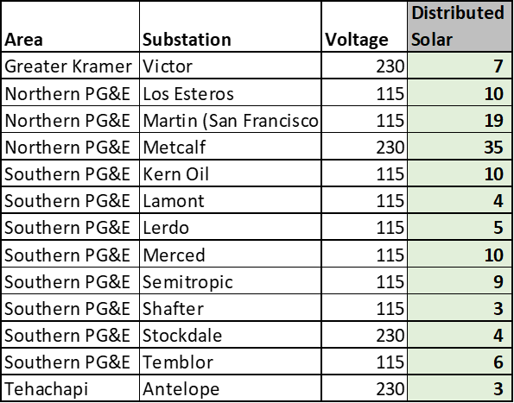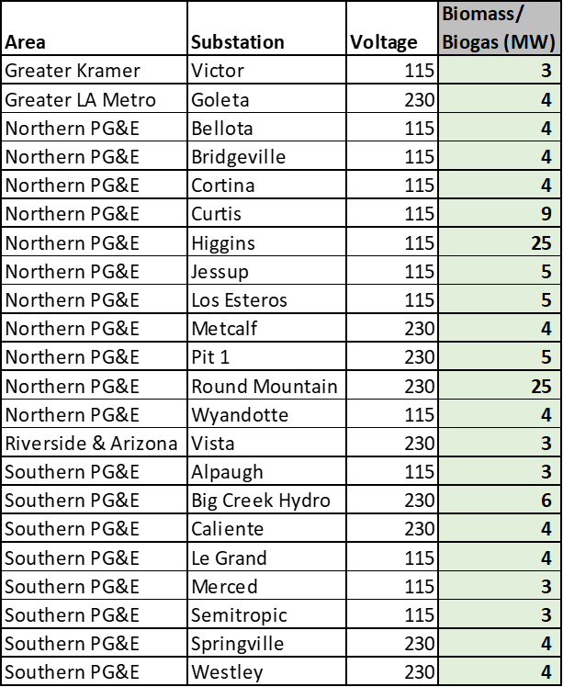

Table 12: Summary of mapped distributed solar resources by substation.

Table 13: Summary of mapped biomass/biogas resources by substation.

## Results

Sections 7.1 through 7.6 summarize the results for the December Proposed Decision following all rounds of mapping and taking into account all the adjustments noted in the previous section. Sections 7.7 through 7.9 summarize the adjustments made following comments and replies on the Proposed Decision. The results are presented in tables broken down by resource type with a discussion of the remaining criteria exceedance flags, followed by a summary and geographic breakdown of resources and final discussion of the potential transmission implications.

### Geothermal Mapping Results for the Proposed Decision

Table 14 depicts a summary of the geothermal resources for the proposed decision portfolio following all rounds of mapping and their compliance with the five criteria. The green 1* flag for criteria 2 (transmission capability limit) indicates level-3 non-compliance flags that staff propose could be alleviated via the transmission upgrade included in the CAISO’s 2021 White Paper for the transmission constraint being exceeded. The mapping adjustments resulted in significant improvements in criteria compliance across all criteria. The key outstanding non-compliances are:

Table 14: Summary of the geothermal resources mapping for the proposed decision portfolio and their compliance with the five criteria.



Criteria 1 – Distance to transmission of appropriate voltage: The geothermal resources mapped to the Control substation in the Eastern Sierra Nevada are nearly 20 miles away, triggering the level-2 flag. However, this area has existing geothermal projects and existing interconnection infrastructure which likely reduces the impacts of the distance to transmission and makes this level-2 flag acceptable. The level-3 flag for the resources mapped to Beatty remains due to the reasons noted in Section 6 . This exceedance reflects the fact that geothermal resources are limited to fixed geographic areas unlike other renewable resources.

Criteria 2 – Transmission Capability:Geothermal mapped to the Geysers remain at level-3 non-compliance, despite relocating geothermal away from Northern California due to continued FCDS exceedance in the Cortina-Vaca Dixon constraint. The implications of this exceedance are discussed in detail in Section 7.5 below. Geothermal mapped to the Beatty substation has been lowered to compliance after accounting for the GLW area constraint’s cost-effective transmission upgrade. The RESOLVE model triggered a partial upgrade of the transmission constraint primarily to enable the geothermal resources to interconnect. Section 7.5 discusses the GLW area constraint transmission upgrade in detail.

Other Criteria:The remaining level-2 non-compliance with Criteria 3b (environmental impacts) and 4 (commercial interest) are acceptable given that geothermal can only be developed in fixed areas with limited capacity. The high values for Important Bird Areas at Bannister and native species richness at the Geysers are significantly less impacted by geothermal than other renewable resources. Additionally, California has not seen significant development interest in geothermal until recently, so the level-2 non-compliance in criteria 4 due to the lack of a significant amount of high-confidence commercial interest aligns with expectations.

### Wind Mapping Results for the Proposed Decision

Table 15 depicts a summary of the wind resources for the proposed decision portfolio following all rounds of mapping and their compliance with the five criteria. Again, the lighter green 1* flags for criteria 2 (transmission capability limit) indicate level-3 non-compliance flags that staff propose could be alleviated via the transmission upgrade included in the CAISO’s 2021 White Paper. The yellow 2* flags for criteria 5 (prior base case alignment) indicate level-3 non-compliance flags that staff have lowered to level-2 after determining that the reduction in resources in this location does not significantly alter the overall mapping in the area, would be unlikely to significantly change any key results of the previous TPP study, and helped improve other criteria compliance. As in Section 6.2, the greyed-out rows in Table 15 highlight substations with no resources mapped but have non-compliance flags for a significant amount of commercial interest or for resources mapped to the substations in the prior base case. The mapping adjustments made improvements in the criteria compliance, but significant non-compliance remains for criteria 2 and criteria 5 for the wind resources located in the Northern PG&E area. The significant remaining non-compliance flags are discussed below by criteria.

Table 15: Summary of the wind resources mapping for the proposed decision portfolio and their compliance with the five criteria.

 

Criteria 1 – Distance to Transmission of Appropriate Voltage:The consistency of level-2 non-compliance across many wind resources reflects the geographic limitations of new wind resource potential. These level-2 flags are acceptable. Unlike solar, wind potential areas are in fixed locations that will often need longer interconnections to reach an appropriate substation. CPUC staff may consider adjusting the interconnection distance criteria in future mapping cycles to account for the specific resource type limitations. The level-2 non-compliance flag for the 500 kV interconnection of offshore wind is also acceptable given the large magnitude of MWs mapped and the very limited range of alternative points of interconnection associated with offshore wind.

Criteria 2 – Transmission Capability Limit:The wind exceedances in the San Diego & Imperial and Southern Nevada Areas are noted as alleviated by the transmission upgrades for the San Diego Internal Constraint and the GLW-VEA Area Constraint noted in the CAISO’s 2021 White Paper. The potential GLW constraint exceedance has already been noted in Section 7.1 and is discussed further in Section 7.5. For the San Diego and Imperial areas, shifting the wind at the ECO substation to FCDS and relocating solar, batteries, and PSH to this area now triggers an FCDS exceedance in the San Diego Internal constraint rather than the EODS exceedance noted in Round 1 analysis in Section 6.2. However, as discussed in detail in Section 7.5, the selected transmission upgrade can still alleviate the exceedance. Finally, resources mapped to the Tehachapi including the wind resources mapped to the Whirlwind and Windhub substations exceed that transmission capability for the Antelope-Vincent constraint which can be alleviated by the upgrade identified in the CAISO’s 2021 White Paper.

The remaining level-3 non-compliance flags occur in the Northern PG&E area, exceeding the Cortina – Vaca-Dixon Line constraint (FCDS). Adjustments made throughout the rounds of mapping reduced geothermal resources mapped to the constraint; however, baseline reconciliation resulted in additional batteries mapped to the area and wind switched to FCDS. Staff shifted additional wind to FCDS to better align with the prior base case and the general commercial interest preference for FCDS wind. The implication of this exceedance is discussed further in Section 7.5.

Criteria 3a & 3b – Land-use and Environmental Impacts: Like for criteria 1, the remaining level-2 flags for both criteria 3a and 3b, and Round Mountain’s level-3 flag for criteria 3b are a systematic reflection of the geographic limitations of where new wind resource potential is located. Thus, the level-2 flags are acceptable. In the future, CPUC staff may consider adjusting these criteria to account for the limitations and impacts of each resource type. For wind resources, for example, the Important Bird Area dataset may need to play a bigger screening role for wind resources than some of the other terrestrial species' datasets. In the Tehachapi area, the Whirlwind substation level-2 criteria 3b non-compliance is due to high values in the Important Bird Areas screen; however, given the significant wind resources already developed at the substation., this level-2 flag non-compliance is acceptable.

Criteria 4 – Commercial Interest:The offshore wind substation flags remain the same as in Round 1 and are acceptable per the offshore wind criteria 4 non-compliance discussion in Section 6.2. The remaining onshore wind substation flags are also consistent with the Round 1 discussion. These remaining non-compliance flags reflect the limited amount of wind resources in the interconnection queues except at a few substations. Even the recent Cluster 14 has very few proposed onshore wind projects, compared to other resource types.

Criteria 5 – Prior Base Case Alignment:The level-3 flag at East County 500 kV, triggered by shifting the wind to the 230 kV substation to better align with other criteria, has been lowered to the level-2 flag. This is acceptable as this change to the lower voltage busbar of the same substation is unlikely to result in a significant difference from the 2021-2022 TPP results. Likewise, Shilo III’s flag has been lowered given its proximity to Birds Landing, and the level-2 flag at Windhub is similarly acceptable. The level-3 flags at the substations in the Northern PG&E area remain per the Criteria 2 discussion above on the Cortina-Vaca Dixon Line Constraint (adjustments made to align with baseline, and general commercial interest preferences, discussed further in Section 7.5).

### Solar and Co-Located Battery Mapping Results for the Proposed Decision

Table 16 and Table 17 depict a summary of the solar and co-located battery resources by area for the proposed decision portfolio following all rounds of mapping and their compliance with the five criteria. Again, the lighter green 1* flag for criteria 2 (transmission capability limit) indicate transmission exceedances that staff propose could be alleviated via the transmission upgrade included in the CAISO’s 2021 White Paper. The lighter yellow 2* flags for criteria 5 (prior base case alignment) indicate level-3 non-compliance flags that staff have lowered to level-2 after determining the change is a relatively minor reduction that does not significantly alter the total resources mapped to the area, would not likely trigger any significant changes from the prior TPP study results, and improves compliance with other criteria. As in Section 6.2 criteria summary tables, the greyed-out rows in Tables 16 and 17 highlight substations with no resources mapped but have non-compliance flags for a significant amount of commercial interest or for resources mapped to the substations in the prior base case. In keeping with the minimization of ratepayer costs policy directive contained in the Methodology, CPUC staff sought to maximize the amount of co-located battery storage resources; in this 2022-2023 TPP, more coordination occurred between the mapping of solar and the mapping of batteries, than in previous years. . CPUC staff mapped a total of 9,701 MW of battery storage to the same substation as EODS solar resources, representing co-located resources. Table 16 and Table 17 summarize the results of this mapping, showing the substations where these resources were assigned, and the criteria associated with those substations.

As seen in Table 16 the compliance with the criteria have been significantly improved for resources mapped to Greater Kramer, Riverside & Arizona, San Diego & Imperial, and Southern Nevada. The key remaining non-compliance flags are discussed below by mapping criteria.

Table 16: Summary of the solar and co-located battery resources mapping for the Greater Kramer, Riverside & Arizona, San Diego & Imperial, and Southern Nevada areas for the proposed decision portfolio as well as their compliance with the five criteria.



Criteria 1 – Distance to Transmission of Appropriate Voltage:The remaining level-2 non-compliance flags at substations with resources mapped are all triggered by the likely higher costs of interconnection to 500 kV substations. The flags for Redbluff, Ocotillo, and El Dorado 500 kV substations are acceptable as no resources have been mapped to these substations. For the remaining 500 kV substations with level-2 flags which do have resources mapped, these flags are acceptable since either no lower voltage substations are available nearby or there is a sufficiently large amount of resources mapped to the substation to justify interconnecting at higher voltage.

Criteria 2 – Transmission Capability Limit:The two areas with non-compliances due to transmission constraint exceedances are marked with the blue 1* flags as the CAISO’s 2021 White Paper transmission upgrades could provide a cost-effect way of alleviating the exceedances. The San Diego Internal Constraint upgrade also noted in Section 7.2, and the GLW-VEA Area Constraint, also noted in Section 7.1, are both discussed in detail in Section 7.5.

Criteria 3a & 3b – Land-use and Environmental Impacts: The two remaining level-2 flags for criteria 3a are both in Southern Nevada. These flags reflect the limited amount of low environmental impact land within a 10-mile radius of the substation. At both the Eldorado and Trout Canyon substations, increasing the distance from the substations reduces this non-compliance albeit increasing interconnection distance. The remaining level-2 flags for criteria 3b in the Greater Kramer substations and Colorado River are acceptable as the resources mapped to these substations have been significantly reduced to mitigate the impact. The 3b criteria are based on the fixed area around the substation and are independent of the amount of resources mapped. For future mapping cycles, staff may need to better tailor the criteria to reflect the relative impacts of the amount mapped to the substation.

Criteria 4 – Commercial Interest: Except for at the Colorado River, Delaney, and Red Bluff substations, the remaining level-2 flags are for the mapped amount exceeding the amount of high-confidence commercial interest. These flags are acceptable because all these substations have significant amounts of total commercial interest. The level-3 and level-2 flags at the Colorado River, Delaney, and Red Bluff substations occur because the substations have significantly more high-confidence commercial interest than the amounts mapped. These flags are acceptable given the fact that staff have mapped a significant amount of resources to all three substations and have increased the amount mapped to the substation in comparison to the prior base case.

Criteria 5 – Prior Base Case Alignment:The remaining non-compliance flags are all level-2 flags or have been lowered to level-2. These level-2 flags are acceptable since they are reductions compared to the prior base cases, and they are minor adjustments that do not significantly alter the overall resources mapped to the area. They likely will not cause significant changes from the previous TPP study, and helped improve compliance with the other criteria.

Table 17: Summary of the solar and co-located battery resources mapping for the Greater LA Metro, Southern PG&E, and Tehachapi areas for the proposed decision portfolio as well as their compliance with the five criteria.

 

As seen in Table 17, the compliance with the criteria has been significantly improved for resources mapped to Southern PG&E and Tehachapi areas. The key remaining non-compliance flags are discussed below by mapping criteria:

Criteria 1 – Distance to Transmission of Appropriate Voltage:Only three substations: Gates 500kV, Midway 500 kV, and Windhub 500 kV have level-2 non-compliance flags; all for the likely higher costs associated with interconnecting to a 500 kV substation. Since no resources are mapped to these substations (as indicated by their greyed-out rows), these flags are acceptable. Resources were instead mapped to alternative lower voltage substations which had good criteria alignment.

Criteria 2 – Transmission Capability Limit:The remaining non-compliance flags have been lowered as the transmission exceedance at these substations can be alleviated by the transmission upgrade noted in the CAISO’s 2021 White Paper. The resources mapped to the four substations with the improved compliance in the SPG&E area triggered an EODS exceedance in the Moss Landing-Las Aguilas 230kV Constraint. The two substations in the Greater LA area and two in the Tehachapi area (Pastoria and Vestal) with the improved compliance flags triggered an FCDS exceedance in the Laguna Bell – Mesa constraint. Finally, the resources at the remaining substations in the Tehachapi area are with the FCDS exceedance in the Antelope-Vincent Constraint. The potential for cost-effective upgrades identified in the CAISO’s 2021 White Paper to alleviate these three exceedances is discussed in detail in Section 7.5.

Criteria 3a & 3b – Land-use and Environmental Impacts: Two substations, Midway and Whirlwind, have the only remaining non-compliance flags. These level-2 flags for criteria 3b are acceptable for the same reasons as noted early in the Table 16 discussion on the Greater Kramer area criteria 3b flags (resource assignments have been reduced to the extent possible).

Criteria 4 – Commercial Interest:Most of the level-2 flags are triggered because the mapped amount exceeds the amount of high-confidence commercial interest. These flags are acceptable because all these substations have adequate amounts of total commercial interest. The level-2 flags at the Midway and Windhub 500 kV substations are because the substations have significantly more commercial interest that the amounts mapped. These flags are acceptable because resources were prioritized to other lower voltage substations with commercial interest to reduce interconnection costs. The non-compliance flags at the Gates 230 kV, Windhub 230 kV, and Tranquility substations are triggered because each substation has significantly more high-confidence commercial interest than was mapped. These are acceptable because relocating additional resources to these substations would have increased non-compliance at other substations or triggered transmission exceedances.

Criteria 5 – Prior Base Case Alignment:The remaining non-compliance flags are all level-2 flags or have been lowered to level-2, except for the level-3 solar flags at the McCall and Mc Mullin substations. These two substations had more mapped solar resource in the 2021-22 TPP base case; however, the substations have no more commercial interest beyond what is mapped. Staff find this non-compliance acceptable; however, they remain at level-3 because preliminary 2021-22 TPP results suggest possible transmission implications. The remaining level-2 flags are acceptable since the reductions compared to the prior base cases are minor, do not cause major shifts to the total resources mapped to the area, likely will not significantly impact the previous TPP study, and helped improve compliance with the other criteria.

### Stand-alone Storage Mapping Results for the Proposed Decision

Table 18 depicts a summary of stand-alone storage resources by area for the proposed decision portfolio and their compliance with the five criteria following all rounds of mapping. The light green 1* flag for criteria 2 (transmission capability limit) indicate transmission exceedances that staff propose could be alleviated via the transmission upgrade included in the CAISO’s 2021 White Paper and the lighter yellow 2* flags for criteria 5 (prior base case alignment) again indicate level-3 non-compliance flags that staff have lowered to level-2 after determining during the additional rounds of mapping that the change is a relatively minor reduction likely without significant impacts. A total of 4,871 MW of stand-alone storage resources were mapped, of which 1,000 MW is PSH and 3,871 MW is batteries. Table 18 shows the summary of this mapping; detailing the additional locational criteria used specifically in mapping battery resources. The compliance with the criteria has been improved following the initial mapping analysis and the remaining key areas of non-compliance are discussed below by mapping criteria. Again, as noted in Section 6.2.D, PSH in this mapping effort as in RESOLVE modeling serves as a representative of location-specific long duration storage resources; and non-PSH long duration storage projects identified in the interconnection queues are weighed under criteria 4 considerations for mapping.

Table 18: Summary of the stand-alone storage resources mapping for the proposed decision portfolio as well as their compliance with the five criteria.

 

Criteria 2 – Transmission Capability Limit:The remaining flags correspond to transmission constraint exceedances that have been raised in the wind, and solar summaries above and are discussed in detail in Section 7.5 below. The Northern PG&E area level-3 flags result from the Cortina –Vaca Dixon line constraint FCDS exceedance. The alleviated exceedance flags in the San Diego & Imperial, Greater LA, and Tehachapi areas correspond to the exceedances and transmission upgrades for the San Diego Internal, the Laguna Bell – Mesa. And the Antelope-Vincent constraints respectively.

Criteria 4 – Commercial Interest:The Lee Lake, Valley, and Moss Landing substations’ remaining level-2 and level-3 flags are triggered by these substations having significantly more high-confidence commercial interest than the amount of resources mapped. These flags are acceptable because relocating additional resources to these substations would have increased non-compliance at other substations or triggered transmission exceedances. The remaining level-2 flags are due to the mapped resources exceeding the amount of high-confidence commercial interest. These level-2 flags are acceptable since the total amount of commercial interest at the substation is greater than the amount mapped.

Criteria 5 – Prior Base Case Alignment:The remaining non-compliance flags are all level-2 flags or have been lowered to level-2. These level-2 flags are acceptable since the reductions compared to the prior base cases are minor that do not significantly reduce when compared previous base case the total amount the total amount of resources mapped to the area. Additionally, these reductions helped improve compliance with the other criteria.

### Transmission Implications of the Mapped Portfolio for the Proposed Decision

As described above, the mapped resources exceed five existing transmission constraints that could be resolved with cost-effective transmission upgrades. The five areas and corresponding transmission constraints are as follows:

* Greater LA Metro and Tehachapi – Laguna Bell - Mesa Constraint: Resources mapped in these two areas resulted in a 1,983 MW FCDS exceedance in the Laguna Bell – Mesa Constraint. This exceedance is caused by the mapping of 14 MW of biomass, 2,226 MW of solar (210 MW FCDS, 2,016 MW EODS), and 1,880 MW of batteries to substations within the constraint. This exceedance could be alleviated by the upgrade identified in the CAISO’s 2021 White Paper. Per the White Paper, this upgrade would expand the FCDS constraint limit by 3,178 MW, cost an estimated $15 million, and take an estimated 27 months to complete.
* Tehachapi – Antelope – Vincent Constraint: Resources mapped in this area resulted in a 367 MW FCDS exceedance in the Antelope-Vincent Constraint. This exceedance is caused by the mapping of 10 MW of biomass, 1614 MW of FCDS solar, 275 MW of wind, 3,051 MW of batteries, and 500 MW of pumped storage to substations within the constraint. This exceedance could be alleviated by the upgrade identified in the CAISO’s 2021.White Paper, which would expand the FCDS limit by 2,700 MW, cost an estimated $15 million, and take an estimated 18 months to complete.
* San Diego & Imperial – San Diego Internal Constraint:Resources mapped in this area resulted in a 614 MW FCDS exceedance in the San Diego Internal Constraint. This exceedance is caused by the mapping of 600 MW of FCDS wind, 100 MW of FCDS solar, and 1,377 MW of batteries and pumped storage to substations within the constraint. The RESOLVE model partially triggered this upgrade to accommodate resources it selected in this area. This transmission upgrade, as noted in the updated CAISO’s 2021 White Paper, would increase the FCDS constraint limit by 2,067 MW, easily alleviating the mapped exceedance, cost an estimated $89 million, and take an estimated 18 months to complete.
* Southern Nevada – GLW-VEA Area Constraint: The geothermal, wind, solar, and battery resources mapped in this area resulted in a 984 MW FCDS and 968 MW EODS exceedance in the GLW-VEA Area Constraint. In total 320 MW of geothermal, 442 MW of FCDS wind, 1,848 MW (175 MW FCDS, 1,673 MW EODS) of solar, and 700 MW of batteries are mapped to the GLW area constraint. The RESOLVE model partially triggered this upgrade when selecting geothermal resources in the area, and this upgrade is consistent with the upgrades that CPUC staff noted in the 2021-2022 TPP base case mapping for this area. The GLW area transmission upgrade would increase FCDS limits by 1,000 MW and EODS limits by 1,110 MW, alleviating the mapped exceedances. Per the CAISO’s 2021 White Paper, the upgrade costs an estimated $200 million and would take an estimated 60 months to complete.
* Southern PG&E – Moss Landing-Las Aguilas 230kV Constraint: Resources mapped in this area resulted in a 417 MW EODS exceedance in this Moss Landing-Las Aguilas 230kV off-peak deliverability constraint. The 810 MW (160 MW FCDS, 650 MW EODS) of solar mapped to substations in this constraint triggered the exceedance. This EODS exceedance cannot be alleviated by mapping additional batteries to the substations as doing so would trigger additional exceedances in multiple other constraints, some of which do not have known upgrades. The CAISO’s 2021 White Paper proposed upgrade could alleviate this exceedance as it provides 1,308 MW of EODS capacity, costs an estimated $48 million, and takes an estimated 98 months to complete.

The mapping resulted in an additional transmission exceedance that cannot be readily alleviated in a cost-effective way by the transmission upgrade identified in the CAISO’s 2021 White Paper; however, alternative transmission upgrades may address the exceedance:

Northern California — Cortina - Vaca-Dixon Line Constraint:Resources mapped to the Northern PG&E area also resulted in the exceedance of the Cortina -Vaca-Dixon 230kV Line Constraint. The mapped resources cause a 435 MW FCDS exceedance of the constraint. The transmission upgrade for this constraint, as noted in the CAISO’s 2021 White Paper, would provide an additional 2,838 MW of FCDS headroom at the estimated cost of $3,531 million and 144 months to complete. The size and costs of this upgrade makes it non-optimal for the amount of exceedance in the area, so it is not considered as an appropriate solution to alleviate the exceedance. This upgrade is a set of upgrades, according to additional information provided by CAISO staff, and depending on the location, type, and size of mapped resources the entire set of upgrades may not be necessary.

The amount of calculated exceedance in this constraint is comparable to the exceedance seen with the 2021-2022 TPP base case resources on the Cortina-Vaca Dixon constraint when using the same updated transmission information. CAISO staff noted that preliminary results from the ongoing 2021-2022 TPP study appear to indicate that the base case would trigger a few smaller upgrades costing $40-50 million each and approximately $180 million in total. The preliminary TPP results also suggest that these several of these upgrades are needed to support existing baseline resources already scheduled to come online. Thus, CPUC staff assume the current mapping in the proposed 2022-2023 TPP base case may likely only require the same upgrades. These smaller upgrades would be a cost-effective way to alleviate the transmission exceedance. A key caveat is that the CAISO is still conducting the 2021-2022 TPP study and necessary upgrade information might change. Additionally, although the total magnitude of the exceedance is slightly less than for the previous base case, the proposed portfolio’s resources and mapped locations do deviate from the prior base case’s mapping. Thus, this current mapping could result in a slightly different upgrade than noted above. CPUC staff consider these smaller upgrades to be a cost-effective solution to the transmission exceedances in this constraint, unlike the larger $3 billion upgrade identified in the CAISO’s 2021 White Paper. The CAISO should consult with the CPUC staff before approving upgrades to address this exceedance if they differ significantly from the ones identified in the preliminary 2021-2022 TPP results.

Lastly, the transmission constraint analysis conducted in busbar mapping is centered on only the CAISO’s Balancing Area Authority (BAA). The transmission capability and potential upgrades needed in other BAAs are unknown. Thus, although the 700 MW of geothermal resources mapped to the Bannister substation within the Imperial Irrigation District’s (IID’s) BAA are unlikely to require any upgrades within the CAISO transmission system, assuming the resources interconnect with the CAISO to the north in the Riverside area, the impacts on the IID’s system are unknown, as are the type and cost of any upgrades that may be required to successfully interconnect the resources to deliver to the CAISO.

### Summary of the Mapped 2032 Portfolio for the December Proposed Decision

Figure 4 summarizes the total mapped capacity by resource type across the eight regions after the final round of mapping for the proposed decision. Additionally, Figure 5 depicts the geographic locations of the mapped resources for the proposed decision. Note, out-of-state wind and offshore wind resources are depicted at their point of interconnection.

Figure 4: Mapping results for the proposed decision’s base case portfolio in 2032; resources aggregated by region and resource type.

.

Figure 5: Mapping results for the proposed decision’s base case portfolio in 2032; resources by location. Circle color reflects resource type and size reflects MW amount mapped to substation.

**Battery Storage Location Summary**

In addition to the functions of the battery storage resources (co-located or stand-alone), locational benefit was also considered in assigning the storage resources to substations, as detailed in the Methodology. Table 19 shows the locational summary of all the mapped storage resources. CPUC staff mapped 4,527 MW of storage resources to LCR (Locational Capacity Requirement) areas, 3,404 MW of storage resources to DAC (Disadvantaged Communities), 10,564 MW of storage resources to air quality non-attainment zones, and 6,835 MW to high-curtailment value zones.

Table 19: Mapped battery resources summary by location in DAC, Non-Attainment Zone, and High-Curtailment Value Zone.

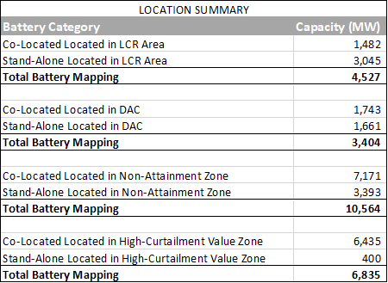

### Final Mapping Adjustments Following Comments and Replies to the Proposed Decision

This section summarizes the adjustments made to the mapping based on stakeholder feedback from comments and replies to the Proposed Decision and updated results from the CAISO’s Draft 2021-2022 TPP report. These adjustments are broken down by resource type below. The updated transmission implications are discussed in Section 7.8.

**Geothermal Adjustments**

Staff relocated 120 MW of geothermal to Nevada (20 MW from Northern California and 100 MW from Greater Imperial areas) acknowledging stakeholders’ comments identifying interest in and perceived need for additional Nevada geothermal resources particularly in Northern and Central Nevada. The 120 MWs are mapped to the Beatty substation bringing the total there to 440 MW.

Table 20 depicts the final mapping of geothermal resources. The criteria compliance for the mapped geothermal resources remains unchanged from Section 7.1. As noted in Section 6.2, mapping geothermal to Beatty would likely require any interconnections to cover a significant distance or the development of a tie-in connecting to existing transmission in Central Nevada particularly for the geothermal resources in Northern and Central Nevada. The additional resources mapped to Southern Nevada creates an additional transmission exceedance in the GLW constraint, which is discussed in detail below in Section 7.8.

Table 20: Summary of the final mapping of geothermal resources and their compliance with the mapping criteria.





**Wind Adjustments**

Staff completed the following adjustments to mapped wind resources in the portfolio to incorporate input from stakeholders’ comments and replies on the Proposed Decision and updated transmission information from the CAISO’s Draft 2021-2022 Transmission Plan Report (2021-22 TPP Draft Report)[12]:

* Added 110 MW of SW_Ext_Tx_Wind to the portfolio bringing the total to 610 MW. This addition accounts for OOS wind identified in the baseline reconciliation process that interconnects to the CAISO system and utilizes existing OOS transmission.
* Mapped the SW_Ext_Tx_Wind to the Mead (350 MW), El Dorado (136 MW), and Palo Verde (124 MW) substations to align with the interconnection points identified in the baseline reconciliation.
* Relocated 438 MW of OOS wind on new OOS transmission to the Palo Verde substation. Maintaining the remaining 1,062 MW of OOS wind on new transmission at the El Dorado substation, permits both Idaho and Wyoming wind as options as the source of this wind. In the 21-22 TPP Draft Report, the CAISO noted its plans to conduct further study of wind seeking to interconnect at El Dorado specifically Idaho wind, and this mapping will enable CPUC staff to utilize the results of this planned and ongoing work. CPUC staff shifted resources to Palo Verde to capture the potential for continued development of New Mexico wind for import into California as demonstrated by the OOS resources identified in baseline reconciliation and stakeholder interest in additional wind resources from New Mexico as noted in PD comments.
* Relocated 120 MW of offshore wind from Morro Bay to the Humboldt substation and shifted its deliverability to energy online.
* Relocated onshore wind resources at Cortina and Bridgeville to other substations in Northern California to reduce the transmission impacts of relocating offshore wind to the Humboldt substation. Staff moved the 34 MW of EO wind at Bridgeville and 66 MW (15 MW of FD, and 51 MW of EO) of wind at Cortina to the Birds Landing (22 MW FD), Kelso (2 MW FD, 48 MW EO), Glenn (15 MW EO) and Los Banos (13 MW FD) substations.

Table 21 depicts the final mapping of wind resources following these adjustments. The removal of resources at the Bridgeville substation increases deviance from previous base case; however, it avoids the level-2 non-compliance environmental and land-use flags at that substation. The level-2 non-compliance in criteria 2 at the Humboldt substation for the EO offshore wind is due to an exceedance in the default limit for EO transmission capability in the Humboldt-Trinity constraint. As noted above, staff shifted onshore wind and biomass resources out of this constraint and added 20 MW of storage into this constraint to minimize this exceedance. This flag is considered acceptable for two reasons. First, the limit exceeded is only a default constraint as identified in the CAISO’s 2021 White Paper and not an actual constraint. Second, the CAISO’s briefing on resources available for near term connection[13] identified an energy only offshore wind project in the CAISO’s queue at the Humboldt substation that did not need any transmission upgrades. The remaining non-compliance flags are unchanged from the wind resources discussion in Section 7.2.

Table 21: Summary of the final mapping of wind resources and their compliance with the mapping criteria.





**Solar and Co-located Storage Adjustments**

Staff completed the following adjustments to mapped solar and co-located storage resources in the portfolio to incorporate input from stakeholders’ comments and replies on the Proposed Decision as well as updated transmission information from the CAISO’s 2021-2022 TPP Draft Report.

* Shifted the deliverability status of solar resources from EODS to FCDS to align with the increase in FCDS solar in the baseline reconciliation due to the accounting changes for hybrid resources noted in Section 4.1. Staff only shifted EODS solar to FCDS at substations which did not already have sufficient FCDS solar mapped. Staff also remapped solar resources between a few substations to correct errors identified in the baseline reconciliation process. Resources at the Wheeler Ridge 230 kV and Kramer 115 kV substations were not included in the mapping for the proposed decision, so staff remapped solar from other substations in the SPG&E area to Wheeler Ridge and remapped solar and battery resources from Kramer 230 kV to the 115 kV bus. Resources at the Tranquility substation were also mistakenly mapped to the Midway substation, which staff corrected. In total, staff needed to account for ~1,250 MW of additional FCDS solar resources and 900 MW fewer EODS solar resources. These adjustments predominately affected mapping in the Southern PG&E area as resources had to be remapped between multiple substations and additional adjustments were required to accommodate the resources within the transmission headroom available or the additional capacity that could be provided by identified cost-effective transmission upgrades. The substations in the Southern PG&E area affected by these adjustments in solar and storage were Arco 230 kV, Gates 230 kV, Henrietta 115kV, Midway 230 kV, Midway 115 kV, Panoche 230 kV, Tranquility 230 kV, Westley 230 kV, Wheeler Ridge 115 kV, and Wheeler Ridge 230 kV. Substations beyond SPG&E where solar EODS resource were shifted to FCDS for baseline reconciliation were Kramer 115 kV and 230 kV, Red Bluff 230 kV, and Vestal 230 kV.
* Remapped 100 MW of solar (50 FCDS, 50 EODS) and 40 MW of storage to the Desert View substation in Southern Nevada shifting resources from the Gamebird and Innovation substations. This adjustment is to limit the reduction in resources mapped to the Desert View substation compared with the previous base case portfolio given potential impact to the transmission upgrades identified for this area in the 2021-22 TPP Draft Report. This mapping seeks to balance commercial interest at the substations in the Southern Nevada area with the prior base case consistency criteria.
* Shifted additional solar at specified substations from EODS to FCDS. The substations identified had significantly more energy only solar than storage mapped to them and are in constraints with sufficient transmission headroom from the base constraint limits or created by potential cost-effective upgrades. The follow substations had the solar amount in parenthesis shifted from EODS to FCDS: Calcite (50 MW), Hassayampa (300 MW), Helm (65 MW), Innovation (145 MW), and Trout Canyon (250 MW).

Table 22 and Table 23 depicts the final mapping of solar and co-located battery resources following these adjustments. Overall, the adjustments were relatively minor and only between substations within the same area. The total amount of solar and storage in each area remained unchanged. The main changes in criteria compliance are increases in flags for transmission exceedances in both the Southern PG&E and Southern Nevada areas. These have been adjusted to level 1 as the exceedance can be alleviated by cost-effective transmission upgraded discussed in Section 7.8. The remaining non-compliance flags are consistent with those discussed in Section 7.3.

Table 22: Summary of the final mapping of solar and co-located battery resources for the Greater LA Metro, Southern PG&E, and Tehachapi areas as well as their compliance with the five criteria.





Table 23: Summary of the final mapping of solar and co-located battery resources for the Greater Kramer, Riverside & Arizona, San Diego & Imperial and Southern Nevada areas as well as their compliance with the five criteria.





Table 24: Summary of the final mapping of stand-alone storage resources and their compliance with the five criteria.





**Stand-alone Storage Mapping Adjustments:**

Staff made only minor adjustments to the mapping of stand-alone storage, specifically to support the mapping of offshore wind to the Humboldt area. 20 MW of batteries (10 MW from Los Esteros and 10 MW from Martin) were shifted into the Humboldt-Trinity constraint area (15 MW to Humboldt and 5 MW to Mendocino). Table 24 shows the final mapping of stand-alone storage resources following these adjustments. The criteria compliance remains consistent with the discussion in Section 7.4

Following stakeholder comments and replies on the Proposed Decision, staff seek to clarify that although the current RESOLVE model only considers pumped storage hydro for long-duration energy storage staff considered other technologies when mapping the resources to busbars. As shown in Table 24, the 500 MWs mapped to the Sycamore substation does align with pumped-storage hydro commercial interest at the substation; however, the 500 MWs mapped to the Whirlwind substation aligns with a storage project in the CAISO queue that utilizes compressed air technology. Staff are labeling these resources as long-duration energy storage (LDES) to make this generalization clearer.

**Biomass and Distributed Solar Adjustments:**

Only minor adjustments were made to the mapping of the biomass/biogas resources selected to facilitate the mapping adjustments of other resources discussed above. The final mapping locations for the biomass resources are shown in Table 25. No changes were made from Table 12 to the mapping of distributed solar.

*Table* 25*: Summary of the final mapping of biomass/biogas resources by substation*.

### Transmission Implications of Final Mapped Portfolio

The mapping adjustments discussed above in Section 7.7 and additional information from the CAISO's draft report for the 2021-2022 TPP result in several changes to the transmission implications of the mapped portfolio and the potential upgrades identified as solutions to the identified transmission exceedances.

Three constraint exceedances identified in Section 7.5 and their potential transmission solutions remain unchanged by the mapping adjustments. Those exceedances are for the Laguna Bell – Mesa Constraint impacting the Greater LA Metro and Tehachapi areas, the Antelope – Vincent Constraint impacting the Tehachapi area, and the San Diego Internal Constraint impacting the San Diego and Greater Imperial areas. The exceedances in Southern Nevada, Southern PG&E, and Northern California areas are impacted by the mapping adjustments above and updated results from the 2021-2022 TPP Draft Report.

* *Southern Nevada – GLW-VEA Area Constraint*: Mapping additional geothermal resources results in the resources mapped in this area exceeding the transmission capacity of the 1,000 MW upgrade identified in Section 7.5, which has an updated cost per the Draft 2021-2022 TPP Report of $278 million. Shifting EODS solar mapped within this constraint that did not have sufficient storage co-located with it further increased the exceedance. Stakeholders’ comments for the PD identified a potentially cost effective additional partial 500 kV upgrade to the GLW system, which could allow an additional 2,000 MW of capacity and cost between $260-300 million, although this project and these estimates have not yet been studied and verified by the CAISO. The CAISO can study the potential cost-effectiveness of this upgrade in addition to the 320 kV upgrade identified both in the CAISO’s 2021 White Paper and in the 2021-2022 TPP Draft Report.
* *Southern PG&E – Multiple Constraints*: Mapping adjustments to account for the changes in baseline reconciliation treatment of solar resources in hybrids and further efforts to increase the amount of FCDS solar mapped resulted in multiple constraint exceedances in the Southern PG&E area. The exceedance of the actual off-peak limit in the Moss Landing Aguillas 230 kV Off-Peak Constraint as identified in Section 7.5 remains. The adjustments also trigger a 110 MW exceedance of actual on peak capability of the Wilson-Storey-Borden 230 kV Constraint. Further exceedances are noted in the on-peak default limits of the Las Aguillas-Panoche 230 kV Line, Warnerville-Wilson 230 kV Line, Moss Landing - Aguillas 230 kV off-peak deliverability constraints. These capacity limits are classified as default in the CAISO’s 2021 White Paper, meaning the CAISO has not studied resources amounts beyond these limits in these areas and the actual transmission capability limit are not known. Thus, further study by the CAISO is needed to determine if these default exceedances will even warrant the need for transmission upgrades. The exceedances in the Moss Landing Aguillas 230 kV Off-Peak Constraint and Wilson-Storey-Borden 230kV On-peak Constraint can be alleviated by upgrades identified in the CAISO’s 2021 White Paper which provide an addition 100 MW of FCDS capacity and 1308 MW of EODS capacity and respectively cost an estimated $232 million and $48 million respectively. However, the CAISO’s 2021-2022 TPP Draft Report identified a larger upgrade that may alleviate all these constraints. The Draft Report identified a new Manning 500 kV substation upgrade interconnecting with the Tranquility and Panoche 230 kV substations costing an estimated $325-485 million and taking six years to complete. Based on the proposed transformer and transmission line ratings, CPUC staff estimate that this upgrade could enable up to 2,000 MW of additional transmission capacity; however, further CAISO guidance and study is needed to ascertain a more accurate capacity number.
* *Northern California – Cortina – Vaca-Dixon Line Constraint*: Mapping adjustments did not significantly change the exceedance in this constraint as discussed in Section 7.5; however, the 2021-2022 TPP Draft Report provides update information on transmission upgrades. Given the similarities in this current mapping and for the 2021-2022 TPP base case, CPUC staff assume two upgrades identified in the draft report could alleviate this exceedance. These upgrades are the Draft Report identified Delevan-Cortina 230 kV line reconducting costing $18 - $35 million and the proposed new Collinsville 500 kV substation costing $475 -675 million and taking an estimated 6 years to complete. As with the Manning substation upgrade above, the Collinsville upgrade could significantly increase the amount of transmission capacity in the area. Based on the proposed transformer and transmission line ratings, CPUC staff estimate that this upgrade could enable over 2,000 MW of additional transmission capacity again noting that staff would rely on further CAISO assessment to establish a more accurate capacity number.

Finally, to reiterate, the transmission constraint analysis conducted in busbar mapping is centered on only the CAISO’s Balancing Area Authority (BAA). Thus, the 600 MW of geothermal resources mapped to the Bannister substation within the Imperial Irrigation District’s (IID’s) BAA may likely require transmission upgrades within the IID system to successfully connect to the CAISO controlled grid.

### Summary of the Final Mapping Results

Figure 6 summarize the total mapped capacity of the resources in the 2032 base case portfolio by location, region, and resource type. As discussed in Section 7.7, no significant mapping changes were made. In summary, the main locational adjustments were: remapping 120 MW of geothermal to Nevada, remapping 120 MW of offshore wind to Humboldt from Morro Bay, the addition of 110 MW of out of state wind on existing out of state transmission, and remapping of solar resources between substations in the Southern PG&E area. Table 26 summarizes the final mapped results by RESOLVE resource type and region to allow a direct comparison with what RESOLVE selected in the 38 MMT portfolio with the 2020 IEPR and High EV assumptions as shown in Table 4. This comparison shows the shifting of resources due to the busbar mapping process.

Figure 6: Final mapping results for the base case portfolio in 2032. Left: Map of resources by location. Circle color reflects resource type and size reflects MW amount mapped. Right: Resources aggregated by region and resource type.

Table 26: Final mapping results summarized by RESOLVE resource type



## Other Assumptions for TPP

Guidance previously provided to CAISO as part of the annual CPUC portfolio transmittal was included in a document called the “Unified Inputs & Assumptions”. CPUC and CAISO staff agree that any necessary content be included in this Report. This section describes the additional modeling assumptions the CPUC *provides to the CAISO’s TPP, besides the portfolio and busbar mapping assumptions described in the rest of this Report.*

### Thermal Generator Retirement

RESOLVE reports the aggregate amount of thermal generation not retained by resource category. Unit-specific information is not modeled. Because the TPP studies require modeling of specific units and locations, CPUC staff provide information to the CAISO regarding which units should be assumed as retired for transmission planning purposes. However, the resource portfolio for the 2022-2023 TPP does not include as an output any not retained thermal generation. Instead, the portfolio does include thermal generation retirements as an input prior to resource optimization.[14] The detailed workbook contained in Appendix F lists the specific units assumed as retired. CPUC staff applied the steps described in the methodology (see Appendix A) to develop this list.

### Demand Response

This subsection provides guidance on modeling treatment of demand response (DR) programs in network reliability studies including allocating capacity from those programs to transmission substations.

The CPUC’s Resource Adequacy (RA) proceeding (R. 19-11-009 or its successor R. 21-10-002) determines what resources can provide system and local resource adequacy capacity. Current RA accounting rules indicate that all existing DR programs count to the extent those program impacts are located within the relevant geographic areas being studied for system and local reliability. For its TPP studies the CAISO utilizes data from Supply-Side Resource Demand Response, which is registered in the CAISO market as either dispatchable, Emergency DR (RDRR) or Economic DR (PDR).

By nature, impacts from DR programs are distributed across large geographies. In order for these impacts to be applied in network reliability studies, DR program capacity must be allocated to transmission substations. To this end, CPUC staff requests the Investor-Owned Utilities (IOUs), in their capacity as Participating Transmission Owners (PTOs), to submit this information through the CAISO’s annual TPP Study Plan stakeholder process. To the extent possible, this data should also allocate impacts of DR programs administered by CCAs or procured from third parties.

Separately, and coupled with the CPUC’s annual Load Impact Protocols (LIP) filings,[15] IOUs are to submit a second, updated filing. Thus, the data for the TPP is first filed in mid-February, followed by the LIP final Report filing in April, which is then followed by the updated filing in August of the same year. These filings and timelines are subject to change when and if the CPUC approves a new DR QC methodology.

While we recognize that the annual TPP Study Plan that concludes in March already incorporates busbar-level details, this additional reporting will validate the results from the earlier filings.

Because the data requirements specified in both filings contain confidential information, the CPUC expects the CAISO and the IOUs to exchange data using their own non-disclosure agreements.

Contact and recipient details for these filings will be provided by the CAISO as part of the 2021-2022 TPP. Both the TPP and updated filings are to contain the following:

* Portfolio aggregate ex-ante load impacts (in MW), by program, for 1-in-2 under CAISO’s August system peak, for each of the full ten-year forecast period, disaggregated by Western Electricity Coordinating Council (WECC) transmission level busbar, in plain Excel format. The WECC busbar shall be identified by two columns (fields):
  + WECC busbar number as used in CAISO power flow models;
  + Substation identifier/name (for example, [22256, ESCNDIDO] for SDG&E; [24214, SANBRDNO] for SCE; and [33207, BAYSHOR2] for PG&E). This applies to all dispatchable IOU DR programs and does not include non-dispatchable programs such as Time-of-Use (TOU) rates;
  + The final year of the forecast (furthest into the future), for all program operating hours (not just the Resource Adequacy [RA] operating window). Disaggregate the data into four geographic zones: PG&E Bay, PG&E Valley, SCE, and SDG&E. PG&E Bay is defined as the Greater Bay Area Local Capacity Area (LCA) and PG&E Valley is defined as everything else in PG&E. This requirement applies to all dispatchable and non-dispatchable programs.
* The methods and assumptions for disaggregating DR impacts by WECC transmission level busbar shall be standard and uniform across each IOU and documented in a supplemental report. To the extent this data does not sufficiently mask individual customer load information, the IOUs shall provide both a public version of the data with individual customer load information masked, and a confidential version of the data with complete information. The IOUs shall make the confidential dataset known and available to the CAISO (with applicable NDAs) by the annual deadline for its request for stakeholder input on “unified planning assumptions” for the TPP.

## Conclusion and Next Steps

The CPUC resource portfolio has been mapped to busbars in reasonable accordance with the criteria and with consideration of state policy objectives, as described in the Methodology (see Appendix A). In total, over 25,500 MW of renewables, including 1,500 MW of out-of-state wind on new out-of-state transmission and 1,700 MW of offshore wind, and over 14,500 MW of storage have been mapped to substations. The results (available in Appendices B, C, and D) are transmitted to the CAISO for use in the reliability and policy-driven base case in the 2022-2023 TPP. In comparison, for the portfolio passed as the base case for the ongoing 2021-2022 TPP study, staff mapped 17,700 MW of renewable resources, including 1,062 MW of out-of-state wind on new out-of-state transmission, and nearly 10,000 MW of storage. Figure 6 compares the amount of resources mapped in this report in the proposed base case portfolio for the 2022-2023 TPP to the amount of resources mapped in the portfolio adopted by the CPUC as the base case for the 2021-2022 TPP.

Figure 7: Final resource comparison between the 2021-2022 TPP base case and the proposed 2022-2023 TPP base case.

The prior busbar mapping of the 2021-2022 TPP base case resources triggered exceedances in three transmission zones, which could be alleviated by three sets of upgrades providing an estimated additional 3,500 MW of transmission capability and costing an estimated $300 million. The 2021-2022 TPP study is still ongoing, and the CAISO has not yet approved any upgrades based on this prior base case portfolio. In comparison, the proposed base case mapping conducted in this Report for the 2022-2023 TPP (using the updated transmission constraints) results in six areas of constraint exceedances. These exceedances could be alleviated by six sets of possible transmission upgrades providing an estimated additional 13,000 – 17,000 MW of transmission capability and costing an estimated $1.2 – 1.8 billion.

While RESOLVE is currently not able to model true hybrids as a potential resource, the RESOLVE updates and new transmission constraints and expressions utilized for this portfolio enabled the busbar mapping process to co-locate 11,800 MW of solar with 9,600 MW of batteries represented by mapping EODS solar and batteries to the same substations. The new transmission expressions better model the interplay between FCDS and EODS resources particularly with respect to storage. These updates capture the ability to use solar and storage together over the same transmission. By co-locating EODS solar with FCDS storage, the busbar mapping process is representing the key aspects of hybrid resources in a deconstructed fashion: utilizing the EODS solar for storage charging and preserving the FCDS transmission headroom for storage deliverability.

The final busbar mapping of resources resulted in several transmission exceedances, which are described in more detail in the subsections below. The transmission constraint analysis conducted in busbar mapping is centered on only the CAISO’s Balancing Area Authority (BAA). The transmission capability and potential upgrades needed in other BAAs are unknown. Thus, for example, although the 700 MW of geothermal resources mapped to the Bannister substation within the Imperial Irrigation District’s (IID’s) BAA are unlikely to require any upgrades within the CAISO transmission system, assuming the resources interconnect with the CAISO to the north in the Riverside area, the impacts on the IID’s system are unknown, as are the type and cost of any upgrades that may be required to successfully interconnect the resources to deliver to the CAISO border.

The grid is ever-evolving and for this reason the CPUC transmits portfolios to the CAISO annually for transmission planning. Nevertheless, several of the exceedances align with those noted in the 2021-2022 TPP 46 MMT portfolio base case and 38 MMT portfolio sensitivity case. This consistency provides additional confidence in the updates to RESOLVE and in the new transmission expressions and constraints adopted in the CAISO’s 2021 White Paper. This consistency also indicated that possible resolution to these exceedances via upgrades being studied in the 2021-2022 TPP, thereby providing an advantage to the transmission planning.

### Guidance on the 38 MMT with 2020 IEPR with High EV Base Case Resource Portfolio

As described in greater detail in Section 7, the mapped resources exceed existing transmission limits for the following constraints:

* **Greater LA & Tehachapi Areas – Laguna Bell - Mesa Constraint:** The FCDS transmission limit exceedance in this constraint could be alleviated by a transmission upgrade that would increase the estimated FCDS transmission capacity by 3,170 MW, with a CAISO estimated cost of $15 million and a 27-month time to complete.
* **Tehachapi Area – Antelope - Vincent Constraint:** The FCDS transmission limit exceedance in this constraint could be alleviated by a transmission upgrade that would increase the estimated FCDS transmission capacity by 2,700 MW, with a CAISO estimated cost of $15 million and a 18-month time to complete
* **San Diego & Imperial Area – San Diego Internal Constraint:** The FCDS transmission limit exceedance in this constraint could be resolved by a transmission upgrade that would increase the estimated FCDS transmission capacity by 2,000 MW, with a CAISO estimated cost of $89 million and 18-month time to complete.
* **Southern Nevada Area – GLW-VEA Area Constraint:** The FCDS and EODS transmission limit exceedances in this constraint could be partially resolved by a transmission upgrade that would increase the estimated transmission capacity by 1,000 MW FCDS and 1,100 MW EODS, with a CAISO estimated cost of $278 million and 5-year time to complete. However, further transmission upgrades are likely needed to alleviate the entire exceedance created by the number of resources mapped to the area. A stakeholder identified partial 500 kV upgrade costing an estimated $280 million, which has not yet been studied by the CAISO, could provide an up to 2,000 MW of additional transmission capability and warrants study by the CAISO as a potential solution to this exceedance.
* **Southern PG&E – Multiple Constraints:** The EODS and FCDS transmission limit exceedances in these constraints could be resolved by transmission upgrades identified in the CAISO’s 2021 White Paper that would increase the estimated the FCDS capacity by 100 MW for the Wilson-Storey-Borden 230 kV Constraint and the EODS capacity by 1,300 MW for the Moss Landing-Las Aguilas 230 kV constraint, with a CAISO estimated cost of $232 million and $48 million respectively, and 4 and 8year time frames to complete. Additionally, the new Manning 500 kV Substation upgrade identified in the 2021-2022 TPP Draft Report could potentially be a more cost-effective upgrade to alleviate these exceedances. The CAISO estimates it would cost $325 – 485 million and take 6 years to complete, but it has the potential to significantly increase transmission capacity for more renewable resources in the area well beyond what the smaller upgrades can provide.
* **Northern California — Cortina - Vaca-Dixon Line Constraint:** The resources mapped to the Northern California area triggered a FCDS exceedance in this constraint; however, the $3.5 billion, 12-year time to complete transmission upgrade identified by the CAISO’s 2021 White Paper is not a cost-effective approach for the only 440 MW exceedance. The resources mapped to the Northern California area in the 2021-2022 TPP base case portfolio result in a similar exceedance to the constraint. The CAISO’s 2021-2022 TPP Draft Report identified a small Delevan-Cortina 230 kV line reconducting costing $18 - $35 million and a new Collinsville 500 kV substation upgrade costing $475 -675 million that takes an estimated 6 years to complete as upgrade solutions that also would significantly increase transmission capacity for renewable resources interconnecting in the Northern California area. These upgrades could be a cost-effective approach to alleviating the exceedance caused by the resources mapped in this portfolio. CPUC staff assume the resource amounts and locations selected would trigger a similar set of upgrades to mitigate this constraint exceedance.

If the TPP policy-driven assessment of the base portfolio identifies the need for upgrades, the CAISO would typically recommend to the CAISO Board of Governors for approval the upgrades as policy-driven transmission upgrades. The CAISO retains more flexibility with approval of projects if they are identified only in the reliability assessments, and if the estimated build time does not necessitate immediate commencement to meet the identified resource need. The CPUC will continue to coordinate with the CAISO and will be engaged in the CAISO's Transmission Planning Process by providing comments or additional guidance through the TPP stakeholder process based on results of the analysis for the base portfolio related to transmission upgrade needs that are identified.

CPUC staff recognize the need for a unique approach with the 1,500 MW of OOS resources on new OOS transmission in the base case resource portfolio. In the 2021-2022 TPP, the 46 MMT base case had 1,062 MW of OOS resources on new transmission. During that mapping, CPUC staff were not able to determine at which busbar injection location the OOS wind would best meet policy goals while minimizing cost to rate payers due to the uncertainty of each injection points’ impacts on the CAISO transmission grid. Thus, for the 2021-2022 TPP, the CPUC did not select a single injection point for the OOS wind, and the CAISO is conducting a special study to assess the impacts at both injection points of the 1,062 MW of OOS wind. For the 1,500 MW of OOS resources on new transmission in the current portfolio, staff mapped 1,062 MW to the El Dorado injection point and 438 MW to the Palo Verde injection point. The El Dorado injection point enables either Idaho Wind or Wyoming Wind to interconnect and permits the CAISO to continue its study of OOS wind with its economic study focus on Idaho Wind as noted in the CAISO’s 2021-2022 TPP Draft Report. The 438 MW of OOS wind at Palo Verde captures the potential for additional wind imported from New Mexico that aligns with recent inclusion of OOS wind from this area as identified in the baseline reconciliation process.

As with the 2021-2022 TPP portfolio submittal, the Working Group agrees that in some cases, more information is needed to understand the full impacts of the battery mappings, particularly in LCR areas before new transmission projects are identified by the CAISO as needed. Accordingly, the CAISO should consult the CPUC before moving forward with any new policy-driven transmission upgrades associated specifically with storage mapping in this planning cycle. Additionally, to the extent that storage resources are required for mitigation of transmission issues identified in the CAISO’s 2021-2022 Transmission Plan, CPUC staff would expect to coordinate with CAISO to enable small adjustments in the CPUC’s mapping of storage resources to allow for the inclusion of this storage in the CAISO’s analysis of these 2022-2023 TPP portfolios.

### Busbar Mapping for 2023-24 TPP and Future Cycles

Staff appreciates the suggestions from stakeholders in response to the questions posed in the August 2021 ruling. Anything not already addressed in the transmittal for the 2022-2023 TPP will be a priority for consideration in the draft workplan for 2023-2024 TPP busbar mapping. Furthermore, CPUC staff continue to strive to resolve the process alignment and timing issues that make it challenging to inform resource busbar mapping for an upcoming TPP with the results of the ongoing TPP.

## Appendices

##### Methodology for Resource-to-Busbar Mapping & Assumption for the TPP

Available at the CPUC’s “2019-2020 IRP Events and Materials” webpage: <https://www.cpuc.ca.gov/industries-and-topics/electrical-energy/electric-power-procurement/long-term-procurement-planning/2019-20-irp-events-and-materials>

##### CEC Busbar Mapping Results for Non-Battery Resources – 38 MMT with 2020 IEPR with high EV base case portfolio

Data Basin link to Excel files: [https://caenergy.databasin.org/galleries/eab0ce3a5be447ce928a310e80c65c8d/ - expand=208848](https://caenergy.databasin.org/galleries/eab0ce3a5be447ce928a310e80c65c8d/#expand=208848)

##### Busbar Mapping Calculator

Workbook available at the CPUC’s “2019-2020 IRP Events and Materials” webpage: <https://www.cpuc.ca.gov/industries-and-topics/electrical-energy/electric-power-procurement/long-term-procurement-planning/2019-20-irp-events-and-materials>

##### Busbar Mapping Dashboard workbook – 38 MMT with 2020 IEPR high EV base case portfolio

Workbook available at the CPUC’s “2019-2020 IRP Events and Materials” webpage: <https://www.cpuc.ca.gov/industries-and-topics/electrical-energy/electric-power-procurement/long-term-procurement-planning/2019-20-irp-events-and-materials>

##### 2020 IRP Baseline Reconciliation (for non-battery and battery mapped resources)

Workbook available at the CPUC’s “2019-2020 IRP Events and Materials” webpage: <https://www.cpuc.ca.gov/industries-and-topics/electrical-energy/electric-power-procurement/long-term-procurement-planning/2019-20-irp-events-and-materials>

##### Retirement List of Thermal Generation Units

Excel file available at the CPUC’s “2019-2020 IRP Events and Materials” webpage: <https://www.cpuc.ca.gov/industries-and-topics/electrical-energy/electric-power-procurement/long-term-procurement-planning/2019-20-irp-events-and-materials>

---- DOCUMENT ENDS ----

**(END OF ATTACHMENT A)**

1. As defined in the Busbar Mapping Methodology. See Appendix A.
2. Referring to the Integrated Energy Policy Report (IEPR) prepared by the California Energy Commission.
3. Referring to the version attached to the 8/17/21 Ruling. Available at: https://www.cpuc.ca.gov/-/media/cpuc-website/divisions/energy-division/documents/integrated-resource-plan-and-long-term-procurement-plan-irp-ltpp/2019-2020-irp-events-and-materials/busbar-mapping-methodology_2021-07-26-f.pdf
4. [White Paper – 2021 Transmission Capability Estimates for use in the CPUC’s Resource Planning Process](http://www.caiso.com/Pages/documentsbygroup.aspx?GroupID=79BEBAD0-E696-4E04-A958-1AAF53A12248) (7/20/2021). Note: CAISO staff issued a Revised White Paper on 10/28/2021, which CPUC staff incorporated into the busbar mapping efforts; however, these updates were not utilized in the RESOLVE portfolio.
5. https://docs.cpuc.ca.gov/SearchRes.aspx?docformat=ALL&docid=434547053
6. This represents the CAISO contribution extrapolated from a 38 MMT by 2030 target using the same assumptions that were used for incorporating post-2030 years into select modeling runs to reflect achievement of the Senate Bill (SB) 100 (DeLeón, 2018) 2045 goals in the development of the 2021-2022 TPP.
7. <https://ecosystems.azurewebsites.net/WECC/Environmental/Environmental_References.html>
8. [Revised White Paper – 2021 Transmission Capability Estimates for use in the CPUC’s Resource Planning Process](http://www.caiso.com/Pages/documentsbygroup.aspx?GroupID=79BEBAD0-E696-4E04-A958-1AAF53A12248) (10/28/2021).
9. Low to Moderate Risk of Environmental or Cultural Resource Sensitivities and Constraints

   <https://ecosystems.azurewebsites.net/WECC/Environmental/Environmental_References.html>
10. High Risk of Environmental or Cultural Resource Sensitivities and Constraints
11. July 28, 2021 news release available at <https://www.boem.gov/newsroom/press-releases/boem-advances-offshore-wind-leasing-process-california>
12. <http://www.caiso.com/InitiativeDocuments/Draft-2021-2022TransmissionPlan.pdf>, released 1/31/2022
13. [Briefing-ResourcesAvailable-NearTermInterconnection.pdf (caiso.com)](http://www.caiso.com/Documents/Briefing-ResourcesAvailable-NearTermInterconnection.pdf), Nov. 17, 2021.
14. The RESOLVE inputs and assumptions for this 2022-2023 TPP analysis incorporated an implementation of the High-Need Scenario of the Mid-Term Reliability Decision D.21-06-035 which included 40-year age-based retirements for peakers and CHP generators that came online by the end of 1986
15. D. 08-04-060 in R. 07-01-041, “Decision Adopting Protocols for Estimating Demand Response Load Impacts. LIP Final Reports are filed annual on April 1.