|  |  |  |  |
| --- | --- | --- | --- |
| **State of California** | | | **Public Utilities Commission**  **San Francisco** |
| **M E M O R A N D U M** | | |  |
| **Date:** | **October 31, 2022** | | |
| **To:** | **The Commission**  **(Meeting of November 17, 2022)** | | |
|  | | | |
| **From:** | | **Commissioner Clifford Rechtschaffen and Commissioner Darcie L. Houck** | |
| **Subject:** | | **New Appointments to the Disadvantaged Communities Advisory Group (DACAG)** | |

**BACKGROUND**:

Senate Bill 350 (de León, Chapter 547, Statutes of 2015), as codified in Public Utilities Code section 400(g), requires the California Public Utilities Commission (CPUC) and the California Energy Commission (CEC) to establish an Advisory Group consisting of representatives from disadvantaged communities (Disadvantaged Communities Advisory Group or DACAG). The purpose of the DACAG is to review and provide advice on proposed clean energy and pollution reduction programs and determine whether those proposed programs will be effective and useful in disadvantaged communities.

The CPUC adopted the initial and revised Charter for the Advisory Group on December 14, 2017, and March 12, 2020, respectively. The CEC adopted the initial and revised Charter for the Advisory Group on December 13, 2017, and March 11, 2020, respectively.

The DACAG is comprised of 11 members who serve two-year staggered terms from the date of appointment. On February 22, 2022, Jose Hernandez resigned from the board. On March 1, 2022, the Commissions issued a solicitation for application to membership in the Advisory Group, with an application deadline of March 31, 2022, to fill this vacant seat. On April 11, 2022, this solicitation was extended to May 15, 2022. On May 16, it was extended to July 15. On July 16, it was extended again to August 31. Finally, on September 1, it was extended to October 15.

On October 20, 2022, CPUC and CEC staff interviewed Sahara Huazano for the open seat. Joint staff consensus was reached to advance her candidacy for consideration by CPUC and CEC commissioners. A brief summary of her qualifications is included below:

**Sahara Huazano:** Based in Indio, Ms. Huazano is Director of Programs for Alianza Coachella Valley, a sustainability organization which focuses on pollution, infrastructure, health care, and youth outreach. She has worked for Alianza since 2014 when she graduated with honors from U. C. Santa Cruz, earning a degree in Environmental Studies. She is the Community Appointed Co-Chair of California Natural Resource Agency’s Salton Sea Management Program Community Engagement Committee and has previously served as Governor Appointed board member of the California Regional Water Quality Control Board, City Council Appointed Planning Commissioner for City of Coachella, and Appointed Member to the California South Coast Air Quality Management District’s Environmental Justice Advisory Group.

The CEC will consider approving Ms. Huazano to the DACAG at their November 16, 2022 business meeting. The appointment will be confirmed once both Commissions vote to approve. Due to there being less than one year remaining in Mr. Hernandez’ term, which ends March 31, 2023, Ms. Huazano would be eligible for reappointment in 2023. The current shortened term would not be counted against her 3-term limit, per the DACAG Charter, Section 3.4.**[1]**

**CONCLUSION**

Ms. Huazano is a highly qualified expert that will make a valuable addition to the Disadvantaged Communities Advisory Group in advising the CPUC and CEC, and we recommend her appointment.

Sincerely,



Clifford Rechtschaffen, Commissioner

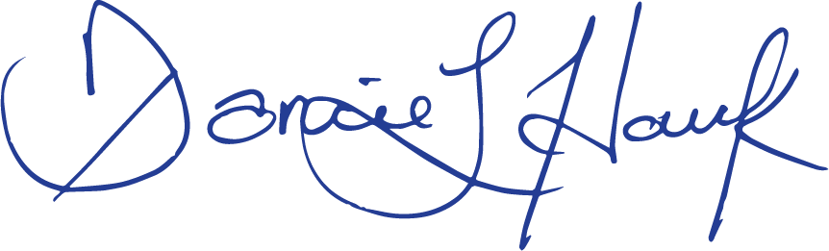

Darcie L. Houck, Commissioner

1. <https://efiling.energy.ca.gov/getdocument.aspx?tn=232679>