PUBLIC UTILITIES COMMISSION OF THE STATE OF CALIFORNIA

Communications Division RESOLUTION T-17766
December 15, 2022

R E S O L U T I O N

RESOLUTION T-17766 adopts the Environmental Assessment and Initial Study Mitigated Negative Declaration in compliance with the California Environmental Quality Act and approves the issuance of a notice to proceed for the Digital 299 Broadband Project.

SUMMARY

This Resolution adopts the Environmental Assessment and Initial Study Mitigated Negative Declaration, approves the issuance of a notice to proceed (NTP), and memorializes commitments made on the part of the project proponent, Vero Fiber Networks, LLC, in the attached Term Sheet.

BACKGROUND

The Commission approved a California Advanced Services Fund (CASF) infrastructure grant application for Inyo Networks, Inc. (Inyo) on March 23, 2017, in Resolution T-17548. Inyo sent a letter to Communications Division terminating the grant that was approved in Resolution T-17548 on September 17, 2020. Subsequently, another carrier, Vero Fiber Networks, LLC (Vero), indicated interest in completing the project that was the subject of the 2017 Commission CASF grant — the Digital 299 Broadband Project (Digital 299) - without seeking CASF funding (See Appendix A for project area).

On September 6, 2021, Vero sent a letter to the Communications Division director stating that Vero will not seek CASF infrastructure funding; will continue the environmental permitting requirements that were begun for the previous Inyo CASF project; and will commit to provide public benefits, specified in a Term Sheet, consistent with the public benefits the Commission identified in Resolution T-17548 (See Appendix B). Because environmental review of the previous Inyo CASF project was well underway, and because Vero committed to delivering many of the public benefits identified in Resolution T-17548, the Commission determined that Digital 299 should continue to follow the same approval process as the previous Inyo CASF project — culminating in this Resolution.

The Commission prepared a Draft Initial Study/Mitigated Negative Declaration (Draft IS/MND) for the project (SCH#2022010017) pursuant to CEQA Guidelines. The CPUC’s Draft IS/MND also includes a Draft Environmental Assessment (Draft EA) prepared pursuant to the National Environmental Policy Act (NEPA) for use in permitting and project approval by federal agencies. The Draft IS/MND was circulated through the State Clearinghouse of the Office of Planning and Research (OPR) for a 30-day public comment period ending on February 3, 2022.

The Commission received approximately 60 comments from the public, as well as from state and federal permitting agencies. Commission staff have prepared a response-to-comments section in the IS/MND and prepared a Final IS/MND for the Commission’s review, approval and adoption based upon the comments received. The Final IS/MND includes a Mitigation Measure (BIO-3) related to the preparation of a Restoration Plan for any disturbance within a dry waterway area, and the Commission makes this Mitigation Measure, as well as the applicant-proposed resource protection measures outlined in Appendix G to the MND, conditions of project approval. The Final IS/MND will be available at: https://ia.cpuc.ca.gov/environment/info/transcon/index.html.

DISCUSSION

Commission staff recommends adoption of the EA and IS/MND for Vero’s Digital 299 Project. Commission staff reviewed the Final IS/MND and attached materials relating to the CEQA process and determined that they support the following findings: the Final IS/MND complies with the requirements of the California Environmental Quality Act; the Final IS/MND represents the Commission’s independent judgement; and that the Final IS/MND is adequate for the Commission’s decision-making purposes.

This Resolution also memorializes the public benefits outlined in Vero’s Term Sheet and makes them conditions of project approval. Vero will provide: high quality, open access middle mile service to anchor institutions and last mile providers along the route from the Samoa Peninsula near Eureka, to Redding, California; and Indefeasible Right of Use (IRU) for 20 years with a 10-year renewal option to nine Tribal Entities, as described below.

The Tribal Entities will receive up to two dark fiber strands pursuant to a contract to be signed with Vero regarding the IRUs. Each fiber pair will be reserved for two years from the date of notice of the completion of construction. Tribal Entities may utilize the IRUs for internal purposes and to directly provide communication services to Tribal members but may not subcontract the fibers. Connection to the Project network will be along the existing route at any available access point.

Specifically, Vero’s public benefit commitments that are memorialized in this resolution and made conditions of project approval are as follows:

- Deployment of High-Quality Advanced Information and Communications Technology Infrastructure in Underserved Areas: Vero will provide critical middle-mile fiber infrastructure that will facilitate last-mile service and improved public services to the 2400 square miles of rural Northern California between Redding and the California coast, encompassing portions of Shasta, Trinity and Humboldt Counties that have been historically underserved.
- Open access to local Providers for last mile services: Vero will offer fiber, based on availability, on fair, reasonable, and non-discriminatory terms to local providers to facilitate last mile service, and will also serve public service entities (such as education, fire, police, health care and government) to facilitate public services.
- Service to Anchor Institutions: Vero will make good-faith efforts to place access points to enable service to anchor institutions (informed by the list of anchor institutions identified to-date and in the March 2017 Digital 299 CASF award).

Nine area Tribes will receive up to two dark fibers at no cost through a
20-year Indefeasible Right of Use (IRU) with a 10-year renewal right:
  - Fiber will be reserved for two years after route completion (one pair for each of the nine Tribes); the fiber option will expire if not exercised through a contract with Vero within the two years;
  - Fiber IRU expires if (a) fiber is not utilized within one year following IRU effective date or (b) fiber is abandoned at any point. "Utilized" means a Tribe has connected to and is sending traffic over the fiber.
  - In the event a Tribal Entity exercises its option, the following shall apply:
    - Each Tribal Entity is responsible for its own property or other taxes related to their ownership or use of the IRU:
    - Tribal Entities may use the fiber for internal purposes and to directly provide communications and broadband services to Tribal members and Tribal owned end-user businesses, but may not sub-IRU the dark fiber strands to any third party;
    - Connection allowed at any available existing access point;
    - Splicing would be at cost plus 20%; and
    - Each Tribal entity who wants to exercise this benefit will enter into a standard IRU agreement with Vero.

Vero will report the status of these IRUs annually to the Communications Division.

Thus, Commission staff is authorized to issue Vero a notice to proceed for the Digital 299 project that memorializes the public benefit commitments contained in this Resolution, and that requires compliance with the mitigation measures and the applicant-proposed resource protection measures contained in the Final IS/MND.

COMMENTS

In compliance with Pub. Util. Code section 311(g)(1), a Notice of Availability was
e-mailed on November 10, 2022, informing all parties on the CASF Distribution List of the availability of the draft of this Resolution, and of the opportunity to comment, at the Commission’s website at http://www.cpuc.ca.gov/.

FINDINGS

- The Commission approved a California Advanced Services Fund (CASF) infrastructure grant application for Inyo Networks, Inc. (Inyo) on March 23, 2017, in Resolution T-17548. On September 17, 2020, Inyo Networks sent a letter to Communications Division terminating the grant that was approved in Resolution T-17548.
- Vero Fiber Networks sent a letter to the Communications Division director on September 6, 2021, stating that: Vero intended to complete the Digital 299 project without CASF infrastructure funding, and to deliver public benefits that were identified as part of the Inyo CASF project.
- The Commission conducted an initial review and determined that a Mitigated Negative Declaration (MND) was the appropriate CEQA review document.
- As the lead agency under the California Environmental Quality Act, the Commission prepared an Environmental Assessment and Initial Study Mitigated Negative Declaration (IS/MND) for the Digital 299 Broadband Project.
- The Commission finds that the Final IS/MND complies with the requirements of the California Environmental Quality Act.
- The Commission finds that the Final IS/MND represents the Commission's independent judgement and analysis on the issues addressed by the IS/MND.
- The Commission finds that the Final MND is adequate for the Commission's decision-making purposes.
- The proposed project will have no significant effects on the environment with the incorporation of the mitigation measures and applicant-proposed resource protection measures identified and listed in the MMRP. The Commission finds that Mitigation Measure BIO-3 fully mitigates any project-related impact to Less-than-Significant.
- Commission staff should be authorized to issue a notice to proceed for the project that ensures Vero Fiber Networks, Inc. implements the measures contained in the MMRP as conditions of project approval and has adopted a system to document and verify MMRP implementation.
- Resolution T-17766 was emailed to the CASF distribution list on November 10, 2022, in compliance with Pub. Util. Code section 311(g)(1).

THERFORE, IT IS ORDERED that:

- Vero Fiber Networks shall comply with all guidelines, requirements, and conditions set forth in this resolution.
- The Final Mitigated Negative Declaration for the Project is adequate for the Commission's decision-making purposes and is hereby adopted pursuant to the California Environmental Quality Act Guidelines and the Public Resources Code.
- Vero shall comply with all terms and conditions identified in the Mitigation Monitoring Compliance and Reporting Program (MMCRP) adopted as part of the Final IS/MND (See Appendix C).
- Commission staff is authorized to issue Vero Fiber Networks a notice to proceed (NTP) for the Digital 299 project that: memorializes the public benefit commitments contained in this Resolution; and requires compliance with the mitigation measures and the applicant-proposed resource protection measures contained in the Final IS/MND.

This resolution is effective today.

I certify that the foregoing resolution was duly introduced, passed, and adopted at a conference of the Public Utilities Commission of the State of California held on ___________________, the following Commissioners voting favorable thereon:

Rachel Peterson
Executive Director

APPENDIX A
MAP OF PROJECT AREA
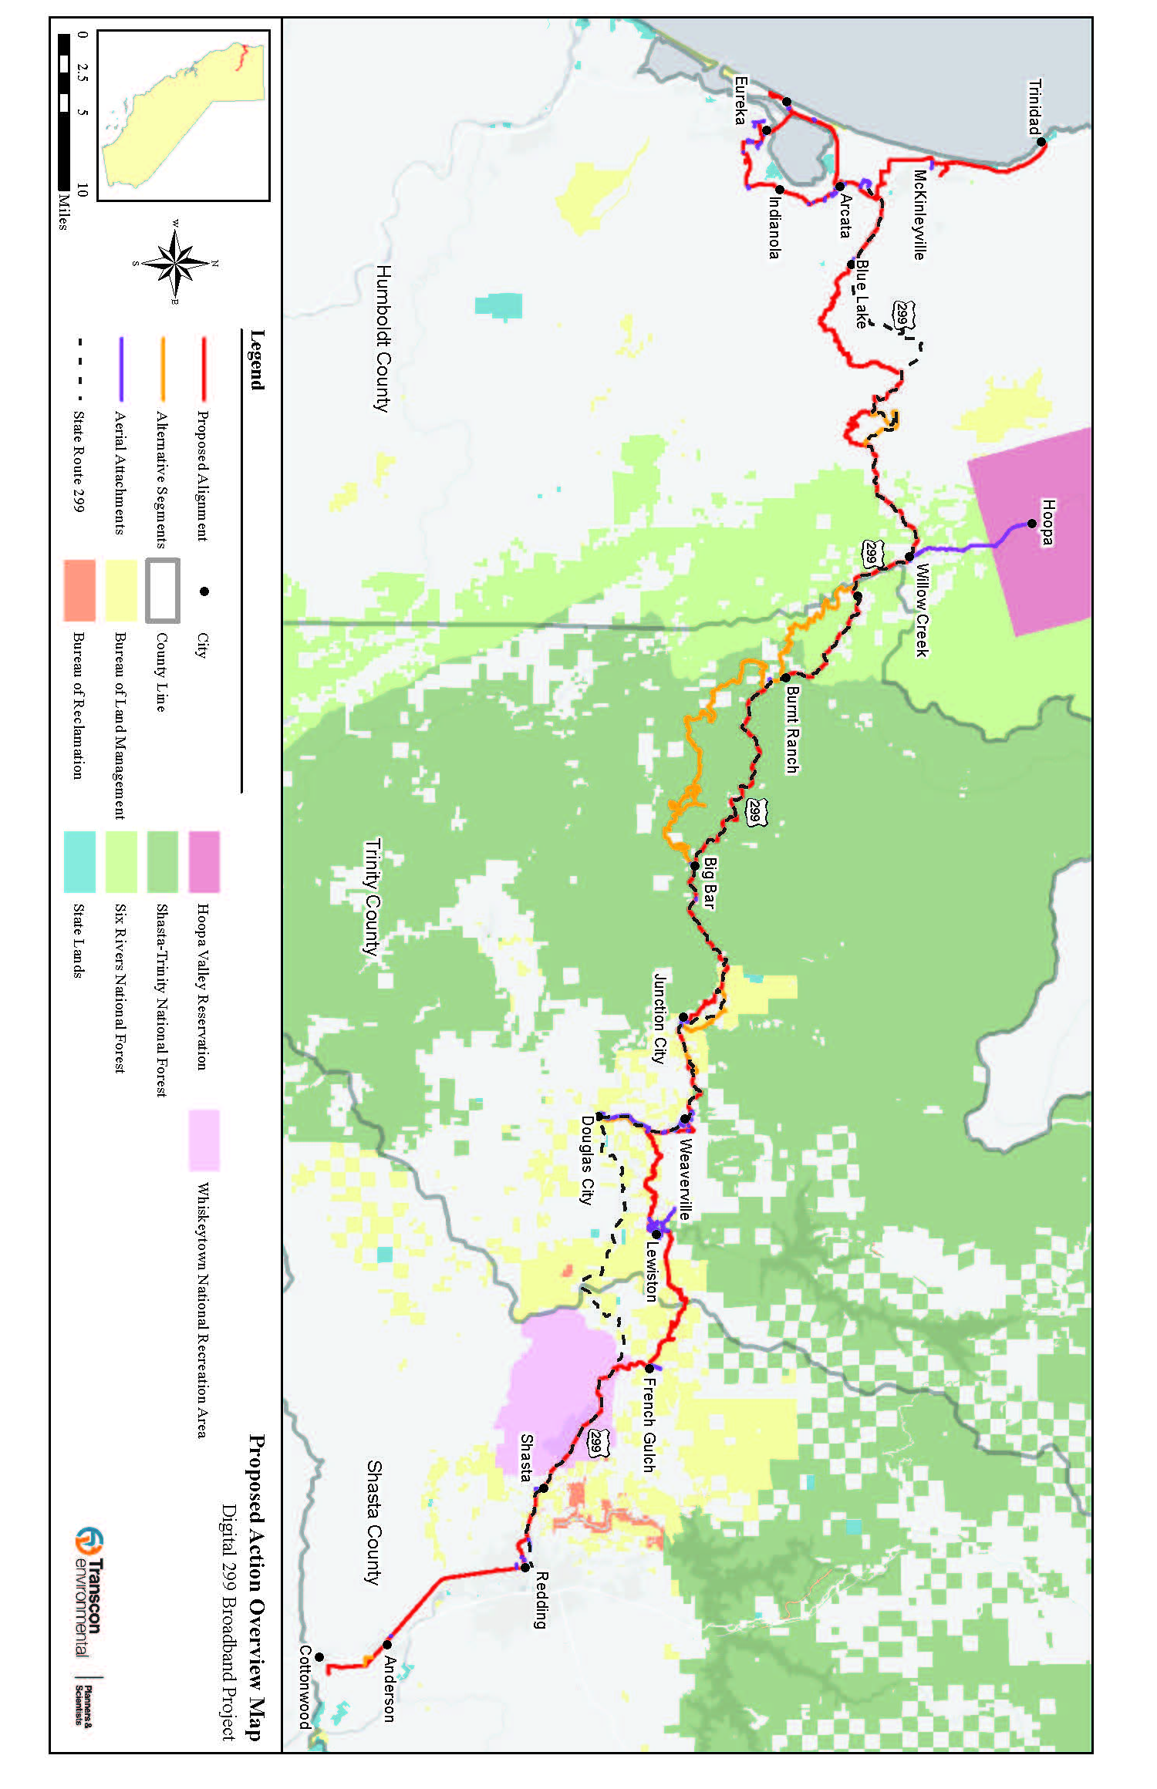
APPENDIX B

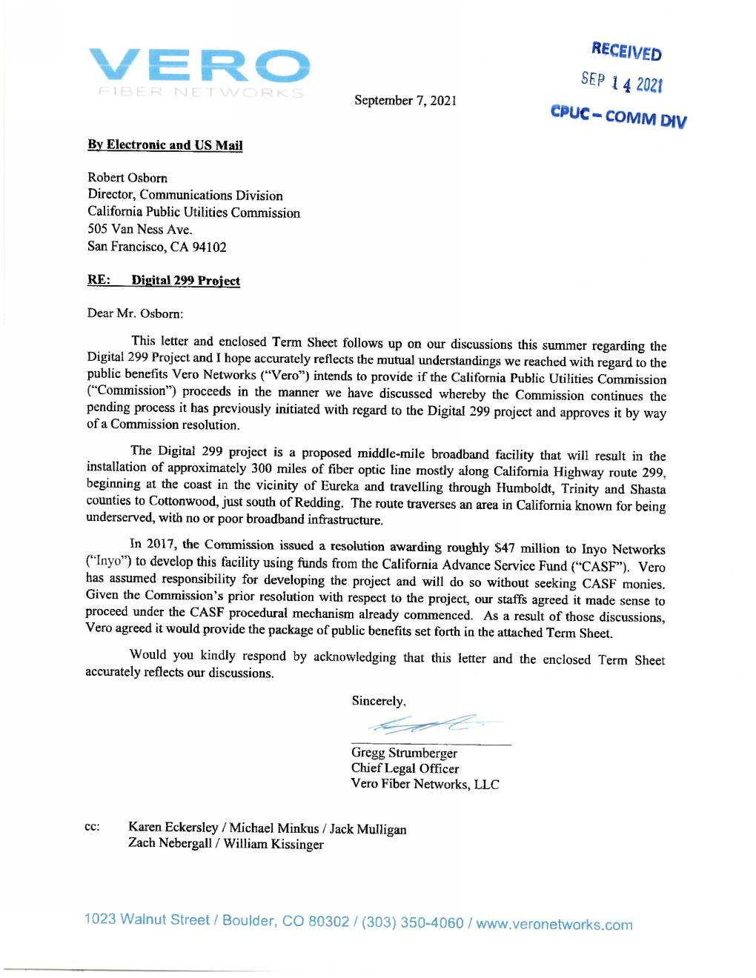
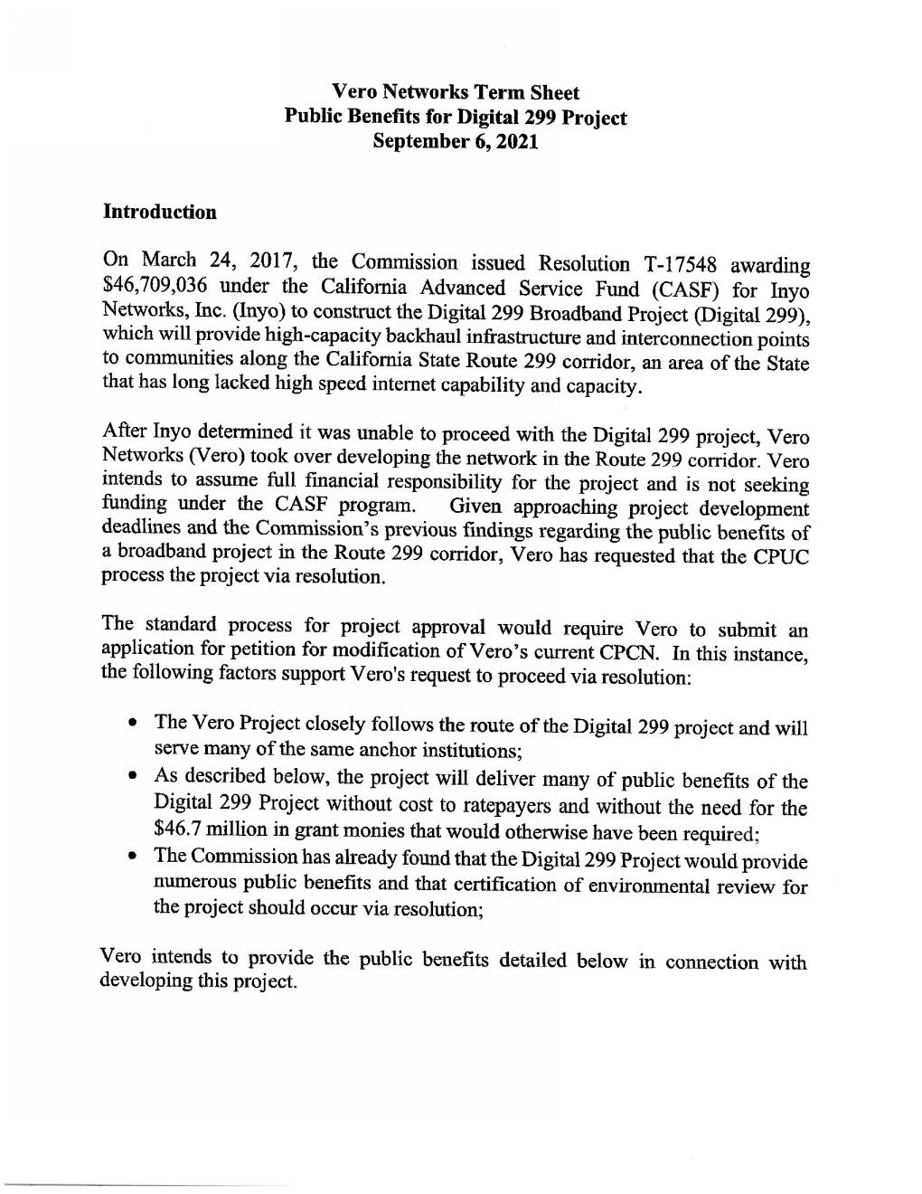
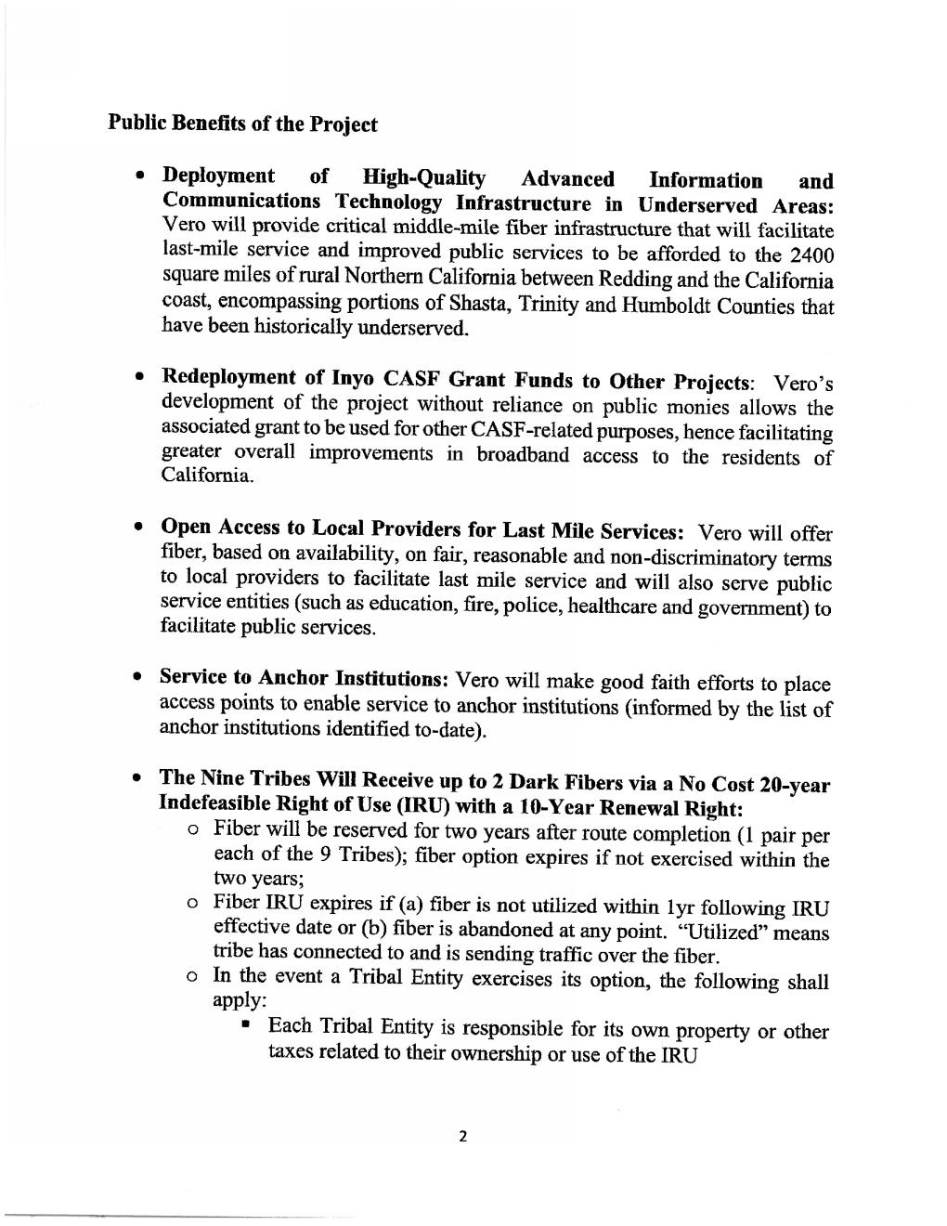

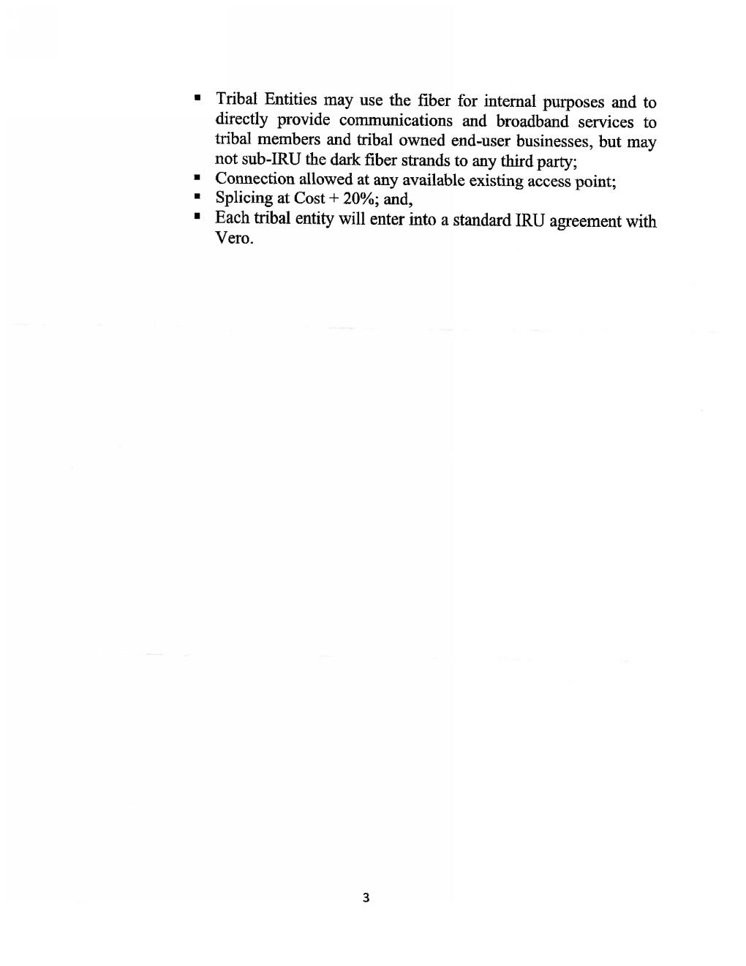

APPENDIX C

DRAFT MITIGATION MONITORING, COMPLIANCE, AND REPORTING PROGRAM
Compliance Plan—Version 2
Digital 299 Fiber Optic Broadband Project

Prepared by:
Transcon Environmental, Inc.

For:
California Public Utilities Commission

October 2022

TABLE OF CONTENTS
Acronyms and Abbreviations iii
1.0 Introduction 1
1.1 Project Overview 1
1.2 Mitigation Monitoring, Compliance, and Reporting Program 2
1.3 Construction Schedule 7
2.0 Roles and Responsibilities 8
2.1 Vero Fiber Networks Roles and Responsibilities 8
2.2 California Public Utilities Commission Roles and Responsibilities 11
2.3 Organizational Chart 11
2.4 Permitting Agencies’ Role 12
3.0 Procedures 14
3.1 Communication Protocol 14
3.2 Pre-construction Compliance Verification of California Environmental Quality Act Mitigation 16
3.3 Monitoring and Compliance Reporting during Construction 18
3.4 Noncompliance Incidents and Stop-work Orders 19
3.5 Minor Project Refinements 23
3.6 Compliance Tracking 24
4.0 Documentation and Submittal Requirements and Records Management 25
4.1 Electronic Submittals 25
4.2 On-site Documentation 25
4.3 Administrative Record 25
4.4 Public Access 25
5.0 Mitigation Monitoring Program Table 26
6.0 References 40

LIST OF TABLES
Table 1 Agency Decisions and Actions 2
Table 2 Government Agencies Involved. 5
Table 3 Plans, Reports, and Other Documentation Required for Compliance Verification 17
Table 4 Vero Specialty Monitors Required During Construction 19
Table 5 Project Impacts with Applicable APMs and Mitigation Measures 26

LIST OF FIGURES
Figure 1 Organizational Chart 11
Figure 2 General Construction Schedule. 15
Figure 3 CPUC Non-Compliance Incident Response 21

LIST OF ATTACHMENTS
Attachment A Project Contact List
Attachment B Site Inspection Form
Attachment C Noncompliance Report Form
Attachment D Minor Project Refinement Form

Acronyms and Abbreviations
ACHP Advisory Council on Historic Preservation
AMM Avoidance and Mitigation Measure
APM Applicant-proposed measure
ARPA Archaeological Resources Protection Act
BE Biological Evaluation
BLM Bureau of Land Management
BMP Best Management Practice
Caltrans California Department of Transportation
CCR California Code of Regulations
CDFW California Department of Fish and Wildlife
CEQA California Environmental Quality Act
CFR Code of Federal Regulations
CPCN Certificate of Public Convenience and Necessity
CPRC California Public Resources Code
CPUC California Public Utilities Commission
CRAT Cultural Resource Awareness Training
CRPM Cultural Resource Protection Measure
CSLC California State Lands Commission
CWA Clean Water Act
DBH Diameter at Breast Height
DOI Department of the Interior
EA/ISMND Environmental Assessment/Initial Study Mitigated Negative Declaration
ECC Environmental Compliance Coordinator
ECPM Environmental Consultant Project Manager
FCA Field Construction Advisor
FHWA Federal Highway Administration
FLPMA Federal Land Policy and Management Act
HDD Horizontal Directional Drilling
ILA In-line Amplifier
LEI Lead Environmental Inspector
LOP Limited Operating Period
MMCRP Mitigation Monitoring, Compliance, and Reporting Program
Mph Miles per Hour
NAGPRA Native American Graves Protection and Repatriation Act
NHPA National Historic Preservation Act
NMFS National Marine Fisheries Service
NPS National Park Service
NTP Notice to Proceed
PFM Petition for Modification
PM Project Manager
PMDP Paleontological Monitoring and Discovery Plan
ROW Right-of-way
SEAP Safety Environmental Awareness Program
SHPO State Historic Preservation Office
SR State Route
SRNF Six Rivers National Forest
STNF Shasta-Trinity National Forest
SUP Special Use Permit
SWRCB State Water Resources Control Board
SWPPP Stormwater Pollution Prevention Plan
TBS Trinity bristle snail
THPO Tribal Historic Preservation Officer
USACE U.S. Army Corps of Engineers
USBR Bureau of Reclamation
USFS U.S. Forest Service
USFWS U.S. Fish and Wildlife Service
WNRA Whiskeytown National Recreation Area
WSRA Wild and Scenic Rivers Act

Introduction
The Digital 299 Fiber Optic Broadband Project (Digital 299, Proposed Action, or Project) is a proposed regional telecommunications network supporting portions of Humboldt, Trinity, and Shasta counties between Cottonwood and Eureka, California, a region known for no or poor broadband infrastructure. Vero Fiber Networks (Vero, the Proponent) proposes to build a network generally following California State Route (SR) 299, with portions crossing federally managed public land, state-owned or controlled property, privately owned property, and tribal lands. The Proposed Action would help close the digital divide in the region by extending internet and mobile data coverage to underserved rural communities.

The California Public Utilities Commission (CPUC) is the Lead Agency for the Project under the California Environmental Quality Act (CEQA) due to the agency’s consideration of a decision to issue a revised Certificate of Public Convenience and Necessity (CPCN) to Vero to allow the construction, operation, and maintenance of the Project. As the lead state agency, CPUC will ensure compliance with all required mitigation measures and proponent-proposed resource avoidance measures. CPUC’s role in mitigation monitoring, compliance, and reporting will be outlined within this Mitigation Monitoring, Compliance, and Reporting Program (MMCRP).

Project Overview
The Digital 299 Project proposes to install approximately 300 miles of new conduit and fiber optic cables through portions of Humboldt, Trinity, and Shasta counties in northern California. The Project Proponent (Vero) is requesting permits and authorization for a 10-foot-wide right-of-way (ROW) through lands administered and/or regulated by the Bureau of Land Management (BLM) Redding Field Office, U.S. Forest Service (USFS) Shasta-Trinity and Six Rivers national forests, National Park Service (NPS) Whiskeytown National Recreation Area (WNRA), U.S. Army Corps of Engineers (USACE), U.S. Bureau of Reclamation (USBR), Federal Highway Administration, U.S. Fish and Wildlife Service (USFWS), National Marine Fisheries Service (NMFS), California Public Utilities Commission (CPUC), California Department of Transportation (Caltrans) districts 1 and 2, California Department of Fish and Wildlife (CDFW), California State Lands Commission (CSLC), California Coastal Commission, and California State Water Resources Control Board (SWRCB).

The ROW would provide for the long-term occupation of conduit and vaults for future maintenance access. Construction of the facilities would temporarily disturb up to a 25-foot-wide corridor. Underground vaults (maximum dimensions of approximately 4 feet by 4 feet by 4 feet) would be spaced approximately every 2,500 feet. Conduit would be installed along adjacent roads within pre-disturbed road shoulders or under the roadway if shoulders are narrow. Digital 299 would include installation of underground fiber optic cables along existing roadways (referred to as the “backbone” or “middle-mile”) during its first phase of construction.

During the second phase of construction, Vero would partner with last-mile providers to build out last-mile connections attached to existing utility poles. These last-mile connections would include direct connections to public buildings such as schools and hospitals (referred to as “Community Anchor Institutions”), customers, and local exchange carriers along the route. Wireless facilities (e.g., cellular towers or equipment) are not proposed as part of the Project. The Project also includes the construction of up to five prefabricated buildings to support signal regeneration, distribution, and interconnection (also referred to as "in-line amplifier” or “ILA” buildings). These buildings would be installed during the first phase of the Project and are all expected to be sited on private land.

Mitigation Monitoring, Compliance, and Reporting Program

Authority
Digital 299 is long and linear, requiring land use and natural resources permits from many federal, state, and local agencies. The Proposed Action’s technical studies, including the Environmental Assessment/Initial Study Mitigated Negative Declaration (EA/ISMND), are meant to support agencies’ discretionary decisions (see Table 1) and address compliance and impacts under the following acts:
- Bald and Golden Eagle Protection Act (50 Code of Federal Regulations [CFR] 22)
- California Coastal Act (14 California Code of Regulations [CCR] 13000 et seq, California Public Resources Code [CPRC] 30000 et seq)
- California Endangered Species Act (14 CCR 783 et seq)
- California Environmental Quality Act (CEQA) (14 CCR 15000 et seq, CPRC 21000 et seq)
- California Fish and Game Code (Section 1600 et seq)
- Clean Air Act (40 CFR 50 et seq)
- Clean Water Act (CWA) (40 CFR 100 et seq)
- Federal Endangered Species Act (50 CFR 17)
- Federal Land Policy and Management Act (FLPMA) Sec. 501 [43 U.S.C. 1761]
- Magnuson-Stevens Fishery Conservation and Management Act (50 CFR 600)
- Migratory Bird Treaty Act (50 CFR 21)
- National Historic Preservation Act (NHPA) (36 CFR 80)
- National Environmental Policy Act (40 CFR 1500–1508)
- Rivers and Harbors Act (33 CFR 209 et seq)
- Wild and Scenic Rivers Act (WSRA) (36 CFR 297)

TABLE 1
AGENCY DECISIONS AND ACTIONS
Regulatory Agency | Permit, Approval, or Consultation | Agency Action
Federal
U.S. Department of the Interior (DOI), BLM | Grant of ROW | Consider issuing an FLPMA ROW grant for the Project to be built and maintained across lands under BLM jurisdiction
DOI, NPS, Pacific West Region | WSRA Section 7 determination | Consider issuing a WSRA Section 7 determination for one horizontal directional drilling (HDD) crossing of the Trinity River located on private land.
DOI, NPS, WNRA | Grant of ROW and Special Use Permit (SUP) | Consider issuing a Grant of ROW for the Project to be built and maintained across lands under WNRA jurisdiction
DOI, USBR | Land Use Authorization | Consider issuing a Land Use Authorization for the installation, operation, and maintenance of an underground fiber optic line along USBR ROW
U.S. Department of Agriculture, USFS, Shasta-Trinity National Forest (STNF) | SUP | Consider issuing an SUP for the Project to be built and maintained across lands under STNF jurisdiction
USFS, Six Rivers National Forest (SRNF) | SUP | Consider issuing an SUP for the Project to be built and maintained across lands under SRNF jurisdiction
USFS, Pacific Southwest Region | WSRA Section 7 determination | Consider issuing a WSRA Section 7 determination for one HDD crossing of the Trinity River located on STNF land
U.S. Department of Defense, USACE | CWA Section 404 and Rivers and Harbors Act Section 10 Permit | Considering issuing a Section 404 Permit for temporary discharge of fill material and Section 10 Permit for structures in Waters of the U.S. as a result of Project construction
Federal Highway Administration (FHWA) | Grant of ROW | Consider issuing a Grant of ROW for crossing federal highway ROW
Bureau of Indian Affairs | Easement | Considering issuing an easement for allotment areas the Project may cross
DOI, USFWS | Federal Endangered Species Act, Section 7 Consultation | Consult with agencies on effects determination for federally-listed species
National Oceanic and Atmospheric Administration, NMFS | Federal Endangered Species Act, Section 7 Consultation | Consult with agencies on effects determination for federally-listed marine species and Essential Fish Habitat
Advisory Council on Historic Preservation (ACHP) | Invitation to participate or comment | Provide guidance to agencies on Section 106 consultation approach.
State
CPUC (lead CEQA agency) | CEQA Declaration and Revised Certificate of Public Convenience and Necessity (CPCN) | As lead CEQA agency, issue a declaration on mitigated or significance findings; consider issuing a revised CPCN to Vero to allow the construction, operation, and maintenance of the Project
Caltrans, District 1 and District 2 | Encroachment Permit | Consider issuing an encroachment permit for areas where the Project would be constructed within Caltrans ROWs
CDFW | Master Streambed and Alteration Agreement (1602 Permit) | Consider issuing a Master Streambed Alteration Agreement to allow the Project to be constructed across or beneath Waters of the State
CSLC | Lease (waters of the State) | Consider issuing a Lease to allow the Project to be constructed across or beneath waters under the jurisdiction of CSLC
California State Water Resources Control Board | CWA Section 401 Permit and Porter-Cologne Act Waste Discharge Requirements | Consider issuing a Section 401 Permit and Waste Discharge Requirements for discharges to Waters of the State as a result of Project construction
California Coastal Commission | Coastal Development Permit | Consider issuing a Coastal Development Permit for portions of the Project that intersect Coastal Zones
California State Historic Preservation Office (SHPO) | NHPA, Section 106 consultation | Respond to agencies’ cultural resources findings/determinations
California Native American Tribes | AB 52 and NHPA | Consult with agencies on the Project and potential impacts to tribal resources

Purpose
The Mitigation Monitoring, Compliance, and Reporting Program (MMCRP) includes provisions for monitoring and reporting. Monitoring refers to the ongoing or periodic process by which Project construction and operation are overseen by the Lead Agency. In the case of the Project, monitoring will ensure that Vero’s compliance with Project conditions is checked on a regular basis. Reporting, which comprises written reviews of Vero’s compliance with applicant-proposed measures (APMs) and mitigation measures presented to the decision-making body or a designated staff person, ensures that the Lead Agency is informed of Vero’s compliance with APMs and mitigation measures. The CEQA Guidelines encourage lead and responsible agencies to cooperate in mitigation monitoring and reporting, where possible.

The MMCRP was prepared consistently with the framework in the Digital 299 EA/ISMND. The MMCRP will be implemented until the final monitoring and reporting procedures identified in the following sections have been completed to the CPUC’s satisfaction.

The purpose of the MMCRP is to:
- Ensure effective implementation of the APMs and mitigation measures adopted by the CPUC
- Facilitate the monitoring, compliance, and reporting activities of the CPUC
- Establish lines of communication related to mitigation monitoring
- Provide a method of effectively documenting and reporting compliance with all APMs and mitigation measures

Therefore, this Compliance Plan:
- Lists mitigation measures and APMs and their monitoring and reporting requirements, as identified in the Final EA/ISMND
- Describes the process by which CPUC Energy Division staff will observe construction of the Project to ensure implementation of each APM and mitigation measure
- Describes the process for recording “noncompliance” (i.e., evidence that Vero is not fully implementing each applicable APM and mitigation measure)

The Compliance Plan was developed to provide guidelines and standardize procedures for environmental compliance on the Project. These procedures have been developed by the CPUC, in coordination with Vero and other responsible agencies, to help define reporting relationships, provide detailed information about the roles and responsibilities of the Project’s environmental compliance team members, define compliance reporting procedures, and establish communication protocol. Throughout the course of Project construction, the protocols, guidelines, procedures, communication lists, and schedules presented in the Compliance Plan may be revised as needed to address specific day-to-day realities of Project construction.

Implementation
Implementation of the MMCRP begins during pre-construction and continues until construction is complete and the CPUC concludes there is no further need for CPUC monitoring of the Project or the CPUC determines implementation of the MMCRP is no longer necessary. Vero Networks must perform post-construction monitoring for the Project to comply with mitigation measures and APM requirements as described in the Final EA/ISMND. Post-construction monitoring by Vero will continue until compliance with post-construction requirements (i.e., revegetation) has been met.

Program Scope

CEQA Mitigation
The Project is subject to APMs and mitigation measures in the Final EA/ISMND, which are collectively referred to as “CEQA mitigation.” These are listed in Table 5 in Section 5 of this Compliance Plan. To the extent CEQA mitigation expressly relies on, includes, or references permits or approvals from other federal, state, and local agencies, all terms and conditions of such permits or approvals are considered incorporated into the scope of the CEQA mitigation.

Other Permits and Authorizations
The primary federal, state, and local government agencies involved in the environmental review and permitting of the Project are shown below in Table 2. Coordination with additional agencies and local jurisdictions may be needed as the Project progresses.

TABLE 2
GOVERNMENT AGENCIES INVOLVED.
Agency | Permit, Approval, or Consultation
DOI, BLM | Grant of ROW will be issued as a result of the Proposed Action crossing 22.6 miles (primary main alignment only) of BLM-administered lands.
DOI, NPS, Pacific West Region | WSRA Section 7 determination
DOI, NPS, WNRA | Grant of ROW and SUP
DOI, USBR | Land Use Authorization for the installation, operation, and maintenance of an underground fiber optic line along the USBR ROW will be issued as a result of the Proposed Action crossing 2.63 miles (primary alignment only) of USBR-administered lands
USFS, STNF | A SUP will be issued as a result of the Proposed Action crossing 62.1 miles (26.03 miles of the primary alignment and 36.05 miles of alternative segments) of USFS-administered lands
USFS, SRNF | A SUP will be issued as a result of the Proposed Action crossing 14.6 miles (7.8 miles of the primary alignment and 6.8 miles of alternative segments) of USFS-administered lands.
USFS, Pacific Southwest Region | WSRA Section 7 determination
USACE | CWA Section 404 and Rivers and Harbors Act Section 10 Permit  Lead federal action agency for Section 7 consultation under the Endangered Species Act
Bureau of Indian Affairs | Easement
DOI, USFWS | Federal Endangered Species Act, Section 7 consultation
National Oceanic and Atmospheric Administration, NMFS | Federal Endangered Species Act, Section 7 consultation
ACHP | Invitation to participate or comment
State
CPUC (Lead CEQA Agency) | CEQA Declaration and Revised CPCN
Caltrans, District 1 and District 2 | Encroachment Permit
CDFW | Master Streambed and Alteration Agreement (1602 Permit)
CSLC | Lease (waters of the State)
California State Water Resources Control Board | CWA Section 401 Permit and Porter-Cologne Act Waste Discharge Requirements
California Coastal Commission | Coastal Development Permit
California SHPO | NHPA, Section 106 consultation
California Native American Tribes | AB 52 and NHPA

Construction Schedule
The total duration of construction for the Proposed Action is estimated at up to 36 months, beginning in the first quarter of 2023. Construction crews generally work 8 to 10 hours a day, 5 days a week during daylight hours. Construction pace is between 500 feet and 2 miles per day, depending on construction method, terrain, and number of crews.

Construction would be avoided during evening and nighttime hours (7:00 p.m. to 7:00 a.m.), and generally on weekends. Saturday work may be required in some areas as needed; approval from the proper agency would be obtained prior to construction on weekends. No work is anticipated to occur on major holidays or during Native American ceremonies. Digital 299 would avoid lane closures during times of inclement weather, including but not limited to rain, snow, and ice.

Phase 2 of the Project (last-mile connections) would begin construction once middle-mile fiber is installed, and as soon as last-mile providers and Vero finalize interconnection points and locations of service drops. Phase 2 construction is expected to begin in 2024. Most of the last-mile connections are expected to be attached to existing utility poles requiring no ground disturbance.

Roles and Responsibilities
Section 2.1 describes specific Vero roles and responsibilities for the Project. Section 2.2 describes the CPUC’s monitoring responsibilities for the Project, ensuring that Vero has adequately implemented mitigation measures and APMs, and ensuring that construction activities are consistent with the Final EA/ISMND.

Vero Fiber Networks Roles and Responsibilities
Vero personnel and contractors are responsible for implementing all mitigation measures, APMs, permit conditions, and the MMCRP. This includes all terms and conditions in permits or approvals from other federal, state, and local agencies. Vero must comply with Project requirements, plan construction activities in a way that meets Project requirements, document compliance activities and mitigation results, and implement the MMCRP.

Vero Fiber Networks Project Manager
Role and Responsibility. Vero’s project manager (PM) is part of Vero’s Major Projects Organization and will provide the overall direction, management, leadership, and corporate coordination for the Project. Vero’s PM is responsible for the Project construction schedule and for ensuring that the Project is completed as required by Project contract documents and conditions, including adopted APMs, mitigation measures, and agency permitting requirements. Vero’s PM will lead environmental compliance throughout the duration of construction for the Project, including direction development and implementation of pre-construction environmental planning, permitting, and compliance activities; the environmental inspection and pre-construction survey program; and the Safety Environmental Awareness Program (SEAP). The PM will be assisted by Vero’s environmental consultants and the construction manager (CM). The Vero PM is the primary compliance point of contact for Vero.

The Vero PM’s responsibilities include but are not limited to:
- Leading coordination among engineering, construction management, and environmental staff for Vero
- Leading coordination between Vero staff and regulatory agencies to ensure that all agency requirements are met
- Leading the integration of environmental responsibilities into all levels of Project construction activities
- Ensuring compliance with Project APMs and mitigation measures, as well as any other Project environmental policies, guidelines, and procedures
- Ensuring that data, including work schedule, location, and critical issue information, are provided to members of the Project construction team as needed
- Communicating Project activities, schedules, and environmental and public relations issues to the Project team as needed

Reporting Relationship. The Vero PM reports to Vero’s Major Projects Organization. The Vero PM gives direction to Vero’s construction manager (CM) and environmental compliance team.

Communication. The Vero PM communicates with the CPUC and resource agencies, all members of the Project environmental compliance team. The Vero PM also oversees all communication with Vero contractors and team members.

Vero Fiber Networks Environmental Consultant Project Manager
Role and Responsibility. Vero’s environmental consultant project manager (ECPM) is responsible for providing support to the PM for successful implementation and compliance under the MMCRP and all other applicable environmental permits. The ECPM is responsible for supporting the PM by managing the drafting of Notices to Proceed (NTPs) and minor Project refinement requests, the development of pre-construction plans and documents, supporting Vero with obtaining all required environmental permits, reviewing Vero-prepared plans to ensure compliance with MMCRP requirements, and attending construction and Project management meetings. The Vero ECPM supports the Vero PM in all management activities.

Reporting Relationship. The Vero ECPM reports to the Vero PM and supports the PM in directing the work of the Vero environmental compliance team and resource specialists.

Communication. The ECPM communicates with the Vero PM and the environmental compliance team.

Vero Fiber Networks Environmental Compliance Coordinator
Role and Responsibility. Vero’s environmental compliance coordinator (ECC) is responsible for providing support to the Vero PM for successful implementation and compliance under the MMCRP and all other applicable environmental permits. The Vero ECC is responsible for supporting the Vero PM by attending construction and Project management meetings; reviewing and submitting regular submittals during construction; reviewing and tracking compliance with Project MMCRP, permits, plans, and regulations; and reviewing daily and weekly monitoring reports during construction.

Reporting Relationship. The Vero ECC reports to the Vero PM and supports the PM in directing the work of the Vero environmental compliance team and resource specialists.

Communication. The Vero ECC communicates with Vero PM and environmental compliance team.

Vero Fiber Networks Lead Environmental Inspector
Role and Responsibility. Vero’s lead environmental inspector (LEI) is responsible for overseeing and verifying the day-to-day on-site compliance effort. The Vero LEI will work closely with construction personnel and will be the primary field employee responsible for verifying and documenting environmental compliance. Multiple Vero LEIs may be needed to effectively monitor compliance during periods of high construction activity or high monitoring demand. The Vero LEIs’ responsibilities will include:
- Supporting the Vero PM in the completion of all necessary resource surveys, supporting the Vero PM, Vero ECC, and resource specialists in implementation strategy of the biological measures in the MMCRP and all plan and permit conditions relevant to resources during the pre-construction phase of the Project
- Providing quality assurance/quality control of all deliverables
- Coordinating with Vero regarding landowner access for surveys and construction activities
- Participating in weekly or bi-monthly meetings
- Managing implementation of the SEAP in the field, including management of training logs

Reporting Relationship. The Vero LEI reports to the Vero PM.

Communication. The Vero LEI communicates with the Vero PM, ECPM, ECC, environmental compliance team, and construction team to coordinate monitoring and implement Project environmental compliance requirements.

Vero Fiber Networks Environmental Compliance Team
Vero’s environmental monitors are the primary field staff responsible for evaluating, documenting, and verifying compliance of construction activities with all applicable requirements. The environmental compliance team for Vero will be led by Vero’s ECPM under the direct supervision of the Vero PM. The ECPM will coordinate the activities of the Vero environmental compliance team, including biological, paleontological, and archaeological monitors (i.e., specialty monitors), to comply with each APM and mitigation measure. The Vero environmental compliance team will work closely with construction personnel to ensure that pre-construction surveys are completed and APMs and mitigation measures are effectively implemented. Specialty monitors will be assigned by Vero as needed and as required to protect sensitive biological, paleontological, archaeological, historic, and Native American resources.

In addition to ensuring compliance during construction, Vero is required to provide updates to the CPUC PM. These updates will be provided in a Weekly Status Report and will include construction schedules for the upcoming week. Vero will also submit a monthly Environmental Compliance Report that provides a summary of the past month’s construction activities and any applicable environmental issues.

Reporting Relationship. The Vero environmental compliance team reports to the Vero ECPM.

Communication. Vero’s environmental compliance team communicates with the LEI and ECPM regarding the status of monitoring and compliance in the field. Vero’s environmental compliance team will also interact with the CPUC PM as needed, during construction.

Vero Fiber Networks Construction Manager and Field Construction Advisors
Vero will identify a construction manager (CM) prior to the start of construction. The construction manager will be responsible for making daily construction work schedules available to on-site construction personnel and monitors and will describe the nature and extent of scheduled construction activities to ensure that adequate monitoring resources are provided. The construction manager will also ensure that construction schedules are provided to the Vero PM so they in turn are provided to the CPUC PM a as part of the Weekly Status Report. The construction manager will be supported by field construction advisors (FCAs) and may delegate responsibilities to the FCAs. The construction manager or FCAs will report spills (e.g., fuel or water) and compliance issues to the Vero environmental compliance team and PM.

Key environmental responsibilities for the construction manager and FCAs include but are not limited to:
- In conjunction with the PM, verifying that all construction workers attend the Project environmental training program prior to beginning work
- Reviewing and understanding the environmental requirements
- In conjunction with the PM, implementing environmental protection requirements and conditions during construction and maintaining compliance with Project requirements, including adopted APMs and mitigation measures, and all Project permits

California Public Utilities Commission Roles and Responsibilities

California Public Utilities Commission Project Manager
The CPUC PM has overall responsibility for determining the effectiveness of compliance with environmental requirements based on the success criteria included for each APM and mitigation measure. The CPUC PM will be notified of noncompliance situations and may be involved in the resolution of the issue(s). All requests for minor Project refinements (Section 3.5) and NTPs will be submitted to the CPUC PM for review and approval. The CPUC PM will issue NTPs for construction of each phase of the Project, as identified by Vero. The CPUC has the authority to halt any construction activity associated with the Project if an activity is determined to be a serious deviation from the approved Project or adopted APMs and mitigation measures. A stop-work order would follow the communication procedure outlined in Section 3.4.3.

Vero’s PM holds the primary responsibility for ensuring compliance with applicable mitigation measures and APMs. The CPUC PM ensures and documents compliance achievement. Compliance is documented through site inspection forms, mitigation measure and APM tracking, and weekly and monthly reports to the CPUC. The CPUC PM will be the designated point of contact for in-field agency staff regarding compliance and minor Project refinements. The CPUC PM will serve as the point of contact for noncompliance events. The CPUC PM will stay apprised of construction activities, schedule changes, and construction progress.

Organizational Chart
Figure 1 is an organizational chart that illustrates communication between CPUC and Vero personnel. The CPUC and Vero are responsible for informing others about changes in staff. Contact information is provided in Attachment A.
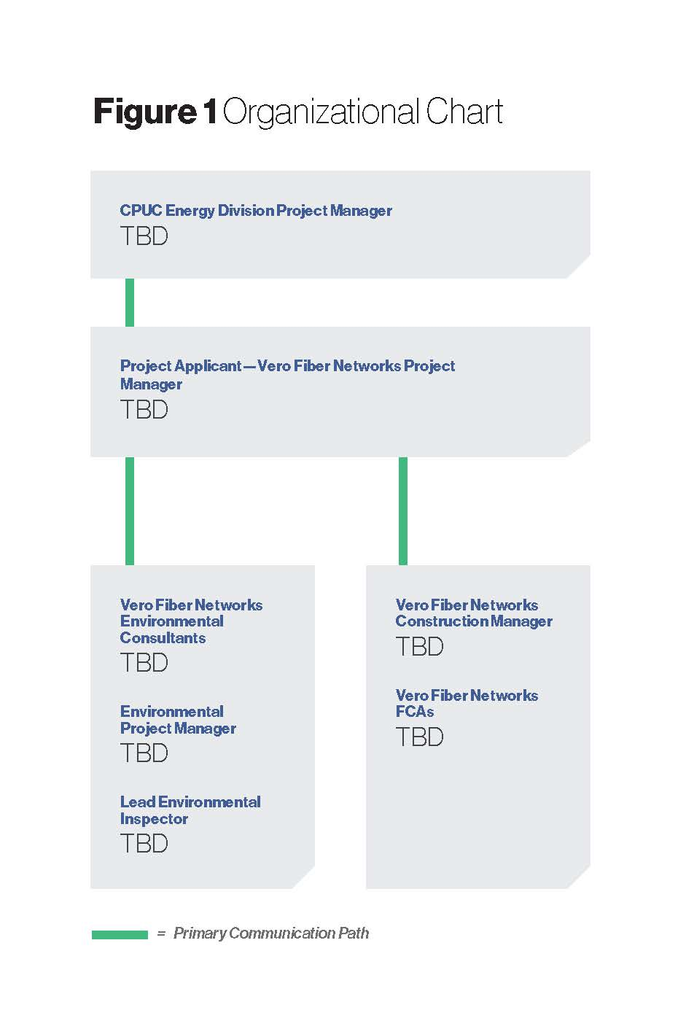

This chart depicts primary communication pathways only and does not preclude communication among various CPUC or Project Proponent field staff (e.g., project manager and construction leads/managers) and/or all environmental managers.

Permitting Agencies’ Role
Personnel from permitting agencies identified in Section 1.2 may periodically visit the Project site to verify compliance with or request information from Vero regarding compliance with laws, regulations, and Project permits. Vero is responsible for responding to requests from permitting agencies and submitting the permits and authorizations to the CPUC according to Project requirements. See Section 4 for document submission procedures.

The CPUC will typically coordinate with the Vero on permitting concerns prior to contacting permitting agencies related to the Project; however, the CPUC may contact permitting agencies at any time regarding the Project and to clarify agency requirements, permit conditions, or approvals related to the agency’s jurisdiction. The CPUC may also ask that Vero obtain input from the permitting agency or that Vero participate in discussion with the CPUC and the permitting agency. The CPUC retains the authority to coordinate directly with other agencies regarding the Project and all permit conditions or plan review comments.

Procedures
This section contains MMCRP procedures for the personnel identified in Section 2. These procedures are relevant during the implementation of the MMCRP (see Section 1.2.3) to help ensure that the Project meets all requirements specified in the APMs, mitigation measures, and agency permits.

Communication Protocol
Communication is a critical component of a successful environmental compliance program. To avoid Project delays and possible work stoppages, the CPUC PM and Vero environmental and construction representatives will interact regularly; maintain professional, responsive communication at all times; and coordinate closely to address and resolve issues in a timely manner. This section presents a communication protocol to accurately and efficiently disseminate information regarding ongoing surveys, APMs, mitigation measures, construction activities, construction contractor oversight, and planned or upcoming work prior to the commencement of construction. These communication protocols may be refined and revised for future versions of this Compliance Plan as needed to address the specific day-to-day realities of Project construction.

Pre-construction Coordination
Vero is required by the terms of the mitigation measures, its APMs, and the permitting requirements of various other regulating agencies to prepare plans and obtain approval of these documents, in addition to performing various surveys and studies prior to construction. During this pre-construction process, Vero may conduct meetings, conference calls, and site visits with the CPUC PM and other agencies and Vero’s environmental representatives, as appropriate. The purpose of the pre-construction coordination process is to discuss document submittal status, document the findings of data reviews and jurisdictional agency approvals, review Vero submittals, and document the status of mitigation measures and APMs as they apply to the Project or phased Project segment (see Section 4 for document submittal procedures). The goal of the pre-construction process is to complete all required actions so the CPUC can issue NTP authorizations.

Communication Protocol during Construction
This section outlines daily, weekly, and monthly communication protocols and processes.

Field Staff Communication During Construction
Regular communication among the CPUC PM, Vero, and construction staff can address many issues that arise during construction. All field staff will be equipped with cell phones or two-way radios (or immediate access to a cell phone or radio) and should be available to receive calls at all times during construction. Off-site staff will be available during normal business hours via email or phone. If field-based staff change regularly (e.g., if lead monitors are on duty only one or two days per week), the use of a single point of contact is highly recommended (e.g., a single cell phone should be assigned to whichever lead monitor is on duty each day) to facilitate communication continuity. Changes to key staff will be reported to the CPUC PM as soon as possible, and the Project contact list in Attachment A will be updated accordingly.

The CPUC primary point of contact in the field is the Vero LEI. The CPUC will contact the Vero LEI if an activity is observed that conflicts with one or more of the APMs, mitigation measures, or Project plans. The CPUC will also contact the Vero LEI regarding construction crew work locations; status of mitigation measures, APMs, and Project plans; and the overall construction schedule. Much of this information can be obtained through participation in tailgate meetings prior to the start of construction each day. The CPUC may discuss construction procedures directly with the construction manager, but such discussions should be limited to basic questions pertaining to clarification of daily Project activities and mitigation measure compliance. All other questions between contractors and CPUC, especially those concerning construction means and methods, should be directed to the Vero LEI. The CPUC will not provide work direction to the contractor or Vero’s environmental monitors and will avoid directing questions to the construction crews.

Progress Meetings and Communication During Construction
Conference calls may be held on a regular basis (i.e., weekly, monthly, or twice monthly) or on an as-needed basis throughout construction. The need for conference calls, whether regular or as needed, should be determined in the early stages of construction. Participants should generally include the CPUC PM, the Vero PM , and representatives from Vero who are knowledgeable about Project engineering and schedule.

Specialty monitors, technical experts, and/or construction contractors will be invited as needed. Call timing and participants may vary according to the topics discussed. Topics discussed on status update conference calls will include overall Project schedule, weekly construction schedules, pertinent environmental compliance issues, any anticipated minor Project changes, and any relevant compliance patterns and trends.

As discussed in Section 2.1.3, Vero will provide a Weekly Status Report, which will include construction schedules for the upcoming week, to the CPUC PM. The Vero PM will provide status updates to the CPUC PM.

In addition, Vero will prepare and distribute a monthly Environmental Compliance Report for distribution to key Project members, including the CPUC PM. The CPUC PM will review the reports to ensure that the status of APMs and mitigation measures is consistent with observations in the field. The report will also be a tool to keep all parties informed of construction progress and compliance trends. The monthly Environmental Compliance Report is described in Section 3.3.1.

Questions and Clarifications
Questions and the need to clarify Project requirements will periodically arise throughout the implementation process. Both Vero and the CPUC PM shall submit important questions and clarifications in writing via email (e.g., full compliance with mitigation measures, procedures, and Project changes). Email correspondence and compliance and monitoring reports should be used to document resolutions.

Construction Schedule
Vero shall keep the CPUC PM informed of delays in the construction schedule as contained in the MMCRP. In particular, Vero shall inform the CPUC of any schedule changes that may affect implementation of the MMCRP. Vero will provide a general schedule once construction has been awarded. Vero anticipates awarding the project before June 30.

Dispute Resolution
The Compliance Plan is intended to reduce or eliminate potential disputes; however, even with the best preparation, differences in mitigation implementation approaches and interpretation may occur. Issues should first be addressed informally at the field level between the CPUC and the Vero environmental compliance team. Questions then may be raised to the Vero ECPM, ECC, PM, or construction manager, as necessary.

Should the issue not be resolved at the field level the following procedure will be observed for dispute resolution:
- Step 1. Disputes and complaints (including those of the public) should be directed first to the CPUC PM for resolution. The CPUC PM will attempt to resolve the dispute. If the dispute can be resolved by Vero, then the CPUC PM will direct the party in question to Vero
- Step 2. Should this informal process fail, the CPUC PM may initiate enforcement or compliance action to address deviations from the approved Project or adopted APMs and mitigation measures
- Step 3. If a dispute or complaint regarding the implementation or evaluation of APMs or mitigation measures cannot be resolved informally or through enforcement or compliance action by the CPUC PM, any affected participant in the dispute or complaint may file a written “notice of dispute” with the CPUC executive director or their designee. This notice should be filed in order to resolve the dispute in a timely manner, with copies concurrently served on other affected participants. Within 10 days of receipt, the executive director or designee(s) shall meet or confer with the filer and other affected participants for the purposes of resolving the dispute. The executive director shall issue an Executive Resolution describing their decision and serve it on the filer and other affected participants
- Step 4. If one or more of the affected parties is not satisfied with the decision as described in the resolution, such parties may appeal it to the CPUC via a procedure to be specified by the CPUC

Parties may also seek review by the CPUC through existing procedures specified in the CPUC Rules of Practice and Procedure for formal and expedited dispute resolution, although a good faith effort should first be made to use the foregoing procedure.

Pre-construction Compliance Verification of California Environmental Quality Act Mitigation
The CPUC will verify compliance with pre-construction APMs and mitigation measures prior to construction. If required by the mitigation measure or APM, Vero must obtain approval of all necessary resource-specific plans, verify that permitting requirements of other agencies have been met, and perform all required surveys and studies before construction begins. The purpose of the pre-construction process is to complete all required actions so that the CPUC can issue NTPs for the Project.

Pre-construction Plan Review and Permit Verification
The CPUC PM will review plans and reports submitted by Vero and will provide comments and request revisions, if necessary. Other agencies may also review plans and reports prior to or concurrent with the CPUC, if required by mitigation measures, APMs, or permits, and provide comments. Vero will provide the CPUC with the other agencies’ comments on these documents to ensure that the plans and reports adequately achieve the goals, performance standards, and any other requirements of the mitigation measure(s) or APM(s). The CPUC will only issue an NTP for the Project if it is satisfied that resource-specific plans and reports comply with the goals, performance standards, and any other requirements of the applicable mitigation measure(s) or APM(s).

The CPUC may authorize construction on a phased basis.. In the event that construction authorization is issued in phases, NTPs will be issued for each phase as soon as pre-construction compliance is satisfactorily accomplished for that phase. Table 3 outlines the plans, reports, and other documentation required for compliance verification.

TABLE 3
PLANS, REPORTS, AND OTHER DOCUMENTATION REQUIRED FOR COMPLIANCE VERIFICATION
Item | Mitigation Measure or APM | Responsible Action Agency
Restoration Plan | AMM BIO-3 | CPUC, CDFW, USACE, SWRCB, USFS, NPS, BLM, USBR, FHWA, Caltrans
HDD Contingency Frac-Out Plan | AMM HYD-2 | CPUC, CDFW, USACE, SWRCB, USFS, NPS, BLM, USBR, FHWA, Caltrans
Paleontological Monitoring and Discovery Plan (PMDP) | AMM CR-9 | CPUC, CDFW, USACE, SWRCB, USFS, NPS, BLM, USBR, FHWA, Caltrans
Stormwater Pollution Prevention Plan (SWPPP) | AMM HZ-1 | CPUC, CDFW, USACE, SWRCB, USFS, NPS, BLM, USBR, FHWA, Caltrans
Fire Prevention Plan | AMM PH-1 | CPUC, CDFW, USACE, SWRCB, USFS, NPS, BLM, USBR, FHWA, Caltrans
Spill Prevention Plan, within the SWPPP | AMM HYD-1 | CPUC, CDFW, USACE, SWRCB, USFS, NPS, BLM, USBR, Caltrans
Hazardous Substance Control and Emergency Response Plan, within the SWPPP | AMM HZ-1 | CPUC, CDFW, USACE, SWRCB, USFS, NPS, BLM, USBR, FHWA, Caltrans
Erosion Control Plans, within the SWPPP | AMM BIO-7 | USFS, BLM
Paleontological Monitoring and Treatment Plan, within the PMDP | AMM CR-9 | CPUC
Key:
AMM = Avoidance Mitigation Measure
APM = Applicant-proposed measure
BLM = Bureau of Land Management
Caltrans = California Department of Transportation
CDFW = California Department of Fish and Wildlife
CPUC = California Public Utilities Commission
FHWA = Federal Highway Administration
NPS = National Park Service
USFS = U.S. Forest Service
USFWS =U.S. Fish and Wildlife Service
USACE = U.S. Army Corps of Engineers
SWCRB = State Water Resources Control Board

Notice to Proceed Process
Vero is required to obtain CPUC authorization prior to initiating construction activities through the NTP process. The NTP process involves Vero submitting an NTP request to the CPUC and the CPUC PM issuing an NTP authorization letter. The Energy Division will not authorize construction activities until all relevant pre-construction requirements are completed as appropriate for the relevant stage of the Project. Before granting an NTP, the Energy Division will confirm that the applicant has complied with all pre-construction APMs and mitigation measures, including specified surveys, and has obtained all appropriate approvals from other regulatory agencies. The CPUC PM may authorize Project activities through one or more NTPs for separate phases of the Project as determined necessary. The applicant may determine the phases based on pre-construction compliance, construction schedule, the anticipated schedule for permit approvals, and other considerations.

Each NTP may include CPUC or other agency conditions or requirements that must be satisfied prior to the start of work or during construction. Note that the CPUC may not include new conditions or requirements that are inconsistent with the Final EA/ISMND; however, the CPUC may include new conditions or requirements that are consistent with the Final EA/ISMND. Construction is defined as all construction-related activities, including site clearing; placement of signs, fences, structures, or other materials; or any mobilization activity that would move construction-related equipment and/or materials onto a site.

The NTP request must include the following, as applicable:
- Description of the work to be performed, including a brief comparison of the proposed work and the Project component as described in the Final EA/ISMND
- Description of all activities required for the Project component or components (for example, electrical, plumbing, excavation, paving, landscaping, or site restoration)
- Identification of any staging areas that would be used during construction
- Brief description of the location of the Project component or components covered in the NTP request, including maps, photographs, or other supporting data
- Estimate of area of total land disturbance and use, both temporary and permanent, associated with the NTP request
- Date of expected construction initiation and duration of work
- Anticipated number of construction workers, including total workers and peak number
- Anticipated equipment over 50 horsepower (e.g., loaders, forklifts, trucks, compressor trailers) required for construction
- Verification that all relevant pre-construction APMs and mitigation measures have been or will be completed or implemented (e.g., submittal of biological resource survey reports)
- List of all relevant APMs and mitigation measures that will be implemented
- Verification that all applicable permits or agency approvals have been or will be obtained for the work covered by the NTP request (if required)
For any pre-construction compliance items that cannot be completed prior to issuance of the NTP due to specific timing requirements for the item (e.g., pre-construction surveys that must be completed within a defined timeframe), a description of the outstanding submittals and timing for when they will be completed and approved prior to construction.

Monitoring and Compliance Reporting during Construction
As the Lead Agency under CEQA, the CPUC is required to ensure that the APMs and mitigation measures are implemented. The Energy Division has primary responsibility for ensuring full compliance with the provisions of the monitoring program.

Vero Fiber Networks Monitoring and Compliance Reports
The Vero LEI will be on-site on a daily basis to coordinate specialty environmental monitors (such as biologists and archeologists), assist construction crews with interpreting APMs and mitigation measures, and help correct compliance problems in a timely manner. Several APMs and mitigation measures require Vero to supply a specialty monitor with specific qualifications. These monitors and the related APMs and mitigation measures are identified in Table 4.

TABLE 4
VERO SPECIALTY MONITORS REQUIRED DURING CONSTRUCTION
Specialty Monitor | Related AMMs or Documents
Biological Monitor | AMM BIO-1, AMM BIO-2, AMM BIO-8, AMM BIO-13, AMM BIO-16, AMM BIO-17, AMM BIO-18, AMM BIO-19
Archaeological Monitor | Cultural Resources Monitoring and Post-Review Discovery Plan
Paleontological Monitor | Paleontological Monitoring and  Discovery Plan
Qualified SWPPP Practitioner (i.e., QSP) | SWPPP

Vero will submit a Weekly Status Report each Friday showing the anticipated construction activities for the following week. The Weekly Status Report will include the type of work activity (e.g., vegetation clearing, grading, foundation installation, structure erection), the location of the work activity, and the day(s) work is anticipated to take place. The CPUC PM will communicate with the Vero LEI to confirm daily work locations and schedule as needed in order to convey unanticipated minor schedule changes.

Vero will prepare and submit a Monthly Environmental Compliance Report to the CPUC by the 10th day of the month for the previous month’s work activities. The Monthly Environmental Compliance Report will include the following:
- Construction status update for all active work phases and a look-ahead work description and schedule for subsequent work
- Compliance summary detailing compliance activities such as notable survey efforts, noncompliance incidents and their resolutions, preparation for implementation of mitigation measures for future work phases, recently submitted or processed Project changes, a list of outstanding agency deliverables, and representative monitoring photographs. Vero is required to keep accurate and detailed accounts of noncompliance incidents (and subsequent resolutions) as identified by the CPUC or as self-reported

As discussed in Sections 3.4.5 and 3.4.4, Vero will also submit Weekly Public Complaint Logs and Noncompliance Incident Reports as detailed below.

Noncompliance Incidents and Stop-work Orders
The CPUC determines if any construction activity deviating from permit conditions, NTPs, APMs, or mitigation measures, particularly when the activity puts a sensitive resource at risk, should be considered a noncompliance incident. A noncompliance incident may include failure to fully comply with all terms and conditions in permits or approvals from other federal, state, and local agencies that are relied upon in the mitigation measures and APMs. In addition, an APM or mitigation measure not implemented according to the timing listed in the MMCRP table (Table 5 in this document) would be considered a noncompliance incident. Examples of noncompliance incident levels are provided under the subheadings below.

Noncompliance Incident Level
The CPUC uses the following levels to categorize the severity of noncompliance incidents.

Minor Compliance Incident: A minor compliance incident is an action that only slightly or partially deviates from Project requirements and does not impact, or have the potential to impact, environmental resources. Examples include the one-time use of an unapproved, pre-existing access road or failure to properly maintain an erosion or sediment control structure, but the structure remains functional. Repeated minor compliance incidents resulting from the same action or individual may result in elevating the noncompliance level.

Noncompliance Level 1: A Level 1 noncompliance incident is an action that deviates from Project requirements or results in the partial implementation of the mitigation measures but does not impact, or have the potential to impact, environmental resources. Examples include failing to properly maintain an erosion control structure, resulting in minor runoff that does not impact a sensitive resource, or work or staging of materials outside of approved work limits where the incident is within a previously disturbed area, such as a gravel lot.

Noncompliance Level 2: A Level 2 noncompliance incident is an action that deviates from Project requirements or mitigation measures that results in minor impacts, or has the potential to result in minor impacts, to environmental resources. Examples include construction activities occurring within an exclusion zone with indirect impacts to sensitive species or significant cultural or paleontological resources that can be rectified or halted before causing permanent damage. A noncompliance Level 2 may be issued when Level 1 incidents are repeated.

Noncompliance Level 3: A Level 3 noncompliance incident is an action that deviates from Project requirements and results in major impacts or has the potential to immediately result in major impacts, to environmental resources. These actions are not in compliance with the APMs, mitigation measures, permit conditions, and/or approval requirements (e.g., minor Project changes, NTPs), and/or violate local, state, or federal law. Examples include irreparable damage to archaeological sites, destruction of active bird nests, and grading of unapproved vegetated areas. A Level 3 noncompliance notice may also be issued if Level 2 incidents are repeated. Level 3 noncompliance incidents may result in a full or partial Project shutdown following a stop-work order from the CPUC PM.

California Public Utilities Commission Incident Response and Communication
The incident response communication process is described in detail below.
- If a noncompliance incident may be discovered.
  - If the issue puts sensitive resources or human health and safety at risk and a stop-work order is warranted, Vero’s LEI will contact the CPUC PM and Vero’s PM immediately, as described further below. If the noncompliance incident does not require immediate resolution, the incident will be discussed in a phone call or email to the Vero PM or on the weekly conference call
- If the incident is minor and can be easily resolved in the field by providing clarification to construction crews, if it requires immediate action to prevent an easily avoidable but serious environmental impact, or if time is needed to investigate a compliance incident further, the LEI will notify the CPUC PM, who may authorize a temporary hold.
- Once the issue is resolved, the CPUC PM will verbally authorize the lift of the hold to Vero’s PM. If the issue is not fully resolved and may require further action or management discussions, the CPUC PM may issue a stop-work order or initiate a stand-down
- If while on-site Vero environmental monitors/PMs are unaware of the issue or are aware of an issue but do not act within a reasonable time period to resolve it, the CPUC PM may record the noncompliance in their reports. Level 1 incidents are generally “issued” in the site inspection form but may also be identified by compliance monitors during review of monitoring reports. Level 2 or 3 incidents require consultation with the CPUC PM and are issued in separate formal reports to Vero
- Vero should contact the CPUC PM immediately for serious noncompliance incidents and report minor noncompliance incidents via email and possibly a phone call. The CPUC PM will send an email notification to the Vero PM to ensure tracking of the incident. The CPUC will typically not issue a noncompliance notice for a minor or Level 1 self-reported incident. Noncompliance incident reporting is described in additional detail in Section 3.4.4
- Following the initial discovery or report, the CPUC PM may request photographs, a written incident description, and other relevant information from Vero staff concerning the cause and potential resolution of the issue. The CPUC PM will direct Vero to submit the information via email or through a formal noncompliance report according to the incident severity. The CPUC PM may issue a follow-up noncompliance report from the CPUC for the same incident
- All noncompliance incidents must be described and tracked in Vero’s monthly report to the CPUC PM. For serious noncompliance incidents, the CPUC PM may issue a stop-work order as described in Section 3.4.3. Work will be suspended within the affected area until a resolution can be planned and the CPUC PM authorizes the resumption of construction activities in writing
- A stand-down may be initiated by the CPUC PM, or Vero, as described in Section 3.4.3. In this case, work will be halted temporarily to discuss a current compliance concern and/or re-align compliance activities as appropriate
- Issues that are not resolved within the length of time agreed upon by Vero and the CPUC PM will be subject to further noncompliance notices and potential stop-work orders
- Serious or emergency compliance incidents that occur on the weekend or after normal business hours (8:00 a.m. to 5:00 p.m.) will be addressed by staff identified as emergency contacts on the Project Contact List (Attachment A)
- Permitting agencies may require notification if there is an incident that relates to an agency’s jurisdiction over the Project. Vero shall be responsible for notifications to permitting agencies and shall provide copies of official notifications and submittals sent to other agencies to the CPUC. If the CPUC finds that a notification to another agency is required, the CPUC may direct Vero to notify the other agency

Construction Halts and Stop-Work Orders
Several scenarios may occur during Project construction for which the LEI may need to communicate immediately with field staff to halt construction activity (when it is safe to do so), including the following:
- A temporary hold is a short-term (i.e., less than 8 hours) cessation of construction activities. This hold would be implemented in circumstances where a minor clarification of a mitigation measure or resolution of a minor issue by the field compliance crews is necessary to ensure environmental compliance where a resource is at risk, or where a serious environmental infraction could occur without immediate intervention. CPUC would consult with the CPUC PM in the case of a temporary hold, and is authorized to end the hold with clear communication to the Vero environmental compliance lead and Vero FCA, if the monitor confirms that environmental compliance will be achieved. Depending on the issue, a temporary hold could transition to a stop-work order (below)
- In the event of a serious noncompliance or safety issue (e.g., take of a listed species; repeated, high-level noncompliance incidents concerning the same resource; or serious worker injury), the CPUC may elect to issue a stop-work order. The stop-work order would be issued in writing by the CPUC PM and may require work to stop on all or portions of the Project, or on certain construction activities, for a time period determined by the CPUC PM on a case-by-case basis. The stop-work order would also include a timeline for resolution of the situation and any potential recommendations from the CPUC. Resolution of the compliance issue would be communicated in writing by Vero to the CPUC PM, who would then issue an end to the stop-work order in writing. The applicant would be required to implement any temporary hold or stop-work order in a responsible manner to avoid hazards to public health and safety, as well as to environmental resources. Certain activities cannot be safely halted mid-course, and all work areas must be first safely secured for protection of humans and wildlife prior to complete cessation of work. Additionally, as appropriate, the applicant should address any serious safety issues by calling 9-1-1 immediately.
- Either the CPUC PM, or Vero, may initiate a construction stand-down to discuss resolution of a noncompliance or safety issue. A stand-down differs from a stop-work order in that the issue at hand would not immediately result in serious consequences, but requires an overall re-alignment of protocols or practices to ensure continued compliance or safety. The stand-down could require work to stop on all, or a portion, of the Project for up to one full day, or until a process and schedule for resolution can be determined by CPUC staff and Vero. The purpose of the stand-down would be to give Vero the opportunity to re-train construction personnel, confer with management staff to achieve resolution, and/or discuss an issue with the CPUC PM. As indicated, a stand-down can be a voluntary action by Vero and should be issued in writing (email is acceptable) with clear timelines and recommendations stated. Resolutions resulting from a stand-down should be submitted in writing to the CPUC PM. A stand-down initiated by Vero does not require approval by the CPUC to re-start work.

Noncompliance Reporting
If Vero discovers a noncompliance incident of any magnitude, they must notify the CPUC PM of the incident (self-report). Noncompliance incidents may also be discovered by the CPUC and brought to the attention of Vero. For both self-reports and discoveries, the CPUC PM may request an email or a formal noncompliance incident report (Attachment C) from Vero, either of which must include a description of the incident and corrective actions taken or proposed. Upon receipt of the noncompliance incident email or formal report, the CPUC PM will determine next steps for reporting and follow-up to reestablish compliance. The CPUC PM will assign the incident a noncompliance level and issue a noncompliance report to Vero. Vero must track all noncompliance incidents and document the incidents and implementation of corrective actions in their monthly reports (see Section 3.3.1 for reporting procedures).

Public Complaints
Mitigation Measure NV-5 includes specific requirements for receiving and handling noise complaints from the public. Vero shall document and report all other complaints to CPUC.

Vero shall provide weekly summaries of public complaints, including how each complaint was addressed, within the Weekly Status Report. The CPUC PM will coordinate with Vero’s PM, who will work with Vero to determine the adequacy of corrective actions or additional measures to be implemented, as necessary.

Public complaints will not reflect negatively on Vero’s environmental compliance record unless a specific Project requirement, permit, or plan requirement was violated.

California Environmental Quality Act Citation Program
Resolution E-4550 (May 9, 2013) created the CEQA Citation Program that authorizes CPUC staff to fine public utilities for noncompliance with CPCNs. The program allows CPUC staff to draft and issue citations and levy fines for noncompliance with a CPCN. CPUC staff will determine whether a fine is appropriate for noncompliance events consistent with Resolution E-4550. Examples of noncompliant activities that may result in fines being issued by CPUC staff include but are not limited to the following:
- Continuing construction after an authorized staff person has required construction to stop
- Starting construction components that have not been approved through an NTP (see Section 3.2.2)
- Violating nest buffer zones;
- Encroachment into an exclusion zone or sensitive resource area designated for avoidance
- Grading, foundation, line work, or other ground disturbance without required biological pre-construction surveys or a biological monitor on site
- Use of new access roads, overland travel routes, staging areas, or extra workspaces that have not been approved
- Failure to properly maintain an erosion or sediment control structure
- Working outside of approved work hours
- Project personnel working without training

Minor Project Refinements
This section describes the CPUC process for approving minor Project refinements. Minor Project refinements would be strictly limited to changes that do not trigger additional permit requirements, do not increase the severity of an impact or create a new significant impact, and are within the geographic scope of the EA/ISMND. The CPUC PM would evaluate any proposed changes from the approved Project to determine whether they are consistent with approved CEQA requirements. If the CPUC determined the changes to be consistent with approved CEQA requirements, a requested change would be processed as a minor Project refinement using the Minor Project Refinement Form (Attachment D). If a Project change would create or have the potential to create a new significant impact, increase the severity of an impact, or occur outside the geographic area evaluated in the EA/ISMND, the applicant would be required to submit a Petition for Modification (PFM). The CPUC would evaluate the PFM under CEQA, as appropriate, to determine what form of supplemental environmental review would be required.

Requests for CPUC PM approval of a minor Project refinement must be made in writing and include the following:
- A detailed description of each proposed change, including an explanation of why the change is necessary
- Identification of the APMs, mitigation measures, Project parameters, or other Project stipulations for which the change is being requested, and citations for any associated approved documents
- Photographs, maps, and other supporting documentation illustrating the difference between the existing conditions in the Project area, the approved Project, and the proposed change
- The potential impacts of the proposed change, including a discussion of each environmental issue area that could be affected by the changes, with accompanying verification that there would be no increase in the severity of identified significant impacts on resources affected by the Project and no new significant impacts after application of previously adopted APM(s) and/or mitigation measure(s)
- Whether the change would conflict with any APMs or mitigation measures
- Whether the change would conflict with any applicable guideline, ordinance, code, rule, regulation, order, decision, statute, or policy
- The date of expected construction at the area of proposed change

The CPUC PM may request additional information, agency consultations, or a site visit in order to process the request.

Examples of minor Project refinements that may be approved by the CPUC PM through submittal of a Minor Project Refinement Form include but are not limited to the following:
- Adding a temporary extra work area. The additional work area must be located in a previously disturbed area with no sensitive resources or sensitive land uses adjacent to the proposed area and must not create any new significant impacts or a substantial increase in the severity of a previously identified significant impact
- Adjusting the alignment of a Project component within the study area that was defined in the original environmental analysis to avoid sensitive resources or effects on homeowners, or adapt to conditions on the ground that vary from the conditions that existed at the time of the original environmental analysis, as long as the adjustment does not create a new significant impact or a substantial increase in the severity of a previously identified significant impact
- Finalizing the engineering design for a Project component that was not specifically described in the Final EA/ISMND or that requires adjustments in order to facilitate construction. The finalized design must not create a new significant impact or a substantial increase in the severity of a previously identified significant impact

Compliance Tracking
The CPUC will track compliance with mitigation requirements. The CPUC will also track important Project procedures (e.g., formal request and approvals) and incidents throughout the Project. The CPUC will track other information as part of the CPUC-authored Monthly Monitoring Summary Report, including NTP and minor Project refinement requests and approvals, resolutions to compliance risks, and documented incidents.

Documentation and Submittal Requirements and Records Management

Electronic Submittals
All required documentation from Vero, including plans, permits, reports, and staff qualifications as required by APMs and mitigation measures, will be maintained by Vero on a SharePoint site with access to these documents provided to the CPUC. In addition, Vero shall provide the CPUC with electronic records (i.e., emails, permits, and authorizations) related to final agency approvals for the Project if the CPUC is not directly involved with the coordination effort, pursuant to Public Utilities Code section 314, Vero must also provide the CPUC with copies of permit amendments and modifications in addition to notifying the CPUC of proposed permit changes. The electronic records may be submitted by email or transmitted via Vero SharePoint site.

On-site Documentation
In addition, copies of the MMCRP and all applicable plans and permits compiled prior to and during construction (e.g., SWPPP, Noise Control Plan, etc.) shall be kept on-site (Vero’s construction trailer), and all supervisory staff working on the Project should be familiar with their contents.

Administrative Record
The CPUC PM will compile all required documentation submitted by Vero into the Project’s Administrative Record during construction and will confirm that the record is complete after completion of all activities required by the adopted APMs and mitigation measures. The CPUC PM will also use this documentation to create a final environmental compliance report or presentation that will discuss APM and mitigation measure implementation and success, with the goal of identifying lessons learned that can be applied to future Projects.

Public Access
Through the CPUC’s public website for the Project, members of the public may request copies of non-confidential records and reports used to track the monitoring program, and the CPUC PM will send copies of publicly available records and reports to members of the public as requested. Certain mitigation monitoring related documents will be made available on the Project website: https://ia.cpuc.ca.gov/environment/info/transcon/.

Mitigation Monitoring Program Table
Table 5 summarizes Project impacts that the Final EA/ISMND determined to be significant or less than significant with mitigation incorporated and identifies associated APMs and mitigation measures required to reduce the impact. Table 5 presents the full list of APMs and mitigation measures and incorporates all changes to the Project, APMs, and mitigation measures, including those that were made as a result of public review of the Draft EA/ISMND (dated January 2022) and the Final EA/ISMND (published May 2022).

A copy of the APMs and mitigation measures should be kept with each crew working on the Project, and all supervisory staff working on the Project should be familiar with its contents.

TABLE 5
PROJECT IMPACTS WITH APPLICABLE APMS AND MITIGATION MEASURES
Applicability | APM or Mitigation Measure
Aesthetics/Visual Resources
VR-1: During siting of ILA buildings | VR-1. ILA Building Siting. ILA buildings will not be located in areas of sensitive resources, including visual resources. Buildings will be placed within a cohesive viewshed comprised of like facilities and development.
VR-2: Applicability: During ILA building design | VR-2. ILA Building Light. ILA buildings will be designed to utilize the minimum necessary outdoor lighting for safety and operations
Air Quality
AQ-1: Project-wide, for the duration of construction | AQ-1. Fugitive Dust Control Measures. The applicant shall implement the following dust-control measures during Project construction:  - Water all exposed surfaces two times per day unless already wet from precipitation. Exposed surfaces include but are not limited to spoils piles, graded areas, unpaved parking areas, staging areas, and access roads  - Cover or maintain at least 2 feet of free-board space on haul trucks transporting soil, sand, or other loose material off-site. Any haul trucks that travel along freeways or major roadways should be covered  - Limit vehicle speeds on unpaved roads to 15 miles per hour (mph).
AQ-2: Project-wide, for the duration of construction | AQ-2. Minimize Idling. Minimize idling time either by shutting equipment off when not in use or reducing the time of idling to 5 minutes, as required by CCR, Title 13, Sections 2449(d)(3) and 2485.
AQ-3: Project-wide, for the duration of construction | AQ-3. Equipment Maintenance. Maintain all construction equipment in proper working condition according to manufacturer specifications. The equipment must be checked by a certified mechanic and determined to be running in proper condition before its first operation at a Project site as well as routinely checked thereafter.
AQ-4: During ILA building construction | AQ-4. ILA Building Construction. Air-quality-related resource protection measures listed in this appendix will be followed during construction of ILA buildings.
Biological Resources
BIO-1: Project-wide, where and when a monitor is needed | AMM BIO-1. Biological Monitoring Requirements. The applicant shall designate one or more Project biologists. Project biologist refers to the qualified person assigned to ensure Project-wide biological measures identified in this document are followed and to document compliance with these measures. The Project biologist will also oversee other biologists and/or biological monitors. Biological monitor refers to a qualified person assigned to ensure biological measures are being implemented during construction activities.  Project biologist(s) or biological monitor(s) shall be on-site as needed according to AMMs. Project biologists and biological monitors shall be familiar with sensitive species and resources and the minimization measures for this proposed Project. The Project biologist(s) shall be responsible for overseeing and training biological monitors; advising the applicant and contractor on compliance with biological measures; notifying the applicant of noncompliance with biological resources conditions; responding directly to inquiries of the lead agencies or resource agencies regarding biological resource issues; maintaining records of tasks related to compliance and reporting for biological resource measures; preparing monthly, annual, and final compliance reports; establishing and enforcing speed limits at Project work areas; and maintaining the ability for regular, direct communication with representatives of the CDFW, USFWS, BLM, USFS, and NPS, including notifying these agencies of dead or injured special-status species and reporting special-status species observations.  Daily logs—When on-site, the Project biologist(s) and/or biological monitor(s) shall maintain electronic records of daily activities, observations, and communications with the applicant or construction personnel. These records shall be made available for review to the lead agencies at any time during or following Project implementation.  Stop Work Authority—The Project biologist(s) and biological monitor(s) shall have written authority to require a halt to activities in any area when determined that there would be an unauthorized adverse impact to biological resources if the activities continued.
BIO-2: Project-wide | AMM BIO-2. Environmental Awareness Training. Key personnel (e.g., crew leads, foremen) will complete an environmental awareness training on the protected species in and around the Project route and on required environmental protection measures. Training shall explain the need for and implementation of minimization measures. The training shall include supporting written material and electronic media, including photographs of protected species; providing information regarding the locations and types of sensitive biological resources within the Project alignment and adjacent areas, as well as explaining the reasons for protecting these resources; informing participants that no snakes, other reptiles, bats, or any other wildlife shall be harmed or harassed, with special emphasis on special-status species; and information on physical characteristics, distribution, behavior, ecology, sensitivity to human activities, legal protection, penalties for violations, reporting requirements, and protection measures; identifying the Project biologist(s) and biological monitor(s) for contact or further comments and questions about the material discussed in the program; educating crews on noxious plants known to occur near the Project alignment; directing trainees to report all observations of listed species and their sign to the Project biologist for inclusion in the compliance reports; a discussion of the Project biologists' and biological monitors' stop-work authority; and a training acknowledgment form to be signed by each worker indicating that they received training and shall abide by the guidelines.
BIO-3: Project-wide | AMM BIO-3. Restoration Plan. During final Project design, a Restoration Plan will be developed that provides detailed plans for the restoration of temporarily disturbed waterways and vegetated areas. The plan will outline restoration and conservation activities, locations, monitoring requirements, and criteria to measure mitigation success. Restoration shall include seeding with locally sourced native species, erosion control measures, non-native plant control, and site monitoring of the restoration of temporarily disturbed waterways and vegetated areas, including riparian habitat, if impacted. This plan shall also be submitted to and approved by the USACE, USFWS, NPS, and CDFW prior to initiating any mitigation activities.
BIO-4: Project-wide where waterways exist | AMM BIO-4. Intermittent Waterways and Ephemeral Drainages. No trenching will occur in intermittent waterways or ephemeral drainages where water is present in these features. Following trenching, intermittent waterways and ephemeral drainages will be restored to their original condition and contours per the guidelines outlined in the Restoration Plan.
BIO-5: Project-wide where wetlands exist | AMM BIO-5. Wetlands. Prior to construction, a qualified biologist will flag the boundaries of wetland resources delineated in the Preliminary Jurisdictional Delineation Report (Appendix F of the EA). Project infrastructure will be designed to avoid these resources, including coastal willow thickets. Where willow thickets and wetlands have been identified, construction of the alignment via the HDD method is required. During construction, crews will stage construction outside of the flagged areas. Manholes, handholes, and boring pits will be placed outside the flagged areas, at least 50 feet from wetland boundaries.
BIO-6: Project-wide where riparian areas exist | AMM BIO-6. Riparian Areas. Prior to construction, a qualified biologist will flag the boundaries of riparian resources delineated in the Preliminary Jurisdictional Delineation Report (Transcon 2021). Project infrastructure will be designed to avoid these resources to the greatest extent practicable. During construction, crews will limit construction activities to the extent practicable. Equipment staging and placement of manholes, handholes, and boring pits will all occur outside of flagged riparian resources. If construction activities fill or disturb riparian areas, then Vero will do the following:  - Obtain and comply with all necessary USACE, SWRCB, CDFW, and California Coastal Commission permits  - Impacted wetlands and/or riparian areas will be restored to pre-construction condition and monitored during and after disturbance. Restoration of temporarily impacted wetlands and riparian areas will be addressed in the Restoration Plan (AMM BIO-3)
BIO-7: USFS and BLM lands only: Suitable habitat along all segments (will be mapped for construction crews) | AMM BIO-7. Riparian Reserves (USFS and BLM lands only). The following AMMs pertain to riparian reserves (defined as 320 feet either side of the channel or the outer edge of the 100-year floodplain or from the edge of the active channel to the top of the inner gorge, whichever is greater) areas on USFS and BLM lands:  - No equipment or vehicles will be permitted to operate where soils are saturated or within the wetted perimeter within the riparian reserves unless staged on existing roads and turnout areas in adherence to all best management practices (BMPs) pertaining to containment and prevention of hazardous spills from reaching water bodies (e.g., absorbent pads, drip pans, and containment trays). Servicing of equipment will occur at existing staging areas located more than 25 feet from springs and wet areas. Drainage of existing staging areas will be directed and dispersed so that rainfall flows away from streams and prevents direct delivery  - The use of existing staging areas located outside the riparian reserve buffer may require surface shaping and drainage structures if needed to direct and disperse flow away from riparian reserves and prevent direct delivery to water bodies. All heavy equipment operations require approved erosion control plans when working outside of the normal operating season  - Splice boxes and barrel vaults will be designed, constructed, and operated outside riparian reserves to eliminate adverse effects that retard or prevent attainment of objectives from the Aquatic Conservation Strategy
BIO-8: Suitable habitat (will be mapped for construction crews). (Biology ID: AMM BIO-7) | AMM BIO-8. Special-Status Plants. Clearance surveys for special-status plant species will occur prior to construction in appropriate habitat during appropriate seasons when special-status plants are present and identifiable (typically in spring and summer). In areas affected by recent wildfire, surveys will be particularly thorough where occurrences of sensitive plants are mapped, due to the elevated potential for dormant plant populations to reappear following burns. If planned construction activities may result in an impact to special-status plant species, the following measures will be taken: 1) a minor re-route of the alignment would be made to avoid the plant(s) and a suitable buffer area to prevent root damage or other incidental damage or 2) in areas that cannot be avoided by a minor re-route, the Project biologist will contact the appropriate agency to discuss the potential for salvaging the affected plants. A biological monitor shall be responsible for designating an appropriate buffer area or bore depth to minimize potential adverse impacts to the plants and their roots. If re-alignment shall occur on BLM-, USFS-, or WNRA-managed lands, the agency botanist must be contacted prior to work.
BIO-9: Project wide | AMM BIO-9. Invasive Species Prevention. Contractor vehicles, equipment, tools, boots, and clothing will be cleaned inside and out prior to mobilization of Project segments on federal lands or the Caltrans ROW to limit the introduction on non-native species and pathogens (e.g., Port Orford cedar root fungus) on the Project corridor, including in areas potentially affected by recent wildfire.  The additional measures below will be applied on federal lands at the following locations:  - Segment 7 between Berry Summit and the mouth of Willow Creek  - Segment 8 between Mayfair Street and Brannan Mountain Road  - Segments 11 and 12 between South Fork and Henessey Roads  - Segments 14, 15, 15A, and 16 between Underwood Mountain and Corral Bottom Roads  - Segments 14A and 17 between Underwood Mountain and East Fork Roads  - Segment 18A1 between Valdor and Canyon Creek Roads  - Segment 18 between East Fork Road and Highway 299  - Segment 21 between Little Browns and Browns Mountain Roads  - Segments 22, 23, and 24 between Deadwood and Trinity Mountain Roads  - Segment 25 on SR 299 through WNRA  Exterior cleaning will consist of washing vehicles and equipment at an off-site location, with attention paid to the tracks, feet, and/or tires and on the undercarriage and with special emphasis on axles, frame, cross members, motor mounts, and on and underneath steps, running boards, and front bumper/brush guard assemblies. Vehicle cabs will be swept out, and refuse will be disposed of in waste receptacles to be disposed of at an approved off-site location. Hand tools and boots will be washed and clothing laundered. The contractor will inspect vehicles, equipment, tools, boots, and clothing to ensure that they are free of soil and debris capable of transporting non-native vegetation seeds, roots, or rhizomes. Seeds and plant parts that result from the cleaning will be collected and bagged for disposal at an approved off-site location. If noxious or invasive weeds are within the Construction Corridor, vehicles will be cleaned before moving on to areas that are weed-free or any location affected by wildfire.  Contractors will avoid or minimize all types of off-road travel that may result in the collection and dispersion of non-native vegetation by construction vehicles and equipment.  Activity boundaries, including equipment staging and parking areas, shall avoid known noxious plant infestation. If unavoidable, prior to implementation of operations where invasive plants are present, invasive plant infestations shall be bladed away from equipment and access routes before operations start. Removed invasive plants or shrubs should be located on the edge of the clearing out of the way of operations to avoid retrieval on equipment. Equipment/machinery shall be cleaned prior to leaving the infested area to operate in another non-contiguous area. Activity boundaries shall avoid areas recently burned by wildfire to the extent possible.  Prior to construction occurring at staging areas and where ground-disturbing activities will take place on USFS and NPS lands, a botanist will consult invasive plant spatial data (i.e., Natural Resource Information System, California Invasive Plant Council/Calfora invasive plant layers, and available federal agency data), survey for invasive plants, document invasive species present, and prescribe site-specific measures.  Rock, sand, or any material used for soil erosion control shall originate from a certified weed-free source if available. Rock source shall be inspected by staff trained in invasive plant identification. Permittee shall provide documentation that material is weed free. (see https://www.cal-ipc.org/solutions/prevention/  weedfreeforage/ and https://www.cal-ipc.org/solutions/prevention/weed  freegravel/ for more information about weed-free erosion control and aggregate sources).
BIO-10: Suitable habitat (will be mapped for construction crews) | AMM BIO-10. Marbled Murrelet. The following measures will be observed between March 24 and August 5 per the USFWS Transmittal of Guidance: Estimating the Effects of Auditory and Visual Disturbance to Northern Spotted Owls and Marbled Murrelets in Northwestern California (USFWS 2006):  - At work areas adjacent to SR 299 (which has high ambient noise levels):  - Within 500 feet of suitable marbled murrelet habitat (see the Biological Evaluation [BE] and Appendix I of the EA), no work activities will take place that generate sound levels 20 or more decibels above ambient sound levels OR that generate maximum sound levels (ambient sound level plus activity-generated sound level) above 90 decibels (excluding vehicle back-up alarms)  - The limited operating period (LOP) may be lifted at a particular segment if a field survey determines that suitable marbled murrelet habitat is not present within 0.25 mile of it  - At work areas NOT adjacent to SR 299:  - Within 0.25 mile of suitable marbled murrelet nesting\roosting habitat (see the BE and Appendix I of the EA), no work activities will take place that generate sound levels 20 or more decibels above ambient sound levels OR that generate maximum sound levels (ambient sound level plus activity-generated sound level) above 90 decibels (excluding vehicle back-up alarms)  - The LOP may be lifted at a particular segment if a field survey determines that suitable marbled murrelet habitat is not present within 0.25 mile of it
BIO-11: Suitable habitat (will be mapped for construction crews) | AMM BIO-11. Northern Spotted Owl. The following measures will be observed between February 1 and July 9 per the USFWS Transmittal of Guidance: Estimating the Effects of Auditory and Visual Disturbance to Northern Spotted Owls and Marbled Murrelets in Northwestern California (USFWS 2006):  - At work areas adjacent to SR 299 (which has high ambient noise levels):  - Within 500 feet of suitable northern spotted owl nesting\ roosting habitat (see the BE and Appendix I of the EA), no work activities will take place that generate sound levels 20 or more decibels above ambient sound levels OR that generate maximum sound levels (ambient sound level plus activity-generated sound level) above 90 decibels (excluding vehicle back-up alarms)  - If suitable nesting habitat is present, the LOP may be lifted if disturbance-only USFWS protocol-level surveys are conducted and determine that no northern spotted owl is nesting within 500 feet  - This LOP may be lifted at a particular segment if a field survey determines that suitable northern spotted owl habitat is not present within 500 feet of it  - If an active nest is identified within 500 feet of work, the LOP will be extended through September 15  - At work areas NOT adjacent to SR 299:  - Within 0.25 mile of suitable northern spotted owl nesting\ roosting habitat (see the BE and Appendix I of the EA), no work activities will take place that generate sound levels 20 or more decibels above ambient sound levels OR that generate maximum sound levels (ambient sound level plus activity-generated sound level) above 90 decibels (excluding vehicle back-up alarms)  - If suitable nesting habitat is present, the LOP may be lifted if disturbance-only USFWS protocol-level surveys are conducted and determine that no northern spotted owl is nesting within 0.25 mile  - This LOP may be lifted at a particular segment if a field survey determines that suitable northern spotted owl habitat is not present within 0.25 mile of it  - If an active nest is identified within 500 feet of work, the LOP will be extended through September 15
BIO-12: Suitable habitat (will be mapped for construction crews) | AMM BIO-12. Northern Spotted Owl. At each discrete location in which vegetation is removed, removal is limited to 6-inch-diameter at breast height (DBH) trees and an area less than 0.1 acre in size.
BIO-13: Project-wide, including aerial attachments and last mile segments | AMM BIO-13. Nesting Birds. To avoid and minimize adverse effects to nesting birds, the following measures shall be implemented:  - If work will occur during the nesting bird season (February 15 until August 31 OR January 1 until August 31 where there is potential for nesting eagles), nesting bird surveys will be conducted with standard nest-locating techniques within 7 days prior to the onset of construction by a Project biologist or biological monitor familiar with the species that may nest in the Action Area. Surveys will occur to a distance of 100 feet (for passerines) or 300 feet (for raptors) from the proposed work, access routes, and staging areas. In areas within 0.5 mile of suitable bald or golden eagle nesting habitat, nesting season begins January 1 and surveys will be performed within 2,640 feet of work. If an active nest is encountered in or adjacent to a work area, a no equipment/no activity buffer will be implemented around the nest (the size of which will be determined by the Project biologist and shall depend on the species’ tolerance to human activity, location of the nest relative to the work area, any vegetation or other materials that may screen the nest from noise and view of work, the nature of the work, and other pertinent information), OR the active nest will be continuously monitored by a Project biologist or biological monitor for disturbance. If the monitoring biologist determines nesting may fail as a result of work activities, all work shall cease (except access along existing roadways) within the recommended avoidance area until the biologist determines the adults and young are no longer reliant on the nest site. If an active nest of a listed bird is found, a 500-foot buffer will be established around the nest. If construction activities are delayed or suspended for more than one week after the completion of the nesting surveys, surveys will be performed again  - If active nests are identified on bridges or associated structures by a Project biologist or biological monitor during the nesting season (February 15 to August 31), work will not occur unless a biological monitor is present to monitor for disturbance  - If work will occur on Segment 8 between January 1 and August 31, crews will contact SRNF Biologist Bryan Yost 2 weeks prior to the start of work to get updated nesting information for bald eagle
BIO-14: Suitable habitat (will be mapped for construction crews) | AMM BIO-14. Aquatic Resources / Fisheries. To avoid and minimize adverse effects to federally-listed and special-status fish and wildlife, the following measures shall be implemented:  - Avoid disruption of natural hydrologic flow paths, including diversion of streamflow and interception of surface and subsurface flow  - Conduct operations at water source developments in such a manner and timing as to avoid and minimize adverse effects to aquatic species and habitat from sedimentation  - No trenching or plowing activities are proposed to occur within perennial aquatic habitats. Perennial waterways will be crossed via one of three methods: 1) conduit attachment to existing bridge, 2) trenching to place conduit above a deep culvert, or 3) HDD  - For all trenching or plowing in intermittent and ephemeral streams, ground disturbance and sidecasting (i.e., the controlled depositing of excavated material) will be done in a manner that will minimize potential for off-site sediment input into stream channels. In addition, these waterways will be restored and maintained in accordance with the SWPPP, Restoration Plan, and any applicable agency permit requirements, which aim to minimize any loose material from entering and remove any loose material that does enter dry channels  - On USFS lands, coordinate with USFS fisheries biologists to restrict ground disturbance and sidecasting of excavated material to minimize potential for off-site sediment input into stream channels. Work within ephemeral and intermittent aquatic habitat or delineated wetlands will be coordinated with USFS fisheries biologists  - Within the Caltrans ROW, a contractor-supplied biologist will coordinate with a Caltrans biologist to restrict ground disturbance and sidecasting of excavated material to minimize potential for off-site sediment input into stream channels. Work within ephemeral and intermittent aquatic habitat or delineated wetlands will be coordinated with the Caltrans biologists  - To avoid potential impacts to Upper Klamath/Trinity spring-run Chinook salmon, work will only occur during an LOP from November through April at all intermittent and perennial waterway crossings within the range of this population. This LOP applies to HDD work, not aerial or bridge crossings, and will be in effect at the following locations:  - Primary alignment: Segments 7, 9, 11A, 13, 14A, 17, 18, 19, 20, 21, 22  - Alternative segments: Segments 11, 14, 15, 15A, 15Alt, 16, 18A1, 18A2  - From May through October, HDD may cross intermittent waterways only if no water is present in the channel within 100 feet of the crossing, as the lack of aquatic habitat will ensure that Upper Klamath/Trinity spring-run Chinook salmon will not be present and not susceptible to disturbance. A biologist will survey the crossing within 48 hours prior to work to verify the channel is dry. Perennial waterways are anticipated to hold water year-round and may only be crossed during the November-April LOP
BIO-15: Suitable habitat (will be mapped for construction crews) | AMM BIO-15. Special-Status Amphibians. When ground-disturbing work is occurring within 25 to 50 feet of waterways that have water present and that are suitable habitat for special-status amphibians, a qualified biologist will conduct a pre-disturbance survey for special-status amphibians (adults, subadults, tadpoles, or egg masses). The survey area will include suitable habitat within 50 feet of perennial and intermittent waterways, within 25 feet of ephemeral drainages, and at least 50 feet upstream and downstream of the work area. The biologist will conduct surveys for special-status amphibians prior to the start of ground-disturbing activities. If no special-status amphibians are detected, work may resume for 3 to 5 days before new surveys need to be conducted.  If a special-status amphibian is confirmed to be present, then a qualified biologist will move the individual to a suitable off-site location within the same waterway.
BIO-16: All bridges and suitable habitat (will be mapped for construction crews). | AMM BIO-16. Special-Status Bats. To avoid and minimize adverse effects to bats, the following measures shall be implemented:  - When work will occur during bat maternity (April 1 to September 15) or hibernation (November 1 to February 28) seasons, suitable habitat (mines, caves, tunnels, buildings, other manmade structures, and trees with a DBH of 45 inches or larger) within 100 feet of work areas will be a surveyed by a qualified biologist for suitable roost locations and signs of roosting bat colonies. If suitable roost locations, roosting bat colonies, or sign are detected within 100 feet of a work area, the Project biologist will contact the CDFW (or relevant agency) to determine the best course of action. Surveys must occur a minimum of 7 days prior to construction  - Prior to initiating conduit installation on any bridge, the Project biologist will conduct pre-disturbance bat roost surveys at the bridge site. If roosting bats may be present, then the Project biologist shall identify the species and contact the CDFW to determine the best course of action. Where bridges may serve as maternity roosts, Project construction will be delayed until conclusion of the maternity season
BIO-17: Suitable habitat (will be mapped for construction crews) | AMM BIO-17. Special-Status Mammals. To avoid and minimize adverse effects to mammals, the following measures shall be implemented:  - If work is being conducted in suitable denning habitat during the denning mammal natal season (February 1 to July 15), the Project biologist or biological monitor will conduct pre-disturbance denning mammal surveys at den sites within the Construction Corridor in addition to a 50-foot buffer area. If any potentially active dens are detected, a no-work buffer will be established within 150 feet of the potential den until the Project biologist determines that the den is not active or that denning season is over  - If a special-status denning mammal species is detected or directly observed within 150 feet of a construction area, the biological monitor will be notified immediately. Any work that may result in direct disturbance to the animal will be temporarily halted until the mammal leaves. If it does not leave on its own, the biological monitor would contact the appropriate agency to determine the best course of action  - Work within 0.25 mile of a known fisher den or unsurveyed dens will not occur between the fisher denning season (February 1 to July 15) unless surveys determine the site to be unoccupied.  - Prior to the commencement of work in suitable habitat, the Project biologist will coordinate with the CDFW to obtain up-to-date information regarding wolf activity
BIO-18: Only within 100 feet of perennial waters (year-round) or within 100 feet of all waterways during the rainy season. Within range on USFS land only (will be mapped for construction crews) | AMM BIO-18. Big Bar Hesperian. Pre-disturbance surveys for Big Bar hesperian will be performed at work areas in riparian habitat at elevations below 3,000 feet. With USFS approval, the Project biologist may deem surveys unnecessary if work will only occur in dry areas on the upper two-thirds of a slope away from moist riparian vegetation. If the species is found during surveys, the Project biologist will contact the STNF biologist to determine the best course of action.
BIO-19: Only within 100 feet of perennial waters (year-round) or within 100 feet of all waterways during the rainy season. Within range on USFS land only (will be mapped for construction crews) | AMM BIO-19. Blue-gray taildropper. Pre-disturbance surveys for blue-gray taildropper will be performed at work areas in suitable habitat. Surveys will be conducted in accordance with the Mollusk Survey Protocol described in Duncan et al. 2003. With USFS approval, the Project biologist may deem surveys unnecessary if work will only occur in dry areas on the upper two-thirds of a slope away from moist riparian vegetation. If the species is found during surveys, the Project biologist will contact the appropriate agency biologist to determine the best course of action.
BIO-20: Suitable habitat (will be mapped for construction crews) | AMM BIO-20. Trinity bristle snail. To avoid and minimize adverse effects to the Trinity bristle snail (TBS), the following measures shall be implemented:  - Work will be conducted during an LOP of June 16 through the start of the rainy season, when TBS will not be present. The end date of the LOP (i.e., the start of the rainy season) will be October 15 unless weather conditions prior to that date result in >0.5 inch of rain within a 3-day period. Operations shall not commence for 3 days following the cessation of rain or until the duff on top of the soil is thoroughly dry (< 10 percent moisture content) and the topsoil below the duff is thoroughly dry (<10 percent soil moisture) in the upper 3 inches of topsoil  - Within portions of the alignment with suitable habitat (see Section 4.9 of the BE for a description) for TBS:  - All entry and exit vault locations and staging areas (“work locations”) will be located in habitat considered not suitable for TBS (e.g., unvegetated, gravel, or paved areas)  - For associated foot traffic (e.g., pedestrian monitoring of the HDD alignment for frac-outs) that must occur in vegetated work areas in suitable habitat, a qualified biologist will conduct a pre-construction survey to flag areas that are suitable habitat for TBS for avoidance  - All HDD at water crossings within 25 feet of suitable TBS habitat will be at a minimum depth of 15 feet below the bed of the stream  - In the event of frac-out during HDD construction, a qualified biologist will identify access routes located outside of TBS habitat for the contractor/designated biologist to access the spill site. The biologist will have authority to stop work and designate activity-free buffers if there are potential impacts to TBS. Recovery activities will avoid impacting these areas and the CDFW will be contacted  - In the event of an equipment failure or the boring drill breaks subsurface during HDD, the equipment will be backed out of the pilot hole to minimize ground disturbance. No additional excavations may occur to retrieve equipment within a bore. If retrieval of drill components via this method is not possible, equipment shall be left within the bore and agencies that have jurisdiction at that location shall be notified
Cultural and Tribal Resources
CR-1: Project-wide, duration of Project | CR-1. Cultural Resources Awareness Training. Prior to ground- and non-ground-disturbing construction activities, all construction crew personnel will complete Cultural Resource Awareness Training (CRAT). The CRAT will educate the construction crew and personnel about Environmentally Sensitive Areas, measures, BMPs, Cultural Resource Protection Measures (CRPMs), Inadvertent Discovery Protocols, types of resources to be aware of in the field (e.g., prehistoric, historic, human remains), and how to flag unanticipated discoveries. Additionally, the construction crew(s) will be educated on the federal and state regulations that provide for protection of cultural and tribal resources, such as the Archaeological Resources Protection Act (ARPA), as well as the penalties that result from violations. Similar CRAT will be provided to the cultural resources team of professionals responsible for the protection and preservation of cultural and tribal resources. This will ensure successful execution of the Project in compliance with Section 106 of the NHPA and CEQA. Implementation of the BMPs, CRPMs, Inadvertent Discovery Protocols, and CRAT will be overseen by the principal investigator and cultural lead. The CRAT must be repeated annually and as needed for new construction personnel and cultural resources personnel. All participants must sign an agreement stating they have completed the training.
CR-2: Project-wide, duration of Project | CR-2. Guiding Principles—CRPMs, BMPs, and IDP for Cultural and Tribal Resources. The guiding principles cultural resource protection are an amalgamation of the guidance documents provided by each federal and state agency, to include:  - State Protocol Agreement Among the California State Director of the BLM and the California SHPO and the Nevada SHPO regarding the Manner in Which the BLM Will Meet its Responsibilities under the NHPA and the National Programmatic Agreement among the BLM, the ACHP, and the National Conference of SHPOs  - Nationwide Programmatic Agreement among the NPS, the ACHP, and the National Conference of SHPOs for Compliance with Section 106 of the NHPA  - Native American Graves Protection and Repatriation Act (NAGPRA) of 1990  - USBR Protocol for NAGPRA Inadvertent Discoveries on Federal Land, California-Great Basin Region  - Manual 8100-The Foundations for Managing Cultural Resources  - Manual 8110-Identifying and Evaluating Cultural Resources  - Manual 8140-Protecting Cultural Resources  - Manual 8150-Permitting Uses of Cultural Resources  - Memorandum of Understanding Between Caltrans and the California SHPO Regarding Compliance with Public Resources Code Section 5024 and Governor’s Executive Order W-26-92  - Standard Environmental Reference-Volume 2, Chapter 2
CR-3: Project-wide, duration of Project | CR-3. Cultural Resource and Environmentally Sensitive Area Avoidance and Management. Vero shall implement the CRPMs with respect to known cultural resources and Environmentally Sensitive Areas, as described in the Cultural Resources Inventory Report (Loftus et al. 2021).
CR-4: Project-wide, duration of Project | CR-4. Best Management Practices. Prior to deviation for existing proposed construction method and cable placement location outside of the studied area of potential effects, Vero shall notify the appropriate jurisdictional authority to consult regarding the potential effects from the revised cable placement location to historical resources and historic properties.
CR-5: Project-wide, duration of Project | CR-5. Best Management Practices. Vero shall avoid cultural resources, eligible or unevaluated for the National Register of Historic Places/California Register of Historic Resources.
CR-6: Project-wide, duration of Project | CR-6. Inadvertent Discovery Protocol. Should inadvertent discovery of cultural resources occur, Vero shall halt all ground-disturbing construction activity and flag the discovery for avoidance by 200 feet as an Environmentally Sensitive Area, and a qualified archaeologist will be contacted for implementation of CRPMs, Treatment Plans, and potential mitigation measures in coordination with the jurisdictional agency and/or tribal authority.
CR-7: Project-wide, duration of Project | CR-7. Inadvertent Discovery Protocol. In the event that historic properties are inadvertently encountered, the vicinity of discovery will be flagged for avoidance from construction activities within 200 feet. Vero will be responsible for notifying the appropriate jurisdictional authority, and the agency shall notify the SHPO/Tribal Historic Preservation Officer (THPO) and federally recognized Indian Tribe(s) within 48 hours, or as soon as reasonably possible. The agency, in consultation with the SHPO/THPO, Indian Tribe(s), and Vero, will make reasonable efforts to avoid, minimize, or mitigate adverse effects on those historic properties. If human remains or other cultural material that may fall under the provisions of NAGPRA are present, the agency will comply with NAGPRA and ARPA. The agency will ensure that any human remains are left in situ, are not exposed, and remain protected while compliance with NAGPRA, ARPA, or other applicable federal, state, and/or local laws and procedures is undertaken. The protection measures will be determined in consultation with the appropriate land-managing agency, Tribe, and SHPO/THPO but would likely include temporary exclusionary fencing to preclude unauthorized construction in the vicinity of the discovery and capping the remains with a protective layer of clean fill.
CR-8: During ILA building siting | CR-8. ILA Building Location. ILA buildings will not be sited in areas of known sensitive cultural or tribal resources. Resource protection measures listed in this appendix will be followed during construction of ILA buildings.
CR-9: Project-wide, duration of Project | CR-9. Inadvertent Discovery Protocol—Paleontological Resources. The Project shall adhere to the requirements of the PMDP. The PMDP includes a series of steps to be implemented in phases: 1) before the commencement of construction-related earthwork, 2) during construction-related earthwork, and 3) after the completion of construction-related earthwork in the event that fossils either are, or are not, discovered and salvaged.
Hazards/Hazardous Materials
HZ-1: SWPPP and spill prevention plan will be employed Project-wide | HZ-1. Spill Prevention. Vero and the construction contractor will develop the following plans prior to construction:  - Spill Prevention Plan to minimize potential for accidental spill or pollutant discharge  - Hazardous Substance Control and Emergency Response Plan to provide protocol for managing hazardous substances during construction (e.g., refueling) and for responding to potential emergencies encountered in the field related to hazardous material
HZ-2: During ILA building construction | HZ-2. ILA Building Construction. The SWPPP and spill prevention plan will be followed during construction of ILA buildings.
Hydrology and Water Quality
HYD-1: During ILA building construction | HYD-1. Spill Prevention. A Spill Prevention Plan will be developed and implemented during construction. The plan will contain spill prevention measures such as operation of equipment near water bodies, refueling operations, inspection of construction equipment for leaks, specific response procedures in the event of a spill, etc.
HYD-2: During ILA building construction | HYD-2. HDD Contingency Frac-Out Plan. An HDD Contingency Frac-Out Plan will be developed and implemented during construction. The Plan will designate procedures, responsibilities, and reporting in the event of a drilling fluid release.
HYD-3: During ILA building construction | HYD-3. HDD Inspection. During HDD drilling, visual inspection along the bore path of the alignment shall take place at all times—i.e., a crew member should be watching closely for potential issues such as a spill or frac-out. At stream crossings with flowing water, the stream shall be monitored upstream and downstream of the crossing.
HYD-4: During ILA building construction | HYD-4. Restoration. A Restoration Plan will be developed and implemented during construction, as described under BIO-3. The Plan will detail restoration of temporarily disturbed natural areas, including stream banks disturbed by construction. Pre-construction surveys will document conditions prior to construction. Exposed or disturbed areas, including channels and stream banks, shall be returned to pre-existing contours and conditions. Native seed mixes will be applied to disturbed areas and subsequent monitoring of sites requiring restoration will occur.
HYD-5: During ILA building construction | HYD-5. Erosion BMPs. Runoff control structures, roadside diversion ditches, erosion-control structures, and energy dissipaters will be cleaned, maintained, repaired, and replaced to meet the standards set by applicable permits and the SWPPP.
Noise
NOI-1: Project-wide, for the duration of construction | NOI-1. Equipment Noise Abatement Maintenance. Ensure that all construction equipment has the manufacturers’ recommended noise abatement measures, such as mufflers and engine enclosures, and is intact, in good condition, and operational.
NOI-2: Project-wide, for the duration of construction | NOI-2. Equipment Idling. Turn off idling equipment that is not imminently needed.
NOI-3: Project-wide, for the duration of construction | NOI-3. Construction Timing. Avoid construction during evening and nighttime hours (7:00 p.m. to 7:00 a.m.) and on weekends.
NOI-4: During ILA building construction | NOI-4. ILA Building Construction. Noise-related Resource Protection Measures listed in this appendix will be followed during construction of ILA buildings.
Public Health and Safety
PH-1: Project-wide, for the duration of construction | PH-1. Fire Prevention. Vero and the construction contractor shall develop and implement a Fire Prevention Plan, which will include a training program for all personnel about the measures to take in the event of a fire, including fire dangers, locations of extinguishers and equipment, emergency response, and individual responsibilities for fire prevention and suppression.
PH-2: Project-wide, for the duration of construction | PH-2. Fire Prevention. All motor vehicles used during construction will carry specified fire prevention equipment, including shovels, water, and fire extinguishers.
PH-3: During ILA building construction | PH-3. ILA Building Construction. The Fire Prevention Plan will be implemented during construction of ILA buildings.
PH-4: During construction in areas underlain by ultramafic rock | PH-4. Naturally Occurring Asbestos. In work areas where soils are underlain by ultramafic rock (see Section 3.2.4.1 of the EA), construction crews will implement the following AMMs to minimize the spread of dust and thereby minimize worker and public exposure to naturally occurring asbestos:  - Construction vehicle speed within the work site will be limited to 15 mph or less  - Construction crews will install temporary wind barriers around the work site and/or limit excavation to periods of calm or low winds  - Construction crews will use water to moisten excavation sites prior to ground disturbance and will keep those areas continually moist to minimize the spread of dust  - Storage piles of excavated soil or rock will be wetted, treated with a chemical dust suppressant, or covered when not in use in order to minimize dust
PH-5: During ILA building construction and throughout ongoing operations and maintenance | PH-5. ILA Building Generators. ILA buildings will be equipped with generators to provide back-up energy for system regeneration in the event of a power outages. ILA buildings will be sited, designed, and maintained free from vegetation and brush that could spark fires from generator use. After power outage or other major weather events, Vero will inspect ILA buildings for safety or equipment issues.
Recreation
RC-1: During and after construction along Hammond Trail | RC-1. Hammond Trail. If construction encroaches onto the pathway of Hammond Trail, the trail will be restored to previous conditions.
RC-2: Prior to and during construction along Hammond Trail | RC-2. Hammond Trail. Appropriate signage will be used to alert recreation users of any closures limiting the use of Hammond Trail.
RC-3: During ILA building siting | RC-3. ILA Buildings. ILA buildings will not be sited within the viewshed of designated recreation use areas.

References
Duncan, Nancy, Tom Burke, Steve Dowlan, and Paul Hohenlohe. 2003. Survey Protocol for Survey and Manage Terrestrial Mollusk Species from the Northwest Forest Plan. Version 3.0. On file with the Bureau of Land Management, and U.S. Forest Service.

Loftus, Shannon, Everett Bassett, Victoria Harvey, Kelly Larsen, Bronwynn Loyd, Jessica Neal, Danial Parker, Lucian Schrader III, Tad Schwennesen, Peter von Der Porten, Zackary Starke, and Erica Thompson. 2021. Digital 299 Fiber Optic Broadband Project Cultural Resources Inventory Report. Prepared for Vero Fiber Networks. Prepared for the Bureau of Land Management Arcata Field Office and Redding Field Office; U.S. Forest Service, Shasta-Trinity National Forest and Six Rivers National Forest; National Park Service, Whiskeytown National Recreation Area; California Public Utilities Commission; Little River State Park; California Department of Transportation, District 1 and District 2;

Transcon Environmental, Inc. (Transcon). 2021. Digital 299 Fiber Optic Broadband Project Preliminary Jurisdictional Delineation Report. Prepared for Vero Fiber Networks. On file with the U.S. Army Corps of Engineers.

Transcon Environmental, Inc. (Transcon). 2022. Digital 299 Fiber Optic Broadband Project Environmental Assessment/Initial Study Mitigated Negative Declaration. Prepared for the Bureau of Land Management, Bureau of Reclamation, Federal Highway Administration, National Park Service, U.S. Army Corps of Engineers, and U.S. Forest Service.

U.S. Fish and Wildlife Service (USFWS). 2006. Transmittal of Guidance: Estimating the Effects of Auditory and Visual Disturbance to Northern Spotted Owls and Marbled Murrelets in Northwestern California. U.S. Fish and Wildlife Service, Arcata Fish and Wildlife Office, Arcata, California.

ATTACHMENT A
PROJECT CONTACT LIST

TABLE A-1
PROJECT CONTACTS
Name | Position | Email | Phone (Work) | Phone (Mobile)
First/Emergency Contacts:
Vero Fiber Networks Consultant:
Karen Collins | Project Manager | kcollins@veronetworks.com | 630-660-5506
Marty Wilcox | Construction Manager | mwilcox@veronetworks.com | 951-453-7310
Jerry Robbins | Consultant Environmental Project Manager | jrobbins@transcon.com | 916-827-6918
Jessica Alden | Consultant Environmental Compliance Coordinator | jalden@transcon.com | 732-456-1930
TBD | Lead Environmental Inspector
California Public Utilities Commission Environmental Team
Michael Rosauer | Project Manager | Michael.rosauer@cpuc.ca.gov | 415-703-2579 | 415 -601-5008
Other Contacts:

ATTACHMENT B
SITE INSPECTION FORM

DIGITAL 299 PROJECT
CPUC SITE INSPECTION FORM

Project: | Digital 299 | Date:
Project Proponent: | Vero Fiber Networks | Report #:
Lead Agency: |  | Monitor(s):
CPUC PM: |  | AM/PM Weather:
Project NTP(s):

SITE INSPECTION CHECKLIST | Yes | No | N/A
WEAP Training
Has WEAP training been completed by all new hires (construction and monitors)?
Erosion and Dust Control (Air and Water Quality)
Have temporary erosion and sediment control measures been installed?
Are erosion and sediment control measures properly installed and functioning?
Is mud tracked onto paved public roadways cleaned up in accordance with the Project’s SWPPP?
Is dust control being implemented (i.e., access roads watered, haul trucks covered, streets cleaned on a regular basis)?
Are work areas being effectively watered prior to excavation or grading?
Is excessive fugitive dust leaving the work area?
Equipment
Are all vehicles observed maintaining a speed limit of 15 mph on unpaved roads?
Are all vehicles/equipment observed arriving on-site clean of sediment or plant debris?
Are vehicles/equipment turned off when not in use?
Work Areas
Is exclusionary fencing or flagging in place to protect sensitive biological or cultural resources?
Are vehicles, equipment, and construction personnel staying within approved work areas and on approved roads?
Are all excavations and trenches covered at the end of the day?
Are ramps installed at 100-foot intervals with ramps not exceeding 2:1 slopes?
Biology
Have pre-construction surveys been completed for biological resources as appropriate?
Are biological monitors present on-site?
Are appropriate measures in place to protect sensitive habitat and/or drainages (i.e., flagging, signage, exclusion fencing, biological monitor, appropriate buffer distance enacted)?
Have wildlife been relocated from work areas?
Have impacts occurred to adjacent habitat (sensitive or non-sensitive)?
Were any threatened or endangered species observed? If yes, list observations below:
Are there wetlands or water bodies present near construction activities?
Have there been any work stoppages for biological resources?
Cultural and Paleontological Resources
Are identified cultural/paleo resources that will not be relocated/salvaged clearly marked for exclusion?
Are archaeological and paleontological monitors on-site if needed?
Are appropriate buffers maintained around sensitive resources (e.g., cultural sites)?
Have there been any work stoppages for cultural/paleo resources?
Hazardous Materials
Are hazardous materials stored appropriately?
Are procedures in place to prevent spills and accidental releases?
Are appropriate fire prevention and control measures in place?
Is contaminated soil properly handled or disposed of, if applicable?
Work Hours and Noise
Are night lighting reduction measures in place, as needed?
Is construction occurring within approved hours?
Are noise control measures in place within 100 feet of sensitive receptors as needed?

PROJECT FACLITIES AND FEATURES MONITORED
DESCRIPTION OF OBSERVED ACTIVITIES (i.e., mitigation measures of particular focus or concern, construction activity, any discussions with first-party monitors or construction crews)
MITIGATION MEASURES VERIFIED (Refer to MMCRP, e.g., MM BIO-5. Report only on MMs pertinent to your observations today)
RECOMMENDED FOLLOW-UP (i.e., items to check on next visit, minor issues to resolve)
COMPLIANCE SUGGESTIONS OR ADDITIONAL OBSERVATIONS (i.e., suggestions to improve compliance on- site, environmental observations of note)

COMPLIANCE SUMMARY
Check all applicable boxes below to indicate new conditions or issues that have occurred since your last visit. Note this information on the monitoring datasheet and document with photographs.

☐ New biological or cultural discovery requiring compliance with mitigation measures, permit conditions, etc.

☐ Potential compliance incident(s) observed. Document incident(s) and potential for environmental resources to be impacted.

☐ New noncompliance issues reported by Vero monitors since your last visit. Describe issues and resolution under “compliance suggestions or additional observations” (above) and include Vero report identification number.

PREVIOUS NONCOMPLIANCE ITEMS REQUIRING FOLLOW-UP OR RESOLVED TODAY:

REPRESENTATIVE SITE PHOTOGRAPHS
Date | Location | Photo | Description

REPRESENTATIVE SITE PHOTOGRAPHS
Date | Location | Photo | Description

REPRESENTATIVE SITE PHOTOGRAPHS
Date | Location | Photo | Description

REPRESENTATIVE SITE PHOTOGRAPHS
Date | Location | Photo | Description

Completed by:
Firm:
Date:

Reviewed by:
Firm:
Date:

ATTACHMENT C
NONCOMPLIANCE REPORT FORM

DIGITAL 299 PROJECT
CONSTRUCTION NONCOMPLIANCE REPORT

Incident Date: |  | Report No.:
Date Submitted: |  | Location:
Level: |  | Relevant Plan/Measure:
Current Land Use: |  | Sensitive Resources:

Description of Incident:
Pertinent Plans/Permits/Mitigation Measures:
Proposed Resolution:
Recommended timeline for follow-up:

Approvals | Date | Name (print) | Signature | Comments
CPUC Project Manager
(if applicable)
Vero Project Manager (if applicable)

Prepared by: |  | Date:

Noncompliance Level | Example
A Level 1 noncompliance incident is an action that deviates from Project requirements or results in the partial implementation of the mitigation measures but has not caused, nor has the potential to cause, impacts on environmental resources. | - Failure to implement adequate dust control measures, resulting in no impact on resources  - Improperly installed, repaired, or maintained erosion or sediment control devices (with no resultant harm to sensitive resources or release of sediment to waters)  - Inadvertent minor incursion into exclusion area, resulting in no harm to sensitive biological or cultural resources  - Work outside the approved work limits where the incident is within a previously disturbed area, such as a gravel lot
A Level 2 noncompliance incident is an action that deviates from Project requirements or mitigation measures and has caused, or has the potential to cause, minor impacts on environmental resources. | - Work without appropriate permit(s) or approval  - Failure to properly maintain an erosion or sediment control structure, but the structure remains functional, and results in minor impacts on resources (e.g., water courses)  - Working outside of approved hours  - Repeated documentation of Level 1 incidents
A Level 3 noncompliance incident is an action that deviates from Project requirements and has caused, or has the potential to cause, immediate and major impacts on environmental resources. These actions are not in compliance with the APMs, mitigation measures, permit conditions, approval requirements (e.g., minor Project changes, NTP), and/or violate local, state, or federal law. | - Construction activities occurring in an exclusion zone with direct impacts to sensitive or endangered species, cultural resources, human remains, or an archaeological site  - Imminent danger or documented impact to a sensitive or threatened and endangered species  - Repeated deviations from required mitigation measures/requirements that have been documented as Level 2 incidents  - Improper installation of erosion or sediment control structures resulting in substantial sedimentation or impacts to water quality or putting sensitive resources at risk

ATTACHMENT D
MINOR PROJECT REFINEMENT FORM

DIGITAL 299 PROJECT
CPUC MINOR PROJECT REFINEMENT FORM
[with instructions]

Minor Project refinements are strictly limited to changes that will not trigger an additional permit requirement, do not substantially increase the severity of a previously identified significant impact based on criteria used in the Final EA/ISMND, create a new significant impact, are located within the geographic boundary of the study area of the Final EA/ISMND, and that do not conflict with any mitigation measure or applicable law or policy.

Date Requested: [date that form is submitted to CPUC Project Manager] |  |  | Report No.: [CPUC Project Manager fills in]
Date Approved: [date CPUC project manager sends the approved form back to applicant] |  |  | Approval Agency: [consider whether another agency or municipality must approve the requested change]
Property Owner(s): |  |  | Location/Milepost:
Land Use/Vegetative Cover: |  |  | Sensitive Resources: [Any resource that could be affected, directly or indirectly, by this action even if mitigation measures will reduce these impacts to less than significant]
Modification From: | ☐ Permit | ☐ Plan/  Procedure |  | ☐ Specification | ☐ Drawing
 | ☐ Mitigation Measure | Other:
[What document contained the official workplan, construction description, mitigation measure, or engineering drawing for this Project component or activity? Include this document title in the description below. Consider whether this change differs from that description].

Describe how Project refinement deviates from current Project. Include photos.

What to include in this section:
- Original Condition: A concise description of the existing condition as it is originally described and approved (NTP, engineering specifications, Final EA/ISMND, etc.)—i.e., how did the applicant originally intend to build this/do this?
- Justification for change: A concise description of and justification for the change requested – i.e., what happened to make the change necessary?
- These descriptions should be detailed enough and include enough background so that a person unfamiliar with the Project should be able to follow the narrative about what the original plan was and why the new plan is needed instead
- The description should be in layman’s terms to the extent possible. Be as specific as possible. The more vague the language, the more conditions may need to be added to account for omissions. Avoid logic leaps
- Maps and Figures: The exact location(s)/Project component(s) the change will affect. Include dimensions, if applicable. A map and/or figure is usually extremely helpful. Make sure the map is at a readable scale. Ideally, the map should be based on the most current Project map and show other Project components, survey areas, underlying topography, etc.
- Environmental Impact: Demonstrate that the applicant has considered how this change will affect environmental/cultural resources. List MMs, plans, permits, etc. that were reviewed in order to ensure that this change will not result in significant impacts
- Include analyses demonstrating that projected impacts will not be significant (e.g., narrative justification, tables, figures, calculations, etc.). Base this analysis on what was previously analyzed in the NTP, Final EA/ISMND, etc.
- Concurrence (if appropriate): Demonstrate that the applicant has considered whether other agencies, municipalities, utilities, etc. would need to provide concurrence with this MPM. If so, either provide anticipated contact/approval schedule, or provide dates/contact reports/emails with approvals.

Resources:
Biological | ☐ No Resources Present | ☐ Resources Present | ☐ N/A, Change would not affect resources
Previous Biological Survey Report Reference: [Include dates of original “baseline” surveys (from EA/ISMND analysis) to prove that the areas/practices were previously analyzed. Include more recent pre-construction sweeps, if applicable, to prove that the applicant has an understanding of what resources are currently present in this new area or could be impacted by this new practice.]
Cultural | ☐ No Resources Present | ☐ Resources Present | ☐ N/A, changes would not affect resources
Previous Cultural Survey Report Reference:
Disturbance Acreage Changes: ☐ Yes ☐ No
Original disturbance acreage: |  | New disturbance acreage: | Original disturbance acreage:

CEQA Section | Applicable | (Y) Define potential impact or (N) briefly explain why CEQA section isn’t applicable. If (Y), describe original and new level of impact, and avoidance/minimization measures to be taken.
Geology, Soils, and Seismicity | ☐ Y
 | ☐ N
Agency Consultation? | ☐ Y
 | ☐ N
Hazardous Materials and Waste | ☐ Y | [Add notes to specify whether agency consultation is necessary, and if so, provide brief summary of that consultation.]
 | ☐ N
Agency Consultation? | ☐ Y
 | ☐ N
Hydrology | ☐ Y
 | ☐ N
Agency Consultation? | ☐ Y
 | ☐ N
Cultural Resources | ☐ Y
 | ☐ N
Agency Consultation? | ☐ Y
 | ☐ N
Traffic and Circulation | ☐ Y
 | ☐ N
Agency Consultation? | ☐ Y
 | ☐ N
Air Quality | ☐ Y
 | ☐ N
Agency Consultation? | ☐ Y
 | ☐ N
Noise and Vibration | ☐ Y
 | ☐ N
Agency Consultation? | ☐ Y
 | ☐ N
Aesthetics/  Visual Resources | ☐ Y
 | ☐ N
Agency Consultation? | ☐ Y
 | ☐ N
Vegetation and Wildlife | ☐ Y
 | ☐ N
Agency Consultation? | ☐ Y
 | ☐ N

Approvals | Date | Name (print) | Signature
Vero Project Manager |  |  |  | Reviewed
CPUC Project Manager |  |  |  | Approved with conditions (see  below)  Denied

For CPUC Compliance Manager Use Only
Refinement Approved | Refinement Denied | Beyond Authority

Conditions of Approval or Reason for Denial:
Prepared by: | Date:

Open access means equal non-discriminatory access to eligible entities on a technology and competitively neutral basis. Entities seeking access to this network who have been denied may file a complaint with the Commission for adjudication.
Bear River Band of Rohnerville Rancheria, Big Lagoon Rancheria, Blue Lake Rancheria, Hoopa Tribe, Karuk Tribe, Resighini Rancheria, Cher-Ae Heights Indian Community of the Trinidad Rancheria, Wiyot Tribe of Table Bluff Rancheria, Yurok Tribe.
See Section 3.4.5 for additional information on public complaints.
http://docs.cpuc.ca.gov/PublishedDocs/Published/G000/M065/K136/65136746.PDF

