PUBLIC UTILITIES COMMISSION OF THE STATE OF CALIFORNIA

Communications Division | RESOLUTION T-17808
Broadband, Video and Market Branch | February 15, 2024

R E S O L U T I O N

Resolution T-17808: Approves funding for the grant application of Kwikbit Internet, Inc., from the California Advanced Services Fund (CASF) up to the amount of $889,083 for the Mobile Home Park 1 Project for unserved areas in Orange, Los Angeles, Riverside and San Diego Counties.

SUMMARY

This Resolution approves up to $889,083 in funding from the California Advanced Services Fund (CASF) Infrastructure Grant Account for the grant application of Kwikbit Internet, Inc. (Kwikbit), to construct the Mobile Home Park 1 project. Kwikbit proposes to deploy a fixed wireless network that will enable high-speed broadband service at speeds of up to 1 gigabit per second (Gbps) download and 1 Gbps upload to 197 unserved households located within 4 Manufactured Home Parks (MHP) in Orange, Los Angeles, Riverside and San Diego Counties. See Table 1 below:

Table 1: Summary of Funding for Kwikbit’s Mobile Home Park 1 project
Project | Project Type | Households | Initial Requested Amount | Updated Requested Amount | CASF  Approved Amount
Mobile Home Park 1 | Fixed Wireless | 197 | $2,827,025 | $889,083 | $889,083

BACKGROUND

The CASF Infrastructure Grant Account (CASF Infrastructure) provides grant funding to Internet service providers/eligible entities to build or upgrade broadband infrastructure in areas that are unserved by existing broadband providers. The CASF program was initiated in 2008, after the program was first adopted by the California Public Utilities Commission (Commission) in Decision (D.) 07-12-054 and enacted into statute pursuant to Senate Bill (SB) 1193.

On October 15, 2017, Governor Brown signed Assembly Bill (AB) 1665 (Garcia) into law. This legislation amended the statute governing the CASF program, Public Utilities Code § 281.

On December 20, 2018, the Commission issued D.18-12-018 adopting programmatic changes to the CASF Program. Appendix 1 of D.18-12-018 set forth the rules, application requirements and guidelines for the CASF Infrastructure Account.

On March 10, 2021, the Commission issued D. 21-03-066 modifying data submission requirements and requiring open access for CASF projects. Revised CASF program guidelines were set forth in Appendix A of D. 21-03-006.

On July 20, 2021, Governor Newsom signed historic broadband legislation to help bridge the digital divide. Among other things, SB 156, authored by the Committee on Budget and Fiscal Review, instituted several changes to the CASF program. The bill changed the definition of “unserved area,” allowing, but not requiring, funding for “an area for which there is no facility-based broadband provider offering at least one tier of broadband service at speeds of at least 25 mbps downstream, 3 mbps upstream…”

Further, SB 156 changed the requirements for the infrastructure that could be funded by the CASF program. Pursuant to Pub. Util. Code Sec. 281(f)(5), the Commission may only fund projects that “deploy infrastructure capable of providing broadband access at speeds of a minimum of 100 mbps downstream and 20 mbps upstream ... “ With SB 156, the legislature added the requirement that each entity that receives CASF funding must report when it uses a licensed contractor or subcontractor with a contract in excess of $25,000 for work funded by CASF, and that the Commission must post this information on a monthly basis.

On November 17, 2022, the Commission issued D.22-11-023 adopting the programmatic changes to the CASF Broadband Infrastructure Grant Account (Infrastructure Account.) Appendix 1 of D.22-11-023 set forth the rules, application requirements and guidelines for the CASF Infrastructure Account.

On June 1, 2023, Kwikbit submitted a CASF Infrastructure application, requesting 100 percent funding of $2,827,025 to deploy a fixed wireless network that would enable provision of broadband Internet service at speeds of up to 1 Gbps download and 1 Gbps upload to 873 unserved households of 12 MHPs in the areas of San Joaquin, Orange, Los Angeles, Stanislaus, Riverside, San Diego, Sacramento, Santa Barbara, Santa Clara, and Sonoma Counties. In its application, Kwikbit did not dispute the California Interactive Broadband Map’s (Broadband Map) depiction of served status but noted that while the Broadband Map indicates that portions of the 12 MHPs are “served,” their application does not seek funding to connect any home that is within the purportedly “served” parts of each MHP as indicated on the Broadband Map.

Kwikbit was founded in 2016 to develop next generation millimeter wave technology to deliver Broadband 2.0 to more people and places. In 2019, Kwikbit launched its first line of commercial 60 GHz products for both indoor and outdoor use cases. As Kwikbit is a facilities-based broadband service provider, pursuant to D. 22-11-023, Appendix 1, Section 4 it is eligible for CASF Infrastructure funding.

NOTICE

On June 1, 2023, the Communications Division received 74 grant applications for CASF Infrastructure Account funding. On June 15, 2023, Staff posted the proposed project area map and project summary for the Mobile Home Parks 1 on the Commission’s CASF Infrastructure Project Summaries webpage and sent notice regarding the project to the CASF Distribution List.

PROTESTS/CHALLENGES

Pursuant to Public Util. Code Sec. 281(f)(8) and as required by D.22-11-023, the Commission provided an opportunity for entities to challenge the applications. Challenges were due on July 6, 2023.

Cal.net, Cox Communications and Comcast submitted timely challenges to Kwikbit’s CASF Infrastructure grant application stating that they have deployed facilities and subscribers in some of the MHPs in the project area.

The outcome of the three challenges is addressed in the Discussion, Section I, Project Area Eligibility.

DISCUSSION
In compliance with D.22-11-023, Staff determined Kwikbit’s Mobile Home Park 1 Project is eligible to receive up to $889,083 in CASF Infrastructure grant funding. Kwikbit is required to comply with all the guidelines, requirements, and conditions associated with the grant of CASF Infrastructure funds. Payments to Kwikbit will be made in accordance with Public Utilities Code, §281(f)(11).

Details of Staff analysis is explained in the following sections:

I. Project Area Eligibility
II. Minimum Performance Criteria
III. Funding Determination
IV. Community Support
V. Compliance Requirements
VI. Payment to CASF Recipients

Key project information and maps are shown in Appendix A and B.

Project Area Eligibility

Staff requested Kwikbit to revise its original application based on the determination of successful challenges submitted by Cal.net, Cox Communications and Comcast.
The revised Mobile Home Park 1 Project Summary was posted on the Commission’s webpage on December 4, 2023. Based on Kwikbit’s revised application, staff determined the Project is eligible for a CASF Infrastructure grant.

Kwikbit revised its proposed project area to remove 8 MHPs. Only areas that are unserved are eligible for a CASF Infrastructure grant. Unserved means there is no provider offering access speeds of 25 Mbps downstream and 3 Mbps upstream. In its original application, Kwikbit claimed that there were 873 unserved households located within 12 MHPs in the project area.

Cal.net, Cox Communications and Comcast claimed that 8 out of the 12 MHPs with locations depicted as unserved on the Broadband Map are already fully served and therefore ineligible for CASF funding. Staff investigated the challenges and asked Kwikbit to provide information to support its claim and Kwikbit could not substantiate its assertion. Based on geo-located street address information and billing information submitted by Cal.net, Cox Communications and Comcast, Staff determined that 8 MHPs in the proposed project area were already fully served. As a result, Staff requested that Kwikbit remove 8 MHPs from the application.

Kwikbit submitted a revised application that includes updated cost estimates and the removal of 8 MHPs from the project area. In its revised application, Kwikbit proposes to serve 4 MHPs in Orange, Los Angeles, Riverside and San Diego Counties for an estimated cost of up to $889,083. Table 2, below, shows the 4 MHPs that are proposed for CASF funding.

Table 2: Mobile Home Parks proposed for CASF funding in revised application

Mobile Home Park | Unserved Locations | CASF Infrastructure Grant Requested Funding
Buena Villa | 34 | $230,329
Cherryfield Village | 17 | $159,460
Country Squires | 102 | $317,098
HideAway Lake Estates | 44 | $182,196
Total | 197 | $889,083

Kwikbit’s revised application is eligible for a CASF grant. Kwikbit did not dispute the Broadband Map’s depiction of served status but noted that while the Broadband Map indicates that portions of the 4 MHPs are “served,” their application does not seek funding to connect any home that is within the purportedly “served” parts of each MHP as indicated on the Broadband Map.

Currently on the Broadband Map’s eligibility layer, the Country Squires MHP does not display any unserved locations due to its initial status as a CASF-funded project by Charter Communications (Resolution T-17680). However, Charter Communications withdrew the project on September 25, 2023, making 102 locations now eligible for funding. This withdrawal occurred after the Broadband Map’s release on April 25, 2023, and while the Broadband Map’s eligibility layer has not been updated to reflect this change, the Country Squires MHP is eligible for CASF funding.

Minimum Performance Criteria
Based on Staff’s review, the Mobile Home Park 1 Project meets the minimum performance criteria pursuant to D. 22-11-023, Appendix 1, Section 6 as summarized in Table 3.
Table 3. Minimum Performance Criteria
 | CASF Performance Criteria | Proposed Project
Project Completion | CEQA-exempt projects must be completed within 12 months, and all other projects shall be completed within 24 months after receiving authorization to construct | 6-12 months  (CEQA Exempt)
Pricing | 5-year price commitment after project completion | 5-year
Speed | Minimum 100/20 Mbps | 1/1 Gbps
Latency | Maximum of 100 ms of latency | < 4 ms
Data Caps | Minimum 1 TB per month | None
Affordability | Low-income plan offered | $45 per month  ($15 consumer co-pay; $30 ACP subsidy)

Project Completion and CEQA

The Project proponent, Kwikbit Internet, offers broadband internet exclusively to Manufactured Home Parks (MHPs) using an innovative fixed wireless technology incorporating low-profile radios that can be deployed with limited disruption to existing buildings. Kwikbit obtains a fiber handoff at the property line of the MHP from a fiber provider that is responsible for delivering the fiber to the property line; when necessary, the fiber provider is responsible for securing all required permitting. This project consists of the four (4) of twelve (12) MHPs that the proponent originally requested funding via CASF. According to industry experts, the Radio over Fiber technique is introduced to help reduce the cost of deployment for projects that utilize the 60 GHz band. Once the connection to fiber has been accomplished, Kwikbit sets up a ring-network in the MHP consisting of broadcast radios approximately 8 inches wide (roughly half the size of a standard iPad). In most cases, these radios are mounted on existing light poles already within the MHP. However, where necessary, Kwikbit will also place utility poles (4 inches square and 20 to 24 feet high). Once the ring infrastructure is built, Kwikbit provides service to homes within the MHP by mounting a small radio (about the size of a cell phone) at the subscriber’s residence. The broadband signal is transmitted wirelessly via 60 GHz from the ring network to the home. The radio mounted outside each location is connected to a router inside the home via ethernet cable.

The Four (4) potential Manufactured Home Parks (MHPs) proposed to be funded are Buena Villa Mobile Home Estates, Cherryfield Village, Country Squires Estates and Hide Away Lake Mobile Estates.

Buena Villa Mobile Home Estates is in Buena Park, California and contains 171 homes. The property is 1,200 feet long and 1,000 feet wide or 27 ½ acres. It is flat land west of Anaheim, and abuts two 8 lane roads, a shopping center, other retail, and residential. Pre-existing utility poles will be used where possible. However, after the fiber handoff, there may be a need to place two utility poles of approximately 20 ft height.

Cherryfield Village is in Paramount, California and contains 119 homes. The property is a rectangle of approximately 1,200 feet long and 300 feet wide, located on flat land north of Long Beach. It is across the street from a warehouse, abuts another manufactured home park, and a 4-lane road. The project proposes to utilize utility poles that already exist in the park.

Country Squires Estates is in Moreno Valley, California and contains 107 homes.
The property is approximately 900 feet long and 800 feet wide, located on flat land 10 miles southeast of Riverside. It is located across the street from a hospital and otherwise abuts raw land and a two-lane road. Aside from the fiber handoff, the project proposes infrastructure consisting of four new utility poles of approximately 20 ft height; however, existing utility poles at the park may be sufficient.

Hide Away Lake Mobile Estates is in Valley Center, California and contains
130 homes. The property, located on rolling foothills, is approximately 1,000 feet long and 600 feet wide. Aside from the fiber handoff, the project proposes using existing utility poles.

Generally, for the four (4) respective projects, Kwikbit is requesting a categorical exemption from CEQA under Sections 15301 and 15303 of the CEQA regulations. Kwikbit’s radios will be mounted on existing utility poles located within each privately owned manufactured home parks and their installation constitutes a Class 1 exemption for the “minor alteration of existing … private structures, facilities, mechanical equipment, or topographical features, involving negligible or no expansion of existing or former use.” (14 C.C.R. § 15301.) Mounting radios on existing light poles also constitutes a Class 3 exemption insofar as it involves “the conversion of existing small structures from one use to another where only minor modifications are made in the exterior of the structure.”(14 C.C.R. § 15303.)

Kwikbit may be required to install new utility poles within privately owned manufactured home parks and those installations are compliant with Class 3 CEQA exemptions (14 C.C.R. § 15303.) Per California case law, this exemption has been applied to the installation of small new telecommunications equipment on numerous existing small structures in scattered locations. Kwikbit’s project involves the possibility of 6 pole placements on private land, including 4 new utility poles in Country Squires Estates and 2 new utility poles in Beuna Villa Estates. Kwikbit’s utility poles occupy a small footprint of 4 inches square and are only 20 to 24 feet in height; the poles are spaced out generously within each park, thus minimizing their impact.

Under CASF Program rules, project construction must be completed, following receipt of permits, within 12 months if the project is categorically exempt from CEQA and within 24 months for all other projects.

Pricing, Speed, Latency, Data Caps, and Affordability

Kwikbit has committed to a broadband pricing plan under the terms shown below in Table 4 for five years from the completion of the project. There is no long-term commitment required of the consumer. Activation and installation fees will be waived.

Table 4: Broadband Pricing Plan

Tier | Upload/Download (Mbps) | Price | Set Up Fee
Basic  (Low Income) | 1000/1000 | $45 per month  ($15 consumer co-pay; $30 ACP subsidy) | $0
Standard Service Plan | 1000/1000 | $50.00/month | $0

Proposed speed offerings (up to 1000 Mbps download and up to 1000 Mbps upload) meet the 100/20 minimum performance requirement.

Funding Determination
Kwikbit is eligible to receive 100 percent funding for its Mobile Home Park 1 Project. AB 1665 authorizes the Commission to award grants to fund all or a portion of the project and requires that it determine, on a case-by-case basis, the level of funding to be provided. Staff used the statutory factors for consideration of the grant funding level, as described by Public Utilities Code § 281(f)(11) and 281(b)(2)(B)(i), and by CASF rules adopted in D.22-11-023. Based on those factors, Staff determined Kwikbit’s request of a 100 percent funding level is appropriate; and thereby recommends a CASF Infrastructure grant of up to $889,083 for the project. Table 5, below, summarizes Staff’s funding level determination for the project.

Table 5. Criteria for Project Funding Level for Kwikbit
Criteria for Project Funding Level for Kwikbit’s Mobile Home Park 1 Project Funding Criteria | Proposed Project
Baseline for Eligible Projects in areas with Internet connectivity (60% of total construction costs) | 60%
Low Income – (up to 40%)  - Low-income area (30%)  - Offers a low-income broadband plan for no more than  $15/month co-pay for a minimum of five (5) years (10%) | 30%  10%
Others: PU Code § 281(f)(11) Criteria – (up to 20%)  - Inaccessible Location (10%)  - Uses Existing Infrastructure (10%)  - Makes a Significant Contribution to the Program Goal (10%) | 0%  10%  10%
Total Funding Level | 120%

Details of the appropriate funding level are described below.

Baseline for Eligible Project qualifies for 60 percent funding level. The CASF program is intended to finance capital costs of projects deploying broadband facilities in unserved areas of California. The identified project area of the Mobile Home Park 1 project meets all the eligibility criteria, as previously described in the Project Area Eligibility section.

Low Income consideration qualifies for 40 percent funding level. According to the Broadband Map, the average median household income of the census block groups in the proposed project area is $80,702. Although the median household income of the project area is above the low-income standard for a family of four set by the Department of Housing and Community Development’s list of state income limits, staff deems the census block group data overestimates the median household income of residents in the mobile home parks because it includes non-mobile home park residents. Kwikbit noted in its application that the median household income (MHI) figures likely reflect incomes of residents located outside the project areas and do not accurately reflect the incomes of the MHP residents. According to the U.S. Census Bureau American Housing Survey, the MHI of manufactured home households is $35,000. The MHI of manufactured home households in San Diego County is $36,700, in Riverside County it is $31,200 and in Los Angeles County it is $37,700. Staff concludes that the project meets the low-income threshold, and therefore should receive the 30 percent funding. Kwikbit is also offering a low-income service plan for $15/month and is therefore eligible for an additional 10 percent funding.

Other Factor Considerations qualifies for 20 percent funding level. The Mobile Home Park 1 Project meets two of the three “Other Factor” criteria and qualifies for the corresponding additional 20 percent funding. The project makes use of existing infrastructure and is eligible for an additional 10 percent funding. Kwikbit proposes to mount radios on existing light poles already within the MHPs. However, where necessary, Kwikbit will also place utility poles (4 inches square and 20 to 24 feet high).

The project makes a significant contribution to the program goal and is eligible for an additional 10 percent funding. There are 3 MHPs in the Mobile Home Park 1 project that belong to Consortia regions that are below the goal of deploying broadband Internet services at served speeds to 98 percent of households.
Table 6, below, summarizes percentage of served households in Consortia Regions of the three MHPs.

Table 6. Served Households in Consortia Regions
Mobile Home Park | Consortium | Percentage of Served Households (Speeds are at least 25 Mbps down AND 3 Mbps up)
Cherryfield Village | Los Angeles Digital Equity Action League Consortium | 90.0%
Country Squires | Inland Empire Consortium Region | 88.9%
HideAway Lake Estates | Southern Border Broadband Consortium | 96.3%

The Buena Villa MHP in the Mobile Home Park 1 project is in Orange County,
a county currently unrepresented by a CASF Broadband Consortia. Orange County has 91.9 percent of their households with access to broadband Internet at served speeds. Therefore, all four MHPs in this project make a significant contribution to the program goal of deploying broadband Internet services at served speeds to 98 percent of households and is eligible for an additional 10 funding.

The funding determination above is for a project providing service to all 4 MHPs. However, if Kwikbit is unable to obtain Rights of Entry to any of the 4 MHPs, the Commission will fund the project with a proportionately reduced grant amount, based on the fund amounts reported in Table 2 above, for the remaining MHPS that will receive service.

Community Input Considerations

The Mobile Home Park 1 project proposes to serve low-income and disadvantaged households in the Mobile Home Parks in Orange, Los Angeles, Riverside and San Diego Counties. According to Kwikbit, mobile home parks lack affordable, reliable internet access compared to residents in more prosperous neighborhoods.

Kwikbit provided letters of support from local, and state elected officials. From the elected officials’ perspective, the project will be highly beneficial to the often-overlooked low-income mobile home residents without broadband internet service. Kwikbit Internet will enable these communities to become fully engaged digital citizens.

Compliance Requirements
Kwikbit is required to comply with all the guidelines, requirements, and conditions associated with the grant of CASF funds as specified in D. 22-11-023. Such compliance includes, but is not limited to, the items noted below.

Deployment Schedule

The Commission expects Kwikbit to complete the project within 12 months from the start date. If Kwikbit is unable to complete the proposed project within the 12-month timeframe requirement, it must notify the Director of Communications Division as soon as Kwikbit becomes aware of this possibility. If such notice is not provided, the Commission may reduce payment for failure to satisfy the requirement of timely notification of Communication Division’s Director.

Execution and Performance

Staff and Kwikbit shall determine a project start date after Kwikbit has obtained all approvals. The Commission may terminate the grant should Kwikbit or any contractor it retains fail to commence work by the designated date, upon five days written notice to Kwikbit. In the event that Kwikbit fails to complete the project in accordance with the terms of CPUC approval as set forth in this resolution, Kwikbit shall reimburse some or all of the CASF funds that it has received. Kwikbit must complete all construction covered by the grant on or before the grant’s termination date.

Letter of Credit

The Commission exempts Certificate of Public Convenience and Necessity (CPCN) holders from providing a letter of credit, on the basis that the company submitted a performance bond to the Commission to maintain its CPCN and that the Commission has other means to enforce compliance. Kwikbit is not a CPCN holder and did not provide a Letter of Credit in its application. Kwikbit receives funding from individual investors and smaller investment firms. Staff reviewed funding sources, financial documents and verbal and documented assurances from Kwikbit indicating that funding will be available through 2028, therefore staff requests a waiver from the Commission for this requirement.

Project Audit

The Commission has the right to conduct any necessary audit, verification, and discovery during project implementation/construction to ensure that CASF funds are spent in accordance with Commission approval.

The Kwikbit invoices will be subject to a financial audit by the Commission at any time within three years of completion of the work.

Providing Voice Service

Kwikbit does not offer voice services.

Reporting

All grantees must submit quarterly progress reports on the status of the project irrespective of whether grantees request reimbursement or payment. Before full payment of the project, Kwikbit must submit a project completion report. Progress reports shall discuss the schedule for deployment, major construction milestones and costs submitted in the proposal; indicate the actual date of completion of each task/milestone as well as problems and issues encountered, the actions taken to resolve these problems and issues during project implementation and construction; and identify future risks to the project.

Before full payment of the project is made, Kwikbit must submit a project completion report. Kwikbit shall also include test results on the download and upload speeds at dispersed locations in the project area in the final completion report. Kwikbit must certify that each progress report is true and correct under penalty of perjury.

Prevailing Wage

Section 1720 of the California Labor Code specifies that CASF-subsidized projects are subject to prevailing wage requirements. Kwikbit has committed to follow state prevailing wage requirements with regards to this project.

Payments to CASF Recipients
The Commission may reimburse Kwikbit’s expense in accordance with Public Utilities Code, §281(f)(10). Details of reimbursable expenses are located in Appendix C.

COMMENTS ON DRAFT RESOLUTION

In compliance with Public Utilities Code § 311(g), a notice letter was emailed on January 12, 2024, informing all parties on the CASF Distribution List of the availability of the draft of this Resolution for public comments at the Commission’s documents website at http://www.cpuc.ca.gov/documents/.
This letter also informed parties that the final conformed Resolution adopted by the Commission will be posted and available on the same website. The Commission received no public comments.

FINDINGS

- Kwikbit submitted an application for CASF funding for its Mobile Home Park 1 Project on June 1, 2023. The originally proposed project would deploy fixed wireless to enable broadband access at speeds of at least 1 Gbps download and
1 Gbps upload to an estimated 873 unserved households located within 12 mobile home parks in San Joaquin, Orange, Los Angeles, Stanislaus, Riverside, San Diego, Sacramento, Santa Barbara, Santa Clara, and Sonoma Counties.

- On June 15, 2023, Staff posted a project summary of the Mobile Home Park 1 Project, including a proposed project area map and project summary. The summary was posted on the “CASF Applications Project Summaries” webpage, which may be found on the Commission’s CASF webpage.

- Staff received challenges to this project from Cal.net, Cox Communications and Comcast. Based on its review of information submitted, Staff concluded 8 MHPs are fully served. Staff requested that Kwikbit revise its application to remove the 8 served MHPs. In its revised application, Kwikbit proposed to serve 4 out of the original 12 MHPs.

- Based on its review, Staff determined that the project qualifies for funding under D.22-11-023 and its Appendix 1 and recommends Commission approval of CASF funding for Kwikbit’s Mobile Home Park 1 Project.

- Kwikbit proposes to offer broadband-speed internet exclusively to MHPs, using fixed wireless technology with a fiber handoff. The fiber provider is responsible for delivering the fiber to the property line; when necessary, the fiber provider is responsible for securing all required permitting.

- Kwikbit proposes that new fiber optic cable would be installed on existing utility poles. New poles would be installed if required or if any existing poles need to be replaced. However, no heavy equipment is planned to be used in any areas on or outside the MHPs.

- The Kwikbit Mobile Home Park 1 Project meets the criteria of the CEQA categorical exemptions found at CEQA Guidelines, 14 C.C.R. § 15301 (Existing facilities) and § 15303 (Conversion of existing small structures from one use to another where only minor modifications are made in the exterior of the structure - Class 3). Thus, the project is categorically exempt from CEQA review.

- Staff has reviewed the documents submitted by Kwikbit and recommends that the Commission approve and fund four (4) of the twelve (12) of the MHPs projects.

- The Commission did not receive public comments on this Resolution.

THEREFORE, IT IS ORDERED that:

- The Commission shall award up to $889,083 to Kwikbit Media, Inc. (Kwikbit) for the Mobile Home Park 1 Project as described herein and summarized in Appendix A of this Resolution, which shall be paid out of the CASF Infrastructure Grant Account in accordance with the guidelines adopted in D.22-11-023 and its Appendix 1, and with the process defined in Appendix C “Payments to CASF Recipients” of this Resolution.

- Kwikbit shall comply with all guidelines, requirements and conditions associated with a CASF award, as specified in D.22-11-023 and its Appendix 1, and all requirements for this project included in this resolution, including Appendices
A - C.

- If Kwikbit fails to complete the project in accordance with the CASF guidelines and requirements outlined in D.22-11-023 and its Appendix 1, and the terms in this Resolution, Kwikbit must reimburse some or all of the CASF funds that it has received.

- If Kwikbit is unable to obtain Rights of Entry to any of the 4 MHPs, the Commission will fund the project with a proportionately reduced grant amount. The grant amount will be calculated by reducing the grant by the proportional amount (specified in Table 2) for any MHPs that are removed from the project due to the inability to obtain Right of Entry from the property owners.

- Kwikbit must complete and execute the consent form (to be sent to the Grantee after this Resolution is adopted) agreeing to the conditions set forth in this Resolution and return it the CASF Staff within 30 calendar days from the date of the adoption of this Resolution. Failure to submit the consent form within 30 calendar days from the adoption date of this Resolution may result in the Commission voiding the grant award.

This Resolution is effective today.

I hereby certify that this Resolution was adopted by the Public Utilities Commission at its regular meeting on February 15, 2024. The following Commissioners approved it.

/s/RACHEL PETERSON
Rachel Peterson
Executive Director

ALICE REYNOLDS
President
GENEVIEVE SHIROMA
DARCIE L. HOUCK
JOHN REYNOLDS
KAREN DOUGLAS
Commissioners

Approved 3-0. Commissioner Genevieve Shiroma and Commissioner John Reynolds being absent, did not participate in the discussion and vote of this item.

Appendix A
Resolution T-17808
Kwikbit’s Mobile Home Park 1 Project
CASF Applicant Key Information

Project Name | Kwikbit’s Mobile Home Park 1 Project
Project Plan | The project proposes to build a fixed wireless network to provide high-speed internet service to 197 unserved locations in 4 mobile home parks (MHPs). Construction of the core fixed wireless network involves mounting discrete 6”x4” radios at a height of approximately 20 feet to existing utility poles. The project will enable speeds of 1 Gbps download and 1 Gbps upload.
Project Size (in square miles) | 0.095
Download/Upload speed | 1 Gbps download/ 1 Gbps upload
Location | Orange, Los Angeles, Riverside and San Diego Counties.
Census Blocks | 060591102012  060375538022  060650487001  060730191052
Median Household Income (MHI) (by Census Block Group) | $80,702
Estimated MHI for the MHPs | $35,000
Estimated potential subscriber size | 197 households
Applicant expectations | 99 -148 households (50-75 percent take rate)
Pricing Plan (Monthly) | 1000/1000 - $50; 1000/1000- $50 ($15 consumer co-pay; $30 ACP subsidy)  (no installation fee)
Deployment Schedule  (from Commission approval date) | 12 months
Proposed Project Budget (Total) | $ 889,083
Amount of CASF funds requested 100% | 100%
Recommended Grant per household passed | $4,513

Appendix B
Resolution T-17808 Kwikbit Mobile Home Park 1 Project
Project location map
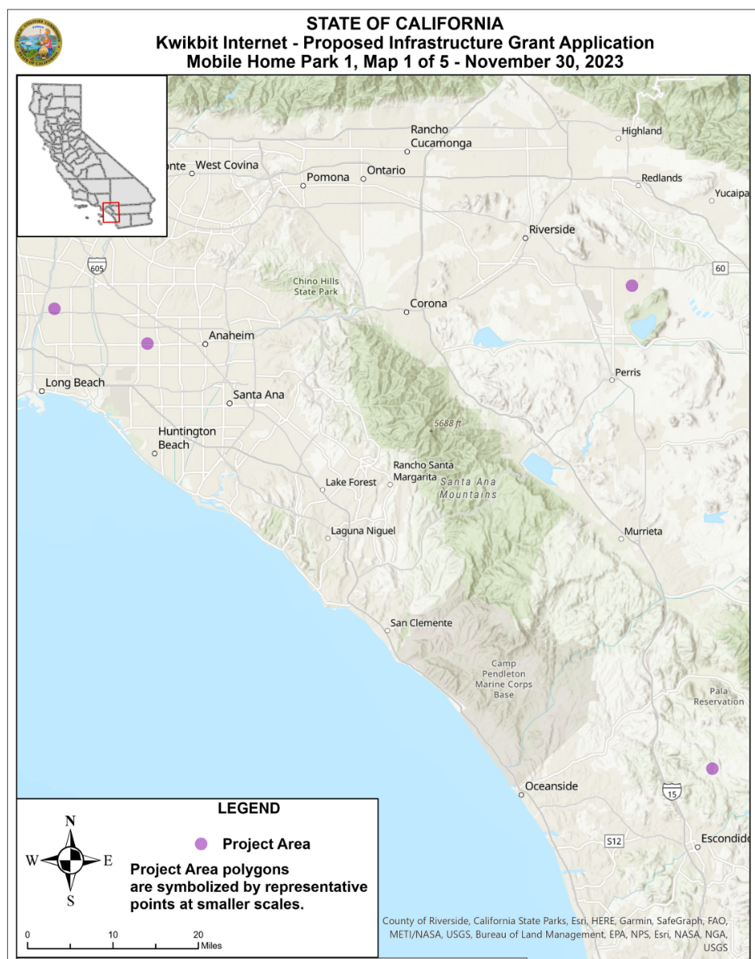
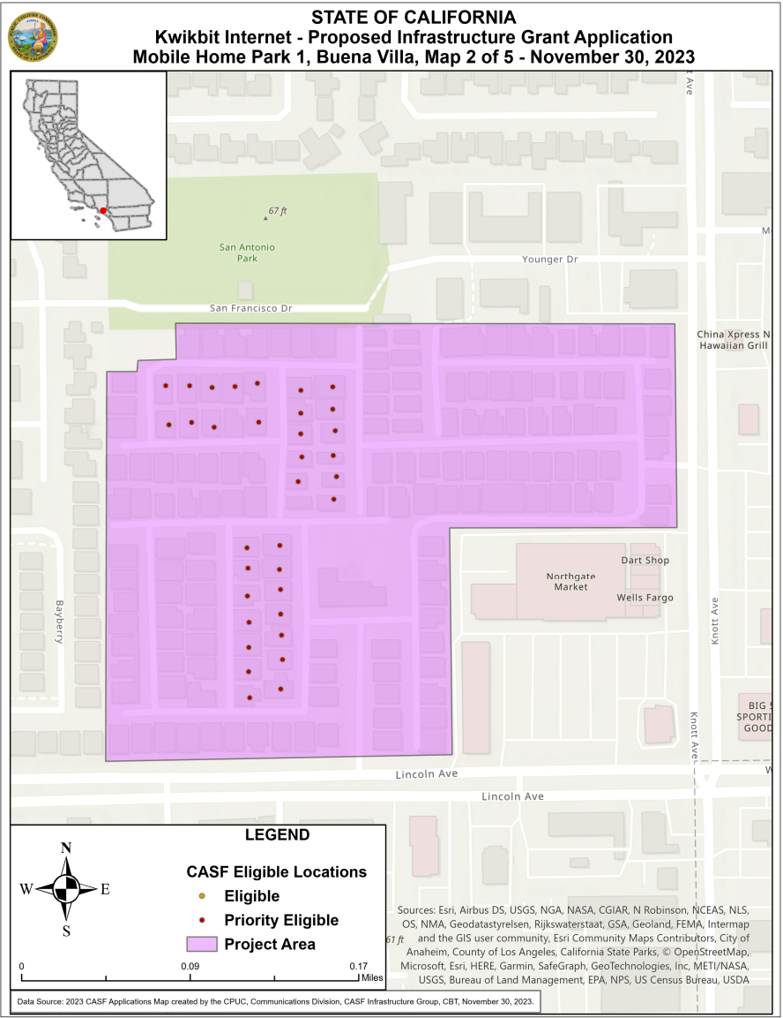

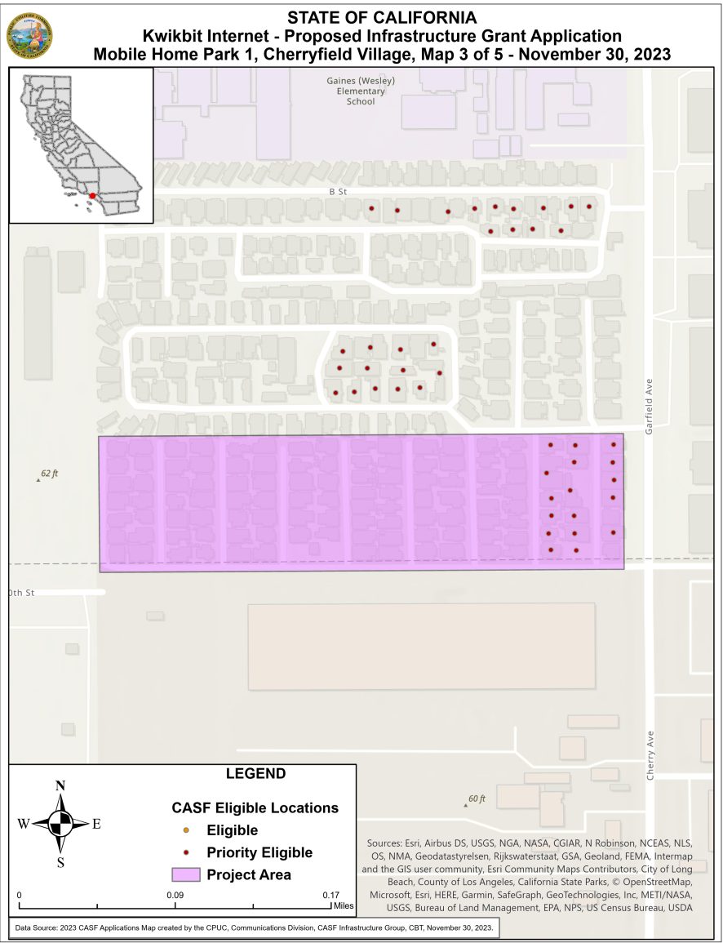
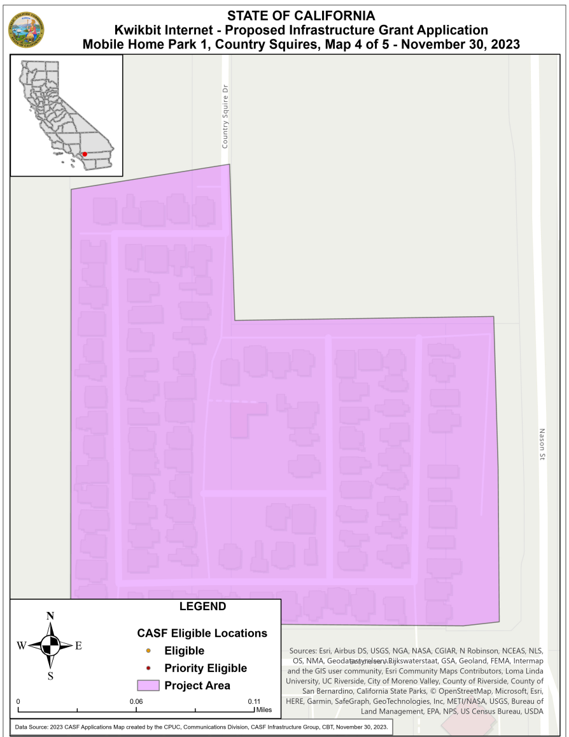

*Not shown as eligible on the California Broadband Map due to withdrawal of 2019 CASF project. There are 102 locations to be served.
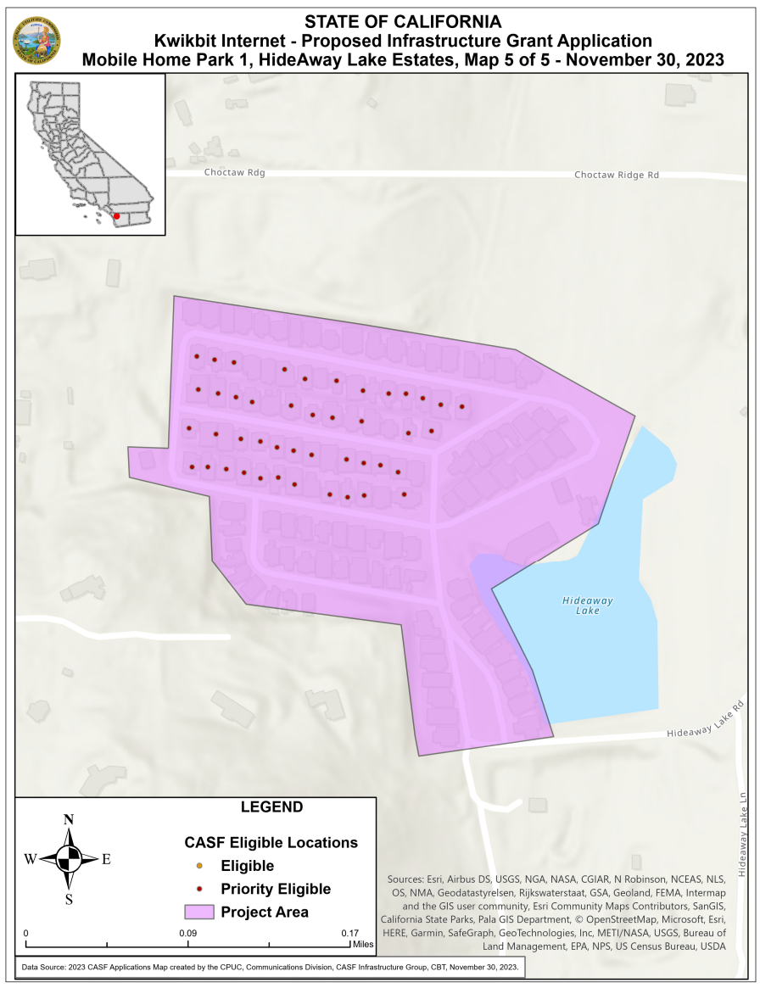
Appendix C
Resolution T-17674 Kwikbit Mobile Home Park 1 Project
Payments to CASF Recipients

Public Utilities Code, §281(f)(10) defines the costs the Commission may reimburse as follows:
- Costs directly related to the deployment of infrastructure;
- Costs to lease access to property or for Internet backhaul services for a period not to exceed five years; and
- Costs incurred by an existing facility-based broadband provider to upgrade its existing facilities to provide for interconnection.

Additionally, D.18-12-018 (Appendix 1, Section 7) caps administrative expenses directly related to the project at 10 percent of the grant amount.

The grantee may submit reimbursement requests at the following intervals:
- 10 percent completion;
- 35 percent completion;
- 60 percent completion;
- 85 percent completion; and
- 100 percent completion.

The final 15 percent payment request (from 85 to 100 percent) will not be paid without an approved completion report. Payments are based on submitted receipts, invoices and other supporting documentation showing expenditures incurred for the project in accordance with the approved CASF funding budget included in the CASF grantee’s application.

Payment to grantees shall follow the process adopted for funds created under Public Utilities Code, § 270. The Commission generally processes payments within 20-25 business days, including Communications Division and Administrative Services review time. The State Controller’s Office (SCO) requires an additional 14- 21 days to issue payment from the day that requests are received by SCO from Administrative Services.

Kwikbit submitted an updated requested amount to reflect the cost of constructing its network to a reduced number of mobile home parks due to several challenges to its initial grant application.
AB 1665 is codified at Public Utilities (Pub. Util.) Code § 281.
https://www.gov.ca.gov/2021/07/20/governor-newsom-signs-historic-broadband-legislation-to-help-bridge-digital-divide/.
See Pub. Util. Code Sec. 281(b)(1)(B)(ii)(I).
See https://www.cpuc.ca.gov/industries-and-topics/internet-and-phone/california-advanced-services-fund/casf-infrastructure-project-summaries for project summaries.
The Commission extended the CASF Infrastructure application deadline from April 1 to June 1, 2023, and all subsequent deadlines are moved back by 2 months.
https://docs.cpuc.ca.gov/PublishedDocs/Published/G000/M322/K691/322691585.PDF
Should the ACP end, the Commission will identify a successor low-income subsidy program in its place; for more information see https://www.fcc.gov/acp.
https://www.researchgate.net/publication/224206064_A_study_on_handoff_issues_in_radio_over_fiber_network_at_60_GHz.
1000 Mbps=1 Gbps
See section 3 in D-22-11-023, Attachment 1, for definition of “Low-Income Areas.”
See D.22-11-023, page A-6, Summary of Funding Criteria - Maximum funding level is 100 percent.
https://www.hcd.ca.gov/docs/grants-and-funding/inc2k22.pdf
MHI data is calculated by “Census Block Group” which represents an average of 40 census blocks and anywhere from 600-3,000 people.
2013 American Community Survey 5-Year Estimates. See: https://prosperitynow.org/sites/default/files/resources/California_Metro%20Opportunity%20Data%20Snapshot_December2017_0.pdf
https://www.apartmentlist.com/rentonomics/mobile-homes-affordability-crisis/
See table 11 in the 2021 Annual Report on the California Advanced Services Fund.
See table 12 in the 2021 Annual Report on the California Advanced Services Fund.
Administrative costs are defined as “indirect overhead costs attributable to a project, per generally accepted accounting principles (GAAP), and the direct cost of complying with Commission administrative and regulatory requirements related to the grant itself.” Applicants seeking additional funds will require a Commission exemption included in a draft resolution.

