PUBLIC UTILITIES COMMISSION OF THE STATE OF CALIFORNIA

Communications Division RESOLUTION T-17850
Broadband Regional Initiatives Branch October 17, 2024

R E S O L U T I O N

RESOLUTION T-17850: Approves 2 applications for grants for up to $23,036,295 from the Last Mile Federal Funding Account in Madera and Napa counties, providing service to 2,843 unserved locations.

- SUMMARY

This Resolution recommends approval of two Last Mile Federal Funding Account grants in the amount of up to $23,036,295.
This Resolution is part of the seventh package of Resolutions approving grants to Federal Funding Account applicants for broadband infrastructure projects serving unserved areas in California. Subsequent Resolutions will be presented for Commission vote as Communications Division Staff completes its analyses of applications.

The 2 projects in this Resolution propose to make investments bringing the social, economic, civic, and public safety benefits of high-speed broadband to 2,843 unserved locations and an estimated unserved population of 8,174 in Madera and Napa counties. An estimated total population of 8,301 people will benefit from these investments as households and businesses that already have service in these communities will benefit from greater customer choice in the broadband market.

Staff recommends grant awards to two entities (listed in the order in which they appear in this Resolution): Comcast and AT&T.

Comcast and AT&T are incumbent telecommunication companies offering service throughout California.

Staff recommends the following two grant applications for Commission approval as shown in Table 1 below. Maps and summaries associated with each project are in the appendices.

Table 1: Summary of Grant Funding

Applicant | Project Name | Estimated  Unserved Locations | Estimated Unserved Units | Estimated Unserved Population | Estimated Benefitting Population | Awarded  Amount
Madera
Comcast | Madera County | 2,206 | 2,035 | 6,548 | 6,653 | $16,987,890
Subtotal |  | 2,206 | 2,035 | 6,548 | 6,653 | $16,987,890
Napa
AT&T | Napa – 1B | 637 | 794 | 1,626 | 1,648 | $6,048,405
Subtotal |  | 637 | 794 | 1,626 | 1,648 | $6,048,405
Grand Total |  | 2,843 | 2,829 | 8,174 | 8,301 | $23,036,295

- BACKGROUND

California’s multi-year broadband investment package established the last mile Federal Funding Account as part of the Budget Act of 2021 and Senate Bill 156 and invested
$2 billion in the program over multiple years. The Federal Funding Account funds the construction of last mile broadband infrastructure projects in unserved areas of California. The Federal Funding Account encourages the deployment of broadband throughout the State to enable the public to access internet-based safety applications, telehealth services, emergency services, and to allow first responders to communicate with each other and collaborate during emergencies.

On April 21, 2022, the Commission issued Decision (D.) 22-04-055, Decision Adopting Federal Funding Account Rules. The rules and guidelines adopted in that decision included, among other items, the following: rules about projects to benefit Environmental and Social Justice Communities, affordable offers, five and ten-year price commitments, low-cost plans, project eligibility, application requirements, application objections, implementation of Public Utilities Code section 281(n) allocating funding between “rural counties” and “urban counties,” a process to reimburse grantees, a ministerial review process whereby Communications Division Staff may approve certain projects, and minimum performance standards for grantees.

The Federal Funding Account D. 22-04-055 includes requirements and preference for a number of affordability requirements including:
- Participation in the Affordable Connectivity Program or access to a “broad-based affordability program.” Given that the Affordable Connectivity Program has lapsed grantees must participate in a successor program when identified by the Commission.
- A five-year price commitment, and preference for a ten-year commitment.
- Preference for a low-cost plan that is $40/month or less and provides speeds of at least 50 Megabits per second (Mbps) down and 20 Megabits per second up.
- Preference for participation in the California and/or federal Lifeline programs (which may include bundled voice and broadband offerings).

Applications that committed to provide voice service and participate in LifeLine must, consistent with the requirement to serve customers in the project area at prices not exceeding those in the application for five years after project completion, provide voice service and participate in LifeLine for five years after project completion. In providing grant funding to projects the Commission is validating the need for and the state’s investment in the provision of communications service, including voice service, and in programs supporting affordability like LifeLine, for the life of the infrastructure.

The Federal Funding Account Decision and Appendix specify additional consideration for disadvantaged communities or Environmental and Social Justice communities. The Commission made available on the Federal Funding Account Public Map, the Applicant Tool, and data downloads locations and census blocks meeting these definitions. A grant application window was opened on June 30, 2023, and closed at
4 p.m. on September 29, 2023; 484 applications were submitted. Application summaries were posted on October 23, 2023, and a 28-day objection period closed on
November 20, 2023. Responses to objections were received until December 20, 2023.

Applications were holistically evaluated: required and supporting documentation and the merits of the applications were compared and assessed on a county basis. Following an initial analysis, Staff sent a data request to applicants and requested additional information. Staff’s holistic evaluation included project engineering, technical feasibility and design, financial viability, cost, applicant capacity, and community need, among other factors. Staff assessed how to manage overlapping applications and applications planning to include some already-served areas in their project area.
Staff also evaluated how applications and groups of applications compared to competing applications in the same county.

The specific locations to be provided service for a given project will be updated and reconciled with the Broadband Serviceable Location Fabric after detailed engineering and project design, and the grant amount may be reduced consistent with a reduction in the number of locations. The Federal Funding Account award will not fund locations supported by a federal broadband program with Capital Project Fund monies.
III. APPLICATION SUMMARIES, DISCUSSION, AND RECOMMENDATIONS

Madera County Summary

The allocation for projects in Madera County in D. 22-04-005 is $66,579,376. This Resolution recommends awarding one grant to Comcast. The recommended grant amount for projects in Madera County is $16,987,890, which leaves a remainder of $49,591,486 of the allocation for Madera County.

Madera County Awards

- Comcast, Madera County

Staff recommends the Commission approve Comcast’s application for a grant of up to $16,987,890 for the Madera County project.

The Madera County project proposes to serve an estimated 2,206 unserved locations based on a March 2024 supplemental application filing. There are approximately 2,035 unserved units in the project area. An estimated unserved population of 6,548 would be offered service. An estimated total population of 6,653 will benefit from these investments in the communities of Chowchilla and Madera. The last-mile fiber project will provide up to 1,250/1,250Mbps service to consumers.

Comcast will deploy approximately 76 miles of last-mile fiber. The network will be 47 percent underground.

The Madera County project will benefit disadvantaged or Environmental and Social Justice communities; 91 percent of the unserved locations are located in disadvantaged communities. Comcast will provide a low-cost plan that meets the requirements in D. 22-04-055, Section 3, and has committed to maintaining the price of that plan for at least ten years.

The program requires all applicants to commit to serve customers in the project area at prices not exceeding those provided in the application for five years after project completion (See Federal Funding Account Appendix A, section 7. “Performance Criteria”). Comcast’s application proposes to freeze the price for one plan, with specifications similar to the low-cost plan requirements, for 10 years and does not request a waiver of the requirement to freeze all other plans offered. Accordingly, this grant is recommended for award with the understanding that Comcast serve customers in the project area at prices not exceeding those in the application for all plans in the application for five years. If Comcast cannot satisfy this requirement Comcast may request a waiver including an explanation of why a waiver is being requested and a rationale for why a waiver should be granted.

The proposed project will cost an estimated $21,151,589, of which the Federal Funding Account will fund approximately 80 percent of costs.

Staff determined that the applicant and the project are financially viable, and the applicant’s engineering meets the program standards. The applicant demonstrated the administrative, technical, and operational capacity to provide broadband service at the scale of this project.

This application received one objection and Comcast responded to the objection. Staff determined that the objector did not provide sufficient documentation to substantiate a claim that it would serve the project area. The project area of Madera County (Comcast) was not modified in response to objections.

Two Federal Funding Account Public Map comments were submitted in Madera County. The comments were outside the Madera County (Comcast) application area. The Madera County (Comcast) project area unserved locations were evaluated in light of the updated Federal Communications Commission and Federal Funding Account unserved data (as of June 30, 2023). In response to objections and this data, the number of unserved locations is unchanged at 2,206, the project area is unchanged, and the total grant amount is unchanged. The specific locations to be provided service will be updated and reconciled with the Broadband Serviceable Location Fabric after detailed engineering and project design, and the grant amount may be reduced consistent with a reduction in the number of locations.

The following submitted letters of support for this application: Madera County Administrative Officer Jay Varney, Central Valley Women’s Entrepreneur Center, Fresno State Connective Initiative, California Partnership for the San Joaquin Valley, Central Valley Business Federation, SJV Rural Development Center, Equality California, Madera County Administrative Office, Chicano Latino Youth Leadership Project Inc., San Joaquin Valley Regional Broadband Consortium.

The proposed project provides the public safety benefits of reliable broadband infrastructure. This project is not located in a High Fire Threat District. This project will connect to Comcast’s middle mile infrastructure.

Based on the information received, the Commission’s Energy Division has determined that this project has not met the requirements for a CEQA categorial exemption at this time. Comcast must comply with the CEQA requirements discussed in the appendices. If Comcast provides additional documentation sufficient to justify a staff determination of CEQA exemption, then the project can be exempted by letter from the Communications Division Director or the director’s delegate or designee.

Comcast and the Madera County (Comcast) project comply with all requirements for approval in D. 22-04-055. The Communications Division recommends that the Commission approve the application of Comcast for a grant of up to $16,987,890 for the Madera County (Comcast) project.

Napa County Summary

The allocation for projects in Napa County in D. 22-04-005 is $10,705,214. This Resolution recommends awarding 1 grant to AT&T for projects in Napa County. The recommended grant amount for projects in Napa County is $6,048,405 which leaves a remainder of $4,656,809 of the allocation for Napa County.

Napa County Awards

- AT&T, Napa - 1B

Staff recommends the Commission approve AT&T’s application for a grant of up to $6,048,405 for the Napa - 1B project.

The Napa - 1B project proposes to serve an estimated 637 unserved locations based on a March 2024 supplemental application filing. There are approximately 794 unserved units in the project area. An estimated unserved population of 1,626 would be offered service. An estimated total population of 1,648 will benefit from these investments in the communities of Napa County. The last-mile fiber project will provide up to 5000/5000 Mbps service to consumers.

AT&T will deploy approximately 32 miles of last-mile fiber. The network infrastructure will be 19 percent underground.

The Napa - 1B project will benefit disadvantaged or Environmental and Social Justice communities; 33 percent of the unserved locations are low income.

The proposed project will cost an estimated $8,657,646, of which the Federal Funding Account will fund approximately 70 percent of costs.

Staff determined that the applicant and the project are financially viable, and the applicant’s engineering meets the program standards. The applicant demonstrated the administrative, technical, and operational capacity to provide broadband service at the scale of this project.

This application received one objection and AT&T responded to the objection. Staff verified that the locations in the project area are not reliably served as defined in D.22-04-055. The project area of Napa - 1B was not modified in response to objections.

One Federal Funding Account Public Map comments were submitted in Napa County. Napa - 1B project area’s unserved locations were evaluated in light of the updated Federal Communications Commission and Federal Funding Account unserved data (as of June 30, 2023). In response to objections, comments, and this data, the number of unserved locations is unchanged at 637, the project area is unchanged, and the total grant amount is unchanged. The specific locations to be provided service will be updated and reconciled with the Broadband Serviceable Location Fabric after detailed engineering and project design, and the grant amount may be reduced consistent with a reduction in the number of locations.

The proposed project provides the public safety benefits of reliable broadband infrastructure. The proposed project provides the public safety benefits of reliable broadband infrastructure and will benefit households located in High Fire Threat Districts 2 and 3. This project will connect to AT&T’s middle-mile infrastructure.

Based on the information that AT&T provided, the Commission’s Energy Division has confirmed that the project meets the criteria for the CEQA categorical exemptions under 14 C.C.R. Section 15301 (Existing facilities), 14 C.C.R. Section 15303 (New Construction or Conversion of Small Structures), and 14 C.C.R. Section 15304 (Minor Alterations to Land). Thus, the Napa - 1B Project is categorically exempt from CEQA review and the CPUC may authorize funds for the construction activities.

AT&T and the Napa - 1B project comply with all requirements for approval in D. 22-04-055. The Communications Division recommends that the Commission approve the application of AT&T for a grant of up to $6,048,405 for the Napa - 1B project.

Comments
In compliance with Public Utilities Code Section 311(g)(1), a Notice of Availability of this draft resolution was e-mailed on September 12, 2024, informing all parties on the CASF Distribution List and the R. 20-09-001 Service List of the availability of the draft of this Resolution, and of the opportunity to comment, at the Commission’s website at http://www.cpuc.ca.gov/.

IV. COMPLIANCE REQUIREMENTS

Awardees are required to comply with all the guidelines, requirements, and conditions associated with the grant of Federal Funding Account awards as specified in D.22-04-055. All Awardees are also required to sign a consent form agreeing to the terms and conditions of the Federal Funding Account. Such compliance includes, but is not limited to, the items noted below.

A. Deployment Schedule: All CEQA-exempt projects must be completed within 18 months, and all other projects shall be completed within 24 months after receiving authorization to construct.

B. Pricing: By accepting these awards, the Awardees commit to serve customers in the project area at prices not exceeding those provided in the application for five years after project completion. Awardees who committed not to increase prices for a period of ten years in their application commit to serve customers in the project area for ten years after project completion. Should the need arise for grant recipients to adjust prices due to externalities outside their control (e.g. inflation), grant recipients may file and serve, on the R. 20-09-001 proceeding service list, a request to modify this requirement with the Communications Division.

C. Speed and Latency: All households in the proposed project areas must be offered a broadband internet service plan with speeds of at least 100 megabits per second megabits per second download and 100 megabits per second upload, with not more than 100 milliseconds of latency.

D. Affordability: All projects shall participate in the Affordable Connectivity Program or otherwise provide access to a broad-based affordability program to low-income customers in the proposed service area of the broadband infrastructure that provides benefits to households commensurate with those provided under the Affordable Connectivity Program. Should the Affordable Connectivity Program end, the Commission will identify a successor low-income subsidy program in which participants must participate. Awardees must participate in a successor to the Affordable Connectivity Program identified after the grant is awarded.

E. Project Audit: The Commission has the right to conduct any necessary audit, verification, and discovery during project implementation/construction to ensure that Federal Funding Account funds are spent in accordance with Commission approval. All recipients of federally funded grants exceeding $750,000 will need to include a budget for a federal audit.

F. Reporting Requirements: Numerous post-award reports are required. In summary, these include monthly contractor reports (if applicable), quarterly progress reports, and a final completion report.

G. Prevailing Wage: Section 1720 of the California Labor Code requires Federal Funding Account projects be subject to prevailing wage requirements. Applicants accepting Federal Funding Account awards are committing to follow state prevailing wage requirements with regards to their projects.

H. Payments to Federal Funding Account Recipients: The Commission may reimburse Awardees’ expenses in accordance with Public Utilities Code Section 281(n)(2), D.22-04-055, and the Appendix. Requests for payments may be submitted as the project is progressively deployed. The prerequisite for first payment is the submittal of a progress report to the Commission showing that a minimum of ten percent of the project (as determined by budget spent) has been completed. Subsequent payments may be made upon at least 25 percent intervals, with the final 15 percent payment request (from 85 to 100 percent) not eligible for payment without an approved completion report. Payments are based on submitted receipts, invoices and other supporting documentation showing expenditures incurred for the project in accordance with the approved Federal Funding Account budget included in the awardee’s application.

FINDINGS OF FACT

- California’s multi-year broadband infrastructure investments in the Budget Act of 2021 and Senate Bill 156 (Statutes 2021, Chapters 84 and 112) provided $2 billion over multiple years to the Last Mile Federal Funding Account to facilitate, via reimbursement, construction of last mile broadband infrastructure projects to connect unserved Californians.

- On April 21, 2022, the Commission approved Decision 22-04-055, which along with the Federal Final Rule, established the Last Mile Federal Funding Account and set program rules.
- The Communications Division opened an application window for the Federal Funding Account on June 30, 2023, and closed it on September 29, 2023. Applicants submitted 484 applications before the deadline. Application summaries were posted on October 23, 2023, and a 28-day objection window closed on November 20, 2023. Responses to objections were received until December 20, 2023.
- Comcast submitted an application for the Madera County project on September 29, 2023.
- AT&T submitted an application for the Napa – 1B project on September 28, 2023.
- Applicants responded to a supplemental data request that was due on March 12, 2024, providing information on project route miles, poles, unserved locations, middle-mile connectivity, and other updated project specific information.
- The Commission has determined that Comcast’s Madera County project is not categorically exempt from California Environmental Quality Act review at this time.
- The Commission has determined that AT&T’s Napa - 1B project is categorically exempt from California Environmental Quality Act (CEQA) review, pursuant to CEQA Guidelines at 14 California Code of Regulations (C.C.R.) Section 15301 regarding exemption for existing facilities, 14 C.C.R Section 15303 regarding new construction or conversion of small structures, and 14 C.C.R Section 15304, which consists of minor public or private alternations in the condition of land.
- Communications Division staff analyzed the applications for compliance with Commission and Federal rules, reviewed local feedback, and conducted fiscal and technical analysis.
- All applications listed above met minimum eligibility requirements provided in Decision 22-04-055.
- Staff recommends approval of the applications in this resolution, as they comply with program rules as stated and contribute to the Federal Funding Account’s goal of building broadband internet infrastructure to communities without access to internet service at sufficient and reliable speeds.
- Draft Resolution T-17850 was emailed to the CASF Distribution List and the R. 20-09-001 Service List on September 12, 2024, in compliance with Public Utilities Code Section 311(g)(1).

THERFORE, IT IS ORDERED that:

- The Commission shall award up to $16,987,890 in Federal Funding Account funds to Comcast in order to complete the Madera County project, as described in the appendices. The specific locations to be provided service will be updated and reconciled with the Broadband Serviceable Location Fabric after detailed engineering and project design, and the grant amount may be reduced consistent with a reduction in the number of locations.
- The Commission shall award up to $6,048,405 in Federal Funding Account funds to AT&T in order to complete the Napa – 1B project, as described in the appendices. The specific locations to be provided service will be updated and reconciled with the Broadband Serviceable Location Fabric after detailed engineering and project design, and the grant amount may be reduced consistent with a reduction in the number of locations.
- To ensure compliance with all program rules and guidelines, the Commission will not release funds to an applicant proposing to enter into agreement(s) with a third party or third parties for the ownership, operation, and/or leasing of the proposed infrastructure or network until the applicant provides the Commission with an advanced copy of the agreement document(s) as well as any signed agreements.

- Applicants that committed to provide voice and/or Lifeline service must provide voice service and participate in LifeLine for five years after project completion in Federal Funding Account project areas.

- For those projects not determined to be categorically exempt, the Commission cannot release funds for construction activities until California Environmental Quality Act (CEQA) review is complete. The awardees must comply with the requirements set forth in the CEQA Section of the Resolution. The awardees must provide their Proponent’s Environmental Assessment for each project prior to the first payment.

- Awardee(s) shall comply with all guidelines, requirements, and conditions set forth in this resolution.
- When a successor to the Affordable Connectivity Program is identified by the Commission, all awardees shall participate in that program.

- All construction covered by the grant must be completed within the applicable 18-month or 24-month time frame. In the event of extenuating circumstances jeopardizing this timeline, the Awardee(s) must notify the Communications Division’s Director as soon as they become aware of any delay. If such notice is not provided, staff can take corrective actions including reducing payment for failure to satisfy this requirement.

- If the awardee(s) fail to complete the project(s) in accordance with the terms outlined in Decision 22-04-055 and with the terms of the Commission’s approval, as set forth in this resolution, awardees must reimburse some or all the Federal Funding Account grants received or take other corrective action.
- If staff evaluation finds any of the projects can be exempt from the California Environmental Quality Act, then the project can be exempted by letter from the Communications Division Director or the director’s delegate or designee.
- The effective date of each award and encumbrance of funds is to be set, in consultation with the Applicant, by letter from the Communications Division Director or the director’s delegate or designee. All awards are contingent on available state budget appropriations funding.

This resolution is effective today.

I certify that the foregoing resolution was duly introduced, passed, and adopted at a conference of the Public Utilities Commission of the State of California held on ___________________, the following Commissioners voting favorable thereon:

Rachel Peterson
Executive Director

Comcast California Environmental Quality Act Compliance Requirements
The following Comcast project is subject to California Environmental Quality Act (CEQA) review:

- Madera County

The Commission must complete CEQA review prior to disbursing Federal Funding Account funds for construction activities. The initial funding granted in this Resolution may be used for project development and other Comcast activities that do not involve construction or any activities that would have any direct or indirect effect on the physical environment.
Prior to any construction activity for the project, Comcast is required to seek further authority from the Commission for such activity by filing a Proponent’s Environmental Assessment (PEA) pursuant to Commission Rule of Practice and Procedure 2.4; and must undergo an environmental review pursuant to CEQA (California Public Resources Code § 21000 et seq.).
Comcast should contact the Supervisor of the Commission’s Energy Division CEQA Unit well in advance of a contemplated filing to (a) consult with staff regarding the process of developing and filing a PEA; (b) provide for cost recovery per Rule of Practice and Procedure 2.5; and (c) enter into a Memorandum of Understanding to allow the Energy Division to initiate the retention of an environmental contractor to perform the environmental review.
Comcast’s listed applications are subject to National Environmental Policy Act (NEPA) review, as acknowledged in its application. Comcast should make every effort to ensure that the Commission’s CEQA Unit is aware of and included in the NEPA process. Comcast must provide a PEA prior to the first payment. The Commission cannot release funds for the construction project until the Commission has completed CEQA review.
Comcast must provide a PEA prior to the first payment. The Commission cannot release funds for the construction phase of this project until the Commission has completed CEQA review.

AT&T California Environmental Quality Act Compliance Requirements
The following AT&T project is categorically exempt from California Environmental Quality Act (CEQA) review:

- Napa - 1B

The Napa – 1B project is located in Napa County, including Napa, Pope Valley, and Angwin. Approximately 33 miles of new fiber will be placed in existing conduit or in new conduit to be installed overhead on existing structures where possible. Where aerial attachment is not possible, fiber will be placed within existing easements along existing roadways using directional boring or micro trenching.
Based on the information that AT&T provided, the Commission’s Energy Division has confirmed that the project meets the criteria for the CEQA categorical exemptions under 14 California Code of Regulations (C.C.R.) Section 15301 (Existing facilities), 14 C.C.R. Section 15303 (New Construction or Conversion of Small Structures), and 14 C.C.R. Section 15304 (Minor Alterations to Land). Thus, the Napa - 1B Project is categorically exempt from CEQA review and the CPUC may authorize funds for the construction activities.

Madera County
Key Information
Project Name | Madera County
Applicant Name | Comcast Cable Communications Management, LLC
Community Names | Chowchilla, Madera
County | Madera
County Allocation | $66,579,376
Project Size (in square miles) | 21
Maximum Download/Upload speed | 1250/1250 Mbps
Lowest cost plan (non-income qualified) | $40/month for 100/100 Mbps
Low-income plan | $9.95/month for 50/10 Mbps, $29.95 for 100/20 Mbps
Low-cost plan | $40/month for 100/100 Mbps minimum
LifeLine Participation | No
Percent Disadvantaged Communities | 91 percent
Percent Low-Income Areas | 17 percent
Median Household Income (weighted) | $73,036
Area Households | 1,956
Area Population | 6,653
Estimated locations within 1000 feet of the project area (location passings) | 2,040
Estimated units within 1000 feet of the project area (unit passings) | 2,242
Unserved locations proposed to be served by the project | 2,206
Unserved locations in the project area | 1,867
Unserved units in the project area | 2,035
Estimated unserved population in the project area | 6,548
Estimated unserved Multiple Dwelling Unit (MDU) locations in the project area | 119
Estimated unserved Multiple Dwelling Unit (MDU) location units in the project area | 287
Community Anchor Institutions benefitting from the project | 5
Public safety locations benefitting from the project | 1
Does the project connect to public open access middle mile? | No
Distance of middle-mile, backhaul, and connection to Middle Mile Broadband Initiative in project | -
Grant costs for middle-mile, backhaul, and connection to Middle Mile Broadband Initiative in project | -
Grant costs for last-mile delivery | $16,987,890
Deployment Schedule | 18 Months
Total Project Cost | $21,151,589
Amount of FFA grant funds requested | $16,987,890
Applicant funded | $4,163,699
Grant (excluding middle mile) per unserved unit in the project area | $8,348
Grant (excluding middle mile) per unit passing | $7,577

Map of Madera County (Comcast)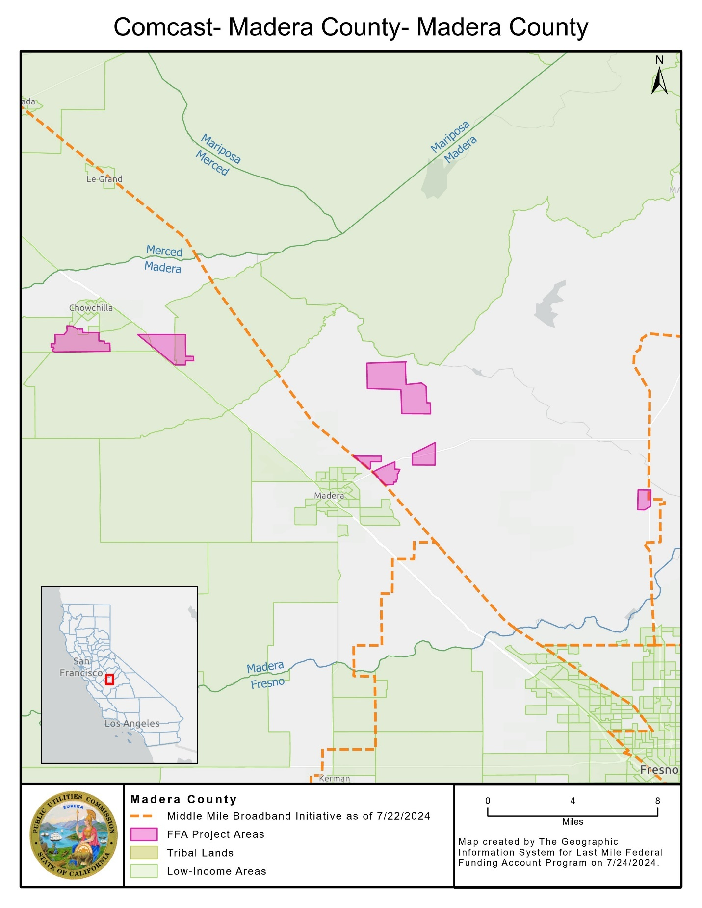

Napa – 1B
Key Information
Project Name | Napa - 1B
Applicant Name | AT&T Services, Inc. on behalf of its affiliate Pacific Bell Telephone Company d/b/a AT&T California
Community Names | Napa County
County | Napa County
County Allocation | $10,705,214
Project Size (in square miles) | 38
Maximum Download/Upload speed | 5000/5000 Mbps
Lowest cost plan (non-income qualified) | $55/month for 300/300 Mbps
Low-income plan | $30/month for 100/100 Mbps
Low-cost plan | No
LifeLine Participation | Yes
Percent Disadvantaged Communities | 0 percent
Percent Low-Income Areas | 33 percent
Median Household Income (weighted) | $89,567
Area Households | 689
Area Population | 1,648
Estimated locations within 1000 feet of the project area (location passings) | 670
Estimated units within 1000 feet of the project area (unit passings) | 851
Unserved locations proposed to be served by the project | 637
Unserved locations in the project area | 633
Unserved units in the project area | 794
Estimated unserved population in the project area | 1,626
Estimated unserved Multiple Dwelling Unit (MDU) locations in the project area | 149
Estimated unserved Multiple Dwelling Unit (MDU) location units in the project area | 310
Community Anchor Institutions benefitting from the project | 2
Public safety locations benefitting from the project | 2
Does the project connect to public open access middle mile? | No
Distance of middle-mile, backhaul, and connection to Middle Mile Broadband Initiative in project | -
Grant costs for middle-mile, backhaul, and connection to Middle Mile Broadband Initiative in project | -
Grant costs for last-mile delivery | $6,048,405
Deployment Schedule | 18 Months
Total Project Cost | $8,657,646
Amount of FFA grant funds requested | $6,048,405
Applicant funded | $2,609,241
Grant (excluding middle mile) per unserved unit in the project area | $7,618
Grant (excluding middle mile) per unit passing | $7,107

Map of Napa – 1B 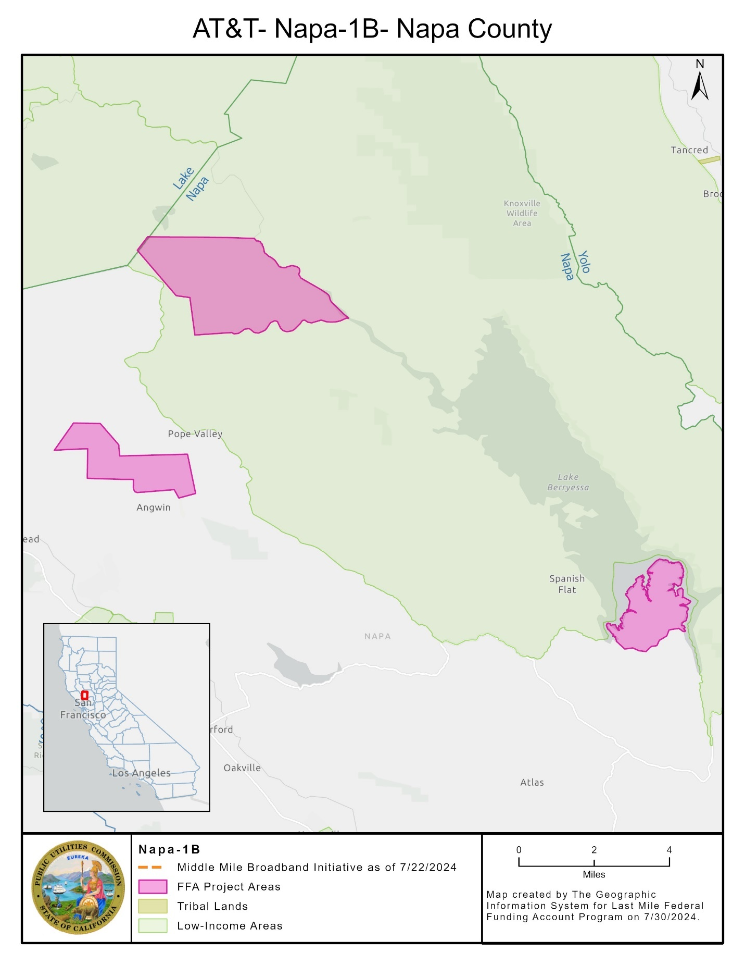

Comcast Service Plans
As a condition of the grant awards in this Resolution, Comcast is obligated to offer service to customers in the project areas of the listed projects at no less than the speeds in the Table below, no more than 100 milliseconds of latency, and no more than the prices in the Table below, including installation, for at least five years following project completion, or ten years for the Low-Cost Plan:
- Madera County
Plan | Speed | Price in 2024 Dollars | Notes
Low-Cost Plan | 100/100 Mbps | $40/month | Ten-year price commitment
Internet Essentials | 50/10 Mbps | $9.95/month | Customers must provide documentation showing eligibility for a qualifying program.  Includes free digital skills training in person and online. Customers have the option to purchase a low-cost Internet-ready computer.
Internet Essentials Plus | 100/20 Mbps | $29.95/month | Customers must provide documentation showing eligibility for a qualifying program.  Includes free digital skills training in person and online. Customers have the option to purchase a low-cost Internet-ready computer.

AT&T Service Plans
As a condition of the grant awards in this Resolution, AT&T is obligated to offer service to customers in the project areas of the listed projects at no less than the speeds in the Table below, no more than 100 milliseconds of latency, and no more than the prices in the Table below, including installation, for at least five years following project completion.
- Napa – 1B
Plan | Speed | Price in 2024 Dollars | Notes
Access from AT&T | 100/100 Mbps | $30/month | Customers must provide documentation showing eligibility for a qualifying program.  Prices include free installation, free Wi-Fi router, and no contract term commitment or deposit.  Price includes $5/month paperless billing credit.
300 Mbps Plan | 300/300 Mbps | $55/month | Price includes $5/month paperless billing credit.
500 Mbps Plan | 500/500 Mbps | $65/month | Price includes $5/month paperless billing credit.
1 Gbps Plan | 1/1 Gbps | $80/month | Price includes $5/month paperless billing credit.
2 Gbps Plan | 2/2 Gbps | $150/month | Price includes $5/month paperless billing credit.
5 Gbps Plan | 5/5 Gbps | $250/month | Price includes $5/month paperless billing credit.

As a condition of the grant awards in this Resolution, AT&T has committed to provide LifeLine-discounted voice service in the project areas listed.

California Public Utilities Commission
Federal Funding Account, Last Mile Program
Guidance to Staff Regarding
CONSENT FORM
Acknowledgement and Acceptance of Terms
Awardee Name:

Key Project Contact:

Project Name:

The Awardee identified above acknowledges receipt of the California Public Utilities Commission Resolution or Award Letter and agrees to comply with all grant terms, conditions, and requirements set forth in the Resolution or Award Letter and those in the Federal Funding Account, Last Mile program rules. Awards are contingent on available state budget appropriations funding.
Undersigned representative of __________________________________ [Name of Awardee] is duly authorized to execute this Consent Form on behalf of the Awardee and to bind the Awardee to the terms, conditions, and requirements set forth in California Public Utilities Commission Resolution or Award Letter and those in the Federal Funding Account, Last Mile program rules.

Dated this _____ day of _____________, 20____.

Signature of Awardee Representative: _____________________________________________________

Title __________________________________________________________

Printed Name __________________________________________________

Name of Representative’s Organization:
______________________________________________________________

Business Address:

Street address, suite/apt. number

City, state, and ZIP Code

Telephone Number: ________________________________

Email Address: _____________________________________

Statute 2021, Chapters 84 and 112.
The Commission Environmental and Social Justice Action plan includes definitions and data indicators for disadvantaged or Environmental and Social Justice communities including Disadvantaged Communities defined by the California Environmental Protection Agency (CalEPA) and low-income households defined as household incomes below 80 percent of the area median income. The Commission’s Environmental and Social Justice Action Plan 2.0 is available at: https://www.cpuc.ca.gov/-/media/cpuc-website/divisions/news-and-outreach/documents/news-office/key-issues/esj/esj-action-plan-v2jw.pdf
The Federal Funding Account Public Map is available at: https://federalfundingaccountmap.vetro.io/
Registration for the Federal Funding Account Applicant Tool is available at: FFA Applicant Tool Registration
Disadvantaged or Environmental and Social Justice communities and individual locations, for purposes of the Federal Funding Account, include those in Disadvantaged Communities census tracts as defined by CalEPA and low-income areas in which the census block group median household income is less than or equal to 80 percent of the higher of the county or state average. This data is available for download on the Federal Funding Account Public Map page (visited June 13, 2024), https://www.cpuc.ca.gov/industries-and-topics/internet-and-phone/broadband-implementation-for-california/last-mile-federal-funding-account/ffa-public-map and the Federal Funding Account Application Resources Page (visited June 13, 2024), https://www.cpuc.ca.gov/industries-and-topics/internet-and-phone/broadband-implementation-for-california/last-mile-federal-funding-account/ffa-application-resources-page .
D.22-04-055 states that “households and businesses with an identified need for additional broadband infrastructure do not have to be the only ones in the service area served by an eligible broadband infrastructure project. Indeed, serving these households and businesses may require a holistic approach that provides service to a wider area, for example, in order to make ongoing service of certain households or businesses within the service area economical.”
Federal broadband programs include the Connect America Fund II (CAFII), Community Connects Grant Program (CCGP), Enhanced Alternative Connect America Cost Model (EACACM), Rural Digital Opportunity Fund (RDOF), Rural E-Connectivity Program (REP), Tribal Broadband Connectivity Program (TBCP), and Telephone Loan Program (TLP).
See Federal Funding Account Public Map, https://federalfundingaccountmap.vetro.io/ (visited August 19, 2024).
See Federal Funding Account Public Map, https://federalfundingaccountmap.vetro.io/ (visited August 19, 2024).
Treasury, Compliance and Reporting Guidance State and Local Fiscal Recovery Funds (November 15, 2021 Version 2.1), available at https://home.treasury.gov/system/files/136/SLFRF-Compliance-and-Reporting-Guidance.pdf.
D. 22-04-055, Appendix A, Section 14.
D.22-054-055, Section 13.2, page 57.
Prices may increase at no more than the rate of inflation, defined by the Consumer Price Index.
Meeting the requirements in Decision 22-04-055 and Appendix. Applicants electing to provide a low-cost broadband plan for all customers for the life of the infrastructure. The low-cost plan must meet the following minimum standards: - Must not include data usage caps; - Must offer speeds that are sufficient for a household with multiple users to simultaneously telework and engage in remote learning, which is defined as 50/20 Mbps; - Must be no more than $40 per month, though recipients electing to provide these plans have the option to adjust plans in accordance with the Consumer Price Index; - The grantee must not charge for installation or setup; - The grantee must provide a free modem or router; and - The service does not require a minimum term. Alternatively, an applicant may offer a plan that meets the above requirements except provide with higher speeds and/or at a lower cost per month.
In its Application for this project, Comcast sought confidential treatment of, among other things, this price and speed pursuant to the CPRA, Public Utilities Code § 583, and G.O. 66-D. As an express requirement to receive this proposed public grant, this information does not qualify as a trade secret, and the public interest in its disclosure outweighs the public interest in its nondisclosure.
Qualifying programs include: Medicaid; Public Housing Assistance; Supplemental Nutrition Assistance Program; Temporary Assistance for Needy Families; Supplemental Security Income; National School Lunch Program or Head Start; Low Income Home Energy Assistance Program; Special Supplemental Nutrition Program for Women, Infants and Children; or a Federal Pell Grant.
Ibid.
Prices may increase at no more than the rate of inflation, defined by the Consumer Price Index.
Qualifying programs/income thresholds include: Supplemental Nutritional Access Program; Supplemental Security Income for California residents; National School Lunch and Head Start Programs; Household income of 200% of federal poverty guidelines or less.

