APPENDIX A  
Statewide Energization Timelines  
Analyses Report

|  |
| --- |
| Statewide Energization Timelines Analyses Report  DRAFT FOR PUBLIC COMMENT |
| Prepared for:    California Public Utilities Commission |
| Submitted by:  Guidehouse Inc.  101 California St  #4100  San Francisco, CA 94111  July 12, 2024  **guidehouse.com** |
| This deliverable was prepared by Guidehouse Inc. for the sole use and benefit of, and pursuant to a client relationship exclusively with the California Public Utilities Commission (“Client”). The work presented in this deliverable represents Guidehouse’s professional judgement based on the information available at the time this report was prepared. Guidehouse is not responsible for a third party’s use of, or reliance upon, the deliverable, nor any decisions based on the report. Readers of the report are advised that they assume all liabilities incurred by them, or third parties, as a result of their reliance on the report, or the data, information, findings, and opinions contained in the report. |

Table of Contents

1. Introduction 1

2. Energization Timeline Data Analysis – All Steps 2

2.1 Objective 2

2.2 Input Data 2

2.3 Outputs 2

2.4 Analysis Methodology 3

3. Energization Timeline Data Analysis – IOU Dependent Steps 5

3.1 Objective 5

3.2 Input Data 5

3.3 Outputs 6

3.4 Analysis Methodology 7

Appendix A. Overview of Energization Data Provided by IOUs 8

A.1 Overall Energization Project Data Count 8

A.2 Impact on Data of Outlier Removal and Data Clean Up 9

Appendix B. Statistics Summary Tables of California IOU Energization Data 10

B.1 Overall Energization Timeline Statistics Calculated by Guidehouse using IOU Data 10

B.2 Comparison of Guidehouse and IOU Energization Timeline Statistics – Energization Timelines by Step 10

B.3 Comparison of Guidehouse and IOU Energization Timeline Statistics – Energization Timelines by Tariff 13

List of Tables

Table 1. Summary of Rule 15, Rule 16, and Rule 15/16 Timelines for IOU Dependent Energization Steps 6

Table 2. Summary of Rule 15, Rule 16, and Rule 15/16 Timelines for IOU Dependent Energization Steps – Acceleration Rates 6

Table 3. Raw Project Count by IOU, Tariff Type, and Energization Step 8

Table 4. Percentage of Outliers Removed Due to Data Cleanup 9

Table 5. Guidehouse Timeline Summary Statistics 10

Table 6. Guidehouse Timeline Statistics Calculated with IOU Data – By Step 11

Table 7. IOU Timeline Statistics Provided in Proceeding Response – By Step 12

Table 8. Differences Between Guidehouse-Calculated and IOU-Provided Timeline Statistics – by Step* 12

Table 9. Guidehouse Timeline Statistics Calculated with IOU Data – By Tariff 13

Table 10. IOU Timeline Statistics Provided in Proceeding Response – By Tariff 14

Table 11. Differences Between Guidehouse-Calculated and IOU-Provided Timeline Statistics – By Tariff 14

List of Equations

Equation 1. Standard Deviation of IOU Dependent Energization Timeline 7

Equation 2. Maximum Energization Timeline Calculation 7

List of Acronyms

* CPUC: California Public Utilities Commission
* IOU: Investor-Owned Utility
* PG&E: Pacific Gas & Electric
* SCE: Southern California Edison
* SDG&E: San Deigo Gas & Electric

# Introduction

This document outlines analyses conducted by Guidehouse to support the California Public Utilities Commission’s (CPUC) evaluation of the timelines associated with investor-owned utility (IOU) energization of load in California. The analysis leveraged data provided to the CPUC[1] by the IOUs on April 22, 2024[2], in response to Order Instituting Rulemaking to Establish Energization Timelines (R.24-01-018)[3]. The data represents the number of business days to complete individual energization projects in the past five years, from January 2019 to December 2023.

The objective of the analysis is to inform CPUC decision-making with respect to its responsibility in the rulemaking to “establish reasonable average and maximum target energization time periods per Public Utilities Code Section 934 (a)(1)”[4]. The analyses assessed data provided by the IOUs across the following parameters according to guidance provided by the CPUC to Guidehouse:

* **IOU service territory** for Pacific Gas & Electric (PG&E), Southern California Edison (SCE), and San Diego Gas & Electric (SDG&E).
* **Step** in the energization process (as defined by the CPUC).
* **Tariff Type and Electric Rule** (i.e., Rule 15, Rule 16, Rule 15 & 16, Rule 29/45, and Rule 15 & 29/45).

The analyses will be used by the CPUC to inform appropriate target energization time periods for projects completed by the IOUs. Guidehouse provided the CPUC with two Excel workbooks[5] containing the data received from the IOUs, results produced by Guidehouse analyses conducted at the direction of CPUC staff, and the tables contained in appendices of this report. Guidehouse does not provide recommendations for what targets to set as that determination is the responsibility of the CPUC.

# Energization Timeline Data Analysis – All Steps

## Objective

The primary objective of the analysis was to evaluate the energization data provided by the IOUs, identify, and remove outlier data, and calculate statistics of the resulting dataset (i.e., average, median, standard deviation, and maximum). The IOUs also provided their own analysis of the datasets. This report compares the Guidehouse analysis results to the IOU analysis results. This comparison helped to validate the analysis methodology and assess the impact of removing data outliers.

## Input Data

Rulemaking 24-01-018 established the energization project data request, which in part requested that IOU’s propose a set of standardized steps for energization project timelines, as well as each IOU’s energization project data for each proposed step. The IOUs responded with a proposed set of standardized steps to complete the energization process, as defined by the Public Utilities Code Section 931 (b). listed below:

1. Customer Initiation/ Intake
2. Engineering & Design
3. Dependencies
4. Site Readiness
5. Construction

Each IOU also provided data for their respective energization projects including project characteristics by tariff type and electric rule, and days associated with each proposed step. Across all IOUs there are more than 125,000 projects included in the dataset, with 34% from PG&E, 27% from SCE, and 40% from SDG&E.

## Outputs

Guidehouse developed a set of summary tables that provide descriptive statistics of IOU energization projects as directed by CPUC staff. In alignment with R.24-01-018 requirements, the tables include the average, median, standard deviation, and maximum number of days for: (a) each of the proposed standardized energization steps; and (b) each tariff type and electric rule associated with energization projects for each IOU.

Guidehouse analysis outputs include:

* A spreadsheet with all IOU energization project timeline data combined.
* A cleaned and consolidated version of the IOU energization project timeline data in which outliers have been identified and removed from the original data provided by the IOUs.

Both datasets include pivot tables to support further evaluations of the underlying data. All data are contained in an Excel workbook that Guidehouse submitted to CPUC, “Statewide Energization Timelines Analyses – All Steps”. The summary tables appear in Appendix B.

## Analysis Methodology

Guidehouse evaluated each IOU dataset for alignment with the proposed energization steps, provided clear indications of the related tariff type and electric rule for each energization project, and addressed major gaps or unknown elements (errors) in the dataset in coordination with CPUC staff.

The **first element** of the data analysis was to align the IOU data to the proposed **energization steps**. As the raw data provided by the IOUs did not fully align to the IOU-proposed steps, Guidehouse made the following assumptions:

* + **PG&E**: To be consistent with the IOU definition of Step 3 (Dependencies), Guidehouse adjusted PG&E’s calculations that initially considered contracting efforts as a distinct step, so that Step 3 included the business days associated with contracting efforts.
  + **SCE:** Did not differentiate between Steps 3 and 4 (Site Readiness) in their timeline calculations; however, because SCE provided the necessary dates related to each step, Guidehouse was able to make this differentiation and calculate the associated timelines for Steps 3 & 4.
  + **SDG&E:** Did not provide data associated with Step 3 or any dates that could inform assumptions for calculating the associated timelines for Steps 3 & 4.
  + **All IOUs:** Not all IOUs provided the total number of days associated with each energization project and those that did had distinct calculation methods. As Steps 3 & 4 can be completed in parallel, the full timeline for an energization project does not equal to the sum of each step’s statistical metric, i.e., average, median, standard deviation, and maximum. Therefore, Guidehouse calculated the total time of project from the date of initiation to the date of energization to reflect the “Initiation to Energization” metric.

Once the raw data were aligned to the energization steps the **second element** of the analysis was to **combine all data** into one database to compare energization project timeline data across IOUs. The components of this uniform format include IOU, Rule Category, Start Year, End Year, the business days associated with each proposed energization step and the overall initiation to energization timeline. From this database, Guidehouse then **identified and removed data outliers and errors.** To complete this element of the analysis, Guidehouse:

* Defined outliers to be datapoints that were either negative (as no energization step could take negative days) or 2 standard deviations above the average.[6]
* Identified outliers for each combination of IOU, tariff type, and energization step independently as each has unique characteristics.
* Quantified data completeness by IOU for each energization step and the number of datapoints removed.

As this effort evaluated the timeline of each energization step independently, the removal of one datapoint does not impact the validity of the other steps associated with that project. The removal of an outlier treats that datapoint as null in any further calculations. On average, this analysis resulted in the removal of about 5% of the data across all IOUs and energization steps. Further details related to the quality of data provided by IOUs and the removal of outliers can be found in **Appendix A**.

Once the outliers were removed, in the **final element** of this analysis Guidehouse developed summary **tables of descriptive statistics** using the cleaned dataset. The resulting tables appear in **Appendix B:**

* **Section B.1** in Appendix B provides the statistics of the complete and clean database developed by Guidehouse based on data for energization projects provided by IOUs.
* **Section B.2** in Appendix B compares the **energization step timeline** statistics (i.e., average, median, standard deviation, and maximum) for the applicable tariff types developed by Guidehouse to those provided by each IOU in the Rulemaking data request.
* **Section B.3** in Appendix B compares the **rule type energization timeline** statistics (i.e., average, median, standard deviation, and maximum) developed by Guidehouse to those provided by each IOU in the Rulemaking data request.

# Energization Timeline Data Analysis – IOU Dependent Steps

## Objective

The primary objective of this task was to calculate the average and maximum energization timelines for “IOU dependent” steps for Electric Rule 15, Rule 16, and Rule 15/16[7]. These are steps in the energization process that the IOUs have control over, excluding steps where a non-IOU party is involved.

## Input Data

The CPUC developed proposed steps for the energization process building upon the steps proposed by the IOUs in response to the Rulemaking 24-01-018 data request. The CPUC steps include designations reflecting whether the step is wholly dependent on actions performed by an IOU or includes actions performed by a non-IOU party:

1. Customer Intake (non-IOU dependent)
2. **Engineering and Design (IOU dependent)**
3. Customer Dependencies (non-IOU dependent)
4. **Utility Dependencies (IOU dependent)**
5. Site Readiness (non-IOU dependent)
6. **Construction (IOU dependent)**
7. **Service Energization Provided to Customer (IOU dependent)**

The CPUC steps reflect the following modifications to the IOU-proposed steps:

* Step 3 (Dependencies) was split into non-IOU actions (Step 3) and IOU actions (Step 4).
* Addition of Step 7 (Service Energization) by the CPUC to include all final inspections, and if performed by IOU, completed; site is “energized”, allowing customer to start receiving service.

The focus of this task was the **IOU dependent steps** (2, 4, 6, and 7) from the CPUC steps. The analysis used the database developed by Guidehouse (described in Section 2) and CPUC assumptions as follows:

* Step 2: Engineering and Design (IOU Step 2)
* Step 4: Dependencies (IOU-dependent portion of IOU Step 3)
* Step 6: Construction (IOU Step 5)
* Step 7: Service Energization Provided to Customer (CPUC assumption)

## Outputs

Guidehouse analyzed the average and maximum timelines for the IOU dependent steps (2, 4, 6, and 7) of Rule 15, Rule 16, and Rule 15/16 energization projects. Results for PG&E, SCE, SDG&E, and all IOUs, appear in Table 1. The calculation methodology appears in Section 3.4. Notably, SDG&E did not provide data for the Dependencies step; therefore, the SDG&E timelines in Table 1 may differ after further insight into the Dependencies step.[8]

Table 1. Summary of Rule 15, Rule 16, and Rule 15/16 Timelines for IOU Dependent Energization Steps

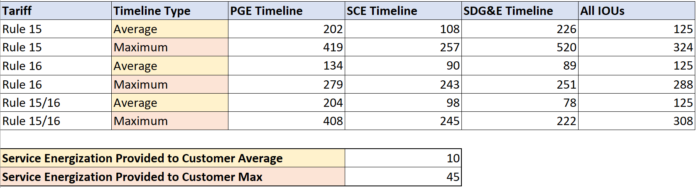

*Note: Calculated in business days.*

Table 2 provides the percentage difference between PG&E, SCE, and SDG&E individual timelines and statewide timelines by timeline type (average and maximum) for IOU dependent steps. This difference reflects the rate of acceleration required for PG&E, SCE, and SDG&E to achieve the statewide timeline types. Again, because SDG&E did not provide data for the Dependencies step, the SDG&E acceleration rates in Table 2 may differ after further insight into the Dependencies step.

Table 2. Summary of Rule 15, Rule 16, and Rule 15/16 Timelines for IOU Dependent Energization Steps – Acceleration Rates

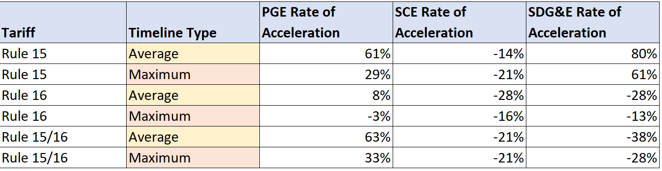

*Note: Percent difference between IOUs’ individual timelines relative to average and maximum timelines for all IOUs, reflecting rate of acceleration required to achieve all IOU timelines.*

Detailed summaries by rule and IOU appear in the workbook Guidehouse provided the CPUC, “Statewide Energization Timelines Analyses – IOU Dependent Steps”.

## Analysis Methodology

Guidehouse utilized the database developed in Section 2 for this analysis. For each of the Electric Rules (i.e., Rule 15, Rule 16, and Rule 15/16) Guidehouse followed the following methodology:

1. Calculated the **average timelines for all energization steps** by IOU and statewide. Additional calculations included **project count, standard deviation, and variance** for each step by IOU and statewide.
2. Calculated the **total average timeline** for the **IOU-dependent steps.** This was done by adding the average timelines for each IOU-dependent step by IOU and statewide.
3. Calculated the IOU-dependent **standard deviation** associated with each IOU timeline and the statewide timeline. To calculate the standard deviations for these total average timelines, Guidehouse used Equation 1 with the outputs from the first step of this task.

Equation 1. Standard Deviation of IOU Dependent Energization Timeline

$$σ_{Total}= \sqrt{σ_{Step 2}^{2}+{(\frac{1}{2}σ_{Step 3})}^{2}+σ_{Step 5}^{2}}=\sqrt{σ_{Step 2}^{2}+\frac{1}{4}σ_{Step 3}^{2}+σ_{Step 5}^{2}}=\sqrt{{var}_{Step 2}+\frac{1}{4}{var}_{Step 3}+{var}_{Step 5}}$$

$$σ=Standard Deviation and var=Variance$$

1. Calculated the **maximum timeline** for each IOU and statewideusing the averages and standard deviations for the IOU-dependent energization steps. Based on guidance from CPUC, the maximum timeline threshold is within two standard deviations from the mean as seen in Equation 2.

Equation 2. Maximum Energization Timeline Calculation

$${Time}_{Max}= {Time}_{Avg}+(2*σ_{Total})$$

1. Added **Service Energization Provided to Customer step** (CPUC assumption) to the average and maximum timelines. The CPUC provided assumed values of **10 days added to the average timelines** and **45 days added to the maximum timelines** for this step.
2. Determined the **acceleration rates** required for PG&E and SCE to achieve the statewide timelines, both average and maximum, for Rule 15, Rule 16, and Rule 15/16. This was done by calculating the percent difference between the IOU (i.e., PG&E and SCE) timelines (i.e., average, and maximum) and the corresponding statewide timeline.

##### Overview of Energization Data Provided by IOUs

###### Overall Energization Project Data Count

Table 3 reflects the number of datapoints provided by IOUs for each Tariff Type and energization step. The purpose of this table is to show the quantity of energization projects for each IOU and Tariff Type, as well as the data quantity and gaps present in the datasets provided by IOUs.

Table 3. Raw Project Count by IOU, Tariff Type, and Energization Step

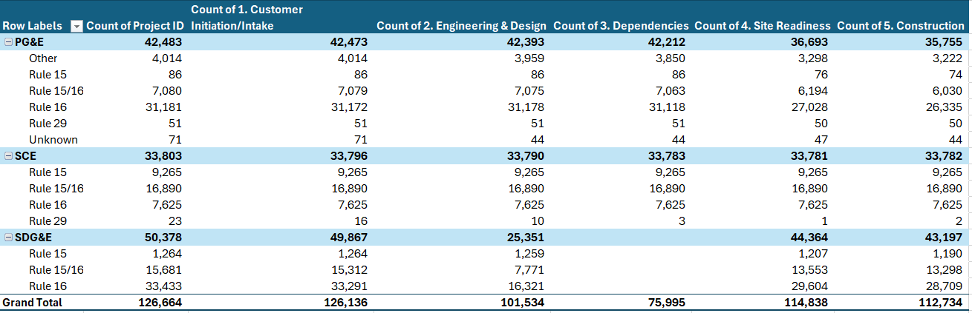

###### Impact on Data of Outlier Removal and Data Clean Up

Table 4 reflects the percentage of projects from Table 3 deemed to be outliers and therefore removed from the dataset.

Table 4. Percentage of Outliers Removed Due to Data Cleanup

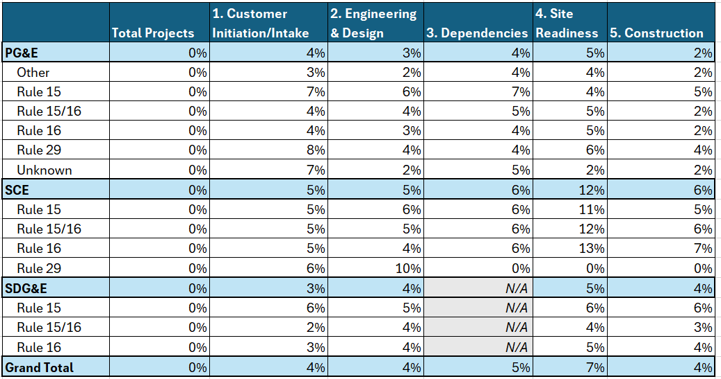

##### Statistics Summary Tables of California IOU Energization Data

###### Overall Energization Timeline Statistics Calculated by Guidehouse using IOU Data

Table 5 provides summary statistics for the database developed by Guidehouse containing energization project data provided by the IOUs in response to R.24-01-018. The table includes the average, median, standard deviation, maximum, and the associated project population for each energization step for each IOU and statewide. The data utilized to develop this table includes all tariff types relevant to each IOU for which IOUs provided data.

Table 5. Guidehouse Timeline Summary Statistics

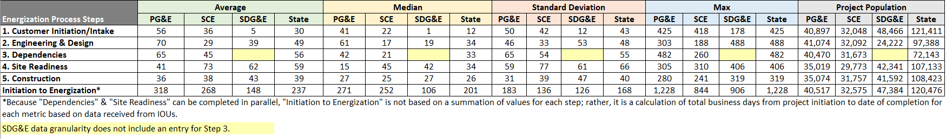

Note: Calculated in business days.

###### Comparison of Guidehouse and IOU Energization Timeline Statistics – Energization Timelines by Step

The data summary statistics provided by IOUs (as seen in Table 7) did not include all tariff types as those developed by Guidehouse in section B.1. Therefore, to make an appropriate comparison Guidehouse only included the same tariff types to those provided by the IOUs (as seen in Table 6) as follows:

* PG&E did not filter out any electric rule in their statistics calculations.[9] No changes to the Guidehouse statistics were required.
* SCE only included statistics for Rule 15, Rule 16, and Rule 15 & 16.[10] Guidehouse excluded Rule 29 data from the calculations.
* SDG&E only included Rule 15 statistics. Guidehouse excluded Rule 16 and Rule 15/16 data from the calculations.

Beyond the level of granularity, the following are additional notes to consider when reviewing these tables and comparing the statistics:

* SDG&E data granularity that does not include step 3 (Dependencies) data and thus is highlighted in the summary tables.
* SCE data granularity does not differentiate between steps 3 (Dependencies) and 4 (Site Readiness). Guidehouse developed data points for each step based on assumptions mentioned above. Therefore, when comparing Guidehouse statistics and SCE-provided statistics the differences for steps 3 and 4 are only approximations based on the assumptions made by Guidehouse.

Table 6 refects business days calculated by Guidehouse for the IOU reported data summaries of the cleaned dataset.

Table 6. Guidehouse Timeline Statistics Calculated with IOU Data – By Step

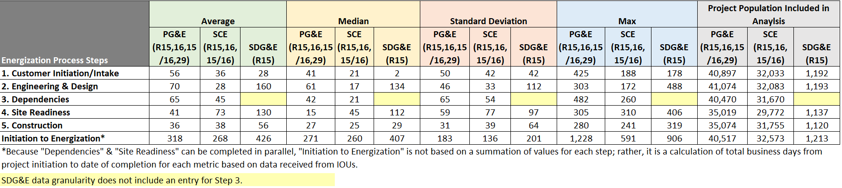 Note: Calculated in business days.

Table 7reflects business days provided by the IOUs in response to R.24-01-018.

Table 7. IOU Timeline Statistics Provided in Proceeding Response – By Step

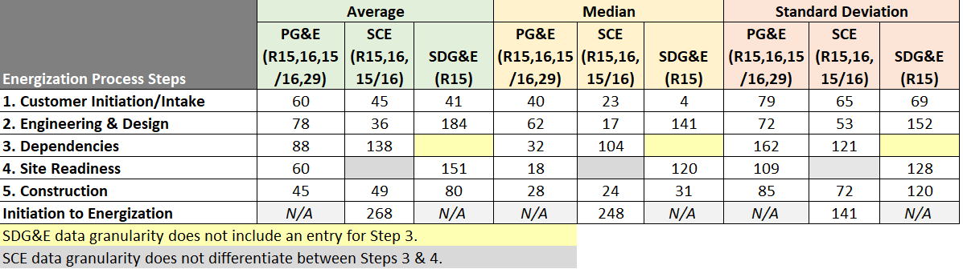

Note: Provided in business days

Table 8 provides the differences between Guidehouse days (Table 6) minus IOU days (Table 7).

Table 8. Differences Between Guidehouse-Calculated and IOU-Provided Timeline Statistics – by Step*

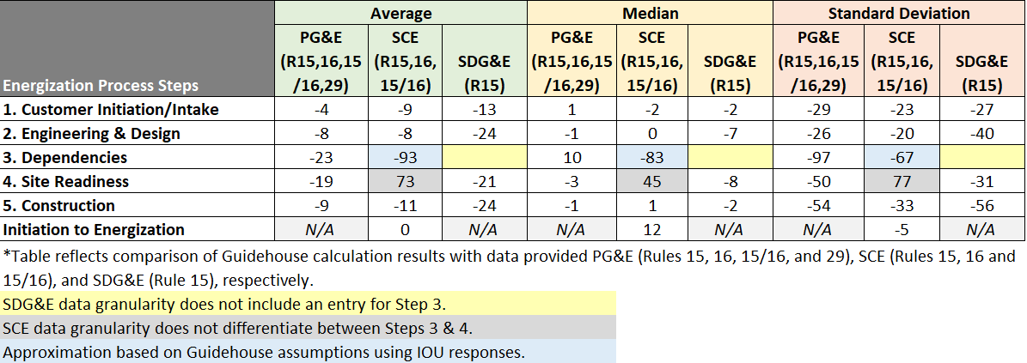

###### Comparison of Guidehouse and IOU Energization Timeline Statistics – Energization Timelines by Tariff

Guidehouse calculations and comparisons in this section reflect that:

* SCE Rule 29 dataset had less than 30 projects with significant data gaps rendering the project population insufficient for a material statistical analysis. The results for SCE Rule 29 are included only for reference and should **not** be considered in CPUC decision-making until SCE provides a more robust dataset for comparison with the other IOU Rule 29 data.
* SDG&E did not provide Rule 45 specific data. SCE and PG&E also do not provide any Rule 45 data as this rule does not apply to them.
* No IOU provided combined Rule 15 & 29/45 data.

Table 9 reflects timeline statistics from the date of project initiation to the date of completion/energization.

Table 9. Guidehouse Timeline Statistics Calculated with IOU Data – By Tariff

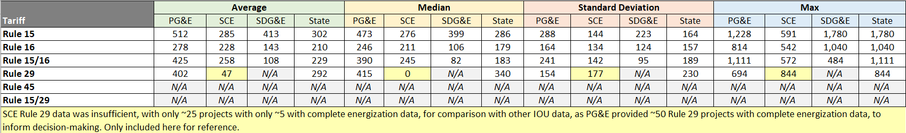

Note: Calculated in business days.

Table 10 refects business days provided by the IOUs in response to R.24-01-018.

Table 10. IOU Timeline Statistics Provided in Proceeding Response – By Tariff

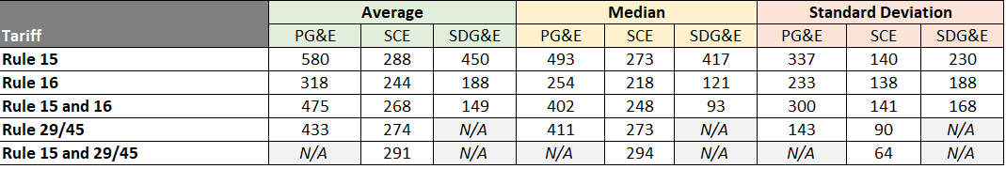

Note: Provided in business days

Table 11 provides the differences between Guidehouse days (Table 9) minus IOU days (Table 10).

Table 11. Differences Between Guidehouse-Calculated and IOU-Provided Timeline Statistics – By Tariff

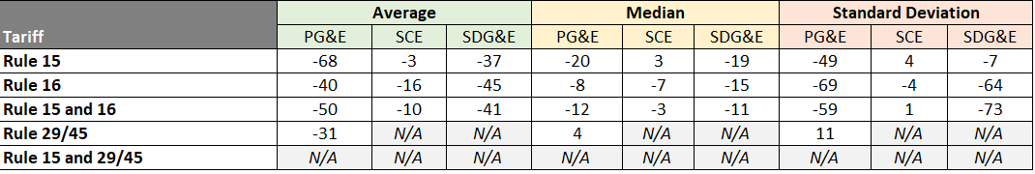

**(END OF APPENDIX A)**

1. CPUC. March 21, 2024. Administrative Law Judge’s Ruling Directing Utility Responses to Questions Regarding Energization Timelines. Available at <https://docs.cpuc.ca.gov/PublishedDocs/Efile/G000/M527/K533/527533715.PDF>
2. SDG&E, PG&E, and SCE. April 22, 2024. Joint IOU Response and data files. Available at <https://www.sdge.com/rates-and-regulations/proceedings/Order-Instituting-Rulemaking-to-Establish-Energization-Timelines>.
3. CPUC. January 25, 2024. Order Instituting Rulemaking to Establish Energization Timelines (R.24-01-018). Available at <https://docs.cpuc.ca.gov/PublishedDocs/Published/G000/M524/K427/524427971.PDF>
4. Purpose of the proceeding as found in the Order Instituting Rulemaking to Establish Energization Timelines (R.24-01-018) published January 25, 2024.
5. Guidehouse workbooks: (1) Statewide Energization Timelines Analyses – Energization Timelines Data Analysis for All Steps; (2) Statewide Energization Timelines Analyses – Energization Timelines for IOU Dependent Steps
6. Recognizing that the energization data provided by IOUs does not follow a normal distribution. While this outlier methodology is typically utilized for data with normal distribution it still provided valuable data cleaning for this data, as can be seen in Table 4 reflects the percentage of projects from Table 3 deemed to be outliers and therefore removed from the dataset.

   Table 4. Percentage of Outliers Removed Due to Data Cleanup.
7. Rule 15/16 refers to energization projects that involve **both** Rule 15 and Rule 16 activities and procedures. Further detail about these rules is available at <https://www.cpuc.ca.gov/industries-and-topics/electrical-energy/infrastructure/electric-reliability/undergrounding-program-description/rule-20/cpuc-rule-20-undergrounding-programs-current-proceeding-r1705010/electric-tariff-rules-15-and-16-distribution-line-and-service-extensions>
8. Without knowing further details on what elements are included in other SDG&E steps (e.g., how the dependencies step is distributed across other steps) and how it may or may not align to the assumptions used in developing the IOU dependent energization step timeline, the SDG&E timeline may vary upon further insight of the data provided for this analysis.
9. PG&E utilized the complete raw data they provided to calculate statistics. Notably, the dataset does not include Rule 15/29 data as they claim to have too few projects associated with that rule. Additionally, there is no Rule 45 data for PG&E as this rule only applies to SDG&E.
10. While SCE did provide statistics for Rule 29 and Rule 15/29, Guidehouse did not include the data from these Rules in calculations since a) the SCE Rule 29 raw data was limited in project counts and b) SCE did not provide any raw data for Rule 15/29.