**PUBLIC UTILITIES COMMISSION OF THE STATE OF CALIFORNIA**

**Communications Division RESOLUTION T-17853**

**Broadband Regional Initiatives Branch November 7, 2024**

**R E S O L U T I O N**

**RESOLUTION T-17853: Approves five applications for grants for up to $60,986,404 from the Last Mile Federal Funding Account in Amador and Solano Counties, providing service to 2,249 unserved locations.**

1. **SUMMARY**

This Resolution recommends approval of five Last Mile Federal Funding Account grants in the amount of up to $60,986,404.

This Resolution is part of the eighth package of Resolutions approving grants to Federal Funding Account applicants for broadband infrastructure projects serving unserved areas in California. Subsequent Resolutions will be presented for Commission vote as Communications Division Staff completes its analyses of applications.

The five projects in this Resolution propose to make investments bringing the social, economic, civic, and public safety benefits of high-speed broadband to 2,249 unserved locations and an estimated unserved population of 5,125 in Amador and Solano Counties. An estimated total population of 9,762 people will benefit from these investments as households and businesses that already have service in these communities will benefit from greater customer choice in the broadband market. The last mile connections funded by these grants build upon the state-owned open-access Middle-Mile Broadband Initiative.

Staff recommends grant awards to two entities (listed in the order in which they appear in this Resolution): Golden State Connect Authority (GSCA) and the City of Vallejo.

Golden State Connect Authority is a Joint Powers Authority formed by member counties, including Amador County. The City of Vallejo is an incorporated city located in Solano County.

Staff recommends the following five grant applications for Commission approval as shown in Table 1 below. Maps and summaries associated with each project are in the appendices.

**Table 1: Summary of Grant Funding**

|  |  |  |  |  |  |  |
| --- | --- | --- | --- | --- | --- | --- |
| **Applicant** | **Project Name** | **Estimated Unserved Locations** | **Estimated Unserved Units** | **Estimated Unserved Population** | **Estimated Benefitting Population** | **Awarded**  **Amount** |
| **Amador** | | | | | | |
| Golden State Connect Authority | GSCA Amador County Broadband Network | 1,778 | 2,059 | 3,539 | 5,389 | $57,180,300 |
| **Subtotal** | | **1,778** | **2,059** | **3,539** | **5,389** | **$57,180,300** |
|  | |  |  |  |  |  |
| **Solano** | | | | | | |
| City of Vallejo | Mare Island Build | 177 | 200 | 673 | 1,049 | $635,908 |
| City of Vallejo | N. Sonoma Blvd. | 68 | 136 | 302 | 1,010 | $1,014,322 |
| City of Vallejo | Porter St to Seaport | 32 | 69 | 149 | 1,726 | $1,680,329 |
| City of Vallejo | Trailer City Park Project | 194 | 201 | 462 | 588 | $475,545 |
| **Subtotal** | | **471** | **606** | **1,586** | **4,373** | **$3,806,104** |
| **Total** | | **2,249** | **2,665** | **5,125** | **9,762** | **$60,986,404** |

1. **BACKGROUND**

California’s multi-year broadband investment package established the last mile Federal Funding Account as part of the Budget Act of 2021 and Senate Bill 156[1] and invested   
$2 billion in the program over multiple years. The Federal Funding Account funds the construction of last mile broadband infrastructure projects in unserved areas of California. The Federal Funding Account encourages the deployment of broadband throughout the State to enable the public to access internet-based safety applications, telehealth services, emergency services, and to allow first responders to communicate with each other and collaborate during emergencies.

On April 21, 2022, the Commission issued Decision (D.) 22-04-055, Decision Adopting Federal Funding Account Rules. The rules and guidelines adopted in that decision included, among other items, the following: rules about projects to benefit Environmental and Social Justice Communities, affordable offers, five and ten-year price commitments, low-cost plans, project eligibility, application requirements, application objections, implementation of Public Utilities Code section 281(n) allocating funding between “rural counties” and “urban counties,” a process to reimburse grantees, a ministerial review process whereby Communications Division Staff may approve certain projects, and minimum performance standards for grantees.

The Federal Funding Account D. 22-04-055 includes requirements and preference for a number of affordability requirements including:

* Participation in the Affordable Connectivity Program or access to a “broad-based affordability program.” Given that the Affordable Connectivity Program has lapsed grantees must participate in a successor program when identified by the Commission.
* A five-year price commitment, and preference for a ten-year commitment.
* Preference for a low-cost plan that is $40/month or less and provides speeds of at least 50 Megabits per second (Mbps) down and 20 Megabits per second up.
* Preference for participation in the California and/or federal Lifeline programs (which may include bundled voice and broadband offerings).

Applications that committed to provide voice service and participate in LifeLine, consistent with the requirement to serve customers in the project area at prices not exceeding those in the application for five years after project completion, must provide voice service and participate in LifeLine for five years after project completion. In providing grant funding to projects the Commission is validating the need for and the state’s investment in the provision of communications service, including voice and programs supporting affordability like LifeLine, for the life of the infrastructure.

The Federal Funding Account Decision and Appendix specify additional consideration for disadvantaged communities or Environmental and Social Justice communities.[2] The Commission made available on the Federal Funding Account Public Map,[3] the Applicant Tool,[4] and data downloads locations and census blocks meeting these definitions.[5] A grant application window was opened on June 30, 2023, and closed at   
4 p.m. on September 29, 2023; 484 applications were submitted. Application summaries were posted on October 23, 2023, and a 28-day objection period closed on   
November 20, 2023. Responses to objections were received until December 20, 2023.

Applications were holistically evaluated: required and supporting documentation and the merits of the applications were compared and assessed on a county basis. Following an initial analysis, Staff sent a data request to applicants and requested additional information. Staff’s holistic evaluation included project engineering, technical feasibility and design, financial viability, cost, applicant capacity, and community need, among other factors. Staff assessed how to manage overlapping applications and applications planning to include some already-served areas in their project area.[6]  
  
Staff also evaluated how applications and groups of applications compared to competing applications in the same county.

The specific locations to be provided service for a given project will be updated and reconciled with the Broadband Serviceable Location Fabric after detailed engineering and project design, and the grant amount may be reduced consistent with a reduction in the number of locations. The Federal Funding Account award will not fund locations supported by a federal broadband program with Capital Project Fund monies.[7]

**III. APPLICATION SUMMARIES, DISCUSSION, AND RECOMMENDATIONS**

**Amador Summary**

The allocation for projects in Amador County in D. 22-04-005 is $57,203,182. This Resolution recommends awarding one grant to GSCA for a project in Amador County. The recommended grant amount for the project in Amador County is $57,180,300, which leaves a remainder of $22,882 of the allocation for Amador County.

**Amador County Awards**

1. *GSCA, GSCA Amador County*

Staff recommends the Commission approve Golden State Connect Authority’s application for a grant of up to $57,180,300 for the GSCA Amador County Broadband Network project.

The GSCA Amador County Broadband Network project proposes to serve an estimated 1,778 unserved locations, based on a March 2024 supplemental application filing, which has since been modified by objections. There are approximately 2,059 unserved units in the project area. An estimated unserved population of 3,539 would be offered service. An estimated total population of 5,389 will benefit from these investments in the communities of Unincorporated Amador County. The last-mile fiber project will provide up to 100 Mbps / 100 Mbps per second service to consumers.

Golden State Connect Authority will deploy approximately 284 miles of open access fiber infrastructure as part of an active or point-to-point ethernet last mile open access network. The network will be 100 percent underground. Amadar County, and the GSCA Amador County Broadband Network, are largely in High Fire Threat Districts 2 and 3. With this in mind the grant is conditional on one or more providers on the GSCA Amador County Broadband Network offering voice service and participating in the California LifeLine program. Voice service and LifeLine participation should extend for at least five-years from project completion.

The GSCA Amador County Broadband Network project will benefit disadvantaged or Environmental and Social Justice communities; 25 percent of the unserved locations are low-income. Golden State Connect Authority has committed to maintaining its prices for at least ten years.

The proposed project will cost an estimated $66,570,300, of which the Federal Funding Account will fund approximately 86 percent of costs.

Staff determined that the applicant and the project are financially viable, and the applicant’s engineering meets the program standards. The applicant demonstrated the administrative, technical, and operational capacity to provide broadband service at the scale of this project.

This application received two objections. For one objection, staff determined that the objectors did not provide sufficient documentation to substantiate the objection. For the other objection, the objector provided information demonstrating that 794 locations in the project area are reliably served. In addition, Staff confirmed that there are approximately 75 locations that received support from the Rural E-Connectivity (ReConnect) Program. The objected to and ReConnect program locations with reliable 25 Mbps download and 3 Mbps upload service will be removed and staff will consult with the applicant on reducing the grant amount in light of the updated project locations. In addition, though not all of the objections were upheld, staff has determined that inclusion of some of the served locations would be necessary for the viability of the project. The project area of GSCA Amador County Broadband Network, beyond the removed objection and ReConnect locations, was not further modified in response to objections; the Federal Final Rule[8] allows projects serving unserved locations to include served locations to make the project [9]. Federal Funding Account award will not fund locations supported by a federal broadband program with Capital Project Fund monies. [10]

No Federal Funding Account Public Map comments were submitted in Amador County.[11] GSCA Amador County Broadband Network project area’s unserved locations were evaluated in light of the updated Federal Communications Commission and Federal Funding Account unserved data (as of June 30, 2023). In response to objections and this data, the number of unserved locations is reduced from 2,647 to 1,778, the project area is unchanged, and the total grant amount is unchanged; staff will consult with the applicant on reducing the grant amount in light of the updated the project locations. The specific locations to be provided service will be updated and reconciled with the Broadband Serviceable Location Fabric after detailed engineering and project design, and the grant amount may be reduced consistent with a reduction in the number of locations.

The following submitted letters of support for this application: The Amador County General Services Administration.

The proposed project provides the public safety benefits of reliable broadband infrastructure. The proposed project provides the public safety benefits of reliable broadband infrastructure and will benefit households located in High Fire Threat Districts 2 and 3. This project will connect to the open-access Middle-Mile Broadband Initiative.

Based on the information received, the Commission’s Energy Division has determined that this project has not met the requirements of California Environmental Quality Act (CEQA) categorial exemption at this time. Golden State Connect Authority must comply with the CEQA requirements discussed in the appendices. If Golden State Connect Authority provides additional documentation sufficient to justify a staff determination of CEQA exemption, then the project can be exempted by letter from the Communications Division Director or the director’s delegate or designee.

Golden State Connect Authority and the GSCA Amador County Broadband Network project comply with all requirements for approval in D. 22-04-055. The Communications Division recommends that the Commission approve the Golden State Connect Authority’s application for a grant of up to $57,180,300 for the GSCA Amador County Broadband Network project.

**Solano Summary**

The allocation for projects in Solano County in D. 22-04-005 is $17,007,524. This Resolution recommends awarding four grants to the City of Vallejo for projects in Solano County. The recommended grant amount for the projects in Solano County is $3,806,104, which leaves a remainder of $13,201,420 of the allocation for Solano County.

**Solano County Awards**

1. *City of Vallejo, Mare Island Build*

Staff recommends the Commission approve City of Vallejo’s application for a grant of up to $645,908 for the Mare Island Build project.

The Mare Island Build project proposes to serve an estimated 177 unserved locations based on a March 2024 supplemental application filing. There are approximately 200 unserved units in the project area. An estimated unserved population of 673 would be offered service. An estimated total population of 1,049 will benefit from these investments in the community of Vallejo. The last-mile fiber project will provide up to 1,000 Mbps/ 1,000 Mbps per second service to consumers.

The City of Vallejo will deploy approximately five miles of last-mile fiber. The network will be 100 percent underground.

The City of Vallejo is the applicant and awardee. The City of Vallejo will retain ownership and anticipates entering into an agreement with Smart Fiber Networks to provide last mile service.

The Mare Island Build project will benefit disadvantaged or Environmental and Social Justice communities; 100 percent of the unserved locations are located in Disadvantaged areas. The City of Vallejo will provide a low-cost plan that meets the requirements in D. 22-04-055, Section 3, and has committed to maintaining its prices for at least ten years.

The proposed project will cost an estimated $635,908, of which the Federal Funding Account will fund approximately 100 percent of costs.

Staff determined that the applicant and the project are financially viable, and the applicant’s engineering meets the program standards. The applicant demonstrated the administrative, technical, and operational capacity to provide broadband service at the scale of this project.

This application received three objections and the City of Vallejo responded to the objections. For one objection, staff determined that the objector did not provide sufficient documentation to substantiate a claim that the project area is already served. For the second objection, 14 of 42 objected to locations were inside the project area. Staff verified that the application seeks funding only for unserved locations within the project area and inclusion of the served locations area is needed for project viability. For the third objection, staff verified that the two objected to locations are already served. Staff confirmed that the inclusion of (2-16) served locations would be necessary for the viability of the project; the Federal Final Rule[12] and D.22-04-055[13] allow projects serving unserved locations to include served locations to make the project viable. The project area of the Mare Island Build was not modified in response to objections.

One Federal Funding Account Public Map comment was submitted in Solano County, which did not relate to the project area.[14] The Mare Island Build project area’s unserved locations were evaluated in light of the updated Federal Communications Commission and Federal Funding Account unserved data (as of June 30, 2023). In response to objections, comments, and this data, the number of unserved locations is unchanged at 177, the project area is unchanged, and the total grant amount is unchanged. The specific locations to be provided service will be updated and reconciled with the Broadband Serviceable Location Fabric after detailed engineering and project design, and the grant amount may be reduced consistent with a reduction in the number of locations.

The following submitted letters of support for this application: Senator Bill Dodd, Third District and Congressman John Garamendi, Eighth District.

The proposed project provides the public safety benefits of reliable broadband infrastructure. This project is not located in a High Fire Threat District. This project will connect to the open-access Middle-Mile Broadband Initiative. The project includes $463,178 for open-access middle-mile fiber and backhaul fiber, and to connect to the Middle Mile Broadband Initiative.

Based on the information that the City of Vallejo provided, the Commission’s Energy Division has confirmed that the project meets the criteria for the CEQA categorical exemptions under 14 C.C.R. § 15301 (Existing Facilities), 14 C.C.R. § 15302 (Replacement or Reconstruction), and 14 C.C.R. § 15303 (New Construction or Conversion of Small Structures). Thus, the Mare Island Build project is categorically exempt from CEQA review and the Commission may authorize funds for construction activities.

The City of Vallejo and the Mare Island Build project comply with all requirements for approval in D. 22-04-055. The Communications Division recommends that the Commission approve the City of Vallejo’s application for a grant of up to $635,908 for the Mare Island Build project.

1. *City of Vallejo, N. Sonoma Blvd.*

Staff recommends the Commission approve the City of Vallejo’s application for a grant of up to $1,014,322 for the N. Sonoma Blvd. project.

The N. Sonoma Blvd. project proposes to serve an estimated 68 unserved locations based on a March 2024 supplemental application filing. There are approximately 136 unserved units in the project area. An estimated unserved population of 302 would be offered service. An estimated total population of 1,010 will benefit from these investments in the community of Vallejo. The last-mile fiber project will provide up to 1,000 Mbps/ 1,000 Mbps service to consumers.

The City of Vallejo will deploy approximately four miles of last mile fiber. The network will be 75 percent underground.

The City of Vallejo is the applicant and awardee. The City of Vallejo will retain ownership and anticipates entering into an agreement with Smart Fiber Networks to provide last mile service.

The N. Sonoma Blvd. project will benefit disadvantaged or Environmental and Social Justice communities; 100 percent of the unserved locations are located in Disadvantaged areas. The City of Vallejo will provide a low-cost plan that meets the requirements in D. 22-04-055, Section 3, and has committed to maintaining the price of that plan for at least ten years.

The proposed project will cost an estimated $1,014,322, of which the Federal Funding Account will fund approximately 100 percent of costs.

Staff determined that the applicant and the project are financially viable, and the applicant’s engineering meets the program standards. The applicant demonstrated the administrative, technical, and operational capacity to provide broadband service at the scale of this project.

This application received two objections and the City of Vallejo responded to the objections. For one objection, staff determined that the objector did not provide sufficient documentation to substantiate a claim that the project area is already served. For the other objection, two objected to locations were inside the proposed project area. Staff verified that the application seeks funding only for unserved locations within the project area. Staff also confirmed that the inclusion of two served locations would be necessary for the viability of the project; the Federal Final Rule[15] and D.22-04-055[16] allow projects serving unserved locations to include served locations to make the project viable. The project area of N. Sonoma Blvd. was not modified in response to objections.

One Federal Funding Account Public Map comment was submitted in Solano County, which did not relate to the project area.[17] The N. Sonoma Blvd. project area’s unserved locations were evaluated in light of the updated Federal Communications Commission and Federal Funding Account unserved data (as of June 30, 2023). In response to objections, comments, and this data, the number of unserved locations is unchanged at 68, the project area is unchanged, and the total grant amount is unchanged. The specific locations to be provided service will be updated and reconciled with the Broadband Serviceable Location Fabric after detailed engineering and project design, and the grant amount may be reduced consistent with a reduction in the number of locations.

The following submitted letters of support for this application: Senator Bill Dodd, Third District and Congressman John Garamendi, Eighth District.

The proposed project provides the public safety benefits of reliable broadband infrastructure. This project is not located in a High Fire Threat District. This project will connect to the open-access Middle-Mile Broadband Initiative. The project includes $617,239 for open-access middle-mile fiber and backhaul fiber, and to connect to the Middle-Mile Broadband Initiative.

Based on the information that the City of Vallejo provided, the Commission’s Energy Division has confirmed that the project meets the criteria for the CEQA categorical exemptions under 14 C.C.R. § 15301 (Existing Facilities),14 C.C.R. § 15302 (Replacement or Reconstruction), and 14 C.C.R. § 15303 (New Construction or Conversion of Small Structures). Thus, the N. Sonoma Blvd. project is categorically exempt from CEQA review and the Commission may authorize funds for construction activities.

The City of Vallejo and the N. Sonoma Blvd. project comply with all requirements for approval in D. 22-04-055. The Communications Division recommends that the Commission approve the City of Vallejo’s application for a grant of up to $1,014,322 for the N. Sonoma Blvd. project.

1. *City of Vallejo, Porter St to Seaport*

Staff recommends the Commission approve the City of Vallejo’s application for a grant of up to $1,680,329 for the Porter St. to Seaport project.

The Porter St. to Seaport project proposes to serve an estimated 32 unserved locations based on a March 2024 supplemental application filing. There are approximately 69 unserved units in the project area. An estimated unserved population of 149 would be offered service. An estimated total population of 1,726 will benefit from these investments in the community of Vallejo. The last-mile fiber project will provide up to 1,000 Mbps / 1,000 Mbps service to consumers.

The City of Vallejo will deploy approximately two miles of last-mile fiber. The network will be 100 percent underground.

The City of Vallejo is the applicant and awardee. The City of Vallejo will retain ownership and anticipates entering into an agreement with Smart Fiber Networks to provide last mile service.

The Porter St. to Seaport project will benefit disadvantaged or Environmental and Social Justice communities; 100 percent of the unserved locations are located in Disadvantaged areas. The City of Vallejo will provide a low-cost plan that meets the requirements in D. 22-04-055, Section 3, and has committed to maintaining the price of that plan for at least ten years.

The proposed project will cost an estimated $1,680,329, of which the Federal Funding Account will fund approximately 100 percent of costs.

Staff determined that the applicant and the project are financially viable, and the applicant’s engineering meets the program standards. The applicant demonstrated the administrative, technical, and operational capacity to provide broadband service at the scale of this project.

This application received three objections and the City of Vallejo responded to the objections. For one objection, staff determined that the objector did not provide sufficient documentation to substantiate a claim that the project area is already served. For the other objection, staff verified that the objected to location is served and not part of the project. Staff verified that the application seeks funding only for unserved locations within the project area. For the third objection, staff verified that approximately 56 locations in the project area receive reliable service. Staff confirmed that the inclusion of the served locations in the project area would be necessary for the viability of the project; the Federal Final Rule[18] and D.22-04-055[19] allow projects serving unserved locations to include served locations to make the project viable. The project area of Porter St. to Seaport was not modified in response to objections.

One Federal Funding Account Public Map comment was submitted in Solano County, which did not relate to the project area.[20] Porter St. to Seaport project area’s unserved locations were evaluated in light of the updated Federal Communications Commission and Federal Funding Account unserved data (as of June 30, 2023). In response to objections, comments, and this data, the number of unserved locations is unchanged at 32, the project area is unchanged, and the total grant amount is unchanged. The specific locations to be provided service will be updated and reconciled with the Broadband Serviceable Location Fabric after detailed engineering and project design, and the grant amount may be reduced consistent with a reduction in the number of locations.

The following submitted letters of support for this application: Senator Bill Dodd, Third District and Congressman John Garamendi, Eighth District.

The proposed project provides the public safety benefits of reliable broadband infrastructure. This project is not located in a High Fire Threat District. This project will connect to the open-access Middle-Mile Broadband Initiative. The project includes $1,322,735 for open-access middle-mile fiber and backhaul fiber, and to connect to the Middle Mile Broadband Initiative.

Based on the information that the City of Vallejo provided, the Commission’s Energy Division has confirmed that the Porter St to Seaport project is categorically exempt from CEQA review, under 14 California Code of Regulations (CCR) § 15301 (Existing Facilities),14 C.C.R. § 15302 (Replacement or Reconstruction), and 14 C.C.R. § 15303 (New Construction or Conversion of Small Structures). Thus, the Commission may authorize funds for construction activities.

The City of Vallejo and the Porter St. to Seaport project comply with all requirements for approval in D. 22-04-055. The Communications Division recommends that the Commission approve the City of Vallejo’s application for a grant of up $1,680,329 for the Porter St. to Seaport project.

1. *City of Vallejo, Trailer City Park Project*

Staff recommends the Commission approve the City of Vallejo’s application for a grant of up to $475,545 for the Trailer City Park project.

The Trailer City Park project proposes to serve an estimated 194 unserved locations based on a March 2024 supplemental application filing. There are approximately 201 unserved units in the project area. An estimated unserved population of 462 would be offered service. An estimated total population of 588 will benefit from these investments in the communities of Vallejo. The last-mile fiber project will provide up to 1,000 Mbps/ 1,000 Mbps service to consumers.

The City of Vallejo will deploy approximately two miles of last mile fiber. The network will be 70 percent underground.

The City of Vallejo is the applicant and awardee. The City of Vallejo will retain ownership and anticipates entering into an agreement with Smart Fiber Networks to provide last mile service.

The Trailer City Park project will benefit disadvantaged or Environmental and Social Justice communities; 100 percent of the unserved locations are located in low-income areas. The City of Vallejo will provide a low-cost plan that meets the requirements in D. 22-04-055, Section 3, and has committed to maintaining the price of that plan for at least ten years.

The proposed project will cost an estimated $475,545, of which the Federal Funding Account will fund approximately 100 percent of costs.

Staff determined that the applicant and the project are financially viable, and the applicant’s engineering meets the program standards. The applicant demonstrated the administrative, technical, and operational capacity to provide broadband service at the scale of this project.

This application received two objections, and the City of Vallejo responded to the objections. For one objection, staff determined that the objector did not provide sufficient documentation to substantiate a claim that the project area is already served. For the other objection, approximately half of the objected to locations were outside of the proposed project area. Staff confirmed approximately 82 locations are served. Staff confirmed that the inclusion of the served locations in the project area would be necessary for the viability of the project; the Federal Final Rule[21] and D.22-04-055[22] allow projects serving unserved locations to include served locations to make the project viable. The project area of Trailer City Park was not modified in response to objections.

One Federal Funding Account Public Map comment was submitted in Solano County, which did not relate to the project area.[23] The Trailer City Park project area’s unserved locations were evaluated in light of the updated Federal Communications Commission and Federal Funding Account unserved data (as of June 30, 2023). In response to objections, comments, and this data, the number of unserved locations is unchanged at 194, the project area is unchanged, and the total grant amount is unchanged. The specific locations to be provided service will be updated and reconciled with the Broadband Serviceable Location Fabric after detailed engineering and project design, and the grant amount may be reduced consistent with a reduction in the number of locations.

The following submitted letters of support for this application: Senator Bill Dodd, Third District and Congressman John Garamendi, Eighth District.

The proposed project provides the public safety benefits of reliable broadband infrastructure. This project is not located in a High Fire Threat District. This project will connect to the open-access Middle-Mile Broadband Initiative. The project includes $91,636 to $197,383 for open-access middle-mile fiber and backhaul fiber, and to connect to the Middle-Mile Broadband Initiative.

Based on the information that the City of Vallejo provided, the Commission’s Energy Division has confirmed that the Trailer City Park project is categorically exempt from CEQA review, under 14 C.C.R. § 15301 (Existing Facilities),14 C.C.R. § 15302 (Replacement or Reconstruction), and 14 C.C.R. § 15303 (New Construction or Conversion of Small Structures). Thus, the Commission may authorize funds for construction activities.

The City of Vallejo and the Trailer City Park project comply with all requirements for approval in D. 22-04-055. The Communications Division recommends that the Commission approve the City of Vallejo’s application for a grant of up to $475,545 for the Trailer City Park project.

**Comments**

In compliance with Public Utilities Code Section 311(g)(1), a Notice of Availability of this draft resolution was e-mailed on October 4, 2024, informing all parties on the CASF Distribution List and the R. 20-09-001 Service List of the availability of the draft of this Resolution, and of the opportunity to comment, at the Commission’s website at <http://www.cpuc.ca.gov/>.

**IV. COMPLIANCE REQUIREMENTS**

Awardees are required to comply with all the guidelines, requirements, and conditions associated with the grant of Federal Funding Account awards as specified in D.22-04-055. All Awardees are also required to sign a consent form agreeing to the terms and conditions of the Federal Funding Account. Such compliance includes, but is not limited to, the items noted below.

A. Deployment Schedule: All CEQA-exempt projects must be completed within 18 months, and all other projects shall be completed within 24 months after receiving authorization to construct.

B. Pricing: By accepting these awards, the Awardees commit to serve customers in the project area at prices not exceeding those provided in the application for five years after project completion. Awardees who committed not to increase prices for a period of ten years in their application commit to serve customers in the project area for ten years after project completion. Should the need arise for grant recipients to adjust prices due to externalities outside their control (*e.g.* inflation), grant recipients may file and serve, on the R. 20-09-001 proceeding service list, a request to modify this requirement with the Communications Division.

C. Speed and Latency: All households in the proposed project areas must be offered a broadband internet service plan with speeds of at least 100 megabits per second download and 100 megabits per second upload, with not more than 100 milliseconds of latency.

D. Affordability: All projects shall participate in the Affordable Connectivity Program or otherwise provide access to a broad-based affordability program to low-income customers in the proposed service area of the broadband infrastructure that provides benefits to households commensurate with those provided under the Affordable Connectivity Program. Should the Affordable Connectivity Program end, the Commission will identify a successor low-income subsidy program in which participants must participate. Awardees must participate in a successor to the Affordable Connectivity Program identified after the grant is awarded.

E. Project Audit: The Commission has the right to conduct any necessary audit, verification, and discovery during project implementation/construction to ensure that Federal Funding Account funds are spent in accordance with Commission approval. All recipients of federally funded grants exceeding $750,000 will need to include a budget for a federal audit.[24]

F. Reporting Requirements: Numerous post-award reports are required. In summary, these include monthly contractor reports (if applicable), quarterly progress reports, and a final completion report.[25]

G. Prevailing Wage: Section 1720 of the California Labor Code requires Federal Funding Account projects be subject to prevailing wage requirements.[26] Applicants accepting Federal Funding Account awards are committing to follow state prevailing wage requirements with regards to their projects.

H. Payments to Federal Funding Account Recipients: The Commission may reimburse Awardees’ expenses in accordance with Public Utilities Code Section 281(n)(2), D.22-04-055, and the Appendix. Requests for payments may be submitted as the project is progressively deployed. The prerequisite for first payment is the submittal of a progress report to the Commission showing that a minimum of ten percent of the project (as determined by budget spent) has been completed. Subsequent payments may be made upon at least 25 percent intervals, with the final 15 percent payment request (from 85 to 100 percent) not eligible for payment without an approved completion report. Payments are based on submitted receipts, invoices and other supporting documentation showing expenditures incurred for the project in accordance with the approved Federal Funding Account budget included in the awardee’s application.

**FINDINGS OF FACT**

1. California’s multi-year broadband infrastructure investments in the Budget Act of 2021 and Senate Bill 156 (Statutes 2021, Chapters 84 and 112) provided $2 billion over multiple years to the Last Mile Federal Funding Account to facilitate, via reimbursement, construction of last mile broadband infrastructure projects to connect unserved Californians.
2. On April 21, 2022, the Commission approved Decision 22-04-055, which along with the Federal Final Rule, established the Last Mile Federal Funding Account and set program rules.
3. The Communications Division opened an application window for the Federal Funding Account on June 30, 2023, and closed it on September 29, 2023. Applicants submitted 484 applications before the deadline. Application summaries were posted on October 23, 2023, and a 28-day objection window closed on November 20, 2023. Responses to objections were received until December 20, 2023.
4. Golden State Connect Authority submitted an application for the GSCA Amador County project on September 29, 2023.
5. The City of Vallejo submitted applications for the Mare Island Build, N. Sonoma Blvd., Porter St. to Seaport, and Trailer City Park Projects on September 29, 2023.
6. Applicants responded to a supplemental data request that was due on March 12, 2024, providing information on project route miles, poles, unserved locations, middle-mile connectivity, and other updated project specific information.
7. The Commission has determined that Golden State Connect Authority’s GSCA Amador County project is not categorically exempt from California Environmental Quality Act review at this time.
8. The Commission has determined that the City of Vallejo’s Mare Island Build, N. Sonoma Blvd., Porter St to Seaport, and Trailer City Park Project projects are categorically exempt from California Environmental Quality Act (CEQA) review pursuant to CEQA Guidelines at 14 California Code of Regulations (C.C.R.) Section 15301 regarding exemption for existing facilities, 14 C.C.R. Section 15302 regarding replacement or reconstruction, and 14 C.C.R. Section 15303 regarding new construction or conversion of small structures.
9. Communications Division staff analyzed the applications for compliance with Commission and Federal rules, reviewed local feedback, and conducted fiscal and technical analysis.
10. All applications listed above met minimum eligibility requirements provided in Decision 22-04-055.
11. Staff recommends approval of the applications in this resolution, as they comply with program rules as stated and contribute to the Federal Funding Account’s goal of building broadband internet infrastructure to communities without access to internet service at sufficient and reliable speeds.
12. Draft Resolution T-17853 was emailed to the CASF Distribution List and the R. 20-09-001 Service List on October 4, 2024, in compliance with Public Utilities Code Section 311(g)(1).

**THERFORE, IT IS ORDERED** that:

1. The Commission shall award up to $57,180,300 in Federal Funding Account funds to Golden State Connect Authority in order to complete the GSCA Amador County Broadband Network, as described in the appendices. The specific locations to be provided service will be updated and reconciled with the Broadband Serviceable Location Fabric after detailed engineering and project design, and the grant amount may be reduced consistent with a reduction in the number of locations.
2. The GSCA Amador County Broadband Network must include one or more providers offering voice service and participating in the California LifeLine program for at least five-years from project completion.
3. The Commission shall award up to $635,908 in Federal Funding Account funds to the City of Vallejo in order to complete the Mare Island Build project, as described in the appendices. The specific locations to be provided service will be updated and reconciled with the Broadband Serviceable Location Fabric after detailed engineering and project design, and the grant amount may be reduced consistent with a reduction in the number of locations.
4. The Commission shall award up to $1,014,322 in Federal Funding Account funds to the City of Vallejo in order to complete the N. Sonoma Blvd. project, as described in the appendices. The specific locations to be provided service will be updated and reconciled with the Broadband Serviceable Location Fabric after detailed engineering and project design, and the grant amount may be reduced consistent with a reduction in the number of locations.
5. The Commission shall award up to $1,680,329 in Federal Funding Account funds to the City of Vallejo in order to complete the Porter St. to Seaport project, as described in the appendices. The specific locations to be provided service will be updated and reconciled with the Broadband Serviceable Location Fabric after detailed engineering and project design, and the grant amount may be reduced consistent with a reduction in the number of locations.
6. The Commission shall award up to $475,545 in Federal Funding Account funds to the City of Vallejo in order to complete the Trailer City Park Project, as described in the appendices. The specific locations to be provided service will be updated and reconciled with the Broadband Serviceable Location Fabric after detailed engineering and project design, and the grant amount may be reduced consistent with a reduction in the number of locations.
7. To ensure compliance with all program rules and guidelines, the Commission will not release funds to an applicant, including but not limited to Golden State Connect Authority and the City of Vallejo, proposing to enter into agreement(s) with a third party or third parties for the ownership, operation, and/or leasing of the proposed infrastructure or network until the applicant provides the Commission with an advanced copy of the agreement document(s) as well as any signed agreements.
8. For those projects not determined to be categorically exempt, the Commission cannot release funds for construction activities until California Environmental Quality Act (CEQA) review is complete. The awardees must comply with the requirements set forth in the CEQA Section of the Resolution. The awardees must provide their Proponent’s Environmental Assessment for each project prior to the first payment.
9. Awardee(s) shall comply with all guidelines, requirements, and conditions set forth in this resolution.
10. When a successor to the Affordable Connectivity Program is identified by the Commission, all awardees shall participate in that program.
11. All construction covered by the grant must be completed within the applicable 18-month or 24-month time frame. In the event of extenuating circumstances jeopardizing this timeline, the Awardee(s) must notify the Communications Division’s Director as soon as they become aware of any delay. If such notice is not provided, staff can take corrective actions including reducing payment for failure to satisfy this requirement.
12. If the awardee(s) fail to complete the project(s) in accordance with the terms outlined in Decision 22-04-055 and with the terms of the Commission’s approval, as set forth in this resolution, awardees must reimburse some or all the Federal Funding Account grants received or take other corrective action.
13. If staff evaluation finds any of the projects can be exempt from the California Environmental Quality Act, then the project can be exempted by letter from the Communications Division Director or the director’s delegate or designee.
14. The effective date of each award and encumbrance of funds is to be set, in consultation with the Applicant, by letter from the Communications Division Director or the director’s delegate or designee. All awards are contingent on available state budget appropriations funding.

This resolution is effective today.

I certify that the foregoing resolution was duly introduced, passed, and adopted at a conference of the Public Utilities Commission of the State of California held on ___________________, the following Commissioners voting favorable thereon:

|  |  |
| --- | --- |
|  |  |
|  | Rachel Peterson  Executive Director |

**Golden State Connect Authority California Environmental Quality Act Compliance Requirements**

The following Golden State Connect Authority project is subject to California Environmental Quality Act (CEQA) review:

* GSCA Amador County Broadband Network

The Commission must complete CEQA review prior to disbursing Federal Funding Account funds for construction activities. The initial funding granted in this Resolution may be used for project development and other Golden State Connect Authority activities that do not involve construction or any activities that would have any direct or indirect effect on the physical environment.  
  
Prior to any construction activity for the project, Golden State Connect Authority is required to seek further authority from the Commission for such activity by filing a Proponent’s Environmental Assessment (PEA) pursuant to Commission Rule of Practice and Procedure 2.4; and must undergo an environmental review pursuant to CEQA (California Public Resources Code § 21000 et seq.).  
  
Golden State Connect Authority should contact the Supervisor of the Commission’s Energy Division CEQA Unit well in advance of a contemplated filing to (a) consult with staff regarding the process of developing and filing a PEA; (b) provide for cost recovery per Rule of Practice and Procedure 2.5; and (c) enter into a Memorandum of Understanding to allow the Energy Division to initiate the retention of an environmental contractor to perform the environmental review.  
  
Golden State Connect Authority’s listed application is subject to National Environmental Policy Act (NEPA) review, as acknowledged in its application. Golden State Connect Authority should make every effort to ensure that the Commission’s CEQA Unit is aware of and included in the NEPA process. Golden State Connect Authority must provide a PEA prior to the first payment. The Commission cannot release funds for the construction project until the Commission has completed CEQA review.  
  
Golden State Connect Authority must provide a PEA prior to the first payment. The Commission cannot release funds for the construction phase of this project until the Commission has completed CEQA review.

**The City of Vallejo California Environmental Quality Act Compliance Requirements**

The following City of Vallejo projects are categorically exempt from California Environmental Quality Act (CEQA) review:

* Mare Island Build
* N. Sonoma Blvd.
* Porter St to Seaport
* Trailer City Park Project

For the Mare Island Build project, the City of Vallejo provided the Commission with its project plans to install new underground fiber in existing underground facilities within existing rights-of-way. The project is located on Mare Island, a peninsula separated from the City of Vallejo by the Napa River. The project will involve the installation of approximately five miles of fiber to be located along Nimitz Avenue, Railroad Avenue, Walnut Avenue, Azuar Drive, and Flagship Drive, butting up to Farragut Village, Coral Sea, and Kirkland Isle II neighborhoods. The City of Vallejo expects to use an existing underground conduit system to place the new fiber. In the event aerial facilities are required for any connections as part of the project, then standard utility poles ranging from 45 to 55 feet in height would be employed. The City of Vallejo shall ensure the poles comply with General Order 95.

For the N. Sonoma Blvd. project, the City of Vallejo provided the Commission with its project plans to install new aerial and underground fiber. Existing utility poles will be used for the aerial installation of new fiber. New underground fiber will be installed in existing conduit within existing rights-of-way and previously disturbed ground adjacent to existing roadways. The N. Sonoma Blvd. project middle-mile component will utilize the existing underground conduit system to extend fiber along Sonoma Blvd. The underground portions of the project will be located along existing roadways. For the last-mile connections, the project will expand into neighborhoods between Broadway and Highway 37, bordered by Sereno Drive to the south and Ifland Way to the north using aerial facilities. The aerial portion of the project will be placed overhead on existing utility poles. The City of Vallejo shall ensure the poles comply with General Order 95.

For the Porter St to Seaport project, the City of Vallejo provided the Commission with its project plans to install new underground fiber in existing underground facilities within existing rights-of-way. The Porter to Seaport project will involve the installation of approximately five miles of fiber in the South Vallejo region. The project alignment will be located along Sonoma Boulevard, Magazine Street, Sandy Beach Road, Porter Street, and Seaport Drive. The City of Vallejo expects to use its existing underground conduit system to place the new fiber. In the event aerial facilities are required for any connections as part of the project, then standard utility poles ranging from 45 to 55 feet in height will be employed. The City of Vallejo shall ensure the poles comply with General Order 95.

For the Trailer City Park Project, the City of Vallejo provided the Commission with its project plans to install new aerial and underground fiber in existing conduit within existing rights-of-way and utility easements. The project is in East Vallejo and will provide last mile drops to Trailer City Mobile Home Park and surrounding residential homes. The project alignment will be located along Springs Road with approximately two miles of underground fiber in existing conduit and approximately one mile of aerial fiber in existing easement. The City of Vallejo shall ensure the poles comply with General Order 95.  
  
Based on the information that the City of Vallejo provided, the Commission’s Energy Division has confirmed that the projects meet the criteria for the CEQA categorical exemptions under 14 C.C.R. § 15301 (Existing Facilities),14 C.C.R. § 15302 (Replacement or Reconstruction), and 14 C.C.R. § 15303 (New Construction or Conversion of Small Structures). Thus, the Mare Island Build project, the N. Sonoma Blvd. project, the Porter St to Seaport project, and the Trailer City Park Project are categorically exempt from CEQA review and the Commission may authorize funds for construction activities.

**GSCA Amador County Broadband Network**

**Key Information**

|  |  |
| --- | --- |
| Project Name | GSCA Amador County Broadband Network |
| Applicant Name | Golden State Connect Authority |
| Community Names | Unincorporated Amador County |
| County | Amador County |
| County Allocation | $57,203,182 |
| Project Size (in square miles) | 81 |
| Maximum Download/Upload speed | 100/100 Mbps |
| Lowest cost plan (non-income qualified) | $70/month with 100/100 Mbps |
| Low-income plan | $40/month with 100/100 Mbps |
| Low-cost plan | $40/month for 50Mbps/20Mbps minimum |
| LifeLine Participation | No[27] |
| Percent Disadvantaged Communities | 0 percent |
| Percent Low-Income Areas | 25 percent |
| Median Household Income (weighted) | $67,837 |
| Area Households | 2,826 |
| Area Population | 5,389 |
| Estimated locations within 1000 feet of the project area (location passings) | 3,285 |
| Estimated units within 1000 feet of the project area (unit passings) | 3,852 |
| Unserved locations proposed to be served by the project | 1,778 |
| Unserved locations in the project area | 1,826 |
| Unserved units in the project area | 2,059 |
| Estimated unserved population in the project area | 3,539 |
| Estimated unserved Multiple Dwelling Unit (MDU) locations in the project area | 164 |
| Estimated unserved Multiple Dwelling Unit (MDU) location units in the project area | 397 |
| Community Anchor Institutions benefitting from the project | 11 |
| Public safety locations benefitting from the project | 8 |
| Does the project connect to public open access middle mile? | Yes |
| Distance of middle-mile, backhaul, and connection to Middle Mile Broadband Initiative in project | 0 |
| Grant costs for middle-mile, backhaul, and connection to Middle Mile Broadband Initiative in project | $0 |
| Grant costs for last-mile delivery | $57,180,300 |
| Deployment Schedule | 18 Months |
| Total Project Cost | $66,570,300 |
| Amount of FFA grant funds requested | $57,180,300 |
| Applicant funded | $9,390,000 |
| Grant (excluding middle mile) per unserved unit in the project area | $27,771 |
| Grant (excluding middle mile) per unit passing | $14,844 |

Map of GSCA Amador County

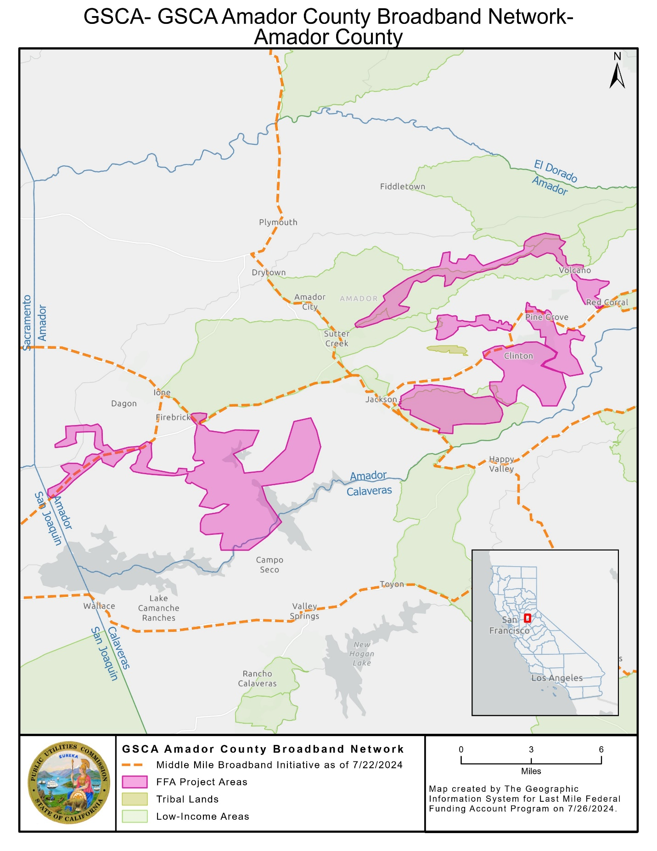

**Mare Island Build**

**Key Information**

|  |  |
| --- | --- |
| **Project Name** | **Mare Island Build** |
| Applicant Name | City of Vallejo |
| Community Names | Vallejo |
| County | Solano |
| County Allocation | $17,007,524 |
| Project Size (in square miles) | 1 |
| Maximum Download/Upload speed | 1,000/1,000 Mbps |
| Lowest cost plan (non-income qualified) | $40/month for 50/20 Mbps |
| Low-income plan | $40/month for 100/100 Mbps |
| Low-cost plan | $40/month for 100/100 Mbps |
| LifeLine Participation | Yes |
| Percent Disadvantaged Communities | 100 percent |
| Percent Low-Income Areas | 0 percent |
| Median Household Income (weighted) | $176,719 |
| Area Households | 147 |
| Area Population | 1,049 |
| Estimated locations within 1000 feet of the project area (location passings) | 418 |
| Estimated units within 1000 feet of the project area (unit passings) | 561 |
| Unserved locations proposed to be served by the project | 177 |
| Unserved locations in the project area | 149 |
| Unserved units in the project area | 200 |
| Estimated unserved population in the project area | 673 |
| Estimated unserved Multiple Dwelling Unit (MDU) locations in the project area | 8 |
| Estimated unserved Multiple Dwelling Unit (MDU) location units in the project area | 59 |
| Community Anchor Institutions benefitting from the project | 1 |
| Public safety locations benefitting from the project | 1 |
| Does the project connect to public open access middle mile? | Yes |
| Distance of middle-mile, backhaul, and connection to Middle Mile Broadband Initiative in project | 4.74 miles |
| Grant costs for middle-mile, backhaul, and connection to Middle Mile Broadband Initiative in project | $463,178 |
| Grant costs for last-mile delivery | $172,730 |
| Deployment Schedule | 4 Months |
| Total Project Cost | $635,908 |
| Amount of FFA grant funds requested | $635,908 |
| Applicant funded | $0 |
| Grant (excluding middle mile) per unserved unit in the project area | $864 |
| Grant (excluding middle mile) per unit passing | $308 |

**Map of Mare Island Build**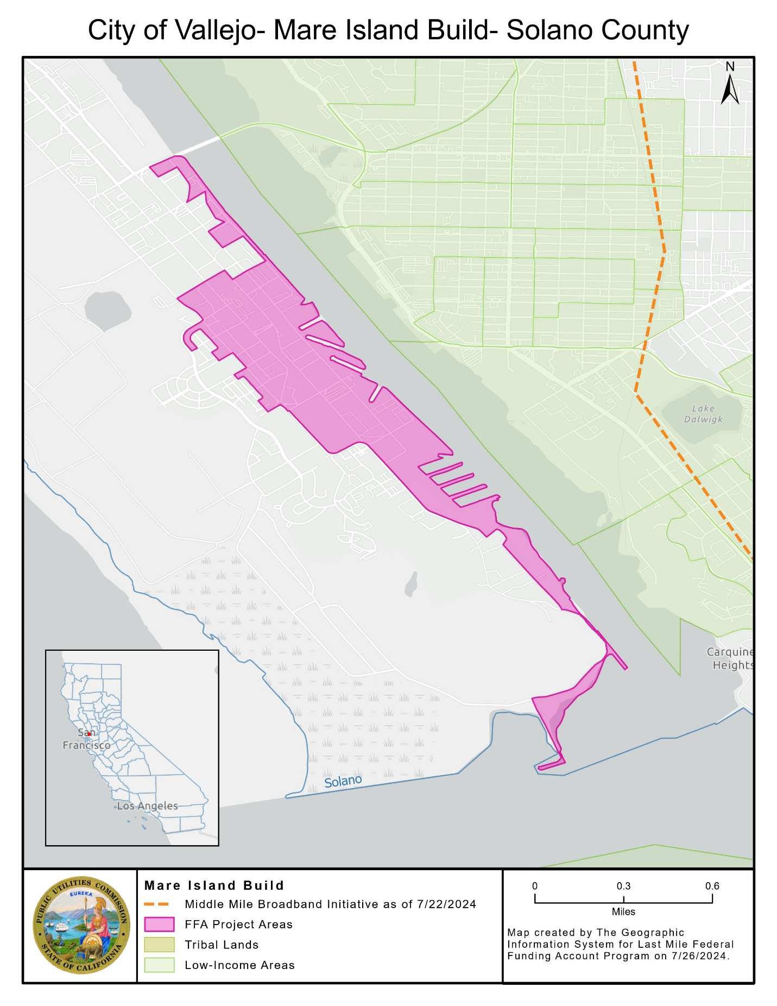

**N. Sonoma Blvd.**

**Key Information**

|  |  |
| --- | --- |
| **Project Name** | **N. Sonoma Blvd.** |
| Applicant Name | City of Vallejo |
| Community Names | Vallejo |
| County | Solano |
| County Allocation | $17,007,524 |
| Project Size (in square miles) | 0.28 |
| Maximum Download/Upload speed | 1,000/1000 Mbps |
| Lowest cost plan (non-income qualified) | $55/month for 100/100 Mbps |
| Low-income plan | $40/month for 100/100 Mbps |
| Low-cost plan | $40/month for 100/100 Mbps |
| LifeLine Participation | Yes |
| Percent Disadvantaged Communities | 100 percent |
| Percent Low-Income Areas | 100 percent |
| Median Household Income (weighted) | $37,375 |
| Area Households | 384 |
| Area Population | 1,010 |
| Estimated locations within 1000 feet of the project area (location passings) | 511 |
| Estimated units within 1000 feet of the project area (unit passings) | 859 |
| Unserved locations proposed to be served by the project | 68 |
| Unserved locations in the project area | 51 |
| Unserved units in the project area | 136 |
| Estimated unserved population in the project area | 302 |
| Estimated unserved Multiple Dwelling Unit (MDU) locations in the project area | 20 |
| Estimated unserved Multiple Dwelling Unit (MDU) location units in the project area | 105 |
| Community Anchor Institutions benefitting from the project | 5 |
| Public safety locations benefitting from the project | 0 |
| Does the project connect to public open access middle mile? | Yes |
| Distance of middle-mile, backhaul, and connection to Middle Mile Broadband Initiative in project | 3.69 miles |
| Grant costs for middle-mile, backhaul, and connection to Middle Mile Broadband Initiative in project | $617,239 |
| Grant costs for last-mile delivery | $229,810 |
| Deployment Schedule | 4 Months |
| Total Project Cost | $1,014,322 |
| Amount of FFA grant funds requested | $1,014,322 |
| Applicant funded | $0 |
| Grant (excluding middle mile) per unserved unit in the project area | $1,690 |
| Grant (excluding middle mile) per unit passing | $268 |

**Map of N. Sonoma Blvd.**

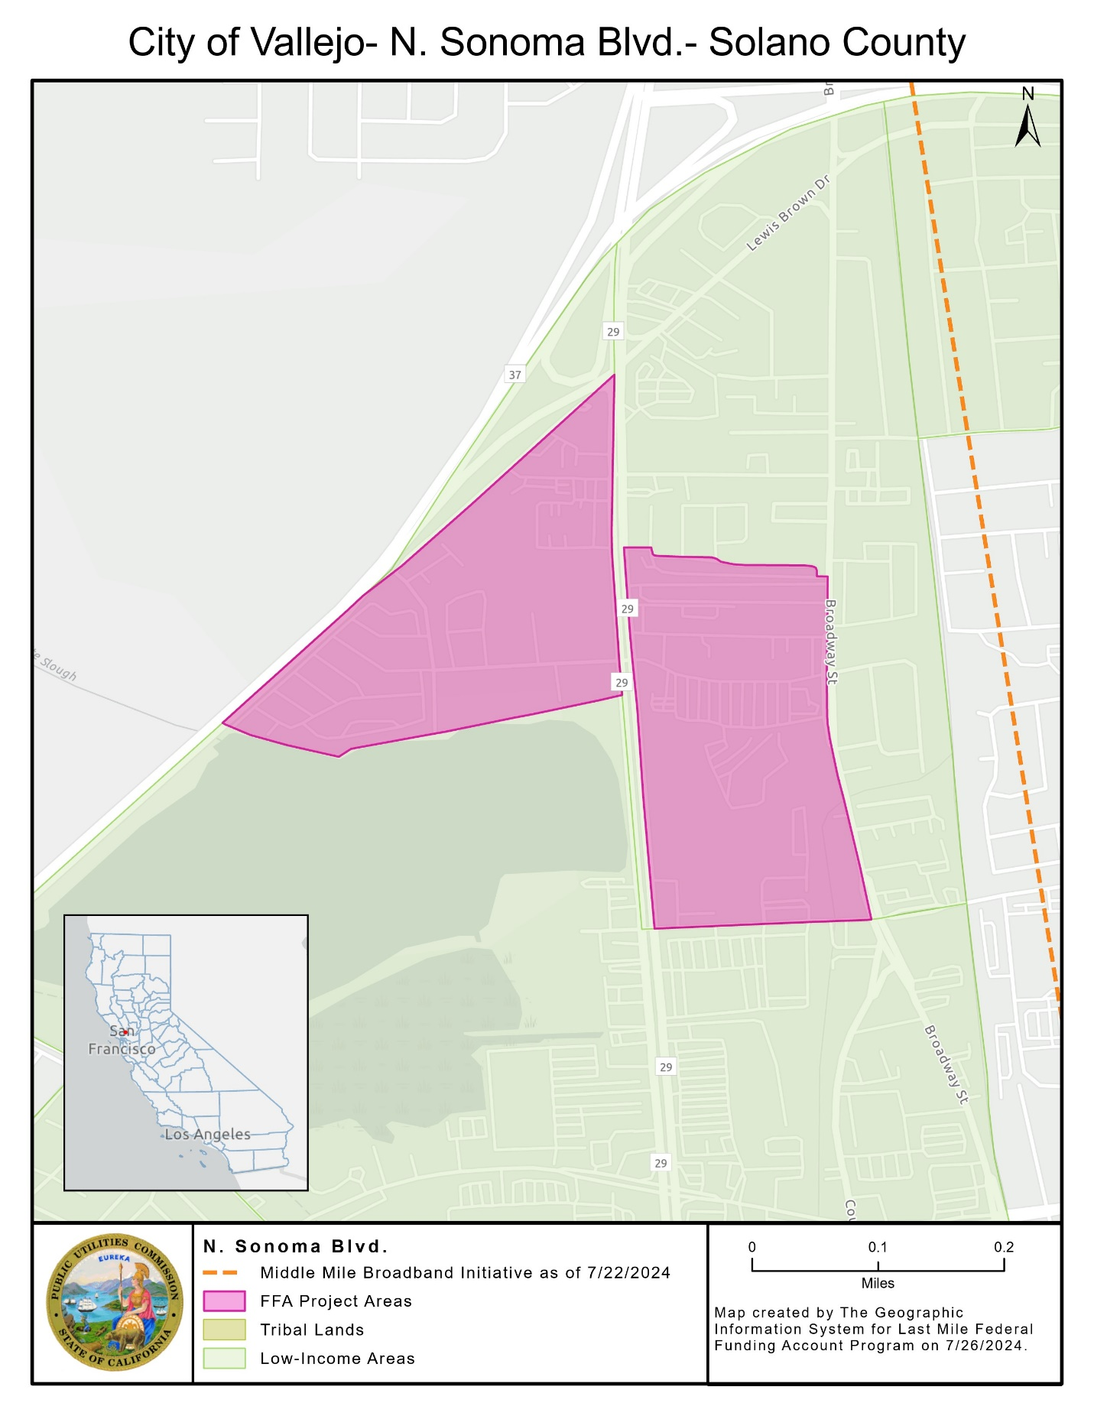

**Porter St to Seaport**

**Key Information**

|  |  |
| --- | --- |
| **Project Name** | **Porter St to Seaport** |
| Applicant Name | City of Vallejo |
| Community Names | Vallejo |
| County | Solano |
| County Allocation | $17,007,524 |
| Project Size (in square miles) | 0.44 |
| Maximum Download/Upload speed | 1000/1000 Mbps |
| Lowest cost plan (non-income qualified) | $55/month for 100/100 Mbps |
| Low-income plan | $40/month for 100/100 Mbps |
| Low-cost plan | $40/month for 100/100 Mbps |
| LifeLine Participation | Yes |
| Percent Disadvantaged Communities | 100 percent |
| Percent Low-Income Areas | 53 percent |
| Median Household Income (weighted) | $67,273 |
| Area Households | 818 |
| Area Population | 1,726 |
| Estimated locations within 1000 feet of the project area (location passings) | 1,055 |
| Estimated units within 1000 feet of the project area (unit passings) | 1,699 |
| Unserved locations proposed to be served by the project | 32 |
| Unserved locations in the project area | 32 |
| Unserved units in the project area | 69 |
| Estimated unserved population in the project area | 149 |
| Estimated unserved Multiple Dwelling Unit (MDU) locations in the project area | 22 |
| Estimated unserved Multiple Dwelling Unit (MDU) location units in the project area | 59 |
| Community Anchor Institutions benefitting from the project | 3 |
| Public safety locations benefitting from the project | 1 |
| Does the project connect to public open access middle mile? | Yes |
| Distance of middle-mile, backhaul, and connection to Middle Mile Broadband Initiative in project | 5.01 miles |
| Grant costs for middle-mile, backhaul, and connection to Middle Mile Broadband Initiative in project | $1,322,735 |
| Grant costs for last-mile delivery | $357,594 |
| Deployment Schedule | 4 Months |
| Total Project Cost | $1,680,329 |
| Amount of FFA grant funds requested | $1,680,329 |
| Applicant funded | $0 |
| Grant (excluding middle mile) per unserved unit in the project area | $5,183 |
| Grant (excluding middle mile) per unit passing | $210 |

Map of Porter St to Seaport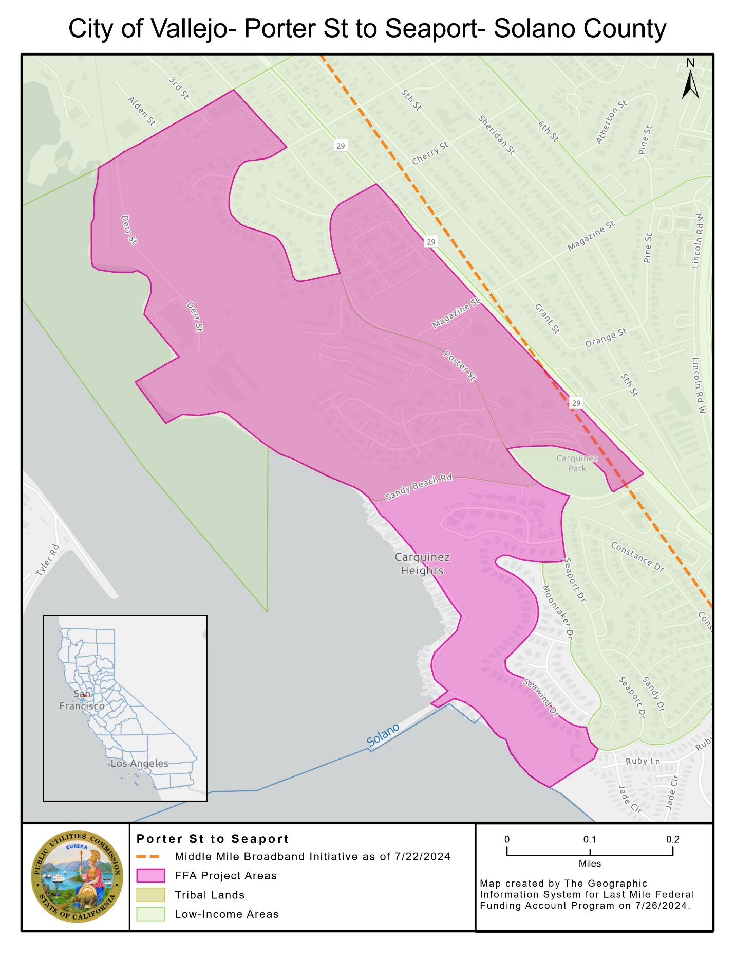

**Trailer City Park Project**

**Key Information**

|  |  |
| --- | --- |
| **Project Name** | **Trailer City Park Project** |
| Applicant Name | City of Vallejo |
| Community Names | Vallejo |
| County | Solano |
| County Allocation | $17,007,524 |
| Project Size (in square miles) | 0.13 |
| Maximum Download/Upload speed | 1000/1000 Mbps |
| Lowest cost plan (non-income qualified) | $55/month for 100/100 Mbps |
| Low-income plan | $40/month for 100/100 Mbps |
| Low-cost plan | $40/month for 100/100 Mbps |
| LifeLine Participation | Yes |
| Percent Disadvantaged Communities | 0 percent |
| Percent Low-Income Areas | 100 percent |
| Median Household Income (weighted) | $53,854 |
| Area Households | 224 |
| Area Population | 588 |
| Estimated locations within 1000 feet of the project area (location passings) | 807 |
| Estimated units within 1000 feet of the project area (unit passings) | 1,206 |
| Unserved locations proposed to be served by the project | 194 |
| Unserved locations in the project area | 190 |
| Unserved units in the project area | 201 |
| Estimated unserved population in the project area | 462 |
| Estimated unserved Multiple Dwelling Unit (MDU) locations in the project area | 3 |
| Estimated unserved Multiple Dwelling Unit (MDU) location units in the project area | 14 |
| Community Anchor Institutions benefitting from the project | 3 |
| Public safety locations benefitting from the project | 0 |
| Does the project connect to public open access middle mile? | Yes |
| Distance of middle-mile, backhaul, and connection to Middle Mile Broadband Initiative in project | 2.15 miles |
| Grant costs for middle-mile, backhaul, and connection to Middle Mile Broadband Initiative in project | $197,383 |
| Grant costs for last-mile delivery | $383,909 |
| Deployment Schedule | 3 Months |
| Total Project Cost | $475,545 |
| Amount of FFA grant funds requested | $475,545 |
| Applicant funded | $0 |
| Grant (excluding middle mile) per unserved unit in the project area | $1,384 |
| Grant (excluding middle mile) per unit passing | $231 |

**Map of Trailer City Park Project**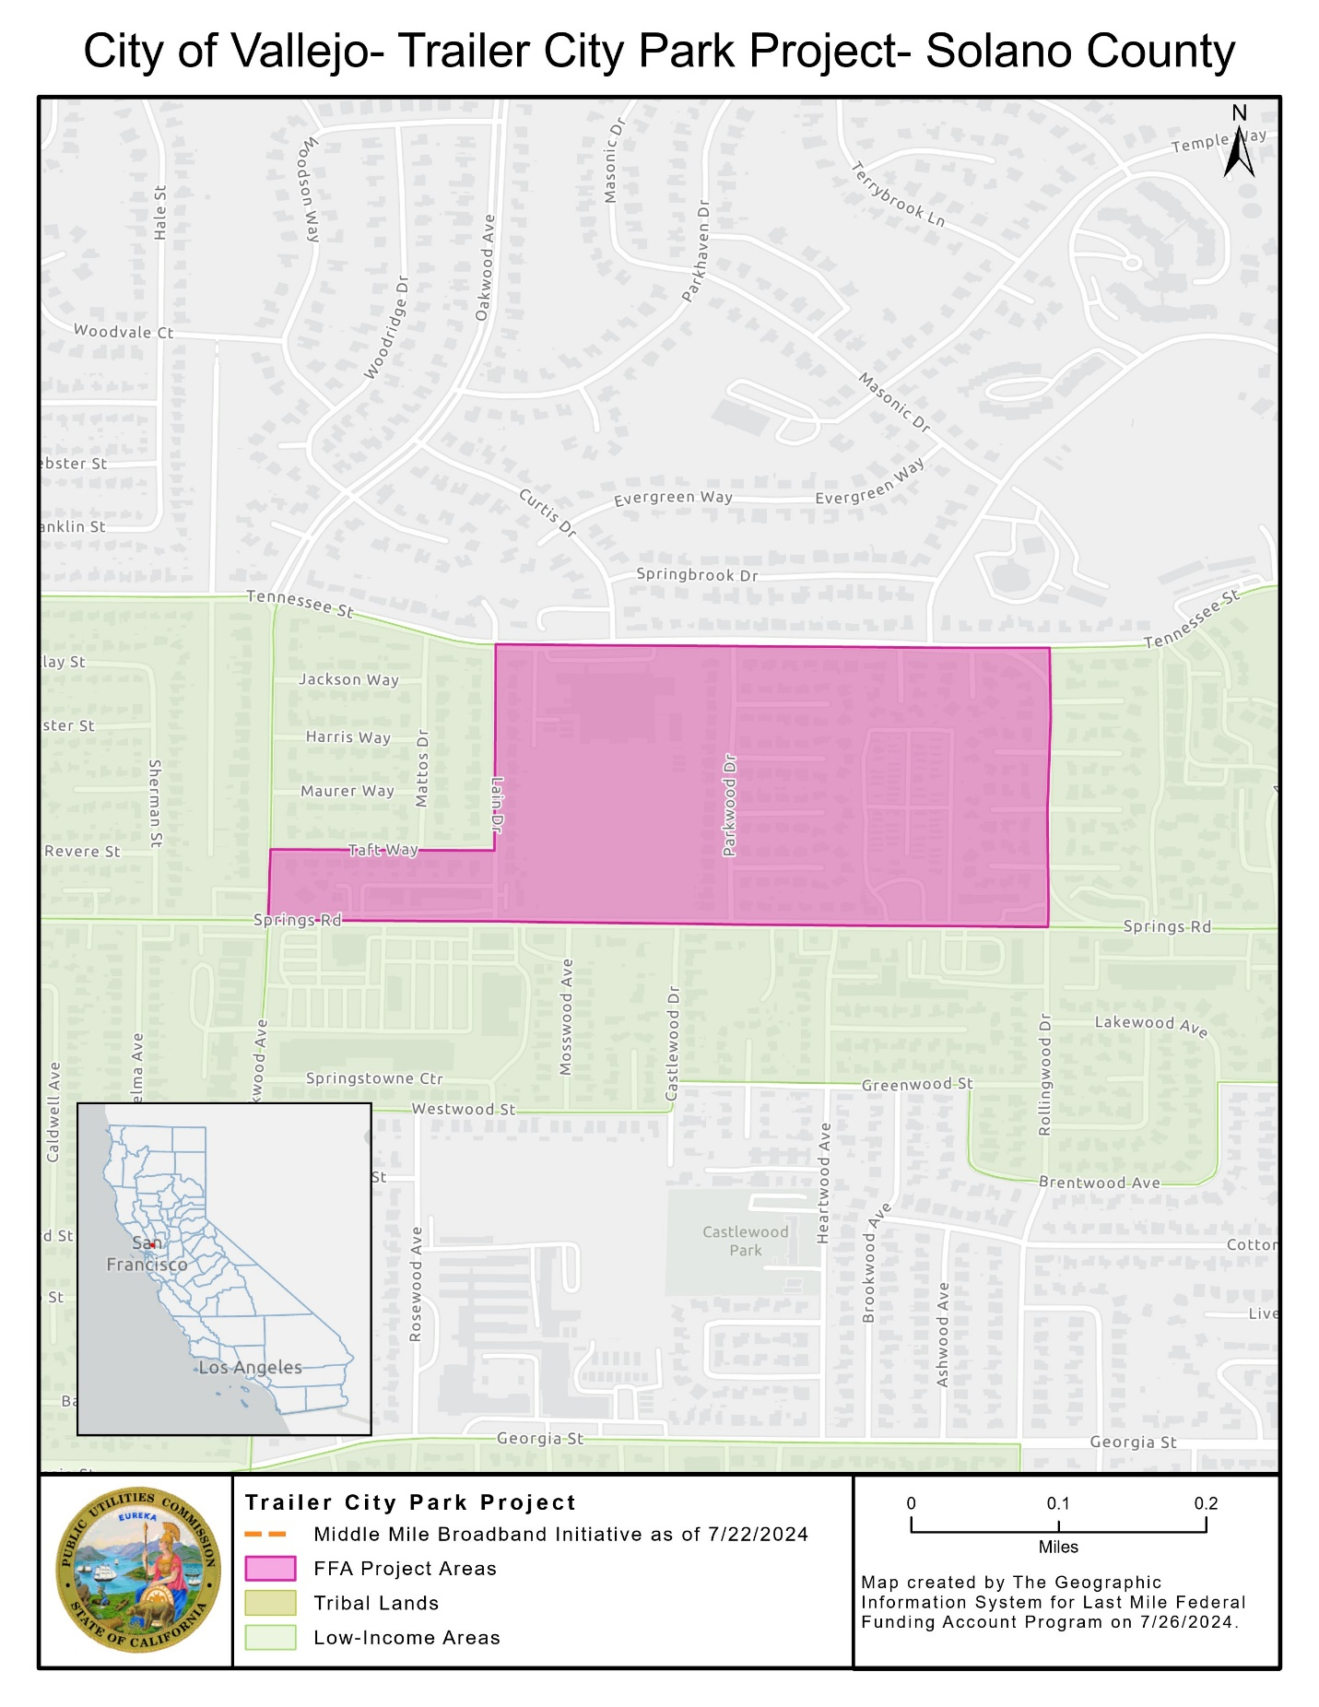

**Golden State Connect Authority Service Plans**

As a condition of the grant awards in this Resolution, Golden State Connect Authority is obligated to offer service to customers in the project areas of the listed projects at no less than the speeds in the Table below, no more than 100 milliseconds of latency, and no more than the prices[28] in the Table below, including installation, for at least five years following project completion.

* GSCA Amador County Broadband Network[29]

Customers of Golden State Connect Authority will be charged $40/month to lease access to Golden State Connect Authority’s open-access fiber, and then an additional charge for service from a partnering Internet Service Provider. The prices listed below are the sum of the Internet Service Provider’s charge for service and Golden State Connect Authority’s charge for fiber access.

|  |  |  |  |
| --- | --- | --- | --- |
|  | | |  |
| **Plan** | **Speed** | **Price in 2024 Dollars** | **Notes** | |
| 100 Mbps Plan | 100/100 Mbps | $70/month | - | |
| 250 Mbps Plan | 250/250 Mbps | $77/month | - | |
| 1 Gbps Plan | 1/1 Gbps | $95/month | - | |
| 10 Gbps Plan | 10/10 Gbps | $250/month | - | |

**City of Vallejo Service Plans**

As a condition of the grant awards in this Resolution, the City of Vallejo is obligated to offer service to customers in the project areas of the listed projects at no less than the speeds in the Table below, no more than 100 milliseconds of latency, and no more than the prices[30] in the Table below, including installation, for at least five years following project completion.

* Mare Island Build
* N. Sonoma Blvd.
* Porter St to Seaport
* Trailer City Park Project

|  |  |  |  |
| --- | --- | --- | --- |
|  | | |  |
| **Plan** | **Speed** | **Price in 2024 Dollars** | **Notes** | |
| Low-Cost Plan | 100/100 Mbps | $40/month | - | |
| Home Fiber - 100 Mbps | 100/100 Mbps | $65/month | - | |
| Home Fiber –1 Gbps | 1/1 Gbps | $85/month | - | |
| Residential - 100 Mbps | 100/100 Mbps | $55/month | Pricing is per unit, for customers buying in bulk | |
| Residential – 1 Gbps | 1/1 Gbps | $75/month | Pricing is per unit, for customers buying in bulk | |
| Fiber Business – 100 Mbps | 100/100 Mbps | $85/month | Passive Optical Network | |
| Fiber Business – 250 Mbps | 250/250 Mbps | $99/month | Passive Optical Network | |
| Fiber Business – 1 Gbps | 1/1 Gbps | $130/month | Passive Optical Network | |
| Commercial 500 Mbps | 500/500 Mbps | $475/month | Dedicated fiber | |
| Commercial 1 Gbps | 1/1 Gbps | $575/month | Dedicated fiber | |
| Direct Fiber Commercial 1 Gbps | 1/1 Gbps | $950/month | Direct Fiber - Available to businesses with 35 employees or fewer | |
| Direct Fiber Commercial 1 Gbps | 1/1 Gbps | $1,150/month | Direct Fiber - Available to businesses with 36 employees or more | |

As a condition of the grant awards in this Resolution, the City of Vallejo has committed to provide LifeLine-discounted voice service in the project areas listed.

**California Public Utilities Commission**

**Federal Funding Account, Last Mile Program**

**Guidance to Staff Regarding**

**CONSENT FORM**

**Acknowledgement and Acceptance of Terms** 

Awardee Name:

Key Project Contact:

Project Name:

The Awardee identified above acknowledges receipt of the California Public Utilities Commission Resolution or Award Letter and agrees to comply with all grant terms, conditions, and requirements set forth in the Resolution or Award Letter and those in the Federal Funding Account, Last Mile program rules. Awards are contingent on available state budget appropriations funding.

Undersigned representative of __________________________________ [Name of Awardee] is duly authorized to execute this Consent Form on behalf of the Awardee and to bind the Awardee to the terms, conditions, and requirements set forth in California Public Utilities Commission Resolution or Award Letter and those in the Federal Funding Account, Last Mile program rules.

Dated this  _____ day of _____________, 20____.

Signature of Awardee Representative: _____________________________________________________

Title __________________________________________________________

Printed Name __________________________________________________

Name of Representative’s Organization:   
 ______________________________________________________________

Business Address:

Street address, suite/apt. number

City, state, and ZIP Code

Telephone Number: ________________________________

Email Address: _____________________________________

1. Statute 2021, Chapters 84 and 112.
2. The Commission Environmental and Social Justice Action plan includes definitions and data indicators for disadvantaged or Environmental and Social Justice communities including Disadvantaged Communities defined by the California Environmental Protection Agency (CalEPA) and low-income households defined as household incomes below 80 percent of the area median income. The Commission’s Environmental and Social Justice Action Plan 2.0 is available at: <https://www.cpuc.ca.gov/-/media/cpuc-website/divisions/news-and-outreach/documents/news-office/key-issues/esj/esj-action-plan-v2jw.pdf>
3. The Federal Funding Account Public Map is available at: <https://federalfundingaccountmap.vetro.io/>
4. Registration for the Federal Funding Account Applicant Tool is available at: [FFA Applicant Tool Registration](https://www.cpuc.ca.gov/ApplicantToolRegister)
5. Disadvantaged or Environmental and Social Justice communities and individual locations, for purposes of the Federal Funding Account, include those in Disadvantaged Communities census tracts as defined by CalEPA and low-income areas in which the census block group median household income is less than or equal to 80 percent of the higher of the county or state average. This data is available for download on the Federal Funding Account Public Map page (visited September 6, 2024), <https://www.cpuc.ca.gov/industries-and-topics/internet-and-phone/broadband-implementation-for-california/last-mile-federal-funding-account/ffa-public-map> and the Federal Funding Account Application Resources Page (visited June 13, 2024), <https://www.cpuc.ca.gov/industries-and-topics/internet-and-phone/broadband-implementation-for-california/last-mile-federal-funding-account/ffa-application-resources-page> .
6. D.22-04-055 states that “households and businesses with an identified need for additional broadband infrastructure do not have to be the only ones in the service area served by an eligible broadband infrastructure project. Indeed, serving these households and businesses may require a holistic approach that provides service to a wider area, for example, in order to make ongoing service of certain households or businesses within the service area economical.”
7. Federal broadband programs include the Connect America Fund II (CAFII), Community Connects Grant Program (CCGP), Enhanced Alternative Connect America Cost Model (EACACM), Rural Digital Opportunity Fund (RDOF), Rural E-Connectivity Program (REP), Tribal Broadband Connectivity Program (TBCP), and Telephone Loan Program (TLP).
8. Department of the Treasury, Final Rule, Coronavirus State and Local Fiscal Recovery Funds, 31 C.F.R. Part 35, 87 FR 4338-4454 (January 27, 2022) (Final Rule), available at: <https://www.federalregister.gov/documents/2022/01/27/2022-00292/coronavirus-state-and-local-fiscal-recovery-funds>.
9. D.22-04-055, Appendix A, Section 2, p. A-5.
10. Federal broadband programs include the Connect America Fund II, Community Connects Grant Program, Enhanced Alternative Connect America Cost Model, Rural Digital Opportunity Fund, Rural E-Connectivity Program, Tribal Broadband Connectivity Program, and Telephone Loan Program.
11. See Federal Funding Account Public Map, <https://federalfundingaccountmap.vetro.io/> (visited September 6, 2024).
12. Department of the Treasury, Final Rule, Coronavirus State and Local Fiscal Recovery Funds, 31 C.F.R. Part 35, 87 FR 4338-4454 (January 27, 2022) (Final Rule), available at: <https://www.federalregister.gov/documents/2022/01/27/2022-00292/coronavirus-state-and-local-fiscal-recovery-funds>.
13. D.22-04-055, Appendix A, Section 2, p. A-5.
14. See Federal Funding Account Public Map, <https://federalfundingaccountmap.vetro.io/> (visited September 6, 2024).
15. Department of the Treasury, Final Rule, Coronavirus State and Local Fiscal Recovery Funds, 31 C.F.R. Part 35, 87 FR 4338-4454 (January 27, 2022) (Final Rule), available at: <https://www.federalregister.gov/documents/2022/01/27/2022-00292/coronavirus-state-and-local-fiscal-recovery-funds>.
16. D.22-04-055, Appendix A, Section 2, p. A-5.
17. See Federal Funding Account Public Map, <https://federalfundingaccountmap.vetro.io/> (visited September 6, 2024).
18. Department of the Treasury, Final Rule, Coronavirus State and Local Fiscal Recovery Funds, 31 C.F.R. Part 35, 87 FR 4338-4454 (January 27, 2022) (Final Rule), available at: <https://www.federalregister.gov/documents/2022/01/27/2022-00292/coronavirus-state-and-local-fiscal-recovery-funds>.
19. D.22-04-055, Appendix A, Section 2, p. A-5.
20. See Federal Funding Account Public Map, <https://federalfundingaccountmap.vetro.io/> (visited September 6, 2024).
21. Department of the Treasury, Final Rule, Coronavirus State and Local Fiscal Recovery Funds, 31 C.F.R. Part 35, 87 FR 4338-4454 (January 27, 2022) (Final Rule), available at: <https://www.federalregister.gov/documents/2022/01/27/2022-00292/coronavirus-state-and-local-fiscal-recovery-funds>.
22. D.22-04-055, Appendix A, Section 2, p. A-5.
23. See Federal Funding Account Public Map, <https://federalfundingaccountmap.vetro.io/> (visited September 6, 2024).
24. Treasury, Compliance and Reporting Guidance State and Local Fiscal Recovery Funds (November 15, 2021 Version 2.1), available at <https://home.treasury.gov/system/files/136/SLFRF-Compliance-and-Reporting-Guidance.pdf>.
25. D. 22-04-055, Appendix A, Section 14.
26. D.22-054-055, Section 13.2, page 57.
27. Grant conditions include one or more providers offering voice service and participating in California LifeLine.
28. Prices may increase at no more than the rate of inflation, defined by the Consumer Price Index.
29. Grant conditions include one or more providers offering voice service and participating in California LifeLine, which may include bundled broadband and voice plans.
30. Prices may increase at no more than the rate of inflation, defined by the Consumer Price Index.