PUBLIC UTILITIES COMMISSION OF THE STATE OF CALIFORNIA

Agenda ID # 23518
COMMUNICATIONS DIVISION RESOLUTION T-17886
June 26, 2025

RESOLUTION

Resolution T-17886 Approval of four (4) public housing infrastructure projects for grant funding from the California Advanced Services Fund Broadband Public Housing Account totaling up to $224,050.

PROPOSED OUTCOME:
- Approves up to $224,050 in funding from the California Advanced Services Fund (CASF) Broadband Public Housing Account (BPHA) for four infrastructure projects from the Housing Authority of the County of Kern (HACK) (1 project) and New Horizons Affordable Housing and Development Inc. (New Horizons) (3 projects).
- Deploys wireless point to multi-point connection and wireless broadband infrastructure utilizing Wi-Fi and CAT6 inside-wiring capable of 100 Megabits per second (Mbps) download and 20 Mbps upload for 95 living units in these four publicly supported housing developments.
- Allows for free broadband service to those that lack such service. Access to broadband service will improve public safety and enable access to government, e-health, and online education opportunities.

SAFETY CONSIDERATIONS:
- Access to broadband service will improve public safety and enable access to government, e-health, and online education opportunities.
ESTIMATED COST:
- $224,050 from the California Advanced Services Fund (CASF) Broadband Public Housing Account (BPHA). CASF’s accounts are funded through a surcharge whereby revenues are deposited to CASF Fund 3141 with the State’s Treasury. The surcharge mechanism is a flat rate for each active access line that telephone corporations service in California levied at the surcharge rate of $0.90. The flat surcharge is divided among the six Universal Service Programs of which CASF receives a 28.50% share. Pursuant to Public Utilities (Pub. Util.) Code section 270, subd. (b), money in the funds may only be expended upon appropriation in the Annual Budget Act or upon supplemental appropriation. For fiscal year 2024/2025, the Commission issued Resolution T-17825 which set an appropriation amount of $30.141 million for the BPHA. These appropriations were adopted in the California Budget Act for the respective fiscal year.
__________________________________________________________

Summary
This Resolution approves up to $224,050 in funding from the California Advanced Services Fund (CASF) Broadband Public Housing Account (BPHA) for four infrastructure projects: one project from the Housing Authority of the County of Kern (HACK) and three projects from the New Horizons Affordable Housing and Development Inc. (New Horizons). These four infrastructure projects will deploy wireless point to multi-point connection and wireless broadband infrastructure utilizing Wi-Fi and CAT6 inside-wiring capable of 100 Megabits per second (Mbps) download and 20 Mbps upload for 95 living units in these publicly supported housing developments located in Kern and Santa Cruz counties. The deployment of broadband service in public housing will bring free broadband service to those that lack such service. Access to broadband service will improve public safety and enable access to government, e-health, and online education opportunities.

Table 1, below, lists four recommended public housing infrastructure projects. Maps associated with each project are found in Appendix A.

Table 1 – Public Housing Infrastructure Projects
Applicant | Project Name | Address | City | Zip | Grant | Household Units
Housing Authority of the County of Kern | Village Congregational Community | 112 Richard Street | Arvin | 93203 | $112,500 | 60
New Horizons Affordable Housing and Development Inc. | 160 Blackburn St. Apartments | 160 Blackburn St. | Watsonville | 95076 | $44,400 | 14
New Horizons Affordable Housing and Development Inc. | 179 Montebello Dr. Apartments | 179 Montebello Dr. | Watsonville | 95076 | $49,900 | 16
New Horizons Affordable Housing and Development Inc. | 1223 Broadway Apartments | 1223 Broadway | Santa Cruz | 95062 | $17,250 | 5
 |  |  |  | TOTAL | $224,050 | 95

Background
On March 7, 2024, the Commission approved D.24-03-041, Decision Adopting Modifications to Broadband Public Housing Account and Tribal Technical Assistance Program Rules and Guidelines (Decision). The rules and guidelines adopted in that decision modified the CASF BPHA Rules and Guidelines expanding eligibility for non-publicly supported housing developments and for project costs. In Resolution T-17825, the Commission allocated $30.1 million in CASF funding for the BPHA for Fiscal Year 2024-2025.
Key provisions of the Decision relevant to this Resolution include:
- Eligible applicants may submit applications for BPHA Infrastructure and BPHA Internet Extension projects.
- The Commission authorized Communications Division (CD) staff (Staff) to review and approve infrastructure and internet extension applications through ministerial review that meet all of the ministerial review criteria. Applications not meeting the ministerial review criteria may only be approved by the Commission via Resolution.
- Grants can be awarded to finance up to 100 percent of the installation costs to install last mile infrastructure, inside wiring and broadband network equipment, but not maintenance or operation costs.
- Projects must be CEQA exempt to be eligible for BPHA funding.
- Grantees must maintain and operate the network for five years after project completion.
- Infrastructure projects proposed network is capable of offering residents the state standard for broadband service or the most current broadband speed standard set by the FCC.
- Applicant attests the low-income community the project seeks to serve does not have access to a broadband service provider that offers free service that meets state standards, as defined in Section III of the BPHA Guidelines.
- Applicant attests that it will not charge residents for broadband internet services.
- Applicant for an Infrastructure project agrees to complete the project within 12 months from the date of Commission approval
- Applicant identified an internet service provider with the required internet bandwidth capacity at the Minimum Point of Entry (MPOE).
- Applicant attests that it expects the property will be in residential use as low-income community for at least 10 years.
- Applicants other than publicly supported and tribal housing developments and farmworker housing attests to stated tenant protection requirements.

Notice
On January 13, 2025, Staff posted the proposed project descriptions for each application submitted in the January 2025 BPHA application round on the Commission’s BPHA webpage.

Discussion
- Applicants’ Request

On January 1, 2025, the Housing Authority of the County of Kern (HACK) (1 project) and New Horizons Affordable Housing and Development Inc. (New Horizons) (3 projects) submitted applications for CASF BPHA funding. All four projects exceed the cost per unit benchmark established in D.24-03-041 and therefore are ineligible for ministerial review and may only be approved by the Commission via Resolution. Table 2, below, lists the per household unit cost established in D.24-03-041 and the per unit cost per proposed project.

Table 2 – Cost Per Unit Comparison
Applicant | Project Name | Grant | Units | Per Unit Cost per  D.24-03-041 | Per Unit Cost
Housing Authority of the County of Kern | Village Congregational Community | $112,500 | 60 | $1,500 or less | $1,875
New Horizons Affordable Housing and Development Inc. | 160 Blackburn St. Apartments | $44,400 | 14 | $3,000 or less | $3,171.43
New Horizons Affordable Housing and Development Inc. | 179 Montebello Dr. Apartments | $49,900 | 16 | $3,000 or less | $3,118.75
New Horizons Affordable Housing and Development Inc. | 1223 Broadway Apartments | $17,250 | 5 | $3,000 or less | $3,450

Applicants: Both applicants are eligible applicants as defined in Section IV of D.24-03-041.

HACK began operating as a public housing authority in 1940 and has assisted nearly 20,000 low-income Kern County residents. HACK’s mission is to improve the quality of life for low-income residents of Kern County by providing safe, affordable housing and assisting residents towards self-sufficiency and homeownership.
New Horizons was established in 2019 and is a nonprofit affiliate of the Housing Authority of the County of Santa Cruz, dedicated to expanding affordable housing opportunities and fostering community development through strategic initiatives. The organization works to enhance housing access and support low-income individuals and families in Santa Cruz County.

Projects: All four projects are eligible projects as defined in D.24-03-041.

HACK requests funding for the installation of a wireless 2.4GHz and 5GHz Wi-Fi 802.11AX mesh network architecture utilizing Cisco, Ruckus, and Siklu access points, bridges and switches to provide wireless broadband coverage to each residential unit.

According to HACK, these installations will be able to provide a minimum download speed of 100 Mbps and minimum upload speed of 20 Mbps during peak use hours.

New Horizons requests funding for the installation of a combined point to multi-point wireless links and a wireless 2.4GHz and 5GHz Wi-Fi 802.11AX network architecture utilizing Aviat, MikroTik, and Ubiquiti access points, bridges and switches to provide wireless broadband coverage to each residential unit.

According to New Horizons, these installations will be able to provide a minimum download speed of 100 Mbps and minimum upload speed of 20 Mbps during peak use hours.

All projects include equipment for broadband traffic management, deployment, security, monitoring and reporting, consisting of layer 2 or layer 3 switches and a firewall that interfaces to the Wide Area Network Internet Service Provider (ISP) equipment providing the broadband service.

- Project Review

The wireless installations for HACK (Village Congregational Community), and New Horizons (160 Blackburn St., 179 Montebello Dr., and 1223 Broadway) use the latest Wi-Fi and mmWave standards, which require more expertise to properly design, configure, and deploy the wireless equipment to meet the coverage needs of multiple housing facilities and to properly interface together as a local area network to connect to the ISP.

The wireless mesh network utilized in the installation for the HACK project is more resilient, as it can be self-adapting to changes in wireless environment conditions. The use of the latest Wi-Fi standard in all these projects offers greater throughput and wireless link management capability and can carry more traffic.

The HACK project will deploy Intermediate Distribution Frame (IDF) Wi-Fi mesh networks that connect to Main Distribution Frame (MDF) utilizing mmWave point-to-multipoint bridges in a star network topology. The deployment of wireless bridges to connect system IDFs addresses access limitations within the property and is often the primary reason for choosing wireless deployment. The complexity, labor, and material cost of wireless deployment has been rising thus increasing the project costs but remains a viable and less costly engineering option of system deployment compared to a direct connection. A direct connection may require heavy construction involving structural modification, trenching, laying conduits, feedthrough and backfill. Wireless bridge connections, when utilized, can also be engineered and deployed relatively quickly, as compared to heavy construction, which can require review and approval and lengthy project planning. The project will meet and is capable of exceeding 100 Mbps download/20 Mbps upload speed.

The New Horizons project will deploy fixed wireless backhaul MDF connected to IDF Wi-Fi build-outs in a star topology to several public housing multi-dwelling unit buildings using point-to-multipoint mmWave bridges and Wi-Fi routers to each residential unit. The project will meet and is capable of exceeding 100 Mbps download/20 Mbps upload speed.

Based on the above, Staff determined that the extra cost per unit is reasonable and recommends approval.

- Compliance Requirements

HACK and New Horizons are required to comply with all the guidelines, requirements, and conditions associated with the grant of CASF funds as specified in D.24-03-041. Compliance includes, but is not limited to the following:
- California Environmental Quality Act (CEQA)
All CASF grants are subject to CEQA requirements unless the projects are statutorily or categorically exempt pursuant to the CEQA Guidelines.

All BPHA projects must be CEQA exempt projects.

Both projects require limited modifications of existing structures.
The projects use wireless network architecture that consist of ISP connection, networking switching equipment and wireless access points or routers. This requires installation/mounting of equipment in existing structures, such as ceilings or rooftops and installation of CAT6 inside-wiring and conduits on existing structures such as walls, hallways, or in the roof.
Based on the above information, these projects meet the criteria of the CEQA categorical exemption for existing facilities (CEQA Guidelines § 15301) and CEQA Guidelines Section 15303 – New Construction or Conversion of Small Structures, involving construction, installation, and/or conversion of limited numbers of new and/or existing facilities/structures.
- Execution and Performance
HACK and New Horizons must start the projects within 30 days from the date this Resolution is approved and complete the projects within a 12-month timeframe. Should the grantee or Contractor fail to begin work within 30 days of grant approval, the Commission or Director of Communications Division, upon 5 days written notice to the grantee, reserves the right to terminate the award. If the grantee is unable to complete the proposed project within the required 12-month timeframe, it must notify the Director of Communications Division as soon as it becomes aware of this prospect. If such notice is not provided, the Commission may reduce or withhold payment for failure to satisfy this requirement.
Grantees must operate and maintain the network for a minimum of five years after it has been installed. The grantee must complete all the performance on the project before the termination date in accordance with the terms of approval granted by the Commission. In the event that HACK and New Horizons fail to complete the projects or subsequently operate and maintain the network service in accordance with the terms of approval granted by the Commission and compliance with the CASF program guidelines, HACK and New Horizons must reimburse some or all of the CASF BPHA funds that it has received.
HACK and New Horizons must sign a consent form within 30 days from the date of the award agreeing to the terms stated in the Resolution authorizing the CASF award. Should HACK and New Horizons not accept the award through failure to submit the consent form within 30 calendar days from the date of the award, the Commission may deem the grant null and void.
Material changes in the entries for this application, such as discontinuing operation or bankruptcy, or change of name (DBA), change of address, telephone, fax number or
e-mail address must be reported immediately by a letter to the CPUC, Director of the Communications Division, 505 Van Ness Avenue, San Francisco, CA 94102.
- Project Audit
The Commission has the right to conduct any necessary audit, quality check, verification, and discovery during project implementation and post-project completion to ensure that CASF funds are spent in accordance with the terms of approval granted by the Commission. Invoices submitted will be subject to a financial audit by the Commission at any time within 5 years of the release of the final payment.

- Reporting
HACK and New Horizons are required to submit a project status report within six months of the project award date if the project has not been completed, irrespective of whether the grantee requests reimbursement or payment. Project status reporting requirements can be found on the Commission’s website. HACK and New Horizons must identify foreseeable risks that might prevent it from meeting future milestones. Before final payment of the project HACK and New Horizons must submit a project completion report with all required supporting documentation in order to receive payment. HACK and New Horizons must include total project cost, project summary breakdown, project milestone deployment details and speed test results in the completion report. HACK and New Horizons must certify that each progress and completion report is true and correct under penalty of perjury.
HACK and New Horizons are required to maintain the broadband network for five years after it has been installed and internet services turned on for residential use. After installation, for a five-year period, HACK and New Horizons must submit quarterly reports showing the percentage of up time, the number of unique log-ons (either by individuals or by units) and the amount of data used.
- Payments
HACK and New Horizons shall submit invoices and payments requests at completion intervals in accordance with D.24-03-041, Section X, Appendix A and with supporting documentation required in D.24-03-041. Project status and completion reports must be submitted with all required supporting documentation in order to receive payment. Payments are based on submitted receipts, invoices and other supporting documentation showing expenditures incurred and work done on the project in accordance with the approved CASF funding budget included in the application. HACK and New Horizons must submit a project completion report before full payment. Final requests for payment must be submitted no later than 90 days after project completion.
Payment to HACK and New Horizons will be made in accordance with, and within the time specified in California Government Code § 927 et seq.
Payment will not exceed the approved grant amount and any additional costs above the approved amount are the responsibility of HACK and New Horizons.
If any portion of reimbursement is found to be out of compliance, HACK and New Horizons will be responsible for refunding any disallowed amount along with appropriate interest rates determined in accordance with applicable Commission decisions.

Comments
In compliance with Public Utilities Code, § 311(g)(1) a Notice of Availability was e-mailed on May 21, 2025, informing all parties on the CASF Distribution List of the availability of the draft of this Resolution for public comments at the Commission’s website at http://www.cpuc.ca.gov/.

Findings AND CONCLUSIONS
- On January 1, 2025, HACK and New Horizons submitted applications for CASF funding for four projects totaling $224,050.

- All projects exceed the cost per unit benchmark established in the ministerial review criteria and are therefore ineligible for ministerial review.

- Based on its review, Staff determined that all four projects meet BPHA eligibility requirements. Staff further determined that all four projects qualify for funding under BPHA guidelines per D.24-03-041 and recommends approval of all four projects.

- The Commission has determined that these projects are categorically exempt from CEQA review, under section 15301 regarding exemption for existing facilities and section 15303 regarding minor modifications to existing structures.

- A notice letter was e-mailed on May 21, 2025, informing all applicants filing for CASF funding and parties on the CASF distribution list, of the availability of the draft of this Resolution for public comments at the Commissions website found here http://www.cpuc.ca.gov/. The Commission received no public comments.

Therefore it is ordered that:
  - The Commission shall award the following grant amounts for the projects listed in Table 1:
- $112,500 to HACK for its Village Congregational Community project;
- $111,550 to New Horizons for its 160 Blackburn St. Apartments, 179 Montebello Dr. Apartments, and 1223 Broadway Apartments projects;
The total grant funding awarded for these projects is up to $224,050. All awards are based on the descriptions of the projects as described in the applications and herein and are predicated on commitments to install and operate broadband infrastructure as expressed in its application and compliance with the requirements in as specified in D.24-03-041 and this Resolution.
  - Grant payments of up to a total of $224,050 for these public housing projects shall be paid out of the CASF Public Housing Account in accordance with the guidelines adopted in D.24-03-041, including compliance with CEQA.
  - HACK and New Horizons must complete and execute the consent form agreeing to the conditions set forth in this Resolution within 30 calendar days from the date of the award. Failure to submit the consent form within 30 calendar days from the date of the adoption of this Resolution may result in the grant being deemed null and void.
  - HACK and New Horizons must submit quarterly progress reports on the status of the project irrespective of whether reimbursement or payment is requested.
  - HACK and New Horizons are required to maintain the broadband network for five years after it has been installed.
  - Payments to HACK and New Horizons shall be in accordance with D.24-03-041, Section X, Appendix A and in accordance with the process defined in the “Payments” section of this Resolution.
  - HACK and New Horizons must complete all performance under the award on or before 12 months from the date this Resolution is approved.
  - By receiving a CASF grant, HACK and New Horizons agree to comply with the terms, conditions and requirements of the grant and thus submits to the jurisdiction of the Commission regarding disbursement and administration of the grant.
  - HACK and New Horizons are required to comply with all guidelines, requirements and conditions associated with the CASF funds award as specified in D.24-03-041, and in accordance with the terms of the Commission’s approval as set forth in this Resolution and be subject to Public Utilities Code sections 2108 and 2111.
  - If HACK and New Horizons fail to complete the projects in accordance with the terms outlined in D.24-03-041 and this Resolution, HACK and New Horizons must reimburse some or all CASF funds it has received.

This Resolution is effective today.

Commissioner Signature blocks to be added
upon adoption of the resolution

The foregoing resolution was duly introduced, passed and adopted at a conference of the Public Utilities Commission of the State of California held on June 26, 2025, the following Commissioners voting favorably thereon:

Dated , at <Voting meeting location>, California

APPENDIX A
Resolution T-17886
Public Housing Projects Locations
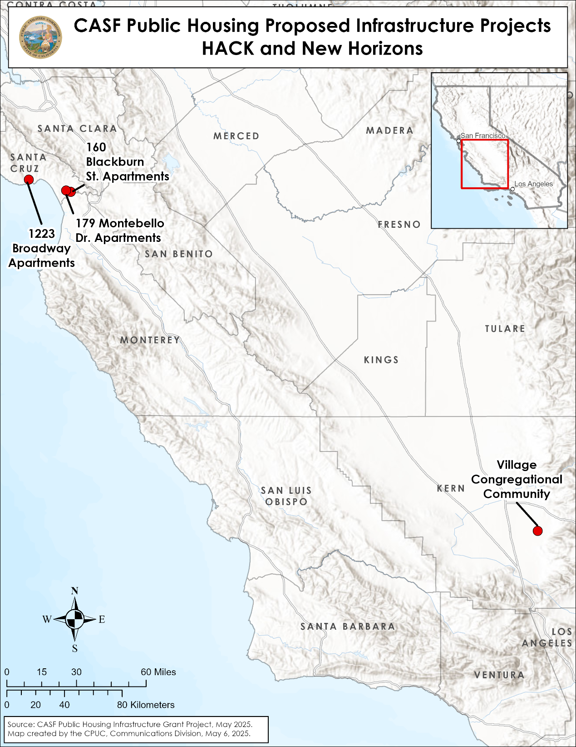

Resolution T-17818, adopted on April 4, 2025, established a new surcharge rate of $0.90 per access line for California’s six Universal Service Public Purpose Programs (PPPs), effective May 1, 2025. The surcharge rate was previously set at $1.11 per access line.
A twisted pair copper cable for ethernet and other networking physical layer under the standard TIA/EIA-568-B.2-1, which was ratified by the TIA/EIA in June 2002. CAT6 provides higher performance than CAT5e and features more stringent specifications for crosstalk and system noise.
The applications were submitted on January 1, 2025, 9 months after the Federal Communications Commission’s (FCC) adoption of increased broadband speed benchmark of 100 megabits per second download speeds and 20 megabits per second upload speeds on March 14, 2024, and are subject to the increased speed benchmark speeds per Decision (D.) 24-03-041.
D.24-03-041 approved modifications for low-income, mobile home, mobile home park, other housing developments, sovereign tribal government and tribally designated housing entity to establish eligibility criteria for non-publicly supported housing developments.
See fn 2; FCC’s current adopted broadband speed benchmark is 100 megabits per second download speeds and 20 megabits per second upload speeds.
https://www.cpuc.ca.gov/-/media/cpuc-website/divisions/communications-division/documents/casf-adoption-and-access/bpha/january-2025-bpha-applicant-request.pdf
D.24-03-041, Appendix 1, p. 13.
D.24-03-041, Appendix A, p. 14.
A mesh network is a network composed of multiple nodes that work together as one large system. In Wi-Fi networks, mesh is a feature of an automated path selection among the distributed wireless access points to their destination for the most optimal path.
mmWave refers to a fixed wireless technology utilizing the electromagnetic spectrum in the Extreme High Frequency, which is the International Telecommunication Union designation for the band of radio frequencies from 30 to 300 gigahertz.
802.11AC Wave2 (Wi-Fi-5 wave2) or 802.11ax Wi-Fi standard per D.24-03-041, Appendix A, , p. 5.
Intermediate Distribution Frame (IDF) is a localized hub and a cable distribution point, typically a rack or a cabinet, which collects and brings internal lines of all locally distributed computing devices to the Main Distribution Frame.
The Main Distribution Frame (MDF) is the centralized distribution point for all IDFs and is the terminating point for all of the computing devices within the local network. The MDF connects and manages telecommunications between the local facility and the outside world.
A star network is a network topology in which all nodes of computing devices are directly connected to a common central location. A star network is often referred to as a hub-and-spoke. https://en.wikipedia.org/wiki/Star_network#/media/File:Star_Topology.png
Applicants have indicated in their applications that projects are experiencing high material costs and supply chain delays.
A construction to a telecommunications space that allows a "feed" or a distribution of power and/or communications connections. A feedthrough often consists of conduit paths from outside premise to housing or panels inside buildings.
The process of filling in the excavated area that serves the telecommunications infrastructure. The backfill is usually compacted to provide support and stability. The backfill material must be compacted correctly to provide a stable foundation.
D.24-03-041, Appendix A, p. 35.
https://www.cpuc.ca.gov/industries-and-topics/internet-and-phone/california-advanced-services-fund/casf-public-housing-account
Project Completion Report templates can be found on the BPHA website.
D.24-03-041 Appendix A, p. 31.

