July 10, 2025 Agenda ID: 23619
RESOLUTION W-5298

TO: PARTIES TO The Sea Ranch Water Company AL 117A-W

This is Draft Resolution W-5298 of the Water Division issued in response to The Sea Ranch Water Company’s Advice Letter 117A-W. This Draft Resolution will appear on the agenda at the next Commission meeting to be held August 14, 2025, which is at least 30 days after the date of this letter. The Commission may vote on this Resolution at that time, or it may postpone a vote until a later meeting. To confirm when the item will be heard, please see the Business Meeting agenda, which is posted on the Commission’s website 10 days before each Business Meeting. When the Commission votes on a Draft Resolution, it may adopt all or part of it as written, amend, modify, or set it aside and prepare a different Resolution. Only when the Commission acts does the Resolution become binding on the parties.

Any member of the public may serve comments on the Draft Resolution as provided in Public Utilities Code § 311(g) and Rule 14.5 of the Commission’s Rules of Practice and Procedure (Rules).

Comments along with a certificate of service (COS) shall be sent via email to: water.division@cpuc.ca.gov by July 31, 2025 at 5:00 PM.

Those submitting comments on the Draft Resolution must serve their comments on the entire service list the Draft Resolution was served to on the same date that the comments are submitted to the Water Division.

Comments shall focus on factual, legal, or technical errors in the proposed Draft Resolution. Comments that merely reargue positions taken in the advice letter or protests will be accorded no weight and are not to be submitted. Comments should list the recommended changes to the Draft Resolution.

Sincerely,

/s/ TERENCE SHIA
Terence Shia, Director
Water Division
California Public Utilities Commission

Enclosures:
Proposed Resolution W-5298
Certificate of Service
Service List

PUBLIC UTILITIES COMMISSION OF THE STATE OF CALIFORNIA
WATER DIVISION | RESOLUTION W-5298
 | August 14, 2025

R E S O L U T I O N
(RES. W-5298) THE SEA RANCH WATER COMPANY. GENERAL RATE CASE.

PROPOSED OUTCOME:
- General rate increase producing additional annual revenues of $1,001,929, or 37.22% for test year 2025.

SAFETY CONSIDERATIONS:
- There are no safety considerations associated with this resolution.

ESTIMATED COST:
- The bi-monthly bill for an average residential customer with a 5/8 x 3/4-inch metered service using 4,400 gallons will increase from $233.95 to $329.52, or 40.85%, for TY 2025.
By Advice Letter 117A-W filed March 19, 2025.

SUMMARY
By Advice Letter (AL) No. 117A-W, submitted on March 19, 2025, The Sea Ranch Water Company (TSRWC) seeks a general rate increase producing additional annual revenues of $1,021,267, or 37.93% based on a Rate of Return (ROR) of 13.90%, for Test Year (TY) 2025.
This Resolution grants TSRWC a general rate increase producing additional annual revenues of $1,001,929, or 37.22%, and a ROR of 13.90% for TY 2025. The bi-monthly bill for an average residential customer with a 5/8 x 3/4-inch metered service using 4,400 gallons will increase from $233.95 to $329.52, or 40.85%, for TY 2025.

BACKGROUND
On March 19, 2025, TSRWC submitted Advice Letter (AL) No. 117A-W requesting authority under General Order 96-B, Rule 1.7 and Rule 7.6.2, Water Industry Rule 7.3.3 (5) and Section 454 of the Public Utilities Code to increase its annual revenues by $1,021,267 or 37.93% for TY 2025 based on a ROR of 13.90%. AL 117A is a revision to the previous AL 117 that was submitted on September 17, 2024. The revision accounts for the change from the allowed ROR of 11.90% to 13.90% per the Water Division Rate of Return and Rate of Margin Water Sewer Utility memorandum released March 12, 2025.
The present rates of TSRWC became effective on May 17, 2023, through AL No. 116, through which the Commission authorized a Consumer Price Index increase. The last general rate increase was effective on October 11, 2012, pursuant to Resolution No. W-4931, which authorized a general rate increase of $697,677, or 57.08%, for test year 2012, an increase in annual revenues of $577,647 or 30.09% for escalation year 2013, and a decrease in annual revenues of $63,415 or -2.54% for escalation year 2014.
Water Division’s bi-monthly bill for an average metered residential customer with a 5/8” x 3/4” size meter with an average bi-monthly use of 4,400 gallons will increase from $233.95 to $329.52. The new rate represents 1.92% of the median household income (MHI) of $102,840 for 2023, for Sonoma County where TSRWC’s service area is located. TSRWC is a Class C investor-owned water utility with 1,934 service connections consisting of 1,923 metered, 10 unmetered, and 1 irrigation customers in Sonoma County. TSRWC’s service area is in the community of Sea Ranch, near Gualala.

NOTICE, Site Visit, PROTESTS, AND PUBLIC MEETING
In accordance with GO 96-B, TSRWC served a copy of AL 117 to its service list on September 16, 2024. A customer notice regarding both the proposed rate increase in the supplement, AL 117A, and the date for a public meeting was mailed to each customer and to the general service list on March 19, 2025.

Site Visit
On March 28, 2025, a site visit was conducted by the WD staff with TSRWC. WD’s inspection included TSRWC’s reservoir, solar panels, four tanks, treatment plant, water testing stations, and pump stations. As there had been significant rainfall, the TSRWC’s Director of Works stated the current level of the reservoir should supply most of the water demand for the year. The banked walls of the reservoir including the weather impacted side were undamaged and in working condition. A visual check found the water clear and free of major particulates. The solar panels stationed off to the side were clean and free of debris.
The four tanks were free of rust and corrosion. Tank No. 7 was in sufficient working order with no viewable issues. Tank No. 6 had minor graffiti etched in the paint, which was a constant occurrence according to the TSRWC’s Director of Works. A work order was already in place to paint over the impacted areas. The area around Tank No. 1 had been cleared of trees in proximity to the tank to protect the tank from tree-fall damage. No significant damage to Tank No. 1 was observed from previous tree damage during the inspection. Tank No. 8’s associated inlet and outlet piping showed exterior rust due to the amount of time with having water coverage.
The treatment plant was clean with the equipment and pipes’ paint showing very low wear. The external CO2 pump had rust on the external guard and minor rust on the exterior with no impairment to operation. The testing stations were orderly and clean. Records are kept in binders locally and their schedule is posted on whiteboards to ensure testing completion.
The pumping stations, pressure reduction station, and associated pumps were all free of significant corrosion and rust. All were in good operating condition.
Overall, the TSRWC site was in good working condition with no major damage or issues. No noticeable leaks, significant equipment damage, or vibrational issues were observed.

Public Meeting
An informal public meeting was held on March 29, 2025, at 10:00 AM, at the Del Mar Hall located at 40600 Leeward Rd, Sea Ranch, CA. There were approximately 6 customers in attendance physically and 2 attended remotely. WD staff provided an overview of the Commission’s GRC process for Class C water utilities. TSRWC’s owner explained the need for the proposed rate increase and fielded questions from customers regarding concerns over the rate increase, service, and operational issues.
During the public meeting, TSRWC’s customers were given an opportunity to ask questions about TSRWC and to the WD, and to comment on TSRWC’s proposed rate increase and quality of service. Of the 8 customers in attendance, 5 were part of the TSRWC board. One of the board members voiced concerns about the amount of work that has been done unpaid by their members as TSRWC did not have sufficient funds. As this board member was previously a mechanical engineer, he had volunteered his time to keep costs down and stressed how the requested rate increases are necessary for the upkeep of TSRWC’s systems. The non-board members asked questions regarding billing and meter accuracy. Post-hearing, a customer mentioned that he was impressed with the work TSRWC has done and now understands why the increases are needed.

Customer Comments and Protests
Six (6) written comments were received from customers regarding TSRWC’s rate increase request. Four comments were in support of the utility receiving the requested rate increase. The two complaints dealt mainly with the proposed rate increase. A customer voiced concerns about the rate’s impact due to her fixed income and in turn asked for a discount given her financial situation. TSRWC responded to all customer letters.

DISCUSSION
In reviewing TSRWC’s rate increase request, the WD independently analyzed the utility’s rate increase request and its operations. Appendix A provides TSRWC 's current Summary of Earnings (SOE); TSRWC’s requested SOE; and WD’s recommended SOE. The WD also provided TSRWC with WD’s recommended revenues, expenses, and rate base. TSRWC agrees with WD’s recommended revenue requirement for TY 2025 shown in Appendix A, and the recommended rates shown in Appendix B.
The WD reviewed TSRWC’s cost data for the years 2021 through 2024 in its expense calculations and have accepted the requested rates that were deemed reasonable.

Operating Expenses
The WD verified TSRWC’s operating expense estimates for TY 2025 by reviewing supporting documents for substantiation and accuracy and included the amounts that were deemed reasonable and prudent. TSRWC developed most of its operating expense estimates for TY 2025 using the recorded amounts from 2021 through 2024 and applying a CPI adjustment factor to escalate the recorded amounts to TY 2025.
WD provided alternative estimates based on an average of recorded years 2021 through 2024 and TSRWC’s requested expenses for 2025, for a total of 4-year average. WD’s recommended expense estimates were used in the Summary of Earnings and calculation of rates.
In cases where WD’s estimations were consistent with TSRWC’s requested values, the requested values were adopted as reasonable. This occurred for six cost categories: purchased power, employee labor, employee pensions and benefits, office supplies and expenses, professional services, and general expenses.
Category | Requested
Purchased Power | $49,110.50
Employee Labor | $198,945.25
Employee Pensions and Benefits | $125,342.59
Office Supplies and Expenses | $118,107.00
Professional Services | $49,251.28
General Expenses | $76,250.00
The two operating expenses that TSRWC requested were higher than WD’s estimation. These operating expenses include uncollectible accounts and office services and rentals. TSRWC’s forecast relied on trend lines that climbed consistently from 2021 through 2023 and dropped back down in 2024. Uncollectable accounts and office services and rentals categories both shared a spiked increase in value for 2023 and then dropped back down in TSRWC’s recorded 2024 values. Given that volatility, a four-year average that provided a more accurate representative estimate of ongoing annual expenses was used instead of the TSRWC’s trended forecast values for these categories.
Category | Requested
Uncollectible Accounts | $9,000.00
Office Services and Rentals | $20,760.00
For five categories of expenses: other plant maintenance, transportation expenses, office salaries, management salaries and insurance, TSRWC estimates were greater than those estimates made by WD. After further analysis and justification as discussed below, WD found these TSRWC estimates to be reasonable. TSRWC provided a document that explained how staffing shortages contributed to deferred maintenance activities and reduced transportation costs due to limited vehicle usage. TSRWC provided documents indicating that the office and management salaries expenses were necessary to maintain essential operations. TSRWC explained that insurance costs for flood and earthquake insurance were justified as essential given the utility’s location.
TSRWC’s estimates for other plant maintenance and transportation expenses were found reasonable following further review of their documentation. TSRWC stated that ongoing staffing shortages have caused deferrals of critical projects and maintenance activities resulting in atypically low recorded expenses. Similarly, the understaffing led to the underutilization of approximately 30% of their vehicle fleet resulting in lower transportation costs being recorded. WD’s figures are accurate for the test year but do not reflect TSRWC’s other plant maintenance and transportation costs. Given TSRWC’s intention to restore full staffing and resume deferred services and repairs, WD accepted the utility’s projected expenses as a more accurate representation of future needs.
TSRWC’s costs for earthquake and flood insurance that TSRWC combines with general liability insurance provided by QBE Specialty Insurance Company is warranted due to operating in a region that is vulnerable to natural disasters, making insurance a critical necessity. The Sea Ranch area is located near the San Andreas Fault, which poses a significant earthquake risk. Given the potential for seismic activity, earthquake insurance is essential to protect infrastructure and ensures continued service in the event of a major tremor. Sea Ranch is also a coastal community exposed to storm surges, heavy rainfall, and rising sea levels, all of which contribute to flood risks. TSRWC's infrastructure, including essential water management systems, could suffer extensive damage in a severe flood, impacting service delivery and necessitating costly repairs. Given the region’s changing climate patterns, which have led to more intense storms, flood insurance is crucial to safeguarding operations and ensuring the utility can quickly recover from any water-related disasters. These factors justify the higher insurance costs requested by TSRWC.
Category | Requested
Other Plant Maintenance | $314,319.20
Transportation Expenses | $42,367.52
Office Salaries | $168,710
Management Salaries | $386,109
Insurance | $415,461

Taxes
The WD’s State and Federal Income Taxes estimates for TSRWC’s income tax expense are based on income tax rates of 8.84% for State and 21.00% for Federal Income Taxes. TSRWC is structured as a C-Corporation, and in its 2023 and 2024 annual reports reported paying State and Federal Income Taxes at the applicable income tax rates for C-Corporations.
The state and federal tax estimates for the 2025 test year are outlined below in the following table.
 | TY 2025
State | $88,845
Federal | $192,399

Accordingly, the WD’s State and Federal Income Tax expense estimates for TSRWC’s TY 2025 are $88,845 and $192,399, respectively.

Utility Plant and Rate Base
For TY 2025, the WD’s analysis of TSRWC’s rate base estimate included examining utility plant-in-service, materials and supplies, and working cash based on the utility’s annual reports from the last four years (2021 through 2024).

Rate Base
The total plant in service before depreciation recommended by WD for Test Year 2025 (TY 2025) is estimated as $19,576,855, an amount which is consistent with TSRWC estimates shown for TY 2025 and WD’s review found no planned plant additions. The basis for the beginning plant comes from TSRWC’s 2024 annual report. Most of the plant items have undergone depreciation, resulting in net plant values $11,700,368 for 2024, and $11,262,772 for TY 2025 per WD’s analysis. TSRWC requested $19,576,855 for plant in service for inclusion in rate base in this GRC. The total rate base calculation incorporated the net plant value of $11,262,772 for TY 2025 before deductions for Contributions in Aid of Construction and Deferred Income Taxes and additions for working cash.
In reviewing TSRWC’s annual reports, WD calculated an average plant in service of $19,588,065 and an average depreciation reserve of $8,148,995. Compared to TSRWC’s values of $19,576,855 and $8,314,083, there was a difference of 0.06% and 1.99% respectively. WD’s calculation of depreciation reserves is based on an average of beginning and end of the year values. TSRWC computes depreciation using a straight-line remaining life method that have estimates of the future life and salvage values re-evaluated periodically to adjust depreciation rates and reflect any changes in estimates in accordance with Standard Practice U-4-W and Standard Practice U-4-SM. As there were no plant additions/retirements in 2024 and 2025, no errors were found in TSRWC’s calculations, and the percent difference is small, WD accepted TSRWC’s calculations. These calculations resulted in a rate base of $6,795,508 for TY 2025.

Rate of Return and Rate of Margin
In accordance with the Commission ratemaking policy adopted by D.92-03-09, two methods are available for the Water Division to utilize for ratemaking for Class C and D water utilities, the Rate of Return (ROR) and Rate of Margin (ROM) methods. D. 92-03-09 directs the WD to calculate the company’s rates and revenue requirement using both methods and to recommend the ratemaking method resulting in the greater return. In this case, the WD determined that the ROR method produced the higher revenue requirement and therefore recommends that the ROR method be used for TSRWC’s TY 2025 GRC.
For 2025, the WD’s recommended ROR for Class C water utilities is 13.90%. TSRWC’s rate increase request was based on a Rate of Return (ROR) of 13.90%. However, TSRWC did not include irrigation rates in their rate increase request calculation which would increase their Rate of Return to 14.05%. The metered revenue is the only revenue that TSRWC included in their total revenue calculation that gave them a Rate of Return of 13.90%. The WD recommends an ROR of 13.90% for TSRWC’s TY 2025 GRC and calculates a revenue requirement, including irrigation revenues, of $3,694,182 for TY 2025 giving a net revenue of $944,576 for TY 2025.

Revenue Requirement
Appendix A shows the Summary of Earnings (SOE) that provides the TY 2025 revenue requirement. The total revenue that TSRWC requests is $3,713,520 and WD calculated the total revenue to be $3,694,182. TSRWC requested a net revenue of $954,948, with total estimated expenses of $1,973,734. However, according to the WD's analysis, total expenses should amount to $1,966,065 and the net revenue, as discussed above, is $944,576 for TY 2025. The calculations for the net plant revenue of $11,262,772 and rate base of $6,795,508 are the same for TSRWC and WD. WD’s calculations are based on the recommended ROR of 13.90%, which aligns with the utility's request.
Because the utility’s last General Rate Case was filed in 2012, a twelve-year interval during which capital, operations and maintenance, and energy costs have continued to rise, the proposed 2025 test year increase of 37.22% is necessary and reasonable to realign rates with actual cost of service.

Rates and Rate Design
TSRWC’s rate structure consists of four (4) rate schedules: Schedule No. 1, General Metered Service, Schedule No. 1-A, General Metered Service Schedule - Outside Users, Schedule No. 3, Irrigation Service, and Schedule No. 3-A, Irrigation Service – Outside Users.
The rates proposed by the WD are shown in Appendix B. For the rate design of TSRWC’s General Metered Service Schedule No. 1, the WD recommends that the increase in gross annual water revenues be implemented in one year, the Test Year of 2025. WD further recommends that to provide a balance between fixed and volumetric charge cost recovery, 65% of Fixed Costs be recovered in Service Charge and 35% be allocated to volumetric (quantity) charges. Based on a 65% fixed cost recovery, for water service, the total increase in revenues from present rates will be $1,001,929 or 37.22% for TY 2025.
At the recommended rates, the bi-monthly bill for an average metered customer with a 5/8 x ¾” service consuming 2,200 gallons per month under TSRWC’s General Metered Schedule No. 1 will increase from $233.95 to $329.52, an $95.57 increase (40.85%) for TY 2025. A comparison of customer bills at present recommended rates is shown in Table 1 below, and in Appendix B.

Table 1
 | A | B | C | D
Year | Service Charge ($) | Quantity Rate ($ per 100 gallons) | Usage (gallons) | Bill (A) + (B x (C / 100))
Present | $138.47 | $2.17 | 4,400 | $233.95
TY 2025 | $163.20 | $3.78 | 4,400 | $329.52

The Utility Rate Comparison shown in Table 2 below provides a monthly rate comparison with nearby water utilities that are regulated by CPUC, including North Gualala Water Company, Point Arena Water Works Inc., and Cazadero Water Company. The WD’s recommended rates are more than twice those of Point Arena Water Works Inc. and Cazadero Water Company and over 50% higher than North Gualala Water Company’s rates based on a typical monthly bill. Sea Ranch’s proposed bi-monthly $163.20 (monthly $81.60) service charge and a single volumetric rate of $3.78 per 100 gallons recovers its full capital and operations and maintenance costs across 1,934 metered connections. These charges reflect the energy-intensive process of lifting coastal well water into ridge-top storage tanks and maintaining long mains with a lower density of service connections in rugged terrain. By contrast, Point Arena Water Works Inc. and Cazadero Water Company each bill monthly and operate simpler gravity-fed or low-lift systems with shorter mains that serve more service connections per length of mains. There are also no booster stations and lower administrative overheads allowing both lower service charges and uniform per CCF rates well below $3.70 per 100 gallons. North Gualala Water Company has the closest rates to The Sea Ranch Water Company with approximately 1,100 metered connections, employs an inclining-block structure that starts at $1.23 per 100 gallons for essential indoor use, and imposes a $55.55 monthly meter charge. Sea Ranch’s small scale, energy intensive coastal pumping network, single-block pricing and strict cost of recovery combine to produce higher fixed and per-unit charges than those of nearby water utilities.
WD reviewed the calculations that TSRWC used for its proposed monthly meter rates and found that TSRWC’s calculation for the recovery of commodity rate and only included federal taxes in its fixed costs and not state income taxes, taxes other than income, and depreciation expense which is contrary to Standard Practice U-7-W. For that reason, WD recalculated the values for TSRWC’s proposed billing values following Standard Practice U-7 which align with WD’s recommended calculations.
Table 2
Utility Rate Comparison for TY 2025
Utility | Monthly Service Charge for ¾” x 5/8” Meter | Quantity Charge ($/100 gallons) for 2,200 gallons | Total Bill
The Sea Ranch Water Company (Proposed gross revenue, using WD’s calc) | $82.10 | $3.79 | $165.54
North Gualala Water Company | $55.55 | $1.23 | $104.61
Point Arena Water Works Inc. | $54.25 | $0.86 | $67.01
Cazadero Water Company | $44.89 | $0.46 | $55.01
WD Recommended | $81.60 | $3.78 | $164.76

Environmental and Social Justice
In February 2019, the Commission adopted an Environmental and Social Justice Action Plan (ESJ Action Plan) to serve as a roadmap to expand public inclusion in Commission decision-making processes to targeted communities across California. The ESJ Action Plan establishes a series of goals related to health and safety, consumer protection, program benefits, and enforcement in all the sectors the Commission regulates. On April 7, 2022, the Commission adopted Version 2.0 of the ESJ Action Plan to guide its decisions and determine that its broad regulatory authority continues to advance equity throughout the state. With this Resolution, the Commission addresses Goal #1 of the ESJ Action Plan, “Consistently integrate equity and access considerations throughout Commission regulatory activities,” and Goal #3: “Strive to improve access to high-quality water, communications, and transportation services for ESJ communities.”
The California Communities Environmental Health Screening Tool, Version 4 (CalEnviroScreen 4.0) provided by the California Office of Environmental Health Hazard Assessment (OEHHA), identifies disadvantaged communities (DAC) by collecting multiple metrics and outputting a single value at the census tract scale.
CalEnviroScreen 4.0 ranks Sea Ranch in the 4th percentile. At the 4th percentile, TSRWC is not a disadvantaged community. Although the community of Sea Ranch and its vicinity served by TSRWC is not classified as a disadvantaged community, the WD considered equity and access considerations through its review of the proposed transaction in this resolution. Given the WD’s review of these current definitions and considerations, the WD recommended revenues for TSRWC should lead to improvements in service for the existing conditions within the community of Sea Ranch and its vicinity.

COMPLIANCE
The WD reviewed the utility’s compliance with water quality standards and financial regulations and required User Fees to the Commission as part of the GRC analysis.
Sanitary Survey
TSRWC’s latest sanitary survey report was conducted by California Department of Public Health’s (CDPH) Drinking Water Field Operations Branch Sonoma District on November 29, 2011. (In 2015, drinking water compliance and enforcement was transferred from the CDPH to the State Water Resources Control Board (SWRCB) Division of Drinking Water (DDW)). DDW is preparing to conduct an updated sanitary survey of the water system in August 2025.
The recommendations from the 2011 Sanitary Survey are:
- The company must perform distribution system asbestos sampling in 2012.
- The company must submit a permit amendment request for the change of chlorine gas disinfection to sodium hypochlorite disinfection.
- The Company should clean any storage tanks not cleaned within the last five years.
- The Company must collect 20 samples for lead and copper during September 2012. Eleven of the sites must be from the same locations used in the March 2012 sampling.
- The Company should inspect the treatment plant alum line between the alarm and the injection point on a monthly basis.
- The Company must collect bacteriological samples over two consecutive days following a water main repair and the results of the sampling must be non-detect for total coliforms prior to lifting any associated boil water orders.

TSRWC has provided WD with documentation that addresses the recommendations from the 2011 inspection report.

Outstanding DDW Compliance Issues

Although all compliance issues arising from CDPH’s sanitary survey were resolved, four new compliance matters have been identified by DDW. These compliance matters reported as violations are:
Violation (No. 2024-9903003) with Monitoring, Routine, Minor (Revised Total Coliform Rule) began on September 1st, 2023, and Short-Term Compliance was achieved on October 27, 2023.
Violation (No. 2025-9903005) with Lead Service Line Reporting-Initially began on October 17th, 2024, and has not reached compliance. DDW has indicated that oversight of this violation is under the jurisdiction of the Environmental Protection Agency (EPA). The EPA sent a warning letter to the utility, and they have failed to submit their lead service line inventory. The system would return to compliance when the utility has submitted their inventory via DDW’s online portal, provide Tier 2 and 3 notifications to their customers and certification to DDW. TSRWC anticipates reaching compliance by August 29th, 2025.
Violation (No. 2025-9903004) with Lead Service Line Inventory-Initially began on October 17th, 2024, and has not reached compliance. DDW has indicated that oversight of this violation is under the jurisdiction of the Environmental Protection Agency (EPA). The EPA sent a warning letter to the utility, and they have failed to submit their lead service line inventory. The system would return to compliance when the utility has submitted their inventory via DDW’s online portal, provide Tier 2 and 3 notifications to their customers and certification to DDW. TSRWC anticipates reaching compliance by August 29th, 2025.
Violation (No. 2025-9903006) with Follow-Up or Routine Tap Monitoring and Reporting Lead and Copper Rule - Initially began on October 1st, 2024, and has not reached compliance. Compliance is anticipated by Summer of 2025.

Financial Audit
The WD also reviewed the Commission’s Utility Audit Branch’s (UAB) 2021 financial review of TSRWC’s financial statements for the year ended December 31, 2019. UAB noted a total of 4 deficiencies with recommendations for TSRWC to address to which TSRWC responded with a corrective action plan to address the relevant deficiencies. On December 30, 2020, TSRWC submitted its revised financial statements to the UAB to correct the material misstatements described in UAB’s financial audit report.
The audit report notes that, “UAB provided a draft review report to TSRWC for comments on January 20, 2021” and that “TSRWC submitted its comments on January 25, 2021, agreeing to implement UAB’s recommendations.”

USER FEES
Pursuant to Public Utilities Code section 433(a), public utilities are required to pay an annual Public Utilities Reimbursement Fee (annual fee) to the Commission. The WD confirmed with the Commission’s Fiscal Office that TSRWC has made its annual fee payments over the last three years, as verified in the Water Division’s Compliance Monitoring and Enforcement Program worksheet. Accordingly, TSRWC has no outstanding unpaid user fees.

UTILITY SAFETY
Safety considerations for water utilities include several factors such as water quality, system design, operation and maintenance, and service. One of the highest safety priorities for the Commission is ensuring that water utilities serving water for human consumption provide water that is not harmful or dangerous to health. As previously noted, TSRWC has three outstanding compliance matters with DDW to resolve. The WD’s recommended revenues will serve to provide the utility with additional revenues needed to address these non-compliance issues and improve water quality.

COMMENTS
Public Utilities Code section 311(g)(1) provides that resolutions generally must be served on all parties and subject to at least 30 days public review and comment prior to a vote of the Commission. Accordingly, the draft resolution was mailed for public comment on ________.

FINDINGS
- The Summary of Earnings (Appendix A) recommended by the Water Division (WD) is reasonable and should be adopted.

- The rates recommended by the WD (Appendix B) are reasonable and should be adopted.

- The Sea Ranch Water Company agrees with the Water Division’s recommended Summary of Earnings and rates (Appendices A and B).

- The water rate increase authorized herein is justified and the resulting rates are just and reasonable.

- Based on the Water Division’s evaluation of TSRWC’s operating expenses, the Water Division finds TSRWC's operating expense estimates for TY 2025 reasonable, except where noted.

- TSRWC’s requested ROR of 13.90% for its TY 2025 GRC is reasonable and within the Water Division’s recommended range of ROR for Class C water utilities.

- Authorizing a ROR of 13.90% for TY 2025 provides for an authorized revenue requirement of $3,694,182.

- TSRWC’s proposed metered service and quantity charges conform to the rate design policy established by D. 92-03-093, which allows a Class C utility to recover 65% of fixed costs through the service charges.

- After the rates approved by this Resolution become effective, TSRWC should be allowed to file a supplement to Advice Letter No. 117A-W to incorporate the revised rate schedules (Appendix B) and to concurrently cancel its presently effective rate schedules.

- TSRWC currently has three outstanding DDW enforcement actions since 2023. The WD’s recommended rates for this GRC through this Resolution should act as the first step towards bringing the necessary revenues to sufficiently support TSRWC in meeting its required water operations and compliance efforts.

THEREFORE, IT IS ORDERED THAT:
- Authority is granted under Public Utilities Code Section 454 to The Sea Ranch Water Company to file a supplement to Advice Letter No. 117A-W to incorporate the revised rate schedules attached to this Resolution as Appendix B for Test Year 2025, and concurrently cancel its presently effective rate Schedules: Schedule No. 1, General Metered Service, Schedule No. 1-A, General Metered Service Schedule - Outside Users, Schedule No. 3, Irrigation Service, and Schedule No. 3-A, Irrigation Service – Outside Users. The effective dates of the revised schedules shall be five (5) days after the date of filing.

This Resolution is effective today.

I certify that the foregoing resolution was duly introduced, passed, and adopted at a conference of the Public Utilities Commission of the State of California held on August 14, 2025; the following Commissioners voting favorably thereon:

APPENDIX A
THE SEA RANCH WATER COMPANY
Summary of Earnings
Test Year 2025
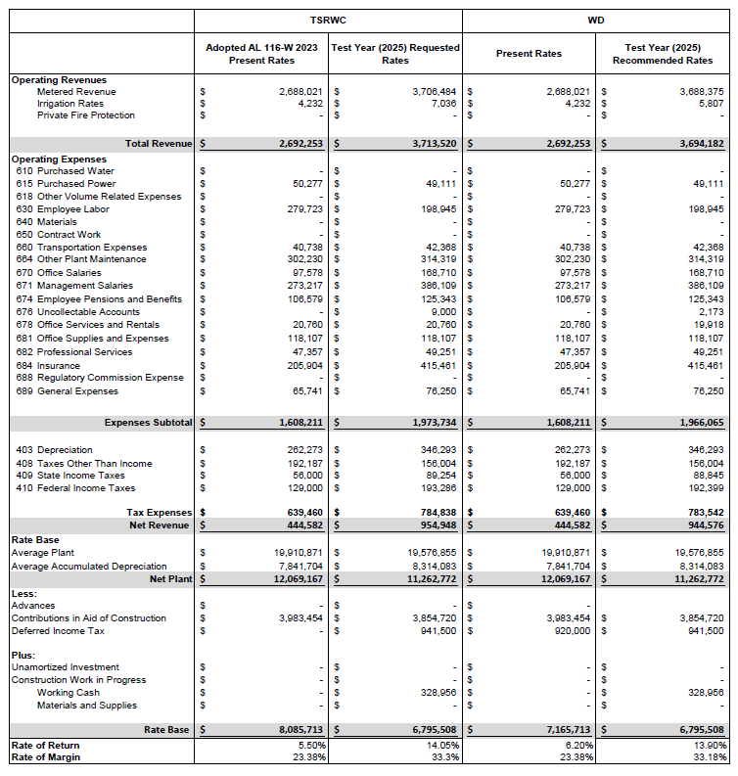
END OF APPENDIX A

APPENDIX B
THE SEA RANCH WATER COMPANY
Tariff Sheets
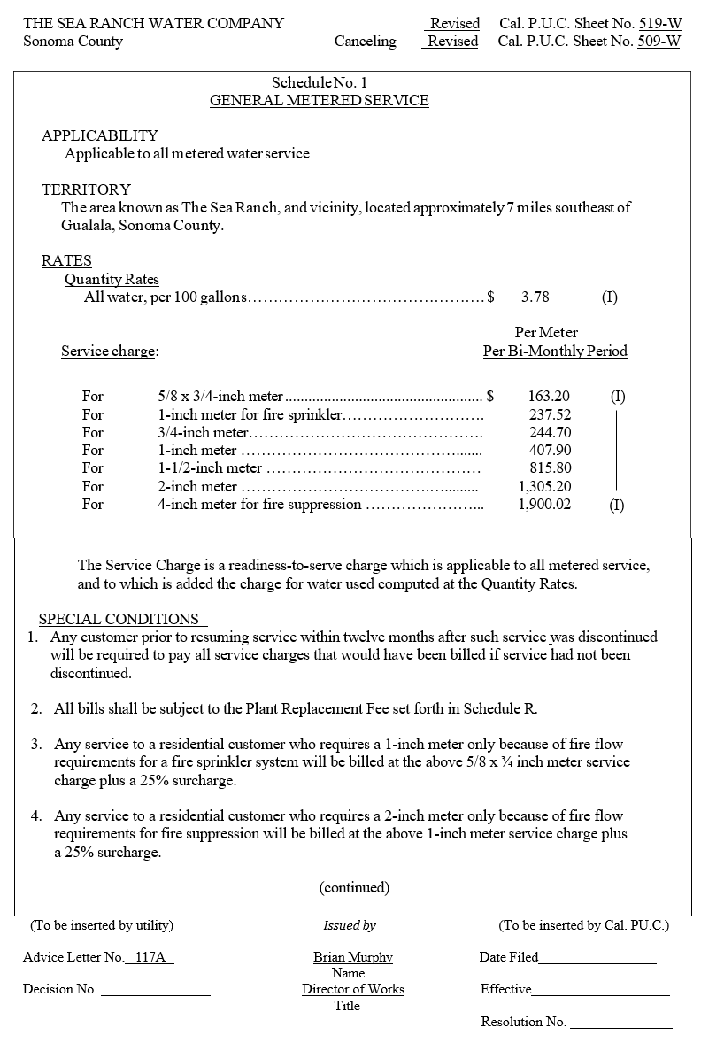

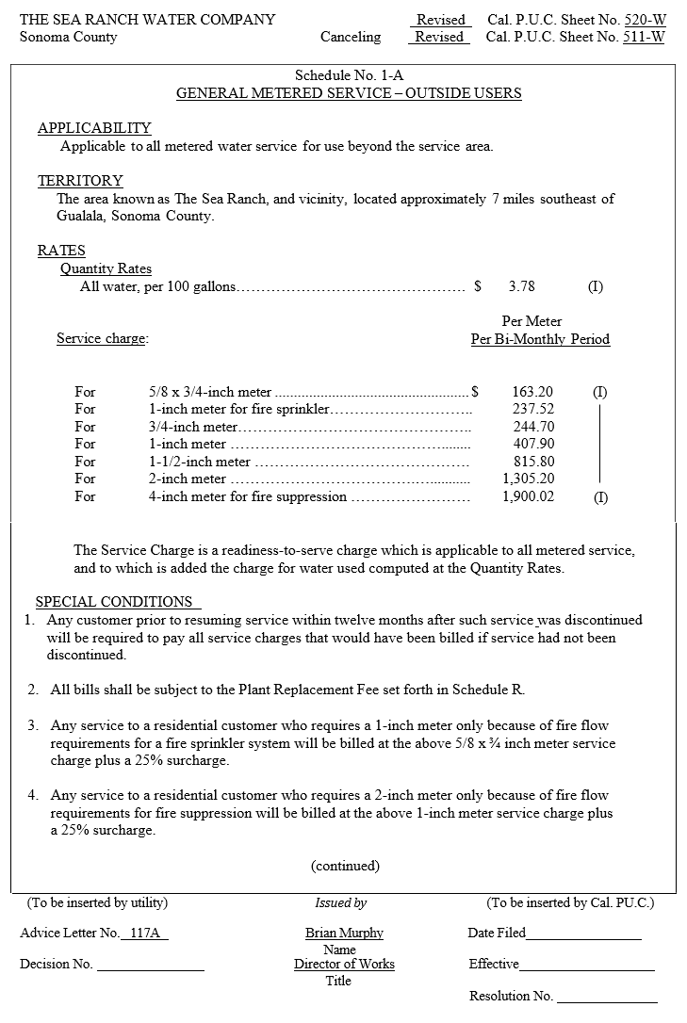

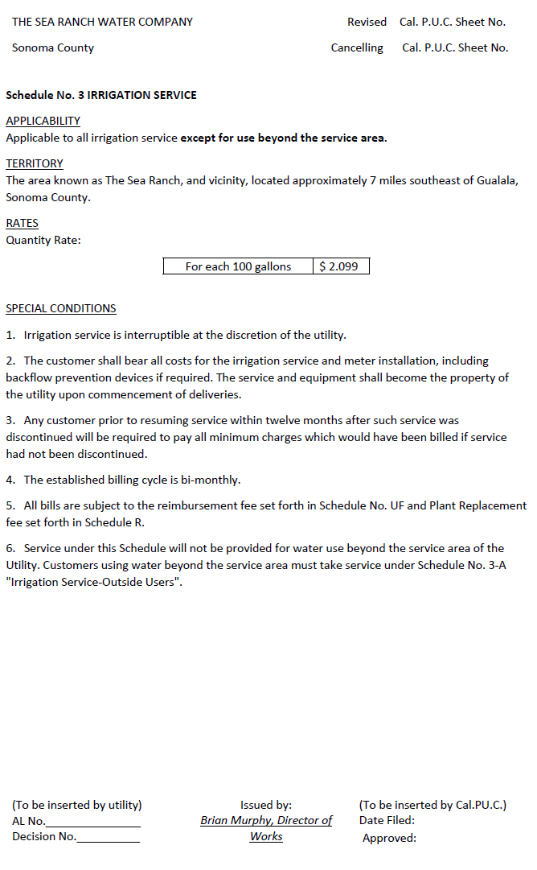
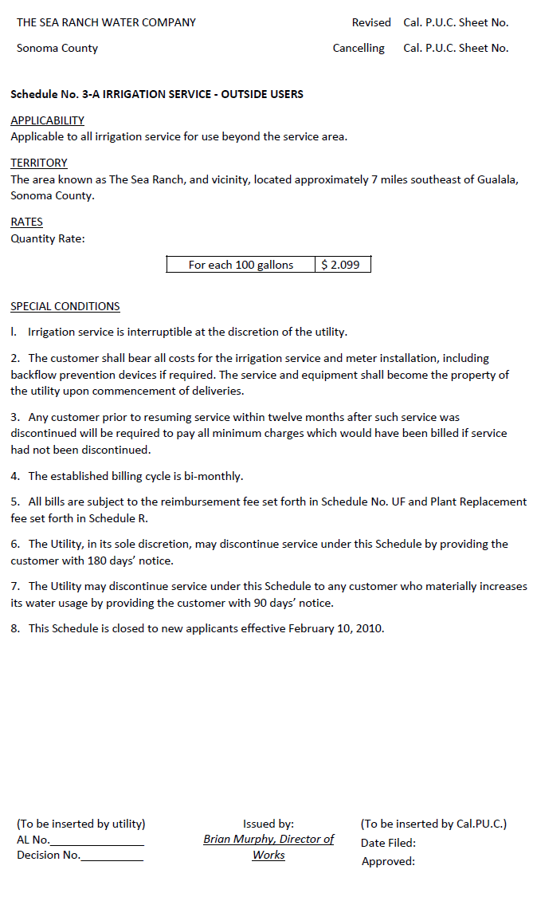
END OF APPENDIX B

APPENDIX C
THE SEA RANCH WATER COMPANY
Comparison of Rates
Test Year 2025
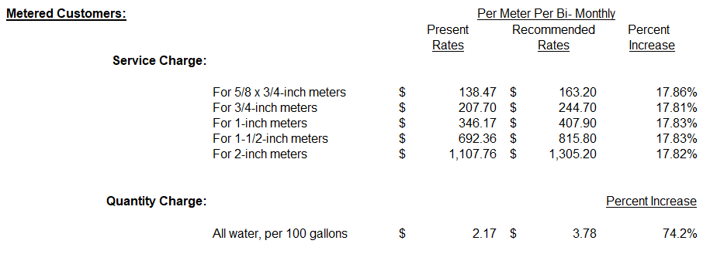
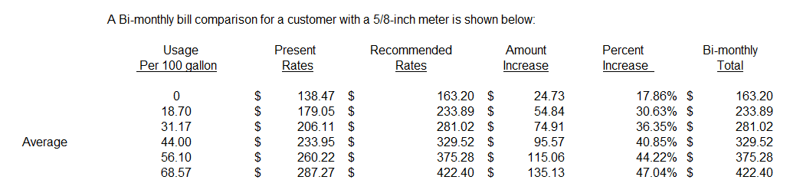

END OF APPENDIX C

CERTIFICATE OF SERVICE
I certify that I have, by either electronic mail or postal mail, this day, served a true copy of Proposed Resolution No. W-5298 on all parties in these filings or their attorneys as shown on the attached lists.
Dated July 10, 2025, at San Francisco, California.

/s/ LEVI GOLDMAN
Levi Goldman

Parties should notify the Water Division, Third Floor, California Public Utilities Commission, 505 Van Ness Avenue, San Francisco, CA 94102, of any change of address to ensure that they continue to receive documents. You must indicate the Resolution number on which your name appears.

THE SEA RANCH WATER COMPANY

ADVICE LETTER NO. 117A-W SERVICE LIST

Division of Water and Audits
California Public Utilities Commission
505 Van Ness Avenue
San Francisco, CA 94102
Water.Division@cpuc.ca.gov

North Gualala Water Company
P.O. Box 1000
Gualala, CA 95445

Point Arena Water Works, Inc.
P.O. Box 205
Point Arena, CA 95468

Users with lower usage or higher usage will have smaller and larger percentage increases respectively for their bi-monthly bills. Along with the 65% of fixed cost allowed to be recovered in service charge per STD U-7-W, the percent bi-monthly increase for the average residential user is higher than the percent increase to the annual revenues.
This information is from the U.S. Census Bureau, American Community Survey (ACS) and Puerto Rico Community Survey (PRCS), 5-Year Estimates, U.S. Census Bureau QuickFacts: Sonoma County, California)
As defined in G.O. 96-B Water Industry Rules Section 1.2., Class B, C, and D investor-owned water utilities serve 2,001 through 10,000, 501 through 2,000, and less than 500 service connections, respectively.
State Income Tax Rate for C-Corporations, https://www.ftb.ca.gov/file/business/types/corporations/c-corporations.html
Standard Practice U-4-W pg. 4 & Standard Practice U-4-SM pg.3
The revenue requirement and rates under the ROR method are based on company’s rate base and under the ROM method the revenue requirement is based on the company’s overall expenses which include operating and maintenance and depreciation expenses, income and other taxes, and an operating margin.
D. 92-03-093, Ordering Paragraph 8
Standard Practice U-7 pg. 6
Standard Practice U-7-W pg. 8 & 4
February 2021, Financial Audit of The Sea Ranch Water Company Financial Statements for the Years Ended December 31, 2019.

