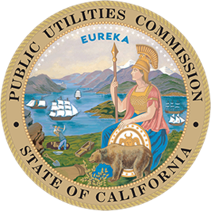
California Public Utilities Commission
505 Van Ness Ave., San Francisco

_________________________________________________________________________________
FOR IMMEDIATE RELEASE PRESS RELEASE
Media Contact: Terrie Prosper, 415.703.1366, news@cpuc.ca.gov Docket #: R.18-04-018

CPUC Launches New Pilot to Electrify Select Mobilehome Parks
SAN FRANCISCO, Nov. 24, 2025 – The California Public Utilities Commission (CPUC) has announced a new electrification initiative to fully electrify select mobilehome parks across the state.
Investor-owned utilities will work directly with the California Energy Commission’s Equitable Building Decarbonization (EBD) program to electrify mobilehome parks. The EBD program provides and installs energy efficiency measures, electric appliances, and associated upgrades to accommodate these measures at little or no cost to participants. Participants will also be enrolled in the CPUC’s existing Mobilehome Park Utility Conversion Program to have their submetered electrical systems converted to direct-metered, utility-owned systems.
This electrification pilot initiative, approved at the CPUC’s Nov. 20 Voting Meeting, will help the CPUC better understand technical, legal, and policy concerns related to mobilehome park electrification and to inform potential changes to the Mobilehome Park Utility Conversion Program.
The CPUC launched this proceeding to evaluate the original Mobilehome Park Pilot Program, established 2014, which incentivized conversions from master-metered natural gas and electric systems to direct utility service. Following positive evaluation results, the CPUC created the current 10-year Mobilehome Park Utility Conversion Program, running from 2021 through 2030.
The new electrification pilot will support California’s long-term decarbonization and equity goals.
More Information
- Proposal Approved
- Mobilehome Park Utility Conversion Program
###
About the California Public Utilities Commission
The CPUC regulates services and utilities, protects consumers, safeguards the environment, and assures
Californians access to safe and reliable utility infrastructure and services. Visit www.cpuc.ca.gov for
more information.

