December 12, 2025 Agenda ID: 23920
RESOLUTION T-17900

TO: CASF Service List

This is Draft Resolution T-17900 of the Communications Division. This Draft Resolution will appear on the agenda at the next Commission meeting to be held January 15, 2026, which is at least 30 days after the date of this letter. The Commission may vote on this Resolution at that time, or it may postpone a vote until a later meeting. To confirm when the item will be heard, please see the Business Meeting agenda, which is posted on the Commission’s website 10 days before each Business Meeting. When the Commission votes on a Draft Resolution, it may adopt all or part of it as written, amend, modify, or set it aside and prepare a different Resolution. Only when the Commission acts does the Resolution become binding on the parties.
Any member of the public may serve comments on the Draft Resolution as provided in Public Utilities Code, § 311(g) and Rule 14.5 of the Commission’s Rules of Practice and Procedure (Rules).
Comments along with a certificate of service (COS) shall be sent via email to: the CASF Service List, angela.beane@cpuc.ca.gov, and federalfundingaccount@cpuc.ca.gov by January 1, 2026, at 5:00 PM.
Those submitting comments on the Draft Resolution must serve their comments on the entire service list the Draft Resolution was served to on the same date that the comments are submitted to the Communications Division.
Comments shall focus on factual, legal, or technical errors in the proposed Draft Resolution. Comments that merely reargue positions taken in the advice letter or protests will be accorded no weight and are not to be submitted. Comments should list the recommended changes to the Draft Resolution.
Replies to comments must be submitted no later than January 6, 2026. Replies shall be submitted and served in the same manner as opening comments.

Sincerely,

/s/
Maria Ellis
Director for Broadband Initiatives
Communications Division
California Public Utilities Commission

PUBLIC UTILITIES COMMISSION OF THE STATE OF CALIFORNIA

Communications Division Agenda ID #23920
Broadband Regional Initiatives Branch RESOLUTION T-17900
January 15, 2026

R E S O L U T I O N

RESOLUTION T-17900 Awards four grants for up to $21,004,828 from the last mile Federal Funding Account to enable investments benefiting around 64,296 Californians and provide service to 1,742 unserved locations in Inyo, Monterey, and Contra Costa counties.

PROPOSED OUTCOME:
- Awards four grants for up to $21,004,828 from the last mile Federal Funding Account to Stimulus Technologies in Inyo County, California Broadband Alliance in Monterey County, and Contra Costa Transportation Authority in Contra Costa County.
SAFETY CONSIDERATIONS:
- There are no adverse safety considerations identified by the Communications Division. The projects which will be implemented by this award have the potential to improve communications resiliency and redundancy.

ESTIMATED COST:
- There are no costs associated with this resolution.
__________________________________________________________
SUMMARY

This Resolution recommends approval of four last mile Federal Funding Account grants in the amount of up to $21,004,828 in Inyo, Monterey, and Contra Costa counties.
The four projects in this Resolution propose to make investments bringing the social, economic, civic, and public safety benefits of high-speed broadband to 1,742 unserved locations and an estimated unserved population of 10,795. An estimated total population of 64,296 people will benefit from these investments as households and businesses that already have broadband service in these communities will have greater customer choice.

This Resolution recommends grant awards to four entities: Stimulus Technologies, California Broadband Alliance, and Contra Costa Transportation Authority. The following grant applications are recommended for Commission approval as shown in Table 1 below. Maps and summaries associated with each project are in the appendices.

Table 1: Summary of Grant Funding

Applicant | Project Name |  | Estimated Unserved Locations | Estimated Unserved Units | Estimated Unserved Population | Estimated Benefitting Population | Awarded Amount
Inyo County
Stimulus |  | Inyo-5 | 27 | 29 | 155 | 155 | $2,767,851
Subtotal |  |  | 27 | 29 | 155 | 155 | $2,767,851
Monterey County
California Broadband Alliance |  | Surfnet-Salinas | 256 | 438 | 1,244 | 1,281 | $3,296,422
Subtotal |  |  | 256 | 438 | 1,244 | 1,281 | $3,296,422
Contra Costa County
Contra Costa Transportation Authority |  | CCTA-West Contra Costa County | 369 | 781 | 4,318 | 21,564 | $4,534,294
Contra Costa Transportation Authority |  | CCTA-East Contra Costa County | 1,090 | 1,586 | 5,078 | 41,296 | $10,401,262
Subtotal |  |  | 1,459 | 2,367 | 9,396 | 62,860 | $14,940,556
Grand Total |  |  | 1,742 | 2,834 | 10,795 | 64,296 | $21,004,828
BACKGROUND

California’s multi-year broadband investment package established the last mile Federal Funding Account as part of the Budget Act of 2021 and Senate Bill 156 and invested
$2 billion in the program over multiple years. The Federal Funding Account funds the construction of last mile broadband infrastructure projects in unserved areas of California. The Federal Funding Account encourages the deployment of broadband throughout the State to enable the public to access internet-based safety applications, telehealth services, emergency services, and to allow first responders to communicate with each other and collaborate during emergencies.

On April 21, 2022, the Commission issued Decision (D.) 22-04-055, Decision Adopting Federal Funding Account Rules. The rules and guidelines adopted in that decision included, among other items, the following: rules about projects to benefit Environmental and Social Justice Communities, affordable offers, five and ten-year price commitments, low-cost plans, project eligibility, application requirements, application objections, implementation of Public Utilities Code Section 281(n) allocating funding between “rural counties” and “urban counties,” a process to reimburse grantees, a ministerial review process whereby Communications Division Staff may approve certain projects, and minimum performance standards for grantees.

The Federal Funding Account D. 22-04-055 includes requirements and preference for a number of affordability requirements including:
- Participation in the Affordable Connectivity Program or access to a “broad-based affordability program.” Given that the Affordable Connectivity Program has lapsed grantees must participate in a successor program when identified by the Commission.
- A five-year price commitment, and preference for a ten-year commitment.
- Preference for a low-cost plan that is $40/month or less and provides speeds of at least 50 megabits per second down and 20 megabits per second up (50/20 Mbps).
- Preference for participation in the California and/or federal Lifeline programs (which may include bundled voice and broadband offerings).

Applications that committed to provide voice service and participate in LifeLine, consistent with the requirement to serve customers in the project area at prices not exceeding those in the application for five years after project completion, must provide voice service and participate in LifeLine for five years after project completion. In providing grant funding to projects the Commission is validating the need for and the state’s investment in the provision of communications service, including voice and programs supporting affordability like LifeLine, for the life of the infrastructure.

The Federal Funding Account Decision and Appendix specify additional consideration for disadvantaged communities or Environmental and Social Justice communities. The Commission made available on the Federal Funding Account Public Map, and data downloads locations and census blocks meeting these definitions. The Commission closed the first round of Federal Funding Account applications on February 20, 2025, awarding over $1 billion in broadband grants for projects in 52 counties across California.

On May 27, 2025, the Commission opened a limited opportunity to submit last mile Federal Funding Account applications in the six counties that did not receive awards in Round 1, which closed on February 20, 2025. The six counties are Calaveras, Contra Costa, Inyo, Monterey, Orange, and Trinity. The opportunity to apply included guidance that applicants “may include unserved locations in adjacent counties, which have remaining allocation, as part of multi-county projects.” This Resolution includes 20 applications from 3 of the 6 counties: Inyo, Monterey, and Contra Costa counties. Application summaries were posted on June 23, 2025, and a 14-day objection period closed July 7, 2025. Responses to objections were received until July 21, 2025.

Applications were holistically evaluated: required and supporting documentation and the merits of the applications were compared and assessed on a county basis. Staff’s holistic evaluation included project engineering, technical feasibility and design, financial viability, cost, applicant capacity, and community need, among other factors. Staff assessed how to manage overlapping applications and applications planning to include some already-served areas in their project area. Staff also evaluated how applications and groups of applications compared to competing applications in the same county.

The specific locations to be provided service for a given project will be updated and reconciled with the Broadband Serviceable Location Fabric after detailed engineering and project design, and the grant amount may be reduced consistent with a reduction in the number of locations. The Federal Funding Account award will not fund locations supported by a federal broadband program with Capital Project Fund monies.

APPLICATION SUMMARIES, DISCUSSION, AND RECOMMENDATIONS

Inyo County Summary
This Resolution recommends approval of last mile Federal Funding Account application to serve locations in Inyo County: Stimulus Technologies’ Inyo-5 project for $2,767,851. The allocation for projects in Inyo County in D. 22-04-005 is $13,221,784. The recommended grant amount for locations in Inyo County is $2,767,851, which leaves a remainder of $10,453,933 in Inyo County’s allocation for.

Inyo County Award

- Stimulus Technologies, Inyo - 5

Stimulus Technologies’ application for a grant of up to $2,767,851 for Stimulus Technologies’ Inyo - 5 project is recommended to the Commission for approval.

Stimulus Technologies proposes to serve an estimated 27 unserved locations in this rural community. There are approximately 29 unserved units in the project area. An estimated unserved population of 155 would be offered service. An estimated total population of 155 will benefit from these investments. The project will offer up to 2.5 Gigabits per second (Gbps) by 2028 as bandwidth becomes available and up to 50 Gbps within 7 to 10 years after the network becomes operational.
Stimulus Technologies will deploy approximately 10.5 miles of last mile fiber. The network infrastructure will be 25% aerial and 75% underground. The network will connect to the open access Middle Mile Broadband Network.

The middle-mile infrastructure is needed to connect the last mile locations. The project middle mile must be open access for the lifetime of the infrastructure meaning that the grantee owning the infrastructure must offer nondiscriminatory interconnection and Internet access at reasonable and equal terms to any telecommunications service provider that wishes to interconnect with that infrastructure, wherever technically feasible. And the pricing, terms, and conditions for other providers to interconnect must be just, reasonable, and nondiscriminatory.

Stimulus Technologies’ Inyo - 5 project will benefit disadvantaged or Environmental and Social Justice communities. The project will serve 100% unserved locations in low-income areas. Stimulus Technologies will provide a low-cost broadband plan that meets the requirements in D. 22-04-055, Section 3, and has committed to maintaining its prices for at least ten years.

The proposed project provides public safety benefits of reliable broadband infrastructure. This project is not located in a High Fire Threat District.

The proposed project will cost an estimated $2,767,851, of which the Federal Funding Account will fund 100% of costs.

The applicant and the project were determined to be financially viable, and the applicant’s engineering meets the program standards. The applicant demonstrated the administrative, technical, and operational capacity to provide broadband service at the scale of this project.

Stimulus Technologies’ Inyo - 5 project received one objection, which claimed Stimulus Technologies should not deploy aerial fiber because the proposed project is in an area with elevated wildfire risk. The proposed deployment is 75% underground; however, D. 22-04-055 does not require underground deployment in High Fire Threat Districts or area with elevated wildfire risk.

The following submitted letters of support for this application: Chairperson of the Inyo County Board of Supervisors Scott Marcellin, Chief Executive Officer of the Lone Pine Chamber of Commerce Angelica Mara, Superintendent of the Lone Pine Unified School District Ed Campbell, Pastor of the Hope City Church Greg Rickets, and Secretary Treasurer of Dow Villa Incorporated Jeane Willey.

Based on the information received, the Commission’s Energy Division has determined that this project has not met the requirements of California Environmental Quality Act (CEQA) categorical exemption at this time. Stimulus Technologies must comply with the CEQA requirements discussed in the appendices. If Stimulus Technologies provides additional documentation sufficient to justify a staff determination of CEQA exemption, then the project can be exempted by letter from the Communications Division Director or the director’s delegate or designee.

Stimulus Technologies and the Inyo 5 project must comply with all requirements for approval in D. 22-04-055. The Communications Division recommends that the Commission approve Stimulus Technologies’ application for a grant of up to $2,767,851 for the Inyo-5 project.
Monterey County Summary
This Resolution recommends approval of one last mile Federal Funding Account grant application to serve locations in Monterey County: California Broadband Alliance’s Surfnet – Salinas project for $3,296,422. The allocation for projects in Monterey County in D. 22-04-005 is $17,276,545. The recommended grant amount in Monterey County is $3,296,422, which leaves a remainder of $13,980,124 in Monterey County’s allocation.

Monterey County Award

- California Broadband Alliance, Surfnet – Salinas

The California Broadband Alliance application for a grant of up to $3,296,422 for the Surfnet – Salinas project is recommended to the Commission for approval.

The California Broadband Alliance proposes to serve an estimated 256 unserved locations. There are approximately 438 unserved units in the project area. An estimated unserved population of 1,244 would be offered service. An estimated total population of 1,281 will benefit from these investments. The project will provide symmetrical speeds up to 1 Gbps.
The project includes approximately 70 locations that have received past support for fixed-wireless service under the California Advanced Services Fund Infrastructure Account and Line Extension grants to Cruzio Media. This recommended award can include only costs to upgrade service to these approximately 70 locations in coordination with the California Advanced Services Fund Infrastructure and Line Extension awardee, Cruzio, a partner with the California Broadband Alliance on other Federal Funding Account applications.
The California Broadband Alliance will deploy approximately 23 miles of last-mile fiber. The network infrastructure will be 100% aerial.

The Surfnet-Salinas project will benefit disadvantaged or Environmental and Social Justice communities: 59% of unserved locations are in low-income areas. The California Broadband Alliance will provide a low-cost broadband plan that meets the requirements in D. 22-04-055, Section 3, and has committed to maintaining its prices for at least ten years.

The proposed project provides public safety benefits of reliable broadband infrastructure. This project is located in High Fire Threat District 2.

The proposed project will cost an estimated $3,296,422, of which the Federal Funding Account will fund 100% of costs.

The California Broadband Alliance signed a Memorandum of Understanding to partner with Surfnet and will retain sole ownership. During the construction phase, Surfnet will be responsible for the construction, administration of the grant, and fulfillment of the terms and reporting obligations. Once operational, Surfnet will lease the infrastructure from the California Broadband Alliance and be responsible for operating the network, provisioning retail broadband service, billing customers, and customer service. The California Broadband Alliance and Surfnet will operate under a comprehensive Operational Agreement and Indefeasible Right of Use upholding responsibility for the maintenance, support, and upgrade of the assets.

As the prospective California Broadband Alliance-Surfnet relationship has been characterized, the applicant, partner, and the project were determined to be financially viable, and the applicant’s engineering meets the program standards. The applicant demonstrated the administrative, technical, and operational capacity to provide broadband service at the scale of this project.

The Surfnet – Salinas project received one objection. The objector claimed that the project proposes aerial deployment in an area subject to wildfire risk. The proposed deployment is aerial; however, D.22-04-055 does not require underground deployment in High Fire Threat Districts.

The following submitted letters of support for this application: The Monterey Bay Economic Partnership (Central Coast Broadband Consortium) President and Chief Executive Officer Tahra Goraya, and the Western Growers Center for Innovation and Technology Executive Director Dennis Donohue.

Based on the information received, the Commission’s Energy Division has determined that the project meets the criteria for CEQA categorical exemptions under 14 California Code of Regulation (C.C.R.) Section 15303 (New Construction or Conversion of Small Structures), Class 3; and 14 C.C.R section 15304 (Minor Alternations to Land). Thus, the Surfnet – Salinas project is categorically exempt from CEQA review and the Commission may authorize funds for the construction activities.

The California Broadband Alliance and the Surfnet – Salinas project must comply with all requirements for approval in D. 22-04-055. The Communications Division recommends that the Commission approve the California Broadband Alliance’s application for a grant of up to $3,296,422 for the Surfnet – Salinas project.
Contra Costa County Summary
This Resolution recommends approval of two last mile Federal Funding Account grant applications to serve locations in Contra Costa County: Contra Costa Transportation Authority’s (CCTA) CCTA – East Contra Costa County project for $10,401,262, and CCTA – West Contra Costa County project for $4,534,294. The allocation for projects in Contra Costa County in D. 22-04-005 is $16,108,600. The recommended grant amount is $14,935,556, which leaves a remainder of $1,173,044 Contra Costa County’s allocation.

Contra Costa County Awards

- Contra Costa Transportation Authority, CCTA - West Contra Costa County

Contra Costa Transportation Authority’s application for a grant of up to $4,534,294 for the CCTA - West Contra Costa County project is recommended to the Commission for approval.
Contra Costa Transportation Authority proposes to serve an estimated 369 unserved locations. There are approximately 781 unserved units in the project area. An estimated unserved population of 4,318 would be offered service. An estimated total population of 21,564 will benefit from these investments. The project will provide symmetrical speeds up to 10 Gbps.
Contra Costa Transportation Authority will deploy approximately 61.7 miles of last-mile fiber. The network infrastructure will be 89% aerial and 11% underground.

The Contra Costa Transportation Authority CCTA - West Contra Costa County project will benefit disadvantaged or Environmental and Social Justice communities: 63% of the unserved locations are in low-income areas. Contra Costa Transportation Authority will provide a low-cost broadband plan that meets the requirements in D. 22-04-055, Section 3, and has committed to maintaining its prices for at least ten years.

The proposed project provides public safety benefits of reliable broadband infrastructure. This project is located in High Fire Threat Districts 2 and 3.

The proposed project will cost an estimated $4,534,294, of which the Federal Funding Account will fund 100% of costs.

The applicant and the project were determined to be financially viable, and the applicant’s engineering meets the program standards. The applicant demonstrated the administrative, technical, and operational capacity to provide broadband service at the scale of this project.

The CCTA - West Contra Costa County project received one objection. The objector claimed that it already offers reliable service exceeding 100/20 Mbps in the proposed project area. It was confirmed that the objection substantiated service to 276 locations by reliable service that meets or exceeds speeds of 25/3 Mbps. Contra Costa Transportation Authority was asked to modify its application to remove 276 locations from the project and reduce the corresponding project costs.

The following submitted letters of support for this application: Contra Costa County Board of Supervisors Chair Candace Andersen, City of Antioch City Manager Bessie Scott, City of El Cerrito Mayor Carolyn Wysinger, City of Hercules City Manager Dante Hall, City of Lafayette Mayor Susan Candell, City of Oakley City Manager Joshua McMurray, City of Pittsburg City Manager Garrett Evans, City of Walnut Creek Mayor Cindy Darling, and City of Brentwood Interim City Manager Darin Gale.

Based on the information received, the Commission’s Energy Division has determined that this project has not met the requirements of CEQA categorical exemption at this time. Contra Costa Transportation Authority must comply with the CEQA requirements discussed in the appendices. If Contra Costa Transportation Authority provides additional documentation sufficient to justify a staff determination of CEQA exemption, then the project can be exempted by letter from the Communications Division Director or the director’s delegate or designee.

Contra Costa Transportation Authority and the CCTA - West Contra Costa County project must comply with all requirements for approval in D. 22-04-055. The Communications Division recommends that the Commission approve Contra Costa Transportation Authority’s application for a grant of up to $4,534,294 for the CCTA - West Contra Costa County project.
- Contra Costa Transportation Authority, CCTA- East Contra Costa County

Contra Costa Transportation Authority’s application for a grant of up to $10,401,262 for the CCTA - East Contra Costa County project is recommended to the Commission for approval.

Contra Costa Transportation Authority proposes to serve an estimated 1,090 unserved locations. There are approximately 1,586 unserved units in the project area. An estimated unserved population of 5,078 would be offered service. An estimated total population of 41,296 will benefit from these investments. The project will provide symmetrical speeds up to 10 Gbps.
Contra Costa Transportation Authority will deploy approximately 144 miles of last-mile fiber. The network infrastructure will be 95% aerial and 5% underground.

Contra Costa Transportation Authority’s CCTA - East Contra Costa County project will benefit disadvantaged or Environmental and Social Justice communities: 26% of the unserved locations are in low-income areas. Contra Costa Transportation Authority will provide a low-cost broadband plan that meets the requirements in D. 22-04-055, Section 3, and has committed to maintaining its prices for at least ten years.

The proposed project provides public safety benefits of reliable broadband infrastructure. This project is located in High Fire Threat Districts 2 and 3.

The proposed project will cost an estimated $10,401,262, of which the Federal Funding Account will fund 100% of costs.

The applicant and the project were determined to be financially viable, and the applicant’s engineering meets the program standards. The applicant demonstrated the administrative, technical, and operational capacity to provide broadband service at the scale of this project.

The Contra Costa Transportation Authority CCTA - East Contra Costa County project received one objection. The objector claimed that it already offers reliable service exceeding 100/20 Mbps in the proposed project area. It was confirmed that the objection substantiated service to 76 locations by reliable wireline service that meets or exceeds speeds of 25/3 Mbps. Contra Costa Transportation Authority was asked to modify its application to remove 76 locations from the project.

The following submitted letters of support for this application: Contra Costa County Board of Supervisors Chair Candace Andersen, City of Antioch City Manager Bessie Scott, City of El Cerrito Mayor Carolyn Wysinger, City of Hercules City Manager Dante Hall, City of Lafayette Mayor Susan Candell, City of Oakley City Manager Joshua McMurray, City of Pittsburg City Manager Garrett Evans, City of Walnut Creek Mayor Cindy Darling, and City of Brentwood Interim City Manager Darin Gale.

Based on the information received, the Commission’s Energy Division has determined that this project has not met the requirements of CEQA categorical exemption at this time. Contra Costa Transportation Authority must comply with the CEQA requirements discussed in the appendices. If Contra Costa Transportation Authority provides additional documentation sufficient to justify a staff determination of CEQA exemption, then the project can be exempted by letter from the Communications Division Director or the director’s delegate or designee.

Contra Costa Transportation Authority and the CCTA - East Contra Costa County project must comply with all requirements for approval in D. 22-04-055. The Communications Division recommends that the Commission approve Contra Costa Transportation Authority‘s application for a grant of up to $10,401,262 for the CCTA - East Contra Costa County project.

COMPLIANCE REQUIREMENTS

Awardees are required to comply with all the guidelines, requirements, and conditions associated with the grant of Federal Funding Account awards as specified in D.22-04-055. All Awardees are also required to sign a consent form agreeing to the terms and conditions of the Federal Funding Account. Such compliance includes, but is not limited to, the items noted below.

A. Deployment Schedule: All CEQA-exempt projects must be completed within 18 months, and all other projects shall be completed within 24 months after receiving authorization to construct. This timeline updates and supersedes the timeline in D.22-04-055 Appendix A, Section 8 on reimbursable expenses.

B. Pricing: By accepting these awards, the Awardees commit to serve customers in the project area at prices not exceeding those provided in the application for five years after project completion. Awardees who committed to not increase prices for a period of ten years in their application commit to serve customers in the project area for ten years after project completion. Should the need arise for grant recipients to adjust prices due to externalities outside their control (e.g. inflation), grant recipients may file and serve, on the R. 20-09-001 proceeding (or successor proceeding) service list, a request to modify this requirement with the Communications Division.

C. Speed and Latency: All households in the proposed project areas must be offered a broadband internet service plan with speeds of at least 100/100 Mbps download and upload, with no more than 100 milliseconds of latency.

D. Affordability: All projects shall participate in the Affordable Connectivity Program or otherwise provide access to a broad-based affordability program to low-income customers in the proposed service area of the broadband infrastructure that provides benefits to households commensurate with those provided under the Affordable Connectivity Program. Should the Affordable Connectivity Program end, the Commission will identify a successor low-income subsidy program in which participants must participate. Awardees must participate in a successor to the Affordable Connectivity Program identified after the grant is awarded.

E. Project Audit: The Commission has the right to conduct any necessary audit, verification, and discovery during project implementation/construction to ensure that Federal Funding Account funds are spent in accordance with Commission approval. All recipients of federally funded grants exceeding $750,000 will need to include a budget for a federal audit.

F. Reporting Requirements: Numerous post-award reports are required. In summary, these include monthly contractor reports (if applicable), quarterly progress reports, and a final completion report.

G. Prevailing Wage: Section 1720 of the California Labor Code requires Federal Funding Account projects to be subject to prevailing wage requirements. Applicants accepting Federal Funding Account awards are committing to follow applicable prevailing wage requirements with regards to their projects.

H. Payments to Federal Funding Account Recipients: The Commission may reimburse Awardees’ expenses in accordance with Public Utilities Code Section 281(n)(2), D.22-04-055, and the Appendix. Requests for payments may be submitted as the project is progressively deployed. The prerequisite for first payment is the submittal of a progress report to the Commission showing that a minimum of ten percent of the project (as determined by budget spent) has been completed. Subsequent payments may be made upon at least 25 percent intervals, with the final 15 percent payment request (from 85 to 100 percent) not eligible for payment without an approved completion report. Payments are based on submitted receipts, invoices and other supporting documentation showing expenditures incurred for the project in accordance with the approved Federal Funding Account budget included in the awardee’s application.

COMMENTS

In compliance with Public Utilities Code Section 311(g)(1), a Notice of Availability of this draft resolution was e-mailed on December 12, 2025, informing all parties on the CASF Distribution List and the R. 20-09-001 Service List of the availability of the draft of this Resolution, and of the opportunity to comment, at the Commission’s website at http://www.cpuc.ca.gov/.

FINDINGS OF FACT

- California’s multi-year broadband infrastructure investments in the Budget Act of 2021 and Senate Bill 156 (Statutes 2021, Chapters 84 and 112) provided $2 billion over multiple years to the last mile Federal Funding Account to facilitate, via reimbursement, construction of last mile broadband infrastructure projects to connect unserved Californians.

- On April 21, 2022, the Commission approved Decision 22-04-055, which along with the Federal Final Rule, established the last mile Federal Funding Account and set program rules.
- The Communications Division opened an application window for the Federal Funding Account on May 27, 2025, and closed it on June 2, 2025. Applicants submitted 72 applications before the deadline. Application summaries were posted on June 23, 2025, and a 14-day objection window closed on July 7, 2025. Responses to objections were received until July 21, 2025.
- Stimulus Technologies submitted an application for the Inyo-5 project on June 5, 2025, and a revised application on October 13, 2025.
- The California Broadband Alliance submitted an application for the Surfnet-Salinas project on April 28, 2025.

- Contra Costa Transportation Authority submitted an application for the CCTA - West Contra Costa County and CCTA - East Contract Costa County projects on June 2, 2025, and revised applications on October 22, 2025, and October 23, 2025, respectively.

- The Commission has determined that the Stimulus Technologies’ Inyo-5 project is not exempt from California Environmental Quality Act review at this time.

- The Commission has determined that the California Broadband Alliance Surfnet-Salinas project is exempt from California Environmental Quality Act (CEQA) review pursuant to 14 California Code of Regulation (C.C.R.) Section 15303 (New Construction or Conversion of Small Structures), Class 3; and 14 C.C.R Section 15304 (Minor Alternations to Land). The Commission may authorize funds for the construction activities.

- The Commission has determined that Contra Costa Transportation Authority’s CCTA - West Contra Costa County and CCTA - East Contra Costa County projects are not exempt from California Environmental Quality Act review at this time.

- Communications Division staff analyzed the applications for compliance with Commission and Federal rules, reviewed local feedback, and conducted fiscal and technical analysis.
- All applications listed above met minimum eligibility requirements provided in Decision 22-04-055.
- Staff recommend approval of the applications in this Resolution, as they comply with program rules as stated and contribute to the Federal Funding Account’s goal of building broadband internet infrastructure to communities without access to internet service at sufficient and reliable speeds.
- Draft Resolution T-17900 was emailed to the CASF Distribution List and the R. 20-09-001 Service List on December 12, 2025, in compliance with Public Utilities Code Section 311(g)(1).

THERFORE, IT IS ORDERED THAT:

- The Commission shall award up to $2,767,851 in Federal Funding Account funds to Stimulus Technologies to complete the Inyo-5 project, as described in the appendices. The specific locations to be provided with service will be updated and reconciled with the Broadband Serviceable Location Fabric after detailed engineering and project design, and the grant amount may be reduced consistent with a reduction in the number of locations.
- The Stimulus Technologies Inyo-5 project middle-mile infrastructure is needed to connect last mile locations. The project middle mile must be open access for the lifetime of the infrastructure meaning that the grantee owning the infrastructure must offer nondiscriminatory interconnection and Internet access at reasonable and equal terms to any telecommunications service provider that wishes to interconnect with that infrastructure, wherever technically feasible. And the pricing, terms, and conditions for other providers to interconnect must be just, reasonable, and nondiscriminatory.

- The Commission shall award up to $3,296,422 in Federal Funding Account funds to the California Broadband Alliance to complete the Surfnet -Salinas project, as described in the appendices. The specific locations to be provided with service will be updated and reconciled with the Broadband Serviceable Location Fabric after detailed engineering and project design, and the grant amount may be reduced consistent with a reduction in the number of locations. The award can include only costs to upgrade service to the approximately 70 locations in coordination with the California Advanced Services Fund Infrastructure and Line Extension awardee, Cruzio, a partner with the California Broadband Alliance on other Federal Funding Account applications.
- The Commission shall award up to $4,534,294 in Federal Funding Account funds to Contra Costa Transportation Authority to complete the CCTA - West Contra Costa County project, as described in the appendices. The specific locations to be provided with service will be updated and reconciled with the Broadband Serviceable Location Fabric after detailed engineering and project design, and the grant amount may be reduced consistent with a reduction in the number of locations.
- The Commission shall award up to $10,401,262 in Federal Funding Account funds to Contra Costa Transportation Authority to complete the CCTA - East Contra Costa County project, as described in the appendices. The specific locations to be provided with service will be updated and reconciled with the Broadband Serviceable Location Fabric after detailed engineering and project design, and the grant amount may be reduced consistent with a reduction in the number of locations.
- To ensure compliance with all program rules and guidelines, the Commission will not release funds to an applicant proposing to enter into agreement(s) with a third party or third parties for the ownership, operation, and/or leasing of the proposed infrastructure or network until the applicant provides the Commission with an advanced copy of the agreement document(s) as well as any signed agreements.

- Applicants that commit to provide voice and/or Lifeline service must provide voice service and participate in LifeLine for five years after project completion in Federal Funding Account project areas.

- For those projects not determined to be categorically exempt, the Commission cannot release funds for construction activities until California Environmental Quality Act (CEQA) review is complete. The awardees must comply with the requirements set forth in the CEQA Section of the Resolution. The awardees must provide their Proponent’s Environmental Assessment for each project prior to the first payment.

- Awardee(s) shall comply with all guidelines, requirements, and conditions set forth in this resolution.
- When a successor to the Affordable Connectivity Program is identified by the Commission, all awardees shall participate in that program.

- All construction covered by the grant must be completed within the applicable 18-month or 24-month time frame. In the event of extenuating circumstances jeopardizing this timeline, the Awardee(s) must notify the Communications Division’s Director as soon as they become aware of any delay. If such notice is not provided, staff can take corrective actions including reducing payment for failure to satisfy this requirement.

- If the awardee(s) fail to complete the project(s) in accordance with the terms outlined in Decision 22-04-055 and with the terms of the Commission’s approval, as set forth in this resolution, awardees must reimburse some or all the Federal Funding Account grants received or take other corrective action.
- If staff evaluation finds any of the projects can be exempt from the California Environmental Quality Act, then the project can be exempted by letter from the Communications Division Director or the director’s delegate or designee.
- Upon approval of the resolution, the effective date of each award and encumbrance of funds is the date of approved resolution. Awardees seeking to modify their effective date must submit a letter to the Communications Division Director and provide justification for the request. Modifications to the effective date may be approved by letter from the Communications Division Director or the director’s delegate or designee. All awards are contingent on available state budget appropriations funding.

- Awardees or applicants must timely disclose their intent to install last mile infrastructure in an applied-for project area and not seek Federal Funding Account reimbursement notwithstanding their awards or applications.

This resolution is effective today.

Commissioner Signature blocks to be added
upon adoption of the resolution

The foregoing resolution was duly introduced, passed and adopted at a conference of the Public Utilities Commission of the State of California held on January 15, 2026, the following Commissioners voting favorably thereon:

Dated , at <Voting meeting location>, California

APPENDIX A
Stimulus Technologies California Environmental Quality Act Compliance Requirements
The following Stimulus Technologies projects are subject to California Environmental Quality Act (CEQA) review:

- Inyo-5

The Commission must complete CEQA review prior to disbursing Federal Funding Account funds for construction activities. The initial funding granted in this Resolution may be used for project development and other Stimulus Technologies activities that do not involve construction or any activities that would have any direct or indirect effect on the physical environment.
Prior to any construction activity for the project, Stimulus Technologies is required to seek further authority from the Commission for such activity by filing a Proponent’s Environmental Assessment (PEA) pursuant to Commission Rule of Practice and Procedure 2.4; and must undergo an environmental review pursuant to CEQA (California Public Resources Code § 21000 et seq.).
Stimulus Technologies should contact the Supervisor of the Commission’s Energy Division CEQA Unit well in advance of a contemplated filing to (a) consult with staff regarding the process of developing and filing a PEA; (b) provide for cost recovery per Rule of Practice and Procedure 2.5; and (c) enter into a Memorandum of Understanding to allow the Energy Division to initiate the retention of an environmental contractor to perform the environmental review.
Stimulus Technologies must provide a PEA prior to the first payment. The Commission cannot release funds for the construction phase of this project until the Commission has completed CEQA review.

APPENDIX B
California Broadband Alliance California Environmental Quality Act Compliance Requirements
The following California Broadband Alliance project is subject to California Environmental Quality Act (CEQA) review:

- Surfnet-Salinas

The project is located in Monterey County, in the city of South Salinas, Spence. California Broadband Alliance provided the Commission with its project plans to construct 23 miles of fiber optic cable, conduit, handholes, pull-boxes, and conduit vaults. All project infrastructure will be built under or along city streets and existing right-of-way used by other utilities. There will be no placement of project infrastructure in new right-of-way or previously undisturbed ground. Following the completion of construction activities, Surfnet Communications, Inc. would return the site to its original condition.
Based on the information that California Broadband Alliance provided, the Commission’s Energy Division has confirmed that the project meets the criteria for the CEQA categorical exemptions under 14 California Code of Regulation (C.C.R.) § 15303 (New Construction or Conversion of Small Structures), Class 3, and 14 C.C.R. § 15304 (Minor Alterations to Land). Thus, Surfnet Communication Project is categorically exempt from CEQA review and the Commission may authorize funds for construction activities.

APPENDIX C
Contra Costa Transportation Authority California Environmental Quality Act Compliance Requirements
The following Contra Costa Transportation Authority project is subject to California Environmental Quality Act (CEQA) review:

- CCTA-West Contra Costa County
- CCTA-East Contra Costa County

The Commission must complete CEQA review prior to disbursing Federal Funding Account funds for construction activities. The initial funding granted in this Resolution may be used for project development and other Contra Costa Transportation Authority activities that do not involve construction or any activities that would have any direct or indirect effect on the physical environment.
Prior to any construction activity for the project, Contra Costa Transportation Authority is required to seek further authority from the Commission for such activity by filing a Proponent’s Environmental Assessment (PEA) pursuant to Commission Rule of Practice and Procedure 2.4; and must undergo an environmental review pursuant to CEQA (California Public Resources Code § 21000 et seq.).
Contra Costa Transportation Authority should contact the Supervisor of the Commission’s Energy Division CEQA Unit well in advance of a contemplated filing to (a) consult with staff regarding the process of developing and filing a PEA; (b) provide for cost recovery per Rule of Practice and Procedure 2.5; and (c) enter into a Memorandum of Understanding to allow the Energy Division to initiate the retention of an environmental contractor to perform the environmental review.
Contra Costa Transportation Authority must provide a PEA prior to the first payment. The Commission cannot release funds for the construction phase of this project until the Commission has completed CEQA review.

APPENDIX D
Stimulus - Inyo 5
Key Information

Project Name | Stimulus - Inyo 5
Applicant Name | Stimulus Technologies of California, LLC
Community Names | Lone Pine
County | Inyo
County Allocation | $13,221,784
Project Size (Square Miles) | 0.84
Maximum Download/Upload Speed | 1,000 / 1,000 Mbps
Lowest Cost Plan (Non-Income-Qualified) | $95 (1000/1000 Mbps)
Low-Income Plan Offered | $30 (100/20 Mbps)
Low-Cost Plan | $40 (150/150 Mbps)
LifeLine Participation | Yes
Percent Disadvantaged Communities | 0%
Percent Low-Income Areas | 100%
Median Household Income (weighted) | $34,286
Estimated Households in Project Area (Estimated Area Households) | 80
Estimated Benefitting Population (Estimated Area Population) | 155
Estimated Locations within 1,000 Feet of the Project Area (Location Passings) | 42
Estimated Units within 1,000 Feet of the Project Area (Unit Passings) | 48
Unserved Locations in the Project Area | 27
Unserved Units in the Project Area | 29
Estimated Unserved Population in the Project Area | 155
Estimated Unserved Locations with Multiple Dwelling Units (MDUs) in the Project Area | 2
Estimated Unserved Multiple Dwelling Units (MDUs) among Locations in the Project Area | 4
Community Anchor Institutions Benefitting from the Project | 0
Public Safety Locations Benefitting from the Project | 0
Any High Fire Threat Districts in the Project Area | No
100% Underground | No
Connection to Public Open-Access Middle-Mile | Yes
Distance of Middle-Mile, Backhaul, Feeder, and Connection to Middle-Mile Broadband Network Proposed by the Project | 0 Miles
Grant Costs for Middle-Mile, Backhaul, Feeder, and Connection to Middle-Mile Broadband Network in Project Area | $0
Grant Costs for Last-Mile Delivery | $2,767,851
Deployment Schedule | 24 months
Total Project Cost | $2,767,851
Amount of FFA Grant Funds Requested | $2,767,851
Applicant Funded | $0
Grant (Excluding Middle-Mile) per Unserved Unit in the Project Area | $95,443
Grant (Excluding Middle-Mile) per Unit Passing | $57,664

Map of Stimulus - Inyo 5 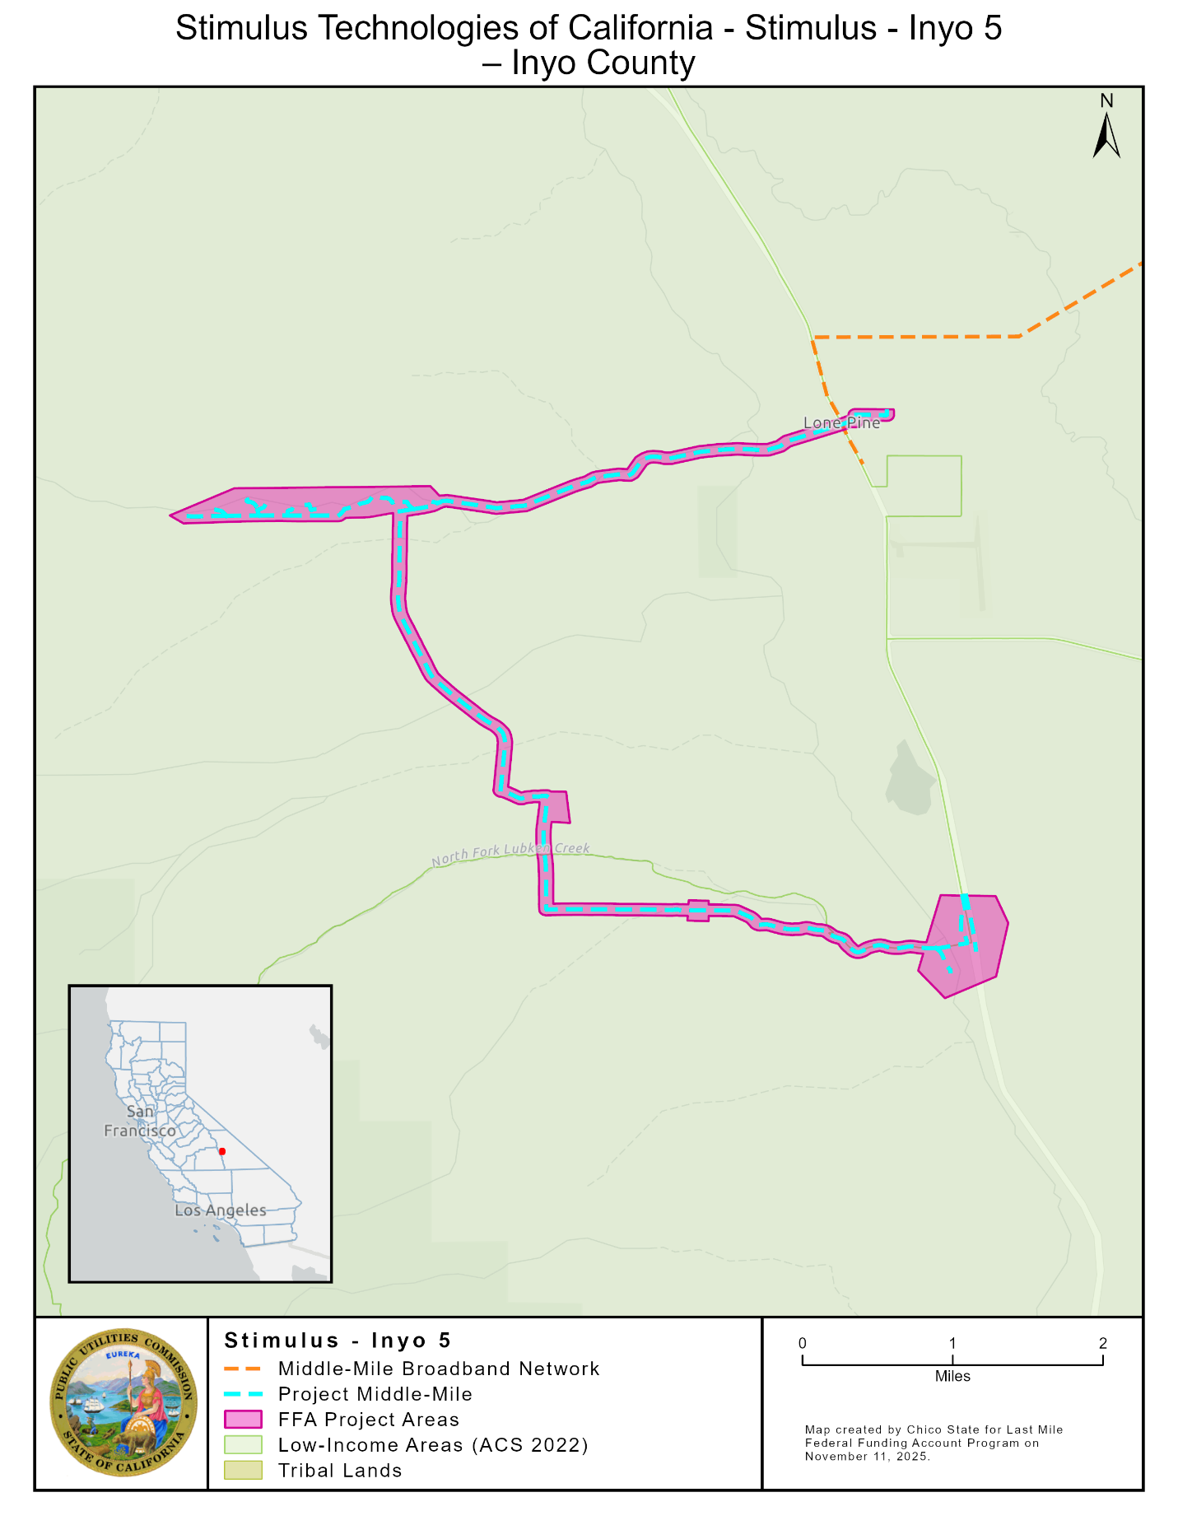

APPENDIX E
Surfnet - Salinas
Key Information

Project Name | Surfnet - Salinas
Applicant Name | California Broadband Alliance and Surfnet Communications Inc
Community Names | South Salinas, Spence
County | Monterey
County Allocation | $17,276,545
Project Size (Square Miles) | 11.57
Maximum Download/Upload Speed | 1,000 / 1,000 Mbps
Lowest Cost Plan (Non-Income-Qualified) | $50 (100/100 Mbps)
Low-Income Plan Offered | $30 (100/100 Mbps)
Low-Cost Plan | $30 (100/100 Mbps)
LifeLine Participation | No
Percent Disadvantaged Communities | 0%
Percent Low-Income Areas | 59%
Median Household Income (weighted) | $53,068
Estimated Households in Project Area (Estimated Area Households) | 352
Estimated Benefitting Population (Estimated Area Population) | 1,281
Estimated Locations within 1,000 Feet of the Project Area (Location Passings) | 313
Estimated Units within 1,000 Feet of the Project Area (Unit Passings) | 467
Unserved Locations in the Project Area | 256
Unserved Units in the Project Area | 400
Estimated Unserved Population in the Project Area | 1,108
Estimated Unserved Locations with Multiple Dwelling Units (MDUs) in the Project Area | 48
Estimated Unserved Multiple Dwelling Units (MDUs) among Locations in the Project Area | 192
Community Anchor Institutions Benefitting from the Project | 2
Public Safety Locations Benefitting from the Project | 0
Any High Fire Threat Districts in the Project Area | No
100% Underground | No
Connection to Public Open-Access Middle-Mile | Yes
Distance of Middle-Mile, Backhaul, Feeder, and Connection to Middle-Mile Broadband Network Proposed by the Project | 0 Miles
Grant Costs for Middle-Mile, Backhaul, Feeder, and Connection to Middle-Mile Broadband Network in Project Area | $0
Grant Costs for Last-Mile Delivery | $3,296,421
Deployment Schedule | 18 months
Total Project Cost | $3,296,421
Amount of FFA Grant Funds Requested | $3,296,421
Applicant Funded | $0
Grant (Excluding Middle-Mile) per Unserved Unit in the Project Area | $8,241
Grant (Excluding Middle-Mile) per Unit Passing | $7,059

Map of Surfnet - Salinas 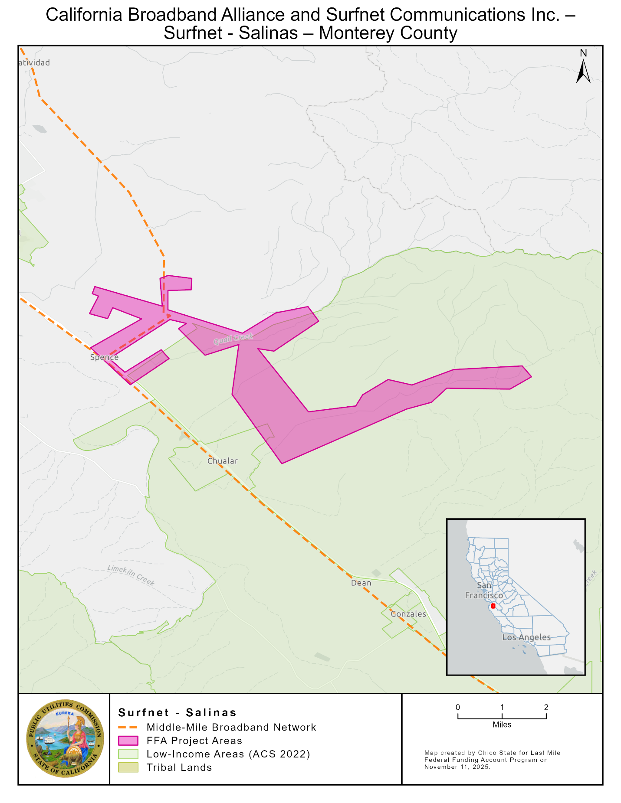

APPENDIX F
CCTA - West Contra Costa County
Key Information

Project Name | CCTA - West Contra Costa County
Applicant Name | Contra Costa Transportation Authority
Community Names | Richmond, San Pablo, Pinole, Hercules, El Cerrito, and Unincorporated County
County | Contra Costa
County Allocation | $16,108,600
Project Size (Square Miles) | 30.43
Maximum Download/Upload Speed | 10,000 / 10,000 Mbps
Lowest Cost Plan (Non-Income-Qualified) | $40 (100/100 Mbps)
Low-Income Plan Offered | No
Low-Cost Plan | $40 (100/100 Mbps)
LifeLine Participation | Yes
Percent Disadvantaged Communities | 66%
Percent Low-Income Areas | 64%
Median Household Income (weighted) | 102,873
Estimated Households in Project Area (Estimated Area Households) | 8,421
Estimated Benefitting Population (Estimated Area Population) | 21,564
Estimated Locations within 1,000 Feet of the Project Area (Location Passings) | 54,367
Estimated Units within 1,000 Feet of the Project Area (Unit Passings) | 81,389
Unserved Locations in the Project Area | 369
Unserved Units in the Project Area | 781
Estimated Unserved Population in the Project Area | 4,318
Estimated Unserved Locations with Multiple Dwelling Units (MDUs) in the Project Area | 182
Estimated Unserved Multiple Dwelling Units (MDUs) among Locations in the Project Area | 594
Community Anchor Institutions Benefitting from the Project | 56
Public Safety Locations Benefitting from the Project | 12
Any High Fire Threat Districts in the Project Area | No
100% Underground | No
Connection to Public Open-Access Middle-Mile | Yes
Distance of Middle-Mile, Backhaul, Feeder, and Connection to Middle-Mile Broadband Network Proposed by the Project | 0 Miles
Grant Costs for Middle-Mile, Backhaul, Feeder, and Connection to Middle-Mile Broadband Network in Project Area | $0
Grant Costs for Last-Mile Delivery | $4,539,294
Deployment Schedule | 24 months
Total Project Cost | $4,539,294
Amount of FFA Grant Funds Requested | $4,539,294
Applicant Funded | $0
Grant (Excluding Middle-Mile) per Unserved Unit in the Project Area | $5,812
Grant (Excluding Middle-Mile) per Unit Passing | $56
Map of CCTA - West Contra Costa County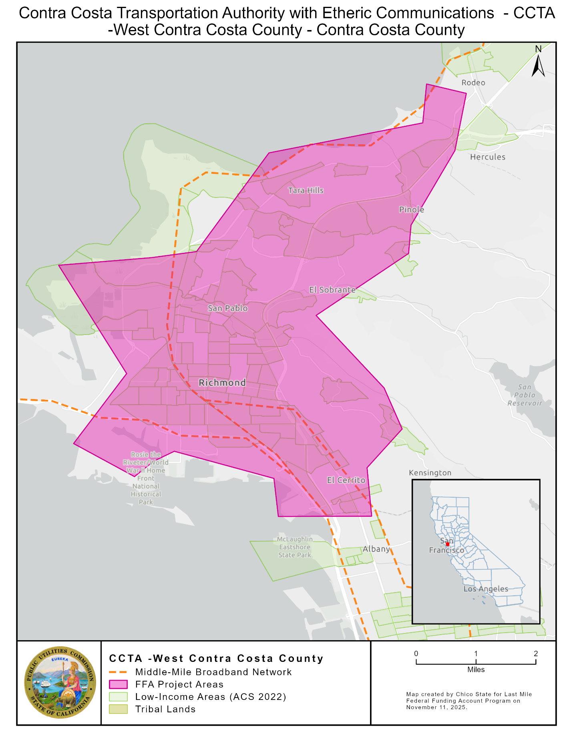

APPENDIX G
CCTA-East Contra Costa County
Key Information

Project Name | CCTA - East Contra Costa County
Applicant Name | Contra Costa Transportation Authority
Community Names | Clayton, Byron, Brentwood, Oakley, Knightsen
County | Contra Costa
County Allocation | $16,108,600
Project Size (Square Miles) | 57.14
Maximum Download/Upload Speed | 10,000 / 10,000 Mbps
Lowest Cost Plan (Non-Income-Qualified) | $40 (100/100 Mbps)
Low-Income Plan Offered | No
Low-Cost Plan | $40 (100/100 Mbps)
LifeLine Participation | Yes
Percent Disadvantaged Communities | 0%
Percent Low-Income Areas | 27%
Median Household Income (weighted) | $144,510
Estimated Households in Project Area (Estimated Area Households) | 14,004
Estimated Benefitting Population (Estimated Area Population) | 41,296
Estimated Locations within 1,000 Feet of the Project Area (Location Passings) | 13,898
Estimated Units within 1,000 Feet of the Project Area (Unit Passings) | 17,757
Unserved Locations in the Project Area | 1,090
Unserved Units in the Project Area | 1,586
Estimated Unserved Population in the Project Area | 5,078
Estimated Unserved Locations with Multiple Dwelling Units (MDUs) in the Project Area | 274
Estimated Unserved Multiple Dwelling Units (MDUs) among Locations in the Project Area | 770
Community Anchor Institutions Benefitting from the Project | 9
Public Safety Locations Benefitting from the Project | 0
Any High Fire Threat Districts in the Project Area | No
100% Underground | No
Connection to Public Open-Access Middle-Mile | Yes
Distance of Middle-Mile, Backhaul, Feeder, and Connection to Middle-Mile Broadband Network Proposed by the Project | 0 Miles
Grant Costs for Middle-Mile, Backhaul, Feeder, and Connection to Middle-Mile Broadband Network in Project Area | $0
Grant Costs for Last-Mile Delivery | $10,401,262
Deployment Schedule | 24 months
Total Project Cost | $10,401,262
Amount of FFA Grant Funds Requested | $10,401,262
Applicant Funded | $0
Grant (Excluding Middle-Mile) per Unserved Unit in the Project Area | $6,558
Grant (Excluding Middle-Mile) per Unit Passing | $586

Map of CCTA-East Contra Costa County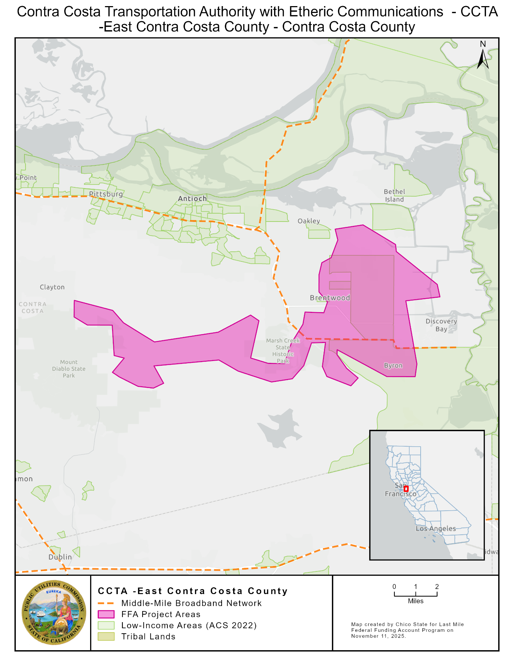

APPENDIX H
Stimulus Technologies Plans
As a condition of the grant awards in this Resolution, Stimulus Technologies is obligated to offer service to customers in the project areas of the listed projects at no less than the speeds in the Table below, no more than 100 milliseconds of latency, and no more than the prices in the Table below, including installation, for at least five years following project completion.
- Inyo-5
Plan | Speed | Price in 2025 Dollars | Notes
Broadbased Low-Income Plan | 100/20 Mbps | $30/month | Low-income broadband plans as defined in the FFA Rules.
Low-Cost Plan | 150/150 Mbps | $40/month | Low-income broadband plans as defined in the FFA Rules.
As a condition of the grant awards in this Resolution, Stimulus Technologies has committed to provide LifeLine-discounted service in the project area listed.
In addition, Stimulus Technologies commits to offer voice service that meets California and Federal Communications Commission requirements for 9-1-1 service.

APPENDIX I
California Broadband Alliance Plans
As a condition of the grant awards in this Resolution, the California Broadband Alliance is obligated to offer service to customers in the project areas of the listed projects at no less than the speeds in the Table below, no more than 100 milliseconds of latency, and no more than the prices in the Table below, including installation, for at least five years following project completion, or ten years for the Low-Cost Plan:.
- Surfnet- Salinas
Plan | Speed | Price in 2025 Dollars | Notes
Broad-based Low-Income Plan | 100/100 Mbps | $30/month | Low-income broadband plans as defined in the FFA Rules.
Low-Cost Plan | 100/100 Mbps | $30/month | Low-income broadband plans as defined in the FFA Rules.

As a condition of the grant awards in this Resolution, California Broadband Alliance has committed to provide LifeLine-discounted service in the project area listed.
In addition, California Broadband Alliance commits to offer voice service that meets California and Federal Communications Commission requirements for 9-1-1 service.

APPENDIX J
Contra Costa Transportation Authority Plans
As a condition of the grant awards in this Resolution, Contra Costa Transportation Authority is obligated to offer service to customers in the project areas of the listed projects at no less than the speeds in the Table below, no more than 100 milliseconds of latency, and no more than the prices in the Table below, including installation, for at least five years following project completion.
- West Contra Costa County
- East Contra Costa County
Plan | Speed | Price in 2025 Dollars | Notes
Contra Costa Transportation Authority - Low-Cost Plan | 100/100 Mbps | $40/month | Low-cost broadband plans as defined in the FFA Rules.  As stated in the applications—  Eligibility: Available to all, meaning no income documentation or qualification requirements are necessary.  Equitable Access: Unlike traditional income-restricted subsidy programs, this plan ensures automatic availability for all customers, regardless of financial status.  No enrollment barriers: Residents do not need to participate in state or federal assistance programs to qualify.

As a condition of the grant awards in this Resolution, Contra Costa Transportation Authority has committed to provide LifeLine-discounted service in the project area listed.
In addition, Contra Costa Transportation Authority commits to offer voice service that meets California and Federal Communications Commission requirements for 9-1-1 service.

APPENDIX K
California Public Utilities Commission
Federal Funding Account, Last Mile Program
Guidance to Staff Regarding
CONSENT FORM
Acknowledgement and Acceptance of Terms
Awardee Name:

Key Project Contact:

Project Name:

The Awardee identified above acknowledges receipt of the California Public Utilities Commission Resolution or Award Letter and agrees to comply with all grant terms, conditions, and requirements set forth in the Resolution or Award Letter and those in the Federal Funding Account, Last Mile program rules. Awards are contingent on available state budget appropriations funding.
Undersigned representative of __________________________________ [Name of Awardee] is duly authorized to execute this Consent Form on behalf of the Awardee and to bind the Awardee to the terms, conditions, and requirements set forth in California Public Utilities Commission Resolution or Award Letter and those in the Federal Funding Account, Last Mile program rules.

Dated this _____ day of _____________, 20____.

Signature of Awardee Representative: _____________________________________________________

Title __________________________________________________________

Printed Name __________________________________________________

Name of Representative’s Organization:
______________________________________________________________

Business Address:

Street address, suite/apt. number

City, state, and ZIP Code

Telephone Number: ________________________________

Email Address: _____________________________________

Statute 2021, Chapters 84 and 112.
The Commission Environmental and Social Justice Action plan includes definitions and data indicators for disadvantaged or Environmental and Social Justice communities including Disadvantaged Communities defined by the California Environmental Protection Agency (CalEPA) and low-income households defined as household incomes below 80 percent of the area median income. The Commission’s Environmental and Social Justice Action Plan 2.0 is available at: https://www.cpuc.ca.gov/-/media/cpuc-website/divisions/news-and-outreach/documents/news-office/key-issues/esj/esj-action-plan-v2jw.pdf.
The Federal Funding Account Public Map is available at: https://federalfundingaccountmap.vetro.io/.
Disadvantaged or Environmental and Social Justice communities and individual locations, for purposes of the Federal Funding Account, include those in Disadvantaged Communities census tracts as defined by CalEPA and low-income areas in which the census block group median household income is less than or equal to 80 percent of the higher of the county or state average. This data is available for download on the Federal Funding Account Public Map page (visited June 13, 2024), https://www.cpuc.ca.gov/industries-and-topics/internet-and-phone/broadband-implementation-for-california/last-mile-federal-funding-account/ffa-public-map and the Federal Funding Account Application Resources Page (visited June 13, 2024), https://www.cpuc.ca.gov/industries-and-topics/internet-and-phone/broadband-implementation-for-california/last-mile-federal-funding-account/ffa-application-resources-page.
See Federal Funding Account Recommendations and Awards, https://www.cpuc.ca.gov/industries-and-topics/internet-and-phone/broadband-implementation-for-california/last-mile-federal-funding-account/federal-funding-account-awards.
See 2025 Federal Funding Account Application Resources, https://www.cpuc.ca.gov/industries-and-topics/internet-and-phone/broadband-implementation-for-california/last-mile-federal-funding-account/ffa-application-resources-page.
D.22-04-055 states that “households and businesses with an identified need for additional broadband infrastructure do not have to be the only ones in the service area served by an eligible broadband infrastructure project. Indeed, serving these households and businesses may require a holistic approach that provides service to a wider area, or example, in order to make ongoing service of certain households or businesses within the service area economical.”
Federal broadband programs include the Connect America Fund II, Community Connects Grant Program, Enhanced Alternative Connect America Cost Model, Rural Digital Opportunity Fund, Rural E-Connectivity Program, Tribal Broadband Connectivity Program, and Telephone Loan Program.
Code of Federal Regulations Part 200, available at https://www.ecfr.gov/current/title-2/subtitle-A/chapter-II/part-200
D. 22-04-055, Appendix A, Section 14.
D.22-04-055, Section 13.2, page 57.
Prices may increase at no more than the rate of inflation, defined by the Consumer Price Index.
Prices may increase at no more than the rate of inflation, defined by the Consumer Price Index.
Prices may increase at no more than the rate of inflation, defined by the Consumer Price Index.

